Supplementary Information
Efficient light upconversion via resonant exciton-exciton annihilation of dark excitons in few-layer transition metal dichalcogenides
Yi-Hsun Chen^{1,2}*†, Ping-yuan Lo^{3†}, Kyle W. Boschen^{2,4}, Guan-Hao Peng³, Chun-Jui Huang³, Luke N. Holtzman⁵, Chih-En Hsu⁶, Yung-Ning Hsu⁶, Madisen Holbrook⁷, Wei-Hua Wang⁸, Katayun Barmak⁵, James Hone⁹, Pawel Hawrylak¹⁰, Hung-Chung Hsueh⁶, Jeffrey A. Davis^{2,4}, Shun-Jen Cheng³*, Michael S. Fuhrer^{1,2,11}, Shao-Yu Chen^{2,12,13}*
¹ School of Physics and Astronomy, Monash University, Clayton, Victoria 3800, Australia
² Australian Research Council Centre of Excellence in Future Low-Energy Electronics Technologies (FLEET), Monash University, Clayton, Victoria 3800, Australia
³ Department of Electrophysics, National Yang Ming Chiao Tung University, Hsinchu 300 093, Taiwan.
⁴ Optical Sciences Centre, Swinburne University of Technology, Hawthorn, VIC 3122, Australia.
⁵ Department of Applied Physics and Applied Mathematics, Columbia University, New York, New York 10027, United States
⁶ Department of Physics, Tamkang University, New Taipei City, 251301 Taiwan
⁷ Department of Physics, Columbia University, New York NY 10027, USA
⁸ Institute of Atomic and Molecular Sciences, Academia Sinica, Taipei 10617, Taiwan
⁹ Department of Mechanical Engineering, Columbia University, New York, New York 10027, United States
¹⁰ Department of Physics, University of Ottawa, Ottawa, Ontario, K1N 6N5, Canada
¹¹ Monash Centre for Atomically Thin Materials, Monash University, Clayton, 3800, VIC, Australia
¹² Center for Condensed Matter Sciences, National Taiwan University, Taipei 10617, Taiwan
¹³ Center of Atomic Initiative for New Material, National Taiwan University, Taipei 10617, Taiwan

Supplementary note 1: Calculation of exciton spectra of atomically thin WSe₂
The exciton state can be expressed in terms of the superposition of electron-hole configurations as $|X_{SQ}〉=\frac{1}{\sqrt{A}}\sum_{vck}{{\hat{c}}_{ck+Q}^{†}{\hat{c}}_{vk}|GS〉}$, where $A$ is the area of the two-dimensional material, $S$ and $Q$ label the quantum number and wave vector of the exciton state, respectively, with ${\hat{c}}_{c/vk}^{\left(†\right)}$ being the annihilation (creation) operator of the electron in conduction/valence band $c$/$v$ carrying momentum $k$. The exciton energy $E_{SQ}^{X}$ and the wavefunction $A_{vck}^{X,SQ}$, where the latter characterises the amplitude of electron-hole configurations ${\hat{c}}_{ck+Q}^{†}{\hat{c}}_{vk}|GS〉$, are determined by the Bethe-Salpeter equation (BSE)
$\left(ϵ_{ck+Q}-ϵ_{vk}\right)A_{vck}^{X,SQ}-\frac{1}{A}\sum_{v^{'}c^{'}k^{'}}{\left[W_{ck+Q,v^{'}k^{'},vk,c^{'}k^{'}+Q}^{eh,d}-V_{ck+Q,v^{'}k^{'},c^{'}k^{'}+Q,vk}^{eh,x}\right]A_{v^{'}c^{'}k^{'}}^{X,SQ}}=E_{SQ}^{X}A_{vck}^{X,SQ}$. (1)
Here, $ϵ_{c/vk}$ is the quasiparticle energy of conduction/valence band $c/v$, $W$ and $V$, with the superscripts respectively indicating the electron-hole direct and exchange interactions, are the Coulomb matrix elements defined as
$W_{ck+Q,v^{'}k^{'},vk,c^{'}k^{'}+Q}=\int{d^{3}r_{1}d^{3}r_{2} ψ_{ck+Q}^{*}\left(r_{1}\right)ψ_{v^{'}k^{'}}^{*}\left(r_{2}\right)W\left(r_{1},r_{2}\right)ψ_{vk}\left(r_{2}\right)ψ_{c^{'}k^{'}+Q}\left(r_{1}\right)} ,$ (2)
$V_{ck+Q,v^{'}k^{'},c^{'}k^{'}+Q,vk}=\int{d^{3}r_{1}d^{3}r_{2} ψ_{ck+Q}^{*}\left(r_{1}\right)ψ_{v^{'}k^{'}}^{*}\left(r_{2}\right)V\left(r_{1}-r_{2}\right)ψ_{c^{'}k^{'}+Q}\left(r_{2}\right)ψ_{vk}\left(r_{1}\right)} ,$ (3)
where, $ψ_{c/vk}\left(r\right)$ is the single-electron wavefunction, $V\left(r\right)=\frac{e^{2}}{4πε_{0}\left|r\right|}$ and $W\left(r_{1},r_{2}\right)=\int{d^{3}r^{'}ε^{-1}\left(r_{1},r^{'}\right)V\left(r^{'}-r_{2}\right)}$ are the bare and screened Coulomb potentials, respectively, and $ε^{-1}\left(r_{1},r_{2}\right)$ is the inverse dielectric function.
The quasiparticle band structures of few-layer transition-metal dichalcogenides (TMDs) are obtained from the first principles calculations. Within the density functional theory (DFT) scheme, the electronic structures of few-layer WSe₂ were investigated through first-principles calculations. The Quantum Espresso code¹, employing ultrasoft pseudopotentials, facilitated these computations. The Perdew-Burke-Ernzerhof (PBE) functional within the generalised gradient approximation², supplemented with a van der Waals (DFT-D3) correction³, was chosen to approximate the exchange-correlation interaction in the quasi-2D anisotropic systems. A plane-wave basis expansion of the wavefunction was achieved with an energy cutoff set at 80 Ry. The Brillouin zone integration of the lattice was conducted using a 12×12×1 k-point grid sampling. Optimised lattice constants of 3.334 Å, 3.351 Å, and 3.341 Å were employed to model mono-, bi-, and four-layer WSe₂ structures, respectively. Furthermore, to address accurate many-body effects beyond mean-field theory, advanced quasiparticle (QP) G₀W₀ calculations were performed using the BerkeleyGW package⁴, based on the DFT results. A nonuniform neck subsampling (NNS) scheme⁵ was employed to ensure efficient convergence with q-point sampling. The QP gaps were converged to better than 0.1 eV utilising a dielectric cutoff of 35 Ry and up to 2600 bands. The quasiparticle band structures for mono-, bi- and four-layer WSe₂ are presented in Supplementary Figure 1.
In the computations of the BSE⁶, the electron-hole exchange interaction is neglected since it generally give rise to few to $\sim 10$meV energy shifts for indirect excitons ($QΓ$, $QK$, $QK$, $K^{'}K$) and bright excitons ($KK$, $QQ$, $ΓΓ$), which is a minor factor in searching for the candidates of high-lying bright exciton states that matches the energy conservation criterion of the resonant EEA. In constructing the electron-hole direct Coulomb matrix elements (2), the screened Coulomb potential is obtained by solving the Poisson’s equation in $k$-space for layered structures, as detailed in Ref. (7). Here, we take the effective thickness of 6.72 Å, 11.70 Å, 23.75 Å for 1L, 2L, 4L WSe₂, respectively, and the dielectric constant of the environment is set to ε = 1 (air). The resulting exciton spectra for 1L, 2L, and 4L WSe₂ are presented in Figure 3c–e in the main text. Note that, for clarity, we do not show the high-lying excitonic Rydberg series (e.g. 2s, 2p) which are less relevant to the upconversion photoluminescence.
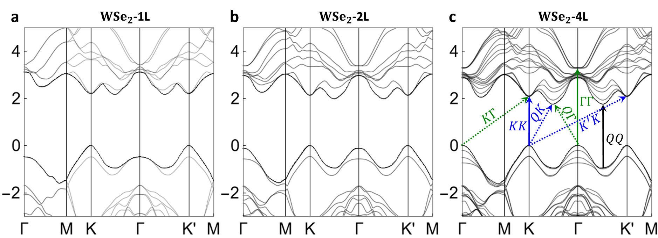
Supplementary Figure 1. First principles calculations of the quasi-particle band structures for (a) 1L, (b) 2L, and (c) 4L WSe₂. The arrows in (c) illustrate the interband transitions for forming various bright excitons ($KK$, $QQ$, $ΓΓ$) and momentum-indirect dark excitons ($K^{'}K$, $KΓ$, $QK$, $QΓ$).

Supplementary note 2: Theory of the resonant exciton-exciton annihilation (EEA)
The exciton-exciton annihilation emerges as an exciton-exciton interaction converting two low-lying excitons (X_{D}) into one high-lying exciton (HX). Since the exciton density in our EEA experiment is very low, we treat individual excitons in few-layer TMDs as bosons.⁸ The EEA process is described by the following Hamiltonian
${\hat{H}}_{X}^{EEA}=\frac{1}{2}\sum_{S,S_{1},S_{2}}{\sum_{Q_{1},Q_{2}}{W_{SQ;S_{1}Q_{1},S_{2}Q_{2}}^{X, EEA}{\hat{X}}_{SQ}^{†}{\hat{X}}_{S_{1}Q_{1}}{\hat{X}}_{S_{2}Q_{2}}}}+h.c. ,$ (4)
where the exciton creation operator is defined as ${\hat{X}}_{SQ}^{†}=\frac{1}{\sqrt{A}}\sum_{vck}{A_{vck}^{X,SQ}{\hat{c}}_{ck+Q}^{†}{\hat{c}}_{vk}}$, and the transition rate of the EEA-induced upconversion is given by
$Γ_{SQ;S_{1}Q_{1},S_{2}Q_{2}}^{EEA}=\frac{2π}{ℏ}{\left|W_{SQ;S_{1}Q_{1},S_{2}Q_{2}}^{X,EEA}\right|}^{2}{\overline{n}}_{S_{1}Q_{1}}^{X}{\overline{n}}_{S_{2}Q_{2}}^{X}δ\left(E_{SQ}^{HX}-E_{S_{1}Q_{1}}^{X}-E_{S_{2}Q_{2}}^{X}\right) .$ (5)
Here, ${\overline{n}}_{S_{i}Q_{i}}^{X}$ and $E_{S_{i}Q_{i}}^{X}$ are the population and the eigenenergy solved from the BSE (1) of the low-lying indirect excitons labelled by $S_{i}$ and $Q_{i}$, respectively, and we label the upconverted high-lying exciton state by HX for clarity. The EEA matrix elements are given by
$W_{SQ;S_{1}Q_{1},S_{2}Q_{2}}^{X,EEA}=W_{SQ;S_{1}Q_{1},S_{2}Q_{2}}^{X,EEA,d}+W_{SQ;S_{1}Q_{1},S_{2}Q_{2}}^{X,EEA,x}$, (6)
$W_{SQ;S_{1}Q_{1},S_{2}Q_{2}}^{X,EEA,d}=\frac{1}{A^{3/2}}\sum_{vck}{\sum_{c^{''}}{\sum_{v^{'}c^{'}k^{'}}{{\left(A_{vck}^{HX,SQ}\right)}^{*}A_{vc^{''}k}^{X,S_{1}Q_{1}}A_{v^{'}c^{'}k^{'}}^{X,S_{2}Q_{2}}}}}W_{ck+Q,v^{'}k^{'},c^{'}k^{'}+Q_{2},c^{''}k+Q_{1}}^{Auger,d}-\frac{1}{A^{3/2}}\sum_{vck}{\sum_{v^{''}}{\sum_{v^{'}c^{'}k^{'}}{{\left(A_{vck}^{HX,SQ}\right)}^{*}A_{v^{''}ck+Q_{2}}^{X,S_{1}Q_{1}}A_{v^{'}c^{'}k^{'}}^{X,S_{2}Q_{2}}W_{v^{'}k^{'},v^{''}k+Q_{2},vk,c^{'}k^{'}+Q_{2}}^{Auger,d}}}}+\left(1↔2\right)$, (7)
$W_{SQ;S_{1}Q_{1},S_{2}Q_{2}}^{X,EEA,x}=\frac{1}{A^{3/2}}\sum_{vck}{\sum_{c^{''}}{\sum_{v^{'}c^{'}k^{'}}{{\left(A_{vck}^{HX,SQ}\right)}^{*}A_{vc^{''}k}^{X,S_{1}Q_{1}}A_{v^{'}c^{'}k^{'}}^{X,S_{2}Q_{2}}}}}W_{ck+Q,v^{'}k^{'},c^{''}k+Q_{1},c^{'}k^{'}+Q_{2}}^{Auger,x}-\frac{1}{A^{3/2}}\sum_{vck}{\sum_{v^{''}}{\sum_{v^{'}c^{'}k^{'}}{{\left(A_{vck}^{HX,SQ}\right)}^{*}A_{v^{''}ck+Q_{2}}^{X,S_{1}Q_{1}}A_{v^{'}c^{'}k^{'}}^{X,S_{2}Q_{2}}W_{v^{'}k^{'},v^{''}k+Q_{2},c^{'}k^{'}+Q_{2},vk}^{Auger,x}}}}+\left(1↔2\right)$. (8)
Here, $W^{X,EEA,d}$ and $W^{X,EEA,x}$ are the direct and exchange terms of the EEA matrix elements, respectively. In Eqs. (7) and (8), the first (second) term originates from the electron (hole)-mediated Auger process, where one electron (hole) is scattered to high (low)-lying conduction (valence) band by obtaining the energy and momentum from the recombined electron-hole pair, forming the HX with the uninvolved hole (electron), as illustrated in Supplementary Figure 2a(b). Such EEA process requires the conservation of momentum $Q=Q_{1}+Q_{2}$, and must fulfil the spin selection rule required by the interband transitions of the electron (hole) and the recombination of the electron-hole pair. Here we note that, for both direct and exchange EEA processes, the resulting upconverted HX is the same.
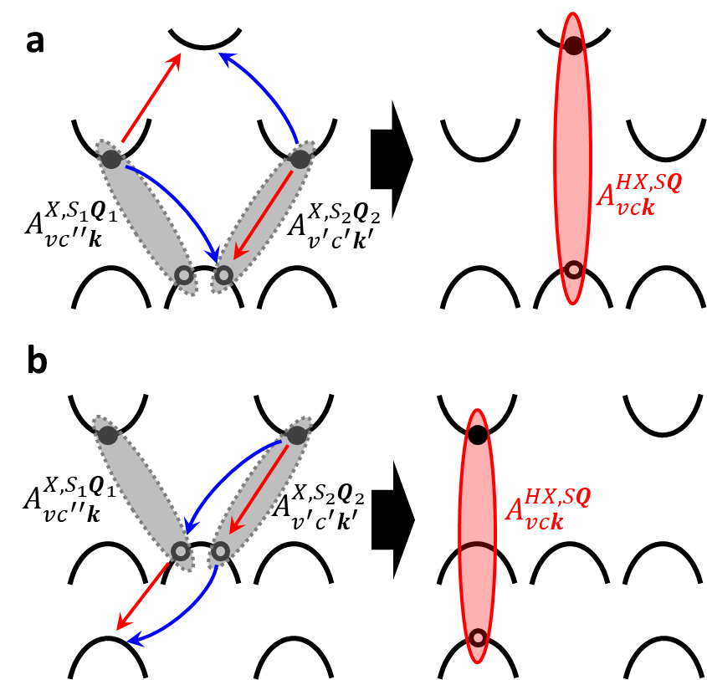
Supplementary Figure 2. Schematics of the (a) electron- and (b) hole-mediated EEA processes. Red and blue arrows on the left panel illustrate the direct and exchange Auger-like processes, respectively, where both processes upconvert the pair of low-lying excitons into the same high-lying exciton on the right panel.
In the main text, we experimentally demonstrate light upconversion through EEA of momentum-indirect excitons in few-layer TMDs. Unlike previous studies, the upconverted high-lying excitons locate around Γ valley in the k-space, and the EEA processes are observed in all kinds of n-layer TMDs with n ≥ 3. To search for the candidates of the upconversion pathways, we first solve the exciton spectra from the BSE (1) by numerically exact diagonalisation⁶, and the results are presented in Fig. 3c–e of the main text. As illustrated in Supplementary Figure 2, the upconverted high-lying exciton is formed at the valley where the uninvolved hole/electron originally resides in the electron-/hole-mediated EEA process, and naturally consists of that uninvolved hole/electron taking the highest valence/lowest conduction band. For example, high-lying $ΓΓ$ excitons with the hole occupying the highest valence band can be upconverted from low-lying $QΓ$ excitons by absorbing the energy of another X_{D} with opposite momentum ($Q^{'}Γ$ or QK), but cannot be upconverted from QK excitons since the hole is not residing around $Γ$-valley (see items 3, 4 and 6 of Supplementary Table 1). Therefore, only a fraction of the high-lying bright exciton states ($KK$, $QQ$ and $ΓΓ$) are viable for the EEA-induced upconversion. Here, we summarise all valid candidates of the high-lying bright excitons that can be upconverted from a pair of low-lying excitons via EEA process in Supplementary Table 1, where each type of bright and momentum-indirect dark excitons is illustrated in Supplementary Figure 1c. All the possible candidates of the high-lying bright excitons that fulfil the band selection rule for the upconversion photoluminescence are highlighted in coloured in Figure 3c–e in the main text.

Supplementary Table 1. List of all possible high-lying bright excitons upconverted from a pair of low-lying excitons carrying opposite momentum via the electron-/hole-mediated EEA process
Low-lying exciton pair | Upconverted bright excitons via electron-/hole-mediated EEA
- $KK+KK$ | $KK$ / $KK$
- $K^{'}K+KK^{'}$ | $KK$ / $KK$
- $QK+Q^{'}K$ | $KK$ / $QQ$
- $QΓ+Q^{'}Γ$ | $ΓΓ$ / $QQ$
- $KΓ+K^{'}Γ$ | $ΓΓ$ / $KK$
- $QK+QΓ$ | $KK,ΓΓ$ / $QQ$
- $K^{'}K+K^{'}Γ$ | $KK,ΓΓ$ / $KK$

REFERENCES
- Giannozzi, P.; Baseggio, O.; Bonfà, P.; Brunato, D.; Car, R.; Carnimeo, I.; Cavazzoni, C.; de Gironcoli, S.; Delugas, P.; Ruffino, F. F.; Ferretti, A.; Marzari, N.; Timrov, I.; Urru, A.; Baroni, S. Quantum ESPRESSO toward the exascale. J. Chem. Phys. 2020,152 (15), 154105. https://doi.org/10.1063/5.0005082
- Perdew, J. P.; Burke, K.; Ernzerhof, M. Generalized gradient approximation made simple. Phys. Rev. Lett. 1996, 77 (18), 3865. https://doi.org/10.1103/PhysRevLett.77.3865
- Witte, J.; Mardirossian, N.; Neaton, J. B.; Head-Gordon, M. Assessing DFT-D3 Damping Functions Across Widely Used Density Functionals: Can We Do Better?. J. Chem. Theory Comput. 2017, 13 (5), 2043. https://doi.org/10.1021/acs.jctc.7b00176
- Deslippe, J.; Samsonidze, G.; Strubbe, D. A.; Jain, M.; Cohen, M. L.; Louie, S. G. BerkeleyGW: A massively parallel computer package for the calculation of the quasiparticle and optical properties of materials and nanostructures. Comput. Phys. Commun. 2012, 183 (6), 1269. https://doi.org/10.1016/j.cpc.2011.12.006
- da Jornada, F. H.; Qiu, D. Y.; Louie, S. G. Nonuniform sampling schemes of the Brillouin zone for many-electron perturbation-theory calculations in reduced dimensionality. Phys. Rev. B, 2017, 95 (3), 035109. https://doi.org/10.1103/PhysRevB.95.035109
- Peng, G.-H.; Lo, P.-Y.; Li, W.-H.; Huang, Y.-C.; Chen, Y.-H.; Lee, C.-H.; Yang, C.-K.; Cheng, S.-J. Distinctive Signatures of the Spin- and Momentum-Forbidden Dark Exciton States in the Photoluminescence of Strained WSe₂ Monolayers under Thermalization. Nano Lett. 2019, 19 (4) 2299. https://doi.org/10.1021/acs.nanolett.8b04786
- Li, W.-H.; Lin, J.-D.; Lo, P.-Y.; Peng, G.-H.; Hei, C.-Y.; Chen, S.-Y.; Cheng, S.-J. The Key Role of Non-Local Screening in the Environment-Insensitive Exciton Fine Structures of Transition-Metal Dichalcogenide Monolayers. Nanomaterials 2023, 13 (11), 1739. https://doi.org/10.3390/nano13111739
- Steinhoff, A.; Jahnke, F.; Florian, M. Microscopic theory of exciton-exciton annihilation in two-dimensional semiconductors. Phys. Rev. B 2021, 104 (15), 155416. https://doi.org/10.1103/PhysRevB.104.155416

