Supplementary
NANOSTRUCTURED ZINC CARBONATE HYDROXIDE MICROFLAKES: ASSESSING THE TOXICITY AGAINST ERYTHROCYTES AND L929 CELLS IN VITRO
Volodymyr Prokopiuk^{1,2}, Anatolii Onishchenko², Yuliia Pazura³, Iryna Bespalova³, Umut Kökbaş⁴, Liliya Tryfonyuk⁵, Pavlo Mateychenko⁶, Kateryna Kot⁷, Saulesh Kurmangaliyeva⁸, Yurii Kot⁷*, Svitlana Yefimova³*, Anton Tkachenko^{2,9}*

¹Research Institute of Experimental and Clinical Medicine, Kharkiv National Medical University, 4 Nauky ave, 61022 Kharkiv, Ukraine
²Department of Cryobiochemistry, Institute for Problems of Cryobiology and Cryomedicine of the National Academy of Sciences of Ukraine, 23 Pereyaslavskaya st, 61015 Kharkiv, Ukraine
³Department of Nanostructured Materials, Institute for Scintillation Materials of the National Academy of Sciences of Ukraine, 60 Nauky ave, 61072 Kharkiv, Ukraine
⁴Medical Biochemistry Department, Nevsehir Haci Bektas Veli University, 2000 Evler Mah. Zübeyde Hanım Cad. 50300 / Nevşehir, Turkey
⁵Institute of Health, National University of Water and Environmental Engineering, 11 Soborna st, 33028 Rivne, Ukraine
⁶Institute for Single Crystals, National Academy of Sciences of Ukraine, 60 Nauky ave, 61072 Kharkiv, Ukraine
⁷Department of Biochemistry, V. N. Karazin Kharkiv National University, 4 Svobody sq, 61022 Kharkiv, Ukraine
⁸Department of Microbiology, Virology and Immunology, West Kazakhstan Marat Ospanov Medical University, 68 Maresyev st, 030012 Aktobe, Republic of Kazakhstan
⁹BIOCEV, First Faculty of Medicine, Charles University, Průmyslová 595, 25250 Vestec, Czech Republic

Table S1
The single cell Ca²⁺-specific fluorescence intensity in L929 cells incubated with ZnCH microflakes
Concentrations of ZnCH microflakes | Fluorescence intensity, rfu/cell
0 mg/L | 75.1 ± 6.2
2 mg/L | 83.9 ± 6.5
10 mg/L | 89.3 ± 6.8
25 mg/L | 127.5 ± 13.9, p < 0.01
50 mg/L | 168.7 ± 14.2, p < 0.001
100 mg/L | 215.3 ± 16.9, p < 0.001
Note: Kruskal-Wallis and Dunn’s tests, means ± SEM (n = 3); rfu – relative fluorescence units. p values provide comparison with the cells not exposed to ZnCH microflakes

Table S2
The single cell reactive nitrogen species (RNS)-specific fluorescence intensity in L929 cells incubated with ZnCH microflakes
Concentrations of ZnCH microflakes | Fluorescence intensity, rfu/cell
0 mg/L | 45.3 ± 9.7
2 mg/L | 72.8 ± 14.6
10 mg/L | 109.5 ± 16.2, p < 0.01
25 mg/L | 181.3 ± 16.8, p < 0.001
50 mg/L | 263.7 ± 19.1, p < 0.001
100 mg/L | 315.1 ± 19.8, p < 0.001
Note: Kruskal-Wallis and Dunn’s tests, means ± SEM (n = 3); rfu – relative fluorescence units. p values provide comparison with the cells not exposed to ZnCH microflakes

Table S3
The single cell ratiometric index (the ratio of liquid disordered phase-specific fluorescence intensity Fl red 633 nm to liquid ordered phase-specific fluorescence intensity Fl green 550 nm) in L929 cells treated with ZnCH microflakes
Concentrations of ZnCH microflakes | Ratiometric index
0 mg/L | 0.84 ± 0.12
2 mg/L | 1.07 ± 0.15
10 mg/L | 1.24 ± 0.18
25 mg/L | 2.80 ± 0.15, p < 0.001
50 mg/L | 3.27 ± 0.18, p < 0.001
100 mg/L | 3.69 ± 0.15, p < 0.001
Note: Kruskal-Wallis and Dunn’s tests, means ± SEM (n = 3); rfu – relative fluorescence units. p values provide comparison with the cells not exposed to ZnCH microflakes

Table S4
The single cell caspase-3-, caspase-8-, and caspase-9-specific fluorescence intensity in L929 cells exposed to ZnCH microflakes
Concentrations of ZnCH microflakes | Fluorescence intensity, rfu/cell
Concentrations of ZnCH microflakes | Caspase-3 | Caspase-8 | Caspase-9
0 mg/L | 7.2 ± 5.5 | 9.4 ± 6.8 | 11.7 ± 5.3
2 mg/L | 8.9 ± 6.7 | 8.5 ± 6.2 | 13.1 ± 6.8
10 mg/L | 15.5 ± 8.9 | 72.5 ± 17.3, p < 0.01 | 19 ± 10.5
25 mg/L | 151.8 ± 11.7, p <0.001 | 186.1 ± 16.9, p < 0.001 | 173.5 ± 14.3, p < 0.001
50 mg/L | 192.6 ± 13, p < 0.001 | 242.5 ± 17.1, p < 0.001 | 239.1 ± 15.7, p < 0.001
100 mg/L | 237.3 ± 15.8, p < 0.001 | 281.3 ± 16.5, p < 0.001 | 270.9 ± 16.8, p < 0.001
Note: Kruskal-Wallis and Dunn’s tests, means ± SEM (n = 3); rfu – relative fluorescence units. p values provide comparison with the cells not exposed to ZnCH microflakes

Table S5
The single cell Ca²⁺-specific fluorescence intensity in erythrocytes exposed to ZnCH microflakes
Concentrations of ZnCH microflakes | Fluorescence intensity, rfu/cell
0 mg/L | 102.6 ± 7.5
20 mg/L | 118.3 ± 7.1
100 mg/L | 141.5 ± 7.3, p < 0.01
250 mg/L | 179.1 ± 9.5, p < 0.001
500 mg/L | 221.8 ± 11.3, p < 0.001
Note: Kruskal-Wallis and Dunn’s tests, means ± SEM (n = 3); rfu – relative fluorescence units. p values provide comparison with the cells not exposed to ZnCH microflakes

Table S6
The single cell reactive nitrogen species (RNS)-specific fluorescence intensity in erythrocytes treated with ZnCH microflakes
Concentrations of ZnCH microflakes | Fluorescence intensity, rfu/cell
0 mg/L | 28.3 ± 7.1
20 mg/L | 31.4 ± 12.7
100 mg/L | 77.9 ± 14.1, p < 0.001
250 mg/L | 165.2 ± 14.5, p < 0.001
500 mg/L | 223.5 ± 17.4, p < 0.001
Note: Kruskal-Wallis and Dunn’s tests, means ± SEM (n = 3); rfu – relative fluorescence units. p values provide comparison with the cells not exposed to ZnCH microflakes

Table S7
The single cell ratiometric index (the ratio of liquid disordered phase-specific fluorescence intensity Fl red 633 nm to liquid ordered phase-specific fluorescence intensity Fl green 550 nm) in red blood cells incubated with ZnCH microflakes
Concentrations of ZnCH microflakes | Ratiometric index
0 mg/L | 0.75 ± 0.10
20 mg/L | 1.01 ± 0.12
100 mg/L | 2.08 ± 0.15, p < 0.001
250 mg/L | 2.60 ± 0.18, p < 0.001
500 mg/L | 3.18 ± 0.15, p < 0.001
Note: Kruskal-Wallis and Dunn’s tests, means ± SEM (n = 3); rfu – relative fluorescence units. p values provide comparison with the cells not exposed to ZnCH microflakes

Table S8
The single cell caspase-3- and caspase-8-specific fluorescence intensity in erythrocytes incubated with ZnCH microflakes
Concentrations of ZnCH microflakes | Fluorescence intensity, rfu/cell
Concentrations of ZnCH microflakes | Caspase 3 | Caspase 8
0 mg/L | 11.5 ± 6.8 | 14.6 ± 5.3
20 mg/L | 15.3 ± 6.5 | 17.2 ± 6.9
100 mg/L | 54.9 ± 10.2, p < 0.001 | 66.8 ± 15.1, p < 0.001
250 mg/L | 127.1 ± 12.5, p < 0.001 | 131.5 ± 15.7, p < 0.001
500 mg/L | 175.7 ± 12.7, p < 0.001 | 178.4 ± 16.5, p < 0.001
Note: Kruskal-Wallis and Dunn’s tests, means ± SEM (n = 3); rfu – relative fluorescence units. p values provide comparison with the cells not exposed to ZnCH microflakes

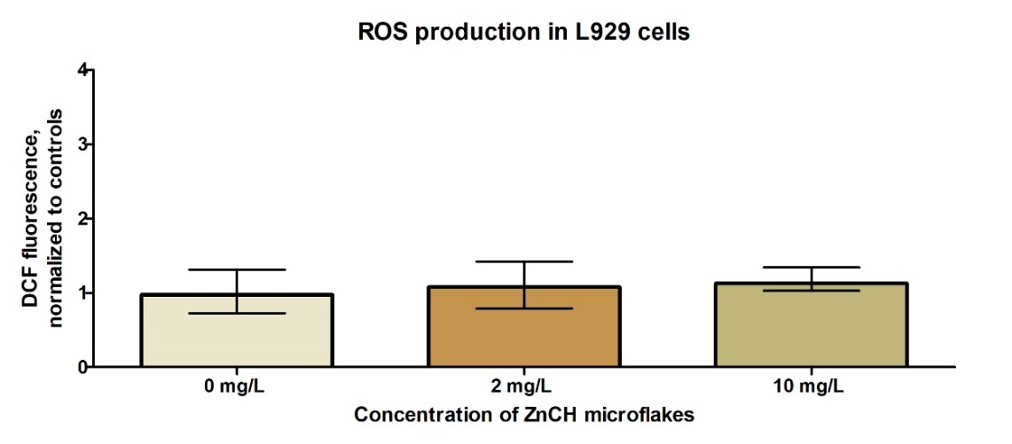
Figure S1. ROS generation in L929 cells exposed to ZnCH microflakes. Dichlorofluorescein (DCF) fluorescence was normalized to control samples. Kruskal-Wallis and Dunn’s tests, Me and interquartile range (n = 3).

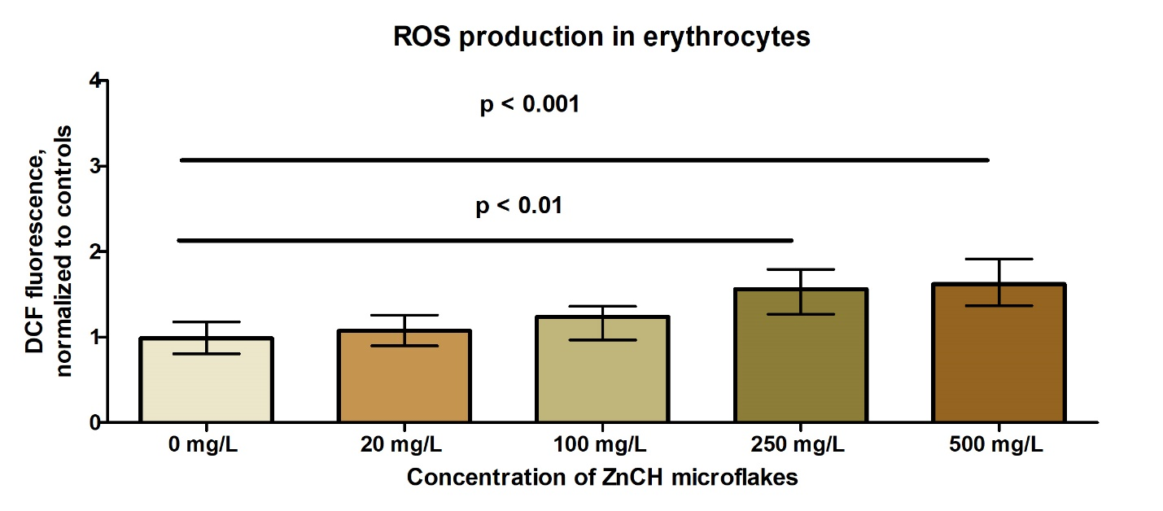
Figure S2. ROS production in mature erythrocytes treated with ZnCH microflakes. Dichlorofluorescein (DCF) fluorescence was normalized to control samples. Kruskal-Wallis and Dunn’s tests, Me and interquartile range (n = 3).
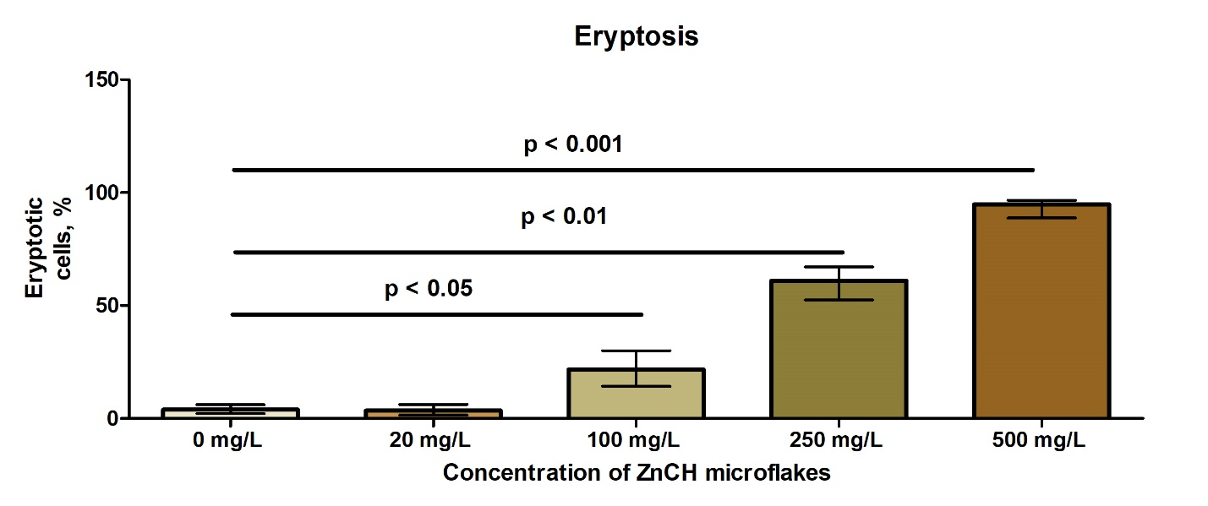
Figure S3. Percentage of cells with externalized phosphatidylserine (eryptotic cells) in erythrocytes exposed to ZnCH microflakes. Kruskal-Wallis and Dunn’s tests, Me and interquartile range (n = 3).

