Programmable Light-Induced Carbene Generation for On Demand Chemical Synthesis: Introducing DigiChemTree
Abhilash Rana,¹ Ruchi Chauhan,¹ Amirreza Mottafegh,² Dong Pyo Kim,² and Ajay K. Singh^{1*}
¹Department of Organic Synthesis & Process Chemistry, CSIR-Indian Institute of Chemical Technology, Hyderabad-500007, India.
And
Academy of Scientific and Innovative Research (AcSIR), Ghaziabad-201002, Uttar Pradesh, India.
²Center for Intelligent Microprocess of Pharmaceutical Synthesis, Department of Chemical Engineering, Pohang University of Science and Technology (POSTECH), Pohang 37673, Republic of Korea
Abhilash Rana and Ruchi Chauhan equally contributed the work
E-mail: ajaysingh015@gmail.com. ajaysingh015@iict.res.in

Table of contents:
S1. | General  S1.1. Materials.  S1.2 Analysis. | S3
S2. | Automated system overview | S4
S3 | Case study-1: Carbene insertion (C-O bond formation) single objective multi-variant auto-optimization. | S20
S4 | Case study-2: Carbene insertion (C-S bond formation) single objective multi-variant auto-optimization. | S48
S5 | Case study-3: Carbene insertion (C-N bond formation) single objective multi-variant auto-optimization. | S70
S6 | Case study-4: Carbene insertion (C-C bond formation, cyclopropanation) single objective multi-variant auto-optimization. | S93
S7 | Case study-5: Carbene insertion (C-C bond formation, cyclopropenation) single objective multi-variant auto-optimization. | S115
S8 | Case study-6: Carbene insertion (N-C-O bond formation, oxazole) single objective multi-variant auto-optimization. | S136
S9 | Case study-7: Carbene insertion (C=C bond formation, fumarate) single objective multi-variant auto-optimization. | S152
S10. | Case study-8: On demand chemical synthesis. | S168
S11. | Spectra | S220
S12. | Troubleshooting | S388
S13. | Supporting references | S389
S1. General
S1.1. Materials: Most of the reagents and chemicals are bought from Sigma-Aldrich and used as such without any further purification. Common organic chemicals and salts were purchased from AVRA chemicals, India. Water used for the experiments was deionized water (18.2 mS conductivity). All work-up and purification procedures were carried out with reagent-grade solvents in air. Analytical thin-layer chromatography (TLC) was performed using analytical chromatography silica gel 60 F254 precoated plates (0.25 mm). The developed chromatogram was analysed by UV lamp (254 nm). PTFE (id = 500 μm) tubing, T-junction, high-purity PFA tubing was purchased from Upchurch IDEX HEALTH &SCIENCE. The photo-batch reactor bought from Lelesil Mumbai India was slightly modified for the continuous flow reaction. Visible light (Blue, Red, Green LED) reactor was bought from the Smartchemsynth Machine Pvt. Ltd, Hyderabad.
S1.2. Analysis: High-resolution mass spectra (HRMS) were obtained from a JMS-T100TD instrument (DART) and Thermo Fisher Scientific Exactive (APCI). Nuclear magnetic resonance (NMR) spectra were recorded on a Bruker 600, 500, 400 or 300 MHz in CDCl₃ or DMSO-d₆ solvent. Chemical shifts for ¹H NMR are expressed in parts per million (ppm) relative to tetramethylsilane (δ 0.00 ppm). Chemical shifts for ¹³C NMR are expressed in ppm relative to CDCl₃ (δ 77.0 ppm). Data are reported as follows: chemical shift, multiplicity (s = singlet, d = doublet, dd = doublet of doublets, t = triplet, q = quartet, quin = quintet, sext = sextet, m = multiplet), coupling constant (Hz). GC/MS analysis was conducted on a Shimadzu technology GCMS-QP2010 instrument equipped with a HP-5 column (30 m × 0.25 mm, Hewlett-Packard) and inbuilt MS 5975C VL MSD system with triple axis detector.

S2. Automated system overview
S2.1. Automated system components
Table S1. Outlines the hardware components utilized in the automated platform, with color coding representing distinct modules (green: operation module, blue: reaction module, yellow: analysis module, purple: fractional sample collection).
Type | Manufacturer |  | Module | Function | Communication protocol | Details in section
Syringe pump |  | HARVARD | Operational module | Solvent delivery | Serial, USB | 2.2.1
HPLC pump |  | KNAUER | Operational  module | Solvent delivery | LAN | 2.2.1
Continuous  Syringe |  | SMART CHEM SYNTH | Operational  module | Solvent delivery | Serial, USB | 2.2.1
Power supply |  | OWON | Reaction module | Reaction | Serial, USB | 2.2.2
Blue LED |  | SMART CHEM SYNTH | Reaction module | Reaction | Serial, USB | 2.2.2
In-line IR |  | METTLER TOLEDO | Analysis module | Sample analysis | Serial, USB | 2.2.3
3D printer |  | ENDER | Collection module | Fractional sample collection | Serial, USB | 2.2.4

S2.2. Automated system hardware module.
S2.2.1 Operational module
The HPLC pumps (figure S1a) and Harvard syringe pump (figure S1b) were directly interfaced to the main computer via an RS-232 interface or LAN. These pumps will help in introducing reactants and reagent solutions into the micro reactor with varied flow rate as the central computer's prescribed flow rate (fr). This control protocol also includes starting/stopping of the pump. The central computer and the HPLC pump communicated through serial communication using ASCII code to exchange information about flow rate, operational status, and duration. This facilitated the transmission of essential details from the main computer to the pumps, enabling them to commence their operations as required. The syringe pump (figure S1c) The parameters for the serial communication of the syringe pump with the computer are given as follows: Baud Rate ‐ 9600, Flow control – none. The basic control protocols include starting/stopping the pump and setting different parameters. Arduino (figure S1d) connected to syringe pump directly interfaced to the main computer via an RS-232 interface or LAN and helps in controlling flow rate. It has inbuilt proximity sensor and pulse will generate through Arduino program.
Figure S1. Picture of working syringe pump and HPLC pump (a) HPLC pump (Knauer) (b) syringe pump (Harvard) (c) Continuous syringe pump with Arduino (smartchemsynth) (d) Arduino.
S2.2.2 Reaction module
We employed a commercially accessible cylindrical blue LED (figure S2b) for the photochemical reaction, utilizing a programmable power supply manufacture by Owon (figure S2a) to regulate the lamp's power (measured in watts) by managing both current and voltage. The Blue LED produces light in the range of wavelength 450-495 nm and it can be operated up to 5 A current, and 14.5 v voltage corresponds to about 70 w wattage. Additionally, rotating fan was attached to the bottom of cylindrical blue LED light to maintain the room temperature throughout the reaction. The central computer and the power supply communicated through serial communication using ASCII code to exchange information about varied voltage, current and operational status.
Figure S2. Manual designed photo-flow reactor; (a) power supply (b-c) blue LED module with cooling fan (1-70W, 460 nm max); (d) 1mL PFA coiled reactor (1.2-meter length, OD = 1.58 mm and id = 1.0 mm).
Figure S3. 3D graph elucidating the correlation among voltage (V), current (Amp), and the emission of blue light (Wattage).

S2.2.3 Analysis module
In-line FTIR analysis
In-situ reaction analysis was accomplished by recording IR (functional group, shifting peak in product) spectra using a benchtop ReactIR 15 base unit with DS Micro Flow Cell (Mettler toledo). It works through sensing the amount of infrared radiation after passing through a sample, generating a 2D graph with absorption on the Y-axis and wavenumber on the X-axis, having optical range from 4000 to 650 cm⁻¹. The system collected spectra with 16 scans at resolution 4 cm⁻¹.
Figure S4. Actual photograph of ReactIR 15 flow cell setup.
Figure S5. Work flow of In-line FTIR measurement when running reaction optimization.
S2.2.4. Collection module.
We employed a commercially accessible 3D printer as an automated collector. The Python program on the central system interfaced with the 3D printer and give commands to the stepper motors on the X, Y, and Z axis of the printer for movement. This information is transmitted via USB serial communication. PFA tubing (od = 1/16, id = 1mm) is connected to the printer nozzle and move along x-aixs, and a test tube stand is placed on the printing platform which move along Y-axis to collect the fraction of reaction mixture output (see figure S6). This configuration enables precise control of the 3D printer, facilitating tasks such as sample collection, reactor stabilization, and washing in diverse scenarios. With this 3D printer setup, we can collect maximum 22 fraction of out coming reaction mixture in one run of experiment.
Figure S6. (a) Original photograph of dismantle 3D printer; (b) Assembled photograph of 3D printer as auto-fraction collector.
S2.3. Automated system software
Table S2. List of the software required for the automated system.
Type | Version | Function
Windows 10 | Professional | Control system
Python | 3.9, 32‐bit | Control of platform
Spyder web | 3.7 | run Bayesian Optimizer alogrithm
Arduino IDE | 1.8.19 | Control temperature
iC IR | 7.0 | Control benchtop In-line FTIR

S2.4. Bayesian optimization
The machine learning algorithm utilized in this project is Bayesian Optimization (BO), implemented through the open-source package Bayesian optimization in an algorithm which uses Baye’s theorem to find the maximum of objective. is a robust machine learning technique, especially suited for optimizing chemical reactions during the initial phases of process development its efficiency lies in the ability to navigate extensive reaction spaces effectively, forecasting optimal reaction conditions with high yields by assessing only a limited number of experiments. The selected initial points are the variable space (reaction conditions), the objectives to attain (e.g., maximize yield and/or conversion, minimize costs), the total number of experiments to perform, the information of communication port (e.g., pump = COM 7, printer = COM 9) and the overall experimental cost (indication how many cycles of experiment to be performed in each run). The initial points are chosen through Latin hypercube sampling for Euclidean and integral variables, while for discrete numeric values, selection is done uniformly at random. The variable space encompasses the range within which the objective is intended to be optimized. It accommodates both discrete and continuous variables. In Bayesian optimization incorporation of multiple variables of the same type (in a single line, as in String varA, varB, varC) is feasible, leaving the determination of the most effective among them to the model. Each time the BO calls the objective function, the platform is run, and the parameter settings are sent to the platform. The model then waits until the result is sent back before updating and deciding on the next experiment.
S2.4.1. Step-by-step instructions for setting up the experiments and operating the automated system.
Step 1
Background collection: This marks the beginning of our new experiment. We'll start by selecting the wavenumber range and then proceed to click on "collect background." It's crucial to ensure that our solvent is running through the In-line IR. Upon clicking "collect background," a new dialogue box will appear, where we'll select 128 scans and proceed to collect the background.
Figure S7. Home page of the iC IR 7.0 containing step-by-step instructions on how to take solvent background before starting experiment.
Step 2
After background collection create new experiment by clicking on tab this dialogue box will appear.
Type your experiment name and select the folder to save your experiment at your desired location then select duration (1h-2day) and scan of sample interval (15sec-) for one run.
Figure S8. User Settings page, where the name of the experiments, folder and the location they are saved to are defined.
Step 3
Upon creating the new experiment, you'll encounter this dialogue box. Firstly, (a) pin all the samples by clicking on "smart pin," followed by clicking on "pin 6 samples." Secondly, (b) export all the pinned spectra by clicking on "spectra" and then exporting all the files in CSV format only, which will be in an Excel file. Thirdly, (c) after clicking on "export," a new dialogue box will appear showing all the CSV files exported from the In-line IR. Create a text document in that folder and save it with a AB.py extension to save the Python code.
Figure S9. User Settings page, where in first step (a) pin all the sample, in second step (b) export spectrum file in CSV format and in third step (c) you can see all the spectrum file in excel format.
Step 4
Open spyder web app in central system where we will write our python code or open the previously saved python code. In this python code we have to define path in mypath and then we write the communication port for syringe pump, power supply and auto collector. Then we will give reaction condition variable such as flow rate (residence time), voltage, current and select no of cycles (1-22) in one run.
Figure S10. Reaction parameter settings page, where you will define the file path and communication port with the instruments attached to central system.

Figure S11. Reaction parameter settings page, where you will define the boundary of flow rate, voltage, current and communication port with the instruments attached to central system.
Figure S12. Example layout on excel file automatically generated from iC IR and bayesian optimizer.

S2.4.2. General Procedure for optimization with automated system.

List of starting material (2a-2g): Previously, reported protocol has been used to synthesized the diazo-compound.¹
Figure S13. Starting material diazo ester reported earlier.

Starting material | Substrate | product | Probable molecule | Reported molecule
(2) 1971 | (3) 1,159,909 | (4) | 1971 × 1159909 = 2,286,180,639 | 5675
(2) 1971 | (5) 31,582 | (6) | 1971 × 31582 = 62,248,122 | 2590
(2) 1971 | (7) 666,981 | (8) | 1971 × 666981 = 1,314,619,551 | 2410
(2) 1971 | (9) 64,464 | (10) | 1971 × 64464 = 127,058,544 | 954
(2) 1971 | (11) 46,269 | (12) | 1971 × 46269 = 91,196,199 | 396
(2) 1971 |   (13) 5,467,743 | (14) | 1971 × 5646743 = 11,129,730,453 | 385
(2) 1971 | (15) 133666 | (16) | 1971 × 133666 = 263,455,686 | 113
Total no of probable molecule = $1.5×{10}^{10}$ |  |  |  | 113
Total no of known molecule = $12523$
Table S3. Literature study of the probable molecules of product and their corresponding reported known molecule.
* Data extracted from Reaxys on 07 march 2024

% known molecule = $\frac{12523}{15000000000} 100$
= ~ 0.00000083%
S3 Case study-1 carbene insertion (C-O bond formation) single objective multi-variant auto-optimization.
S3.1. Background collection
The collection of solvent background or an air background before automated experiment stand out as most important step in obtaining finest quality infrared data from a fully operational React IR 15. Each sample measurement will use the background to 'ratio out' all infrared absorbing materials in the optical path and the source solvent peaks. It will give infrared fingerprint end-result in form of absorbance versus wavenumber of only the reaction mixture components. For background collection set the scan to128 scans at 4 cm⁻¹ resolutions.
Sample preparation: We prepared 0.5 M stock solutions of compound 2a, reagent 3a, and product 4a in ethyl acetate, with each solution loaded into separate syringes. Our analysis utilized an In-line FTIR system. The experimental procedure began by introducing ethyl acetate solvent using a syringe pump for 10 min, during which data was recorded. Subsequently, the stock solution of compound 2a was introduced into the In-line FTIR for another 10 minutes. This process was repeated for the reaction product 4a and reagent 3a, each pumped for 10 minutes. After collecting all relevant data, we identified the signature peak present in the product. Using this peak as a reference, we employed a Bayesian optimizer to fine-tune and optimize the reaction conditions for improved results.
Figure S14. In-line IR background analysis of EtOAc, 0.5 M stock solution of 2a, 3a, and 4a in EtOAc.
The distinctive keto peak associated with benzoic acid (3a) in the initial substrate undergoes a noticeable shift in the resulting product (4a), aligning within the range of 1756 to 1775 cm⁻¹. This specific peak, falling within this range, is designated as the signature peak for our analysis. During the optimization of the reaction through Bayesian methods, this signature peak serves as a pivotal reference point. We utilize it to calculate the area under the curve in the In-line FT-IR spectra, providing a quantitative measure of the area in the forthcoming reaction mixture.
Micro reactor system: As shown in Figure. S2d, we had utilized pump to deliver the solution at varied flow rates. Stock solution starting material and reagent were introduced through a T-mixer with the same flow rate to maintain a stoichiometric ratio. Subsequently, they passed through a PFA tubing (od 1/16, id 1mm, l = 1.3 m, vol = 1 mL) for the carbene insertion reaction. The cylindrical reactor was enveloped by cylindrical blue light LED for irradiation. To enhance light absorption, the entire reactor was covered with aluminum foil.
S3.2. General procedure for the auto-optimized synthesis of compound 3a.
In our approach we are employing a python-coded based Bayesian optimization strategy for further refinement. Initial steps involved the preparation of stock solutions for compound 2a (0.1 M in EtOAc) and reagent 3a (0.2 M in EtOAc), each filled into separate syringes and connected to a syringe pump. The solutions were then directed through a PFA tubular reactor (inner diameter = 1 mm, length = 1.3 m, volume = 1 mL) surrounded by a cylindrical-shaped blue LED light source. Once the solution setup was complete, input ranges for variable flow rates, voltages, and current were specified in the Python code designed for the reaction. The Bayesian optimizer systematically explored these varying reaction conditions, aiming to achieve maximum yield. The optimization process involved running 50-60 experiments in a 24 h time fame, and the results were tabulated in the optimization table (Table S4).

S3.2.1. Python code for optimizing condition of carbene insertion reaction (C-O bond formation).

Table S4. Auto-optimization table of carbene insertion reaction into O-H bonds of carboxylic acid.
No. of experiments | Flow rate  mL/min | Voltage  (V) | Light intensity  (W) | area-results | Yield  (%) | Space time yield  (g mL⁻¹ h⁻¹)
1 | 0.066608 | 10.882021 | 24.45 | 0.088501 | 22.30199 | 0.013547726
2 | 0.029862 | 14.306068 | 65.808 | 0.200355 | 50.48887 | 0.013750297
3 | 0.065704 | 12.421805 | 40.39 | 0.171524 | 43.22355 | 0.025900525
4 | 0.099795 | 10.154336 | 16.488 | 0.227276 | 57.27289 | 0.052125911
5 | 0.075772 | 13.720454 | 57.344 | 0.256559 | 64.65212 | 0.044677424
6 | 0.041725 | 10 | 13.469 | 0.019331 | 4.871431 | 0.001853775
7 | 0.046836 | 11.089352 | 24.981 | 0.097945 | 24.68185 | 0.010542825
8 | 0.095982 | 10 | 13.83 | 0.026577 | 6.697226 | 0.005862467
9 | 0.098594 | 14.4 | 66.616 | 0.381375 | 96.10539 | 0.086416489
10 | 0.027592 | 13.123195 | 49.103 | 0.092042 | 23.19437 | 0.005836805
11 | 0.094381 | 12.699958 | 43.77 | 0.071 | 17.89184 | 0.015400604
12 | 0.1 | 13.164905 | 49.799 | 0.270311 | 68.11758 | 0.062123235
13 | 0.025 | 12.628105 | 42.957 | 0.135531 | 34.15342 | 0.007786979
14 | 0.040461 | 13.437396 | 53.558 | 0.200978 | 50.64587 | 0.01868879
15 | 0.076298 | 12.251856 | 38.395 | 0.12583 | 31.70879 | 0.022064265
16 | 0.090613 | 12.933006 | 46.788 | 0.166475 | 41.95121 | 0.034668386
17 | 0.028235 | 10 | 15.458 | 0.039305 | 9.904745 | 0.002550535
18 | 0.061374 | 14.4 | 67.262 | 0.330339 | 83.24446 | 0.046594855
19 | 0.102368 | 14.08762 | 62.363 | 0.08926 | 22.49326 | 0.077462861
20 | 0.104702 | 14.27705 | 65.017 | 0.054675 | 13.77794 | 0.08534457
21 | 0.119409 | 14.2009 | 63.843 | 0.111543 | 28.10851 | 0.074518828
22 | 0.066445 | 12.17059 | 37.334 | 0.114956 | 28.96858 | 0.017554331
23 | 0.125 | 11.8592 | 33.843 | 0.025144 | 6.336214 | 0.007223285
24 | 0.066 | 13.39582 | 52.746 | 0.099361 | 25.03868 | 0.015071283
25 | 0.056156 | 14.49334 | 68.059 | 0.238695 | 60.15044 | 0.032096196
26 | 0.125 | 12.5 | 41.184 | 0.196633 | 49.55094 | 0.056488073
27 | 0.066 | 14.16656 | 63.265 | 0.200791 | 50.59875 | 0.035006859
28 | 0.069702 | 14.5 | 68.049 | 0.26917 | 67.83005 | 0.04311836
29 | 0.094102 | 14.5 | 67.904 | 0.379021 | 95.51218 | 0.081969534
30 | 0.124355 | 13.5 | 53.919 | 0.097555 | 24.58357 | 0.027880665
31 | 0.125 | 14.27383 | 64.7 | 0.267493 | 67.40745 | 0.076844498
32 | 0.066 | 12.9345 | 46.537 | 0.106264 | 26.77822 | 0.016118345
33 | 0.082366 | 12 | 35.361 | 0.025258 | 6.364942 | 0.004781204
34 | 0.124833 | 14.13302 | 62.821 | 0.208424 | 52.52224 | 0.065533216
35 | 0.115972 | 14.5 | 68.02 | 0.351063 | 88.46685 | 0.093568259
36 | 0.036977 | 12 | 35.328 | 0.153633 | 38.71507 | 0.013055891
37 | 0.066536 | 14 | 60.984 | 0.276992 | 69.80117 | 0.042355933
38 | 0.115403 | 14.5 | 68.081 | 0.291776 | 73.5267 | 0.077385039
39 | 0.087432 | 14.00118 | 60.736 | 0.199524 | 50.27946 | 0.046119953
40 | 0.106282 | 13.49823 | 53.844 | 0.233256 | 58.77983 | 0.05697481
41 | 0.123375 | 14.15004 | 62.812 | 0.293364 | 73.92687 | 0.083181036
42 | 0.072075 | 14.492 | 67.649 | 0.272292 | 68.61679 | 0.048416336
43 | 0.067177 | 14.00765 | 60.664 | 0.209733 | 52.8521 | 0.032380065
44 | 0.110513 | 12.11331 | 36.53 | 0.10991 | 27.697 | 0.027915211
45 | 0.120569 | 14.34578 | 66.173 | 0.279088 | 70.32936 | 0.077333411
46 | 0.089661 | 14.12967 | 55.222 | 0.258843 | 65.22768 | 0.053337216
47 | 0.099916 | 13.9295 | 60.131 | 0.341064 | 85.94713 | 0.078317941
48 | 0.125 | 14.5 | 68.339 | 0.285321 | 71.90006 | 0.087711599
49 | 0.027135 | 13.5 | 54.216 | 0.127316 | 32.08326 | 0.007939683
50 | 0.096834 | 13.9295 | 60.131 | 0.337922 | 85.15536 | 0.075202916
51 | 0.039347 | 13.56446 | 54.622 | 0.263359 | 66.3657 | 0.023814975
52 | 0.078418 | 14.5 | 67.875 | 0.315884 | 79.60184 | 0.056929023
53 | 0.099858 | 14.5 | 69.733 | 0.396378 | 99.88607 | 0.090966741
54 | 0.11909 | 14.1 | 62.209 | 0.247817 | 62.44916 | 0.067826082
55 | 0.082793 | 14.2 | 63.659 | 0.298597 | 75.24557 | 0.056815836
56 | 0.088865 | 14.5 | 68.005 | 0.339088 | 85.44918 | 0.07231565
57 | 0.068636 | 14.41542 | 66.722 | 0.282448 | 71.17607 | 0.044553396
58 | 0.075903 | 14 | 60.802 | 0.192995 | 48.63418 | 0.033666296
59 | 0.084141 | 14.2 | 63.801 | 0.211859 | 53.38785 | 0.040968016
60 | 0.10001 | 11.43321 | 29.232 | 0.099703 | 25.12486 | 0.022916168
61 | 0.099987 | 13.437396 | 53.422 | 0.25504 | 64.26933 | 0.058606013
62 | 0.095871 | 13.537396 | 55.717 | 0.260815 | 65.72462 | 0.057465893
Reaction condition: compound 2a (0.1 M in EtOAc); reagent 3a (0.2 M in EtOAc); 1 mL reactor volume.
Graph: We have plotted 3D graph of optimization table S4, we have taken flow rate on X-axis, blue light intensity (watt) on Y-axis and product yield on Z axis.
Figure S15. AI based system to auto-optimize and navigate this complexity and identify the optimal conditions for the photo activated C-O bond formation reaction. Compound 2a (0.1 M in EtOAc); reagent 3a (0.2 M in EtOAc); 1 mL reactor volume.

Figure S16. Reproducibility test for the AI based system to auto-optimization for the photo activated O-H reaction. Compound 2a (0.1 M in EtOAc); reagent 3a (0.2 M in EtOAc); 1 mL reactor volume.

Figure S17. AI based system navigated multi-numerical variable complexity and identify the optimal conditions for the photo activated O-H reaction. Compound 2a (0.1 M in EtOAc); reagent 3a (0.2 M in EtOAc); 1 mL reactor volume.

S3.3. Procedure for the synthesis, of compound 4a for longer time.
Figure S18. Schematic presentation of continuous flow for the synthesis, of compound 4a.
To prepare the stock solution of compound 2a (2.20 g, 0.01 mol) was dissolved in ethyl acetate (100 mL) charged in one syringe, another syringe charged with the reagent 3a (2.56 g, 0.02 mol) dissolved in ethyl acetate (100 mL). These two syringes connected via pump and out-put is further connected with the T₁-mixer. Both syringes were running with the 50 μL/min. flow rate each to maintain the stoichiometry and then passed through PFA tubular reactor (id = 1000 µm, l = 1.3 m, vol. = 1 mL) under blue light (70 W) exposure. The room temperature of the reactor was controlled by fan attached to the bottom of the photochemical reactor. The out-put of the tubular reactor was connected with spring based back pressure regulator (~3 bar) to maintain the evaporation. Then out coming first one hour of the product mixture 4a was discarded and next 5 h of the product mixture [30 mL; 2a (0.32 g)] was collected in HPLC bottle. The EtOAc reaction mixture washed it with 10% aq. NaOH and separated through the separating funnel. The organic EtOAc phase was concentrated under reduced pressure to give the product 4a (0.45 g in 5 h, 99.88%) as a colorless oil. ¹H NMR (400 MHz, CDCl₃) δ 8.12 – 8.10 (m, 2H), 7.60 – 7.51 (m, 3H), 7.47 – 7.38 (m, 4H), 6.15 (s, 1H), 3.74 (s, 3H). ¹³C NMR (126 MHz, CDCl₃) δ 168.97, 165.71, 135.36, 133.65, 132.55, 129.99, 129.14, 129.03, 128.55, 74.14, 52.82. IR (ν_{max}): 3023.51, 1754.46, 1724.80, 1255.08, 815.32 cm⁻¹. HRMS (ESI): m/z calcd for C₁₆H₁₄ClO₄ [M+H]⁺ 305.7335, found 305.7332.
Quantum efficiency (φ) calculation:
The values of the number of incident photons (N_{photons}) were calculated using the following
equations. Here,
$$N_{photon}=\frac{Pλt}{hc}$$
Area of lamp (a) = 448 cm² = 352 x 10⁻⁴ m²
Power of the light (p) = 70W = 70 𝐽 𝑠^{­1}
λ = Wavelength of the light (420 nm) = 420 x 10⁻⁹ m
t = Duration of irradiation time, 5 h = 18000 s,
h = Planck’s constant = 6.626 x 10⁻³⁴ J s
c = Velocity of light = 3 x 10⁸ m s⁻¹
No of photons incident
$$N_{photon}=\frac{70 J s^{-1} ×420× {10}^{-9 }m ×18000 s}{6.626 × {10}^{-34} J s× 3×{10}^{8} m s^{-1}}$$
$$N_{photon}= 2.6 ×{10}^{24}$$
$$Mole’s photons incident =\frac{N_{photon}}{N}$$
[N = Avogadro’s number (6.02214 × 10²³)]
$$Mole’s photons incident=\frac{2.6 ×{10}^{24}}{6.02214×{ 10}^{23}}$$
$$Mole’s photons incident =4.38 mole$$
Moles of product formed is:
$$Mole’s of product formed =\frac{productivity}{mole. wt}$$
The product formed is = 0.45 g.
$$ofMole’s of product formed=\frac{0.45}{304}$$
$$Mole’s of product formed =1.5 ×{10}^{-3}$$
Quantum efficiency (φ):
$$Quantum efficiency \left(∅\right):=\frac{Mole’s of product formed}{Mole’s photons incident}×100$$
$$Quantum efficiency \left(∅\right):=\frac{1.5 ×{10}^{-3}}{4.38} ×100$$
$$Quantum efficiency \left(∅\right):=0.34 \%$$
$$Productivity \left(per h\right):=\frac{0.45}{5}= 0.09 g/h$$
$$Space time yield :=\frac{productivity}{volume of reactor}$$
$$=\frac{0.09}{1}=0.09 g {mL}^{-1}h^{-1}$$
Space time yield in previous reported batch process²

Productivity = 33 mg in 12 h
$$Productivity \left(per h\right):=\frac{0.033}{12}= 0.00275 g/h$$

$$Space time yield :=\frac{productivity}{volume of reactor}$$
$$=\frac{0.0028}{4}=0.0007 g {mL}^{-1}h^{-1}$$

Table S5: Comparative table for the carbene insertion into O-H bonds of carboxylic acid.
Entry | Compound 2a | Reagent 3a | Product 4a | Comparative result
1 |  |  |  | 99.8%, 10 min. (our study)  Blue light, overnight, 91%  ²  Guanidine (5 mol%), Rh(OAC)₄ (2.5 mol%), 3 h, 89%  ³

S3.5. General procedure for scope of substrate for carbene insertion into the O-H bonds of carboxylic acid for synthesis of compound 4b−4p.
Figure S19. Scope of substrate for the photo activated O-H reaction. Compound 2 (0.1 M in EtOAc); reagent 3 (0.2 M in EtOAc); 1 mL reactor volume.

Example 2. 1-(4-chlorophenyl)-2-methoxy-2-oxoethyl 2,4,5-trifluorobenzoate (4b):
The title compound was synthesised following the general procedure described in section 3.3, and involve corresponding reactant exchange with compound 2a and compound 3b (2,4,5-trifluorobenzoic acid). The crude mixture was concentrated under vacuum and the product was purified by flash chromatography; Rf = 0.5 (10% ethylacetate/hexane); to give compound 4b (0.48 g in 5 h, 90%) as a colorless oil. ¹H NMR (400 MHz, CDCl₃) δ 7.90 – 7.83 (m, 1H), 7.51 – 7.49 (m, 2H), 7.42 – 7.39 (m, 2H), 7.07 – 7.01 (m, 1H), 6.13 (s, 1H), 3.76 (s, 3H). ¹³C NMR (101 MHz, CDCl₃) δ 168.57, 161.79, 159.44, 157.34, 154.87, 152.81, 147.69, 145.64, 135.69, 131.89, 129.31, 129.04, 120.50, 120.33, 107.62, 107.46, 107.40, 107.23, 74.78, 53.10. ¹⁹F NMR (376 MHz, CDCl₃) δ -107.92, -107.95, -107.96, -107.99, -123.52, -123.55, -123.59, -123.61, -140.79, -140.85, -140.90.IR (ν_{max}): 3021.92, 2925.33, 1746.25, 1623.42, 1518.64, 1216.49, 824.87 cm⁻¹. HRMS (ESI): m/z calcd for C₁₆H₁₁ClF₃O₄ [M+H]⁺ 359.0292, found 359.0298.
Example 3. 1-(4-chlorophenyl)-2-methoxy-2-oxoethyl benzo[d][1,3]dioxole-5-carboxylate (4c):
The title compound was synthesised following the general procedure described in section 3.3, and involve corresponding reactant exchange with compound 2a and compound 3c (benzo[d][1,3]dioxole-5-carboxylic acid). The crude mixture was concentrated under vacuum and the product was purified by flash chromatography; Rf = 0.5 (10% ethylacetate/hexane); to give compound 4c (0.45 g in 5 h, 86%) as a colorless oil ¹H NMR (400 MHz, CDCl₃) δ 7.74 – 7.72 (m, 1H), 7.52 – 7.49 (m, 3H), 7.41 – 7.39 (m, 2H), 6.85 (d, J = 8.2 Hz, 1H), 6.10 (s, 1H), 6.05 (s, 2H), 3.75 (s, 3H). ¹³C NMR (101 MHz, CDCl₃) δ 169.13, 165.13, 152.34, 147.95, 135.44, 132.66, 131.09, 129.21, 129.08, 126.16, 123.01, 109.85, 108.24, 102.06, 74.15, 52.90. IR (ν_{max}): 2955.71, 2920.24, 1754.04, 1718.03, 1256.96, 1036.39, 831.60 cm⁻¹. HRMS (ESI): m/z calcd for C₁₇H₁₄ClO₆ [M+H]⁺ 349.0473, found 349.0475.
Example 4. 1-(4-chlorophenyl)-2-methoxy-2-oxoethyl 4-isobutylbenzoate (4d):
The title compound was synthesised following the general procedure described in section 3.3, and involve corresponding reactant exchange with compound 2a and compound 3d (4-isobutylbenzoic acid). The crude mixture was concentrated under vacuum and the product was purified by flash chromatography; Rf = 0.4 (10% ethylacetate/hexane); to give compound 4d (0.46 g in 5 h, 86%) as a colorless oil. ¹H NMR (400 MHz, CDCl₃) δ 8.04 – 8.01 (m, 2H), 7.53 – 7.51 (m, 2H), 7.39 – 7.37 (m, 2H), 7.22 (d, J = 8.3 Hz, 2H), 6.14 (s, 1H), 3.73 (s, 3H), 2.52 (d, J = 7.2 Hz, 2H), 1.91 – 1.83 (m, 1H), 0.89 (d, J = 6.6 Hz, 6H). ¹³C NMR (101 MHz, CDCl₃) δ 169.02, 165.73, 148.11, 135.25, 132.68, 129.90, 129.27, 129.07, 129.00, 126.57, 73.97, 52.71, 45.42, 30.12, 22.29. IR (ν_{max}): 3022.14, 2960.22, 1753.90, 1721.69, 1492.80, 1215.16, 1016.94 cm⁻¹. HRMS (ESI): m/z calcd for C₂₀H₂₂ClO₄ [M+H]⁺ 361.1201, found 361.1209.
Example 5. 1-(4-chlorophenyl)-2-methoxy-2-oxoethyl 4-phenoxybenzoate (4e):
The title compound was synthesised following the general procedure described in section 3.3, and involve corresponding reactant exchange with compound 2a and compound 3e (4-phenoxybenzoic acid). The crude mixture was concentrated under vacuum and the product was purified by flash chromatography; Rf = 0.6 (10% ethylacetate/hexane); to give compound 4e (0.49 g in 5 h, 83%) as a colorless oil. ¹H NMR (400 MHz, CDCl₃) δ 8.11 – 8.08 (m, 2H), 7.54 – 7.52 (m, 2H), 7.42 – 7.38 (m, 4H), 7.22 – 7.18 (m, 1H), 7.09 – 7.00 (m, 4H), 6.15 (s, 1H), 3.76 (s, 3H). ¹³C NMR (101 MHz, CDCl₃) δ 169.06, 165.19, 162.51, 155.48, 135.36, 132.65, 132.22, 130.13, 129.15, 129.03, 124.72, 123.25, 120.23, 117.40, 74.05, 52.83. IR (ν_{max}): 3022.03, 1754, 1720.35, 1491.57, 1215.73, 865.28 cm⁻¹. HRMS (ESI): m/z calcd for C₂₂H₁₈ClO₅ [M+H]⁺ 397.0837, found 397.0847.
Example 6. 1-(4-chlorophenyl)-2-methoxy-2-oxoethyl benzofuran-2-carboxylate (4f):
The title compound was synthesised following the general procedure described in section 3.3, and involve corresponding reactant exchange with compound 2a and compound 3f (benzofuran-2-carboxylic acid). The crude mixture was concentrated under vacuum and the product was purified by flash chromatography; Rf = 0.5 (10% ethylacetate/hexane); to give compound 4f (0.45 g in 5 h, 87%) as a colorless oil. ¹H NMR (400 MHz, CDCl₃) δ 7.67 – 7.65 (m, 2H), 7.57 – 7.51 (m, 3H), 7.45 – 7.37 (m, 3H), 7.30 – 7.25 (m, 1H), 6.19 (s, 1H), 3.75 (s, 3H). ¹³C NMR (101 MHz, CDCl₃) δ 168.53, 158.52, 156.04, 144.36, 135.54, 132.01, 129.17, 129.11, 128.12, 126.81, 123.99, 123.02, 115.41, 74.21, 52.94. IR (ν_{max}): 2956.04, 2854.56, 1730.43, 1566.86, 1172.31, 888.28 cm⁻¹. HRMS (ESI): m/z calcd for C₁₈H₁₄ClO₅ [M+H]⁺ 345.0524, found 345.0531.
Example 7. Methyl 2-(4-chlorophenyl)-2-(2-(2,4,5-trifluorophenyl)acetoxy)acetate (4g):
The title compound was synthesised following the general procedure described in section 3.3, and involve corresponding reactant exchange with compound 2a and compound 3g (2-(2,4,5-trifluorophenyl)acetic acid). The crude mixture was concentrated under vacuum and the product was purified by flash chromatography; Rf = 0.4 (10% ethylacetate/hexane); to give compound 4g (0.48 g in 5 h, 87%) as a colorless oil. ¹H NMR (400 MHz, CDCl₃) δ 7.39 – 7.34 (m, 4H), 7.22 – 7.15 (m, 1H), 6.97 – 6.90 (m, 1H), 5.94 (s, 1H), 3.77 (d, J = 3.8 Hz, 2H), 3.71 (s, 3H). ¹³C NMR (101 MHz, CDCl₃) δ 169.27, 168.63, 157.40, 157.32, 154.95, 154.88, 150.95, 150.82, 150.69, 148.46, 148.32, 148.20, 148.00, 147.87, 145.60, 145.57, 145.47, 145.44, 135.54, 131.94, 129.17, 128.99, 119.33, 119.28, 119.13, 119.09, 117.10, 117.05, 117.00, 116.92, 116.87, 116.82, 105.83, 105.62, 105.55, 105.34, 74.36, 52.89, 33.32. ¹⁹F NMR (471 MHz, CDCl₃) δ -118.27, -118.30, -134.23, -134.27, -142.50, -142.54, -142.57. IR (ν_{max}): 3024.90, 2958.73, 1749.06, 1633.89, 1215.42, 979.95, 850.85. HRMS (ESI): m/z calcd for C₁₇H₁₃ClF₃O₄ [M+H]⁺ 373.0449, found 373.0456.
Example 8. Methyl 2-(4-chlorophenyl)-2-(2-(4-isobutylphenyl)acetoxy)acetate (4h):
The title compound was synthesised following the general procedure described in section 3.3, and involve corresponding reactant exchange with compound 2a and compound 3h (2-(4-isobutylphenyl)acetic acid). The crude mixture was concentrated under vacuum and the product was purified by flash chromatography; Rf = 0.4 (10% ethylacetate/hexane); to give compound 4h (0.49 g in 5 h, 88%) as a colorless oil. ¹H NMR (400 MHz, CDCl₃) δ 7.37 – 7.32 (m, 4H), 7.20 (d, J = 8.1 Hz, 2H), 7.10 (d, J = 8.1 Hz, 2H), 5.91 (s, 1H), 3.74 (d, J = 3.8 Hz, 2H), 3.69 (s, 3H), 2.45 (d, J = 7.2 Hz, 2H), 1.89 – 1.79 (m, 1H), 0.89 (d, J = 6.6 Hz, 6H). ¹³C NMR (101 MHz, CDCl₃) δ 171.00, 168.85, 140.75, 135.27, 132.28, 130.43, 73.92, 52.76, 45.09, 40.47, 30.23, 22.39. IR (ν_{max}): 3020.64, 2957.88, 1748.49, 1492.75, 1215.51, 1016.03 cm⁻¹. HRMS (ESI): m/z calcd for C₂₁H₂₄ClO₄ [M+H]⁺ 375.8685, found 375.8690.
Example 9. 1-(4-chlorophenyl)-2-methoxy-2-oxoethyl 2-(4-isobutylphenyl)propanoate (4i):
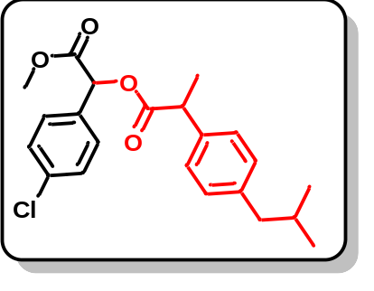
The title compound was synthesised following the general procedure described in section 3.3, and involve corresponding reactant exchange with compound 2a and compound 3i (2-(4-isobutylphenyl)propanoic acid). The crude mixture was concentrated under vacuum and the product was purified by flash chromatography; Rf = 0.5 (10% ethylacetate/hexane); to give compound 4i (0.49 g in 5 h, 85%) as a colorless oil. ¹H NMR (400 MHz, CDCl₃) δ 7.31 (d, J = 1.5 Hz, 2H), 7.27 – 7.19 (m, 4H), 7.13 – 7.06 (m, 2H), 5.89 (d, J = 3.3 Hz, 1H), 3.90 – 3.83 (m, 1H), 3.65 (d, J = 31.5 Hz, 3H), 2.44 (dd, J = 10.1, 7.2 Hz, 2H), 1.89 – 1.79 (m, 1H), 1.56 (dd, J = 7.2, 2.0 Hz, 3H), 0.89 (t, J = 6.8 Hz, 6H). ¹³C NMR (101 MHz, CDCl₃) δ 173.89, 173.82, 168.94, 168.74, 140.78, 140.71, 137.02, 136.92, 135.18, 135.08, 132.44, 132.39, 129.40, 129.33, 128.98, 128.91, 128.82, 128.71, 127.46, 127.37, 73.90, 73.71, 52.72, 52.59, 45.10, 45.06, 44.96, 44.82, 30.24, 22.41, 18.49, 18.35. IR (ν_{max}): 3020.99, 2956.85, 2872.11, 1744.81, 1599.53, 1215.33, 1016.16 cm⁻¹. HRMS (ESI): m/z calcd for C₂₂H₂₆ClO₄ [M+H]⁺ 389.1514, found 389.1520.
Example 10. Methyl 2-(2-([1,1'-biphenyl]-4-yl)acetoxy)-2-(4-chlorophenyl)acetate (4j):
The title compound was synthesised following the general procedure described in section 3.3, and involve corresponding reactant exchange with compound 2a and compound 3j (2-([1,1'-biphenyl]-4-yl)acetic acid). The crude mixture was concentrated under vacuum and the product was purified by flash chromatography; Rf = 0.5 (10% ethylacetate/hexane); to give compound 4j (0.52 g in 5 h, 87%) as a colorless oil. ¹H NMR (400 MHz, CDCl₃) δ 7.58 – 7.55 (m, 4H), 7.45 – 7.32 (m, 9H), 5.94 (s, 1H), 3.87 – 3.77 (m, 2H), 3.70 (s, 3H). ¹³C NMR (101 MHz, CDCl₃) δ 170.82, 168.84, 140.74, 140.29, 135.36, 132.22, 132.18, 129.83, 129.07, 128.94, 128.81, 127.38, 127.09, 74.04, 52.80, 40.45. IR(ν_{max}): 3024.43, 1744.86, 1489.15, 1215.88, 1013.88 cm⁻¹. HRMS (ESI): m/z calcd for C₂₃H₂₀ClO₄ [M+H]⁺ 395.1045, found 395.1055.
Example 11. Methyl 2-(2-(9H-fluoren-9-yl)acetoxy)-2-(4-chlorophenyl)acetate (4k):
The title compound was synthesised following the general procedure described in section 3.3, and involve corresponding reactant exchange with compound 2a and compound 3k (2-(9H-fluoren-9-yl)acetic acid). The crude mixture was concentrated under vacuum and the product was purified by flash chromatography; Rf = 0.45 (10% ethylacetate/hexane); to give compound 4k (0.55 g in 5 h, 91%) as a colorless oil. ¹H NMR (400 MHz, CDCl₃) δ 7.71 (d, J = 7.5 Hz, 2H), 7.50 (dd, J = 10.7, 7.6 Hz, 2H), 7.43 – 7.29 (m, 8H), 6.04 (s, 1H), 4.49 (t, J = 6.9 Hz, 1H), 3.78 (s, 3H), 3.01 (dd, J = 16.5, 6.8 Hz, 1H), 2.90 (dd, J = 16.5, 7.1 Hz, 1H). ¹³C NMR (101 MHz, CDCl₃) δ 171.66, 168.85, 145.93, 140.86, 140.81, 135.32, 132.15, 129.05, 129.01, 127.59, 127.30, 127.25, 124.46, 120.00, 74.07, 52.83, 43.37, 38.15. IR (ν_{max}): 3019.04, 2922.32, 1741.47, 1489.45, 1216.03, 1144.72 cm⁻¹. HRMS (ESI): m/z calcd for C₂₄H₂₀ClO₄ [M+H]⁺ 407.1045, found 407.1053.
Example 12. 1-(4-chlorophenyl)-2-methoxy-2-oxoethyl (3R)-3-methoxy-3-phenylpropanoate (4l):
The title compound was synthesised following the general procedure described in section 3.3, and involve corresponding reactant exchange with compound 2a and compound 3l ((R)-3-methoxy-3-phenylpropanoic acid). The crude mixture was concentrated under vacuum and the product was purified by flash chromatography; Rf = 0.6 (10% ethylacetate/hexane); to give compound 4l (0.44 g in 5 h, 82%) as a colorless oil. ¹H NMR (400 MHz, CDCl₃) δ 7.50 – 7.48 (m, 2H), 7.41 – 7.33 (m, 7H), 5.93 (s, 1H), 4.90 (s, 1H), 3.59 (s, 3H), 3.49 (s, 3H). ¹³C NMR (101 MHz, CDCl₃) δ 170.10, 168.34, 135.70, 135.47, 132.02, 129.14, 129.00, 128.96, 128.69, 127.46, 82.49, 74.15, 57.71, 52.76. IR (ν_{max}): 2929.68, 1750.89, 1598.38, 1217.54, 1164.43, 1016.87, 828.38 cm⁻¹. HRMS (ESI): m/z calcd for C₂₂H₁₈ClO₅ [M+H]⁺ 363.0994, found 363.0999.
Example 13. 1-(4-chlorophenyl)-2-methoxy-2-oxoethyl 5-methylisoxazole-3-carboxylate (4m):
The title compound was synthesised following the general procedure described in section 3.3, and involve corresponding reactant exchange with compound 2a and compound 3m (5-methylisoxazole-3-carboxylic acid). The crude mixture was concentrated under vacuum and the product was purified by flash chromatography; Rf = 0.6 (10% ethylacetate/hexane); to give compound 4m (0.38 g in 5 h, 82%) as a colorless oil. ¹H NMR (400 MHz, CDCl₃) δ 7.87 – 7.83 (m, 2H), 7.77 – 7.68 (m, 2H), 6.83 (d, J = 0.8 Hz, 1H), 6.50 (s, 1H), 4.12 (s, 3H), 2.86 (d, J = 0.7 Hz, 3H). ¹³C NMR (101 MHz, CDCl₃) δ 171.80, 168.21, 159.34, 155.55, 135.69, 131.62, 129.25, 129.15, 128.83, 128.04, 111.21, 102.55, 74.70, 72.26, 53.07, 12.40. IR (ν_{max}): 3021.10, 2957.90, 1746.23, 1598.19, 1207.20, 1006.59, 808.66 cm⁻¹. HRMS (ESI): m/z calcd for C₁₄H₁₃ClNO₅ [M+H]⁺ 310.0477, found 310.0478.
Example 14. 1-(4-chlorophenyl)-2-methoxy-2-oxoethyl 5-acetylthiophene-2-carboxylate (4n):
The title compound was synthesised following the general procedure described in section 3.3, and involve corresponding reactant exchange with compound 2a and compound 3n (5-acetylthiophene-2-carboxylic acid). The crude mixture was concentrated under vacuum and the product was purified by flash chromatography; Rf = 0.6 (10% ethylacetate/hexane); to give compound 4n (0.47 g in 5 h, 90%) as a colorless oil. ¹H NMR (400 MHz, CDCl₃) δ 7.84 (d, J = 4.0 Hz, 1H), 7.64 (d, J = 4.0 Hz, 1H), 7.49 – 7.46 (m, 2H), 7.40 – 7.37 (m, 2H), 6.09 (s, 1H), 3.74 (s, 3H), 2.58 (s, 3H). ¹³C NMR (101 MHz, CDCl₃) δ 190.79, 168.43, 160.69, 149.64, 138.16, 135.61, 134.49, 131.85, 131.76, 129.22, 128.99, 74.54, 53.00, 27.07. IR (ν_{max}): 3021.89, 1724.77, 1673.48, 1524.47, 1214.90, 1017.28 cm⁻¹. HRMS (ESI): m/z calcd for C₁₆H₁₄ClO₅S [M+H]+ 353.0245, found 353.0250.
Example 15. 1-(4-chlorophenyl)-2-methoxy-2-oxoethyl 5-chlorothiophene-2-carboxylate (4o):
The title compound was synthesised following the general procedure described in section 3.3, and involve corresponding reactant exchange with compound 2a and compound 3o (5-chlorothiophene-2-carboxylic acid). The crude mixture was concentrated under vacuum and the product was purified by flash chromatography; Rf = 0.5 (10% ethylacetate/hexane); to give compound 4o (0.47 g in 5 h, 91%) as a colorless oil. ¹H NMR (400 MHz, CDCl₃) δ 7.68 (d, J = 4.1 Hz, 1H), 7.48 – 7.46 (m, 2H), 7.40 – 7.37 (m, 2H), 6.95 (d, J = 5.0 Hz, 1H), 6.08 (s, 1H), 3.74 (s, 3H). ¹³C NMR (126 MHz, CDCl₃) δ 168.53, 160.11, 138.53, 135.47, 134.15, 132.03, 130.39, 129.13, 128.95, 127.54, 74.20, 52.87. IR (ν_{max}): 3022.57, 1755.23, 1717.81, 1422.40, 1215.11, 1089.70 cm⁻¹. HRMS (ESI): m/z calcd for C₁₄H₁₁Cl₂O₄S [M+H]⁺ 344.9750, found 344.9756.
Example 16. 1-(4-chlorophenyl)-2-methoxy-2-oxoethyl (1s,3s)-adamantane-1-carboxylate (4p):
The title compound was synthesised following the general procedure described in section 3.3, and involve corresponding reactant exchange with compound 2a and compound 3p (admantyl acid). The crude mixture was concentrated under vacuum and the product was purified by flash chromatography; Rf = 0.5 (10% ethylacetate/hexane); to give compound 4p (0.48 g in 5 h, 88%) as viscous oil. ¹H NMR (400 MHz, CDCl₃) δ 7.42 – 7.40 (m, 2H), 7.35 – 7.32 (m, 2H), 5.88 (s, 1H), 3.68 (s, 3H), 2.02 (s, 3H), 1.97 (s, 6H), 1.71 (s, 6H). ¹³C NMR (101 MHz, CDCl₃) δ 176.70, 169.12, 135.10, 132.72, 129.00, 128.80, 73.24, 52.65, 40.75, 38.69, 36.46, 27.90. IR (ν_{max}): 2907.80, 2853.75, 1754.93, 1730.89, 1215.77, 1072.97 cm⁻¹. HRMS (ESI): m/z calcd for C₂₀H₂₄ClO₄ [M+H]⁺ 363.1358, found 363.1364.
S4. Case study-2: Carbene insertion (C-S bond formation) single objective multi-variant auto-optimization.
S4.1 Background collection
Sample Preparation: We prepared 0.5 M stock solutions of compound 2a, reagent 5a, and product 6a in ethyl acetate, each loaded into separate syringes. For our analysis, we utilized an In-line FTIR system. The experimental protocol commenced with the initial introduction of ethyl acetate solvent for 10 minutes using a syringe pump, during which data was recorded. Subsequently, the stock solution of compound 2a was introduced into the In-line FTIR for another 10 minutes. This procedure was repeated for the reaction product 6a and reagent 5a, with each pumped for 10 minutes. After collecting all relevant data, we identified the signature peak present in the product. Using this peak as a reference, we employed a Bayesian optimizer to fine-tune and optimize the reaction conditions for enhanced outcomes.
Figure S20. In-line IR background analysis of EtOAc, 0.5 M stock solution of 2a, 5a, and 6a in EtOAc.
The distinctive shifting peak associated with product (6a) aligning within the range of 2070 to 2085 cm⁻¹ was observed. This specific peak, falling within this range, is designated as the signature peak for our analysis. During the optimization of the reaction through Bayesian methods, this signature peak serves as a pivotal reference point. We utilize it to calculate the area under the curve in the In-line FT-IR spectra, providing a quantitative measure of the area in the forthcoming reaction mixture.
S4.2. General procedure for the auto-optimized synthesis of compound 6a.
In our approach we are employing a Python-coded based Bayesian optimization strategy for further refinement. Initial steps involved the preparation of stock solutions for compound 2a (0.1 M in EtOAc) and reagent 5a (0.2 M in EtOAc), each filled into separate syringes and connected to a syringe pump. The solutions were then directed through a PFA tubular reactor (inner diameter = 1 mm, length = 1.3 m, volume = 1 mL) surrounded by a cylindrical-shaped blue LED light source. Once the solution setup was complete, input ranges for variable flow rates, voltages, and current were specified in the Python code designed for the reaction. The Bayesian optimizer systematically explored these varying reaction conditions, aiming to achieve maximum yield. The optimization process involved running 70-80 experiments and the results were tabulated in the optimization table (Table S6).

S4.2.1. Python code for optimizing condition of carbene insertion reaction (C-S bond formation).

Table S6. Auto-optimization table of carbene insertion reaction into S-H bonds of thiophenol.
No. of experiments | Flow rate  mL/min | Voltage  (V) | Light intensity  (W) | area-results | Yield  (%) | Spacetime yield  (g mL⁻¹ h⁻¹)
1 | 0.12187 | 14.0141 | 61.3 | 0.639877 | 62.1628401 | 0.066363879
2 | 0.15077 | 14.1614 | 63.583 | 0.725702 | 70.500557 | 0.093113272
3 | 0.14389 | 14.3314 | 65.894 | 0.771888 | 74.987459 | 0.094519922
4 | 0.17094 | 14.5 | 65.85 | 0.94132 | 91.4474572 | 0.136936568
5 | 0.1 | 12.3572 | 39.777 | 0.536517 | 52.1216116 | 0.045658532
6 | 0.16593 | 14.0518 | 62.246 | 0.886884 | 86.1591028 | 0.125236288
7 | 0.2 | 14.5 | 68.778 | 0.790801 | 76.8248211 | 0.134597087
8 | 0.1894 | 14.5 | 68.778 | 0.910954 | 88.4974578 | 0.146830026
9 | 0.17392 | 14.5 | 68.778 | 0.978956 | 95.1037234 | 0.144894251
10 | 0.2 | 14 | 60.96 | 0.672707 | 65.3522124 | 0.114497076
11 | 0.175 | 14.5 | 68.3 | 0.97634 | 94.849584 | 0.145404412
12 | 0.14684 | 14.5 | 68.213 | 0.909719 | 88.3774799 | 0.113681579
13 | 0.16295 | 14.5 | 68.169 | 0.953319 | 92.6131374 | 0.132199882
14 | 0.2 | 14 | 61.002 | 0.758361 | 73.6733365 | 0.129075686
15 | 0.15126 | 14.5 | 68.368 | 0.919708 | 89.3478923 | 0.118389317
16 | 0.13402 | 14.2839 | 66.944 | 0.797798 | 77.5045665 | 0.090991539
17 | 0.15638 | 14.0233 | 61.295 | 0.669423 | 65.0331781 | 0.089088222
18 | 0.12526 | 14.0342 | 61.455 | 0.745254 | 72.4000163 | 0.079442916
19 | 0.1 | 14.5 | 68.281 | 0.900546 | 87.4863403 | 0.076638034
20 | 0.11313 | 14.0352 | 61.319 | 0.61147 | 59.4031537 | 0.058869642
21 | 0.1 | 11.0324 | 25.032 | 0.206977 | 20.107424 | 0.017614103
22 | 0.16846 | 14.0379 | 61.305 | 0.851698 | 82.7408495 | 0.122101466
23 | 0.18174 | 12.3572 | 39.777 | 0.205725 | 19.9857946 | 0.031818232
24 | 0.18955 | 11.7409 | 32.482 | 0.466023 | 45.2732528 | 0.075174335
25 | 0.13922 | 14.1921 | 63.566 | 0.75473 | 73.3205917 | 0.089419389
26 | 0.14375 | 14.5 | 67.904 | 0.870399 | 84.5576163 | 0.106479178
27 | 0.18405 | 10.0002 | 15.42 | 0.103039 | 10.0100439 | 0.016138974
28 | 0.2 | 14 | 60.844 | 0.794354 | 77.1699884 | 0.13520182
29 | 0.18552 | 14.3822 | 66.263 | 0.894818 | 86.9298759 | 0.14127454
30 | 0.10265 | 14.104 | 62.297 | 0.769329 | 74.738857 | 0.067206227
31 | 0.16804 | 14.4279 | 66.956 | 0.89149 | 86.606567 | 0.127487499
32 | 0.17293 | 14.5 | 68.961 | 0.977279 | 94.9408061 | 0.143822675
33 | 0.1 | 14.4738 | 67.545 | 0.691974 | 67.2239651 | 0.058888193
34 | 0.12095 | 14.0335 | 61.184 | 0.622655 | 60.4897553 | 0.064090227
35 | 0.12869 | 14.3928 | 66.309 | 0.896598 | 87.1027996 | 0.098193111
36 | 0.1 | 13.466 | 54.12 | 0.584978 | 56.8295061 | 0.049782647
37 | 0.1653 | 14.5 | 67.41 | 0.931312 | 90.475199 | 0.131010621
38 | 0.1583 | 14.0035 | 60.003 | 0.89358 | 86.8096066 | 0.120379576
39 | 0.17399 | 14.0821 | 61.355 | 0.855364 | 83.0969945 | 0.126652484
40 | 0.1736 | 14.0805 | 61.186 | 0.830028 | 80.63565 | 0.122625536
41 | 0.19014 | 14.052 | 60.143 | 0.717789 | 69.7318435 | 0.116147199
42 | 0.17339 | 14.4756 | 68.784 | 1.008769 | 97.9786321 | 0.148819392
43 | 0.10246 | 14.0741 | 61.785 | 0.789538 | 76.6853989 | 0.068828949
44 | 0.1083 | 13.3572 | 52.066 | 0.597804 | 58.0628649 | 0.055084704
45 | 0.15031 | 13.3544 | 52 | 0.649264 | 63.0610165 | 0.083033424
46 | 0.16092 | 14.4505 | 67.288 | 0.928714 | 90.203136 | 0.127155681
47 | 0.18975 | 11.1796 | 26.503 | 0.190577 | 18.5101582 | 0.03076777
48 | 0.1005 | 10 | 15.48 | 0.061864 | 6.00866015 | 0.005289904
49 | 0.18795 | 11.6288 | 30.954 | 0.394747 | 38.3405627 | 0.063125513
50 | 0.16037 | 10.909 | 23.563 | 0.227011 | 22.0488806 | 0.030975176
51 | 0.19911 | 12.9452 | 46.563 | 0.687769 | 66.8008888 | 0.116514351
52 | 0.19707 | 13.7912 | 57.233 | 0.794465 | 77.1639433 | 0.133210677
53 | 0.10353 | 13.9953 | 60.109 | 0.823241 | 79.9588677 | 0.07251652
54 | 0.1882 | 13.6429 | 54.882 | 0.765239 | 74.3253118 | 0.122535087
55 | 0.11839 | 13.1852 | 49.839 | 0.751321 | 72.9734992 | 0.075680553
56 | 0.19909 | 14.499 | 68.131 | 0.903623 | 87.7661243 | 0.153066613
57 | 0.10173 | 10.0506 | 15.849 | 0.092939 | 9.02687938 | 0.008044347
58 | 0.11477 | 12.3255 | 39.218 | 0.464055 | 45.0722357 | 0.045314959
59 | 0.12176 | 12.3888 | 39.803 | 0.521891 | 50.6896686 | 0.054066493
60 | 0.19812 | 12.2467 | 38.122 | 0.419045 | 40.7005527 | 0.070637079
61 | 0.14555 | 12.194 | 36.286 | 0.272067 | 26.4250314 | 0.033692391
62 | 0.18235 | 12.5432 | 39.924 | 0.590353 | 57.3391722 | 0.091592791
63 | 0.18723 | 12.0402 | 34.157 | 0.234019 | 22.7295461 | 0.03727952
64 | 0.2 | 12.29 | 37.001 | 0.427683 | 41.5395351 | 0.072777266
65 | 0.12925 | 10.4935 | 19.748 | 0.193939 | 18.8366989 | 0.021327476
66 | 0.10105 | 10.525 | 20.027 | 0.360808 | 35.0441719 | 0.031021031
67 | 0.16517 | 14.4505 | 67.288 | 0.895807 | 87.0069803 | 0.12588946
68 | 0.14869 | 14.3822 | 66.263 | 0.842513 | 81.8306979 | 0.106586481
69 | 0.13311 | 13.3572 | 52.066 | 0.573379 | 55.6905397 | 0.064937597
70 | 0.10145 | 10.5483 | 20.261 | 0.195224 | 18.961507 | 0.016851129
71 | 0.17331 | 10.5219 | 20.043 | 0.288514 | 28.0224779 | 0.042543603
72 | 0.15263 | 10.5261 | 20.094 | 0.355223 | 34.5017181 | 0.046130136
73 | 0.1 | 13.466 | 54.12 | 0.692583 | 67.2684578 | 0.058927169
74 | 0.1 | 14.5 | 67.41 | 0.819158 | 79.5622985 | 0.069696573
75 | 0.19775 | 14.4028 | 66.182 | 0.858552 | 83.3885166 | 0.144453093
76 | 0.11677 | 10.5449 | 20.13 | 0.190198 | 18.4733471 | 0.018896483
77 | 0.12524 | 11.6656 | 31.411 | 0.290907 | 28.2549027 | 0.030998522
78 | 0.1297 | 14.4989 | 67.952 | 0.796329 | 77.3449879 | 0.08787721
79 | 0.17576 | 14.5 | 68.3 | 0.975133 | 94.7116708 | 0.145823544
80 | 0.14697 | 10.0002 | 15.42 | 0.118176 | 11.4780716 | 0.014777526
81 | 0.18865 | 11.7409 | 32.482 | 0.225615 | 21.9132914 | 0.036213336
82 | 0.11754 | 14.4997 | 67.304 | 0.77118 | 74.9023428 | 0.077123227
83 | 0.17818 | 10.0003 | 16.025 | 0.114992 | 11.1688195 | 0.017432928
84 | 0.11092 | 10 | 16.01 | 0.175406 | 17.0366456 | 0.016553813
Reaction condition: compound 2a (0.1 M in EtOAc); reagent 5a (0.2 M in EtOAc); 1 mL reactor volume.
Graph: We have plotted 3D graph of optimization table S6, we have taken flow rate on X-axis, blue light intensity (watt) on Y-axis and product yield on Z axis.
Figure S21. AI based system to auto-optimize and navigate this complexity and identify the optimal conditions for the photo activated S-H insertion reaction. Compound 2a (0.1 M in EtOAc); reagent 5a (0.2 M in EtOAc); 1 mL reactor volume.

Figure S22. Reproducibility test for the AI based system to auto-optimization for the photo activated S-H insertion reaction. Compound 2a (0.1 M in EtOAc); reagent 5a (0.2 M in EtOAc); 1 mL reactor volume.

Figure S23. AI based system navigated multi-numerical variable complexity and identify the optimal condition for the phtoto activated S-H insertion reaction. Compound 2a (0.1 M in EtOAc); reagent 5a (0.2 M in EtOAc); 1 mL reactor volume.

S4.3. General procedure of running AI-optimized condition for longer time for synthesis of compound (6a).
Figure S24. Schematic presentation of continuous flow for the synthesis, of compound 6a.
To prepare the stock solution of compound 2a (2.20 g, 0.01 mol) was dissolved in ethyl acetate (100 mL) charged in one syringe, another syringe charged with the reagent 5a (1.9 mL, 0.02 mol) dissolved in ethyl acetate (100 mL). These two syringes connected via pump and out-put is further connected with the T1-mixer and both syringes were running with the 173 μL/min. flow rate to maintain the stoichiometry and then passed through PFA tubular reactor (id = 1000 µm, l = 1.3 m, vol. = 1 mL) under blue light (69W) exposure. The room temperature of the reactor was controlled by fan attached to the bottom of the photochemical reactor. The out-put of the tubular reactor was connected with spring based back pressure regulator (~3 bar) to maintain the evaporation. Then outcoming first one hour of the product mixture 6a was discarded and next 5 h of the product mixture [52 mL; 2a (0.546 g)] was collected in HPLC bottle. The EtOAc reaction mixture washed it with 10% aq. NaOH and separated through the separating funnel. The organic EtOAc phase was concentrated under reduced pressure to give the product 6a (0.74 g in 5 h, 97.98%) as a colorless oil. ¹H NMR (400 MHz, CDCl₃) δ 7.37 – 7.33 (m, 4H), 7.29 – 7.25 (m, 5H), 4.86 (s, 1H), 3.67 (s, 3H). ¹³C NMR (101 MHz, CDCl₃) δ 170.55, 134.32, 133.16, 133.10, 129.98, 129.14, 128.89, 128.40, 55.73, 52.88. IR (ν_{max}): 3021.35, 2952.59, 1737.18, 1487.9, 1214.19, 829.21 cm⁻¹. HRMS (ESI): m/z calcd for C₁₅H₁₄ClO₂S [M+H]⁺ 293.0398, found 293.0404. Verified the analytical data with those reported in the literature.⁴
Quantum efficiency (φ) calculation:
The values of the number of incident photons (N_{photons}) were calculated using the following
equations. Here,
$$N_{photon}=\frac{Pλt}{hc}$$
Area of lamp (a) = 448 cm² = 352 x 10⁻⁴ m²
Power of the light (p) = 69W = 69 𝐽 𝑠^{­1}
λ = Wavelength of the light (420 nm) = 420 x 10⁻⁹ m
t = Duration of irradiation time, 5 h = 18000 s,
h = Planck’s constant = 6.626 x 10⁻³⁴ J s
c = Velocity of light = 3 x 10⁸ m s⁻¹
No of photons incident
$$N_{photon}=\frac{69 J s^{-1} ×420× {10}^{-9 }m ×18000 s}{6.626 × {10}^{-34} J s× 3×{10}^{8} m s^{-1}}$$
$$N_{photon}= 2.6 ×{10}^{24}$$
$$Mole’s photons incident =\frac{N_{photon}}{N}$$
[N = Avogadro’s number (6.02214 × 10²³)]
$$Mole’s photons incident=\frac{2.6 ×{10}^{24}}{6.02214×{ 10}^{23}}$$
$$Mole’s photons incident =4.38 mole$$
Moles of product formed is:
$$Mole’s of product formed =\frac{productivity}{mole. wt}$$
The product formed is = 0.74 g.
$$ofMole’s of product formed=\frac{0.74}{292}$$
$$Mole’s of product formed =2.5 ×{10}^{-3}$$
Quantum efficiency (φ):
$$Quantum efficiency \left(∅\right):=\frac{Mole’s of product formed}{Mole’s photons incident}×100$$
$$Quantum efficiency \left(∅\right):=\frac{2.5 ×{10}^{-3}}{4.38} ×100$$
$$Quantum efficiency \left(∅\right):=0.57 \%$$
$$Productivity \left(per h\right):=\frac{0.74}{5}= 0.148 g/h$$
$$Space time yield :=\frac{productivity}{volume of reactor}$$
$$=\frac{0.148}{1}=0.148 g {mL}^{-1}h^{-1}$$
Space time yield in previous reported batch process ⁴

Productivity = 130 mg in 12 h
$$Productivity \left(per h\right):=\frac{0.130}{12}= 0.011 g/h$$

$$Space time yield :=\frac{productivity}{volume of reactor}$$
$$=\frac{0.011}{1}=0.011 g {mL}^{-1 }h^{-1}$$
Figure S25. Scope of substrate for the photo activated S-H insertion reaction. Compound 2 (0.1 M in EtOAc); reagent 5 (0.2 M in EtOAc); 1 mL reactor volume.
S4.3.2. General procedure for scope of substrate for carbene insertion into the S−H bonds of organic aromatic thiol for synthesis of compound 6b−6h.
Example 18. Methyl 2-((4-bromophenyl)thio)-2-(4-chlorophenyl)acetate (6b).
The title compound was synthesised following the general procedure described in section 4.3, and involve corresponding reactant exchange with compound 2a and compound 5b (4-bromobenzenethiol). The crude mixture was concentrated under vacuum and the product was purified by flash chromatography; Rf = 0.5 (5% ethylacetate/hexane); to give compound 6b (0.76 g in 5 h, 79%) as a colorless oil. ¹H NMR (400 MHz, CDCl₃) δ 7.39 – 7.32 (m, 4H), 7.30 – 7.25 (m, 2H), 7.22 – 7.17 (m, 2H), 4.83 (s, 1H), 3.68 (s, 3H). ¹³C NMR (126 MHz, CDCl₃) δ 170.23, 137.70, 134.68, 132.24, 129.94, 128.98, 122.88, 55.62, 52.98. IR (ν_{max}): 3020.98, 1736.81, 1483.63, 1214.01, 817.91, 667.71 cm⁻¹. HRMS (ESI): m/z calcd. for C₁₅H₁₃BrClO₂S [M+H]⁺ 370.9503, found 370.9509.
Example 19. Methyl 2-(4-bromophenyl)-2-((4-chlorophenyl)thio)acetate (6c).
The title compound was synthesised following the general procedure described in section 4.3, and involve corresponding reactant exchange with compound 2b and compound 5c (4-chlorobenzenethiol). The crude mixture was concentrated under vacuum and the product was purified by flash chromatography; Rf = 0.5 (5% ethylacetate/hexane); to give compound 6c (0.75 g in 5 h, 78%) as a colorless oil. ¹H NMR (400 MHz, CDCl₃) δ 7.42 (d, J = 8.4 Hz, 2H), 7.28 – 7.25 (m, 4H), 7.21 (d, J = 8.6 Hz, 2H), 4.81 (s, 1H), 3.66 (s, 3H). ¹³C NMR (126 MHz, CDCl₃) δ 170.15, 134.75, 134.59, 134.47, 131.91, 131.43, 130.26, 129.30, 122.66, 55.79, 52.96. IR (ν_{max}): 3019.95, 2952.20, 1735.81, 1497.43, 1213.23, 817.44, 626.54 cm⁻¹. HRMS (ESI): m/z calcd for C₁₅H₁₃BrClO₂S [M+H]⁺ 370.9503, found 370.9510.
Example 20. Methyl 2-(4-bromophenyl)-2-((4-fluorophenyl)thio)acetate (6d).
The title compound was synthesised following the general procedure described in section 4.3, and involve corresponding reactant exchange with compound 2b and compound 5d (4-fluorobenzenethiol). The crude mixture was concentrated under vacuum and the product was purified by flash chromatography; Rf = 0.5 (5% ethylacetate/hexane); to give compound 6d (0.74 g in 5 h, 81%) as a colorless oil. ¹H NMR (500 MHz, CDCl₃) δ 7.42–7.40 (m, 2H), 7.34 – 7.32 (m, 2H), 7.27– 7.24 (m, 2H), 6.96 – 6.92 (m, 2H), 4.77 (s, 1H), 3.64 (s, 3H). ¹³C NMR (101 MHz, CDCl₃) δ 170.25, 164.38, 161.90, 136.37, 136.29, 134.63, 131.81, 130.29, 127.85, 127.82, 122.52, 116.34, 116.13, 56.26, 52.83. ¹⁹F NMR (471 MHz, CDCl₃) δ -111.71.IR (ν_{max}): 3021.30, 1737.68, 1437.42, 1216.36, 828.38, 668.88 cm⁻¹. HRMS (ESI): m/z calcd for C₁₅H₁₃BrFO₂S [M+H]⁺ 354.9798, found 354.9802.
Example 21. Methyl 2-(4-bromophenyl)-2-(p-tolylthio)acetate (6e).
The title compound was synthesised following the general procedure described in section 4.3, and involve corresponding reactant exchange with compound 2b and compound 5e (4-methylbenzenethiol). The crude mixture was concentrated under vacuum and the product was purified by flash chromatography; Rf = 0.5 (5% ethylacetate/hexane); to give compound 6e (0.77 g in 5 h, 85%) as a colorless oil. ¹H NMR (400 MHz, CDCl₃) δ 7.42 (d, J = 8.5 Hz, 2H), 7.30 – 7.24 (m, 4H), 6.79 (d, J = 8.9 Hz, 2H), 4.70 (s, 1H), 3.77 (s, 3H), 3.66 (s, 3H). ¹³C NMR (101 MHz, CDCl₃) δ 170.57, 160.44, 136.48, 135.02, 131.72, 130.36, 123.05, 122.33, 114.63, 56.67, 55.36, 52.75. IR (ν_{max}): 3020.59, 1735.43, 1437.72, 1214.76, 1010.62, 826.89 cm⁻¹. HRMS (ESI): m/z calcd for C₁₆H₁₆BrO₂S [M+H]⁺ 351.0049, found 351.0055.
Example 22. Methyl 2-(4-bromophenyl)-2-((3-methoxyphenyl)thio)acetate (6f).
The title compound was synthesised following the general procedure described in section 4.3, and involve corresponding reactant exchange with compound 2b and compound 5f (3-methoxybenzenethiol). The crude mixture was concentrated under vacuum and the product was purified by flash chromatography; Rf = 0.5 (5% ethylacetate/hexane); to give compound 6f (0.74 g in 5 h, 79%) as a yellow oil. ¹H NMR (500 MHz, CDCl₃) δ 7.44 –7.42 (m, 2H), 7.31–7.30 (m, 2H), 7.18 – 7.14 (m, 1H), 6.93 – 6.91 (m, 1H), 6.86 – 6.85 (m, 1H), 6.80 – 6.78 (m, 1H), 4.87 (s, 1H), 3.71 (s, 3H), 3.67 (s, 3H). ¹³C NMR (101 MHz, CDCl₃) δ 170.39, 159.74, 134.82, 134.33, 131.82, 130.25, 129.89, 124.70, 122.47, 117.58, 114.29, 55.56, 55.26, 52.90. IR (ν_{max}): 3019.75, 1737.02, 1481.61, 1215.45, 669.75 cm⁻¹. HRMS (ESI): m/z calcd for C₁₆H₁₆BrO₃S [M+H]⁺ 366.9998, found 366.9993.
Example 23. Methyl 2-(4-bromophenyl)-2-(naphthalen-1-ylthio)acetate (6g).
The title compound was synthesised following the general procedure described in section 4.3, and involve corresponding reactant exchange with compound 2b and compound 5g (3-methoxybenzenethiol). The crude mixture was concentrated under vacuum and the product was purified by flash chromatography; Rf = 0.5 (5% ethylacetate/hexane); to give compound 6g (0.77 g in 6 h, 77%) as a colorless oil. ¹H NMR (400 MHz, CDCl₃) δ 7.83 (d, J = 1.4 Hz, 1H), 7.77 – 7.74 (m, 1H), 7.72 – 7.69 (m, 2H), 7.50 – 7.42 (m, 3H), 7.41 – 7.38 (m, 2H), 7.33 – 7.31 (m, 2H), 4.95 (s, 1H), 3.64 (s, 3H). ¹³C NMR (101 MHz, CDCl₃) δ 170.47, 134.80, 133.56, 132.77, 132.22, 131.88, 130.50, 130.29, 129.72, 128.75, 127.74, 127.66, 126.74, 126.69, 122.55, 55.73, 52.92. IR (ν_{max}): 3053.68, 2951.64, 1738.16, 1489.43, 1212.16, 634.22 cm⁻¹. HRMS (ESI): m/z calcd for C₁₉H₁₆BrO₂S [M+H]⁺ 387.0049, found 387.0053.
Example 24. Methyl 2-(4-chlorophenyl)-2-((1-phenyl-1H-tetrazol-5-yl)thio)acetate (6h).
The title compound was synthesised following the general procedure described in section 4.3, and involve corresponding reactant exchange with compound 2a and compound 5h (1-phenyl-1H-tetrazole-5-thiol). The crude mixture was concentrated under vacuum and the product was purified by flash chromatography; Rf = 0.5 (5% ethylacetate/hexane); to give compound 6h (0.70 g in 6 h, 75%) as a colorless oil. ¹H NMR (400 MHz, CDCl₃) δ 7.56 – 7.49 (m, 5H), 7.45 – 7.42 (m, 2H), 7.32 – 7.29 (m, 2H), 5.78 (s, 1H), 3.76 (s, 3H). ¹³C NMR (126 MHz, CDCl₃) δ 169.17, 152.44, 135.38, 133.34, 132.35, 130.39, 129.93, 129.92, 129.38, 123.77, 54.07, 53.70. IR (ν_{max}): 3018.80, 2955.24, 1741.03, 1216.96, 1009.64, 832.24 cm⁻¹. HRMS (ESI): m/z calcd for C₁₆H₁₄ClN₄O₂S [M+H]⁺ 361.0521, found 361.0526
Table S7. Comparative result for the carbene insertion into S-H bonds of thiols.
Entry | Compound 2a | Reagent 5a | Product 6a | Comparative result
1 |  |  |  | 98%, 5.7 min. (our study)  [(CH₃CN)₄Cu]PF₆ (5 mol%), 12-24 h, 89%  ⁴  Fe(OTf)₂ (15 mol%), 24-48 h, 35 %  ⁵

S5. Case study-3: Carbene insertion (C-N bond formation) single objective multi-variant auto-optimization.
S5.1. Background collection
Sample Preparation: We prepare 0.5 M stock solution of compound 2a in ethyl acetate, 0.5 M stock solution of reagent 7a in ethyl acetate and 0.5 M stock solution of product 8a in ethyl acetate. The three of the solution taken in three different syringes.
Delivery system: The HPLC pumps and syringe pump were directly interfaced to the main computer via an RS-232 interface or LAN. These pumps will help in introducing reactants and reagent solutions into the microreactor with varied flow rate as the central computer's prescribed flow rate (fr). The central computer and the HPLC pump communicated through serial communication using ASCII code to exchange information about flow rate, operational status, and duration. This facilitated the transmission of essential details from the main computer to the pumps, enabling them to commence their operations as required. To conduct our analysis, we utilized an In-line FTIR system. The experimental protocol involved the initial introduction of the solvent, ethyl acetate, for a duration of 10 min. using a syringe pump, during which data was recorded. Subsequently, a previously prepared stock solution of compound 2a was similarly introduced into the In-line FTIR for 10 min. This process was repeated for the reaction product 8a and reagent 7a, each pumped for 10 min. Upon collecting all relevant data, we identified the signature peak present in the product. Using this peak as a reference, we employed a Bayesian optimizer to fine-tune and optimize the reaction conditions for improved results.
Figure S26. In-line IR background analysis of EtOAc, 0.5 M stock solution of 2a, 7a, and 8a in EtOAc.
The distinctive C-N stretching associated with product (8a) aligning within the range of 1295 to 1325 cm⁻¹ was observed. This specific peak, falling within this range, is designated as the signature peak for our analysis. During the optimization of the reaction through Bayesian methods, this signature peak serves as a pivotal reference point. We utilize it to calculate the area under the curve in the In-line FT-IR spectra, providing a quantitative measure of the area in the forthcoming reaction mixture.
S5.2. General procedure for the auto-optimized synthesis of compound 8a.
Initial steps involved the preparation of stock solutions for compound 2a (0.1 M in EtOAc) and reagent 7a (0.3 M in EtOAc), each filled into separate syringes and connected to a syringe pump. The solutions were then directed through a PFA tubular reactor (inner diameter = 1 mm, length = 1.3 m, volume = 1 mL) surrounded by a cylindrical-shaped blue LED light source. Once the solution setup was complete, input ranges for variable flow rates, voltages, and current were specified in the Python code designed for the reaction. The Bayesian optimizer systematically explored these varying reaction conditions, aiming to achieve maximum yield. The optimization process involved running 40-44 experiments and the results were tabulated in the optimization table (Table S8).

S5.2.1. Python code for optimizing condition of carbene insertion reaction (C-N bond formation).

Table S8. Auto-optimization table of carbene insertion reaction (C-N bond formation).
No. of experiments | Flow rate  mL/min | Voltage  (V) | Light intensity  (W) | area-results | Yield  (%) | Spacetime yield  (g mL⁻¹ h⁻¹)
1 | 0.118968 | 12.38799 | 40.459 | 1.196524 | 71.6165410 | 0.0702906
2 | 0.093580 | 10.18322 | 17.197 | 0.279182 | 16.7101331 | 0.012900
3 | 0.111095 | 13.78164 | 59.183 | 1.514104 | 90.6249622 | 0.0830608
4 | 0.05 | 11.07727 | 25.851 | 0.628177 | 37.5988264 | 0.0155095
5 | 0.066191 | 14.23180 | 65.638 | 1.482614 | 88.7401704 | 0.0484595
6 | 0.061313 | 10.04277 | 15.985 | 0.343314 | 20.5487147 | 0.0103943
7 | 0.115638 | 13.65416 | 57.251 | 1.346334 | 80.5832479 | 0.0768775
8 | 0.069548 | 12.82883 | 17.25 | 0.234918 | 14.0607889 | 0.0080677
9 | 0.099196 | 11.69255 | 69.716 | 1.506151 | 90.1489571 | 0.0737751
10 | 0.093306 | 10.18078 | 17.163 | 0.291460 | 17.4450195 | 0.0134288
11 | 0.092505 | 14.3295 | 68.113 | 1.537078 | 92.0000251 | 0.0702116
12 | 0.051560 | 14.48697 | 69.75 | 1.456641 | 87.1855572 | 0.0370862
13 | 0.111049 | 13.75428 | 58.757 | 1.311133 | 78.4763496 | 0.0718964
14 | 0.118626 | 10.00002 | 15.663 | 0.210988 | 12.6248993 | 0.0123556
15 | 0.050115 | 10.06854 | 16.238 | 0.178406 | 10.6783159 | 0.0044149
16 | 0.062578 | 13.06313 | 49.698 | 1.021805 | 61.158672 | 0.0315746
17 | 0.100030 | 12.22525 | 38.894 | 1.029414 | 61.6143808 | 0.0508472
18 | 0.05 | 10.10525 | 16.638 | 0.240613 | 14.4016513 | 0.0059406
19 | 0.111160 | 13.82081 | 60.249 | 1.373565 | 82.2131677 | 0.0753953
20 | 0.093994 | 11.74773 | 33.39 | 0.921292 | 55.1429018 | 0.0427608
21 | 0.122704 | 14.31194 | 67.567 | 1.225070 | 73.3251847 | 0.0742279
22 | 0.057572 | 10.62465 | 21.511 | 0.980855 | 58.7079763 | 0.0278848
23 | 0.086404 | 14 | 62.807 | 1.494519 | 89.4526871 | 0.0637649
24 | 0.148922 | 11 | 25.125 | 0.133867 | 8.01247153 | 0.0098441
25 | 0.052426 | 12 | 36.174 | 1.244392 | 74.4816629 | 0.0322148
26 | 0.15 | 11 | 25.18 | 0.156175 | 9.34772818 | 0.0115678
27 | 0.05 | 10.0673 | 15.564 | 0.303881 | 18.1884792 | 0.0075027
28 | 0.05 | 10 | 15.604 | 0.378768 | 22.6707418 | 0.0093516
29 | 0.15 | 13 | 48.67 | 1.093202 | 65.4323299 | 0.0809725
30 | 0.063750 | 11.6785 | 32.683 | 1.165559 | 69.7631768 | 0.0366912
31 | 0.052816 | 12.9356 | 47.678 | 1.242195 | 74.3501624 | 0.0323970
32 | 0.05 | 13.3951 | 53.794 | 1.265565 | 75.7489373 | 0.0312464
33 | 0.055842 | 11 | 29.217 | 0.797093 | 47.7090838 | 0.0219795
34 | 0.101936 | 14.0832 | 67.409 | 1.504863 | 90.0718120 | 0.0757479
35 | 0.05 | 13.0828 | 49.985 | 0.773444 | 46.2935985 | 0.0190961
36 | 0.132422 | 11 | 26.081 | 0.482431 | 28.8753526 | 0.0315458
37 | 0.05 | 10.085 | 16.437 | 0.105391 | 6.30806718 | 0.0026020
38 | 0.067590 | 12.315 | 40.073 | 1.017212 | 60.8840568 | 0.0339503
39 | 0.089018 | 14 | 63.507 | 1.528104 | 91.4628977 | 0.0671702
40 | 0.053891 | 11.315 | 28.469 | 0.783364 | 46.8873703 | 0.0208464
41 | 0.139535 | 13.38552 | 58.881 | 1.272373 | 76.1564519 | 0.0876686
42 | 0.1282496 | 11.937 | 35.17 | 0.748672 | 44.8109424 | 0.0474126
43 | 0.15 | 13.2041 | 51.367 | 0.640692 | 38.3479029 | 0.0474555
44 | 0.068291 | 14 | 62.656 | 1.513058 | 90.562340 | 0.0510233
Reaction condition: compound 2a (0.1 M in EtOAc); reagent 7a (0.3 M in EtOAc); 1 mL reactor volume.

Graph: We have plotted 3D graph of optimization table S8, we have taken flow rate on X-axis, blue light intensity (watt) on Y-axis and product yield on Z axis.

Figure S27. AI based system to auto-optimize and navigate this complexity and identify the optimal conditions for the photo activated N-H insertion reaction. Compound 2a (0.1 M in EtOAc); reagent 7a (0.3 M in EtOAc); 1 mL reactor volume.

Figure S28. Reproducibility test for the AI based system to auto-optimization for the photo activated N-H insertion reaction. Compound 2a (0.1 M in EtOAc); reagent 7a (0.3 M in EtOAc); 1 mL reactor volume.

Figure S29. AI based system navigated multi-numerical variable complexity and identify the optimal conditions for the photo activated N-H insertion reaction. Compound 2a (0.1 M in EtOAc); reagent 7a (0.3 M in EtOAc); 1 mL reactor volume.

S5.3. General procedure of running AI optimized condition for longer time for synthesis of compound 8a.
Figure S30. Schematic presentation of continuous flow for the synthesis, of compound 8a.
To prepare the stock solution of compound 2a (2.20 g, 0.01 mol) was dissolved in ethyl acetate (100 mL) charged in one syringe, another syringe charged with the reagent 7a (2.9 mL, 0.03 mol) dissolved in ethyl acetate (100 mL). These two syringes connected via pump and out-put is further connected with the T₁-mixer and both syringes were running with the 46 μL/min. each flow rate to maintain the stoichiometry and then passed through PFA tubular reactor (id = 1000 µm, l = 1.3 m, vol. = 1 mL) under blue light (68.0±2 W) exposure. The room temperature of the reactor was controlled by fan attached to the bottom of the photochemical reactor. The out-put of the tubular reactor was connected with spring based back pressure regulator (~3 bar) to maintain the evaporation. First one hour of the product mixture was discarded and next 5 h of the product mixture [28 mL; 2a (0.294 g)] was collected in HPLC bottle The organic EtOAc phase was concentrated under reduced pressure and purified through the regular batch process protocols to give the product 8a (0.35 g in 5 h, 92 %) as a colourless oil. ¹H NMR (400 MHz, CDCl₃) δ 7.43 – 7.40 (m, 2H), 7.30 – 7.27 (m, 2H), 7.11 – 7.07 (m, 2H), 6.71 – 6.67 (m, 1H), 6.52 – 6.49 (m, 2H), 5.03 (s, 1H), 5.00 (s, 1H), 3.69 (s, 3H). ¹³C NMR (126 MHz, CDCl₃) δ 171.86, 145.67, 136.29, 134.17, 129.33, 129.10, 128.67, 118.37, 113.50, 60.12, 52.98. IR (ν_{max}): 3418.02, 3020.09, 1740.08, 1214.36, 688.27 cm⁻¹. HRMS (ESI): m/z calcd for C₁₅H₁₅ClNO₂ [M+H]⁺ 276.0786, found 276.0782. Verified the analytical data with those reported in the literature.⁶
Quantum efficiency (φ) calculation:
The values of the number of incident photons (N_{photons}) were calculated using the following
equations. Here,
$$N_{photon}=\frac{Pλt}{hc}$$
Area of lamp (a) = 448 cm² = 352 x 10⁻⁴ m²
Power of the light (p) = 68W = 68 𝐽 𝑠^{­1}
λ = Wavelength of the light (420 nm) = 420 x 10⁻⁹ m
t = Duration of irradiation time, 5 h = 18000 s,
h = Planck’s constant = 6.626 x 10⁻³⁴ J s
c = Velocity of light = 3 x 10⁸ m s⁻¹
No of photons incident
$$N_{photon}=\frac{68 J s^{-1} ×420× {10}^{-9 }m ×18000 s}{6.626 × {10}^{-34} J s× 3×{10}^{8} m s^{-1}}$$
$$N_{photon}= 2.58 ×{10}^{24}$$
$$Mole’s photons incident =\frac{N_{photon}}{N}$$
[N = Avogadro’s number (6.02214 × 10²³)]
$$Mole’s photons incident=\frac{2.58 ×{10}^{24}}{6.02214×{ 10}^{23}}$$
$$Mole’s photons incident =4.28 mole$$
Moles of product formed is:
$$Mole’s of product formed =\frac{productivity}{mole. wt}$$
The product formed is = 0.35 g.
$$Mole’s of product formed=\frac{0.35}{275}$$
$$Mole’s of product formed =1.2 ×{10}^{-3}$$
Quantum efficiency (φ):
$$Quantum efficiency \left(∅\right):=\frac{Mole’s of product formed}{Mole’s photons incident}×100$$
$$Quantum efficiency \left(∅\right):=\frac{1.2 ×{10}^{-3}}{4.28} ×100$$
$$Quantum efficiency \left(∅\right):=0.28 \%$$
$$Productivity \left(per h\right):=\frac{0.29}{5}= 0.058 g/h$$
$$Space time yield :=\frac{productivity}{volume of reactor}$$
$$=\frac{0.058}{1}=0.058 g {mL}^{-1} h^{-1}$$
Table S9. Comparative result for the carbene insertion into N-H bonds of amines.
Entry | Compound 2a | Reagent 5a | Product 6a | Comparative result
1 |  |  |  | 92%, 11 min. (our study)  Blue light, chiral spiro phosphamides (2 mol%), 1 h  ⁶  White light, 80 min., 83%  ¹

Figure S31. Scope of substrate for the photo activated N-H insertion reaction. Compound 2a (0.1 M in EtOAc); reagent 7a (0.3 M in EtOAc); 1 mL reactor volume.
S5.3.1. General procedure for scope of substrate for carbene insertion into the N−H bonds of organic aromatic and aliphatic amines for synthesis of compound 8b−8j.
Example 26. Methyl 2-(benzylamino)-2-(4-chlorophenyl)acetate (8b).
The title compound was synthesized following the general procedure described in section 5.3 and involved corresponding reactant exchange with compound 2a and compound 7b (benzyl amine). The crude mixture was concentrated under vacuum, and the product was purified by flash chromatography; to give compound 8b (0.74 g in 5 h, 89%) as a colorless oil. ¹H NMR (400 MHz, CDCl₃) δ 7.34 – 7.22 (m, 9H), 4.36 (s, 1H), 3.70 (d, J = 6.2 Hz, 2H), 3.66 (s, 3H), 2.32 (s, 1H). ¹³C NMR (101 MHz, CDCl₃) δ 173.02, 139.28, 136.61, 133.96, 129.05, 128.89, 128.51, 128.31, 127.27, 63.64, 52.36, 51.30. IR (ν_{max}): 3340.60, 2951.52, 1736.67, 1489.77, 1169.20, 769.20 cm⁻¹. HRMS (ESI): m/z calcd for C₁₆H₁₇ClNO₂ [M+H]⁺ 290.0948, found 290.0967.
Example 27. Methyl 2-(4-chlorophenyl)-2-(dibenzylamino)acetate (8c).
The title compound was synthesized following the general procedure described in section 5.3 and involved corresponding reactant exchange with compounds 2a and 7c (dibenzylamine). The crude mixture was concentrated under vacuum, and the product was purified by flash chromatography; to give compound 8c (0.79 g in 5 h, 74%) as a colourless liquid. ¹H NMR (400 MHz, CDCl₃) δ 7.34 – 7.21 (m, 14H), 4.57 (s, 1H), 3.77 (s, 3H), 3.73 (d, J = 2.9 Hz, 4H). ¹³C NMR (101 MHz, CDCl₃) δ 172.28, 139.32, 135.32, 133.87, 130.26, 128.88, 128.69, 128.48, 127.28, 65.31, 54.35, 51.67. IR (ν_{max}): 3024.08, 1736.91, 1451.25, 1213.67, 688.73 cm⁻¹. HRMS (ESI): m/z calcd for C₂₃H₂₃ClNO₂ [M+H]⁺ 380.1412, found 380.1408.
Example 28. Methyl 2-((5-bromopyrimidin-2-yl)amino)-2-(4-chlorophenyl)acetate (8d).
The title compound was synthesized following the general procedure described in section 5.3 and involved corresponding reactant exchange with compound 2a and compound 7d (5-bromopyrimidin-2-amine). The crude mixture was concentrated under vacuum, and the product was purified by flash chromatography; to give compound 8d (0.83 g in 5 h, 83%) as a yellow liquid. ¹H NMR (500 MHz, CDCl₃) δ 8.21 (s, 2H), 7.40 – 7.38 (m, 2H), 7.33 – 7.32 (m, 2H), 6.61 (s, 1H), 5.56 (d, J = 6.8 Hz, 1H), 3.74 (s, 3H). ¹³C NMR (101 MHz, CDCl₃) δ 171.30, 159.18, 158.36, 135.38, 134.50, 129.11, 128.84, 107.86, 58.01, 52.93. IR(ν_{max}): 3251.65, 3001.76, 2952.73, 1742.79, 1577.46, 1429.20, 1170.80 cm⁻¹. HRMS (ESI): m/z calcd for C₁₃H₁₂BrClN₃O₂ [M+H]⁺ 355.9796, found 355.9792.
Example 29. Methyl 2-(tert-butylamino)-2-(4-chlorophenyl)acetate (8e).
The title compound was synthesized following the general procedure described in section 4.8.2 and involved corresponding reactant exchange with compound 2a and compound 7e (tert-butyl amine). The crude mixture was concentrated under vacuum, and the product was purified by flash chromatography; to give compound 8e (0.56 g in 5 h, 81%) as a colorless oil. ¹H NMR (500 MHz, CDCl₃) δ 7.37 – 7.27 (m, 4H), 4.46 (s, 1H), 3.68 (s, 3H), 2.03 (s, 1H), 1.08 (s, 9H). ¹³C NMR (101 MHz, CDCl₃) δ 175.11, 139.37, 133.50, 128.76, 59.08, 52.58, 51.36, 29.52. IR (ν_{max}): 3341.84, 2928.86, 1736.93, 1488.43, 1167.16, 823.38 cm⁻¹. HRMS (ESI): m/z calcd for C₁₃H₁₉ClNO₂ [M+H]⁺ 256.1099, found 256.1103.
Example 30. Methyl 2-(4-chlorophenyl)-2-(2-(pyridin-4-yl)-1H-benzo[d]imidazol-1-yl)acetate (8f).
The title compound was synthesized following the general procedure described in section 5.3 and involved corresponding reactant exchange with compound 2a and compound 7f (2-(pyridin-4-yl)-1H-benzo[d]imidazole). The crude mixture was concentrated under vacuum, and the product was purified by flash chromatography; to give compound 8f (0.92 g in 5 h, 84%) as an off white solid and mp: 166-168 °C. ¹H NMR (400 MHz, CDCl₃) δ 8.77 (d, J = 6.0 Hz, 2H), 7.88 (d, J = 8.1 Hz, 1H), 7.56 – 7.55 (m, 2H), 7.37 – 7.33 (m, 3H), 7.25 – 7.23 (m, 1H), 7.15 – 7.09 (m, 3H), 6.37 (s, 1H), 3.76 (s, 3H). ¹³C NMR (101 MHz, CDCl₃) δ 168.01, 151.50, 150.58, 143.19, 137.46, 135.06, 134.64, 131.44, 129.23, 128.53, 124.32, 123.55, 123.51, 120.76, 120.51, 112.40, 61.38, 53.44. IR (ν_{max}): 2958.15, 1747.03, 1411.75,1212.68, 1004.48 cm⁻¹. HRMS (ESI): m/z calcd for C₂₁H₁₇ClN₃O₂ [M+H]⁺ 378.1007, found 378.1009.
Example 31. Methyl 2-(4-chlorophenyl)-2-(indolin-1-yl)acetate (8g).
The title compound was synthesized following the general procedure described in section 5.3 and involved corresponding reactant exchange with compound 2a and compound 7g (indoline). The crude mixture was concentrated under vacuum, and the product was purified by flash chromatography; Rf = 0.5 (30% ethylacetate/hexane); to give compound 8g (0.70 g in 5 h, 81%) as a white solid and mp: 105-107 °C. ¹H NMR (400 MHz, CDCl₃) δ 7.39 (s, 4H), 7.13 – 7.06 (m, 2H), 6.76 – 6.72 (m, 1H), 6.47 (d, J = 7.9 Hz, 1H), 5.29 (s, 1H), 3.78 (s, 3H), 3.66 (dd, J = 17.9, 8.6 Hz, 1H), 3.23 – 3.17 (m, 1H), 3.05 – 2.89 (m, 2H). ¹³C NMR (101 MHz, CDCl₃) δ 171.30, 150.63, 134.33, 133.76, 130.25, 130.03, 128.92, 127.24, 124.77, 118.64, 106.90, 63.21, 52.15, 49.90, 28.20. IR (ν_{max}): 2954.36, 1714.79, 1213.16, 1013.78, 838.25 cm⁻¹. HRMS (ESI): m/z calcd for C₁₇H₁₇ClNO₂ [M+H]⁺ 302.0942, found 302.0970.
Example 32. Methyl 2-(4-chlorophenyl)-2-(methyl(tetrahydro-2H-pyran-4-yl)amino)acetate (8h).
The title compound was synthesized following the general procedure described in section 5.3 and involved corresponding reactant exchange with compound 2a and compound 7h (N-methyltetrahydro-2H-pyran-4-amine). The crude mixture was concentrated under vacuum, and the product was purified by flash chromatography; to give compound 8h (0.62 g in 5 h, 75%) as a colourless liquid. ¹H NMR (400 MHz, CDCl₃) δ 7.38 – 7.36 (m, 2H), 7.33 – 7.30 (m, 2H), 4.47 (s, 1H), 4.00 – 3.95 (m, 2H), 3.70 (s, 3H), 3.32 – 3.21 (m, 2H), 2.74 – 2.66 (m, 1H), 2.24 (s, 3H), 1.72 – 1.59 (m, 4H).¹³C NMR (101 MHz, CDCl₃) 172.32, 135.51, 133.93, 129.92, 128.70, 68.63, 67.57, 67.36, 56.94, 51.93, 33.42, 29.69, 28.64. IR (ν_{max}): 2952.50, 2846.49, 1738.35, 1489.25, 1206.43, 1011.50, 816.53 cm⁻¹. HRMS (ESI): m/z calcd for C₁₅H₂₁ClNO₃ [M+H]⁺ 298.1210, found 298.1230.
Example 33. Methyl 2-(4-chlorophenyl)-2-(diisopropylamino)acetate (8i).
The title compound was synthesized following the general procedure described in section 5.3 and involved corresponding reactant exchange with compounds 2a and 7i (diisopropylamine). The crude mixture was concentrated under vacuum, and the product was purified by flash chromatography; to give compound 8i (0.66 g in 5 h, 82%) as a white solid. ¹H NMR (400 MHz, CDCl₃) δ 7.29 – 7.22 (m, 4H), 4.73 (s, 1H), 3.73 (s, 3H), 3.30 – 3.20 (m, 2H), 1.10 (d, J = 6.6 Hz, 6H), 0.96 (d, J = 6.7 Hz, 6H). ¹³C NMR (126 MHz, CDCl₃) δ 175.62, 138.16, 133.05, 129.78, 128.33, 61.04, 51.69, 45.95, 23.24, 21.55. IR (ν_{max}): 2963.52, 2871.93, 1740.85, 1459.80, 1140.85, 1015.15, 821.93 cm⁻¹. HRMS (ESI): m/z calcd for C₁₅H₂₃ClNO₂ [M+H]⁺ 284.1412, found 284.1411.
Example 34. Methyl 2-(((3s,5s,7s)-adamantan-1-yl)amino)-2-(4-chlorophenyl)acetate (8j).
The title compound was synthesized following the general procedure described in section 5.3 and involved corresponding reactant exchange with compound 2a and compound 7j (adamantly amine). The crude mixture was concentrated under vacuum, and the product was purified by flash chromatography; to give compound 8j (0.76 g in 5 h, 85%) as a white solid. ¹H NMR (400 MHz, CDCl₃) δ 7.37 – 7.26 (m, 4H), 4.57 (s, 1H), 3.67 (s, 3H), 2.04 (d, J = 7.0 Hz, 4H), 1.64 – 1.55 (m, 12H). ¹³C NMR (101 MHz, CDCl₃) δ 175.05, 139.49, 133.33, 128.68, 128.63, 56.90, 52.45, 51.31, 43.07, 36.51, 29.56. IR (ν_{max}): 3328.25, 2904.43, 2848.81, 1736.79, 1487.26, 1163.15, 821.61 cm⁻¹. HRMS (ESI): m/z calcd for C₁₉H₂₅ClNO₂ [M+H]⁺ 334.1574, found 334.1592.
S6 Case study-4: Carbene insertion (C-C bond formation, cyclopropanation) single objective multi-variant auto-optimization.
5.6.1 Background collection
Sample Preparation: We prepare 0.5 M stock solution of compound 2a in DCE, 0.5 M stock solution of reagent 9a in DCE and 0.5 M stock solution of product 10a in DCE. The three of the solution taken in three different syringes. To conduct our analysis, we utilized an In-line FTIR system. The experimental protocol involved the initial introduction of the solvent, DCE, for a duration of 10 min. using a syringe pump, during which data was recorded. Subsequently, a previously prepared stock solution of compound 2a was similarly introduced into the In-line FTIR for 10 min. This process was repeated for the reaction product 10a and reagent 9a, each pumped for 10 min. Upon collecting all relevant data, we identified the signature peak present in the product. Using this peak as a reference, we employed a Bayesian optimizer to fine-tune and optimize the reaction conditions for improved results.
Figure S32. In-line IR background analysis of DCE, 0.5 M stock solution of 2a, 9a, and 10a in DCE.
The distinctive shifting peak associated with product (10a) aligning within the range of 1910 to 1950 cm⁻¹ was observed. This specific peak, falling within this range, is designated as the signature peak for our analysis. During the optimization of the reaction through Bayesian methods, this signature peak serves as a pivotal reference point. We utilize it to calculate the area under the curve in the In-line FT-IR spectra, providing a quantitative measure of the area in the forthcoming reaction mixture.
S6.2. General procedure for the auto-optimized synthesis of compound 10a.
Initial steps involved the preparation of stock solutions for compound 2a (0.1 M in DCE) and reagent 9a (0.2 M in DCE), each filled into separate syringes and connected to a syringe pump. The solutions were then directed through a PFA tubular reactor (inner diameter = 1 mm, length = 5.0 m, volume = 4 mL) surrounded by a cylindrical-shaped blue LED light source. Once the solution setup was complete, input ranges for variable flow rates, voltages, and current were specified in the Python code designed for the reaction. The Bayesian optimizer systematically explored these varying reaction conditions, aiming to achieve maximum yield. The optimization process involved running 50-60 experiments and the results were tabulated in the optimization table (Table S10).
S6.2.1. Python code for optimizing condition for C-C bond formation (cyclopropanation).

Table S10. Auto-optimization table of C-C bond formation (cyclopropanation).
No. of experiments | Flow rate  mL/min. | Voltage  (V) | Light intensity  (W) | area-results | Yield  (%) | Space time yield  (g mL⁻¹ h⁻¹)
1 | 0.05238 | 11.3274 | 27.907 | 0.221759 | 15.04351243 | 0.001690215
2 | 0.11695 | 12.0946 | 36.33 | 0.883698 | 59.94760912 | 0.015038322
3 | 0.0759 | 14.4634 | 67.166 | 0.965877 | 65.52240341 | 0.010667408
4 | 0.13854 | 14 | 60.298 | 1.178701 | 79.95979035 | 0.023761515
5 | 0.05488 | 12.406 | 40.357 | 0.586033 | 39.75484522 | 0.004679845
6 | 0.10281 | 14.484 | 67.22 | 1.280536 | 86.8679929 | 0.019156777
7 | 0.09679 | 14.0054 | 60.698 | 1.104894 | 74.9529292 | 0.015561319
8 | 0.05326 | 14.1323 | 62.576 | 0.860929 | 58.40302362 | 0.006672119
9 | 0.10344 | 14.0963 | 62.093 | 1.268002 | 86.01772127 | 0.019085509
10 | 0.06814 | 14.4914 | 67.943 | 1.050196 | 71.24236934 | 0.010412806
11 | 0.09225 | 14.4998 | 67.938 | 1.119739 | 75.95997262 | 0.015030675
12 | 0.05962 | 14.5 | 67.889 | 1.076398 | 73.01983999 | 0.009338135
13 | 0.1326 | 14.2594 | 64.379 | 1.344057 | 91.17708048 | 0.025933223
14 | 0.09069 | 10.0003 | 15.612 | 0.104695 | 7.102216975 | 0.001381595
15 | 0.08657 | 14.5 | 64.141 | 0.86797 | 58.88066544 | 0.010933707
16 | 0.09243 | 12.5787 | 42.061 | 0.566808 | 38.45067481 | 0.007623321
17 | 0.06643 | 14.5 | 58.947 | 0.863185 | 58.55606437 | 0.008343791
18 | 0.14817 | 14.0122 | 59.401 | 0.97105 | 65.87332531 | 0.020936167
19 | 0.05161 | 14.0002 | 60.993 | 0.980286 | 66.49986981 | 0.007361765
20 | 0.07201 | 14.0001 | 60.965 | 0.938318 | 63.65287767 | 0.009831916
21 | 0.14721 | 14.4998 | 60.856 | 1.198318 | 81.29055295 | 0.025668748
22 | 0.1287 | 13.7505 | 57.251 | 1.108318 | 75.18520381 | 0.02075574
23 | 0.14672 | 14.4002 | 62.576 | 1.206441 | 81.84159463 | 0.025756728
24 | 0.11723 | 14.5 | 68.44 | 1.244494 | 84.42300408 | 0.021228869
25 | 0.06946 | 12.406 | 40.357 | 0.32261 | 21.88496316 | 0.003260678
26 | 0.15 | 10 | 15.58 | 0.069309 | 4.701729369 | 0.001512781
27 | 0.05 | 10 | 15.58 | 0.294156 | 19.95472311 | 0.002140144
28 | 0.05058 | 14.1178 | 62.919 | 0.412608 | 27.99017662 | 0.003036769
29 | 0.128 | 14.5 | 68.353 | 1.37646 | 93.37520968 | 0.025637098
30 | 0.09281 | 14.5 | 68.251 | 1.167093 | 79.17233598 | 0.015761427
31 | 0.05643 | 14.5 | 68.179 | 0.679223 | 46.07659507 | 0.005577219
32 | 0.05563 | 10.002 | 15.602 | 0.132377 | 8.980086695 | 0.001071561
33 | 0.14537 | 10.0003 | 15.612 | 0.289655 | 19.64938782 | 0.006127046
34 | 0.14994 | 13.0001 | 47.886 | 0.798213 | 54.14854499 | 0.017415325
35 | 0.14993 | 10.0356 | 15.895 | 0.277093 | 18.79721676 | 0.006045182
36 | 0.15 | 14.5 | 67.947 | 0.979234 | 66.42850506 | 0.021373372
37 | 0.14897 | 10.7891 | 22.869 | 0.293017 | 19.87745653 | 0.006351655
38 | 0.14945 | 11.2435 | 27.424 | 0.330208 | 22.4003903 | 0.007180899
39 | 0.05023 | 10.7667 | 22.585 | 0.504851 | 34.24768463 | 0.00368996
40 | 0.09691 | 13.0001 | 47.886 | 0.921254 | 62.49530347 | 0.012991021
41 | 0.05134 | 12.3099 | 39.229 | 0.813469 | 55.18346951 | 0.006077041
42 | 0.14539 | 14.1487 | 62.167 | 1.265278 | 85.83293271 | 0.026767991
43 | 0.05 | 14.5 | 67.831 | 0.983382 | 66.70989382 | 0.007154636
44 | 0.05 | 13.1051 | 41.708 | 0.871355 | 59.1102944 | 0.006339579
45 | 0.05 | 14.5 | 67.802 | 1.223662 | 83.00981927 | 0.008902803
46 | 0.11106 | 14.5 | 67.744 | 1.27144 | 86.25094561 | 0.020547019
47 | 0.15 | 12.5787 | 42.061 | 0.927784 | 62.93828047 | 0.020250392
48 | 0.15 | 13.1051 | 48.708 | 0.957731 | 64.96980148 | 0.020904034
49 | 0.1251 | 14.5 | 69.301 | 1.406376 | 95.40462773 | 0.02560083
50 | 0.15 | 13.3803 | 52.251 | 1.129606 | 76.6293224 | 0.024655484
51 | 0.15 | 11.126 | 26.133 | 0.46734 | 31.70304294 | 0.010200454
52 | 0.15 | 14.5 | 67.947 | 1.313304 | 89.09088268 | 0.028664992
53 | 0.13 | 13.3538 | 52.209 | 1.04556 | 70.92787602 | 0.019778238
54 | 0.06674 | 14.4746 | 67.719 | 1.186773 | 80.50737233 | 0.011525218
55 | 0.15 | 12.6835 | 43.512 | 0.99783 | 67.69000587 | 0.021779259
56 | 0.15 | 13.3591 | 55.044 | 1.033796 | 70.12983905 | 0.022564276
57 | 0.14801 | 10.0012 | 15.5 | 0.037879 | 2.569605777 | 0.000815802
58 | 0.09802 | 12.9662 | 46.924 | 0.988208 | 67.03727621 | 0.014094782
59 | 0.14937 | 14.4998 | 60.391 | 1.096345 | 74.37298887 | 0.023829005
60 | 0.14409 | 14.1585 | 61.436 | 1.12544 | 76.34671257 | 0.023596711
Reaction condition: compound 2a (0.1 M in DCE); reagent 9a (0.2 M in DCE); 4 mL reactor volume.
Graph:
We have plotted 3D graph of optimization table S10, we have taken flow rate on X-axis, blue light intensity (watt) on Y-axis and product yield on Z axis.
Figure S33. AI based system to auto-optimize and navigate this complexity and identify the optimal conditions for the photo activated cyclopropanation reaction. Compound 2a (0.1 M in DCE); reagent 9a (0.2 M in DCE); 4 mL reactor volume.

Figure S34. Reproducibility test for the AI based system to auto-optimization for the photo activated cyclopropanation reaction. Compound 2a (0.1 M in DCE); reagent 9a (0.2 M in DCE); 4 mL reactor volume.

Figure S35. AI based system navigated multi-numerical variable complexity and identify the optimal condition for the photo activated cyclopropanation reaction. Compound 2a (0.1 M in DCE); reagent 9a (0.2 M in DCE); 4 mL reactor volume.

S6.3. General procedure for AI optimized carbene insertion into the double bonds of aromatic alkenes for longer run to synthesis compound 10a.
Figure S36. Schematic presentation of continuous flow for the synthesis, of compound 9a.
To prepare the stock solution of compound 2a (2.20 g, 0.01 mol) was dissolved in ethyl acetate (100 mL) charged in one syringe, another syringe charged with the reagent 9a (2.4 mL, 0.02 mol) dissolved in ethyl acetate (100 mL). These two syringes connected via pump and out-put is further connected with the T-mixer and both syringes were running with the 125 μL/min. flow rate to maintain the stoichiometry and then passed through PFA tubular reactor (id = 1000 µm, l = 5 m, vol. = 4 mL) under blue light (69W) exposure. The room temperature of the reactor was controlled by fan attached to the bottom of the photochemical reactor. The out-put of the tubular reactor was connected with spring based back pressure regulator (~3 bar) to maintain the evaporation. First one hour of the product mixture was discarded and next 5 h of the product mixture [37.5 mL; 2a (0.393 g)] was collected in HPLC bottle. The organic EtOAc phase was concentrated under reduced pressure to give the product 10a (0.507 g in 5 h, 95%) as a colorless oil. ¹H NMR (400 MHz, CDCl₃) δ 7.12 – 7.07 (m, 5H), 6.97 – 6.93 (m, 2H), 6.79 – 6.77 (m, 2H), 3.67 (s, 3H), 3.11 (dd, J = 9.3, 7.4 Hz, 1H), 2.14 (dd, J = 9.3, 5.0 Hz, 1H), 1.84 (dd, J = 7.3, 5.0 Hz, 1H). ¹³C NMR (101 MHz, CDCl₃) δ 173.99, 135.99, 133.56, 133.33, 133.07, 131.63, 129.46, 128.15, 128.07, 128.02, 126.68, 52.80, 36.82, 33.31, 20.47. IR (ν_{max}): 3024.29, 2953.82, 1716.75, 1494.38, 1213.56, 825.68 cm⁻¹. HRMS (ESI): m/z calcd for C₁₇H₁₆ClO₂ [M+H]⁺ 286.0833, found 286.0842. Verified the analytical data with those reported in the literature.⁷
Quantum efficiency (φ) calculation:
The values of the number of incident photons (N_{photons}) were calculated using the following
equations. Here,
$$N_{photon}=\frac{Pλt}{hc}$$
Area of lamp (a) = 448 cm² = 352 x 10⁻⁴ m²
Power of the light (p) = 69W = 69 𝐽 𝑠^{­1}
λ = Wavelength of the light (420 nm) = 420 x 10⁻⁹ m
t = Duration of irradiation time, 5 h = 18000 s,
h = Planck’s constant = 6.626 x 10⁻³⁴ J s
c = Velocity of light = 3 x 10⁸ m s⁻¹
No of photons incident
$$N_{photon}=\frac{69 J s^{-1} ×420× {10}^{-9 }m ×18000 s}{6.626 × {10}^{-34} J s× 3×{10}^{8} m s^{-1}}$$
$$N_{photon}= 2.6 ×{10}^{24}$$
$$Mole’s photons incident =\frac{N_{photon}}{N}$$
[N = Avogadro’s number (6.02214 × 10²³)]
$$Mole’s photons incident=\frac{2.6 ×{10}^{24}}{6.02214×{ 10}^{23}}$$
$$Mole’s photons incident =4.31 mole$$
Moles of product formed is:
$$Mole’s of product formed =\frac{productivity}{mole. wt}$$
The product formed is = 0.507 g.
$$ofMole’s of product formed=\frac{0.507}{285}$$
$$Mole’s of product formed =1.7 ×{10}^{-3}$$
Quantum efficiency (φ):
$$Quantum efficiency \left(∅\right):=\frac{Mole’s of product formed}{Mole’s photons incident}×100$$
$$Quantum efficiency \left(∅\right):=\frac{1.7 ×{10}^{-3}}{4.31} ×100$$
$$Quantum efficiency \left(∅\right):=0.39 \%$$
$$Productivity \left(per h\right):=\frac{0.507}{5}= 0.101 g/h$$
$$Space time yield :=\frac{productivity}{volume of reactor}$$
$$=\frac{0.101}{4}=0.025 g {mL}^{-1} h^{-1}$$
Space time yield in previous reported batch process⁸
Productivity = 100.4 mg in 12 h
$$Productivity \left(per h\right):=\frac{0.100}{12}= 0.008 g/h$$

$$Space time yield :=\frac{productivity}{volume of reactor}$$
$$=\frac{0.008}{3}=0.0026 g {mL}^{-1} h^{-1}$$

Figure S37. Scope of substrate for the photo activated cyclopropanation reaction. Compound 2a (0.1 M in DCE); reagent 9a (0.2 M in DCE); 4 mL reactor volume.
S6.3.1. General procedure for scope of substrate for synthesis of compound 10b−10i.
Example 36. Methyl 1-(4-chlorophenyl)-2-(4-fluorophenyl)cyclopropane-1-carboxylate (10b).
The title compound was synthesised following the general procedure described in section 6.3, and involve corresponding reactant exchange with compound 2a and compound 9b (1-fluoro-4-vinylbenzene). The crude mixture was concentrated under vacuum and the product was purified by flash chromatography; Rf = 0.5 (5% ethylacetate/hexane); to give compound 10b (0.37 g in 5 h, 65%) as a colorless oil. ¹H NMR (400 MHz, CDCl₃) δ 7.13 –7.10 (m, 2H), 6.96 –6.93 (m, 2H), 6.81 – 6.71 (m, 4H), 3.66 (s, 3H), 3.09 (dd, J = 9.3, 7.3 Hz, 1H), 2.13 (dd, J = 9.4, 5.1 Hz, 1H), 1.78 (dd, J = 7.3, 5.1 Hz, 1H). ¹³C NMR (101 MHz, CDCl₃) δ 173.83, 162.92, 160.48, 133.34, 133.28, 133.20, 131.75, 129.57, 129.49, 128.17, 115.07, 114.85, 52.81, 36.65, 32.50, 20.55. ¹⁹F NMR (471 MHz, CDCl₃) δ -114.38 (s). IR (ν_{max}): 3021.76, 1715.56, 1437.27, 1214.76, 836.50 cm⁻¹. HRMS (ESI): m/z calcd for C₁₇H₁₅ClFO₂ [M+H]⁺ 305.0739, found 305.0748.
Example 37. Methyl 1-(4-chlorophenyl)-2-(4-methoxyphenyl)cyclopropane-1-carboxylate (10c).
The title compound was synthesised following the general procedure described in section 6.3, and involve corresponding reactant exchange with compound 2a and compound 9c (1-methoxy-4-vinylbenzene). The crude mixture was concentrated under vacuum and the product was purified by flash chromatography; Rf = 0.5 (5% ethylacetate/hexane); to give compound 10c (0.375 g in 5 h, 63%) as a colorless oil. ¹H NMR (400 MHz, CDCl₃) δ 7.11 – 7.08 (m, 2H), 6.97 – 6.94 (m, 2H), 6.70 – 6.68 (m, 2H), 6.64 – 6.61(m, 2H), 3.68 (s, 3H), 3.64 (s, 3H), 3.08 – 3.04 (m, 1H), 2.13 – 2.10 (m, 1H), 1.78 – 1.75 (m, 1H).¹³C NMR (101 MHz, CDCl₃) δ 190.83, 173.95, 158.31, 133.69, 133.32, 132.89, 132.03, 131.69, 130.08, 129.07, 128.51, 127.99, 127.84, 114.37, 113.42, 55.22, 55.13, 52.63, 36.42, 32.81, 20.43. IR (ν_{max}): 3020.53, 1714.16, 1437.97, 1214.91, 833.50 cm⁻¹. HRMS (ESI): m/z calcd for C₁₈H₁₈ClO₃ [M+H]⁺ 317.0939, found 317.0942.
Example 38. Methyl 1-(4-bromophenyl)-2-phenylcyclopropane-1-carboxylate (10d).
The title compound was synthesised following the general procedure described in section 6.3, and involve corresponding reactant exchange with compound 2b and compound 9a (styrene). The crude mixture was concentrated under vacuum and the product was purified by flash chromatography; Rf = 0.5 (5% ethylacetate/hexane); to give compound 10d (0.494 g in 5 h, 80%) as a colorless oil. ¹H NMR (400 MHz, CDCl₃) δ 7.23 (d, J = 8.4 Hz, 2H), 7.08 – 7.05 (m, 3H), 6.88 (d, J = 8.4 Hz, 2H), 6.77 – 6.75 (m, 2H), 3.63 (s, 3H), 3.10 (t, J = 8.3 Hz, 1H), 2.12 (dd, J = 9.3, 5.0 Hz, 1H), 1.82 (dd, J = 7.2, 5.1 Hz, 1H). ¹³C NMR (101 MHz, CDCl₃) δ 173.78, 135.88, 134.03, 133.64, 130.94, 128.08, 127.97, 126.63, 121.26, 52.73, 36.82, 33.21, 20.37. IR (ν_{max}): 3021.33, 1715.74, 1491.81, 1214.63, 668.65 cm⁻¹. HRMS (ESI): m/z calcd for C₁₇H₁₆BrO₂ [M+H]⁺ 331.0328, found 331.0337.
Example 39. Methyl 1-(4-fluorophenyl)-2-phenylcyclopropane-1-carboxylate (10e).
The title compound was synthesised following the general procedure described in section 6.3, and involve corresponding reactant exchange with compound 2c and compound 9a (styrene). The crude mixture was concentrated under vacuum and the product was purified by flash chromatography; Rf = 0.5 (5% ethylacetate/hexane); to give compound 10e (0.370 g in 6 h, 73%) as a colorless oil. ¹H NMR (500 MHz, CDCl₃) δ 7.05 – 7.01 (m, 3H), 6.97 – 6.94 (m, 2H), 6.78 – 6.73 (m, 4H), 3.59 (s, 3H), 3.10 (dd, J = 9.3, 7.3 Hz, 1H), 2.12 (dd, J = 9.3, 5.0 Hz, 1H), 1.82 (dd, J = 7.3, 5.0 Hz, 1H). ¹³C NMR (101 MHz, CDCl₃) δ 173.92, 162.89, 160.45, 135.99, 133.49, 133.41, 130.66, 130.63, 127.99, 127.76, 126.41, 114.67, 114.46, 52.46, 36.54, 33.09, 20.36. ¹⁹F NMR (377 MHz, CDCl₃) δ -114.84. IR (ν_{max}): 3023.59, 2954.03, 1715.89, 1510.89, 1216.92 cm⁻¹. HRMS (ESI): m/z calcd for C₁₇H₁₆FO₂ [M+H]⁺ 271.1129, found 271.1139.
Example 40. Methyl 1-(4-methoxyphenyl)-2-phenylcyclopropane-1-carboxylate (10f).
The title compound was synthesised following the general procedure described in section 6.3, and involve corresponding reactant exchange with compound 2d and compound 9a (styrene). The crude mixture was concentrated under vacuum and the product was purified by flash chromatography; Rf = 0.5 (5% ethylacetate/hexane); to give compound 10f (0.403 g in 5 h, 76%) as a colorless oil. ¹H NMR (400 MHz, CDCl₃) δ 7.04 – 7.00 (m, 3H), 6.92 – 6.90 (m, 2H), 6.76 – 6.73 (m, 2H), 6.62 (d, J = 8.6 Hz, 2H), 3.62 (s, 3H), 3.59 (s, 3H), 3.06 (t, J = 8.2 Hz, 1H), 2.11 – 2.07 (m, 1H), 1.81 – 1.71 (m, 1H). ¹³C NMR (101 MHz, CDCl₃) δ 174.64, 158.56, 136.59, 133.03, 128.21, 127.82, 126.87, 126.37, 113.26, 55.07, 52.63, 36.79, 33.30, 20.81 IR (ν_{max}): 3028.49, 2952.42, 1714.73, 1513.38, 1247.84, 934.88 cm⁻¹. HRMS (ESI): m/z calcd for C₁₈H₁₉O₃ [M+H]⁺ 283.1329, found 283.1335.
Example 41. Methyl 1-(4-nitrophenyl)-2-phenylcyclopropane-1-carboxylate (10g).
The title compound was synthesised following the general procedure described in section 6.3, and involve corresponding reactant exchange with compound 2e and compound 9a (styrene). The crude mixture was concentrated under vacuum and the product was purified by flash chromatography; Rf = 0.5 (5% ethylacetate/hexane); to give compound 10g (0.373 g in 5 h, 67%) as a colorless oil. ¹H NMR (500 MHz, CDCl₃) δ 7.99 – 7.97 (m, 2H), 7.21– 7.18 (m, 2H), 7.09 – 7.07 (m, 3H), 6.80 – 6.7 (m, 2H), 3.68 (s, 3H), 3.21 (dd, J = 9.3, 7.4 Hz, 1H), 2.22 (dd, J = 9.3, 5.2 Hz, 1H), 1.96 (dd, J = 7.4, 5.2 Hz, 1H). ¹³C NMR (101 MHz, CDCl₃) δ 172.97, 146.94, 142.76, 135.21, 132.89, 128.23, 128.01, 127.06, 122.98, 52.94, 37.04, 33.64, 20.06. IR (ν_{max}): 3023.03, 2953.82, 1720.22, 1519.83, 1214.04 cm⁻¹. HRMS (ESI): m/z calcd for C₁₇H₁₆NO₄ [M+H]⁺ 298.1074, found 298.1082.
Example 42. Methyl 2-phenyl-1-(2,4,5-trifluorophenyl)cyclopropane-1-carboxylate (10h).
The title compound was synthesised following the general procedure described in section 6.3, and involve corresponding reactant exchange with compound 2k and compound 9a (styrene). The crude mixture was concentrated under vacuum and the product was purified by flash chromatography; Rf = 0.5 (5% ethylacetate/hexane); to give compound 10h (0.368 g in 5 h, 64%) as a colorless oil. ¹H NMR (400 MHz, CDCl₃) δ 7.11 – 7.09 (m, 3H), 6.88 – 6.85 (m, 3H), 6.67 – 6.60 (m, 1H), 3.68 (s, 3H), 3.22 (dd, J = 9.3, 7.6 Hz, 1H), 2.10 (dd, J = 9.4, 5.3 Hz, 1H), 1.86 (dd, J = 7.5, 5.4 Hz, 1H). ¹³C NMR (126 MHz, CDCl₃) δ 172.59, 158.68, 158.62, 156.71, 156.64, 150.53, 150.42, 150.32, 148.62, 148.53, 148.43, 148.32, 147.15, 147.13, 147.05, 147.03, 145.50, 145.21, 145.18, 145.11, 145.08, 135.62, 135.19, 129.30, 128.13, 127.94, 127.89, 127.17, 126.94, 120.23, 120.19, 120.08, 120.04, 119.60, 119.56, 119.51, 119.47, 119.43, 105.40, 105.24, 105.18, 105.02, 52.75, 52.10, 33.60, 33.10, 32.27, 19.72, 18.86. ¹⁹F NMR (471 MHz, CDCl₃) δ -113.59, -134.16, -134.20, -143.40, -143.44, -143.47. IR (ν_{max}): 3027.15, 2926.40, 1725.42, 1516.46, 1264.81, 885.38 cm⁻¹. HRMS (ESI): m/z calcd for C₁₇H₁₄F₃O₂ [M+H]⁺ 307.0940, found 307.0949.
Example 43. Methyl 1,2-diphenylcyclopropane-1-carboxylate (10i).
The title compound was synthesised following the general procedure described in section 6.3, and involve corresponding reactant exchange with compound 2l and compound 9a (styrene). The crude mixture was concentrated under vacuum and the product was purified by flash chromatography; Rf = 0.5 (5% ethylacetate/hexane); to give compound 10i (0.395 g in 5 h, 79%) as a colorless oil. ¹H NMR (300 MHz, CDCl₃) δ 7.12 – 7.09 (m, 3H), 7.05 – 7.00 (m, 5H), 6.78 – 6.74 (m, 2H), 4.19 – 4.06 (m, 2H), 3.09 (dd, J = 9.3, 7.3 Hz, 1H), 2.11 (dd, J = 9.3, 4.9 Hz, 1H), 1.86 (dd, J = 7.3, 4.9 Hz, 1H), 1.17 (t, J = 7.1 Hz, 3H). ¹³C NMR (101 MHz, CDCl₃) δ 173.77, 136.59, 134.99, 132.05, 128.18, 127.80, 127.72, 127.02, 126.38, 61.33, 37.73, 33.04, 20.27, 14.30. IR (ν_{max}): 3028.05, 2983.04, 1711.52, 1451.75, 1252.14, 1164.61 cm⁻¹. HRMS (ESI): m/z calcd for C₁₈H₁₉O₂ [M+H]⁺ 267.1380, found 267.1391.
Table S11. Comparative result for C-C bond formation (cyclopropanation).
Entry | Compound 2a | Reagent 9a | Product 10a | Comparative result
1 |  |  |  | 94.7%, 32 min. (our study)  Bis(imino)pyridine iron complexes, 12 h, 88%  ⁸  Borane-catalyzed, 18-24 h, 83%  ⁹  Tris(pentafluorophenyl)borane-catalyzed, 69%  ¹⁰
2 |  |  |  | 75%, 32 min. (our study)  Rh₂(S-TPPTTL)₄, 13 h, 61%  ¹¹  Rh₂(S-biTISP)₂, 22 h, 86% ¹²
3 |  |  |  | 73%, 32 min. (our study)  bismuth–rhodium complexes, 22 h, 90% (based on ¹H NMR), 32% ee  ¹³
4 |  |  |  | 76%, 32 min. (our study)  Ag, 16 h, 95%  ¹⁴.  bis(imino)pyridine iron complex, 12 h, 83%  ⁸

S7 Case study-5: Carbene insertion (C-C bond formation, cyclopropenation) single objective multi-variant auto-optimization.
S7.1. Background collection
Sample Preparation: We prepare 0.5 M stock solution of compound 2a in DCE, 0.5 M stock solution of reagent 11a in DCE and 0.5 M stock solution of product 12a in DCE. The three of the solution taken in three different syringes.
To conduct our analysis, we utilized an In-line FTIR system. The experimental protocol involved the initial introduction of the solvent, DCE, for a duration of 10 min. using a syringe pump, during which data was recorded. Subsequently, a previously prepared stock solution of compound 2a was similarly introduced into the In-line FTIR for 10 min. This process was repeated for the reaction product 12a and reagent 11a, each pumped for 10 min. Upon collecting all relevant data, we identified the signature peak present in the product. Using this peak as a reference, we employed a Bayesian optimizer to fine-tune and optimize the reaction conditions for improved results.
Figure S38. In-line IR background analysis of DCE, 0.5 M stock solution of 2a, 11a, and 12a in DCE.
The distinctive shifting peak associated with product (12a) aligning within the range of 1730 to 1770 cm⁻¹ was observed. This specific peak, falling within this range, is designated as the signature peak for our analysis. During the optimization of the reaction through Bayesian methods, this signature peak serves as a pivotal reference point. We utilize it to calculate the area under the curve in the In-line FT-IR spectra, providing a quantitative measure of the area in the forthcoming reaction mixture.
S7.2. General procedure for the auto-optimized synthesis of compound 12a.
In our approach we are employing a Python-coded based Bayesian optimization strategy for further refinement. Initial steps involved the preparation of stock solutions for compound 2a (0.1 M in DCE) and reagent 11a (0.2 M in DCE), each filled into separate syringes and connected to a syringe pump. The solutions were then directed through a PFA tubular reactor (inner diameter = 1 mm, length = 5.1 m, volume = 4 mL) surrounded by a cylindrical-shaped blue LED light source. Once the solution setup was complete, input ranges for variable flow rates, voltages, and current were specified in the Python code designed for the reaction. The Bayesian optimizer systematically explored these varying reaction conditions, aiming to achieve maximum yield. The optimization process involved running 50-60 experiments and the results were tabulated in the optimization table (Table S12).

S7.2.1. Python code for optimizing condition of C-C bond formation, (cyclopropenation)

Table S12. Auto-optimization table of C-C bond formation, (cyclopropenation)
No. of experiments | Flow rate  mL/min | Voltage  (V) | Light intensity  (W) | area-results | Yield  (%) | Space time yield  (g mL⁻¹ h⁻¹)
1 | 0.120701 | 14.1092 | 60.443 | 0.454837 | 73.79562 | 0.018972347
2 | 0.090227 | 14.0756 | 60.142 | 0.467826 | 75.90304 | 0.014587312
3 | 0.066047 | 10.6181 | 20.55 | 0.114833 | 18.63123 | 0.002621043
4 | 0.052175 | 14.1067 | 60.91 | 0.445654 | 72.30571 | 0.008035533
5 | 0.05922 | 10.4612 | 19.499 | 0.106311 | 17.24857 | 0.00217571
6 | 0.127527 | 13.1035 | 49.136 | 0.358988 | 58.24447 | 0.015821093
7 | 0.130375 | 10.6304 | 21.864 | 0.249116 | 40.41815 | 0.01122407
8 | 0.093723 | 14.4455 | 68.115 | 0.583323 | 94.642 | 0.018893381
9 | 0.069852 | 12.4586 | 49.071 | 0.41648 | 67.57234 | 0.010053734
10 | 0.15 | 14.5 | 68.251 | 0.48846 | 79.25083 | 0.025320639
11 | 0.149893 | 10.9074 | 23.886 | 0.260363 | 42.24293 | 0.01348699
12 | 0.099249 | 14.5 | 68.105 | 0.574865 | 93.26972 | 0.019717253
13 | 0.05 | 14.5 | 68.077 | 0.497185 | 80.66643 | 0.008590974
14 | 0.15 | 11.2061 | 26.928 | 0.254111 | 41.22857 | 0.013172528
15 | 0.11223 | 14.5 | 68.352 | 0.539139 | 87.47331 | 0.020910486
16 | 0.144445 | 14.5 | 68.164 | 0.452476 | 73.41256 | 0.022586684
17 | 0.064064 | 14.5 | 68.091 | 0.514453 | 83.4681 | 0.011389749
18 | 0.054786 | 10.9936 | 24.807 | 0.238132 | 38.63604 | 0.004508601
19 | 0.098561 | 13.1959 | 50.192 | 0.135787 | 22.03094 | 0.004625063
20 | 0.107359 | 10.7921 | 22.836 | 0.231832 | 37.61388 | 0.008601343
21 | 0.099419 | 13.6901 | 56.831 | 0.288356 | 46.78469 | 0.009907242
22 | 0.099154 | 14.4518 | 69.581 | 0.591693 | 96.00162 | 0.020275353
23 | 0.078101 | 10.4687 | 19.751 | 0.212029 | 34.40092 | 0.00572277
24 | 0.149026 | 13.6182 | 55.984 | 0.326608 | 52.99094 | 0.016820669
25 | 0.128138 | 12.0086 | 35.58 | 0.349058 | 56.63337 | 0.015457169
26 | 0.133455 | 13.0499 | 48.233 | 0.377999 | 61.32894 | 0.017433312
27 | 0.138758 | 11.0478 | 25.215 | 0.373725 | 60.6355 | 0.017921097
28 | 0.15 | 10.2395 | 17.684 | 0.307325 | 49.86234 | 0.015931019
29 | 0.09817 | 14.4834 | 68.2 | 0.559436 | 90.76642 | 0.018979449
30 | 0.091267 | 13.7496 | 57.585 | 0.510067 | 82.75648 | 0.016087754
31 | 0.126242 | 12.456 | 40.893 | 0.384914 | 62.45087 | 0.016792756
32 | 0.068906 | 12.2385 | 38.326 | 0.424445 | 68.86463 | 0.010107247
33 | 0.092488 | 14.5 | 68.324 | 0.56245 | 91.25543 | 0.017977269
34 | 0.112444 | 13.2561 | 51.079 | 0.403716 | 65.50143 | 0.015687966
35 | 0.075546 | 14.4222 | 67.192 | 0.506462 | 82.17159 | 0.013222475
36 | 0.088877 | 13.7497 | 57.553 | 0.351022 | 56.95202 | 0.010781474
37 | 0.092205 | 13.7496 | 57.553 | 0.373007 | 60.51901 | 0.01188573
38 | 0.097674 | 14.4875 | 67.973 | 0.565181 | 91.69853 | 0.019077477
39 | 0.125538 | 12.4198 | 40.238 | 0.361648 | 58.67605 | 0.015689738
40 | 0.125824 | 12.4595 | 40.787 | 0.387129 | 62.81025 | 0.016833468
41 | 0.12398 | 12.5461 | 42.079 | 0.403667 | 65.49348 | 0.017295347
42 | 0.139188 | 10.9791 | 24.766 | 0.253061 | 41.05821 | 0.012172546
43 | 0.15 | 12.1401 | 37.379 | 0.251172 | 40.75173 | 0.013020177
44 | 0.15 | 10.8394 | 23.41 | 0.227043 | 36.83689 | 0.011769385
45 | 0.133045 | 12.5478 | 42.296 | 0.293369 | 47.59803 | 0.01348861
46 | 0.15 | 13.8612 | 59.614 | 0.303369 | 49.2205 | 0.015725949
47 | 0.149999 | 11.0341 | 25.511 | 0.233369 | 37.86326 | 0.01209723
48 | 0.050002 | 11.4698 | 29.911 | 0.173369 | 28.12848 | 0.002995803
49 | 0.098806 | 14.4781 | 67.772 | 0.569669 | 92.4267 | 0.019451826
50 | 0.149282 | 10.0468 | 16.022 | 0.133369 | 21.63863 | 0.006880448
51 | 0.140899 | 11.6944 | 32.679 | 0.264725 | 42.95065 | 0.012890129
52 | 0.137499 | 14.2234 | 65.412 | 0.39556 | 64.17815 | 0.018796038
53 | 0.063767 | 10.58 | 21.028 | 0.221869 | 35.99742 | 0.004889304
54 | 0.138262 | 11.4412 | 29.286 | 0.208132 | 33.76865 | 0.009944801
55 | 0.076134 | 13.8555 | 59.2 | 0.413512 | 67.09079 | 0.010879806
Reaction condition: compound 2a (0.1 M in DCE); reagent 11a (0.2 M in DCE); 4 mL reactor volume.
Graph:
We have plotted 3D graph of optimization table S12, we have taken flow rate on X-axis, blue light intensity (watt) on Y-axis and product yield on Z axis.
Figure S39. AI based system to auto-optimize and navigate this complexity and identify the optimal conditions for the photo activated cyclopropenation reaction. Compound 2a (0.1 M in DCE); reagent 11a (0.2 M in DCE); 4 mL reactor volume.

Figure S40. Reproducibility test for the AI based system to auto-optimization for the photo activated cyclopropenation reaction. Compound 2a (0.1 M in DCE); reagent 11a (0.2 M in DCE); 4 mL reactor volume.

Figure S41. AI based system navigated multi-numerical variable complexity and identify the optimal condition for the photo activated cyclopropenation reaction. Compound 2a (0.1 M in DCE); reagent 11a (0.2 M in DCE); 4 mL reactor volume.

S7.3. General procedure for AI optimized carbene insertion into the triple bonds of aromatic alkynes for synthesis of compound 12a
Figure S42. Schematic presentation of continuous flow for the synthesis, of compound 12a.
To prepare the stock solution of compound 2a (2.20 g, 0.01 mol) was dissolved in ethyl acetate (100 mL) and connected with pump. Another pump was connected with the reagent 11a (2.3 mL, 0.02 mol) dissolved in ethyl acetate (100 mL). These two pump out-put is further connected with the T₁-mixer and pumps were running with the flow rate 50 μL/min.each to maintain the stoichiometry and then passed through PFA tubular reactor (id = 1000 µm, l = 5 m, vol. = 4 mL) under blue light (68.581 W) exposure. The room temperature of the reactor was controlled by fan attached to the bottom of the photochemical reactor. The out-put of the tubular reactor was connected with spring based back pressure regulator (~3 bar) to maintain the evaporation. First one hour of the product mixture was discarded and next 5 h of the product mixture [30 mL; 2a (0.315 g)] was collected in HPLC bottle. The organic EtOAc phase was concentrated under reduced pressure to give the product 12a (0.410 g in 5 h, 96%) as a yellow oil. ¹H NMR (400 MHz, CDCl₃) δ 7.59 – 7.57 (m, 2H), 7.42 – 7.39 (m, 3H), 7.34 – 7.31 (m, 2H), 7.25 – 7.22 (m, 2H), 7.17 (s, 1H), 3.70 (s, 3H). ¹³C NMR (126 MHz, CDCl₃) δ 174.65, 139.48, 132.32, 130.25, 129.94, 129.68, 129.01, 128.23, 125.11, 117.09, 99.86, 52.32, 32.98. IR (ν_{max}): 3021.78, 1720.27, 1595.83, 1490.51, 1214.17, 830.32 cm⁻¹. HRMS (ESI): m/z calcd for C₁₇H₁₄ClO₂ [M+H]⁺ 285.0677, found 285.0686. Verified the analytical data with those reported in the literature.¹⁵
Quantum efficiency (φ) calculation:
The values of the number of incident photons (N_{photons}) were calculated using the following
equations. Here,
$$N_{photon}=\frac{Pλt}{hc}$$
Area of lamp (a) = 448 cm² = 352 x 10⁻⁴ m²
Power of the light (p) = 70W = 70 𝐽 𝑠^{­1}
λ = Wavelength of the light (420 nm) = 420 x 10⁻⁹ m
t = Duration of irradiation time, 5 h = 18000 s,
h = Planck’s constant = 6.626 x 10⁻³⁴ J s
c = Velocity of light = 3 x 10⁸ m s⁻¹
No of photons incident
$$N_{photon}=\frac{70 J s^{-1} ×420× {10}^{-9 }m ×18000 s}{6.626 × {10}^{-34} J s× 3×{10}^{8} m s^{-1}}$$
$$N_{photon}= 2.6 ×{10}^{24}$$
$$Mole’s photons incident =\frac{N_{photon}}{N}$$
[N = Avogadro’s number (6.02214 × 10²³)]
$$Mole’s photons incident=\frac{2.6 ×{10}^{24}}{6.02214×{ 10}^{23}}$$
$$Mole’s photons incident =4.31 mole$$
Moles of product formed is:
$$Mole’s of product formed =\frac{productivity}{mole. wt}$$
The product formed is = 0.410 g.
$$ofMole’s of product formed=\frac{0.410}{284}$$
$$Mole’s of product formed =1.4 ×{10}^{-3}$$
Quantum efficiency (φ):
$$Quantum efficiency \left(∅\right):=\frac{Mole’s of product formed}{Mole’s photons incident}×100$$
$$Quantum efficiency \left(∅\right):=\frac{1.4 ×{10}^{-3}}{4.31} ×100$$
$$Quantum efficiency \left(∅\right):=0.32 \%$$
$$Productivity \left(per h\right):=\frac{0.410}{5}= 0.082 g/h$$
$$Space time yield :=\frac{productivity}{volume of reactor}$$
$$=\frac{0.082}{4}=0.02 g {mL}^{-1} h^{-1}$$
Space time yield in previous reported batch process ¹⁵
Productivity = 67 mg in 16 h
$$Productivity \left(per h\right):=\frac{0.067}{16}= 0.0041 g/h$$

$$Space time yield :=\frac{productivity}{volume of reactor}$$
$$=\frac{0.0041}{2}=0.002 g {mL}^{-1} h^{-1}$$
Figure S43. Scope of substrate for the photo activated cyclopropenation reaction. Compound 2a (0.1 M in DCE); reagent 11a (0.2 M in DCE); 4 mL reactor volume.
S.7.3.1. General procedure for scope of substrate for carbene insertion into the S−H bonds of organic aromatic thiol for synthesis of compound 12b-12h.
Example 45. Methyl 1-(4-chlorophenyl)-2-(3-fluorophenyl)cycloprop-2-ene-1-carboxylate (12b).
The title compound was synthesised following the general procedure described in section 7.3, and involve corresponding reactant exchange with compound 2a and compound 11b (1-ethynyl-3-fluorobenzene). The crude mixture was concentrated under vacuum and the product was purified by flash chromatography; Rf = 0.4 (5% ethylacetate/hexane); to give compound 12b (0.410 g in 5 h, 90%) as a yellow oil. ¹H NMR (500 MHz, CDCl₃) δ 7.42 – 7.35 (m, 2H), 7.32 – 7.23 (m, 6H), 7.12 – 7.08 (m, 1H), 3.71 (s, 3H). ¹³C NMR (101 MHz, CDCl₃) δ 174.26, 164.08, 161.62, 139.02, 132.52, 130.72, 130.64, 129.59, 129.28, 128.32, 127.11, 125.66, 125.64, 117.45, 117.24, 116.60, 116.38, 101.44, 52.40, 33.28. ¹⁹F NMR (471 MHz, CDCl₃) δ -112.83 (s). IR (ν_{max}): 3021.73, 1726.97, 1587.32, 1214.51, 1014.81 cm⁻¹. HRMS (ESI): m/z calcd for C₁₇H₁₃ClFO₂ [M+H]⁺ 303.0583, found 303.0597.
Example 46. Methyl 1-(4-bromophenyl)-2-phenylcycloprop-2-ene-1-carboxylate (12c).
The title compound was synthesised following the general procedure described in section 7.3, and involve corresponding reactant exchange with compound 2b and compound 11a (ethynylbenzene). The crude mixture was concentrated under vacuum and the product was purified by flash chromatography; Rf = 0.4 (5% ethylacetate/hexane); to give compound 12c (0.440 g in 5 h, 89%) as a colorless oil. ¹H NMR (400 MHz, CDCl₃) δ 7.59 – 7.57 (m, 2H), 7.42 – 7.39 (m, 3H), 7.33 (d, J = 12.0 Hz, 2H), 7.24 (d, J = 8.5 Hz, 2H), 7.17 (s, 1H), 3.70 (s, 3H). ¹³C NMR (101 MHz, CDCl₃) δ 174.57, 140.01, 131.18, 130.28, 130.07, 129.95, 129.03, 125.09, 120.45, 117.04, 99.78, 52.34, 33.06. IR (ν_{max}): 3136.19, 2950.74, 1719.37, 1587.93, 1216.09, 629.14 cm⁻¹. HRMS (ESI): m/z calcd for C17H14BrO2 [M+H]+ 329.0172, found 329.0180.
Example 47. Methyl 1-(4-fluorophenyl)-2-phenylcycloprop-2-ene-1-carboxylate (12d).
The title compound was synthesised following the general procedure described in section 7.3, and involve corresponding reactant exchange with compound 2c and compound 11a (ethynylbenzene). The crude mixture was concentrated under vacuum and the product was purified by flash chromatography; Rf = 0.4 (5% ethylacetate/hexane); to give compound 12d (0.302 g in 5 h, 75%) as a yellow oil. ¹H NMR (500 MHz, CDCl₃) δ 7.64 – 7.62 (m, 2H), 7.47 – 7.38 (m, 5H), 7.22 (s, 1H), 7.01 – 6.98 (m, 2H), 3.73 (s, 3H). ¹³C NMR (101 MHz, CDCl₃) δ 174.96, 162.85, 160.42, 136.79, 130.22, 129.95, 129.90, 129.04, 125.30, 117.41, 115.07, 114.86, 100.23, 52.33, 32.95. ¹⁹F NMR (377 MHz, CDCl₃) δ -116.21. IR (ν_{max}): 3024.19, 2952.42, 1718.44, 1507.81, 1217.41, 1019.92, 837.24 cm⁻¹. HRMS (ESI): m/z calcd for C₁₇H₁₄FO₂ [M+H]⁺ 269.0972, found 269.0990.
Example 48. Methyl 1-(4-methoxyphenyl)-2-phenylcycloprop-2-ene-1-carboxylate (12e).
The title compound was synthesised following the general procedure described in section 7.3, and involve corresponding reactant exchange with compound 2d and compound 11a (ethynylbenzene). The crude mixture was concentrated under vacuum and the product was purified by flash chromatography; Rf = 0.4 (5% ethylacetate/hexane); to give compound 12e (0.380 g in 5 h, 90%) as a yellow oil. ¹H NMR (400 MHz, CDCl₃) δ 7.60 – 7.58 (m, 2H), 7.40 – 7.30 (m, 5H), 7.18 (s, 1H), 6.81 (d, J = 8.7 Hz, 2H), 3.72 (s, 3H), 3.68 (s, 3H). ¹³C NMR (101 MHz, CDCl₃) δ 175.36, 158.32, 133.16, 130.02, 129.93, 129.40, 128.96, 125.59, 117.71, 113.62, 100.63, 55.25, 52.23. IR (ν_{max}): 3021.06, 1718.02, 1606.03, 1511.72, 1214.64 cm⁻¹. HRMS (ESI): m/z calcd for C₁₈H₁₇O₃ [M+H]⁺ 281.1172, found 281.1185.
Example 49. Methyl 1-(4-nitrophenyl)-2-phenylcycloprop-2-ene-1-carboxylate (12f).
The title compound was synthesised following the general procedure described in section 7.3, and involve corresponding reactant exchange with compound 2e and compound 11a (ethynylbenzene). The crude mixture was concentrated under vacuum and the product was purified by flash chromatography; Rf = 0.4 (5% ethylacetate/hexane); to give compound 12f (0.390 g in 5 h, 88%) as a yellow oil. ¹H NMR (400 MHz, CDCl₃) δ 8.16 – 8.13 (m, 2H), 7.60 – 7.56 (m, 4H), 7.47 – 7.44 (m, 3H), 7.19 (s, 1H), 3.73 (s, 3H). ¹³C NMR (101 MHz, CDCl₃) δ 173.75, 148.59, 146.45, 130.63, 129.99, 129.13, 129.05, 124.45, 123.33, 116.18, 98.99, 52.46, 33.25. IR (ν_{max}): 3022.46, 2925.68, 1722.41, 1520.33, 1215.42 cm⁻¹. HRMS (ESI): m/z calcd for C₁₇H₁₄NO₄ [M+H]⁺ 296.0917, found 296.0927.
Example 50. Methyl 2-(4-fluorophenyl)-1-(4-methoxyphenyl)cycloprop-2-ene-1-carboxylate (12g).
The title compound was synthesised following the general procedure described in section 7.3, and involve corresponding reactant exchange with compound 2a and compound 11c (1-ethynyl-4-fluorobenzene). The crude mixture was concentrated under vacuum and the product was purified by flash chromatography; Rf = 0.4 (5% ethylacetate/hexane); to give compound 12g (0.385 g in 5 h, 86%) as a yellow oil. ¹H NMR (400 MHz, CDCl₃) δ 7.60 – 7.58 (m, 2H), 7.40 – 7.30 (m, 5H), 6.81 (d, J = 8.8 Hz, 2H), 3.72 (s, 3H), 3.68 (s, 3H). ¹³C NMR (101 MHz, CDCl₃) δ 175.36, 158.32, 133.16, 130.02, 129.93, 129.40, 128.96, 125.59, 117.71, 113.62, 100.63, 55.25, 52.23. ¹⁹F NMR (376 MHz, CDCl₃) δ -110.11, IR (ν_{max}): 2954.04, 2844.40, 1723.50, 1602.75, 1247.68, 1029.28 cm⁻¹. HRMS (ESI): m/z calcd for C₁₈H₁₆FO₃ [M+H]⁺ 299.1078, found 299.1089.
Example 51. Methyl 2-phenyl-1-(2,4,5-trifluorophenyl)cycloprop-2-ene-1-carboxylate (12h).
The title compound was synthesised following the general procedure described in section 7.3, and involve corresponding reactant exchange with compound 2k and compound 11a (ethynylbenzene). The crude mixture was concentrated under vacuum and the product was purified by flash chromatography; Rf = 0.4 (5% ethylacetate/hexane); to give compound 12h (0.408 g in 5 h, 89%) as a yellow oil. ¹H NMR (500 MHz, CDCl₃) δ 7.66 – 7.65 (m, 2H), 7.48 – 7.42 (m, 3H), 7.22 (s, 1H), 7.03 – 6.98 (m, 1H), 6.93 – 6.88 (m, 1H), 3.71 (s, 3H). ¹³C NMR (176 MHz, CDCl₃) δ 174.06, 157.56, 156.13, 149.99, 148.57, 147.43, 145.97, 130.64, 130.05, 129.14, 125.39, 125.29, 124.77, 118.69, 117.83, 117.75, 105.78, 105.62, 105.50, 98.98, 52.69, 29.83, 29.28. ¹⁹F NMR (471 MHz, CDCl₃) δ -115.94, -115.96, -135.30, -135.34, -142,94, -142.98, -143.01. IR (ν_{max}): 3071.13, 2956.10, 1724.39, 1512.59, 1247.95, 880.71 cm⁻¹. HRMS (ESI): m/z calcd for C₁₇H₁₂F₃O₂ [M+H]⁺ 305.0784, found 305.0797.

Table S13. Comparative result for C-C bond formation, (cyclopropenation).
Entry | Compound 2a | Reagent 11a | Product 12a | Comparative result
1 | 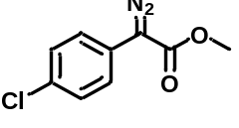 |  |  | 95%, 40 min, (our study)  Blue LED, 16 h, 80%  ¹⁵  dirhodium tetraacetate, 10 h, 72%  ¹⁶
2 |  |  |  | 89%, 40 min, (our study)  Cu, 16h, 81%  ¹⁷  dirhodium tetraacetate, 10h, 69%  ¹⁶
3 | 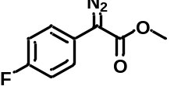 |  | 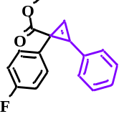 | 75%, 40 min, (our study)  tris(pentafluorophenyl)borate, 24h, 75%  ¹⁸  Irradiation, 16 h, 56%  ¹⁵
4 | 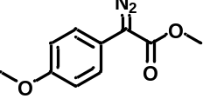 |  | 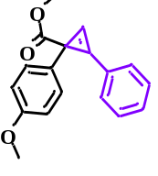 | 90%, 40 min, (our study)  tris(pentafluorophenyl)borate, 24h, 50%  ¹⁸  dirhodium tetraacetate, 10 h, 50%  ¹⁹
5 | 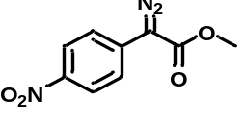 |  | 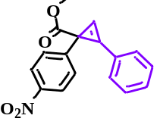 | 88%, 40 min, (our study)  dirhodium tetraacetate, 64%  ²⁰

S8. Case study-6: Carbene insertion (N-C-O bond formation, oxazole) single objective multi-variant auto-optimization.
S.8.1 Background collection
Sample Preparation: We prepare 0.5 M stock solution of compound 2a in DCE, 0.5 M stock solution of reagent 13a in DCE and 0.5 M stock solution of product 14a in DCE. The three of the solution taken in three different syringes.
To conduct our analysis, we utilized an In-line FTIR system. The experimental protocol involved the initial introduction of the solvent, DCE, for a duration of 10 min. using a syringe pump, during which data was recorded. Subsequently, a previously prepared stock solution of compound 2a was similarly introduced into the In-line FTIR for 10 min. This process was repeated for the reaction product 14a and reagent 13a, each pumped for 10 min. Upon collecting all relevant data, we identified the signature peak present in the product. Using this peak as a reference, we employed a Bayesian optimizer to fine-tune and optimize the reaction conditions for improved results.
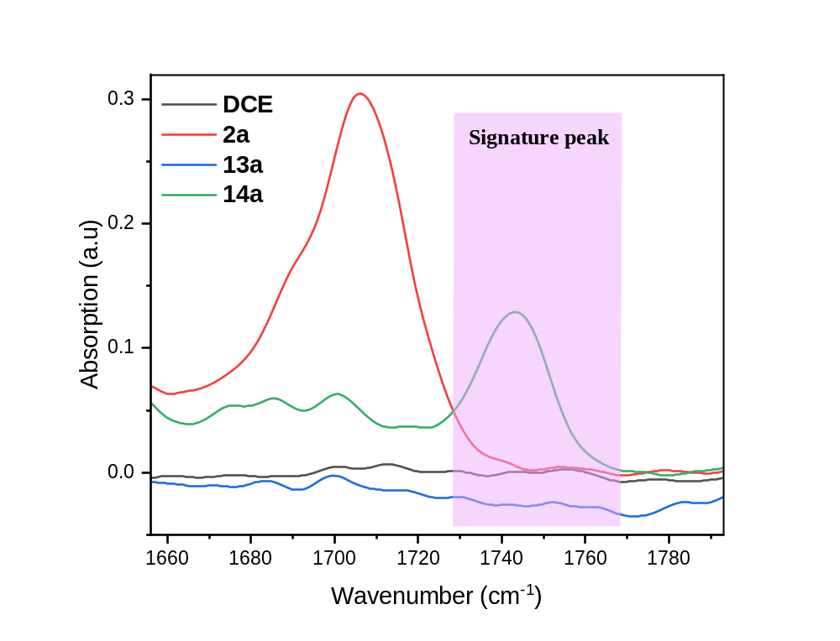Figure S44. In-line IR background analysis of DCE, 0.5 M stock solution of 2a, 13a, and 14a in DCE.
The distinctive shifting peak associated with product (14a) aligning within the range of 1730 to 1770 cm⁻¹. This specific peak, falling within this range, is designated as the signature peak for our analysis. During the optimization of the reaction through Bayesian methods, this signature peak serves as a pivotal reference point. We utilize it to calculate the area under the curve in the In-line FT-IR spectra, providing a quantitative measure of the area in the forthcoming reaction mixture.
S8.2. General procedure for the auto-optimized synthesis of compound 14a.
In our approach we are employing a Python-coded based Bayesian optimization strategy for further refinement. Initial steps involved the preparation of stock solutions for compound 2a (0.1 M in DCE) and reagent 13a (0.2 M in DCE), each filled into separate syringes and connected to a syringe pump. The solutions were then directed through a PFA tubular reactor (inner diameter = 1 mm, length = 1.3 m, volume = 1 mL) surrounded by a cylindrical-shaped blue LED light source. Once the solution setup was complete, input ranges for variable flow rates, voltages, and current were specified in the Python code designed for the reaction. The Bayesian optimizer systematically explored these varying reaction conditions, aiming to achieve maximum yield. The optimization process involved running 40-45 experiments and the results were tabulated in the optimization table (Table S14).
S8.2.1. Python code for optimized condition for N-C-O bond formation, (oxazole)
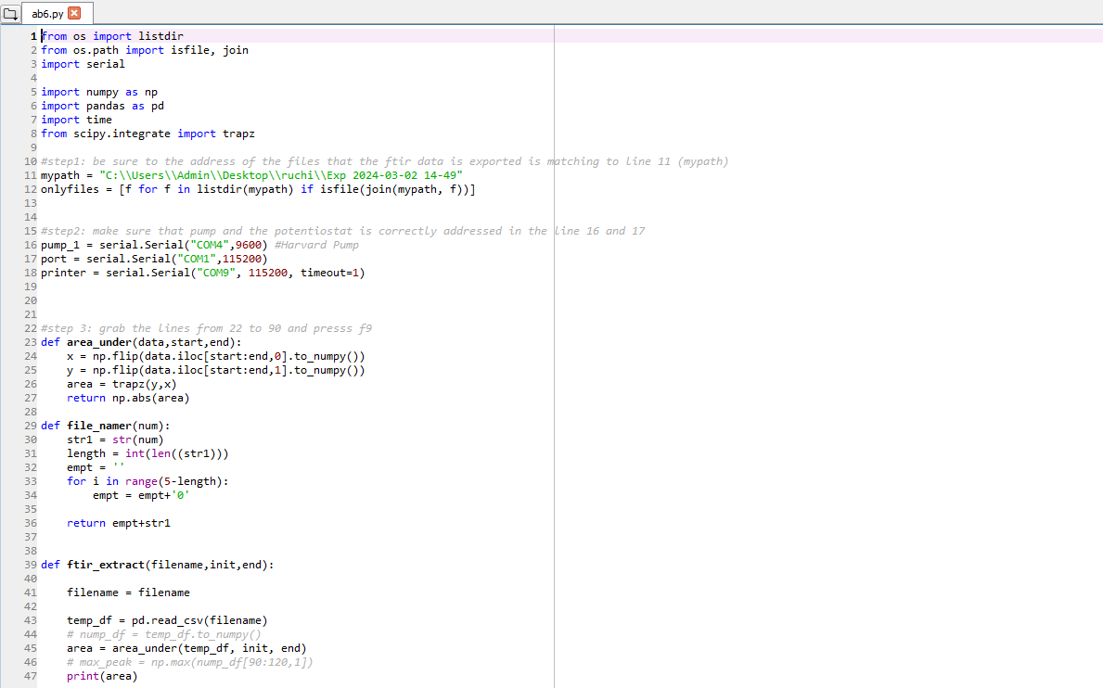
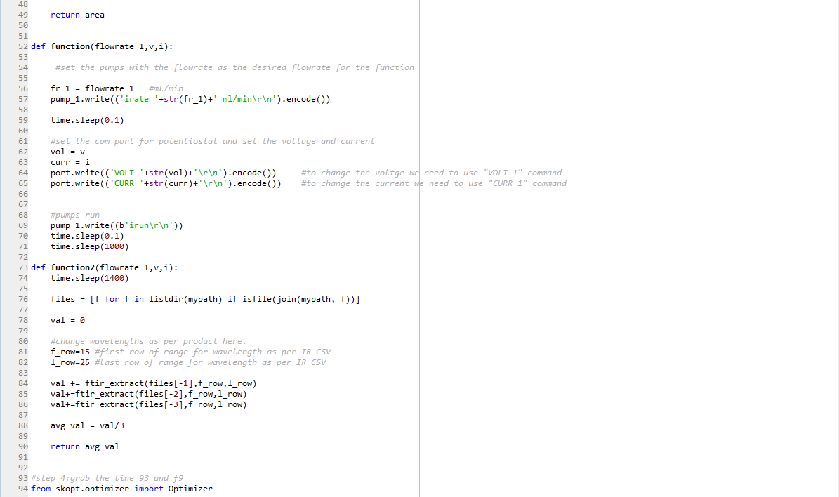
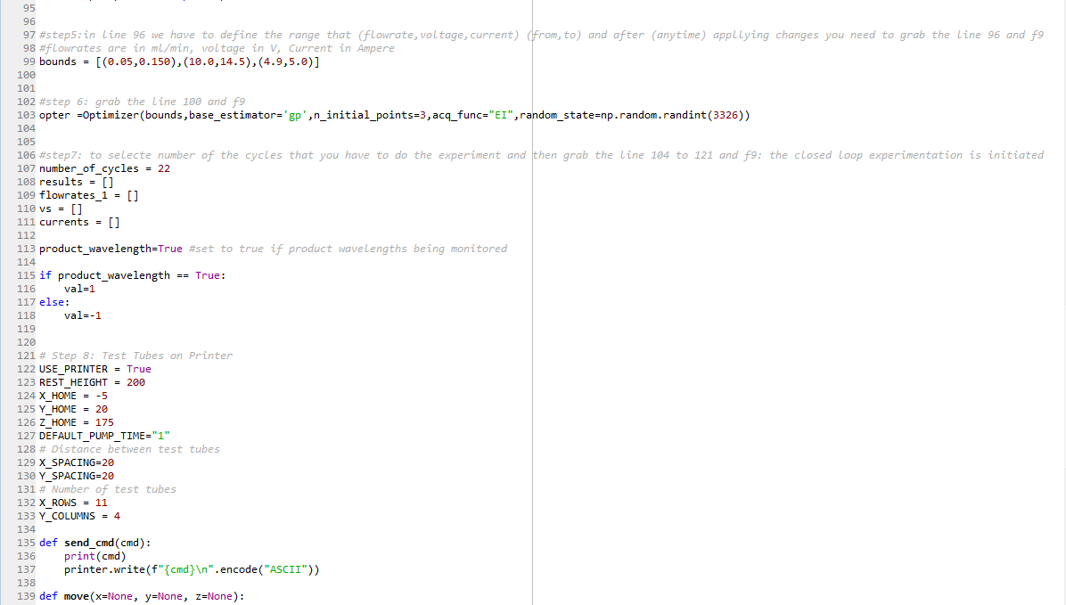
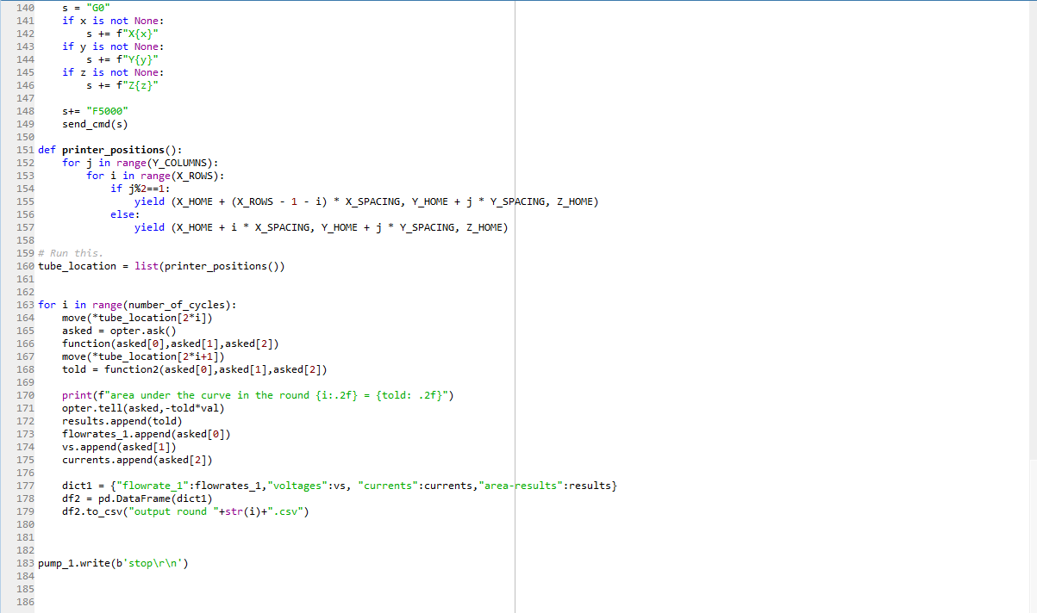

Table S14. Auto-optimization table of carbene insertion reaction (N-C-O bond formation, oxazole).
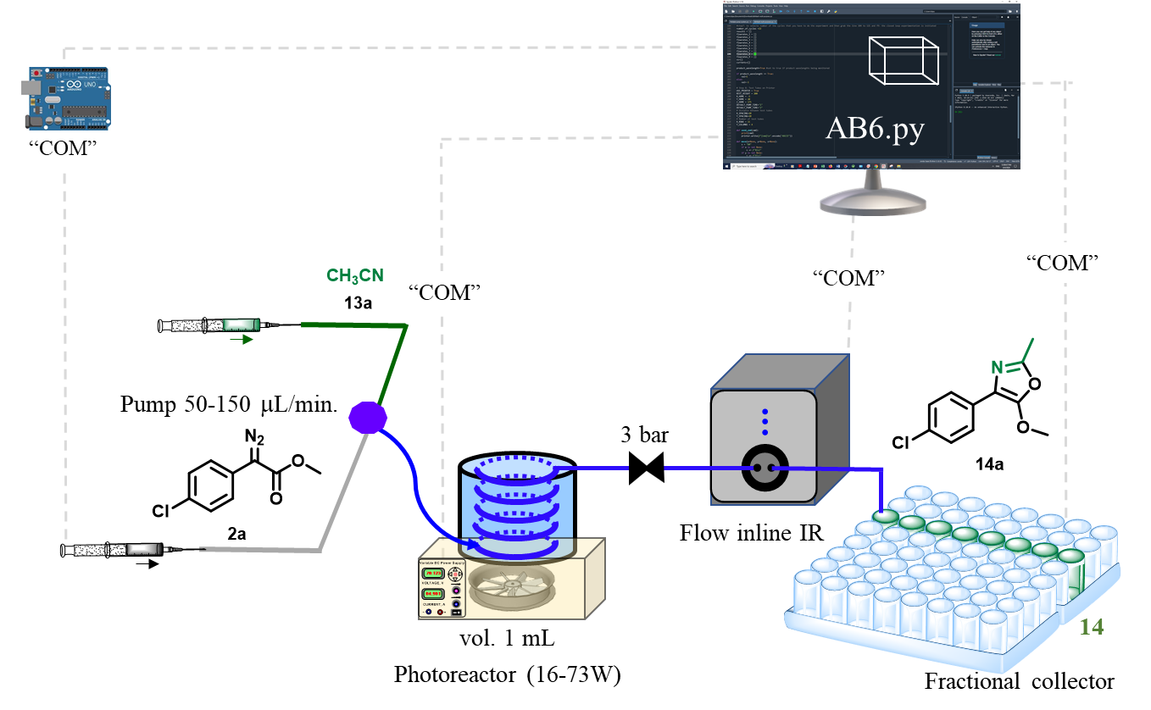
No. of experiments | Flow rate  mL/min | Voltage  (V) | Light intensity  (W) | area-results | Yield  (%) | Space time yield  (g mL⁻¹ h⁻¹)
1 | 0.060718 | 12.40142 | 41.056 | 1.155747 | 66.97147 | 0.027204
2 | 0.10674 | 10.77376 | 22.862 | 0.55897 | 32.39033 | 0.02313
3 | 0.107843 | 10.36182 | 18.909 | 0.267647 | 15.50919 | 0.011189
4 | 0.108263 | 10.79726 | 23.103 | 0.543014 | 31.46576 | 0.02279
5 | 0.099346 | 10.72808 | 22.398 | 0.541964 | 31.40494 | 0.020873
6 | 0.068879 | 10.66267 | 21.772 | 0.510561 | 29.58525 | 0.013633
7 | 0.060402 | 14.4994 | 69.755 | 1.570414 | 91.00002 | 0.036772
8 | 0.149805 | 14.34272 | 67.192 | 1.231955 | 71.38748 | 0.071544
9 | 0.053698 | 14.13864 | 64.004 | 1.410356 | 81.72518 | 0.029359
10 | 0.145992 | 13.77436 | 58.806 | 1.178274 | 68.27688 | 0.066685
11 | 0.129902 | 14.38545 | 67.638 | 1.292653 | 74.90471 | 0.065096
12 | 0.15 | 14.44019 | 68.469 | 1.252034 | 72.55097 | 0.072805
13 | 0.13959 | 12.22695 | 38.597 | 0.937301 | 54.31332 | 0.050721
14 | 0.147351 | 14.00744 | 62.093 | 1.237856 | 71.72945 | 0.07071
15 | 0.070144 | 14.49956 | 69.252 | 1.496397 | 86.71099 | 0.04069
16 | 0.15 | 12.64771 | 44.051 | 1.159221 | 67.17278 | 0.067408
17 | 0.141495 | 14.42064 | 16.392 | 0.123688 | 7.167289 | 0.006785
18 | 0.15 | 14.47181 | 68.795 | 1.170652 | 67.83517 | 0.068073
19 | 0.05 | 14.30231 | 66.266 | 1.542238 | 89.36728 | 0.029893
20 | 0.060666 | 14.03974 | 62.491 | 1.458827 | 84.53391 | 0.034309
21 | 0.146306 | 13.80666 | 59.163 | 1.196568 | 69.33694 | 0.067866
22 | 0.053558 | 13.26608 | 51.711 | 1.147437 | 66.48996 | 0.023824
23 | 0.101353 | 12.36236 | 40.263 | 0.970972 | 56.26446 | 0.03815
24 | 0.111683 | 10.08164 | 68.24 | 1.389288 | 80.50436 | 0.06015
25 | 0.050659 | 14.27468 | 66.303 | 1.43998 | 83.44181 | 0.028279
26 | 0.05 | 10.52857 | 20.456 | 0.350086 | 20.28625 | 0.006786
27 | 0.05 | 15 | 73.955 | 1.561132 | 90.46212 | 0.03026
28 | 0.15 | 13.76539 | 58.639 | 1.178978 | 68.31763 | 0.068557
29 | 0.063485 | 10.41661 | 19.403 | 0.406903 | 23.57859 | 0.010014
30 | 0.139424 | 10.02272 | 15.941 | 0.291171 | 16.87234 | 0.015738
31 | 0.062383 | 14.73195 | 70.464 | 1.57821 | 91.45174 | 0.038167
32 | 0.082665 | 14.57888 | 70.718 | 1.457362 | 84.44903 | 0.046703
33 | 0.064109 | 14.40021 | 67.925 | 1.564911 | 90.68111 | 0.038892
34 | 0.146834 | 10.72916 | 22.411 | 0.51166 | 29.64892 | 0.029125
35 | 0.05799 | 14.59723 | 70.971 | 1.55543 | 90.13171 | 0.034967
36 | 0.077781 | 14.85116 | 74.015 | 1.550575 | 89.85043 | 0.046754
37 | 0.149019 | 10.96034 | 24.693 | 0.691132 | 40.04866 | 0.039926
38 | 0.06201 | 14.99412 | 73.149 | 1.543011 | 89.4121 | 0.037092
39 | 0.09372 | 13.86823 | 60.073 | 1.510841 | 87.54798 | 0.054892
40 | 0.060974 | 14.27468 | 66.303 | 0.979244 | 56.74375 | 0.023147
41 | 0.064852 | 14.76182 | 73.203 | 1.320306 | 76.50714 | 0.033193
42 | 0.13607 | 13.16311 | 50.48 | 0.771156 | 44.68577 | 0.040678
43 | 0.053277 | 10.40976 | 19.38 | 0.261369 | 15.14544 | 0.005398
44 | 0.147724 | 10.71269 | 22.349 | 0.495395 | 28.70643 | 0.02837
Reaction condition: compound 2a (0.1 M in DCE); reagent 13a (0.2 M in DCE); 1 mL reactor volume.

Graph:
We have plotted 3D graph of optimization table S14, we have taken flow rate on X-axis, blue light intensity (watt) on Y-axis and product yield on Z axis.
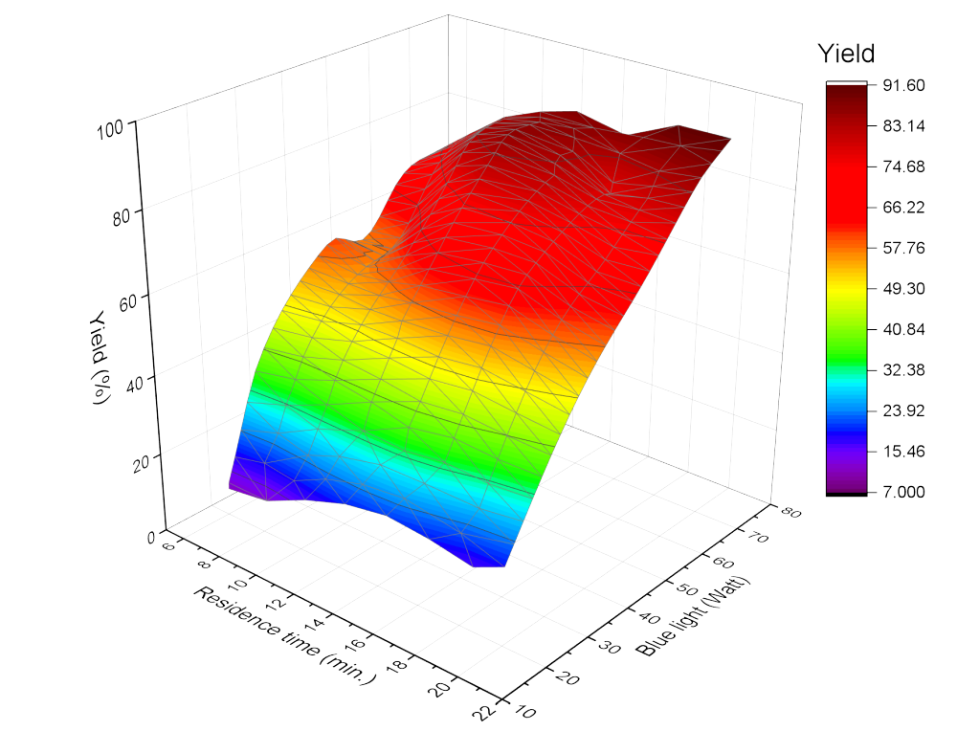
Figure S45. AI based system to auto-optimize and navigate this complexity and identify the optimal conditions for the photo activated [3+2] cycloaddition reaction. Compound 2a (0.1 M in DCE); reagent 13a (0.2 M in DCE); 1 mL reactor volume.

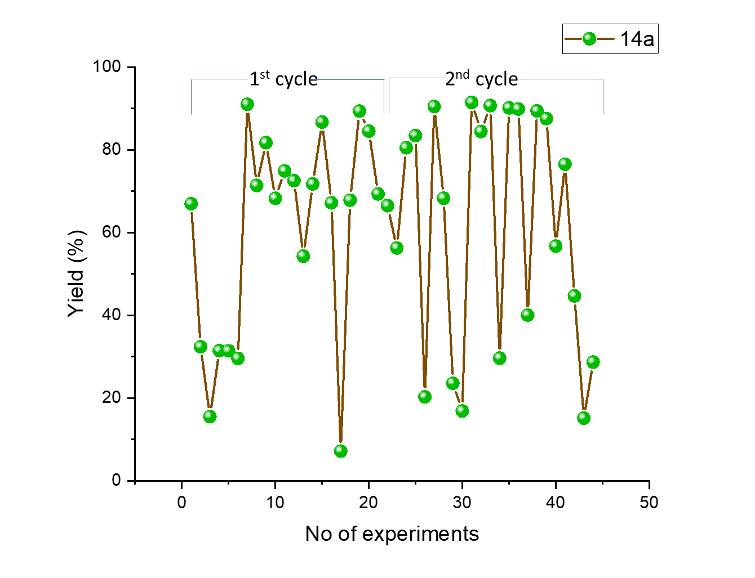
Figure S46. Reproducibility test for the AI based system to auto-optimization for the photo activated [3+2] cycloaddition reaction.Compound 2a (0.1 M in DCE); reagent 13a (0.2 M in DCE); 1 mL reactor volume.

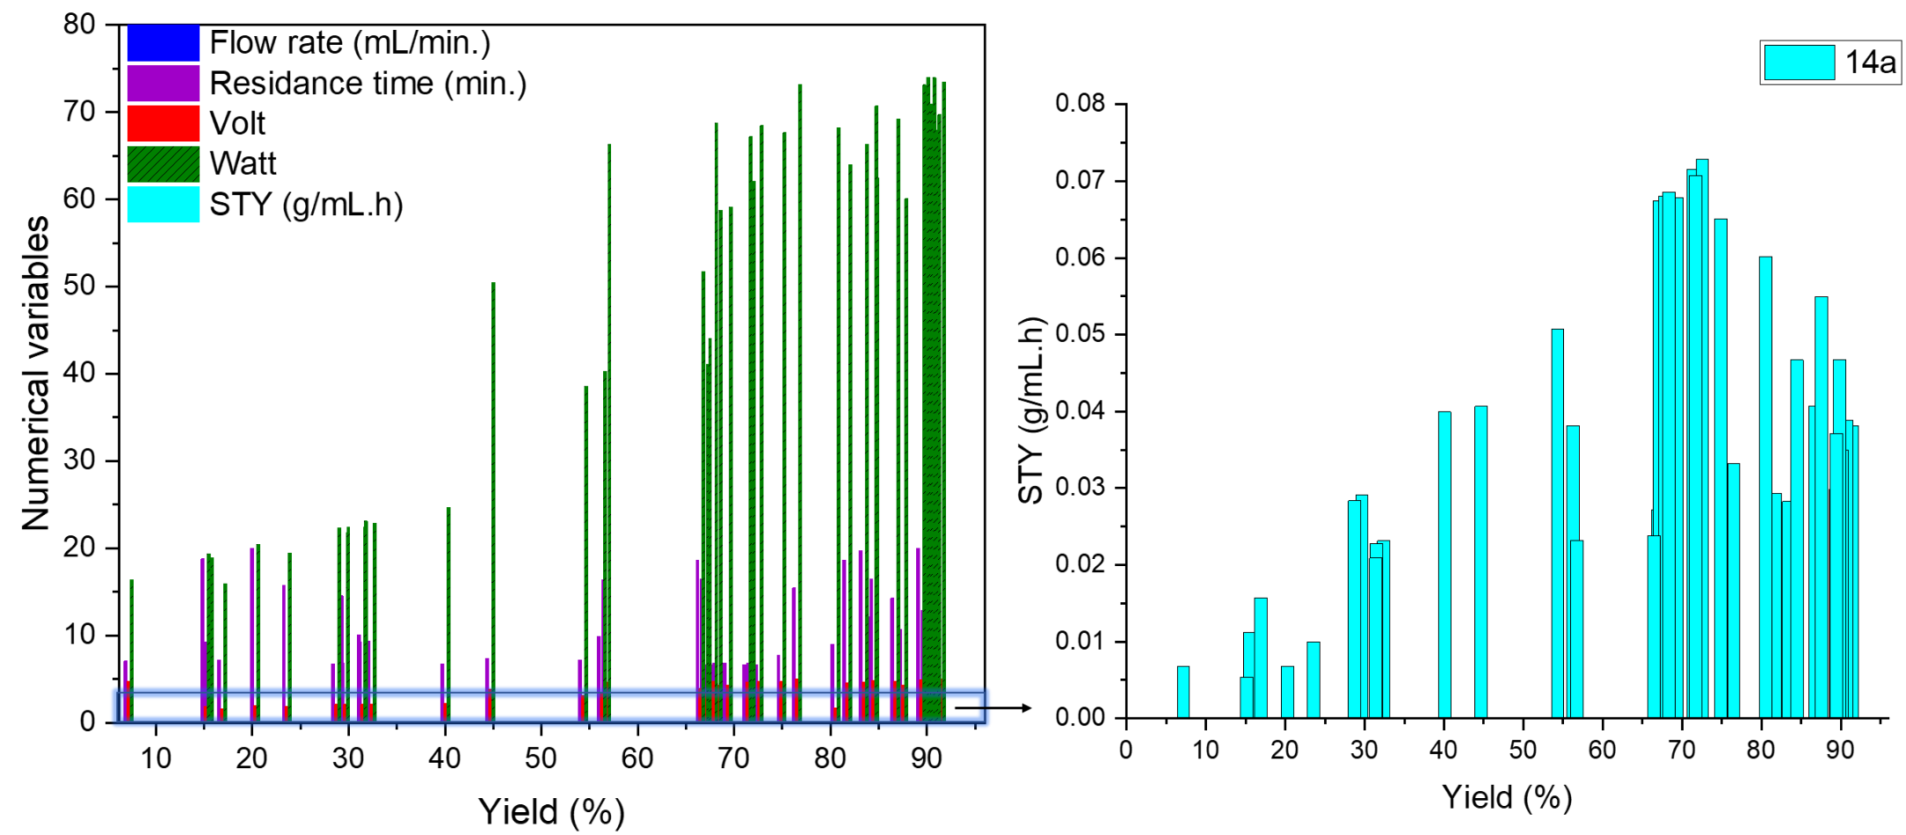
Figure S47. AI based system navigated multi-numerical variable complexity and identify the optimal condtitons for the photo activated [3+2] cycloaddition reaction. Compound 2a (0.1 M in DCE); reagent 13a (0.2 M in DCE); 1 mL reactor volume.

S.8.3. General procedure for AI optimized carbene insertion into the triple bonds of C≡N for synthesis of compound 14a.
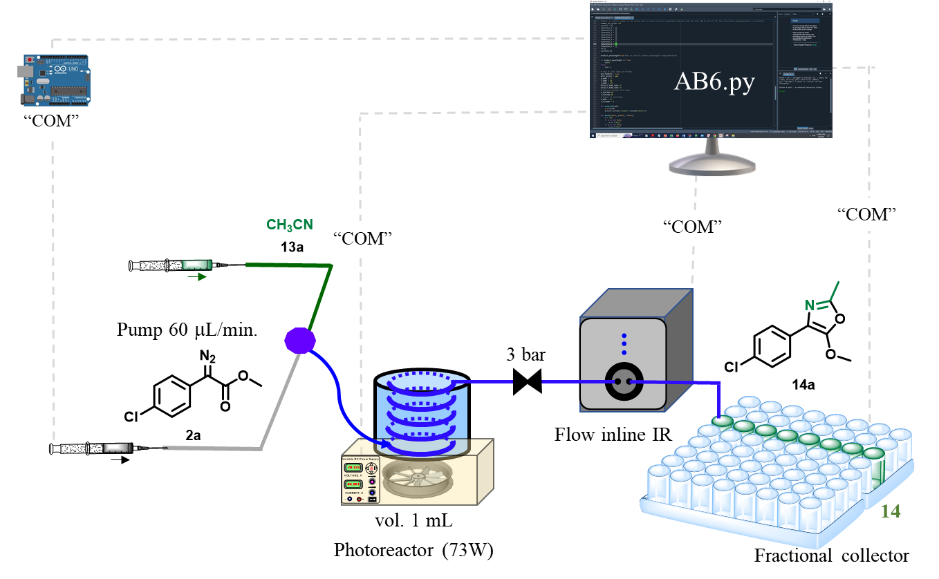
Figure S48. Schematic presentation of continuous flow for the synthesis, of compound 14a.
To prepare the stock solution of compound 2a (2.20 g, 0.01 mol) was dissolved in DCE (100 mL) and connected with pump. Another pump was connected with the reagent 13a (1.09 mL, 0.026 mol) dissolved in DCE (100 mL). These two pump out-put is further connected with the T₁-mixer and pumps were running with the flow rate 31 μL/min. each to maintain the stoichiometry and then passed through PFA tubular reactor (inner diameter = 1 mm, length = 1.3 m, volume = 1 mL) under blue light (73.464 W) exposure. The room temperature of the reactor was controlled by fan attached to the bottom of the photochemical reactor. The out-put of the tubular reactor was connected with spring based back pressure regulator (~3 bar) to maintain the evaporation. First one hour of the product mixture was discarded and next 5 h of the product mixture [18.6 mL; 2a (0.195 g)] was collected in HPLC bottle. The organic EtOAc phase was concentrated under reduced pressure to give the product 13a (0.190g in 5 h, 91%) as a colourless oil. ¹H NMR (500 MHz, CDCl₃) δ 7.70 – 7.67 (m, 2H), 7.32 – 7.30 (m, 2H), 4.00 (s, 3H), 2.38 (s, 3H). ¹³C NMR (126 MHz, CDCl₃) δ 154.28, 151.75, 131.56, 130.07, 129.22, 128.56, 126.01, 113.27, 59.84, 14.11. IR (ν_{max}): 3019.92, 1741.94, 1646.73, 1214.78, 1013.60,745.47 cm⁻¹. HRMS (ESI): m/z calcd for C₁₁H₁₁ClNO₂ [M+H]⁺ 224.0473, found 224.0451. Verified the analytical data with those reported in the literature.²¹
Quantum efficiency (φ) calculation:
The values of the number of incident photons (N_{photons}) were calculated using the following
equations. Here,
$$N_{photon}=\frac{Pλt}{hc}$$
Area of lamp (a) = 448 cm² = 352 x 10⁻⁴ m²
Power of the light (p) = 70W = 70 𝐽 𝑠^{­1}
λ = Wavelength of the light (420 nm) = 420 x 10⁻⁹ m
t = Duration of irradiation time, 5 h = 18000 s,
h = Planck’s constant = 6.626 x 10⁻³⁴ J s
c = Velocity of light = 3 x 10⁸ m s⁻¹
No of photons incident
$$N_{photon}=\frac{70 J s^{-1} ×420× {10}^{-9 }m ×18000 s}{6.626 × {10}^{-34} J s× 3×{10}^{8} m s^{-1}}$$
$$N_{photon}= 2.6 ×{10}^{24}$$
$$Mole’s photons incident =\frac{N_{photon}}{N}$$
[N = Avogadro’s number (6.02214 × 10²³)]
$$Mole’s photons incident=\frac{2.6 ×{10}^{24}}{6.02214×{ 10}^{23}}$$
$$Mole’s photons incident =4.31 mole$$
Moles of product formed is:
$$Mole’s of product formed =\frac{productivity}{mole. wt}$$
The product formed is = 0.190 g.
$$ofMole’s of product formed=\frac{0.190}{223}$$
$$Mole’s of product formed =0.8 ×{10}^{-3}$$
Quantum efficiency (φ):
$$Quantum efficiency \left(∅\right):=\frac{Mole’s of product formed}{Mole’s photons incident}×100$$
$$Quantum efficiency \left(∅\right):=\frac{0.8×{10}^{-3}}{4.31} ×100$$
$$Quantum efficiency \left(∅\right):=0.18 \%$$
$$Productivity \left(per h\right):=\frac{0.190}{5}= 0.038 g/h$$
$$Space time yield :=\frac{productivity}{volume of reactor}$$
$$=\frac{0.038}{1}=0.038 g {mL}^{-1} h^{-1}$$
Space time yield in previous reported batch process ²¹
Productivity = 39.8 mg in 24 h
$$Productivity \left(per h\right):=\frac{0.39}{24}= 0.0016 g/h$$

$$Space time yield :=\frac{productivity}{volume of reactor}$$
$$=\frac{0.0016}{1}=0.0016 g{ mL}^{-1} h^{-1}$$

Table S15. Comparative result for the carbene insertion (N-C-O bond formation, oxazole).
Entry | Compound 2a | Reagent 13a | Product 14a | Comparative result
1 |  | 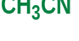 | 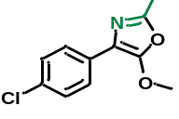 | 91.4%, 16.6 min. (our study)  Blue LED, RVC (+), Pt (−), 1.5 h, 88%  ²²  Et₃SiCl, Blue LED, 8 h, 83%  ²³  Blue LED, 24 h, 89%  ²¹

S9. Case study-7: Carbene insertion (C=C bond formation, fumarate) single objective multi-variant auto-optimization.
S9.1 Background collection
Sample Preparation: We prepare 0.5 M stock solution of compound 2a in DCE, 0.5 M stock solution of reagent 15 in DCE and 0.5 M stock solution of product 16a in DCE. The three of the solution taken in three different syringes.
To conduct our analysis, we utilized an In-line FTIR system. The experimental protocol involved the initial introduction of the solvent, DCE, for a duration of 10 min. using a syringe pump, during which data was recorded. Subsequently, a previously prepared stock solution of compound 2a was similarly introduced into the In-line FTIR for 10 min. This process was repeated for the reaction product 16a and reagent 15, each pumped for 10 min. Upon collecting all relevant data, we identified the signature peak present in the product. Using this peak as a reference, we employed a Bayesian optimizer to fine-tune and optimize the reaction conditions for improved results.
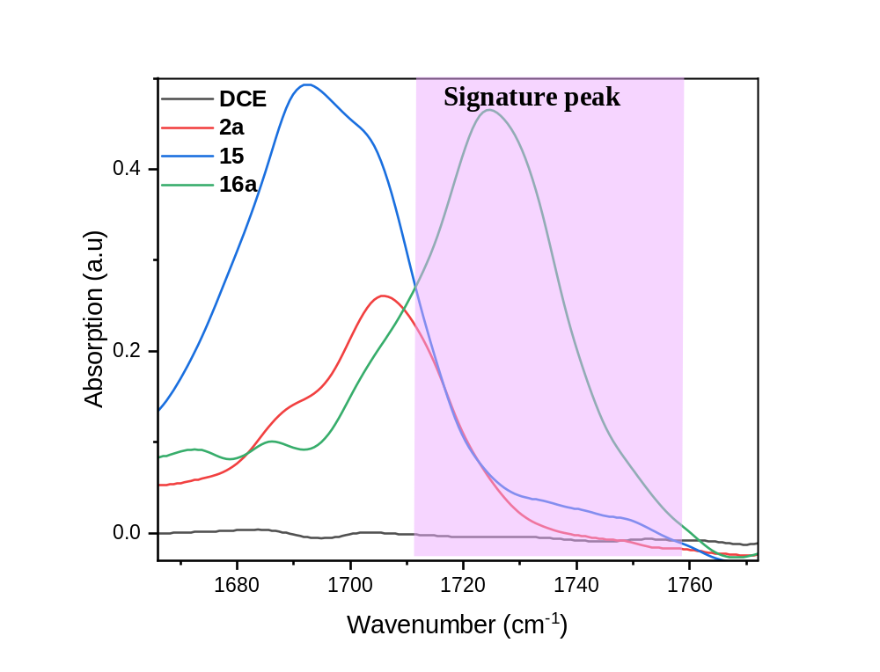
Figure. S49. In-line IR background analysis of DCE, 0.5 M stock solution of 1a, 15a, and 16a in DCE.
The distinctive shifting peak associated with product (16a) aligning within the range of 1715 to 1760 cm⁻¹. This specific peak, falling within this range, is designated as the signature peak for our analysis. During the optimization of the reaction through Bayesian methods, this signature peak serves as a pivotal reference point. We utilize it to calculate the area under the curve in the In-line FT-IR spectra, providing a quantitative measure of the area in the forthcoming reaction mixture.
S8.2. General procedure for the auto-optimized synthesis of compound 16a.
Initial steps involved the preparation of stock solutions for compound 2a (0.1 M in DCE) and reagent 15 (0.1 M in DCE), each filled into separate syringes and connected to a syringe pump. The solutions were then directed through a PFA tubular reactor (inner diameter = 1 mm, length = 1.3 m, volume = 1 mL) surrounded by a cylindrical-shaped blue LED light source. Once the solution setup was complete, input ranges for variable flow rates, voltages, and current were specified in the Python code designed for the reaction. The Bayesian optimizer systematically explored these varying reaction conditions, aiming to achieve maximum yield. The optimization process involved running 40-45 experiments and the results were tabulated in the optimization table (Table S16).

S8.2.1. Python code for optimized condition for C=C bond formation, fumarate 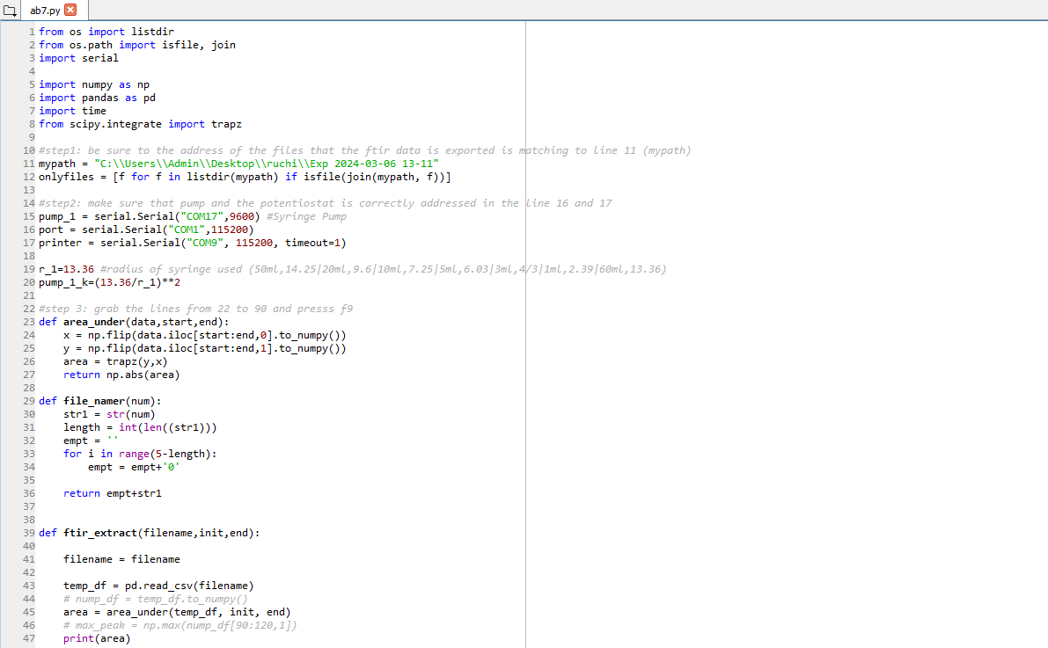
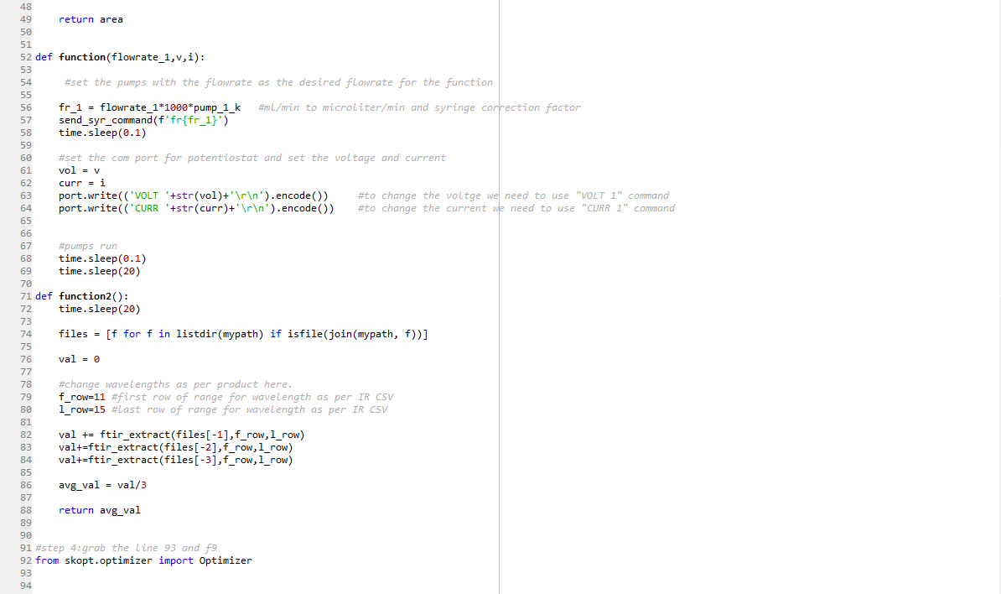
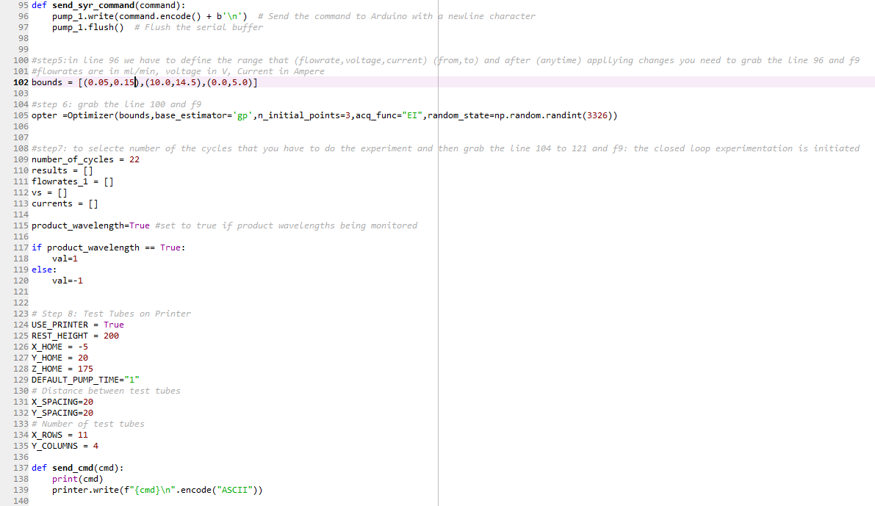

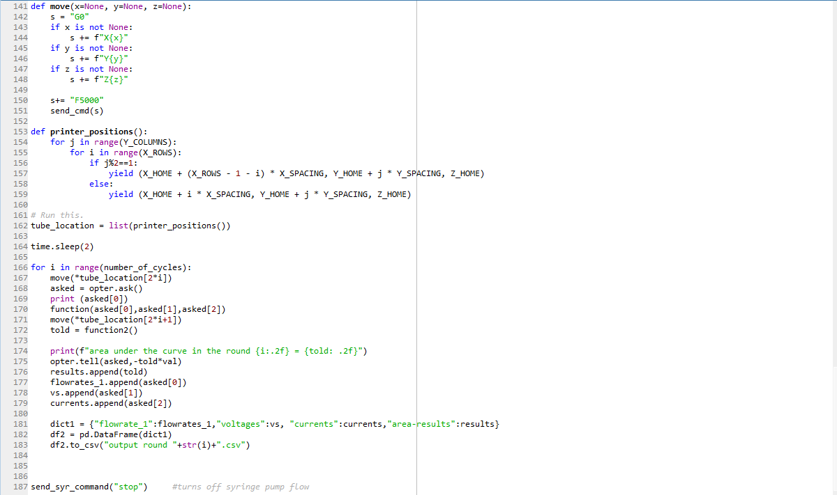

Table S16. Auto-optimization table of cross coupling reaction (C=C bond formation, fumarate).
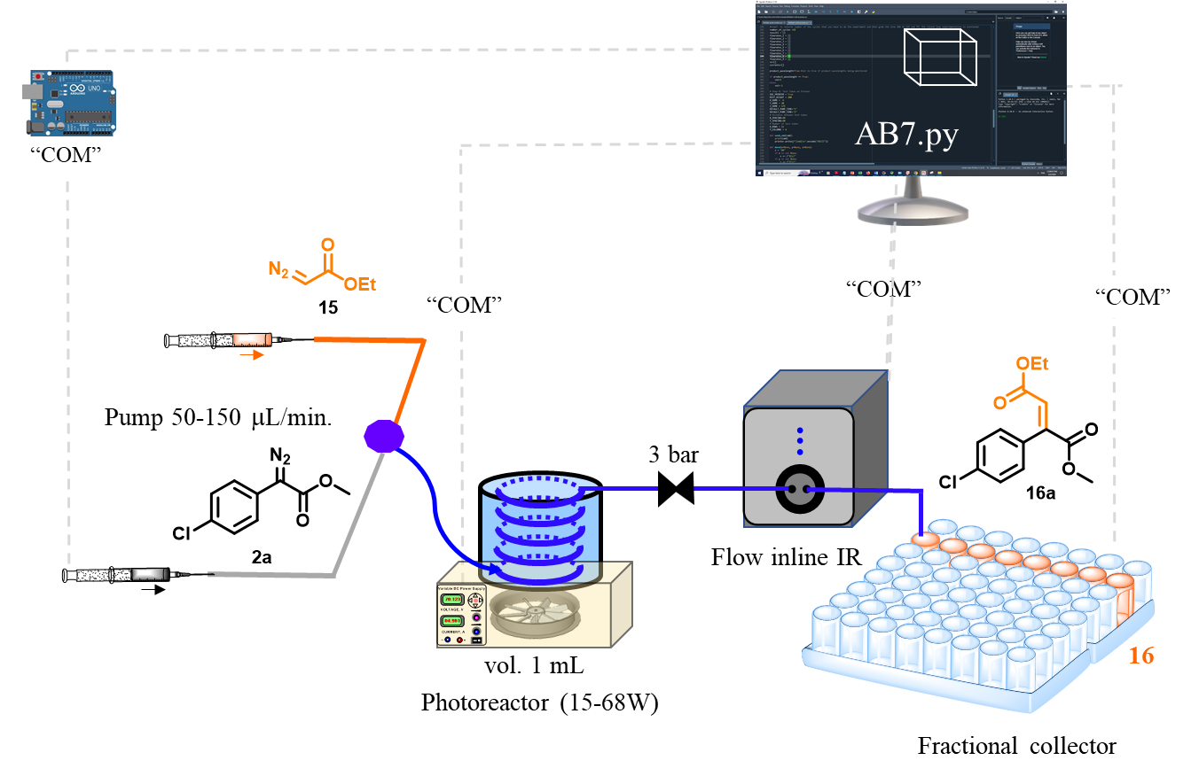
No. of experiments | Flow rate  mL/min | Voltage  (V) | Light intensity  (W) | area-results | Yield  (%) | Space time yield  (g mL⁻¹ h⁻¹)
1 | 0.114805 | 11.92934 | 34.102 | 0.470179 | 36.42071 | 0.033618
2 | 0.098673 | 12.30966 | 38.515 | 0.854069 | 66.1574 | 0.052485
3 | 0.103371 | 11.69926 | 31.712 | 0.830144 | 64.3041 | 0.053443
4 | 0.053233 | 14.41624 | 67.034 | 1.090795 | 84.49451 | 0.036163
5 | 0.15 | 12.46267 | 41.012 | 0.60424 | 46.80531 | 0.056447
6 | 0.136292 | 11.89984 | 34.436 | 0.627558 | 48.61151 | 0.053268
7 | 0.0808 | 13.69994 | 57.96 | 1.106513 | 85.71207 | 0.055682
8 | 0.070825 | 11.19236 | 26.491 | 0.542513 | 42.0238 | 0.02393
9 | 0.052078 | 10.03053 | 15.605 | 0.349642 | 27.08376 | 0.01134
10 | 0.109072 | 12.22021 | 37.699 | 0.508583 | 39.39557 | 0.034548
11 | 0.100732 | 12.0365 | 35.578 | 0.421314 | 32.63555 | 0.026431
12 | 0.114871 | 11.90975 | 34.56 | 0.456292 | 35.345 | 0.032643
13 | 0.148623 | 14.25763 | 65.083 | 1.000345 | 77.48811 | 0.092593
14 | 0.053555 | 10.00233 | 15.532 | 0.192328 | 14.89802 | 0.006415
15 | 0.05 | 12.69937 | 44.027 | 0.739746 | 57.30175 | 0.023035
16 | 0.129758 | 11.12454 | 26.086 | 0.44318 | 34.32936 | 0.035814
17 | 0.123543 | 12.8464 | 45.873 | 0.795025 | 61.58378 | 0.06117
18 | 0.142808 | 11.61169 | 31.302 | 0.302434 | 23.42699 | 0.026898
19 | 0.080479 | 11.63094 | 31.389 | 0.381501 | 29.5516 | 0.019121
20 | 0.081458 | 14.41624 | 67.034 | 1.148959 | 88.99998 | 0.058288
21 | 0.065678 | 12.35186 | 39.644 | 0.714388 | 55.33753 | 0.029221
22 | 0.068097 | 12.28934 | 39.054 | 0.431773 | 33.44574 | 0.018311
23 | 0.094075 | 10.32873 | 18.363 | 0.20385 | 15.79052 | 0.011943
24 | 0.054858 | 12.70035 | 44.104 | 0.90043 | 69.74862 | 0.030763
25 | 0.132587 | 14.37057 | 66.907 | 0.816223 | 63.22577 | 0.067399
26 | 0.15 | 10 | 15.53 | 0.124816 | 9.668397 | 0.01166
27 | 0.149923 | 11.35554 | 28.524 | 0.250264 | 19.38581 | 0.023367
28 | 0.15 | 10 | 16.018 | 0.193638 | 14.99947 | 0.018089
29 | 0.15 | 10 | 16.018 | 0.19419 | 15.04221 | 0.018141
30 | 0.081458 | 14.32353 | 66.382 | 1.09276 | 84.64676 | 0.055437
31 | 0.14972 | 10.04417 | 15.585 | 0.164063 | 12.70858 | 0.015298
32 | 0.124635 | 14.5 | 68.203 | 0.653962 | 50.6568 | 0.050762
33 | 0.050661 | 10.01346 | 15.52 | 0.189311 | 14.6643 | 0.005973
34 | 0.148887 | 14.32353 | 66.382 | 0.96474 | 74.73017 | 0.089456
35 | 0.059379 | 10 | 15.499 | 0.156635 | 12.13321 | 0.005792
36 | 0.050761 | 11.45305 | 29.297 | 0.368252 | 28.5253 | 0.011642
37 | 0.052621 | 12.00522 | 35.367 | 0.75496 | 58.48026 | 0.024741
38 | 0.090012 | 10.00458 | 15.458 | 0.35354 | 27.38574 | 0.019819
39 | 0.079081 | 14.4398 | 67.541 | 1.03432 | 80.11992 | 0.050941
40 | 0.129892 | 10.00877 | 15.502 | 0.417781 | 32.3619 | 0.033797
41 | 0.080521 | 14.47602 | 68.587 | 1.140182 | 88.32009 | 0.057177
42 | 0.078882 | 10.02039 | 14.682 | 0.251696 | 19.4967 | 0.012365
43 | 0.094613 | 14.48282 | 68.427 | 1.068802 | 82.79091 | 0.062978
44 | 0.094114 | 14.49842 | 68.595 | 1.089417 | 84.38781 | 0.063854
Reaction condition: compound 2a (0.1 M in DCE); reagent 15 (0.1 M in DCE); 1 mL reactor volume.
Graphs:
We have plotted 3D graph of optimization table S16, we have taken flow rate on X-axis, blue light intensity (watt) on Y-axis and product yield on Z axis.
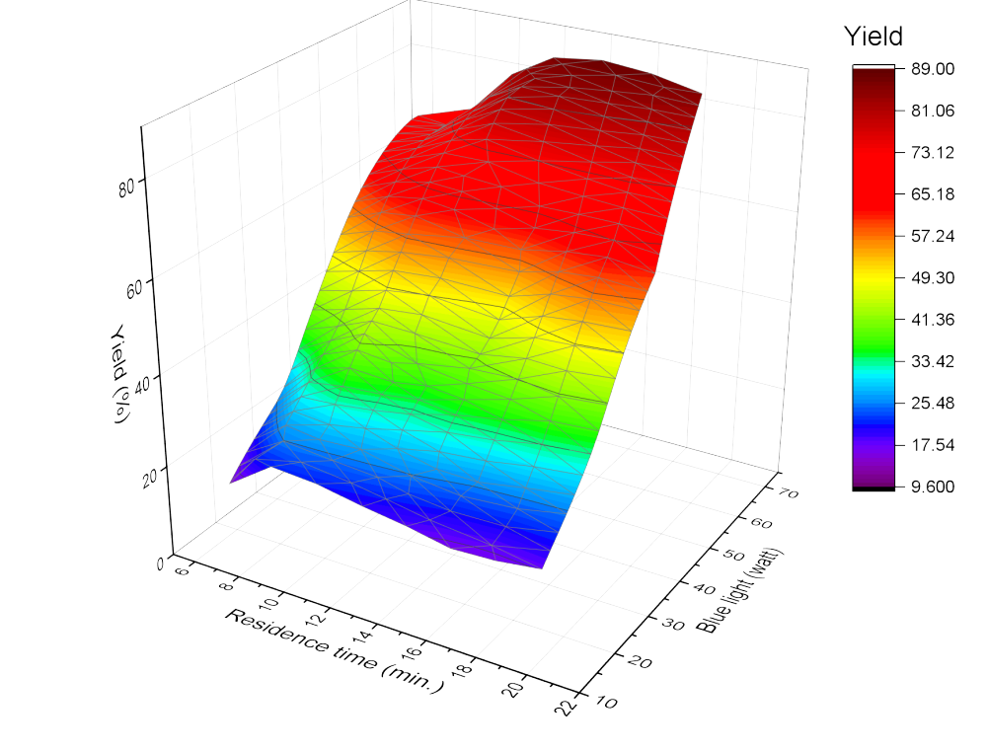
Figure S50. AI based system to auto-optimize and navigate this complexity and identify the optimal conditions for the photo activated cross-coupling reaction. Compound 2a (0.1 M in DCE); reagent 15 (0.1 M in DCE); 1 mL reactor volume.

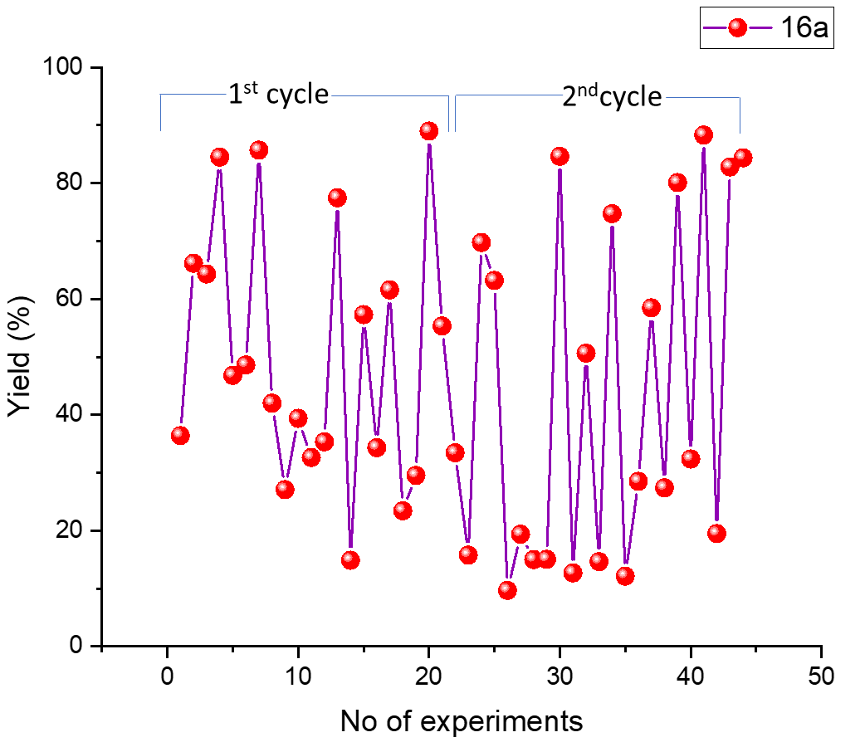
Figure S51. Reproducibility test for the AI based system to auto-optimization for the photo activated cross copling reaction. Compound 2a (0.1 M in DCE); reagent 15 (0.1 M in DCE); 1 mL reactor volume.

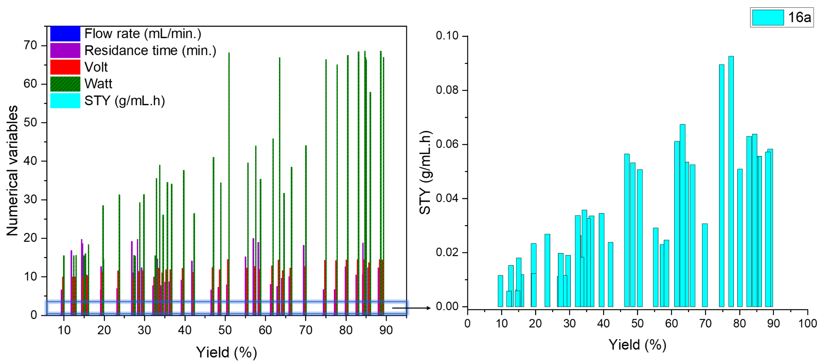
Figure S52. AI based system navigated multi-numerical variable complexity and identify the optimal condition for the photo activated cross coupling reaction. Compound 2a (0.1 M in DCE); reagent 15 (0.1 M in DCE); 1 mL reactor volume.

S.8.3. General procedure for AI optimized cross coupling reaction of ethyl diazoetherate and aryldiazoester for synthesis of compound 16a.
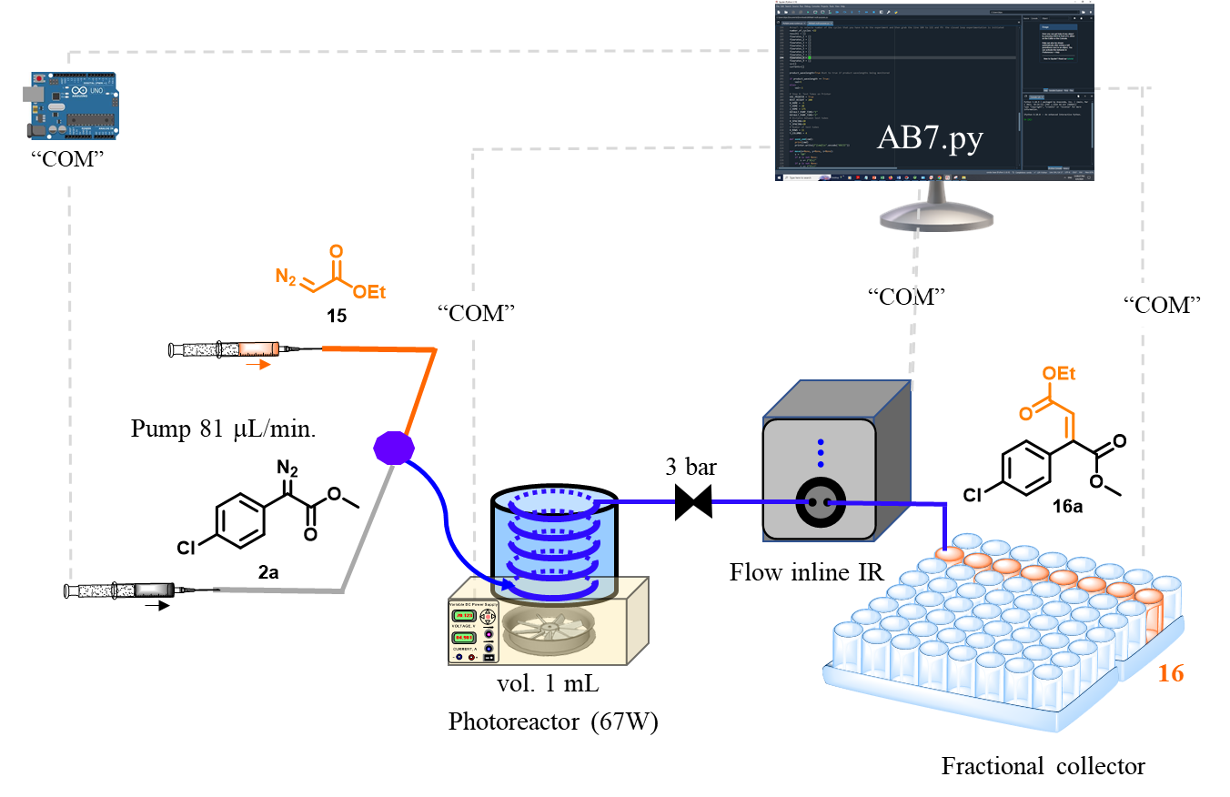
Figure S53. Schematic presentation of continuous flow for the synthesis, of compound 16.
To prepare the stock solution of compound 2a (2.20 g, 0.01 mol) was dissolved in DCE (100 mL) and connected with pump. Another pump was connected with the reagent 15 (1.32 mL, 0.01 mol) dissolved in DCE (100 mL). These two pump out-put is further connected with the T₁-mixer and pumps were running with the flow rate 40 μL/min.each to maintain the stoichiometry and then passed through PFA tubular reactor (inner diameter = 1 mm, length = 1.3 m, volume = 1 mL) under blue light (67.034 W) exposure. The room temperature of the reactor was controlled by fan attached to the bottom of the photochemical reactor. The out-put of the tubular reactor was connected with spring based back pressure regulator (~3 bar) to maintain the evaporation. First one hour of the product mixture was discarded and next 5 h of the product mixture [24.3 mL; 2a (0.255 g)] was collected in HPLC bottle. The organic EtOAc phase was concentrated under reduced pressure to give the product 16a (0.29 g in 5 h, 89%) as a colourless oil. ¹H NMR (400 MHz, CDCl₃) δ 7.35– 7.32 (m, 2H), 7.21 – 7.16 (m, 2H), 7.03 (s, 1H), 4.06 (q, J = 7.1 Hz, 2H), 3.79 (s, 3H), 1.10 (t, J = 7.1 Hz, 3H). ¹³C NMR (126 MHz, CDCl₃) δ 166.34, 164.93, 142.65, 134.63, 132.35, 130.36, 129.81, 128.06, 61.02, 52.97, 13.84. IR (ν_{max}): 2985.96, 1719.69, 1439.07, 1242.01, 832.82 cm⁻¹. HRMS (ESI): m/z calcd for C₁₃H₁₄ClO₄ [M+H]⁺ 269.0575, found 269.0590. Verified the analytical data with those reported in the literature.²⁴
Quantum efficiency (φ) calculation:
The values of the number of incident photons (N_{photons}) were calculated using the following
equations. Here,
$$N_{photon}=\frac{Pλt}{hc}$$
Area of lamp (a) = 448 cm² = 352 x 10⁻⁴ m²
Power of the light (p) = 67W = 67 𝐽 𝑠^{­1}
λ = Wavelength of the light (420 nm) = 420 x 10⁻⁹ m
t = Duration of irradiation time, 5 h = 18000 s,
h = Planck’s constant = 6.626 x 10⁻³⁴ J s
c = Velocity of light = 3 x 10⁸ m s⁻¹
No of photons incident
$$N_{photon}=\frac{67 J s^{-1} ×420× {10}^{-9 }m ×18000 s}{6.626 × {10}^{-34} J s× 3×{10}^{8} m s^{-1}}$$
$$N_{photon}= 2.5 ×{10}^{24}$$
$$Mole’s photons incident =\frac{N_{photon}}{N}$$
[N = Avogadro’s number (6.02214 × 10²³)]
$$Mole’s photons incident=\frac{2.5 ×{10}^{24}}{6.02214×{ 10}^{23}}$$
$$Mole’s photons incident =4.1 mole$$
Moles of product formed is:
$$Mole’s of product formed =\frac{productivity}{mole. wt}$$
The product formed is = 0.290 g.
$$ofMole’s of product formed=\frac{0.290}{268}$$
$$Mole’s of product formed =1.1 ×{10}^{-3}$$
Quantum efficiency (φ):
$$Quantum efficiency \left(∅\right):=\frac{Mole’s of product formed}{Mole’s photons incident}×100$$
$$Quantum efficiency \left(∅\right):=\frac{1.1×{10}^{-3}}{4.1} ×100$$
$$Quantum efficiency \left(∅\right):=0.27 \%$$
$$Productivity \left(per h\right):=\frac{0.290}{5}= 0.058 g/h$$
$$Space time yield :=\frac{productivity}{volume of reactor}$$
$$=\frac{0.058}{1}=0.058 g {mL}^{-1} h^{-1}$$
Space time yield in previous reported batch process ²⁴
Productivity = 41.5 mg in 12 h
$$Productivity \left(per h\right):=\frac{0.041}{12}= 0.0034 g/h$$

$$Space time yield :=\frac{productivity}{volume of reactor}$$
$$=\frac{0.0034}{2}=0.0017 g {mL}^{-1} h^{-1}$$
Table S17. Comparative result for the carbene insertion (C=C bond formation, fumarate).
Entry | Compound 2a | Reagent 15a | Product 16a | Comparative result
1 | 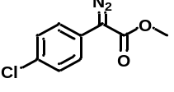 | 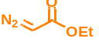 | 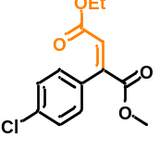 | 89%, 12.3 min. (our study)  Blue LED, 12 h, 93%  ²⁴  Artificial metalloenzymes, 22 h, 68%  ²⁵

S10. Case study-8: On demand chemical synthesis.
After individually optimizing the experimental conditions and validating our codes for carbene insertion reactions with varied nucleophiles photo chemically, we aimed to integrate all the python codes (AB1, AB2, AB3, AB4, AB5, AB6, AB7) with optimized conditions. We drew inspiration from the natural grafting technique observed in hibiscus plants, where the root remains the same, but a portion of one plant is placed into the branch of another, resulting in the growth of the same kind of flower with different colours. Similarly, in our "digichemtree" approach, we maintain the same starting material, 4-chloro phenyl diazoester (2a), but graft our tree with varied nucleophiles (3a, 5a, 7a, 9a, 11a, 13, 15) to obtain our respective carbene-inserted products photo chemically. The neural network remains unchanged from our individual experiments, but we've now integrated a total of 9 pumps to flow the starting material and nucleophiles. The outlets of these pumps are connected to an 8-port valve for mixing purposes. The resulting stock solution then passes through a 1 mL PFA tubular reactor with a blue LED and tunable power supply. For fraction collection, we've utilized our tailor-made 3D printer module. This integrated system employs 4 syringe pumps and 5 HPLC pumps. As a model reaction, we've conducted 7 chemical transformations with 7 different nucleophiles.

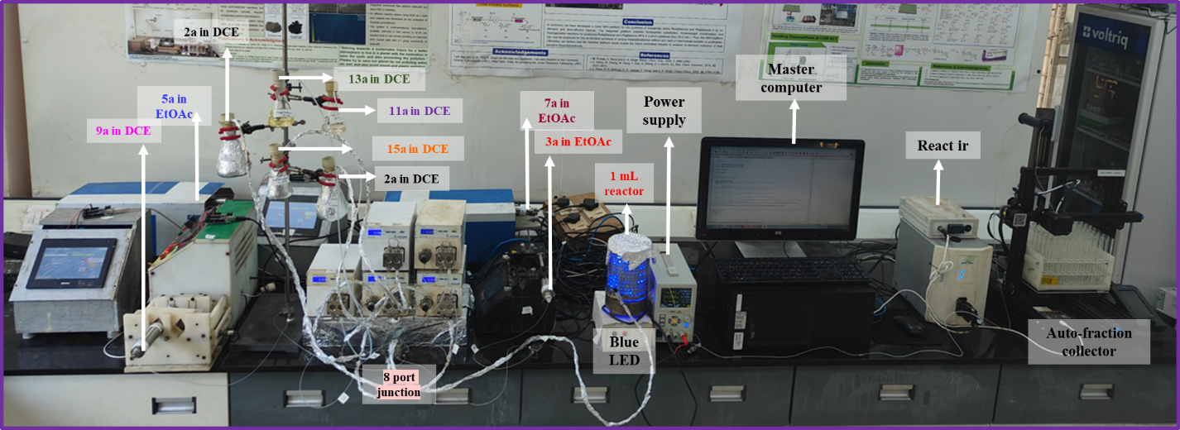
Figure S54. Actual picture of the setup.

S10.1. Python code for integrated optimized condition for carbene insertion reactions.
AB1.PY CODE (for benzoic acid)
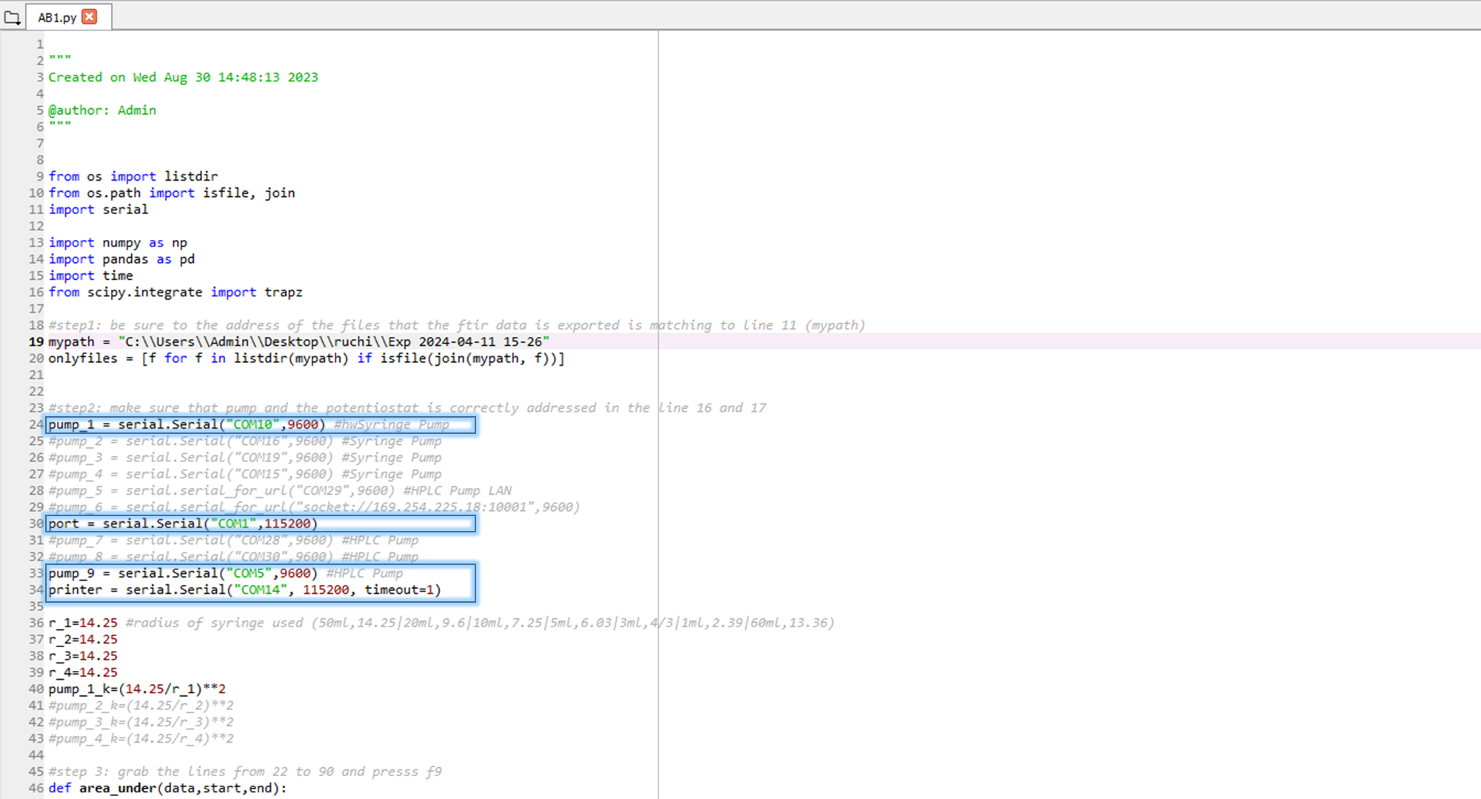
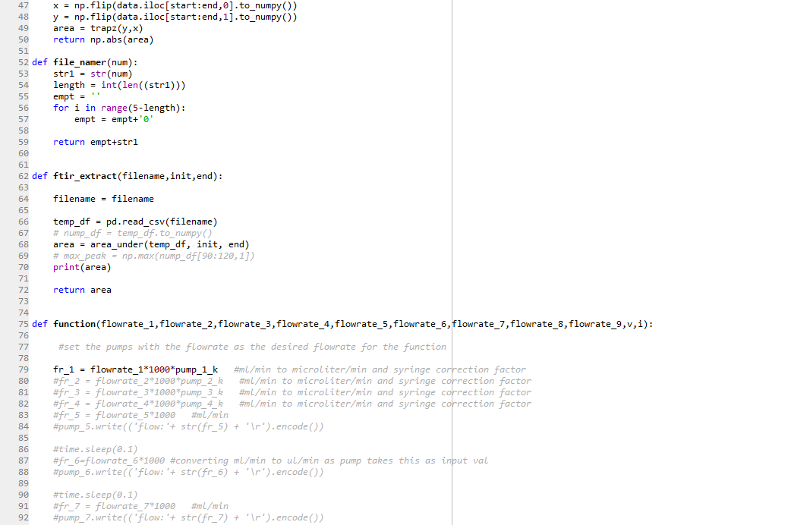
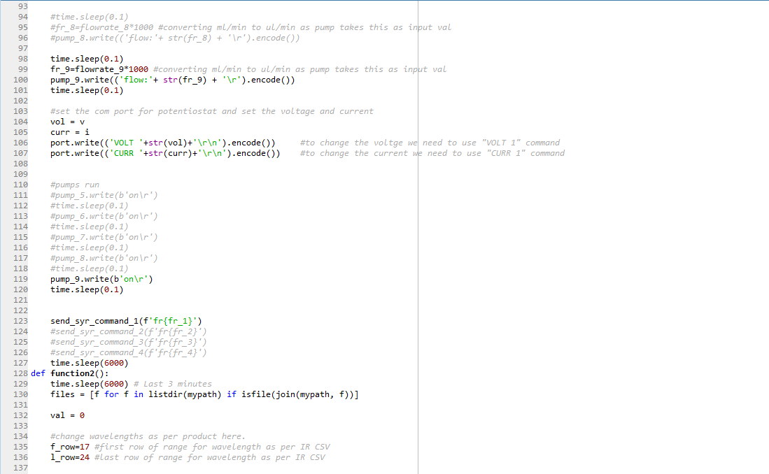
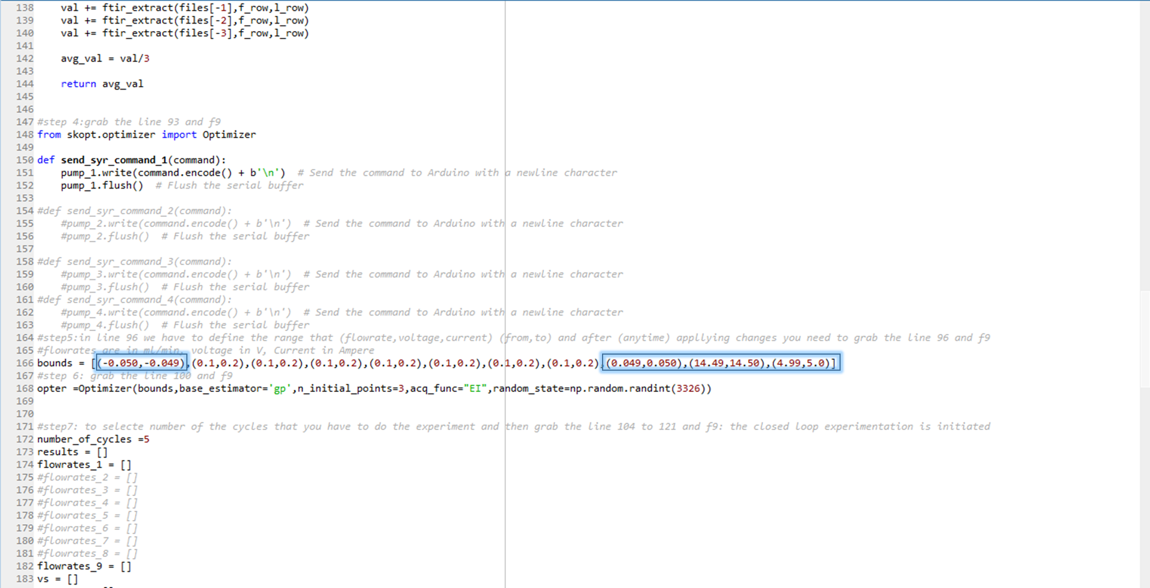
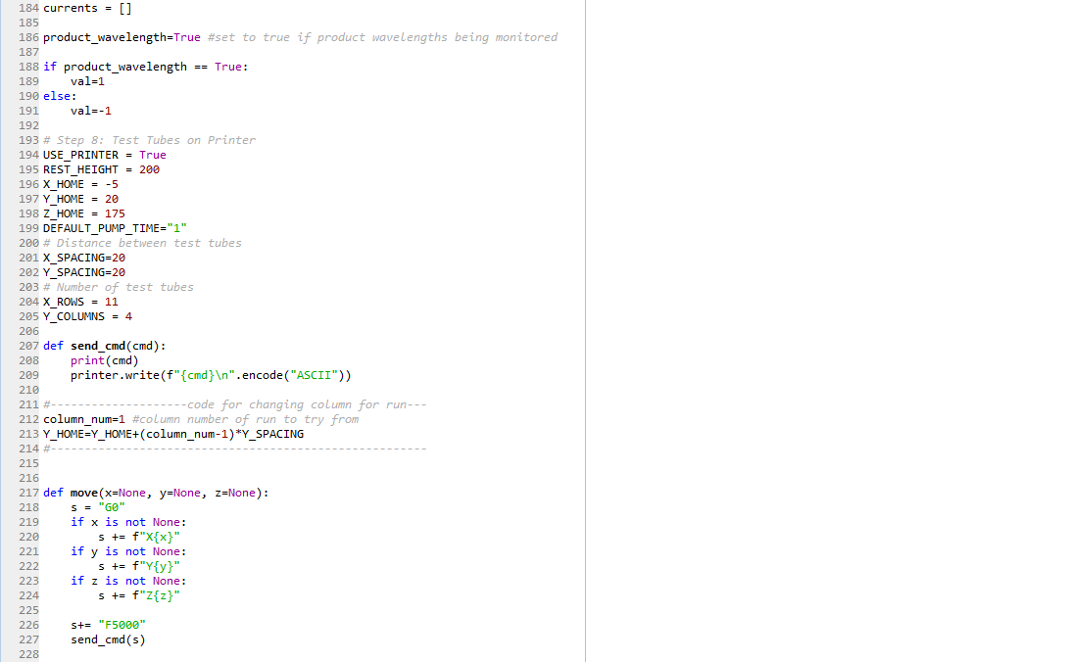
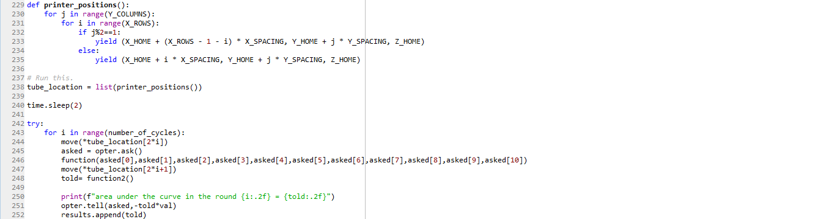
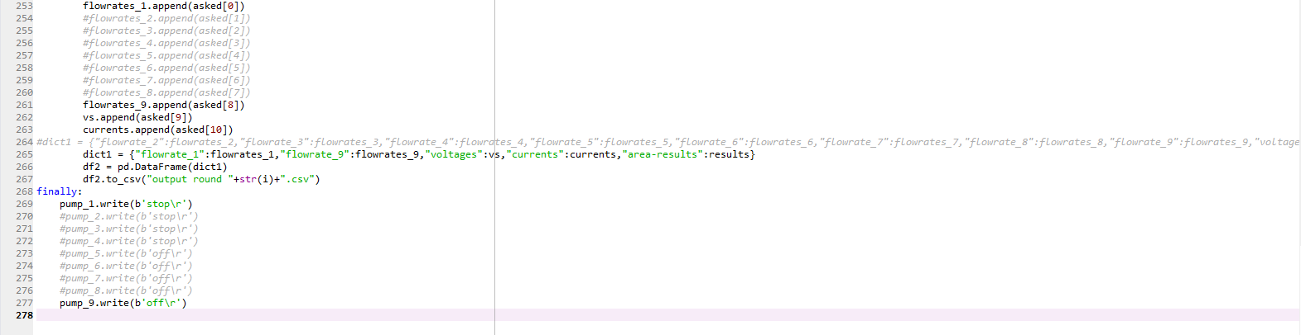

AB2.py (for thiophenol)
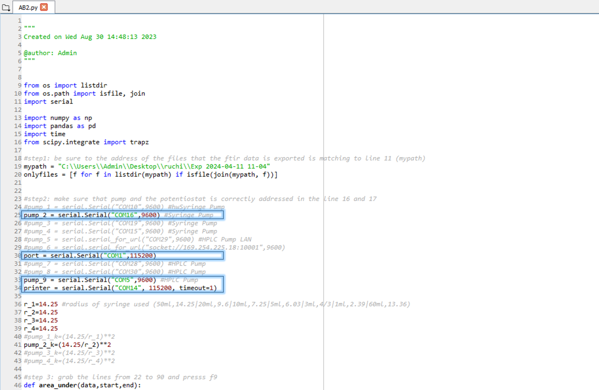

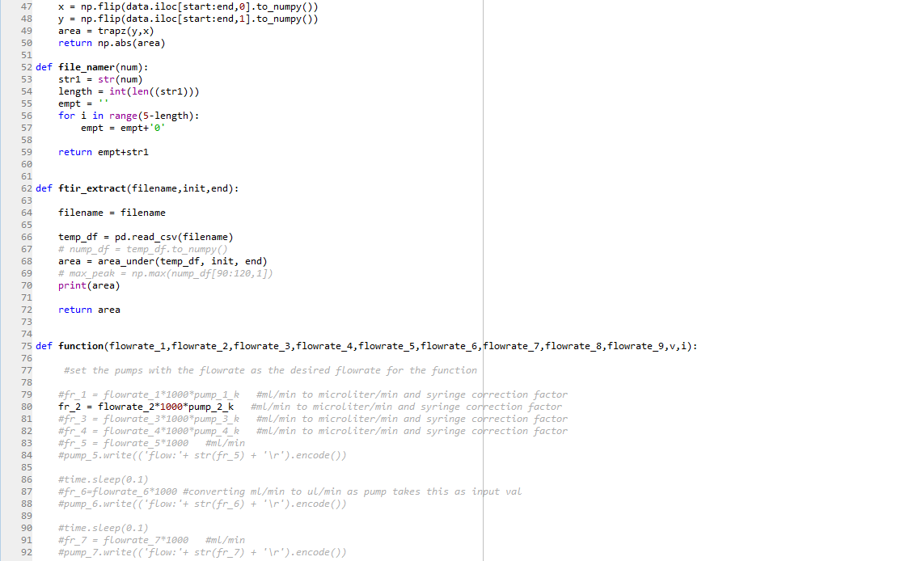

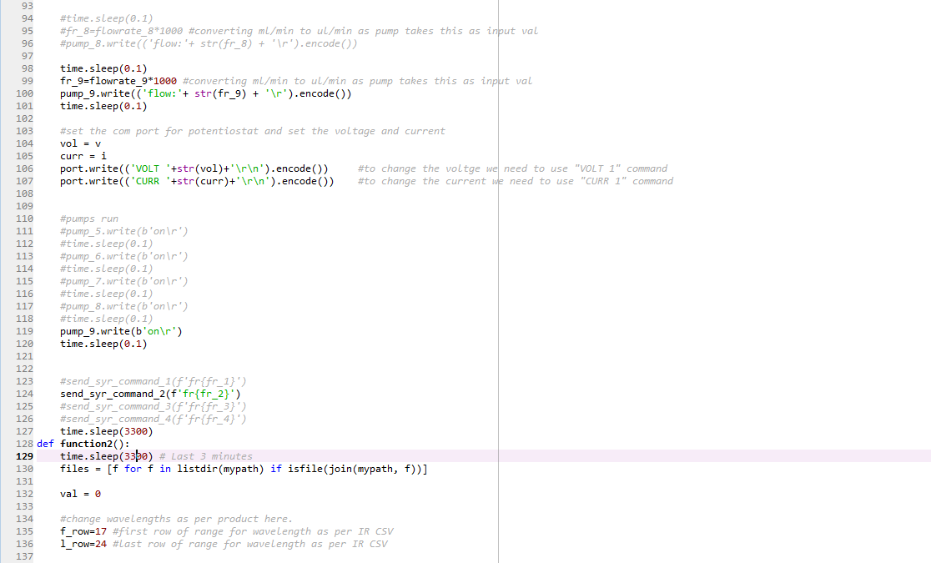

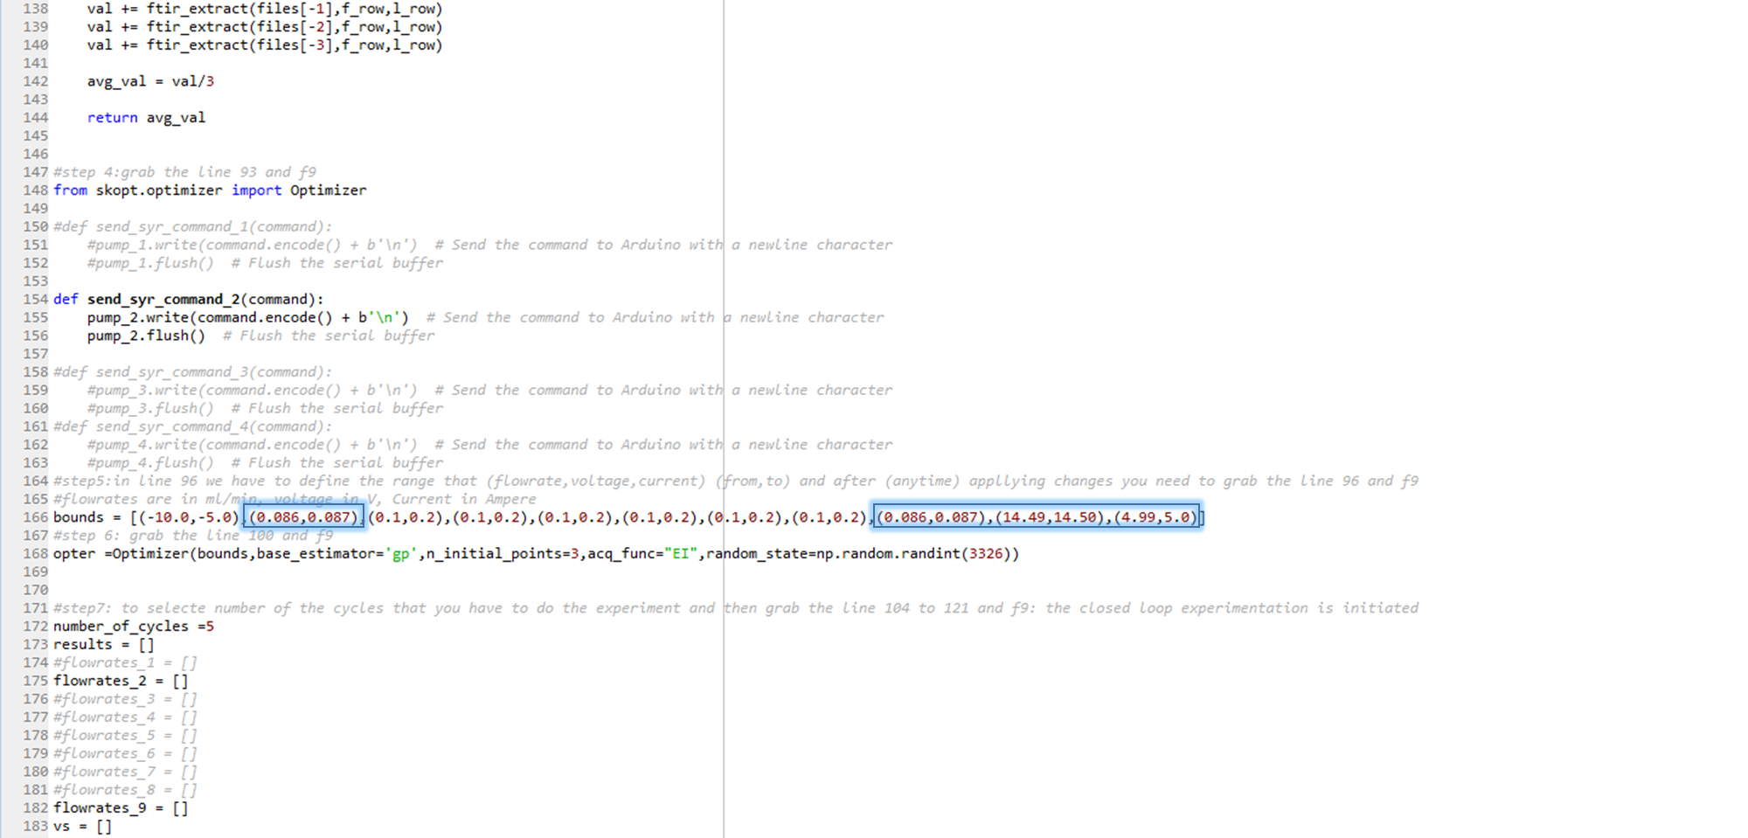

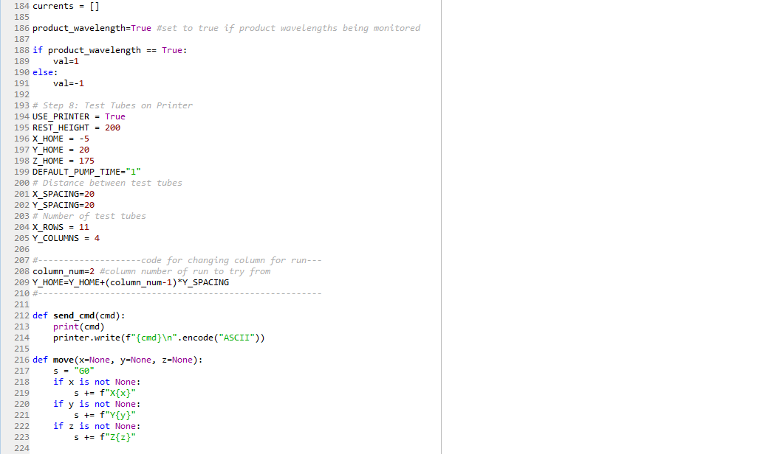

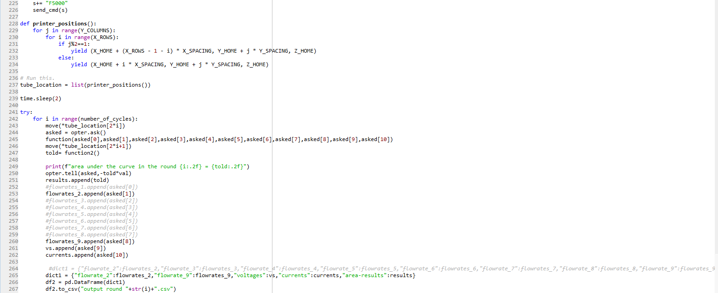
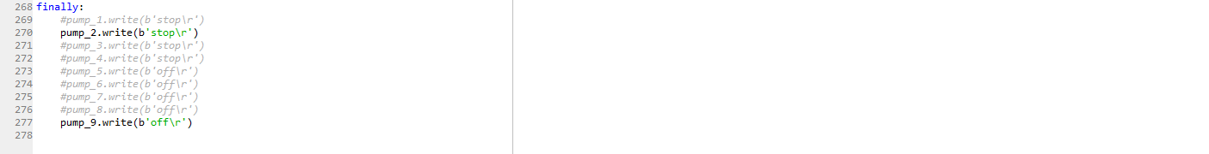

AB3.py (for aniline)
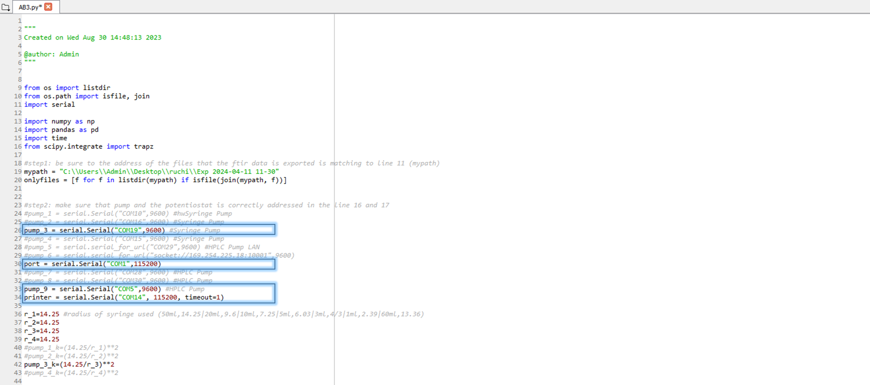

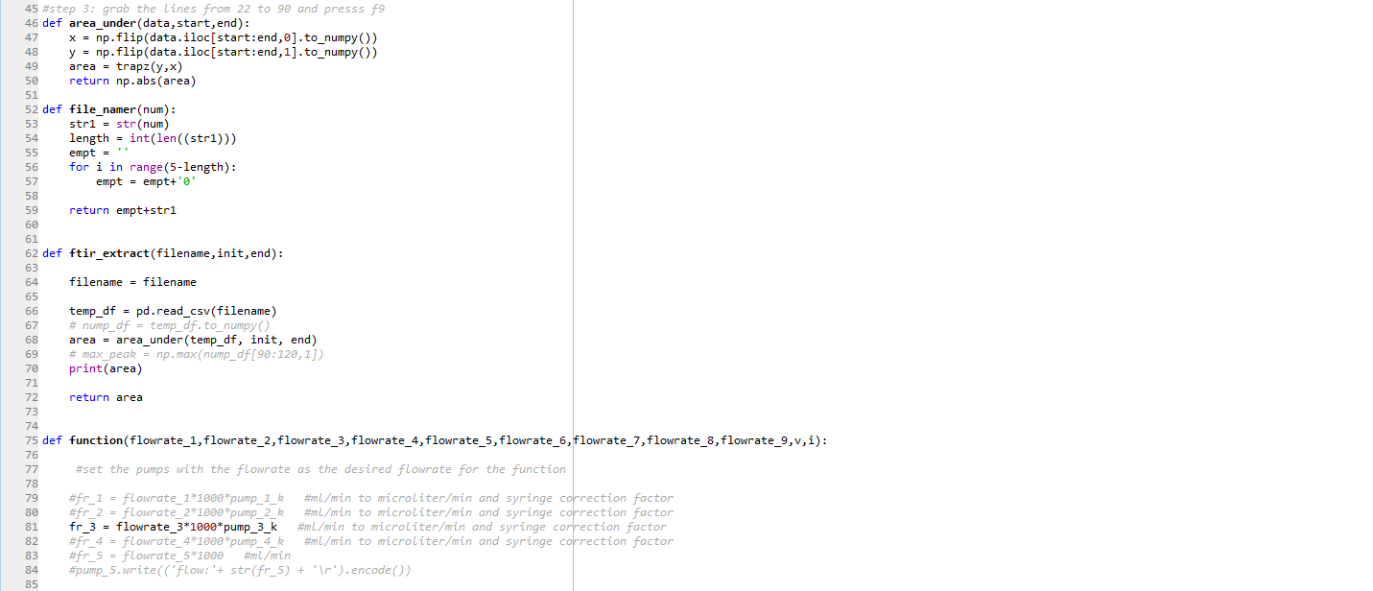

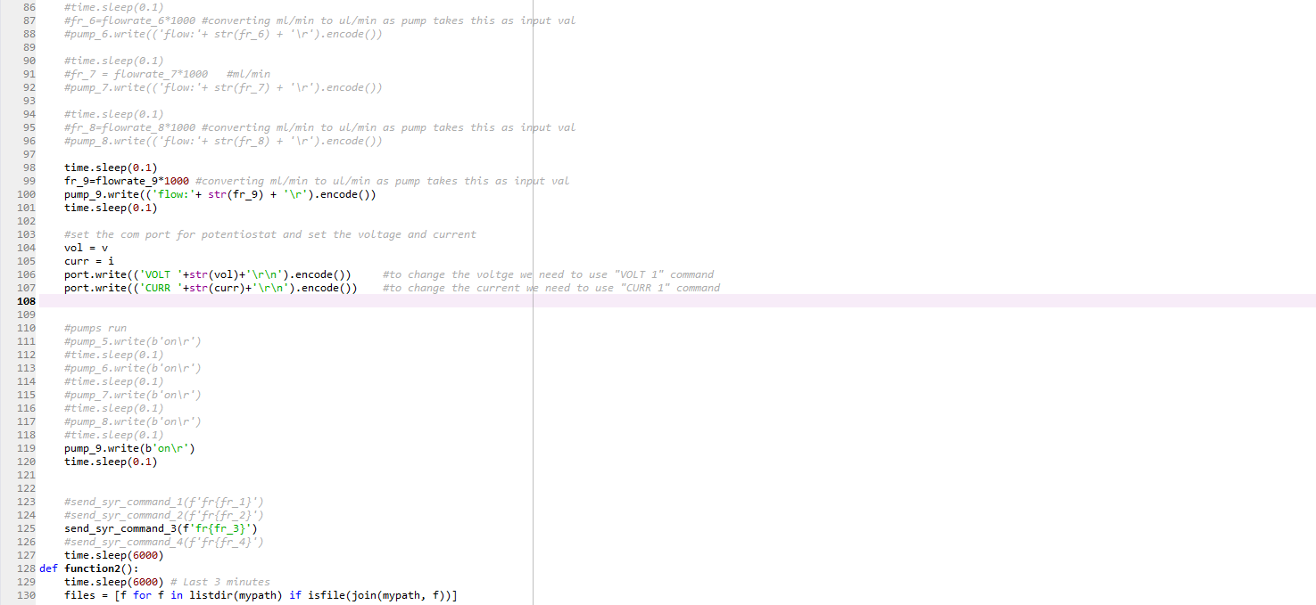

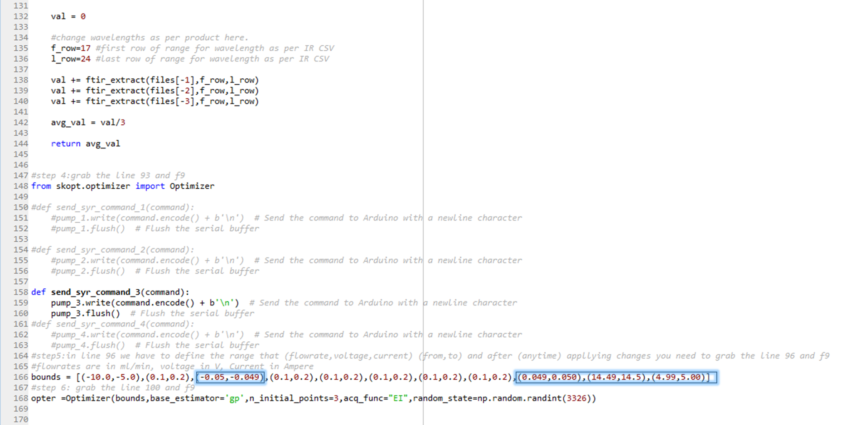

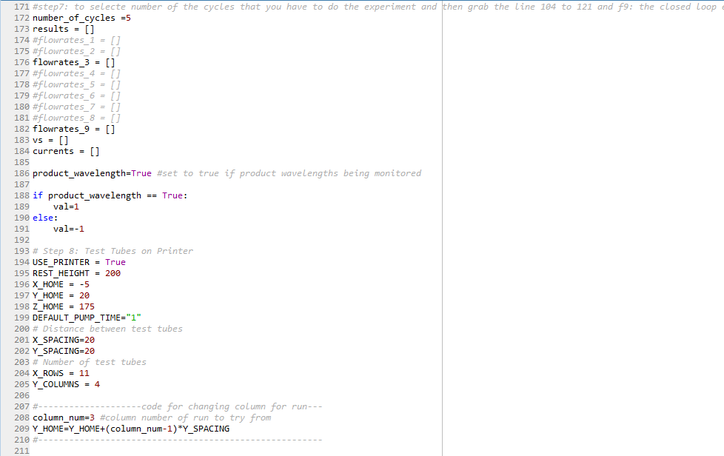

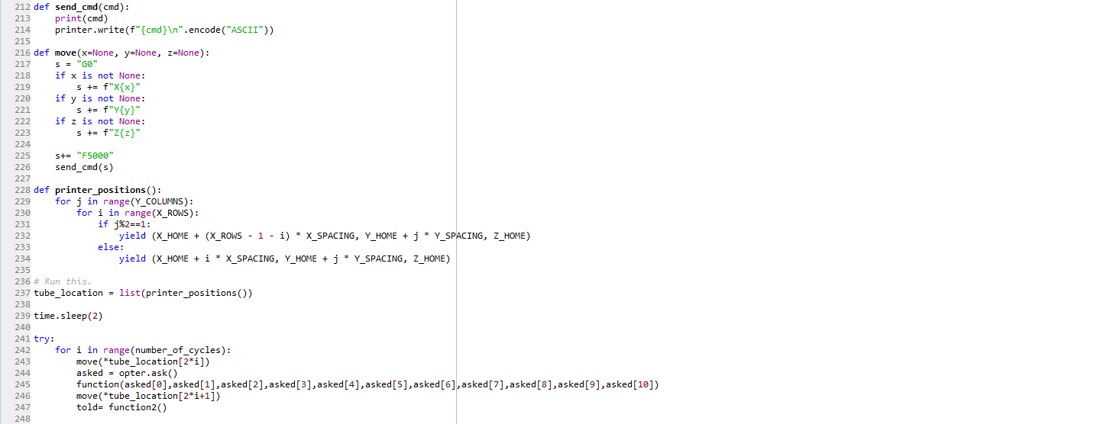
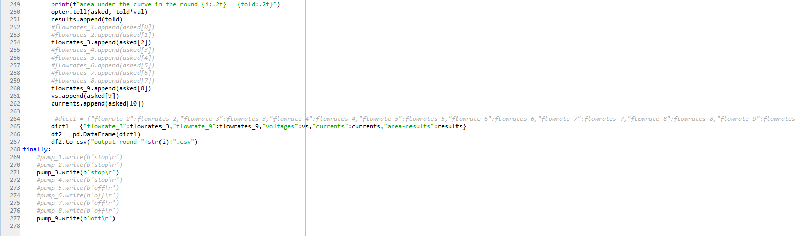

AB4.py (for styrene)
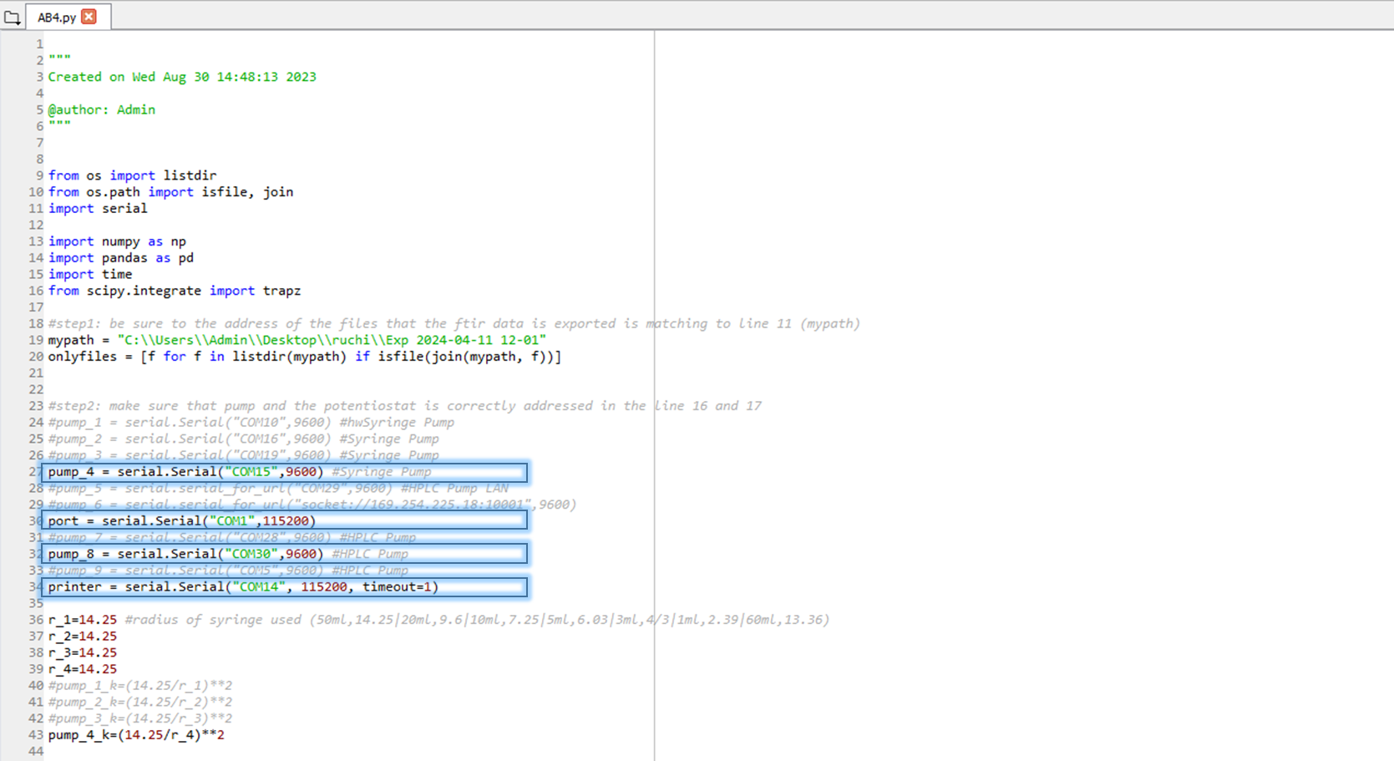

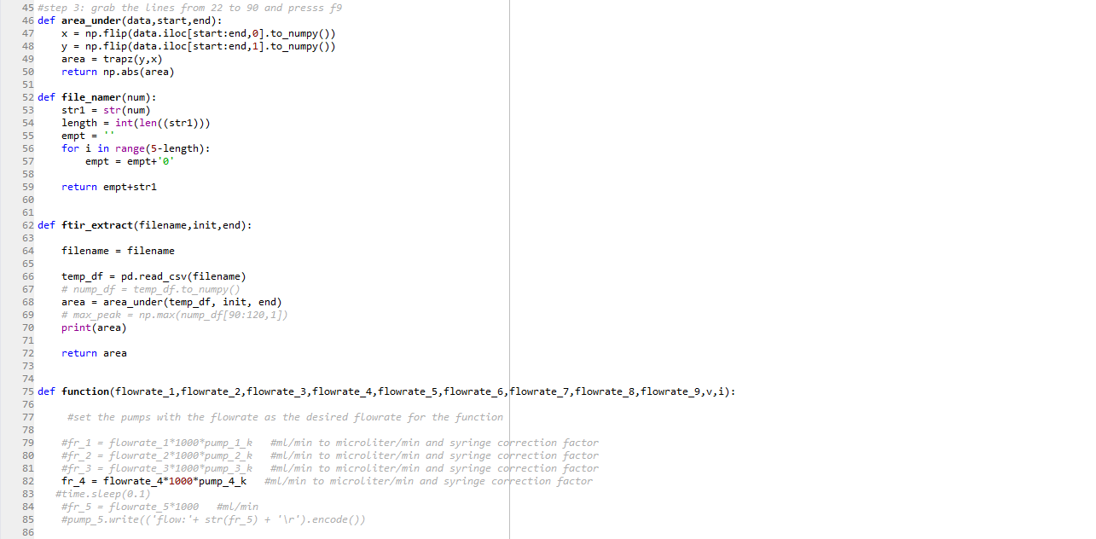

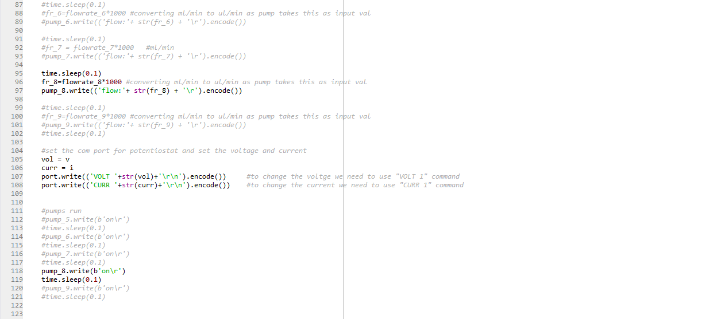

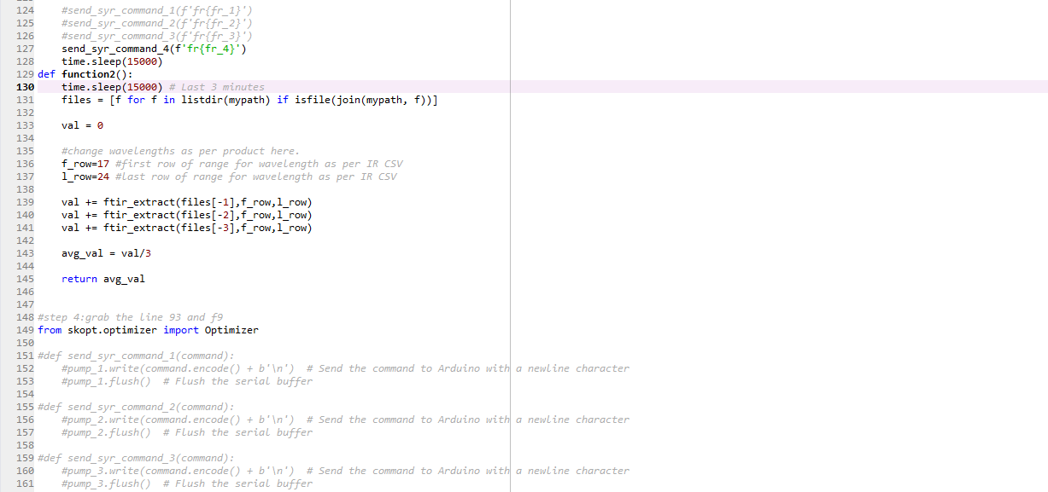

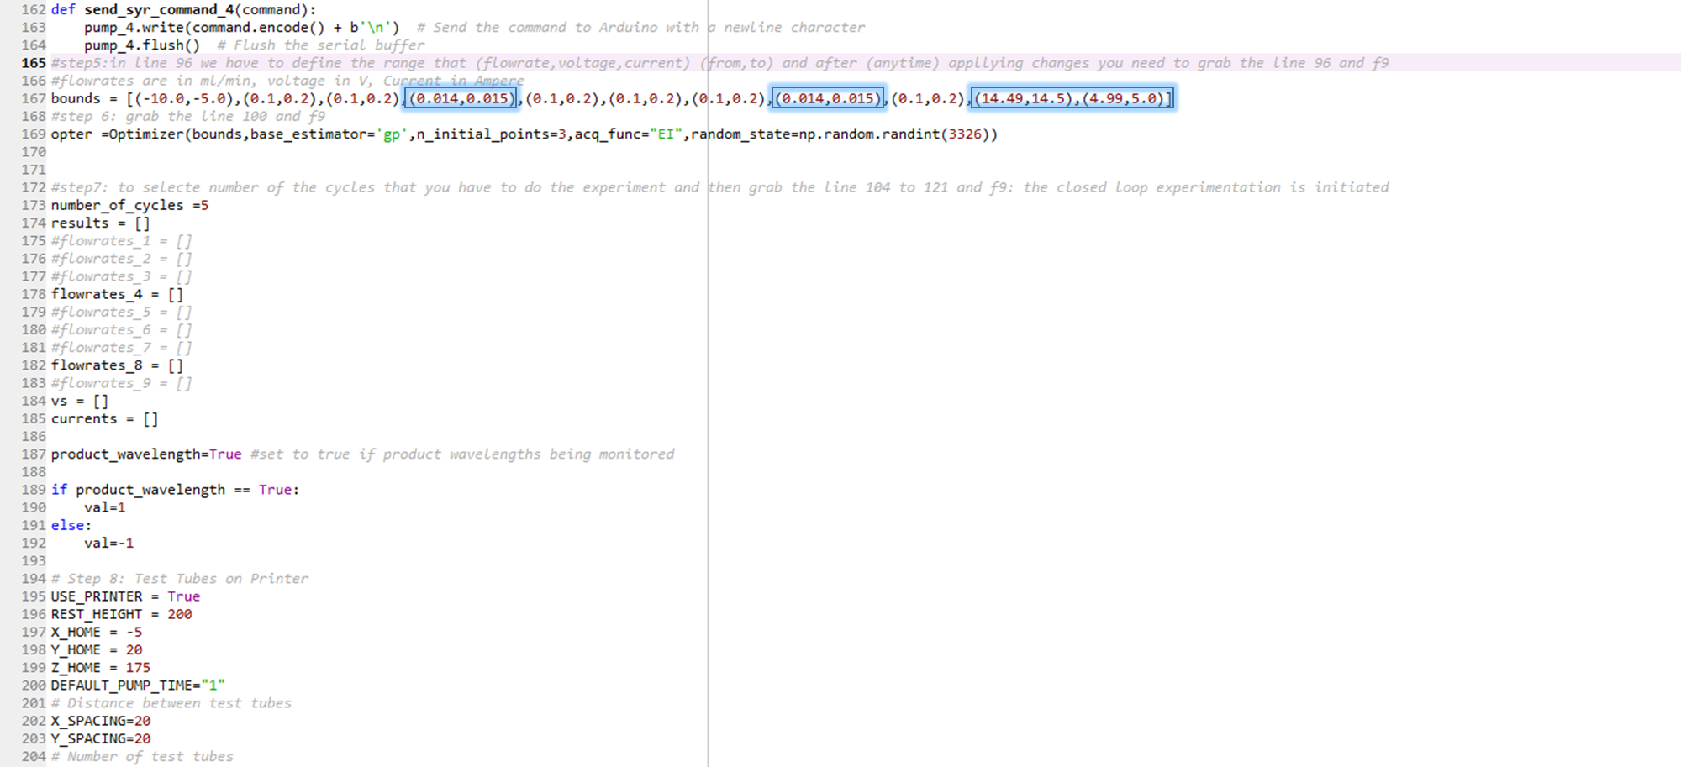

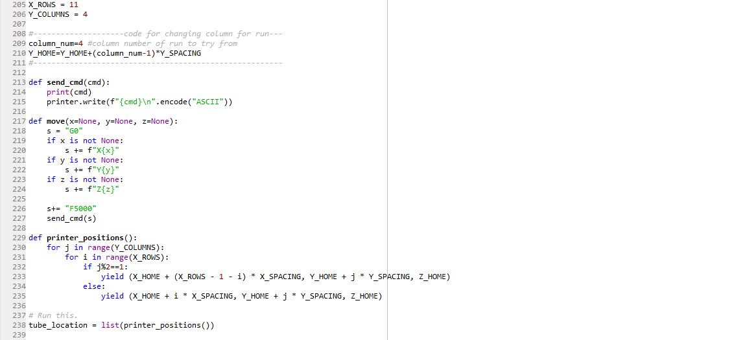

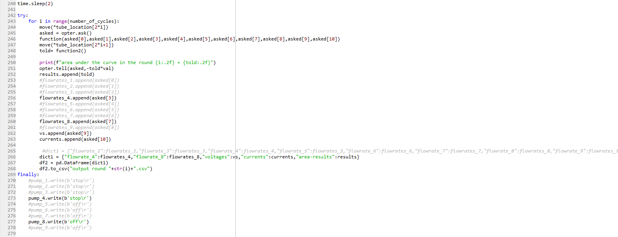

AB5.py (for phenyl acetylene)
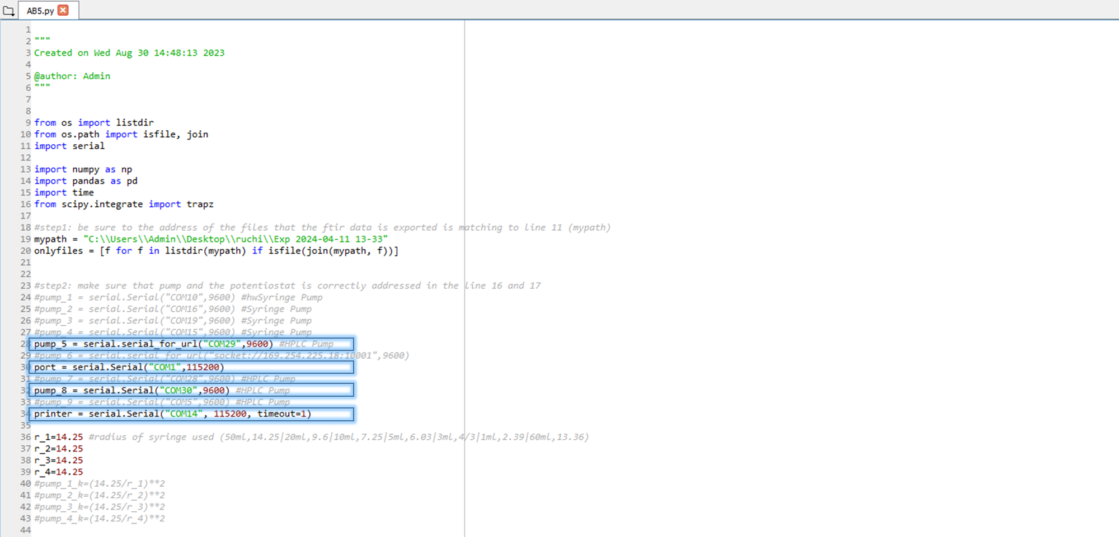

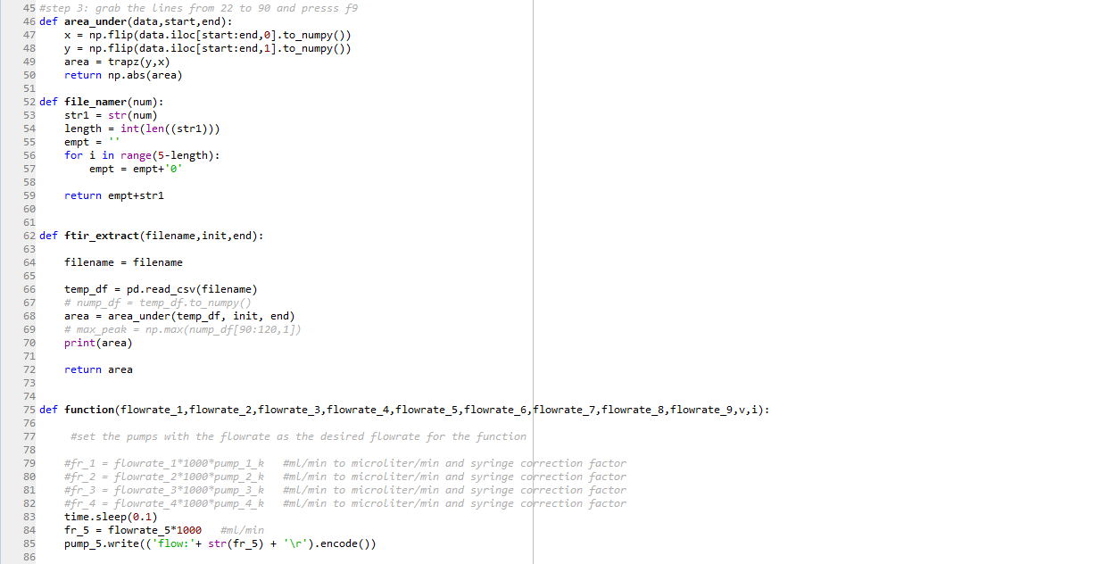
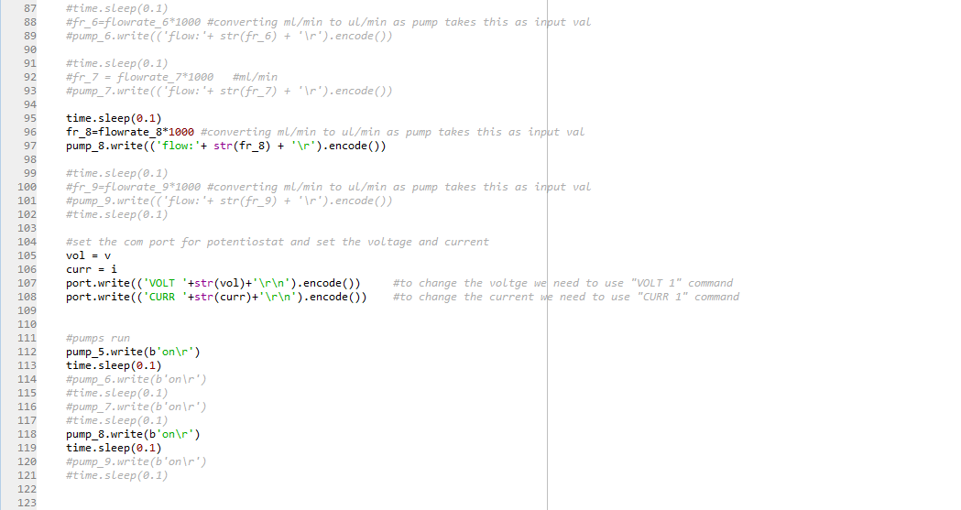

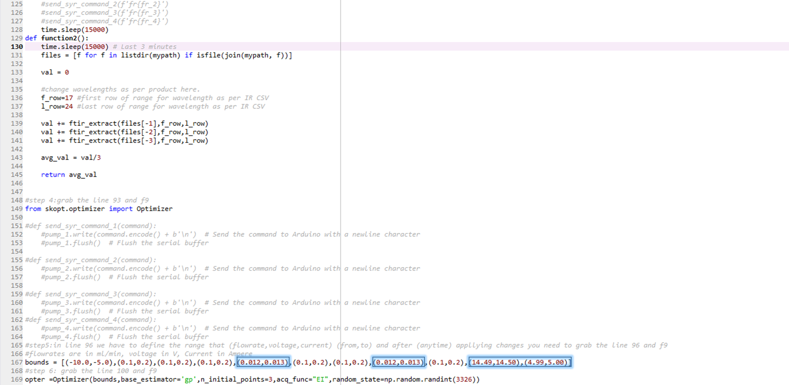

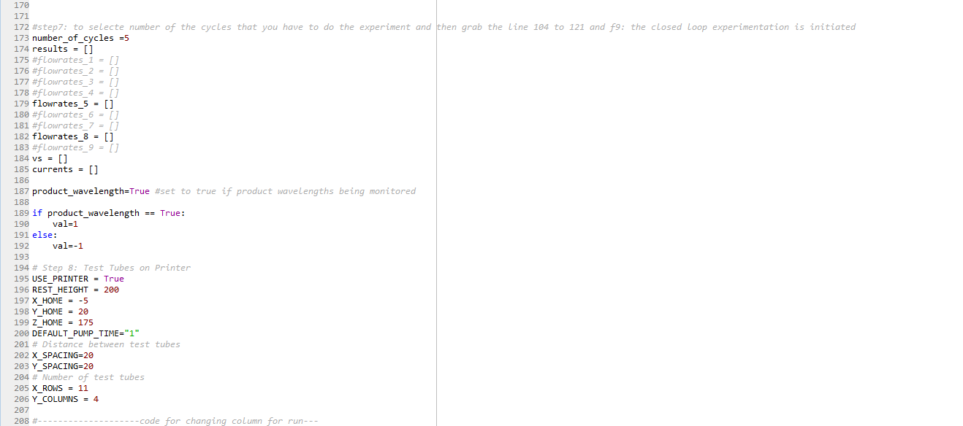

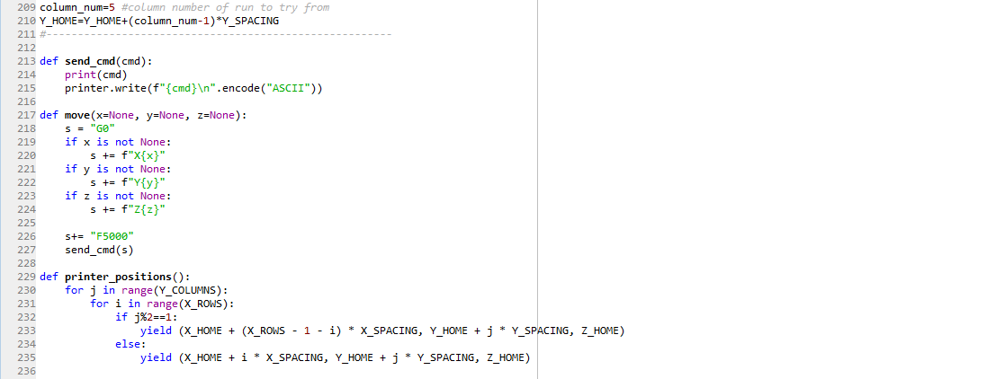

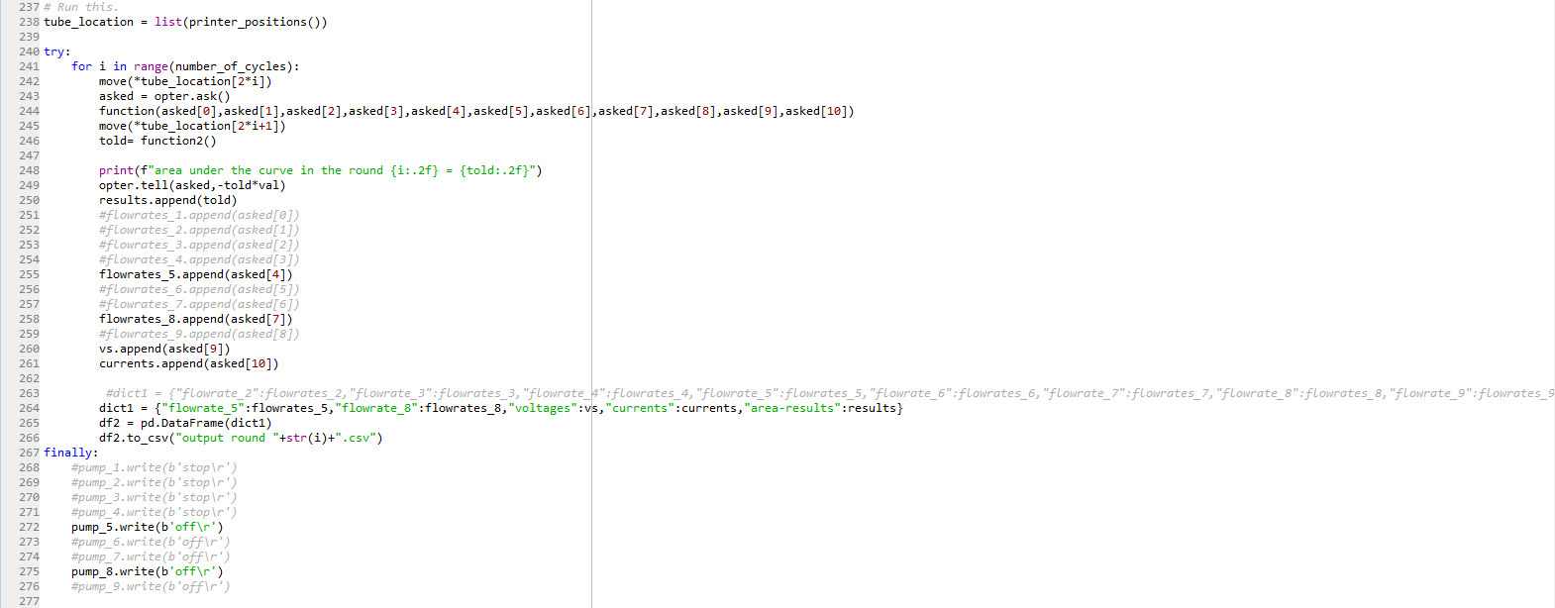

AB6.py (for acetonitrile)
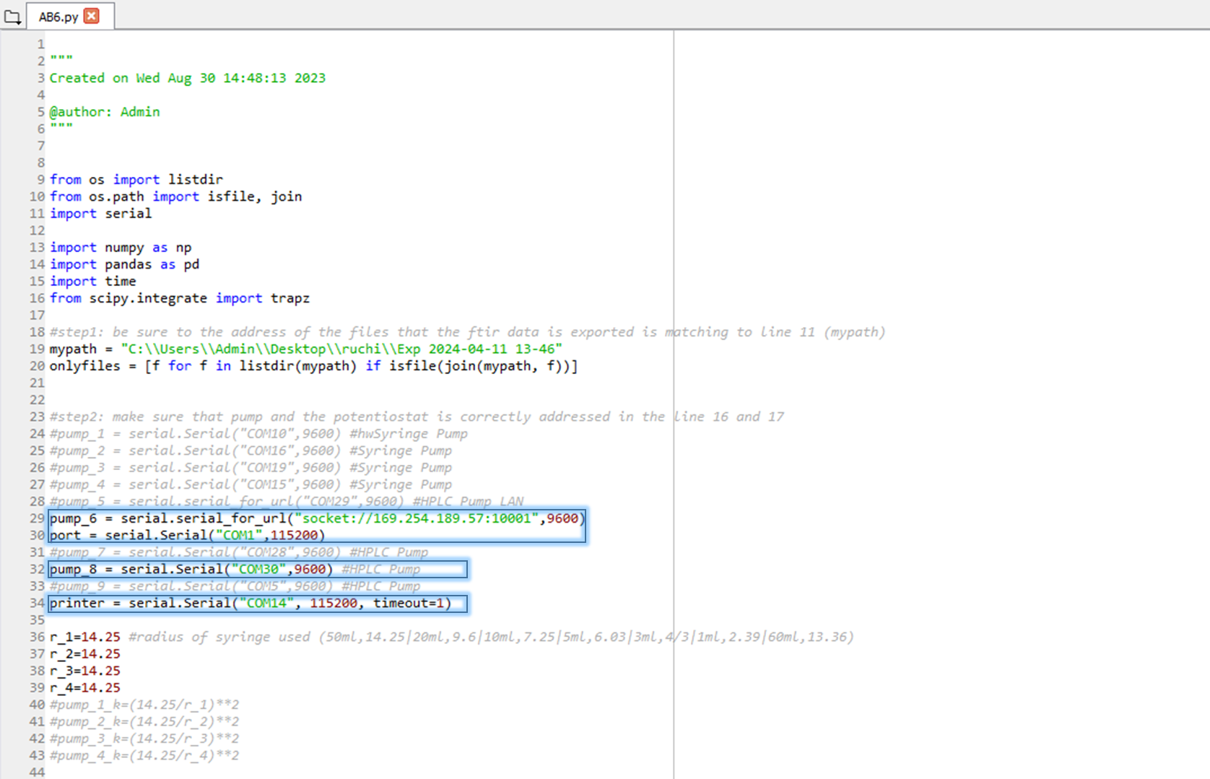
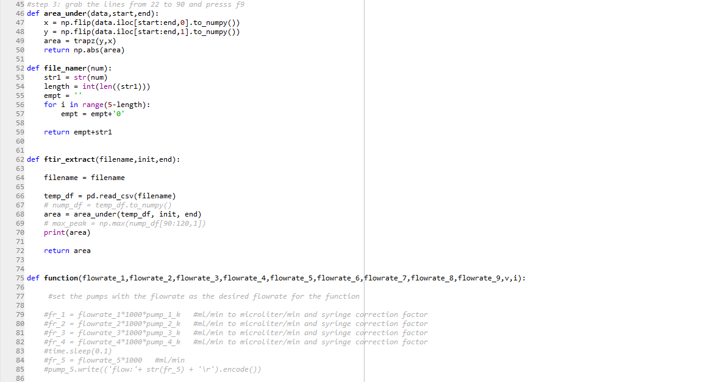
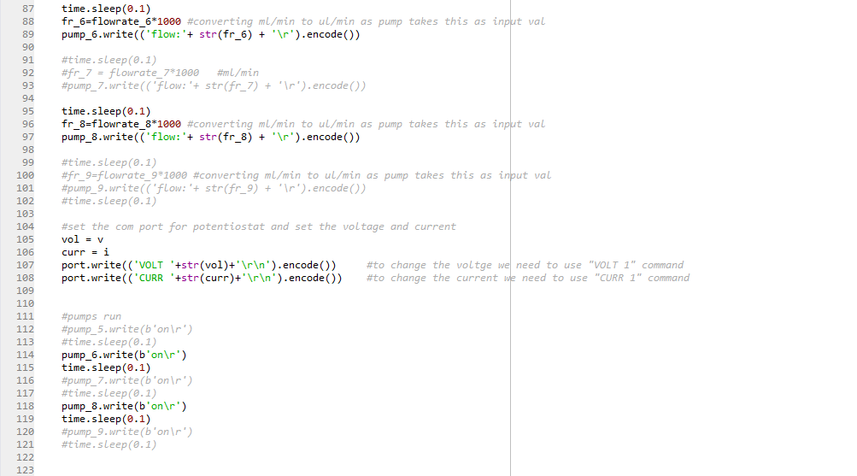
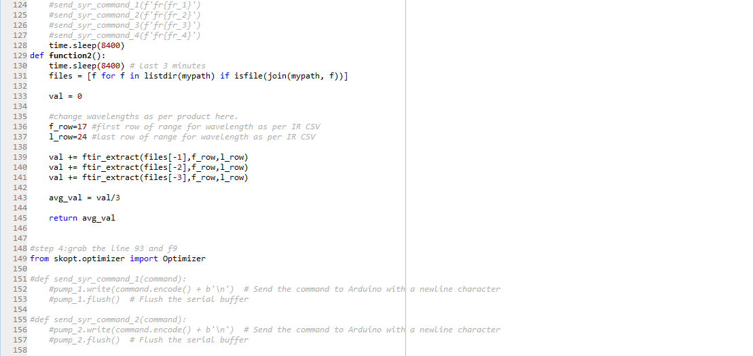
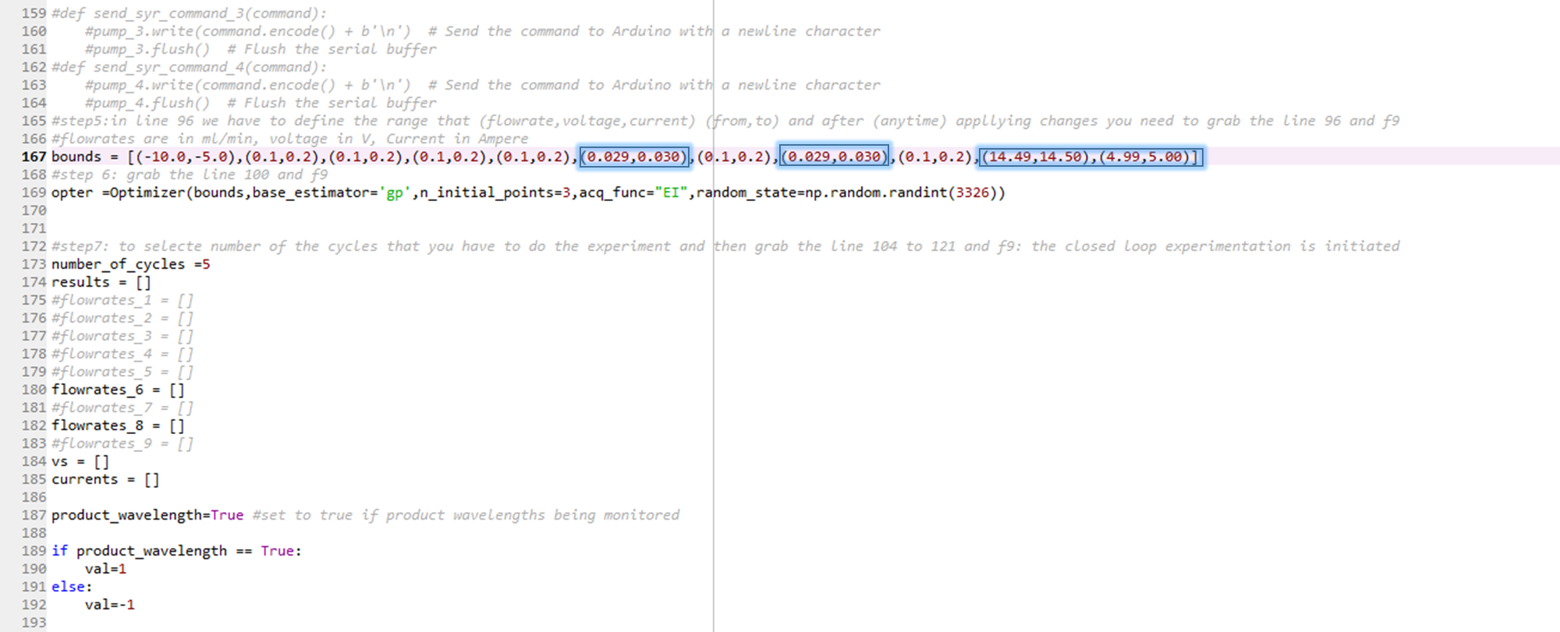
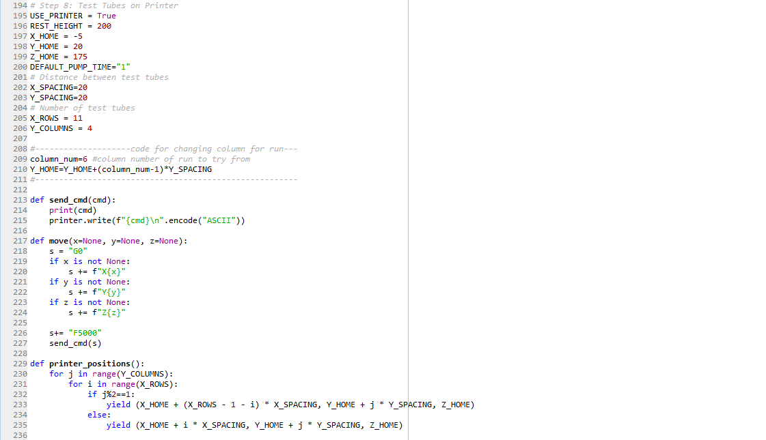
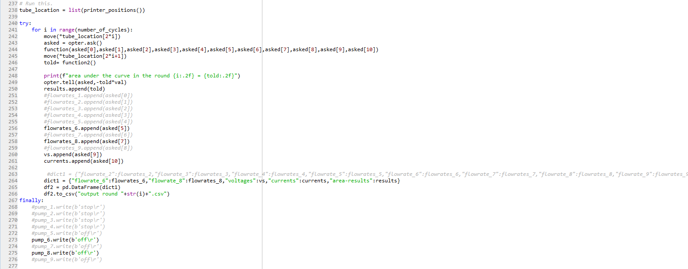

AB7.py (for diazoetherate)

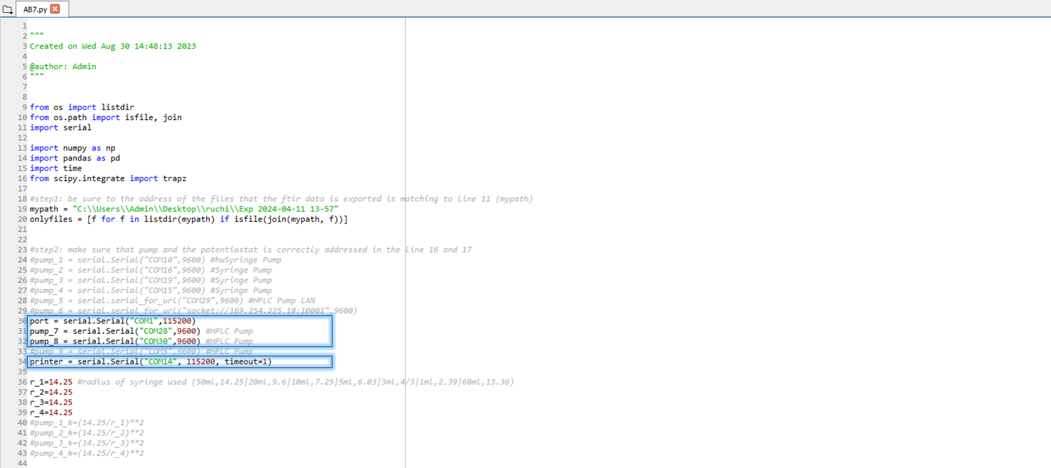

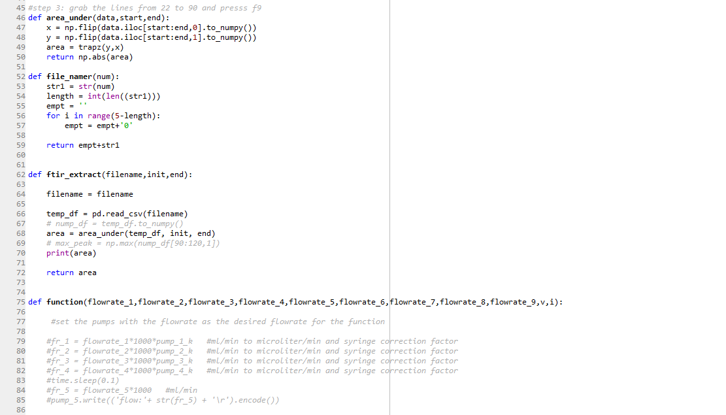

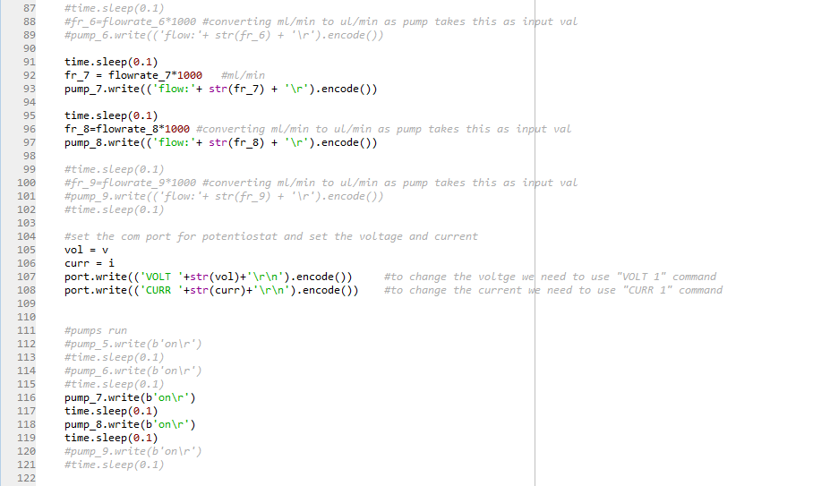

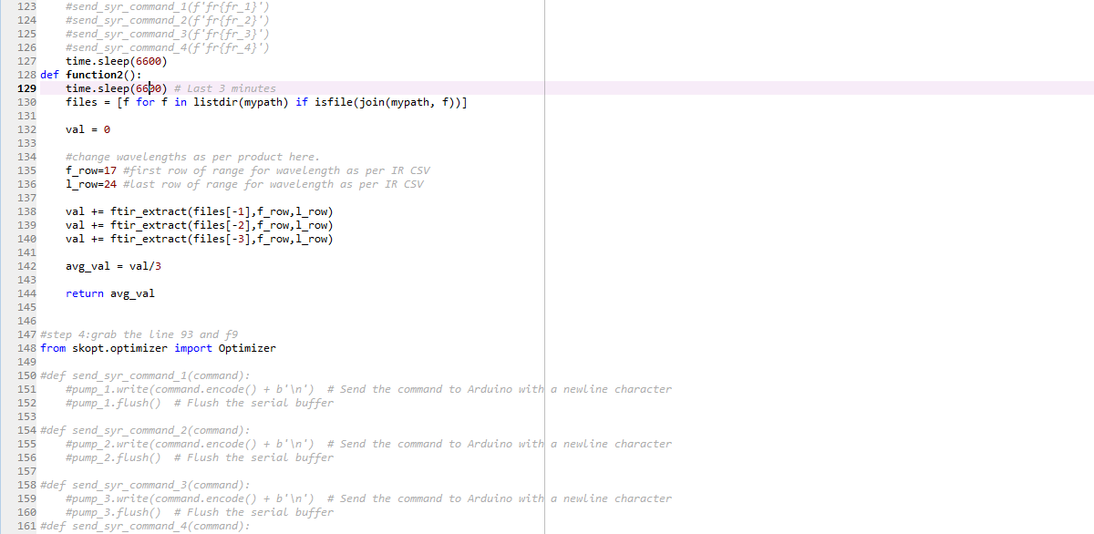

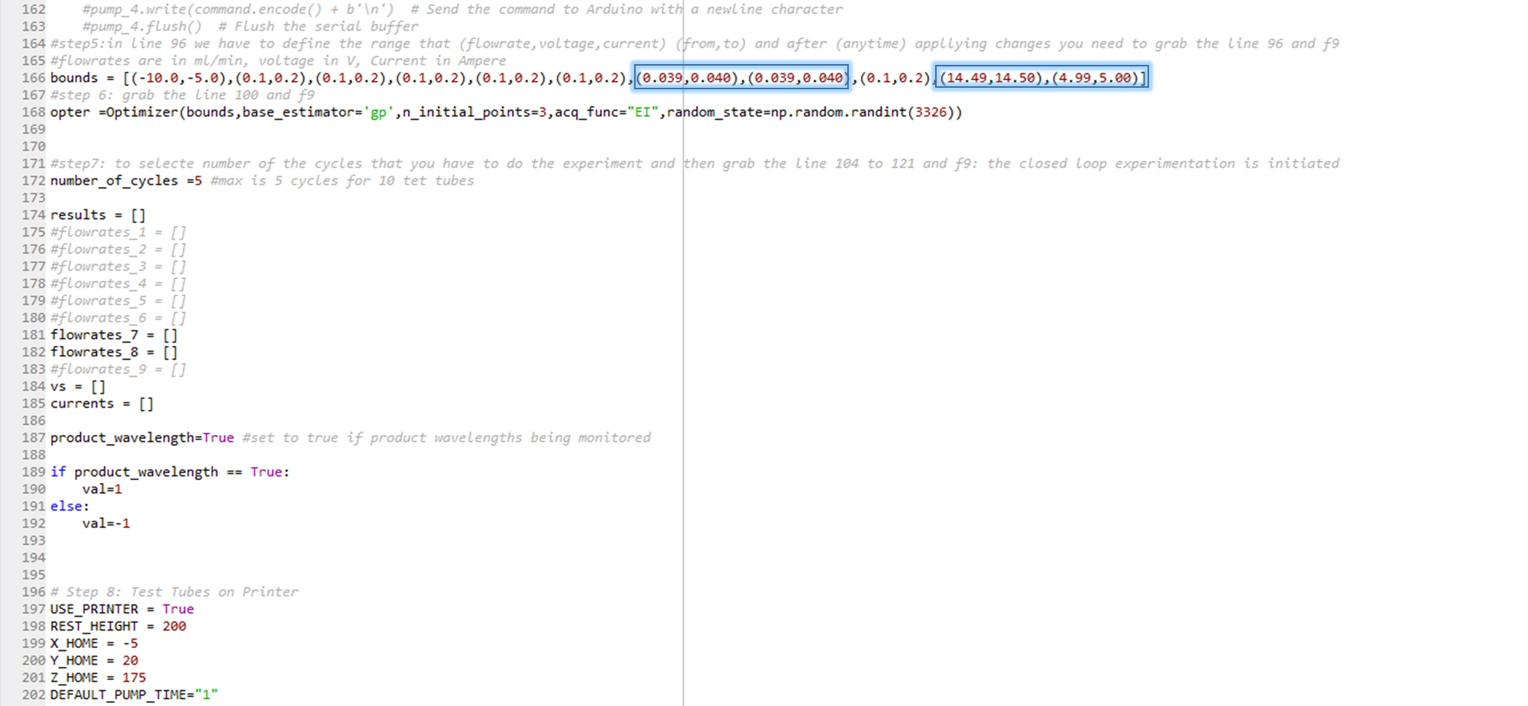

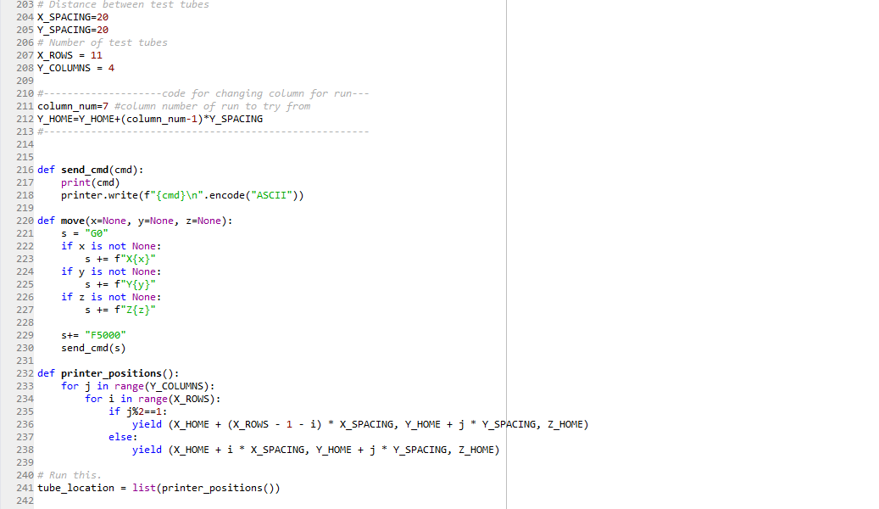

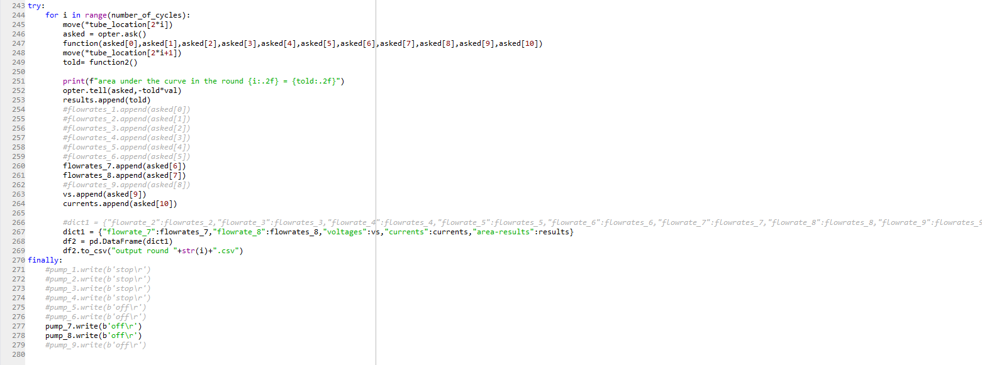
S10.2. General procedure of Integrated AI optimized carbene inserion reaction into diazo ester photochemically.
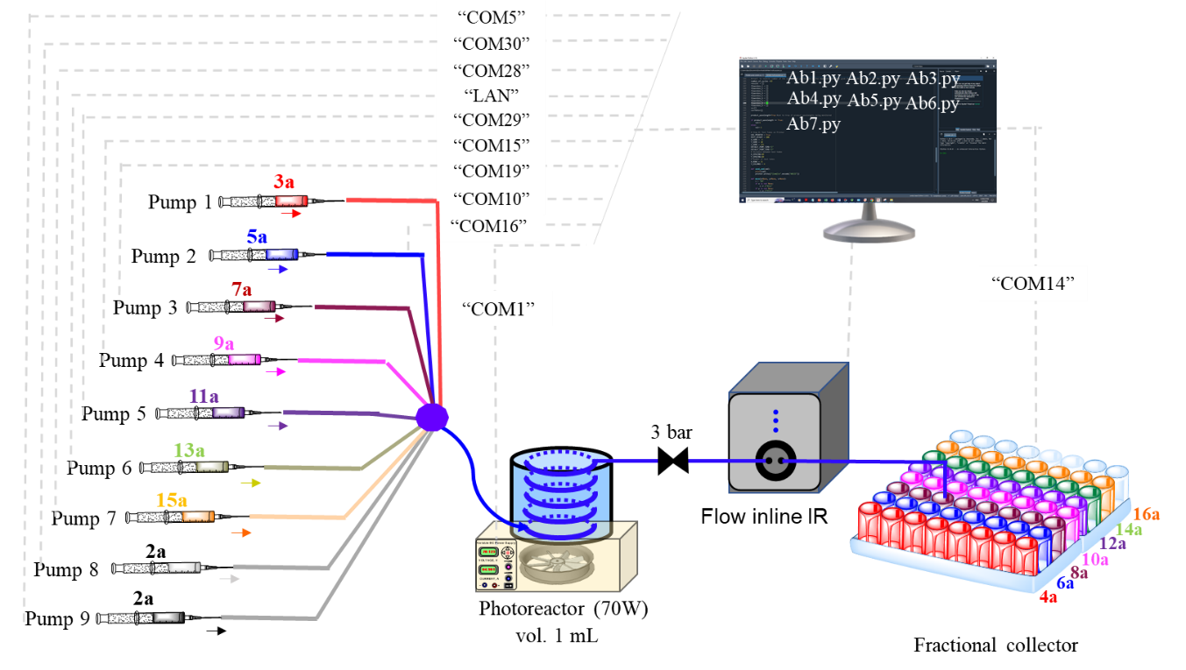
Figure S55. Schematic diagram of Integrated AI optimized carbene inserion reaction into diazo ester photochemically.
Our interest turned to integrating our protocol into a unified flow process akin to grafting techniques observed in hibiscus plants. In this process, reminiscent of the grafting of branches onto a common trunk, we maintain the same starting material and combine it with different substrates to yield respective products, each designated with a distinct colour. We coined this process "digichemtree," where we sequentially run seven different reagents, each mixed with the starting material to obtain a single product at a time.
Before commencing the experiment, we prepared 0.1 M stock solutions of compound 2a in both EtOAc and DCE, each stored in separate conical flasks covered with aluminum foil. Similarly, we prepared 0.2 M stock solutions of compounds 3a, 5a, and 7a in EtOAc, each loaded into syringes and connected to pumps. Additionally, 0.2 M stock solutions of compounds 9a, 11a, 13a, and 15a in DCE were prepared, also stored in separate conical flasks and connected to pumps. After ensuring all connections were secure, we checked communication ports with the master computer. Our integrated continuous flow setup, coupled with AI, was now prepared for operation. Upon executing the code AB1.py, pumps 1 and 9 were activated. Pump 1 dispensed the 0.2 M solution of 3a in EtOAc, while pump 9 in EtOAc dispensed the 0.1 M solution of 2a, each at an optimized flow rate of 50 μL/min. The resulting reaction mixture flowed through a 1 mL PFA tubular reactor, exposed to blue LED illumination (70 watts), with a residence time of 10 minutes under 3 bar pressure. Upon completion, the first drop of product emerged, and subsequent solution was collected in individual test tubes over a period of 6000 seconds using tailor made auto fraction collector. Following the first test tube of product, the subsequent ones were reserved for external analysis.
After the successful execution of the AB1.py experiment code, we proceeded to test the AB2.py code. This time, pumps 2 and 9 were activated. Pump 2 delivered the 0.2 M solution of 5a in EtOAc, while pump 9 dispensed the 0.1 M solution of 2a in EtOAc, each at an optimized flow rate of 86 μL/min. The resulting reaction mixture traversed through a 1 mL PFA tubular reactor, subjected to intense blue LED illumination (70 watts), with a residence time of 11 minutes under 3 bar pressure. As the reaction concluded, the initial drop of product appeared, and the ensuing solution was meticulously collected in individual test tubes over a span of 3300 seconds utilizing a tailor-made auto fraction collector. Following the first test tube of product, the subsequent ones were reserved for external analysis.
Energized by the successful outcomes of the preceding experiments, we were keen to explore our AB3.py code for a photochemical N-H insertion reaction. Initiating the AB3.py experiment code prompted pump 3 to dispense the 0.2 M solution of 7a in EtOAc, while pump 9 delivered the 0.1 M solution of 2a in EtOAc, each flowing at an optimized rate of 46 μL/min. The resultant reaction mixture journeyed through a 1 mL PFA tubular reactor, bathed in vibrant blue LED illumination (70 watts), with a residence time of 10.86 minutes under 3 bar pressure. Upon completion, the droplet of product emerged, and the successive solution was gathered into individual test tubes over a period of 6000 seconds via the tailor-made auto fraction collector. Following the first test tube of product, the subsequent ones were reserved for external analysis.
Having accomplished three successful experimental runs, we were tantalized by the prospect of investigating the feasibility of the remaining experiment codes. We started with clicking on experiment code AB4.py, now pump 4 and pump 8 is activated, pumping the 0.2 M solution of reagent 9a in DCE with pump 4 and 0.1 M solution of compound 2a in DCE each flowing at an optimized rate of 15 μL/min. The resultant reaction mixture journeyed through a 1 mL PFA tubular reactor, bathed in vibrant blue LED illumination (70 watts), with a residence time of 32.0 min under 3 bar pressure. Upon completion, the droplet of product emerged, and the successive solution was gathered into individual test tubes over a period of 15000 seconds via the tailor-made auto fraction collector. Following the first test tube of product, the subsequent ones were reserved for external analysis. Next we have run experiment code AB5.py This time, pumps 5 and 8 were activated. Pump 5 delivered the 0.2 M solution of 11a in DCE, while pump 8 dispensed the 0.1 M solution of 2a in DCE, each at an optimized flow rate of 12.5 μL/min. The resulting reaction mixture traversed through a 1 mL PFA tubular reactor, subjected to intense blue LED illumination (70 watts), with a residence time of 40 min under 3 bar pressure. As the reaction concluded, the initial drop of product appeared, and the ensuing solution was meticulously collected in individual test tubes over a span of 3300 seconds utilizing a tailor-made auto fraction collector. Following the first test tube of product, the subsequent ones were reserved for external analysis.
Then for [3+2] cycloaddtion reaction have done utilizing experiment code AB6.py, in which upon executing, pumps 6 and 8 were activated. Pump 6 dispensed the 0.2 M solution of 13a in DCE, while pump 8 dispensed the 0.1 M solution of 2a in DCE, each at an optimized flow rate of 31 μL/min. The resulting reaction mixture flowed through a 1 mL PFA tubular reactor, exposed to blue LED illumination (70 watts), with a residence time of 16.6 minutes under 3 bar pressure. Upon completion, the first drop of product emerged, and subsequent solution was collected in individual test tubes over a period of 8400 seconds using tailor made auto fraction collector. Following the first test tube of product, the subsequent ones were reserved for external analysis.
In last for cross coupling reaction experiment code AB7.py is subjected and pump 7 and pump 8 is activated, pumping the 0.2 M solution of reagent 15a in DCE with pump 8 and 0.1 M solution of compound 2a in DCE each flowing at an optimized rate of 40 μL/min. The resultant reaction mixture journeyed through a 1 mL PFA tubular reactor, bathed in vibrant blue LED illumination (70 watts), with a residence time of 12.5 minutes under 3 bar pressure. Upon completion, the droplet of product emerged, and the successive solution was gathered into individual test tubes over a period of 6600 seconds via the tailor-made auto fraction collector. Following the first test tube of product, the subsequent ones were reserved for external analysis
S11. Spectra
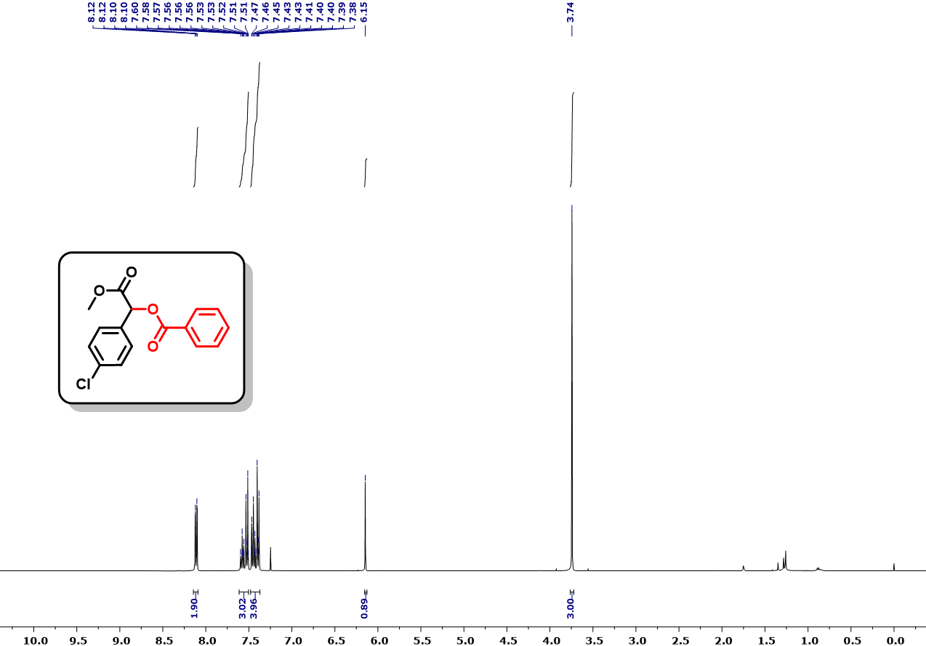
Fig. S56. ¹H NMR (400 MHz, CDCl₃) spectra of 1-(4-chlorophenyl)-2-methoxy-2-oxoethyl benzoate (4a).
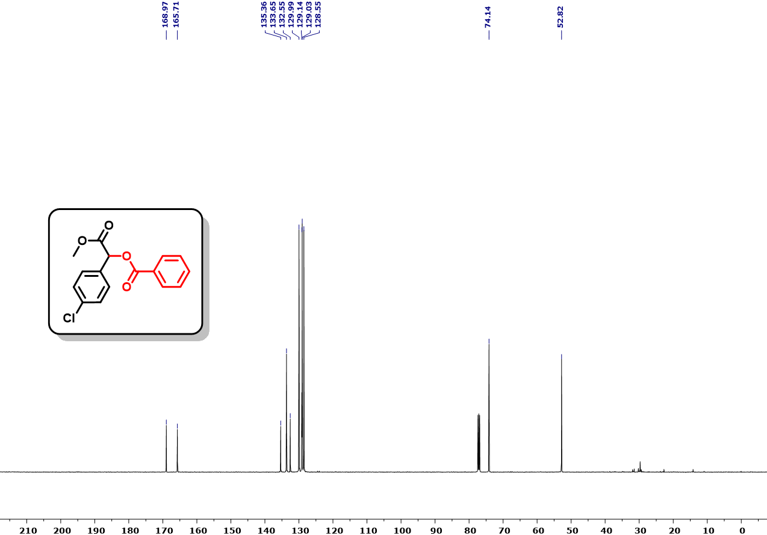
Fig. S57. ¹³C NMR (126 MHz, CDCl₃) spectra of 1-(4-chlorophenyl)-2-methoxy-2-oxoethyl benzoate (4a).
.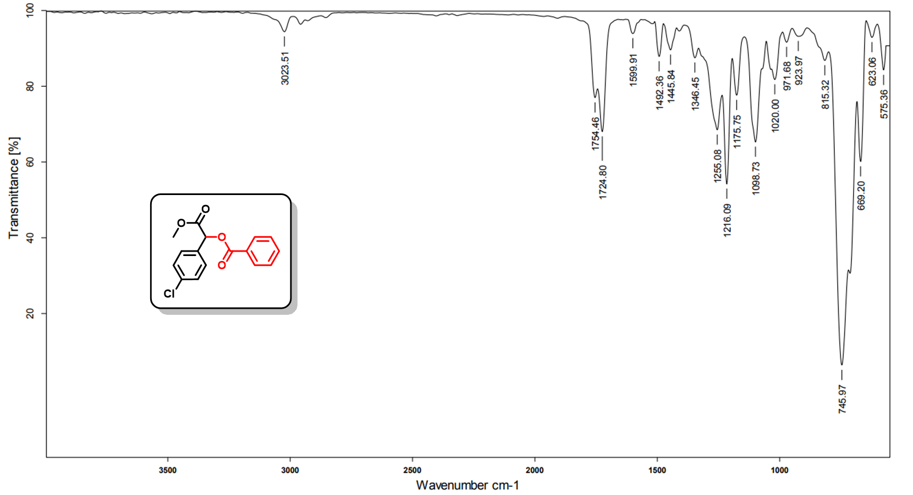
Fig. S58. IR spectra of spectra of 1-(4-chlorophenyl)-2-methoxy-2-oxoethyl benzoate (4a).
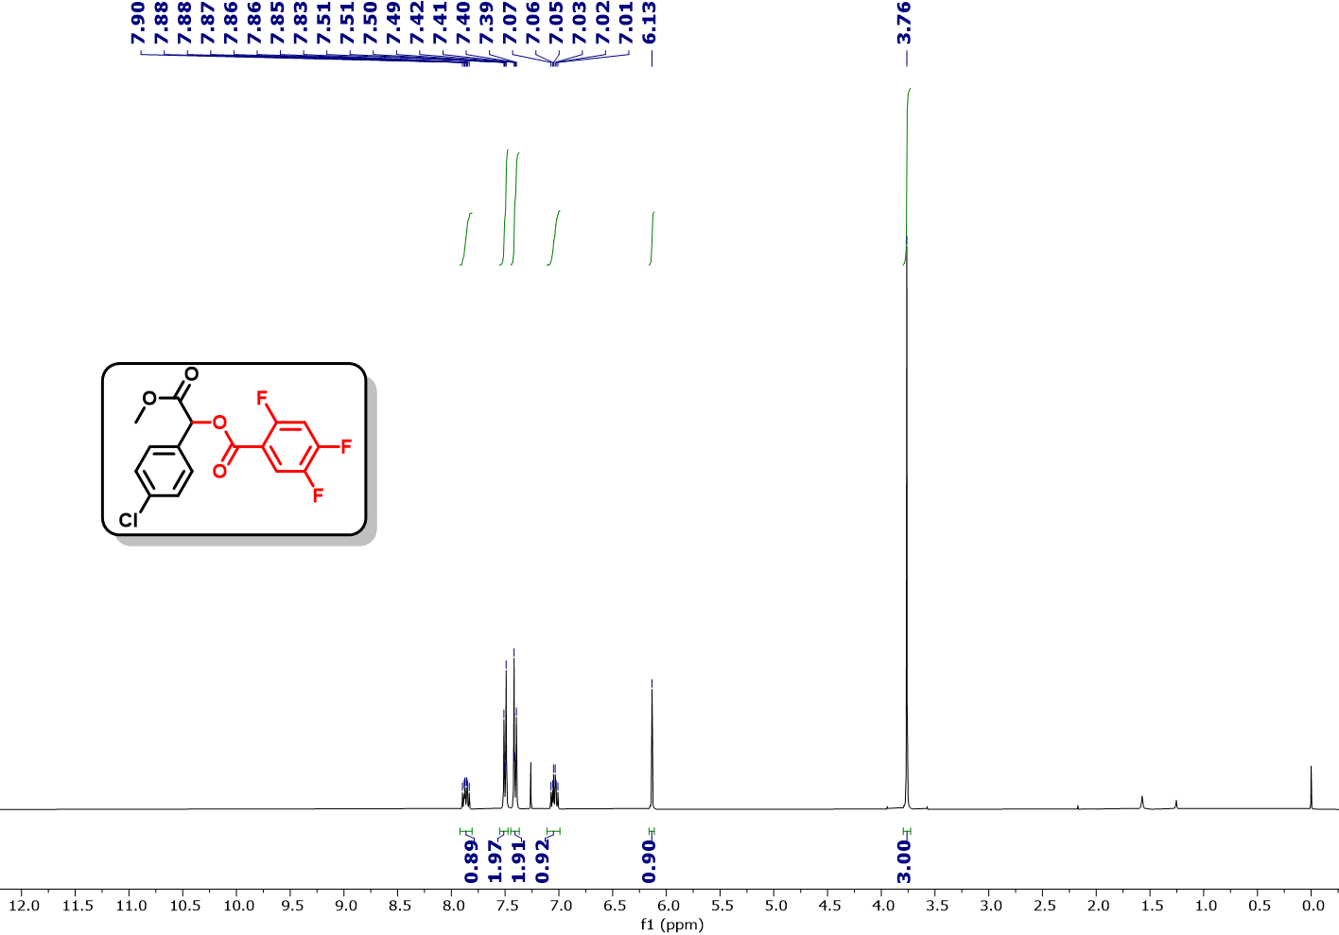
Fig. S59. ¹H NMR (400 MHz, CDCl₃) spectra of 1-(4-chlorophenyl)-2-methoxy-2-oxoethyl 2,4,5-trifluorobenzoate (4b).
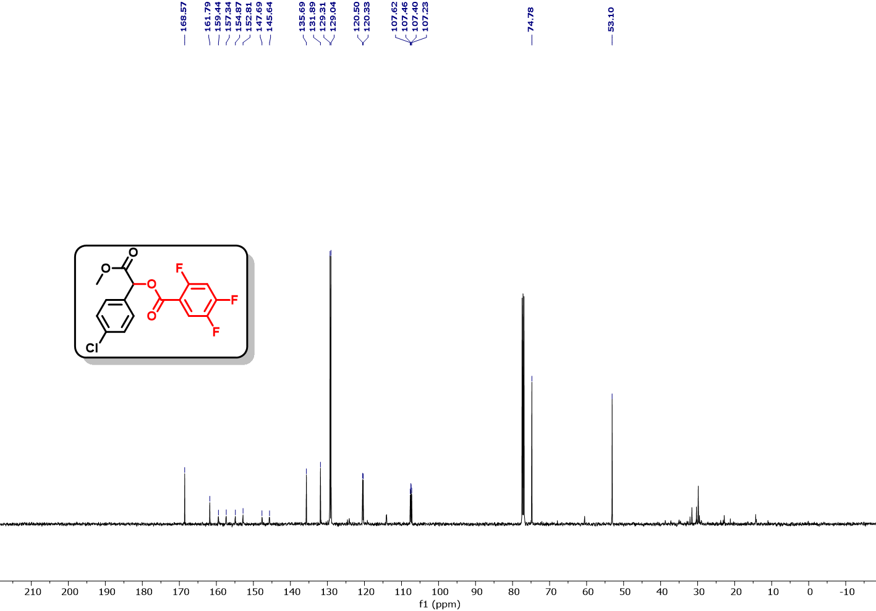
Fig. S60. ¹³C NMR (126 MHz, CDCl₃) spectra of 1-(4-chlorophenyl)-2-methoxy-2-oxoethyl 2,4,5-trifluorobenzoate (4b).
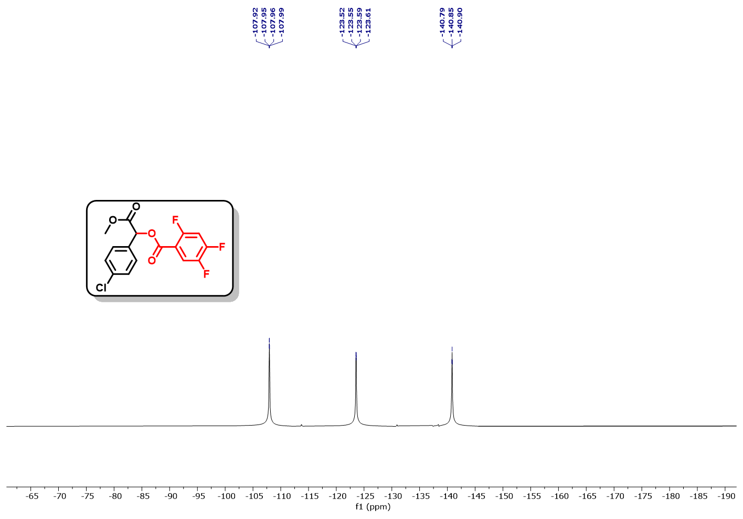
Fig. S61. ¹⁹F NMR (376 MHz, CDCl₃) spectra of 1-(4-chlorophenyl)-2-methoxy-2-oxoethyl 2,4,5-trifluorobenzoate (4b).
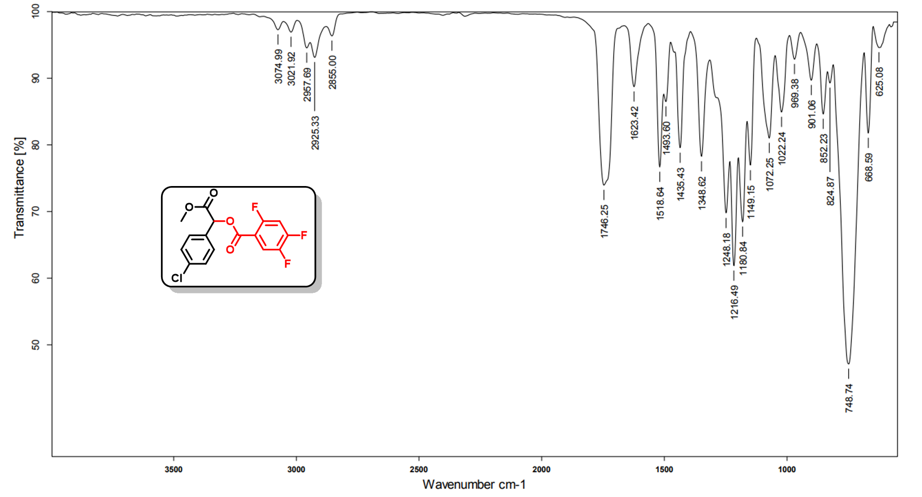
Fig. S62. IR spectra of spectra of 1-(4-chlorophenyl)-2-methoxy-2-oxoethyl 2,4,5-trifluorobenzoate (4b).
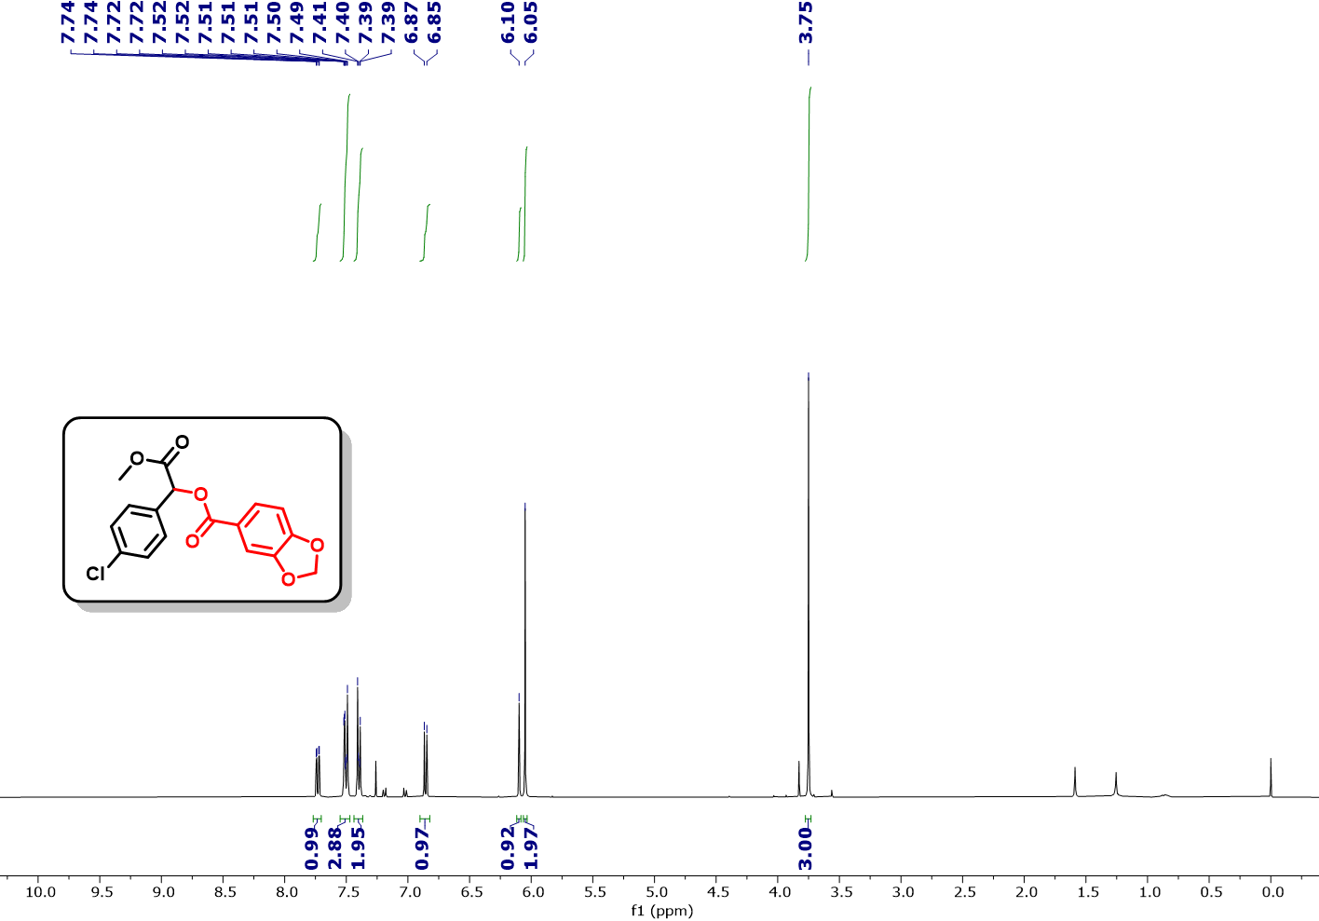
Fig. S63. ¹H NMR (400 MHz, CDCl₃) spectra of 1-(4-chlorophenyl)-2-methoxy-2-oxoethyl benzo[d][1,3]dioxole-5-carboxylate (4c).
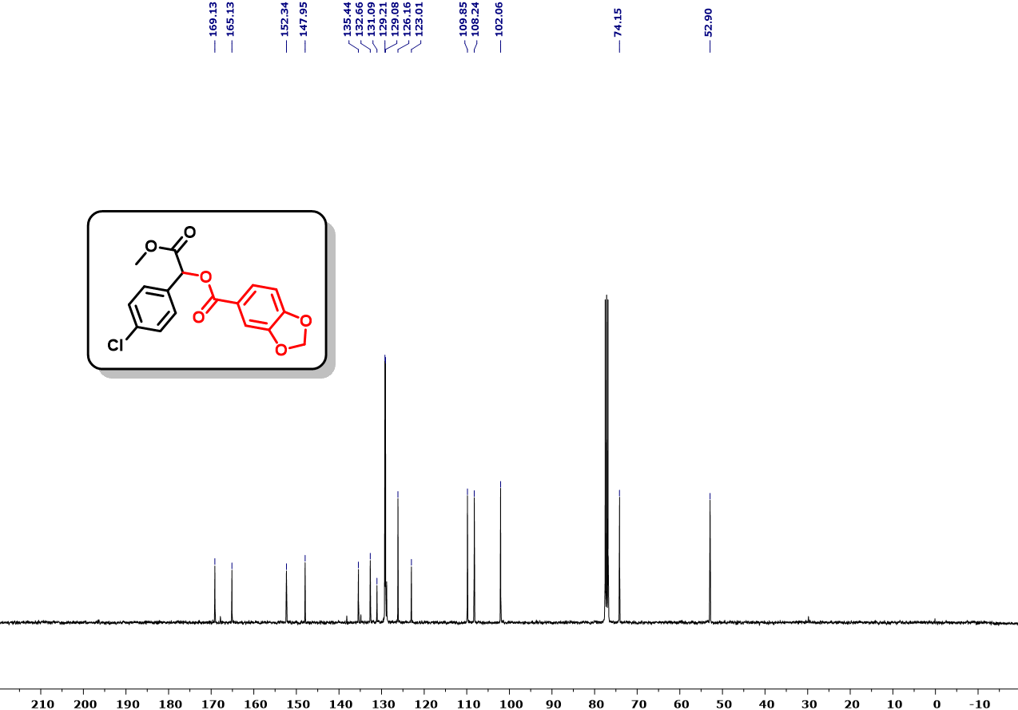
Fig. S64. ¹³C NMR (101 MHz, CDCl₃) spectra of 1-(4-chlorophenyl)-2-methoxy-2-oxoethyl benzo[d][1,3]dioxole-5-carboxylate (4c).
.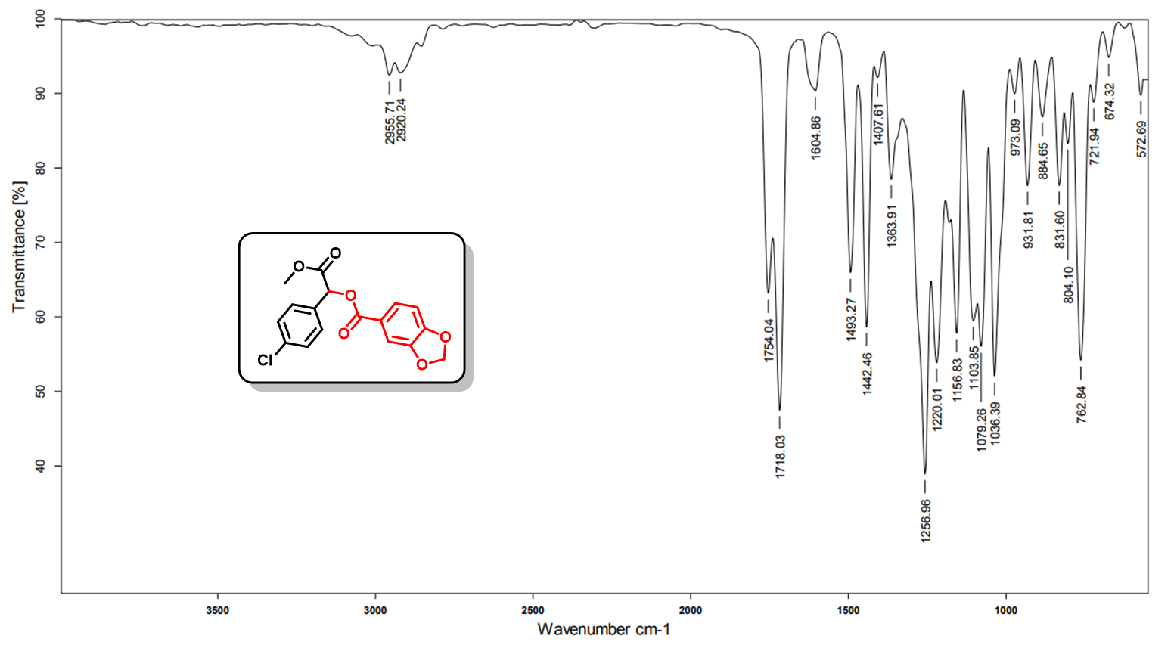
Fig. S65. IR spectra of spectra of 1-(4-chlorophenyl)-2-methoxy-2-oxoethyl benzo[d][1,3]dioxole-5-carboxylate (4c).
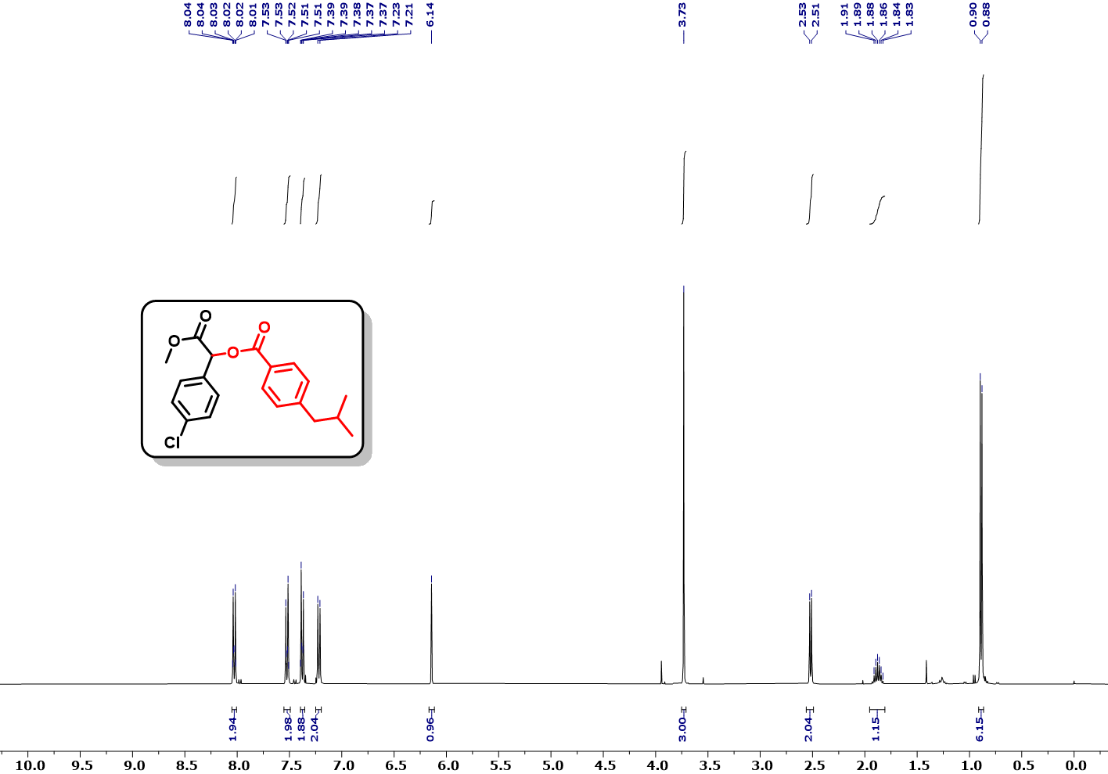
Fig. S66. ¹H NMR (400 MHz, CDCl₃) spectra of 1-(4-chlorophenyl)-2-methoxy-2-oxoethyl 4-isobutylbenzoate (4d).
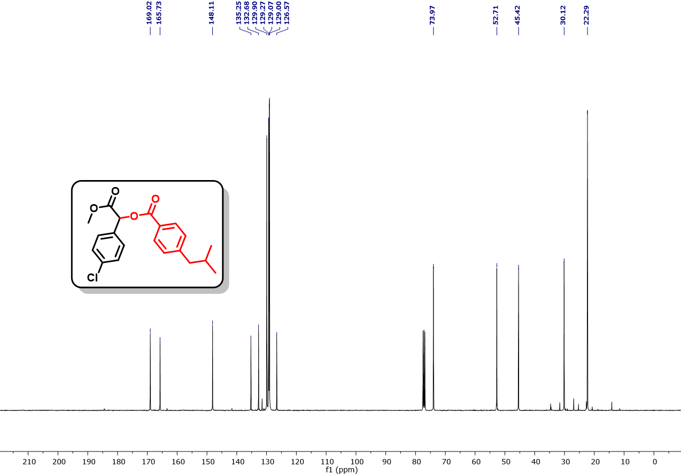
Fig. S67. ¹³C NMR (101 MHz, CDCl₃) spectra of 1-(4-chlorophenyl)-2-methoxy-2-oxoethyl 4-isobutylbenzoate (4d).
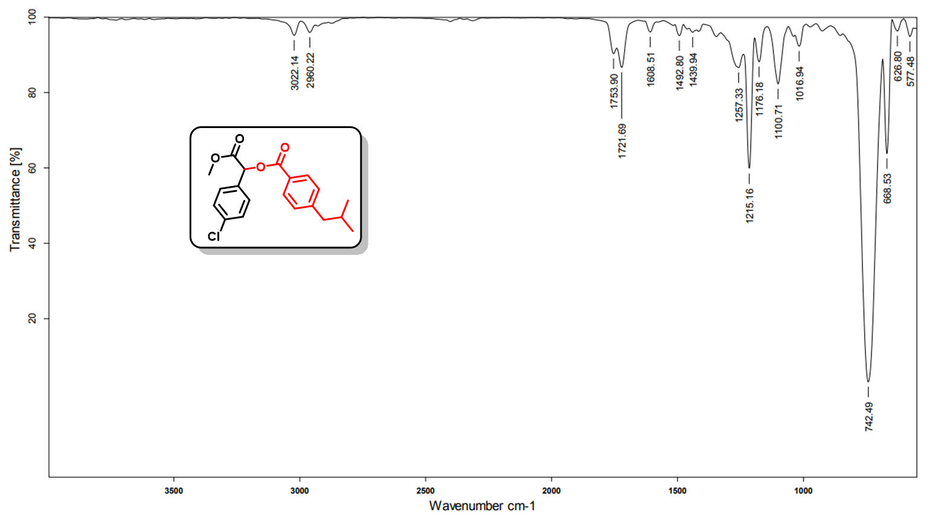
Fig. S68. IR spectra of spectra of 1-(4-chlorophenyl)-2-methoxy-2-oxoethyl 4-isobutylbenzoate (4d).
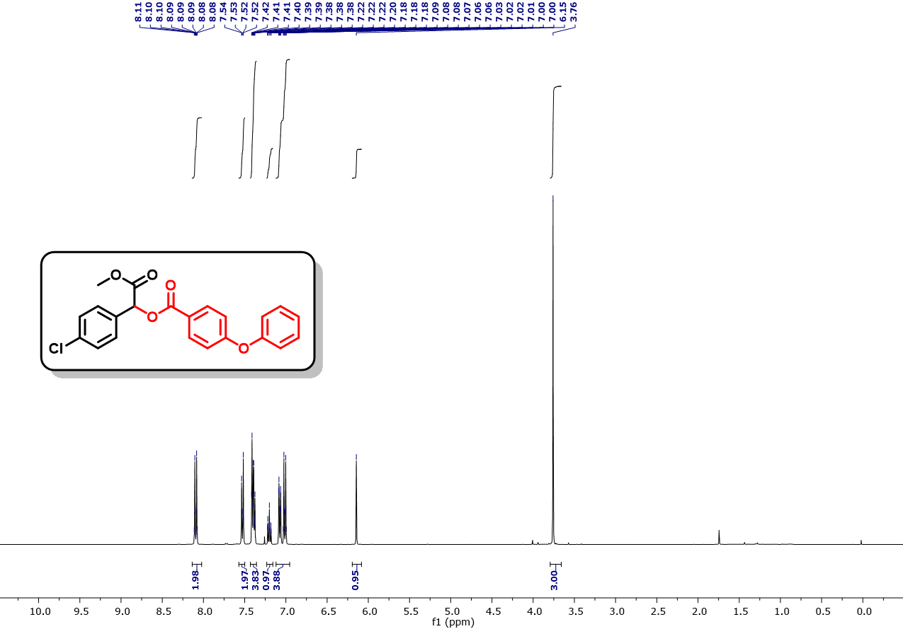
Fig. S69. ¹H NMR (400 MHz, CDCl₃) spectra of 1-(4-chlorophenyl)-2-methoxy-2-oxoethyl 4-phenoxybenzoate (4e).
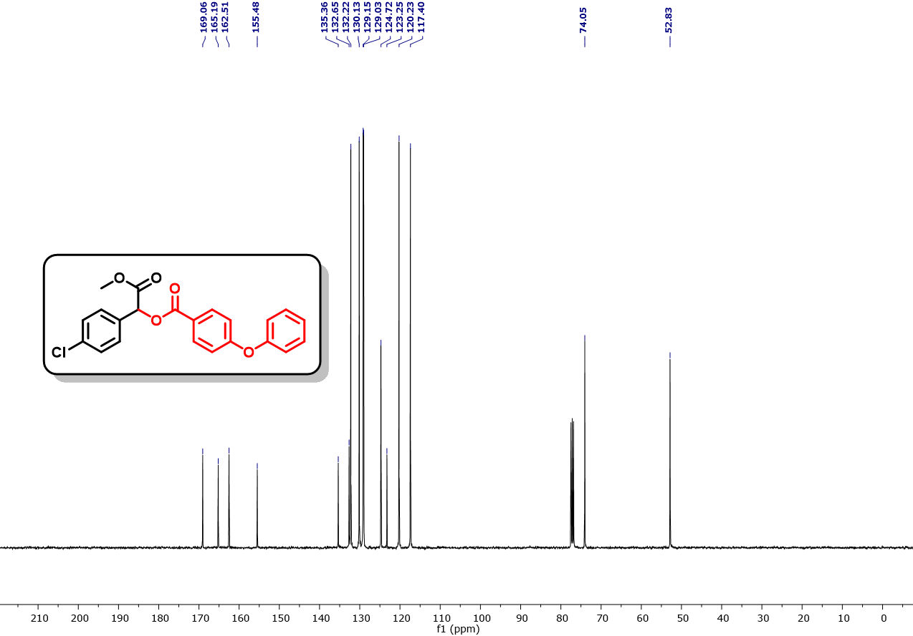
Fig. S70. ¹³C NMR (101 MHz, CDCl₃) spectra of 1-(4-chlorophenyl)-2-methoxy-2-oxoethyl 4-phenoxybenzoate (4e).
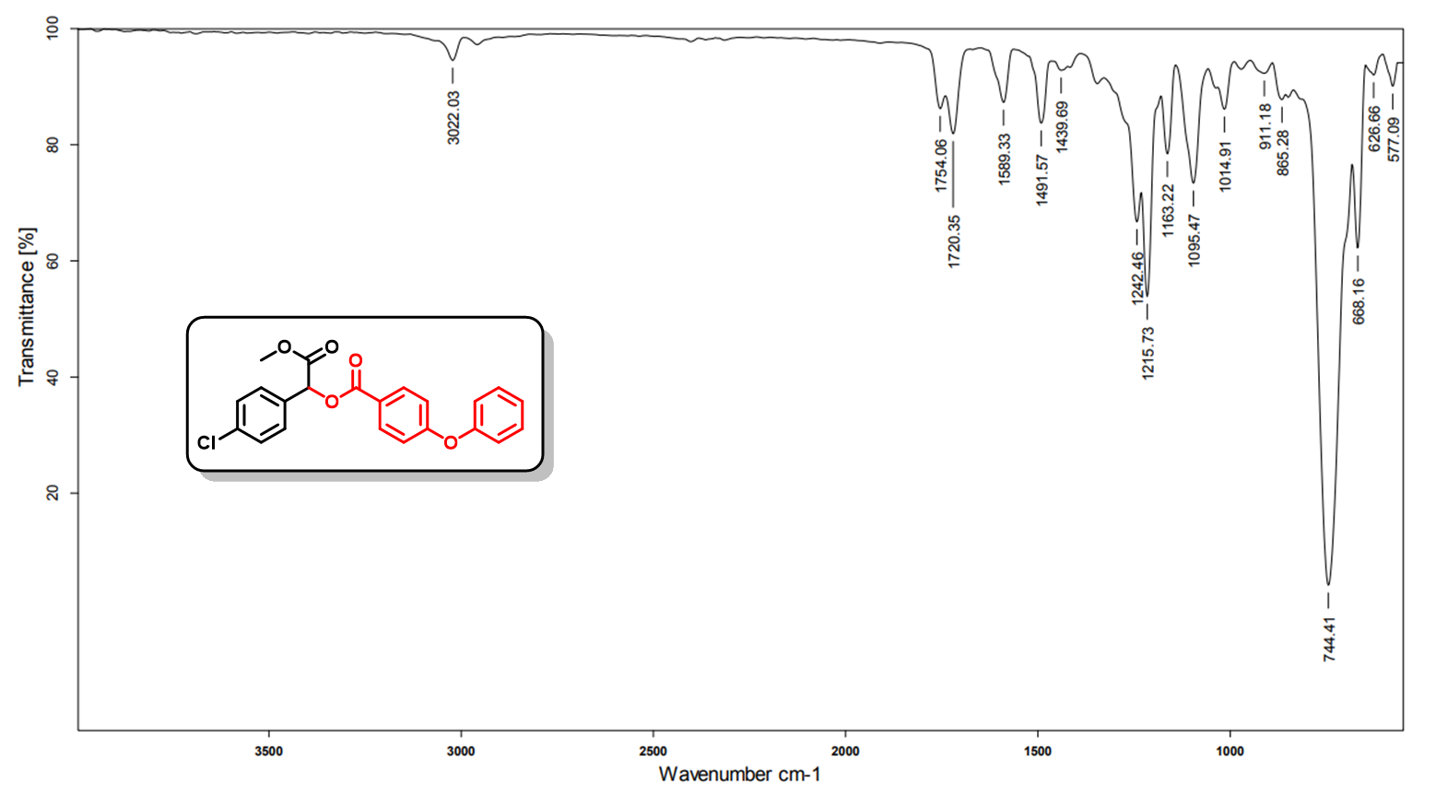
Fig. S71. IR spectra of spectra of 1-(4-chlorophenyl)-2-methoxy-2-oxoethyl 4-phenoxybenzoate (4e).
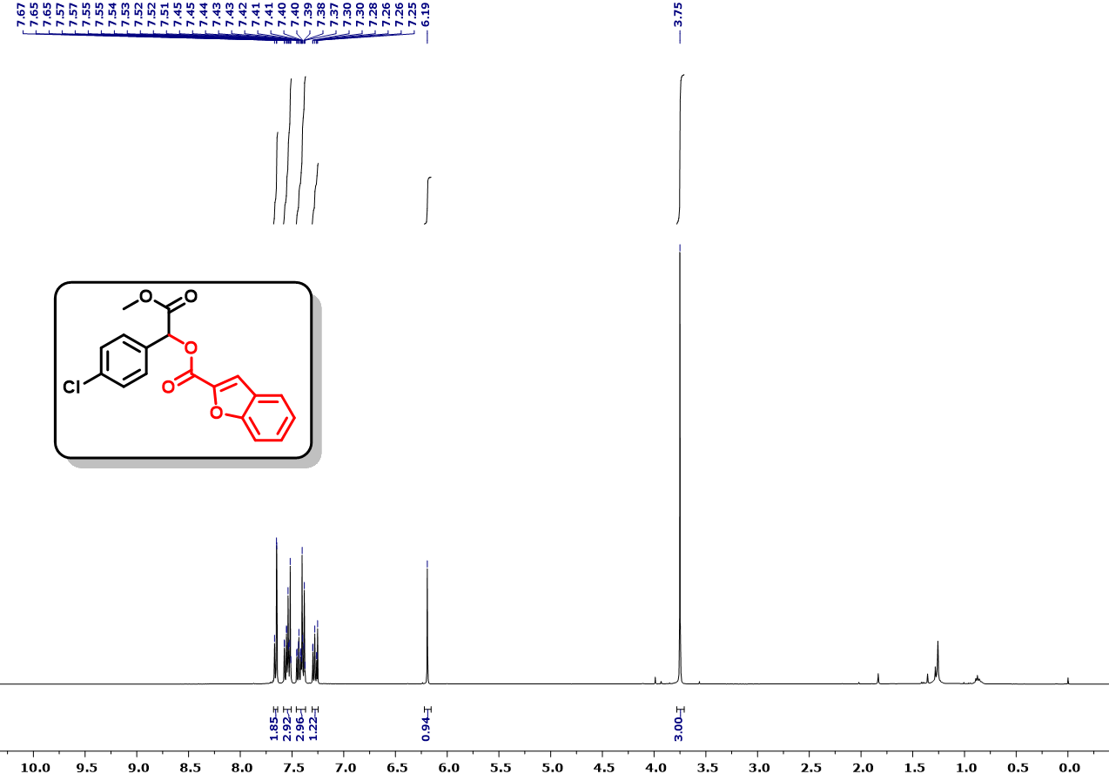
Fig. S72. ¹H NMR (400 MHz, CDCl₃) spectra of 1-(4-chlorophenyl)-2-methoxy-2-oxoethyl benzofuran-2-carboxylate (4f).
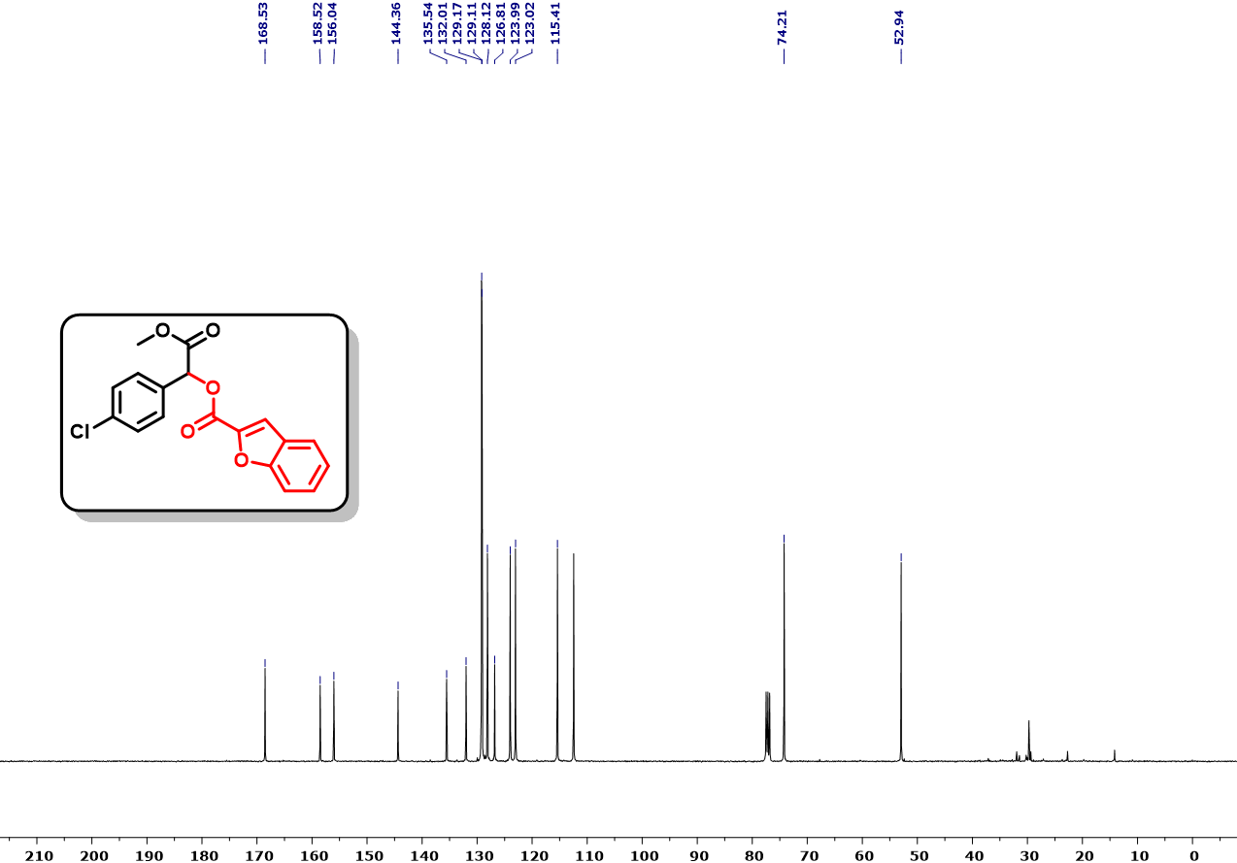
Fig. S73. ¹³C NMR (101 MHz, CDCl₃) spectra of 1-(4-chlorophenyl)-2-methoxy-2-oxoethyl benzofuran-2-carboxylate (4f).
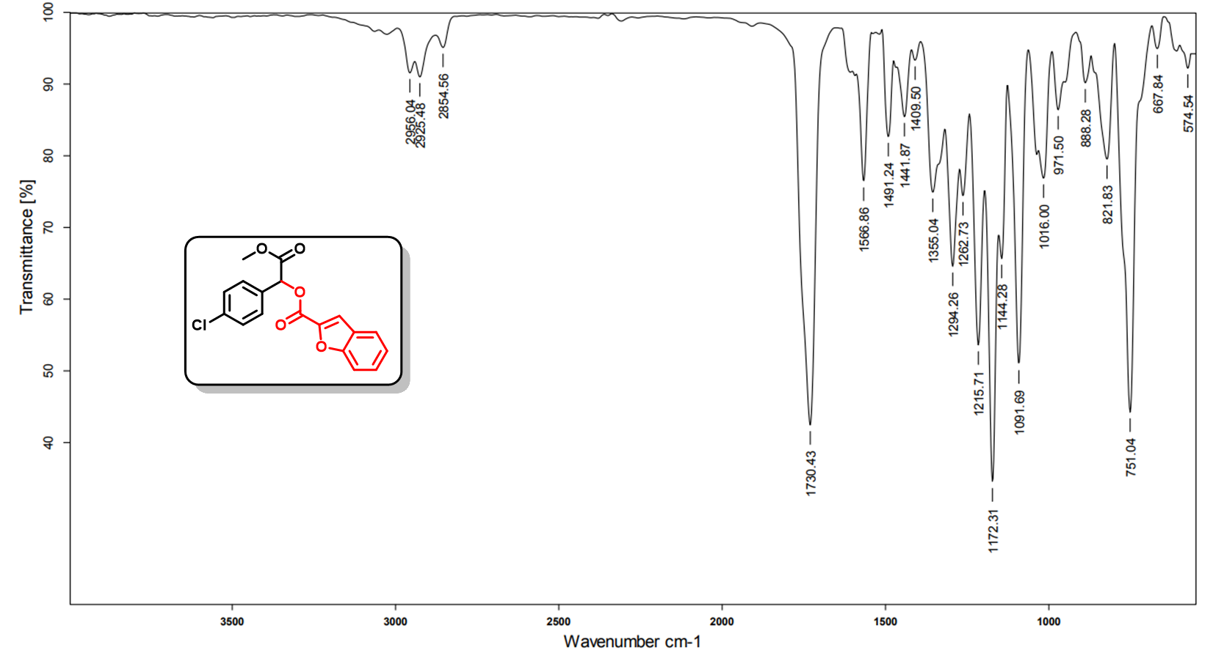
Fig. S74. IR spectra of spectra of 1-(4-chlorophenyl)-2-methoxy-2-oxoethyl benzofuran-2-carboxylate (4f).
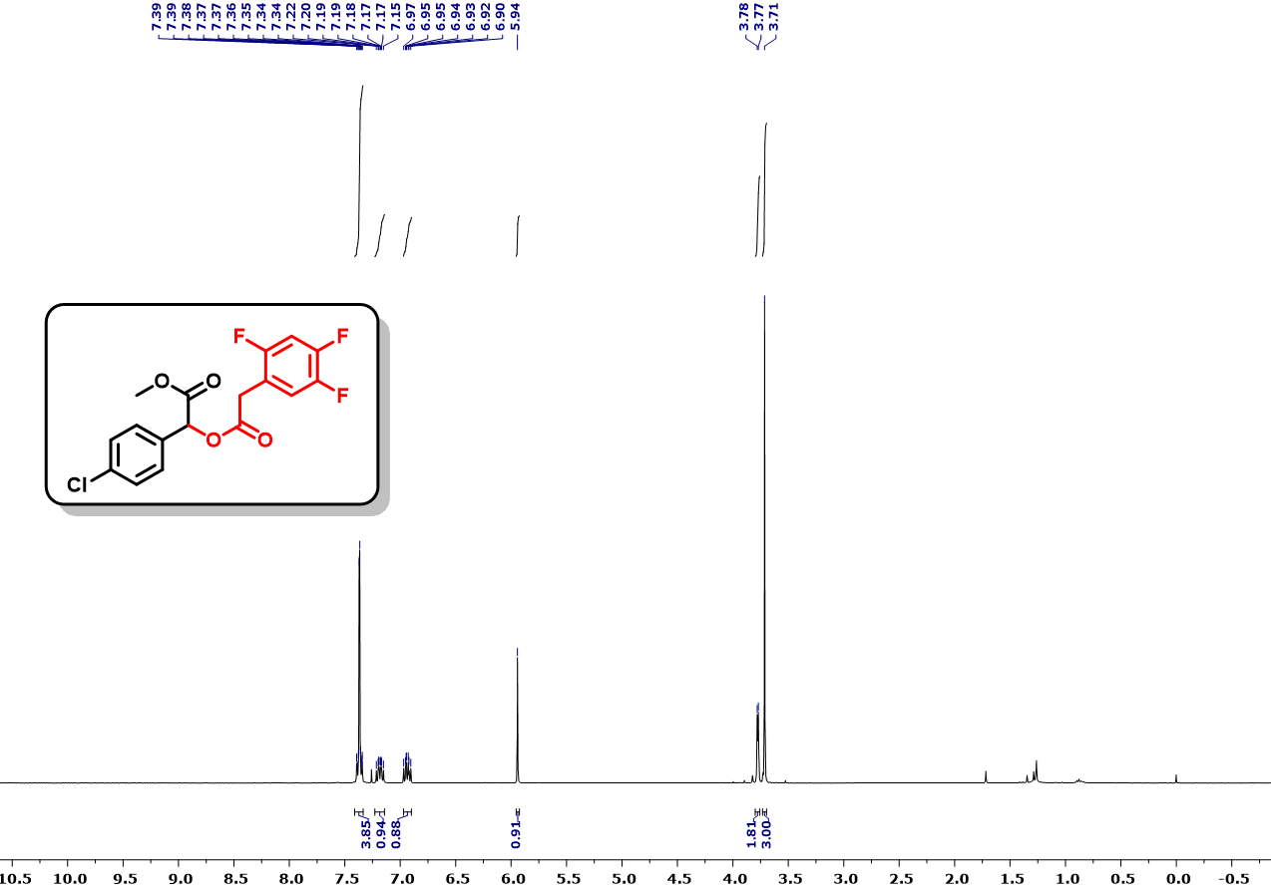
Fig. S75. ¹H NMR (400 MHz, CDCl₃) spectra of methyl 2-(4-chlorophenyl)-2-(2-(2,4,5-trifluorophenyl)acetoxy)acetate (4g).
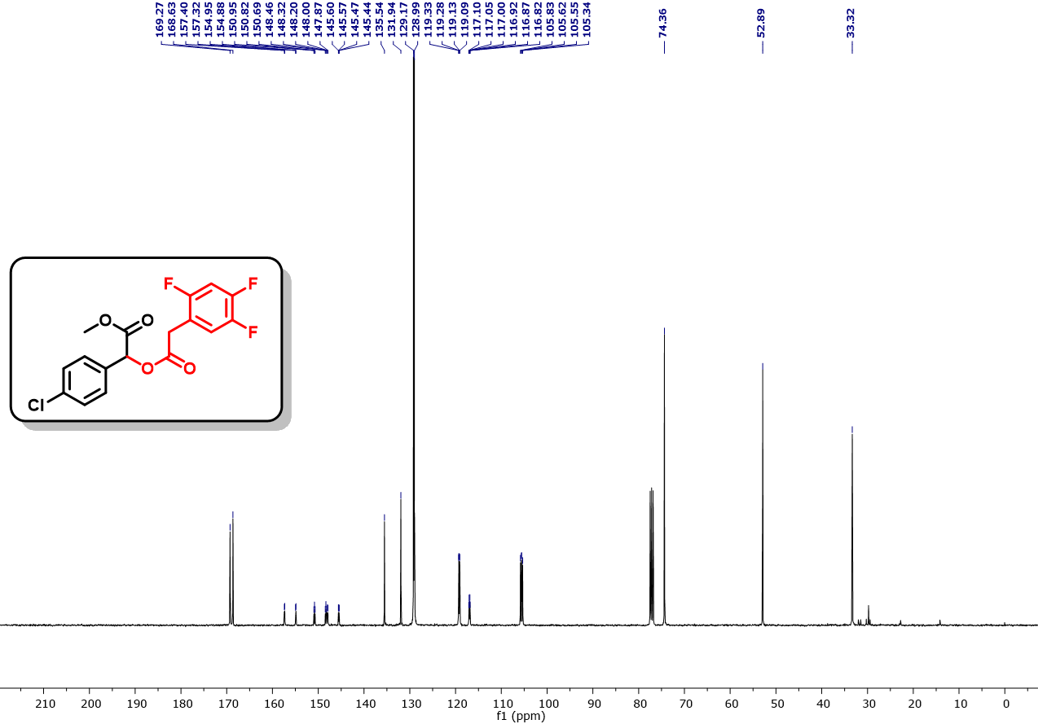
Fig. S76. ¹³C NMR (101 MHz, CDCl₃) spectra of methyl 2-(4-chlorophenyl)-2-(2-(2,4,5-trifluorophenyl)acetoxy)acetate (4g).
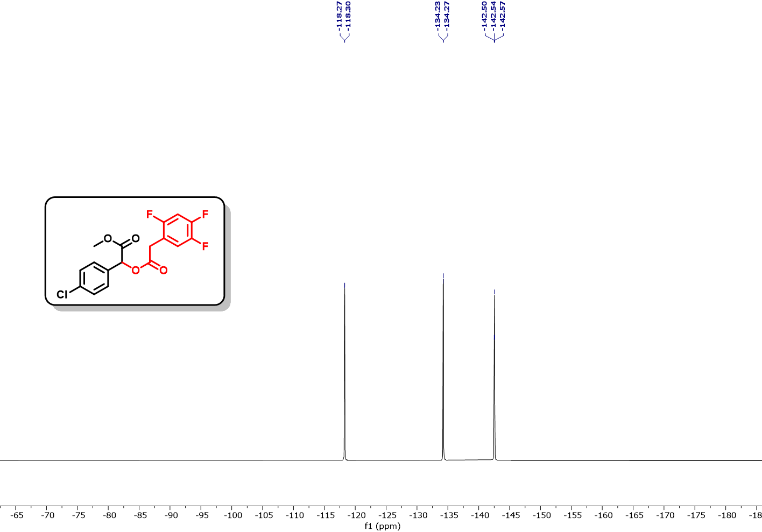
Fig. S77. ¹⁹F NMR (471 MHz, CDCl₃) spectra of methyl 2-(4-chlorophenyl)-2-(2-(2,4,5-trifluorophenyl)acetoxy)acetate (4g).
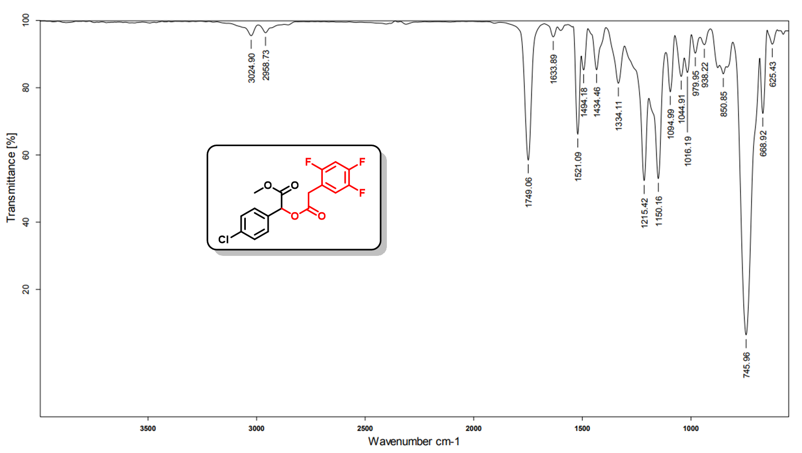
Fig. S78. IR spectra of spectra of methyl 2-(4-chlorophenyl)-2-(2-(2,4,5-trifluorophenyl)acetoxy)acetate (4g).
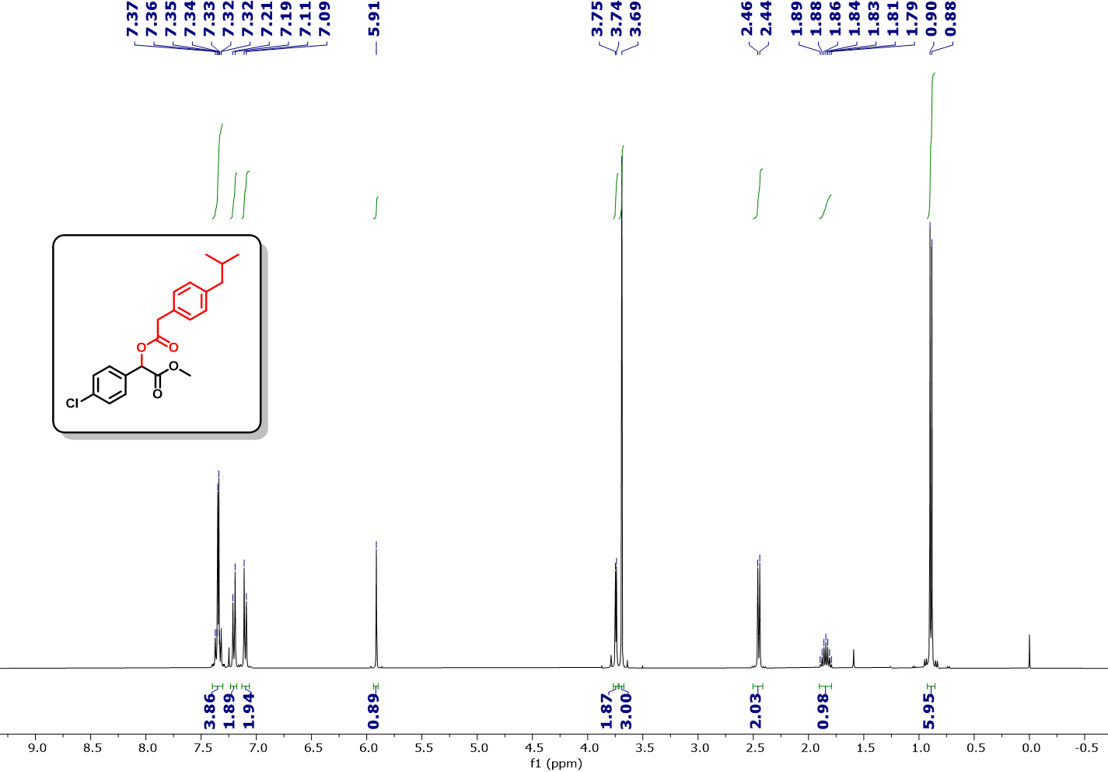
Fig. S79. ¹H NMR (400 MHz, CDCl₃) spectra of methyl 2-(4-chlorophenyl)-2-(2-(4-isobutylphenyl)acetoxy)acetate (4h).
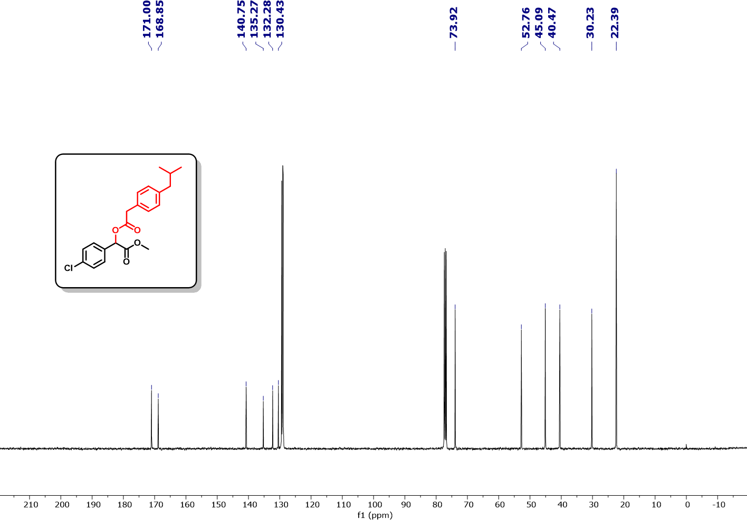
Fig. S80. ¹³C NMR (101 MHz, CDCl₃) spectra of methyl 2-(4-chlorophenyl)-2-(2-(4-isobutylphenyl)acetoxy)acetate (4h).
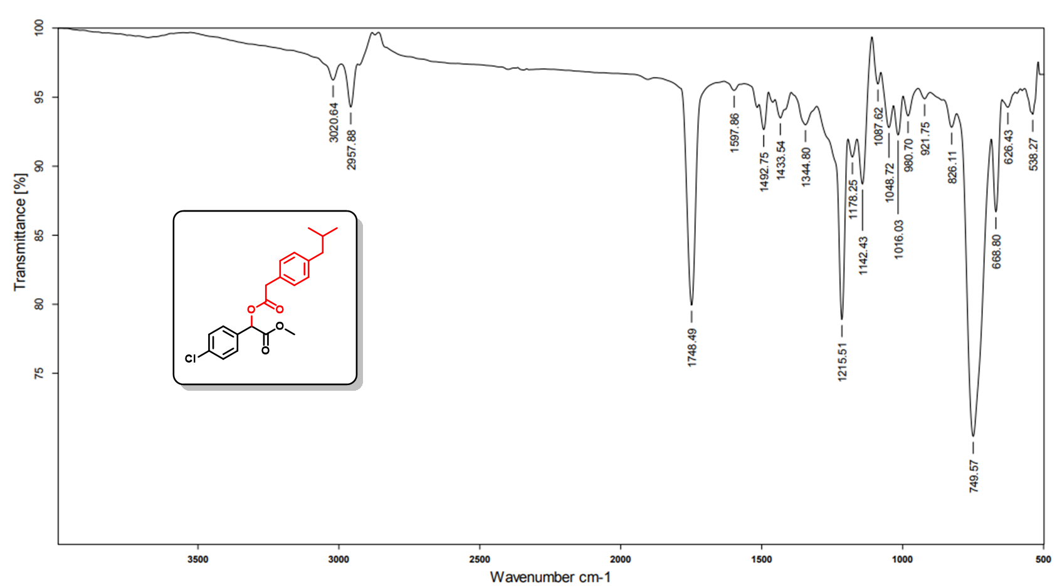
Fig. S81. IR spectra of spectra of methyl 2-(4-chlorophenyl)-2-(2-(4-isobutylphenyl)acetoxy)acetate (4h).
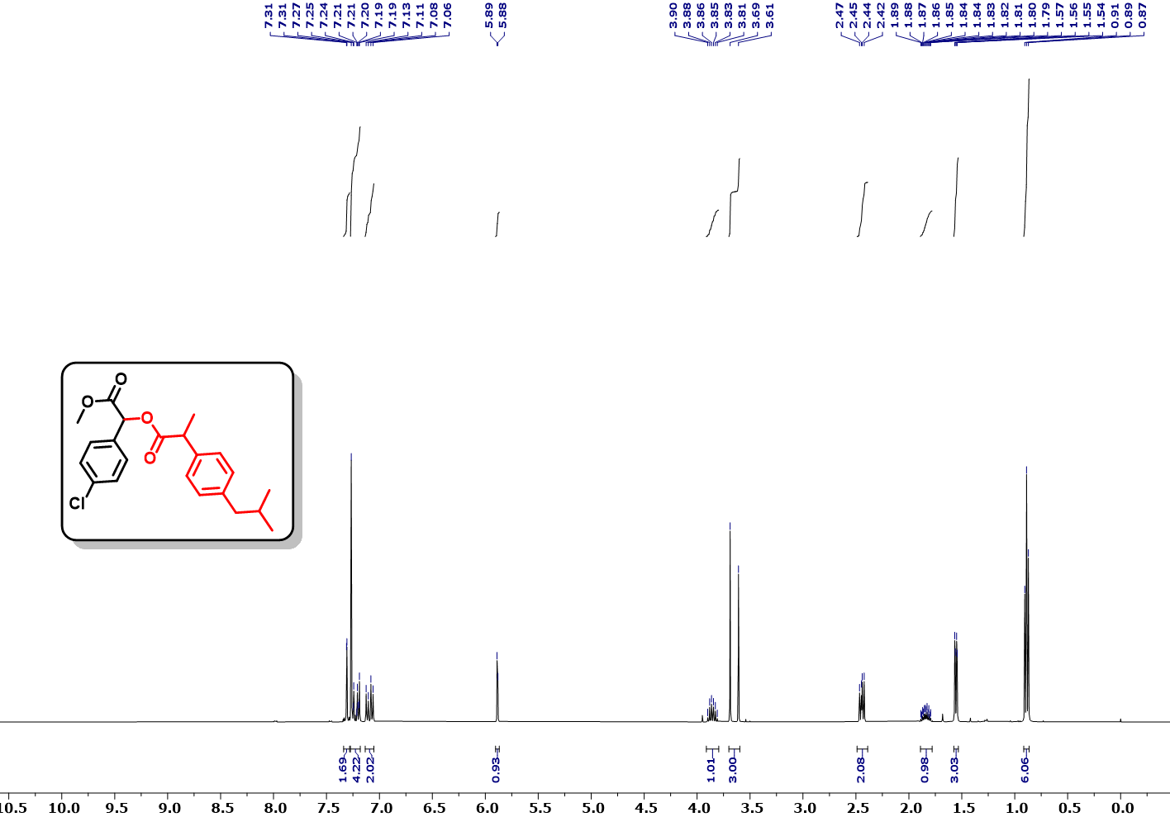
Fig. S82. ¹H NMR (400 MHz, CDCl₃) spectra of 1-(4-chlorophenyl)-2-methoxy-2-oxoethyl 2-(4-isobutylphenyl)propanoate (4i).
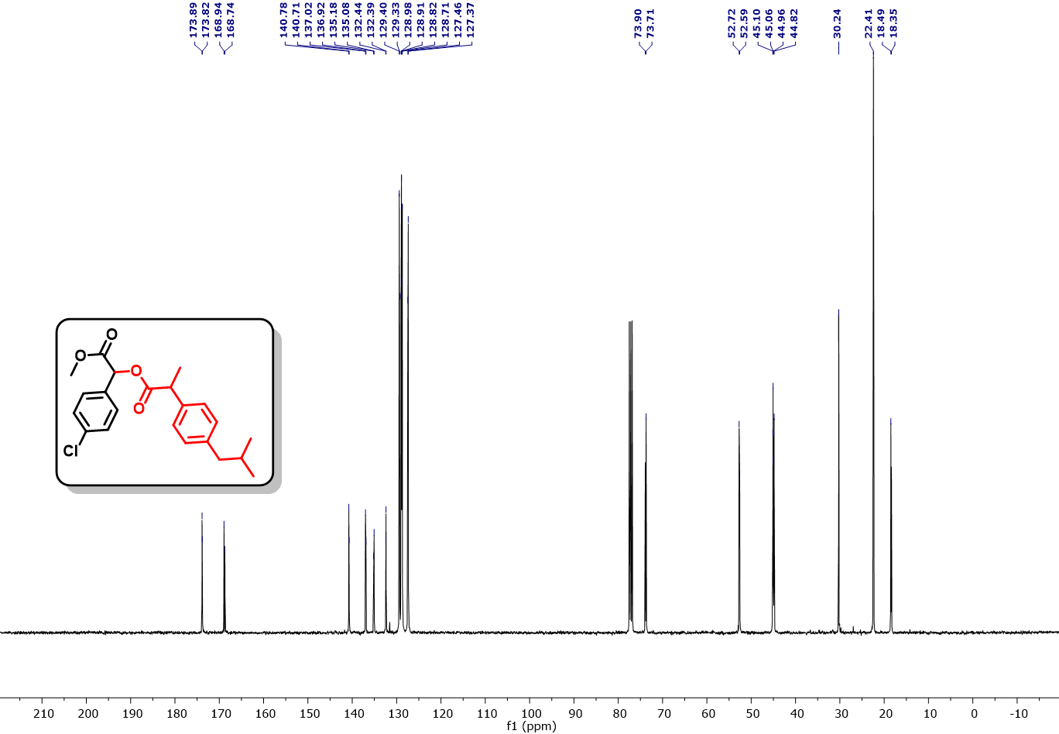
Fig. S83. ¹H NMR (101 MHz, CDCl₃) spectra of 1-(4-chlorophenyl)-2-methoxy-2-oxoethyl 2-(4-isobutylphenyl)propanoate (4i).
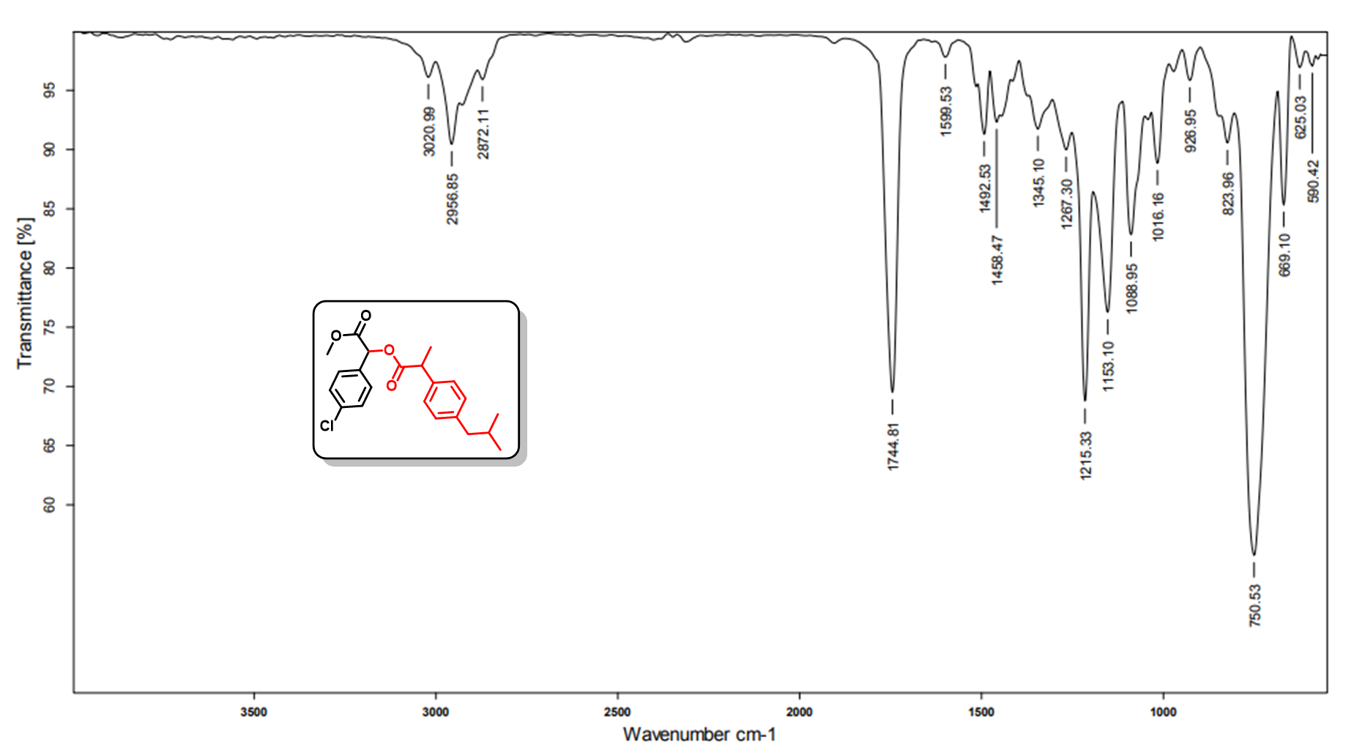
Fig. S84. IR spectra of spectra of 1-(4-chlorophenyl)-2-methoxy-2-oxoethyl 2-(4-isobutylphenyl)propanoate (4i).
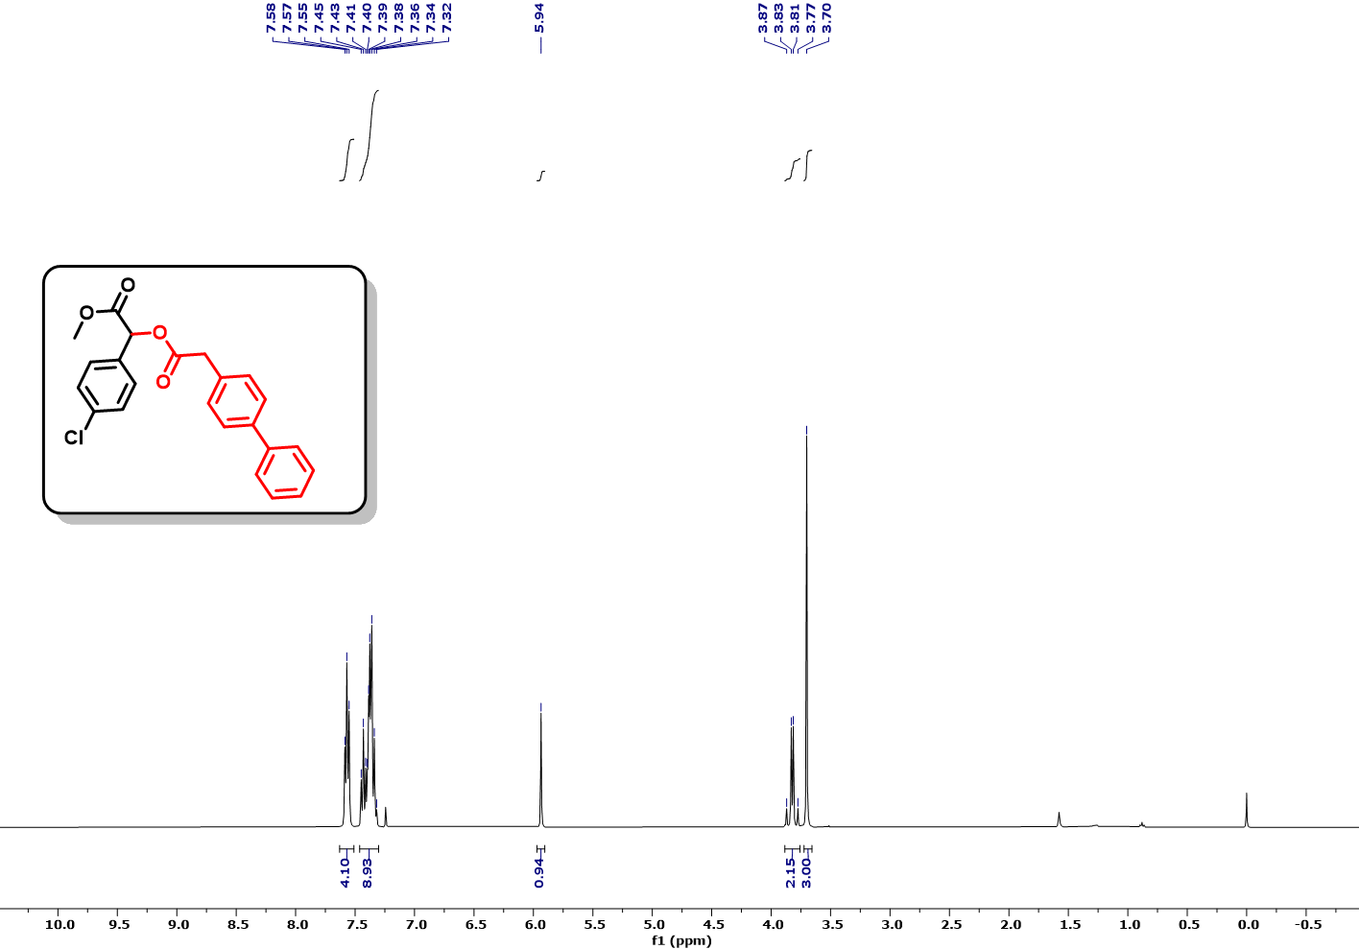
Fig. S85. ¹H NMR (400 MHz, CDCl₃) spectra of methyl 2-(2-([1,1'-biphenyl]-4-yl)acetoxy)-2-(4-chlorophenyl)acetate (4j).
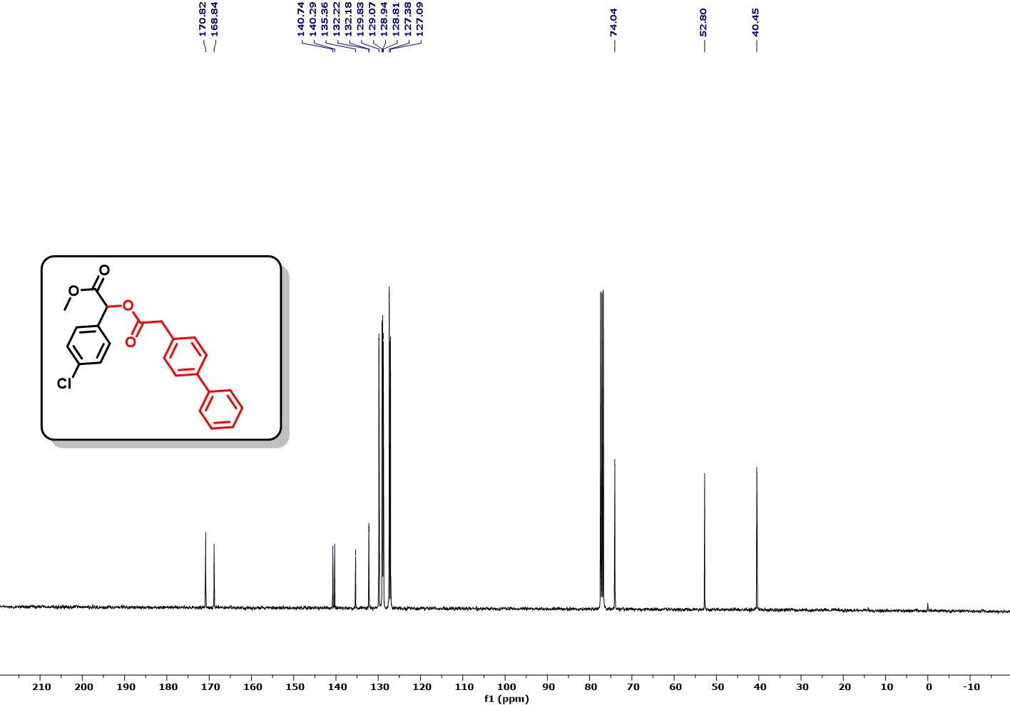
Fig. S86. ¹³C NMR (101 MHz, CDCl₃) spectra of methyl 2-(2-([1,1'-biphenyl]-4-yl)acetoxy)-2-(4-chlorophenyl)acetate (4j).
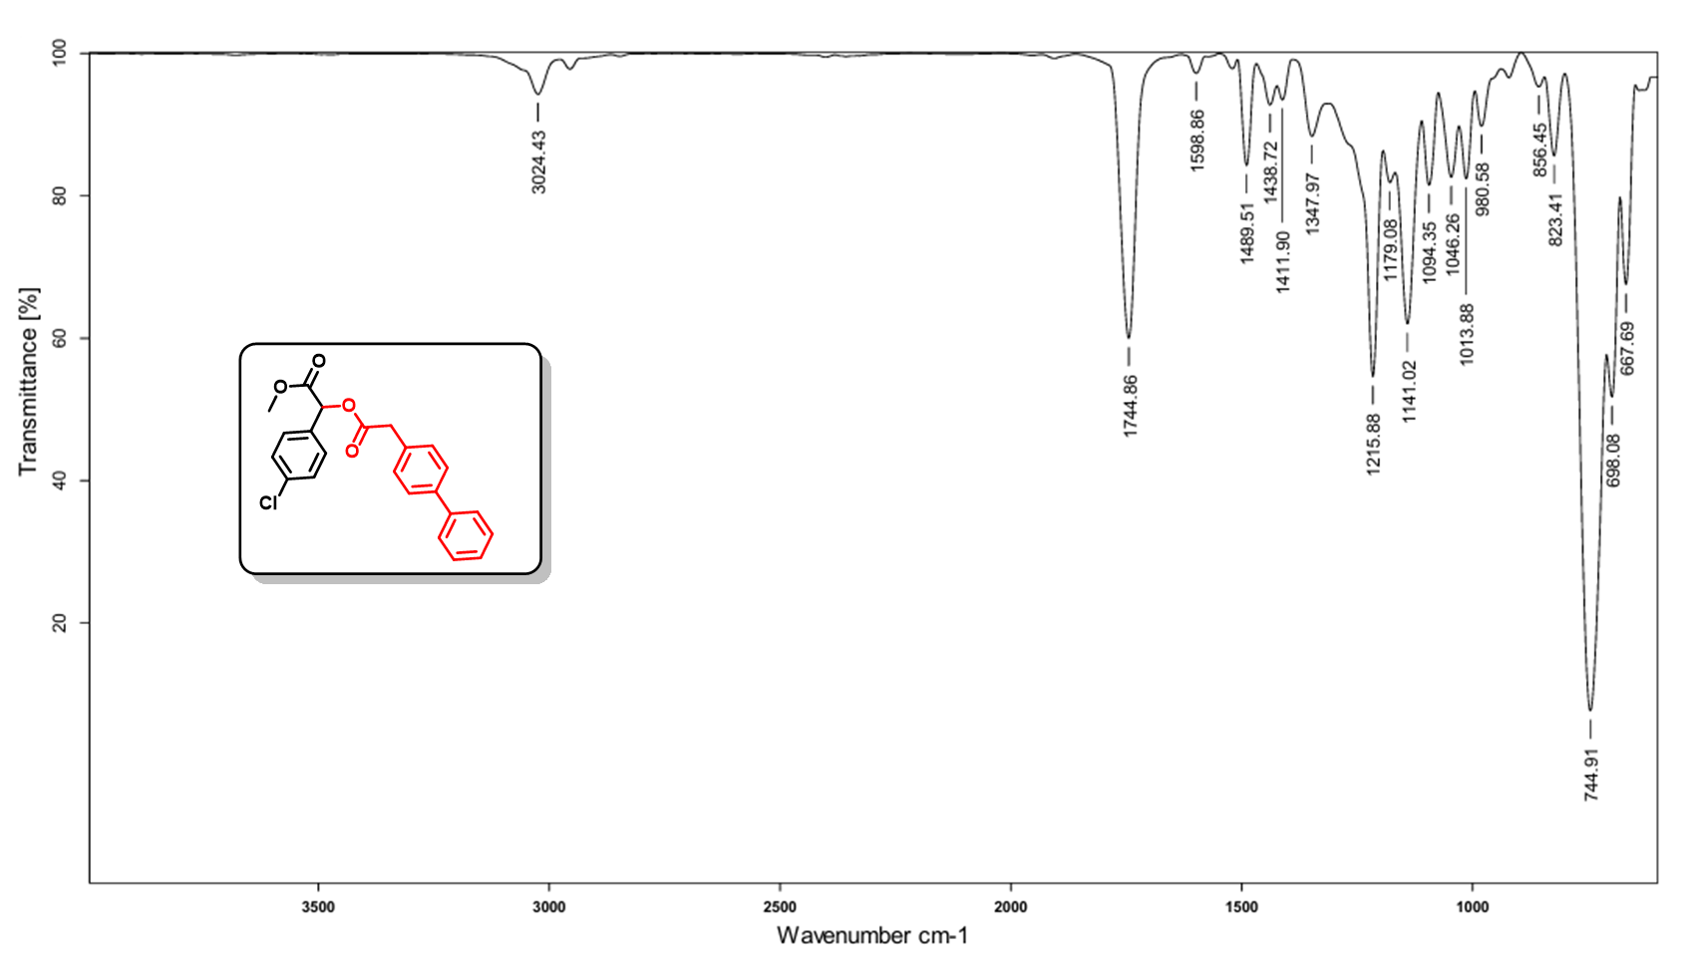
Fig. S87. IR spectra of spectra of methyl 2-(2-([1,1'-biphenyl]-4-yl)acetoxy)-2-(4-chlorophenyl)acetate (4j).
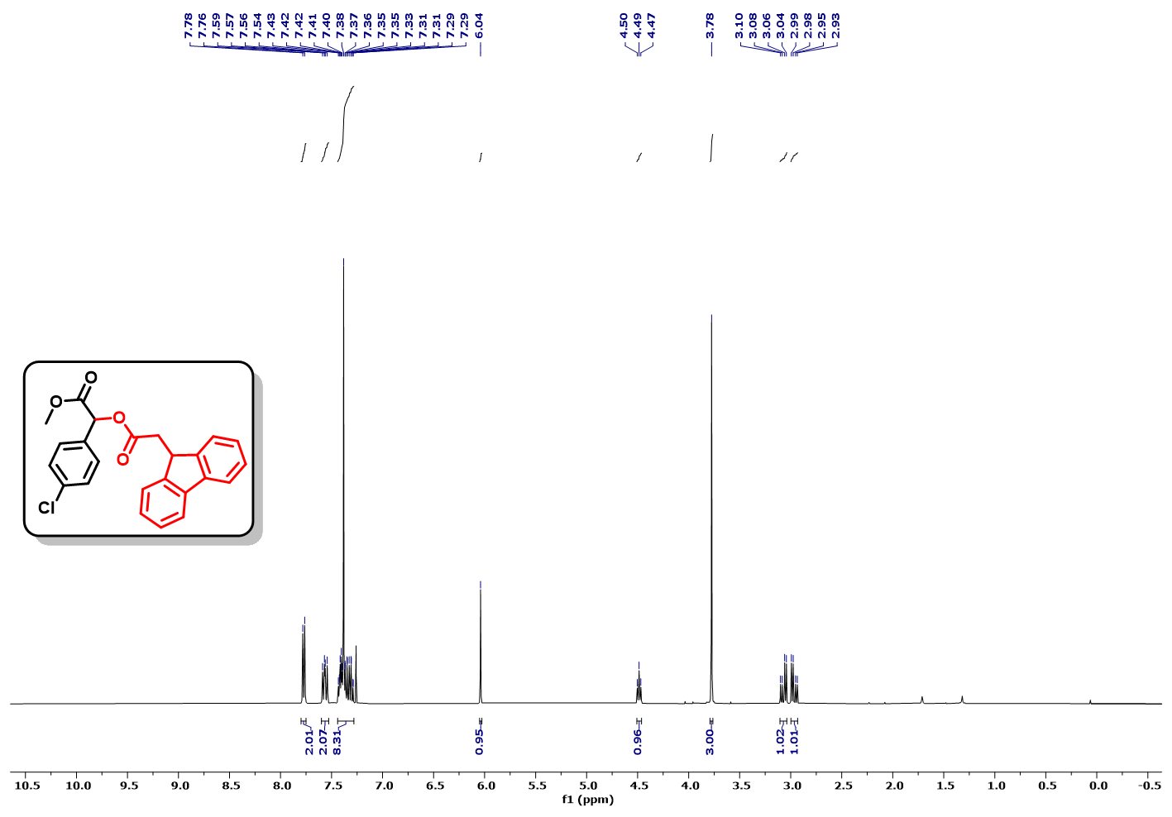
Fig. S88. ¹H NMR (400 MHz, CDCl₃) spectra of methyl 2-(2-(9H-fluoren-9-yl)acetoxy)-2-(4-chlorophenyl)acetate (4k).
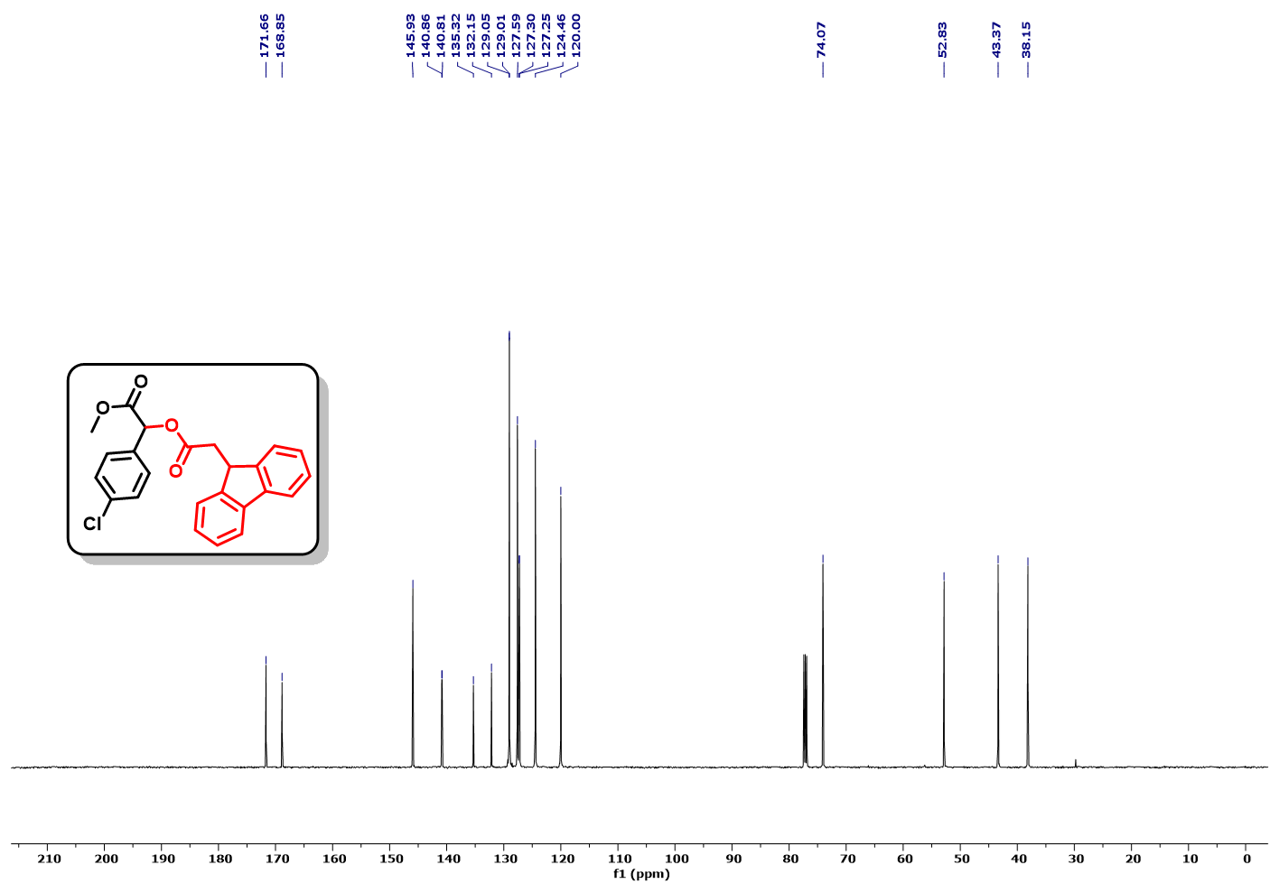
Fig. S89. ¹³C NMR (126 MHz, CDCl₃) spectra of methyl 2-(2-(9H-fluoren-9-yl)acetoxy)-2-(4-chlorophenyl)acetate (4k).
Fig. S90. IR spectra of spectra of methyl 2-(2-(9H-fluoren-9-yl)acetoxy)-2-(4-chlorophenyl)acetate (4k).
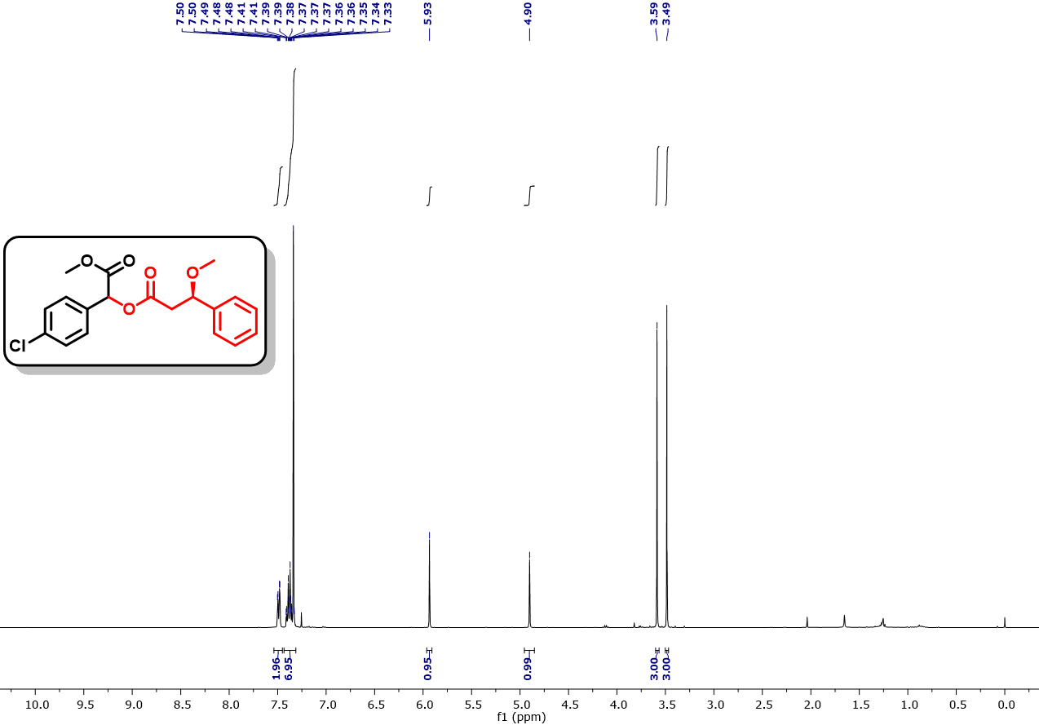
Fig. S91. ¹H NMR (400 MHz, CDCl₃) spectra of 1-(4-chlorophenyl)-2-methoxy-2-oxoethyl (3R)-3-methoxy-3-phenylpropanoate (4l).
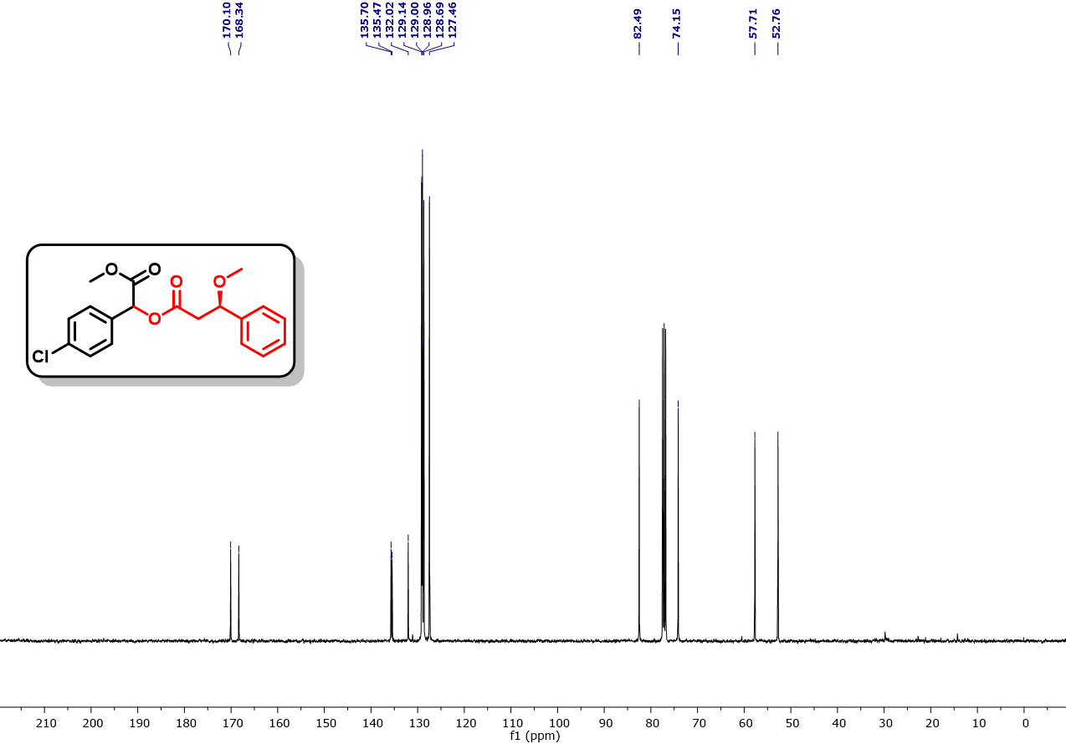
Fig. S92. ¹³C NMR (101 MHz, CDCl₃) spectra of 1-(4-chlorophenyl)-2-methoxy-2-oxoethyl (3R)-3-methoxy-3-phenylpropanoate (4l).
Fig. S93. IR spectra of spectra of 1-(4-chlorophenyl)-2-methoxy-2-oxoethyl (3R)-3-methoxy-3-phenylpropanoate (4l).

Fig. S94. ¹H NMR (400 MHz, CDCl₃) spectra of 1-(4-chlorophenyl)-2-methoxy-2-oxoethyl 5-methylisoxazole-3-carboxylate (4m).
Fig. S95. ¹³C NMR (101 MHz, CDCl₃) spectra of 1-(4-chlorophenyl)-2-methoxy-2-oxoethyl 5-methylisoxazole-3-carboxylate (4m).
Fig. S96. IR spectra of spectra of 1-(4-chlorophenyl)-2-methoxy-2-oxoethyl 5-methylisoxazole-3-carboxylate (4m).
Fig. S97. ¹H NMR (400 MHz, CDCl₃) spectra of 1-(4-chlorophenyl)-2-methoxy-2-oxoethyl 5-acetylthiophene-2-carboxylate (4n).
Fig. S98. ¹³C NMR (101 MHz, CDCl₃) spectra of 1-(4-chlorophenyl)-2-methoxy-2-oxoethyl 5-acetylthiophene-2-carboxylate (4n).
Fig. S99. IR spectra of spectra of 1-(4-chlorophenyl)-2-methoxy-2-oxoethyl 5-acetylthiophene-2-carboxylate (4n).
Fig. S100. ¹H NMR (500 MHz, CDCl₃) spectra of 1-(4-chlorophenyl)-2-methoxy-2-oxoethyl 5-chlorothiophene-2-carboxylate (4o).
Fig. S101. ¹³C NMR (126 MHz, CDCl₃) spectra of 1-(4-chlorophenyl)-2-methoxy-2-oxoethyl 5-chlorothiophene-2-carboxylate (4o).
Fig. S102. IR spectra of spectra of 1-(4-chlorophenyl)-2-methoxy-2-oxoethyl 5-chlorothiophene-2-carboxylate (4o).
Fig. S103. ¹H NMR (400 MHz, CDCl₃) spectra of 1-(4-chlorophenyl)-2-methoxy-2-oxoethyl (1s,3s)-adamantane-1-carboxylate (4p).
Fig. S104. ¹³C NMR (101 MHz, CDCl₃) spectra of 1-(4-chlorophenyl)-2-methoxy-2-oxoethyl (1s,3s)-adamantane-1-carboxylate (4p).
Fig. S105. IR spectra of spectra of 1-(4-chlorophenyl)-2-methoxy-2-oxoethyl (1s,3s)-adamantane-1-carboxylate (4p).
Fig. S106. ¹H NMR (400 MHz, CDCl₃) spectra of methyl 2-(4-chlorophenyl)-2-(phenylthio)acetate (6a).
Fig. S107. ¹³C NMR (101 MHz, CDCl₃) spectra of methyl 2-(4-chlorophenyl)-2-(phenylthio)acetate (6a).
Fig. S108. IR spectra of spectra of methyl 2-(4-chlorophenyl)-2-(phenylthio)acetate (6a).
Fig. S109. ¹H NMR (400 MHz, CDCl₃) spectra of methyl 2-((4-bromophenyl)thio)-2-(4-chlorophenyl)acetate (6b).
Fig. S110. ¹³C NMR (126 MHz, CDCl₃) spectra of methyl 2-((4-bromophenyl)thio)-2-(4-chlorophenyl)acetate (6b).
Fig. S111. IR spectra of spectra of methyl 2-((4-bromophenyl)thio)-2-(4-chlorophenyl)acetate (6b).
Fig. S112. ¹H NMR (400 MHz, CDCl₃) spectra of methyl 2-(4-bromophenyl)-2-((4-chlorophenyl)thio)acetate (6c).
Fig. S113. ¹³C NMR (126 MHz, CDCl₃) spectra of methyl 2-(4-bromophenyl)-2-((4-chlorophenyl)thio)acetate (6c).
Fig. S114. IR spectra of spectra of methyl 2-(4-bromophenyl)-2-((4-chlorophenyl)thio)acetate (6c).
Fig. S115. ¹H NMR (500 MHz, CDCl₃) spectra of methyl 2-(4-bromophenyl)-2-((4-fluorophenyl)thio)acetate (6d).
Fig. S116. ¹³C NMR (101 MHz, CDCl₃) spectra of methyl 2-(4-bromophenyl)-2-((4-fluorophenyl)thio)acetate (6d).
Fig. S117. ¹⁹F NMR (471 MHz, CDCl₃) spectra of methyl 2-(4-bromophenyl)-2-((4-fluorophenyl)thio)acetate (6d).
Fig. S118. IR spectra of spectra of methyl 2-(4-bromophenyl)-2-((4-fluorophenyl)thio)acetate (6d).
Fig. S119. ¹H NMR (400 MHz, CDCl₃) spectra of methyl 2-(4-bromophenyl)-2-(p-tolylthio)acetate (6e).
Fig. S120. ¹H NMR (101 MHz, CDCl₃) spectra of methyl 2-(4-bromophenyl)-2-(p-tolylthio)acetate (6e).
Fig. S121. IR spectra of spectra of methyl 2-(4-bromophenyl)-2-(p-tolylthio)acetate (6e).
Fig. S122. ¹H NMR (500 MHz, CDCl₃) spectra of methyl 2-(4-bromophenyl)-2-((3-methoxyphenyl)thio)acetate (6f).
Fig. S123. ¹H NMR (101 MHz, CDCl₃) spectra of methyl 2-(4-bromophenyl)-2-((3-methoxyphenyl)thio)acetate (6f).
Fig. S124. IR spectra of spectra of methyl 2-(4-bromophenyl)-2-((3-methoxyphenyl)thio)acetate (6f).
Fig. S125. ¹H NMR (400 MHz, CDCl₃) spectra of methyl 2-(4-bromophenyl)-2-(naphthalen-1-ylthio)acetate (6g).
Fig. S126. ¹³C NMR (101 MHz, CDCl₃) spectra of methyl 2-(4-bromophenyl)-2-(naphthalen-1-ylthio)acetate (6g).
Fig. S127. IR spectra of spectra of methyl 2-(4-bromophenyl)-2-(naphthalen-1-ylthio)acetate (6g).
Fig. S128. ¹H NMR (400 MHz, CDCl₃) spectra of methyl 2-(4-chlorophenyl)-2-((1-phenyl-1H-tetrazol-5-yl)thio)acetate (6h).
Fig. S129. ¹³C NMR (126 MHz, CDCl₃) spectra of methyl 2-(4-chlorophenyl)-2-((1-phenyl-1H-tetrazol-5-yl)thio)acetate (6h).
Fig. S130. IR spectra of spectra of methyl 2-(4-chlorophenyl)-2-((1-phenyl-1H-tetrazol-5-yl)thio)acetate (6h).
Fig. S131. ¹H NMR (400 MHz, CDCl₃) spectra of methyl 2-(4-chlorophenyl)-2-(phenylamino)acetate (8a).
Fig. S132. ¹³C NMR (126 MHz, CDCl₃) spectra of methyl 2-(4-chlorophenyl)-2-(phenylamino)acetate (8a).
Fig. S133. IR spectra of methyl 2-(4-chlorophenyl)-2-(phenylamino)acetate (8a).
Fig. S134. ¹H NMR (400 MHz, CDCl₃) spectra of methyl 2-(benzylamino)-2-(4-chlorophenyl)acetate (8b).
Fig. S135. ¹³C NMR (101 MHz, CDCl₃) spectra of methyl 2-(benzylamino)-2-(4-chlorophenyl)acetate (8b).
Fig. S136. IR spectra of methyl 2-(benzylamino)-2-(4-chlorophenyl)acetate (8b).
Fig. S137. ¹H NMR (400 MHz, CDCl₃) spectra of methyl 2-(4-chlorophenyl)-2-(dibenzylamino)acetate (8c).
Fig. S138. ¹³C NMR (101 MHz, CDCl₃) spectra of methyl 2-(4-chlorophenyl)-2-(dibenzylamino)acetate (8c).
Fig. S139. IR spectra of methyl 2-(4-chlorophenyl)-2-(dibenzylamino)acetate (8c).
Fig. S140. ¹H NMR (500 MHz, CDCl₃) spectra of methyl 2-((5-bromopyrimidin-2-yl)amino)-2-(4-chlorophenyl)acetate (8d).
Fig. S141. ¹³C NMR (101 MHz, CDCl₃) spectra of methyl 2-((5-bromopyrimidin-2-yl)amino)-2-(4-chlorophenyl)acetate (8d).
Fig. S142. IR spectra of methyl 2-((5-bromopyrimidin-2-yl)amino)-2-(4-chlorophenyl)acetate (8d).
Fig. S143. ¹H NMR (500 MHz, CDCl₃) spectra of methyl 2-(tert-butylamino)-2-(4-chlorophenyl)acetate (8e).
Fig. S144. ¹³C NMR (101 MHz, CDCl₃) spectra of methyl 2-(tert-butylamino)-2-(4-chlorophenyl)acetate (8e).
Fig. S145. IR spectra of methyl 2-(tert-butylamino)-2-(4-chlorophenyl)acetate (8e).
Fig. S146. ¹H NMR (400 MHz, CDCl₃) spectra of methyl 2-(4-chlorophenyl)-2-(2-(pyridin-4-yl)-1H-benzo[d]imidazol-1-yl)acetate (8f).
Fig. S147. ¹³C NMR (101 MHz, CDCl₃) spectra of methyl 2-(4-chlorophenyl)-2-(2-(pyridin-4-yl)-1H-benzo[d]imidazol-1-yl)acetate (8f).
Fig. S148. IR spectra of methyl 2-(4-chlorophenyl)-2-(2-(pyridin-4-yl)-1H-benzo[d]imidazol-1-yl)acetate (8f).
Fig. S149. ¹H NMR (400 MHz, CDCl₃) spectra of methyl 2-(4-chlorophenyl)-2-(indolin-1-yl)acetate (8g).
Fig. S150. ¹³C NMR (101 MHz, CDCl₃) spectra of methyl 2-(4-chlorophenyl)-2-(indolin-1-yl)acetate (8g).
Fig. S151. IR spectra of methyl 2-(4-chlorophenyl)-2-(indolin-1-yl)acetate (8g).
Fig. S152. ¹H NMR (400 MHz, CDCl₃) spectra of methyl 2-(4-chlorophenyl)-2-(methyl(tetrahydro-2H-pyran-4-yl)amino)acetate (8h).
Fig. S153. ¹³C NMR (101 MHz, CDCl₃) spectra of Methyl 2-(4-chlorophenyl)-2-(methyl(tetrahydro-2H-pyran-4-yl)amino)acetate (8h).
Fig. S154. IR spectra of Methyl 2-(4-chlorophenyl)-2-(methyl(tetrahydro-2H-pyran-4-yl)amino)acetate (8h).
Fig. S155. ¹H NMR (400 MHz, CDCl₃) spectra of methyl 2-(4-chlorophenyl)-2-(diisopropylamino)acetate (8i).
Fig. S156. ¹³C NMR (126 MHz, CDCl₃) spectra of methyl 2-(4-chlorophenyl)-2-(diisopropylamino)acetate (8i).
Fig. S157. IR spectra of methyl 2-(4-chlorophenyl)-2-(diisopropylamino)acetate (8i).
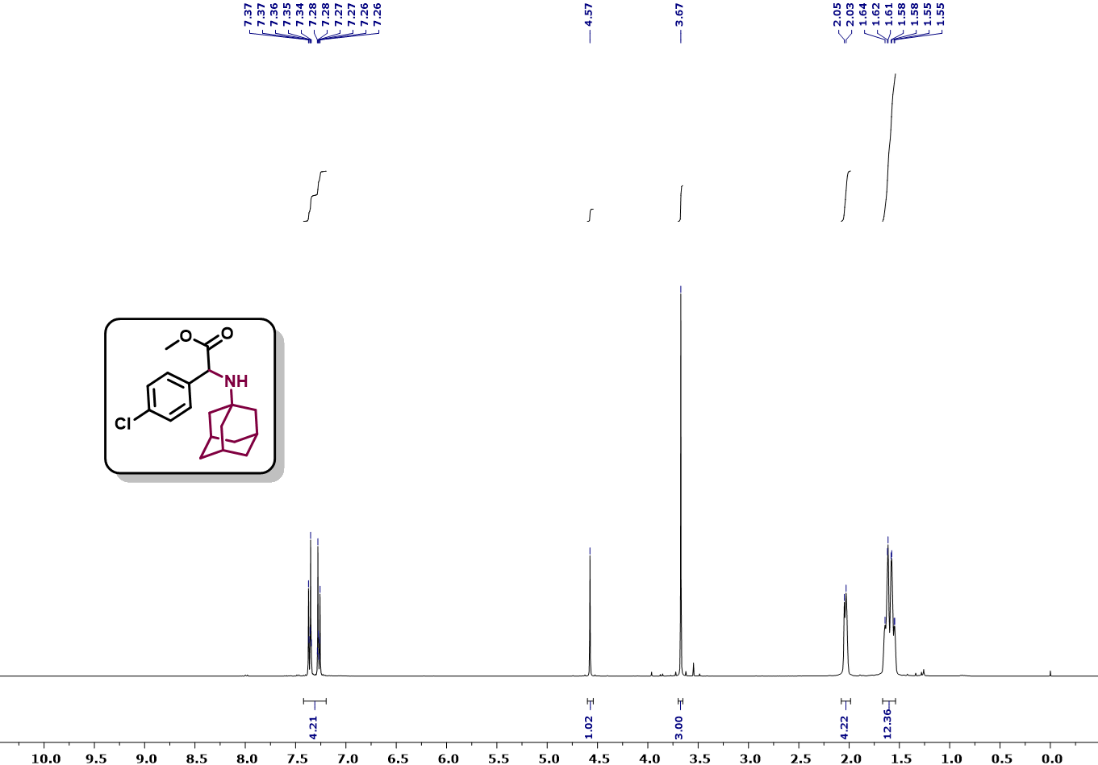
Fig. S158. ¹H NMR (400 MHz, CDCl₃) spectra of methyl 2-(((3s,5s,7s)-adamantan-1-yl)amino)-2-(4-chlorophenyl)acetate (8j).
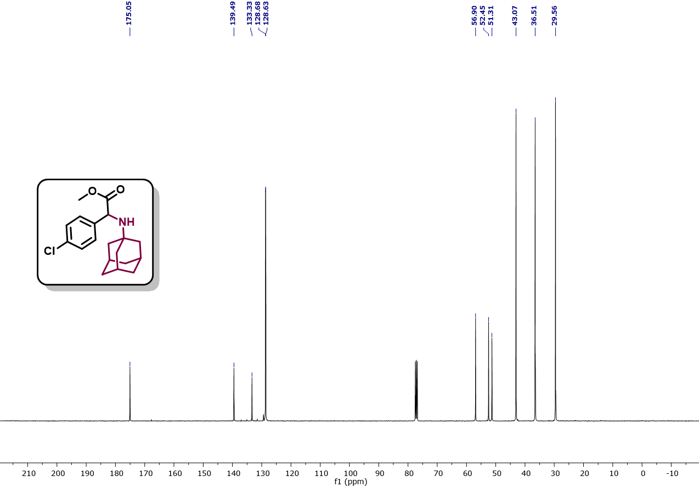
Fig. S159. ¹³C NMR (101 MHz, CDCl₃) spectra of methyl 2-(((3s,5s,7s)-adamantan-1-yl)amino)-2-(4-chlorophenyl)acetate (8j).
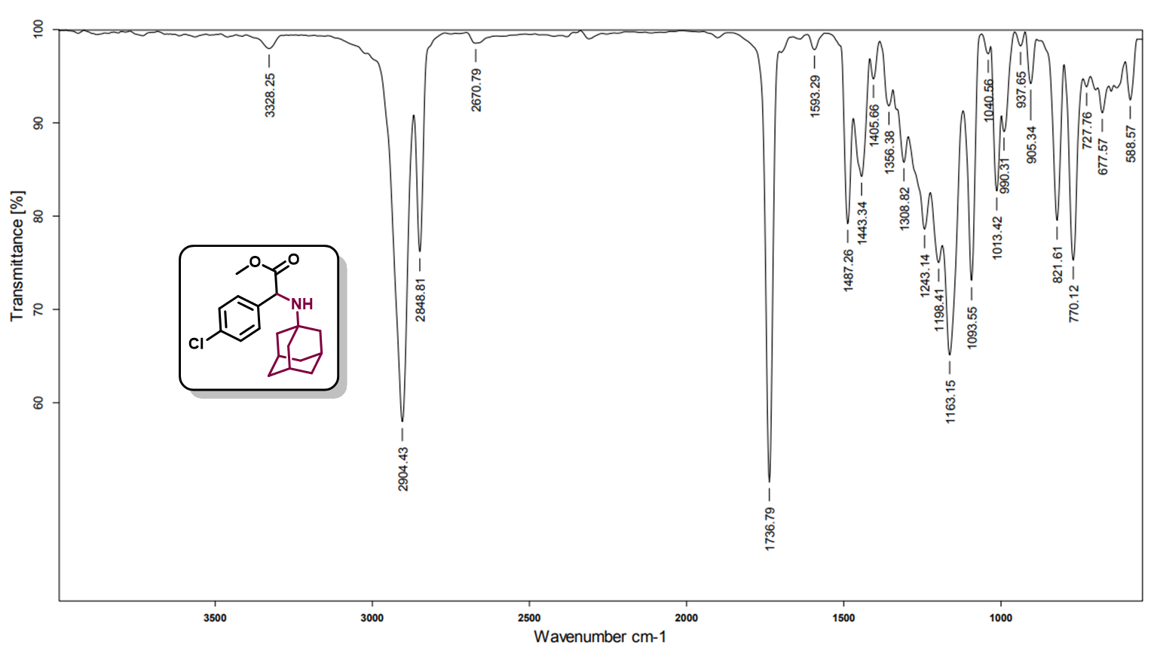
Fig. S160. IR spectra of methyl 2-(((3s,5s,7s)-adamantan-1-yl)amino)-2-(4-chlorophenyl)acetate (8j).
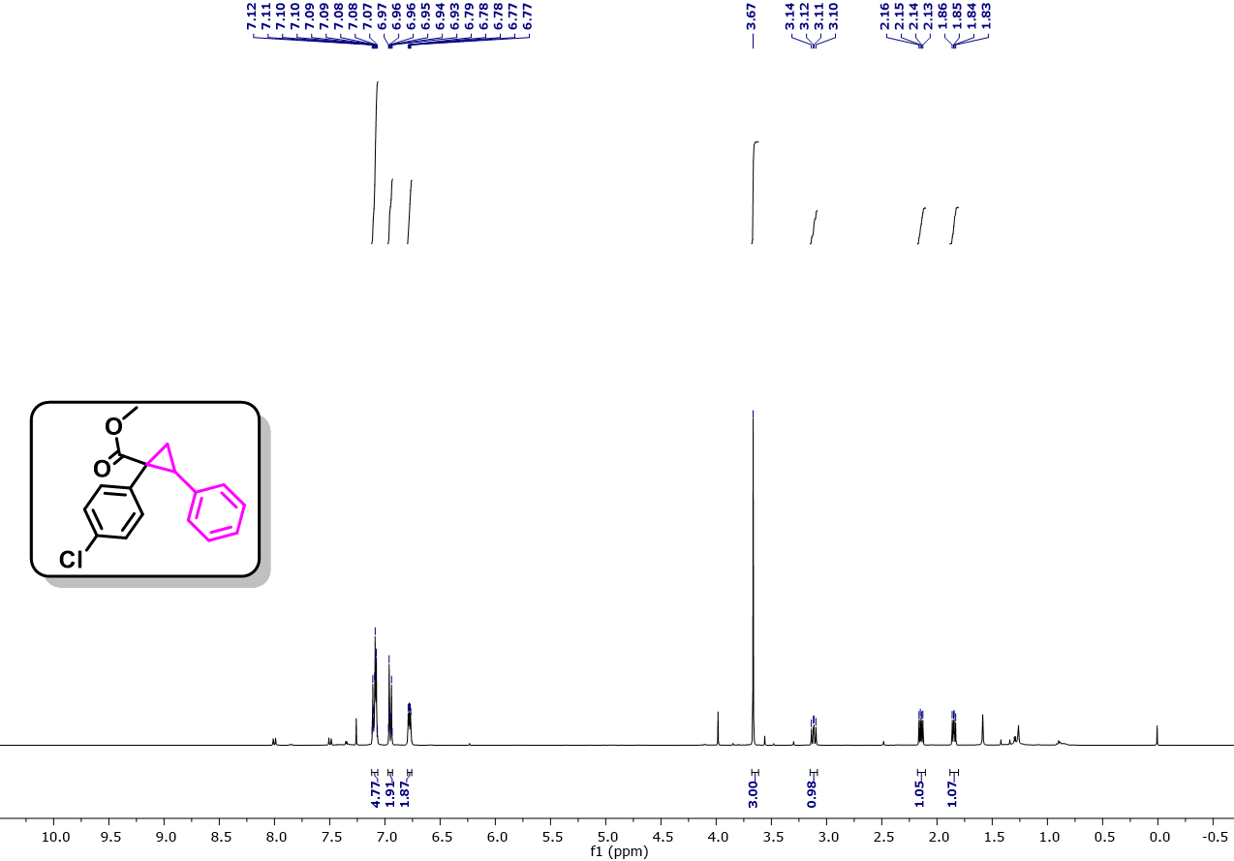
Fig. S161. ¹H NMR (400 MHz, CDCl₃) spectra of methyl 1-(4-chlorophenyl)-2-phenylcyclopropane-1-carboxylate (10a).
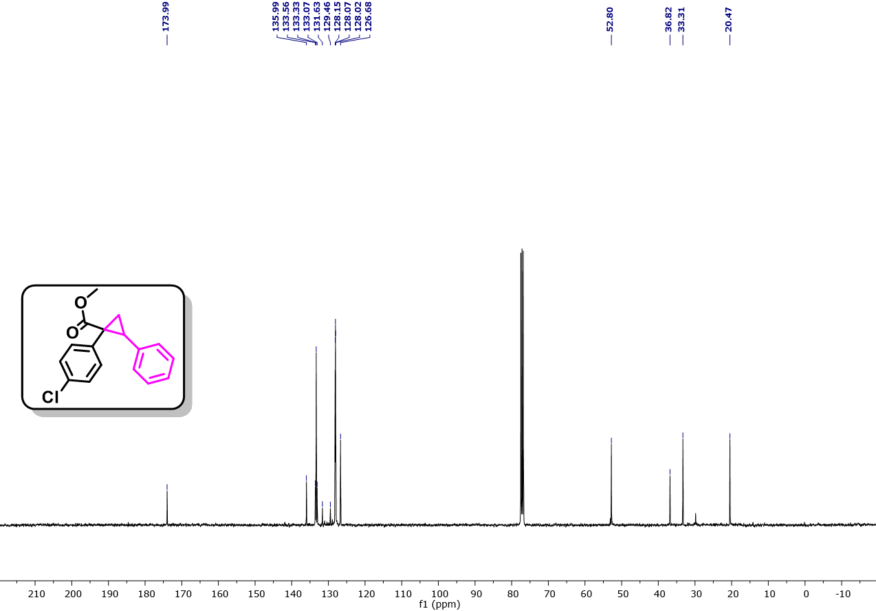
Fig. S162. ¹³C NMR (101 MHz, CDCl₃) spectra of methyl 1-(4-chlorophenyl)-2-phenylcyclopropane-1-carboxylate (10a).
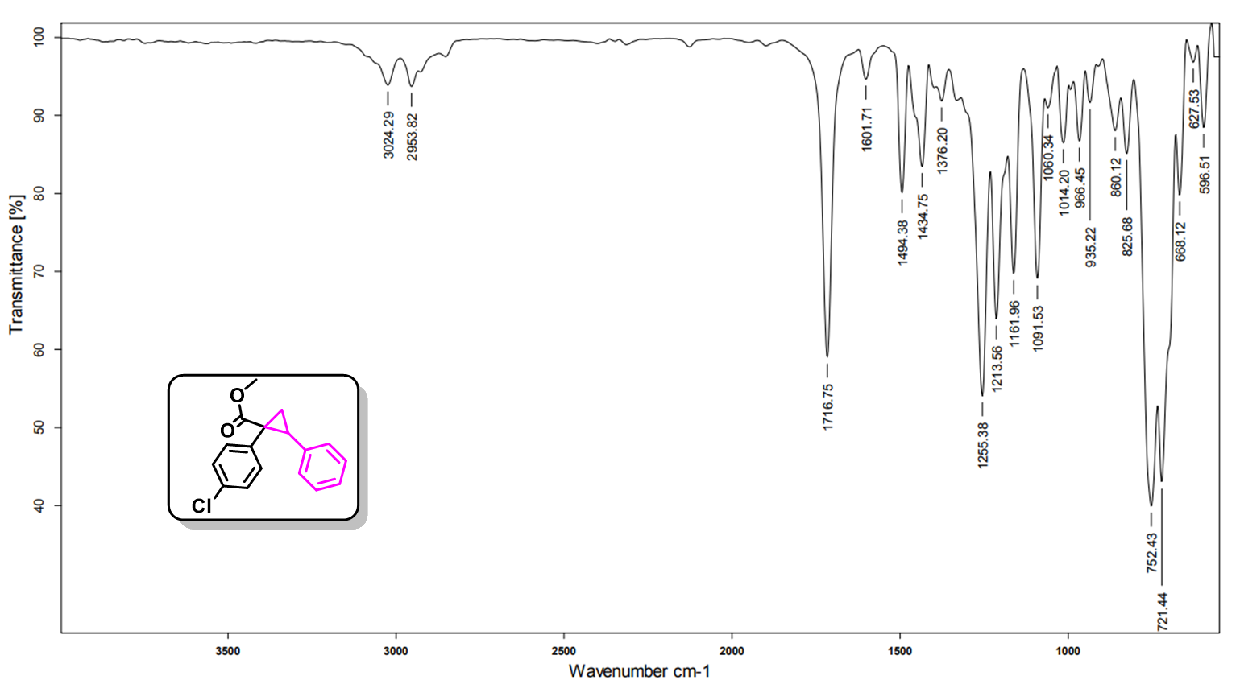
Fig. S163. IR spectra of spectra of methyl 1-(4-chlorophenyl)-2-phenylcyclopropane-1-carboxylate (10a).
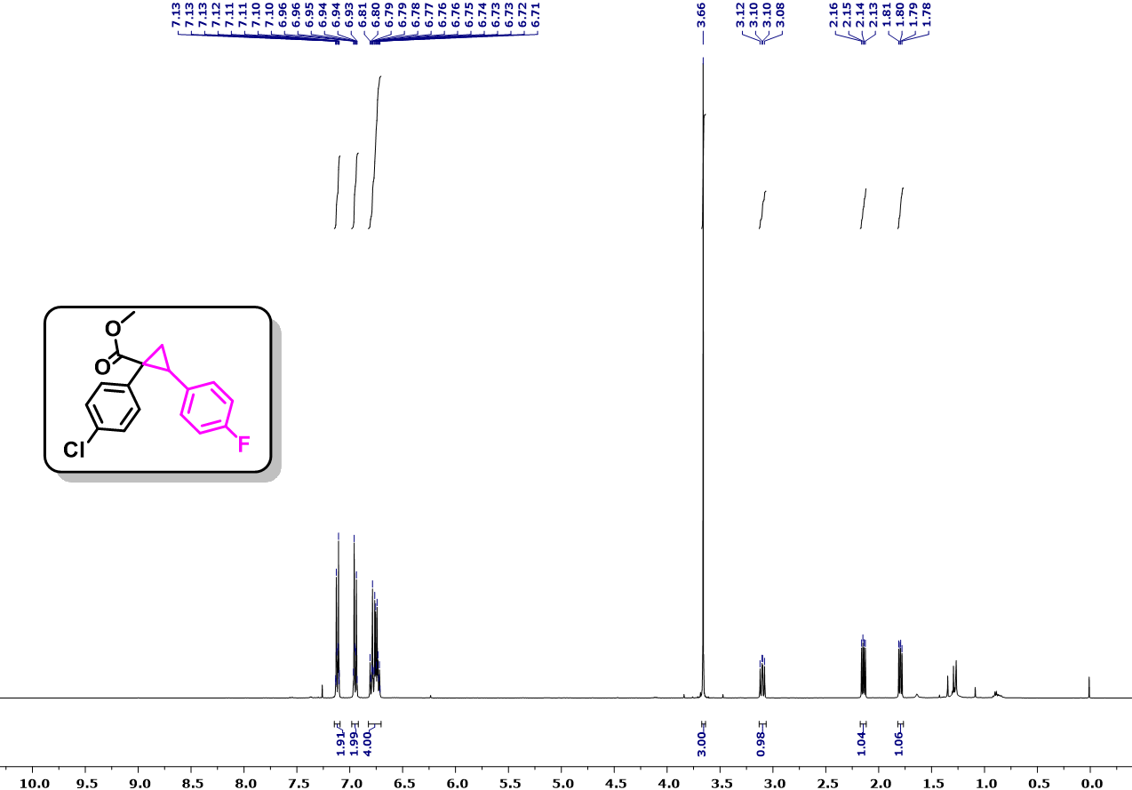
Fig. S164. ¹H NMR (400 MHz, CDCl₃) spectra of methyl 1-(4-chlorophenyl)-2-(4-fluorophenyl)cyclopropane-1-carboxylate (10b).
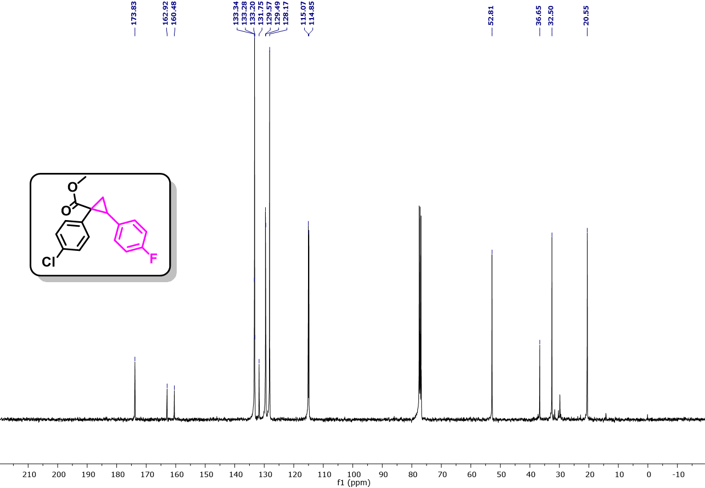
Fig. S165. ¹³C NMR (101 MHz, CDCl₃) spectra of methyl 1-(4-chlorophenyl)-2-(4-fluorophenyl)cyclopropane-1-carboxylate (10b).
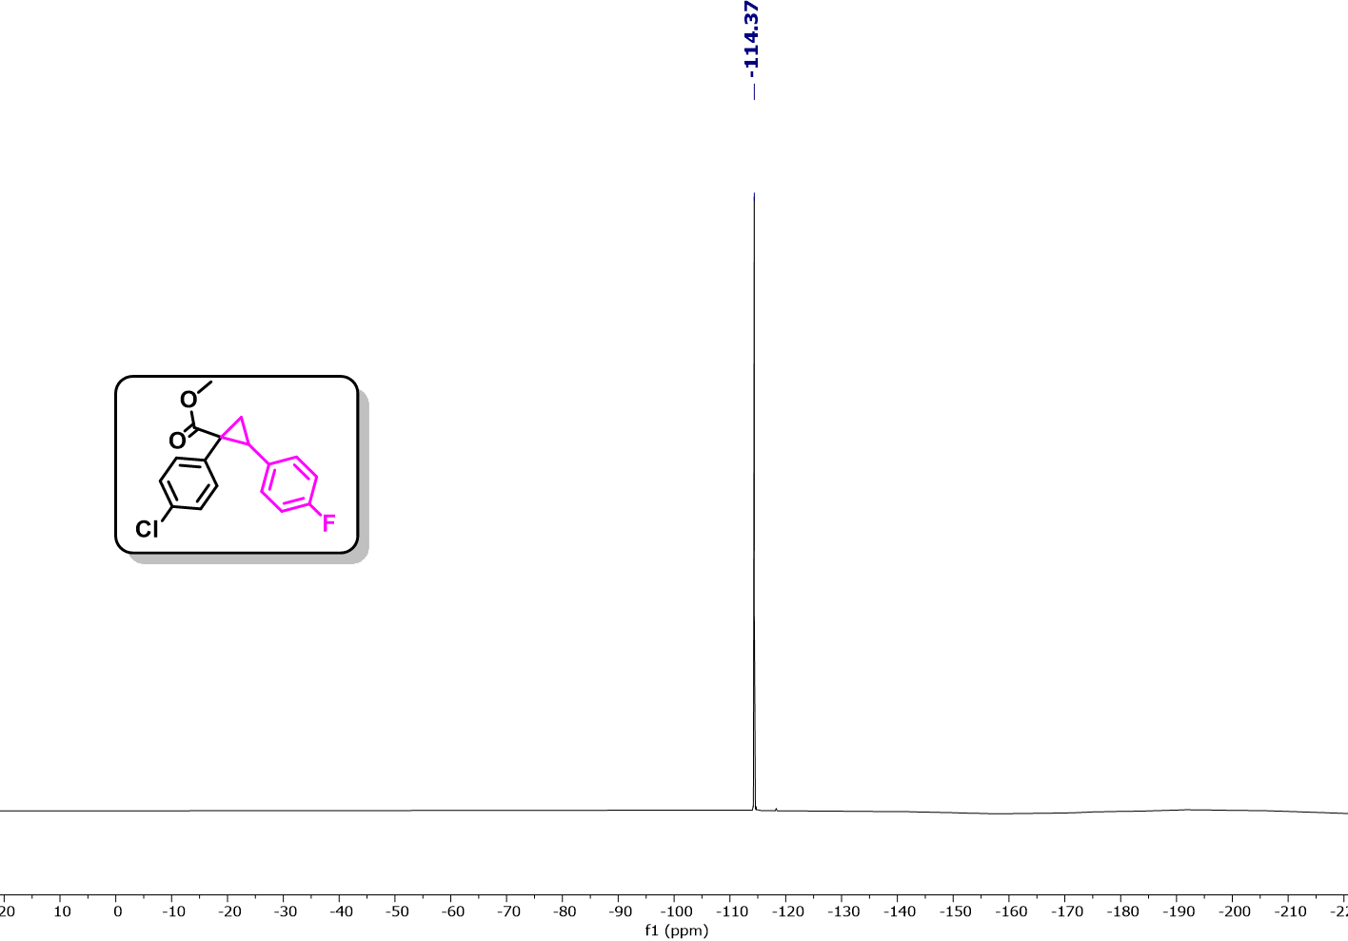
Fig. S166. ¹⁹F NMR (471 MHz, CDCl₃) spectra of methyl 1-(4-chlorophenyl)-2-(4-fluorophenyl)cyclopropane-1-carboxylate (10b).
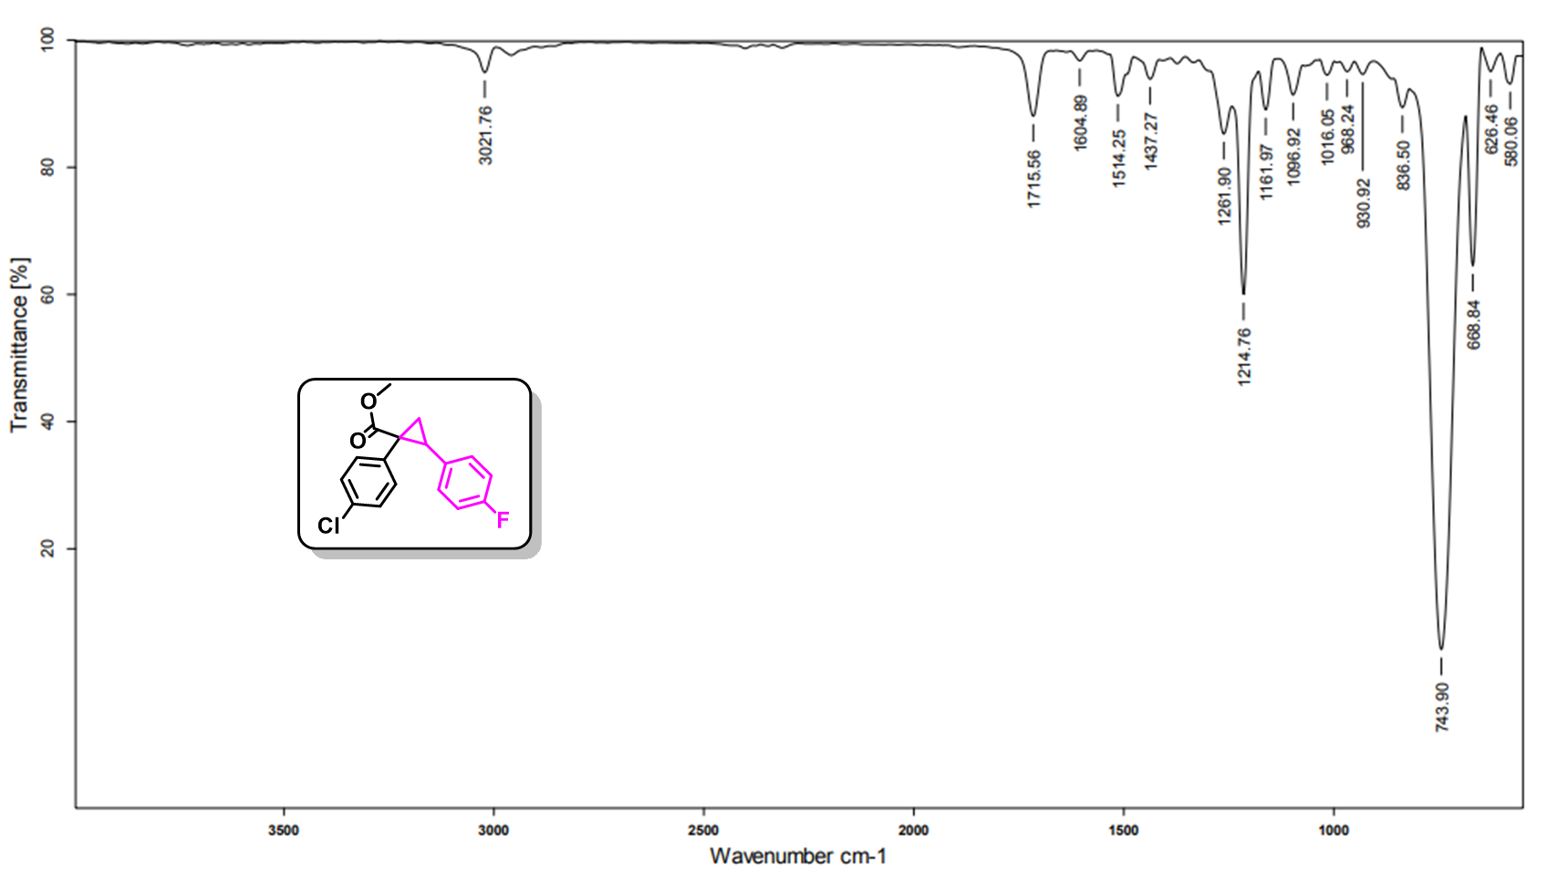
Fig. S167. IR spectra of spectra of methyl 1-(4-chlorophenyl)-2-(4-fluorophenyl)cyclopropane-1-carboxylate (10b).
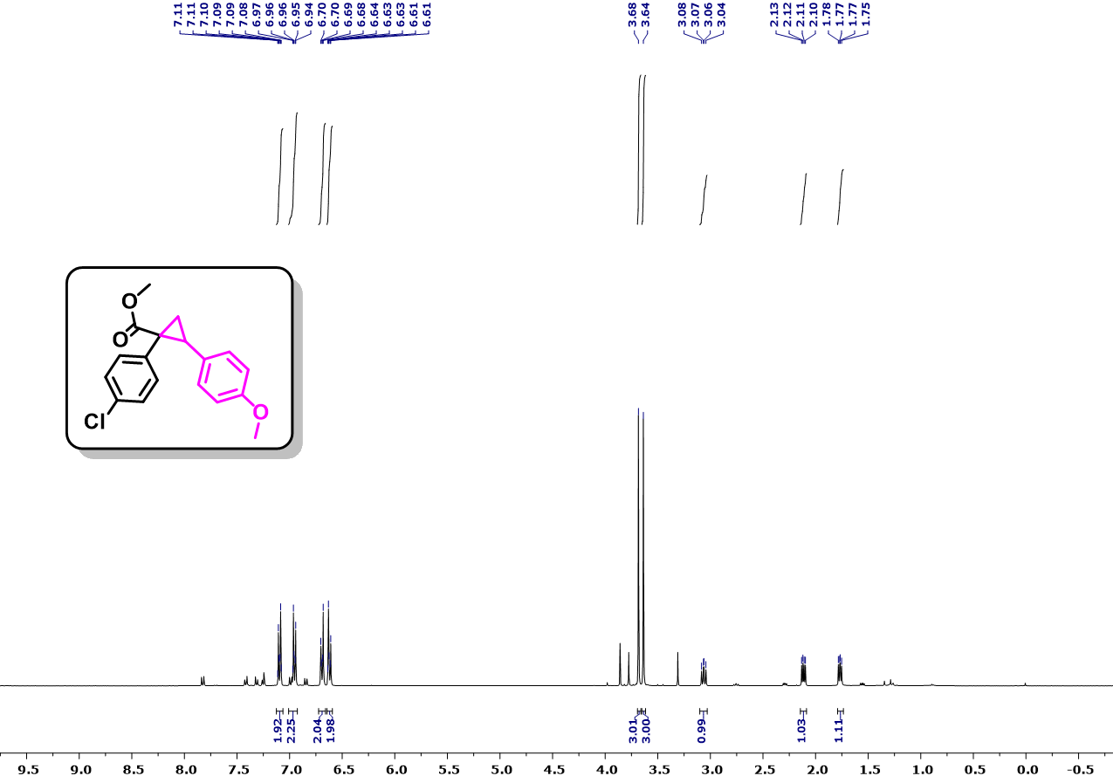
Fig. S168. ¹H NMR (400 MHz, CDCl₃) spectra of methyl 1-(4-chlorophenyl)-2-(4-methoxyphenyl)cyclopropane-1-carboxylate (10c).
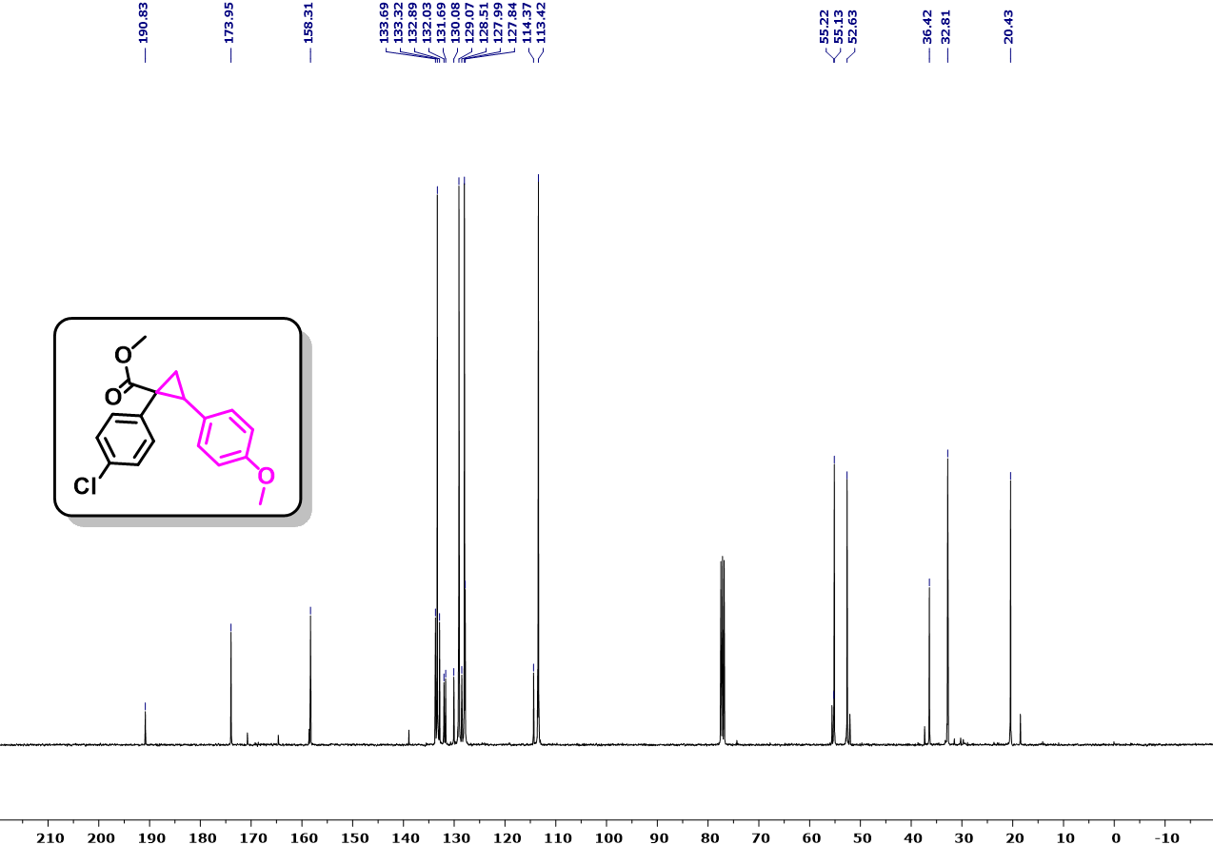
Fig. S169. ¹³C NMR (101 MHz, CDCl₃) spectra of methyl 1-(4-chlorophenyl)-2-(4-methoxyphenyl)cyclopropane-1-carboxylate (10c).
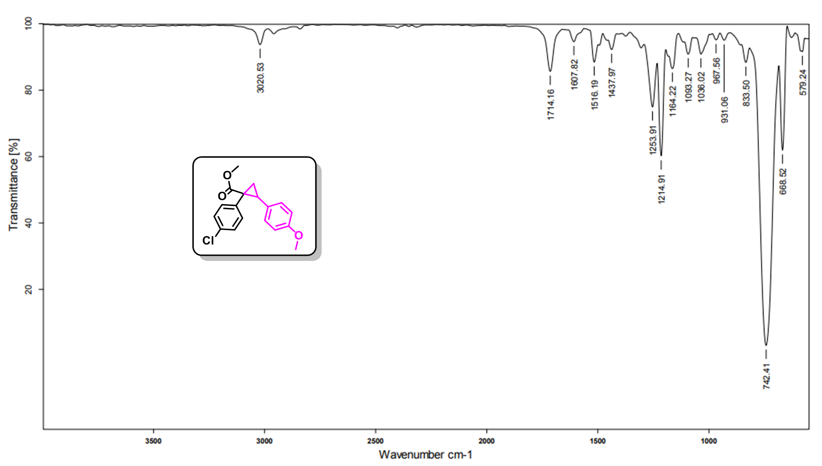
Fig. S170. IR spectra of spectra of methyl 1-(4-chlorophenyl)-2-(4-methoxyphenyl)cyclopropane-1-carboxylate (10c).
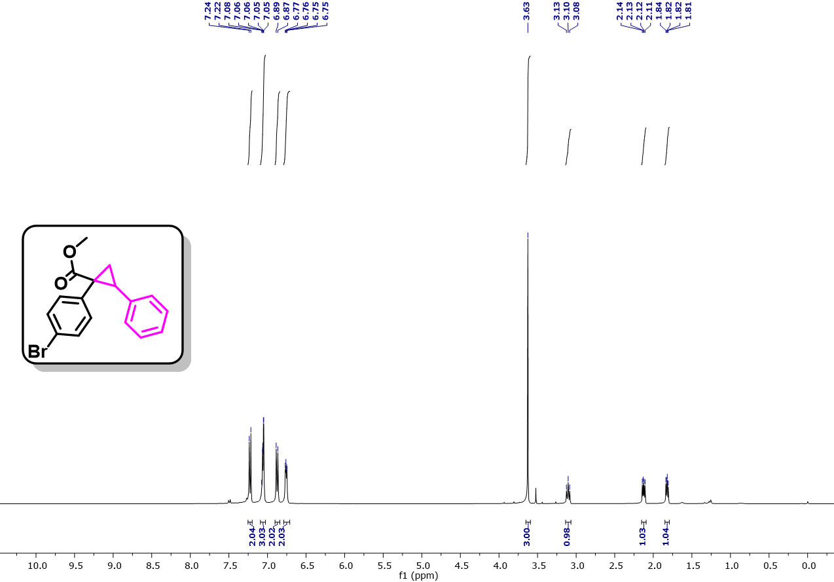
Fig. S171. ¹H NMR (400 MHz, CDCl₃) spectra of methyl 1-(4-bromophenyl)-2-phenylcyclopropane-1-carboxylate (10d).
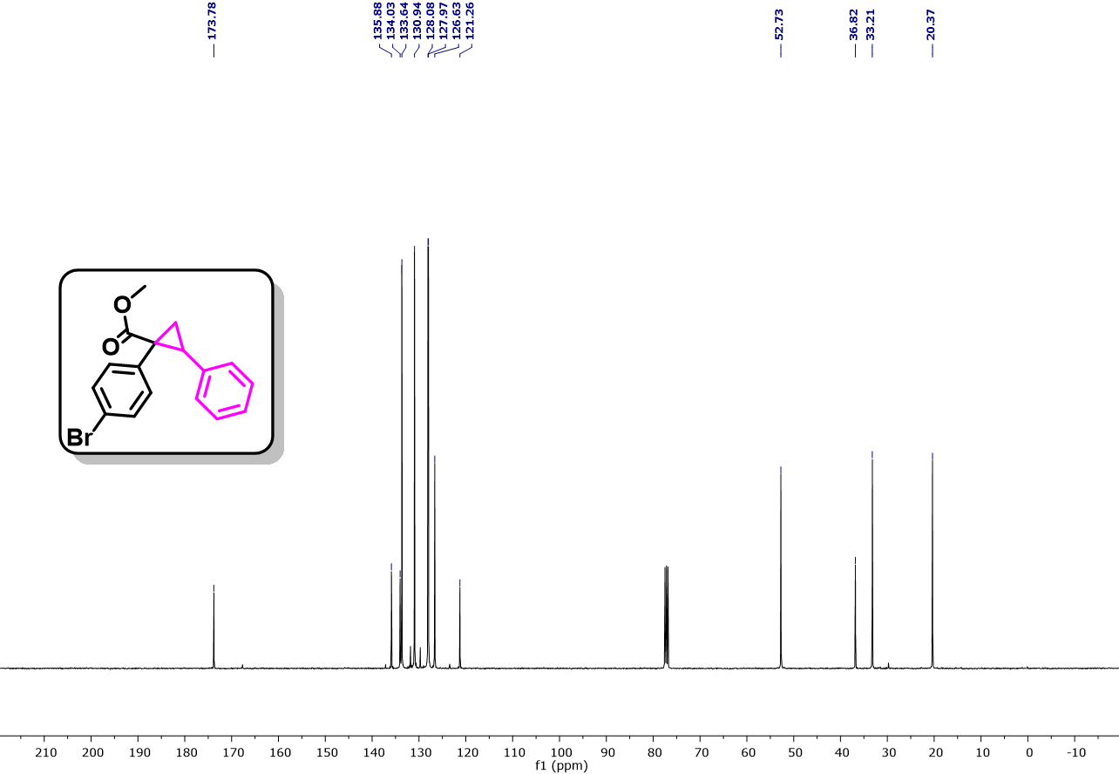
Fig. S172. ¹³C NMR (101 MHz, CDCl₃) spectra of methyl 1-(4-bromophenyl)-2-phenylcyclopropane-1-carboxylate (10d).
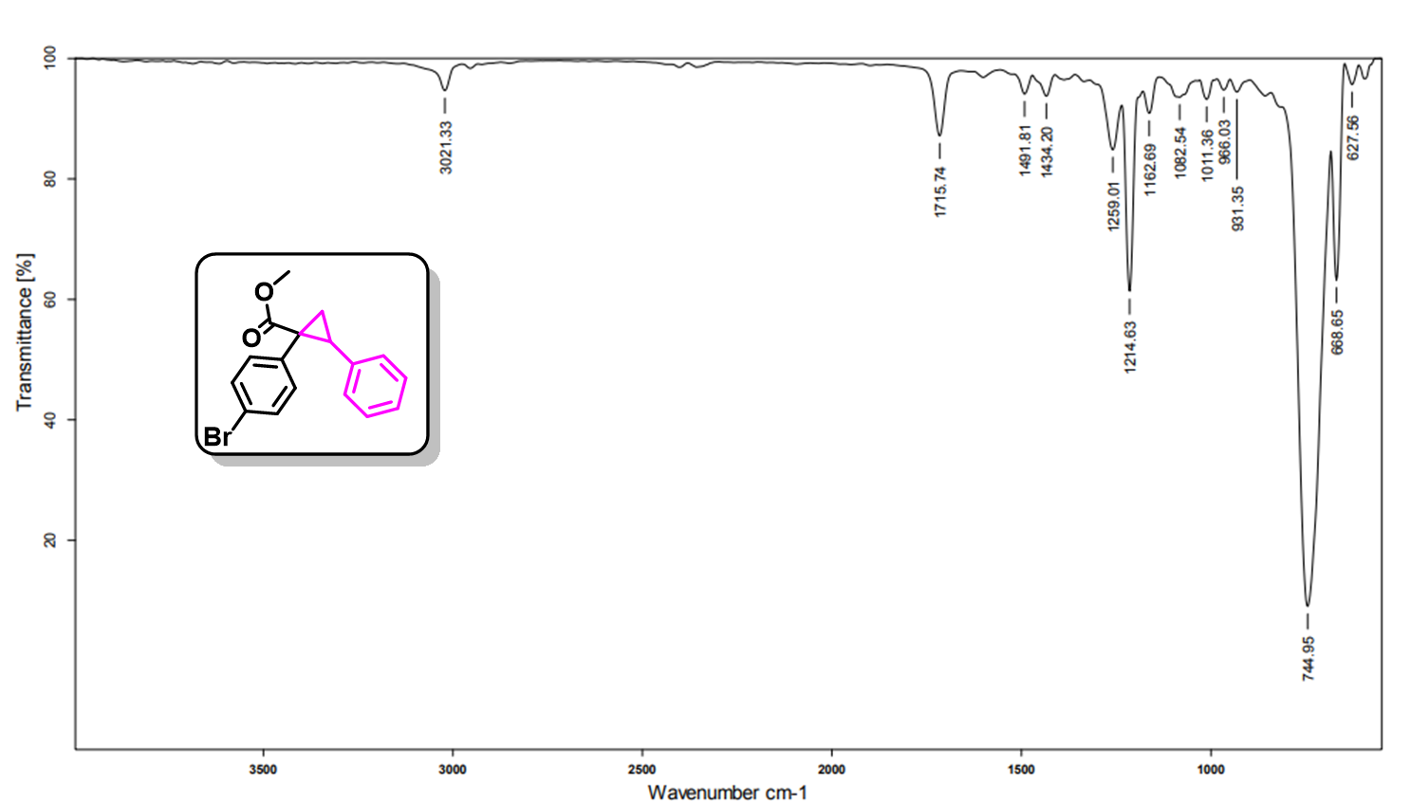
Fig. S173. IR spectra of spectra of methyl 1-(4-bromophenyl)-2-phenylcyclopropane-1-carboxylate (10d).
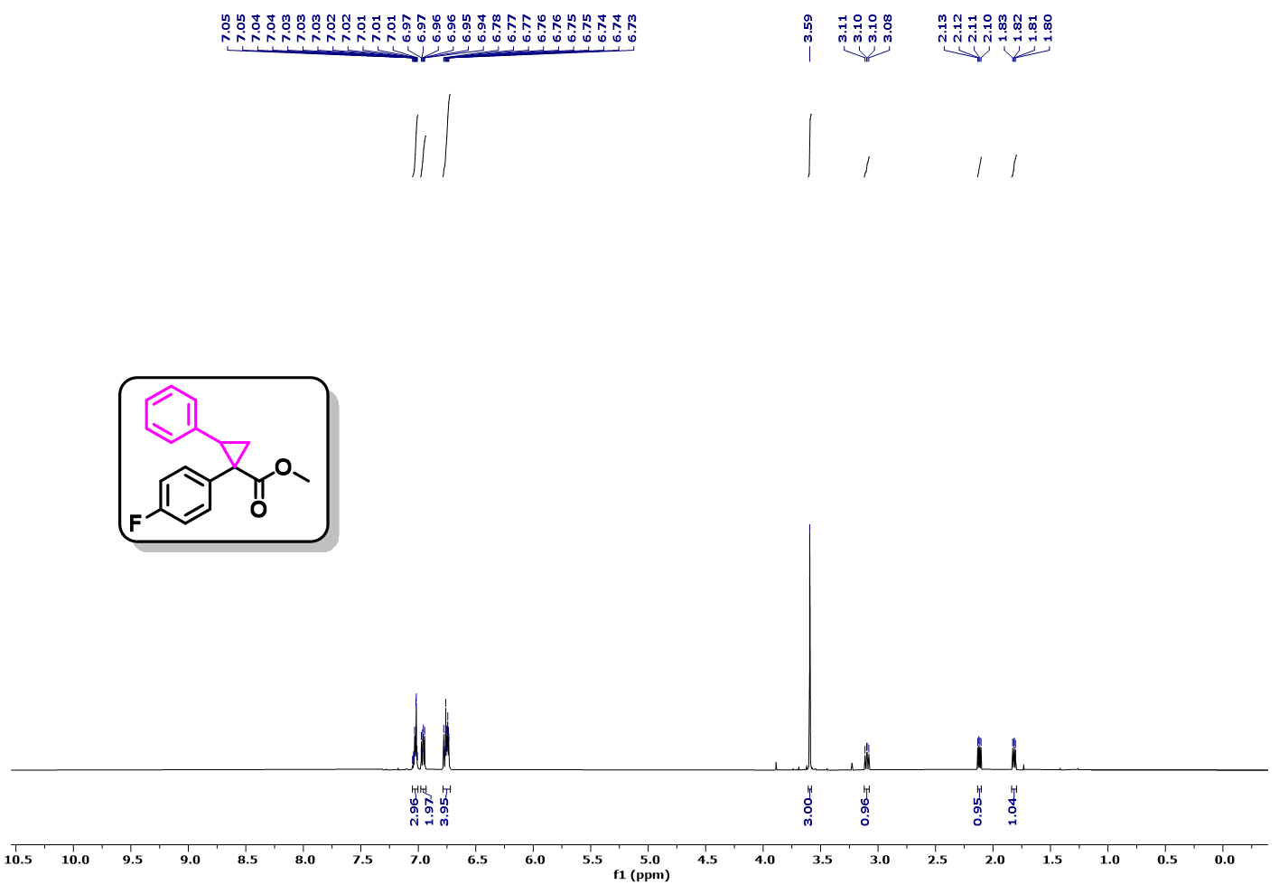
Fig. S174. ¹H NMR (500 MHz, CDCl₃) spectra of methyl 1-(4-fluorophenyl)-2-phenylcyclopropane-1-carboxylate (10e).
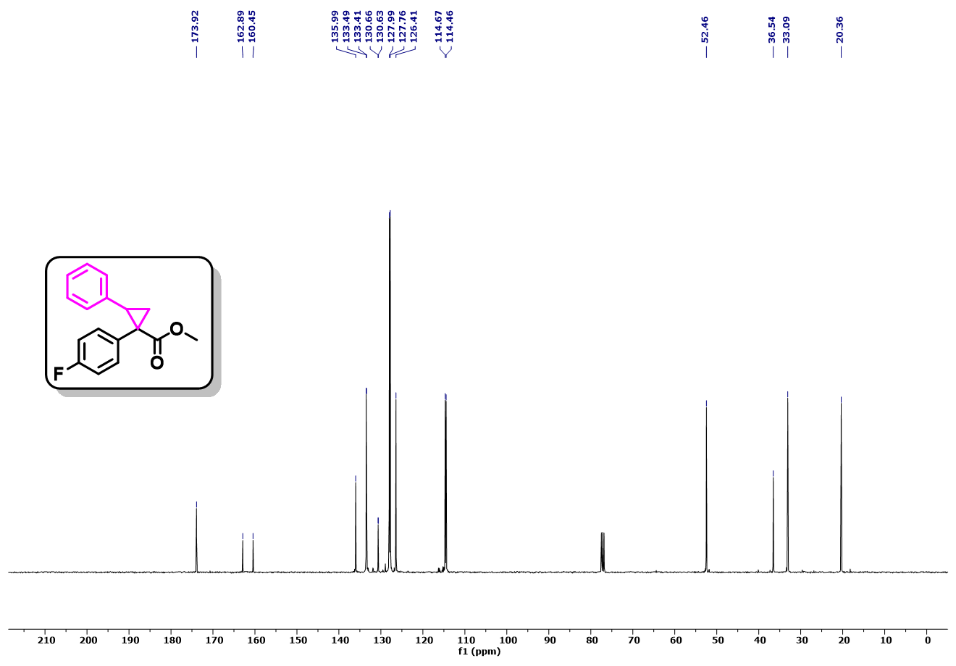
Fig. S175. ¹³C NMR (101 MHz, CDCl₃) spectra of methyl 1-(4-fluorophenyl)-2-phenylcyclopropane-1-carboxylate (10e).
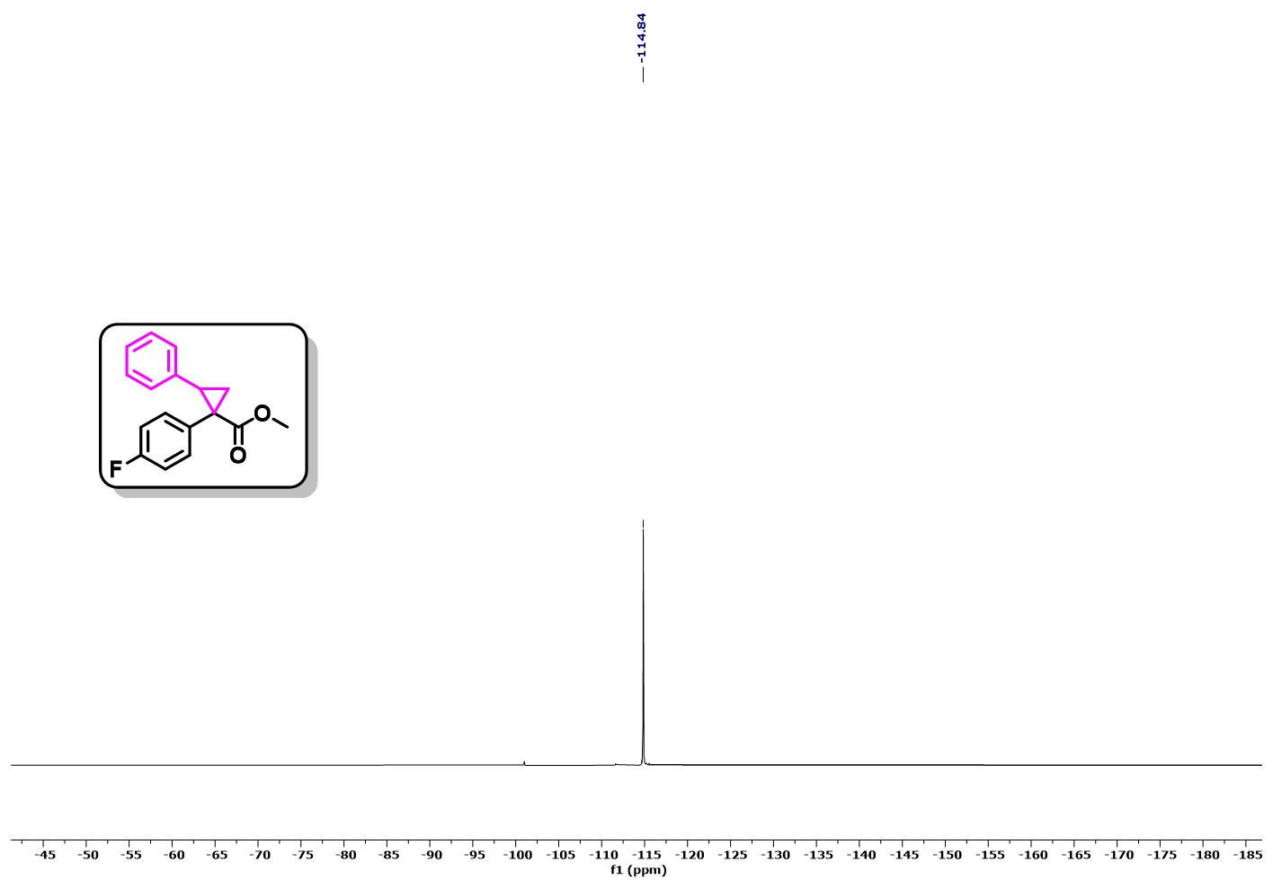
Fig. S176. ¹⁹F NMR (377 MHz, CDCl₃) spectra of methyl 1-(4-fluorophenyl)-2-phenylcyclopropane-1-carboxylate (10e).
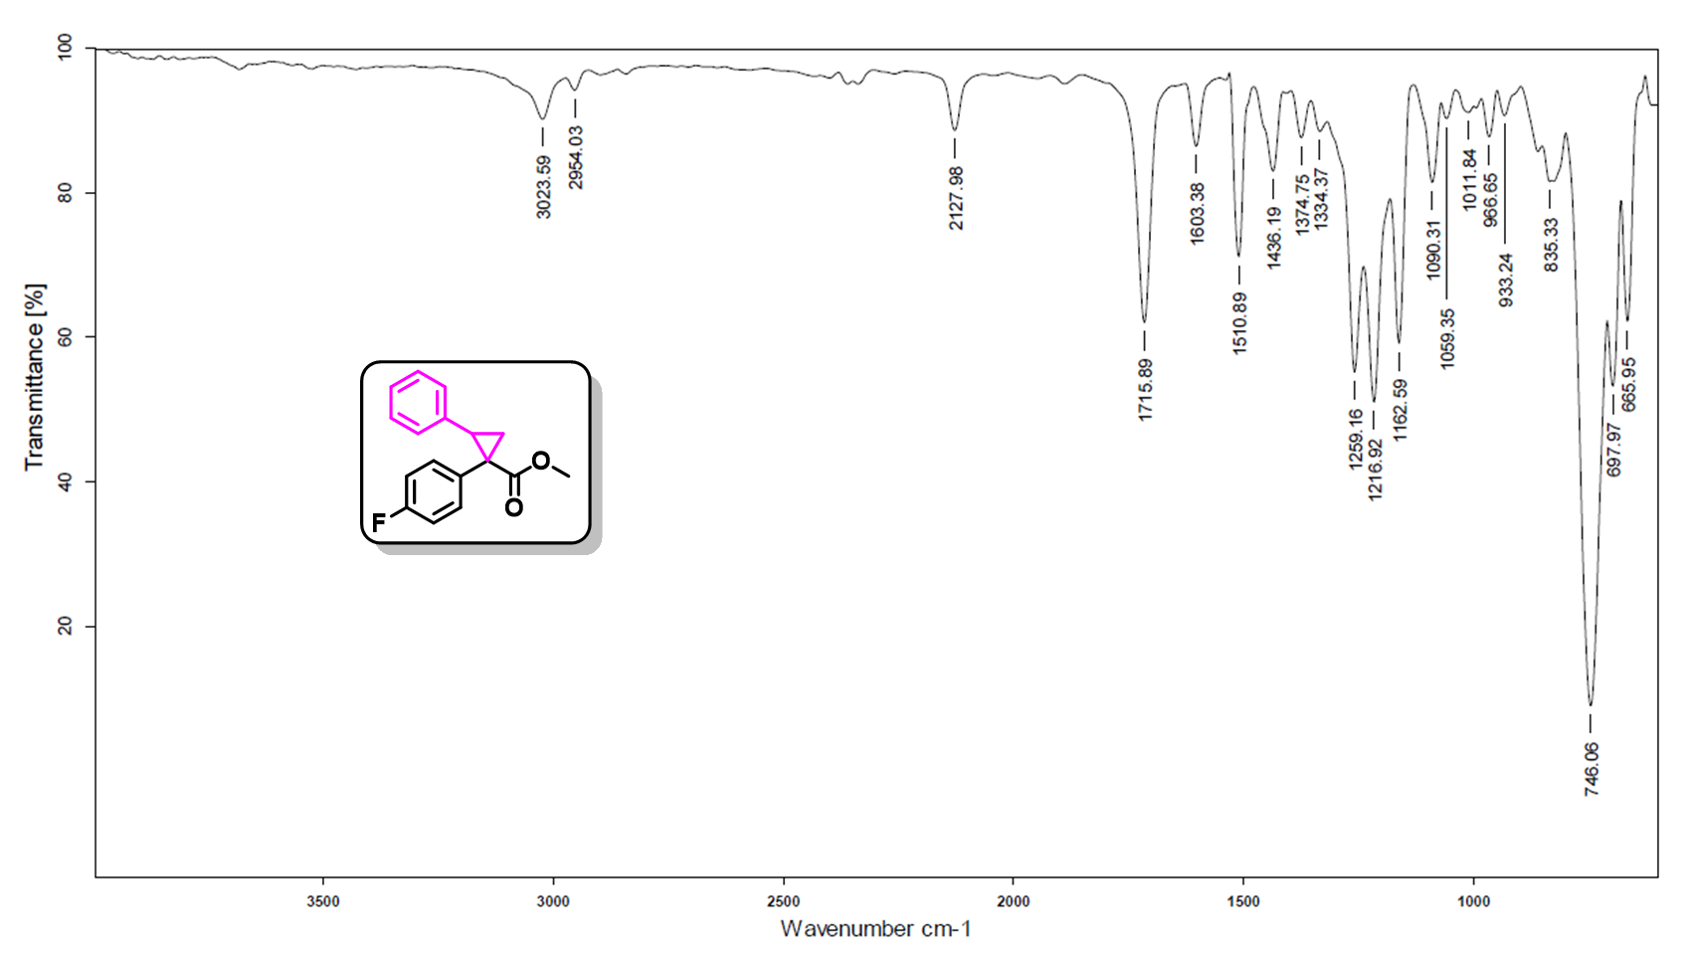
Fig. S177. IR spectra of spectra of methyl 1-(4-fluorophenyl)-2-phenylcyclopropane-1-carboxylate (10e).
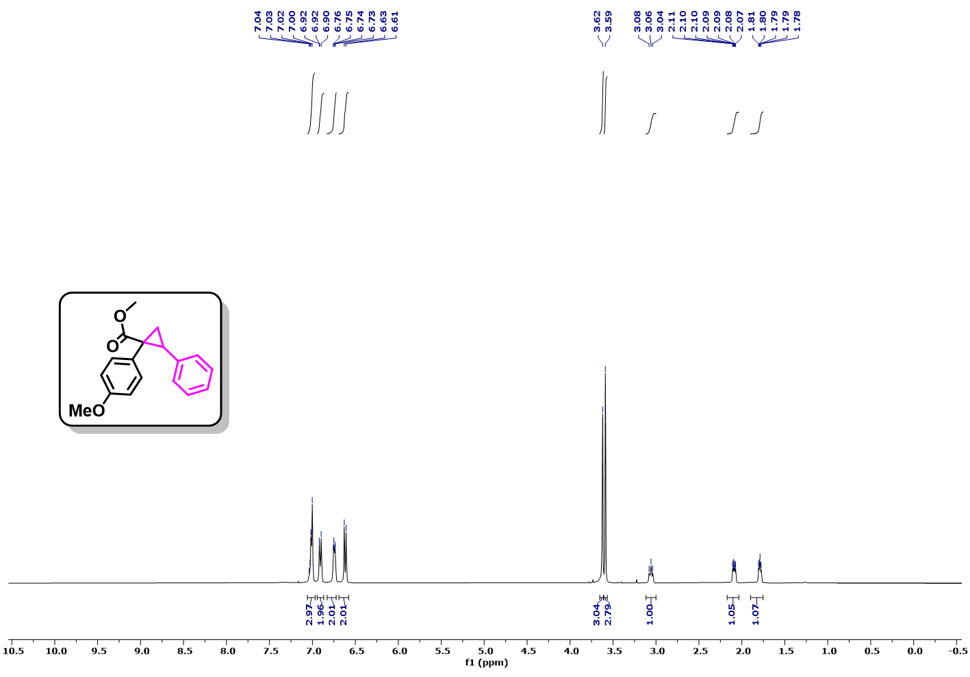
Fig. S178. ¹H NMR (400 MHz, CDCl₃) spectra of methyl 1-(4-methoxyphenyl)-2-phenylcyclopropane-1-carboxylate (10f).
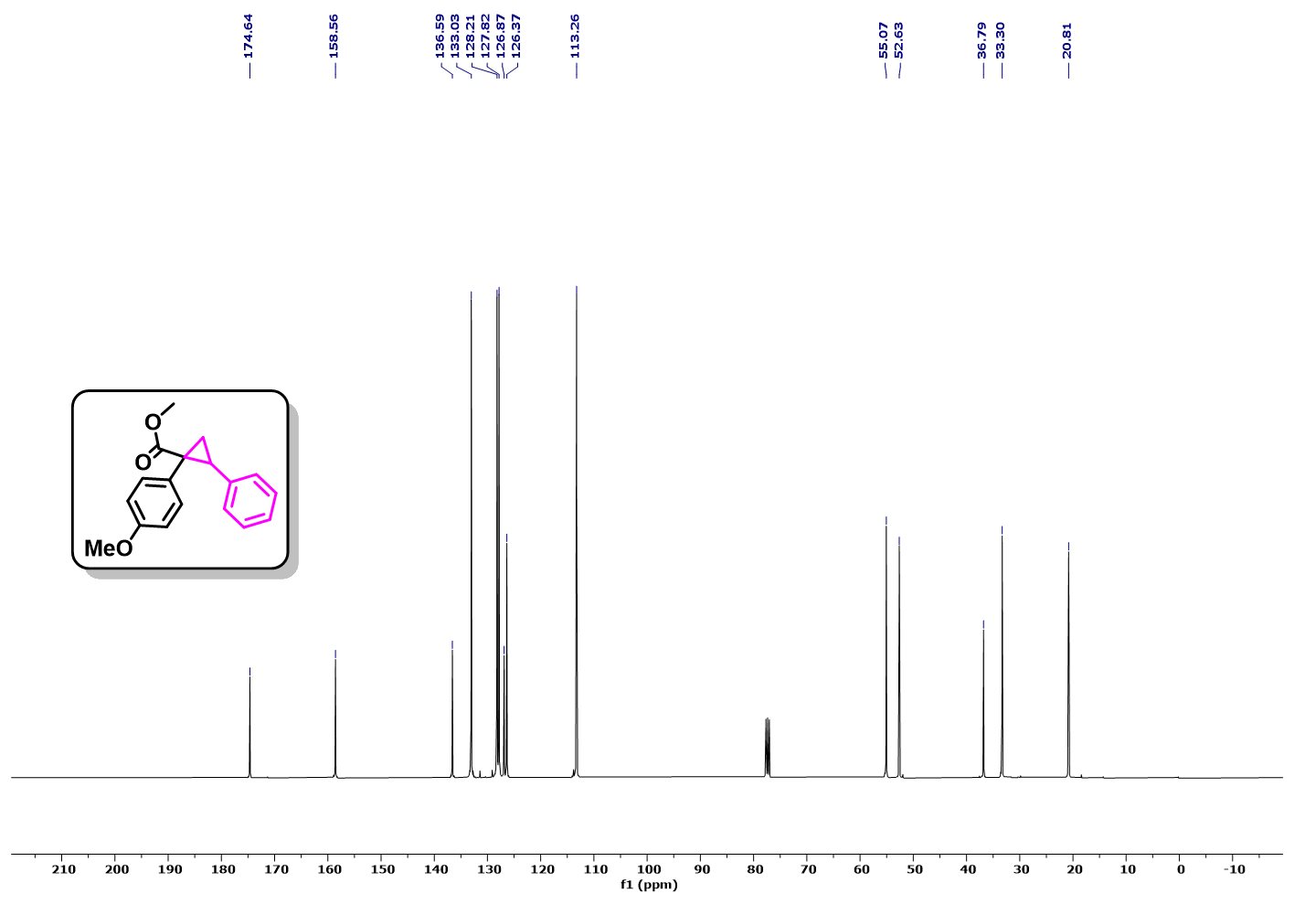
Fig. S179. ¹³C NMR (101 MHz, CDCl₃) spectra of methyl 1-(4-methoxyphenyl)-2-phenylcyclopropane-1-carboxylate (10f).
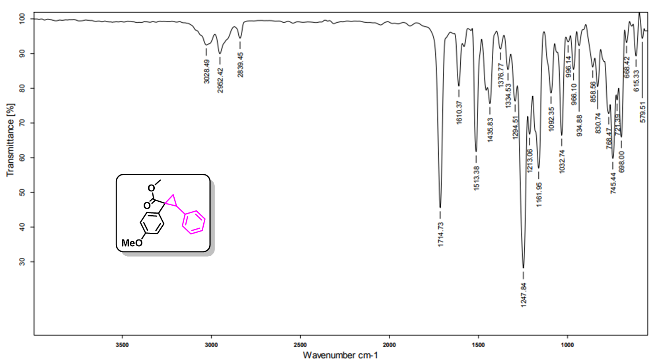
Fig. S180. IR spectra of spectra of methyl 1-(4-methoxyphenyl)-2-phenylcyclopropane-1-carboxylate (10f).
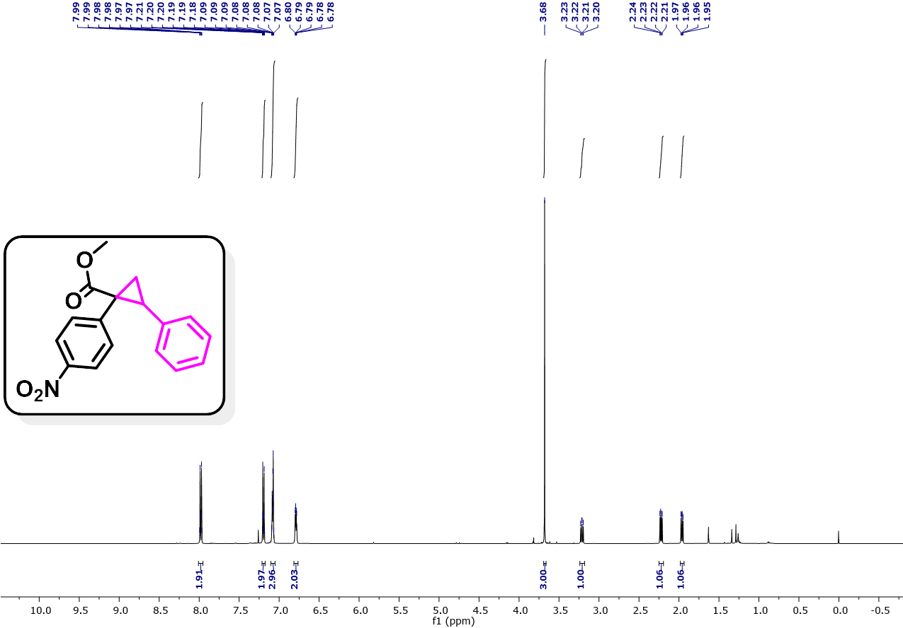
Fig. S181. ¹H NMR (500 MHz, CDCl₃) spectra of methyl 1-(4-nitrophenyl)-2-phenylcyclopropane-1-carboxylate (10g).
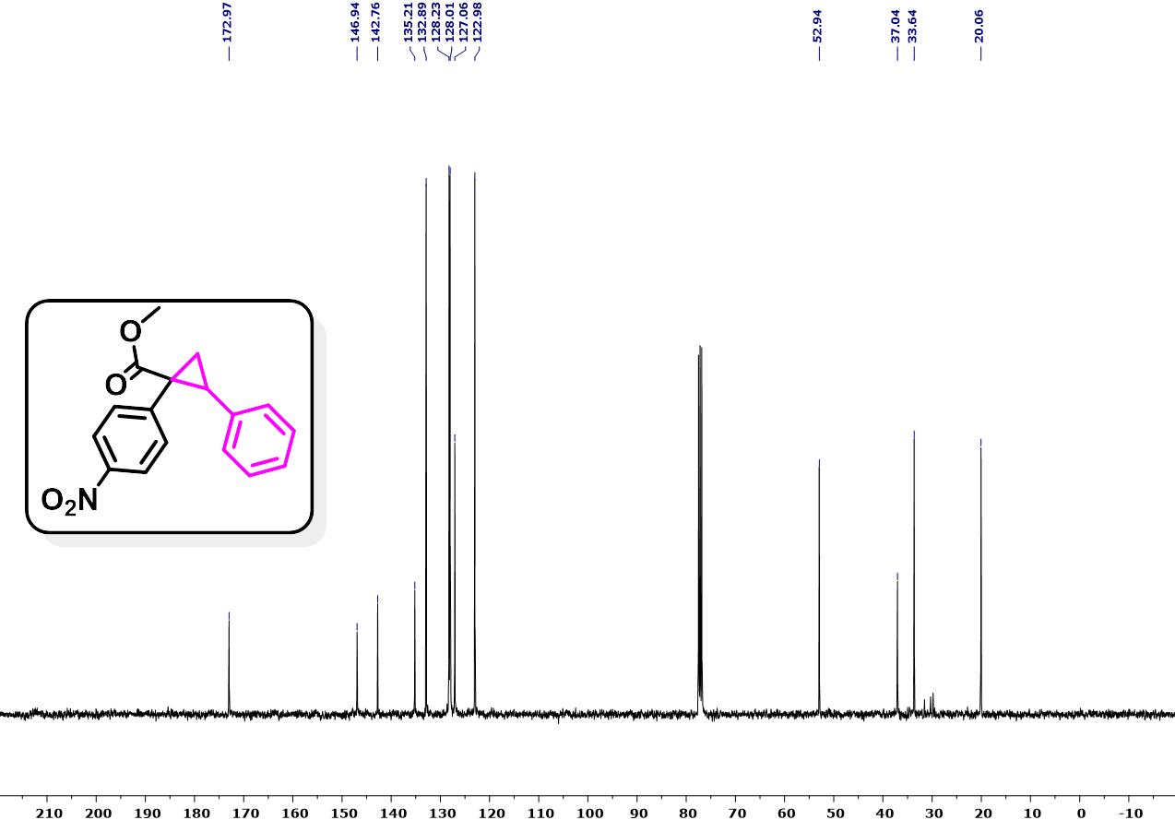
Fig. S182. ¹³C NMR (101 MHz, CDCl₃) spectra of methyl 1-(4-nitrophenyl)-2-phenylcyclopropane-1-carboxylate (10g).
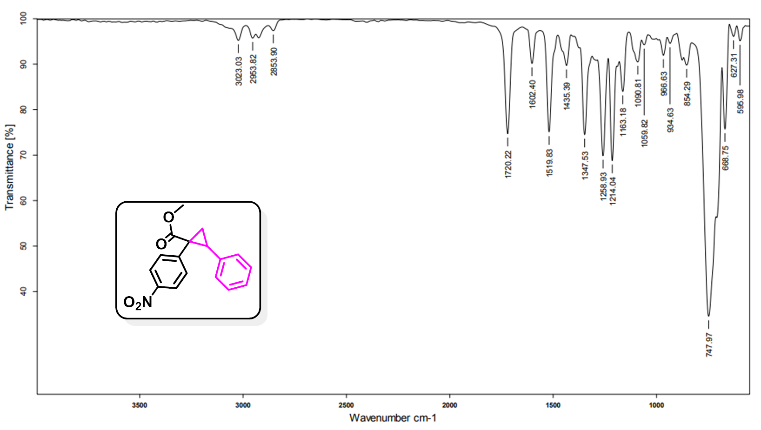
Fig. S183. IR spectra of spectra of methyl 1-(4-nitrophenyl)-2-phenylcyclopropane-1-carboxylate (10g).
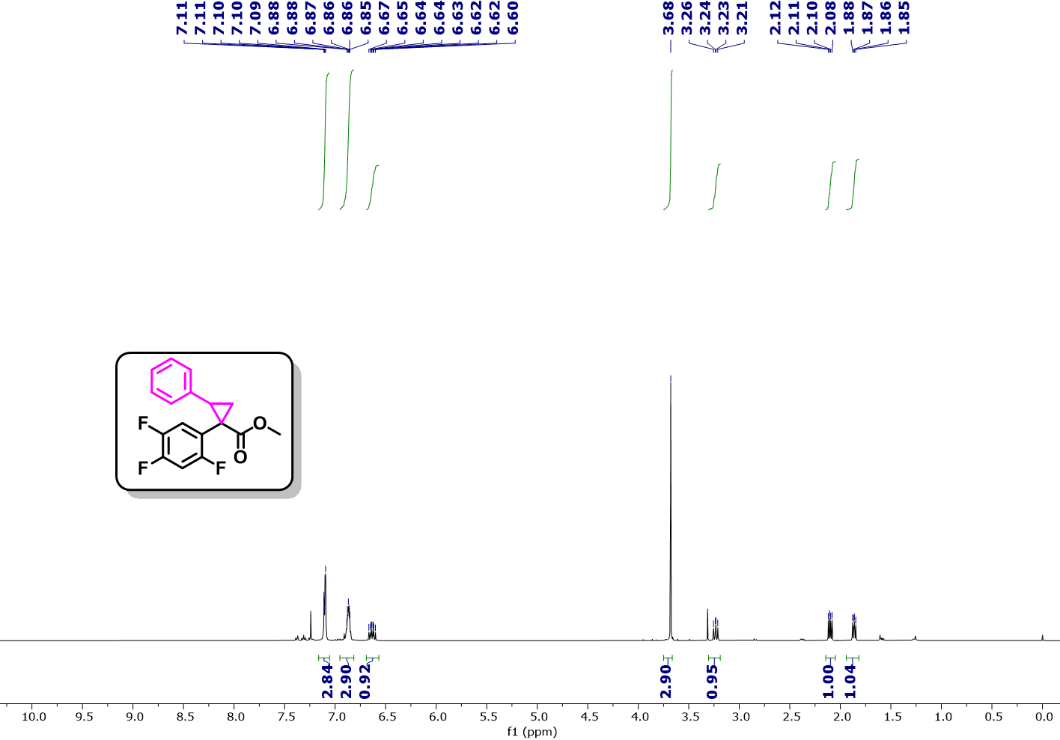
Fig. S184. ¹H NMR (400 MHz, CDCl₃) spectra of methyl 2-phenyl-1-(2,4,5-trifluorophenyl)cyclopropane-1-carboxylate (10h).
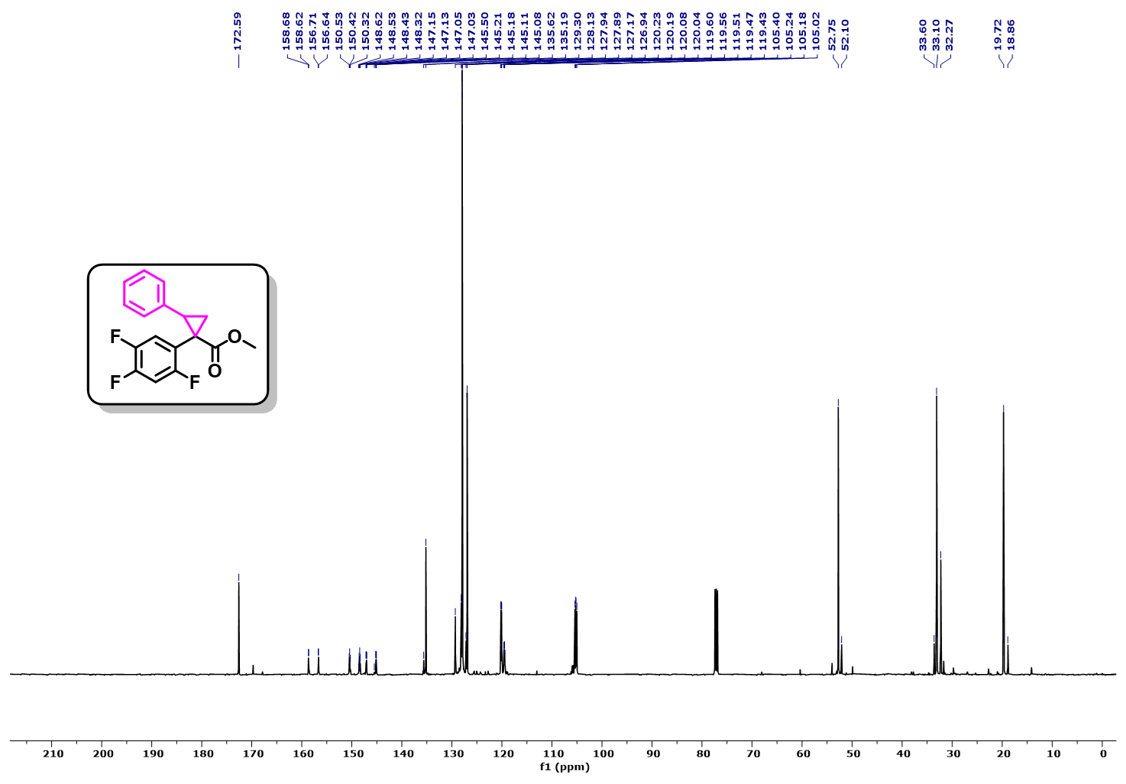
Fig. S185. ¹³C NMR (126 MHz, CDCl₃) spectra of methyl methyl 2-phenyl-1-(2,4,5-trifluorophenyl)cyclopropane-1-carboxylate (10h).
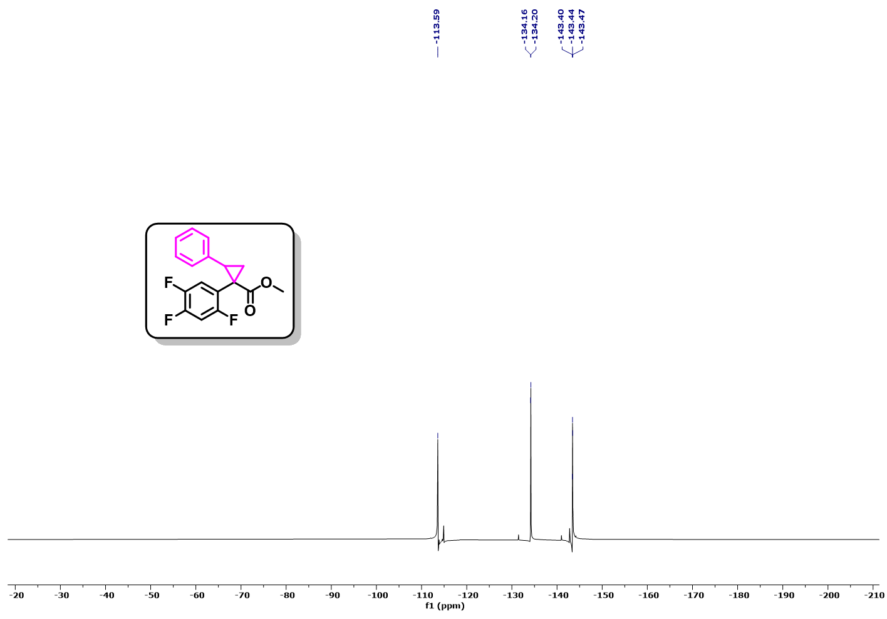
Fig. S186. ¹⁹F NMR (471 MHz, CDCl₃) spectra of methyl 2-phenyl-1-(2,4,5-trifluorophenyl)cyclopropane-1-carboxylate (10h).
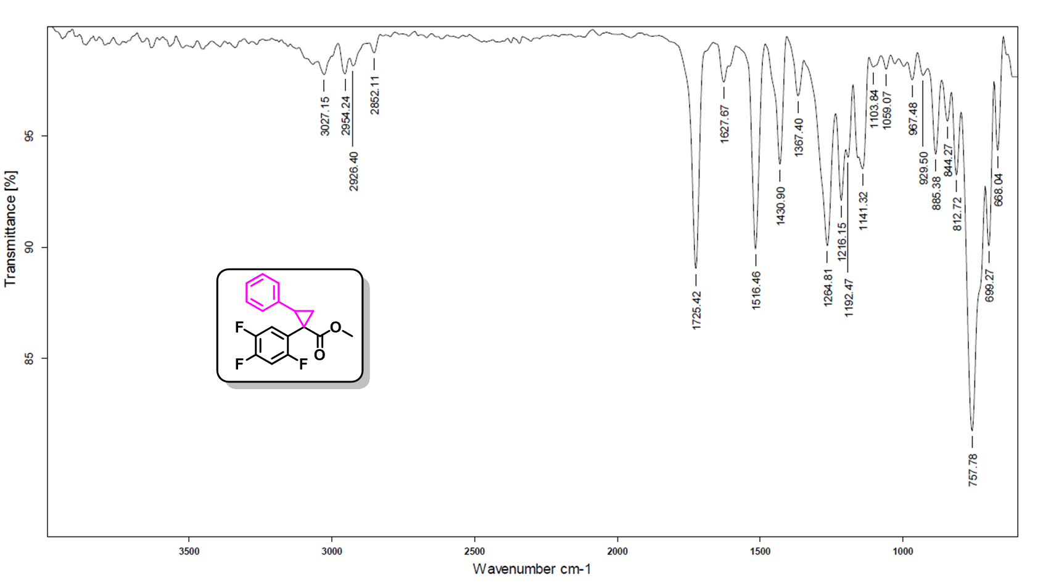
Fig. S187. IR spectra of spectra of methyl 2-phenyl-1-(2,4,5-trifluorophenyl)cyclopropane-1-carboxylate (10h).
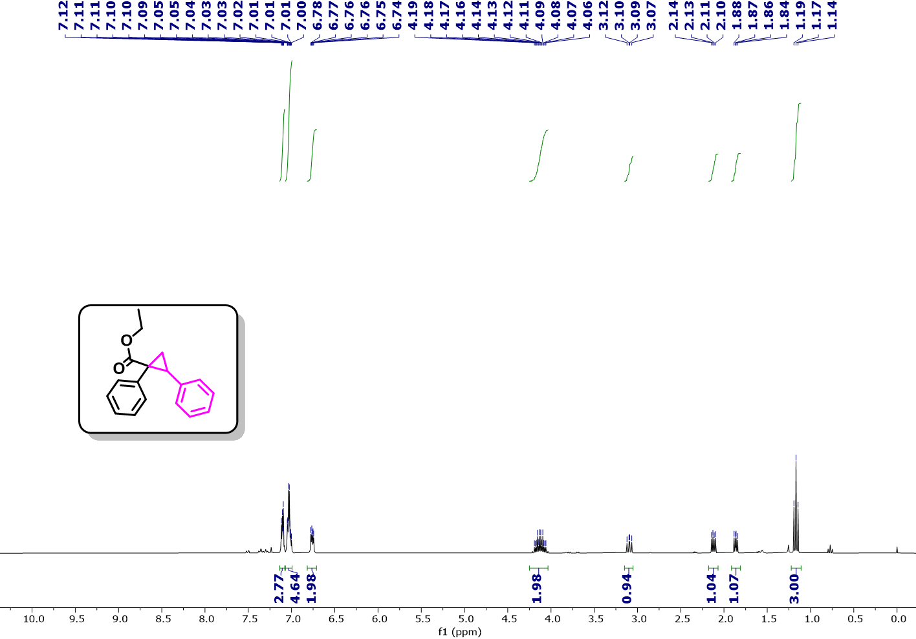
Fig. S188. ¹H NMR (300 MHz, CDCl₃) spectra of ethyl 1,2-diphenylcyclopropane-1-carboxylate (10i).
Fig. S189. ¹³C NMR (101 MHz, CDCl₃) spectra of ethyl 1,2-diphenylcyclopropane-1-carboxylate (10i).
Fig. S190. IR spectra of spectra of ethyl 1,2-diphenylcyclopropane-1-carboxylate (10i).
Fig. S191. ¹H NMR (400 MHz, CDCl₃) spectra of methyl 1-(4-chlorophenyl)-2-phenylcycloprop-2-ene-1-carboxylate (12a).
Fig. S192. ¹³C NMR (126 MHz, CDCl₃) spectra of methyl 1-(4-chlorophenyl)-2-phenylcycloprop-2-ene-1-carboxylate (12a).
Fig. S193. IR spectra of spectra of methyl 1-(4-chlorophenyl)-2-phenylcycloprop-2-ene-1-carboxylate (12a).
Fig. S194. ¹H NMR (500 MHz, CDCl₃) spectra of methyl 1-(4-chlorophenyl)-2-(3-fluorophenyl)cycloprop-2-ene-1-carboxylate (12b).
Fig. S195. ¹³C NMR (101 MHz, CDCl₃) spectra of methyl 1-(4-chlorophenyl)-2-(3-fluorophenyl)cycloprop-2-ene-1-carboxylate (12b).
Fig. S196. IR spectra of spectra of methyl 1-(4-chlorophenyl)-2-(3-fluorophenyl)cycloprop-2-ene-1-carboxylate (12b).
Fig. S197. ¹H NMR (400 MHz, CDCl₃) spectra of methyl 1-(4-bromophenyl)-2-phenylcycloprop-2-ene-1-carboxylate (12c).
Fig. S198. ¹³C NMR (101 MHz, CDCl₃) spectra of methyl 1-(4-bromophenyl)-2-phenylcycloprop-2-ene-1-carboxylate (12c).
Fig. S199. IR spectra of spectra of methyl 1-(4-bromophenyl)-2-phenylcycloprop-2-ene-1-carboxylate (12c).
Fig. S200. ¹H NMR (500 MHz, CDCl₃) spectra of methyl 1-(4-fluorophenyl)-2-phenylcycloprop-2-ene-1-carboxylate (12d).
Fig. S201. ¹³C NMR (101 MHz, CDCl₃) spectra of methyl 1-(4-fluorophenyl)-2-phenylcycloprop-2-ene-1-carboxylate (12d).
Fig. S202. ¹⁹F NMR (377 MHz, CDCl₃) spectra of methyl 1-(4-fluorophenyl)-2-phenylcycloprop-2-ene-1-carboxylate (3c).
Fig. S203. IR spectra of spectra of methyl 1-(4-fluorophenyl)-2-phenylcycloprop-2-ene-1-carboxylate (3c).
Fig. S204. ¹H NMR (400 MHz, CDCl₃) spectra of methyl 1-(4-methoxyphenyl)-2-phenylcycloprop-2-ene-1-carboxylate (12e).
Fig. S205. ¹³C NMR (101 MHz, CDCl₃) spectra of methyl 2-(4-fluorophenyl)-1-(4-methoxyphenyl)cycloprop-2-ene-1-carboxylate (12e).
Fig. S206. IR spectra of spectra of methyl 2-(4-fluorophenyl)-1-(4-methoxyphenyl)cycloprop-2-ene-1-carboxylate (12e).
Fig. S207. ¹H NMR (400 MHz, CDCl₃) spectra of methyl 1-(4-nitrophenyl)-2-phenylcycloprop-2-ene-1-carboxylate (12f).
Fig. S208. ¹³C NMR (101 MHz, CDCl₃) spectra of methyl 1-(4-nitrophenyl)-2-phenylcycloprop-2-ene-1-carboxylate (12f).
Fig. S209. IR spectra of spectra of methyl 1-(4-nitrophenyl)-2-phenylcycloprop-2-ene-1-carboxylate (12f).
Fig. S210. ¹H NMR (400 MHz, CDCl₃) spectra of methyl 2-(4-fluorophenyl)-1-(4-methoxyphenyl)cycloprop-2-ene-1-carboxylate (12g).
Fig. S211. ¹³C NMR (101 MHz, CDCl₃) spectra of methyl 2-(4-fluorophenyl)-1-(4-methoxyphenyl)cycloprop-2-ene-1-carboxylate (12g).
Fig. S212. ¹⁹F NMR (376 MHz, CDCl₃) spectra of methyl 2-(4-fluorophenyl)-1-(4-methoxyphenyl)cycloprop-2-ene-1-carboxylate (12g).
Fig. S213. IR spectra of spectra of methyl 2-(4-fluorophenyl)-1-(4-methoxyphenyl)cycloprop-2-ene-1-carboxylate (12g).
Fig. S214. ¹H NMR (500 MHz, CDCl₃) spectra of methyl 2-phenyl-1-(2,4,5-trifluorophenyl)cycloprop-2-ene-1-carboxylate (12h).
Fig. S215. ¹³C NMR (176 MHz, CDCl₃) spectra of methyl 2-phenyl-1-(2,4,5-trifluorophenyl)cycloprop-2-ene-1-carboxylate (12h).
Fig. S216. ¹⁹F NMR (471 MHz, CDCl₃) spectra of methyl 2-phenyl-1-(2,4,5-trifluorophenyl)cycloprop-2-ene-1-carboxylate (12h).
Fig. S217. IR spectra of spectra of methyl 2-phenyl-1-(2,4,5-trifluorophenyl)cycloprop-2-ene-1-carboxylate (3h).
Fig. S218. ¹H NMR (500 MHz, CDCl₃) spectra of 4-(4-chlorophenyl)-5-methoxy-2-methyloxazole (14a).
Fig. S219. ¹³C NMR (101 MHz, CDCl₃) spectra of 4-(4-chlorophenyl)-5-methoxy-2-methyloxazole (14a).
Fig. S220. IR spectra of spectra of 4-(4-chlorophenyl)-5-methoxy-2-methyloxazole (14a).
Fig. S221. ¹H NMR (400 MHz, CDCl₃) spectra of 4-ethyl 1-methyl 2-(4-chlorophenyl)maleate (16a).
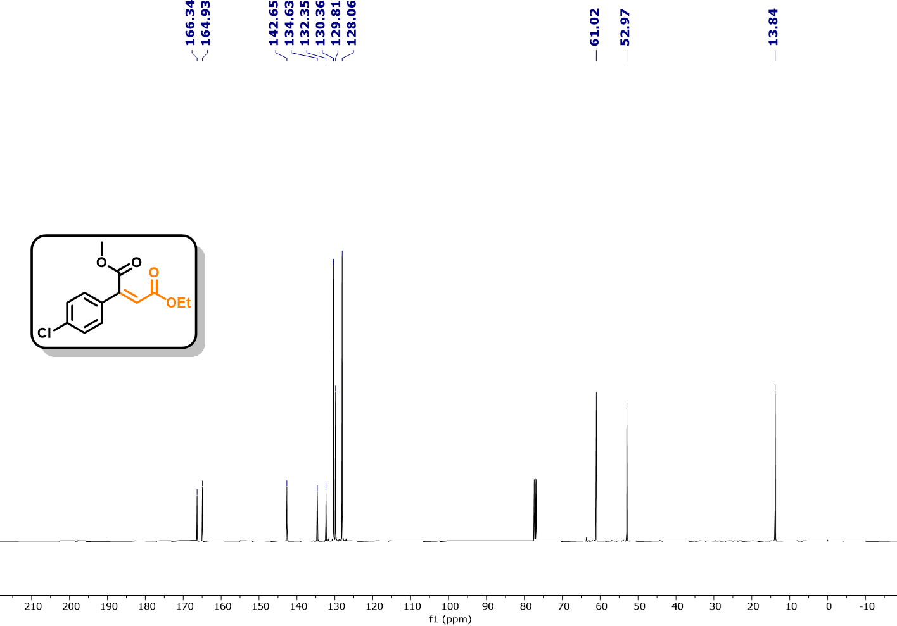
Fig. S222. ¹³C NMR (126 MHz, CDCl₃) spectra of 4-ethyl 1-methyl 2-(4-chlorophenyl)maleate (16a).
Fig. S223. IR spectra of spectra of 4-ethyl 1-methyl 2-(4-chlorophenyl)maleate (16a).

S12. Troubleshooting
Question: Where to buy AI-system for the reaction optimization?
Answer: No need to buy from any place the python code is available in supporting information.
Question: Where to buy the 3D printer and Arduino board?
Answer: We bought through Amazon.
Question: Any other company photo-flow reactor will work?
Answer: Yes, it’ll work but need to change the python code accordingly.
Question: Does other tube id work?
Answer: Other higher tube id (e.g., 2-5 mm) also work, but further need to optimize to get the optimal condition.
Question: Does code will work for the production 100 kg scale?
Answer: Yes, it’ll work but further auto-optimization may give you better reaction condition.
Question: Does current code will work with any other company hardware set-up?
Answer: Yes, it’ll work but slight modification needed in python code.
Question: Can we replace the In-line IR with other analysis unit?
Answer: Yes, you can replace with HPLC, In-line NMR, GC-MS, LC-MS, XAS etc but the analysis code need to rewrite as per the analysis system manual.
Question: Do we need the super computer to run the auto-reaction optimization?
Answer: We don’t need any supercomputer. Any normal PC will work for the reaction auto-optimization and on demand synthesis.
Question: Optimization will have effected by the current failure?
Answer: Yes, before starting the experiment make sure system have proper battery back-up.
Question: How many pump we can connect with one AI system?
Answer: Infinite.

S13. References:
1 Rana, A., Chauhan, R. & Singh, A. K. Thermal/photochemical micro-flow probe system for direct C–H bond functionalization of biologically active molecules. React. Chem. Eng., 9, 1313-1319, doi:10.1039/D4RE00083H (2024).
2 Jurberg, I. D. & Davies, H. M. L. Blue light-promoted photolysis of aryldiazoacetates. Chem. Sci., 9, 5112-5118, doi:10.1039/C8SC01165F (2018).
3 Tan, F. et al. Asymmetric Catalytic Insertion of α-Diazo Carbonyl Compounds into O–H Bonds of Carboxylic Acids. ACS Catal., 6, 6930-6934, doi:10.1021/acscatal.6b02184 (2016).
4 Keipour, H., Jalba, A., Delage-Laurin, L. & Ollevier, T. Copper-Catalyzed Carbenoid Insertion Reactions of α-Diazoesters and α-Diazoketones into Si–H and S–H Bonds. J. Org. Chem., 82, 3000-3010, doi:10.1021/acs.joc.6b02998 (2017).
5 Keipour, H., Jalba, A., Tanbouza, N., Carreras, V. & Ollevier, T. α-Thiocarbonyl synthesis via the FeII-catalyzed insertion reaction of α-diazocarbonyls into S–H bonds. Org. Biomol. Chem., 17, 3098-3102, doi:10.1039/C9OB00261H (2019).
6 Pan, J. B. et al. A Spiro Phosphamide Catalyzed Enantioselective Proton Transfer of Ylides in a Free Carbene Insertion into N− H Bonds. Angew. Chem., 135, e202300691 (2023).
7 Wang, B., Howard, I. G., Pope, J. W., Conte, E. D. & Deng, Y. Bis (imino) pyridine iron complexes for catalytic carbene transfer reactions. Chem. Sci., 10, 7958-7963 (2019).
8 Wang, B., Howard, I. G., Pope, J. W., Conte, E. D. & Deng, Y. Bis(imino)pyridine iron complexes for catalytic carbene transfer reactions. Chem. Sci., 10, 7958-7963, doi:10.1039/C9SC02189B (2019).
9 Dasgupta, A. et al. Borane-catalyzed stereoselective C–H insertion, cyclopropanation, and ring-opening reactions. Chem 6, 2364-2381 (2020).
10 Mancinelli, J. P. & Wilkerson-Hill, S. M. Tris(pentafluorophenyl)borane-Catalyzed Cyclopropanation of Styrenes with Aryldiazoacetates. ACS Catal., 10, 11171-11176, doi:10.1021/acscatal.0c03218 (2020).
11 Sharland, J. C. et al. Asymmetric synthesis of pharmaceutically relevant 1-aryl-2-heteroaryl- and 1,2-diheteroarylcyclopropane-1-carboxylates. Chem. Sci., 12, 11181-11190, doi:10.1039/D1SC02474D (2021).
12 Davies, H. M. & Venkataramani, C. Dirhodium tetraprolinate-catalyzed asymmetric cyclopropanations with high turnover numbers. Org. Lett., 5, 1403-1406 (2003).
13 Singha, S., Buchsteiner, M., Bistoni, G., Goddard, R. & Fürstner, A. A New Ligand Design Based on London Dispersion Empowers Chiral Bismuth–Rhodium Paddlewheel Catalysts. J. Am.Chem. Soc., 143, 5666-5673 (2021).
14 Chen, L. et al. An Inexpensive and Recyclable Silver-Foil Catalyst for the Cyclopropanation of Alkenes with Diazoacetates under Mechanochemical Conditions. Angew. Chem. Int. Ed., 54, 11084-11087, doi:https://doi.org/10.1002/anie.201504236 (2015).
15 Hommelsheim, R., Guo, Y., Yang, Z., Empel, C. & Koenigs, R. M. Blue-Light-Induced Carbene-Transfer Reactions of Diazoalkanes. Angew. Chem.Int. Ed., 58, 1203-1207, doi:https://doi.org/10.1002/anie.201811991 (2019).
16 Li, C., Zeng, Y. & Wang, J. Au-catalyzed isomerization of cyclopropenes: a novel approach to indene derivatives. Tetrahedron Lett., 50, 2956-2959 (2009).
17 Chen, L., Leslie, D., Coleman, M. G. & Mack, J. Recyclable heterogeneous metal foil-catalyzed cyclopropenation of alkynes and diazoacetates under solvent-free mechanochemical reaction conditions. Chem. Sci., 9, 4650-4661, doi:10.1039/C8SC00443A (2018).
18 Stefkova, K., Heard, M. J., Dasgupta, A. & Melen, R. L. Borane catalysed cyclopropenation of arylacetylenes. Chem. Comm., 57, 6736-6739 (2021).
19 Muriel, B. & Waser, J. Azide radical initiated ring opening of cyclopropenes leading to alkenyl nitriles and polycyclic aromatic compounds. Angew. Chem. Int.Ed., 60, 4075-4079 (2021).
20 Chuprakov, S., Rubin, M. & Gevorgyan, V. Direct palladium-catalyzed arylation of cyclopropenes. J. Am. Chem. Soc., 127, 3714-3715 (2005).
21 Saha, A. et al. Photoinduced [3+2] Cycloaddition of Carbenes and Nitriles: A Versatile Approach to Oxazole Synthesis. Angew. Chem.Int. Ed., 62, e202308916, doi:https://doi.org/10.1002/anie.202308916 (2023).
22 Maiti, D., Saha, A., Guin, S., Maiti, D. & Sen, S. Unveiling catalyst-free electro-photochemical reactivity of aryl diazoesters and facile synthesis of oxazoles, imide-fused pyrroles and tetrahydro-epoxy-pyridines via carbene radical anions. Chem. Sci., 14, 6216-6225, doi:10.1039/D3SC00089C (2023).
23 Bai, J. et al. Visible light-induced synthesis of polysubstituted oxazoles from diazo compounds. Org. Biomol. Chem., 21, 5511-5515, doi:10.1039/D3OB00878A (2023).
24 Xiao, T., Mei, M., He, Y. & Zhou, L. Blue light-promoted cross-coupling of aryldiazoacetates and diazocarbonyl compounds. Chem. Comm., 54, 8865-8868, doi:10.1039/C8CC04609C (2018).
25 Upp, D. M. et al. Engineering Dirhodium Artificial Metalloenzymes for Diazo Coupling Cascade Reactions**. Angew. Chem. Int. Ed., 60, 23672-23677, doi:https://doi.org/10.1002/anie.202107982 (2021).

