Supplementary
S1. Active site residues of gbPGIP, amPG and xcPG proteins.
gbPGIP | amPG | xcPG
K121, M122, R124, T145, E169, Y195, T219, F242, E243, L285, E286, Q288, T314 | D196, D217, D218, R272, K274 | D244, D265, D266, R330, K332

S2. LRRs in pvPGIP and gbPGIP analysed by LRRsearch tool.
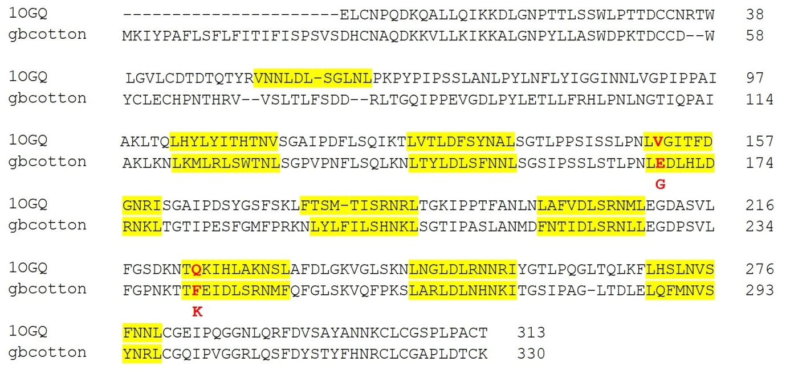
S3. Pictorial representation of structural alignment of wild (red) and muated (blue) gb-PGIP, (a) Before MD simulation and (b) After MD simulation.
