Supporting Information
Neutral 4π-electron Tetrasilacyclobutadiene contains unusual features of a Möbius-type aromatic ring

Mohd Nazish,ª Tim Patten,ª Yuqing Huang,^{b} Lili Zhao,*^{b} Anna Krawczuk,*ª Gernot Frenking*^{b, c} and Herbert W. Roesky*ª
ªInstitut für Anorganische Chemie, Universität Göttingen, Tammannstrasse 4, 37077 Göttingen (Germany).
^{b} State Key Laboratory of Materials-Oriented Chemical Engineering, School of Chemistry and Molecular Engineering, Nanjing Tech University, Nanjing 211816, China.
^{c}Fachbereich Chemie, Philipps-Universität Marburg, Hans Meerwein-Strasse 4, D-35043 Marburg, Germany.
*Corresponding Authors: anna.krawczuk@uni-goettingen.de; hroesky@gwdg.de; ias_llzhao@njtech.edu.cn; frenking@chemie.uni-marburg.de

Contents: Page No.
(S1) Experimental Section S2
(S2) X-ray crystallographic analysis S13
(S3) Computational Details S23
(S4) References S38

- Experimental Section
All manipulations were carried out using standard Schlenk and glove box techniques under an atmosphere of high-purity dinitrogen. THF, hexane, and toluene were distilled over Na/K alloy (25:75), while diethyl ether was distilled over potassium mirror. Deuterated NMR solvents C₆D₆, C₇D_{8,} and THF-d₈ were dried by stirring for 2 days over Na/K alloy followed by distillation in vacuum and degassed. ¹H, ¹³C{¹H} NMR spectra were recorded on Bruker Avance 200, Bruker Avance 300, and Bruker Avance 500 MHz NMR spectrometers and were referenced to the resonances of the solvent used. Microanalyses were performed by the Analytisches Labor für Anorganische Chemie der Universität Göttingen. Melting points were determined in sealed glass capillaries under dinitrogen and were uncorrected. LIFDI measurements were performed on a Joel AccuTOF spectrometer under an inert atmosphere, while all other reagents were used as received.
Synthesis of 1; [RSiCl(CAAc); R = C₆H₄P(^{i}Pr)₂]; A mixture of RSiCl₃ (335 mg, 1 mmol), cAAC (442 mg, 1 mmol), and KC₈ (300 mg, 2.2 mmol) was taken in a 100 mL round bottom flask and 50 mL of THF was added at -80 °C. The reaction mixture was allowed to warm to room temperature slowly and stirred until all the KC₈ was consumed completely to give a yellow-coloured solution of compound 1. After solvent evaporation and filtration of insoluble residue, the Et₂O solution was concentrated to 10 mL under reduced pressure. The flask was stored at 0 °C for 2 weeks to obtain X-ray quality yellow crystals of 1 (Yield: 378 mg, 70 %), Mp: 205 - 210 °C.
¹H NMR (500 MHz, C₆D₆, 298 K, ppm): δ 0.91 (dd, 3 H, CHMe, J = 10 Hz), 1.04 (s, 3 H, CMe) 1.09 (dd, 3 H, CHMe, J = 5 Hz), 1.12 (s, 3 H, CMe₃), 1.17 (dd, 6 H, CHMe₂, J = 5 Hz), 1.24-1.25 (m, 6 H, CHMe₂), 1.27 (d, 3 H, CHMe, J = 5 Hz), 1.57-1.60 (m, 5 H, CH₂ & Me), 1.66 (d, 3 H, CHMe, J = 5 Hz), 1.77 (d, 3 H, CHMe, J = 5 Hz), 1.93 (sep, 1 H, CH), 2.15 (sep, 1 H, CH), 3.18 (sep, 1 H, CH), 3.29 (sep, 1 H, CH), 7.12-7.15 (m, 3 H, ArH), 7.19-7.23 (m, 2 H, ArH), 7.32-7.33 (m, 1 H, ArH), 8.20-8.22 (m, 1 H, ArH). ¹³C{¹H} NMR (126 MHz, C₆D₆, 298 K, ppm): δ 15.61, 19.04, 19.08, 20.02, 20.18, 20.80, 20.93, 23.93, 24.07, 24.51, 25.69, 25.75, 26.40, 26.54, 27.90, 28.20, 28.62, 29.78, 30.14, 31.03, 31.07, 32.64, 32.67, 49.58, 49.60, 55.16, 65.92, 67.83, 71.82, 124.24, 125.72, 128.35, 128.64, 129.03, 131.82, 131.83, 134.85, 141.03, 141.10, 143.96, 144.05, 148.59, 148.84, 154.31, 154.66, 195.48, 195.61. ³¹P{¹H} NMR (202 MHz, C₆D₆, 298 K, ppm): δ 8.99. ²⁹Si{¹H} NMR (99 MHz, C₆D₆, 298 K, ppm): δ 25.37 (d, J_{Si-P} = 46.53 Hz). Elemental analysis (%) calcd. for C₃₂H₅₁ClNPSi (541.32): C, 72.62; H, 9.45; N, 2.57; Found: C, 72.86; H, 9.23; N, 2.42; MS (LIFDI, toluene): m/z = 541.7 ([M+]⁺).
Synthesis of 2 [R(cAAC)Si-SiR; THF (50 mL) was added to a mixture of 1 (290 mg, 0.5 mmol), RSiCl₃ (170 mg, 0.5 mmol), and KC₈ (150 mg, 1.1 mmol) in a 100 mL round bottom flask at -80 °C. The reaction mixture was allowed to warm to room temperature slowly to give a red-colored solution of compound 2. After solvent evaporation and filtration of insoluble residue, the Et₂O solution was concentrated to 10-15 mL under reduced pressure. The flask was stored at 0 °C for 2 weeks to obtain X-ray quality yellow crystals of 2 (Yield: 174 mg, 48 %); Mp: 192 - 200 °C.
¹H NMR (500 MHz, C₆D₆, 298 K, ppm): δ 0.63 (d, 3 H, CHMe, J = 5 Hz), 0.68 (dd, 3 H, CMe, J = 5 Hz) 0.77 (dd, 3 H, CHMe, J = 5 Hz), 1.02 (s, 3 H, CMe), 1.05-1.13 (dd, 6 H, CHMe₂, J = 5 Hz), 1.17 (d, 3 H, CHMe, J = 5 Hz), 1.25 (s, 3 H, CMe), 1.26 (dd, 3 H, CHMe, J = 5 Hz), 1.31-1.33 (m, 5 H, CH₂ & CHMe), 1.40-1.45 (m, 5 H, CH₂ & CHMe), 1.47 (dd, 3 H, CHMe, J = 5 Hz), 1.77 (d, 3 H, CHMe, J = 5 Hz), 1.86 (s, 3 H, CHMe), 2.23 (sep, 1 H, CH), 2.26 (s, 3 H, CHMe), 2.40 (sep, 1 H, CH), 2.52 (sep, 1 H, CH), 3.34 (sep, 1 H, CH), 3.58 (sep, 2 H, CH), 5.23-5.25 (m, 1 H, ArH), 6.69-6.72 (m, 1 H, ArH), 6.74-6.77 (m, 1 H, ArH), 6.91-6.94 (m, 1 H, ArH), 6.99-7.02 (m, 2 H, ArH), 7.03-7.06 (m, 1 H, ArH), 7.24-7.26 (m, 2 H, ArH), 7.29-7.32 (m, 1 H, ArH), 8.72-8.74 (m, 1 H, ArH). ¹³C{¹H} NMR (126 MHz, C₆D₆, 298 K, ppm): δ 15.60, 17.53, 17.56, 17.68, 18.40, 18.77, 18.84, 19.99, 20.05, 20.44, 20.52, 20.54, 20.72, 21.15, 21.28, 22.27, 22.41, 24.36, 24.43, 24.51, 24.56, 25.07, 25.41, 25.81, 26.61, 26.88, 27.41, 27.55, 28.37, 28.58, 28.87, 29.50, 30.21, 32.94, 32.98, 37.46, 37.49, 48.88, 57.83, 65.92, 67.83, 67.88, 124.39, 124.44, 125.30, 125.92, 126.68, 126.71, 126.91, 128.35, 128.99, 130.09, 131.19, 131.49, 131.79, 135.86, 135.98, 139.90, 143.10, 143.13, 143.16, 143.20, 146.57, 146.61, 146.66, 146.70, 151.09, 152.21, 152.75, 152.79, 153.06, 153.09, 154.40, 154.43, 154.66, 154.68, 187.37, 187.44. ³¹P{¹H} NMR (202 MHz, C₆D₆, 298 K, ppm): δ 1.67, 38.13. ²⁹Si{¹H} NMR (99 MHz, C₆D₆, 298 K, ppm): δ 25.17 (d, J_{Si-P} = 31 Hz), 122.15. Elemental analysis (%) calcd. for C₄₄H₆₉NP₂Si₂ (727.43): C, 72.38; H, 9.53; N, 1.92; Found: C, 72.42; H, 9.39; N, 1.74; MS (LIFDI, toluene): m/z = 717.3 ([M-5H₂]⁺).
Synthesis of 3 [R₂L₂Si₄]; A mixture of PhC(N^{t}Bu)₂SiCl (150 mg, 0.5 mmol), 2 (364 mg, 0.5 mmol), and KC₈ (150 mg, 1.1 mmol) was placed in a 100 mL round bottom flask and 50 mL of THF was added at -80 °C. The reaction mixture was allowed to warm to room temperature slowly and stirred at the same temperature until all the KC₈ was consumed. After the evaporation of volatiles and filtration of insoluble residue, the Et₂O solution was concentrated to 10 mL under reduced pressure. The flask was stored at -30 °C for two weeks to obtain X-ray quality red block-shaped crystals of 3 (Yield: 96 mg, 40 %). Mp: Decomp. at 215 °C.
¹H NMR (500 MHz, C₇D₈, 298 K, ppm): δ 1.25 (dd, 12 H, CHMe_{2,} J = 5 Hz), 1.35 (dd, 12 H, CHMe₂) 1.50 (s, 36 H, CMe₃), 2.27 (sep, 4 H, CH), 7.02-7.05 (m, 8 H, ArH), 7.23-7.24 (m, 2 H, ArH), 7.54-7.55 (m, 4 H, ArH), 8.20-8.21 (m, 2 H, ArH). ¹³C NMR (126 MHz, C₆D₆, 298 K, ppm): δ 21.21, 21.31, 25.11, 25.24, 31.99, 55.27, 124.29, 125.39, 126.70, 127.84, 128.23, 129.16, 129.33, 129.71, 130.87, 134.17, 136.97, 137.06, 137.22, 137.46, 140.46, 140.54, 159.97, 160.34, 168.64. ³¹P{¹H} NMR (202 MHz, C₇D₈, 298 K, ppm): δ 4.95. ²⁹Si{¹H} NMR (99 MHz, C₇D₈, 298 K, ppm): δ 51.31 (t, J_{Si-P} = 17,82 Hz), -93.71 (d, J_{Si-P} = 27,72 Hz). Elemental analysis (%) calcd. for C₅₄H₈₂N₄P₂Si₄ (962.52): C, 67.31; H, 8.79; N, 5.81 Found: C, 67.13; H, 8.93; N, 5.67; MS (LIFDI, toluene): m/z = 717.3 ([M-PhC(^{t}BuN)₂Si+CH₃]⁺).

Figure S1. ¹H NMR (500 MHz, C₆D₆) spectrum of 1 at 298 K.

Figure S2. ¹³C NMR (126 MHz, C₆D₆) spectrum of 1 at 298 K.
Figure S3. ³¹P NMR (202 MHz, C₆D₆) spectrum of 1 at 298 K.

Figure S4. ²⁹Si NMR (99 MHz, C₆D₆) spectrum of 1 at 298 K.
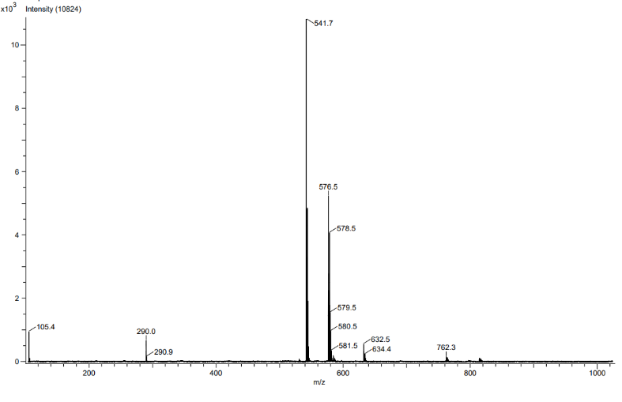
Figure S5. LIFDI mass spectrum of 1 at 298 K.

Figure S6. ¹H NMR (500 MHz, C₆D₆) spectrum of 2 at 298 K.
Figure S7. ¹³C NMR (126 MHz, C₆D₆) spectrum of 2 at 298 K.

Figure S8. ³¹P NMR (202 MHz, C₆D₆) spectrum of 2 at 298 K.
Figure S9. ²⁹Si NMR (99 MHz, C₆D₆) spectrum of 2 at 298 K.

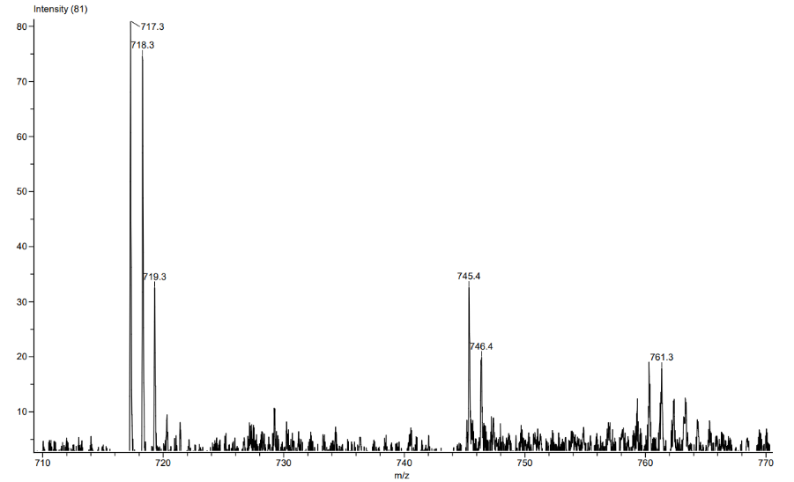
Figure S10. LIFDI mass spectrum of 2 at 298 K.

Figure S11. ¹H NMR (500 MHz, C₇D₈) spectrum of 3 at 298 K.

Figure S12. ¹³C NMR (126 MHz, C₇D₈) spectrum of 3 at 298 K.
Figure S13. ³¹P NMR (202 MHz, C₇D₈) spectrum of 3 at 298 K.

Figure S14. ²⁹Si NMR (99 MHz, C₇D₈) spectrum of 3 at 298 K.
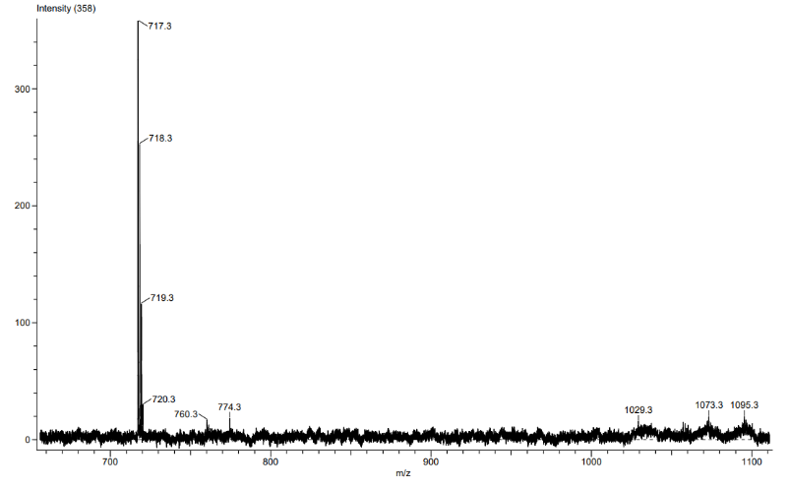
Figure S15. LIFDI mass spectrum of 3 at 298 K.
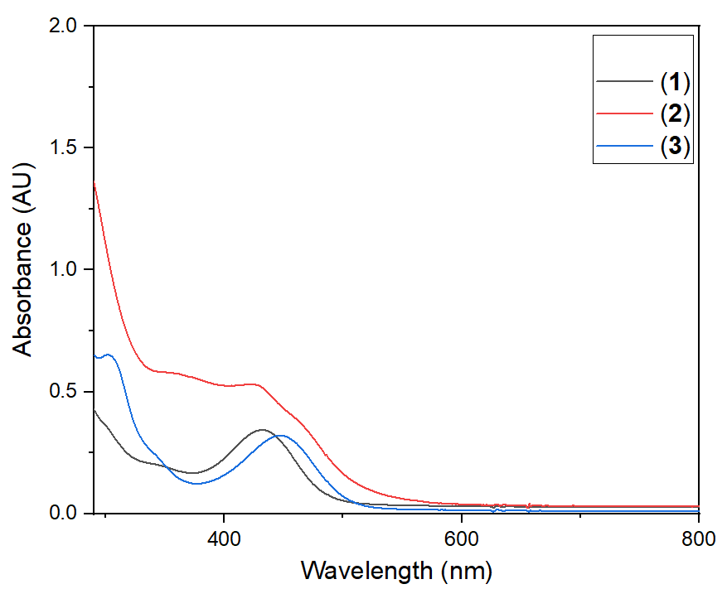
Figure S16. UV-Vis spectra of 1-3 in toluene.

(2) X-ray crystallographic analysis
The data were collected from shock-cooled crystals at 100(2) K on a Bruker D8 three- circle diffractometer equipped with an Incoatec Mo Microsource (MoKα=0.71073Å) and PHOTON III detector. The data were integrated with SAINT.^{S1} An empirical absorption correction was applied using SADABS^{S2, S3} (1-3). The structures were solved by SHELXT^{S4} and refined on F² using SHELXL^{S5} in the graphical user interface SHELXLE.^{S6} All non-hydrogen atoms were refined with anisotropic displacement parameters. Hydrogen atoms were positioned with the idealized geometry and refined using the riding model with the isotropic displacement parameter U_{iso} constrained to 1.5 U_{eq} of their pivot atoms for terminal sp³ carbon atoms and 1.2 times for all other carbon atoms. An overview of the crystallographic data for compounds 1-3 can be found in Table S1 and the individual bond lengths and angles are listed in Tables S2-S4 for 1-3, respectively.

Table S1. Crystal data and structure refinement for compounds 1 – 3 at 100(2) K.
Compound | 1 | 2 | 3
CCDC | 2178970 | 2178971 | 2178974
Empirical Formula | C₃₂H₄₉ClNPSi | C₄₄H₆₇NP₂Si₂ | C₅₄H₈₂N₄P₂Si₄
Formula weight | 542.23 | 728.10 | 961.53
Temperature (K) | 100(2) | 100(2) | 100(2)
Wavelength (Å) | 0.71073 | 0.71073 | 0.71073
Crystal system | Triclinic | Triclinic | Monoclinic
Space group | P-1 | P-1 | C2/c
a (Å) | 8.9268(7) | 9.6755(4) | 27.7983(13)
b (Å) | 12.5462(9) | 15.1358(7) | 10.6021(5)
c (Å) | 14.7624(11) | 16.5849(8) | 19.9502(10)
α | 76.497(2) | 103.436(2) | 90
β (deg) | 79.230(2) | 101.043(2) | 102.938(2)
γ | 77.234(2) | 107.284(2) | 90
V (Å³) | 1551.9(2) | 2165.04(17) | 5730.5(5)
Z | 2 | 2 | 4
μ/mm⁻¹ | 1.160 | 1.117 | 1.115
Crystal size(mm) | 0.352 x 0.153 x 0.151 | 0.274 x 0.215 x 0.112 | 0.208 x 0.185 x 0.129
Θ max (deg) | 26.414 | 27.490 | 27.501
Reflections collected | 73540 | 135740 | 80408
Independent reflections | 6355 | 9906 | 6572
R_{int} | 0.1170 | 0.0371 | 0.0296
Data/restraints/  parameters | 6355 / 0 / 337 | 9906 / 18 / 479 | 6572 / 0 / 299
R1ª (I >2σ(I)) | 0.0340 | 0.0369 | 0.0307
wR2^{b}(all data ) | 0.0852 | 0.1021 | 0.0815
Δρ_{max}/Δρ_{min}(e Å⁻³) | 0.266 / -0.305 | 0.645 / -0.348 | 0.368 / -0.159
Shape and color | yellow-orange blocks | red blocks | red blocks
ªR1 = Σ||F_{o}| – |F_{c}||/Σ|F_{o}|. ^{b}wR₂ = [Σw(F_{o}² – F_{c}²)²/Σ(F_{o}²)²]^{1/2}
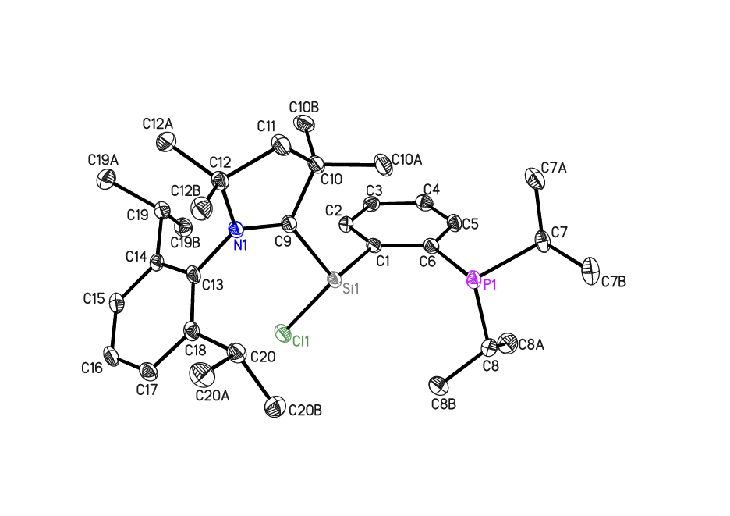
Figure S17 Asymmetric unit of compound 1 with thermal ellipsoids at 50% probability level. Hydrogen atoms are omitted for clarity.
The asymmetric unit contains one molecule, and no disorder treatment was required.

Table S2. Bond lengths[Ǻ] and angles [°] for 1.
Cl1—Si1 | 2.1272 (6) | C9—C10 | 1.537 (2)
P1—C6 | 1.8425 (16) | C10—C10A | 1.526 (2)
P1—C7 | 1.8635 (16) | C10—C10B | 1.537 (2)
P1—C8 | 1.8667 (17) | C10—C11 | 1.540 (2)
Si1—C9 | 1.8484 (16) | C11—C12 | 1.529 (2)
Si1—C1 | 1.9104 (15) | C12—C12B | 1.523 (2)
N1—C9 | 1.3481 (19) | C12—C12A | 1.527 (2)
N1—C13 | 1.4542 (18) | C13—C14 | 1.406 (2)
N1—C12 | 1.513 (2) | C13—C18 | 1.410 (2)
C1—C2 | 1.398 (2) | C14—C15 | 1.395 (2)
C1—C6 | 1.414 (2) | C14—C19 | 1.526 (2)
C2—C3 | 1.383 (2) | C15—C16 | 1.383 (2)
C3—C4 | 1.389 (2) | C16—C17 | 1.377 (2)
C4—C5 | 1.378 (2) | C17—C18 | 1.394 (2)
C5—C6 | 1.404 (2) | C18—C20 | 1.521 (2)
C7—C7A | 1.527 (2) | C19—C19B | 1.527 (2)
C7—C7B | 1.531 (2) | C19—C19A | 1.535 (2)
C8—C8A | 1.526 (2) | C20—C20B | 1.532 (2)
C8—C8B | 1.530 (2) | C20—C20A | 1.539 (2)

C6—P1—C7 | 102.94 (7) | C9—C10—C10B | 107.48 (13)
C6—P1—C8 | 101.87 (7) | C10A—C10—C11 | 109.99 (13)
C7—P1—C8 | 102.79 (7) | C9—C10—C11 | 103.25 (12)
C9—Si1—C1 | 108.83 (7) | C10B—C10—C11 | 111.76 (14)
C9—Si1—Cl1 | 109.36 (5) | C12—C11—C10 | 107.67 (13)
C1—Si1—Cl1 | 100.39 (5) | N1—C12—C12B | 111.92 (13)
C9—N1—C13 | 123.33 (13) | N1—C12—C12A | 111.17 (13)
C9—N1—C12 | 115.46 (12) | C12B—C12—C12A | 107.82 (13)
C13—N1—C12 | 121.14 (11) | N1—C12—C11 | 101.27 (12)
C2—C1—C6 | 118.19 (14) | C12B—C12—C11 | 111.18 (13)
C2—C1—Si1 | 120.51 (11) | C12A—C12—C11 | 113.47 (13)
C6—C1—Si1 | 121.18 (12) | C14—C13—C18 | 121.37 (13)
C3—C2—C1 | 122.18 (14) | C14—C13—N1 | 118.87 (13)
C2—C3—C4 | 119.31 (15) | C18—C13—N1 | 119.76 (13)
C5—C4—C3 | 119.92 (15) | C15—C14—C13 | 118.17 (14)
C4—C5—C6 | 121.46 (14) | C15—C14—C19 | 117.43 (14)
C5—C6—C1 | 118.88 (14) | C13—C14—C19 | 124.27 (13)
C5—C6—P1 | 122.65 (12) | C16—C15—C14 | 121.10 (15)
C1—C6—P1 | 118.46 (11) | C17—C16—C15 | 119.86 (14)
C7A—C7—C7B | 110.32 (14) | C16—C17—C18 | 121.75 (15)
C7A—C7—P1 | 108.68 (11) | C17—C18—C13 | 117.63 (14)
C7B—C7—P1 | 109.09 (11) | C17—C18—C20 | 118.00 (14)
C8A—C8—C8B | 110.14 (15) | C13—C18—C20 | 124.34 (13)
C8A—C8—P1 | 117.18 (12) | C14—C19—C19B | 110.46 (13)
C8B—C8—P1 | 109.42 (12) | C14—C19—C19A | 112.66 (13)
N1—C9—C10 | 107.74 (13) | C19B—C19—C19A | 109.18 (13)
N1—C9—Si1 | 129.35 (11) | C18—C20—C20B | 111.65 (13)
C10—C9—Si1 | 120.03 (11) | C18—C20—C20A | 111.73 (13)
C10A—C10—C9 | 115.62 (13) | C20B—C20—C20A | 108.44 (13)
C10A—C10—C10B | 108.70 (13)

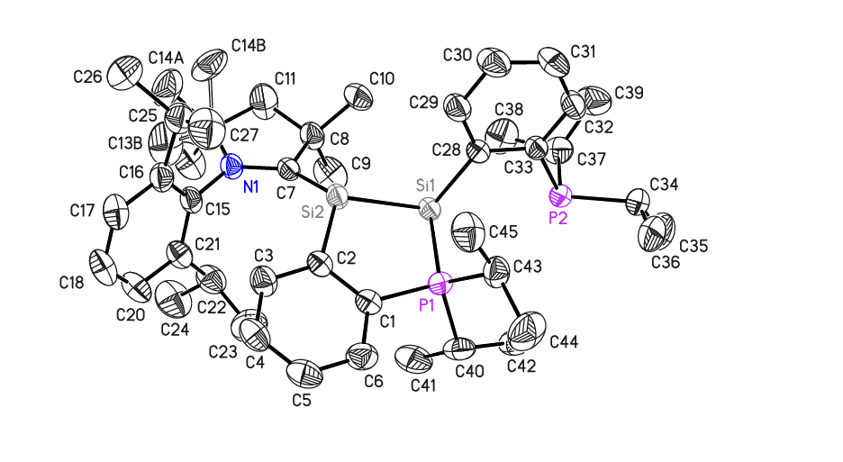
Figure S18 Asymmetric unit of compound 2 (including disorder of terminal methyl groups) with thermal ellipsoids at 50% probability level. Hydrogen atoms are omitted for clarity.

The asymmetric unit displays one molecule. The terminal methyl groups were disordered over two positions. All disordered groups were refined with distance restraints and restraints for the anisotropic displacement parameters. The occupancies of the major positions were refined to 0.869(6).

Table S3. Bond lengths[Ǻ] and angles [°] for 2.
N1—C7 | 1.3767 (17) | Si1—Si2 | 2.3673 (5)
N1—C15 | 1.4348 (17) | C20—C21 | 1.395 (2)
N1—C12 | 1.5052 (19) | C21—C22 | 1.516 (2)
C1—C6 | 1.4020 (19) | C22—C23 | 1.529 (3)
C1—C2 | 1.411 (2) | C22—C24 | 1.538 (3)
C1—P1 | 1.8207 (14) | C25—C27 | 1.529 (3)
C6—C5 | 1.377 (2) | C25—C26 | 1.542 (3)
C7—C8 | 1.5479 (19) | C28—C29 | 1.402 (2)
C7—Si2 | 1.8097 (14) | C28—C33 | 1.4136 (18)
C8—C10 | 1.524 (2) | C29—C30 | 1.387 (2)
C8—C9 | 1.524 (3) | C30—C31 | 1.371 (2)
C8—C11 | 1.542 (2) | C31—C32 | 1.371 (2)
C11—C12 | 1.500 (2) | C32—C33 | 1.4049 (19)
C11—C14B | 1.871 (17) | C33—P2 | 1.8426 (15)
C12—C13B | 1.43 (2) | C34—C36 | 1.532 (3)
C12—C14A | 1.528 (3) | C34—C35 | 1.533 (3)
C12—C13A | 1.543 (3) | C34—P2 | 1.8629 (17)
C12—C14B | 1.665 (18) | C37—C38 | 1.518 (3)
C15—C16 | 1.408 (2) | C37—C39 | 1.523 (3)
C15—C21 | 1.410 (2) | C37—P2 | 1.8725 (17)
C16—C17 | 1.394 (2) | C40—C41 | 1.524 (3)
C16—C25 | 1.523 (2) | C40—C42 | 1.530 (2)
C17—C18 | 1.372 (3) | C43—C45 | 1.523 (2)
C18—C20 | 1.375 (3) | C43—C44 | 1.527 (2)
P1—C40 | 1.8441 (15) | Si2—C2 | 1.9073 (14)
P1—C43 | 1.8525 (15) | C2—C3 | 1.4048 (19)
P1—Si1 | 2.2926 (5) | C3—C4 | 1.381 (2)
Si1—C28 | 1.9572 (14) | C4—C5 | 1.377 (3)

C7—N1—C15 | 124.20 (11) | P1—Si1—Si2 | 85.332 (17)
C7—N1—C12 | 115.65 (11) | C18—C20—C21 | 121.76 (16)
C15—N1—C12 | 120.10 (11) | C20—C21—C15 | 117.78 (15)
C6—C1—C2 | 121.24 (13) | C20—C21—C22 | 118.68 (14)
C6—C1—P1 | 119.26 (11) | C15—C21—C22 | 123.49 (14)
C2—C1—P1 | 119.50 (10) | C21—C22—C23 | 111.32 (16)
C5—C6—C1 | 120.63 (15) | C21—C22—C24 | 112.56 (16)
N1—C7—C8 | 106.34 (11) | C23—C22—C24 | 109.76 (17)
N1—C7—Si2 | 134.11 (10) | C16—C25—C27 | 110.11 (15)
C8—C7—Si2 | 119.04 (10) | C16—C25—C26 | 113.00 (15)
C10—C8—C9 | 108.79 (15) | C27—C25—C26 | 109.03 (17)
C10—C8—C11 | 106.91 (15) | C29—C28—C33 | 116.67 (12)
C9—C8—C11 | 113.53 (17) | C29—C28—Si1 | 122.87 (10)
C10—C8—C7 | 115.88 (14) | C33—C28—Si1 | 120.34 (10)
C9—C8—C7 | 109.32 (13) | C30—C29—C28 | 122.64 (14)
C11—C8—C7 | 102.42 (13) | C31—C30—C29 | 119.75 (15)
C12—C11—C8 | 108.77 (14) | C30—C31—C32 | 119.54 (14)
C12—C11—C14B | 58.0 (7) | C31—C32—C33 | 121.76 (14)
C8—C11—C14B | 129.0 (6) | C32—C33—C28 | 119.49 (13)
C13B—C12—C11 | 136.5 (9) | C32—C33—P2 | 121.71 (11)
C13B—C12—N1 | 115.1 (9) | C28—C33—P2 | 118.77 (10)
C11—C12—N1 | 101.10 (12) | C36—C34—C35 | 112.2 (2)
C11—C12—C14A | 112.7 (2) | C36—C34—P2 | 108.16 (16)
N1—C12—C14A | 112.89 (16) | C35—C34—P2 | 109.62 (13)
C11—C12—C13A | 112.4 (2) | C38—C37—C39 | 110.34 (17)
N1—C12—C13A | 110.71 (17) | C38—C37—P2 | 109.94 (12)
C14A—C12—C13A | 107.1 (2) | C39—C37—P2 | 116.49 (14)
C13B—C12—C14B | 115.5 (14) | C41—C40—C42 | 110.64 (16)
C11—C12—C14B | 72.3 (7) | C41—C40—P1 | 109.14 (12)
N1—C12—C14B | 107.2 (6) | C42—C40—P1 | 111.36 (11)
C16—C15—C21 | 120.87 (13) | C45—C43—C44 | 110.72 (15)
C16—C15—N1 | 119.71 (13) | C45—C43—P1 | 109.09 (11)
C21—C15—N1 | 119.41 (13) | C44—C43—P1 | 115.90 (13)
C17—C16—C15 | 118.19 (14) | C33—P2—C34 | 103.85 (8)
C17—C16—C25 | 117.98 (14) | C33—P2—C37 | 101.07 (7)
C15—C16—C25 | 123.59 (13) | C34—P2—C37 | 101.58 (9)
C18—C17—C16 | 121.46 (16) | C7—Si2—C2 | 122.93 (6)
C17—C18—C20 | 119.83 (15) | C7—Si2—Si1 | 114.21 (5)
C1—P1—C40 | 103.60 (7) | C2—Si2—Si1 | 106.69 (5)
C1—P1—C43 | 107.43 (7) | C3—C2—C1 | 115.83 (13)
C40—P1—C43 | 108.76 (8) | C3—C2—Si2 | 127.72 (11)
C1—P1—Si1 | 110.15 (5) | C1—C2—Si2 | 116.39 (10)
C40—P1—Si1 | 110.77 (6) | C4—C3—C2 | 122.51 (15)
C43—P1—Si1 | 115.41 (5) | C5—C4—C3 | 120.54 (14)
C28—Si1—P1 | 98.52 (4) | C4—C5—C6 | 119.24 (14)
C28—Si1—Si2 | 105.02 (4) | C12—C14B—C11 | 49.8 (5)

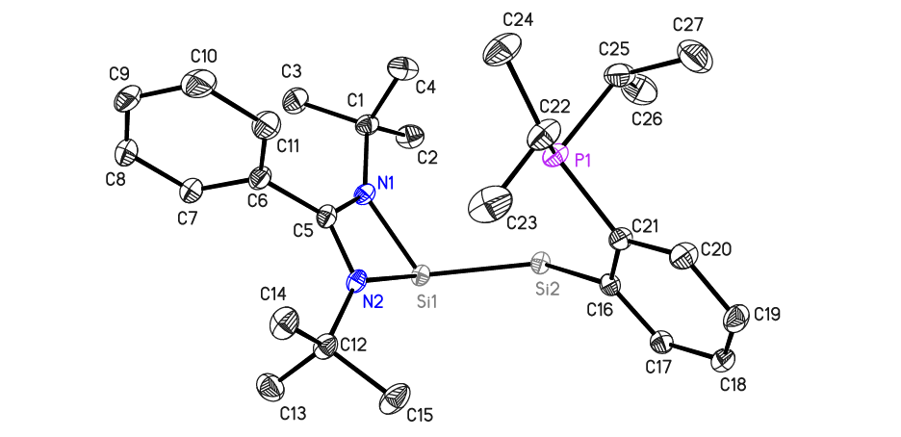
Figure S19 Asymmetric unit containing half of the complex molecule of compound 3. Thermal ellipsoids are drawn at 50% probability level and hydrogen atoms are omitted for clarity.
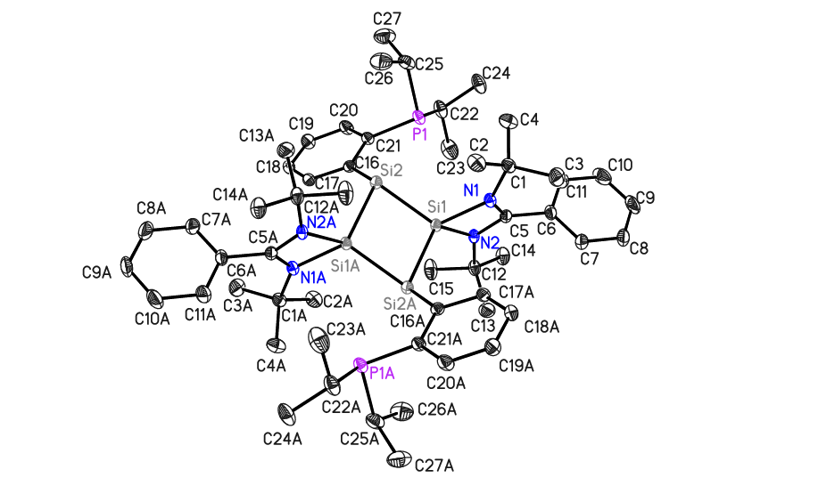
Figure S20 Molecular structure of compound 3 in a crystalline state. Thermal ellipsoids are drawn at 50% probability level and hydrogen atoms are omitted for clarity.
The asymmetric unit is composed of half of the complex molecule. No disorder was observed during the refinement process.

Table S4. Bond lengths[Ǻ] and angles [°] for 3.
C2—C1 | 1.5276 (17) | C6—C7 | 1.3921 (17)
N2—C5 | 1.3403 (14) | C7—C8 | 1.3864 (18)
N2—C12 | 1.4813 (15) | C8—C9 | 1.377 (3)
N2—Si1 | 1.8562 (9) | C9—C10 | 1.381 (2)
N1—C5 | 1.3341 (15) | C10—C11 | 1.3924 (18)
N1—C1 | 1.4867 (14) | C12—C13 | 1.5294 (18)
N1—Si1 | 1.8622 (10) | C12—C14 | 1.5313 (15)
Si2—C16 | 1.9086 (11) | C12—C15 | 1.5338 (16)
Si2—Si1 | 2.2792 (4) | C16—C17 | 1.4079 (15)
Si2—Si1^{i} | 2.3018 (4) | C16—C21 | 1.4148 (15)
C1—C4 | 1.5320 (16) | C17—C18 | 1.3850 (16)
C1—C3 | 1.5336 (16) | C18—C19 | 1.3883 (16)
P1—C21 | 1.8371 (11) | C19—C20 | 1.3859 (16)
P1—C22 | 1.8620 (12) | C20—C21 | 1.4027 (15)
P1—C25 | 1.8728 (14) | C22—C23 | 1.521 (2)
Si1—C5 | 2.3184 (11) | C22—C24 | 1.5337 (17)
C5—C6 | 1.4885 (15) | C25—C27 | 1.5263 (19)
C6—C11 | 1.3894 (17) | C25—C26 | 1.527 (2)

C5—N2—C12 | 130.91 (9) | N2—C5—Si1 | 53.16 (5)
C5—N2—Si1 | 91.53 (7) | C6—C5—Si1 | 176.90 (8)
C12—N2—Si1 | 132.85 (7) | C11—C6—C7 | 120.17 (11)
C5—N1—C1 | 130.05 (9) | C11—C6—C5 | 120.22 (11)
C5—N1—Si1 | 91.47 (7) | C7—C6—C5 | 119.59 (11)
C1—N1—Si1 | 136.79 (8) | C8—C7—C6 | 119.81 (13)
C16—Si2—Si1 | 124.08 (4) | C9—C8—C7 | 119.99 (14)
C16—Si2—Si1^{i} | 115.06 (4) | C8—C9—C10 | 120.55 (13)
Si1—Si2—Si1^{i} | 80.24 (1) | C9—C10—C11 | 120.11 (14)
N1—C1—C2 | 106.05 (9) | C6—C11—C10 | 119.37 (13)
N1—C1—C4 | 109.73 (9) | N2—C12—C13 | 109.43 (10)
C2—C1—C4 | 109.30 (10) | N2—C12—C14 | 112.60 (10)
N1—C1—C3 | 112.03 (10) | C13—C12—C14 | 110.17 (10)
C2—C1—C3 | 109.06 (10) | N2—C12—C15 | 105.56 (9)
C4—C1—C3 | 110.54 (10) | C13—C12—C15 | 109.92 (11)
C21—P1—C22 | 103.12 (5) | C14—C12—C15 | 109.06 (10)
C21—P1—C25 | 102.25 (6) | C17—C16—C21 | 117.50 (10)
C22—P1—C25 | 102.25 (6) | C17—C16—Si2 | 119.18 (8)
N2—Si1—N1 | 70.40 (4) | C21—C16—Si2 | 122.90 (8)
N2—Si1—Si2 | 129.37 (3) | C18—C17—C16 | 121.98 (10)
N1—Si1—Si2 | 118.77 (3) | C17—C18—C19 | 120.01 (10)
N2—Si1—Si2^{i} | 114.53 (3) | C20—C19—C18 | 119.41 (10)
N1—Si1—Si2^{i} | 124.93 (3) | C19—C20—C21 | 121.30 (10)
Si2—Si1—Si2^{i} | 99.76 (2) | C20—C21—C16 | 119.73 (10)
N2—Si1—C5 | 35.30 (4) | C20—C21—P1 | 123.56 (8)
N1—Si1—C5 | 35.12 (4) | C16—C21—P1 | 116.67 (8)
Si2—Si1—C5 | 133.96 (3) | C23—C22—C24 | 110.50 (12)
Si2^{i}—Si1—C5 | 126.28 (3) | C23—C22—P1 | 108.85 (9)
N1—C5—N2 | 106.54 (9) | C24—C22—P1 | 109.48 (9)
N1—C5—C6 | 126.08 (10) | C27—C25—C26 | 110.20 (12)
N2—C5—C6 | 127.36 (10) | C27—C25—P1 | 116.63 (10)
N1—C5—Si1 | 53.41 (5) | C26—C25—P1 | 110.21 (9)
C5—N1—C1—C2 | −174.73 (11) | C6—C7—C8—C9 | 0.6 (2)
Si1—N1—C1—C2 | 24.58 (15) | C7—C8—C9—C10 | −0.8 (3)
C5—N1—C1—C4 | 67.33 (15) | C8—C9—C10—C11 | 0.2 (3)
Si1—N1—C1—C4 | −93.36 (12) | C7—C6—C11—C10 | −0.8 (2)
C5—N1—C1—C3 | −55.85 (15) | C5—C6—C11—C10 | 177.64 (12)
Si1—N1—C1—C3 | 143.47 (10) | C9—C10—C11—C6 | 0.6 (2)
C5—N2—Si1—N1 | 1.62 (6) | C5—N2—C12—C13 | 75.01 (14)
C12—N2—Si1—N1 | 158.30 (11) | Si1—N2—C12—C13 | −73.42 (12)
C5—N2—Si1—Si2 | 113.26 (6) | C5—N2—C12—C14 | −47.87 (16)
C12—N2—Si1—Si2 | −90.06 (10) | Si1—N2—C12—C14 | 163.71 (8)
C5—N2—Si1—Si2^{i} | −118.75 (6) | C5—N2—C12—C15 | −166.75 (11)
C12—N2—Si1—Si2^{i} | 37.93 (11) | Si1—N2—C12—C15 | 44.82 (14)
C12—N2—Si1—C5 | 156.68 (14) | C21—C16—C17—C18 | 2.25 (17)
C5—N1—Si1—N2 | −1.63 (6) | Si2—C16—C17—C18 | 175.04 (9)
C1—N1—Si1—N2 | 163.70 (12) | C16—C17—C18—C19 | 0.18 (18)
C5—N1—Si1—Si2 | −126.57 (6) | C17—C18—C19—C20 | −1.53 (19)
C1—N1—Si1—Si2 | 38.76 (12) | C18—C19—C20—C21 | 0.37 (19)
C5—N1—Si1—Si2^{i} | 105.16 (6) | C19—C20—C21—C16 | 2.12 (19)
C1—N1—Si1—Si2^{i} | −89.51 (11) | C19—C20—C21—P1 | −175.36 (10)
C1—N1—Si1—C5 | 165.33 (14) | C17—C16—C21—C20 | −3.34 (17)
C1—N1—C5—N2 | −164.69 (10) | Si2—C16—C21—C20 | −175.85 (9)
Si1—N1—C5—N2 | 2.22 (9) | C17—C16—C21—P1 | 174.30 (8)
C1—N1—C5—C6 | 16.89 (18) | Si2—C16—C21—P1 | 1.80 (13)
Si1—N1—C5—C6 | −176.20 (10) | C22—P1—C21—C20 | −31.96 (12)
C1—N1—C5—Si1 | −166.91 (13) | C25—P1—C21—C20 | 73.91 (11)
C12—N2—C5—N1 | −159.64 (11) | C22—P1—C21—C16 | 150.49 (9)
Si1—N2—C5—N1 | −2.23 (9) | C25—P1—C21—C16 | −103.63 (9)
C12—N2—C5—C6 | 18.76 (19) | C21—P1—C22—C23 | −71.34 (10)
Si1—N2—C5—C6 | 176.17 (10) | C25—P1—C22—C23 | −177.22 (9)
C12—N2—C5—Si1 | −157.42 (13) | C21—P1—C22—C24 | 167.78 (9)
N1—C5—C6—C11 | −93.89 (15) | C25—P1—C22—C24 | 61.90 (11)
N2—C5—C6—C11 | 88.01 (15) | C21—P1—C25—C27 | −60.00 (11)
N1—C5—C6—C7 | 84.53 (15) | C22—P1—C25—C27 | 46.56 (12)
N2—C5—C6—C7 | −93.57 (15) | C21—P1—C25—C26 | 66.60 (10)
C11—C6—C7—C8 | 0.1 (2) | C22—P1—C25—C26 | 173.15 (10)
C5—C6—C7—C8 | −178.27 (12)
Symmetry code: (i) −x+3/2, −y+3/2, −z+1.
(3) Computational details
Geometry optimizations without symmetry restrictions were performed with the Gaussian 16 program.^{S7} The calculations were carried out for all molecules using the BP86^{S8} functional with def2-SVP^{S9} basis sets and dispersion correction by Grimme with Becke-Johnson damping D3(BJ)^{S10} (termed as BP86+D3(BJ)/def2-SVP). Vibrational frequency calculations were performed for all stationary points to identify whether they were local minima (no imaginary frequencies). The structures were illustrated by CYLview.^{S11} Natural bond orbitals were obtained from a calculation of the molecules at the BP86+D3(BJ)/def2-TZVPP level by using NBO 7.0^{S12} as implemented with Gaussian 16 program.

Figure S21. Optimized geometries of the compounds 1 – 3 at the BP86+(D3BJ)/def2-SVP level. Selected bond lengths in Å, the experimental values are given in parentheses. Hydrogen atoms are omitted for clarity (color code, C: gray, N: blue, P: orange, Si: yellow, Cl: green).
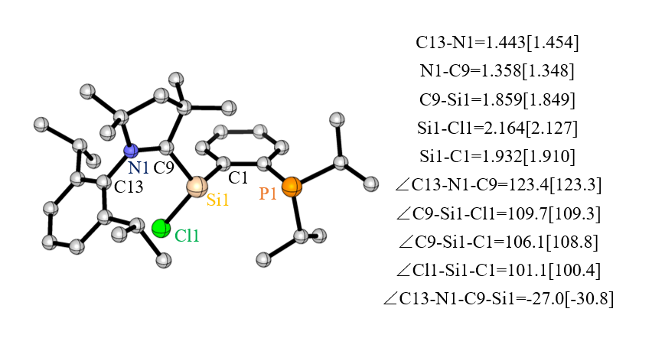
1

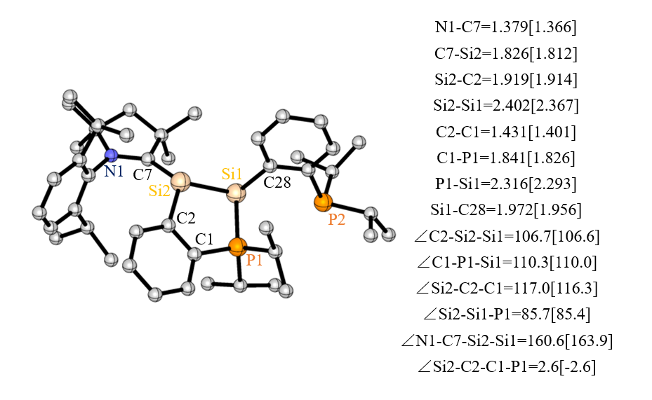
2

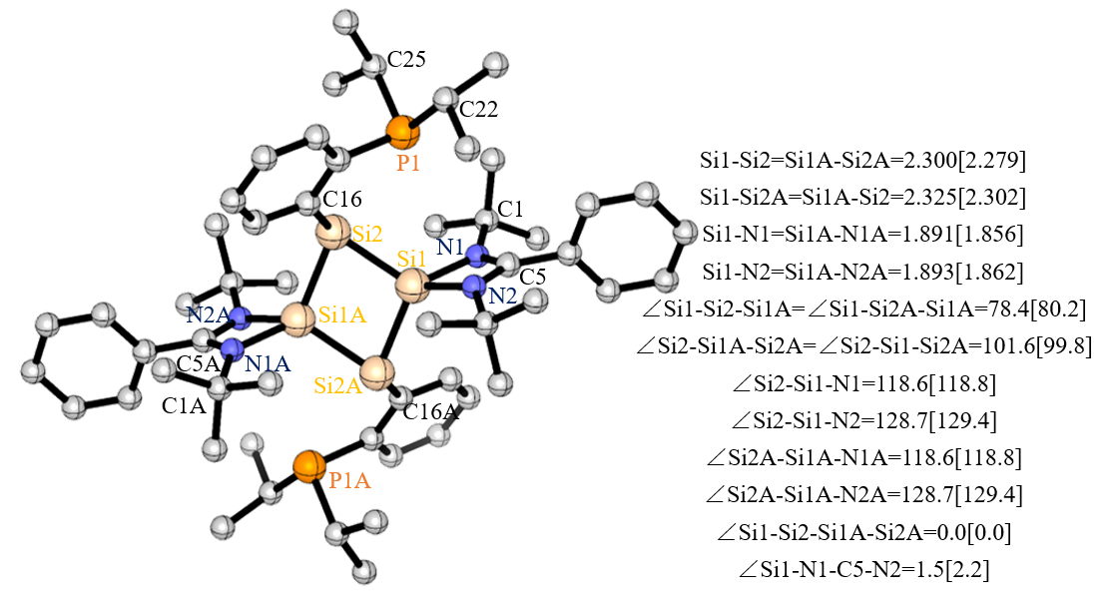
3

Figure S22. Plot of the HOMOs of 1 - 2.

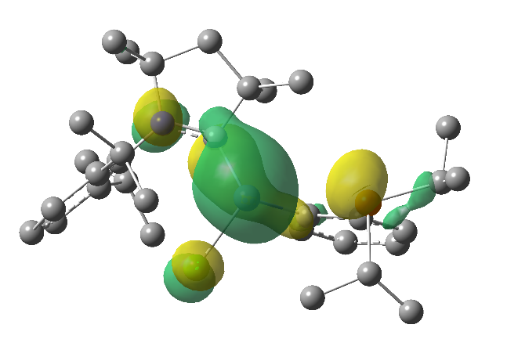  HOMO of 1 | 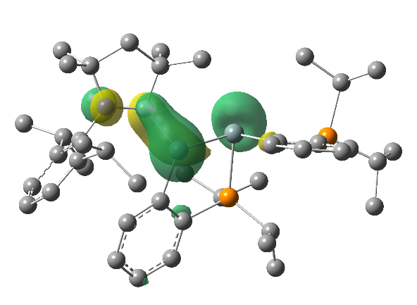  HOMO of 2

Table S5. Coordinates and energeties of 1 – 3

1
Cl 0.464663000 0.622197000 -2.263494000
P -3.599507000 0.849731000 0.328500000
Si -0.426232000 0.354424000 -0.309888000
N 2.137785000 -0.150074000 0.965079000
C -1.736164000 -1.015603000 -0.682514000
C -1.351759000 -2.241176000 -1.277508000
H -0.291368000 -2.411286000 -1.517406000
C -2.290261000 -3.245104000 -1.559808000
H -1.962912000 -4.196225000 -2.009546000
C -3.646413000 -3.032063000 -1.258629000
H -4.393280000 -3.813389000 -1.472833000
C -4.052030000 -1.813885000 -0.692883000
H -5.120585000 -1.657233000 -0.479994000
C -3.115176000 -0.794950000 -0.402915000
C -5.243174000 0.444205000 1.172387000
H -5.914338000 -0.089655000 0.462827000
C -4.967254000 -0.466239000 2.379302000
H -4.487586000 -1.419833000 2.077799000
H -5.911900000 -0.714142000 2.909899000
H -4.292128000 0.034772000 3.105317000
C -5.932708000 1.749445000 1.598924000
H -6.230680000 2.371366000 0.730167000
H -5.263982000 2.362904000 2.240629000
H -6.852970000 1.531766000 2.182567000
C -4.159800000 1.779424000 -1.233778000
H -4.596843000 2.714190000 -0.813370000
C -5.219318000 1.070497000 -2.083351000
H -4.821275000 0.124431000 -2.505868000
H -5.525750000 1.713725000 -2.936992000
H -6.136128000 0.828193000 -1.507252000
C -2.927850000 2.163366000 -2.066171000
H -2.433009000 1.269654000 -2.500107000
H -2.169782000 2.697389000 -1.457819000
H -3.219597000 2.822110000 -2.912481000
C 0.811545000 -0.416253000 0.843805000
C 0.343465000 -1.120305000 2.133187000
C -1.029260000 -0.667197000 2.658988000
H -1.844988000 -0.953761000 1.967869000
H -1.071645000 0.432309000 2.791041000
H -1.234185000 -1.152772000 3.636624000
C 0.291025000 -2.644267000 1.854765000
H -0.519245000 -2.876818000 1.136642000
H 0.093498000 -3.195369000 2.798543000
H 1.238885000 -3.025375000 1.426043000
C 1.461668000 -0.746407000 3.140994000
H 1.161860000 0.177927000 3.677124000
H 1.623986000 -1.535559000 3.902469000
C 2.736996000 -0.461243000 2.321909000
C 3.689226000 -1.667734000 2.242035000
H 3.183587000 -2.584612000 1.887508000
H 4.105730000 -1.874045000 3.248520000
H 4.536636000 -1.449116000 1.563174000
C 3.522158000 0.729659000 2.885020000
H 3.941431000 0.455224000 3.874400000
H 2.874975000 1.615192000 3.023144000
H 4.366661000 1.004382000 2.221664000
C 2.948041000 0.359801000 -0.114816000
C 3.535504000 -0.554153000 -1.032896000
C 4.365889000 -0.038094000 -2.046264000
H 4.828850000 -0.731355000 -2.765839000
C 4.591202000 1.337841000 -2.170240000
H 5.244318000 1.721484000 -2.969777000
C 3.953390000 2.226253000 -1.297215000
H 4.091529000 3.310585000 -1.430312000
C 3.112676000 1.765379000 -0.265262000
C 3.221394000 -2.047613000 -1.032929000
H 2.586283000 -2.253831000 -0.150066000
C 4.482959000 -2.926049000 -0.941556000
H 4.205527000 -3.998952000 -0.874845000
H 5.105106000 -2.677948000 -0.058862000
H 5.120863000 -2.807345000 -1.842491000
C 2.397245000 -2.422327000 -2.282195000
H 3.006626000 -2.325114000 -3.205548000
H 1.520562000 -1.756093000 -2.398179000
H 2.050496000 -3.475339000 -2.218119000
C 2.353304000 2.795579000 0.569588000
H 1.753506000 2.243096000 1.321977000
C 3.295869000 3.774432000 1.298411000
H 4.055120000 3.255049000 1.914597000
H 2.715745000 4.449958000 1.961298000
H 3.839419000 4.415534000 0.572987000
C 1.360074000 3.590095000 -0.306318000
H 1.898005000 4.225179000 -1.041939000
H 0.738272000 4.255898000 0.327513000
H 0.688015000 2.916242000 -0.870315000

2
N 3.400198000 -1.320965000 -0.435744000
C 0.015851000 2.502520000 0.306237000
C 0.156561000 3.901644000 0.428432000
H -0.671327000 4.566392000 0.135617000
C 2.021767000 -1.341409000 -0.410050000
C 1.571898000 -2.667413000 -1.078089000
C 1.127925000 -2.372938000 -2.532328000
H 1.894052000 -1.801298000 -3.092093000
H 0.195244000 -1.770311000 -2.524278000
H 0.933106000 -3.320975000 -3.078290000
C 0.435650000 -3.410411000 -0.350408000
H 0.289704000 -4.412024000 -0.808824000
H -0.529852000 -2.870610000 -0.430700000
H 0.664281000 -3.541868000 0.726292000
C 2.862277000 -3.526105000 -1.021044000
H 2.857165000 -4.114618000 -0.079412000
H 2.924527000 -4.245469000 -1.862408000
C 4.058246000 -2.556892000 -0.993658000
C 4.652973000 -2.295969000 -2.392026000
H 5.092115000 -3.233689000 -2.789503000
H 5.462435000 -1.541790000 -2.336962000
H 3.893631000 -1.942623000 -3.113498000
C 5.190828000 -3.073574000 -0.093330000
H 5.652084000 -3.965944000 -0.563087000
H 4.818814000 -3.371881000 0.903837000
H 5.985030000 -2.310724000 0.037122000
C 4.182962000 -0.222332000 0.040313000
C 4.611876000 -0.217086000 1.400482000
C 5.458640000 0.825579000 1.829076000
H 5.806728000 0.840816000 2.873664000
C 5.838160000 1.856220000 0.958609000
H 6.500047000 2.662249000 1.312714000
P -1.597291000 1.800848000 -0.237219000
Si -1.397963000 -0.476973000 -0.605017000
C 5.345597000 1.876193000 -0.352044000
H 5.606703000 2.713972000 -1.017242000
C 4.509939000 0.849143000 -0.835881000
C 3.938066000 0.958532000 -2.245412000
H 3.385533000 0.021489000 -2.448611000
C 2.916487000 2.108788000 -2.335379000
H 3.386154000 3.089125000 -2.108658000
H 2.088928000 1.957188000 -1.618328000
H 2.489120000 2.162621000 -3.358362000
C 5.034801000 1.124328000 -3.313805000
H 5.802925000 0.327346000 -3.251717000
H 5.556604000 2.099125000 -3.210675000
H 4.592012000 1.095215000 -4.331222000
C 4.107492000 -1.230782000 2.425973000
H 3.563575000 -2.021434000 1.871625000
C 5.250760000 -1.881429000 3.227219000
H 6.028014000 -2.315874000 2.567519000
H 4.856494000 -2.690600000 3.876505000
H 5.750222000 -1.145481000 3.891874000
C 3.084254000 -0.578921000 3.380949000
H 3.533971000 0.268647000 3.940383000
H 2.721530000 -1.323243000 4.120679000
H 2.201361000 -0.204849000 2.822762000
C -2.429305000 -1.093782000 0.958935000
C -1.789412000 -1.638468000 2.100325000
H -0.684667000 -1.620012000 2.138084000
C -2.507413000 -2.155681000 3.189560000
H -1.966868000 -2.557097000 4.062410000
C -3.911349000 -2.136189000 3.172770000
H -4.489633000 -2.520631000 4.028299000
C -4.575368000 -1.630257000 2.043836000
H -5.676451000 -1.634052000 2.030328000
C -3.857983000 -1.131558000 0.933084000
C -6.432240000 -0.059410000 0.008731000
H -6.866641000 -0.901095000 0.592426000
C -6.346374000 1.172539000 0.921593000
H -5.935647000 2.047117000 0.373397000
H -5.702248000 0.990110000 1.805911000
H -7.355296000 1.457026000 1.291087000
C -7.340915000 0.209755000 -1.201164000
H -6.905579000 0.992392000 -1.859550000
H -8.340091000 0.565795000 -0.869410000
H -7.500518000 -0.697555000 -1.818557000
C -5.067387000 -2.193548000 -1.484568000
H -5.642095000 -1.871490000 -2.383231000
C -3.756081000 -2.832322000 -1.965102000
H -3.970170000 -3.728365000 -2.587580000
H -3.137792000 -3.161420000 -1.103164000
H -3.138848000 -2.125772000 -2.554369000
C -5.908503000 -3.193551000 -0.683925000
H -6.094460000 -4.109132000 -1.286948000
H -6.898064000 -2.787393000 -0.390597000
H -5.378746000 -3.505744000 0.240232000
C -1.968929000 2.709852000 -1.830987000
H -1.964341000 3.792846000 -1.572831000
C -0.831314000 2.419855000 -2.820597000
H -0.751688000 1.326936000 -3.007129000
H 0.145684000 2.774356000 -2.440073000
H -1.031001000 2.922817000 -3.790078000
C -3.334665000 2.316681000 -2.405107000
H -3.519111000 2.872652000 -3.349044000
H -4.169939000 2.529640000 -1.708842000
H -3.368538000 1.228975000 -2.616134000
C -2.859253000 2.302000000 1.049558000
H -3.693460000 1.603589000 0.823605000
C -3.374930000 3.741878000 0.948807000
H -2.579061000 4.478488000 1.182384000
H -4.186942000 3.893205000 1.691720000
H -3.791733000 3.981211000 -0.049607000
C -2.310386000 1.976247000 2.445270000
H -1.939145000 0.934925000 2.503954000
H -3.114861000 2.093786000 3.201262000
H -1.477386000 2.657996000 2.714187000
P -4.706104000 -0.538274000 -0.609254000
Si 0.781256000 -0.261195000 0.381727000
C 1.093823000 1.616647000 0.625858000
C 2.267186000 2.218836000 1.150461000
H 3.105582000 1.586527000 1.459198000
C 2.398500000 3.606266000 1.287290000
H 3.337475000 4.019535000 1.688926000
C 1.349589000 4.462826000 0.908380000
H 1.452990000 5.555653000 0.995315000

3
C -1.334607000 -2.446724000 2.596595000
H -1.246168000 -2.589820000 1.499133000
H -1.471371000 -3.436522000 3.076588000
H -0.384858000 -2.005551000 2.961741000
N -2.521762000 1.600274000 1.144613000
N -2.253469000 -0.237594000 2.263646000
Si -0.986962000 -1.105650000 -1.006110000
C -2.530115000 -1.531628000 2.924226000
P -4.237744000 -1.080416000 -1.327764000
Si -1.186187000 0.307048000 0.797719000
C -2.643552000 -1.363541000 4.453039000
H -3.528284000 -0.763157000 4.739319000
H -1.736239000 -0.874530000 4.862492000
H -2.740576000 -2.360181000 4.930316000
C -3.826436000 -2.138708000 2.348650000
H -3.772947000 -2.161841000 1.241470000
H -4.710530000 -1.533871000 2.636043000
H -3.976640000 -3.169329000 2.731213000
C -2.993613000 0.888109000 2.187668000
C -4.105525000 1.284321000 3.088554000
C -3.829292000 1.825076000 4.362038000
H -2.783741000 1.930659000 4.689310000
C -4.883421000 2.226820000 5.197214000
H -4.663130000 2.654557000 6.187637000
C -6.216164000 2.083402000 4.771037000
H -7.041496000 2.397899000 5.428655000
C -6.493259000 1.538179000 3.504764000
H -7.535117000 1.422684000 3.167686000
C -5.442568000 1.142820000 2.663403000
H -5.647419000 0.725067000 1.666859000
C -2.564808000 3.048452000 0.848242000
C -1.575917000 3.781900000 1.781900000
H -0.552030000 3.369693000 1.658466000
H -1.882648000 3.664152000 2.842031000
H -1.552076000 4.866552000 1.548275000
C -3.971582000 3.651768000 1.015637000
H -3.959517000 4.697208000 0.645570000
H -4.295077000 3.672356000 2.073729000
H -4.725262000 3.091684000 0.429694000
C -2.108134000 3.171807000 -0.618767000
H -2.792318000 2.613758000 -1.289007000
H -1.091398000 2.744094000 -0.740841000
H -2.080721000 4.235188000 -0.930683000
C -1.822173000 -0.562374000 -2.649467000
C -1.030126000 -0.257126000 -3.785410000
H 0.067992000 -0.287365000 -3.688083000
C -1.607740000 0.106707000 -5.010692000
H -0.963478000 0.357021000 -5.869823000
C -3.007303000 0.169437000 -5.135178000
H -3.471673000 0.467444000 -6.088646000
C -3.813174000 -0.164637000 -4.033462000
H -4.908453000 -0.131220000 -4.146799000
C -3.241795000 -0.544682000 -2.799357000
C -5.914002000 -0.265739000 -1.637506000
H -6.256095000 -0.492965000 -2.671518000
C -5.755405000 1.252392000 -1.489764000
H -5.042824000 1.666413000 -2.231418000
H -5.362044000 1.504400000 -0.483599000
H -6.728799000 1.773069000 -1.618720000
C -6.949072000 -0.829631000 -0.652237000
H -7.911099000 -0.279219000 -0.733624000
H -6.595519000 -0.739222000 0.397861000
H -7.162623000 -1.902267000 -0.835084000
C -4.612647000 -2.895060000 -1.777548000
H -5.289805000 -3.212866000 -0.951089000
C -3.330138000 -3.734435000 -1.687994000
H -3.563065000 -4.813228000 -1.822410000
H -2.811594000 -3.603302000 -0.716941000
H -2.609359000 -3.442423000 -2.480556000
C -5.323775000 -3.109227000 -3.117885000
H -4.690040000 -2.763176000 -3.961012000
H -6.294043000 -2.575104000 -3.179426000
H -5.531952000 -4.189857000 -3.277623000
C 1.334607000 2.446724000 -2.596595000
H 1.246168000 2.589820000 -1.499133000
H 1.471371000 3.436522000 -3.076588000
H 0.384858000 2.005551000 -2.961741000
N 2.521762000 -1.600274000 -1.144613000
N 2.253469000 0.237594000 -2.263646000
Si 0.986962000 1.105650000 1.006110000
C 2.530115000 1.531628000 -2.924226000
P 4.237744000 1.080416000 1.327764000
Si 1.186187000 -0.307048000 -0.797719000
C 2.643552000 1.363541000 -4.453039000
H 3.528284000 0.763157000 -4.739319000
H 1.736239000 0.874530000 -4.862492000
H 2.740576000 2.360181000 -4.930316000
C 3.826436000 2.138708000 -2.348650000
H 3.772947000 2.161841000 -1.241470000
H 4.710530000 1.533871000 -2.636043000
H 3.976640000 3.169329000 -2.731213000
C 2.993613000 -0.888109000 -2.187668000
C 4.105525000 -1.284321000 -3.088554000
C 3.829292000 -1.825076000 -4.362038000
H 2.783741000 -1.930659000 -4.689310000
C 4.883421000 -2.226820000 -5.197214000
H 4.663130000 -2.654557000 -6.187637000
C 6.216164000 -2.083402000 -4.771037000
H 7.041496000 -2.397899000 -5.428655000
C 6.493259000 -1.538179000 -3.504764000
H 7.535117000 -1.422684000 -3.167686000
C 5.442568000 -1.142820000 -2.663403000
H 5.647419000 -0.725067000 -1.666859000
C 2.564808000 -3.048452000 -0.848242000
C 1.575917000 -3.781900000 -1.781900000
H 0.552030000 -3.369693000 -1.658466000
H 1.882648000 -3.664152000 -2.842031000
H 1.552076000 -4.866552000 -1.548275000
C 3.971582000 -3.651768000 -1.015637000
H 3.959517000 -4.697208000 -0.645570000
H 4.295077000 -3.672356000 -2.073729000
H 4.725262000 -3.091684000 -0.429694000
C 2.108134000 -3.171807000 0.618767000
H 2.792318000 -2.613758000 1.289007000
H 1.091398000 -2.744094000 0.740841000
H 2.080721000 -4.235188000 0.930683000
C 1.822173000 0.562374000 2.649467000
C 1.030126000 0.257126000 3.785410000
H -0.067992000 0.287365000 3.688083000
C 1.607740000 -0.106707000 5.010692000
H 0.963478000 -0.357021000 5.869823000
C 3.007303000 -0.169437000 5.135178000
H 3.471673000 -0.467444000 6.088646000
C 3.813174000 0.164637000 4.033462000
H 4.908453000 0.131220000 4.146799000
C 3.241795000 0.544682000 2.799357000
C 5.914002000 0.265739000 1.637506000
H 6.256095000 0.492965000 2.671518000
C 5.755405000 -1.252392000 1.489764000
H 5.042824000 -1.666413000 2.231418000
H 5.362044000 -1.504400000 0.483599000
H 6.728799000 -1.773069000 1.618720000
C 6.949072000 0.829631000 0.652237000
H 7.911099000 0.279219000 0.733624000
H 6.595519000 0.739222000 -0.397861000
H 7.162623000 1.902267000 0.835084000
C 4.612647000 2.895060000 1.777548000
H 5.289805000 3.212866000 0.951089000
C 3.330138000 3.734435000 1.687994000
H 3.563065000 4.813228000 1.822410000
H 2.811594000 3.603302000 0.716941000
H 2.609359000 3.442423000 2.480556000
C 5.323775000 3.109227000 3.117885000
H 4.690040000 2.763176000 3.961012000
H 6.294043000 2.575104000 3.179426000
H 5.531952000 4.189857000 3.277623000

(4) References
S1 Bruker AXS Inc., in Bruker Apex CCD, SAINT v8.30C (Ed.: Bruker AXS Inst. Inc.), WI, USA, Madison, (2013).
S2 Krause, L., Herbst-Irmer, R., Sheldrick, G. M. & Stalke, D. Comparison of silver and molybdenum microfocus X-ray sources for zsingle-crystal structure determination. J. Appl. Crystallogr. 48, 3–10, (2015).
S3 Sevvana, M., Ruf, M., Usón, I., Sheldrick, G. M. & Herbst-Irmer, R. Non-merohedral twinning: from minerals to proteins. Acta Crystallogr. D75, 1040-1050, (2019).
S4 Sheldrick, G. M. SHELXT−Integrated space-group and crystal structure determination. Acta Crystallogr., Sect. A: Found. Adv A71, 3-8, (2015).
S5 Sheldrick, G. M. Crystal structure refinement with SHELXL. Acta Crystallogr., Sect. C: Struct. Chem. C71, 3-8, (2015).
S6 Hübschle, C. B., Sheldrick, G. M. & Dittrich, B. ShelXle: a Qtgraphical user interface for SHELXL. J. Appl. Crystallogr. 44, 1281-1284, (2011).
S7 Frisch, M. J., Trucks, G. W., Schlegel, H. B., Scuseria, G. E., Robb, M. A., Cheeseman, J. R., Scalmani, G., Barone, V., Petersson, G. A., Nakatsuji, H., Li, X., Caricato, M., Marenich, A. V., Bloino, J., Janesko, B. G., Gomperts, R., Mennucci, B., Hratchian, H. P., Ortiz, J. V., Izmaylov, A. F., Sonnenberg, J. L., Williams-Young, D., Ding, F., Lipparini, F., Egidi, F., Goings, J., Peng, B., Petrone, A., Henderson, T., Ranasinghe, D., Zakrzewski, V. G., Gao, J., Rega, N., Zheng, G., Liang, W., Hada, M., Ehara, M., Toyota, K., Fukuda, R., Hasegawa, J., Ishida, M., Nakajima, T., Honda, Y., Kitao, O., Nakai, H., Vreven, T., Throssell, K., Montgomery, J. A., Jr., Peralta, J. E., Ogliaro, F., Bearpark, M. J., Heyd, J. J., Brothers, E. N., Kudin, K. N., Staroverov, V. N., Keith, T. A., Kobayashi, R., Normand, J., Raghavachari, K., Rendell, A. P., Burant, J. C., Iyengar, S. S., Tomasi, J., Cossi, M., Millam, J. M., Klene, M., Adamo, C., Cammi, R., Ochterski, J. W., Martin, R. L., Morokuma, K., Farkas, O., Foresman, J. B., Ortiz, J.V., Cioslowski, J. & Fox, D. J. Gaussian 16, Revision A.03, Gaussian, Inc, Wallingford CT (2016).
S8 (a) Becke, A. D. Density-functional exchange-energy approximation with correct asymptotic behavior. Phys. Rev. A 38, 3098-3100, (1988). (b) Perdew, J. P. Density-functional approximation for the correlation energy of the inhomogeneous electron gas. Phys. Rev.B 33, 8822-8824, (1986).
S9 (a) Zhao, Y. & Truhlar, D. G. The M06 suite of density functionals for main group thermochemistry, thermochemical kinetics, noncovalent interactions, excited states, and transition elements: Two new functionals and systematic testing of four M06-class functionals and 12 other functionals. Theor. Chem. Acc. 120, 215-241, (2008). (b) Weigend, F. Accurate coulomb-fitting basis sets for H to Rn. Phys. Chem. Chem. Phys. 8, 1057-1065, (2006). (c) Weigend, F. & Ahlrichs, R. Balanced basis sets of split valences, triple zeta valence and quadruple zeta valence quality for H to Rn: Design and assessment of accuracy. Phys. Chem. Chem. Phys. 7, 3297-3305, (2005).
S10 Grimme, S., Antony, J., Ehrlich, S. & Krieg, H. A consistent and accurate ab initio parametrization of density functional dispersion correction (DFT-D) for the 94 elements H-Pu. J. Chem. Phys. 132, 154104, (2010).
S11 Legault, C. Y. CYLview, 1.0b; Université de Sherbrooke, Sherbrooke (Québec) Canada, (2009); http://www.cylview.org.
S12 (a) Reed, A. E., Curtiss, L. A. & Weinhold, F. Intermolecular interactions from a natural bond orbital, donor-acceptor viewpoint. Chem. Rev. 88, 899-926, (1988). (b) Glendening, E. D., Landis, C. R. & Weinhold, F. NBO 7.0: New Vistas in Localized and Delocalized Chemical Bonding Theory, J. Comput. Chem., 40, 2234-2241, (2019).

