Supplementary Table 1. Sequence information for the primers used in this study
Name | Sequence | Applications
VcCEN_expression_F | 5’-CATAGGAATCCACAGGTATGTG-3’ | For expression analysis
VcCEN_expression_R | 5’-AAGACAGCAGCAACAGGGAG-3’ | For expression analysis
VcUBC28_expression_F | 5’-CCATCCACTTCCCTCCAGATTATCC-3’ | For expression analysis
VcUBC28_expression_R | 5’-ACAGATTGAGAGCAGCACCTTGG-3’ | For expression analysis
VcCEN_gRNA1F | 5’-GATTGTCACCCTTCCAACAACAAGG-3’ | For construction of the CRISPR/Cas9 vector
VcCEN_gRNA1R | 5’-AAACCCTTGTTGTTGGAAGGGTGAC-3’ | For construction of the CRISPR/Cas9 vector
VcCEN_gRNA2F | 5’-GATTGTATCACCCTTCCAACAACAA-3’ | For construction of the CRISPR/Cas9 vector
VcCEN_gRNA2R | 5’-AAACTTGTTGTTGGAAGGGTGATAC-3’ | For construction of the CRISPR/Cas9 vector
Cas9_F | 5’-ACTAAGGCTGAGAGGGGAGG -3’ | For PCR analysis to confirm transformation
Cas9_R | 5’-GATCTCACCGTTAGCGAGGG -3’ | For PCR analysis to confirm transformation
VcCEN_F | 5'-TGTCCATGTCTGTGTCCGTG-3' | For sequence analysis
VcCEN_R | 5'-TCCTATGTTTGGCCTTGGAA-3' | For sequence analysis

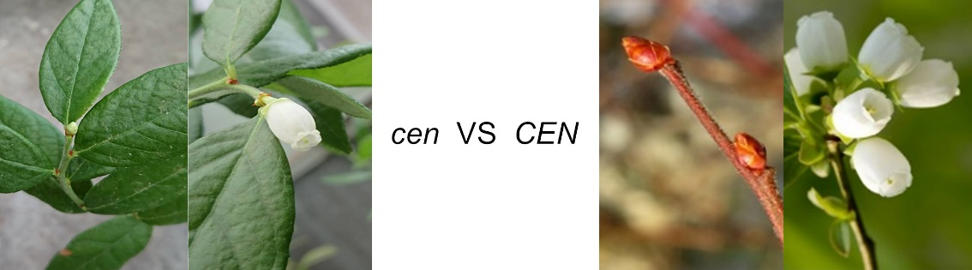Supplementary Figure 1. Comparison of the flower architecture between the mutant (cen) and WT (CEN). The cen mutants produced a single or double flower at the top of the shoot and bloomed within 1 month after bud formation without entering dormancy. In contrast, WT produced an apical bud and multiple axillary buds with several flowers.

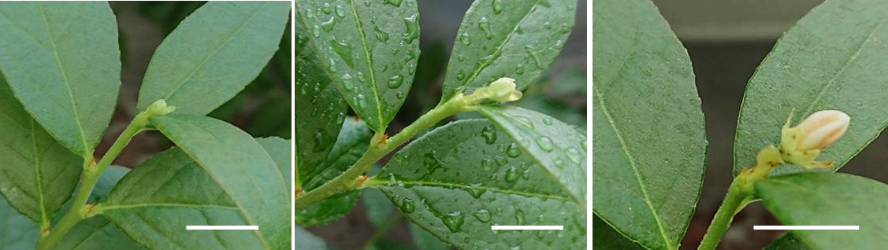
Supplementary Figure 2. Direct transformation into a flower without growth cessation and typical bud set. Bar = 2 cm. The plant was photographed every 6 days in July.

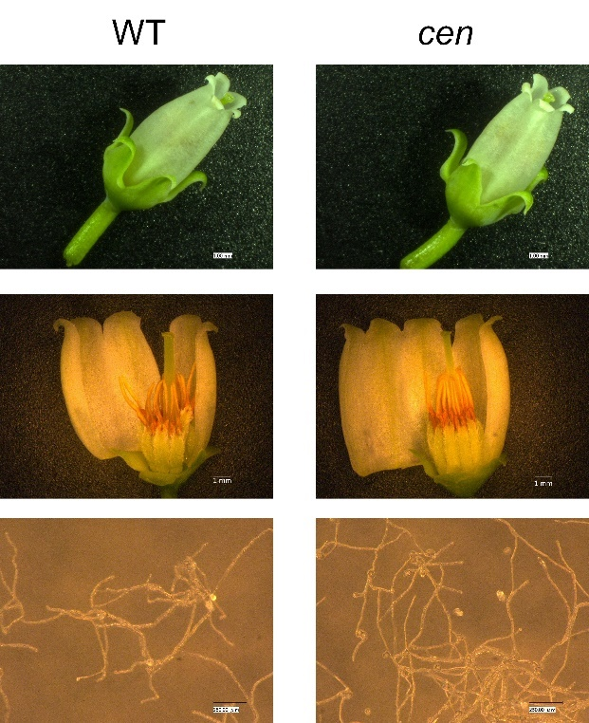
Supplementary Figure 3. Morphological comparison of the flower and pollen germination between WT and the cen mutant.

