Supplementary text for
“Proteome allocations change linearly with specific growth rate of Saccharomyces cerevisiae under glucose-limitation”
Jianye Xia^{1,2}, Benjamin J. Sánchez², Yu Chen^{1,2}, Kate Campbell², Sergo Kasvandik³,
Jens Nielsen^{2,4,*}

¹ State Key Laboratory of Bioreactor Engineering, East China University of Science and Technology, Shanghai, 200237, China
² Department of Biology and Biological Engineering, Chalmers University of Technology, Gothenburg, SE41296, Sweden
³ Institute of Technology, University of Tartu, Tartu, 50411, Estonia
⁴ BioInnovation Institute, Ole Maaløes Vej 3, DK2200 Copenhagen N, Denmark
*Correspondence: nielsenj@chalmers.se

Statistics information about the proteome data obtained in our experiment
We did biological triplicates at each specific growth rate, which were implemented through glucose-limited chemostats. And we got the absolute proteome data for each samples (supplementary data file Supp_data1_proteome.xlsx). We then did a basic statistics with our proteome datasets. It was found that 2,821 proteins were detected at once for all 27 samples (9 specific growth rates with 3 sample for each), and 1,787 proteins were detected among all the 9 studied specific growth rates (with at least two times detected in all triplicate samples). There were 137 proteins that were only detected under a specific growth rate, and these proteins were listed as bellow in the Table S1.
Table S1. The unique proteins that are only detected in each of the studied specific growth rate.
μ / h⁻¹ | Number | Unique proteins detected
0.027 | 33 | RAD50, THI20, SRB4, VPS35, CYR1, MAD1, PIK1, POP1, MDS3, VAM6, SRP102, SEA4, EXO84, YNL035C, PCL6, CIN2, YMR114C, HRD3, LOT6, YDR262W, VPS33, GTR2, ATG21, RRP45, ARO10, PTH2, MNR2, YFR039C, FMN1, YDR186C, PPZ2, RMR1, YSY6
0.044 | 17 | NAB6, YHR003C, YAP1801, AAT1, MNN4, GRX3, UTR1, PIB1, MED1, YOR111W, RTS3, SSU72, GPI17, HPA2, RAM1, TDA2, YIP5
0.102 | 12 | INO80, RIM2, SWC4, ATG3, SNL1, PDR17, JSN1, VPH2, YKL069W, VPS41, YLR241W, RTG1
0.152 | 10 | HEH2, POL12, YPR091C, LOA1, SPT8, YMR147W, VPS51, LSM5, ARL3, LCP5
0.214 | 10 | MLP2, SEC15, NST1, TAO3, HDA1, NCB2, CDC36, GFD1, PCC1, SOK2
0.254 | 13 | YOL087C, DUG2, CCM1, TSR4, YCK2, HDA2, PBP2, PSY2, ARL1, CDC8, UBC5, SEE1, YUH1
0.284 | 18 | POL2, DAL2, TFC3, GEA1, TFB1, CCA1, RPC37, YJR149W, GAL83, MRM1, MCM5, UTR4, SEC6, MAK3, MCT1, SAM35, OCA4, FCF1
0.334 | 9 | RPC82, YJL213W, GUF1, SIF2, YPP1, VTC3, STB1, SMD1, CEF1
0.379 | 15 | ISM1, IMA1, PDR15, SIS2, DUS1, RCM1, NUP100, SAL1, SAP190, HSM3, RPC31, NAT3, RRP36, DBF20, IES4
Six proteins were detected only under purely respiratory metabolism condition, which are IDP3, FMP40, MDR1, YIL055C, YDR476C, AIM3; while three proteins were detected only under respire-fermentative condition, which are SCS7, TRZ1 and NOC4.

Table S2. Linear correlation between 18 selected mRNAs absolute concentrations and their corresponding FPKM values.
Genes | Log10 absolute concentration | Log10 FPKM
YKL166C | 0.941901 | 1.408673
YMR037C | 1.283648 | 1.760375
YGL248W | 1.084783 | 1.8142
YJL196C | 0.997079 | 1.951155
YPL203W | 1.146113 | 2.123908
YCR005C | 1.292791 | 2.086909
YMR169C | 0.519345 | 2.108885
YNR016C | 1.914004 | 2.360884
YGL205W | 1.553753 | 2.508488
YKL148C | 1.889795 | 2.623546
YHR183W | 2.009526 | 2.743294
YFR053C | 2.257163 | 3.029681
YGL055W | 1.898622 | 3.322376
YLR044C | 2.461568 | 3.423363
YHR007C | 2.108334 | 3.570917
YKL060C | 2.379701 | 3.884723
YBR072W | 3.016487 | 4.271733
YGR192C | 3.067624 | 4.174969

Estimation of the translation speed of ribosome in S. cerevisiae
For better interpreting the observed model between ribosome protein fraction and specific growth rate (Eqn. 1 in main text), the equation is transformed to the following format,
$μ=τ\left(f_{r}-f_{r}^{0}\right)$ (S1)
With $τ=2.86 h^{-1}$ and $f_{r}^{0}=0.13$, here $τ$ is interpreted as ribosome specific translation rate, and $τ=2.86 h^{-1}$ means 2.86 gram of new protein will be translated per gram ribosome per hour, and $f_{r}^{0}$ means the minimum ribosome fraction in the proteome required for maintaining the cell alive when it has no growth. Then the average amino acid molecular weight was calculated to be 128.65 Da according to the amino acid compositions of all proteins detected under all 9 specific growth rates experiment (supplementary data file Supp_data4_averageAminoAcidMW.xlsx). Given the ribosomal protein molecular weight to be 1.62$×$10⁶ Da¹, the peptide elongation rate (PER) was estimated to be,
$$τ= \frac{2.86 gram protein}{gram ribosome∙hour}=\frac{2.86/128.65}{\frac{1}{1.62×{10}^{6}}∙3600 sec}≈10\frac{AA}{Ribosome∙sec}$$
this agrees with 2.8-10 AA/Ribosome/s reported in Bionumbers database² and 10.5 AA/Ribosome/s in Waldron et al³.
Statistics information about the transcriptome data obtained in our experiment
Using the absolute mRNA quantification method, we quantified 5401 mRNAs in the 9 tested specific growth rate conditions with unit of copies per cell and shown in supplementary data file: Supp_data3_transcriptome.xlsx. The most abundant mRNA among all 9 conditions is the translational elongation factor EF-1 alpha, TEF1, with an average value of 436 copies per cell. And the less abundant mRNA is the function unknown protein, YL138C, with an average value of 0.16 copies per cell.
GO terms enrichment analysis for significantly correlated 845 genes
BP (biological process), MF (molecular function), and CC (cellular component) enrichment analysis were carried out for 845 genes which showed significant correlations in between mRNA and protein level. The results is shown in Fig. S4. From the results, it is shown that for BP enrichment analysis, the top three terms are structural constituent of ribosome with corrected p value = 1.97 $×$ 10-37, structural molecule activity with corrected p value = 3.99 $×$ 10-17 and rRNA binding with corrected p value = 3.2 $×$ 10-4, respectively; for BP enrichment analysis, the top three terms are translation with corrected p value = $×$ 10-37

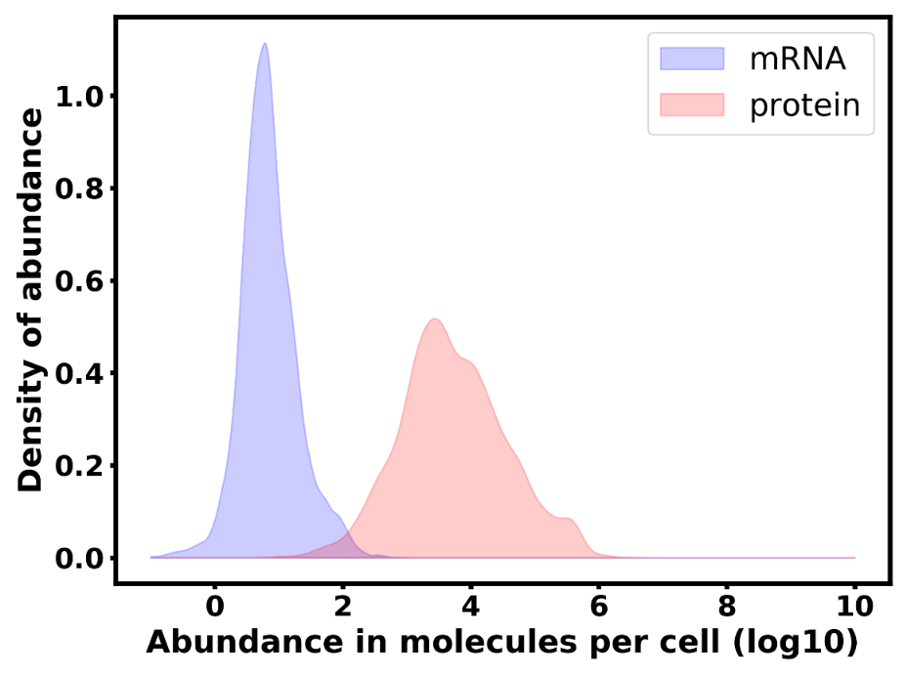
(A)
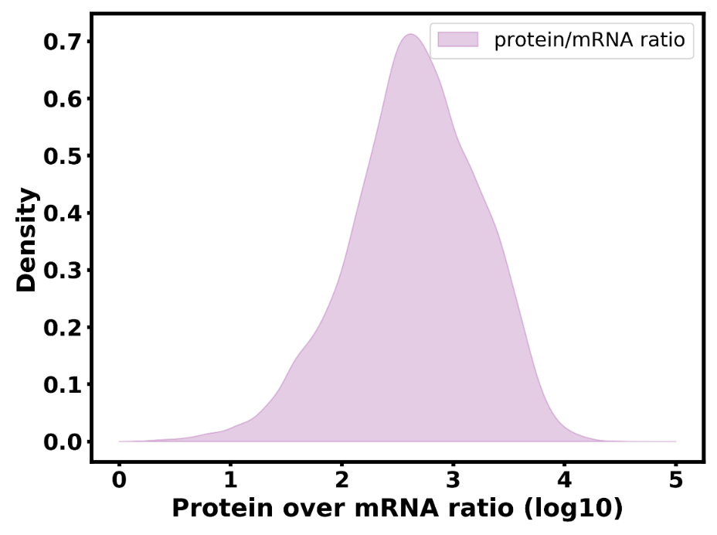
(B)
Figure S1. Distribution of mRNA and protein abundance and their ratios across all test conditions. (A) Abundance distribution of transcriptome and proteome, in average the abundance of proteins are 3 orders bigger than that of the mRNAs. It is also noticed that few transcripts show value less than 1 copy per cell, that is caused by unequal expression among different single cells even under the steady state culture. (B) Density plot of protein over mRNA ratios with all genes detected in the 9 studied conditions.

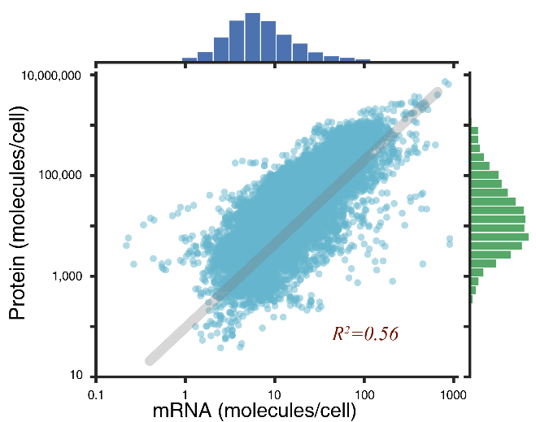
Figure S2. Correlation between protein and mRNA abundance for all data, using all values of individual samples across different dilution rates (n=9) with biological replicates (n=3). The upper panel shows the distribution of mRNA abundance, with a median value of ~6 molecules per cell. Right panel shows the distribution of protein abundance, with a median value of ~13,534 molecules per cell. The average dry cell weight was assumed to be 13 pg according to a previous study of this strain under similar growth conditions ⁴.

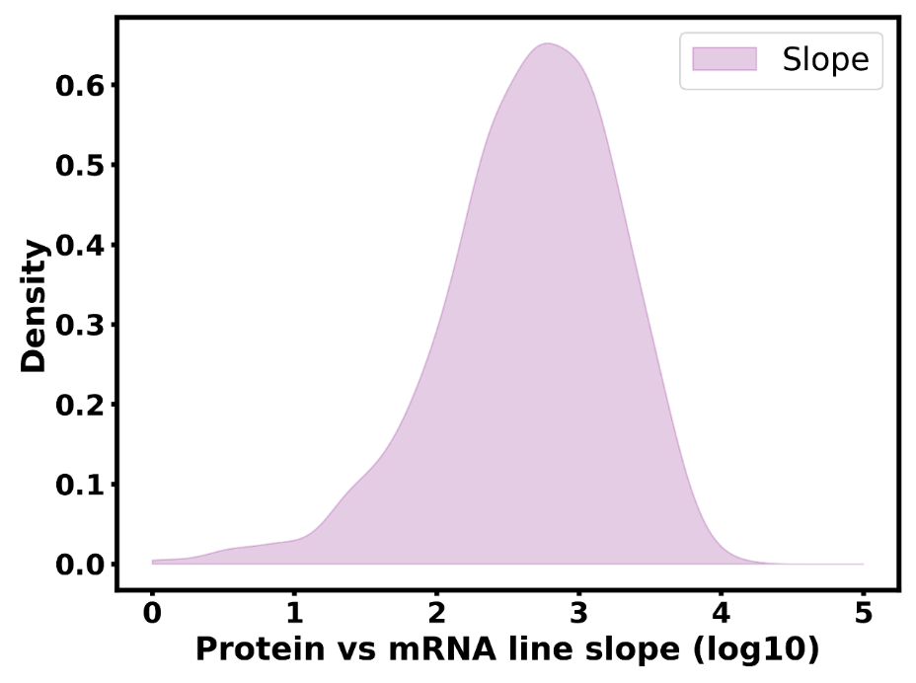
Figure S3. Density plot of protein versus mRNA regressed line slope. The plot shows that the slopes cover three orders among different transcripts.
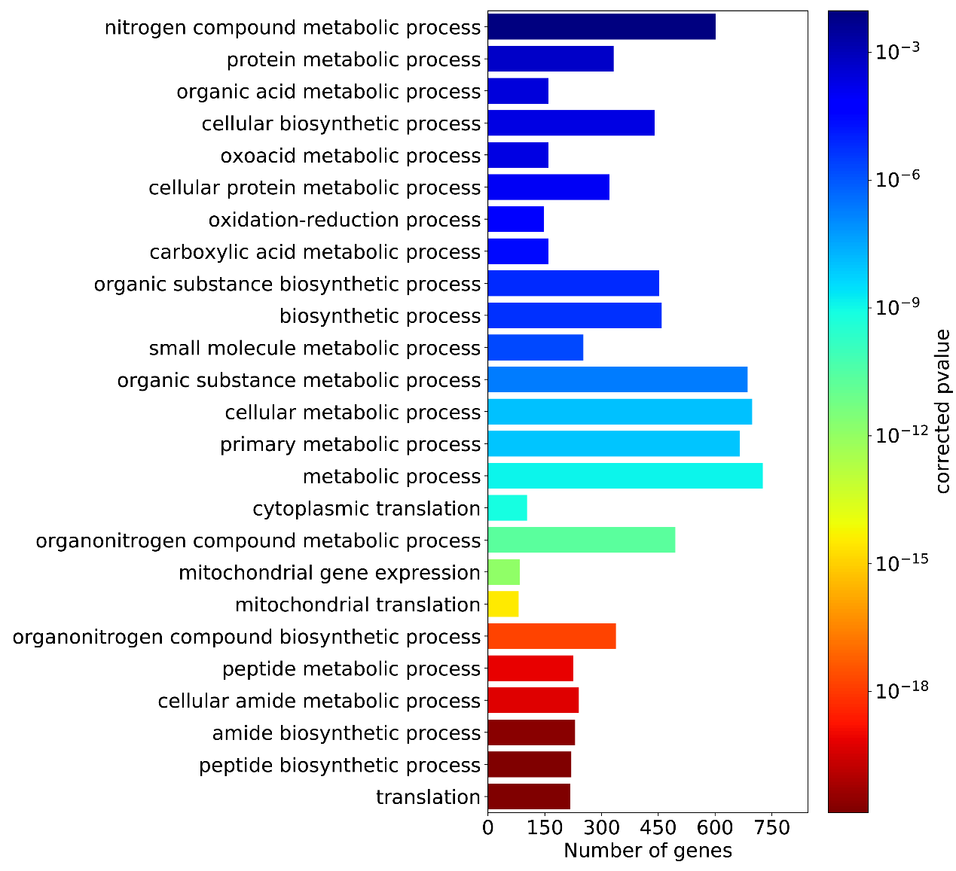
(A)
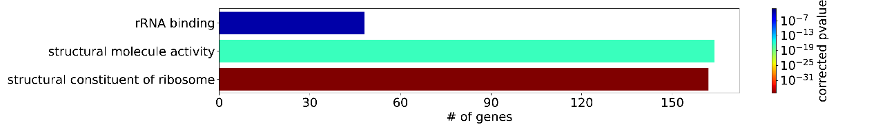
(B)
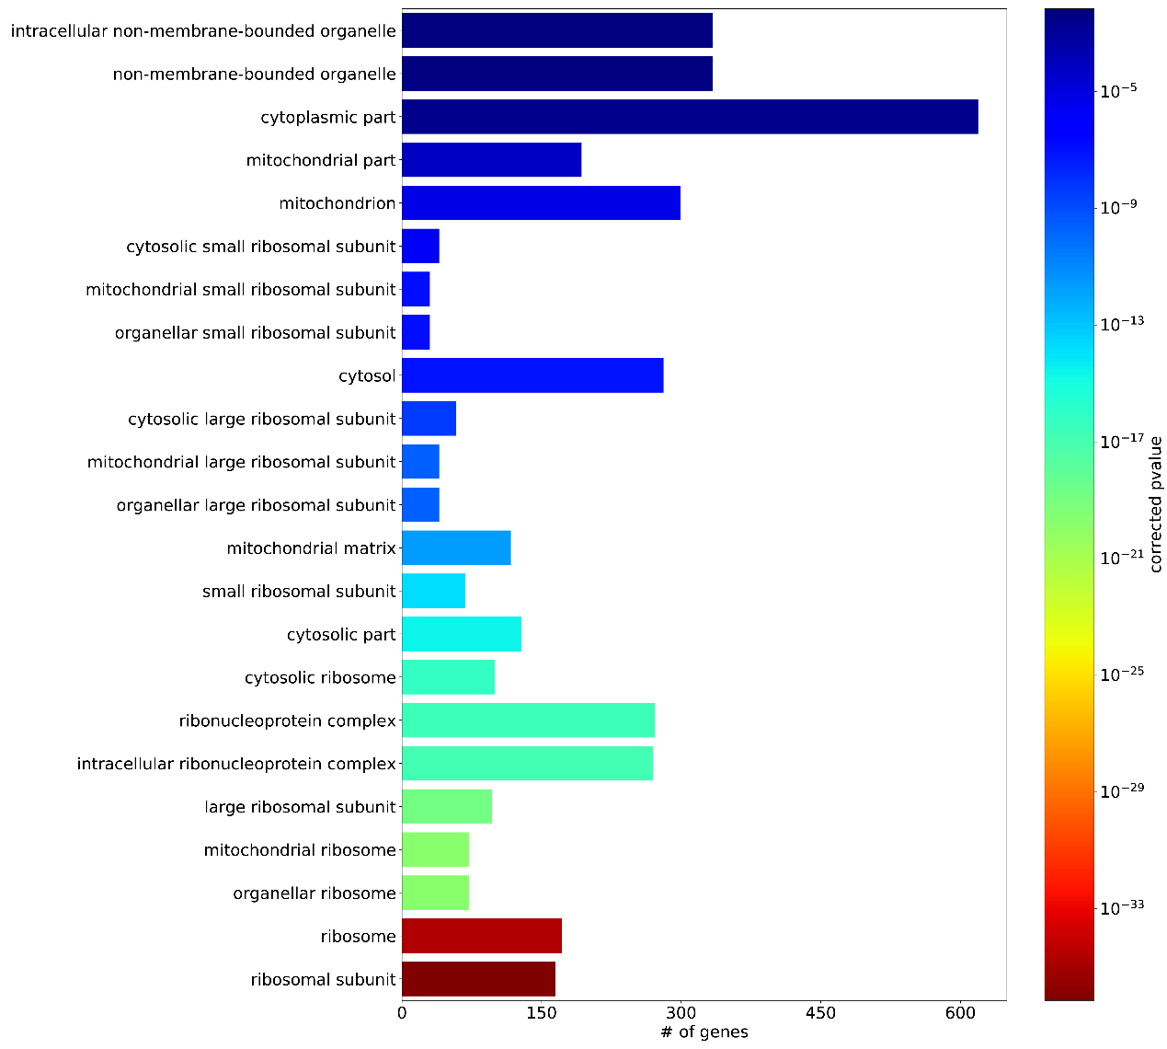
(C)
Figure S4. GO terms Enrichment analysis of 845 genes with which significant correlations (p value < 0.01) were observed. (A) GO term biological process (BP) enrichment analysis, (B) GO term molecular function (MF) enrichment analysis, and (C) GO term cellular component (CC) enrichment analysis.

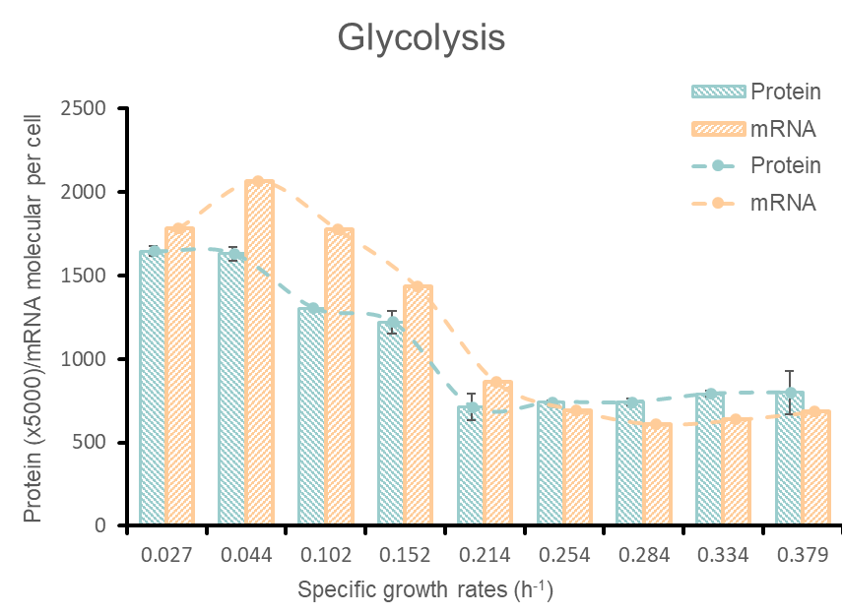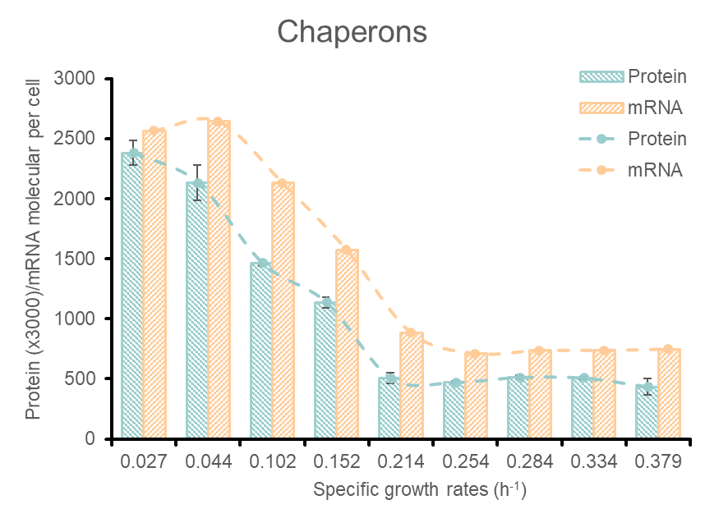
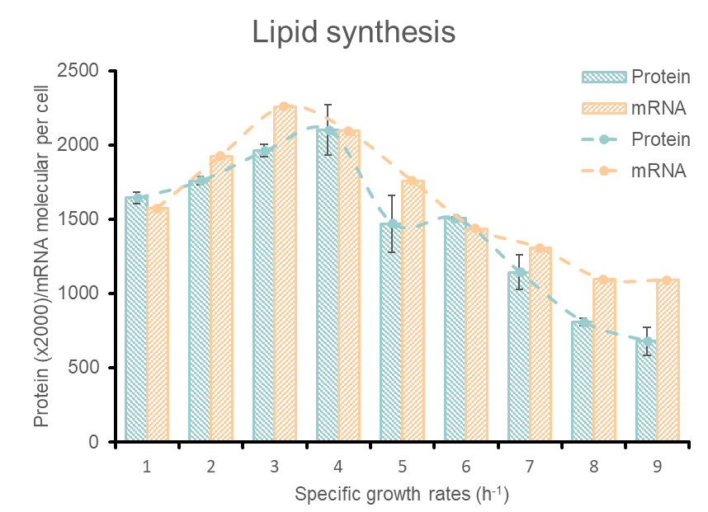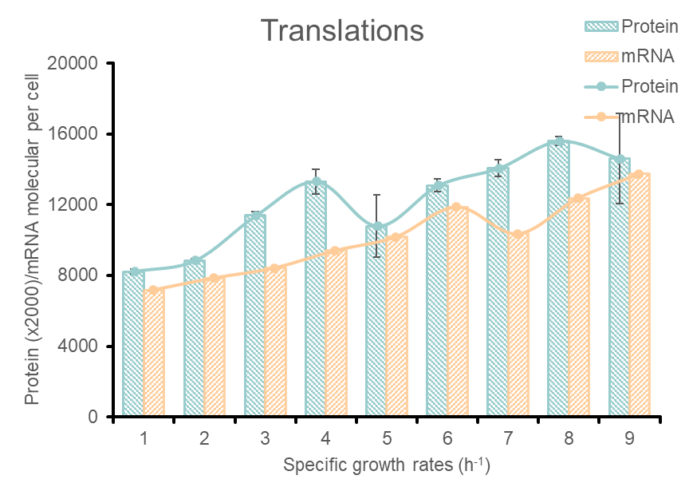
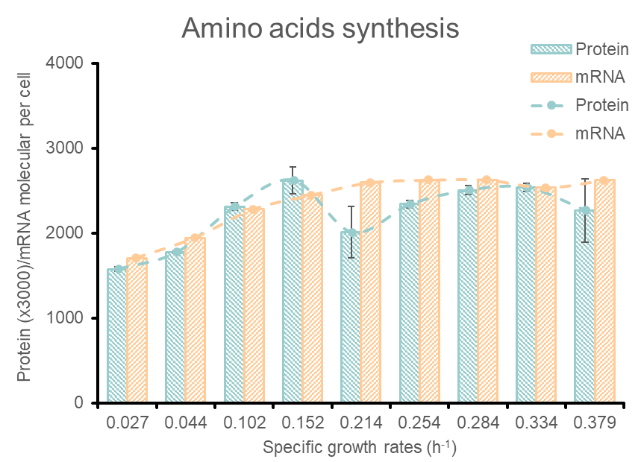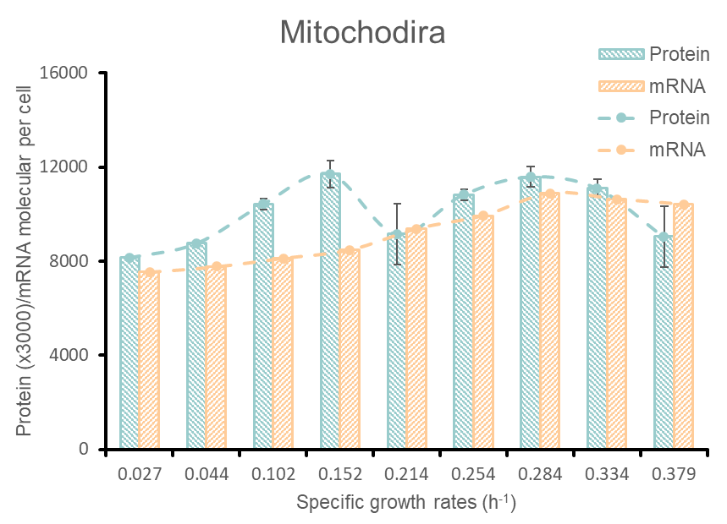
Figure S5. The absolute concentrations of mRNA and protein under different specific growth rates. It is clear that similar trends among the absolute concentration of mRNA, protein and protein allocation in glycolysis, chaperon, translation, amino synthesis and mitochondrial functional groups. For the lipid metabolism related genes, although the mRNA and protein change trend are almost the same, it is not consistent with the protein allocation trend.

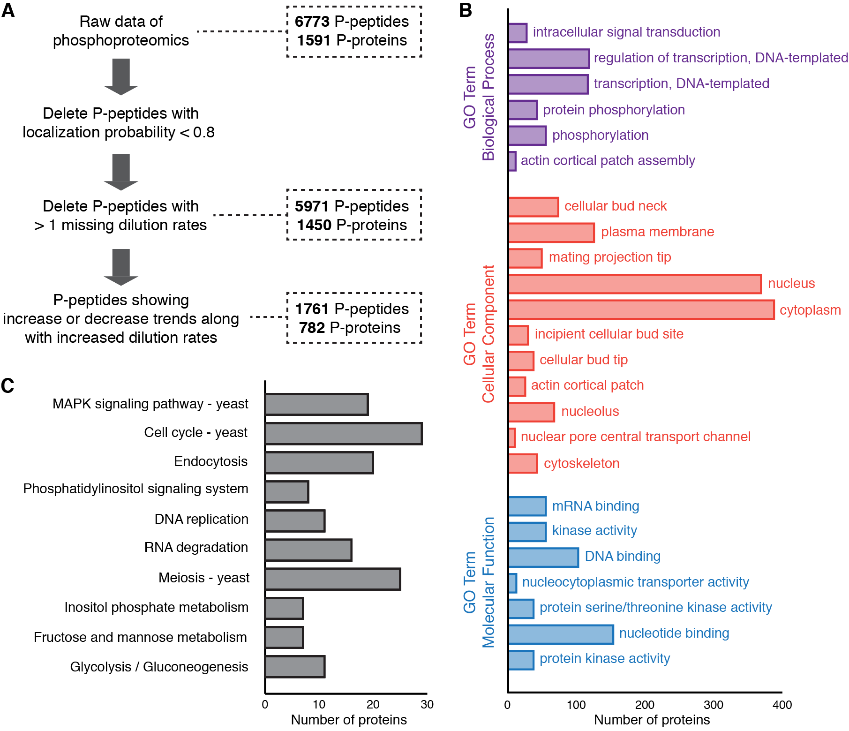
Figure S6. Phosphoproteomics data analyzing method and enrichment analysis. (A) Workflow of phosphoproteomics data processing and number of phosphopeptides (P-peptides) and phosphoproteins (P-proteins) at each step. (B) Enrichment of P-proteins in Gene Ontology (GO) terms. Only the significantly (false discovery rate, FDR < 0.01) enriched GO terms are shown. (C) Enrichment of P-proteins in KEGG pathways. All the pathways are shown without being filtered by statistics.

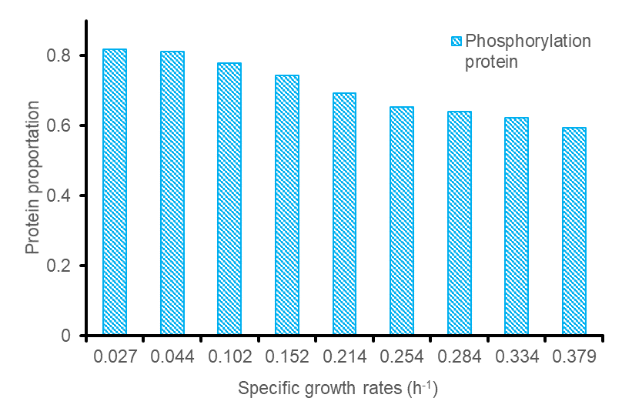
Figure S7. Phosphorylation level of chaperone proteins studied across nine specific growth rates. Protein phosphorylation level were calculated by the ratio of phosphorylated protein to total protein of chaperon. It is clear that although proteins of chaperon are highly phosphorylated, a downward trend is shown with the increase of specific growth rate.

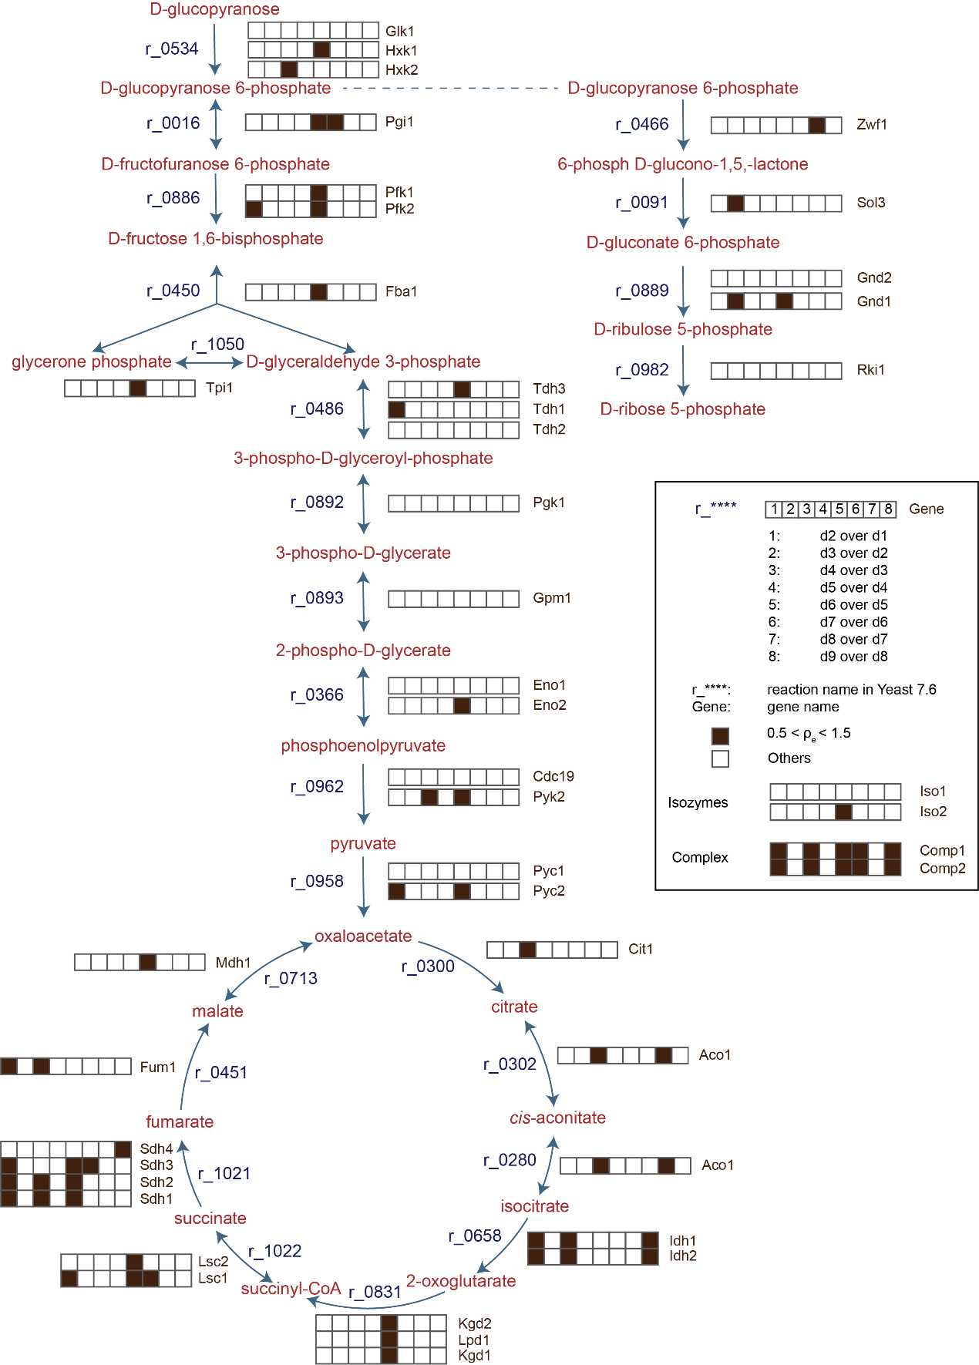
(A)
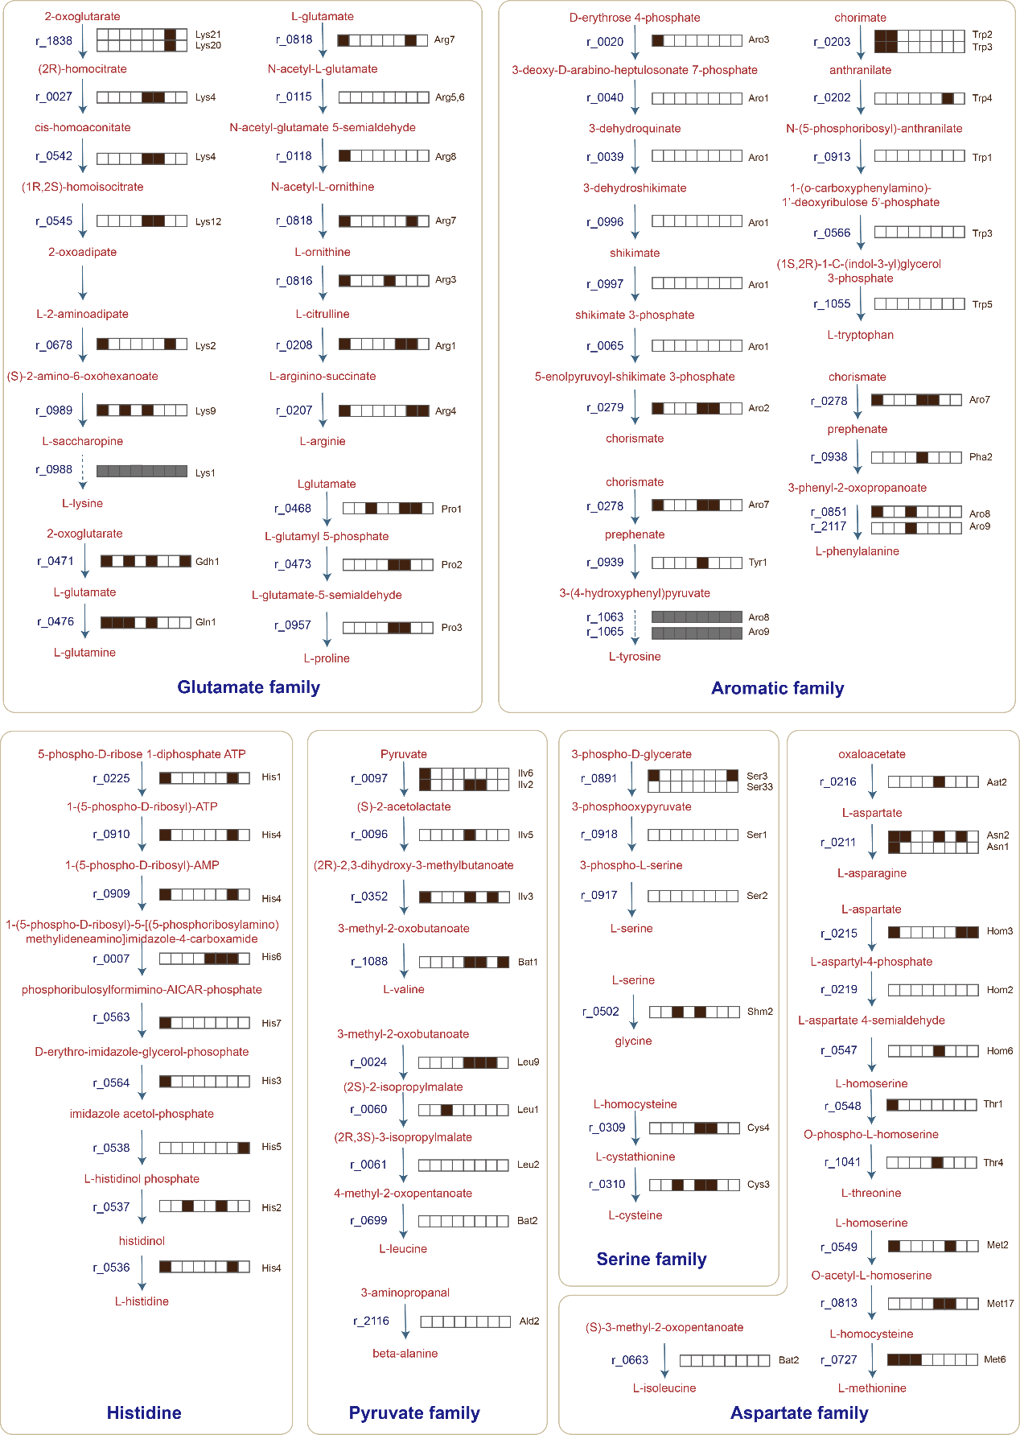
(B)
Figure S8. Enzyme activity regulation events of central carbon metabolism and amino acid synthesis pathway. Hierarchical regulation analysis method was used to investigate enzymatic activity regulation events. The black block indicates that enzyme activity regulation events may exist, while the white block indicates that enzyme activity regulation events are almost non-existent.(A) Central carbon metabolic pathways; (B) Amino acid synthesis pathways.
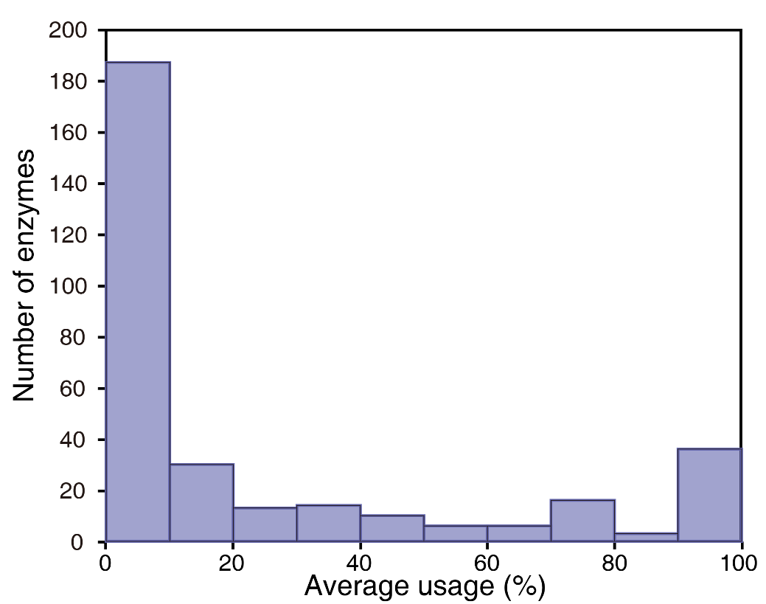
Figure S9. Number of enzymes with different average enzyme usages (n=321) for enzyme usage analysis.
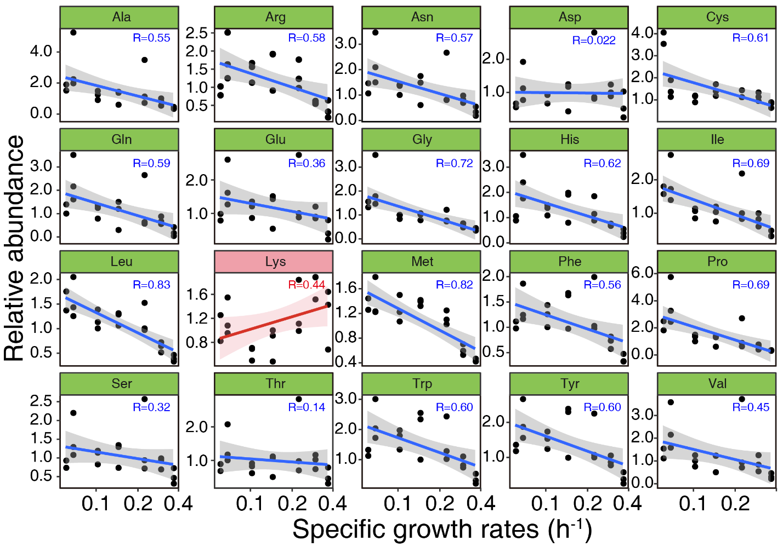
(B)
Fig. S10 Linear correlation regression of individual amino acids to specific growth rate. Among them, only lysine shows an increasing trend (marked in red).

References:
1. Warner JR. The assembly of ribosomes in yeast. The Journal of Biological Chemistry 246, 447-454 (1971).

2. Milo R, Jorgensen P, Moran U, Weber G, Springer M. BioNumbers--the database of key numbers in molecular and cell biology. Nucleic Acids Res 38, D750-D753, BNID 100986 (2010).

3. Waldron C, Lacroute F. Effect of growth rate on the amounts of ribosomal and transfer ribonucleic acids in yeast. J Bacteriol 122, 855-865 (1975).

4. Lahtvee P-J, et al. Absolute quantification of protein and mRNA abundances demonstrate variability in gene-specific translation efficiency in yeast. Cell Systems 4, 495-504.e495 (2017).

