Supplementary Material
Figure S1
The Dot Probe task in the fNIRS/ET Setup
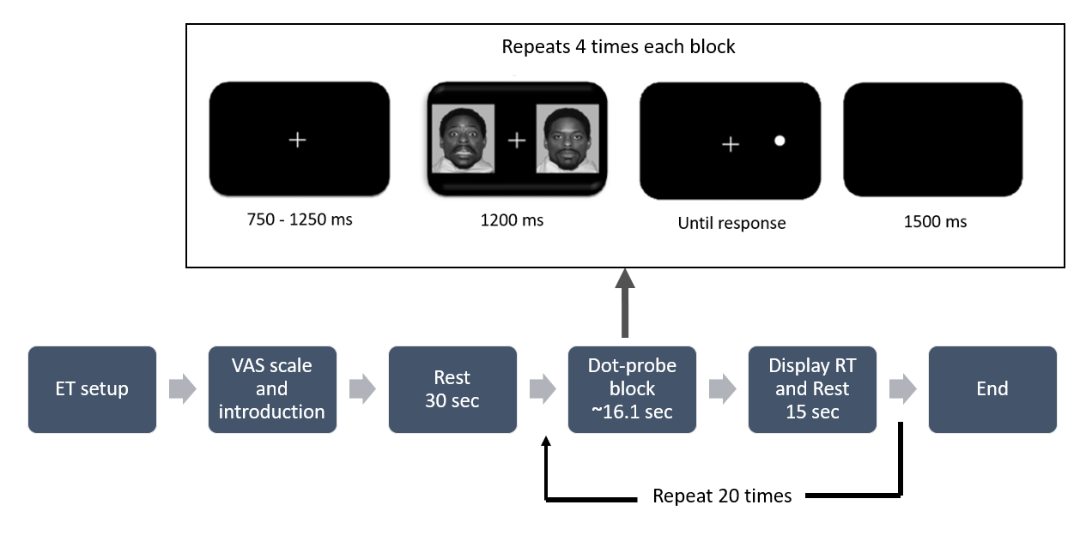 Note. The visualization is from a master’s project (Ougendal, 2023). VAS: visual analogous scale. This dot-probe version consisted of five blocks (repeated 4 times): fearful-neutral incongruent, fearful-neutral congruent, neutral-neutral, happy-neutral incongruent, and happy-neutral congruent. Each block consisted of four trials. In line with the dot-probe in the EEG/ET session, each trial had 50/50 male/female stimuli, and the same person was used in each face pair.

Table S1
Outcomes for 1,000 Random Split-Halves for the Dwell-Bias and N2pc Metrics
AB metric | 1,000 random split-halves
Dwell-bias | .30
N2pc | -.75

Table S2
Distribution of participants in the Beck Anxiety Inventory categories of minimal, mild, moderate and severe symptoms of anxiety
Category within the Beck Anxiety Inventory | N (62) |  | %
Minimal | 38 |  | 61.29
Mild | 16 |  | 25.81
Moderate | 6 |  | 9.68
Severe | 2 |  | 3.23

Table S3
Distribution of participants in the Beck Depression Inventory categories of minimal, mild, moderate and severe symptoms of depression
Category within the Beck Depression Inventory II | N (62) |  | %
Minimal | 36 |  | 61.29
Mild | 14 |  | 25.81
Moderate | 9 |  | 9.68
Severe | 3 |  | 3.23

Figure S2
Relationship Between BAI Sum Scores and Reliable AB Metrics
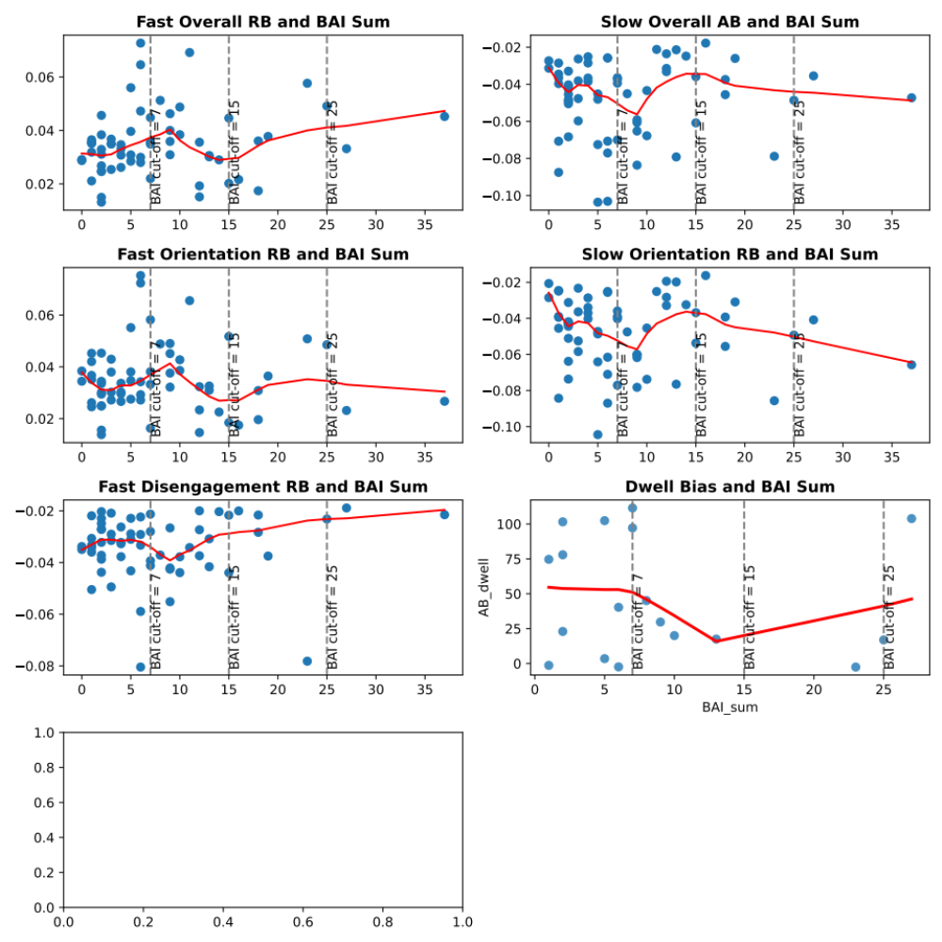
Note. Each blue dot represents a datapoint, and the red line is the locally estimated scatterplot smoothing (LOESS) estimated curve. Vertical lines presents cut-off values indicating minimal, mild and moderate anxiety symptoms in the BAI total score (7, 15 and 25). BAI: Beck Anxiety Inventory.

Figure S3
Relationship Between BDI Sum Scores and Reliable AB Metrics
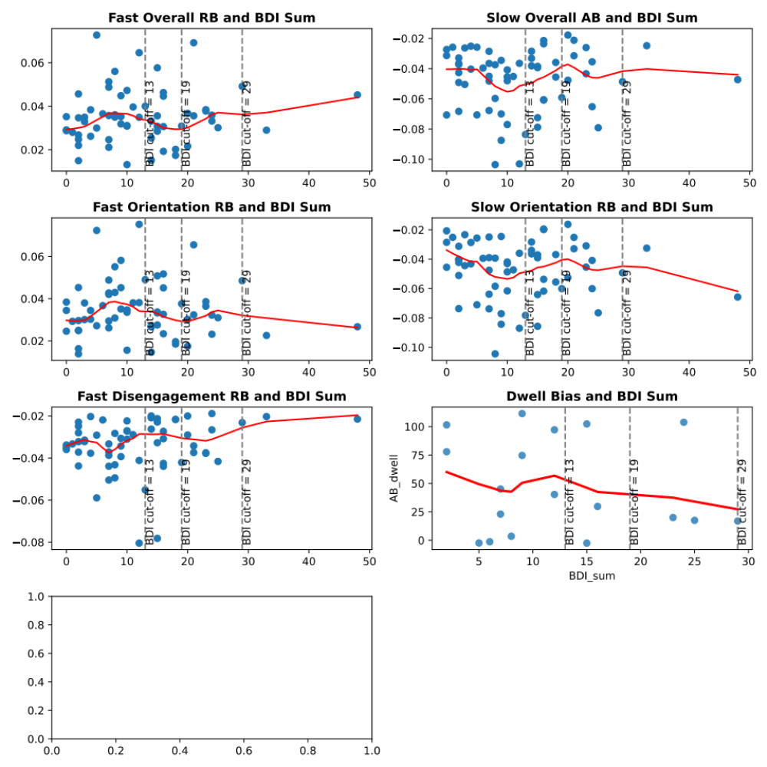
Note. Each blue dot represents a datapoint, and the red line is the locally estimated scatterplot smoothing (LOESS) estimated curve. Vertica lines presents cut-off values indicating minimal, mild and moderate depression in the BDI total score (13,19, and 29). BDI: Beck Depression Inventory II.

Figure S4
Correlation Matrix for the Reliable AB Metrics
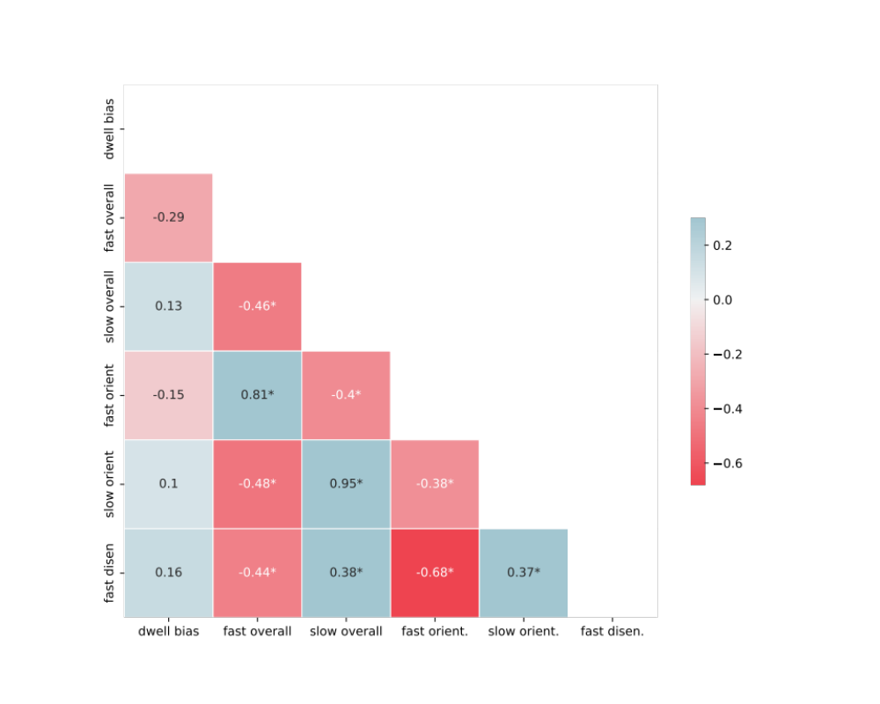
Note. The blue color indicates positive correlations, and the red color indicates negative correlations. Fast overall: fast overall response-based, slow overall: slow overall response-based, fast orient.: fast orientation response-based, slow orient.: slow orientation response-based, fast disen.: fast disengagement response-based, slow disen.: slow disengagement response-based. * p-value <.05
Figure S5
Correlations Across Trials Between Dwell Time Bias and the Overall, Orientation, and Disengagement RB Scores for All Participants
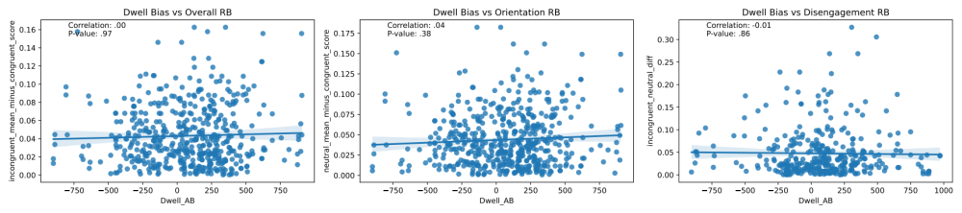
Note. The scores included the data from the fast and slow subcategories.
Table S4
Reliability Outcomes for the fNIRS/ET Session
AB measure | AB metric | Split-half | Cronbach’s alpha / 1,000 random split-halves*
Traditional | Overall | .51 | .28*
Traditional | Orientation | .67 | .39*
Traditional | Disengagement | .54 | .40*
Response-based | Fast overall | .63 | .48*
Response-based | Slow overall | .58 | .47*
Response-based | Fast orientation | .74 | .65*
Response-based | Slow orientation | .36 | .46*
Response-based | Slow disengagement | .27 | .24*
Response-based | Fast disengagement | .65 | .56*
Dwell time difference | Dwell-bias | .06 | .08
Note. The average number of trials for each of the six response-based metrics, derived from the participant reaction time patterns, were as follows: 8.6 trials for fast overall (SD = 2.7, range = 4.0–16.0), 6.3 trials for slow overall (SD = 2.8, range = 0.0–12.0), 8.3 trials for fast orientation (SD = 3.1, range = 2.0–14.0), 6.6 trials for slow orientation (SD = 3.3, range = 1.0–14.0), 6.9 trials for slow disengagement (SD = 3.3, range = 1.0–14.0), and 8.3 trials for fast disengagement (SD = 3.2, range = 2.0-15.0).
Table S5
Overview of the AB Metric Calculation Methods for Happy-Neutral Stimuli Trials
AB measure | AB metric | Calculation
Traditional (RT) | Overall  Orientation  Disengagement | Incongruent – congruent  Neutral – congruent  Incongruent – neutral
Response-based (RT) | Overall (fast and slow)  Orientation (fast and slow)  Disengagement (fast and slow) | Incongruent – congruent [trial #]  Neutral – congruent [trial #]  Incongruent – neutral [trial #]
Note. Neutral refers to neutral-neutral trials. Incongruent and congruent trials in happy-neutral trials were calculated based on the whether the dot was placed behind the relatively more negative stimuli (i.e. neutral face). RT: Reaction time based

Table S6
Group Averages and Reliability Outcomes for AB Measures
AB measure | AB metric | Mean score (SD) [range] | Split-half | Cronbach’s alpha / 1,000 random split-halves* | Test-retest
Traditional | Overall | 2.37 (35.12) [-122.75, 76.08] | .06 | .1* | -.09
Traditional | Orientation | 0.84 (27.67) [-52.12, 74.14] | .08 | -.2* | -.03
Traditional | Disengagement | 1.53 (35.66) [-93.98, 95.78] | .19 | .05* | -.04
Response-based | Fast overall | 44.65 (20.61) [7.89,117.8] | .46 | .55* | .13
Response-based | Slow overall | -57.0 (36.74) [-179.67, -6.18] | .49 | .37* | .04
Response-based | Fast orientation | 43.19 (19.95) [9.39, 104.36] | .50 | .45* | .40
Response-based | Slow orientation | -57.70 (33.68) [-140.39, -0.52] | .37 | .41* | .05
Response-based | Slow disengagement | 64.71 (36.94) [8.07, 200.48] | .27 | .29* | .27
Response-based | Fast disengagement | -45.92 (23.36) [-138.89, -13.78] | .60 | .5* | .36
Note. *1,000 random split-halves were conducted when Cronbach’s alpha could not be calculated. The values in bold were above the threshold for fair internal consistency.

