Supplementary information

Table of content

Tables
Table S1: Cohort statistics
Table S2: Exclusion criteria for donors, cases, and controls.

Figures
Figure S1: PCA of technical variance and known confounding effects.
Figure S2: PCA of normalized data.
Figure S3: PCA of osteoporosis.
Figure S4: Donor variance in PCA.
Figure S5: Illustration of the slope calculation for a single molecule.
Figure S6: Random Forest performance in osteoporosis prediction.
Figure S7: Hold-one-batch-out cross validation demonstrates stable methodology.

Table S1: Cohort statistics. All five Danish regions are represented.
 |  | Number of participants |  |  |  | Number of samples
 |  | Cases | Controls | Total |  | Cases | Controls | Total
N |  | 99 | 99 | 198 |  | 271 | 269** | 540
Gender
 | F | 83 | 83 | 166 |  | 227 | 225 | 452
 | M | 16 | 16 | 32 |  | 44 | 44 | 88
Year of birth
 | [1955,1955) | 25 | 25 | 50 |  | 61 | 61 | 122
 | [1955,1965) | 55 | 55 | 110 |  | 173 | 171 | 344
 | [1965,1975) | 14 | 14 | 28 |  | 23 | 23 | 46
 | [1975,1995) | 5 | 5 | 10 |  | 14 | 14 | 28
Donation region*
 | Region H | 25 | 25 | 50 |  | 85 | 83 | 168
 | Region M | 34 | 34 | 68 |  | 64 | 64 | 128
 | Region N | 24 | 24 | 48 |  | 75 | 75 | 150
 | Region S | 9 | 9 | 18 |  | 27 | 27 | 54
 | Region SJ | 7 | 7 | 14 |  | 20 | 20 | 40
Number of samples per participant
 | 1 | 60 | 60 | 120 |  | 60 | 60 | 120
 | 5 | 23 | 23 | 46 |  | 115 | 115 | 230
 | 6 | 16 | 16** | 32 |  | 96 | 94** | 190
*When counting unique participants, the most recent region of donation is considered
**Two controls missed one sample because of missingness in the storage or obstructed sample preparation. For both it was the most recent sample.

Table S2: Exclusion criteria for participants, cases, and controls.
Variable | ICD-10 | ATC
Alcoholism | F10 | N07BB01
Psychiatric eating disorders  (anorexia nervosa, Bulimia nervosa) | F50
Anorexia | R63.0
Testicular dysfunction | E29  E34.5 | G03B
Ovarian dysfunction | E28 | G03FA  G03FB

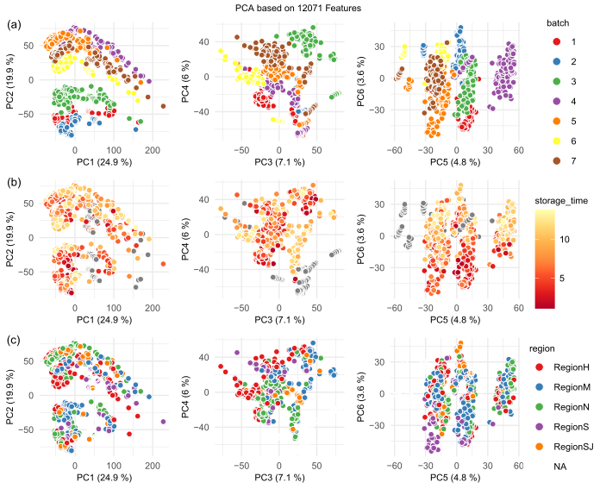
Figure S1: PCA of technical variance and known confounding effects. Positive ionization data.
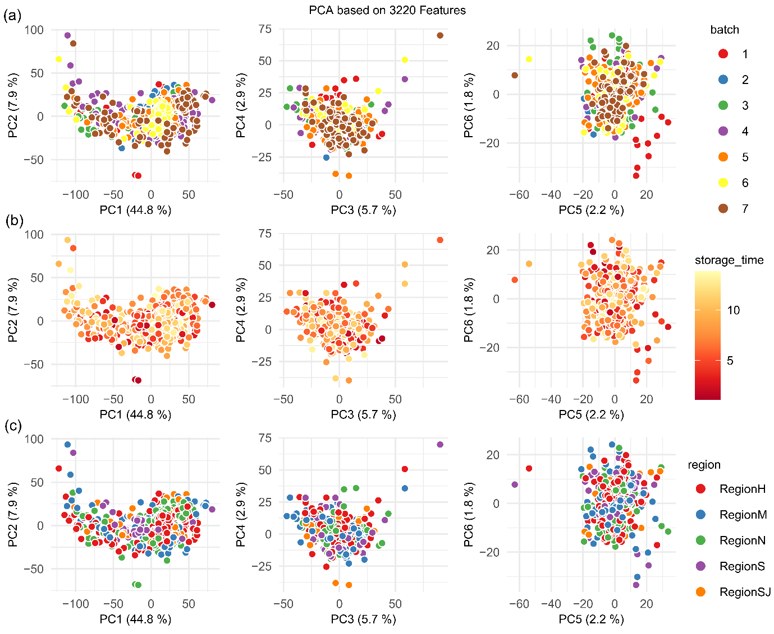
Figure S2: PCA of normalized data. Positive ionization data.

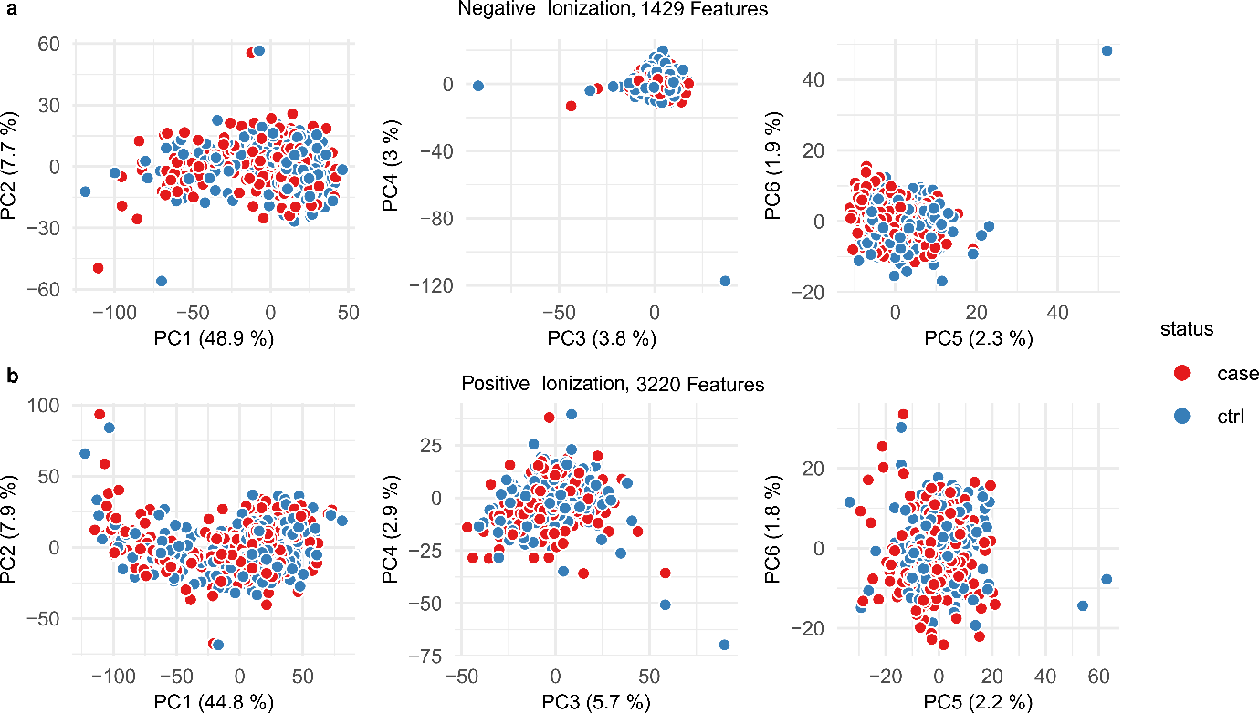
Figure S3 | PCA of osteoporosis. First 6 principal components of negative and positive ionization for the full dataset before calculating slopes.

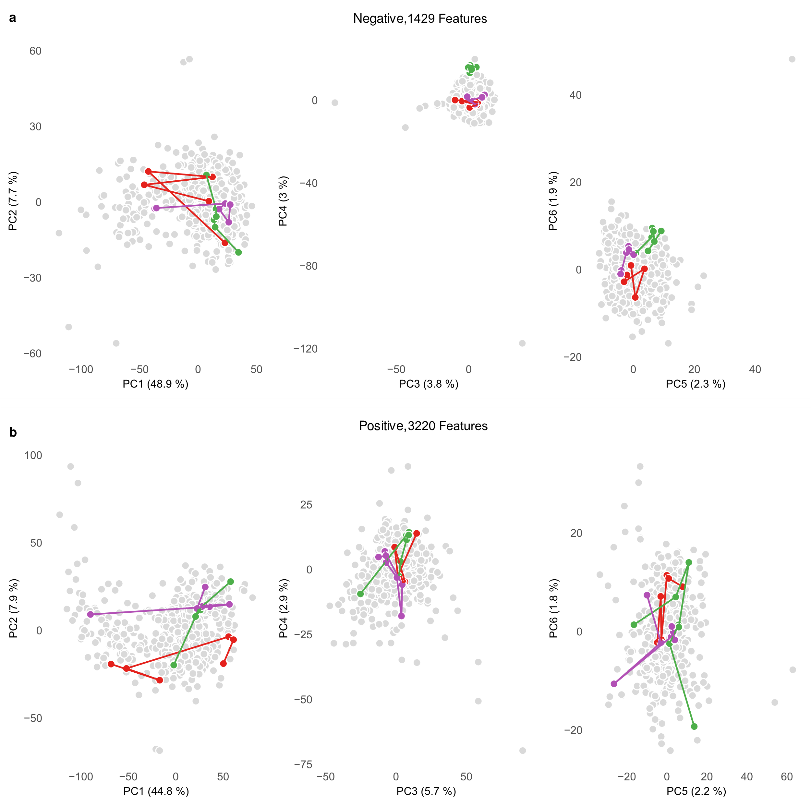
Figure S4 | Participant variance in PCA. a. negative ionization data colored by samples from three random participants. The first two components show that the major sources of variance are not caused by individual effects. The next four components show some clustering on individual participants. b. The same plot for positive data. Here no participant clusters are seen likely because of more features resulting in spurious correlations and random noise.

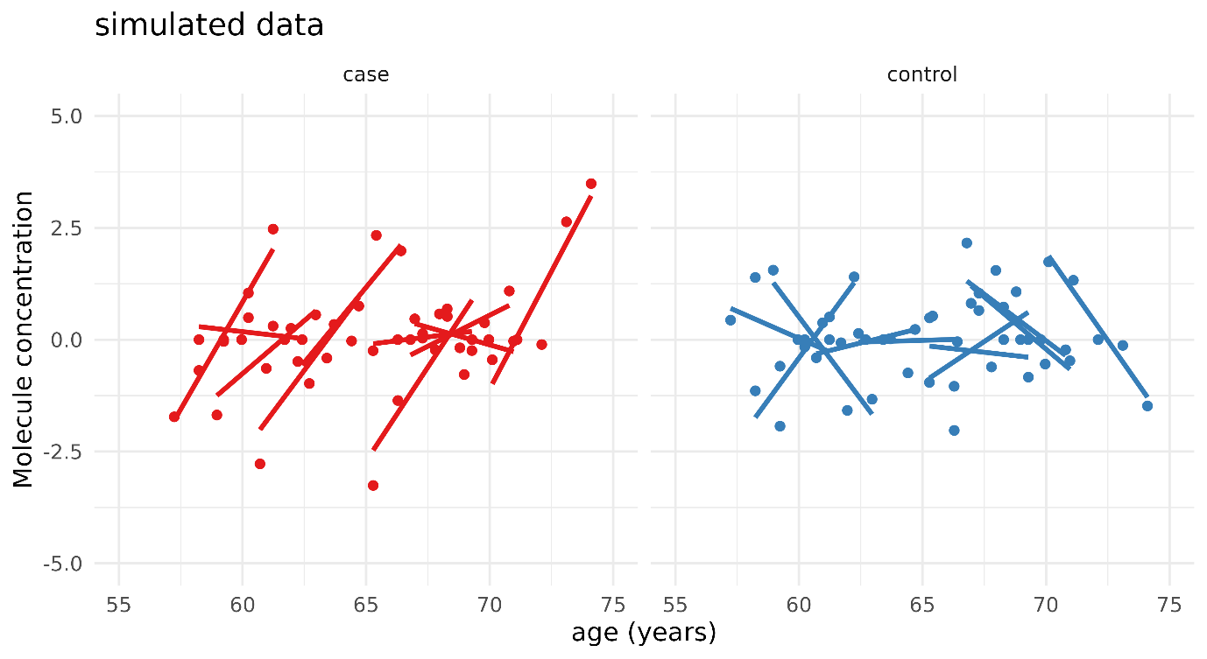
Figure S5 | Illustration of the slope’s calculation for a single molecule. Normalized to a mean of 0 per individual.

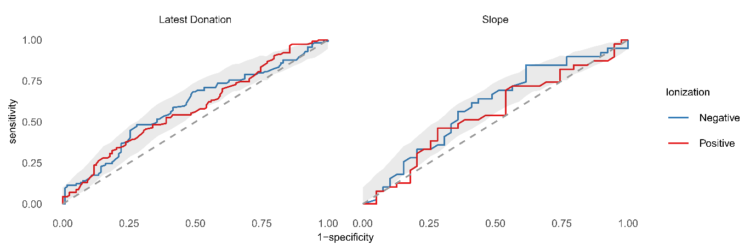
Figure S6 | Random Forest performance in osteoporosis prediction. All random forest results are non-significant.

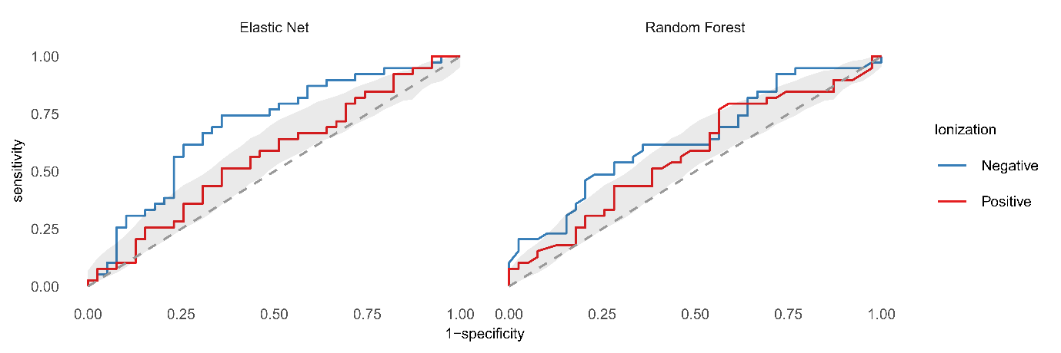
Figure S7 | Hold-one-batch-out cross validation demonstrates stable methodology. Only models of slope values (longitudinal data). The elastic net on negative ionization data validates, while the positive ionization data most likely becomes too underpowered. Elastic Net AUCs are 0.69 and 0.57 for positive and negative data. Random Forest AUCs are 0.64 and 0.57.

