Supporting Information
Multivalent LecA/LecB Inhibitors based on the Co-assemblies of Perylene Monoimide-carbohydrate Conjugates for Antibiotic-free Antibacterial and Wound Healing
Jian-Xing Yangª, Hai-Qing Liª, Fangqian Yin^{a,b}, Wen-Juan Yin^{c}, Ke-Rang Wangª*
[ª] J. X. Yang, H. Q. Li, F. Yin, Prof. K. R. Wang
College of Chemistry and Materials Science, State Key Laboratory of New Pharmaceutical Preparations and Excipients, Key Laboratory of Medicinal Chemistry and Molecular Diagnosis (Ministry of Education), Key Laboratory of Chemical Biology of Hebei Province, Hebei Research Center of the Basic Discipline of Synthetic Chemistry, Hebei University, Baoding, 071002, P. R. China. E-mail: kerangwang@hbu.edu.cn.
[^{b}] F. Yin
College of Chemical Engineering & Material, Hebei Key Laboratory of Heterocyclic Compounds, Handan key laboratory of organic small molecule materials, Handan University, Handan 056005, P. R. China.
[^{c}] Dr. W. J. Yin
College of Basic Medical Science, Hebei University, Baoding 071002, P. R. China.
S1. Materials
¹H NMR and ¹³C NMR spectra were measured on a 400 MHz or 600 MHz spectrometer (Bruker Company). HRMS analysis was recorded on a Bruer Daltoni (Apex Ultra) for ESI mode and FT-MALDI MS for MALDI-TOFF mode. UV-visible absorption spectra were measured on a Cary 5000 UV-Vis-NIR Spectrophotometer (Agilent). Fluorescence spectra were obtained on a F-7000 instrument (Hitachi Instruments). The data of DLS was measured on BI-APDV (Brookhaven). The TEM image was recorded on Tecnai G2 F20 S-Twin (FEI). SYTO 9 and PI were all purchased from Sigma-Aldrich. Scanning electron microscopy (SEM) images were taken using a Scanning Electron Microscopes SU3800 (Hitachi High-Tech). L929 cell were obtained from Servicebio (Wuhan, China). Fluorescent images were captured on a confocal laser scanning microscope (Zeiss LSM 880). P. aeruginosa was obtained from Dalian University of Technology. BALB/c mice (16-18 g, 6-weeks-old, female) were obtained from Beijing Vital River Laboratory Animal Technology.
S2. Synthesis
Scheme S1. (a) CuSO₄·5H₂O, sodium ascorbate, THF/H₂O, 55℃; (b) CH₂Cl₂, HCl; (c) CH₃OH, CH₃ONa.
PMI-3AcGal: The mixture of PMI-1 (150 mg, 0.19 mmol) and azido-galactose (288.6 mg, 0.69 mmol) was dissolved in THF (25 mL) solution. Then, a water solution of CuSO₄⋅5H₂O (143.9 mg, 0.58 mmol) and sodium ascorbate (114.2 mg, 0.58 mmol) was added. The reaction mixture was stirred for 10 h at 55°C under a N₂ atmosphere. The reaction solvents were evaporated under vacuum. The residue was resolved by CH₂Cl₂ and purified by silica-gel column chromatography using CH₂Cl₂/CH₃OH (v/v = 30/1) as the eluent. Compound PMI-3AcGal (281.2 mg) was obtained with a yield of 72.0%. ¹H NMR (CDCl₃, 400 MHz): δ (ppm) 1.47 (s, 9H, -Boc), 1.95-1.96 (m, 18H, Ac-H), 2.03 (s, 9H, Ac-H), 2.13 (s, 9H, Ac-H), 2.30 (s, 1H), 2.50 (s, 1H), 3.50 (s, 1H), 3.89-3.92 (m, 1H), 4.10 (d, J = 8 Hz, 6H), 4.23-4.25 (m, 3H), 4.40 (s, 1H), 4.46-4.48 (m, 3H), 4.59-4.62 (m, 12H), 4.87 (s, 3H), 4.96-4.99 (m, 2H), 5.15-5.20 (m, 3H), 5.37 (s, 3H), 5.55 (s, 3H), 6.70 (d, J = 8 Hz, 1H), 6.93 (s, 1H), 7.34 (t, 1H, J = 8.0 Hz, perylene-H), 7.73 (s, 3H, Triaz-H), 7.91-7.93 (t, J = 8 Hz, 2H, perylene-H), 8.05 (d, J = 8.0 Hz, 1H, perylene-H), 8.11-8.19 (m, 3H, perylene-H), 13C NMR (CDCl₃, 100 MHz): δ(ppm) 20.70, 28.47, 31.83, 49.86, 58.78, 60.11, 61.15, 64.84, 66.92, 67.68, 68.41, 69.09, 70.61, 70.75, 79.70, 100.94, 116.90, 118.61, 118.91, 124.09, 124.42, 125.71, 126.04, 128.48, 128.89, 130.03, 131.10, 131.61, 137.94, 138.42, 144.81, 150.20, 155.62, 163.73, 163.79, 167.41, 169.64, 170.11, 170.23, 170.42. HRMS: C₉₄H₁₁₃N₁₃NaO₃₈, calcd. for 2055.99, found 2054.72.
PMI-3Gal: In a 25 mL flask, 200 mg (0.052 mmol) of PMI-3AcGal was dissolved in 15 mL of CH₂Cl₂. 0.5 mL of HCl was carefully added at a temperature of 0 °C. The mixture was stirred for 2 h. Then, the solvent was removed under reduced pressure. The solid was dissolved in 50 mL of CH₂Cl₂, washed with NaHCO₃ aqueous solution, and dried with anhydrous sodium sulfate. The sample was obtained without any purification. Then MeONa (100.6 mg, 1.86 mmol) were dissolved in anhydrous MeOH (20 mL). The reaction mixture was stirred at room temperature for 10 h. The reaction mixture was placed in a cellulose dialysis tube (cutoff 1000) and dialyzed against water for 12 h. The compound PMI-3Gal (110.32 mg) was obtained through lyophilization with a yield of 90.5%. ¹H NMR (DMSO-d₆+D₂O, 600 MHz): δ (ppm) 1.92 (s, 1H), 2.22 (s, 1H), 3.30-3.33 (m, 1H), 3.51-3.53 (m, 9H), 3.65-3.69 (m, 11H), 3.78 (s, 3H), 3.90-3.92 (m, 3H), 4.09-4.11 (m, 3H), 4.19-4.21 (t, J = 6.0 Hz, 3H), 4.41 (s, 1H), 4.54-4.58 (m, 13H ), 4.73 (s, 3H), 6.57-6.80 (m, 1H), 7.31-7.51 (m, 1H), 8.06-8.08 (m, 5H), 8.17 (s, 3H, perylene-H), 8.20-8.24 (m, 2H, perylene-H), 8.26-8.27 (m, 1H). ¹³C NMR (DMSO-d₆/D₂O, 100 MHz): δ (ppm) 33.91, 42.18, 49.63, 50.77, 50.89, 52.11, 59.79, 59.95, 60.04, 60.42, 61.15, 64.27, 67.11, 68.09, 70.38, 73.27, 75.32, 103.45, 110.04, 115.46, 116.98, 118.05, 118.67, 123.78, 124.14, 124.54, 125.07, 127.58, 128.51, 129.51, 130.60, 137.61, 138.19, 143.92, 150.52, 162.79, 162.90, 166.92. HRMS: calcd for C₆₅H₈₂N₁₃O₂₄, 1428.5517; found, 1428.5584.
PMI-3AcFuc: The reaction and purification processes were similar with PMI-3AcGal with a yield of 60.8%. ¹H NMR (CDCl₃, 400 MHz): δ (ppm) 1.16-1.18 (d, J = 8 Hz, 9H), 1.47 (s, 9H, -Boc), 1.94-1.96 (m, 18H, Ac-H), 2.12 (s, 9H, Ac-H), 2.60 (m, 4H), 3.52 (s, 2H), 3.78-3.82 (m, 4H), 3.90 (s, 10H), 4.24-4.26 (d, J = 4 Hz, 3H), 4.43-4.45 (d, J = 8 Hz, 3H), 4.55-4.65 (m, 12H), 4.87 (s, 1H), 4.95-4.99 (m, 3H), 5.13-5.17 (m, J = 8 Hz, 3H), 5.20-5.21 (d, J = 4 Hz, 3H), 5.63-5.65 (t, J = 4 Hz, 1H), 6.66-6.68 (d, J = 8 Hz, 1H), 7.11 (s, 1H), 7.65 (t, J = 4.0 Hz, 1H, perylene-H), 7.74 (s, 3H, Triaz-H), 7.85-7.87 (d, J = 4 Hz, 2H, perylene-H), 8.03-8.14 (m, 3H, perylene-H), ¹³C NMR (CDCl₃, 100 MHz): δ (ppm) 16.00, 20.67, 20.76, 28.50, 31.82, 42.99, 49.94, 50.44, 51.04, 60.16, 64.84, 67.55, 68.56, 69.10, 69.27, 70.11,71.07, 79.07, 96.20, 100.79, 111.01, 124.15, 125.63, 125.99, 128.14, 129.95, 131.04, 137.86, 138.33, 144.77, 150.12, 155.69, 163.72, 163.79, 167.47, 169.76, 170.19, 170.67. HRMS: calcd for C₈₈H₁₀₇N₁₃O₃₂, 1858.7145; found, 1858.7228.
PMI-3Fuc: Compound PMI-3Fuc was synthesized in a similar manner to the process of synthesis of PBI-3Gal with a yield of 88.6%. ¹H NMR (DMSO-d₆+D₂O, 600 MHz): δ (ppm) 1.09-1.11 (9H), 1.72-1.80 (m, 1H), 2.11-2.12 (m, 1H), 3.28-3.29 (m, 7H), 3.48-3.50 (m, 5H), 3.61-3.68 (m, 9H), 3.78-3.88 (t, J = 6Hz, 2H), 3.83-3.88 (m, 4H), 4.04-4.07 (m, 2H), 4.15-4.16 (d, J = 6 Hz, 2H), 4.39-4.41 (t, J = 6Hz, 2H), 4.53-4.57 (m, 13H), 4.65-4.71 (m, 3H), 6.78-6.79 (d, J = 6 Hz, 1H), 7.49-7.51 (t, J = 6 Hz, 1H), 8.05 (s, 3H), 8.14 (s, 3H), 8.15-8.16 (m, 1H), 8.23-8.24 (m, 2H), 8.29-8.32 (m, 2H), 8.48-8.50 (t, J = 6 Hz, 1H, perylene-H). ¹³C NMR (DMSO-d₆/D₂O, 100 MHz): δ (ppm) 16.49, 34.01, 42.20, 49.61, 50.89, 52.12, 59.81, 60.03, 64.29, 65.85, 66.04, 66.91, 67.89, 68.10, 69.49, 70.07, 70.12, 70.94, 71.43, 73.44, 98.99, 103.21, 110.02, 115.50, 116.95, 124.13, 124.45, 125.17, 127.61, 128.47, 129.56, 137.83, 138.31, 143.96, 150.96, 162.78, 162.90, 166.92. HRMS: calcd for C₆₅H₈₂N₁₃O₂₁, 1380.5670; found, 1380.7228.
S3. Methods
Bacterial adhesion capacity tests: Briefly, PMI-3Gal, PMI-3Fuc, and PMI-3Gal@PMI-3Fuc with different concentrations in water were prepared. Then their absorption spectra were measured using a UV-Vis spectrophotometer. According to the Lambert Beer's law, and standard curves for PMI-3Gal, PMI-3Fuc, and PMI-3Gal@PMI-3Fuc were obtained. Next, 3.0 mL bacteria at working concentration (about 9×10⁸ colony forming units (CFU) mL⁻¹ ) and with different concentrations (50 μM, 75 μM, 100 μM, 125 μM, 150 μM, and 200 μM in the final mixed solution) of PMI-3Gal, PMI-3Fuc, and PMI-3Gal@PMI-3Fuc were incubated at 37°C for 6 h. The absorbance spectra of the supernatants were detected by UV-vis spectrophotometer. The adhesion concentrations of PMI-3Gal, PMI-3Fuc, and PMI-3Gal@PMI-3Fuc were determined according to the corresponding standard curve.
Photothermal properties: To determine the photothermal properties of the synthesized samples, 0.5 mL of PMI-3Gal, PMI-3Fuc and PMI-3Gal@PMI-3Fuc aqueous solutions with different concentrations (25 μM, 50 μM, 75 μM, and 100 μM) were put into a 1 mL small bottle and were exposed to continuous 635 nm near-infrared (NIR) laser (New Industries Optoelectronic Technology Co., Ltd, Changchun, China) for 10 min with 0.4 W/cm² power density. The temperature variation of the suspensions was monitored in real time by a visible infrared thermometer (Fluke VT04, Fluke Co., Ltd, Shanghai, China) and the data was recorded every 30 s. The change of temperature under different NIR laser power density irradiation was monitored.
Antibacterial activity evaluation: Gram-negative P. aeruginosa was used to evaluate the antibacterial activity of different compounds PMI-3Gal, PMI-3Fuc, and PMI-3Gal@PMI-3Fuc. The bacteria were grown in Luria Bertani (LB) broth at 37 °C. The bacteria suspensions were dispersed at a concentration of 9×10⁸ CFU/mL was cultured with PBS, and different concentrations of compounds PMI-3Gal, PMI-3Fuc, and PMI-3Gal@PMI-3Fuc (with different concentrations: 50, 75, 100, 125, 150 and 200 µM) were added to the bacterial suspension. The control experimental group was pure bacteria without incubation with samples. The treated mixture was incubated for 6 hours, centrifuged and the precipitate was redispersed in an equal volume of water, and their final concentrations has changed. The samples were added to a 96 well plate, and irradiated with 635 nm laser (0.4 W/cm²) for 10 minutes. Untreated bacteria were used as a blank control. The control group was not exposed to light. Then 8 μL of bacterial suspension was spread on a solid agar plate for bactericidal activity determination. After incubation at 37 ° C for 12 hours, the colonies were photographed and counted. The relative bacterial activity of the control group was set at 100%. Repeat all measurements three times. A quantitative analysis was then performed using ImageJ software. Antimicrobial resistance strain of bacteria used in this manuscript is WE3101 (resistant to Imipenem and Meropenem, isolated from mucus samples of Neurocritical care patient). It is given as a kind gift from Dr. Wen-Juan Yin in Hebei University Health Science Center.
SEM experiment: The photothermal damage of PMI-3Gal, PMI-3Fuc and PMI-3Gal@PMI-3Fuc to bacteria was further observed. For P. aeruginosa, the representative final bacterial solutions of the control, PMI-3Gal, PMI-3Fuc and PMI-3Gal@PMI-3Fuc groups (with or without 635 nm laser irradiation) were selected for subsequent treatment. The bacterial solution was separated by centrifugation, washed twice with PBS, fixed at room temperature for 4 h with 4% paraformaldehyde. And then, all the samples were washed with PBS twice, and dehydrated in gradient with 30%, 50%, 70%, 80%, 90%, and 100% (v/v%) ethanol for 15 min respectively. Finally, the dry dead bacteria were adhered to the conductive tape and sputter coated with gold for observation.
Live/Dead assay: The live/dead assay of PMI-3Gal, PMI-3Fuc, and PMI-3Gal@PMI-3Fuc were used to further evaluate whether the bacteria could be killed under light irradiation. P. aeruginosa suspension (3 mL, 9×10⁸ CFU/mL) was centrifuged for 5 min to discard the medium. The bacteria were diluted with PBS and treated with different concentration of PMI-3Gal, PMI-3Fuc, and PMI-3Gal@PMI-3Fuc solution, incubated at 37°C for 6 h, and then the bacterial suspension of the light group was irradiated with a 635 nm laser (0.4 W·cm⁻²) for 10 min, and the other group was treated in the same way without irradiation. The mixture of bacteria and PBS treated in the same way without irradiation was set as the control. Subsequently, 3 μL of the mixture SYTO 9 and PI was taken and stained for 15 min under a light-proof condition, 5 µL of stained bacteria solution was placed on the glass slide and then sealed it with a cover glass and left to dry. The images were observed using a confocal laser scanning microscope. SYTO 9 and PI were excited by 488 and 561 nm lasers, and with emission channels set at 500-550 and 570-620 nm, respectively.
Cytotoxicity assay: The L929 cell were obtained from Servicebio (Wuhan, China) and cultured in MEM medium with 10% fetal bovine serum and 1% penicillin-streptomycin in a humidified atmosphere containing 5% CO₂. The medium was refreshed every day. The MTT assay was adopted to investigate the cytotoxicity of PMI-3Gal, PMI-3Fuc, and PMI-3Gal@PMI-3Fuc. L929 cells were seeded in a 96-well plate at an initial cell density of 7.0×10³ cells per well and incubated overnight. Next, the medium was replaced with 200 μL of medium containing different concentrations of PMI-3Gal, PMI-3Fuc and PMI-3Gal@PMI-3Fuc. After 24 h incubation, the cells were washed with PBS one time, then L929 cells were added by 20 μL of MTT solution and cultured for another 4 h. After sucking up the culture medium carefully, 100 μL of DMSO was added to each well to dissolve the formed formazan. The absorbance at 490 nm was measured on a microplate reader (Epoch, America BioTek).
Migration of L929 cells: The endothelial cell migration was analyzed by scratch test. Briefly, L929 cells were added into each well of 6-well plates and cultured for 24 h to reach 80~90% confluence. Then cell layers were scratched with a 200 µL pipette tip, the cells were washed with PBS buffer for 3 times to remove most of the floating microspheres. Then L929 cells were cultured with MEM containing PMI-3Gal, PMI-3Fuc and PMI-3Gal@PMI-3Fuc in each well was 100 μM. Cells cultured without samples were regarded as control. After incubation for 0, 12, 24, and 48 h, the morphology of L929 cells was observed under inverted fluorescence microscope (OLYMPUS, Japan). The migration assay was performed using Image J to quantitatively measure the area of the initial scratch (S₀) and healing scratch (St). The migration percentage was calculated as: Migration percentage = (1-S_{t}/S₀) ×100%.
Inhibit biofilm: The potential of PMI-3Gal, PMI-3Fuc, and PMI-3Gal@PMI-3Fuc to inhibit the formation of the P. aeruginosa biofilm was tested. After being cocultured with PMI-3Gal, PMI-3Fuc, and PMI-3Gal@PMI-3Fuc for 24 h, fluorescence image was used to observe the morphology of the biofilm. P. aeruginosa (100 μL) cultured overnight in the LB medium (1×10⁸ CFU) and PMI-3Gal, PMI-3Fuc, and PMI-3Gal@PMI-3Fuc mixture was then added into a 96-well plate and incubated at 37 °C for 1 day. Then, the medium was poured away and the plates were washed three times with 200 μL of sterile PBS buffer. 200 μL of anhydrous methanol was added to each well for 30 min, the bacteria fixed using methanol were stained with 0.5% (w/v) crystal violet solution (150 μL per well) for 30 min. The unbound dye in the wells was washed with sterile PBS solution for several times. The residue biofilm was dissolved with 33% acetic acid (200 μL per well) to release the dye. The inhibition effect of materials with various concentrations on biofilm formation was quantitatively analyzed by measuring the absorption value at 595 nm.
Biofilm dispersion assay: P. aeruginosa was cultured in 96-well plate (10⁸ CFU/mL) for 48 h with aerobically static incubation at 37°C inside an incubator to establish biofilm. Then the different concentrations of drugs were added to the wells. After 48 h, the wells were washed 3 times with deionized water to remove residual planktonic bacteria. 200 μL of anhydrous methanol was added to each well for 30 min, then 200 μL of 0.1% (w/v) crystal violet solution in ethanol was added to each well to stain the biofilm for 30 min without light. The excess crystal violet was aspirated, and wells were washed with PBS buffer and dried under room temperature. Finally, the remaining dyes was dissolved in 35% acetic acid into each well, and the biofilm was observed by measuring the absorbance at 595 nm using a plate reader. The biofilm without any sample was considered as a negative control.
Imaging of 3D biofilms: P. aeruginosa was diluted into 1 × 10⁸ CFU/mL with medium as the seeding solution. Subsequently, 2 mL of seeding solution was added into a 24-well plate with sterile coverslips cultured at 37°C for 24 h and then the coverslips were rinsed with PBS buffer for three times to remove planktonic bacteria. And then cocultured with PMI-3Gal, PMI-3Fuc and PMI-3Gal@PMI-3Fuc in the dark at 37°C for 4 h, and SYTO 9 and PI for 15 min. Finally, the biofilm samples were imaged under CLSM. The biofilm biomass was quantified by Imaris software.
Full-thickness P. aeruginosa-infected and wound healing test in vivo: All animal experimental protocols were approved by the Institute of Radiation Medicine Chinese Academy of Medical Science (approval number：IRM-DWLL-2023202) and complied with the institutional animal regulations. BALB/c mice (18-20 g, 6-weeks old, female) were obtained from Beijing Vital River Laboratory Animal Technology Co., Ltd (Beijing, China, Certificate NO. SCK 2021-0006. BALB/c mice were divided into 8 groups including control group (PBS, PBS-NIR) and 6 treatment group (PMI-3Gal, PMI-3Gal-NIR, PMI-3Fuc, PMI-3Fuc-NIR, PMI-3Gal@PMI-3Fuc, PMI-3Gal@PMI-3Fuc-NIR). Continuous gas inhalation anaesthetization with 4% isoflurane using a noninvasive anesthesia apparatus (ABS, Shanghai Yuyan Instruments Co., Ltd), the dorsum of rat was depilated with a shaver. Then oval skin wounds of diameter 10 mm were made on the back of each mouse. The suspension of P. aeruginosa (50 μL, 10⁷ CFU mL⁻¹) was applied on the wound site to establish infective model. The infected wound was treated with 50 μL of saline (control), PMI-3Gal, PMI-3Fuc, and PMI-3Gal@PMI-3Fuc. The NIR laser was conducted (635 nm, 0.4 W·cm⁻²) for 10 min at day 3 and 6. The real-time temperatures at different times were recorded with a thermal camera. During the experiment period, the healing of the wound was measured and photographed every day. The rate of wound closure at various time points was calculated with the following formula:
Wound Closure (%) = A_{n} day / A₀ day × 100%
where the A₀ day and A_{n} day respectively represented the wound area on day 0 and day n after the treatment (n = 2, 4 and 7). At 7 days’ treatment, the infectious tissues of mice were separated and homogenized in normal saline. 5 μL of the diluted solution was poured onto LB agar plate and subjected to culture for 14 h at 37℃. The grown colonies on the plate were then counted for analysis. The viability of the bacteria was calculated with the following formula:
Bacterial Viability (%) = CFU_{S} / CFU_{c} × 100%
where the CFU_{S} and CFU_{c} refer to the colony forming units in the sample and control, respectively. Moreover, after 7-days treatment, mice were sacrificed and tissues from healing wound were obtained for pathological analysis. H&E staining, Masson’s trichrome staining, TNF-α, IL-6 and CD31 staining were implemented to assess the wound healing mechanism.

S4. Additional Figures and Table
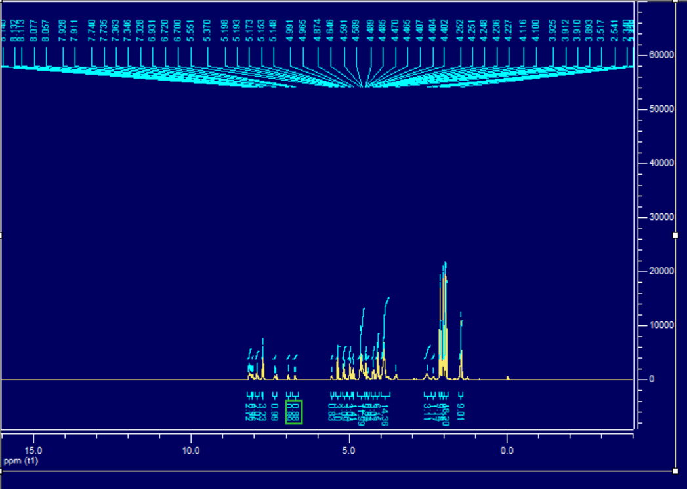
Figure S1. ¹H NMR (CDCl₃, 400 MHz) of compound PMI-3AcGal.
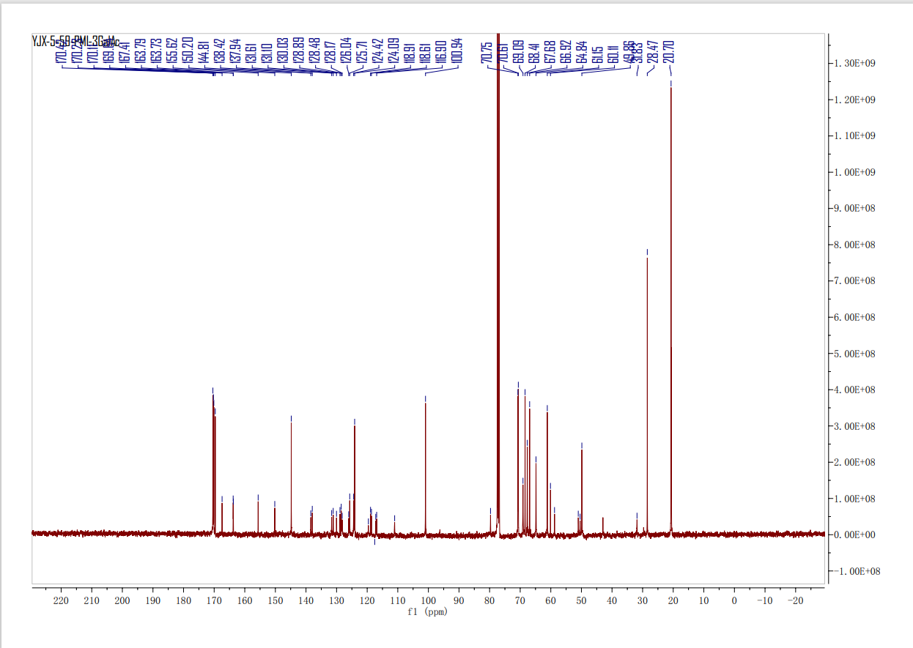
Figure S2. ¹³C NMR (CDCl₃, 100 MHz) of compound PMI-3AcGal.
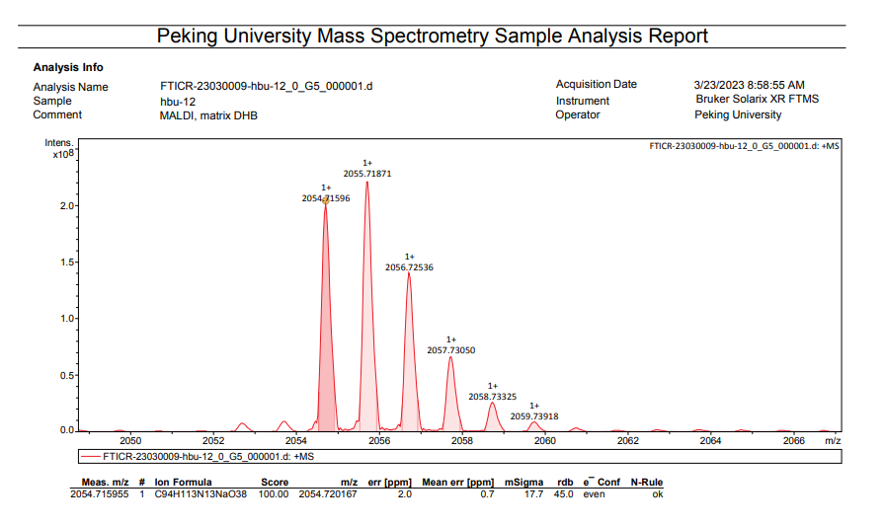
Figure S3. HRMS (MALDI-TOF) of compound PMI-3AcGal.
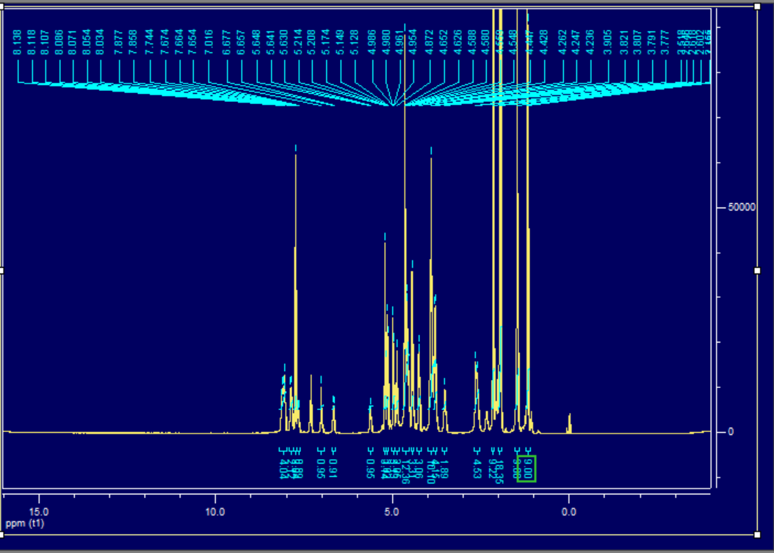
Figure S4. ¹H NMR (CDCl₃, 400 MHz) of compound PMI-3AcFuc.
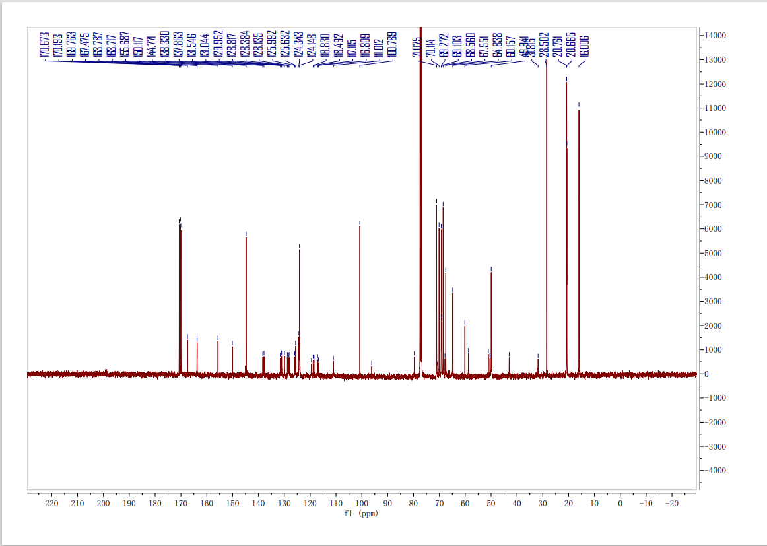
Figure S5. ¹³C NMR (CDCl₃, 100 MHz) of compound PMI-3AcFuc.
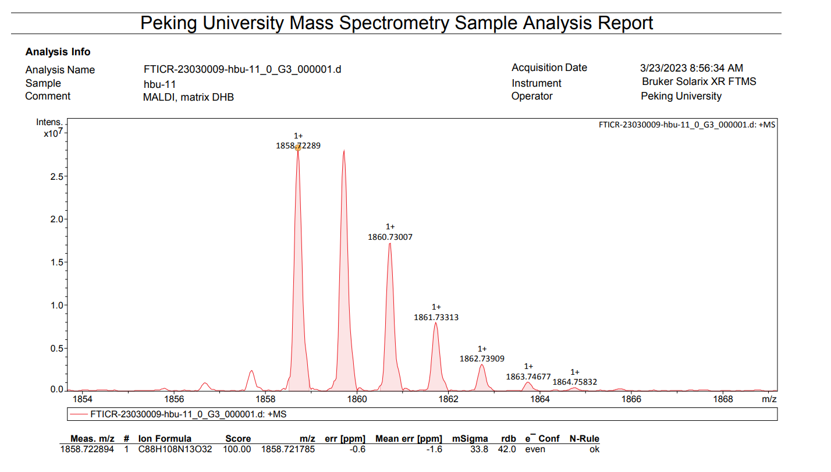
Figure S6. HRMS (MALDI-TOF) of compound PMI-3AcFuc.
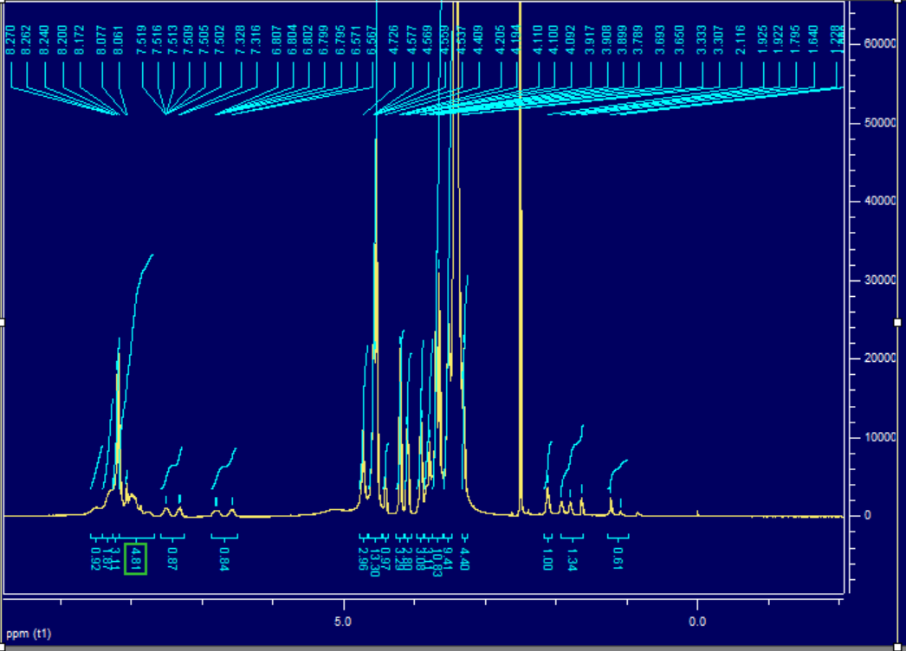
Figure S7. ¹H NMR (DMSO-d₆+D₂O, 600 MHz) of compound PMI-3Gal.
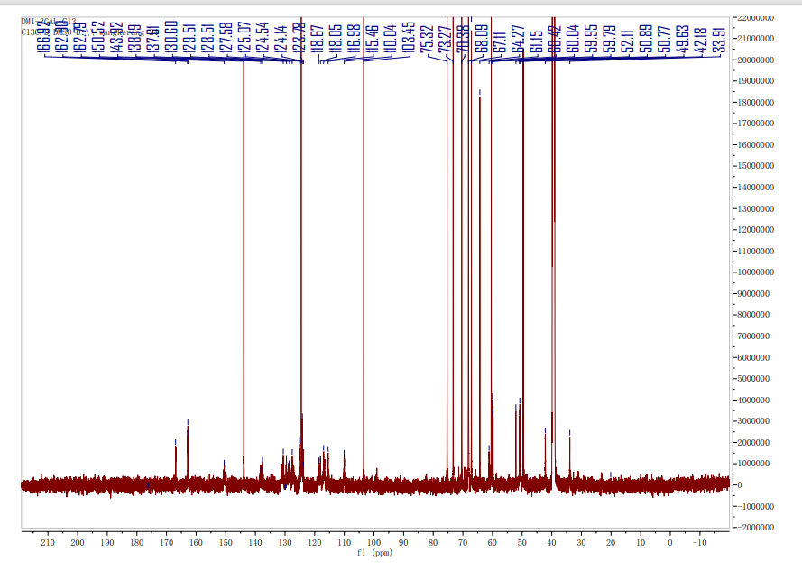
Figure S8. ¹³C NMR (DMSO-d₆+D₂O, 100 MHz) of compound PMI-3Gal.
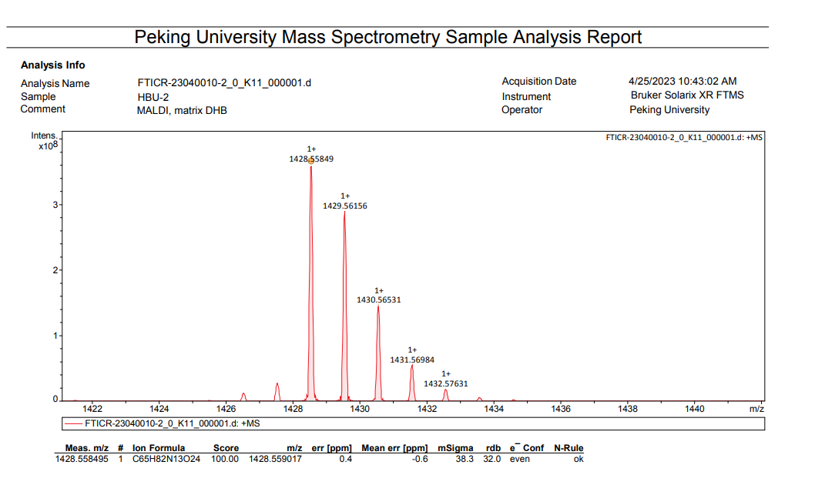
Figure S9. HRMS (MALDI-TOF) of compound PMI-3Gal.
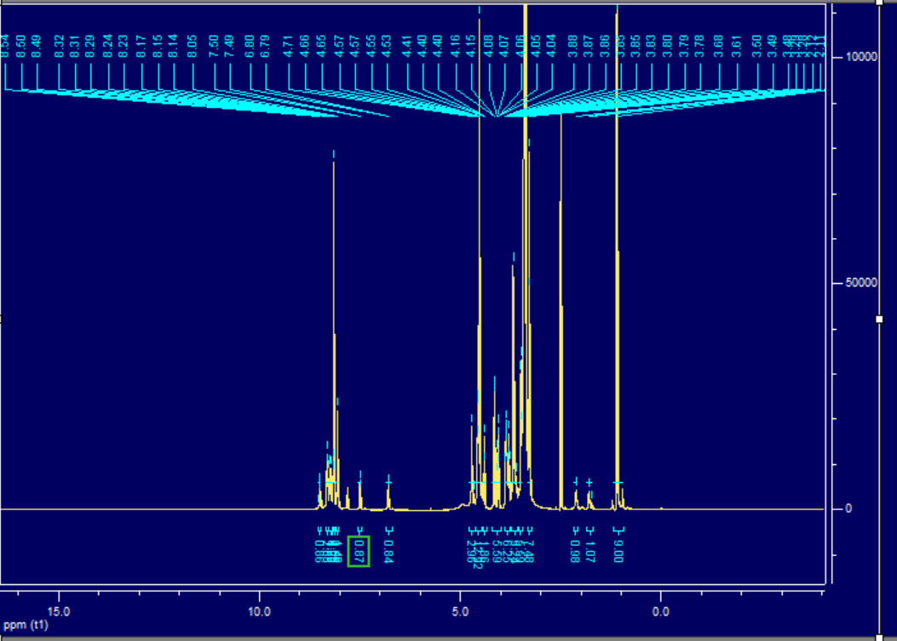
Figure S10. ¹H NMR (DMSO-d₆+D₂O, 600 MHz) of compound PMI-3Fuc.
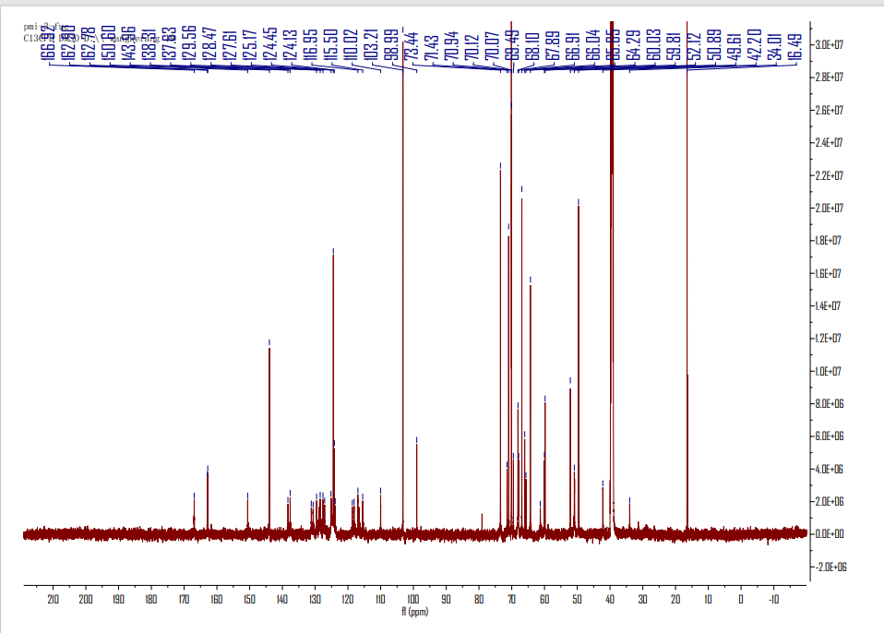
Figure S11. ¹³C NMR (DMSO-d₆+D₂O, 100 MHz) of compound PMI-3Fuc.
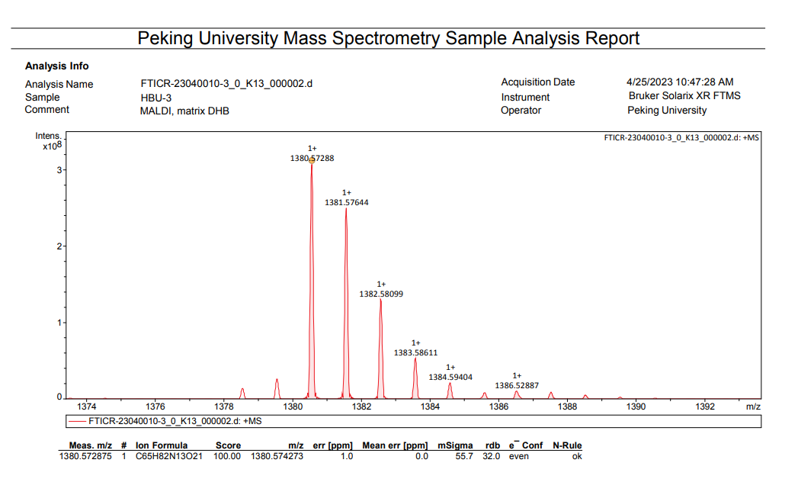
Figure S12. HRMS (MALDI-TOF) of compound PMI-3Fuc.
Figure S13. Solvent-dependent fluorescence emission spectra (λ_{ex} = 600 nm) spectra of PMI-3Gal (a), PMI-3Fuc (b) and PMI-3Gal@PMI-3Fuc (c) under various ratio of DMSO and H₂O.
Figure S14. DLS results (a-c) and SEM images (d-f) of PMI-3Gal (a and d), and PMI-3Fuc (b and e) and PMI-3Gal@PMI-3Fuc (c and f). (g-i) SEM partial enlarged image of PMI-3Gal (g), and PMI-3Fuc (h) and PMI-3Gal@PMI-3Fuc (i).
Figure S15. Linear time data versus -lnθ (a-c) obtained from the cooling period and the temperature changes (d-f) of PMI-3Gal (a and d), PMI-3Fuc (b and e) and PMI-3Gal@PMI-3Fuc (c and f) dispersions rose until reaching a stable temperature and then cooled down naturally under the concentration of 100 μM; Heating and cooling cycles of PMI-3Gal (g), PMI-3Fuc (h) and PMI-3Gal@PMI-3Fuc (i) at the concentration of 100 μM; Concentration-dependent temperature change curves of PMI-3Gal (j), PMI-3Fuc (k) and PMI-3Gal@PMI-3Fuc (l) suspension under 635 nm laser irradiation (0.4 W cm⁻²).
Figure S16. The standard curves of absorbance value against the concentrations of PMI-3Gal (a), PMI-3Fuc (b) and PMI-3Gal@PMI-3Fuc (c).
Table S1. Adhesion effects for P. aeruginosa of PMI-3Gal, PMI-3Fuc and PMI-3Gal@PMI-3Fuc under different concentrations.
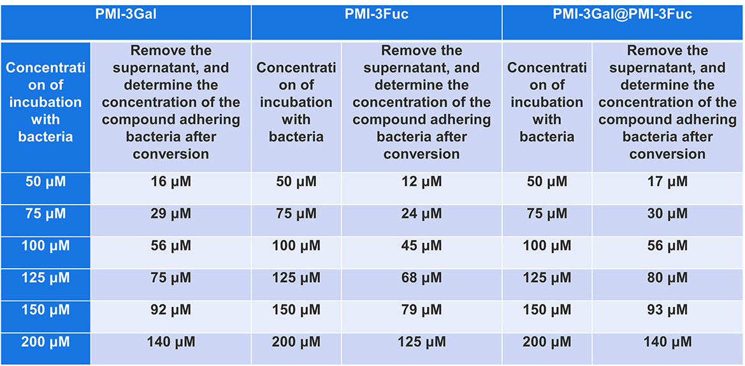
Figure S17. Photographs of bacterial colonies formed by multidrug-resistant P. aeruginosa after exposed to PMI-3Gal (a), PMI-3Fuc (b) and PMI-3Gal@PMI-3Fuc (c) with and without a laser irradiation.
Figure S18. Photograph images of bacterial plates (a) and the bacterial viability (d) collected with various ratios of the co-assemblies of PMI-3Gal@PMI-3Fuc under the concentration of 200 μM; Photograph images of bacterial plates of PMI-3Gal@PMI-3Fuc (1:1) against E. coli (b) and S. aureus (c) under the concentration of 200 μM.
Figure S19. Live/dead fluorescent staining images (a-c) of PMI-3Gal (a), PMI-3Fuc (b) and PMI-3Gal@PMI-3Fuc (c) with and without a laser irradiation. Scale bar = 20 μm.
Figure S20. Cell viability of PMI-3Gal, PMI-3Fuc and PMI-3Gal@PMI-3Fuc against L929 cells under the concentrations of 20, 40, 60, 80 and 100 μM for 24 h determined by MTT assay (n = 5).
Figure S21. (a) Migration of L929 cells on the PMI-3Gal, PMI-3Fuc and PMI-3Gal@PMI-3Fuc under the concentration of 100 μ; (b) The quantitative of migration rates with PMI-3Gal, PMI-3Fuc and PMI-3Gal@PMI-3Fuc. Data are presented as mean ± SD (n = 3).
Figure S22. Hemolysis test of PMI-3Gal, PMI-3Fuc and PMI-3Gal@PMI-3Fuc at the concentration of 100 μM, with 1% TX-100 as the positive control and PBS as the negative control.
Figure S23. Infrared thermal images of mice treated with PBS, PMI-3Gal, PMI-3Fuc and PMI-3Gal@PMI-3Fuc under 635 nm laser irradiation (0.4 W cm⁻²).
Figure S24. H&E-stained images of heart, liver, spleen, lung and kidney from mice after 7 days treatment of PMI-3Gal, PMI-3Fuc and PMI-3Gal@PMI-3Fuc.
Figure S25. Time-dependent body-weight curves of mice after different treatments.

