Supporting information

Adjustable Fabrication and Evaluation of Regenerated Chitin Fibers with Partial Deacetylation Sen Xue ª, Zihao Zhang ª, Guorui Zhang ª, Kai Wu ª, Hong Tan ª, Qiang Fu ^{a, b,}*
ª College of Polymer Science and Engineering, State Key Laboratory of Polymer Materials Engineering, Sichuan University, Chengdu 610065, PR China
^{b} Guangdong Provincial Laboratory of Chemistry and Fine Chemical Engineering Jieyang Center, Jieyang 515200, China
* Corresponding author. E-mail: qiangfu@scu.edu.cn (Qiang Fu).

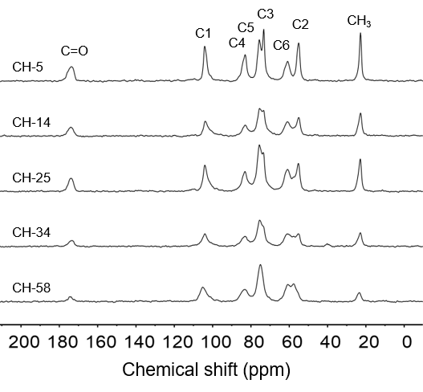
Figure S1. CP/MAS ¹³C NMR spectra of partly deacetylated chitin.

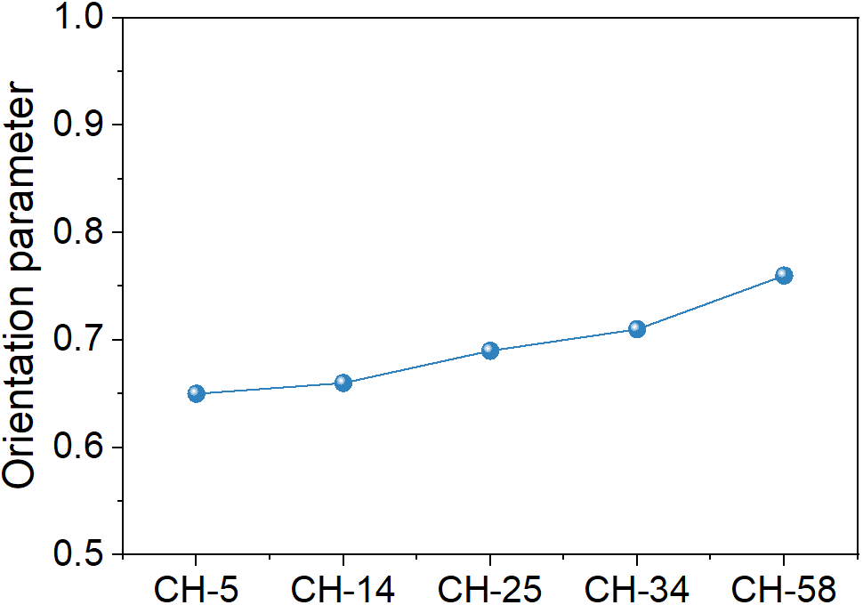
Figure S2. Orientation parameter of deacetylated chitin fibers.
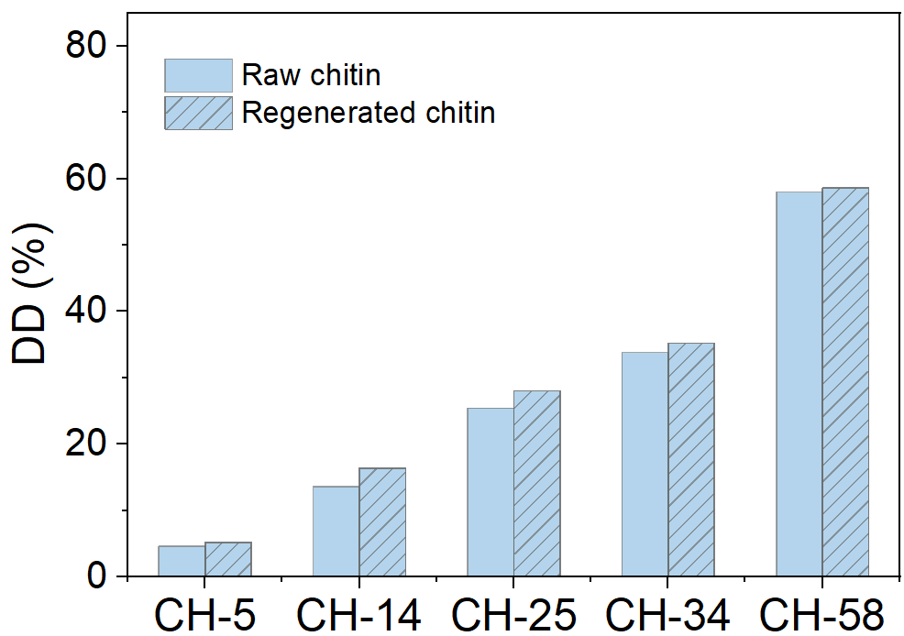
Figure S3. The degree of deacetylation of partly deacetylated chitin and regenerated deacetylated chitin fibers.

Table S1. Degree of deacetylation (DD) of chitin deacetylated with different time.
Deacetylation time/min | 0 | 10 | 20 | 30 | 60
DD/% | 4.6 | 13.6 | 25.4 | 33.8 | 58
Table S2. Degree of deacetylation (DD) of regenerated chitin fibers
Sample | CH-5 | CH-14 | CH-25 | CH-34 | CH-58
DD/% | 5.2 | 16.4 | 28 | 35.2 | 58.6

