Extended Data Figure 1. Analysis of membranes from Synechocystis strains expressing the FLAG-PsaA subunit instead of PsaA and either containing (FLAG-psaA) or lacking PsaC (FLAG-psaA/ΔpsaC). The complexes were separated by CN PAGE and the gel was photographed (CN scan) and scanned for Chl fluorescence (CN fluor). Note the different PSI and identical PSII mobilities of complexes in the control and PsaC-lacking strain. Designation of complexes: F.PSI(3), F.PSI(2) and F.PSI(1), FLAG-tagged trimeric, dimeric and monomeric PSI; F.PSI(3)ΔC, F.PSI(2)ΔC and F.PSI(1)ΔC, FLAG-tagged trimeric, dimeric and monomeric PSI lacking PsaC; PSII(2) and PSII(1), dimeric and monomeric PSII; CP47m and CP47m, unassembled CP47 and CP43 modules; FP, free pigments. The loading of the membranes was based on the same OD_{750nm} corresponding to 5 μg of Chlll for FLAG-psaA strain and 4 μg of Chl for FLAG-psaA/ΔpsaC strain.

Extended Data Figure 2. Analysis of membranes from the Synechocystis wild-type strain and the strain lacking PsaL (ΔpsaL). The complexes were separated by CN PAGE and the gel was photographed (CN scan). Designation of complexes as in Figure S1. White arrows designate stained PsaD, PsaF and PsaE proteins belonging to the PSI trimer. The loading of the membranes was based on the same OD750nm corresponding to 5 μg of Chl for both strains.

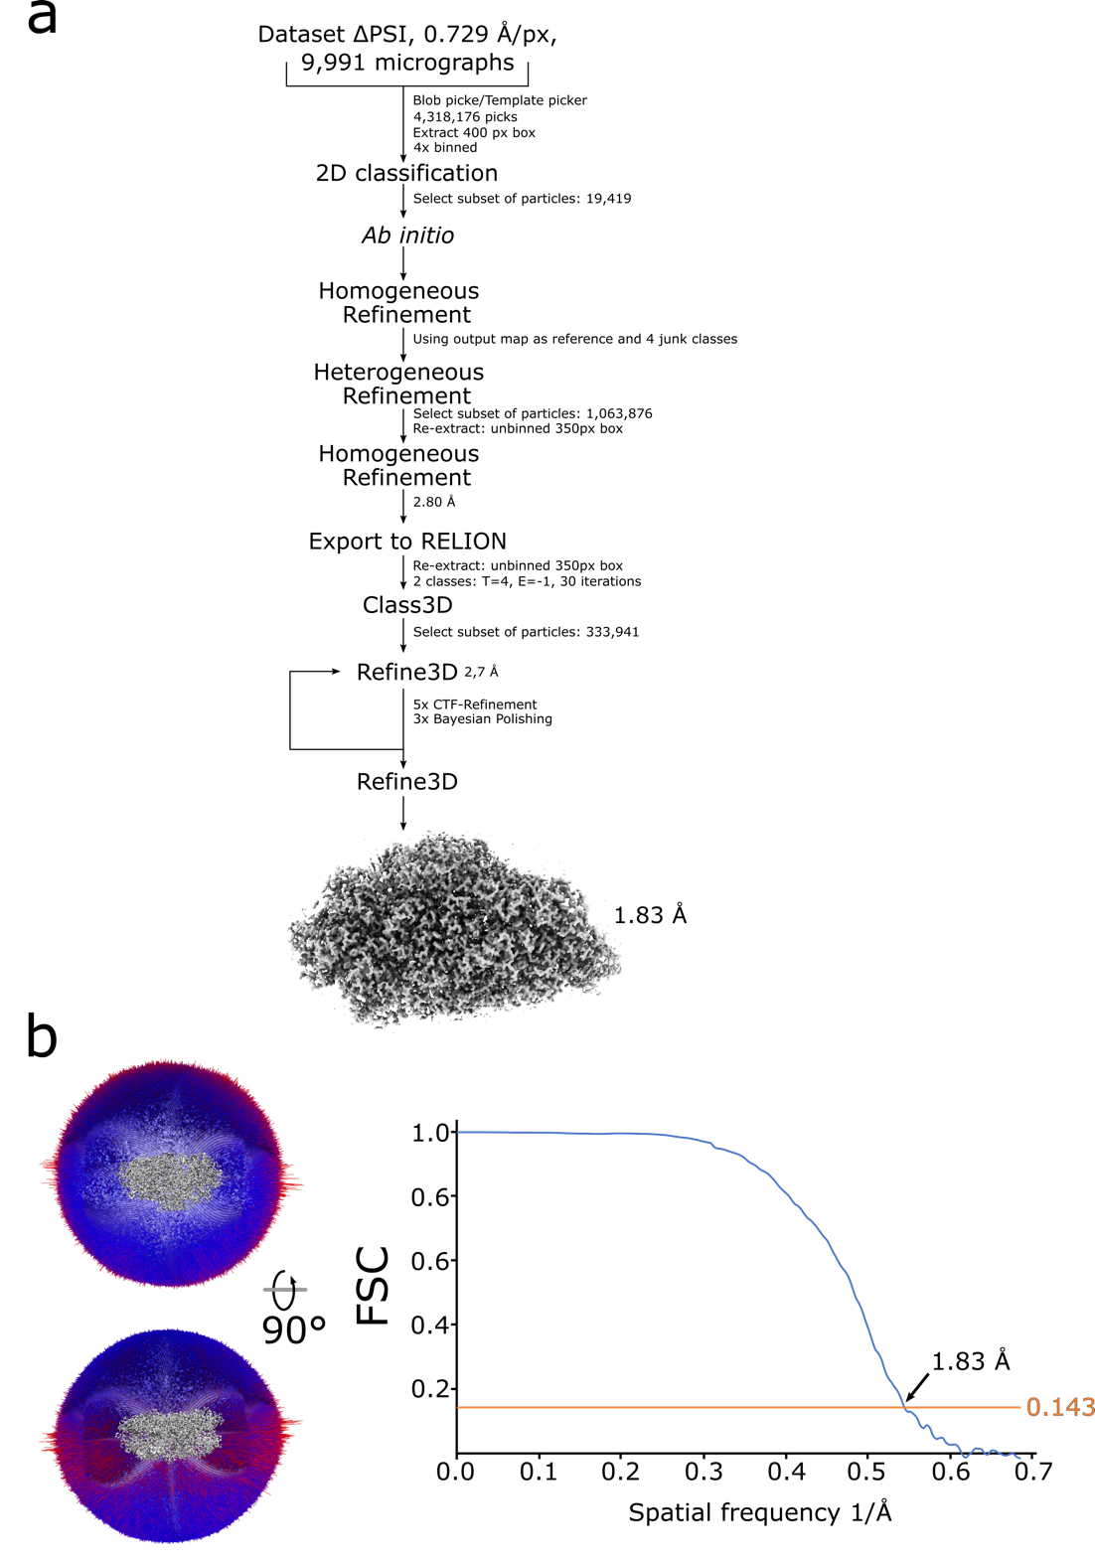

Extended Data Figure 3. Cryo EM data processing, angular distribution, and Fourier shell correlation plot.
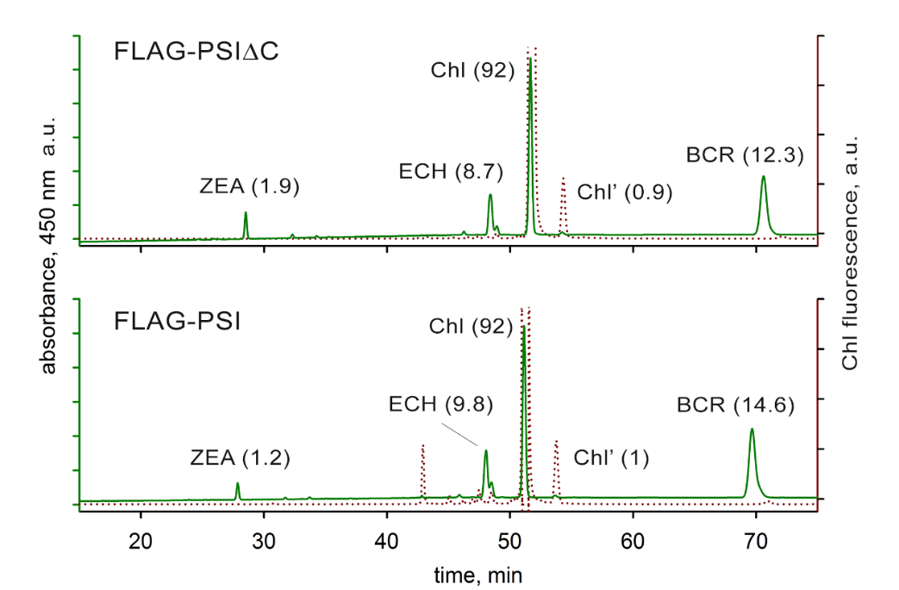

Extended Data Figure 4. HPLC analysis of pigments extracted from the isolated PSI complexes. FLAG-PSIΔC and the control FLAG-PSI pulldowns were obtained using FLAG affinity chromatography from strains expressing FLAG-PsaA instead of PsaA and containing or lacking PsaC. The extracted carotenoids and Chl were separated by HPLC and detected by a diode-array detector (DAD) at 450 nm (solid green light). Although the C13²-epimer of chlorophyll a (Chl’) can be detected using DAD, its quantification is not precise due to its too weak signal, specifically when compared to the absorbance of Chl. However, the fluorescence emission of the Chl’ epimer at 670 nm can be detected using more sensitive fluorescence detector after excitation at 435 nm (dotted red line). Molar stoichiometries of the identified pigments in FLAG-PSIΔC are shown in parentheses (normalized to 92 Chls and 1 Chl’ in FLAG-PSI) and these values represent the means of three technical replicates; standard deviations were below 10%. ZEA – zeaxanthin, ECH – echinenone, BRC - β-carotene, a.u. – arbitrary units.

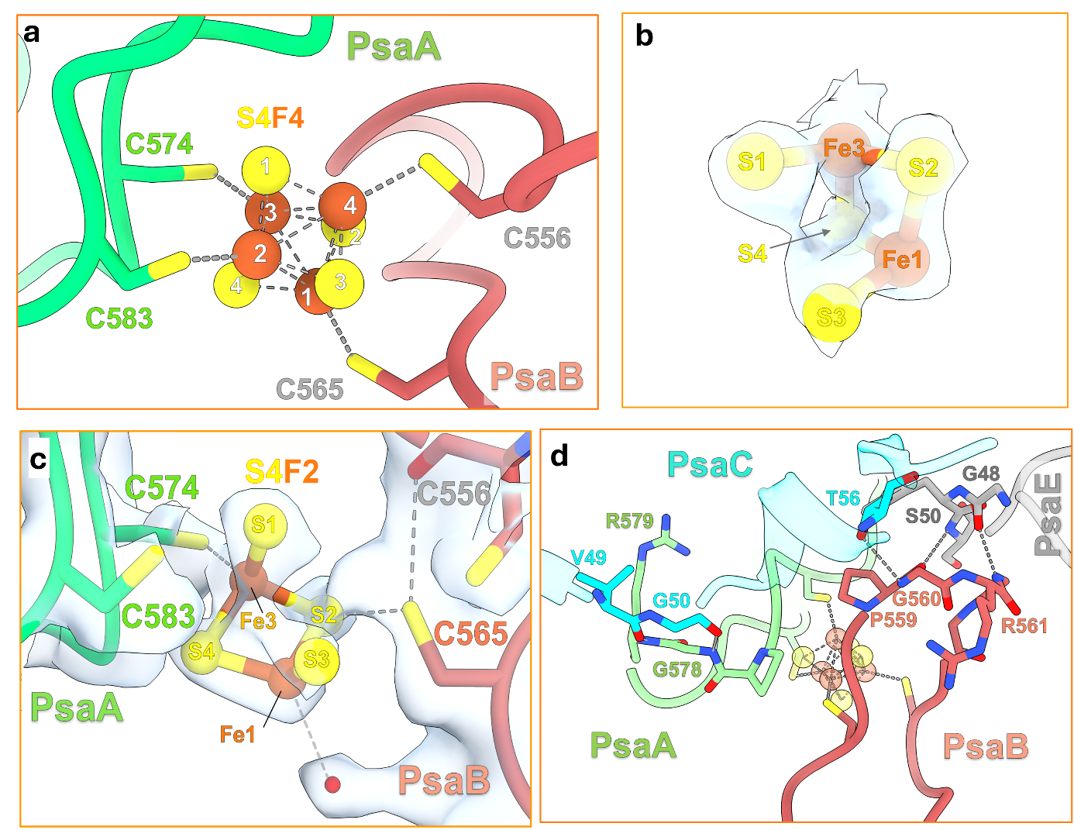

Extended Data Figure S5: Organisation of the Fx [4Fe-4S] cluster in the mature PSI (5OY0). (a) Coordination of the Iron-Sulfur cluster with cysteine residues from PsaA and PsaB in the mature PSI. (b) Model and density of the F_{X} cluster from the PSIΔC. S designates sulfur and Fe designates iron atoms. (c) Coordination of the F_{X} cluster from the PSIΔC with cysteine residues from PsaA and PsaB. The density of the designated atoms and residues is shown. (d) Wide view of the Fe-S coordination site. PsaB loop, PsaE, PsaC and the Fe-S cluster from the mature PSI are shown in red, dark grey, light cyan and transparent orange/yellow, respectively. Interactions between residues are shown.

Extended Data Figure 6. Construction of the Synechocystis mutants. (a) The FLAG-psaA/ΔpsaB strain was prepared by replacement of the original psaA and psaB genes by a construct containing psaA gene with an N-terminally attached sequence encoding 1xFLAG and gentamycin resistance cassette downstream. The FLAG-psaA strain was prepared by the insertion of the original psaB gene between FLAG-psaA gene and gentamycin resistance cassette and selecting for autotrophy. (b) The FLAG-psaA/ΔpsaC strain was prepared by replacing most of the original psaC gene by the chloramphenicol resistance cassette

Extended Data Table 1. Mass spectrometric identification of protein bands designated in the 2D gel analysis of the FLAG-PSI preparation in Fig. 1.

Accession number | Mass spectrometric analysis
Accession number | Length (AA) | Size (Da) | Sequence coverage (%) | Intensity
PsaA  P29254 | 751 | 82,950 | 20 | 38,597,000
PsaB  P29255 | 731 | 81,292 | 12 | 16,375,000
PsaC  P32422 | 81 | 8,828 | 49 | 3,492,300
PsaD  P19569 | 141 | 15644 | 90 | 78,489,000
PsaF  P29256 | 165 | 18,249 | 48 | 47,937,000
PsaL  P37277 | 157 | 16624 | 11 | 1,035,500
PsbE  P12975 | 74 | 8145 | 96 | 29,097,000
PsaK1  P72712 | 86 | 8,644 | 20 | 422,860
PsaK2  P74564 | 90 | 9,306 | 10 | 2,644,000

Extended Data Table 2. List of the most abundant proteins (the peak intensity above 200 000) identified in the FLAG-PSIΔC preparation and comparison of their abundance with the FLAG-PSI preparation using MS analysis.
Accession numbers | Protein name | Mw | Protein coverage | Unique peptides | Intensity | Ratio PSIΔC/PSI
P29255 | Photosystem I subunit PsaB | 81292 | 74 | 274 | 7750000 | 0.97
P29256 | Photosystem I subunit PsaF | 18249 | 86 | 164 | 6450000 | 1.32
P72712 | Photosystem I subunit PsaK1 | 8644 | 94 | 85 | 5150000 | 1.80
P72804 | Thylakoid protein Slr1796 | 22969 | 77 | 149 | 4260000 | 451.75
P29254 | Photosystem I subunit PsaA | 82950 | 66 | 238 | 3140000 | 1.26
P72986 | Photosystem I subunit PsaM | 3380 | 100 | 40 | 2400000 | 2.00
P74063 | Photosystem I factor Ycf3 | 19878 | 99 | 99 | 1750000 | 3.50
P37277 | Photosystem I subunit PsaL | 16624 | 50 | 73 | 1670000 | 0.64
P05429 | Photosystem II subunit PsbB | 55903 | 73 | 152 | 1400000 | 2.36
P73690 | Ycf51-like protein Sll1702 | 19077 | 60 | 70 | 955000 | 299.37
Q55329 | Photosystem I subunit PsaJ | 4532 | 100 | 18 | 942000 | 0.95
P09193 | Photosystem II subunit PsbC | 50303 | 52 | 135 | 863000 | 1.76
Q55700 | Metalloprotease FtsH2 | 68496 | 94 | 137 | 551000 | 12.24
P73437 | Metalloprotease FtsH4 | 68199 | 87 | 133 | 413000 | 119.36
P72991 | Metalloprotease FtsH3 | 67250 | 72 | 111 | 407000 | 13.94
P23349 | 50S ribosomal protein L12 | 13259 | 99 | 45 | 379000 | n.d.!
P74227 | Elongation factor Tu | 43733 | 91 | 65 | 340000 | 283.33
P36236 | 50S ribosomal protein L1 | 25852 | 90 | 48 | 272000 | 53.44
P73308 | 50S ribosomal protein L5 | 20230 | 99 | 50 | 229000 | 142.24
P73293 | 50S ribosomal protein S9 | 15086 | 91 | 20 | 215000 | 30.07
Q55330 | Photosystem I subunit PsaI | 4413 | 100 | 10 | 205000 | 1.18

Extended Data Table 3. Cryo-EM single particle analysis. Summary of the data collection, refinement, and validation statistics of the PSIΔC assembly intermediate of Synechocystis.
 | PSIΔC (EMDB-60522) (PDB 8ZWB)
Data collection and processing
Magnification | 165,000
Voltage (kV) | 300
Electron exposure (e–/Å2) | 34.41
Defocus range (μm) | -0.5 to -1.9
Pixel size (Å) | 0.729
Initial particle images (no.) | 9,991
Symmetry imposed | C1
Final particle images (no.) | 333,941
Map resolution (Å)  FSC threshold 0.143 | 1.83
Refinement
Initial model used (PDB code) | 5OY0
Map sharpening B factor (Å2) | -10.1
Model composition  Non-hydrogen atoms  Protein residues  Ligands  Waters | 21,0821  1,787  147  356
B factors (Å2) (min/max/mean)  Protein  Ligand  Waters | 17.49/116.47/41.57  18.16/101.04/41.25  21.08/76.13/43.07
R.m.s. deviations  Bond lengths (Å)  Bond angles (°) | 0.009  1.028
Validation  MolProbity score  Clashscore  Poor rotamers (%) | 1.16  3.72  0.35
Ramachandran plot  Favored (%)  Allowed (%)  Disallowed (%) | 98.64  1.4  0.00

Extended Data Table 4. List of primers used for constructing mutants.
Primer  designation | Primer name | Sequence (5’ - 3’)
F1 | psaA up1 HindIII | ACAGGGAAAGCTTATACATCC
R1 | psaA flag R GA | CTTTCGGGTGGACTAATTGTTGCGGCCGCTTTATCATCATC
F2 | psaA F GA | ATGATGATAAAGCGGCCGCAACAATTAGTCCACCCGAAAG
R2 | psaA R GA | ATTTGCAGATTATTGCTAGCCTAGCCAATGGAAAGACTGCG
F3 | psaA down F GA | GCAGTCTTTCCATTGGCTAGGCTAGCAATAATCTGCAAATT
R3 | psaB down1 EcoRI | GGCCGAATTCTTCTCTGATCC
F4 | psaC up 800 | GATACACTGGCACCAACTCCAATTCCCAGACTAGGA
R4 | psaC Cm up rev | CGGTGGTATATCCAGTGATTTTTTTCTCCATTGACTATCGGC
F5 | psaC up Cm fwd | GGAGCCGATAGTCAATGGAGAAAAAAATCACTGGATATACCACCG
R5 | psaC Cm dw rev | ACCAGATCTATACGATCGCTTATTATCACTTATTCAGGCGTAGCAC
F6 | psaC dw Cm fwd | GTGCTACGCCTGAATAAGTGATAATAAGCGATCGTATAGATCTGGT
R6 | psaC dw 400 | CTAATCTCCAAACGTTCTGACACCTCCTGGTTGGTCAGAC

