Supporting information

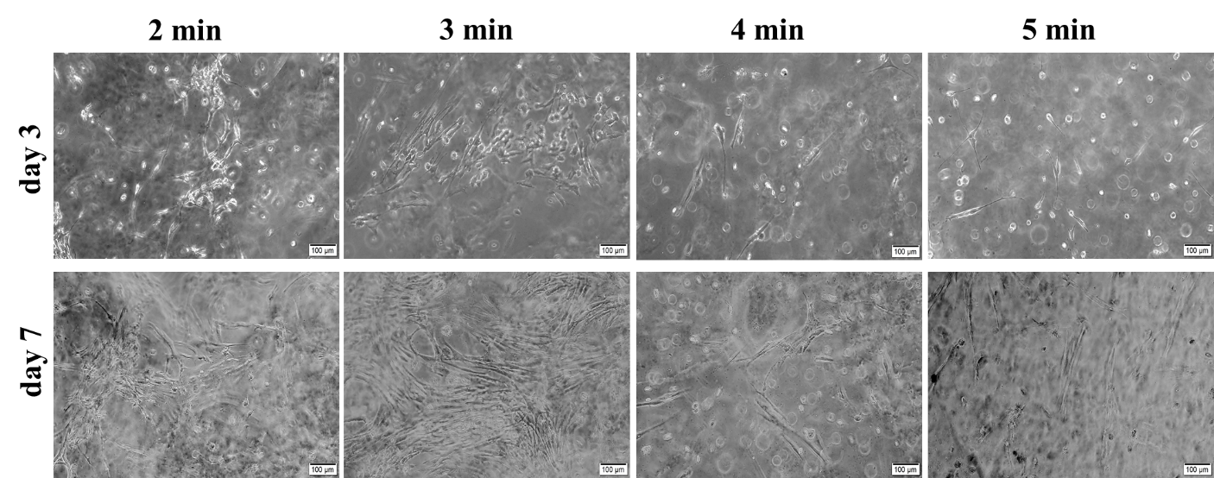

Fig. S1 Phase contrast microscope images of cell-laden GelMA-based bioink constructs after various UV exposure times of 2, 3, 4, and 5 min.

