Photoinduced reduction of aquatic Cr(VI) on CdS/MoS₂ heterostructures
Haseeb Ullah^{ab,}, Rizwana Ghazi^{b}, Shili Gai^{c}, Abeer A. AlObaid^{d}, Nabil Al-Zaqri^{d}, Zia ur Rehman^{a*}
ªDepartment of Chemistry, Quaid-i-Azam University, 45320 Islamabad, Pakistan.
^{b}Department of Chemistry, Khushal Khan Khattak University, Karak, Pakistan.
^{c}Key Laboratory of Superlight Materials and Surface Technology, Ministry of Education, College of Materials Science and Chemical Engineering, Harbin Engineering University, Harbin, 150001, P. R. China.
^{d}Department of Chemistry, College of Science, King Saud University, P.O. Box 2455, Riyadh 11451, Saudi Arabia.

*Corresponding author
Email: zrehman@qau.edu.pk
Tel: 92-(051)90642245
Fax: 92-(051)90642241

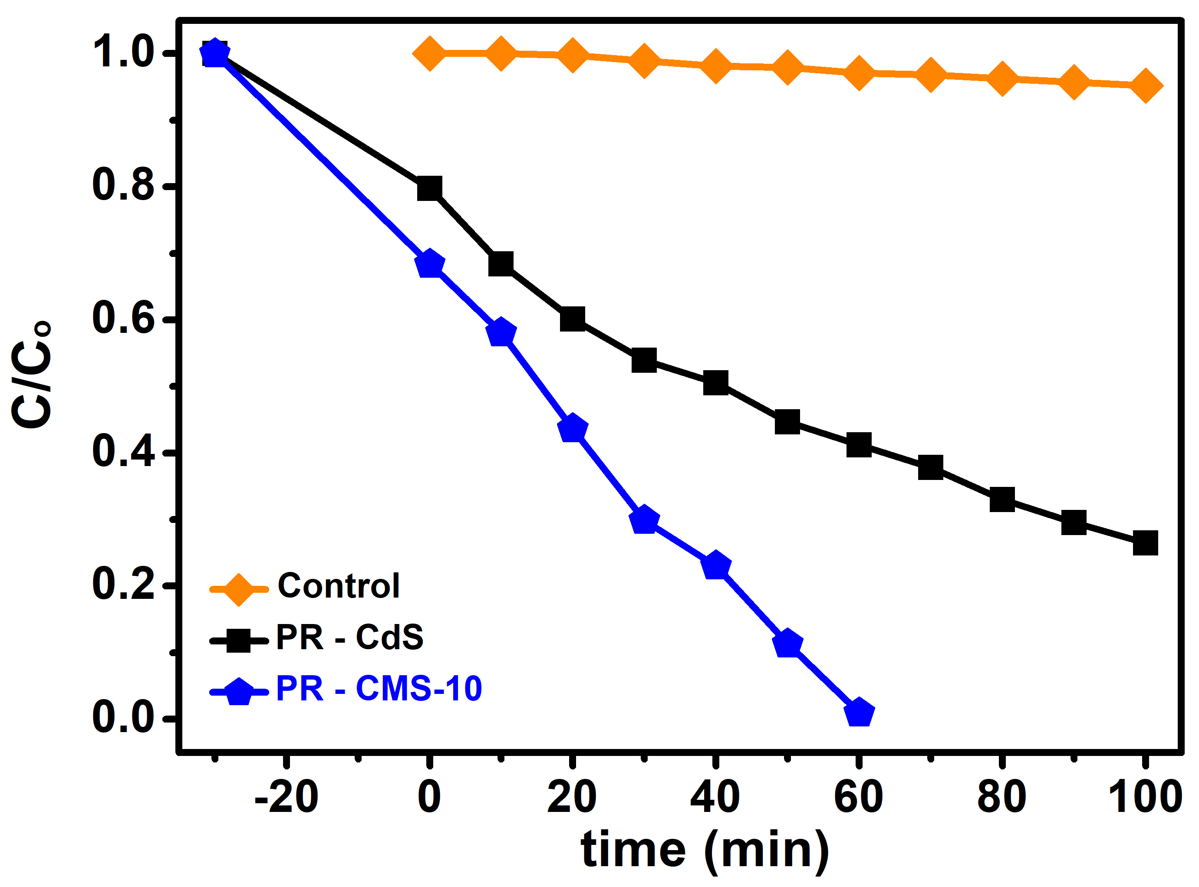
Fig. S1: Photoreduction ratio with time using pristine CdS NRs and CM-10 HSs.

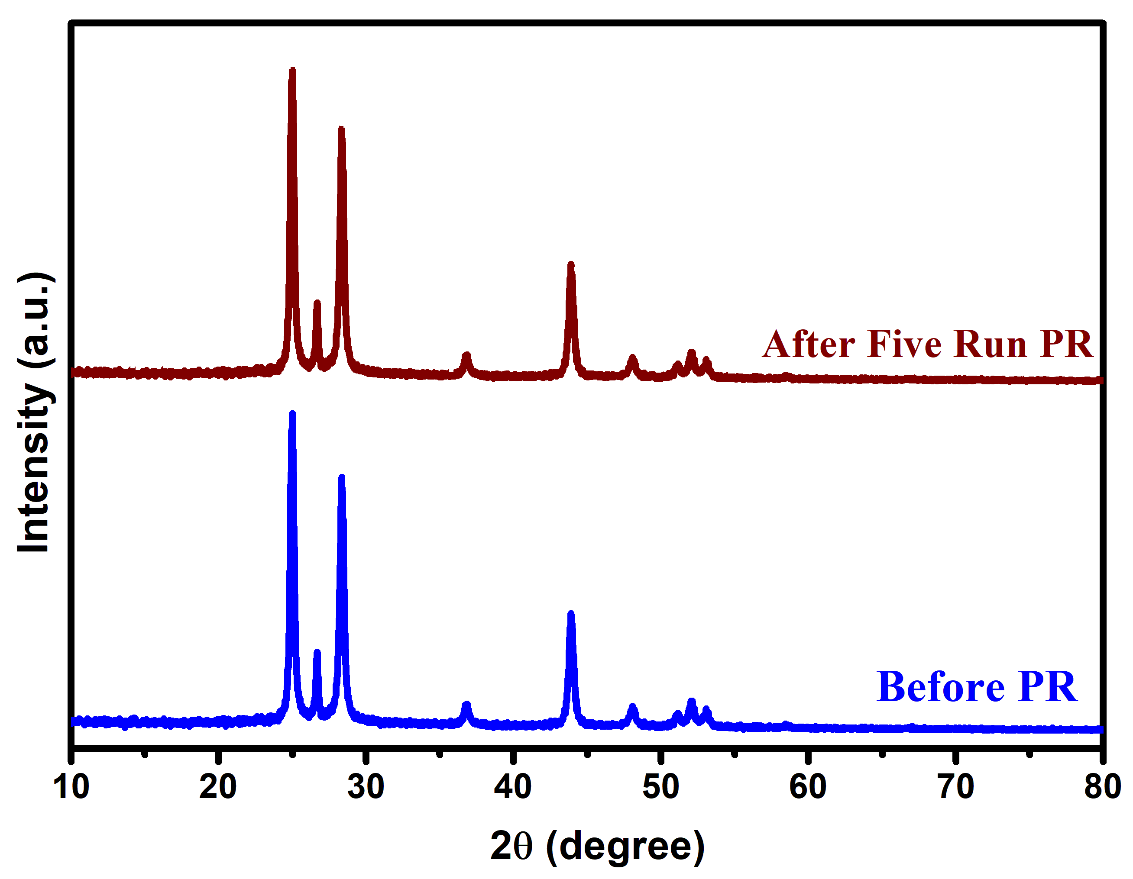
Fig. S2: XRD pattern for CM-10 HSs before the activity and after recycling five times for Cr(VI)reduction.

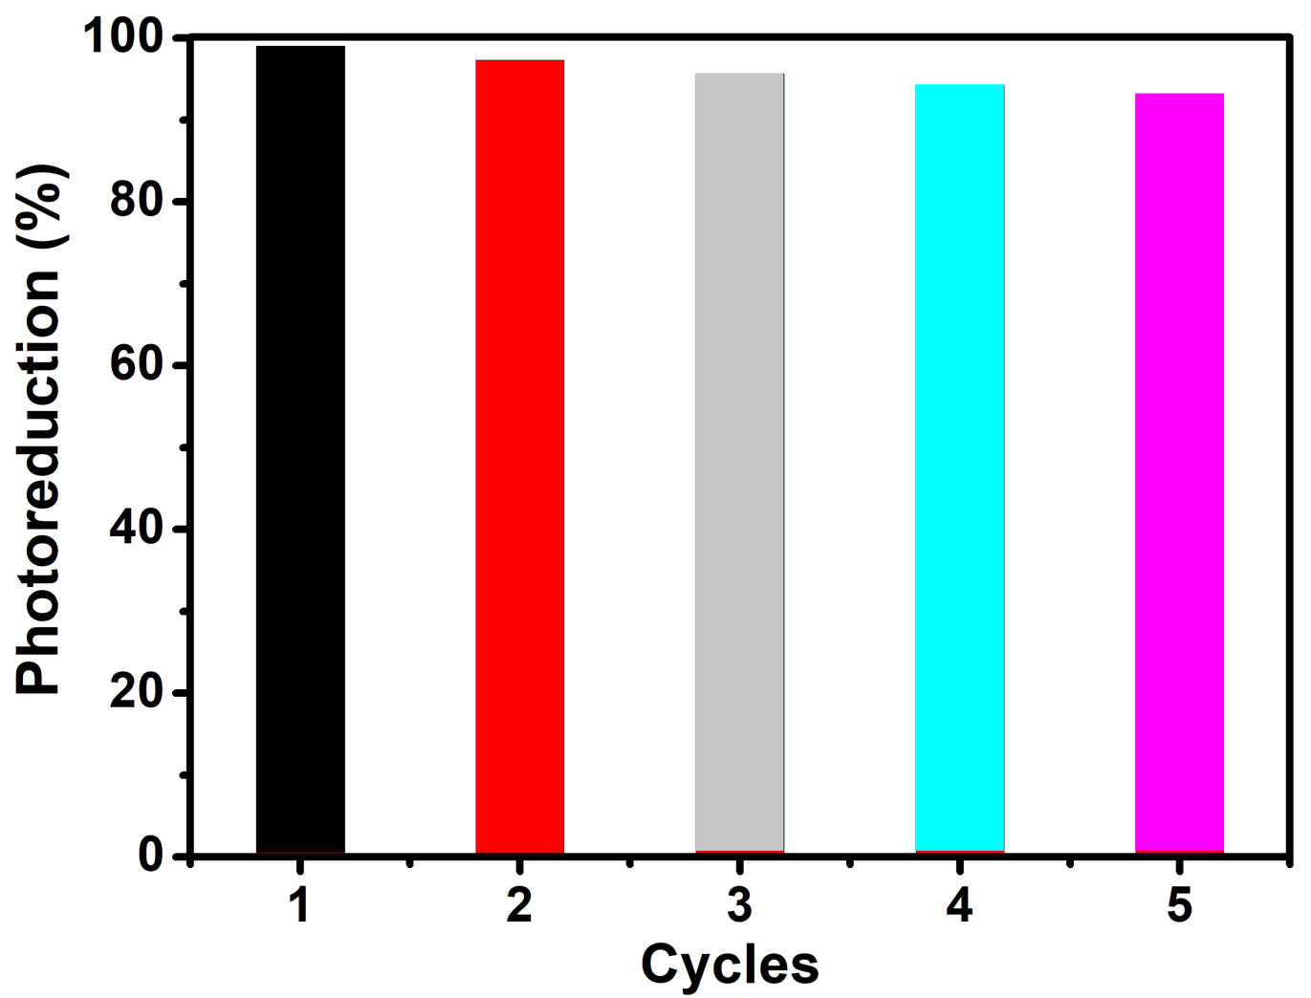
Fig. S3: Stability test of CM-10 HSs for five cycles.

