SUPPLEMENTARY MATERIALS

eFigure 1. Image acquisition and data management
eFigure 2. Overview of the study timeline

Appendix 1. Description of the data source and data collection process
Appendix 2. Description of the data monitoring, cleaning, and retention
Appendix 3. Details on the AI-based Mammography Imaging Analysis Software
Appendix 4. Sample size and power considerations
Appendix 5. Detailed statistical analyses
Appendix 6. CONSORT-AI checklist

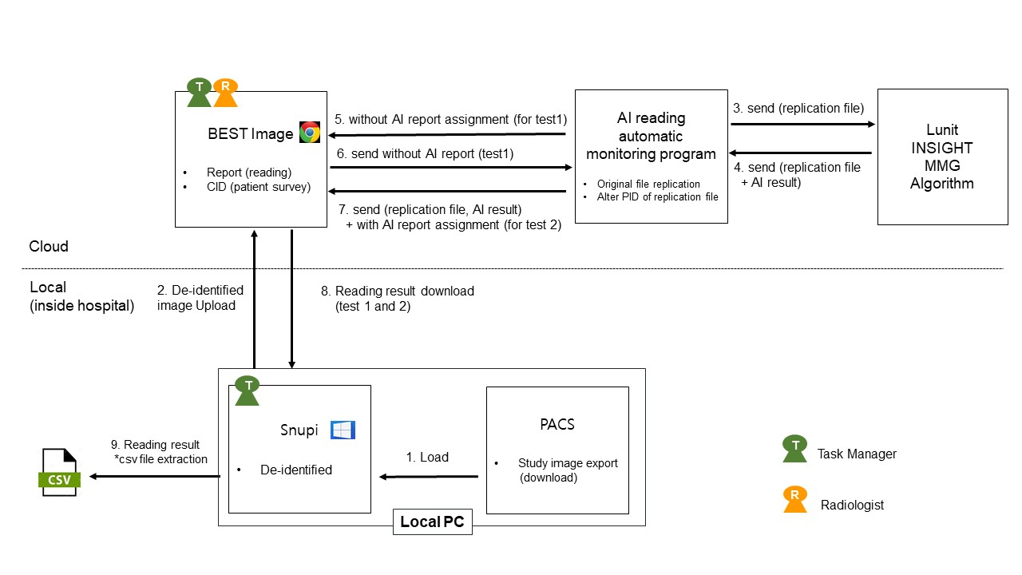
eFigure 1. Image acquisition and data management

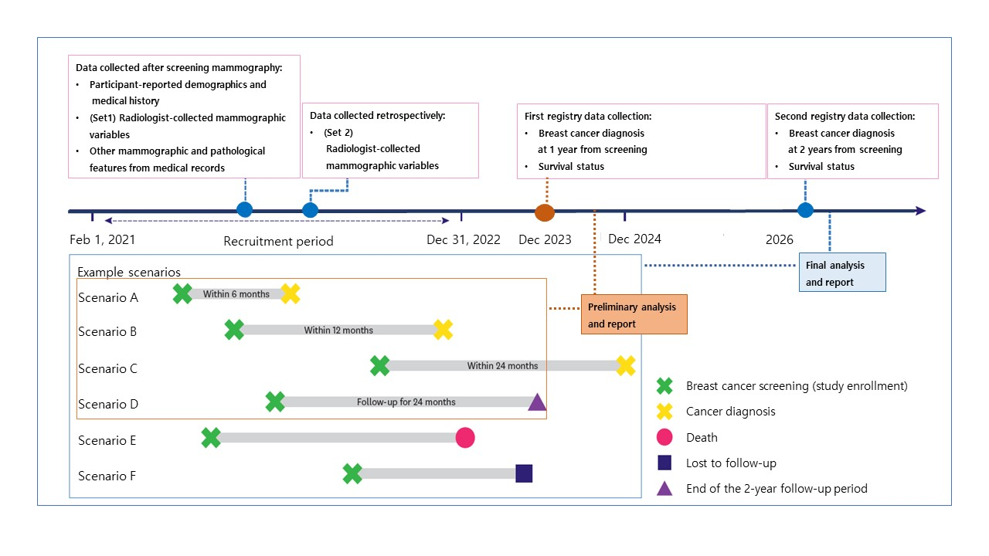
Scenarios A and B: Enrolled and diagnosed with cancer at 6 or 12 months; classified as having breast cancer diagnosis within 1 year from screening. Scenario C: Diagnosed with cancer within 24 months of enrollment; classified as having breast cancer diagnosis within 2 years from screening. Scenario D: Not diagnosed with cancer until 24 months after enrollment. Results of Scenarios A–D can be termed positive or negative depending on the cancer diagnosis. Scenario E: Died during the study because of any reason and cannot be included in the study. Scenario F: Lost to follow-up and cannot be included in the study because of no available records.
The preliminary analysis was done on pathologically proven cases at least one year after the last participant's enrollment. The final analysis will be planned and reviewed with data linked to the National Cancer Registry expected to be available after 2026.
eFigure 2. Overview of the study timeline. Scenarios

Appendix 1. Description of the data source and data collection process
Participant-reported demographics and medical history were collected from the Participant Information Sheet and study questionnaire; radiologist-collected mammographic findings were collected from the radiologist data collection forms; standalone AI findings were collected from the image data file; other mammographic and pathologic features were collected from medical records and pathology report (if available); breast cancer onset and survival status were collected from registry databases. Mammograms from participants were exported to the study platform (BEST image) for entry of reading results after Digital Imaging and Communication in Medicine (DICOM) standard de-identification according to the Health Insurance Portability and Accountability Act (HIPPA) ¹. Idea to Reality in Medicine (IRM)’s commercial BEST image is a certified local program included in the platform support for a multicenter study initiative by the Korean Society of Radiology. IRM’s commercial SNUPI program was used for de-identification, including participant identification (ID), participant name, study instance unique identifiers (UIDs), participant sex, participant birth date, participant age, study date, series date, private tags, study description, and series description. The study participant ID was assigned instead of the institution participant ID and the relevant mapping information was saved in an independent computer by the Principal Investigator (PI) at the site. If the participant had mammography records at the relevant hospital from within the past four years, all such data were exported to the study platform so that a reader can maintain the same environment as the actual reading at the hospital. Set 1 was part of the standard screening procedure and Set 2 was performed independently after Set 1 and did not affect the actual reading results of the participants.
Appendix 2. Description of the data monitoring, cleaning, and retention
A data cleaning method was employed to correct inconsistencies or errors that were not captured during data entry (e.g., outliers or conflicting data). Data queries were identified on an ongoing basis during data collection. To enable evaluations and/or audits from regulatory authorities or the sponsor, the investigator agreed to retain all records, including the identity of all participants (sufficient information to link records, eg, electronic case report forms and medical charts), source documents, detailed records of participant disposition, and adequate documentation of relevant correspondence (eg, letters, meeting minutes, telephone calls reports). When the study was completed, a clinical study report was submitted. All records and documents were transferred to the document retention staff and retained for five years. If the investigator became unable for any reason (e.g., retirement or relocation) to continue to retain study records for the required period, the study records must be transferred to a designee, such as another investigator or another institution. After the retention period, records and documents will be destroyed to prevent disclosure of the contents of the documents and preserve confidentiality, and documents related to personal information will be destroyed according to the Personal Data Protection Act Enforcement Decree Article 16.

Appendix 3. Details on the AI-based Mammography Imaging Analysis Software
Computer-aided detection (CAD) is used to assist the reading of medical images. It was first developed for educational and academic purposes, and it became commercialized in 1998 with US Food and Drug Administration (FDA) approval for the ImageChecker system—the first commercial CAD system for mammography. CAD differentiates structures and sections on medical images based on complex pattern recognition, but its low specificity and undesirably high recall rate make its use limited in clinical practice ¹. Subsequent advancements in AI technology have improved the accuracy of CAD. In particular, CAD using the convolution neural network, a deep learning technology optimized for image analysis and classification, is providing diagnostic performance that is equivalent or superior to those of radiologists ². Lunit INSIGHT MMG, software aids mammogram reading by detecting breast cancer. It was developed by training an AI algorithm using breast cancer mammography data (>50000 cases), and the total training data included more than 200000 cases collected in Korea, the United States, and the United Kingdom ³. A clinical study on Lunit INSIGHT MMG was conducted to obtain authorization from the Korean Ministry of Food and Drug Safety (MFDS). It assessed the improvement in reading performance of 14 radiologists using 160 malignant cases and 160 non-malignant cases (64 positive cases, 96 normal cases) collected at two sites. Reading with Lunit INSIGHT MMG significantly improved the accuracy of breast cancer detection and decreased the false positive rate in both the breast radiologist group and the general radiologist group, suggesting the potential of Lunit INSIGHT MMG to improve breast cancer detection, and reduce the need for additional tests ³. In addition, the reading accuracy was similar between the breast radiologist group and the general radiologist group when Lunit INSIGHT MMG was used, suggesting its potential to contribute to high reading accuracy in small- and medium-sized hospitals or local hospitals, which may have a potential shortage of breast radiologists ³. In a recent study using Swedish breast cancer screening cohort data, Lunit INSIGHT MMG showed superior performance compared with two other commercial AI-based software products ⁴.The area under the receiver operating characteristic curve (AUROC) for Lunit INSIGHT MMG (0.956) was higher than those for the other products (0.922 and 0.920), and the sensitivity of Lunit INSIGHT MMG (81.9%) was similar to that of physicians (77.4% and 80.1%); the competitor products exhibited significantly lower sensitivity than physicians ⁴.The superior performance of Lunit INSIGHT MMG compared with other products is a result of using at least four times more breast cancer cases as training data than the other commercial products. Furthermore, over half of the training data were derived from dense breasts, which are difficult to read; and the lesion locations were marked by breast radiologists for most breast cancer cases in the training data ³. Further details on Lunit INSIGHT MMG are provided in the following table.
Table. Lunit INSIGHT MMG AI-CAD ³
Product Name | Lunit INSIGHT MMG
Item Name | CADe/x for medical imaging (Class 3)
Area of Application | To aid physicians in reading mammograms
Purpose of Use | The software detects areas where breast cancer is suspected using mammographic images, marks areas where malignant lesions are suspected, and displays the probability of malignant lesions to assist with interpreting the physician’s diagnosis
Function | A visualization and quantitative estimation of the likelihood of the presence of a malignant lesion.  Suspicious lesions are marked using a heat map, and each lesion, as well as each breast, is given an abnormality score, which reflects the likelihood of a malignancy.
Performance | Accuracy in detecting a malignant lesion: 96% AUROC  Up to 12.6% improvement in reading accuracy and 13.8% reduction of the non-malignant recall rate
Training Data | Total of 170,230 mammograms  More than 30,000 pathologically proven cancer-positive mammograms

Appendix 4. Sample size and power considerations
The sample size was derived based on the following assumptions using R (version 4.0.3.; R Foundation for Statistical Computing, Vienna, Austria)
- Primary endpoint: cancer detection rate (CDR)
- Hypotheses of primary interest:
- Null hypothesis: There is no difference in CDR between with and without AI.
- Alternative hypothesis: There is a difference in CDR between with and without AI.
- Prevalence:
- 3.21 per 1,000 exams; 3,781/1,176,717 ≒ 0.00321 ⁵
- Type I error (α): 0.05 (two-sided)
- Power (1-β): 80%
Sensitivity results from a previous study are presented in Table 1 and were used in the sample size derivation ⁶.
Table. Contingency Table for Comparison of Sensitivity from Results of a Previous Study ^{3,6}
2 x 2 Table | Without AI (detection O) | Without AI (detection X)
With AI (Detection O) | 1,657 | 242
With AI (Detection X) | 29 | 312
Note: AI, artificial intelligence

The sample size calculation formula is based on the McNemar’s test as per the following:
$$n= {\left(\frac{z_{1-α/2}\sqrt{p_{disc}}+z_{1-β}\sqrt{p_{disc}+{p_{diff}}^{2}}}{p_{diff}}\right)}^{2}$$
$p_{disc}$: proportion of discordant pairs, i.e., 0.12098
$p_{diff}$: difference in the proportions of detected cases, i.e., 0.095
$z_{1-α/2}$: $1-α/2$ th percentile of standard normal distribution, i.e., 1.96
$z_{1-β}$: $1-β$ th percentile of standard normal distribution, i.e., 0.84

Here, $p_{disc}$ and $p_{diff}$ refer to the proportion of discordant pairs and the difference in the proportion, respectively, between cancer detection in total participants with AI and without AI. As they are not affected by negative data, the proportions derived from data from the table below were multiplied by prevalence and used in the sample size calculation.
Table. Sample Size Calculation
Prevalence | CDR without AI | CDR with AI | $$p_{disc}$$ | N
3.21 per 1,000 exams | 0.0024 | 0.0027 | 0.00038 | 32,714
Note: AI = artificial intelligence; CDR = cancer detection rate

The target sample size is 32714 participants, corresponding to approximately 16000 participants per year. The total number of expected participants changed from the initial study design due to the COVID-19 pandemic, but no effect was observed on the primary study endpoint. Given the same cancer prevalence as 3.21 per 1000 examinations, it was calculated that the sample size could be maintained if approximately 24,000 people were recruited, while still maintaining 80% power and detecting more than 90 cases of cancers.

Appendix 5. Detailed statistical analyses
All statistical analyses and reporting will take place after the relevant endpoints have been measured from all the study participants. All statistical analyses will be performed using R version 4.0 or higher, and/or SAS version 9.4 or higher. Data obtained from the mammograms will be classified into: (FA set) all mammograms assessed by the AI- based CADe/x software for this study after receiving an identification (ID) code; (per protocol [PP] set) all mammograms included in the FA set except 1) any mammograms where all study procedures are not completed; 2) any data from the mammograms obtained or handled in violation of the study protocol. The main study population will be the FA set (intention-to-treat analysis), and additional analyses will be conducted with the PP set (mainly the primary endpoints, further described below). Where the analysis results from each set are different, the results of both analyses were presented and the reasons for different results will be described in detail. The interim analyses included diagnostic accuracy in the primary and secondary study outcomes, calculated using pathologic results as the gold standard reference group obtained within six months from screening. Final analyses will be performed once the data from all participants have been collected and cleaned, and database lock has occurred. The analysis will examine primary and secondary study outcomes based on diagnosis accuracies calculated using cancer registry data as the reference group obtained within one year and two years from screening.
The data structure had the following outline based on the malignancy scale (7-point scale) and the gold standard ³:
Table. Diagnostic Accuracy Assessment According to the Gold Standard
Screening | Gold Standard
Screening | (+) | (-)
(+) | a | b | a + b
(-) | c | d | c + d
 | a + c | b + d | N

The following diagnostic accuracy endpoints were derived for each test (eg, with the primary endpoint, breast radiologists in Set 1 without AI-CAD [Test 1] and breast radiologists in Set 1 with AI-CAD [Test 2]):
- Cancer detection rate = a / N × 1000 (i.e., presented as per 1000 participants)
- Recall rate = (a + b) / N × 100 (i.e., presented as a percentage)
For descriptive analyses, continuous data were described by the sample size, mean, median, standard deviation, quartile 1, quartile 3, interquartile range, minimum, and maximum. Unless otherwise specified, the minimum and maximum values were presented with the same number of decimals as the raw data and the other statistics with one more decimal than the raw data except for the standard deviation, where two more decimals than the raw data will be presented. Categorical variables were described by frequency and percentages (n, %). Percentages were calculated using the specified denominator in the table and presented with one decimal point. Missing data were included as a separate category in some cases, depending on the nature of the variable.
In the interim analysis, the diagnostic accuracy endpoints (i.e., cancer detection rate, recall rate) were derived, with the corresponding two-sided 95% CI as estimated using the Clopper-Pearson exact method. Unless otherwise specified, the endpoint estimates and two-sided 95% CIs will be presented with two decimal points. When inferential tests are performed for differences between diagnosis tests, a two-sided p < 0.05 indicated statistical significance. Correction for multiple comparisons were not performed in the interim analysis. Therefore, each comparative analysis was presented with an unadjusted two-sided 95% CI.
If the sample size allows, the primary and secondary endpoint comparisons of the diagnostic accuracy derived variables were presented stratified by subgroups of patients. The subgroups of interest included:
- Breast density: fatty breast (density A and B), dense breast (density C and D)
- Participant age (age 40-49, 50-59, 60-69, ≥70 years)
- Pathologic features of breast cancer that are detected or missed by AI and reader
- Tumor size (≤20 mm, 20-50 mm, >50 mm)
- Breast cancer type (carcinoma in situ, infiltrating breast cancer)
- Histological grade of invasive cancers (grade 1, grade 2, grade 3)
- Lymph node statues of cancers (positive or negative)
- Molecular subtype (luminal A, luminal B, HER2 enrich, triple negative)
- Immunologic marker [(estrogen receptor (ER; positive or negative), progesterone receptor (PR; positive or negative), and HER2 (positive or negative)

Appendix 6. CONSORT-AI checklist

Section |  | CONSORT 2010 itemª | CONSORT-AI item |  | Pg^{b}
Title and abstract
Title and Abstract | 1a | Identification as a randomized trial in the title | CONSORT-AI 1a,b Elaboration | (i) Indicate that the intervention involves artificial intelligence/machine learning in the title and/or abstract and specify the type of model. | 1
Title and Abstract | 1b | Structured summary of trial design, methods, results, and conclusions (for specific guidance see CONSORT for abstract) |  | (ii) State the intended use of the AI intervention within the trial in the title and/or abstract. | 2
Introduction
Background and objectives | 2a | Scientific background and explanation of rationale | CONSORT-AI 2a (i) Extension | Explain the intended use of the AI intervention in the context of the clinical pathway, including its purpose and its intended users (for example, healthcare professionals, patients, public). | 3
Background and objectives | 2b | Specific objectives or hypotheses |  |  | 4
Methods
Trial design | 3a | Description of trial design (such as parallel, factorial) including allocation ratio |  |  | 18,19
Trial design | 3b | Important changes to methods after trial commencement (such as eligibility criteria), with reasons |  |  | 18,19
Participants | 4a | Eligibility criteria for participants | CONSORT-AI 4a (i) Elaboration | State the inclusion and exclusion criteria at the level of participants. | 19
Participants | 4a | Eligibility criteria for participants | CONSORT-AI 4a (ii) Extension | State the inclusion and exclusion criteria at the level of the input data. | 19
Participants | 4b | Settings and locations where the data were collected | CONSORT-AI 4b Extension | Describe how the AI intervention was integrated into the trial setting, including any onsite or offsite requirements. | 19-21
Interventions | 5 | The interventions for each group with sufficient details to allow replication, including how and when they were actually administered | CONSORT-AI 5 (i) Extension | State which version of the AI algorithm was used. | 21
Interventions | 5 |  | CONSORT-AI 5 (ii) Extension | Describe how the input data were acquired and selected for the AI intervention. | 19-21
Interventions | 5 |  | CONSORT-AI 5 (iii) Extension | Describe how poor quality or unavailable input data were assessed and handled. | 19-21
Interventions | 5 |  | CONSORT-AI 5 (iv) Extension | Specify whether there was human–AI interaction in the handling of the input data, and what level of expertise was required of users. | 19-21
Interventions | 5 |  | CONSORT-AI 5 (v) Extension | Specify the output of the AI intervention | 19-21
Interventions | 5 |  | CONSORT-AI 5 (vi) Extension | Explain how the AI intervention’s outputs contributed to decision-making or other elements of clinical practice. | 19-21
Outcomes | 6a | Completely defined pre-specified primary and secondary outcome measures, including how and when they were assessed |  |  | 21
Outcomes | 6b | Any changes to trial outcomes after the trial commenced, with reasons |  |  | NA
Sample size | 7a | How sample size was determined |  |  | 22
Sample size | 7b | When applicable, explanation of any interim analyses and stopping guidelines |  |  | 22
Randomization
Sequence generation | 8a | Method used to generate the random allocation sequence |  |  | NA
Sequence generation | 8b | Type of randomization; details of any restriction (such as blocking and block size) |  |  | NA
Allocation concealment mechanism | 9 | Mechanism used to implement the random allocation sequence (such as sequentially numbered containers), describing any steps taken to conceal the sequence until interventions were assigned |  |  | NA
Implementation | 10 | Who generated the random allocation sequence, who enrolled participants, and who assigned participants to interventions |  |  | NA
Blinding | 11a | If done, who was blinded after assignment to interventions (for example, participants, care providers, those assessing outcomes) and how |  |  | NA
Blinding | 11b | If relevant, description of the similarity of interventions |  |  | NA
Statistical methods | 12a | Statistical methods used to compare groups for primary and secondary outcomes |  |  | 22,23
Statistical methods | 12b | Methods for additional analyses, such as subgroup analyses and adjusted analyses |  |  | 22,23
Results
Participant flow (a diagram is strongly recommended) | 13a | For each group, the numbers of participants who were randomly assigned, received intended treatment, and were analyzed for the primary outcome |  |  | 4,24
Participant flow (a diagram is strongly recommended) | 13b | For each group, losses and exclusions after randomization, together with reasons |  |  | 4,24
Recruitment | 14a | Dates defining the periods of recruitment and follow-up |  |  | 4
Recruitment | 14b | Why the trial ended or was stopped |  |  | NA
Baseline data | 15 | A table showing baseline demographic and clinical characteristics for each group |  |  | 15
Numbers analyzed | 16 | For each group, number of participants (denominator) included in each analysis and whether the analysis was by original assigned groups |  |  | 5
Outcomes and estimation | 17a | For each primary and secondary outcome, results for each group, and the estimated effect size and its precision (such as 95% confidence interval) |  |  | 5,16
Outcomes and estimation | 17b | For binary outcomes, presentation of both absolute and relative effect sizes is recommended |  |  | 5,16
Ancillary analyses | 18 | Results of any other analyses performed, including subgroup analyses and adjusted analyses, distinguishing pre-specified from exploratory |  |  | 5,17
Harms | 19 | All important harms or unintended effects in each group (for specific guidance see CONSORT for harms) | CONSORT-AI 19 Extension | Describe results of any analysis of performance errors and how errors were identified, where applicable. If no such analysis was planned or done, justify why not. | 18-23
Discussion
Limitations | 20 | Trial limitations, addressing sources of potential bias, imprecision, and, if relevant, multiplicity of analyses |  |  | 9,10
Generalizability | 21 | Generalizability (external validity, applicability) of the trial findings |  |  | 10
Interpretation | 22 | Interpretation consistent with results, balancing benefits and harms, and considering other relevant evidence |  |  | 6-9
Other information
Registration | 23 | Registration number and name of trial registry |  |  | 2
Protocol | 24 | Where the full trial protocol can be accessed, if available |  |  | 2
Funding | 25 | Sources of funding and other support (such as supply of drugs), role of funders |  |  | 10
ªWe strongly recommend reading this statement in conjunction with the CONSORT 2010 Explanation and Elaboration for important clarifications on all the items.
^{b}Indicates page numbers to be completed by authors during protocol development.

REFERENCES
1 Giger ML, Chan HP, Boone J. Anniversary paper: History and status of CAD and quantitative image analysis: the role of Medical Physics and AAPM. Med Phys 2008; 35: 5799-820.
2 Wu N, Phang J, Park J, et al. Deep Neural Networks Improve Radiologists' Performance in Breast Cancer Screening. IEEE Trans Med Imaging 2020; 39: 1184-94.
3 Kim HE, Kim HH, Han BK, et al. Changes in cancer detection and false-positive recall in mammography using artificial intelligence: a retrospective, multireader study. Lancet Digit Health 2020; 2: e138-e48.
4 Salim M, Wåhlin E, Dembrower K, et al. External Evaluation of 3 Commercial Artificial Intelligence Algorithms for Independent Assessment of Screening Mammograms. JAMA Oncol 2020; 6: 1581-88.
5 Hong S, Song SY, Park B, et al. Effect of Digital Mammography for Breast Cancer Screening: A Comparative Study of More than 8 Million Korean Women. Radiology 2020; 294: 247-55.
6 Jo HM, Lee EH, Ko K, et al. Prevalence of Women with Dense Breasts in Korea: Results from a Nationwide Cross-sectional Study. Cancer Res Treat 2019; 51: 1295-301.

