Supplementary information
A single-phase ferroelectric perovskite nitride integrated on silicon
Authors
Songhee Choi^{1,†}, Qiao Jin^{1,†}, Xian Zi^{2,†}, Jinfeng Zhang³, Qinghua Zhang¹, Wei Li⁴, Shuai Xu^{1,5}, Shengru Chen^{1,5}, Haitao Hong^{1,5}, Cui Ting^{1,5}, Dongke Rong^{1,5}, Qianying Wang^{1,5}, Gang Tang⁶, Chen Ge¹, Can Wang^{1,5}, Zhiguo Chen¹, Lin Gu⁴, Lingfei Wang³, Qian Li⁴, Shanmin Wang^{7,*}, Jiawang Hong^{2,*}, Kuijuan Jin^{1,5,*}, and Er-Jia Guo^{1,5,*}

Affiliations
¹ Beijing National Laboratory for Condensed Matter Physics and Institute of Physics, Chinese Academy of Sciences, Beijing 100190, China
² School of Aerospace Engineering, Beijing Institute of Technology, Beijing 100081, China
³ Hefei National Research Center for Physical Sciences at Microscale, University of Science and Technology of China, Hefei 230026, China
⁴ School of Materials Science and Engineering Tsinghua University Beijing 100084, China
⁵ Department of Physics & Center of Materials Science and Optoelectronics Engineering, University of Chinese Academy of Sciences, Beijing 100049, China
⁶ Beijing Institute of Technology, Zhuhai Beijing Institute of Technology (BIT), Zhuhai 519088, P. R. China
⁷ Department of Physics, Southern University of Science and Technology, Shenzhen 518055, China
†These authors contribute equally to the manuscript.
*Corresponding author Emails: kjjin@iphy.ac.cn, wangsm@sustech.edu.cn, hongjw@bit.edu.cn, and ejguo@iphy.ac.cn

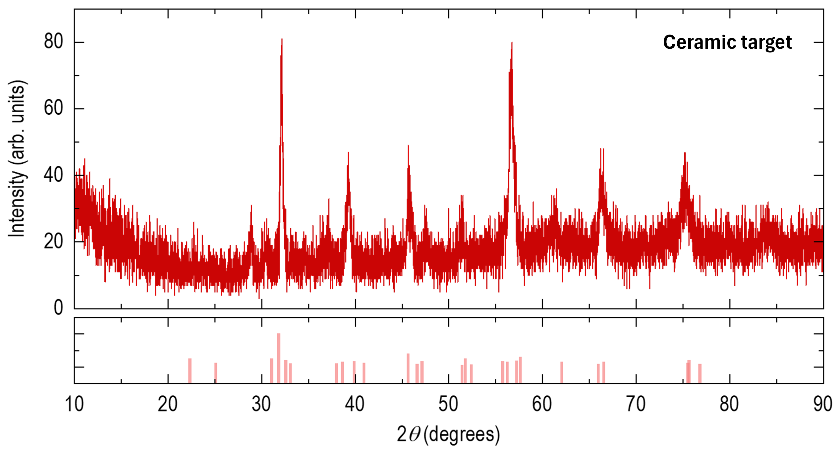
Figure S1. Powder X-ray diffraction θ-2θ of CeTaN₃ ceramic target.

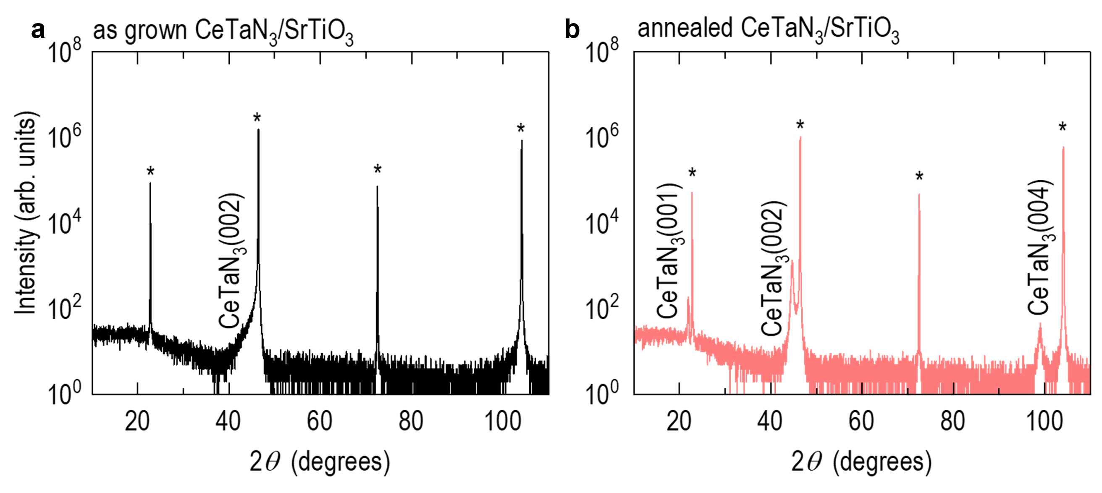
Figure S2. XRD θ-2θ of amorphous and crystallized CeTaN₃ thin films on STO substrates using rapid thermal process (RTP). (a) Amorphous CeTaN₃ and (b) Crystalline CeTaN₃ before and after RTP, respectively. RTP was performed at the temperature of 800℃ in ammonia (NH₃) conditions with 10,000 Pa for a 1 hour with heating rate of 200 ℃/min.

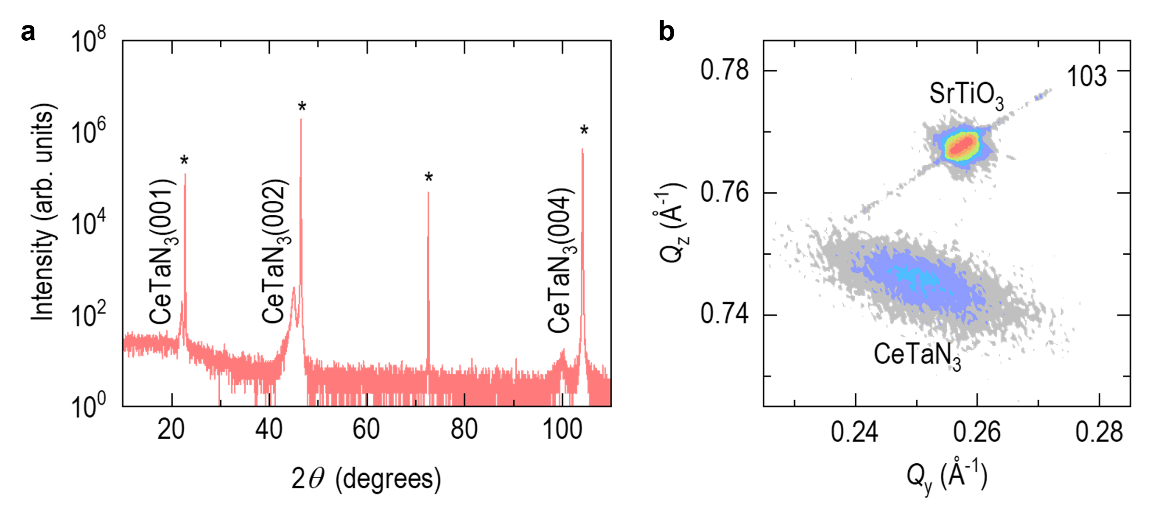Figure S3. Crystallized CeTaN₃ thin films on SrTiO₃ substrates. (a) XRD θ-2θ results. The asterisks(*) correspond to {001}-oriented SrTiO₃ substrate. (b) reciprocal space mapping (RSM) corresponding 103 CeTaN₃ and 103 SrTiO₃, yielding the in-plane and out-of-plane lattice constants of CTN films are 3.99 and 4.02 Å, respectively.
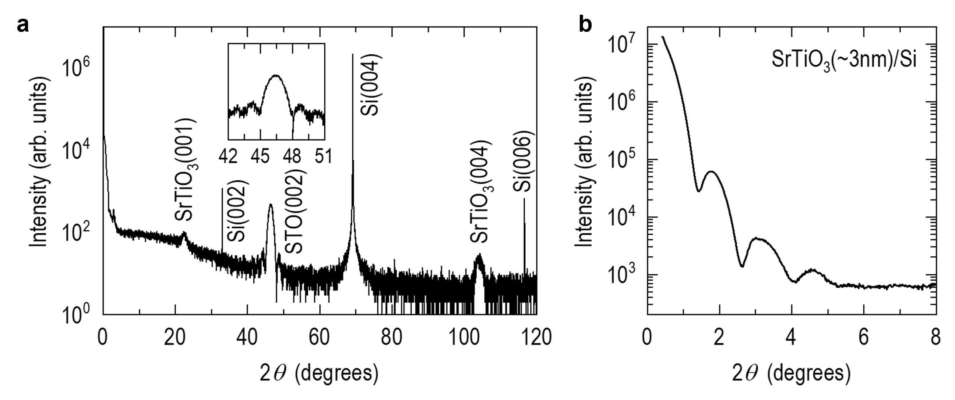
Figure S4. Structural characterization of 3nm-thick STO capped Si substrate. (a) XRD θ-2θ scan exhibits the epitaxial growth of STO on Si without any impurity peaks. The inset shows the detail of the STO 002 peak, revealing the Kiessig fringes. (b) X-ray reflection (XRR) shows Fourier oscillations, confirming the flat surface and about 3nm thickness of the STO capping layer.
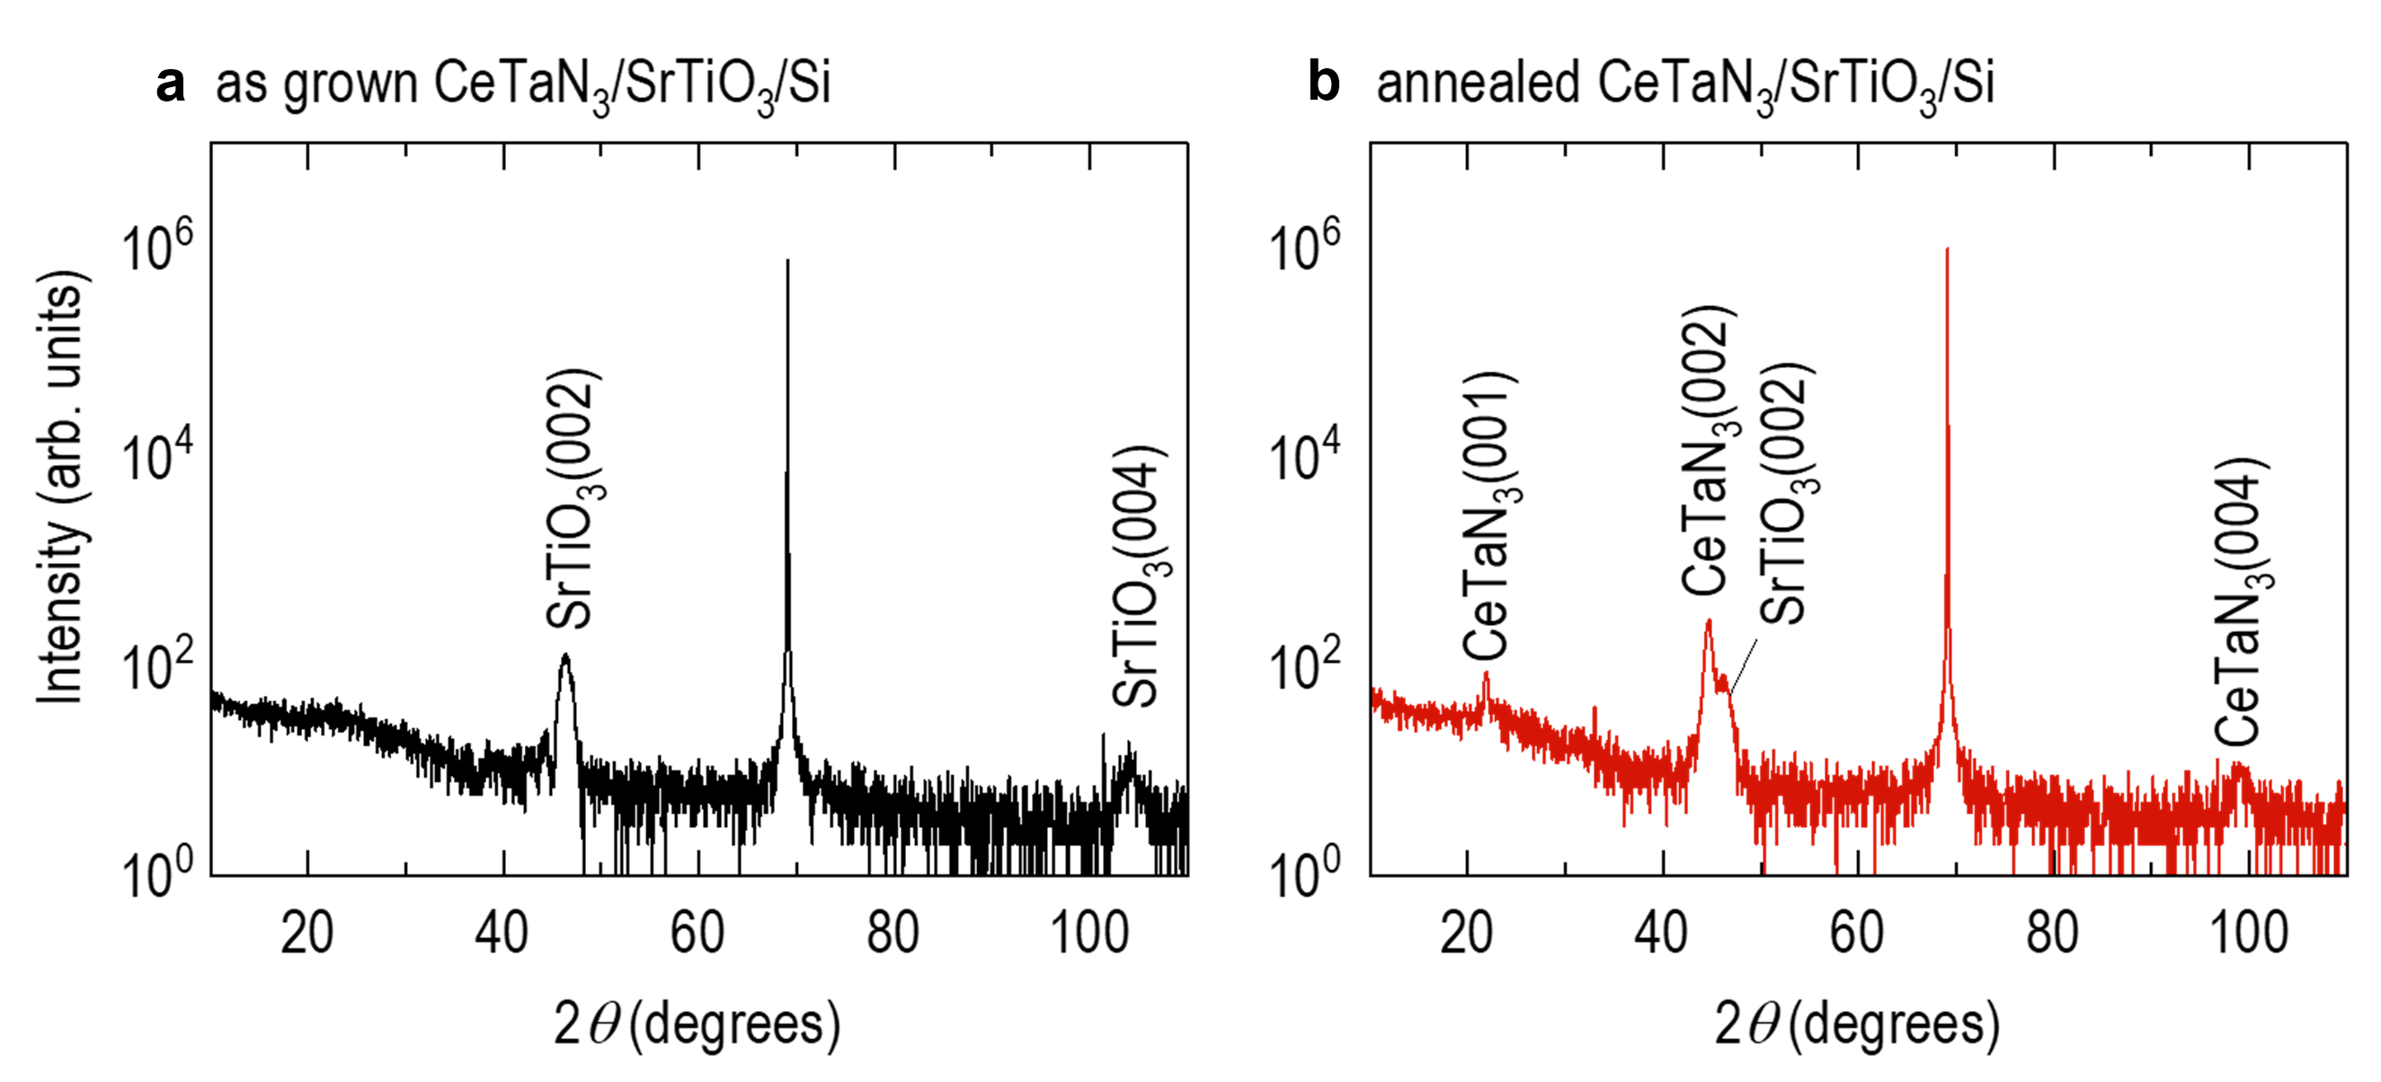
Figure S5. XRD θ-2θ of CeTaN₃ crystallization on STO/Si substrate using RTP. (a) Before RTP, XRD result only shows the STO peaks without any peaks from CeTaN₃ films, suggesting that the CeTaN₃ is amorphous. (b) We find the 00l reflections of CeTaN₃ films, indicating that the CeTaN₃ films are crystallized after RTP.

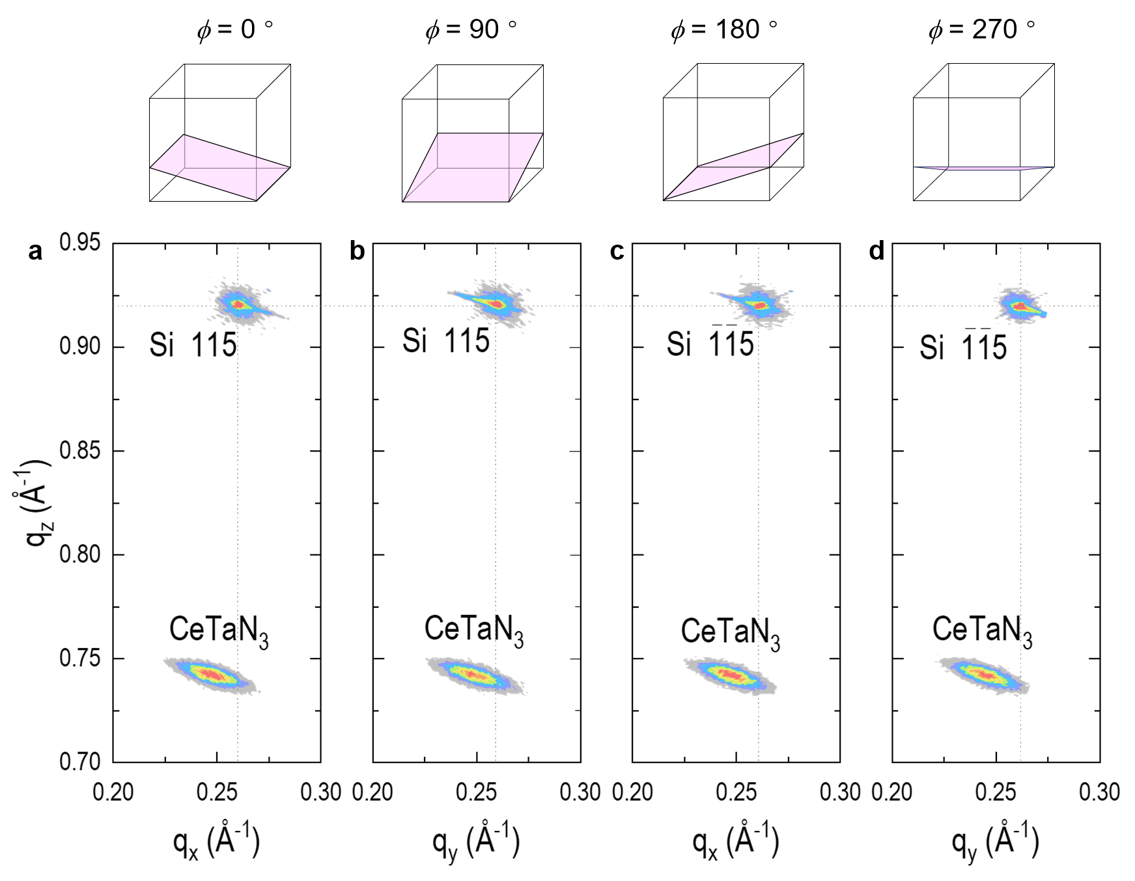
Figure S6. Tetragonal structure of CeTaN₃ thin films confirmed by RSM. The diffraction peaks, associated with the indices 103, 013, $\overline{1}$03, and 0$\overline{1}$3 reflections of CeTaN₃, reveal consistent positioning of q_{x} and q_{y}. The phi-dependent RSM results suggest that the CeTaN₃ thin film exhibits a tetragonal structure. The average in-plane lattice parameter is calculated to be a = b = 4.03 Å, while the averaged out-of-plane lattice parameter is c = 4.49 Å.
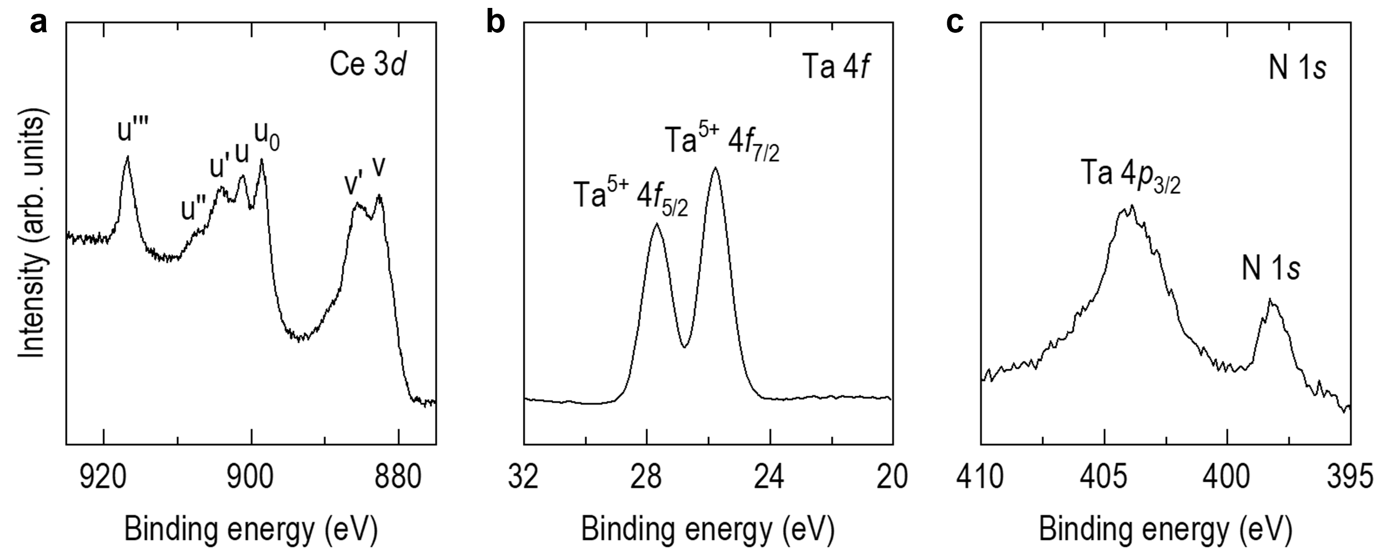
Figure S7. X-ray photoelectron spectroscopy of CeTaN₃ thin films. Ce 3d, Ta 4d, and N 1s, respectively. (a) Ce represents two oxidation states of Ce³⁺ and Ce⁴⁺. The peaks of u' (901.3 eV), u₀ (898.5 eV), and v' (885.5 eV) correspond to the positions of Ce³⁺ determined from Ce₂O₃, while peaks of u''' (916.8 eV), u'' (907.2 eV), u (901.1 eV) and v (882.7 eV) match Ce⁴⁺ determined from CeO₂. The presence of two oxidization states may attribute to the inevitable nitrogen vacancies in the surface layers of CeTaN₃ thin films. (b) The result of Ta spectroscopy reveals a single oxidation state of Ta⁴⁺. Ta⁵⁺ 4f_{5/2} is located at 27.7 eV, and Ta⁵⁺ 4f_{7/2} is at 25.8 eV. (c) N shows a distinct single peak at 398.1 eV, nearby where a peak corresponding to Ta 4p_{3/2} was observed at 403.9 eV.
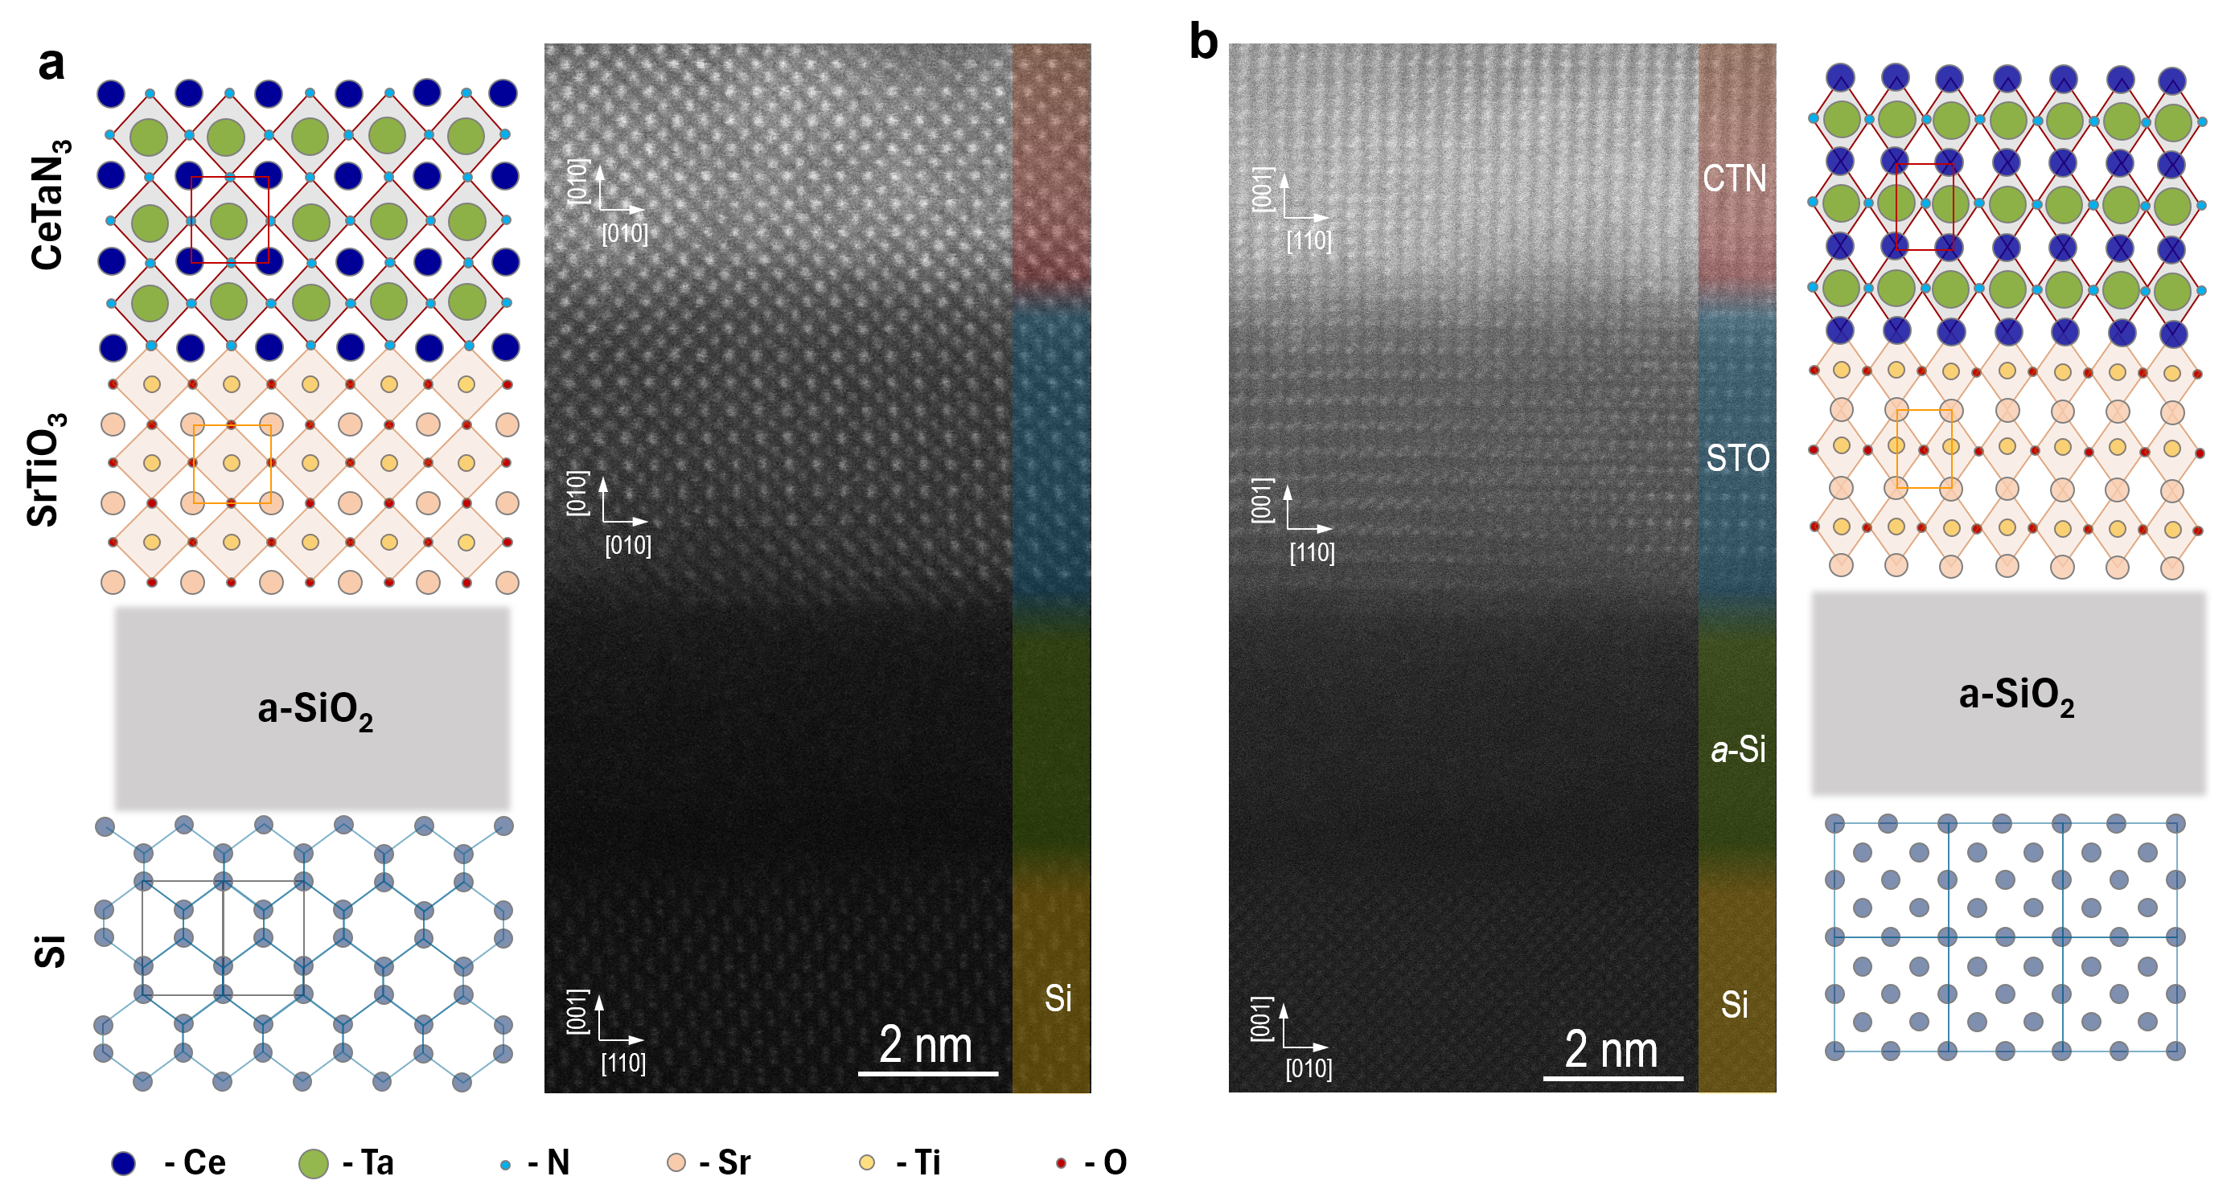
Figure S8. High resolution STEM images of CeTaN₃/SrTiO₃/a-SiO₂/Si with a plane view directed towards (a) Si 110 and (b) Si 010 orientations.

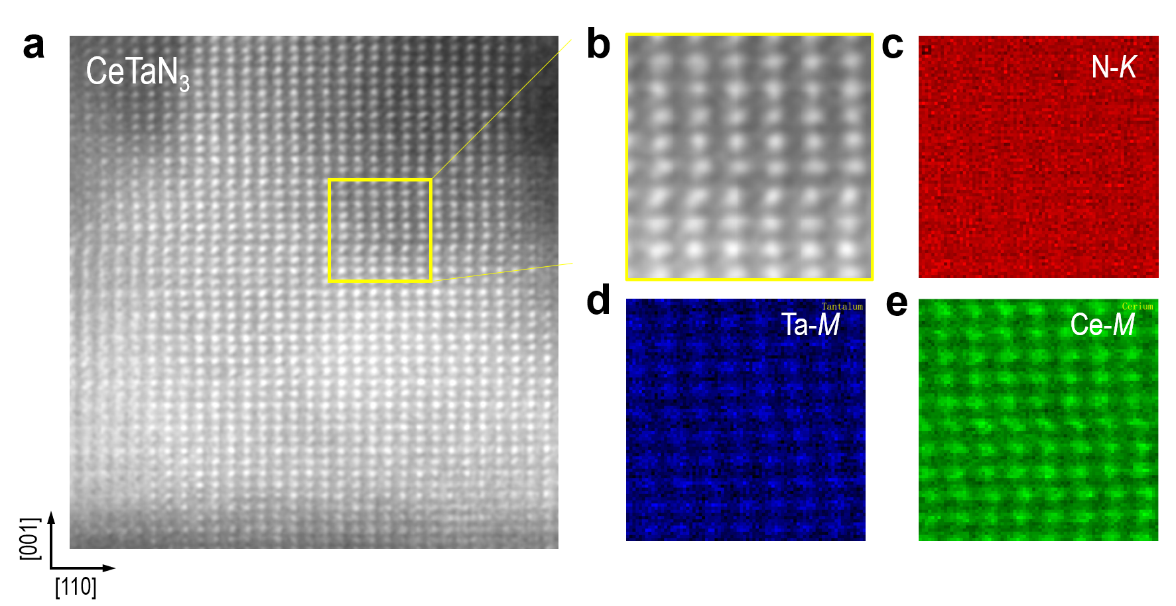
Figure S9. Chemical distribution in CeTaN₃ thin films. (a) HAADF-STEM image of a representative position in CeTaN₃ thin films. (b) A zoom-in HAADF-STEM image and (c)-(e) EDX image of N, Ce, and Ta element. These results indicate that the CeTaN₃ films exhibit a high-crystallinity and chemical homogeneity.
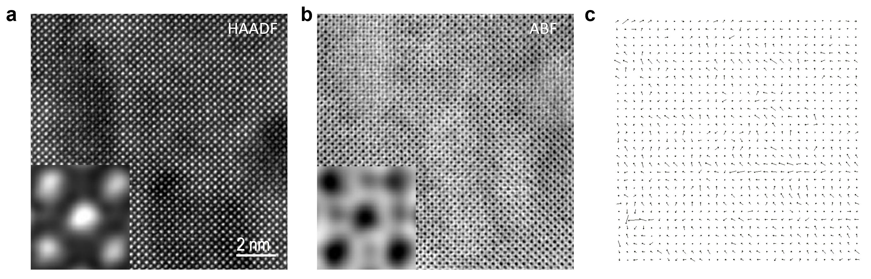
Figure S10. STEM results of CeTaN₃ thin films. To investigate atomic displacements intuitively related with ferroelectricity, (a) HAADF (high angle annular dark field) and (b) ABF (annular bright field) STEM were conducted. (c) Ce atoms displacements were deduced from TEM images. The arrows representing the motion of Ce atoms results to partial polarization, with most of these arrows pointing upward and some pointing to the left.
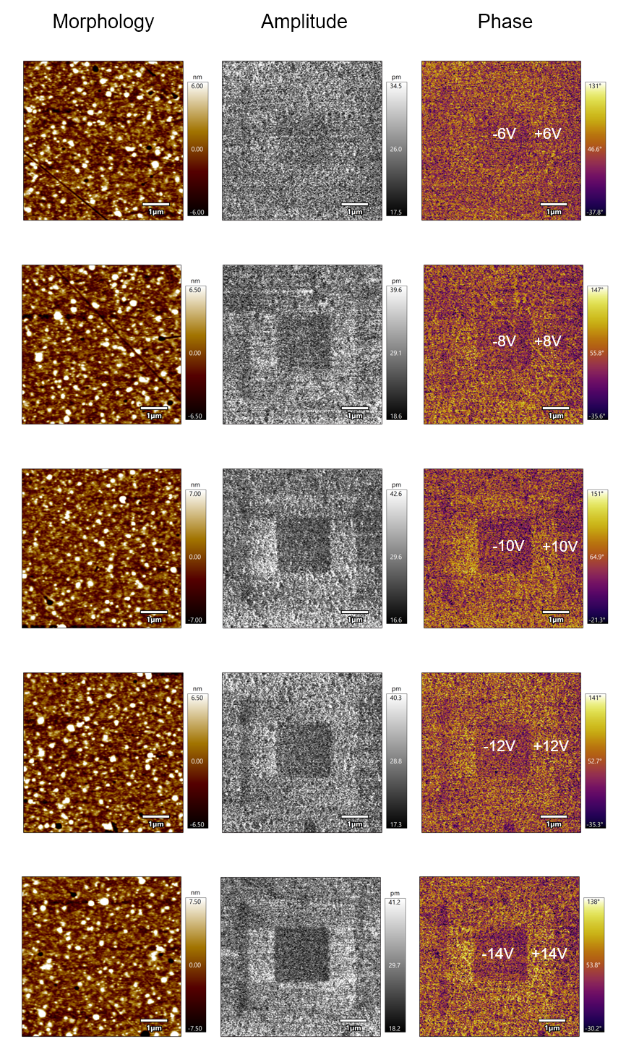
Figure S11. Piezoelectric properties of CeTaN₃ thin films by piezoelectric force microscopy (PFM). As a function of applied voltage from 6 to 14 V, the square shapes show reversal phase and amplitude of piezoelectric responses.

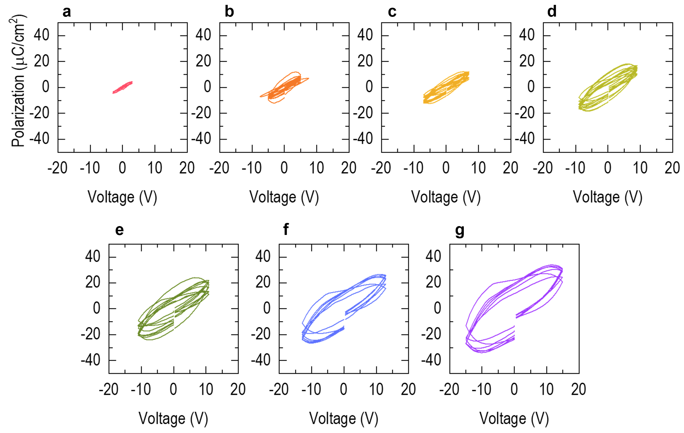
Figure S12. P-V loops for a 80nm-thickness CeTaN₃ capacitor. (a)-(g) Polarization as a function of applied voltage from 3, 5, 7, 9, 11, and 15 V. The polarization of 80nm-thickness CeTaN₃ was measured several times at different positions. Below critical voltages (~5 V), there is no hysteresis, showing ohmic contact response. Above the voltage 7 V, hysteric curves occur implicating ferroelectric property of CeTaN₃. The remanent polarizations increase from 6 to17 μC/cm² to growing voltage sweeping range from 7 to 15 V.

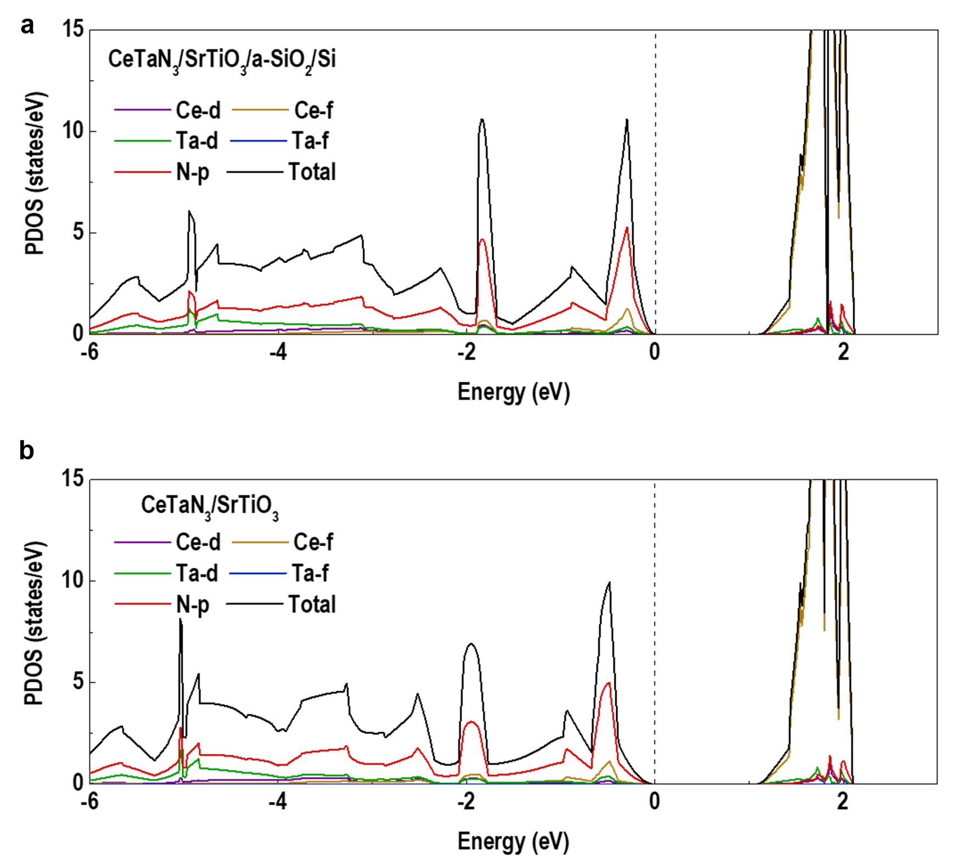
Figure S13 HSE density of states (DOS) for CeTaN₃/SrTiO₃/α-SiO₂/Si and CeTaN₃/SrTiO₃, including total density of states (TDOS) and the orbital-projected density of states (PDOS). We conclude that the conduction band is mainly contributed by Ce-f states, and the valence band is mainly contributed by N-p states.

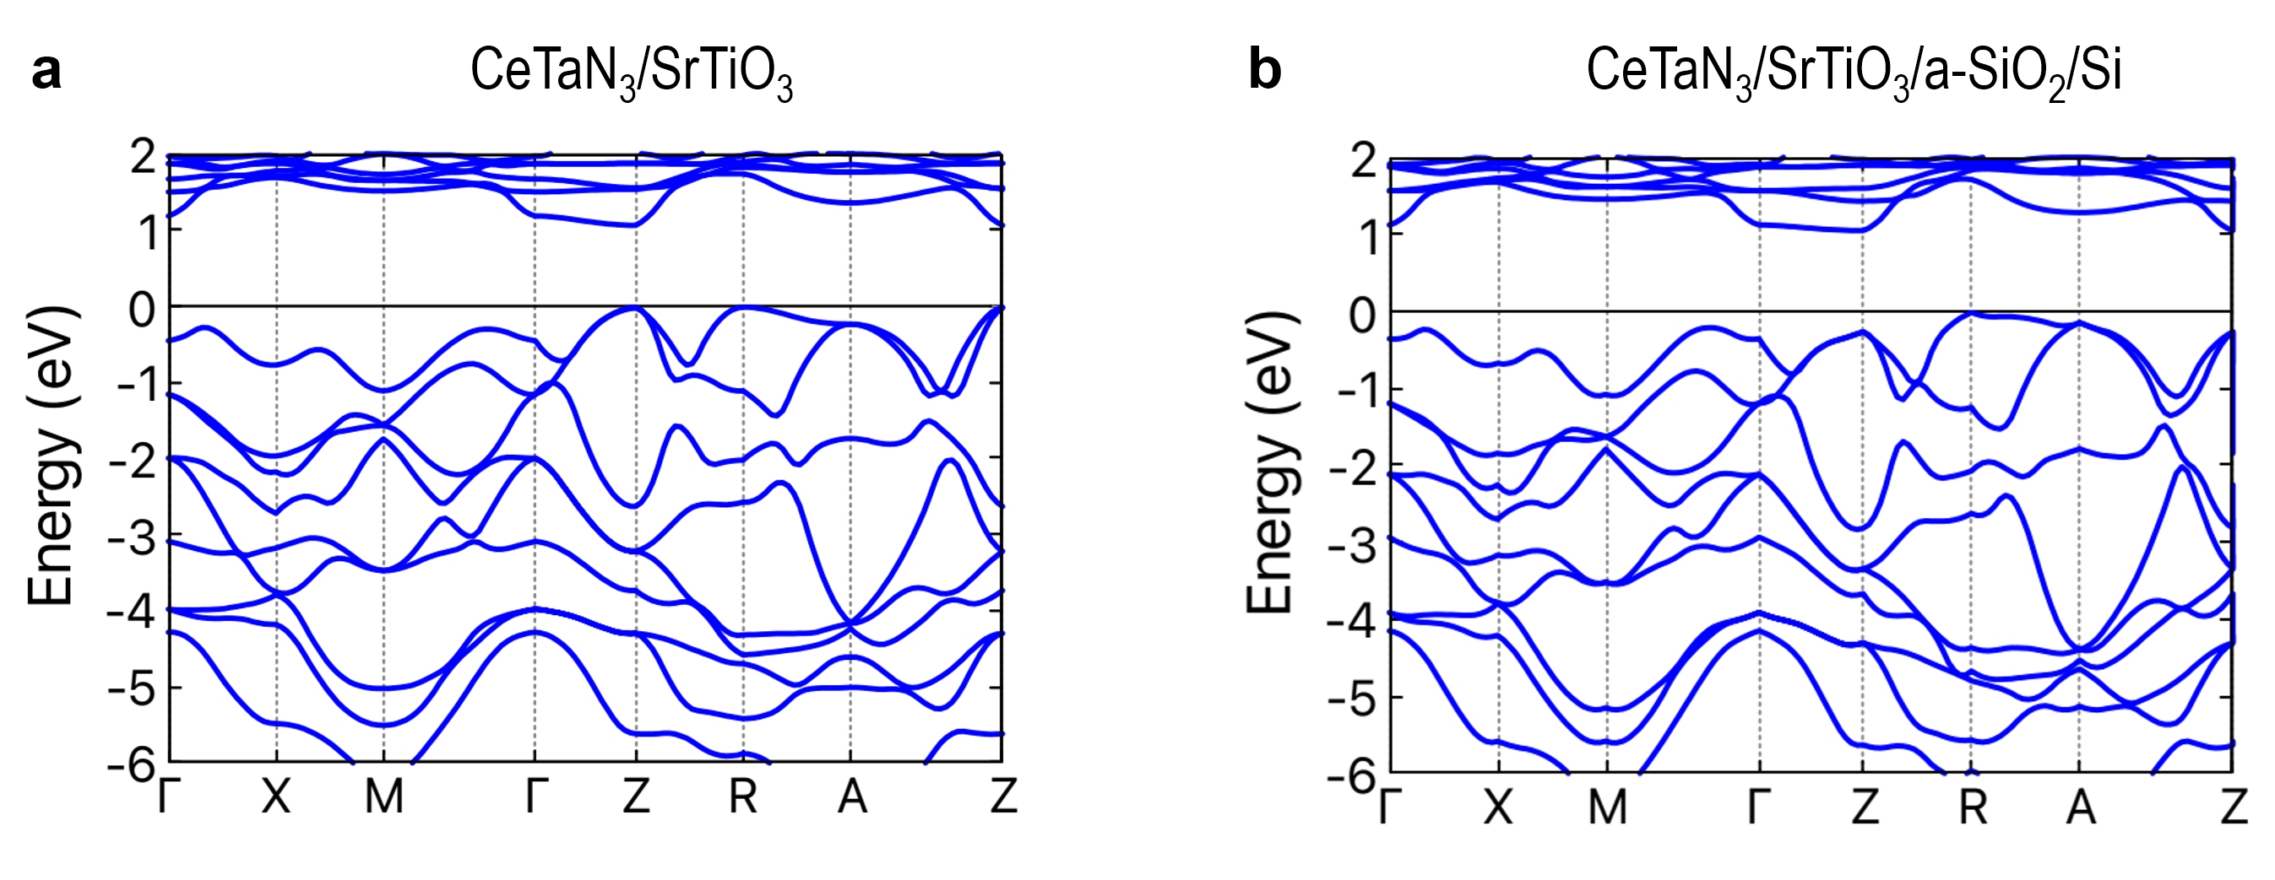
Figure S14. Band structures, as calculated with the HSE06 functional for (a) CeTaN₃/SrTiO₃/α-SiO₂/Si, (b) CeTaN₃/SrTiO₃. The indirect band gaps are indicated. The zero of energy is set at the valence-band maximum.

