Supplementary materials

Novel simultaneous oil-water separation strategy with Janus membrane via integrating two opposite wettability microfibers

Wenbin Jin^{[a]}, Hai Wan^{[a]}, Yao Zhang^{[a]}, Yuan Liang^{[a]}, Shuohan Huang^{[a]}, Yuwei Chen^{[b]}, Peng Wei^{[c]}, Yanping Wang^{[a]}, Yong He^{[a]} and Yumin Xia^{[a,} *]

[a] State Key Laboratory for Modification of Chemical Fibers and Polymer Materials, Key Laboratory of High Performance Fibers & Products, Ministry of Education, Engineering Research Center of Technical Textiles, Ministry of Education, College of Materials Science and Engineering, College of Science, Innovation Center for Textile Science and Technology in Donghua University, China
[b] Key Laboratory of Rubber-Plastics, Ministry of Education/Shandong Provincial Key Laboratory of Rubber-Plastics, Qingdao University of Science & Technology, China
[c] College of Textiles, Henan Key Laboratory of Functional Textile Materials, Zhongyuan University of Technology, China
*Corresponding author. E-mail: xym@dhu.edu.cn

Wet spinning of PAN fibers
The preparation of PAN fibers was wet spinning. As shown in Figure S1, the monomer acrylonitrile (AN) and solvent N, N-Dimethylformamide were firstly blended for polymerization, and then bubbles and monomers were removed to obtain PAN polymer spinning solution. After filtration, the spinning solution was extruded into fibers, and double diffusion (the coagulant diffuses into the solution and the solvent of solution diffuses into the coagulation bath) occurred in the coagulation bath. Finally, the PAN fiber was obtained after washing, drawing, and winding. During drawing process, V₂ was greater than V₁, causing a drawing ratio of V₂/V₁.
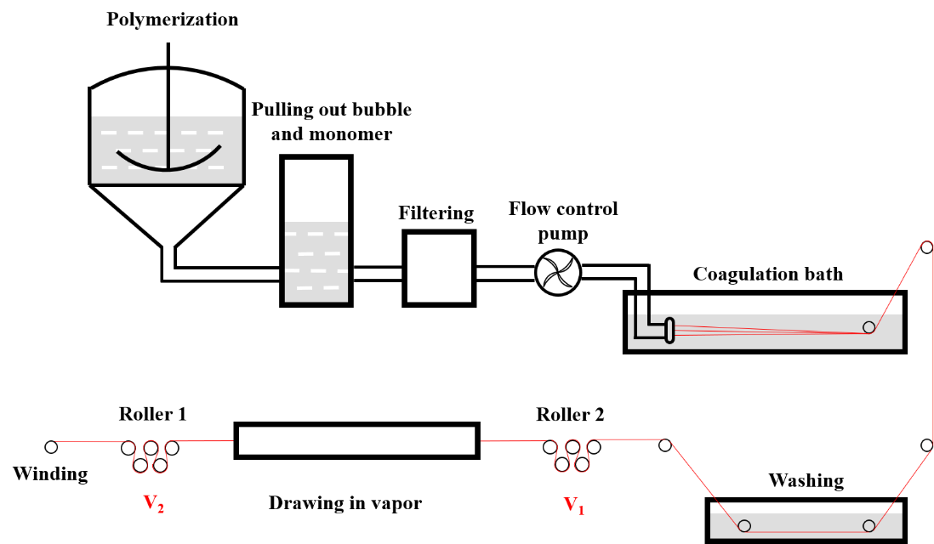
Figure S1. Wet spinning of PAN fibers

Amidoximation of PAMF
- Hydroxylammonium chloride was first neutralized with a basic catalyst to form hydroxylamine.
- The cyanide C≡N belonged to surface of PAMF reacted with hydroxylamine in a half-addition reaction to form an intermediate, which continued reacting with hydroxylamine to form amidoxime group, obtaining the A-PAMF.
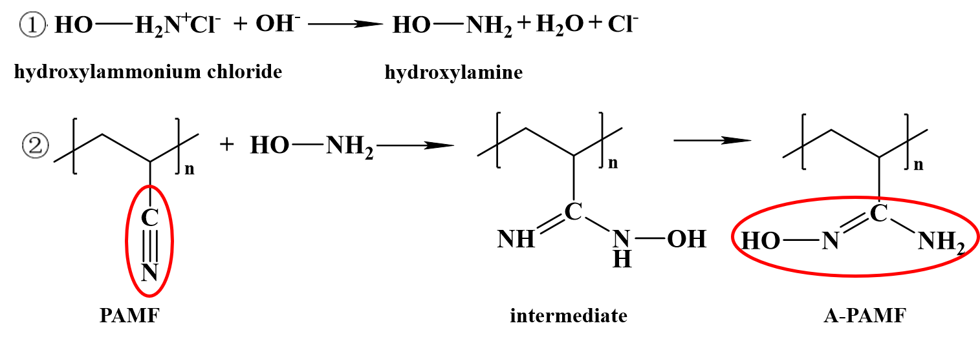
Figure S2. Amidoximation of PAMF

Scanning electron microscope (SEM) images of PAMF and A-PAMF
SEM images showed the surface morphology of PAMF and A-PAMF with no significant difference. The diameters of them were about tens of micrometers, and the lengths ranged from tens to hundreds of micrometers. There was no significant difference between the surface morphology of PAMF and A-PAMF. This was because hydroxylamine hydrochloride could only contact with the surface of PAMF during amidoximation, and only the C≡N on the surface of PAMF would be modified to amidoxime group, with the overall microfiber remained unchanged. Therefore, there was no significant difference in the surface morphology of microfibers, such as the aspect ratio and specific surface area.
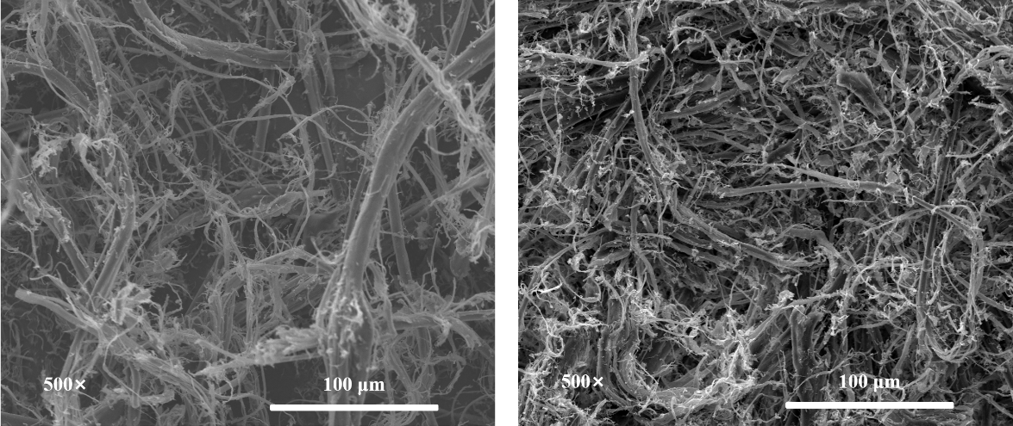
Figure S3. SEM images of PAMF and A-PAMF

Attenuated total reflectance-Fourier Transform infrared spectroscopy (ATR-FTIR) of PAMF and A-PAMF
Figure S4 showed the ATR-FTIR image of PAMF and A-PAMF. The characteristic peaks of stretching vibrations for N-O, C=N, and N-H groups of A-PAMF were observed clearly at 941cm⁻¹, 1654cm⁻¹ and 3377cm⁻¹, but PAMF was not. It could be sure that the amidoximation in the surface of PAMF was successful and A-PAMF was obtained. However, there was no significant change in the peaks of -CH and -CH₂ bonds on the carbon chain, indicating that the amidoximation only occurred on the surface -CN group of PAMF rather than carbon chain. Meanwhile, the characteristic peak of -CN group at 2242cm⁻¹ of obtained A-PAMF indicated there were unreacted PAN in A-PAMF. The reason was that hydroxylamine hydrochloride only came into contact with the surface of PAMF, and it was reasonable that only the -CN groups on the surface of PAMF had been amidoximized. Therefore, the inside of A-PAMF was actually still PAN and the characteristic peak still existed in the infrared spectrum of A-PAMF.
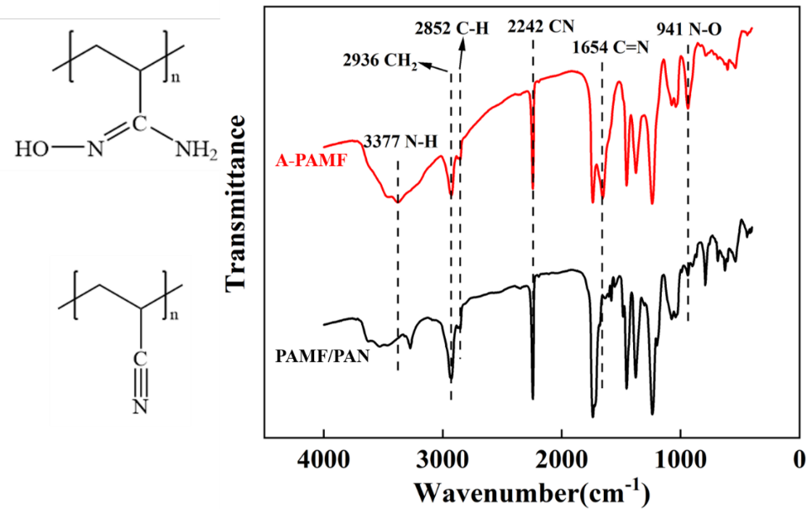
Figure S4. ATR-FTIR spectra of PAMF/PAN and A-PAMF

X-ray photoelectron spectroscopy (XPS) of PAMF and A-PAMF
The modification of PAMF to A-PAMF was further demonstrated by X-ray photoelectron spectroscopy (XPS) that efficiently identified the surface functional groups from C≡N to C(NH₂)=NOH. The XPS survey spectra of PAMF and A-PAMF were presented at Figure S5, which showed the typical C1s, O1s and N1s, at around 284.4 eV, 531.4 eV and 398.8 eV, respectively.
The chemical bonds of the element carbon were C-C, C-N, C=N, C≡N and C=O, centered at 284.4 eV, 286.6 eV, 285.4 eV 285.8 eV and 286.5 eV, respectively. According to the fitting of XPS C1s spectrum of PAMF and A-PAMF, C-C and C≡N were the first and second species in PAMF. And there was peaks of C-N and C=N in C1s spectrum of A-PAMF, demonstrating the successful amidoximation of C (NH₂)=NOH. In addition, the peaks of C=O in the C1s and O1s spectra of PAMF and A-PAMF came from the PAN spinning and oiling in industry.
XPS O1s spectra could be divided into three components of O-N, O-H, and C=O with the curve fitting, which were centered at 532.1 eV, 530.6 eV, and 531.4 eV Furthermore, C=O was due to the organic oils during the PAN spinning and oiling. However, the O-N and O-H peaks in the A-PAMF O1s spectrum were able to demonstrate the occurrence of amidoximation, but these peaks were not found in the PAMF O1s spectrum.
According to the fitting, XPS N1s spectra could be divided into three components of C-N, C=N, and C≡N, which were centered at 398.5 eV, 399.4 eV, and 398.8 eV, respectively. Because of the conversion of PAMF to A-PAMF, the peaks corresponding to C-N and C=N (C(NH₂)=NOH) significantly increased in the XPS N1s spectrum of A-PAMF instead of PAMF. But the peaks of C≡N were in both spectra, which proved that the amidoximation reaction only occurred on the surface of PAMF, while the interior of PAMF was actually still the PAN with C≡N. In addition, there was a shake-up line in the N1s spectrum because many unsaturated functional groups (C≡N) were in the PAN main chain.
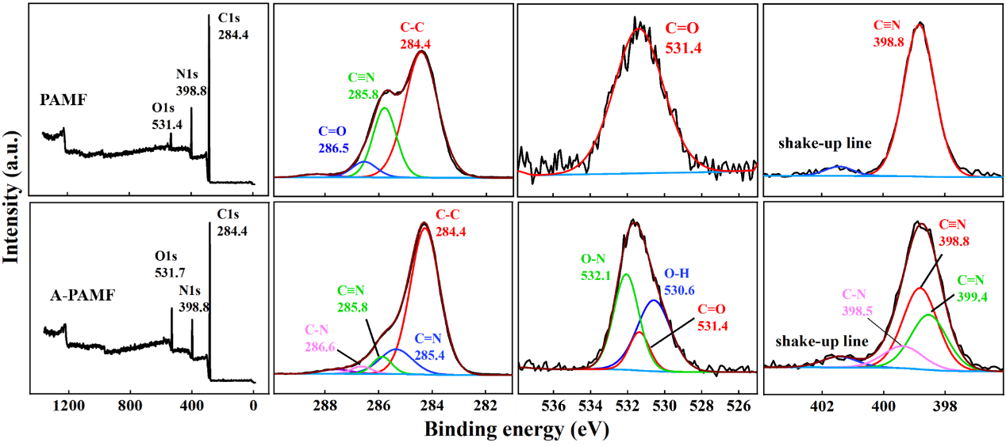
Figure S5. XPS spectra of PAMF and A-PAMF

X-ray diffraction (XRD) of PAMF and A-PAMF
The XRD spectrum of PAMF and A-PAMF was presented in Figure S6, and three major characteristic diffraction peaks were 16.58°, 22.38° and 28.50°. It was shown that a sharp and broad diffraction peak at 2θ =17° corresponds to (100) reflection with d = 5.3 Å, a relatively weak diffraction peak at 2θ =28.5° corresponds to (110) reflection with d=3 Å, and amorphous peaks between 2θ =20° and 30°. The diffraction at 2θ = 16.58° attributed to the hexagonal packing of rod like chains and the amorphous nature of the samples, and it was the reflections of the orthorhombic structure of PAN. But the other diffractions were found to be less intensive and broader after amidoximation. The decreased intensity indicated that the crystallinity would reduce, and the broadening represented the reduction of crystal size. The decreased crystallinity was relatively significant from 27.86 % of PAN to 13.75 % due to the amidoximation, which disrupted the ordered arrangement of pristine PAN. The crystallinity (%) were calculated by the following formula:
crystallinity (%) = [(total area - amorphous peak area) / total area] ×100
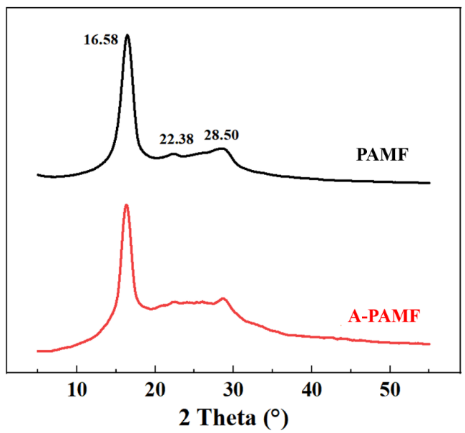
Figure S6. XRD spectra of PAMF and A-PAMF

¹H-nuclear magnetic resonance (¹H-NMR) of PAMF and A-PAMF
Figure S7 showed the ¹HNMR spectra recorded in DMSO-d₆, evidencing signals of number and type of protons. The peaks at δ = 2.5 ppm，δ = 3.35 ppm，δ = 1.24 ppm，δ = 2.04 ppm and δ = 3.12 ppm belonged to the chemical shifts of protons in the solvent DMSO-d₆, residual water, methyl CH₃, methylene CH₂, and methine CH with cyanide, respectively. In addition, according to the fitting integrals, the ratio of the protons in CH and CH₂ was 1:2, which indicated that the carbon chain of PAMF had not been disrupted, and only the side chains C≡N were modified.
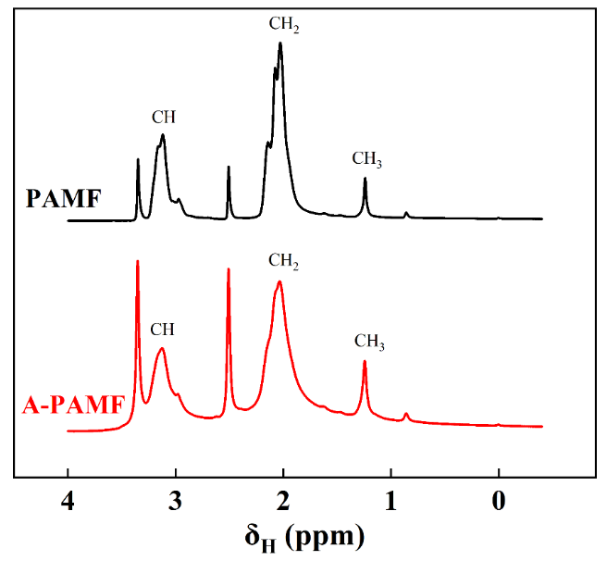
Figure S7. ¹H-NMR spectra of PAMF and A-PAMF

Wettability of PAMF and A-PAMF
To test the hydrophilicity, PAMF and A-PAMF membranes were prepared, and 10 μL of water droplets were added to the surfaces for adsorption. Water droplet was fully adsorbed in 360 s for PAMF membrane but only 200 s for A-PAMF membrane of amidoximation, which evidenced that the modification was successful and the hydrophilicity was significantly enhanced after the modification.
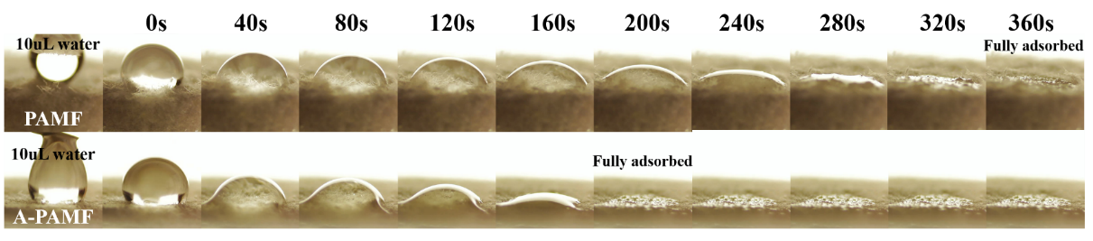Figure S8. Hydrophilicity of PAMF and A-PAMF

For lipophobicity in the water, of 10 μL chloroform droplets were added to PAMF and A-PAMF membranes. The result indicated that the PAMF membrane adsorbed the chloroform droplet quickly, but the A-PAMF membrane did not, and the chloroform droplet was able to remain standing for a long time. After amidoximation modification, the lipophobicity of A-PAMF was greatly enhanced compared to PAMF.
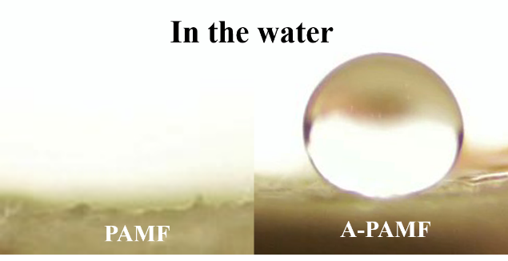
Figure S9. Lipophobicity of PAMF and A-PAMF

Preparation of JMM
Firstly, the POMF was filtered into a 5 mm thickness as lipophilic/hydrophobic side within a square frame mold made of stacked glass slips. Secondly, the filtered POMF side was covered by glass slips to prevent the contamination, and the square frame mold was enlarged for filtering the same thickness of A-PAMF as hydrophilic/lipophobic side against POMF side. Finally, after the whole membrane was removed from the mold, washed, and dried, JMM with opposite wettability in its two sides was obtained.
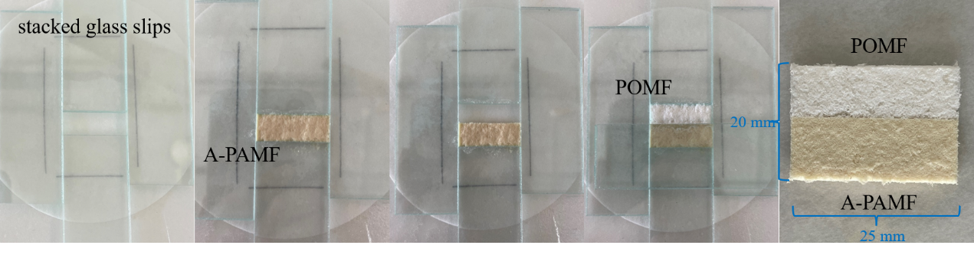
Figure S10. Preparation process of JMM

SEM and EDS of JMM
To further understand the elemental composition and distribution of POMF/A-PAMF JMM, SEM-EDS analysis was performed in Figure S11 which could confirm the successful preparation. With no significant difference, the diameters of POMF and A-PAMF ranged from 6 μm to 20 μm and 2 μm to 12 μm, as shown in SEM images in Figure S11(a) and (b). Though it was at the boundary as shown in Figure S11(c), SEM images showed that there was a whole microfiber membrane without gaps or cracks instead of POMF and A-PAMF being separated. That was due to the fact that microfibers were interspersed and overlapped with each other to blind and link these two microfibers together. Therefore, the boundary of POMF and A-PAMF could not be seen in SEM, but not in EDS.
The JMM was rich in C element and the distribution was uniform due to carbon chains of polymers, as shown in Figure S11(d). The distribution of O element of POMF side was significantly more than the A-PAMF side in Figure S11(e), because the “-CH₂O-” of POM was repeating unit which contained a much O element. However, no O element was presence in PAN, and only a few cyanides “-CN” on the PAMF surface was modified by amidoximation with introducing O element of “-OH”. Similarly, Figure S11(f) showed that the A-PAMF side was significantly richer in the distribution of N element than the POMF side due to the redundant distribution of N element (amidoxime groups “C(NH₂)=NOH” and cyanides “-CN”) in A-PAMF. Furthermore, the A-PAMF side had a little O element and POMF side had a little N element in Figure S11(e) and (f). Except for the O element distribution of hydroxyl (NOH) in A-PAMF, the main reason was that the interpenetration of microfibers into each other to form a whole inseparable membrane. And meanwhile, the formed boundary by interpenetration of microfibers with two different wettability met the function of adsorbing, separating, and dredging of the oil and water phases, and this was the reason that the POMF/A-PAMF JMM could simultaneously separate water and oil with various densities.
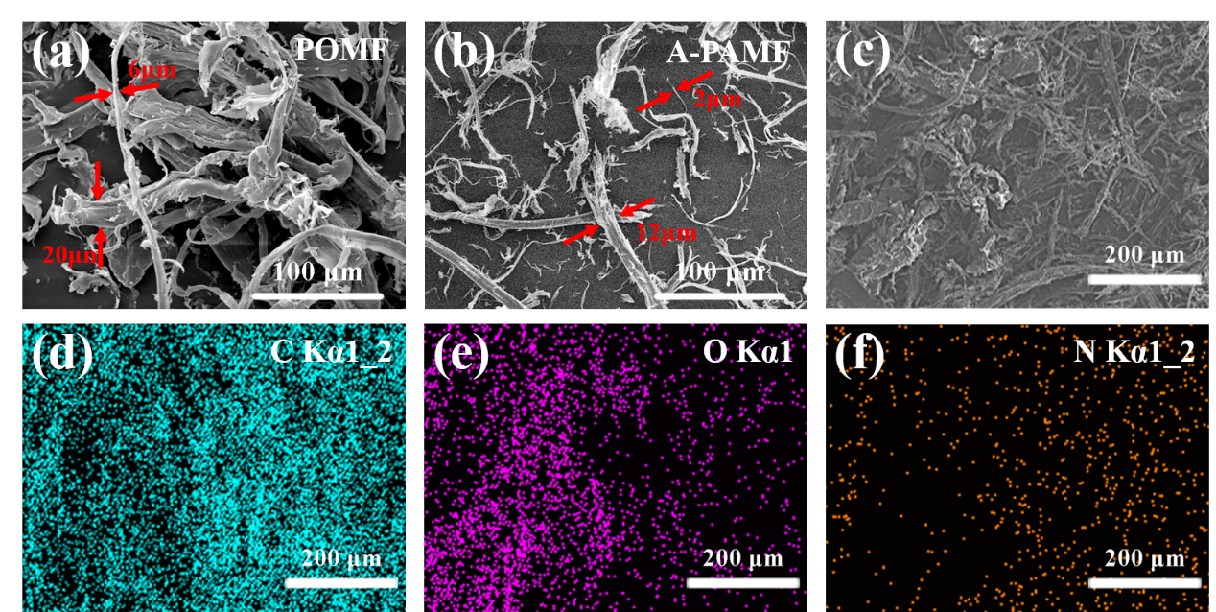
Figure S11. SEM images and EDS mapping of JMM

Preparation of zigzag microfibers
For preparing zigzag A-PAMF between POMF, the zigzag mold was firstly placed on the right side of the frame mold, filtering the left half with POMF to the thickness of 5 mm. Then it was moved to the right and filtered POMF was covered to prevent the contamination, and A-PAMF was introduced in the zigzag gap to form a shape of zigzag. Finally, removed the zigzag mold and filtered POMF to the right half to make the whole membrane rectangular. Similarly, the zigzag POMF between A-PAMF could be obtained by the same path.
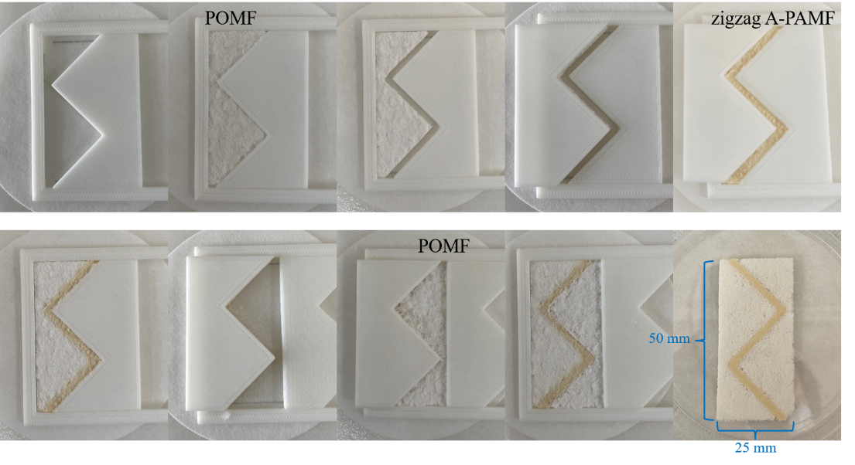
Figure S12. Preparation of zigzag A-PAMF between POMF

Preparation of IJMM
The interdigital mold was first placed on the left side of the frame mold, and the POMF side was filtered in the right half in a shape of interdigital boundary. Then when filtering A-PAMF, with the filtered POMF covered to prevent the contamination, the A-PAMF was filtered in the left half in the frame mold. Finally, a microfiber bank was built around the membrane to obtain IJMM (Figure S13 and Figure 5(b)).
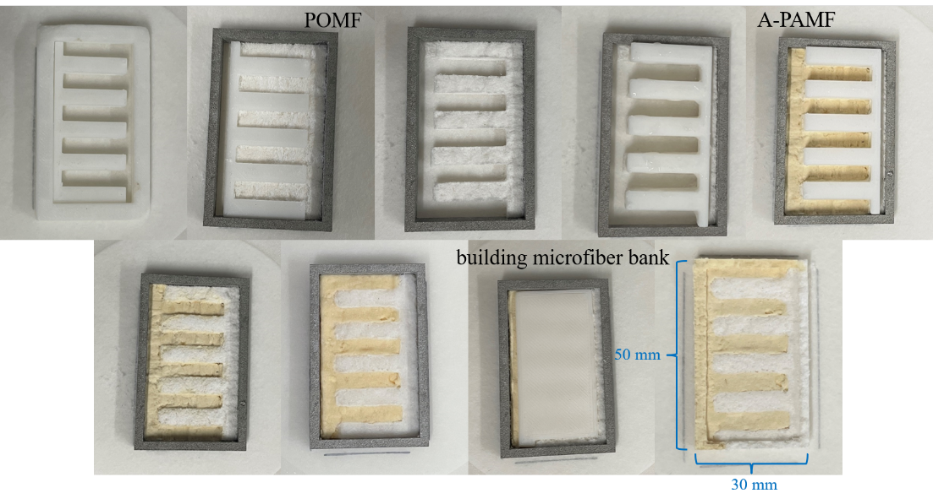
Figure S13. Preparation process of IJMM

Preparation of mixed oil (MO)
According to theoretical calculation for making the mixed oil's (MO) density akin to that of water, the volume ratio of cyclohexane and chloroform was 69 ml:31 ml. But actually, considering the mutual dissolution of cyclohexane/chloroform and MO/water, the MO was floating on the water indicating that the density of the MO was less than water. Therefore, some chloroform needed to be added into MO to increase density until water droplets were suspended in MO (volume ratio 69 ml:31+5.5 ml), evidencing that the density of MO was similar to that of water, displaying in Table S1. Thus, the MO made with ratio of 69 ml:36.5 ml of cyclohexane and chloroform was used for oil-water mixture separation.
Table S1 Volume ratio of MO, stirring and standing
Volume ratio (cyclohexane: chloroform) | standing for 0 min after stirring | standing for 5 min after stirring
69 ml:31 ml + 0 ml | 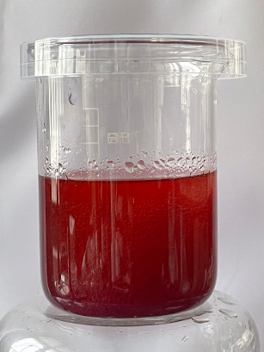 | 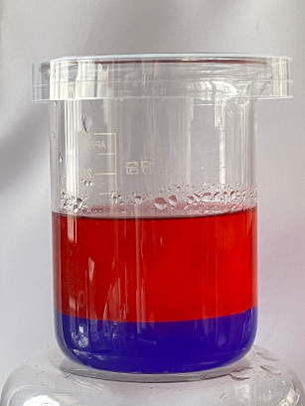
69 ml:31ml + 0.5 ml | 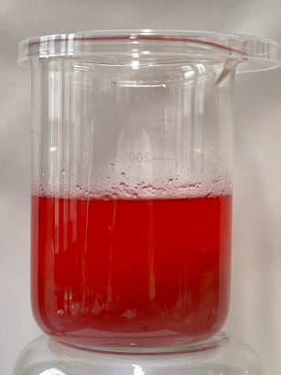 | 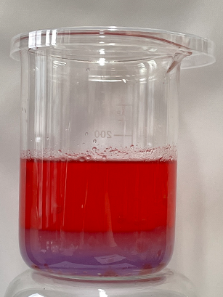
69 ml:31 ml + 1 ml |  | 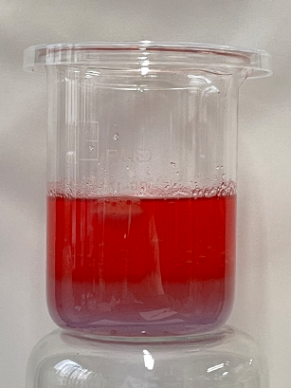
69 ml:31 ml + 1.5 ml | 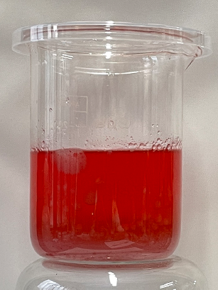 | 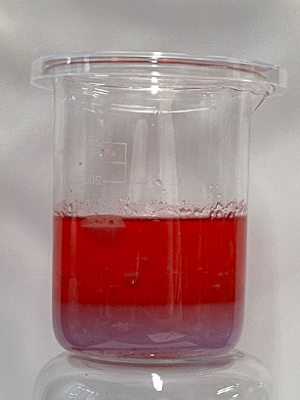
69 ml:31 ml + 2 ml | 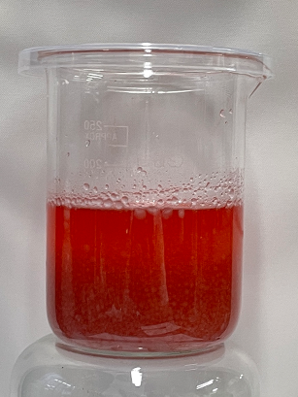 | 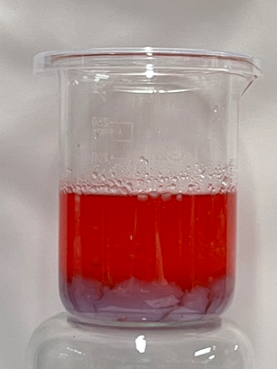
69 ml:31 ml + 2.5 ml | 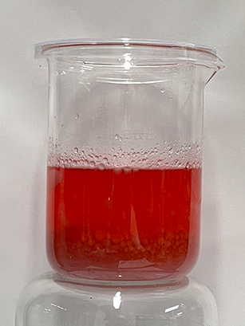 | 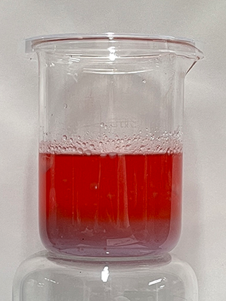
69 ml:31 ml + 3 ml |  | 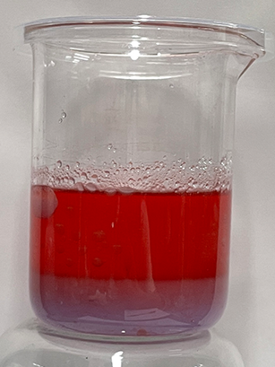
69 ml:31 ml +3.5 ml | 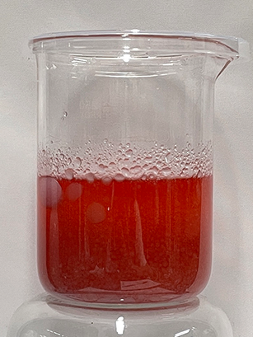 | 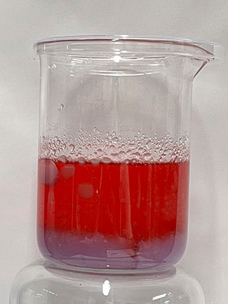
69 ml:31 ml +4 ml | 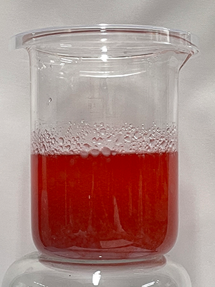 | 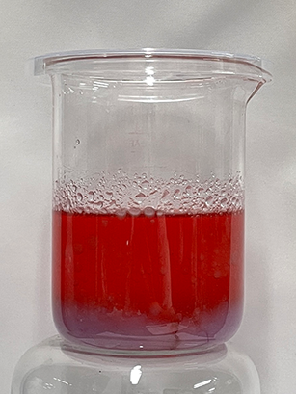
69 ml:31 ml +4.5 ml | 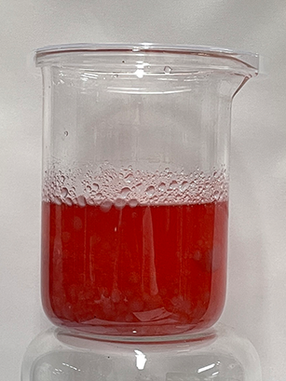 | 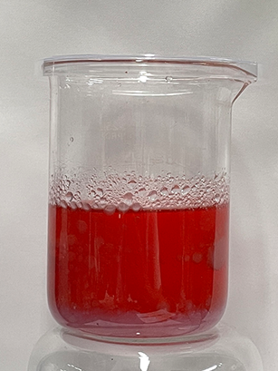
69 ml:31 ml +5 ml | 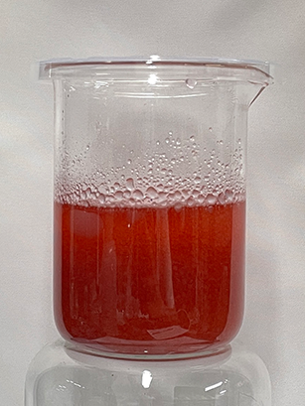 | 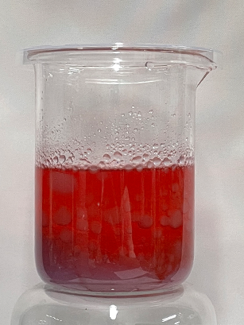
69 ml:31 ml +5.5 ml | 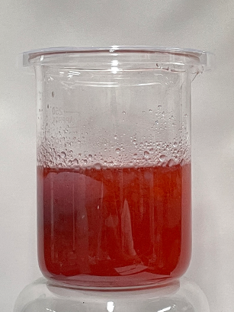 | 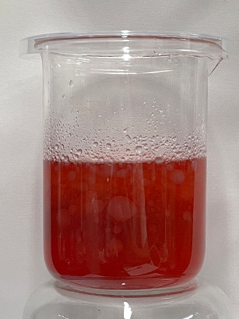
69 ml:31 ml +6 ml | 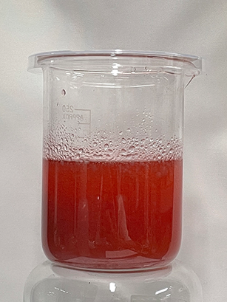 | 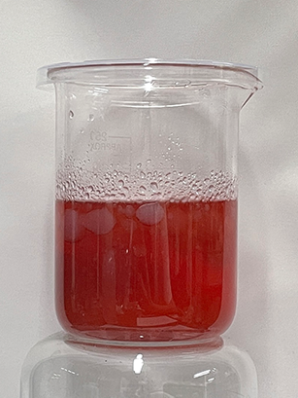

Three-phase systems separation for hours and litter scale
Three-phase systems separation for hours and litters scale was carried out. 400mL of light oil (cyclohexane), water and heavy oil(chloroform) were sequentially added into the separatory funnel of the device. Water and heavy oil were firstly added, stratifying the heavy oil under the water. After opening the funnel piston, the heavy oil flowed out to contact with the microfiber membrane. A-PAMF repelled and POMF adsorbed and dredged the heavy oil this moment at the boundary, and separate it into the heavy oil collector on the left. After finishing separating the heavy oil, the water phase flowed out next, contacting the microfiber membrane. POMF repelled and A-PAMF adsorbed and dredged water, which was separated into the water collector on the right. Light oil was finally added, and due to the density difference light oil would be on top of the water phase. Therefore, the light oil started to flow out of the funnel after the water phase was separated, and it was collected in the light oil collector on the left.
The three-phase systems separation for hours and litters scale lasted for 34 h, proving the long-term chemical stability. Despite the anti-volatilization measures, the liquid phase inevitably volatilized, resulting in a filtrate volume of 365mL of heavy oil, 387mL of water, and 378mL of light oil, respectively. And the separation efficiency of heavy oil, water and light oil were 91.25%, 96.75% and 94.5%.

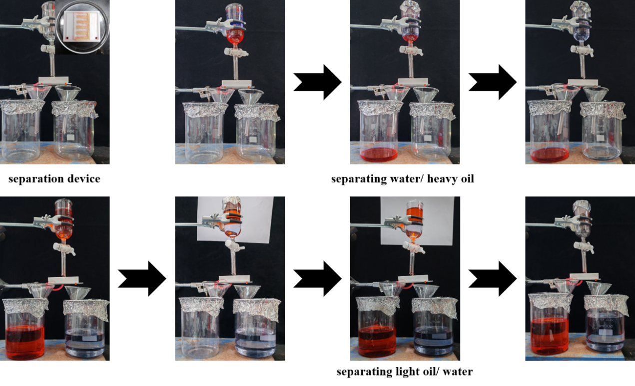
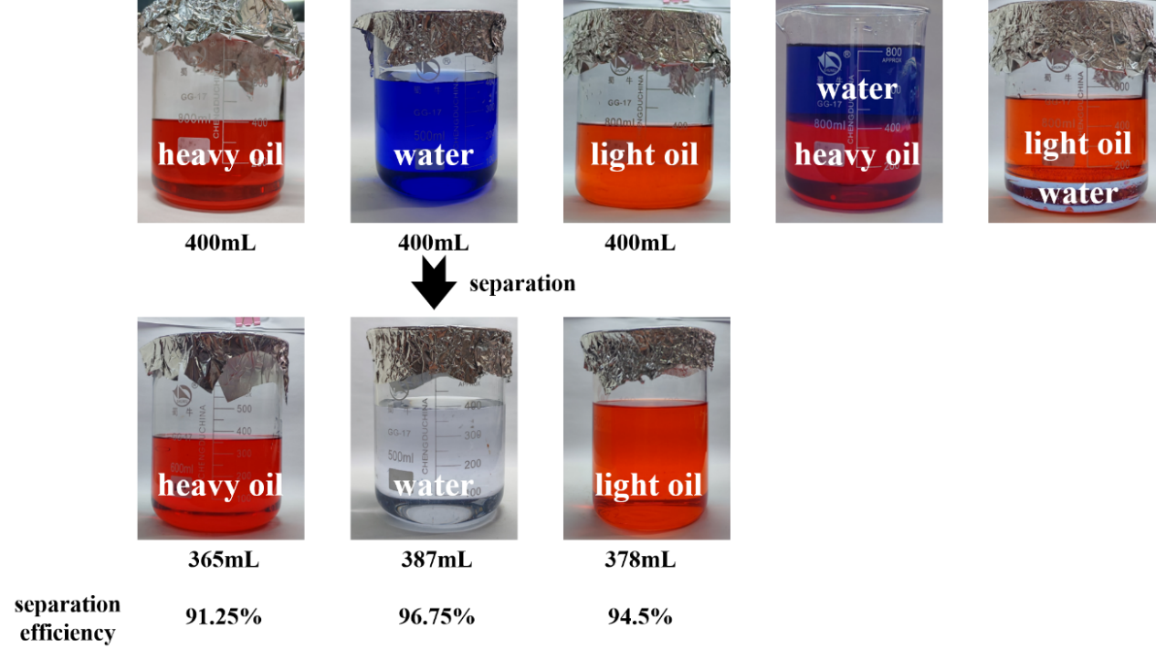
Figure S14. Three-phase systems separation for hours and litters scale

