Suplementary material S2. Interpretation of the hydrogeological parameter of the pumping test conducted on on exploration borehole GKLA1 or subsequent pumping well PW2.
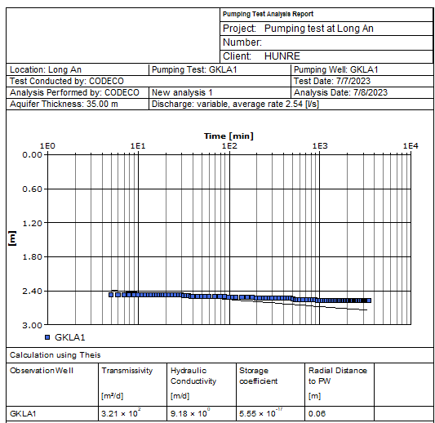 | 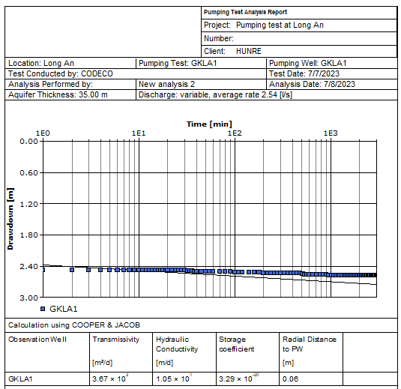
a) | b)
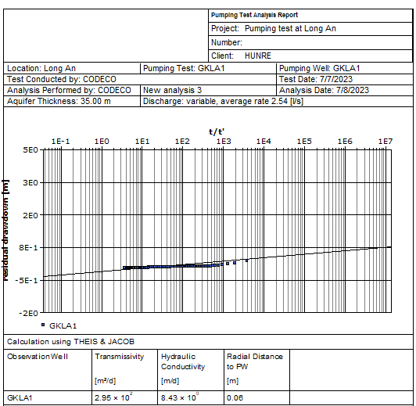 | Fig. S2.1. The analysis of hydrogeological parameters derived from pumping test data using AQUIFER TEST software, Version 11.0, developed by Waterloo Hydrogeologic Company. The interpretations are detailed as follows:  a) Analysis conducted through Theis standard curve method.  b) Utilization of the Jacov method for analysis.  c) Application of the Theis-Jacov method for analyzing water level recovery data.
c)
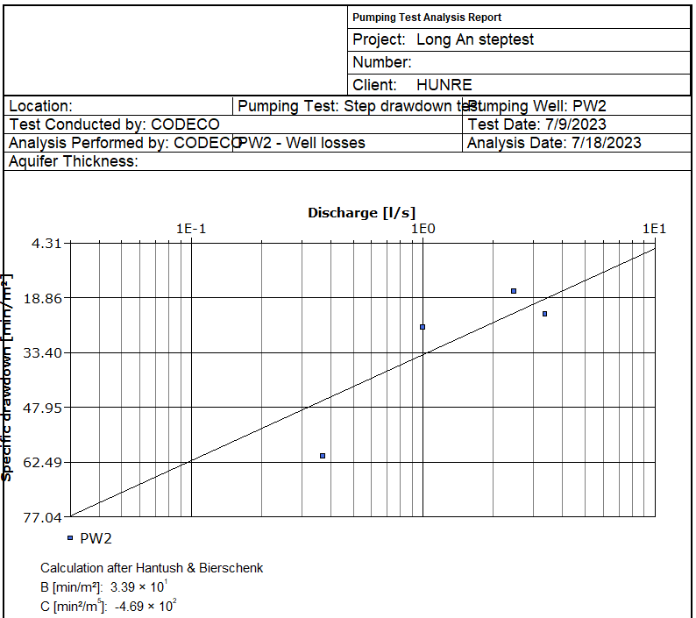 |  | Fig. S2.2. Results of determining parameters B and C according to the step drawdown test using AQUIFER TEST software of Version 11.0 of Waterloo Hydrogeologic Company.  The determined coefficients B = 33.9 and C = -0.0469 give us the formula to determine the performance of the pumping well to exploit groundwater PW2 as follows:  V = (33.9Q)/(33.9Q-0.0469Q²)

