Suplementary Material S5. The hydrogeological parameters and boundary conditions
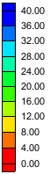
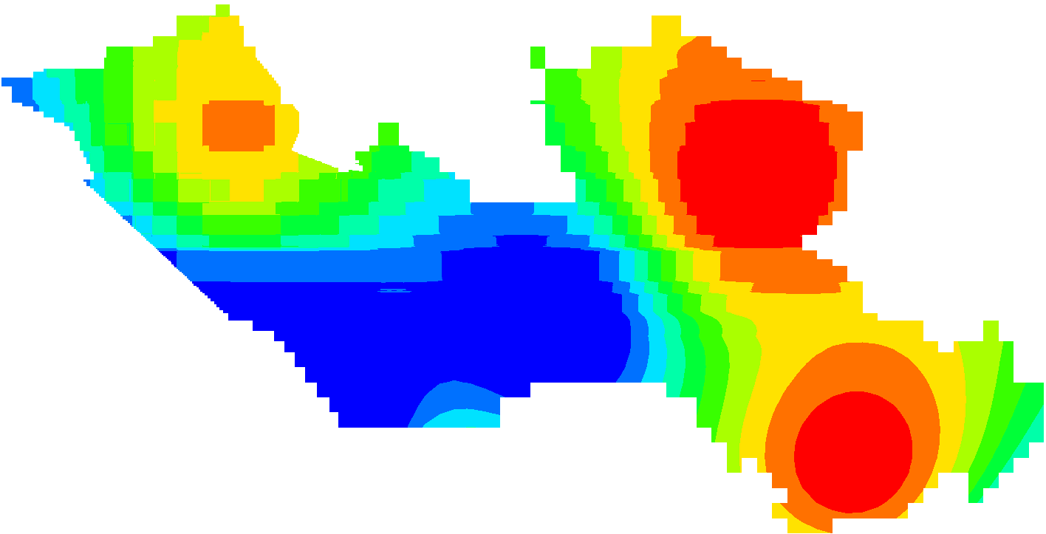
Figure S5.1 Map of hydraulic conductivities of aquifer n₂¹
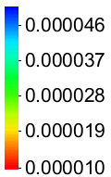
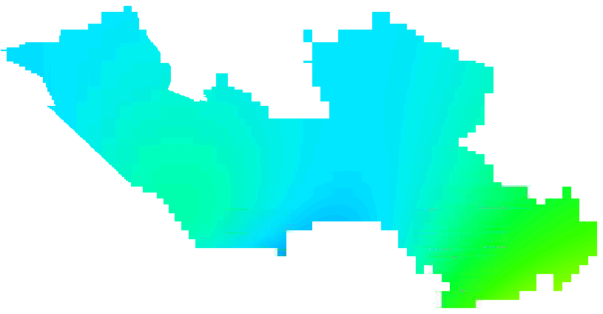

Figure S5.2 Map of storativity coefficient of aquifer n₂¹
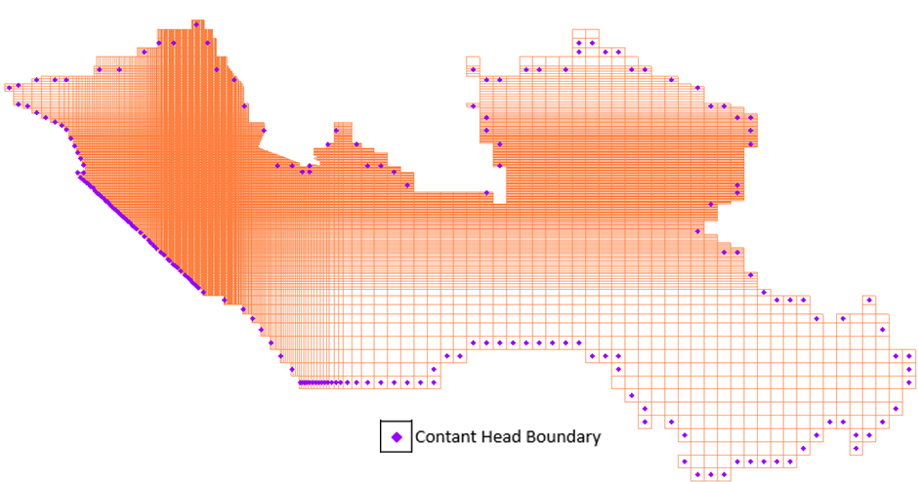
Figure S5.3 Boundary conditions of aquifer n₂¹
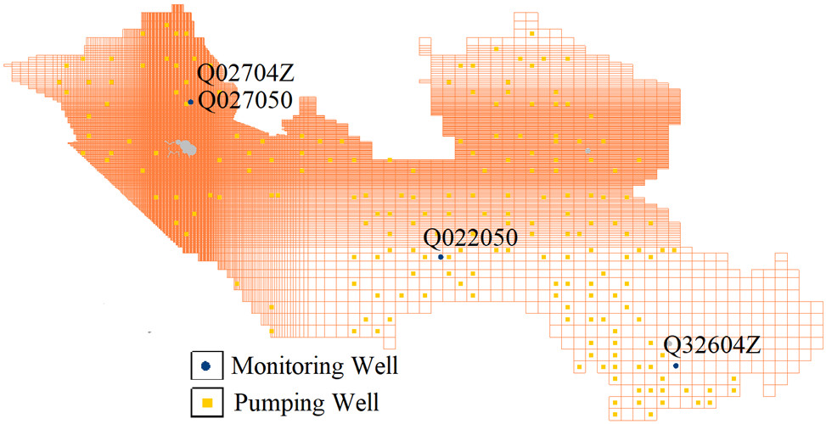
Figure S5.4 Distribution of pumping wells and monitoring wells in the aquifer n₂¹
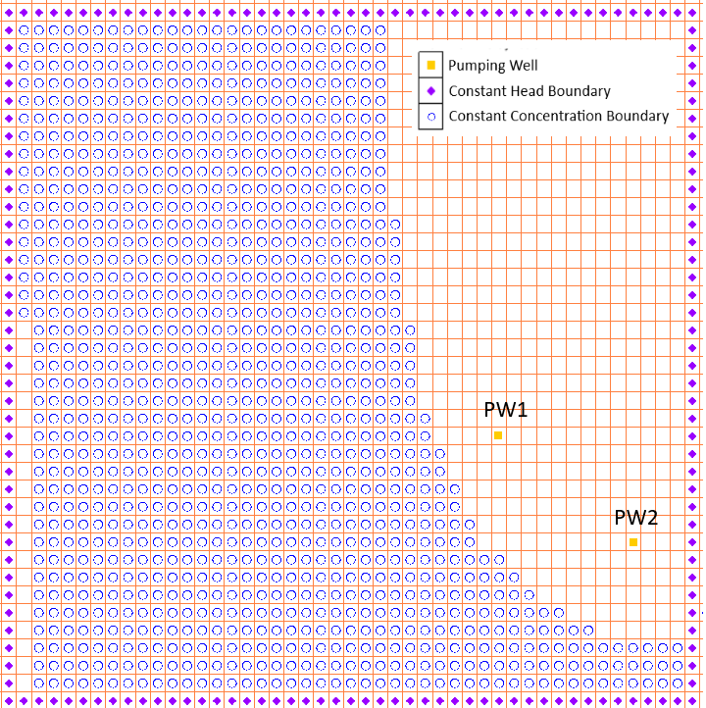
Figure S5.5 Boundary conditions of aquifer n₂¹ for the solute transport model in the PilotSite

