Association of serum creatinine variability and risk of 1-year mortality among patients with cancer

eTable 1. The International Classification of Diseases (ICD) Tenth Revision (ICD-10) codes of conditions.
eTable 2. Cancer types of all participants.
eTable 3. Basic biomarkers of participants.
eTable 4. Stratified analysis according to the difference between the last and the first value of serum creatinine.
eTable 5. Cox proportional hazards regression analyses of the association between the first and mean creatinine and the risk of mortality within a year from discharge.
eTable 6. Stratified analysis according to whether has value out of the clinically normal range and the number of creatinine measurements.
eFigure 1. Subgroup analysis of creatinine fluctuation and risk of 1-year mortality according to cancer type.
eFigure 2 a. Subgroup analysis of the standard deviation (SD) of creatinine and risk of mortality within a year from discharge according to the basic characteristics of participants.
eFigure 2 b. Subgroup analysis of the coefficient of variation (CV) of creatinine and risk of mortality within a year from discharge according to the basic characteristics of participants.
eFigure 3 a. Sensitivity analysis of creatinine s standard deviation (SD) and risk of mortality within a year from discharge.
eFigure 3 b. Sensitivity analysis of creatinine s coefficient of variation (CV) and risk of mortality within a year from discharge.
eFigure 4 a. Restricted cubic spline plot for the first value of creatinine and risk of mortality within a year from discharge.
eFigure 4 b. Restricted cubic spline plot for the mean value of creatinine and risk of mortality within a year from discharge.
eFigure 5 a. Subgroup analysis of the first value of creatinine and risk of deceased within a year from discharge according to cancer type.
eFigure 5 b. Subgroup analysis of the coefficient of variation of creatinine and risk of deceased within a year from discharge according to cancer type.

eTable 1. The International Classification of Diseases (ICD) Tenth Revision (ICD-10) codes of conditions.
Conditions | ICD-10 Codes
Liver cancer | C22
Lung cancer | C34
Colorectal cancer | C18.2, C18.200, C18.201, C18.3, C18.300, C18.301, C18.4, C18.400, C18.401, C18.5, C18.500, C18.501, C18.6, C18.600, C18.601, C18.7, C18.700, C18.701, C18.801, C18.802, C18.803, C18.804, C18.805, C18.806, C18.9, C18.900, C18.901, C18.902, C18.904, C19, C19.x00, C19.x01, C20, C20.x00, C20.x01, C20.x03, C20.x04, C21.801, C21.802, C26.803
Gastric cancer | C16
Pancreatic cancer | C25, C25.0, C25.000, C25.001, C25.1, C25.100, C25.101, C25.2, C25.200, C25.201, C25.3, C25.300, C25.301, C25.4, C25.400, C25.401, C25.7, C25.700, C25.701, C25.801, C25.802, C25.803, C25.804, C25.805, C25.9, C25.900, C25.901
Renal cancer | C64, C64.x00, C64.x01, C64.x03, C64.x04, C65, C65.x00, C65.x01, C65.x02
Esophageal cancer | C15, C15.0, C15.000, C15.001, C15.1, C15.100, C15.101, C15.2, C15.200, C15.201, C15.3, C15.300, C15.301, C15.4, C15.400, C15.401, C15.5, C15.500, C15.501, C15.801, C15.802, C15.803, C15.9, C15.900, C15.901, C15.902, C15.904
Renal injury | E230, E240, E243, E248, E250, E258, E259, E278, E279, E351, E850, E854, E896, I120, I131, I132, M100, M300, M318, M321, M348, M350, M351, N00-N28, N032-N037, N052-N057, Z490, Z491, Z492, Z940, Z992
Data were expressed as absolute numbers and percentages;

eTable 2. Cancer types of all participants.
Cancer type | Total (n=41,911) | Death (n=9,050) | Alive (n=32,861) | P-Value
Liver cancer | 18,110 (43.2%) | 4,399 (48.6%) | 13,711 (41.7%) | <0.001
Lung cancer | 5,185 (12.4%) | 1,305 (14.4%) | 3,880 (11.8%) | <0.001
Colorectal cancer | 4,113 (9.8%) | 353 (3.9%) | 3,760 (11.4%) | <0.001
Gastric cancer | 3,645 (8.7%) | 613 (6.8%) | 3,032 (9.2%) | <0.001
Pancreatic cancer | 1,725 (4.1%) | 760 (8.4%) | 965 (2.9%) | <0.001
Renal cancer | 1,461 (3.5%) | 79 (0.9%) | 1,382 (4.2%) | <0.001
Esophageal cancer | 1,053 (2.5%) | 234 (2.6%) | 819 (2.5%) | <0.001
Other cancer | 6,619 (15.8%) | 1,307 (14.4%) | 5,312 (16.2%) | <0.001
Data were expressed as absolute numbers and percentages;

eTable 3. Basic biomarkers of participants.
Variables | Total (n=41,911) | Death (n=9,050) | Alive (n=32,861) | P-Value
Alpha-fetoprotein |  |  |  | <0.001
Low | 17 (0) | 8 (0.1%) | 9 (0)
Normal | 28,145 (67.2%) | 5,432 (60.0%) | 22,713 (69.1%)
High | 13,749 (32.8%) | 3,610 (39.9%) | 10,139 (30.9%)
Albumin |  |  |  | <0.001
Low | 20,991 (50.1%) | 6,176 (68.2%) | 14,815 (45.1%)
Normal | 20,660 (49.3%) | 2,851 (31.5%) | 17,809 (54.2%)
High | 260 (0.6%) | 23 (0.3%) | 237 (0.7%)
Total bilirubin |  |  |  | <0.001
Low | 19 (0) | 2 (0) | 17 (0.1%)
Normal | 33,115 (79.0%) | 6,005 (66.4%) | 27,110 (82.5%)
High | 8,777 (20.9%) | 3,043 (33.6%) | 5,734 (17.4%)
LDL-cholesterol |  |  |  | <0.001
Low | 3,812 (9.1%) | 915 (10.1%) | 2,897 (8.8%)
Normal | 30,952 (73.9%) | 6,247 (69.0%) | 24,705 (75.2%)
High | 7,147 (17.1%) | 1,888 (20.9%) | 5,259 (16.0%)
HDL-cholesterol |  |  |  | <0.001
Low | 24,716 (59.0%) | 5,909 (65.3%) | 18,807 (57.2%)
Normal | 15,915 (38.0%) | 2,961 (32.7%) | 12,954 (39.4%)
High | 1,280 (3.1%) | 180 (2.0%) | 1,100 (3.3%)
Total cholesterol |  |  |  | <0.001
Low | 3,512 (8.4%) | 971 (10.7%) | 2,541 (7.7%)
Normal | 35,185 (84.0%) | 7,134 (78.8%) | 28,051 (85.4%)
High | 3,214 (7.7%) | 945 (10.4%) | 2,269 (6.9%)
Glucose |  |  |  | <0.001
Low | 793 (1.9%) | 275 (3.0%) | 518 (1.6%)
Normal | 31,641 (75.5%) | 6,191 (68.4%) | 25,450 (77.4%)
High | 9,477 (22.6%) | 2,584 (28.6%) | 6,893 (21.0%)
WBC counts |  |  |  | <0.001
Low | 6,612 (15.8%) | 1,382 (15.3%) | 5,230 (15.9%)
Normal | 30,436 (72.6%) | 5,916 (65.4%) | 24,520 (74.6%)
High | 4,863 (11.6%) | 1,752 (19.4%) | 3,111 (9.5%)
Data were expressed as absolute numbers and percentages;
Abbreviations: HDL, high-density lipoprotein; LDL, low-density lipoprotein; WBC, white blood cells.

eTable 4. Stratified analysis according to the difference between the last and the first value of serum creatinine.
Last-first value of Cr. |  |  | SD of Cr. |  | CV of Cr.
Last-first value of Cr. |  |  | Case (%) | HR (95% CI) | Case (%) | HR (95% CI)
<-5 µmol/L |  | Quartile 1 | 396 (18.41) | 1.00 (Ref.) | 361 (16.32) | 1.00 (Ref.)
 |  | Quartile 2 | 1,018 (18.74) | 1.06 (0.94-1.19) | 925 (17.93) | 1.17 (1.04-1.32)
 |  | Quartile 3 | 1,308 (19.50) | 1.14 (1.02-1.27) | 1,265 (19.48) | 1.32 (1.17-1.49)
 |  | Quartile 4 | 1,443 (25.69) | 1.36 (1.21-1.53) | 1,614 (26.71) | 1.65 (1.47-1.86)
 |  | p-trend |  | <0.001 |  | <0.001
-5 to 5 µmol/L |  | Quartile 1 | 1,414 (18.72) | 1.00 (Ref.) | 1,300 (17.80) | 1.00 (Ref.)
 |  | Quartile 2 | 657 (19.36) | 1.15 (1.05-1.27) | 675 (19.15) | 1.16 (1.05-1.27)
 |  | Quartile 3 | 378 (18.95) | 1.25 (1.11-1.41) | 428 (20.34) | 1.31 (1.17-1.46)
 |  | Quartile 4 | 249 (20.99) | 1.40 (1.22-1.62) | 295 (24.64) | 1.52 (1.33-1.73)
 |  | p-trend |  | <0.001 |  | <0.001
>5 µmol/L |  | Quartile 1 | 154 (19.97) | 1.00 (Ref.) | 169 (17.59) | 1.00 (Ref.)
 |  | Quartile 2 | 344 (20.84) | 1.02 (0.84-1.23) | 375 (20.90) | 1.28 (1.07-1.54)
 |  | Quartile 3 | 448 (25.23) | 1.24 (1.04-1.50) | 498 (26.49) | 1.55 (1.30-1.85)
 |  | Quartile 4 | 1,241 (33.77) | 1.85 (1.56-2.20) | 1,145 (35.36) | 2.32 (1.97-2.75)
 |  | p-trend |  | <0.001 |  | <0.001
Adjusted for Model 3;
Abbreviations: CI, confidence interval; Cr., creatinine; CV, coefficient of variation (standard deviation/mean); HR, hazard ratio; SD, standard deviation;

eTable 5. Cox proportional hazards regression analyses of the association between the first and mean creatinine and the risk of mortality within a year from discharge.
Variables |  | HR (95% CI)
Variables |  | Model 1 | Model 2 | Model 3
The first Cr.
Quartile 1 | 2,623 (25.2%) | 1.00 (Ref.) | 1.00 (Ref.) | 1.00 (Ref.)
Quartile 2 | 2,121 (20.18%) | 0.69 (0.65 - 0.73) | 0.78 (0.74 - 0.83) | 0.81 (0.76 - 0.86)
Quartile 3 | 1,969 (18.73%) | 0.60 (0.57- 0.64) | 0.73 (0.69 - 0.78) | 0.77 (0.72 - 0.82)
Quartile 4 | 2,337 (22.3%) | 0.75 (0.70 - 0.80) | 0.87 (0.82 - 0.92) | 0.88 (0.83 - 0.94)
p-trend |  | <0.001 | <0.001 | <0.001
Mean Cr.
Quartile 1 | 2,549 (24.33%) | 1.00 (Ref.) | 1.00 (Ref.) | 1.00 (Ref.)
Quartile 2 | 2,156 (20.64%) | 0.72 (0.68 - 0.76) | 0.78 (0.74 - 0.83) | 0.81 (0.77 - 0.86)
Quartile 3 | 1,931 (18.34%) | 0.60 (0.56 - 0.64) | 0.71 (0.67 - 0.76) | 0.76 (0.71 - 0.81)
Quartile 4 | 2,414 (23.07%) | 0.84 (0.78 - 0.89) | 0.922 (0.87 - 0.98) | 0.94 (0.88 - 0.99)
p-trend |  | <0.001 | 0.011 | 0.041
Model 1 was adjusted for sex, age, cancer type;
Model 2 was further adjusted for comorbidity index (≤0, 1-4, 5-8, ≥9), days of hospitalization, renal injury (yes/no), chemoradiotherapy (radiotherapy, chemotherapy, immunotherapy, and other), operation (none, general anesthesia, local anesthesia), systolic blood pressure (mmHg), respiratory rate (per minute), pulse (per minute);
Model 3 was adjusted for biomarkers (including alpha-fetoprotein, albumin, total bilirubin, white blood cell counts, glucose, total- and LDL-cholesterol) as categorical variables (low, normal, high) on the bases of model 2.
Abbreviations: CI, confidence interval; Cr., Creatinine; HR, hazard ratio;

eTable 6. Stratified analysis according to whether has value out of the clinically normal range and the number of creatinine measurements.
 | In the normal range |  | With value out of normal range
The first Cr. | Case (%) | HR (95% CI) | Case (%) | HR (95% CI)
Quartile 1 | 1,776 (19.64%) | 1.00 (Ref.) | 520 (36.72%) | 1.00 (Ref.)
Quartile 2 | 1,821 (20.17%) | 0.91 (0.84 - 0.97) | 455 (34.6%) | 0.89 (0.77 - 1.01)
Quartile 3 | 1,641 (18.85%) | 0.85 (0.79 - 0.92) | 478 (31.68%) | 0.87 (0.76 - 1.00)
Quartile 4 | 1,807 (19.08%) | 0.87 (0.81 - 0.94) | 552 (38.76%) | 1.07 (0.93 - 1.24)
p-trend |  | <0.001 |  | 0.305
Mean Cr.
Quartile 1 | 1,846 (20.4%) | 1.00 (Ref.) | 514 (36.33%) | 1.00 (Ref.)
Quartile 2 | 1,754 (19.33%) | 0.78 (0.73 - 0.84) | 480 (33.9%) | 0.91 (0.79 - 1.04)
Quartile 3 | 1,638 (18.08%) | 0.77 (0.71 - 0.83) | 482 (34.02%) | 0.97 (0.85 - 1.11)
Quartile 4 | 1,807 (19.94%) | 0.86 (0.80 - 0.93) | 529 (37.36%) | 1.19 (1.04 - 1.37)
p-trend |  | 0.003 |  | 0.008
Adjusted for Model 3;
Abbreviations: CI, confidence interval; Cr., Creatinine; HR, hazard ratio;

eFigure 1. Subgroup analysis of creatinine fluctuation and risk of 1-year mortality according to cancer type.
Abbreviations: CI, confidence interval; Cr., creatinine; CV, coefficient of variation (standard deviation/mean); HR, hazard ratio; Q1 to Q4, quartile 1 to quartile 4; SD, standard deviation;
eFigure 2 a. Subgroup analysis of the standard deviation (SD) of creatinine and risk of mortality within a year from discharge according to the basic characteristics of participants.
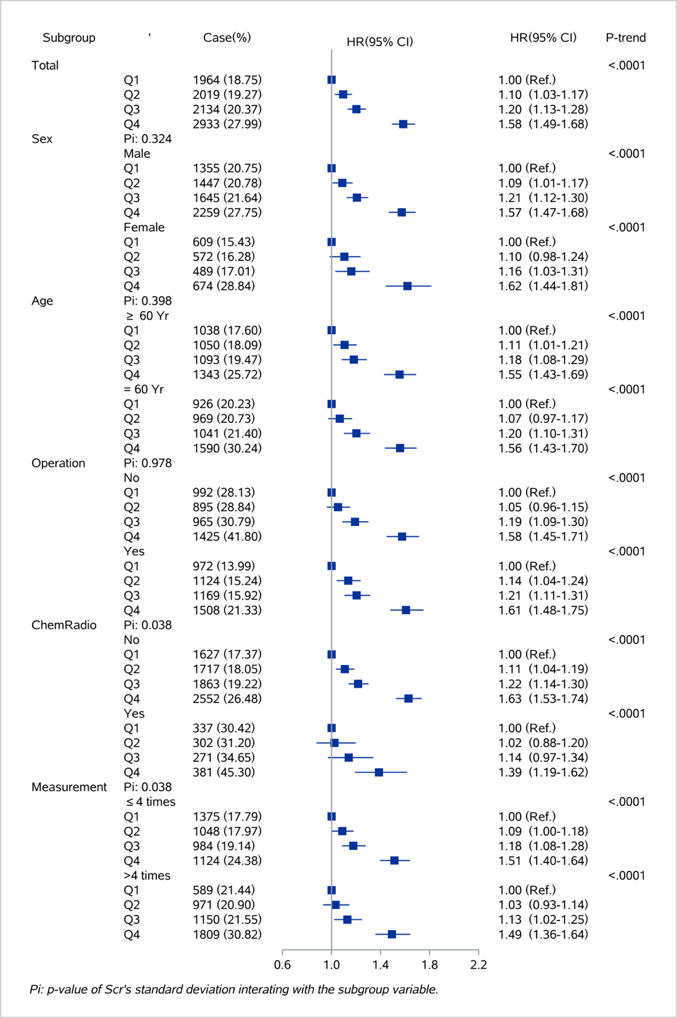
Abbreviations: CI, confidence interval; HR, hazard ratio; Q1 to Q4, quartile 1 to quartile 4;

eFigure 2 b. Subgroup analysis of the coefficient of variation (CV) of creatinine and risk of mortality within a year from discharge according to the basic characteristics of participants.
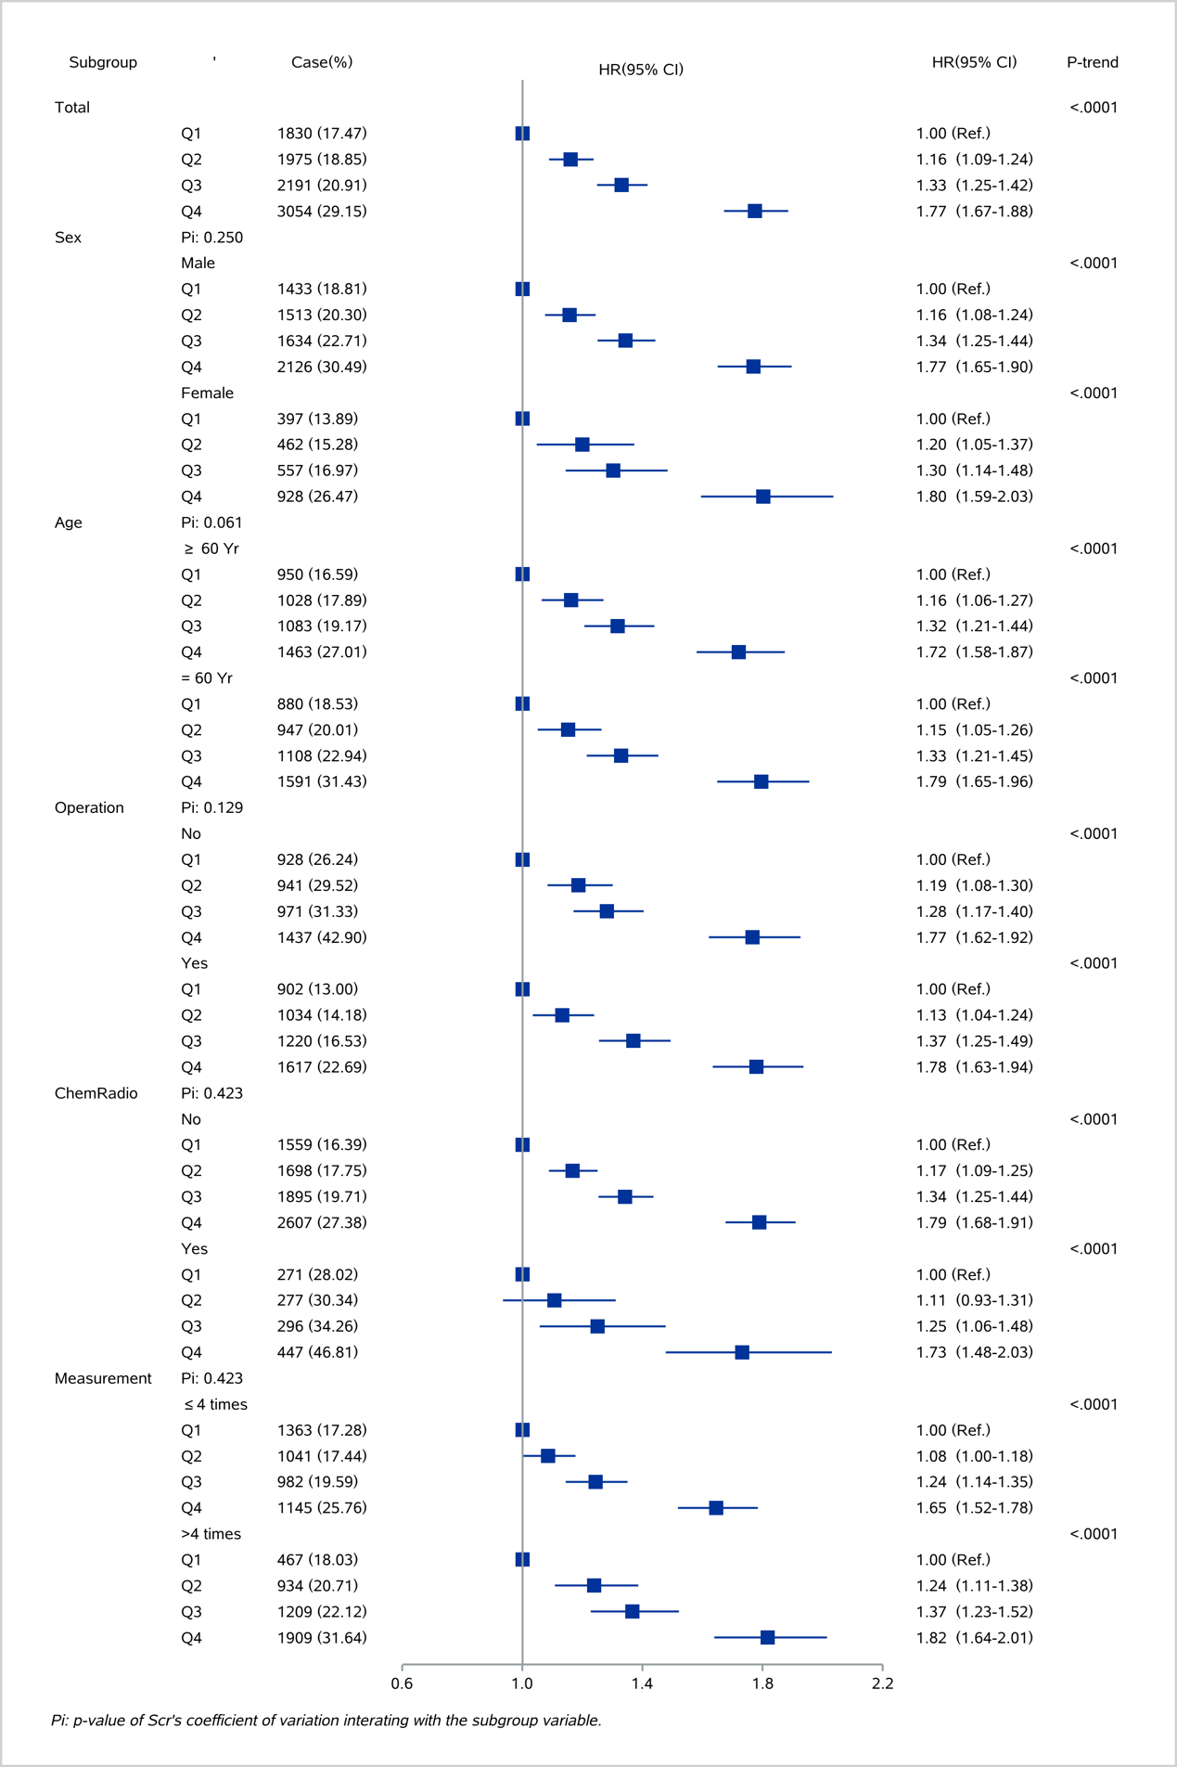
Abbreviations: CI, confidence interval; HR, hazard ratio; Q1 to Q4, quartile 1 to quartile 4;

eFigure 3 a. Sensitivity analysis of creatinine s standard deviation (SD) and risk of mortality within a year from discharge.
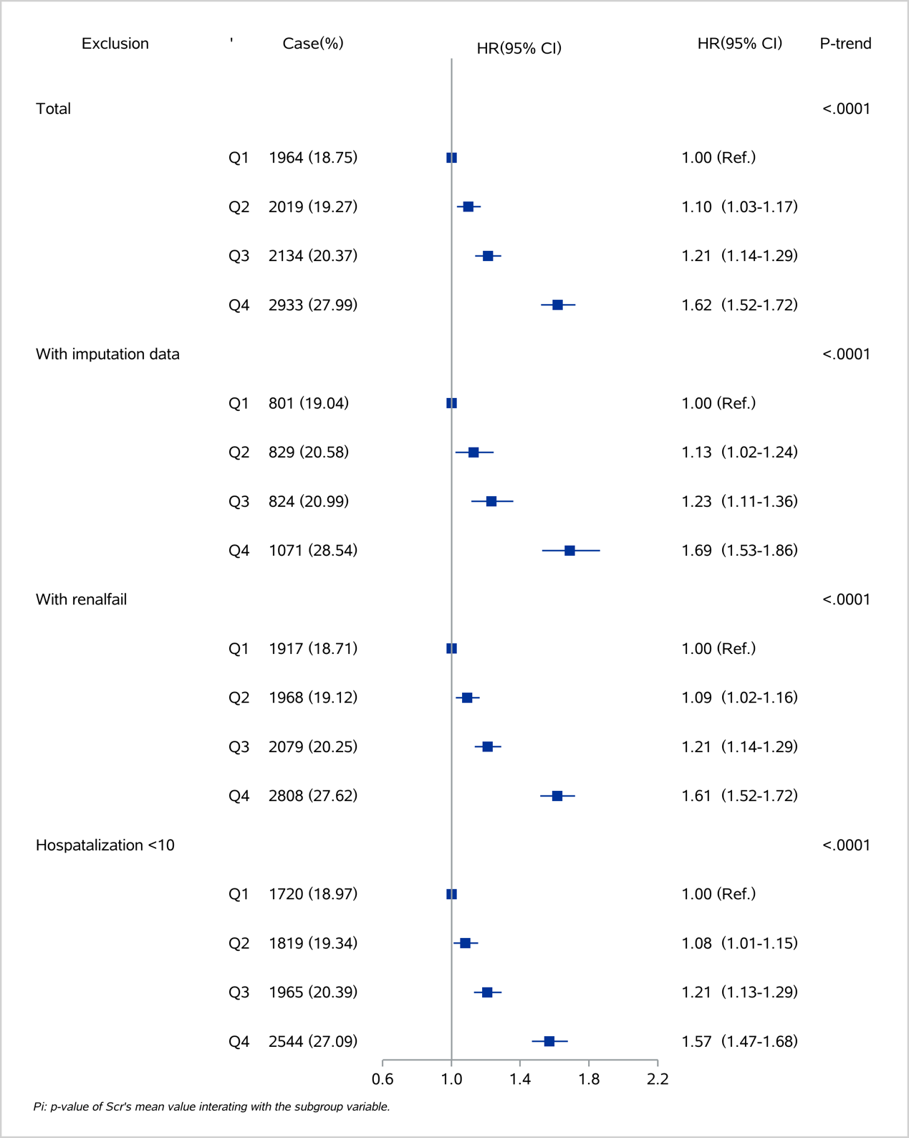
Abbreviations: CI, confidence interval; HR, hazard ratio; Q1 to Q4, quartile 1 to quartile 4;

eFigure 3 b. Sensitivity analysis of creatinine s coefficient of variation (CV) and risk of mortality within a year from discharge.
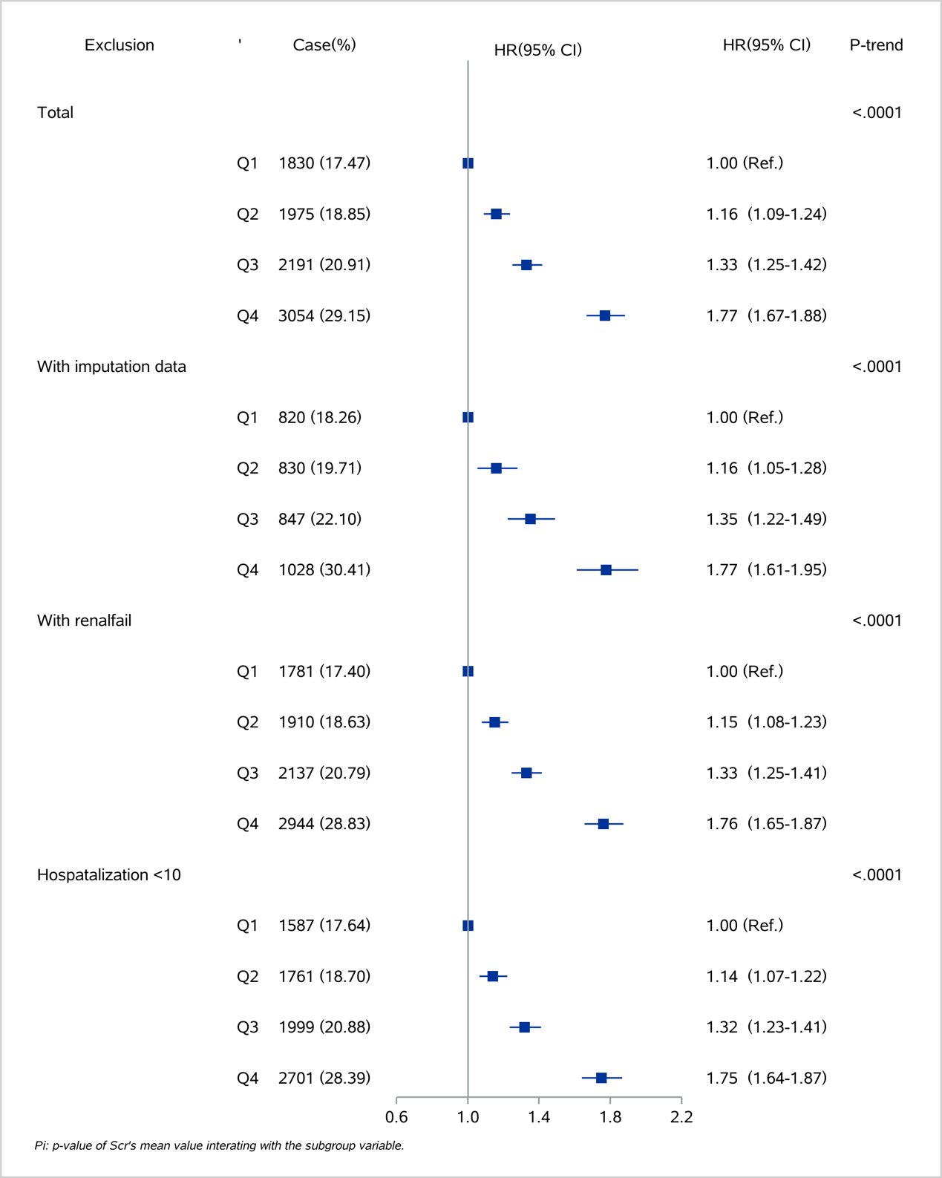
Abbreviations: CI, confidence interval; HR, hazard ratio; Q1 to Q4, quartile 1 to quartile 4;

eFigure 4 a. Restricted cubic spline plot for the first value of creatinine and risk of mortality within a year from discharge.
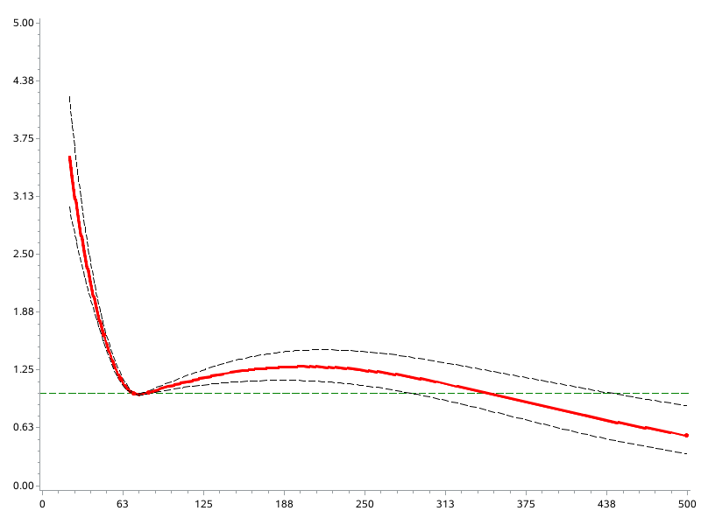

eFigure 4 b. Restricted cubic spline plot for the mean value of creatinine and risk of mortality within a year from discharge.
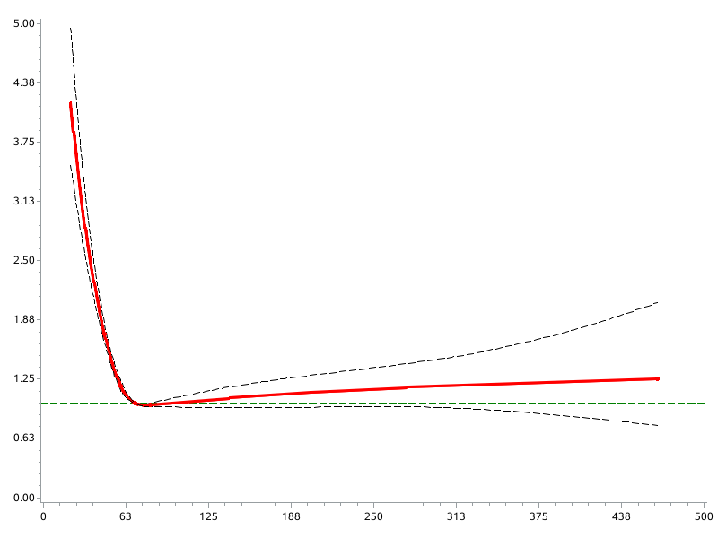

eFigure 5 a. Subgroup analysis of the first value of creatinine and risk of deceased within a year from discharge according to cancer type.
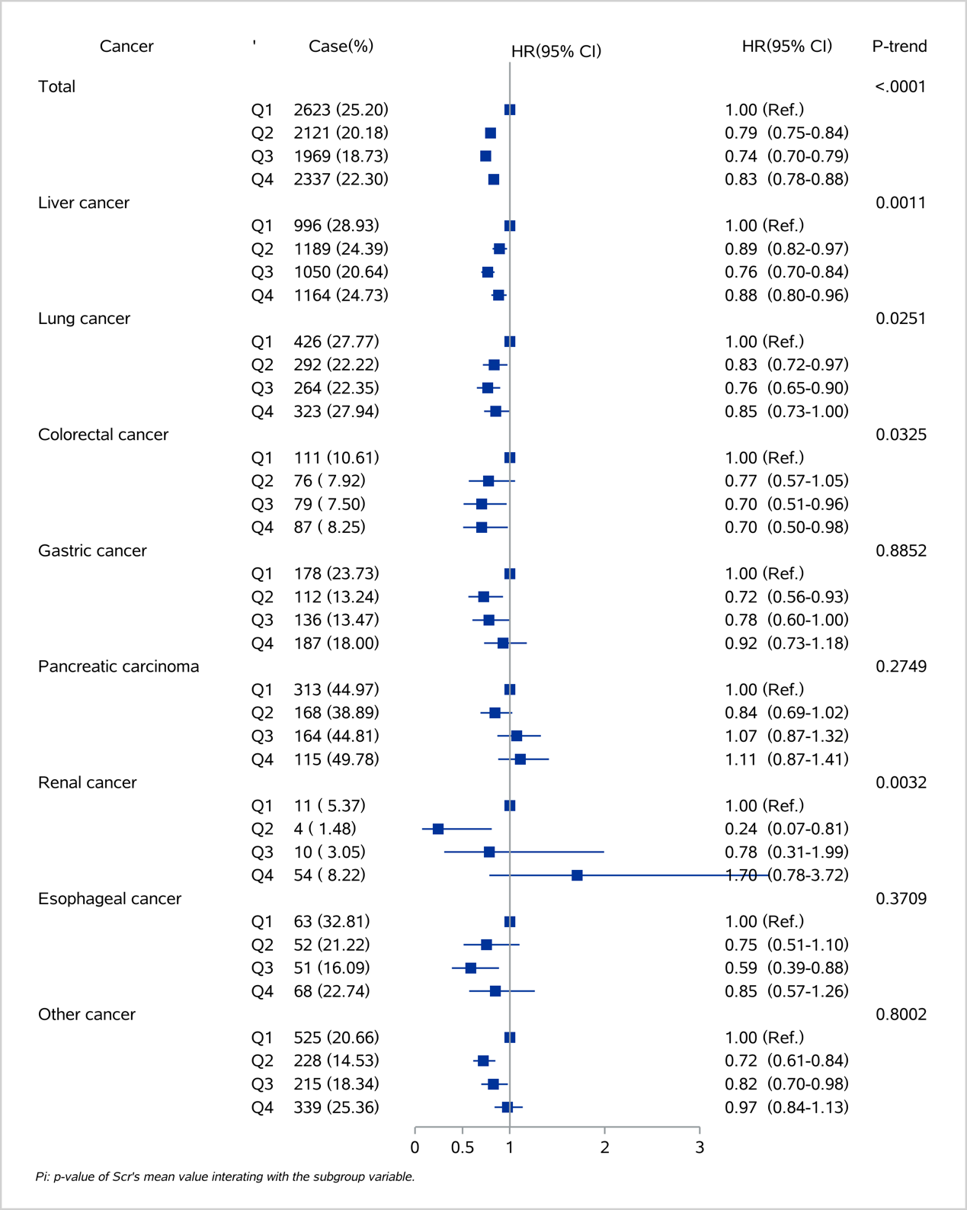
Abbreviations: CI, confidence interval; HR, hazard ratio; Q1 to Q4, quartile 1 to quartile 4;

eFigure 5 b. Subgroup analysis of the coefficient of variation of creatinine and risk of deceased within a year from discharge according to cancer type.
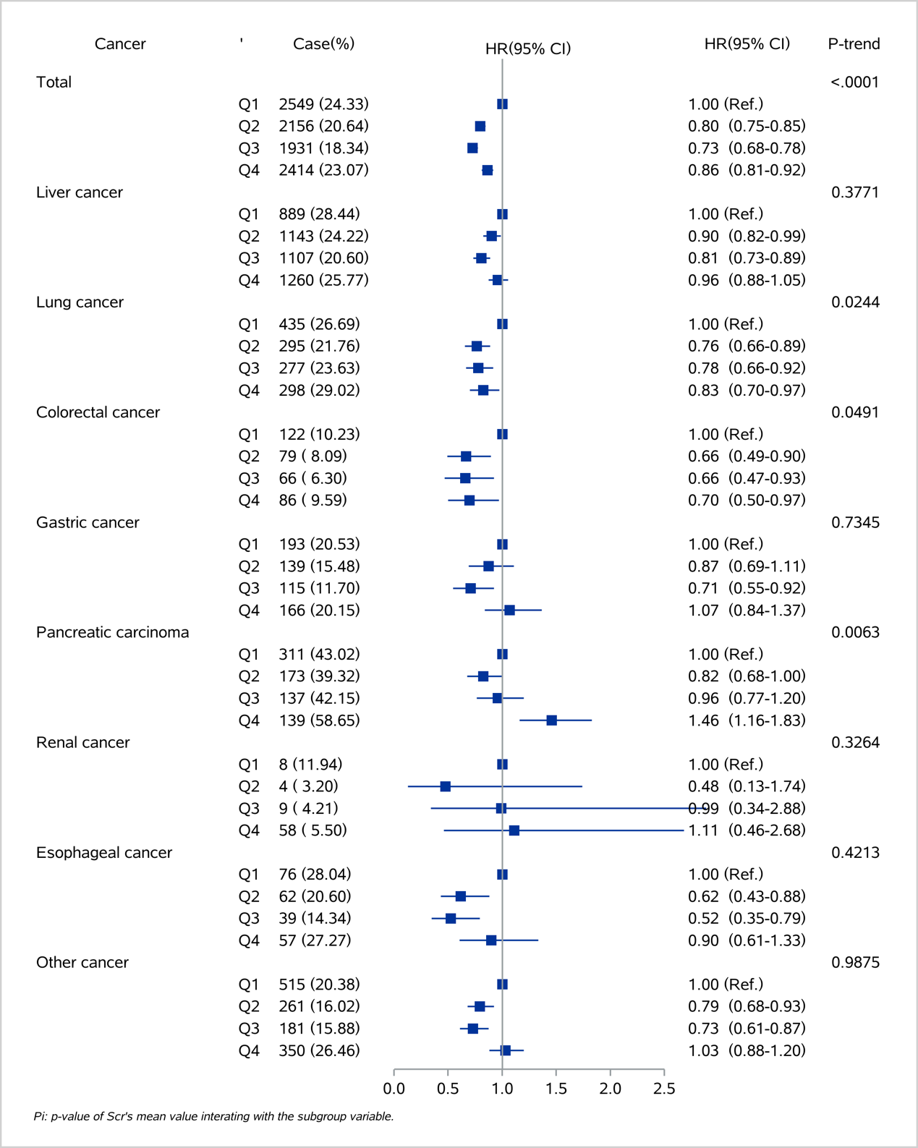
Abbreviations: CI, confidence interval; HR, hazard ratio; Q1 to Q4, quartile 1 to quartile 4;

