Supplementary Figures and Tables

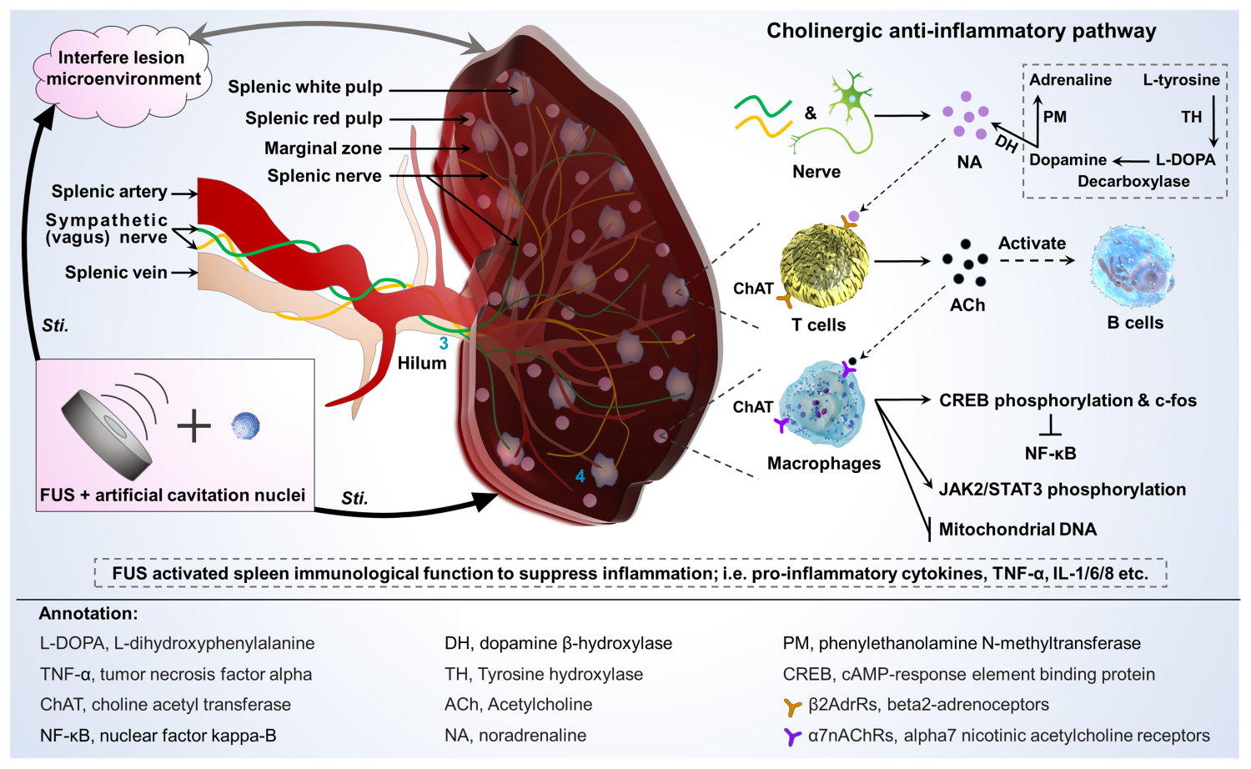
Supplementary Figure 1 Diagram of spleen structure and cholinergic signaling pathway.

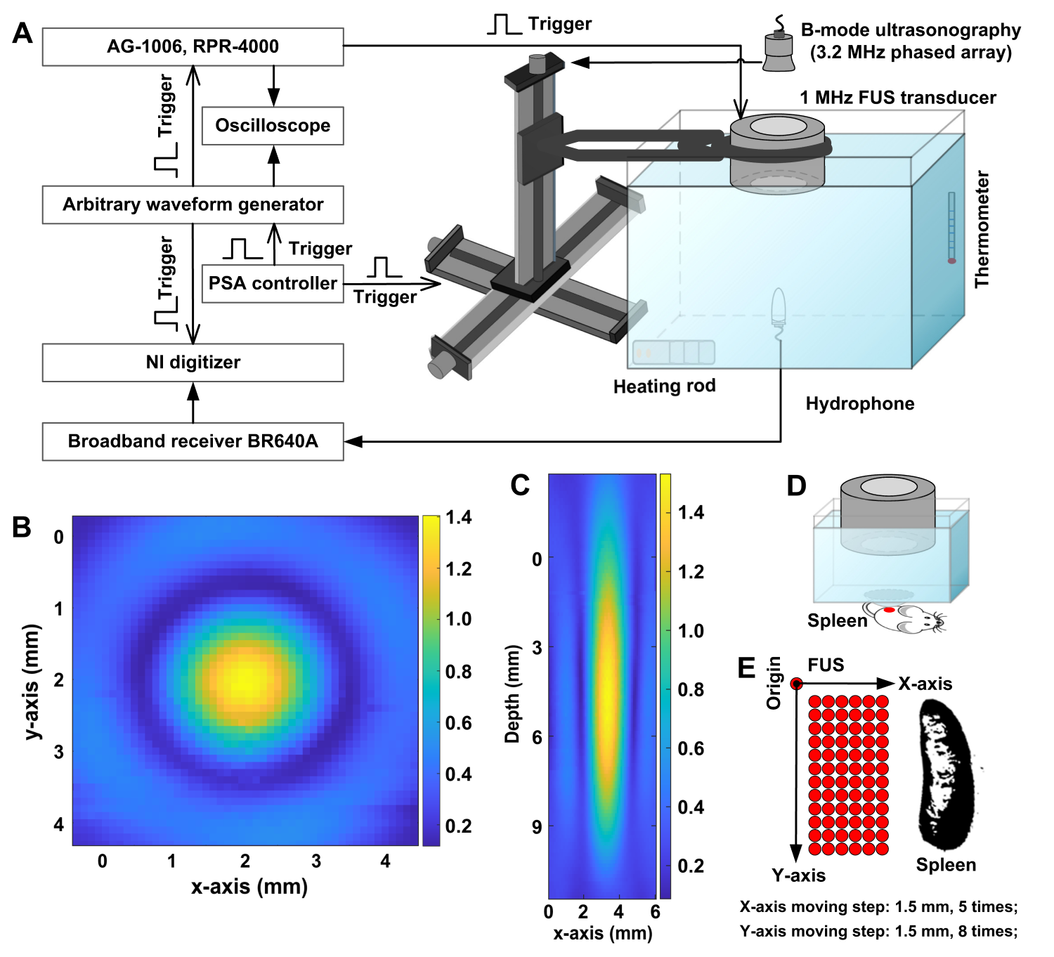
Supplementary Figure 2 The ultrasound platform applied for FUS sti. spleen to treat tumor. A, experimental setup used for acoustic field calibration. B-C, the xy and xz profile of the ultrasound focal region, respectively. D, experimental platform of FUS sti. spleen based on the device shown in figure A, except that the tank was replaced with a capsule covered with a sound permeable film at the bottom. E, motion scheme of FUS irradiation on spleen displaced by a computer-controlled XYZ motorized positioning stage.

Supplementary Figure 3 Representative FCM plots and statistical diagram of immune cell proportion in spleen. A, representative FCM plot of CD4 T cells (CD3⁺ CD4⁺ gated on CD45⁺), and corresponded quantification. B, representative FCM plot of Th1 cells (IFN-γ⁺ gated on CD3⁺ CD4⁺ CD45⁺), and corresponded quantification. C, representative FCM plot of Th2 cells (IL-4⁺ gated on CD3⁺ CD4⁺ CD45⁺), and corresponded quantification. D, representative FCM plot of Th17 cells (IL-17⁺ gated on CD3⁺ CD4⁺ CD45⁺), and corresponded quantification. E, representative FCM plot of B cells (CD19⁺ B220⁺ gated on CD3⁺ CD4⁺ CD45⁺), and corresponded quantification. F, representative FCM plot of NK cells (CD3⁻ NK1.1⁺ gated on CD45⁺), and corresponded quantification. G, representative FCM plot of CD8 T cells (CD3⁺ CD8⁺ gated on CD45⁺), and corresponded quantification. H, representative FCM plot of Mφ (CD11b⁺ F4/80⁺ gated on CD45⁺), and corresponded quantification. I, representative FCM plot of Mφ1 (CD11c⁺ CD206⁻ gated on CD11b⁺ F4/80⁺ CD45⁺) and Mφ2 (CD11c⁻ CD206⁺ gated on CD11b⁺ F4/80⁺ CD45⁺), and corresponded quantification. J, representative FCM plot of DC1 (CD8⁺ CD11b⁻ gated on total cells) and DC2 (CD8⁻ CD11b⁺ gated on total cells), and corresponded quantification. K, representative FCM plot of Treg cells (CD25⁺ Foxp3⁺ gated on CD3⁺ CD4⁺ CD45⁺), and corresponded quantification. L, representative FCM plot of M-MDSCs (LY6G⁻ LY6C⁺ gated on CD45⁺ CD11b⁺) and PMN-MDSCs (LY6G⁺ LY6C⁻ gated on CD45⁺ CD11b⁺), and corresponded quantification. S1, the control group of xenograft H22 HCC in situ; S2, FUS sti. spleen to treat orthotopic H22 HCC.

Supplementary Figure 4 Representative FCM plots and statistical diagram of immune cell proportion in blood. A, representative FCM plot of CD4 T cells (CD3⁺ CD4⁺ gated on CD45⁺), and corresponded quantification. B, representative FCM plot of Th1 cells (IFN-γ⁺ gated on CD3⁺ CD4⁺ CD45⁺), and corresponded quantification. C, representative FCM plot of Th2 cells (IL-4⁺ gated on CD3⁺ CD4⁺ CD45⁺), and corresponded quantification. D, representative FCM plot of Th17 cells (IL-17⁺ gated on CD3⁺ CD4⁺ CD45⁺), and corresponded quantification. E, representative FCM plot of B cells (CD19⁺ B220⁺ gated on CD3⁺ CD4⁺ CD45⁺), and corresponded quantification. F, representative FCM plot of NK cells (CD3⁻ NK1.1⁺ gated on CD45⁺), and corresponded quantification. G, representative FCM plot of CD8 T cells (CD3⁺ CD8⁺ gated on CD45⁺), and corresponded quantification. H, representative FCM plot of Mφ (CD11b⁺ F4/80⁺ gated on CD45⁺), and corresponded quantification. I, representative FCM plot of Mφ1 (CD11c⁺ CD206⁻ gated on CD11b⁺ F4/80⁺ CD45⁺) and Mφ2 (CD11c⁻ CD206⁺ gated on CD11b⁺ F4/80⁺ CD45⁺), and corresponded quantification. J, representative FCM plot of DC1 (CD8⁺ CD11b⁻ gated on total cells) and DC2 (CD8⁻ CD11b⁺ gated on total cells), and corresponded quantification. K, representative FCM plot of Treg cells (CD25⁺ Foxp3⁺ gated on CD3⁺ CD4⁺ CD45⁺), and corresponded quantification. L, representative FCM plot of M-MDSCs (LY6G⁻ LY6C⁺ gated on CD45⁺ CD11b⁺) and PMN-MDSCs (LY6G⁺ LY6C⁻ gated on CD45⁺ CD11b⁺), and corresponded quantification. S1, the control group of xenograft H22 HCC in situ; S2, FUS sti. spleen to treat orthotopic H22 HCC.

Supplementary Figure 5 Representative FCM plots and statistical diagram of immune cell proportion in tumor. A, representative FCM plot of CD4 T cells (CD3⁺ CD4⁺ gated on CD45⁺), and corresponded quantification. B, representative FCM plot of Th1 cells (IFN-γ⁺ gated on CD3⁺ CD4⁺ CD45⁺), and corresponded quantification. C, representative FCM plot of Th2 cells (IL-4⁺ gated on CD3⁺ CD4⁺ CD45⁺), and corresponded quantification. D, representative FCM plot of Th17 cells (IL-17⁺ gated on CD3⁺ CD4⁺ CD45⁺), and corresponded quantification. E, representative FCM plot of B cells (CD19⁺ B220⁺ gated on CD3⁺ CD4⁺ CD45⁺), and corresponded quantification. F, representative FCM plot of NK cells (CD3⁻ NK1.1⁺ gated on CD45⁺), and corresponded quantification. G, representative FCM plot of CD8 T cells (CD3⁺ CD8⁺ gated on CD45⁺), and corresponded quantification. H, representative FCM plot of Mφ (CD11b⁺ F4/80⁺ gated on CD45⁺), and corresponded quantification. I, representative FCM plot of Mφ1 (CD11c⁺ CD206⁻ gated on CD11b⁺ F4/80⁺ CD45⁺) and Mφ2 (CD11c⁻ CD206⁺ gated on CD11b⁺ F4/80⁺ CD45⁺), and corresponded quantification. J, representative FCM plot of DC1 (CD8⁺ CD11b⁻ gated on total cells) and DC2 (CD8⁻ CD11b⁺ gated on total cells), and corresponded quantification. K, representative FCM plot of Treg cells (CD25⁺ Foxp3⁺ gated on CD3⁺ CD4⁺ CD45⁺), and corresponded quantification. L, representative FCM plot of M-MDSCs (LY6G⁻ LY6C⁺ gated on CD45⁺ CD11b⁺) and PMN-MDSCs (LY6G⁺ LY6C⁻ gated on CD11b⁺ CD45⁺), and corresponded quantification. S1, the control group of xenograft H22 HCC in situ; S2, FUS sti. spleen to treat orthotopic H22 HCC.

Supplementary Figure 6 Representative FCM plots and statistical diagram of immune cell proportion in para-carcinoma tissue. A, representative FCM plot of CD4 T cells (CD3⁺ CD4⁺ gated on CD45⁺), and corresponded quantification. B, representative FCM plot of Th1 cells (IFN-γ⁺ gated on CD3⁺ CD4⁺ CD45⁺), and corresponded quantification. C, representative FCM plot of Th2 cells (IL-4⁺ gated on CD3⁺ CD4⁺ CD45⁺), and corresponded quantification. D, representative FCM plot of Th17 cells (IL-17⁺ gated on CD3⁺ CD4⁺ CD45⁺), and corresponded quantification. E, representative FCM plot of B cells (CD19⁺ B220⁺ gated on CD3⁺ CD4⁺ CD45⁺), and corresponded quantification. F, representative FCM plot of NK cells (CD3⁻ NK1.1⁺ gated on CD45⁺), and corresponded quantification. G, representative FCM plot of CD8 T cells (CD3⁺ CD8⁺ gated on CD45⁺), and corresponded quantification. H, representative FCM plot of Mφ (CD11b⁺ F4/80⁺ gated on CD45⁺), and corresponded quantification. I, representative FCM plot of Mφ1 (CD11c⁺ CD206⁻ gated on CD11b⁺ F4/80⁺ CD45⁺) and Mφ2 (CD11c⁻ CD206⁺ gated on CD11b⁺ F4/80⁺ CD45⁺), and corresponded quantification. J, representative FCM plot of DC1 (CD8⁺ CD11b⁻ gated on total cells) and DC2 (CD8⁻ CD11b⁺ gated on total cells), and corresponded quantification. K, representative FCM plot of Treg cells (CD25⁺ Foxp3⁺ gated on CD3⁺ CD4⁺ CD45⁺), and corresponded quantification. L, representative FCM plot of M-MDSCs (LY6G⁻ LY6C⁺ gated on CD45⁺ CD11b⁺) and PMN-MDSCs (LY6G⁺ LY6C⁻ gated on CD45⁺ CD11b⁺), and corresponded quantification. S1, the control group of xenograft H22 HCC in situ; S2, FUS sti. spleen to treat orthotopic H22 HCC.

Supplementary Figure 7 Representative FCM plots and statistical diagram of immune cell proportion in spleen. A, FCM plot of CD4 T cells (CD3⁺ CD4⁺ gated on CD45⁺), and corresponded quantification. B, FCM plot of Th1 cells (IFN-γ⁺ gated on CD3⁺ CD4⁺ CD45⁺), and corresponded quantification. C, FCM plot of Th2 cells (IL-4⁺ gated on CD3⁺ CD4⁺ CD45⁺), and corresponded quantification. D, FCM plot of Th17 cells (IL-17⁺ gated on CD3⁺ CD4⁺ CD45⁺), and corresponded quantification. E, FCM plot of B cells (CD19⁺ B220⁺ gated on CD3⁺ CD4⁺ CD45⁺), and corresponded quantification. F, FCM plot of NK cells (CD3⁻ NK1.1⁺ gated on CD45⁺), and corresponded quantification. G, FCM plot of CD8 T cells (CD3⁺ CD8⁺ gated on CD45⁺), and corresponded quantification. H, FCM plot of Mφ (CD11b⁺ F4/80⁺ gated on CD45⁺), and corresponded quantification. I, FCM plot of Mφ1 (CD11c⁺ CD206- gated on CD11b⁺ F4/80⁺ CD45⁺) and Mφ2 (CD11c⁻ CD206⁺ gated on CD11b⁺ F4/80⁺ CD45⁺), and corresponded quantification. J, representative FCM plot of DC1 (CD8⁺ CD11b⁻ gated on total cells) and DC2 (CD8⁻ CD11b⁺ gated on total cells), and corresponded quantification. K, representative FCM plot of Treg cells (CD25⁺ Foxp3⁺ gated on CD3⁺ CD4⁺ CD45⁺), and corresponded quantification. L, representative FCM plot of M-MDSCs (LY6G⁻ LY6C⁺ gated on CD45⁺ CD11b⁺) and PMN-MDSCs (LY6G⁺ LY6C⁻ gated on CD45⁺ CD11b⁺), and corresponded quantification. L1, the control group of xenograft Hepa1-6 HCC in situ; L2, FUS sti. spleen to treat orthotopic Hepa1-6 HCC.

Supplementary Figure 8 Representative FCM plots and statistical diagram of immune cell proportion in blood. A, FCM plot of CD4 T cells (CD3⁺ CD4⁺ gated on CD45⁺), and corresponded quantification. B, FCM plot of Th1 cells (IFN-γ⁺ gated on CD3⁺ CD4⁺ CD45⁺), and corresponded quantification. C, FCM plot of Th2 cells (IL-4⁺ gated on CD3⁺ CD4⁺ CD45⁺), and corresponded quantification. D, FCM plot of Th17 cells (IL-17⁺ gated on CD3⁺ CD4⁺ CD45⁺), and corresponded quantification. E, FCM plot of B cells (CD19⁺ B220⁺ gated on CD3⁺ CD4⁺ CD45⁺), and corresponded quantification. F, FCM plot of NK cells (CD3⁻ NK1.1⁺ gated on CD45⁺), and corresponded quantification. G, FCM plot of CD8 T cells (CD3⁺ CD8⁺ gated on CD45⁺), and corresponded quantification. H, FCM plot of Mφ (CD11b⁺ F4/80⁺ gated on CD45⁺), and corresponded quantification. I, FCM plot of Mφ1 (CD11c⁺ CD206⁻ gated on CD11b⁺ F4/80⁺ CD45⁺) and Mφ2 (CD11c⁻ CD206⁺ gated on CD11b⁺ F4/80⁺ CD45⁺), and corresponded quantification. J, representative FCM plot of DC1 (CD8⁺ CD11b⁻ gated on total cells) and DC2 (CD8⁻ CD11b⁺ gated on total cells), and corresponded quantification. K, representative FCM plot of Treg cells (CD25⁺ Foxp3⁺ gated on CD3⁺ CD4⁺ CD45⁺), and corresponded quantification. L, representative FCM plot of M-MDSCs (LY6G⁻ LY6C⁺ gated on CD45⁺ CD11b⁺) and PMN-MDSCs (LY6G⁺ LY6C⁻ gated on CD45⁺ CD11b⁺), and corresponded quantification. L1, the control group of xenograft Hepa1-6 HCC in situ; L2, FUS sti. spleen to treat orthotopic Hepa1-6 HCC.

Supplementary Figure 9 Representative FCM plots and statistical diagram of immune cell proportion in tumor. A, FCM plot of CD4 T cells (CD3⁺ CD4⁺ gated on CD45⁺), and corresponded quantification. B, FCM plot of Th1 cells (IFN-γ⁺ gated on CD3⁺ CD4⁺ CD45⁺), and corresponded quantification. C, FCM plot of Th2 cells (IL-4⁺ gated on CD3⁺ CD4⁺ CD45⁺), and corresponded quantification. D, FCM plot of Th17 cells (IL-17⁺ gated on CD3⁺ CD4⁺ CD45⁺), and corresponded quantification. E, FCM plot of B cells (CD19⁺ B220⁺ gated on CD3⁺ CD4⁺ CD45⁺), and corresponded quantification. F, FCM plot of NK cells (CD3⁻ NK1.1⁺ gated on CD45⁺), and corresponded quantification. G, FCM plot of CD8 T cells (CD3⁺ CD8⁺ gated on CD45⁺), and corresponded quantification. H, FCM plot of Mφ (CD11b⁺ F4/80⁺ gated on CD45⁺), and corresponded quantification. I, FCM plot of Mφ1 (CD11c⁺ CD206⁻ gated on CD11b⁺ F4/80⁺ CD45⁺) and Mφ2 (CD11c⁻ CD206⁺ gated on CD11b⁺ F4/80⁺ CD45⁺), and corresponded quantification. J, representative FCM plot of DC1 (CD8⁺ CD11b⁻ gated on total cells) and DC2 (CD8⁻ CD11b⁺ gated on total cells), and corresponded quantification. K, representative FCM plot of Treg cells (CD25⁺ Foxp3⁺ gated on CD3⁺ CD4⁺ CD45⁺), and corresponded quantification. L, representative FCM plot of M-MDSCs (LY6G⁻ LY6C⁺ gated on CD45⁺ CD11b⁺) and PMN-MDSCs (LY6G⁺ LY6C⁻ gated on CD45⁺ CD11b⁺), and corresponded quantification. L1, the control group of xenograft Hepa1-6 HCC in situ; L2, FUS sti. spleen to treat orthotopic Hepa1-6 HCC.

Supplementary Figure 10 Representative FCM plots and statistical diagram of immune cell proportion in para-carcinoma tissue. A, FCM plot of CD4 T cells (CD3⁺ CD4⁺ gated on CD45⁺), and corresponded quantification. B, FCM plot of Th1 cells (IFN-γ⁺ gated on CD3⁺ CD4⁺ CD45⁺), and corresponded quantification. C, FCM plot of Th2 cells (IL-4⁺ gated on CD3⁺ CD4⁺ CD45⁺), and corresponded quantification. D, FCM plot of Th17 cells (IL-17⁺ gated on CD3⁺ CD4⁺ CD45⁺), and corresponded quantification. E, FCM plot of B cells (CD19⁺B220⁺ gated on CD3⁺ CD4⁺ CD45⁺), and corresponded quantification. F, FCM plot of NK cells (CD3⁻ NK1.1⁺ gated on CD45⁺), and corresponded quantification. G, FCM plot of CD8 T cells (CD3⁺ CD8⁺ gated on CD45⁺), and corresponded quantification. H, FCM plot of Mφ (CD11b⁺ F4/80⁺ gated on CD45⁺), and corresponded quantification. I, FCM plot of Mφ1 (CD11c⁺ CD206⁻ gated on CD11b⁺ F4/80⁺ CD45⁺) and Mφ2 (CD11c⁻ CD206⁺ gated on CD11b⁺ F4/80⁺ CD45⁺), and corresponded quantification. J, representative FCM plot of DC1 (CD8⁺ CD11b⁻ gated on total cells) and DC2 (CD8⁻ CD11b⁺ gated on total cells), and corresponded quantification. K, representative FCM plot of Treg cells (CD25⁺ Foxp3⁺ gated on CD3⁺ CD4⁺ CD45⁺), and corresponded quantification. L, representative FCM plot of M-MDSCs (LY6G⁻ LY6C⁺ gated on CD45⁺ CD11b⁺) and PMN-MDSCs (LY6G⁺ LY6C⁻ gated on CD45⁺ CD11b⁺), and corresponded quantification. L1, the control group of xenograft Hepa1-6 HCC in situ; L2, FUS sti. spleen to treat orthotopic Hepa1-6 HCC.

Supplementary Figure 11 Representative FCM plots and statistical diagram of immune cell proportion in spleen. A, representative FCM plot of NK cells (CD3⁻ NK1.1⁺ gated on CD45⁺), and corresponded quantification. B, representative FCM plot of CD8 T cells (CD3⁺ CD8⁺ gated on CD45⁺), and corresponded quantification. C, representative FCM plot of Treg cells (CD25⁺ Foxp3⁺ gated on CD3⁺ CD4⁺ CD45⁺), and corresponded quantification. D, representative FCM plot of Mφ (CD11b⁺ F4/80⁺ gated on CD45⁺), and corresponded quantification. E, representative FCM plot of Mφ1 (CD11c⁺ CD206⁻ gated on CD11b⁺ F4/80⁺ CD45⁺) and Mφ2 (CD11c⁻ CD206⁺ gated on CD11b⁺ F4/80⁺ CD45⁺), and corresponded quantification. F, representative FCM plot of DC1 (CD8⁺ CD11b⁻ gated on total cells) and DC2 (CD8⁻ CD11b⁺CD8⁻ gated on total cells), and corresponded quantification. G, representative FCM plot of M-MDSCs (LY6G⁻ LY6C⁺ gated on CD45⁺ CD11b⁺) and PMN⁻MDSCs (LY6G⁺ LY6C⁻ gated on CD45⁺ CD11b⁺), and corresponded quantification. P1, the control group of subcutaneous 4T1 breast tumor; P2, FUS sti. spleen to suppress 4T1 breast tumor proliferation.

Supplementary Figure 12 Representative FCM plots and statistical diagram of immune cell proportion in blood. A, representative FCM plot of NK cells (CD3⁻ NK1.1⁺ gated on CD45⁺), and corresponded quantification. B, representative FCM plot of CD8 T cells (CD3⁺ CD8⁺ gated on CD45⁺), and corresponded quantification. C, representative FCM plot of Treg cells (CD25⁺ Foxp3⁺ gated on CD3⁺ CD4⁺ CD45⁺), and corresponded quantification. D, representative FCM plot of Mφ (CD11b⁺ F4/80⁺ gated on CD45⁺), and corresponded quantification. E, representative FCM plot of Mφ1 (CD11c⁺ CD206⁻ gated on CD11b⁺ F4/80⁺ CD45⁺) and Mφ2 (CD11c⁻ CD206⁺ gated on CD11b⁺ F4/80⁺ CD45⁺), and corresponded quantification. F, representative FCM plot of DC1 (CD8⁺ CD11b⁻ gated on total cells) and DC2 (CD8⁻ CD11b⁺ gated on total cells), and corresponded quantification. G, representative FCM plot of M-MDSCs (LY6G⁻ LY6C⁺ gated on CD45⁺ CD11b⁺) and PMN-MDSCs (LY6G⁺ LY6C⁻ gated on CD45⁺ CD11b⁺), and corresponded quantification. P1, the control group of subcutaneous 4T1 breast tumor; P2, FUS sti. spleen to suppress 4T1 breast tumor proliferation.

Supplementary Figure 13 Representative FCM plots and statistical diagram of immune cell proportion in tumor. A, representative FCM plot of NK cells (CD3⁻ NK1.1⁺ gated on CD45⁺), and corresponded quantification. B, representative FCM plot of CD8 T cells (CD3⁺ CD8⁺ gated on CD45⁺), and corresponded quantification. C, representative FCM plot of Treg cells (CD25⁺ Foxp3⁺ gated on CD3⁺ CD4⁺ CD45⁺), and corresponded quantification. D, representative FCM plot of Mφ (CD11b⁺ F4/80⁺ gated on CD45⁺), and corresponded quantification. E, representative FCM plot of Mφ1 (CD11c⁺ CD206⁻ gated on CD11b⁺ F4/80⁺ CD45⁺) and Mφ2 (CD11c⁻ CD206⁺ gated on CD11b⁺ F4/80⁺ CD45⁺), and corresponded quantification. F, representative FCM plot of DC1 (CD8⁺ CD11b⁻ gated on total cells) and DC2 (CD8⁻ CD11b⁺ gated on total cells), and corresponded quantification. G, representative FCM plot of M-MDSCs (LY6G⁻ LY6C⁺ gated on CD45⁺ CD11b⁺) and PMN-MDSCs (LY6G⁺ LY6C⁻ gated on CD45⁺ CD11b⁺), and corresponded quantification. P1, the control group of subcutaneous 4T1 breast tumor; P2, FUS sti. spleen to suppress 4T1 breast tumor proliferation.

Supplementary Figure 14 Representative FCM plots and statistical diagram of immune cell proportion in lung. A, representative FCM plot of NK cells (CD3⁻ NK1.1⁺ gated on CD45⁺), and corresponded quantification. B, representative FCM plot of CD8 T cells (CD3⁺ CD8⁺ gated on CD45⁺), and corresponded quantification. C, representative FCM plot of Treg cells (CD25⁺ Foxp3⁺ gated on CD3⁺ CD4⁺ CD45⁺), and corresponded quantification. D, representative FCM plot of Mφ (CD11b⁺ F4/80⁺ gated on CD45⁺), and corresponded quantification. E, representative FCM plot of Mφ1 (CD11c⁺ CD206⁻ gated on CD11b⁺ F4/80⁺ CD45⁺) and Mφ2 (CD11c⁻ CD206⁺ gated on CD11b⁺ F4/80⁺ CD45⁺), and corresponded quantification. F, representative FCM plot of DC1 (CD8⁺ CD11b⁻ gated on total cells) and DC2 (CD8⁻ CD11b⁺ gated on total cells), and corresponded quantification. G, representative FCM plot of M-MDSCs (LY6G⁻ LY6C⁺ gated on CD45⁺ CD11b⁺) and PMN-MDSCs (LY6G⁺ LY6C⁻ gated on CD45⁺ CD11b⁺), and corresponded quantification. P1, the control group of subcutaneous 4T1 breast tumor; P2, FUS sti. spleen to suppress 4T1 breast tumor proliferation.

Supplementary Figure 15 Representative FCM plots and statistical diagram of immune cell proportion in spleen. A, representative FCM plot of NK cells (CD3⁻ NK1.1⁺ gated on CD45⁺), and corresponded quantification. B, representative FCM plot of CD8 T cells (CD3⁺ CD8⁺ gated on CD45⁺), and corresponded quantification. C, representative FCM plot of Treg cells (CD25⁺ Foxp3⁺ gated on CD3⁺ CD4⁺ CD45⁺), and corresponded quantification. D, representative FCM plot of Mφ (CD11b⁺ F4/80⁺ gated on CD45⁺), and corresponded quantification. E, representative FCM plot of Mφ1 (CD11c⁺ CD206⁻ gated on CD11b⁺ F4/80⁺ CD45⁺) and Mφ2 (CD11c⁻ CD206⁺ gated on CD11b⁺ F4/80⁺ CD45⁺), and corresponded quantification. F, representative FCM plot of DC1 (CD8⁺ CD11b⁻ gated on total cells) and DC2 (CD8⁻ CD11b⁺ gated on total cells), and corresponded quantification. G, representative FCM plot of M-MDSCs (LY6G⁻ LY6C⁺ gated on CD45⁺ CD11b⁺) and PMN-MDSCs (LY6G⁺ LY6C⁻ gated on CD45⁺ CD11b⁺), and corresponded quantification. Q1, the control group of xenograft H22 HCC in situ; Q2, FUS sti. spleen; Q3, injection of atomoxetine hydrochloride to block CAP; Q4, FUS sti. spleen after injection of atomoxetine hydrochloride; Q5, NK cell clearance; Q6, FUS sti. spleen after NK cell depletion; Q7, CD8 T cell clearance; Q8, FUS sti. spleen after CD8 T cell depletion.

Supplementary Figure 16 Representative FCM plots and statistical diagram of immune cell proportion in blood. A, representative FCM plot of NK cells (CD3⁻ NK1.1⁺ gated on CD45⁺), and corresponded quantification. B, representative FCM plot of CD8 T cells (CD3⁺ CD8⁺ gated on CD45⁺), and corresponded quantification. C, representative FCM plot of Treg cells (CD25⁺ Foxp3⁺ gated on CD3⁺ CD4⁺ CD45⁺), and corresponded quantification. D, representative FCM plot of Mφ (CD11b⁺ F4/80⁺ gated on CD45⁺), and corresponded quantification. E, representative FCM plot of Mφ1 (CD11c⁺ CD206⁻ gated on CD11b⁺ F4/80⁺ CD45⁺) and Mφ2 (CD11c⁻ CD206⁺ gated on CD11b⁺ F4/80⁺ CD45⁺), and corresponded quantification. F, representative FCM plot of DC1 (CD8⁺ CD11b⁻ gated on total cells) and DC2 (CD8⁻ CD11b⁺ gated on total cells), and corresponded quantification. G, representative FCM plot of M-MDSCs (LY6G⁻ LY6C⁺ gated on CD45⁺ CD11b⁺) and PMN-MDSCs (LY6G⁺ LY6C⁻ gated on CD45⁺ CD11b⁺), and corresponded quantification. Q1, the control group of xenograft H22 HCC in situ; Q2, FUS sti. spleen; Q3, injection of atomoxetine hydrochloride to block CAP; Q4, FUS sti. spleen after injection of atomoxetine hydrochloride; Q5, NK cell clearance; Q6, FUS sti. spleen after NK cell depletion; Q7, CD8 T cell clearance; Q8, FUS sti. spleen after CD8 T cell depletion.

Supplementary Figure 17 Representative FCM plots and statistical diagram of immune cell proportion in tumor. A, representative FCM plot of NK cells (CD3⁻ NK1.1⁺ gated on CD45⁺), and corresponded quantification. B, representative FCM plot of CD8 T cells (CD3⁺ CD8⁺ gated on CD45⁺), and corresponded quantification. C, representative FCM plot of Treg cells (CD25⁺ Foxp3⁺ gated on CD3⁺ CD4⁺ CD45⁺), and corresponded quantification. D, representative FCM plot of Mφ (CD11b⁺ F4/80⁺ gated on CD45⁺), and corresponded quantification. E, representative FCM plot of Mφ1 (CD11c⁺ CD206⁻ gated on CD11b⁺ F4/80⁺ CD45⁺) and Mφ2 (CD11c⁻ CD206⁺ gated on CD11b⁺ F4/80⁺ CD45⁺), and corresponded quantification. F, representative FCM plot of DC1 (CD8⁺ CD11b⁻ gated on total cells) and DC2 (CD8⁻ CD11b⁺ gated on total cells), and corresponded quantification. G, representative FCM plot of M-MDSCs (LY6G⁻ LY6C⁺ gated on CD45⁺ CD11b⁺) and PMN-MDSCs (LY6G⁺ LY6C⁻ gated on CD45⁺ CD11b⁺), and corresponded quantification. Q1, the control group of xenograft H22 HCC in situ; Q2, FUS sti. spleen; Q3, injection of atomoxetine hydrochloride to block CAP; Q4, FUS sti. spleen after injection of atomoxetine hydrochloride; Q5, NK cell clearance; Q6, FUS sti. spleen after NK cell depletion; Q7, CD8 T cell clearance; Q8, FUS sti. spleen after CD8 T cell depletion.

Supplementary Figure 18 Representative FCM plots and statistical diagram of immune cell proportion in para-carcinoma tissue. A, representative FCM plot of NK cells (CD3⁻ NK1.1⁺ gated on CD45⁺), and corresponded quantification. B, representative FCM plot of CD8 T cells (CD3⁺ CD8⁺ gated on CD45⁺), and corresponded quantification. C, representative FCM plot of Treg cells (CD25⁺ Foxp3⁺ gated on CD3⁺ CD4⁺ CD45⁺), and corresponded quantification. D, representative FCM plot of Mφ (CD11b⁺ F4/80⁺ gated on CD45⁺), and corresponded quantification. E, representative FCM plot of Mφ1 (CD11c⁺ CD206⁻ gated on CD11b⁺ F4/80⁺ CD45⁺) and Mφ2 (CD11c⁻ CD206⁺ gated on CD11b⁺ F4/80⁺ CD45⁺), and corresponded quantification. F, representative FCM plot of DC1 (CD8⁺ CD11b⁻ gated on total cells) and DC2 (CD8⁻ CD11b⁺ gated on total cells), and corresponded quantification. G, representative FCM plot of M-MDSCs (LY6G⁻ LY6C⁺ gated on CD45⁺ CD11b⁺) and PMN-MDSCs (LY6G⁺ LY6C⁻ gated on CD45⁺ CD11b⁺), and corresponded quantification. Q1, the control group of xenograft H22 HCC in situ; Q2, FUS sti. spleen; Q3, injection of atomoxetine hydrochloride to block CAP; Q4, FUS sti. spleen after injection of atomoxetine hydrochloride; Q5, NK cell clearance; Q6, FUS sti. spleen after NK cell depletion; Q7, CD8 T cell clearance; Q8, FUS sti. spleen after CD8 T cell depletion.

Supplementary Figure 19 Representative FCM plots and statistical diagram of immune cell proportion in spleen. A, representative FCM plot of NK cells (CD3⁻ NK1.1⁺ gated on CD45⁺), and corresponded quantification. B, representative FCM plot of CD8 T cells (CD3⁺ CD8⁺ gated on CD45⁺), and corresponded quantification. C, representative FCM plot of Treg cells (CD25⁺ Foxp3⁺ gated on CD3⁺ CD4⁺ CD45⁺), and corresponded quantification. D, representative FCM plot of Mφ (CD11b⁺ F4/80⁺ gated on CD45⁺), and corresponded quantification. E, representative FCM plot of Mφ1 (CD11c⁺ CD206⁻ gated on CD11b⁺ F4/80⁺ CD45⁺) and Mφ2 (CD11c⁻ CD206⁺ gated on CD11b⁺ F4/80⁺ CD45⁺), and corresponded quantification. F, representative FCM plot of DC1 (⁻CD8⁺ CD11b⁻ gated on total cells) and DC2 (CD8⁻ CD11b⁺ gated on total cells), and corresponded quantification. G, representative FCM plot of M-MDSCs (LY6G⁻ LY6C⁺ gated on CD45⁺ CD11b⁺) and PMN-MDSCs (LY6G⁺ LY6C⁻ gated on CD45⁺ CD11b⁺), and corresponded quantification. H1, the control group of xenograft H22 HCC in situ; H2, FUS sti. spleen; H3, splenic nerve denervation by absolute ethanol; H4, FUS sti. spleen after splenic nerve denervation.
Supplementary Figure 20 Representative FCM plots and statistical diagram of immune cell proportion in blood. A, representative FCM plot of NK cells (CD3⁻ NK1.1⁺ gated on CD45⁺), and corresponded quantification. B, representative FCM plot of CD8 T cells (CD3⁺ CD8⁺ gated on CD45⁺), and corresponded quantification. C, representative FCM plot of Treg cells (CD25⁺ Foxp3⁺ gated on CD3⁺ CD4⁺ CD45⁺), and corresponded quantification. D, representative FCM plot of Mφ (CD11b⁺ F4/80⁺ gated on CD45⁺), and corresponded quantification. E, representative FCM plot of Mφ1 (CD11c⁺ CD206⁻ gated on CD11b⁺ F4/80⁺ CD45⁺) and Mφ2 (CD11c⁻ CD206⁺ gated on CD11b⁺ F4/80⁺ CD45⁺), and corresponded quantification. F, representative FCM plot of DC1 (⁻CD8⁺ CD11b⁻ gated on total cells) and DC2 (CD8⁻ CD11b⁺ gated on total cells), and corresponded quantification. G, representative FCM plot of M-MDSCs (LY6G⁻ LY6C⁺ gated on CD45⁺ CD11b⁺) and PMN-MDSCs (LY6G⁺ LY6C⁻ gated on CD45⁺ CD11b⁺), and corresponded quantification. H1, the control group of xenograft H22 HCC in situ; H2, FUS sti. spleen; H3, splenic nerve denervation by absolute ethanol; H4, FUS sti. spleen after splenic nerve denervation. H5, removal of the spleen; H6, FUS stimulated the splenic position after splenectomy.
Supplementary Figure 21 Representative FCM plots and statistical diagram of immune cell proportion in tumor. A, representative FCM plot of NK cells (CD3⁻ NK1.1⁺ gated on CD45⁺), and corresponded quantification. B, representative FCM plot of CD8 T cells (CD3⁺ CD8⁺ gated on CD45⁺), and corresponded quantification. C, representative FCM plot of Treg cells (CD25⁺ Foxp3⁺ gated on CD3⁺ CD4⁺ CD45⁺), and corresponded quantification. D, representative FCM plot of Mφ (CD11b⁺ F4/80⁺ gated on CD45⁺), and corresponded quantification. E, representative FCM plot of Mφ1 (CD11c⁺ CD206⁻ gated on CD11b⁺ F4/80⁺ CD45⁺) and Mφ2 (CD11c⁻ CD206⁺ gated on CD11b⁺ F4/80⁺ CD45⁺), and corresponded quantification. F, representative FCM plot of DC1 (⁻CD8⁺ CD11b⁻ gated on total cells) and DC2 (CD8⁻ CD11b⁺ gated on total cells), and corresponded quantification. G, representative FCM plot of M-MDSCs (LY6G⁻ LY6C⁺ gated on CD45⁺ CD11b⁺) and PMN-MDSCs (LY6G⁺ LY6C⁻ gated on CD45⁺ CD11b⁺), and corresponded quantification. H1, the control group of xenograft H22 HCC in situ; H2, FUS sti. spleen; H3, splenic nerve denervation by absolute ethanol; H4, FUS sti. spleen after splenic nerve denervation. H5, removal of the spleen; H6, FUS stimulated the splenic position after splenectomy.
Supplementary Figure 22 Representative FCM plots and statistical diagram of immune cell proportion in para-carcinoma tissue. A, representative FCM plot of NK cells (CD3⁻ NK1.1⁺ gated on CD45⁺), and corresponded quantification. B, representative FCM plot of CD8 T cells (CD3⁺ CD8⁺ gated on CD45⁺), and corresponded quantification. C, representative FCM plot of Treg cells (CD25⁺ Foxp3⁺ gated on CD3⁺ CD4⁺ CD45⁺), and corresponded quantification. D, representative FCM plot of Mφ (CD11b⁺ F4/80⁺ gated on CD45⁺), and corresponded quantification. E, representative FCM plot of Mφ1 (CD11c⁺ CD206⁻ gated on CD11b⁺ F4/80⁺ CD45⁺) and Mφ2 (CD11c⁻ CD206⁺ gated on CD11b⁺ F4/80⁺ CD45⁺), and corresponded quantification. F, representative FCM plot of DC1 (⁻CD8⁺ CD11b⁻ gated on total cells) and DC2 (CD8⁻ CD11b⁺ gated on total cells), and corresponded quantification. G, representative FCM plot of M-MDSCs (LY6G⁻ LY6C⁺ gated on CD45⁺ CD11b⁺) and PMN-MDSCs (LY6G⁺ LY6C⁻ gated on CD45⁺ CD11b⁺), and corresponded quantification. H1, the control group of xenograft H22 HCC in situ; H2, FUS sti. spleen; H3, splenic nerve denervation by absolute ethanol; H4, FUS sti. spleen after splenic nerve denervation. H5, removal of the spleen; H6, FUS stimulated the splenic position after splenectomy.

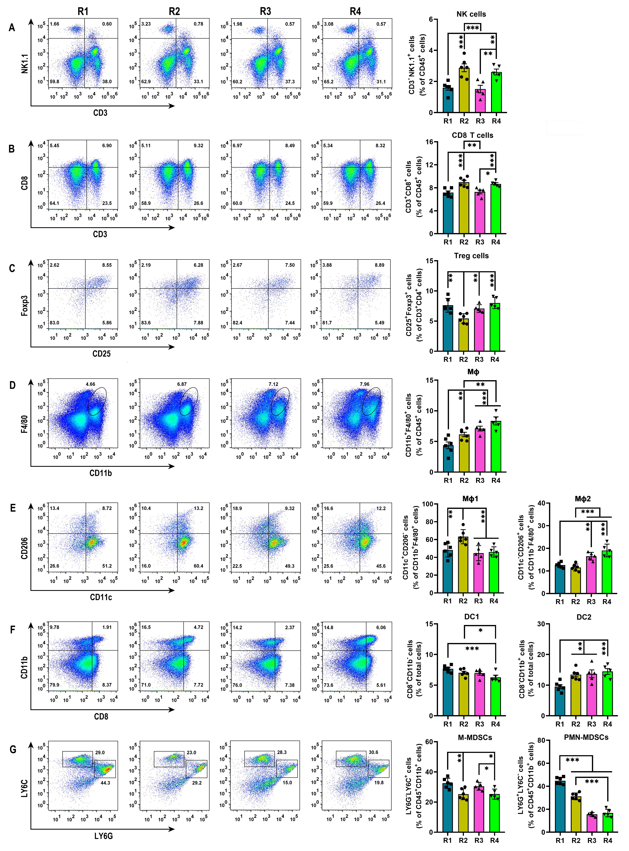
Supplementary Figure 23 Representative FCM plots and statistical diagram of immune cell proportion in spleen. A, representative FCM plot of NK cells (CD3⁻ NK1.1⁺ gated on CD45⁺), and corresponded quantification. B, representative FCM plot of CD8 T cells (CD3⁺ CD8⁺ gated on CD45⁺), and corresponded quantification. C, representative FCM plot of Treg cells (CD25⁺ Foxp3⁺ gated on CD3⁺ CD4⁺ CD45⁺), and corresponded quantification. D, representative FCM plot of Mφ (CD11b⁺ F4/80⁺ gated on CD45⁺), and corresponded quantification. E, representative FCM plot of Mφ1 (CD11c⁺ CD206⁻ gated on CD11b⁺ F4/80⁺ CD45⁺) and Mφ2 (CD11c⁻ CD206⁺ gated on CD11b⁺ F4/80⁺ CD45⁺), and corresponded quantification. F, representative FCM plot of DC1 (⁻CD8⁺ CD11b⁻ gated on total cells) and DC2 (CD8⁻ CD11b⁺ gated on total cells), and corresponded quantification. G, representative FCM plot of M-MDSCs (LY6G⁻ LY6C⁺ gated on CD45⁺ CD11b⁺) and PMN-MDSCs (LY6G⁺ LY6C⁻ gated on CD45⁺ CD11b⁺), and corresponded quantification. R1, the control group of xenograft H22 carcinoma in situ; R2, the group subjected to FUS sti. spleen; R3, the group administered to PMN-MDSCs depletion; R4, the group performed with FUS sti. spleen after PMN-MDSCs clearance.
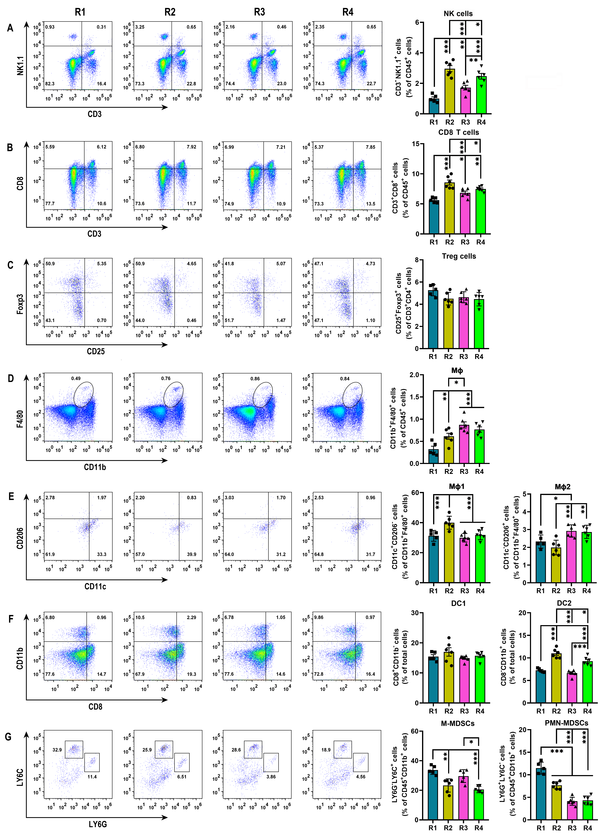
Supplementary Figure 24 Representative FCM plots and statistical diagram of immune cell proportion in blood. A, representative FCM plot of NK cells (CD3⁻ NK1.1⁺ gated on CD45⁺), and corresponded quantification. B, representative FCM plot of CD8 T cells (CD3⁺ CD8⁺ gated on CD45⁺), and corresponded quantification. C, representative FCM plot of Treg cells (CD25⁺ Foxp3⁺ gated on CD3⁺ CD4⁺ CD45⁺), and corresponded quantification. D, representative FCM plot of Mφ (CD11b⁺ F4/80⁺ gated on CD45⁺), and corresponded quantification. E, representative FCM plot of Mφ1 (CD11c⁺ CD206⁻ gated on CD11b⁺ F4/80⁺ CD45⁺) and Mφ2 (CD11c⁻ CD206⁺ gated on CD11b⁺ F4/80⁺ CD45⁺), and corresponded quantification. F, representative FCM plot of DC1 (⁻CD8⁺ CD11b⁻ gated on total cells) and DC2 (CD8⁻ CD11b⁺ gated on total cells), and corresponded quantification. G, representative FCM plot of M-MDSCs (LY6G⁻ LY6C⁺ gated on CD45⁺ CD11b⁺) and PMN-MDSCs (LY6G⁺ LY6C⁻ gated on CD45⁺ CD11b⁺), and corresponded quantification. R1, the control group of xenograft H22 carcinoma in situ; R2, the group subjected to FUS sti. spleen; R3, the group administered to PMN-MDSCs depletion; R4, the group performed with FUS sti. spleen after PMN-MDSCs clearance.
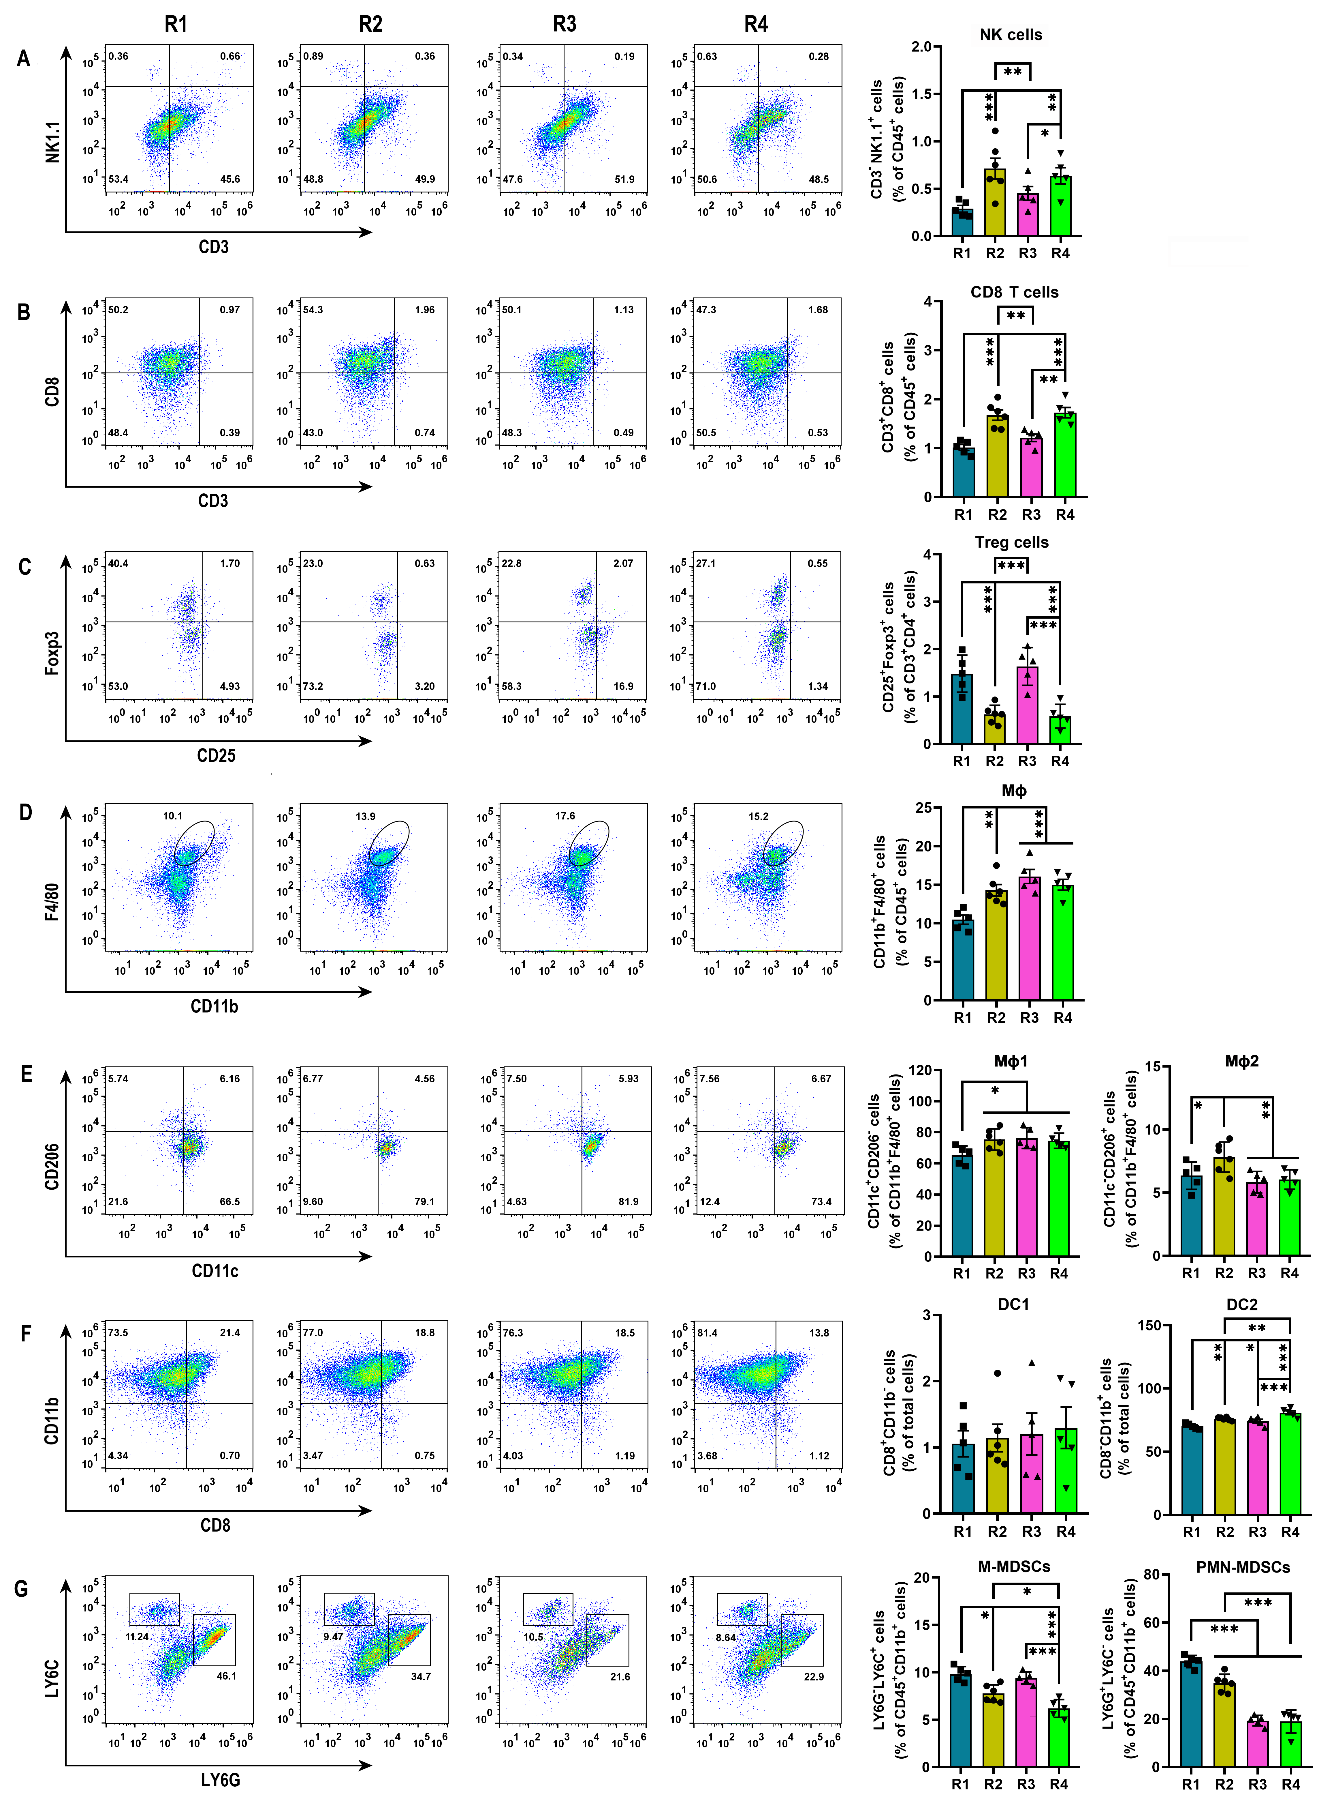
Supplementary Figure 25 Representative FCM plots and statistical diagram of immune cell proportion in tumor. A, representative FCM plot of NK cells (CD3⁻ NK1.1⁺ gated on CD45⁺), and corresponded quantification. B, representative FCM plot of CD8 T cells (CD3⁺ CD8⁺ gated on CD45⁺), and corresponded quantification. C, representative FCM plot of Treg cells (CD25⁺ Foxp3⁺ gated on CD3⁺ CD4⁺ CD45⁺), and corresponded quantification. D, representative FCM plot of Mφ (CD11b⁺ F4/80⁺ gated on CD45⁺), and corresponded quantification. E, representative FCM plot of Mφ1 (CD11c⁺ CD206⁻ gated on CD11b⁺ F4/80⁺ CD45⁺) and Mφ2 (CD11c⁻ CD206⁺ gated on CD11b⁺ F4/80⁺ CD45⁺), and corresponded quantification. F, representative FCM plot of DC1 (⁻CD8⁺ CD11b⁻ gated on total cells) and DC2 (CD8⁻ CD11b⁺ gated on total cells), and corresponded quantification. G, representative FCM plot of M-MDSCs (LY6G⁻ LY6C⁺ gated on CD45⁺ CD11b⁺) and PMN-MDSCs (LY6G⁺ LY6C⁻ gated on CD45⁺ CD11b⁺), and corresponded quantification. R1, the control group of xenograft H22 carcinoma in situ; R2, the group subjected to FUS sti. spleen; R3, the group administered to PMN-MDSCs depletion; R4, the group performed with FUS sti. spleen after PMN-MDSCs clearance.
Supplementary Figure 26 Representative FCM plots and statistical diagram of immune cell proportion in para-carcinoma tissue. A, representative FCM plot of NK cells (CD3⁻ NK1.1⁺ gated on CD45⁺), and corresponded quantification. B, representative FCM plot of CD8 T cells (CD3⁺ CD8⁺ gated on CD45⁺), and corresponded quantification. C, representative FCM plot of Treg cells (CD25⁺ Foxp3⁺ gated on CD3⁺ CD4⁺ CD45⁺), and corresponded quantification. D, representative FCM plot of Mφ (CD11b⁺ F4/80⁺ gated on CD45⁺), and corresponded quantification. E, representative FCM plot of Mφ1 (CD11c⁺ CD206⁻ gated on CD11b⁺ F4/80⁺ CD45⁺) and Mφ2 (CD11c⁻ CD206⁺ gated on CD11b⁺ F4/80⁺ CD45⁺), and corresponded quantification. F, representative FCM plot of DC1 (⁻CD8⁺ CD11b⁻ gated on total cells) and DC2 (CD8⁻ CD11b⁺ gated on total cells), and corresponded quantification. G, representative FCM plot of M-MDSCs (LY6G⁻ LY6C⁺ gated on CD45⁺ CD11b⁺) and PMN-MDSCs (LY6G⁺ LY6C⁻ gated on CD45⁺ CD11b⁺), and corresponded quantification. R1, the control group of xenograft H22 carcinoma in situ; R2, the group subjected to FUS sti. spleen; R3, the group administered to PMN-MDSCs depletion; R4, the group performed with FUS sti. spleen after PMN-MDSCs clearance.

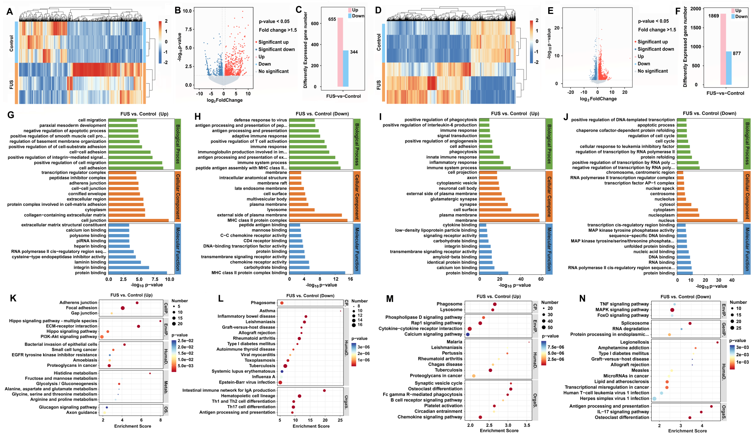
Supplementary Figure 27 RNA-seq analysis of the NK cells and CD8 T cells sorted from spleen after FUS stimulation. A-C, heatmap diagram, volcano plot and number statistics of differentially expressed genes in NK cells, respectively. D-F, heatmap diagram, volcano plot and number statistics of differentially expressed genes in CD8 T cells, respectively. G-H, GO pathway enrichment of the upregulated genes and downregulated genes in NK cells, respectively. I-J, GO pathway enrichment of the upregulated genes and downregulated genes in CD8 T cells, respectively. K-L, KEGG pathway enrichment of the upregulated genes and downregulated genes in NK cells, respectively. M-N, KEGG pathway enrichment of the upregulated genes and downregulated genes in CD8 T cells, respectively.
Supplementary Figure 28 Representative FCM plots and statistical diagram of immune cell proportion in spleen. A, representative FCM plot of NK cells (CD3⁻ NK1.1⁺ gated on CD45⁺), and corresponded quantification. B, representative FCM plot of CD8 T cells (CD3⁺ CD8⁺ gated on CD45⁺), and corresponded quantification. C, representative FCM plot of Treg cells (CD25⁺ Foxp3⁺ gated on CD3⁺ CD4⁺ CD45⁺), and corresponded quantification. D, representative FCM plot of Mφ (CD11b⁺ F4/80⁺ gated on CD45⁺), and corresponded quantification. E, representative FCM plot of Mφ1 (CD11c⁺ CD206⁻ gated on CD11b⁺ F4/80⁺ CD45⁺) and Mφ2 (CD11c⁻ CD206⁺ gated on CD11b⁺ F4/80⁺ CD45⁺), and corresponded quantification. F, representative FCM plot of DC1 (CD11b⁻ CD8⁺ gated on total cells) and DC2 (CD11b⁺ CD8⁻ gated on total cells), and corresponded quantification. G, representative FCM plot of M-MDSCs (LY6G⁻ LY6C⁺ gated on CD45⁺ CD11b⁺) and PMN-MDSCs (LY6G⁺ LY6C⁻ gated on CD45⁺ CD11b⁺), and corresponded quantification. K1, the control group of xenograft H22 HCC in situ; K2-K4, FUS sti. spleen on day 0, 4 and 8 respectively after H22 cancer cell implantation.
Supplementary Figure 29 Representative FCM plots and statistical diagram of immune cell proportion in blood. A, representative FCM plot of NK cells (CD3⁻ NK1.1⁺ gated on CD45⁺), and corresponded quantification. B, representative FCM plot of CD8 T cells (CD3⁺ CD8⁺ gated on CD45⁺), and corresponded quantification. C, representative FCM plot of Treg cells (CD25⁺ Foxp3⁺ gated on CD3⁺ CD4⁺ CD45⁺), and corresponded quantification. D, representative FCM plot of Mφ (CD11b⁺ F4/80⁺ gated on CD45⁺), and corresponded quantification. E, representative FCM plot of Mφ1 (CD11c⁺ CD206⁻ gated on CD11b⁺ F4/80⁺ CD45⁺) and Mφ2 (CD11c⁻ CD206⁺ gated on CD11b⁺ F4/80⁺ CD45⁺), and corresponded quantification. F, representative FCM plot of DC1 (CD11b⁻ CD8⁺ gated on total cells) and DC2 (CD11b⁺ CD8⁻ gated on total cells), and corresponded quantification. G, representative FCM plot of M-MDSCs (LY6G⁻ LY6C⁺ gated on CD45⁺ CD11b⁺) and PMN-MDSCs (LY6G⁺ LY6C⁻ gated on CD45⁺ CD11b⁺), and corresponded quantification. K1, the control group of xenograft H22 HCC in situ; K2-K4, FUS sti. spleen on day 0, 4 and 8 respectively after H22 cancer cell implantation.

Supplementary Figure 30 Representative FCM plots and statistical diagram of immune cell proportion in tumor. A, representative FCM plot of NK cells (CD3⁻ NK1.1⁺ gated on CD45⁺), and corresponded quantification. B, representative FCM plot of CD8 T cells (CD3⁺ CD8⁺ gated on CD45⁺), and corresponded quantification. C, representative FCM plot of Treg cells (CD25⁺ Foxp3⁺ gated on CD3⁺ CD4⁺ CD45⁺), and corresponded quantification. D, representative FCM plot of Mφ (CD11b⁺ F4/80⁺ gated on CD45⁺), and corresponded quantification. E, representative FCM plot of Mφ1 (CD11c⁺ CD206⁻ gated on CD11b⁺ F4/80⁺ CD45⁺) and Mφ2 (CD11c⁻ CD206⁺ gated on CD11b⁺ F4/80⁺ CD45⁺), and corresponded quantification. F, representative FCM plot of DC1 (CD11b⁻ CD8⁺ gated on total cells) and DC2 (CD11b⁺ CD8⁻ gated on total cells), and corresponded quantification. G, representative FCM plot of M-MDSCs (LY6G⁻ LY6C⁺ gated on CD45⁺ CD11b⁺) and PMN-MDSCs (LY6G⁺ LY6C⁻ gated on CD45⁺ CD11b⁺), and corresponded quantification. K1, the control group of xenograft H22 HCC in situ; K2-K4, FUS sti. spleen on day 0, 4 and 8 respectively after H22 cancer cell implantation.
Supplementary Figure 31 Representative FCM plots and statistical diagram of immune cell proportion in para-carcinoma tissue. A, representative FCM plot of NK cells (CD3⁻ NK1.1⁺ gated on CD45⁺), and corresponded quantification. B, representative FCM plot of CD8 T cells (CD3⁺ CD8⁺ gated on CD45⁺), and corresponded quantification. C, representative FCM plot of Treg cells (CD25⁺ Foxp3⁺ gated on CD3⁺ CD4⁺ CD45⁺), and corresponded quantification. D, representative FCM plot of Mφ (CD11b⁺ F4/80⁺ gated on CD45⁺), and corresponded quantification. E, representative FCM plot of Mφ1 (CD11c⁺ CD206⁻ gated on CD11b⁺ F4/80⁺ CD45⁺) and Mφ2 (CD11c⁻ CD206⁺ gated on CD11b⁺ F4/80⁺ CD45⁺), and corresponded quantification. F, representative FCM plot of DC1 (CD11b⁻ CD8⁺ gated on total cells) and DC2 (CD11b⁺ CD8⁻ gated on total cells), and corresponded quantification. G, representative FCM plot of M-MDSCs (LY6G⁻ LY6C⁺ gated on CD45⁺ CD11b⁺) and PMN-MDSCs (LY6G⁺ LY6C⁻ gated on CD45⁺ CD11b⁺), and corresponded quantification. K1, the control group of xenograft H22 HCC in situ; K2-K4, FUS sti. spleen on day 0, 4 and 8 respectively after H22 cancer cell implantation.

Supplementary Figure 32 Representative FCM plots and statistical diagram of immune cell proportion in spleen. A, representative FCM plot of CD4 T cells (CD3⁺ CD4⁺ gated on CD45⁺), and corresponded quantification. B, representative FCM plot of Th1 cells (IFN-γ⁺ gated on CD3⁺ CD4⁺ CD45⁺), and corresponded quantification. C, representative FCM plot of Th2 cells (IL-4⁺ gated on CD3⁺ CD4⁺ CD45⁺), and corresponded quantification. D, representative FCM plot of Th17 cells (IL-17⁺ gated on CD3⁺ CD4⁺ CD45⁺), and corresponded quantification. E, representative FCM plot of B cells (CD19⁺ B220⁺ gated on CD3⁺ CD4⁺ CD45⁺), and corresponded quantification. F, representative FCM plot of NK cells (CD3⁻ NK1.1⁺ gated on CD45⁺), and corresponded quantification. G, representative FCM plot of CD8 T cells (CD3⁺ CD8⁺ gated on CD45⁺), and corresponded quantification. H, representative FCM plot of Mφ (CD11b⁺ F4/80⁺ gated on CD45⁺), and corresponded quantification. I, representative FCM plot of Mφ1 (CD11c⁺ CD206⁻ gated on CD11b⁺ F4/80⁺ CD45⁺) and Mφ2 (CD11c⁻ CD206⁺ gated on CD11b⁺ F4/80⁺ CD45⁺), and corresponded quantification. J, representative FCM plot of DC1 (CD8⁺ CD11b⁻ gated on total cells) and DC2 (CD8⁻ CD11b⁺ gated on total cells), and corresponded quantification. K, representative FCM plot of Treg cells (CD25⁺ Foxp3⁺ gated on CD3⁺ CD4⁺ CD45⁺), and corresponded quantification. L, representative FCM plot of M-MDSCs (LY6G⁻ LY6C⁺ gated on CD45⁺ CD11b⁺) and PMN-MDSCs (LY6G⁺ LY6C⁻ gated on CD45⁺ CD11b⁺), and corresponded quantification. #1, the normal mice group; #2, the control group of subcutaneous H22 tumor mice; #3, FUS sti. spleen; #4, FUS int. tumor; #5, FUS sti. spleen and FUS int. tumor synergistically.

Supplementary Figure 33 Representative FCM plots and statistical diagram of immune cell proportion in blood. A, representative FCM plot of CD4 T cells (CD3⁺ CD4⁺ gated on CD45⁺), and corresponded quantification. B, representative FCM plot of Th1 cells (IFN-γ⁺ gated on CD3⁺ CD4⁺ CD45⁺), and corresponded quantification. C, representative FCM plot of Th2 cells (IL-4⁺ gated on CD3⁺ CD4⁺ CD45⁺), and corresponded quantification. D, representative FCM plot of Th17 cells (IL-17⁺ gated on CD3⁺ CD4⁺ CD45⁺), and corresponded quantification. E, representative FCM plot of B cells (CD19⁺ B220⁺ gated on CD3⁺ CD4⁺ CD45⁺), and corresponded quantification. F, representative FCM plot of NK cells (CD3⁻ NK1.1⁺ gated on CD45⁺), and corresponded quantification. G, representative FCM plot of CD8 T cells (CD3⁺ CD8⁺ gated on CD45⁺), and corresponded quantification. H, representative FCM plot of Mφ (CD11b⁺ F4/80⁺ gated on CD45⁺), and corresponded quantification. I, representative FCM plot of Mφ1 (CD11c⁺ CD206⁻ gated on CD11b⁺ F4/80⁺ CD45⁺) and Mφ2 (CD11c⁻ CD206⁺ gated on CD11b⁺ F4/80⁺ CD45⁺), and corresponded quantification. J, representative FCM plot of DC1 (CD8⁺ CD11b⁻ gated on total cells) and DC2 (CD8⁻ CD11b⁺ gated on total cells), and corresponded quantification. K, representative FCM plot of Treg cells (CD25⁺ Foxp3⁺ gated on CD3⁺ CD4⁺ CD45⁺), and corresponded quantification. L, representative FCM plot of M-MDSCs (LY6G⁻ LY6C⁺ gated on CD45⁺ CD11b⁺) and PMN-MDSCs (LY6G⁺ LY6C⁻ gated on CD45⁺ CD11b⁺), and corresponded quantification. #1, the normal mice group; #2, the control group of subcutaneous H22 tumor mice; #3, FUS sti. spleen; #4, FUS int. tumor; #5, FUS sti. spleen and FUS int. tumor synergistically.

Supplementary Figure 34 Representative FCM plots and statistical diagram of immune cell proportion in tumor. A, representative FCM plot of CD4 T cells (CD3⁺ CD4⁺ gated on CD45⁺), and corresponded quantification. B, representative FCM plot of Th1 cells (IFN-γ⁺ gated on CD3⁺ CD4⁺ CD45⁺), and corresponded quantification. C, representative FCM plot of Th2 cells (IL-4⁺ gated on CD3⁺ CD4⁺ CD45⁺), and corresponded quantification. D, representative FCM plot of Th17 cells (IL-17⁺ gated on CD3⁺ CD4⁺ CD45⁺), and corresponded quantification. E, representative FCM plot of B cells (CD19⁺ B220⁺ gated on CD3⁺ CD4⁺ CD45⁺), and corresponded quantification. F, representative FCM plot of NK cells (CD3⁻ NK1.1⁺ gated on CD45⁺), and corresponded quantification. G, representative FCM plot of CD8 T cells (CD3⁺ CD8⁺ gated on CD45⁺), and corresponded quantification. H, representative FCM plot of Mφ (CD11b⁺ F4/80⁺ gated on CD45⁺), and corresponded quantification. I, representative FCM plot of Mφ1 (CD11c⁺ CD206⁻ gated on CD11b⁺ F4/80⁺ CD45⁺) and Mφ2 (CD11c⁻ CD206⁺ gated on CD11b⁺ F4/80⁺ CD45⁺), and corresponded quantification. J, representative FCM plot of DC1 (CD8⁺ CD11b⁻ gated on total cells) and DC2 (CD8⁻ CD11b⁺ gated on total cells), and corresponded quantification. K, representative FCM plot of Treg cells (CD25⁺ Foxp3⁺ gated on CD3⁺ CD4⁺ CD45⁺), and corresponded quantification. L, representative FCM plot of M-MDSCs (LY6G⁻ LY6C⁺ gated on CD45⁺ CD11b⁺) and PMN-MDSCs (LY6G⁺ LY6C⁻ gated on CD45⁺ CD11b⁺), and corresponded quantification. #1, the normal mice group; #2, the control group of subcutaneous H22 tumor mice; #3, FUS sti. spleen; #4, FUS int. tumor; #5, FUS sti. spleen and FUS int. tumor synergistically.

Supplementary Table 1 the antibodies used in flow cytometry.
Antibody | Conjugate | Clone | Isotype | Manufacturer
Anti- mouse CD45 | PE/Cyanine 7 | 30-F11 | Rat IgG2b,κ | Biolegend, Cat. No. 103114
Anti- mouse/ human CD11b | FITC | M1/70 | Rat IgG2b,κ | Biolegend, Cat. No. 101205
Anti- mouse F4/80 | PE | BM8 | Rat IgG2b,κ | Biolegend, Cat. No. 123110
Anti-mouse CD11c | PerCP/Cyanine5.5 | N418 | Armenian Hamster IgG | Biolegend, Cat. No. 117327
Anti-mouse CD206 (MMR) | APC | C068C2 | Rat IgG2b,κ | Biolegend, Cat. No. 141707
Anti-mouse CD3 | FITC | 17A2 | Rat IgG2b,κ | Biolegend, Cat. No. 100204
Anti-mouse CD4 | PerCP/Cyanine5.5 | RM4-5 | Rat IgG2a,κ | Biolegend, Cat. No. 100540
Anti-mouse CD8α | APC/Cyanine7 | 53-6.7 | Rat IgG2a,κ | Biolegend, Cat. No. 100714
Anti-mouse NK1.1 | APC | S17016D | Mouse IgG2a, κ | Biolegend, Cat. No. 156506
Anti-mouse CD19 | Brilliant Violet 510™ | 6D5 | Rat IgG2a,κ | Biolegend, Cat. No. 115546
Anti-mouse/ human B220 | FITC | RA3-6B2 | Rat IgG2a, κ | Biolegend, Cat. No. 103205
Anti-mouse Ly6C | PE | HK1.4 | Rat IgG2c, κ | Biolegend, Cat. No. 128007
Anti-mouse Ly6G | APC | 1A8 | Rat IgG2a, κ | Biolegend, Cat. No. 127613
Anti-mouse CD103 | PE | QA17A24 | Mouse IgG1, κ | Biolegend, Cat. No. 156904
Anti-mouse IL4 | PE | 11B11 | Rat IgG1, κ | Biolegend, Cat. No.504104
Anti-mouse IFN-γ | APC | XMG1.2 | Rat IgG1, κ | Biolegend, Cat. No. 505810
Anti-mouse FOXP3 | PE | 150D | Mouse IgG1, κ | Biolegend, Cat. No. 320008
Anti-mouse CD25 | APC | PC61 | Rat IgG1, λ | Biolegend, Cat. No. 102012
Anti-mouse IL17A | Brilliant Violet 421™ | TC11-18H10.1 | Rat IgG1, κ | Biolegend, Cat. No. 506926

Supplementary Table 2 Summary of flow cytometric markers for immune cells.
Cell type | Markers
CD4 T cell | CD45⁺ CD3⁺ CD4⁺
Th1 cell | CD45⁺ CD3⁺ CD4⁺ IFN-γ⁺
Th2 cell | CD45⁺ CD3⁺ CD4⁺ IL-4⁺
Th17 cell | CD45⁺ CD3⁺ CD4⁺ IL-17⁺
CD8 T cell | CD45⁺ CD3⁺ CD8a⁺
B cell | CD45⁺ CD19⁺ B220⁺
NK cell | CD45⁺ CD3⁻ NK1.1⁺
Mφ | CD45⁺ CD11b⁺ F4/80⁺
Mφ | Mφ1: CD45⁺ CD11b⁺ F4/80⁺ CD11C⁺ CD206⁻
Mφ | Mφ2: CD45⁺ CD11b⁺ F4/80⁺ CD11C⁻ CD206⁺
DC | DC1: CD45⁺ CD11b⁻ CD8a⁺
DC | DC2: CD45⁺ CD11b⁺ CD8a⁻
Treg | CD45⁺ CD3⁺ CD4⁺ CD25⁺ Foxp3⁺
MDSC | M-MDSC: CD45⁺ CD11b⁺ Ly6G⁻ Ly6C⁺
MDSC | PMN-MDSC: CD45⁺ CD11b⁺ Ly6G⁺ Ly6C⁻

