Effect of glacial melting on the physiological performance of Macrocystis pyrifera in Fjord of the Mountains, Magellanic Sub-Antarctic ecoregion, Chile

SUPPLEMENTARY INFORMATION

Diana Coral-Santacruz, Fabio Méndez, Johanna Marambio, Francisco Bahamonde, Pilar A. Haye & Andrés Mansilla*

Affiliations
Doctorado en Biología y Ecología Aplicada, Facultad de Ciencias del Mar, Universidad Católica del Norte, Coquimbo, Chile.
Laboratory of Antarctic and Sub-Antarctic Marine Ecosystems (LEMAS), Faculty of Sciences, University of Magallan, Punta Arenas, Chile.
Cape Horn International Center (CHIC), University of Magallan, Punta Arenas, Chile.
Doctorado en Ciencias Antárticas y Subantárticas, Universidad de Magallanes, Punta Arenas, Chile.
Laboratorio de Diversidad Marina (LADIMAR), Departamento de Biología Marina, Facultad de Ciencias del Mar, Universidad Católica del Norte, Coquimbo, Chile.
Instituto Milenio en Socio-Ecología Costera (SECOS), Coquimbo, Chile.

Correspondence
Dr. Andrés Mansilla, University of Magallanes, Punta Arenas, Chile. E-mail: andres.mansilla@umag.cl; Phone: +56 9 9959 7333

Table S1. Photosynthetic parameter values: rETRmax (µmol electrons m⁻²s⁻¹), Alpha (µmol photons m⁻²s⁻¹), Ek (µmol photons m⁻²s⁻¹), Chl-a (mg g⁻¹ DW), Chl-c (mg g⁻¹ DW) and Fucoxanthin (mg g⁻¹ DW) measured in Macrocystis pyrifera individuals obtained from three sites (German Glacier, Bernal Glacier, and Jaime Island) in the Fjord of the Mountains, Magellanic Sub-Antarctic ecoregion, Chile.

Site | Zone | Individual | rETRmax | Alpha | Ek | Chl-a | Chl-c | Fucoxanthin
German Glacier | Apical | 1 | 27.766 | 0.266 | 104329 | 0.242 | 0.060 | 0.124
German Glacier | Apical | 2 | 21.185 | 0.196 | 108.054 | 0.281 | 0.069 | 0.147
German Glacier | Apical | 3 | 20.462 | 0.314 | 65.070 | 0.158 | 0.045 | 0.095
German Glacier | Apical | 4 | 19.254 | 0.296 | 64.984 | 0.334 | 0.199 | 0.162
German Glacier | Apical | 5 | 24.246 | 0.284 | 85.304 | 0.336 | 0.301 | 0.132
German Glacier | Apical | 6 | 27.903 | 0.270 | 103.448 | 0.298 | 0.092 | 0.163
German Glacier | Apical | 7 | 22.747 | 0.286 | 79.474 | 0.300 | 0.087 | 0.136
German Glacier | Basal | 2 | 28.402 | 0.184 | 154.678 | 0.259 | 0.076 | 0.138
German Glacier | Basal | 3 | 31.231 | 0.237 | 131.966 | 0.227 | 0.084 | 0.170
German Glacier | Basal | 4 | 32.208 | 0.175 | 183.920 | 0.246 | 0.078 | 0.153
German Glacier | Basal | 5 | 36.691 | 0.239 | 153.250 | 0.335 | 0.232 | 0.156
German Glacier | Basal | 6 | 30.269 | 0.217 | 139.598 | 0.324 | 0.119 | 0.160
German Glacier | Basal | 7 | 35.684 | 0.177 | 201.513 | 0.335 | 0.266 | 0.148
Bernal Glacier | Apical | 1 | 26.095 | 0.134 | 195.088 | 0.332 | 0.169 | 0.178
Bernal Glacier | Apical | 2 | 27.514 | 0.174 | 158.036 | 0.292 | 0.086 | 0.175
Bernal Glacier | Apical | 3 | 30.790 | 0.168 | 183.722 | 0.302 | 0.113 | 0.196
Bernal Glacier | Apical | 4 | 17.010 | 0.187 | 90.851 | 0.333 | 0.198 | 0.173
Bernal Glacier | Apical | 5 | 19.231 | 0.158 | 121.761 | 0.330 | 0.216 | 0.166
Bernal Glacier | Apical | 6 | 21.170 | 0.196 | 108.032 | 0.320 | 0.103 | 0.196
Bernal Glacier | Apical | 7 | 23.273 | 0.208 | 112.094 | 0.330 | 0.221 | 0.161
Bernal Glacier | Basal | 1 | 25.962 | 0.152 | 170.702 | 0.329 | 0.133 | 0.165
Bernal Glacier | Basal | 2 | 31.914 | 0.200 | 159.522 | 0.336 | 0.364 | 0.118
Bernal Glacier | Basal | 3 | 28.553 | 0.186 | 153.527 | 0.331 | 0.253 | 0.150
Bernal Glacier | Basal | 4 | 33.859 | 0.178 | 190.583 | 0.332 | 0.177 | 0.175
Bernal Glacier | Basal | 5 | 24.892 | 0.149 | 167.150 | 0.325 | 0.170 | 0.179
Bernal Glacier | Basal | 6 | 26.560 | 0.224 | 118.476 | 0.340 | 0.399 | 0.102
Bernal Glacier | Basal | 7 | 30.660 | 0.189 | 162.334 | 0.245 | 0.095 | 0.189
Jaime Island | Apical | 1 | 9.962 | 0.111 | 89.582 | 0.279 | 0.122 | 0.197
Jaime Island | Apical | 2 | 13.785 | 0.088 | 156.193 | 0.271 | 0.102 | 0.202
Jaime Island | Apical | 3 | 22.342 | 0.153 | 145.560 | 0.210 | 0.078 | 0.202
Jaime Island | Apical | 4 | 17.965 | 0.074 | 244.222 | 0.290 | 0.065 | 0.206
Jaime Island | Apical | 5 | 24.419 | 0.091 | 267.964 | 0.202 | 0.066 | 0.187
Jaime Island | Basal | 1 | 22.062 | 0.287 | 76.802 | 0.323 | 0.176 | 0.179
Jaime Island | Basal | 2 | 18.614 | 0.261 | 71.321 | 0.321 | 0.135 | 0.190
Jaime Island | Basal | 3 | 17.602 | 0.225 | 78.402 | 0.326 | 0.132 | 0.163
Jaime Island | Basal | 4 | 23.623 | 0.222 | 106.219 | 0.336 | 0.303 | 0.136
Jaime Island | Basal | 5 | 18.024 | 0.190 | 94.958 | 0.334 | 0.311 | 0.129

Table S2. Summary of two-way analysis of variance (ANOVA) for photosynthetic response of three populations of Macrocystis pyrifera located in the Fjord of the Mountains, Magellanic Sub-Antarctic ecoregion, Chile.

Parameters | Source | Df | SS | MS | F | p
rETRmax | Sitio | 2 | 12.748 | 6.374 | 11.521 | 0.000688***
rETRmax | Zone | 1 | 8.237 | 8.237 | 14.887 | 0.001260**
rETRmax | ID | 16 | 5.610 | 0.351 | 0.634 | 0.8162284
rETRmax | Residuals | 17 | 9.406 | 0.553
Alpha | Sitio | 2 | 10.602 | 5.301 | 4.820 | 0.022*
Alpha | Zone | 1 | 0.589 | 0.589 | 0.536 | 0.474
Alpha | ID | 16 | 6.114 | 0.382 | 0.347 | 0.980
Alpha | Residuals | 17 | 18.696 | 1.100
Ek | Sitio | 2 | 2.215 | 1.1073 | 0.784 | 0.472
Ek | Zone | 1 | 0.257 | 0.2568 | 0.182 | 0.675
Ek | ID | 16 | 9.513 | 0.5946 | 0.421 | 0.955
Ek | Residuals | 17 | 24.015 | 1.4127
*Df degrees of freedom, SS sums of squares, MS mean squares, F F statistic; Significant effects (p < 0.05) are indicated in bold

Table S3. Summary of two-way analysis of variance (ANOVA) for pigment concentration of three populations of Macrocystis pyrifera located in the Fjord of the Mountains, Magellanic Sub-Antarctic ecoregion, Chile.

Parameters | Source | Df | SS | MS | F | p
Chlorophyll-a | Sitio | 2 | 4.943 | 2.471 | 3.316 | 0.0608
Chlorophyll-a | Zone | 1 | 2.555 | 2.555 | 3.428 | 0.0816
Chlorophyll-a | ID | 16 | 15.831 | 0.989 | 1.328 | 0.2838
Chlorophyll-a | Residuals | 17 | 12.670 | 0,745
Chlorophyll-c | Sitio | 2 | 3.126 | 1.563 | 1.483 | 0.2549
Chlorophyll-c | Zone | 1 | 4.924 | 4.924 | 4.673 | 0.0452
Chlorophyll-c | ID | 16 | 10.037 | 0.627 | 0.595 | 0.8470
Chlorophyll-c | Residuals | 17 | 17.913 | 1.054
Fucoxanthin | Sitio | 2 | 8.827 | 4.413 | 4.219 | 0.0525
Fucoxanthin | Zone | 1 | 2.209 | 2.209 | 2.112 | 0.1644
Fucoxanthin | ID | 16 | 7.182 | 0.449 | 0.429 | 0.9511
Fucoxanthin | Residuals | 17 | 17.782 | 1.046
*Df degrees of freedom, SS sums of squares, MS mean squares, F F statistic
Significant effects (p < 0.05) are indicated in bold.

Table S4. Ratios of mean pigment concentration of chlorophyll-a/chlorophyll-c (Chl-a/Chl-c) and of chlorophyll-a/fucoxanthin (Chl-a/Fucox) in apical and basal fronds of Macrocystis pyrifera located in the Fjord of the Mountains, Magellanic Sub-Antarctic ecoregion, Chile.

Zone | Site | Chl-a/Chl-c | Chl-a/Fucox
Apical | German Glacier | 2,29 | 2,03
Apical | Bernal Glacier | 2,03 | 1,80
Apical | Jaime Island | 2,89 | 1,26
Basal | German Glacier | 2,02 | 1,86
Basal | Bernal Glacier | 1,41 | 2,08
Basal | Jaime Island | 1,55 | 2,06

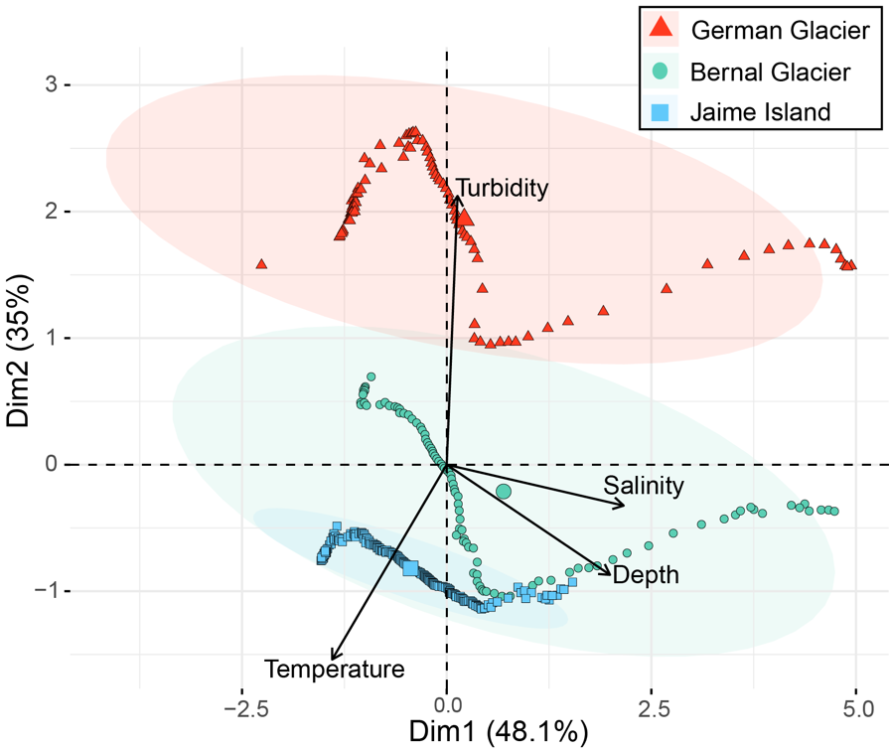

Fig. 1S Principal Component Analysis plot for first two Principal Components of the environmental variables (temperature, salinity, turbidity) measured in three populations of Macrocystis pyrifera located in Fjord of the Mountains, Magellanic Sub-Antarctic ecoregion, Chile.

