Supplementary figures

Supplementary Fig.1: Selection of noise-minimization’s cut-off percentage based on percentage of singleton haplotypes.
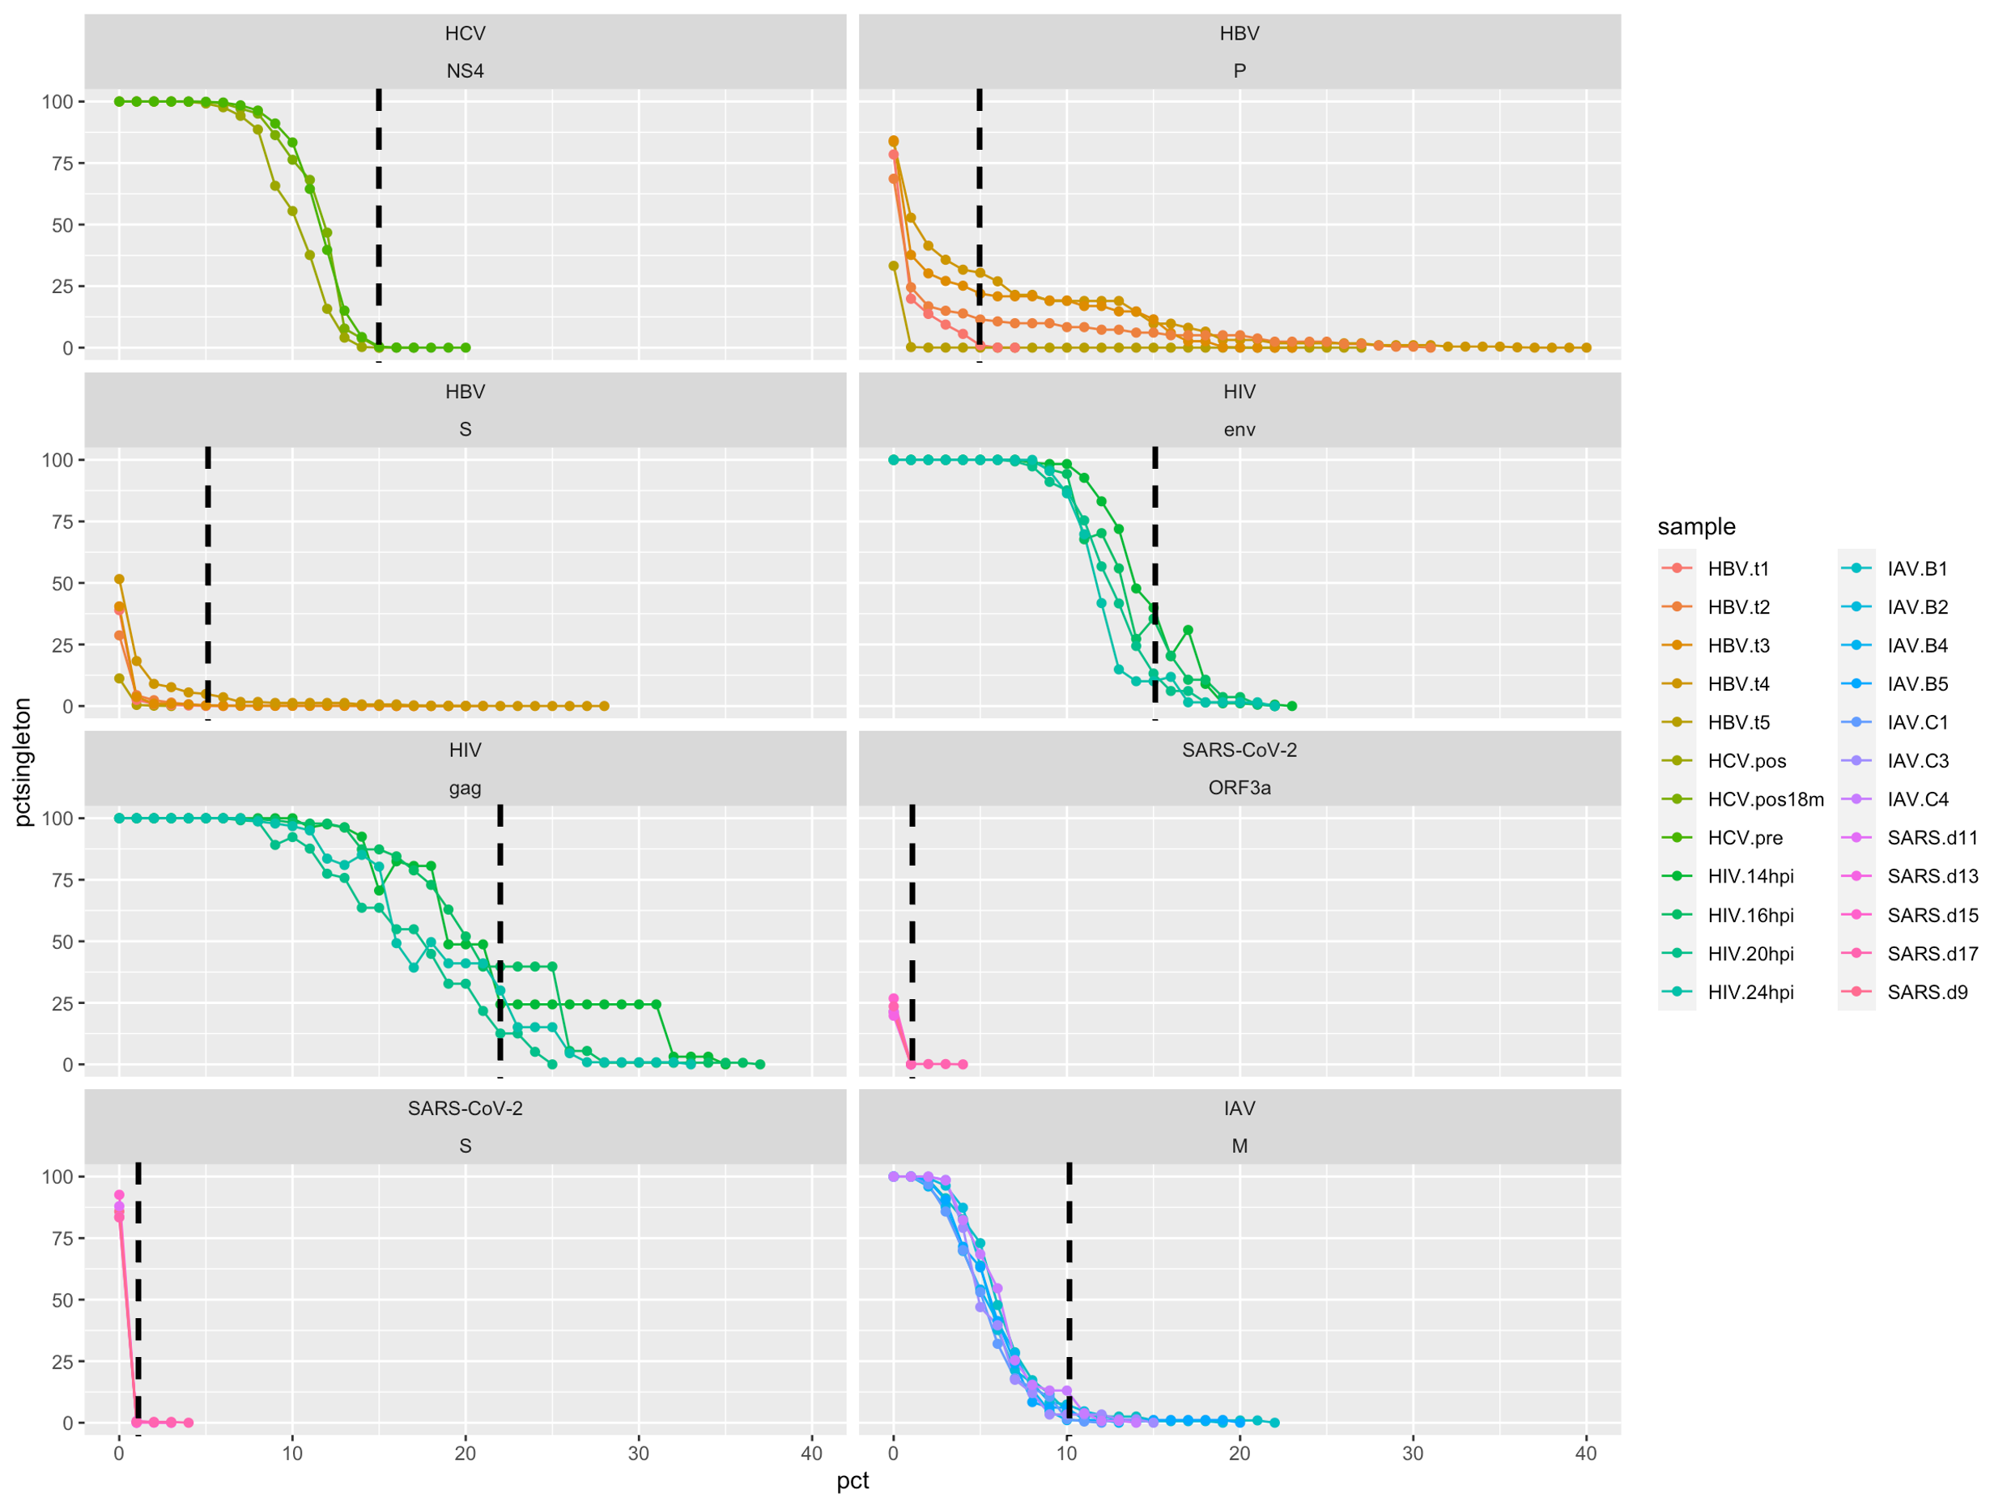
Connected scatter plot with points indicating the percentage of singleton haplotypes (y-axis: pctsingleton) changing at different noise-minimization cut-off percentages (x-axis: pct). Lines and dots are colored by individual samples. Vertical dashed lines represent selected cut-off percentages for each gene and viral species.
Supplementary Fig.2: Effect of down-sampling after noise-minimization on nine diversity metrics in HCV’s NS4 coding region samples. 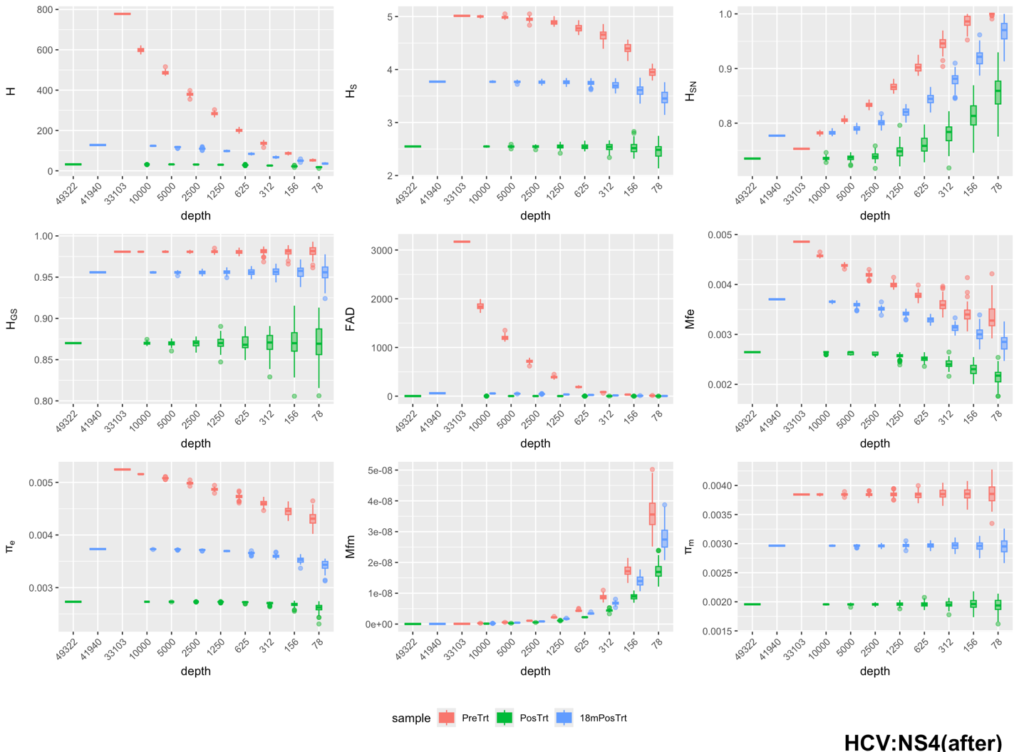
Distribution of nine diversity metrics, including the number of haplotypes (H), Shannon entropy (H_{S}), normalized Shannon entropy (H_{SN}), Gini-Simpson index (H_{GS}), functional attribute diversity (FAD), mutation frequency at the entity level (Mfe), nucleotide diversity at the entity level (π_{e}), mutation frequency at the molecular level (Mfm), and nucleotide diversity (π_{m}). These metrics are computed at different sample sizes (100 repeated random samplings with replacement for each size), arranged from left to right and top to bottom. For all plots, horizontal lines indicate medians, boxes the 25th to 75th percentile, whiskers the lowest and highest values excluding outliers, and dots the outliers.

Supplementary Fig.3: Effect of down-sampling before noise-minimization on nine diversity metrics in HCV’s NS4 coding region samples. 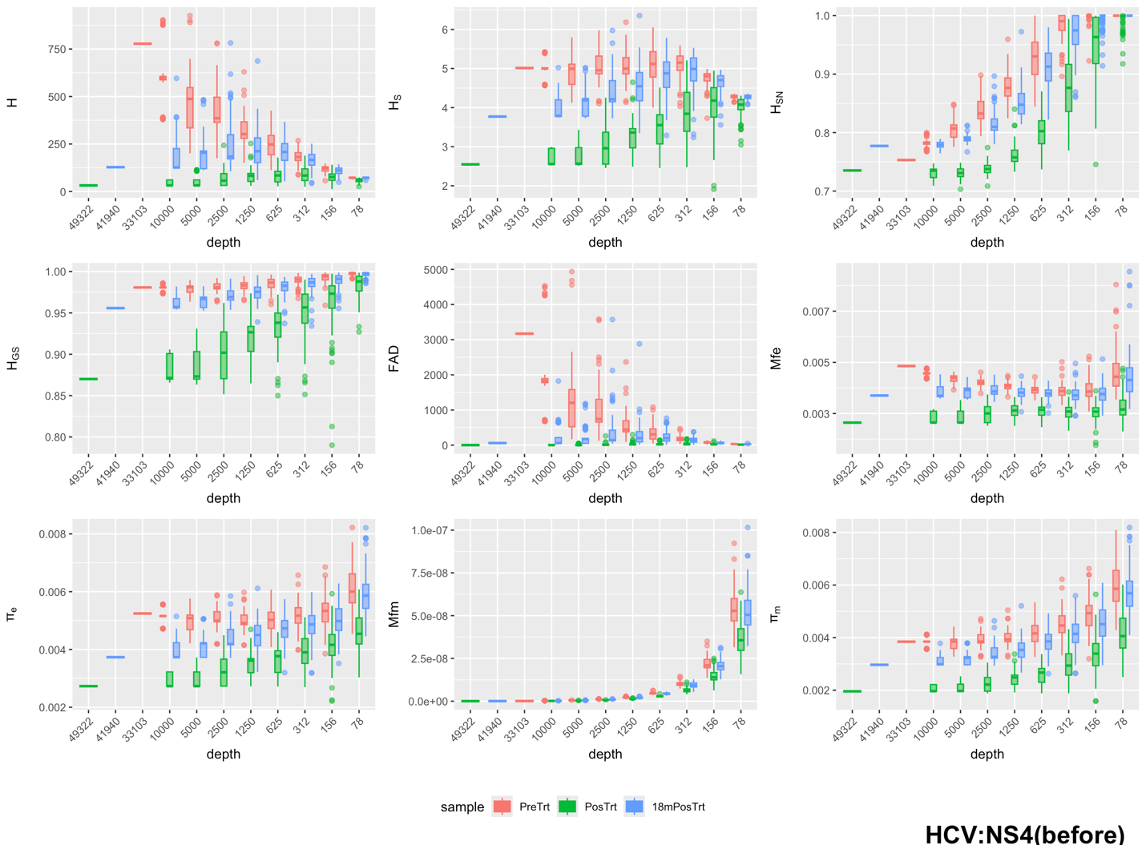
Distribution of nine diversity metrics, including the number of haplotypes (H), Shannon entropy (H_{S}), normalized Shannon entropy (H_{SN}), Gini-Simpson index (H_{GS}), functional attribute diversity (FAD), mutation frequency at the entity level (Mfe), nucleotide diversity at the entity level (π_{e}), mutation frequency at the molecular level (Mfm), and nucleotide diversity (π_{m}). These metrics are computed at different sample sizes (100 repeated random samplings with replacement for each size), arranged from left to right and top to bottom. For all plots, horizontal lines indicate medians, boxes the 25th to 75th percentile, whiskers the lowest and highest values excluding outliers, and dots the outliers.

Supplementary Fig.4: Effect of down-sampling after noise-minimization on nine diversity metrics in HBV’s S gene samples.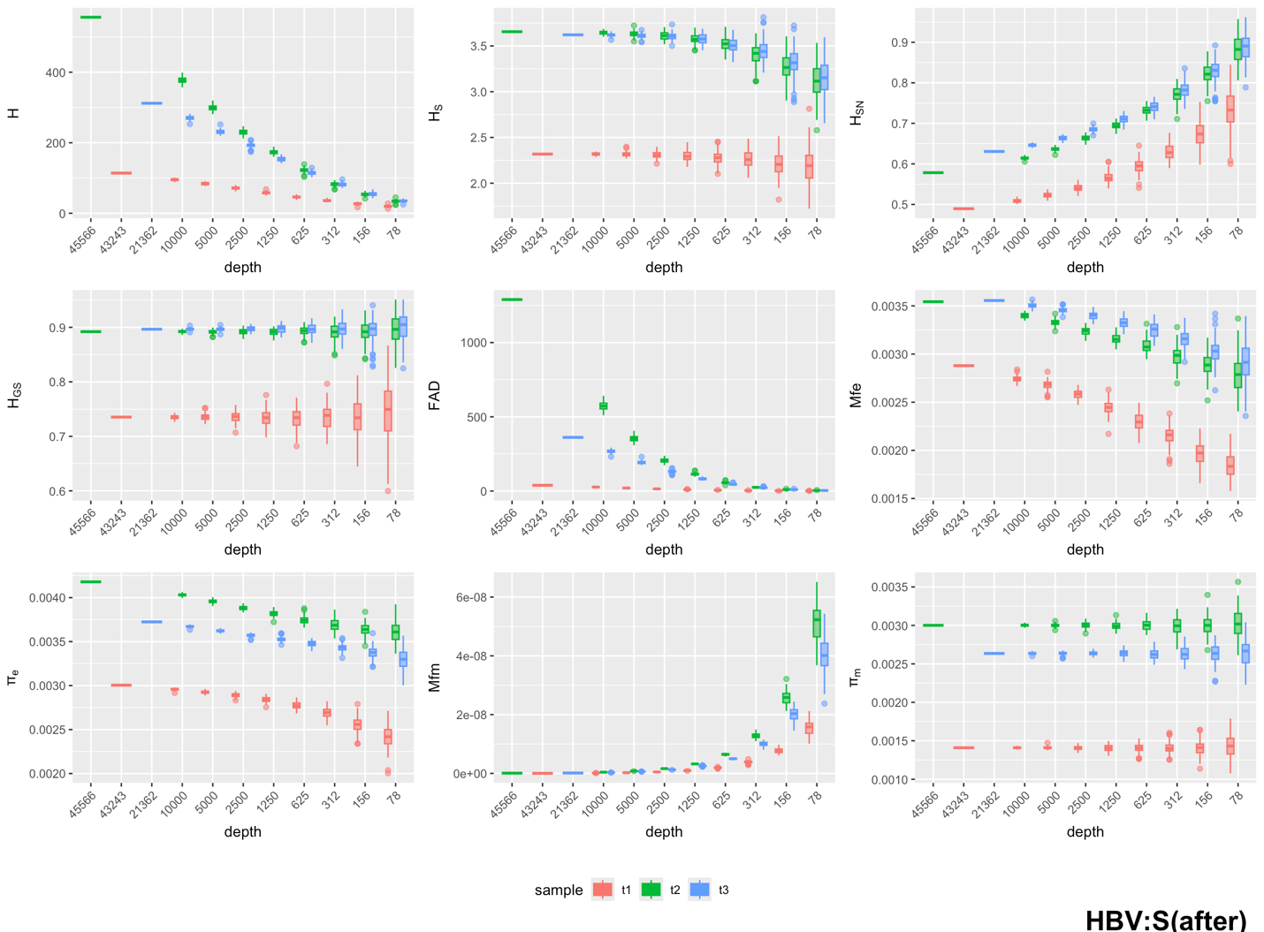
Distribution of nine diversity metrics, including the number of haplotypes (H), Shannon entropy (H_{S}), normalized Shannon entropy (H_{SN}), Gini-Simpson index (H_{GS}), functional attribute diversity (FAD), mutation frequency at the entity level (Mfe), nucleotide diversity at the entity level (π_{e}), mutation frequency at the molecular level (Mfm), and nucleotide diversity (π_{m}). These metrics are computed at different sample sizes (100 repeated random samplings with replacement for each size), arranged from left to right and top to bottom. For all plots, horizontal lines indicate medians, boxes the 25th to 75th percentile, whiskers the lowest and highest values excluding outliers, and dots the outliers.

Supplementary Fig.5: Effect of down-sampling before noise-minimization on nine diversity metrics in HBV’s S gene samples.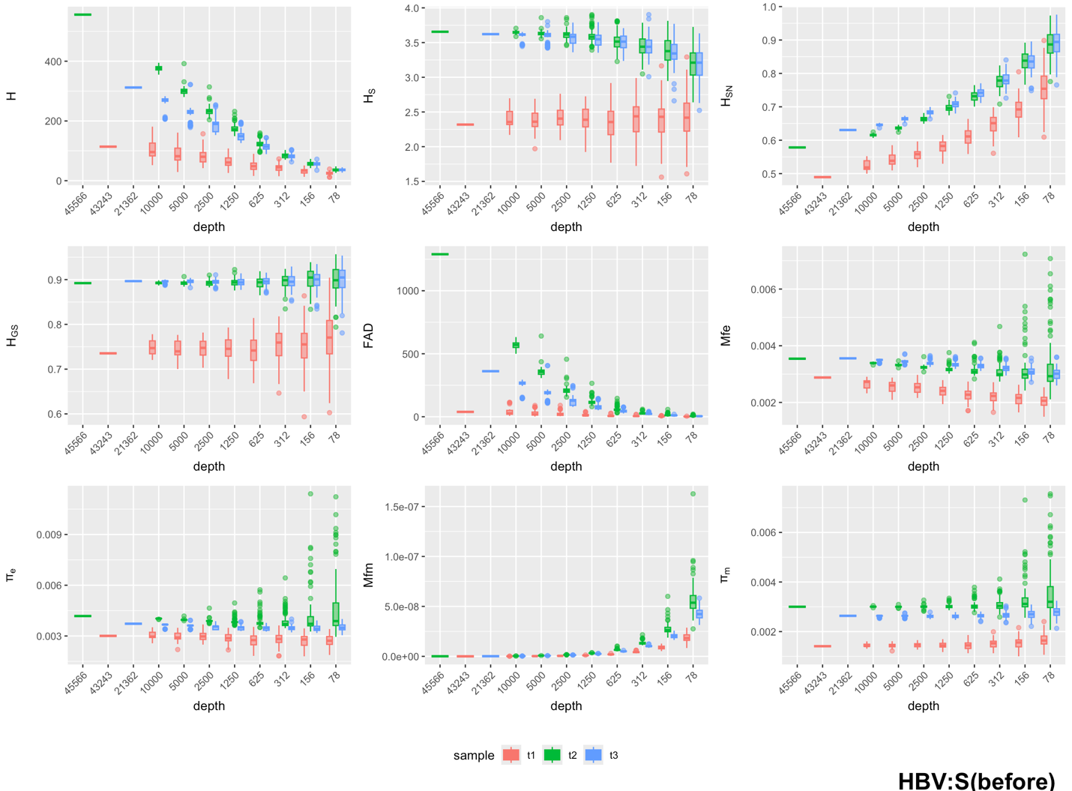
Distribution of nine diversity metrics, including the number of haplotypes (H), Shannon entropy (H_{S}), normalized Shannon entropy (H_{SN}), Gini-Simpson index (H_{GS}), functional attribute diversity (FAD), mutation frequency at the entity level (Mfe), nucleotide diversity at the entity level (π_{e}), mutation frequency at the molecular level (Mfm), and nucleotide diversity (π_{m}). These metrics are computed at different sample sizes (100 repeated random samplings with replacement for each size), arranged from left to right and top to bottom. For all plots, horizontal lines indicate medians, boxes the 25th to 75th percentile, whiskers the lowest and highest values excluding outliers, and dots the outliers.

Supplementary Fig.6: Effect of down-sampling after noise-minimization on nine diversity metrics in HIV’s env gene samples.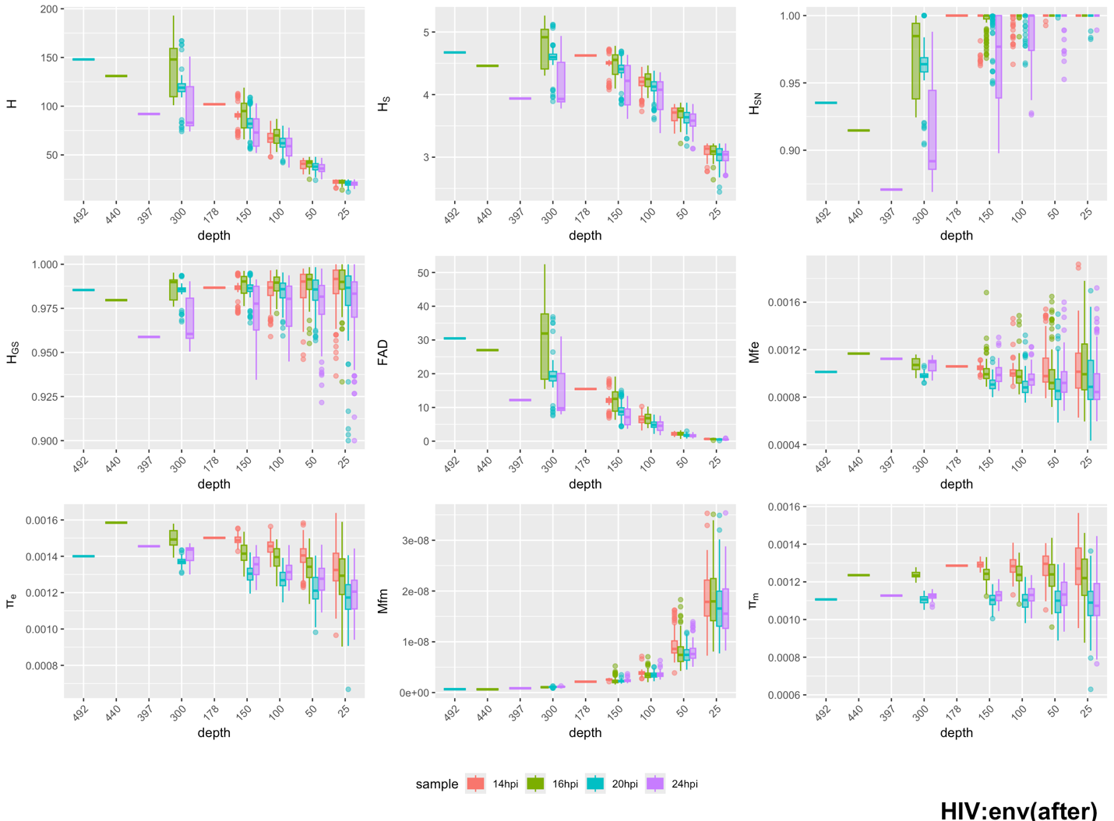

Distribution of nine diversity metrics, including the number of haplotypes (H), Shannon entropy (H_{S}), normalized Shannon entropy (H_{SN}), Gini-Simpson index (H_{GS}), functional attribute diversity (FAD), mutation frequency at the entity level (Mfe), nucleotide diversity at the entity level (π_{e}), mutation frequency at the molecular level (Mfm), and nucleotide diversity (π_{m}). These metrics are computed at different sample sizes (100 repeated random samplings with replacement for each size), arranged from left to right and top to bottom. For all plots, horizontal lines indicate medians, boxes the 25th to 75th percentile, whiskers the lowest and highest values excluding outliers, and dots the outliers.

Supplementary Fig.7: Effect of down-sampling before noise-minimization on nine diversity metrics in HIV’s env gene samples.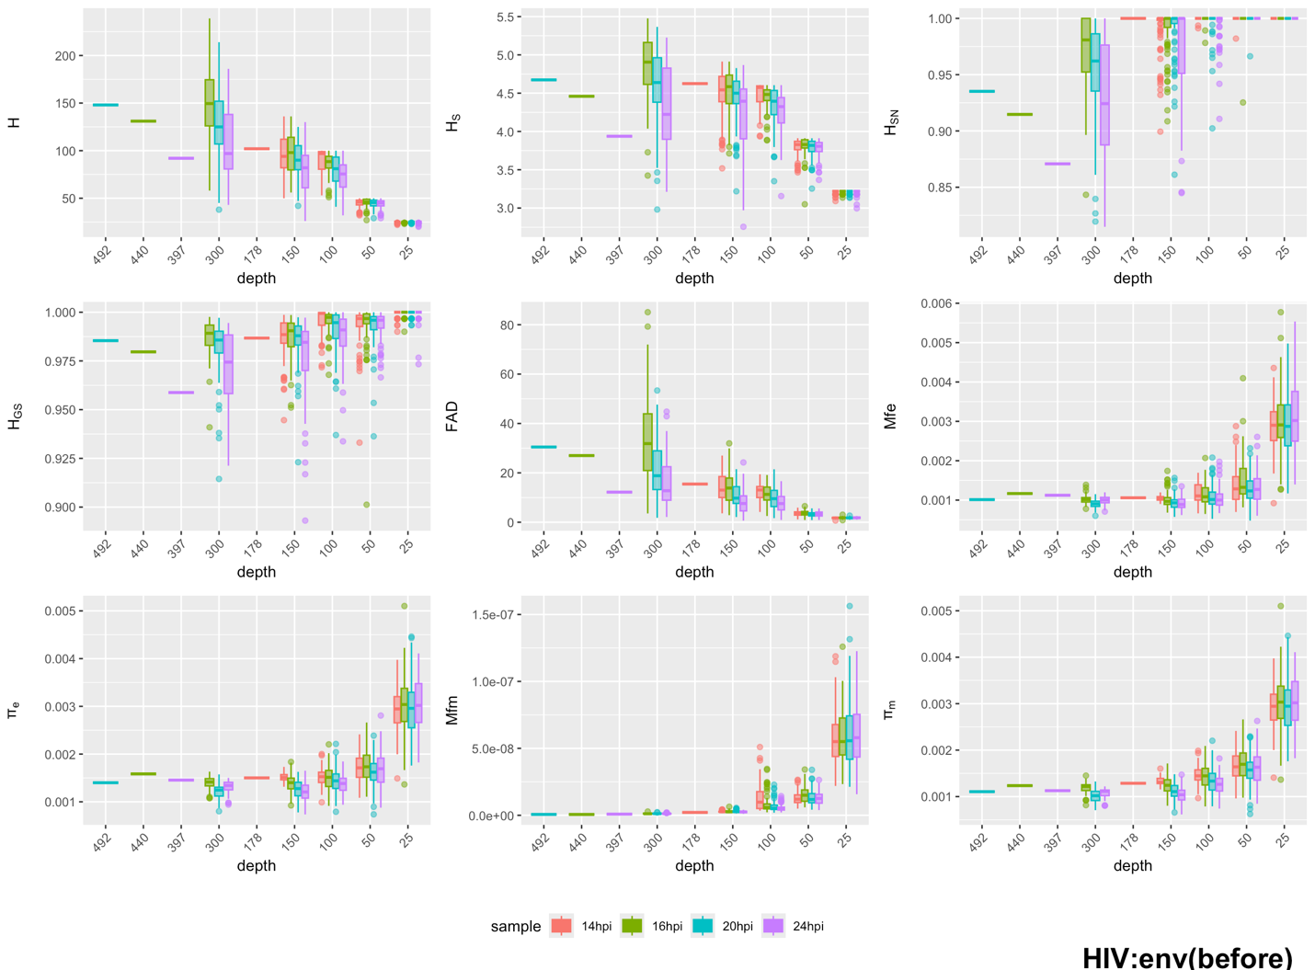
Distribution of nine diversity metrics, including the number of haplotypes (H), Shannon entropy (H_{S}), normalized Shannon entropy (H_{SN}), Gini-Simpson index (H_{GS}), functional attribute diversity (FAD), mutation frequency at the entity level (Mfe), nucleotide diversity at the entity level (π_{e}), mutation frequency at the molecular level (Mfm), and nucleotide diversity (π_{m}). These metrics are computed at different sample sizes (100 repeated random samplings with replacement for each size), arranged from left to right and top to bottom. For all plots, horizontal lines indicate medians, boxes the 25th to 75th percentile, whiskers the lowest and highest values excluding outliers, and dots the outliers.

Supplementary Fig.8: Effect of down-sampling after noise-minimization on nine diversity metrics in SARS-CoV-2’s S gene samples.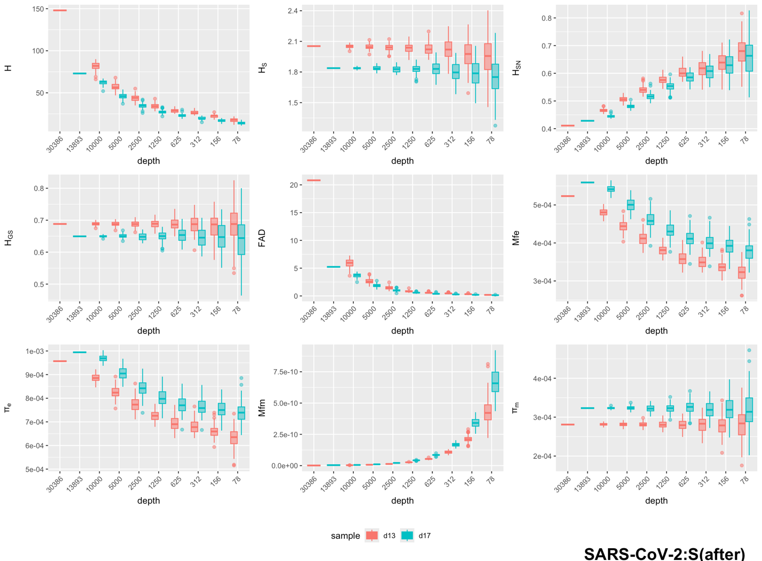
Distribution of nine diversity metrics, including the number of haplotypes (H), Shannon entropy (H_{S}), normalized Shannon entropy (H_{SN}), Gini-Simpson index (H_{GS}), functional attribute diversity (FAD), mutation frequency at the entity level (Mfe), nucleotide diversity at the entity level (π_{e}), mutation frequency at the molecular level (Mfm), and nucleotide diversity (π_{m}). These metrics are computed at different sample sizes (100 repeated random samplings with replacement for each size), arranged from left to right and top to bottom. For all plots, horizontal lines indicate medians, boxes the 25th to 75th percentile, whiskers the lowest and highest values excluding outliers, and dots the outliers.

Supplementary Fig.9: Effect of down-sampling before noise-minimization on nine diversity metrics in SARS-CoV-2’s S gene samples.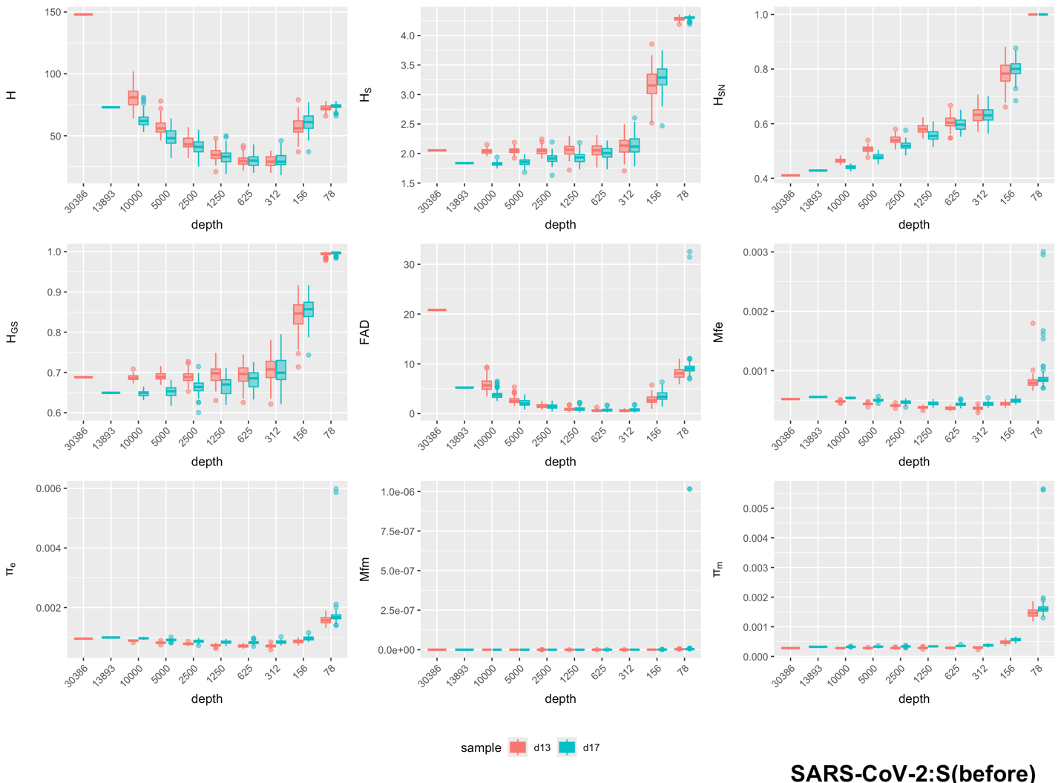

Distribution of nine diversity metrics, including the number of haplotypes (H), Shannon entropy (H_{S}), normalized Shannon entropy (H_{SN}), Gini-Simpson index (H_{GS}), functional attribute diversity (FAD), mutation frequency at the entity level (Mfe), nucleotide diversity at the entity level (π_{e}), mutation frequency at the molecular level (Mfm), and nucleotide diversity (π_{m}). These metrics are computed at different sample sizes (100 repeated random samplings with replacement for each size), arranged from left to right and top to bottom. For all plots, horizontal lines indicate medians, boxes the 25th to 75th percentile, whiskers the lowest and highest values excluding outliers, and dots the outliers.

Supplementary Fig.10: Effect of down-sampling after noise-minimization on nine diversity metrics in IAV’s M gene segment samples.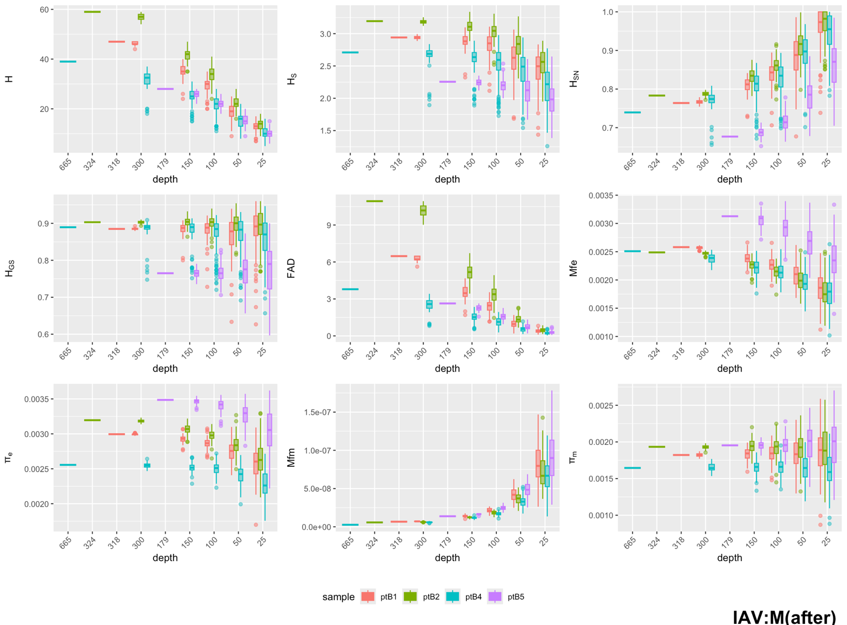
Distribution of nine diversity metrics, including the number of haplotypes (H), Shannon entropy (H_{S}), normalized Shannon entropy (H_{SN}), Gini-Simpson index (H_{GS}), functional attribute diversity (FAD), mutation frequency at the entity level (Mfe), nucleotide diversity at the entity level (π_{e}), mutation frequency at the molecular level (Mfm), and nucleotide diversity (π_{m}). These metrics are computed at different sample sizes (100 repeated random samplings with replacement for each size), arranged from left to right and top to bottom. For all plots, horizontal lines indicate medians, boxes the 25th to 75th percentile, whiskers the lowest and highest values excluding outliers, and dots the outliers.

Supplementary Fig.11: Effect of down-sampling before noise-minimization on nine diversity metrics in IAV’s M gene segment samples.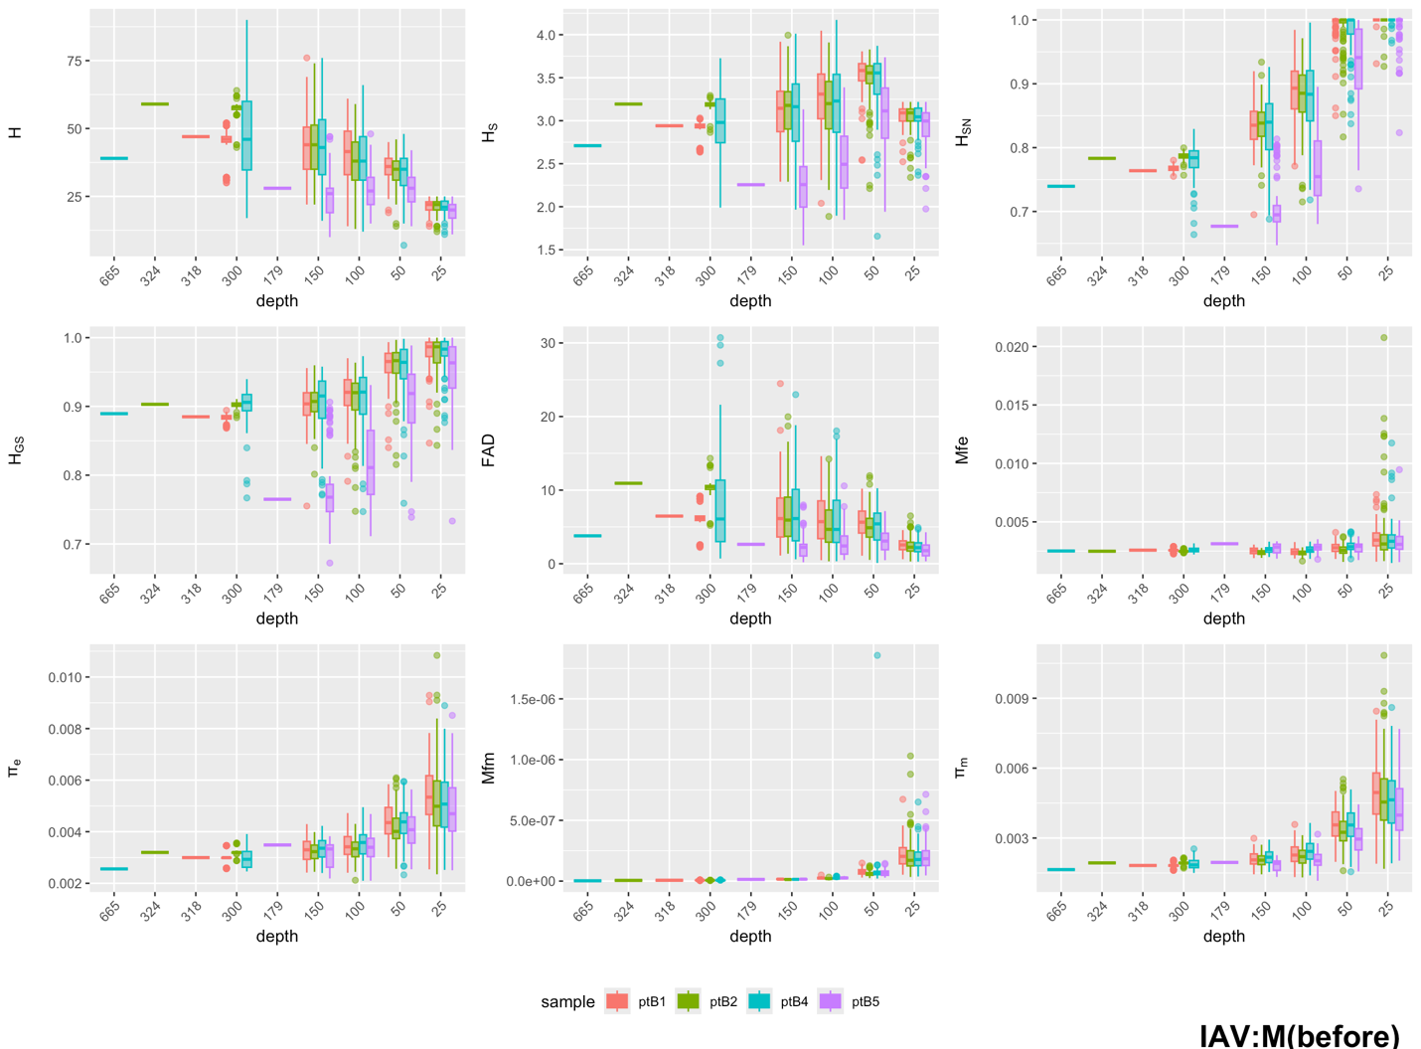
Distribution of nine diversity metrics, including the number of haplotypes (H), Shannon entropy (H_{S}), normalized Shannon entropy (H_{SN}), Gini-Simpson index (H_{GS}), functional attribute diversity (FAD), mutation frequency at the entity level (Mfe), nucleotide diversity at the entity level (π_{e}), mutation frequency at the molecular level (Mfm), and nucleotide diversity (π_{m}). These metrics are computed at different sample sizes (100 repeated random samplings with replacement for each size), arranged from left to right and top to bottom. For all plots, horizontal lines indicate medians, boxes the 25th to 75th percentile, whiskers the lowest and highest values excluding outliers, and dots the outliers.

Supplementary Fig.12: Viral quasispecies and OTU comparisons among HBV’s P and S genes samples.
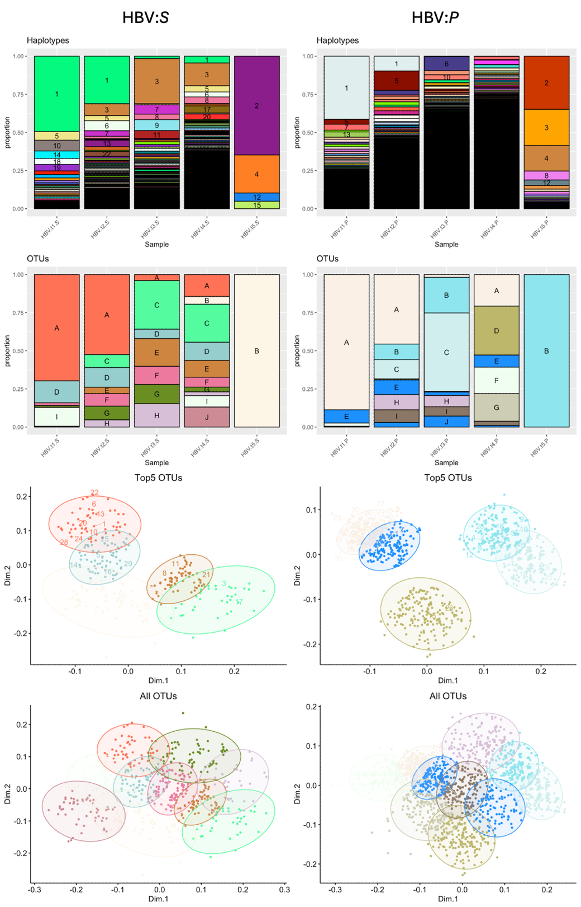
From top to bottom: 1. Stacked bar chart presenting the proportion of each unique haplotype (same color) identified across different samples within each gene dataset. 2. Stacked bar chart presenting the proportion of new OTUs, each consisting of genetically closely related haplotypes. 3. Multidimensional scaling (MDS) plot of haplotypes' pairwise SNV distance (dot), showing the five largest OTUs (circle) with a color scheme corresponding to plot b. 4. MDS plot of all OTUs.
Supplementary Fig.13: Viral quasispecies and OTU comparisons among HIV’s env and gag genes samples.
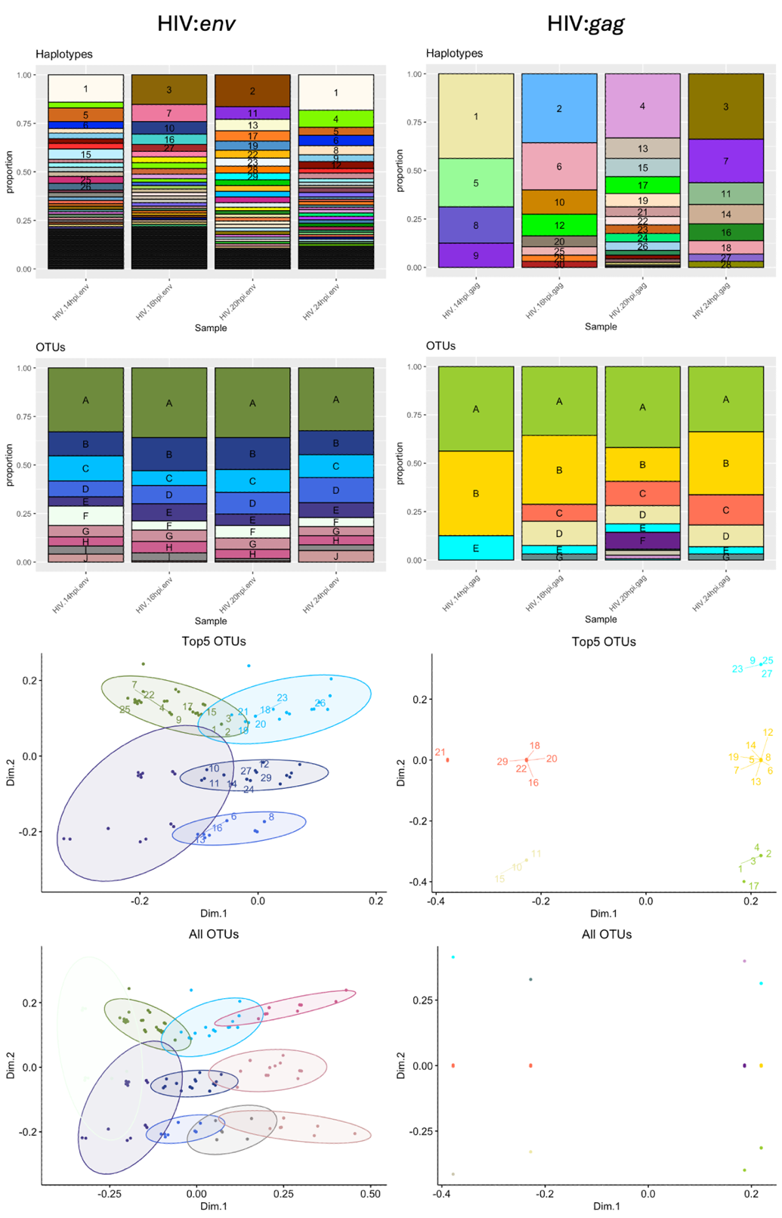
From top to bottom: 1. Stacked bar chart presenting the proportion of each unique haplotype (same color) identified across different samples within each gene dataset. 2. Stacked bar chart presenting the proportion of new OTUs, each consisting of genetically closely related haplotypes. 3. Multidimensional scaling (MDS) plot of haplotypes' pairwise SNV distance (dot), showing the five largest OTUs (circle) with a color scheme corresponding to plot b. 4. MDS plot of all OTUs.
Supplementary Fig.14: Viral quasispecies and OTU comparisons among SARS-CoV-2’s S and ORF3a genes samples.
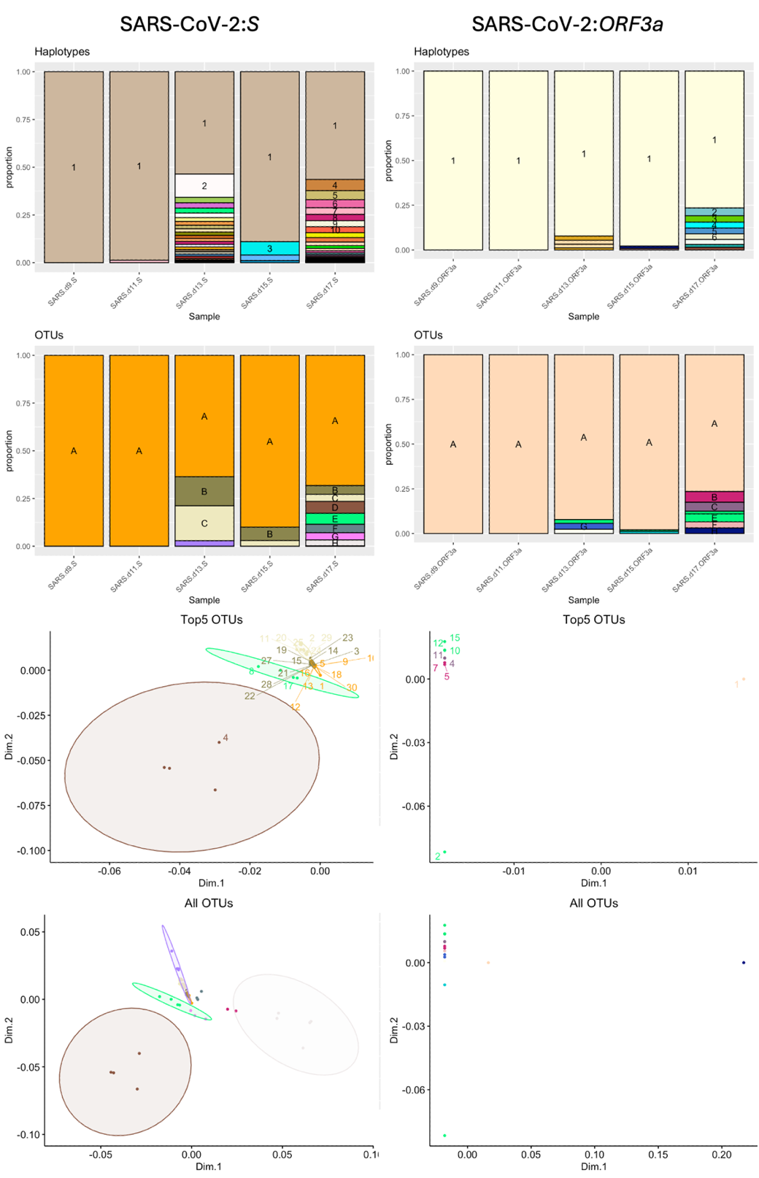
From top to bottom: 1. Stacked bar chart presenting the proportion of each unique haplotype (same color) identified across different samples within each gene dataset. 2. Stacked bar chart presenting the proportion of new OTUs, each consisting of genetically closely related haplotypes. 3. Multidimensional scaling (MDS) plot of haplotypes' pairwise SNV distance (dot), showing the five largest OTUs (circle) with a color scheme corresponding to plot b. 4. MDS plot of all OTUs.

