Supplementary Materials
Fig. S1. Mesopore classification algorithm.
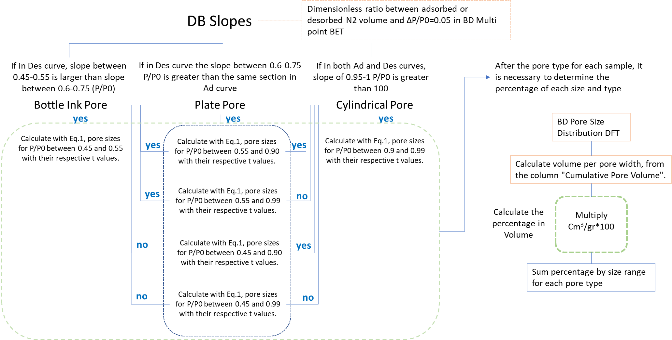

Fig. S2. Spearman rank correlation coefficients. Feldspar 0-2 cm.
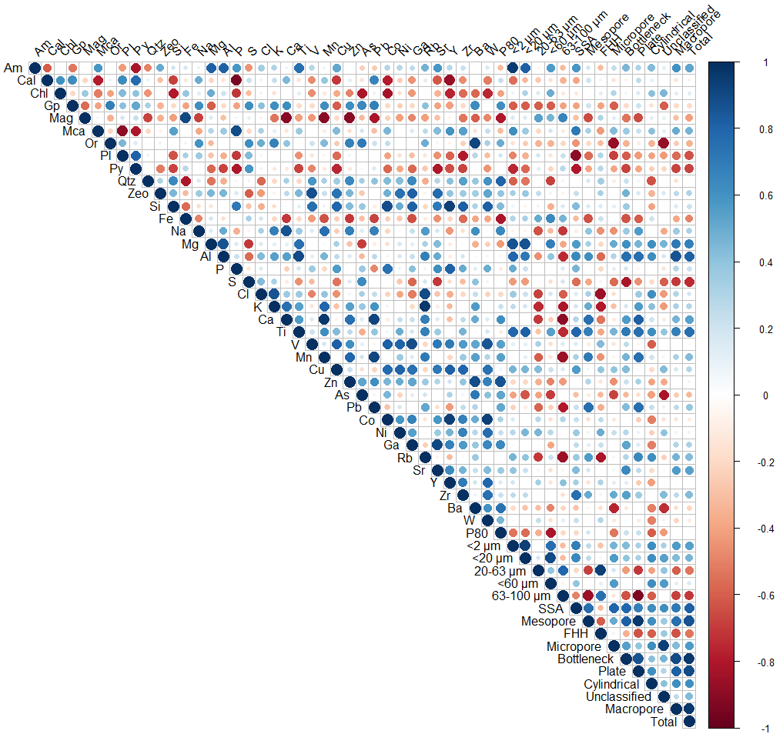

Fig. S3. Spearman rank correlation coefficients. Feldspar 50 cm.
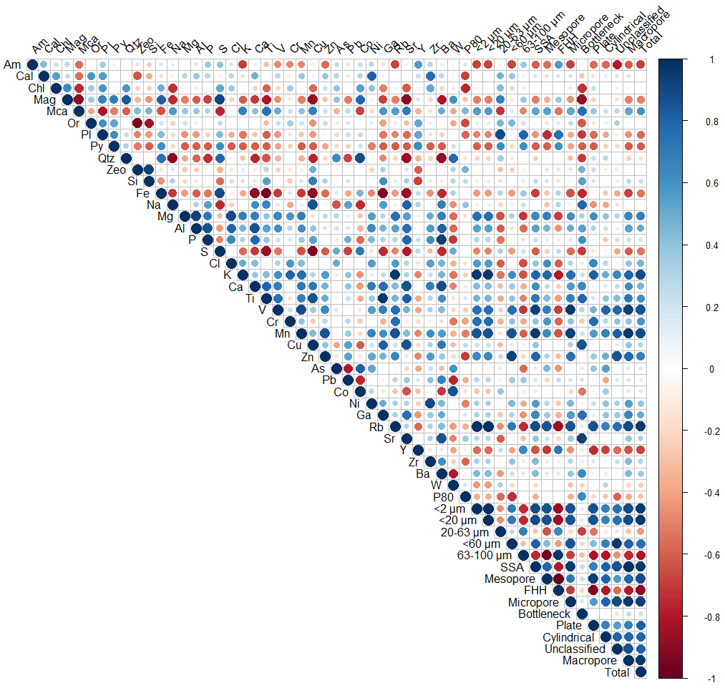

Fig. S4. Spearman rank correlation coefficients. Goethite 0-2 cm.
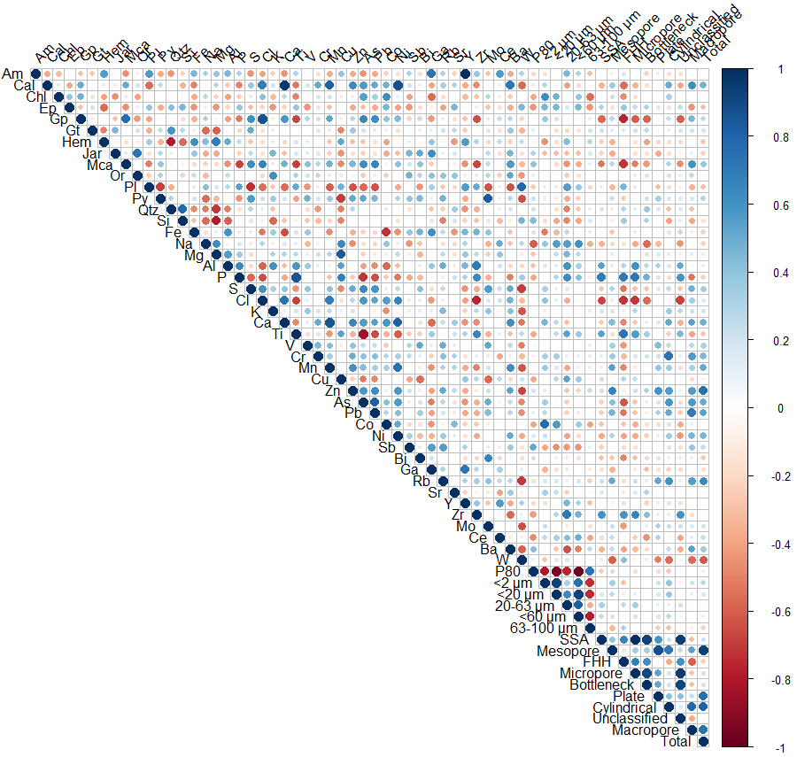

Fig. S5. Spearman rank correlation coefficients. Goethite 50 cm.
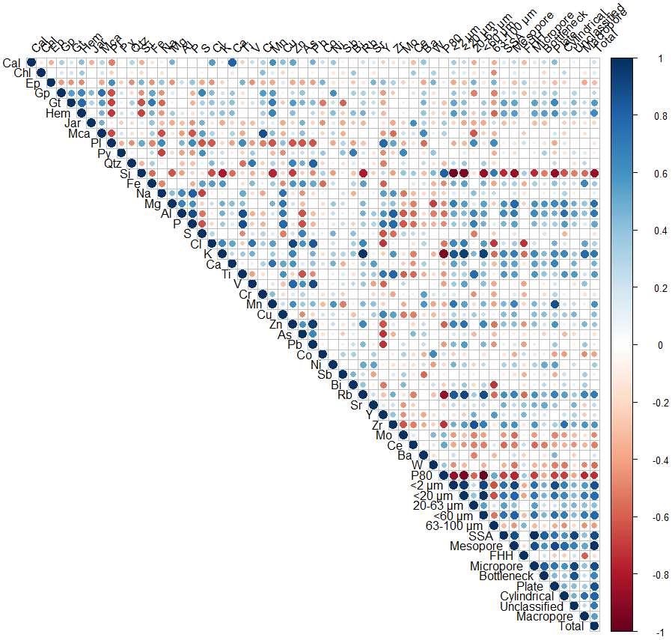

Fig. S6. Spearman rank correlation coefficients. Jarosite 0-2 cm.
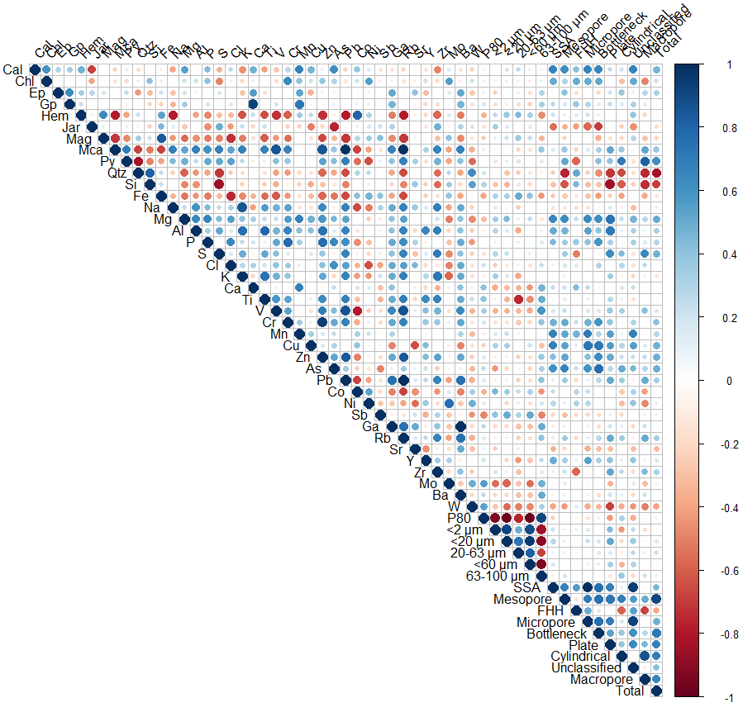

Fig. S7. Spearman rank correlation coefficients. Jarosite 50 cm.
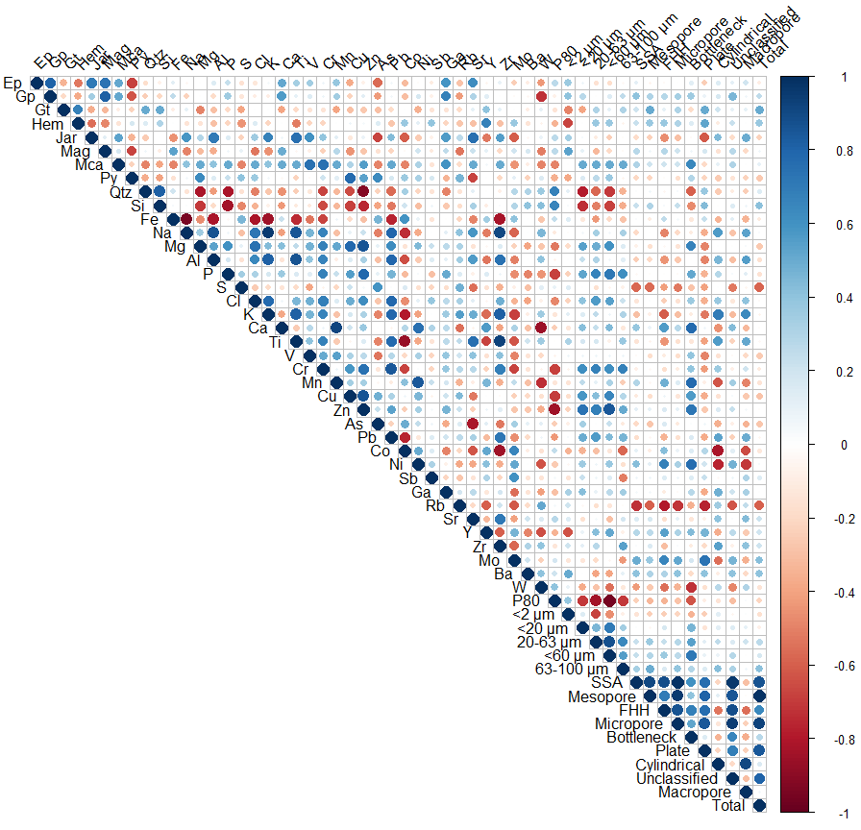

Fig. S8. Spearman rank correlation coefficients. Sulfate crusts.
