Supplemental Table 1. Key resource table
REAGENT or RESOURCE | SOURCE | IDENTIFIER
Antibodies
Rabbit anti-mTOR | Cell Signaling Technology | #2983; RRID:AB_2105622
Rabbit anti-p-mTOR (Ser2448) | Cell Signaling Technology | #5536; RRID:AB_10691552
Rabbit anti-P70S6K | Cell Signaling Technology | #9202; RRID:AB_331676
Rabbit anti-p-P70S6K (Thr389) | Cell Signaling Technology | #9234; RRID:AB_2269803
Rabbit anti-RIP3 | Abcam | #ab62344; RRID:AB_956268
Rabbit anti-GAPDH | Good Here | #AB-P-R001; RRID:AB_3096355
Mouse anti-GFAP | Cell Signaling Technology | #3670; RRID:AB_561049
Mouse anti-IBA1 | Abcam | #ab283319; RRID:AB_2924797
Mouse anti-NEUN | Proteintech | #66836-1-lg; RRID:AB_2882179
Goat anti-C3d | R&D | #AF2655; RRID:AB_2066622
Rabbit anti-TNF-α | ABclonal | #A11534; RRID:AB_2758597
Rabbit anti-Atf3 | Affinity | #DF3110; RRID:AB_2835487
Rabbit anti-c-Fos | Cell Signaling Technology | #2250; RRID:AB_2247211
Rabbit anti-GS | Proteintech | #11037-2-AP; RRID:AB_2110650
Rabbit anti-TSC2 | Cell Signaling Technology | #4308; RRID:AB_10547134
Mouse anti-Ub | Cell Signaling Technology | #3936; RRID:AB_331292
Rabbit anti-XIAP | Cell Signaling Technology | #2042; RRID:AB_2214870
Rabbit anti-PML | Abcam | #ab179466; RRID:AB_2891128
Rabbit anti-RAG1 | Abcam | #ab172637; RRID: AB_3101878
Rabbit anti-ITCH | Cell Signaling Technology | #12117; RRID:AB_2797822
Mouse anti-ITCH | Proteintech | #67757-1-lg; RRID:AB_2918525
Rabbit anti-p62 | Cell Signaling Technology | #8025; RRID:AB_10859911
Rabbit anti-FLAG | Proteintech | #20543-1-AP; RRID:AB_11232216
Rabbit anti-HA | Proteintech | #51064-2-AP; RRID:AB_11042321
Chemicals, peptides, and recombinant proteins
GSK872 | Abcam | #ab254395
Rapamycin | MCE | #HY-10219
Chloroquine | MCE | #HY-17589A
SAR405 | MCE | #HY-12481
MG132 | MCE | #HY-13259
EBSS | Solarbio | #H2020
DAB | ZSGBBIO technology | #ZLI-9018
DMSO | MCE | #HY-Y0320
DAPI | Abcam | #ab104139
Lipofectamine 3000 | Invitrogen | #3000015
RIPA lysis buffer | Beyotime | #P0013C
Protein A/G agarose beads | Santa Cruz | #sc-2003
Puromycin | Solarbio | #P8230

Supplemental Table 2. Primers for RT-PCR
Target genes | Forward (5’ - 3’) | Reverse (5’ - 3’)
IL-6 | TTTCTCTCCGCAAGAGACTTCC | TGTGGGTGGTATCCTCTGTGA
IL-1β | GGGATGATGACGACCTGCTA | ACAGCACGAGGCATTTTTGT
GAPDH | TCTCTGCTCCTCCCTGTTCT | ATCCGTTCACACCGACCTTC
TSC2 | GCCATGTGGTTCATTAGGTGC | GGTGCTCCGTGCTCTGAACT
RIP3 | TCGTGGGCTCTGAAGAACTG | ACCATAGCCTTCACCTCCCT

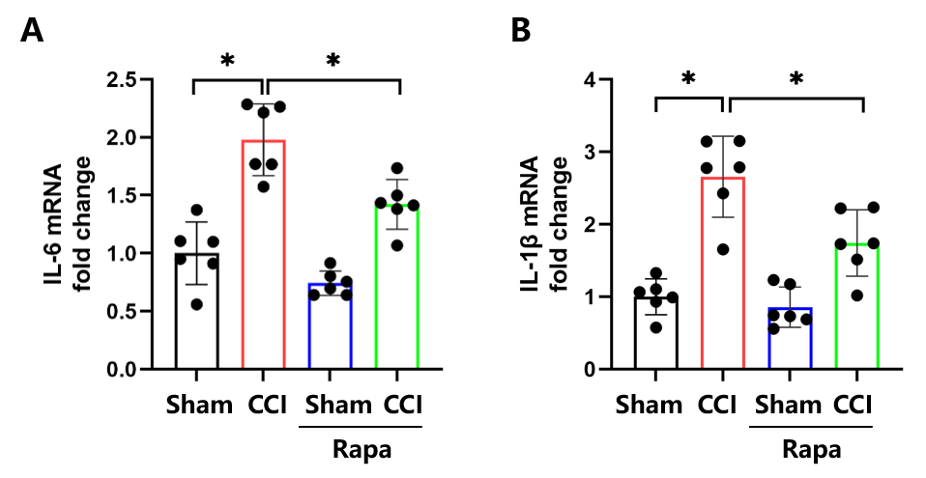
Supplementary Fig. S1. (A, B) mRNA levels of IL-6 (A) and IL-1β (B) in CCI rats treated with rapamycin. (*p < 0.05, n = 6 in each group)
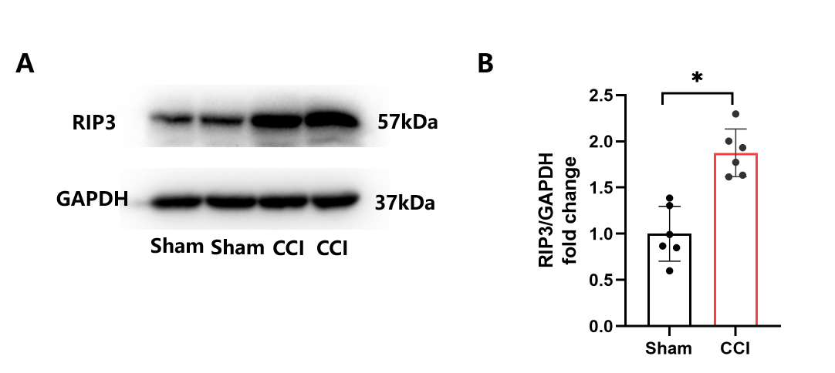
Supplementary Fig. S2. (A, B) Western blotting and quantification of the RIP3 to GAPDH ratio in Sham and CCI rats. (*p < 0.05, n = 6 in each group)
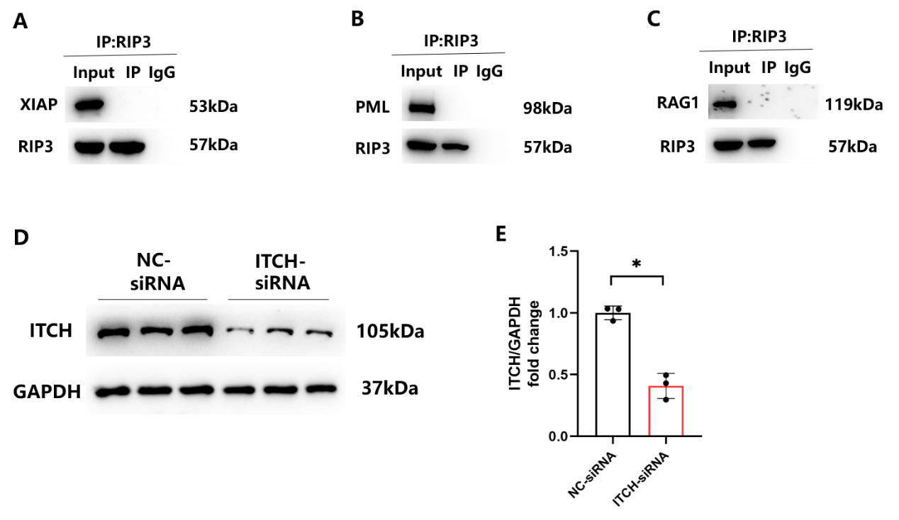
Supplementary Fig. S3. (A-C) Prepare cell lysates and immunoprecipitate with normal IgG or anti-RIP3 antibodies. Co-IP illustrated an absence of any interaction of XIAP(A) /PML(B) /RAG1(C) with RIP3. (D, E) Protein expression of ITCH in NC-siRNA and ITCH-siRNA astrocytes as determined and quantified using western blots. (*p < 0.05, n = 3 in each group)
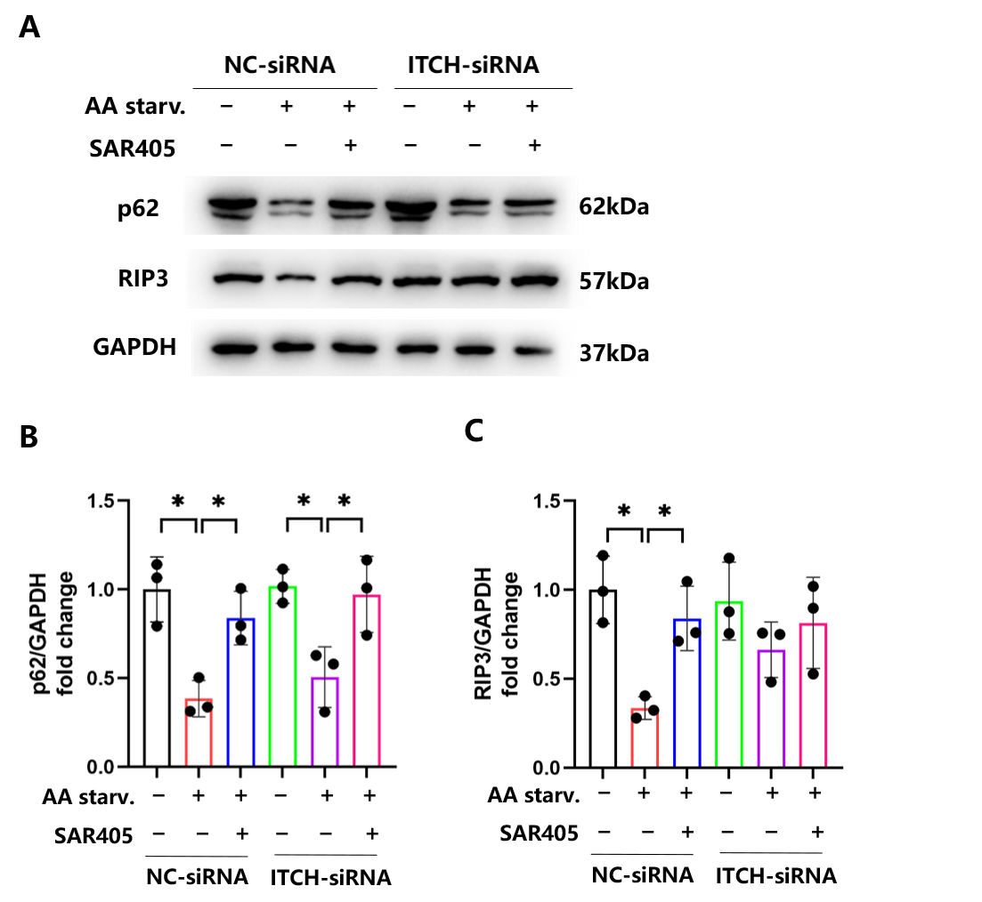
Supplementary Fig. S4. (A-C) NC-siRNA and ITCH-siRNA astrocytes were treated with EBSS medium with or without 10μM SAR405 for 24 hours. Protein expressions of p62 and RIP3 were determined and quantified using western blots. (*p < 0.05, n = 3 in each group)

