Supporting Information for

Robust low threshold continuous-wave full-color upconversion lasing in rare-earth activated nanocrystal-in-glass microcavity
Zhigang Gao ¹, Lugui Cui ², Yushi Chu ², Luyue Niu ², Lehan Wang ², Rui Zhao ¹, Yulong Yang ², Xiaofeng Liu ³, Jing Ren ^{2✉} and Guoping Dong ^{4✉}
¹ College of Physics and Electronic Engineering, Taishan University, Taian 271021, China
² Key Laboratory of In-fiber Integrated Optics of Ministry of Education, College of Physics and Optoelectronic Engineering, Harbin Engineering University, Harbin 150001, China
³ School of Materials Science and Engineering, Zhejiang University, Hangzhou, China
⁴ State Key Laboratory of Luminescent Materials and Devices, and Guangdong Provincial Key Laboratory of Fiber Laser Materials and Applied Techniques, South China University of Technology, Guangzhou 510640, China
Correspondence: Jing Ren (ren.jing@hrbeu.edu.cn); Guoping Dong (dgp@scut.edu.cn)

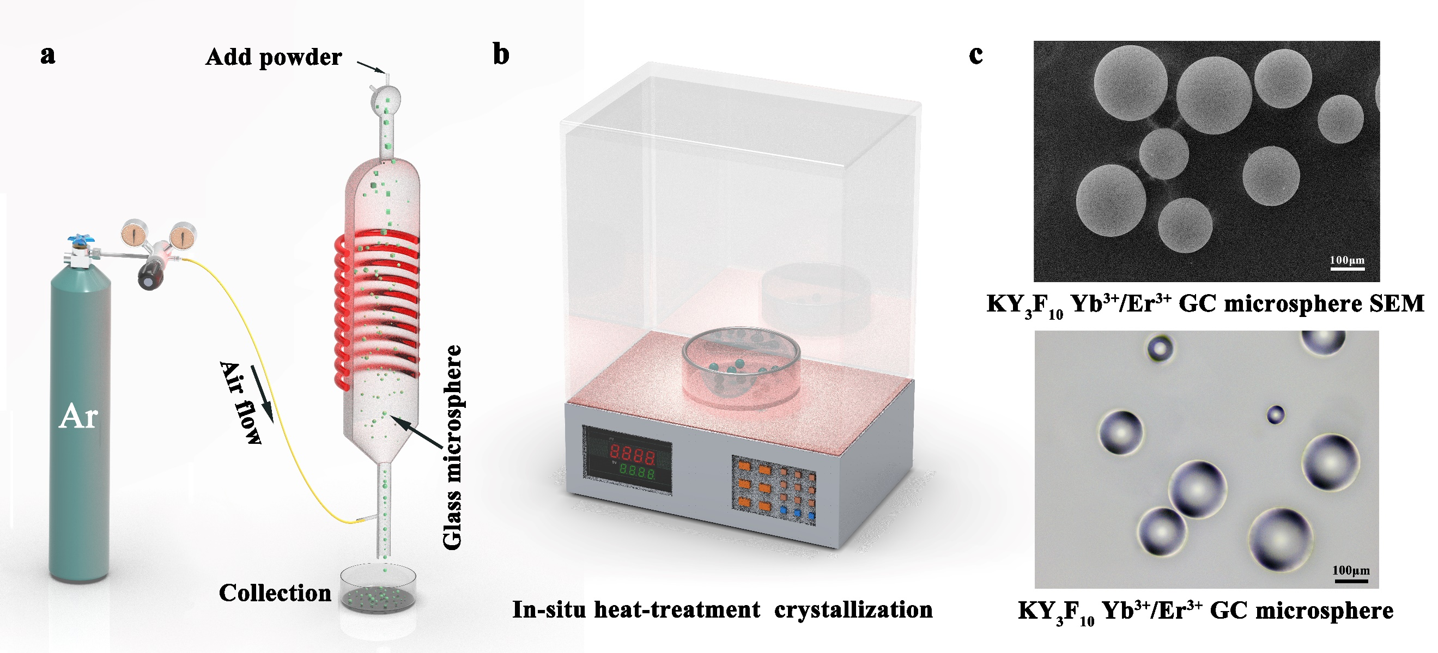
Fig. S1 a Schematic of the powder floating method used to prepare precursor glass (PG) microspheres; b Nano-glass composite (GC) microspheres were obtained by heat-treatment induced crystallization of the PG microspheres; c Scanning electron microscopy (SEM) images of the as-made GC microspheres.

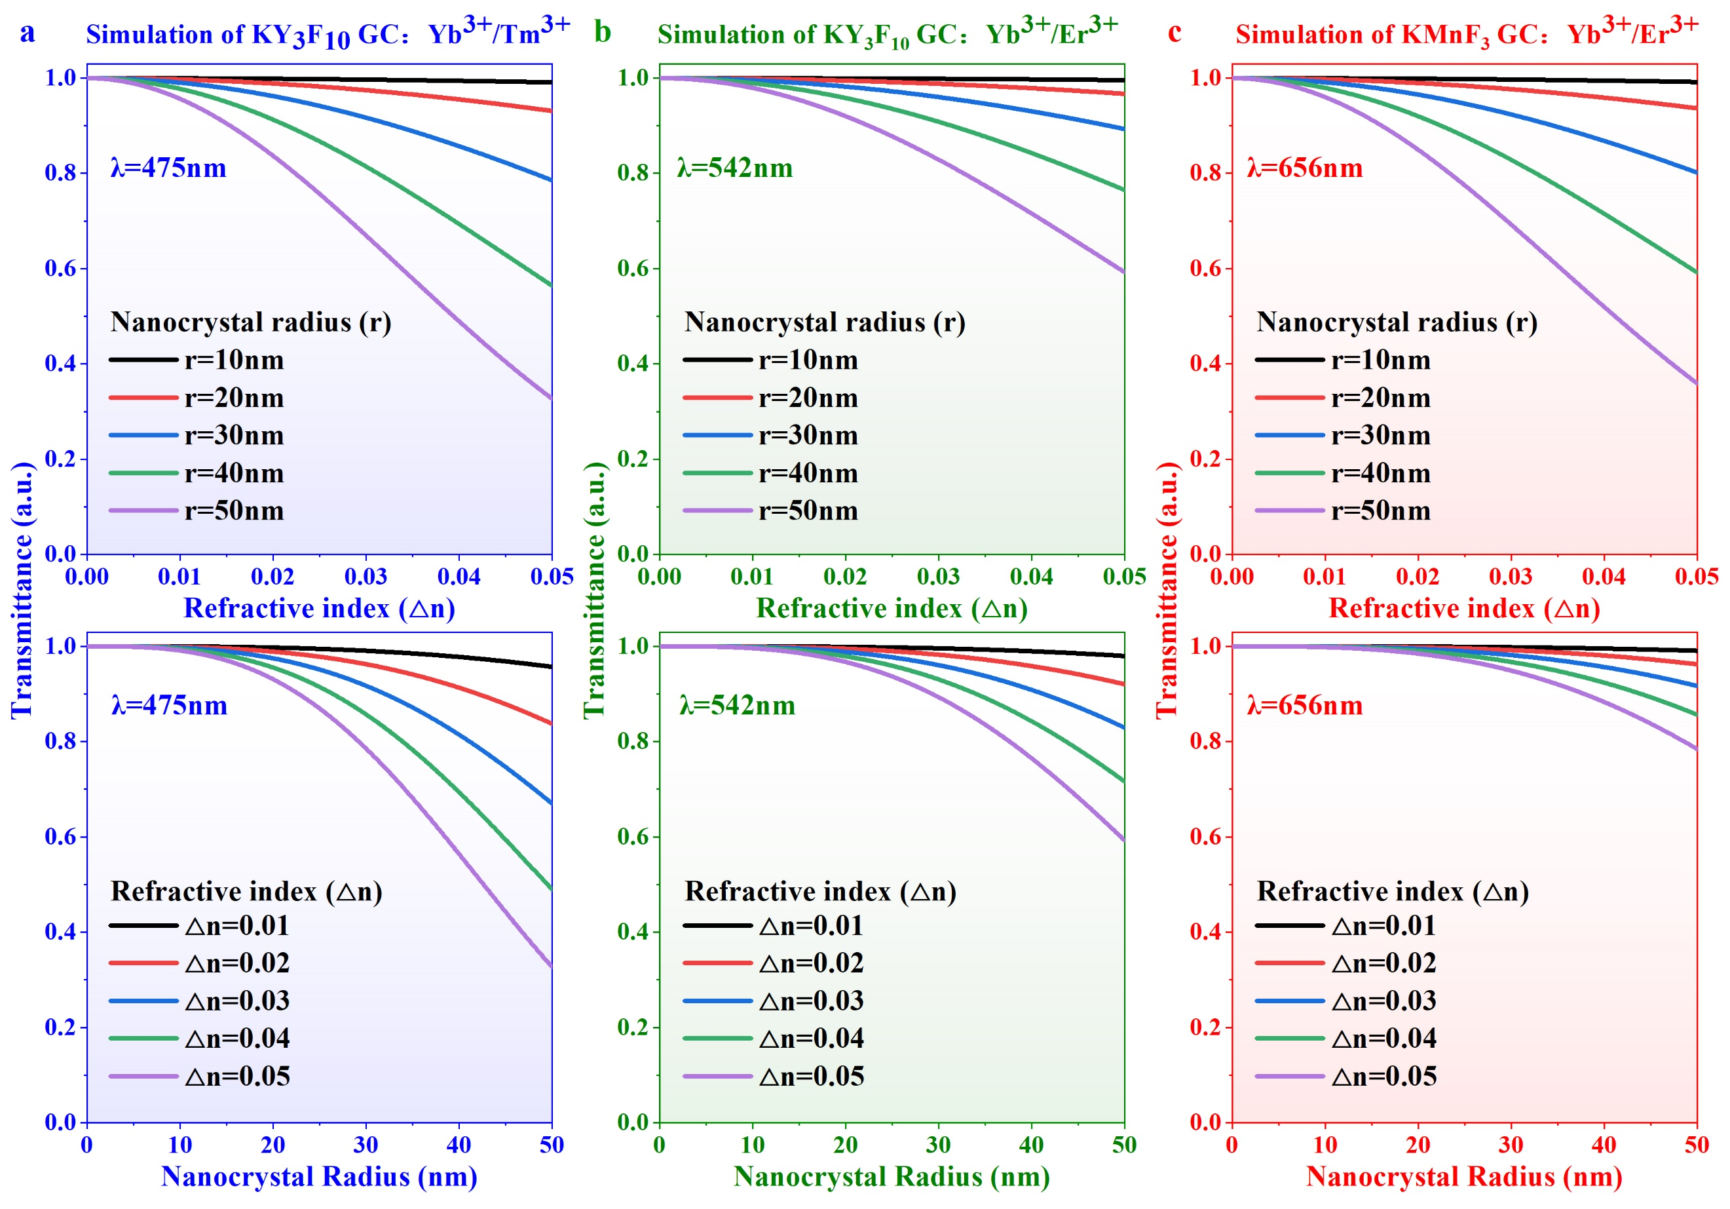
Fig. S2 Theoretical transmittance of the GCs incorporating a Yb³⁺/Tm³⁺, b Yb³⁺/Er³⁺ doped KY₃F₁₀ NCs, and c Yb³⁺/Er³⁺ doped KMnF₃ NCs. The first row shows the dependence of transmittance on the refractive indices difference between the NCs and the glass matrix at different fixed particle radii of NCs, and the second row is dependence of transmittance on the particle size of NCs at different fixed refractive index differences.
The light scattering by the nano-glass composites can be described by using the Rayleigh scattering model, and the theoretical transmittance can be obtained as ^{[1]}:
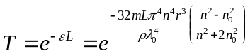 (S1)
where, ε is the scattering loss, L is the optical path, m is the total mass of the embedded NCs, ρ is the packing density of NCs in the glass matrix, r is the radius of NCs, n₀ and n are the refractive indices of the glass matrix and the NCs respectively, λ₀ is the wavelength of light in vacuum. The numerical model of Rayleigh scattering was constructed by function analysis using COSMOL Multiphysics software. The following parameters were used in the calculation: The refractive indices of the glass matrix, KY₃F₁₀ and KMnF₃ NCs are 1.52, 1.48, 1.45, respectively ^{[2]}. The volume fraction ρ of KY₃F₁₀ and KMnF₃ NCs is 20%, and their respective densities are 3.10 g/cm³, and 2.69 g/cm³.
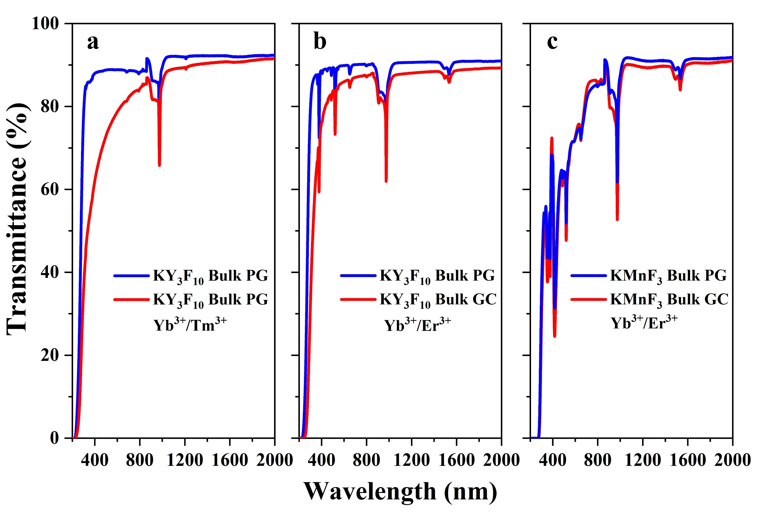
Fig. S3 Transmission spectra of samples. a-b PG and the corresponding GC samples incorporating a Yb³⁺/Tm³⁺, b Yb³⁺/Er³⁺doped KY₃F₁₀, and cYb³⁺/Er³⁺ doped KMnF₃ NCs. The transmittance reduces in the wavelength region near the electronic absorption edge because of the Rayleigh scattering induced by the NCs, but at the output wavelength of the lasers, the transmittance exceeds 80%. The main reason for maintaining the high transmittance after crystallization are the small size of the crystals, small refractive index mismatch between the crystals and glass matrix, and the absence of birefringence because of the isotropic nature of the crystals.

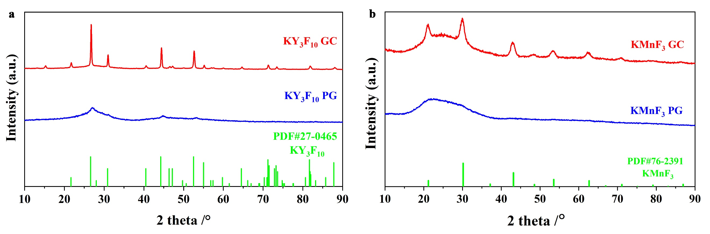
Fig. S4 X-ray diffraction (XRD) patterns of the precursor glass (PG) and the corresponding GC samples incorporating a KY₃F₁₀ and b KMnF₃ nanocrystals. The PG samples display a typical amorphous hump, while several sharp diffraction peaks attributing to the KY₃F₁₀ (JCPDS No. 27-0465) and KMnF₃ crystals (JCPDS No. 76-2391) appear in the GC samples.

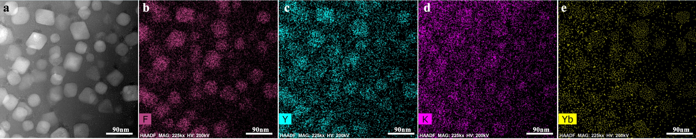
Fig. S5 a HAADF-STEM image of the microsphere, and b-e elemental mappings with the concentration reflected by the brightness in color.
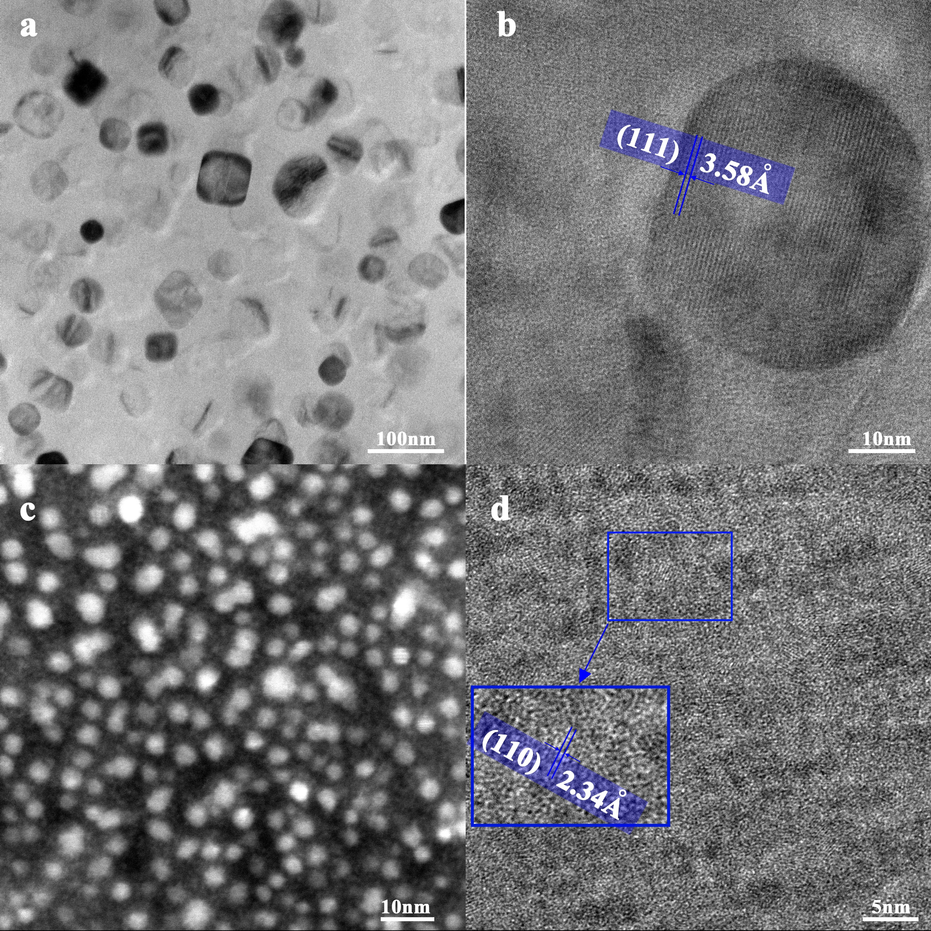
Fig. S6 a, c Transmission electron microscopy (TEM) images of the GCs incorporating a KY₃F₁₀ and c KMnF₃ crystals. The sizes of KY₃F₁₀ and KMnF₃ NCs are among 20~50 nm and 8~20 nm respectively, and these NCs are uniformly dispersed in the amorphous glass matrix. b, d High-resolution transmission electron microscopy (HR-TEM) images of a single b KY₃F₁₀ and d KMnF₃ nanocrystal. The crystal lattices with a d-spacings of 3.58 and 2.34 $\text{Å}$ match well with the (111) planes of the KY₃F₁₀ and KMnF₃ crystals, respectively.

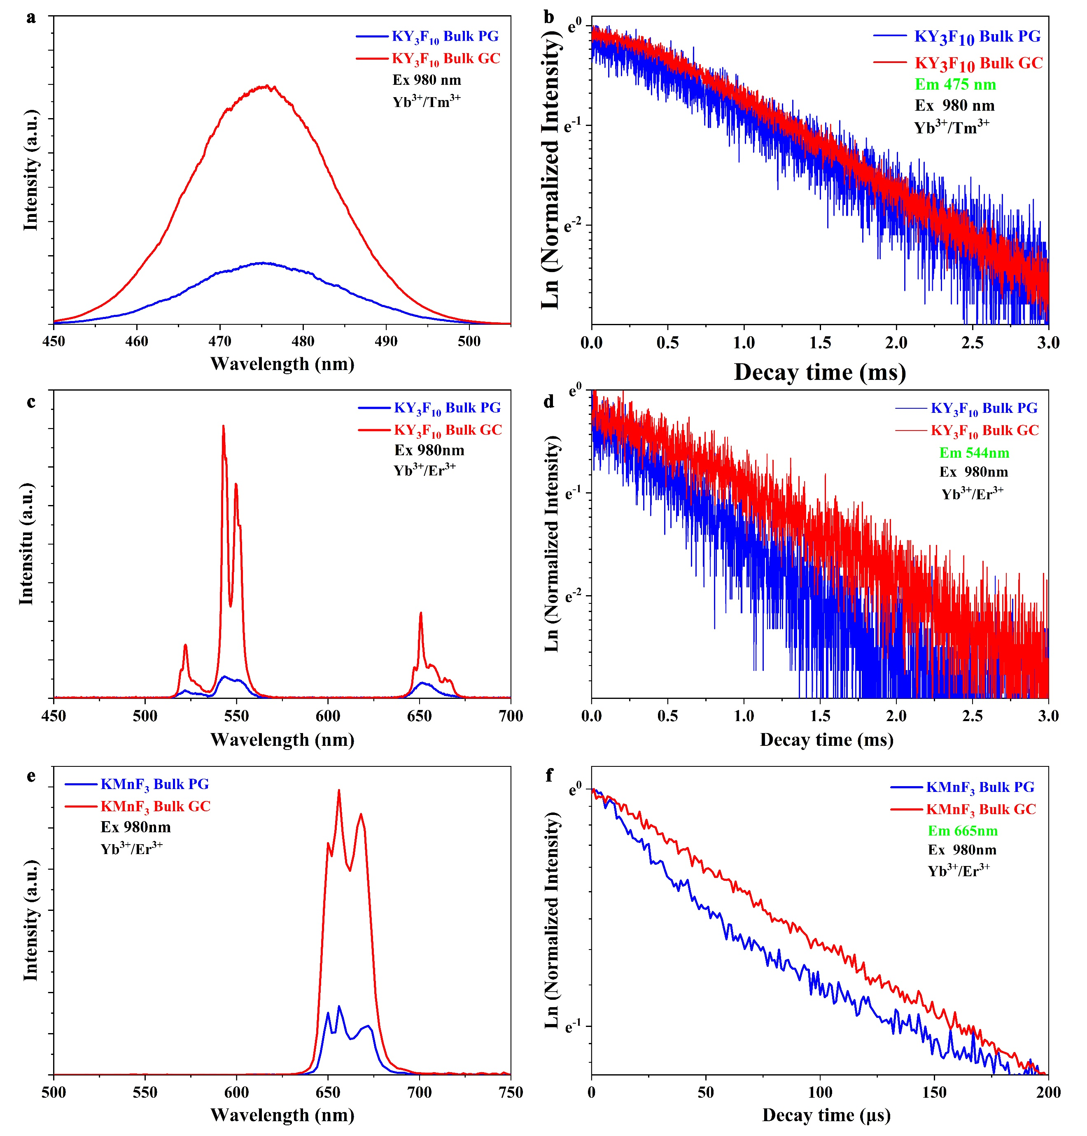
Fig. S7 Upconversion luminescence spectra of the PG and GC samples under excitation by a 980 nm laser diode. a PG and the corresponding GC incorporating Yb³⁺/Tm³⁺ doped KY₃F₁₀ NCs, c PG and the corresponding GC incorporating Yb³⁺/Er³⁺ doped KY₃F₁₀ NCs, e PG and the corresponding GC incorporating Yb³⁺/Er³⁺ doped KMnF₃ NCs. In all cases, as compared to the PG samples, the UCL intensities of the GC samples are much stronger. The corresponding decay curves of the upconversion emissions of samples are shown in b, d and f. The decay rates of GCs are slower than those of PGs due to the change of the local environment for rare earth ions as a result of the transition from amorphous glassy phase of high-lattice phonon energies to the crystalline phase with much lower phonon energies.

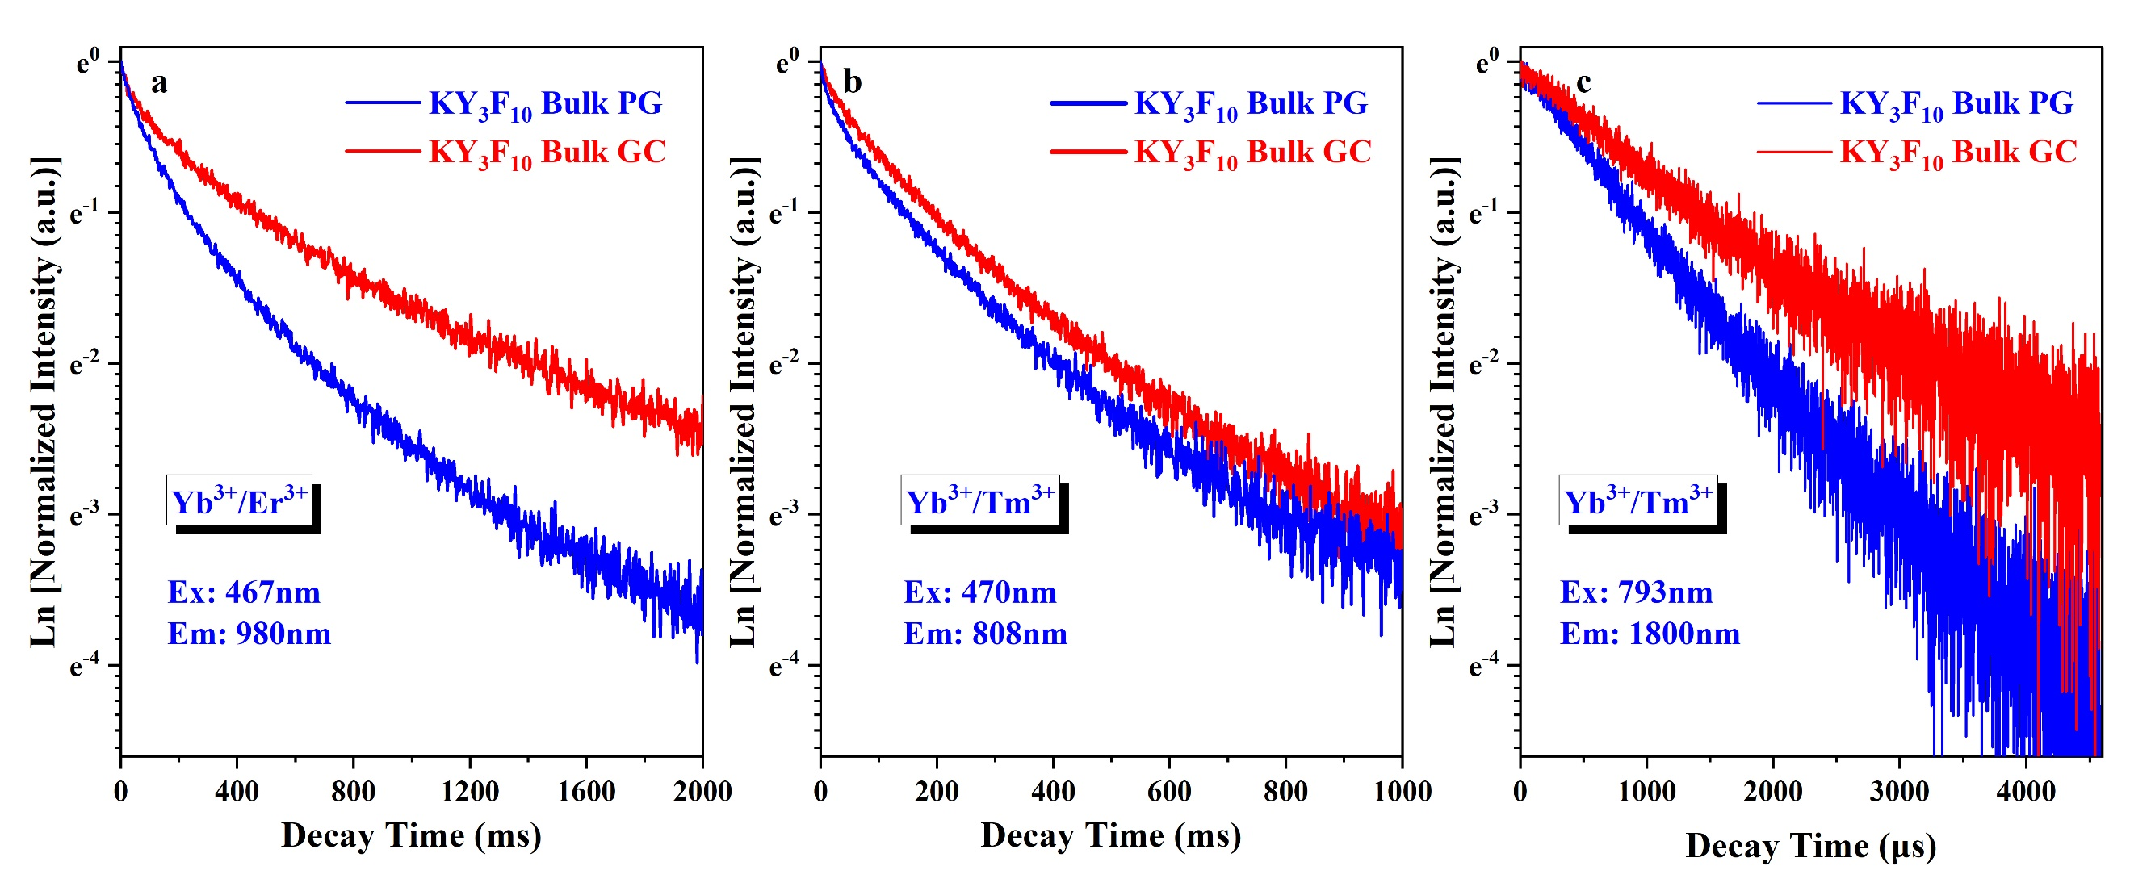
Fig. S8 PL decay curves of samples. a Decay curves of the 980 nm emission from the PG and the corresponding GC incorporating Yb³⁺/Er³⁺ codoped KY₃F₁₀ NCs. Decay curves of the b 808 nm and c 1800 nm emissions from the PG and the corresponding GC incorporating Yb³⁺/Tm³⁺ codoped KY₃F₁₀ NCs. In all cases, the PL decay times of GCs are longer than those of PGs, benefiting the promotion of upconversion luminescence.
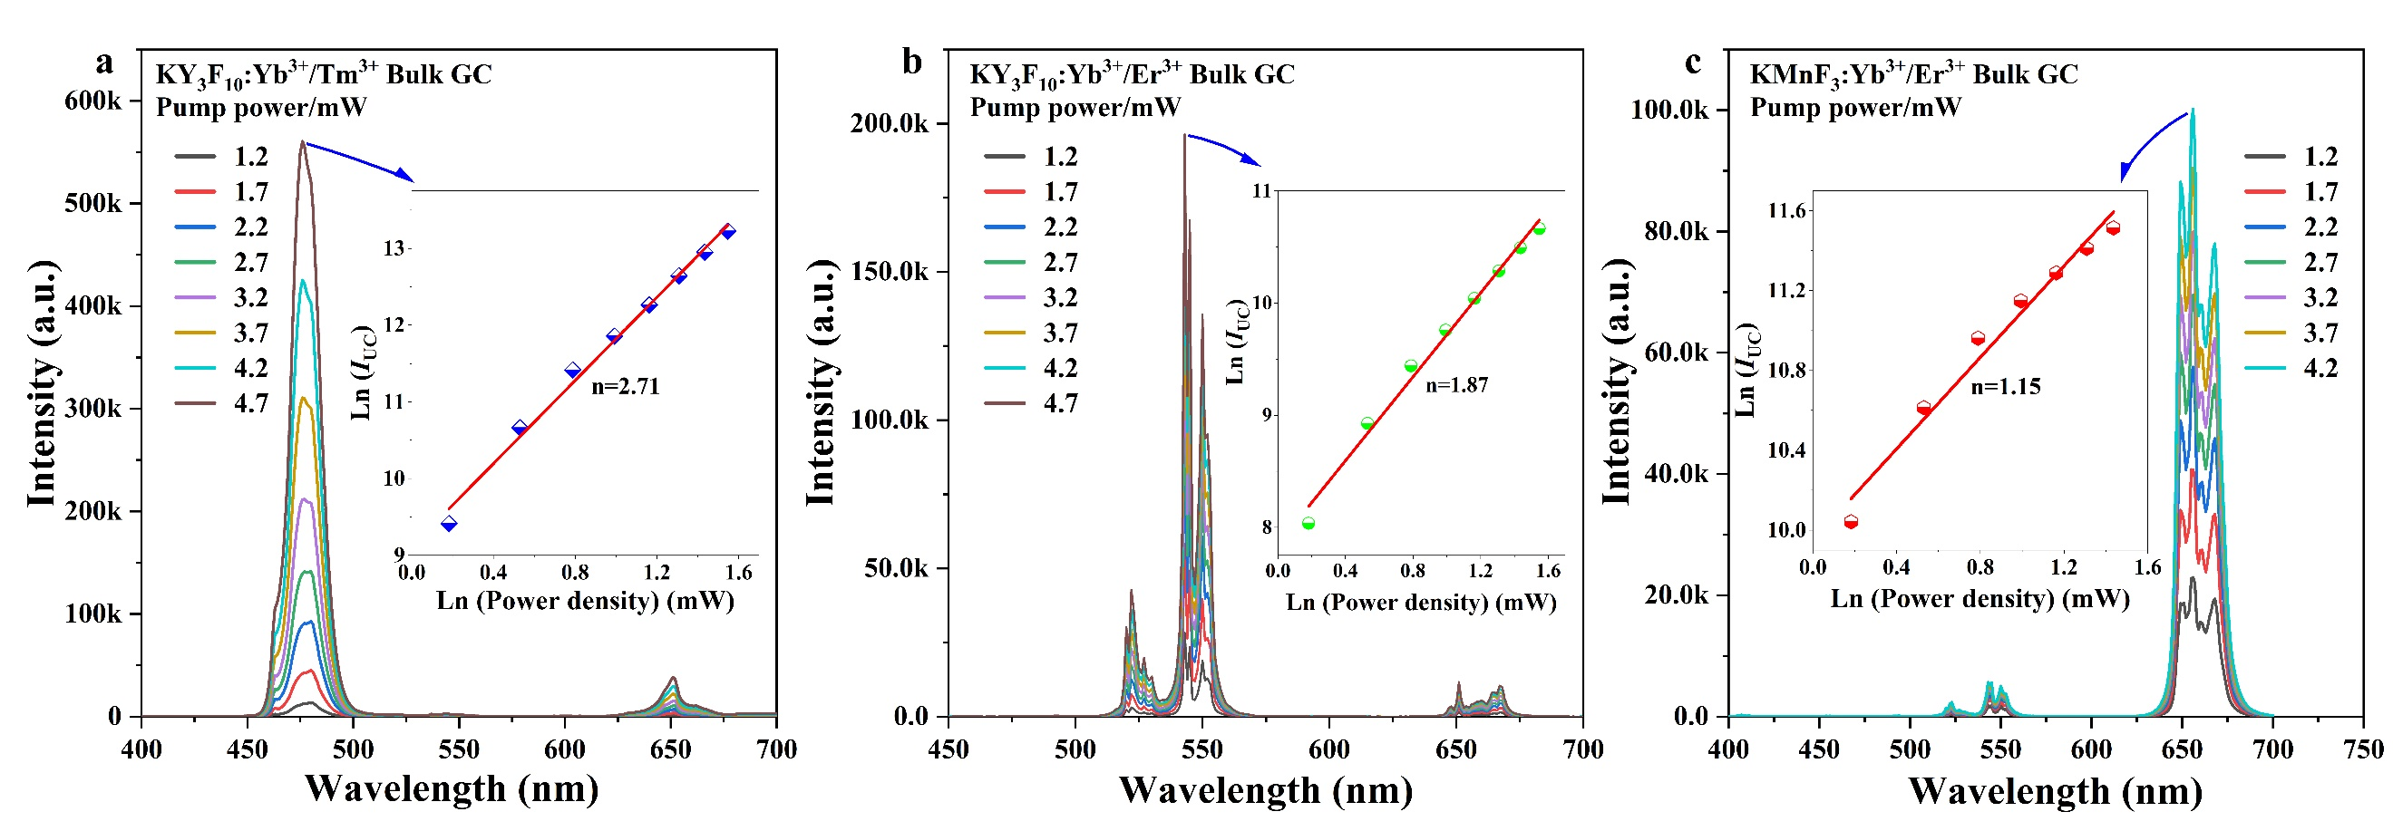
Fig. S9 Upconversion luminescence spectra of a the 475 nm blue emission from the PG and the corresponding GC incorporating Yb³⁺/Tm³⁺ doped KY₃F₁₀ NCs, b the 544 nm green emission from the PG and the corresponding GC incorporating Yb³⁺/Er³⁺ doped KY₃F₁₀ NCs, and c the 665 nm red emission from the PG and the corresponding GC incorporating Yb³⁺/Er³⁺ doped KMnF₃ NCs under different excitation powers (P_{pump}). Insets: Plots of Log(P_{pump}) versus Log(I_{UC}), and fits to a linear function. I_{UC} stands for the peak intensity of the upconversion luminescence. The results indicate that the blue and red UC emissions occur through a two-photon absorption process, while the red emission is dominated by a three-photon absorption process.

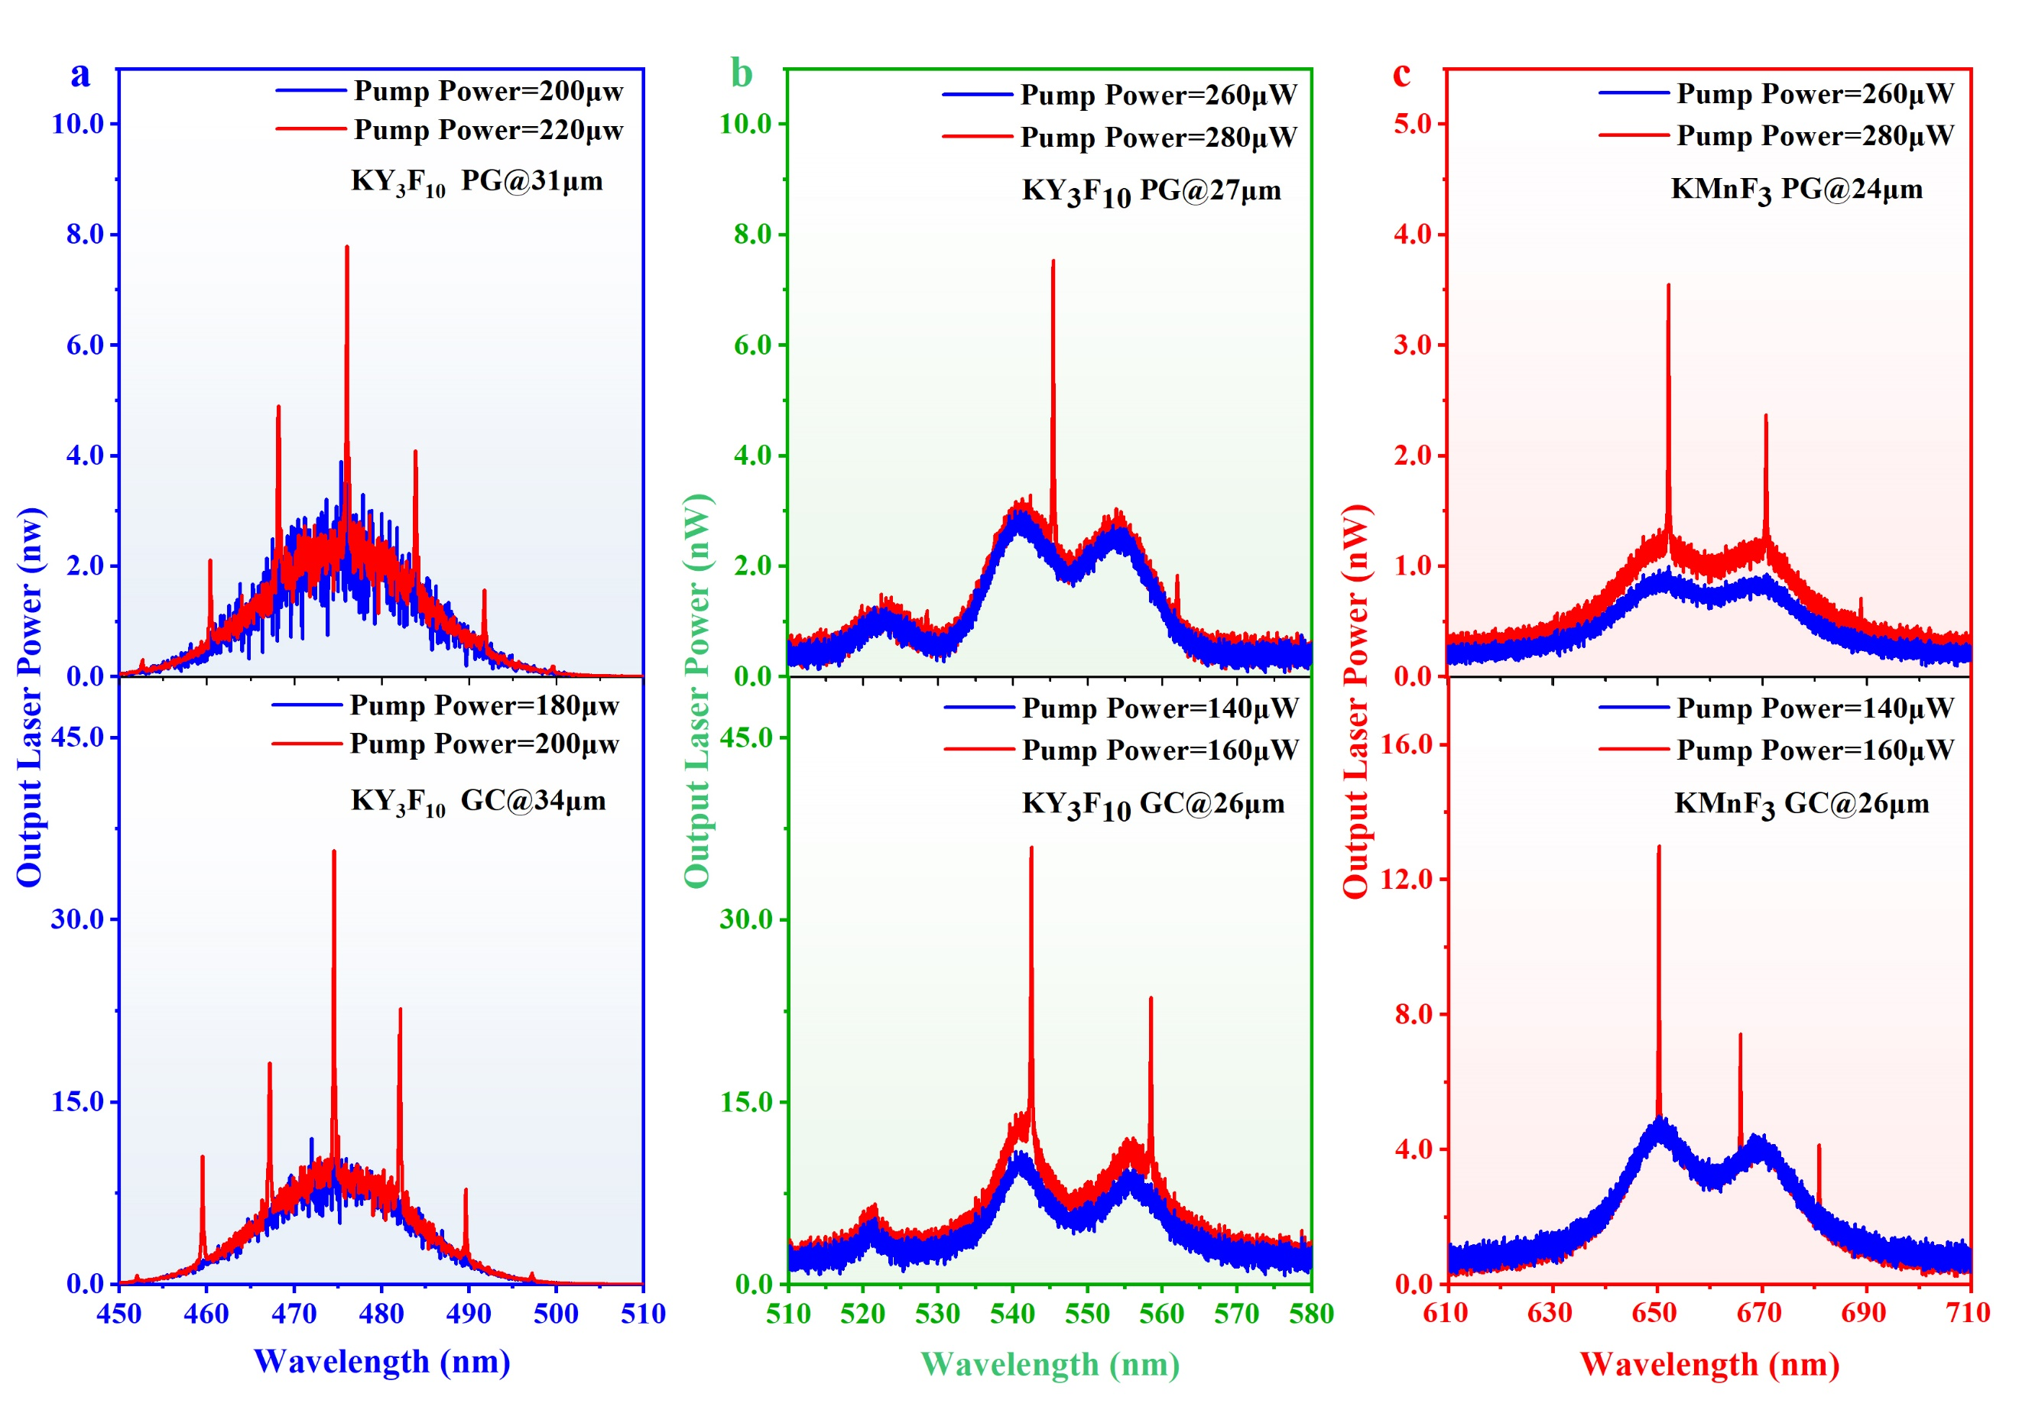
Fig. S10 UC emission spectra of a blue, b green, and c red microspheres obtained at pumping powers of a 980 nm LD below and above the threshold.
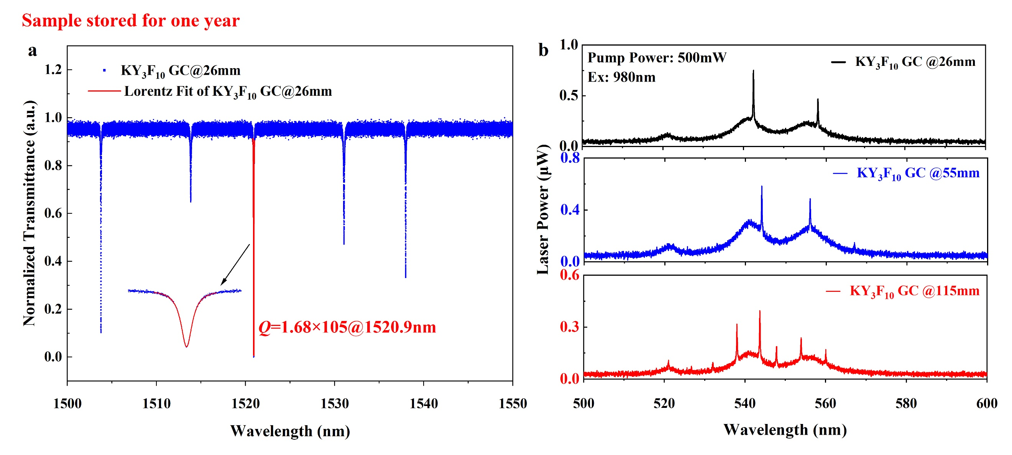
Fig. S11 a Quality factor, and b laser spectra measured of a Yb³⁺/Er³⁺-doped GC microsphere stored at ambient atmosphere for one year.

Note1: Simulation method
Simulation is performed by using the commercial finite element software COSMOL Multiphysics for model construction, calculation and result processing. In the simulation, the characteristic frequency of the wave optics module was used to calculate the quality factor (Q), resonance frequency, and corresponding electric field distribution of WGM microspheres. Transmittance spectrum and coupling efficiency of WGM microspheres were calculated using frequency domain methods. It should be noted that due to the large size of the microsphere, a symmetric structure was used in the analysis of its characteristic frequencies and frequency domain to reduce the degrees of freedom in model analysis. Perfect electrical conductor boundary conditions were applied on the symmetry plane to ensure that the model is in standard TE mode.

Note 2: Calculation of resonant wavelengths of WGM
All the WGMs shown in Figure 3(c) can be ascribed to transverse electric (TE) modes, with the resonance wavelengths well fitted by the asymptotic equation: ^{[3-4]}
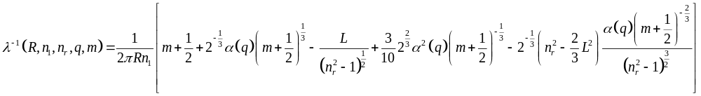 S(2)
where 𝜆 is the resonant wavelength, 𝑅 is the microsphere radius, 𝑛₁ is the refractive index of the microcavity, 𝑛_{𝑟}= 𝑛₁/𝑛₂ with 𝑛₂ the refractive index of the surrounding medium, 𝐿=𝑛_{𝑟} for TE modes, 𝛼(𝑞) are the roots of the Airy function, and 𝑞 as the radial mode number, respectively. There are slightly differences between the theoretical and experimental wavelengths, which is ascribed to the ellipsoid of the microsphere, the relative position of the microsphere and the coupling tapered fiber and the ambient temperature fluctuation.
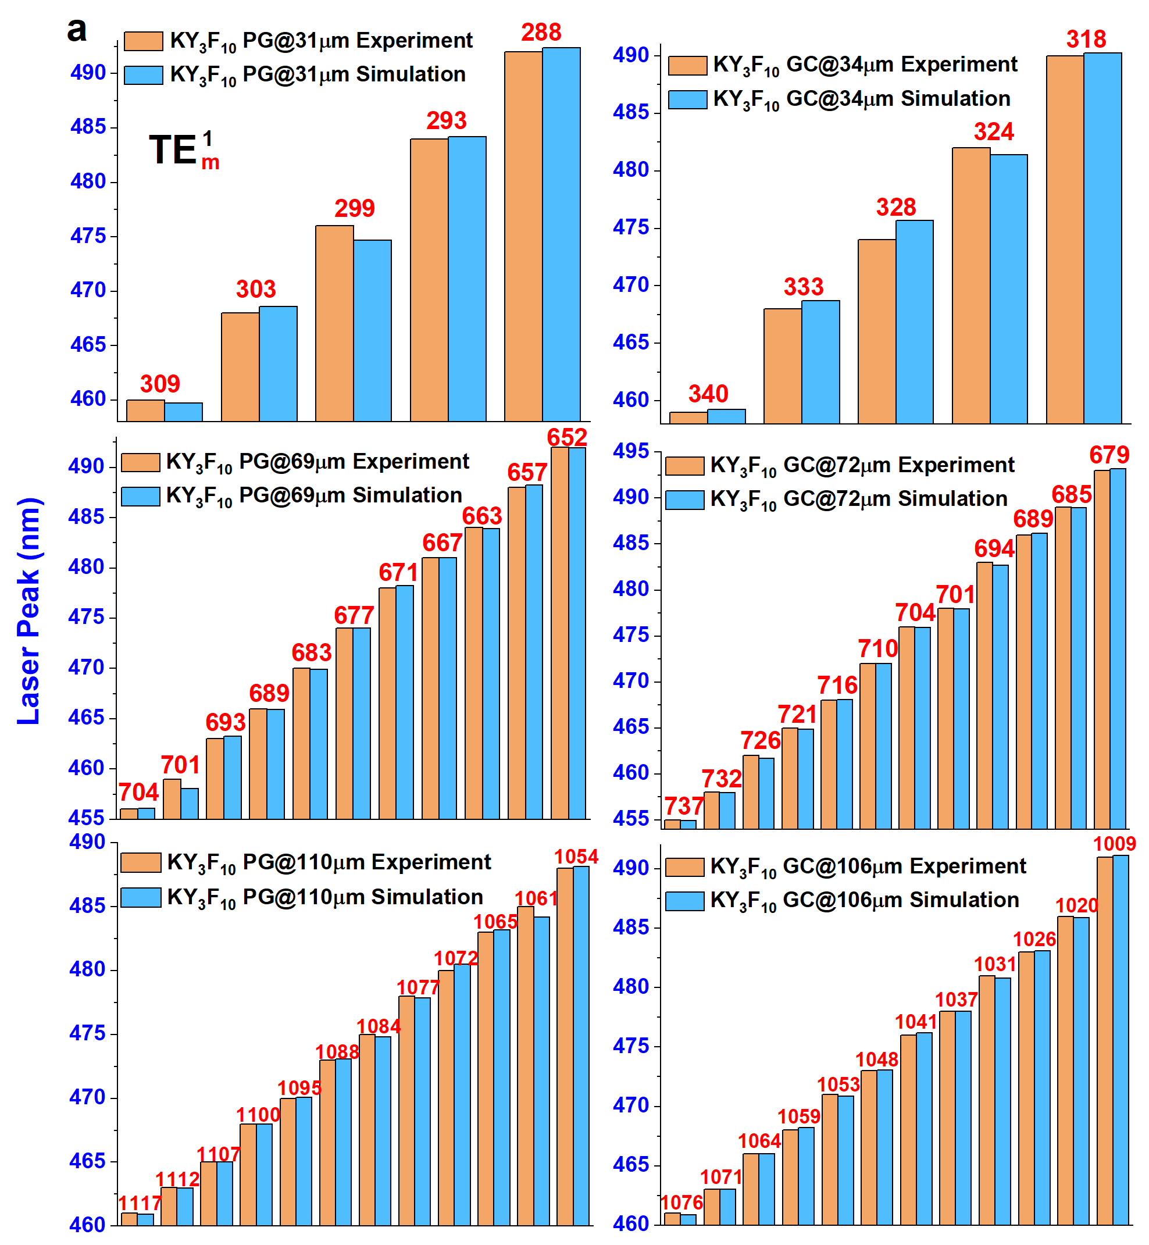
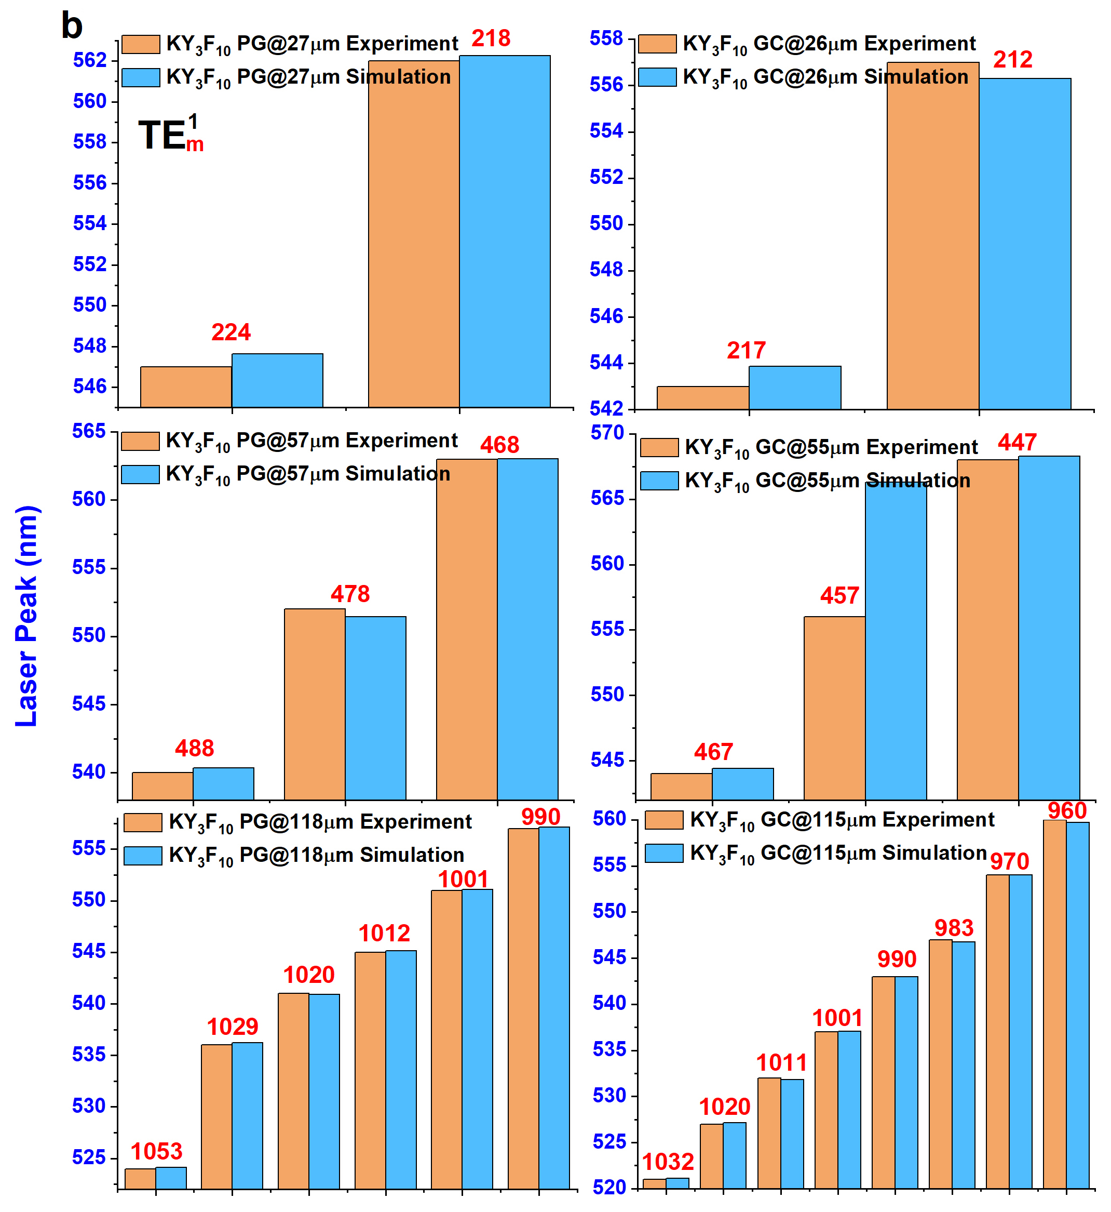
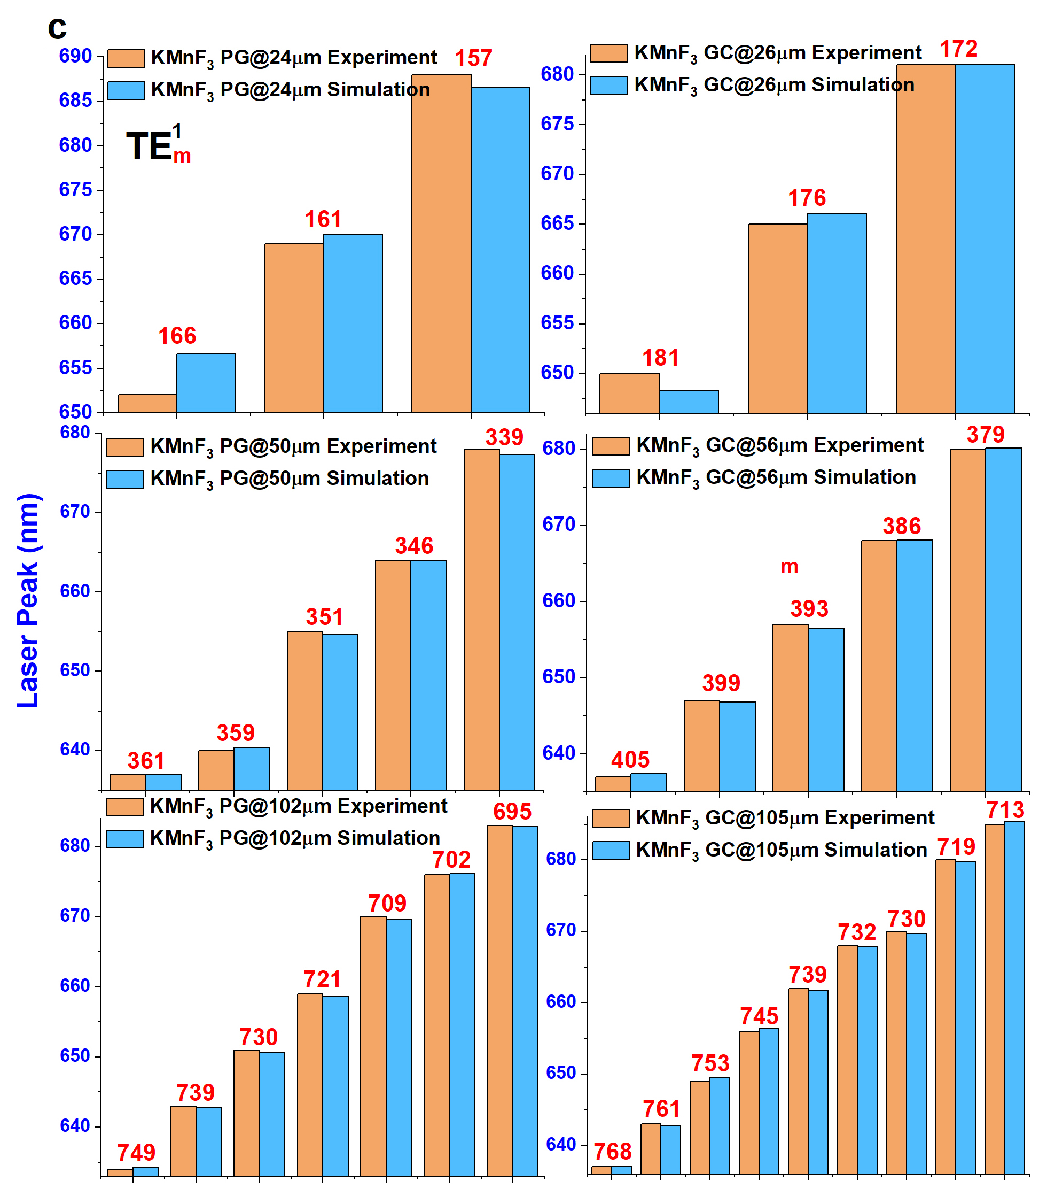
Fig. S12 a–c Experimentally determined λ_{exp} (orange columns) and theoretically calculated λ_{cal} (blue columns) resonance wavelengths of blue a, green b and red c microspheres. m is azimuthal quantum number of TE modes marked in the figure.
Note 3: Judd-Ofelt (JO) analysis and calculation of σ_{em}×τ
The JO intensity parameters (Ω_{2,} Ω_{4,} Ω₆) were obtained by fitting the experimentally determined oscillator strength f_{exp} against the theoretical ones ^{[5-6]}. Based on the JO parameters, the spontaneous transition probability A_{rad} can be expressed as:
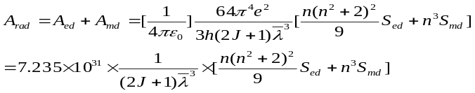 S(3)
where A_{ed} (s⁻¹) and A_{md} (s⁻¹) are the electric-dipole and magnet-dipole transition probabilities, respectively, and S_{ed} (cm²) and S_{md} (cm²) are the electric-dipole and magnet-dipole line strengths according to:
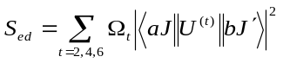 S(4)
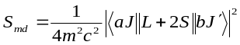 S(5)
The emission cross-section, σ_{em}, can be calculated from the measured emission spectra according to the Fuchtbauer-Ladenburg equation:
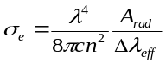 S(6)
where ∆λ_{eff} is the effective fluorescence bandwidth that can be calculated by dividing the area of the emission band by its peak height.

Table S1 Comparison of laser performance of infrared-to-visible UC WGM lasers
Year | Cavity design | Pump parameter | Wavelength  (nm) | FWHM  (nm) | Threshold | Q value | Slope efficiency
1999  ^{[7]} | Tm³⁺-doped ZBLAN microsphere (diameter D: 65 μm) | 1064 nm ns-pulsed laser, room temperature (RT), free space coupling | 480 | / | 20 mW | / | /
1999  ^{[8]} | Er³⁺-doped ZBLAN microsphere (D: 120 μm) | 801 nm CW laser, RT, prism coupling | 539 | / | 30 µW | / | /
2009  ^{[9]} | Er³⁺-doped silica microtoroid | 1450 nm CW laser, RT, tapered optical fiber coupling | 550 | / | 690 µW | / | /
2010  ^{[10]} | Er³⁺-doped ZBNA microsphere (D: 60 μm) | 978 nm LD laser, RT, tapered optical fiber coupling | 550 | <1 nm | 3 µW | ~1000 | /
2013  ^{[11]} | Tm³⁺-doped silica microtoroid | 1064 nm CW laser, RT, tapered optical fiber coupling | 450 | / | 32 µW | / | /
2013  ^{[12]} | NaYF₄:Yb³⁺/Er³⁺@NaYF₄ nanoparticle-coated micro bottle (D: 80 μm) | 980 nm ns-pulsed laser, RT, free space coupling | 407 | < 0.2 | 8.5 kW/cm² | >2035 | Note
2013  ^{[12]} |  | 980 nm ns-pulsed laser, RT, free space coupling | 540 | < 0.2 | 5.5 kW/cm² | >2700 | Note
2013  ^{[12]} |  | 980 nm ns-pulsed laser, RT, free space coupling | 655 | < 0.2 | 7.5 kW/cm² | >3275 | Note
2017  ^{[13]} | Yb³⁺/ Tm³⁺/Er³⁺ doped NaYF₄ hexagonal microrod (radius R: 4 μm) | 980 nm ns-pulsed laser, RT, free space coupling | 450 | / | 4.8 mJ/cm² | / | /
2017  ^{[13]} |  | 980 nm ns-pulsed laser, RT, free space coupling | 540 | / | 3.8 mJ/cm² | / | /
2017  ^{[13]} |  | 980 nm ns-pulsed laser, RT, free space coupling | 654 | / | 3.0 mJ/cm² | / | /
2018  ^{[14]} | Yb³⁺/Er³⁺ doped fluorosilicate glass microsphere (D: 58 μm) | 980 nm LD, RT, tapered optical fiber coupling | 545 | / | 52.5 µW | / | /
2018  ^{[15]} | NaYF₄:Gd³⁺/Tm³⁺@NaGdF₄ nanoparticle-coated polystyrene microsphere (D: 5 μm) | 1064 nm CW laser, RT, free space coupling | 450 | 0.7 | 44 kW/cm² | 643 | /
2021  ^{[16]} | NaGdF₄:Yb³⁺/Tm³⁺(or Er³⁺)@NaGdF₄ nanoparticle-coated polystyrene microsphere (D: 5 μm) | 980 nm CW laser, RT, free space coupling | 471 | 0.25 | 4 W/cm² | 1884 | /
2021  ^{[16]} |  | 980 nm CW laser, RT, free space coupling | 557 | 0.5 | 40 W/cm² | 1114 | /
2021  ^{[16]} |  | 980 nm CW laser, RT, free space coupling | 665 | 0.5 | 40 W/cm² | 1330 | /
2021  ^{[17]} | NaYF₄:Yb³⁺/Er³⁺(or Tm³⁺) embedded amorphous microspheres (D < 3 μm) | 980 nm CW laser, RT, free space coupling | 474 | 0.48 | 1.5 kW/cm² | 988 | /
2021  ^{[17]} |  | 980 nm CW laser, RT, free space coupling | 525 | 0.27 | 817 W/cm² | 1944 | /
2021  ^{[17]} |  | 980 nm CW laser, RT, free space coupling | 550 | 0.28 | 589 W/cm² | 1964 | /
2021  ^{[17]} |  | 980 nm CW laser, RT, free space coupling | 660 | 0.48 | 4.7 W/cm² | 1375 | /
2022  ^{[18]} | Yb³⁺-Tm³⁺-Er³⁺ co-doped silica microsphere (D: 53 μm) | 975 nm LD laser, RT, tapered optical fiber coupling | 480 | / | 300 µW | / | /
2022  ^{[18]} | Yb³⁺-Tm³⁺-Er³⁺ co-doped silica microsphere (D: 53 μm) | 975 nm LD laser, RT, tapered optical fiber coupling | 550 | / | 500 µW | / | /
2022  ^{[18]} | Yb³⁺-Tm³⁺-Er³⁺ co-doped silica microsphere (D: 53 μm) | 975 nm LD laser, RT, tapered optical fiber coupling | 660 | / | 90 µW | / | /
2022  ^{[19]} | Yb³⁺-Er³⁺ co-doped silica microsphere (D: 57 μm) | 975 nm LD laser, RT, tapered optical fiber coupling | 410 |  | 170 µW
2022  ^{[19]} | Yb³⁺-Er³⁺ co-doped silica microsphere (D: 57 μm) | 975 nm LD laser, RT, tapered optical fiber coupling | 450 |  | 2.7 µW
2022  ^{[19]} | Yb³⁺-Er³⁺ co-doped silica microsphere (D: 57 μm) | 975 nm LD laser, RT, tapered optical fiber coupling | 560 |  | 18 µW
2022  ^{[19]} | Yb³⁺-Er³⁺ co-doped silica microsphere (D: 57 μm) | 975 nm LD laser, RT, tapered optical fiber coupling | 660 |  | 0.18 µW
This work | Yb³⁺/Er³⁺, or Yb³⁺/Tm³⁺ doped nano-glass composite microspheres (D ~ 30 μm) | 978 nm LD laser, RT, tapered optical fiber coupling | 470 | 0.204 | 183 µW | 2304 | 0.21%
This work |  | 978 nm LD laser, RT, tapered optical fiber coupling | 545 | 0.164 | 150 µW | 3323 | 0.24%
This work |  | 978 nm LD laser, RT, tapered optical fiber coupling | 650 | 0.156 | 157 µW | 4167 | 0.26%
Note: the original description in the main text is inconsistent with Fig. 5(b), and the correct values were given here
References
[1] Kang, S. et al. Enhanced 2 µm mid-infrared laser output from Tm³⁺-activated glass ceramic microcavities, Laser Photonics Rev. 14, 1900396 (2020).
[2] Shannon, R., Shannon, R., Medenbach, O. & Fischer, R. Refractive index and dispersion of fluorides and oxides, J. Phys. Chem. Ref. Data 31, 931-970 (2002).
[3] Yang, S., Wang, Y. & Sun, H. Advances and prospects for whispering gallery mode microcavities, Adv. Opt. Mater. 3, 1136-1162 (2015).
[4] Thung, Y. et al. Ultrahigh quality microlasers from controlled self-assembly of ultrathin colloidal semiconductor quantum wells, Laser Photonics Rev. 17, 2200849 (2023).
[5] Judd, B. Optical absorption intensities of rare-earth ions, Phys. Rev. 127, 750-61 (1962).
[6] Ofelt, G. Intensities of crystal spectra of rare-earth ions, J. Chem. Phys. 37, 511-20 (1962).
[7] Fujiwara, H. & Sasaki, K. Upconversion lasing of a thulium-ion-doped fluorozirconate glass microsphere, J. Appl. Phys. 86, 2385-2388 (1999).
[8] Klitzing, W. et al. Very low threshold lasing in Er³⁺ doped ZBLAN microsphere, Electron. Lett. 35, 1745-1746 (1999).
[9] Lu, T., Yang, L., Loon, R., Polman, A. & Vahala, K. On-chip green silica upconversion microlaser, Opt. Lett. 34, 482-484 (2009).
[10] Wu, Y., Ward, J. & Chormaic, S. Ultralow threshold green lasing and optical bistability in ZBNA (ZrF₄-BaF₂-NaF-AlF₃) microspheres, J. Appl. Phys. 107, 033103 (2010).
[11] Mehrabani, S. & Armani, A. Blue upconversion laser based on thulium-doped silica microcavity, Opt. Lett. 38, 4346-4348 (2013).
[12] H. Zhu, X. Chen, L. M. Jin, Q. J. Wang, F. Wang, and S. F. Yu, Amplified Spontaneous Emission and Lasing from Lanthanide-Doped Up-Conversion Nanocrystals, ACS Nano 7, 11420-11426 (2013)
[13] Ting Wang, Huan Yu, Chun Kit Siu, Jianbei Qiu, Xuhui Xu, and Siu Fung Yu, White-Light Whispering-Gallery-Mode Lasing from Lanthanide Doped Upconversion NaYF4 Hexagonal Microrods, ACS Photonics 4, 1539-1543 (2017)
[14] Wang, X. et al. Single mode green lasing and multicolor luminescent emission from an Er³⁺-Yb³⁺ co-doped compound fluorosilicate glass microsphere resonator, OSA Continuum 1, 261-273 (2018).
[15] Bravo, A. et al. Continuous-wave upconverting nanoparticle microlasers, Nat. Nanotech. 13, 572-577 (2018).
[16] Yang, X., Lyu, Z., Dong, H., Sun, L. & Yan, C. Lanthanide Upconverted Microlasing: Microlasing Spanning Full Visible Spectrum to Near-Infrared under Low Power, CW Pumping, Small 17, 2103140 (2021).
[17] B. S. Moon, T. K. Lee, W. C. Jeon, S. K. Kwak, Y. J. Kim, D. H. Kim, Continuous-wave upconversion lasing with a sub-10 W cm⁻² threshold enabled by atomic disorder in the host matrix, Nat. Commun. 12, 4437 (2021)
[18] Jiang, B. et al. Room-temperature Continuous-Wave Upconversion White Microlaser Using a Rare-earth-Doped Microcavity, ACS Photonics 9, 2956-2962 (2022).
[19] B. Jiang, S. Zhu, L. Ren, L. Shi, and X. Zhang, Simultaneous ultraviolet, visible, and near-infrared continuous-wave lasing in a rare-earth-doped microcavity, Adv. Photon. 4, 046003 (2022)

