Synergistic Phytoremediation of Cadmium-Contaminated Soil: Intercropping Rapeseed and Kenaf for Enhanced Biomass, Metal Uptake, and Soil Health
Wajid Saeed^{1#}, Samavia Mubeen^{1#}, Wangqiang Fang¹, Muzammal Rehman¹, Wenyue Ma¹, Jiao Pan¹, Dengjie Luo¹, Pingwu Liu², Yun Li^{1*}, Peng Chen^{1*}

¹Guangxi Key Laboratory of Agro-environment and Agric-products safety, Key Laboratory of Plant Genetics and Breeding, College of Agriculture, Guangxi University, Nanning 530004, China.
²Sanya Nanfan Research Institute, Hainan University, China
Figure S1

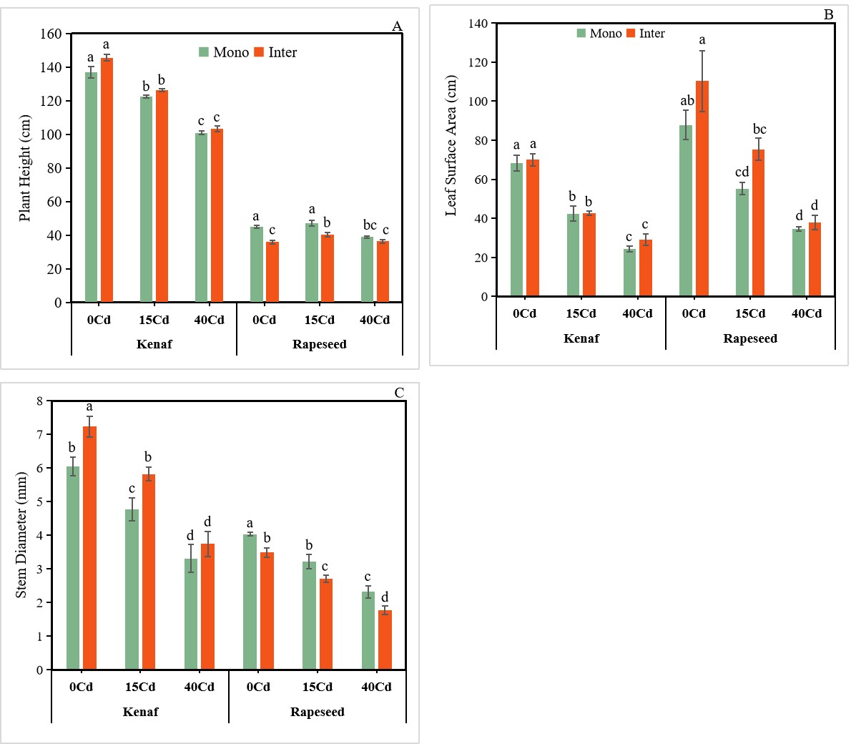

Figure S1: The impact of intercropping on various growth parameters, including (A) the height of the plants, (B) the surface area of the leaves and (C) the diameter of the stems, of kenaf and rapeseed plants cultivated in soil contaminated with Cd. The bars are represented as the mean ± standard deviation (n=3). The presence of different letters on bars indicates a statistically significant difference (p≤0.05).
Figure S2

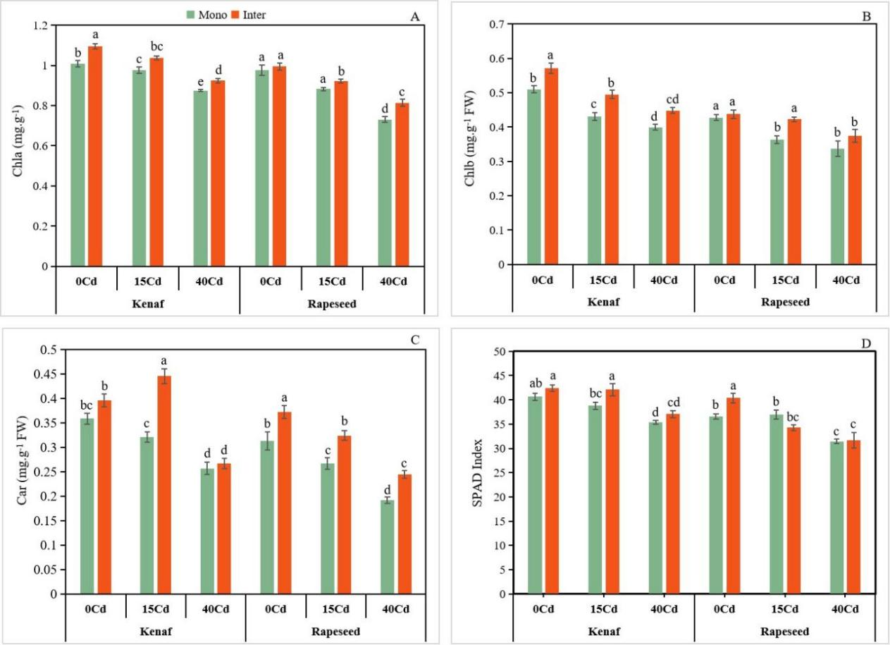

Figure S2. The impact of intercropping on (A) chlorophyll a (B) chlorophyll b, (C) carotenoids, and (D) SPAD index of kenaf and rapeseed plants cultivated in soil contaminated with Cd. The bars are represented as the mean ± standard deviation (n=3). The presence of distinct letters on the bars denotes a statistically significant difference (p≤0.05).
Table S1: Bioconcentration factor (BCF) and translocation factor (TF) for Cd in kenaf and rapeseed plants cultivated under monoculture and intercropping systems at varying levels of Cd in the soil.

Treatment (mg.kg⁻¹) | Cropping pattern | Kenaf |  |  | rapeseed
 |  | BCF  (Root/Soil) | TF (Shoot/Root) | PEE  (%) | BCF (Root/Soil) | TF (Shoot/Root) | PEE  (%)
15 | Mono | 0.82±0.03^{d} | 0.78±0.06ª | 23.68^{b} | 2.51±0.08^{c} | 0.95±0.02ª | 70.59ª
 | Inter | 1.52±0.11ª | 0.85±0.07ª | 39.37ª | 3.56±0.12ª | 0.92±0.02ª | 55.31^{b}
40 | Mono | 0.90±0.02^{c} | 0.63±0.02^{b} | 13.89^{c} | 2.11±0.07^{d} | 0.97±0.04ª | 44.51^{c}
 | Inter | 1.37±0.05^{b} | 0.66±0.01^{b} | 20.12^{b} | 2.89±0.04^{b} | 0.95±0.001ª | 48.79^{c}

