Appendix A. CEC 2013 Test Suite
Functions Type | No | Functions | fi*=fi(x*)
Unimodal Functions | 1 | Sphere Function | -1400
Unimodal Functions | 2 | Rotated High Conditioned Elliptic Function | -1300
Unimodal Functions | 3 | Rotated Bent Cigar Function | -1200
Unimodal Functions | 4 | Rotated Discus Function | -1100
Unimodal Functions | 5 | Different Powers Function | -1000
Basic  Multimodal  Functions | 6 | Rotated Rosenbrock’s Function | -900
Basic  Multimodal  Functions | 7 | Rotated Schaffers F7 Function | -800
Basic  Multimodal  Functions | 8 | Rotated Ackley’s Function | -700
Basic  Multimodal  Functions | 9 | Rotated Weierstrass Function | -600
Basic  Multimodal  Functions | 10 | Rotated Griewank’s Function | -500
Basic  Multimodal  Functions | 11 | Rastrigin’s Function | -400
Basic  Multimodal  Functions | 12 | Rotated Rastrigin’s Function | -300
Basic  Multimodal  Functions | 13 | Non-Continuous Rotated Rastrigin’s Function | -200
Basic  Multimodal  Functions | 14 | Schwefel's Function | -100
Basic  Multimodal  Functions | 15 | Rotated Schwefel's Function | 100
Basic  Multimodal  Functions | 16 | Rotated Katsuura Function | 200
Basic  Multimodal  Functions | 17 | Lunacek Bi_Rastrigin Function | 300
Basic  Multimodal  Functions | 18 | Rotated Lunacek Bi_Rastrigin Function | 400
Basic  Multimodal  Functions | 19 | Expanded Griewank’s plus Rosenbrock’s Function | 500
Basic  Multimodal  Functions | 20 | Expanded Scaffer’s F6 Function | 600
Composition Functions | 21 | Composition Function 1 (n=5,Rotated) | 700
Composition Functions | 22 | Composition Function 2 (n=3,Unrotated) | 800
Composition Functions | 23 | Composition Function 3 (n=3,Rotated) | 900
Composition Functions | 24 | Composition Function 4 (n=3,Rotated) | 1000
Composition Functions | 25 | Composition Function 5 (n=3,Rotated) | 1100
Composition Functions | 26 | Composition Function 6 (n=5,Rotated) | 1200
Composition Functions | 27 | Composition Function 7 (n=5,Rotated) | 1300
Composition Functions | 28 | Composition Function 8 (n=5,Rotated) | 1400
Search Range: [-100,100]D

Appendix B. Convergence graphs
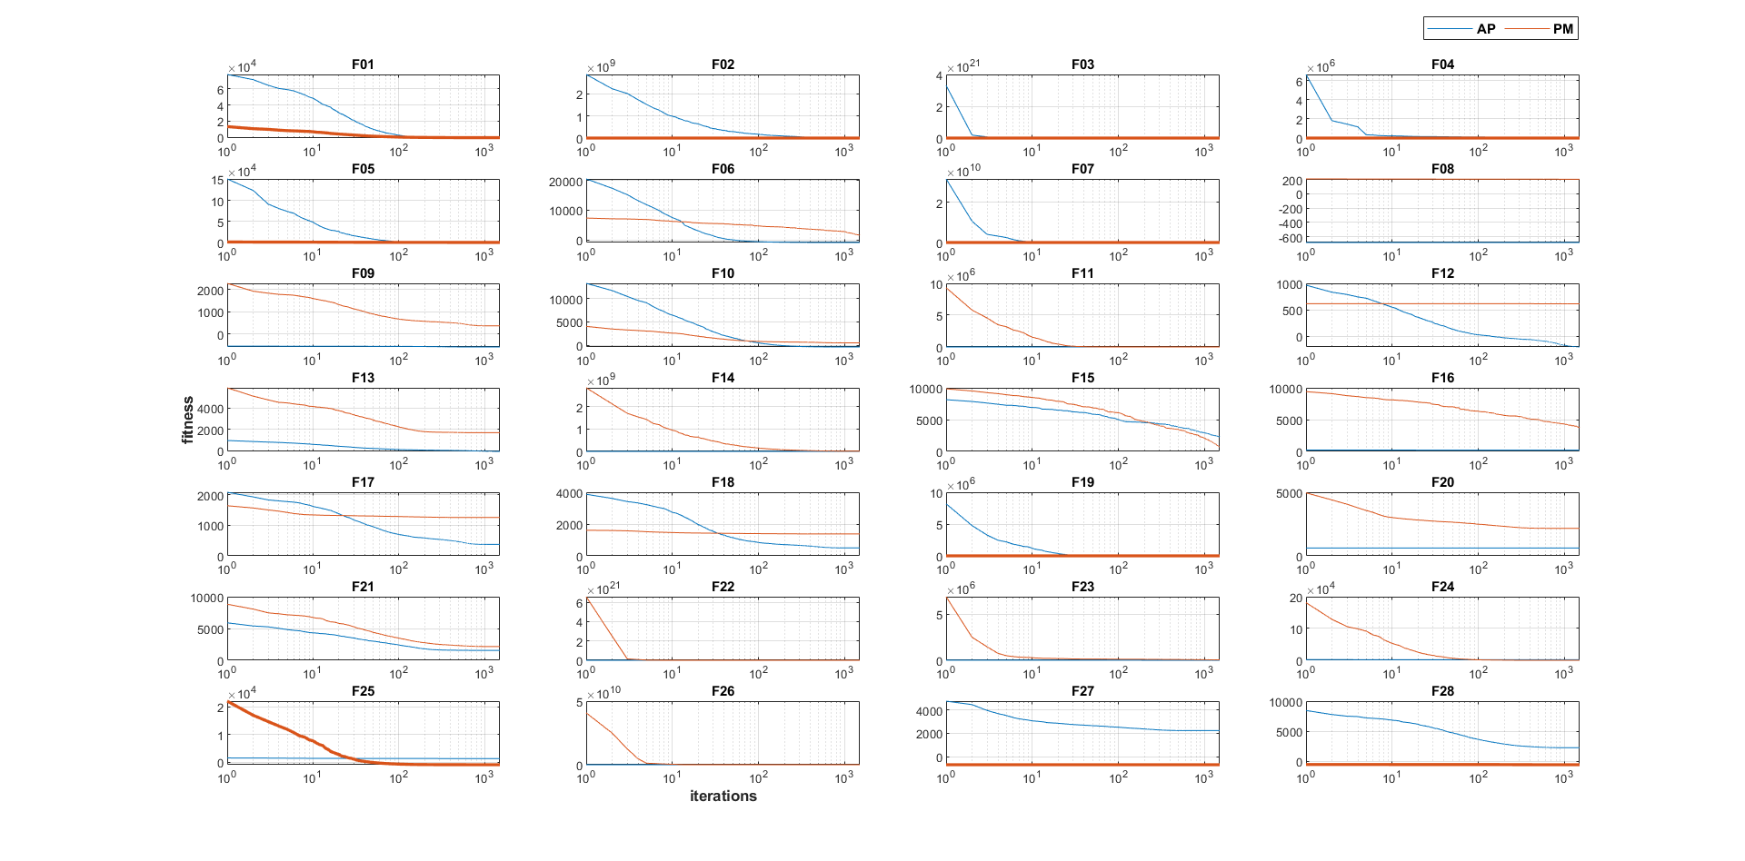
Appendix B - Fig. 1. Convergence graphs of PSOPM and PSOAP at 30 dimensions and 20 population values ​​of 28 functions in the CEC 2013 test suite
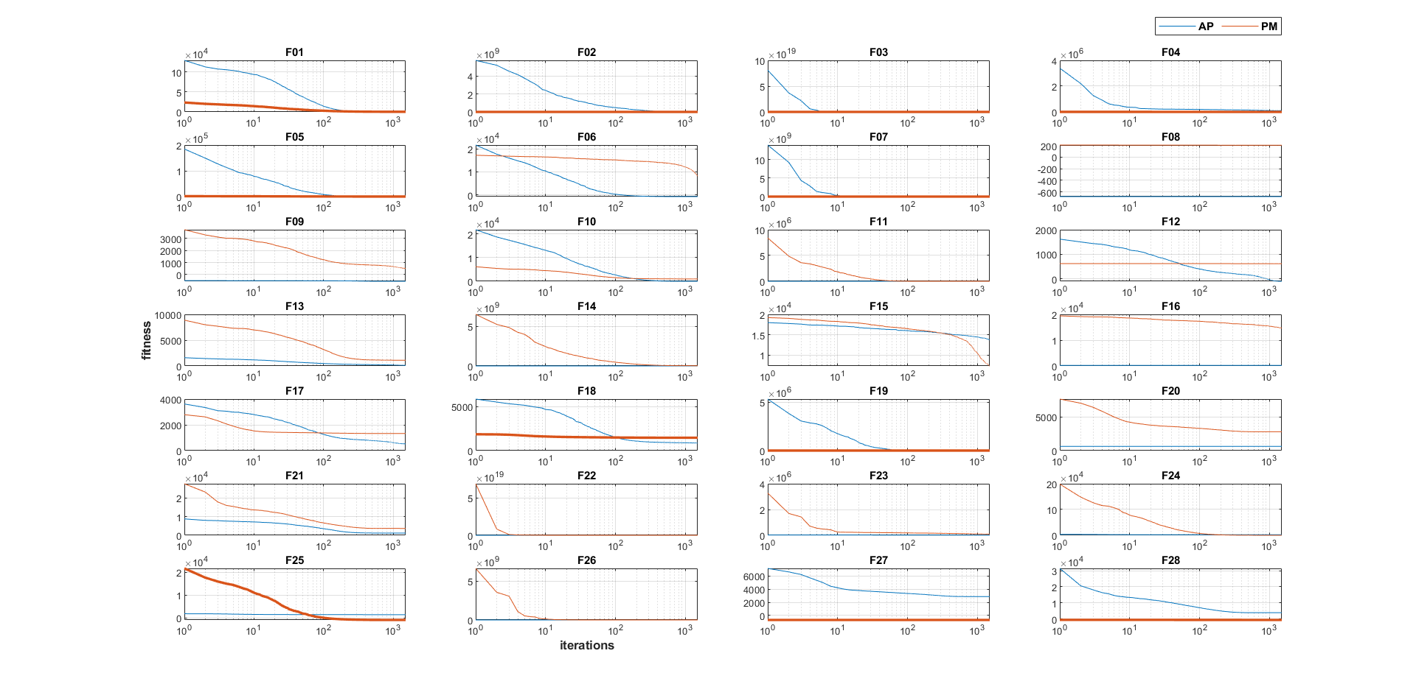
Appendix B - Fig. 2. Convergence graphs of PSOPM and PSOAP at 50 dimensions and 20 population values ​​of 28 functions in the CEC 2013 test suite
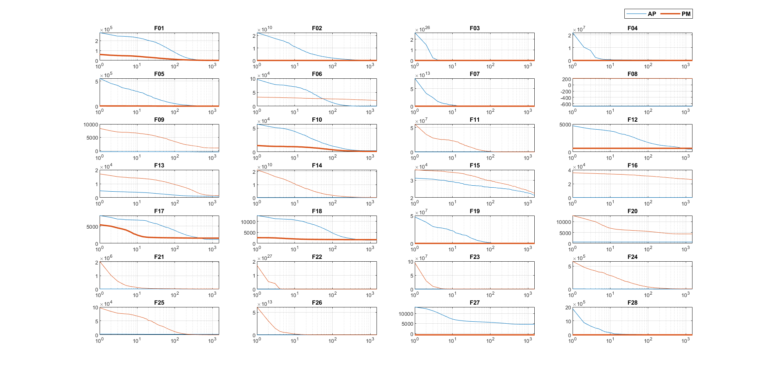
Appendix B - Fig. 3. Convergence graphs of PSOPM and PSOAP at 100 dimensions and 20 population values ​​of 28 functions in the CEC 2013 test suite
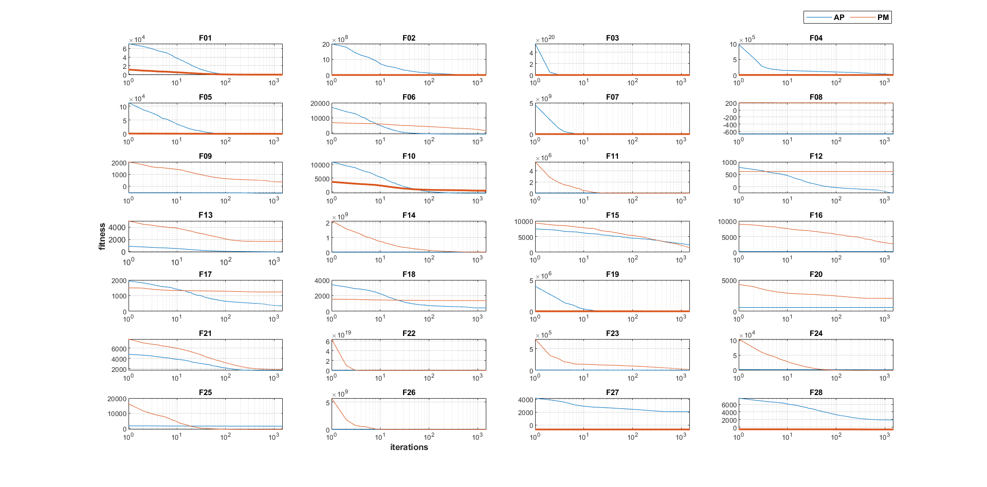
Appendix B - Fig. 4. Convergence graphs of PSOPM and PSOAP at 30 dimensions and 50 population values ​​of 28 functions in the CEC 2013 test suite
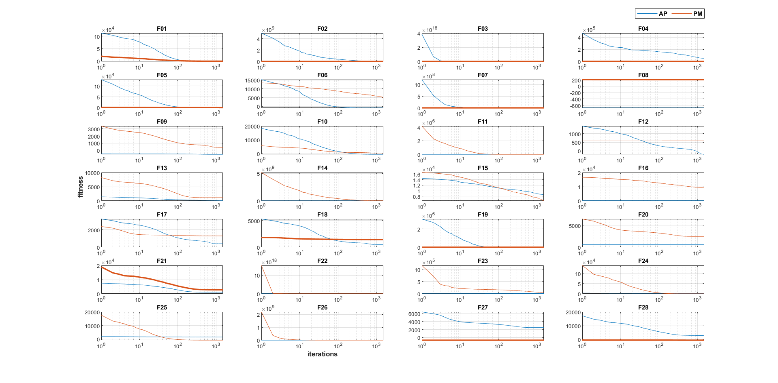
Appendix B - Fig. 5. Convergence graphs of PSOPM and PSOAP at 50 dimensions and 50 population values ​​of 28 functions in the CEC 2013 test suite
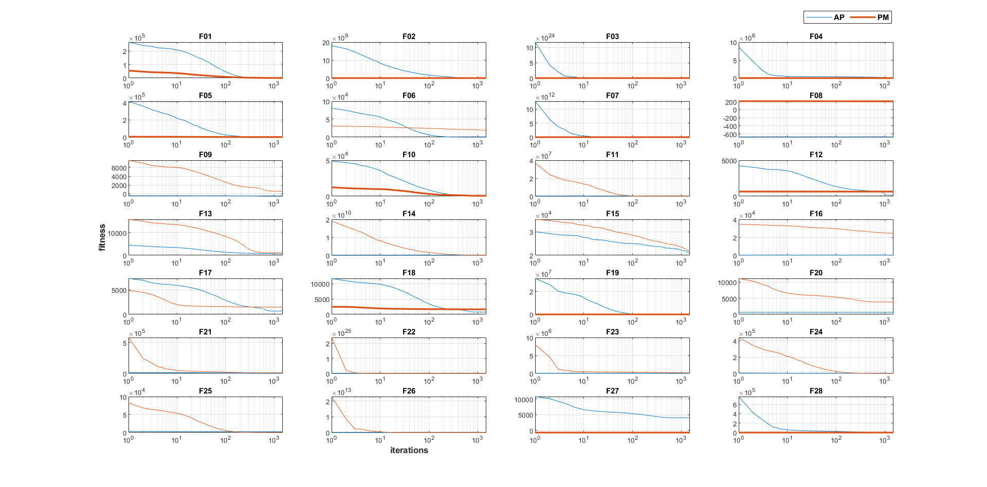
Appendix B - Fig. 6. Convergence graphs of PSOPM and PSOAP at 100 dimensions and 50 population values ​​of 28 functions in the CEC 2013 test suite
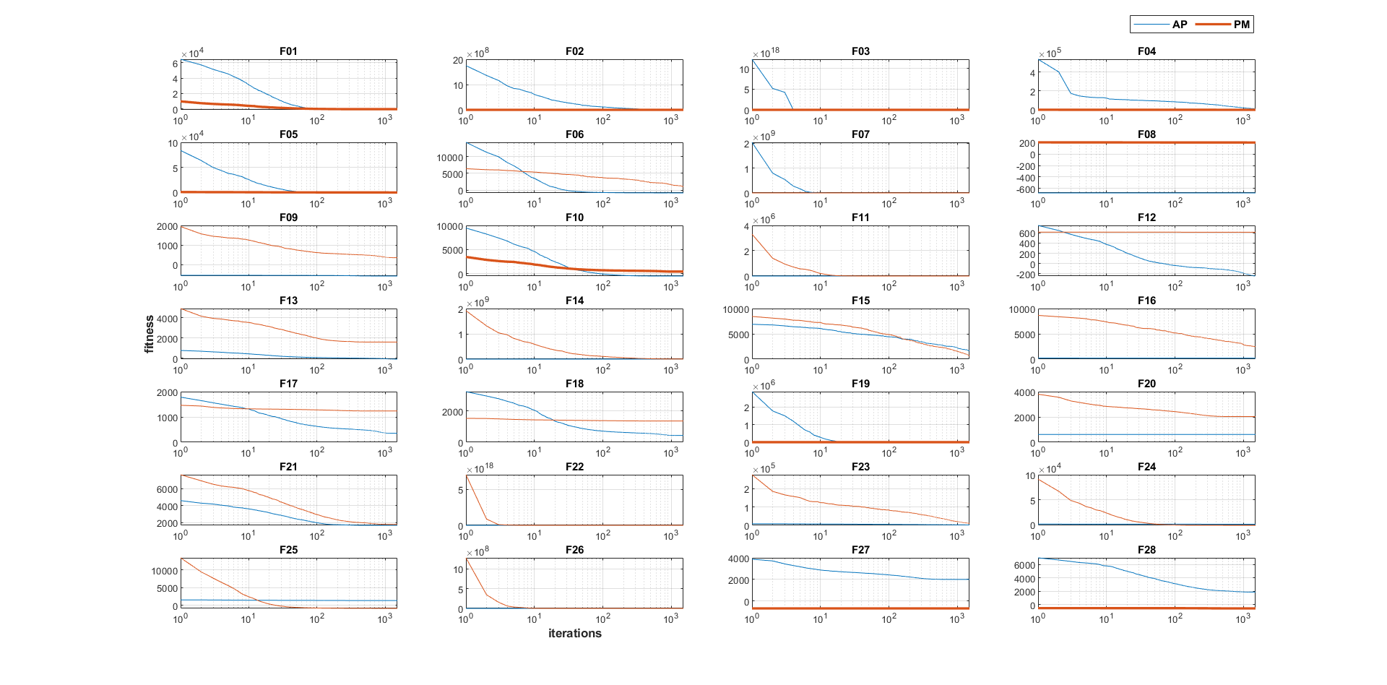
Appendix B - Fig. 7. Convergence graphs of PSOPM and PSOAP at 30 dimensions and 100 population values ​​of 28 functions in the CEC 2013 test suite
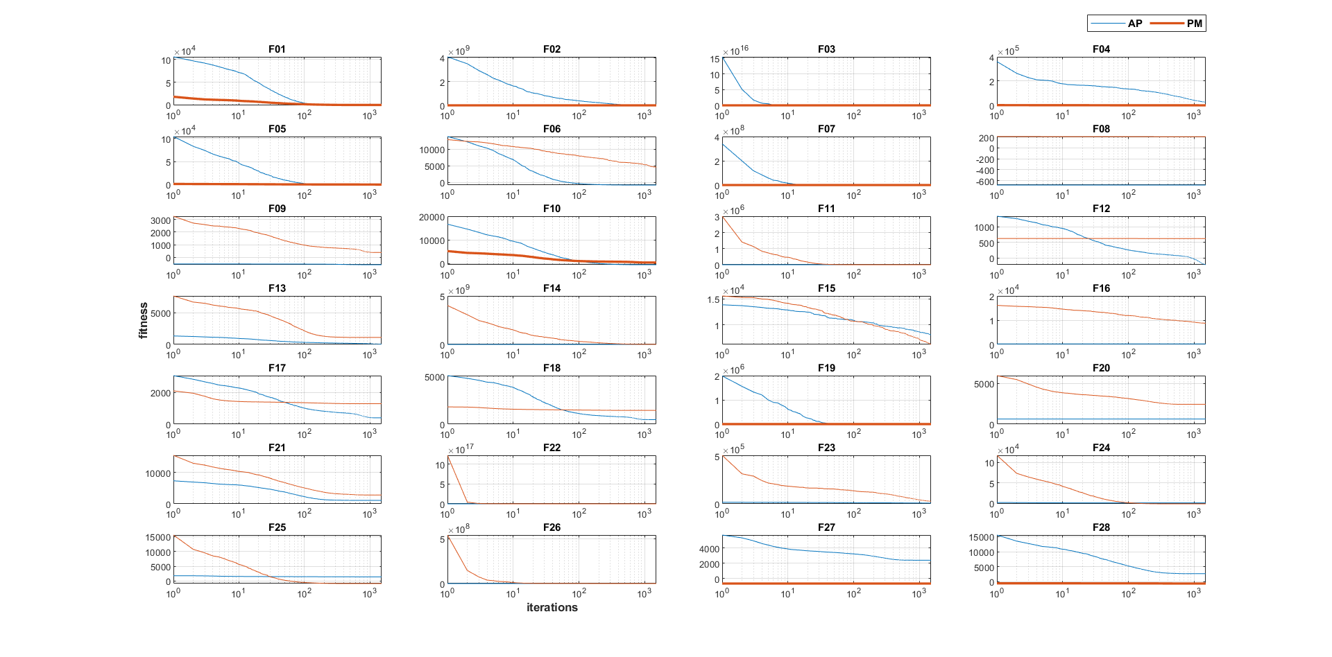
Appendix B - Fig. 8. Convergence graphs of PSOPM and PSOAP at 50 dimensions and 100 population values ​​of 28 functions in the CEC 2013 test suite
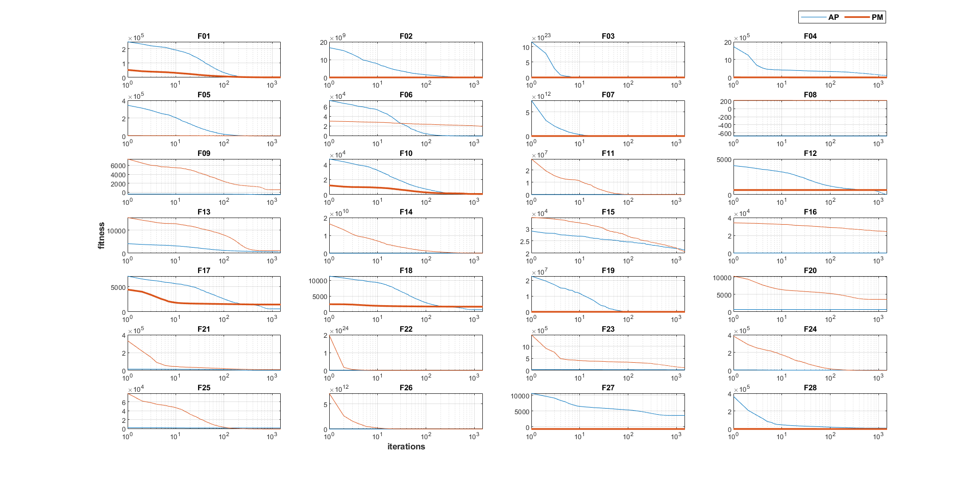
Appendix B - Fig. 9. Convergence graphs of PSOPM and PSOAP at 100 dimensions and 100 population values ​​of 28 functions in the CEC 2013 test suite

