Graphical abstract

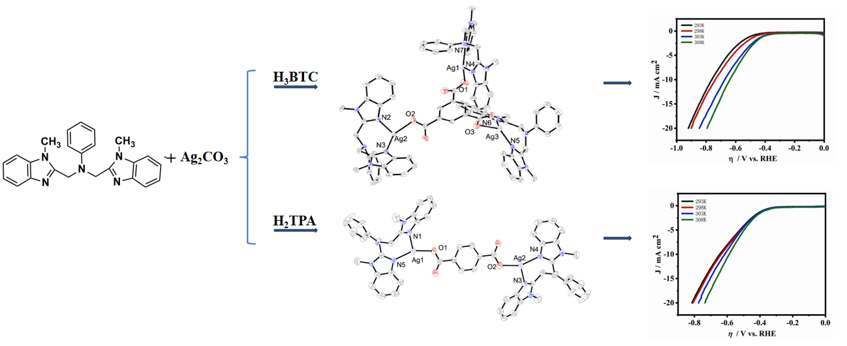
Two silver complexes based on L = 1,3-bis[(N-methylbenzimidazole)methylene]-2-aniline were synthesized and characterized. Structural analysis shows that the two complexes are trinuclear fan-shaped and binuclear central symmetric structures respectively. The electrocatalytic hydrogen evolution reaction performance of silver(I) complex composite carbon paste electrodes (CE-1 and CE-2) were studied. The research results indicate that the overpotential (η₁₀^{293 K}) of CE-1 and CE-2 showed a positive shift of 203 and 319 mV compared to CE (965 mV), and Tafel slopes (b^{293 K}) are 193 and 175 mV·dec⁻¹, respectively. The above results manifest that CE-1 and CE-2 have a good electrocatalytic effect on HER and CE-2 is significantly better than CE-1, which is attributed to the greater deformability of the silver(I) ion coordination environment in complex 2.

