Supplementary Information for

Synthetic heparan sulfate mimics based on chitosan derivatives show broad-spectrum antiviral activity

Table of Content
1. Materials and general methods …………………………………………………..…… 3
2. Preparation of desulfated heparin derivatives …………………………………...… 3
3. Preparation of chondroitin sulfate derivatives ……………………………………... 5
4. Preparation of 23-m15 and 15-m10 starting chitosans ………………….………… 6
5. Preparation of chitosan sulfated derivatives ………………………….…………….. 6
5.1. General procedures ……………………………………………………………………. 6
5.1.1. Procedure 1: Oleic-acid grafted chitosan …………………………..…………… 6
5.1.2. Procedure 2: O-sulfation of chitosan ………………………………..……………. 6
5.1.3. Procedure 3: N-sulfation of chitosan …………………………….……...……….. 7
5.2. Examples ………………………...……………………………………….…………..…. 7
5.2.1. Synthesis of Mw-mX-O-Z polysaccharides ………………………………...…… 7
5.2.2. Synthesis of Mw-mX-N-Z polysaccharides ………………..……………..……... 8
5.2.3. Synthesis of Mw-mX-N,O-Z polysaccharides ………..…………………………. 9
5.2.4. Synthesis of Mw-mX-nY-O-Z polysaccharides …………..…...….………....….. 9
5.2.5. Synthesis of Mw-mX-nY-N-Z polysaccharides …………………………...……. 16
6. Mechanism of action of compound 17………………………………………………. 17
6.1. Protein production ………………………………………………………………….. 17
6.2. Surface Plasmon Resonance (SPR)……………………………………………… 17
6.3. Thermal shift assays……………………………………………………………….. 18
6.4. Negative stain electron microscopy………………………………………………. 18
7. Preliminary toxicological evaluation ..………………………..……………..………. 19
7.1 Phase 1: Single dose administration of ET36. Dose score ……..……..…..…. 19
7.2. Phase II: Administration of ET36 at repeated dose. Dose confirmation …...... 21
8. Radiolabeling and biodistribution of compound 17 in mice ……………………. 24
8.1 Preparation of N-4-hydroxyphenylmethyl derivative of 17……..…………..…. 24
8.2. Radiolabelling of polysaccharide 17 with Iodine-131 ………………………..... 24
8.3. Animal experiments ……………………………………………………………..... 25
9. Supplementary figures…………………………………………………………………. 27
10. NMR and ATR-FTIR Spectra………….……………………………………………… 30
- Materials and general methods
Κ-Carrageenan, Ι-carrageenan, fucoidan, heparin and exoheparin were purchased from Alfa-Aesar. Commercial chitosan samples were purchased from Glentham Life Science Ltd. (United Kingdom) (5-m20, 20-m10, 30-m15, and 50-m15), from Sigma-Aldrich (125-m20) and from Infiqus, S.L (58-m10). Chitosan 23-m15 and 15-m10 were obtained by homemade preparation (see section 2). All reagents were commercially available and were used without further purification. ¹H NMR spectra, in D₂O as the solvent, were recorded on a Varian INOVA-500 using standard Varian pulse sequences. The sample temperature was maintained constant at 298 K. Attenuated total reflection-Fourier transform infrared (ATR-FTIR) spectra were acquired using a Perkin Elmer UATR Two spectrometer in the range between 4000 and 400 cm⁻¹, 4 scans. Elemental analysis was determined in a Leco CHNS-932 elemental analyzer.
- Preparation of desulfated heparin derivatives
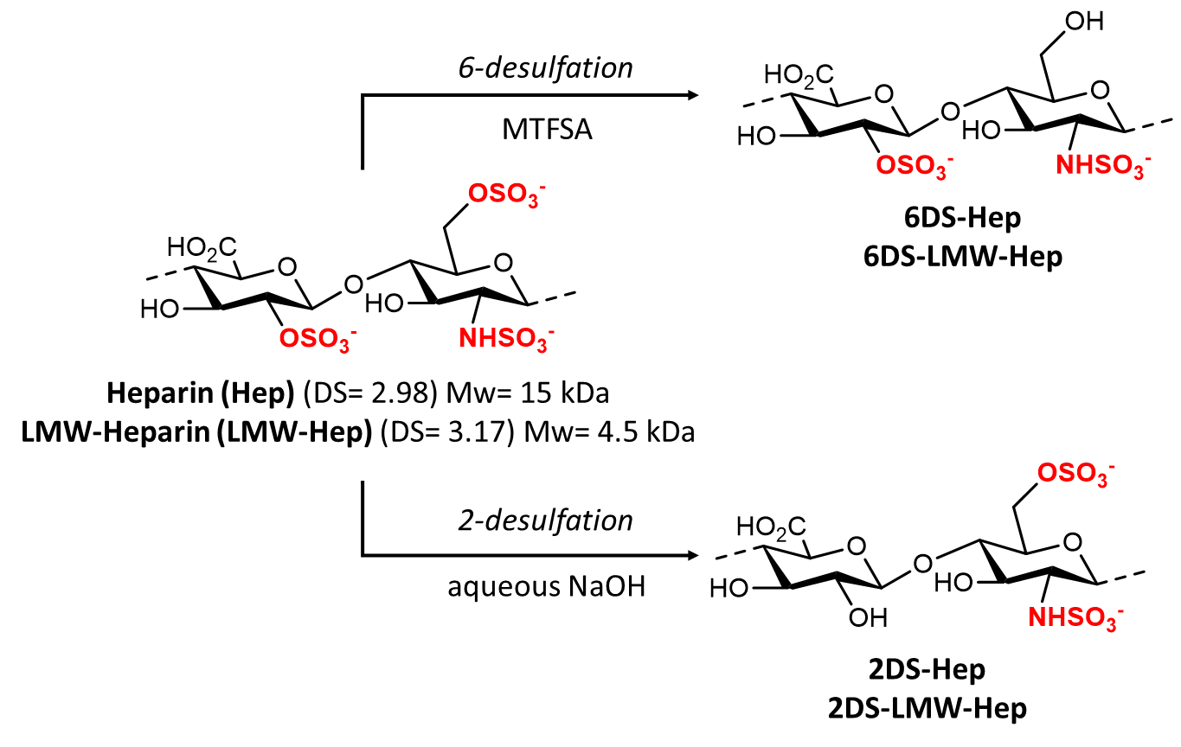
Pyridinium Heparinate:¹ Amberlite IR-120 H⁺ ion exchange resin (35 g) was placed in a glass column, washed with deionized water, regenerated with 10% aqueous HCl for 30 minutes, and washed with water until the pH was neutral. A solution of Hep or LMW-Hep (1 g) in 45 mL deionized water was applied. The combined filtrate and wash solutions were adjusted to pH 6.0 with pyridine. After removal of the solvent by evaporation, the product was freeze-dried. Subsequently, the pyridinium salt of heparin served as the starting compound for the 6- and 2-O-desulfation procedures.
6-O-desulfation procedure:² The pyridinium salt of Hep or LMW-Hep (0.1 g) was dissolved in pyridine (10 mL) and N-methyl-N-(trimethylsilyl)trifluoroacetamide (MTFSA) and then heated to 110 ºC for 2 h. After cooling to room temperature, deionized water (10 mL) was added and the mixture was dialyzed against deionized water for 3 days (MWCO = 3.5 kDa). After adjusting the pH of the resulting dialysate to 9.5, the mixture was further dialyzed overnight against deionized water Finally, the resulting dialysate was subjected to freeze-drying.
2-O-desulfation procedure:³ Hep or LMW-Hep (0.5 g) was dissolved in 0.4M aqueous NaOH (10 mL). The solution was frozen and lyophilized overnight. Dissolution and lyophilization were performed twice. The pH was adjusted to 9.0 with 20% acetic acid. After a 3-day dialysis (MWCO = 3.5 kDa) against deionized water, the reaction mixture was concentrated and lyophilized.
Table S1. Desulfated heparin derivatives
Heparin Derivative | Mw (KDa) | DS^{[a]} | Supplier
Heparin | 15 ^{[b]} | 2.98 | Alfa-Aesar
6-O-DS-Heparin | 15 | 1.68 | -
2-O-DS-Heparin | 15 | 1.85 | -
LMW-Heparin | 4.5 | 3.10 | Alfa-Aesar
2-O-DS-LMW-Heparin | 4.5 | 2.27 | -
6-O -DS-LMW-Heparin | 4.5 | 2.10 | -
[a] The total degree of sulfation (DS) was determined from the sulfur (%S) and nitrogen (%N) content determined by elemental analysis using a Heraeus CHN-O analyzer, and the calculation was performed according to Eq: DS= (S%/32.06)/(N%/14.01).
- Preparation of chondroitin sulfate derivatives.
Chondroitin sulfates were prepared according to previously described procedures described by us.
Table S2. Chondroitin sulfate derivatives
Chondroitin sulfate derivative | Disaccharide units | Ratio | DS | Reference
CS-E | GlcA-GalNAc(4,6S)/GlcA-GalNAc | 80:20 | 1.60 | ⁴
CS-Z | GlcA(2S,3S)-GalNAc/GlcA(2,3S)-GalNAc(6S) | 44:56 | 2.55 | ⁴
CS-Q | GlcA(3S)-GalNAc/GlcA(3S)-GalNAc(6S) | 77:23 | 1.23 | ⁴
CS-A,C | GlcA-GalNAc(4S)/GlcA-GalNAc(6S) | 75:25 | 0.97 | ⁵
CS-A | GlcA-GalNAc(4S)/GlcA-GalNAc | 75:25 | 0.75 | ⁵

- Preparation of 23-m15 and 15-m10 starting chitosans
Starting chitosan (degree of deacetylation 85%; molecular weight 50–150 kDa) was purchased from IDEBIO, S.L. (Spain) and purified before use.⁶ Briefly, chitosan (5.0 g) was dissolved in a 0.5 M solution of acetic acid in water (1 L), and the solution was stirred for 24 h, keeping the pH between 4.0 and 4.5 by adding acetic acid as needed. The solution was then filtered to remove undissolved particles, and chitosan was precipitated again with an aqueous NaOH solution (10% w/v) until the pH = 8. The resulting suspension was centrifuged (15 min, 3900 rpm) and the supernatant was removed, with the remaining solid washed with an EtOH/H₂O mixture (70:30 v/v → 50:50 v/v → 30:70 v/v → 0:100) (400 mL). The resulting solid was finally resuspended in H₂O and lyophilized. Purified chitosan (1.0 g) was solved in a 0.1N aqueous solution of HCl (66 mL) and was stirred overnight at room temperature. Subsequently, the solution was heated in an orbital shaker (100 rpm). In parallel, KNO₂ (6.7 mg) was solved in an aqueous solution of HCl (0.1 N) (2.5 mL) at 37 °C in a dark bottle, on which is poured the chitosan solution. The mixture was reacted for 7 min (23-m15) or 15 min (15-m10), and then chitosan was precipitated with an aqueous solution of NaOH (50% w/v) until pH= 8. The precipitate was washed with mixtures of H₂O/EtOH (80:20; 90:10; 100:0). Finally, the solid was dried at 60 °C and analyzed by GPC.
Table S3. Starting chitosans were obtained from commercial suppliers or by homemade preparation
Chitosan^{[a]} | Mw (KDa) | DDA^{[d]} | Supplier
5-m20 | ≤ 5 ^{[b]} | 87%^{[e]} | Glentham Life Sciences
15-m10 | ≈ 15 ^{[c]} | 90%^{[e]} | Homemade preparation^{[f]}
20-m10 | ≈ 20 ^{[b]} | 90%^{[e]} | Glentham Life Sciences
23-m15 | ≈ 23 ^{[c]} | 85%^{[e]} | Homemade preparation^{[g]}
30-m15 | ≈ 30 ^{[b]} | 85%^{[e]} | Glentham Life Sciences
50-m15 | ≈ 50 ^{[b]} | 85%^{[e]} | Glentham Life Sciences
58-m10 | ≈ 58 ^{[c]} | 90%^{[e]} | Infiqus
90-m15 | ≈ 90^{[b]} | 85%^{[e]} | ChitoPharm
125-m20 | ≈ 190 -310 ^{[b]} | 85%^{[e]} | Sigma-Aldrich
[a] The starting samples are named according to their molecular weight; [b] Data provided by the supplier; [c] Data measured by GPC; [d] De-acetylation degree; [e] Values estimated by ¹H NMR (400 MHz, 70 °C): Degree of Deacetylation (DDA) (%)= 1-[(1/3H_{Ac})/(1/6H₂₋₆)]x100 where H_{Ac} is the integration value of the three protons of the acetyl group (≈ 2.00 ppm) and H₂₋₆ the integration value for signals from protons (H2, H3, H4, H5, H6 and H6’) of the glucosamine (≈ 3.5 – 4.4 ppm). [f] 15-m10 was prepared according to the procedure described below. [g] See ref. ⁷.
23-m15: ¹H NMR (D₂O, 500 MHz, 25 ºC, TFA (1%)) (selected signals): H₃C–CONH– (2.02 ppm); H₂ (3.10 ppm); H₂₋₅ (3.46-3.90 ppm). M_{w} (kDa)= 23.0
15-m10: ¹H NMR (D₂O, 500 MHz, 25 ºC, TFA (1%)) (selected signals): H₃C–CONH– (1.96 ppm); H₂ (3.06 ppm); H₂₋₅ (3.49-3.99 ppm). M_{w} (kDa)= 15.0.
- Preparation of chitosan sulfated derivatives
  - General procedures
    - Procedure 1: Oleic-acid grafted chitosan
Oleic-acid grafted chitosan was synthesized via the reaction of the amino group of chitosan with the carboxyl group of oleic acid. Briefly, 1.0 g of chitosan (Mw-mX) was dissolved in a solution mixture of 100 mL of 1% (v/v) acetic acid water solution and was stirred at room temperature for 15 hours. Then, 85 mL of methanol was added and the mixture was stirred for an additional hour. In parallel, oleic acid (OA) (0.57 mL) was reacted with 1-ethyl-3-(3-dimethylaminopropyl)carbodiimide (EDC) (0.17 g) in a methanol solution (15 mL) for 2 hours at room temperature after which the obtained solution was poured into the chitosan solution. After being allowed to react for 18 h, the mixture was dialyzed firstly against a solution of ethanol in water (10% v/v) for 18 hours and, finally, against distilled water for 2 days. The obtained solution was lyophilized to obtain oleic-acid grafted chitosan (Mw-mX-nY).
In order to obtain derivatives with different degrees of substitution, reactions with different chitosan-EDC-oleic acid ratios were carried out.
    - Procedure 2: O-sulfation of chitosan
A solution of chitosan (Mw-mX) or oleic-acid grafted chitosan (Mw-mX-nY) (0.5 g) in formic acid (23 mL) was stirred for 1 h at room temperature. Subsequently, dimethylformamide (DMF) (122 mL) was added and the mixture was stirred for another 2 h. In parallel, a solution of chlorosulfonic acid (1.4 mL) in DMF (8 mL) was prepared. This mixture was added dropwise into the chitosan solution within 15 min and was kept at room temperature for 5 h. The resulting yellow solution was added to a saturated solution of anhydrous sodium acetate in ethanol (300 mL), and the mixture was kept overnight. The obtained precipitate was washed with an ethanol/water (4:1) mixture (v/v) and then dissolved in water (45 mL). The pH of the obtained solution was increased to pH 7.5 with 1 M NaOH. Finally, the solution was concentrated to one-fourth of the original volume and then dialyzed against deionized water and freeze-dried to obtain O-sulfated chitosan (Mw-mX-O-Z) or oleic-acid grafted O-sulfated chitosan (Mw-mX-nY-O-Z).
The application of this process allows to achieve a degree of O-sulfation of about 1.5-1.8, depending on the starting material used. To obtain derivatives with different degrees of sulfation, reactions with different chitosan-chlorosulfonic acid ratios were carried out.
    - Procedure 3: N-sulfation of chitosan
Chitosan (Mw-mX), O-sulfated chitosan (Mw-mX-O-Z) or oleic-acid grafted chitosan (Mw-mX-nY-O-Z) (1.0 g) was dispersed in deionized water (30 mL), and Na₂CO₃ (357 mg) and Me₃N·SO₃ (710 mg) were added. The obtained suspension was heated at 50 °C until a yellow viscous solution was formed (∼24 h). The mixture was cooled, dialyzed exhaustively against Milli-Q water, and then lyophilized to give N-sulfated chitosan (Mw-mX-N-Z) N, O-sulfated chitosan (Mw-mX-N,O-Z) or oleic-acid grafted N-sulfated chitosan (Mw-mX-nY-N-Z).
The application of this process allows to achieve a degree of N-sulfation of about 1.5-1.8, depending on the starting material used. To obtain derivatives with different degrees of sulfation, reactions with different chitosan-chlorosulfonic acid ratios were carried out.
In order to obtain derivatives with different degrees of sulfation, reactions with different chitosan-Na₂CO₃-Me₃N·SO₃ ratios were carried out.
  - Examples
5.2.1. Synthesis of Mw-mX-O-Z polysaccharides
5-m20-O-1.8 (compound 1)
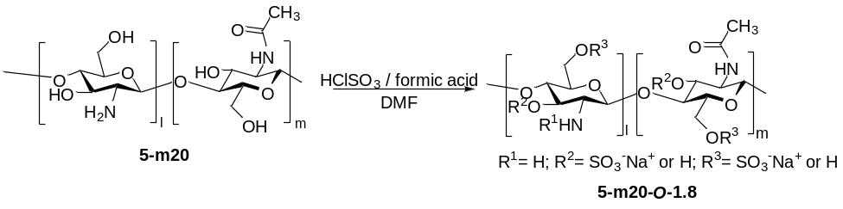
5-m20-O-1.8 was prepared from 5-m20 according to Procedure 2 (section 5.1.2), using a 5-m20:chlorosulfonic acid ratio of 1:2.8 (g:mL). Yield of 5-m20-O-1.8: 65%.
¹H NMR (D₂O, 500 MHz) (selected signals): H₃C–CONH– (1.92 ppm); H₂ (3.40 ppm); H_{6(a,b)} (H) and H₃ (H) (3.55-3.83 ppm) and H_{6(a,b)} (SO₃⁻) and H₃ (SO₃⁻) (3.82-4.38 ppm).
Elemental analysis: S(%)= 12.33; N(%)= 2.94. S/N= 1.8.

15-m5-O-1.6 (compound 2)
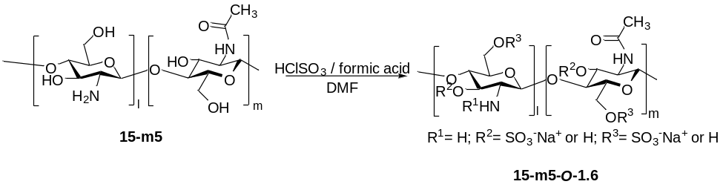
15-m5-O-1.6 was prepared from 15-m5 according to Procedure 2 (section 5.1.2), using a 15-m5:chlorosulfonic acid ratio of 1:2.8 (g:mL). Yield of 15-m5-O-1.6: 95%.
¹H NMR (D₂O, 500 MHz) (selected signals): H₃C–CONH– (2.06 ppm); H₂ (3.28 ppm); H_{6(a,b)} (H) and H₃ (H) (3.44-3.96 ppm) and H_{6(a,b)} (SO₃⁻) and H₃ (SO₃⁻) (4.02-4.51 ppm) and H₁ (4.87 ppm).
Elemental analysis: S(%)= 13.46; N(%)= 3.55. S/N= 1.6.
5.2.2. Synthesis of Mw-mX-N-Z polysaccharides
15-m5-N-0.7 (compound 7)
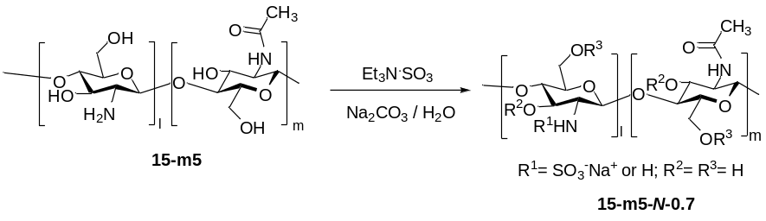
15-m5-N-0.7 was prepared from 15-m5 according to Procedure 3 (section 5.1.3), using a 15-m5: Na₂CO₃:Me₃N·SO₃ ratio of 1:0.3:0. 7 (g:g:g). Yield of 15-m5-N-0.7: 89%.
¹H NMR (D₂O + Na₂CO₃, pH=9.0, 500 MHz, 70º) (selected signals): H₃C–CONH– (2.04 ppm); H₂ (H) (2.70 ppm); H₂ (SO₃⁻) (3.09 ppm); H₃-H₆ (3.55-4.18 ppm) and H₁ (4.58 ppm). ATR-FTIR (cm⁻¹): 2890, 1674, 1525, 1135, 1095, 1063, 998.
Elemental analysis: S(%)= 8.63; N(%)= 5.2. Z= 0.7.

5.2.3. Synthesis of Mw-mX-N,O-Z polysaccharides
15-m5-N,O-2.0 (compound 11)
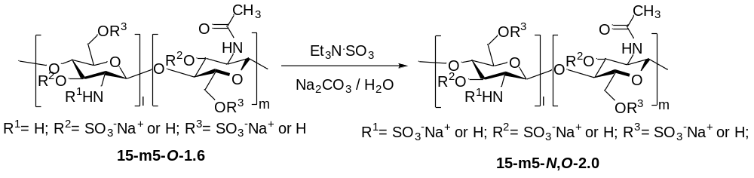
15-m5-N,O-2.0 was prepared from 15-m5-O-1.6 according to Procedure 3 (section 5.1.3), using a 15-m5-O-1.6: Na₂CO₃:Me₃N·SO₃ ratio of 1:0.3:0.7 (g:g:g). Yield of 15-m5-N,O-2.0: 65%.
¹H NMR (D₂O + Na₂CO₃, pH=9.0, 500 MHz, 70º) (selected signals): H₃C–CONH– (1.92 ppm); H₂ (H) (3.02 ppm); H₂ (SO₃⁻) (3.20 ppm); H_{6(a,b)} (H) and H₃ (H) (3.43-3.96 ppm) and H_{6(a,b)} (SO₃⁻) and H₃ (SO₃⁻) (4.04-4.41 ppm).
Elemental analysis: S(%)= 14.52; N(%)= 3.09. Z= 2.00.
5.2.4. Synthesis of Mw-mX-nY-O-Z polysaccharides
15-m10-n3-O-1.6 (compound 12)
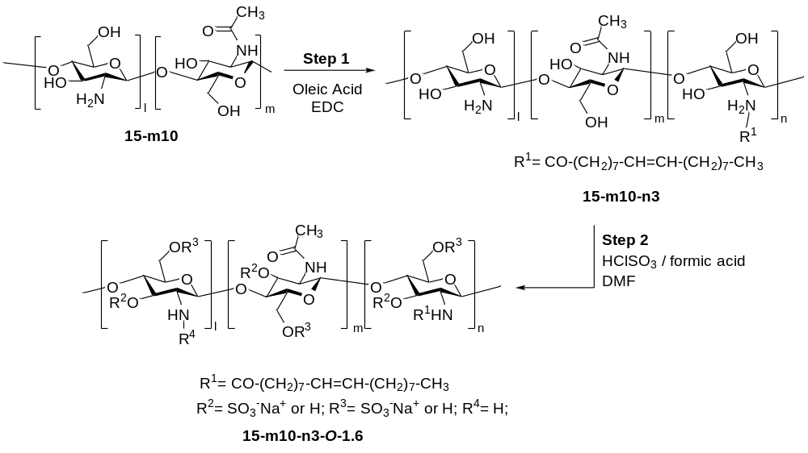
Step 1: Chitosan 15-m10 was grafted with oleic acid according to Procedure 1 (section 5.1.1), using a 15-m10:EDC:oleic acid ratio of 1:0.17:0.57 (g/g/mL). Yield of 15-m10-n3: 85%.
¹H NMR (D₂O, 500 MHz, 25 ºC, TFA (1%)) (selected signals): -CO-CH₂-(CH₂)₅-CH₂-CH=CH-CH₂-(CH₂)₆-CH₃ (0.58 ppm); -CO-CH₂-(CH₂)₅-CH₂-CH=CH-CH₂-(CH₂)₆-CH₃ (0.98-1.25 ppm); -CO-CH₂-(CH₂)₅-CH₂-CH=CH-CH₂-(CH₂)₆-CH₃ (1.61-2.01); H₃C–CONH– (1.95 ppm); H₂ (2.85 ppm); H₃₋₆ (3.27-3.76 ppm) and H₁ (4.99 ppm).

Step 2: 15-m10-n3-O-1.6 was prepared from 15-m10-n3 according to Procedure 2 (section 5.1.2) using a 15-m10-n3:chlorosulfonic acid ratio of 1:2.8 (g:mL). Yield of 15-m10-n3-O-1.6: 96%
¹H NMR (D₂O, 500 MHz, 25 ºC) (selected signals): -CO-CH₂-(CH₂)₅-CH₂-CH=CH-CH₂-(CH₂)₆-CH₃ (0.77 ppm); -CO-CH₂-(CH₂)₅-CH₂-CH=CH-CH₂-(CH₂)₆-CH₃ (1.07-1.55 ppm); -CO-CH₂-(CH₂)₅-CH₂-CH=CH-CH₂-(CH₂)₆-CH₃ (1.86-1.93 and 2.23-2.31); H₃C–CONH– (1.95 ppm); H₂ (3.07 ppm); H₃(H) and H_{6a-b} (H) (3.23-3.77 ppm); H₃ (SO₃⁻) and H_{6a-b} (SO₃⁻) (3.85-4.55 ppm); H₁ (4.87 ppm) and -CO-CH₂-(CH₂)₅-CH₂-CH=CH-CH₂-(CH₂)₆-CH₃ (5.81 ppm).
ATR-FTIR (cm⁻¹): 2918, 2850, 1633, 1538, 1457, 1398, 1215 (SO₂ st as), 1064, 1001 (SO₂ st sy), 941, 799 (S-O st).
Elemental analysis: %S= 12.43; %N= 2.96; S/N= 1.6.
15-m5-n4-O-1.7 (compound 13)
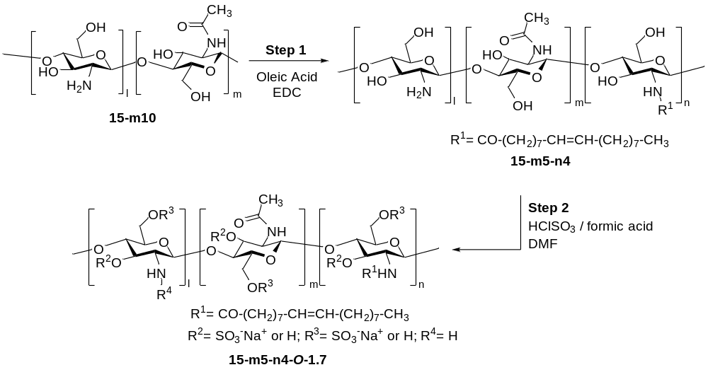
Step 1: 15-m10 was grafted with oleic acid according to Procedure 1 (section 5.1.1), using a CHIT-15-m10:EDC:oleic acid ratio of 1:0.34:1.14 (g:g:mL). Yield of 15-m5-n4: 70%.
¹H NMR (D₂O, 500 MHz, 25 ºC, TFA (1%)) (selected signals): -CO-CH₂-(CH₂)₅-CH₂-CH=CH-CH₂-(CH₂)₆-CH₃ (0.55 ppm); -CO-CH₂-(CH₂)₅-CH₂-CH=CH-CH₂-(CH₂)₆-CH₃ (0.97-1.26 ppm); -CO-CH₂-(CH₂)₅-CH₂-CH=CH-CH₂-(CH₂)₆-CH₃ (1.59-1.80); H₃C–CONH– (1.97 ppm); H₂ (2.86 ppm); H₃₋₆ (3.32-3.68 ppm) and H₁ (5.02 ppm).
Step 2: 15-m5-n4-O-1.7 was prepared from 15-m5-n4 according to Procedure 2 (section 5.1.2), using a 15-m5-n2-3:chlorosulfonic acid ratio of 1:2.8 (g:mL)Yield of 15-m5-n4-O-1.7: 96%
¹H NMR (D₂O, 500 MHz, 25 ºC) (selected signals): -CO-CH₂-(CH₂)₅-CH₂-CH=CH-CH₂-(CH₂)₆-CH₃ (0.77 ppm); -CO-CH₂-(CH₂)₅-CH₂-CH=CH-CH₂-(CH₂)₆-CH₃ (0.96-1.62 ppm); -CO-CH₂-(CH₂)₅-CH₂-CH=CH-CH₂-(CH₂)₆-CH₃ (1.83-1.99 and 2.13-2.34); H₃C–CONH– (2.07 ppm); H₂ (3.04 ppm); H₃(H) and H_{6a-b} (H) (3.12-3.46 ppm) and H₃ (SO₃⁻) and H_{6a-b} (SO₃⁻) (3.68-4.37 ppm).
ATR-FTIR (cm⁻¹): 2927, 1632, 1527, 1456, 1387, 1215 (SO₂ st as), 1124, 1065, 997 (SO₂ st sy), 941, 800 (S-O st).
Elemental analysis: %S= 13.54; %N= 3.52; S/N= 1.7.
20-m10-n1-2-O-1.7 (compound 15)
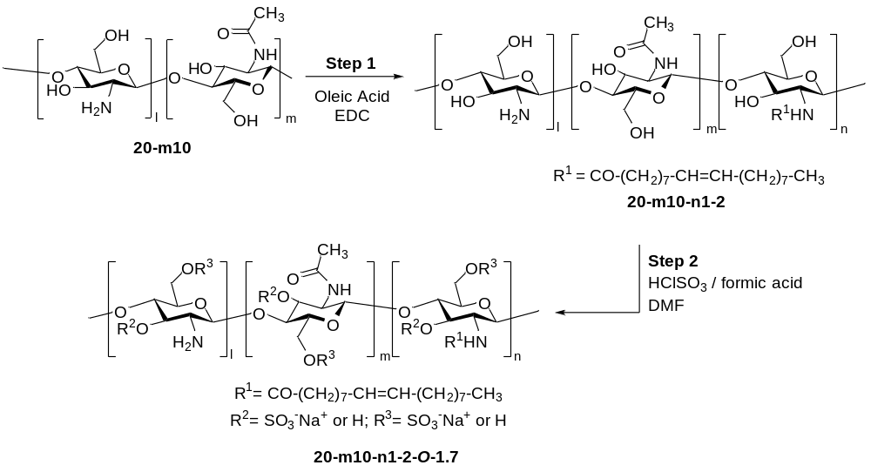
Step 1: 20-m10 was grafted with oleic acid according to Procedure 1 (section 5.1.1), using a 20-m10:EDC:oleic acid ratio of 1:0.17:0.57 (g:g:mL). Yield of 20-m10-n1-2: 66%.
¹H NMR (D₂O, 500 MHz, 25 ºC, TFA (1%)) (selected signals): -CO-CH₂-(CH₂)₅-CH₂-CH=CH-CH₂-(CH₂)₆-CH₃ (0.71 ppm); -CO-CH₂-(CH₂)₅-CH₂-CH=CH-CH₂-(CH₂)₆-CH₃ (1.05-1.47 ppm); -CO-CH₂-(CH₂)₅-CH₂-CH=CH-CH₂-(CH₂)₆-CH₃ (1.80-1.89 and 2.03-2.11); H₃C–CONH– (1.90 ppm); H₂ (3.00 ppm) H₃₋₆ (3.42-3.86 ppm); H₁ (4.67 ppm) and -CO-CH₂-(CH₂)₅-CH₂-CH=CH-CH₂-(CH₂)₆-CH₃ (5.13 ppm).

Step 2: 20-m10-n1-2-O-1.7 was prepared from 20-m10-n1-2 according to Procedure 2 (section 5.1.2), using a 20-m10-n1-2:chlorosulfonic acid ratio of 1:2.8 (g:mL). Yield of 20-m10-n1-2-O-1.7: 99%
¹H NMR (D₂O, 500 MHz, 25 ºC) (selected signals): -CO-CH₂-(CH₂)₅-CH₂-CH=CH-CH₂-(CH₂)₆-CH₃ (0.73 ppm); -CO-CH₂-(CH₂)₅-CH₂-CH=CH-CH₂-(CH₂)₆-CH₃ (1.03-1.51 ppm); -CO-CH₂-(CH₂)₅-CH₂-CH=CH-CH₂-(CH₂)₆-CH₃ (1.89-1.94); H₃C–CONH– (1.95 ppm); H₂ (3.06 ppm); H₃(H) and H_{6a-b} (H) (3.2-3.98 ppm); H₃ (SO₃⁻) and H_{6a-b} (SO₃⁻) (4.00-4.60 ppm).
Elemental analysis: %S= 14.00; %N= 3.66; S/N= 1.7.
30-m10-n1-2-O-1.7 (compound 16)
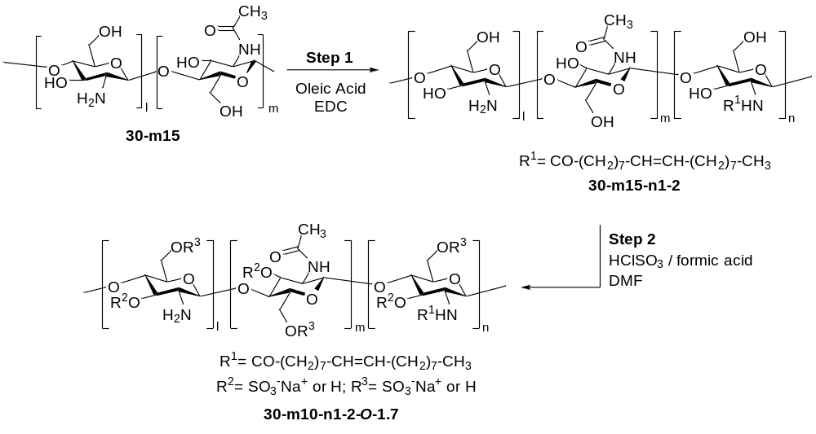
Step 1: 30-m15 was grafted with oleic acid according to Procedure 1 (section 5.1.1), using a 30-m15:EDC:oleic acid ratio of 1:0.17:0.57 (g:g:mL). Yield of 30-m15-n1-2: 72%.
¹H NMR (D₂O, 500 MHz, 25 ºC, TFA (1%)) (selected signals): -CO-CH₂-(CH₂)₅-CH₂-CH=CH-CH₂-(CH₂)₆-CH₃ (0.78 ppm); -CO-CH₂-(CH₂)₅-CH₂-CH=CH-CH₂-(CH₂)₆-CH₃ (1.07-1.56 ppm); -CO-CH₂-(CH₂)₅-CH₂-CH=CH-CH₂-(CH₂)₆-CH₃ (1.87-1.96 and 2.10-2.19); H₃C–CONH– (1.95 ppm); H₂ (3.06 ppm) H₃₋₆ (3.45-3.79 ppm); H₁ (4.87 ppm) and -CO-CH₂-(CH₂)₅-CH₂-CH=CH-CH₂-(CH₂)₆-CH₃ (5.20 ppm).
Step 2: 30-m15-n1-2-O-1.7 was prepared from 30-m15-n1-2 according to Procedure 2 (section 5.1.2), using a 30-m15-n1-2:chlorosulfonic acid ratio of 1:2.8 (g:mL). Yield of 30-m15-n1-2-O-1.7: 99%
¹H NMR (D₂O, 500 MHz, 25 ºC) (selected signals): -CO-CH₂-(CH₂)₅-CH₂-CH=CH-CH₂-(CH₂)₆-CH₃ (0.74 ppm); -CO-CH₂-(CH₂)₅-CH₂-CH=CH-CH₂-(CH₂)₆-CH₃ (1.03-1.53 ppm); H₃C–CONH– (1.92 ppm); H₂ (3.02 ppm); H₃(H) and H_{6a-b} (H) (3.20-3.99 ppm); H₃ (SO₃⁻) and H_{6a-b} (SO₃⁻) (4.01-4.59 ppm); H₁ (4.89 ppm).
ATR-FTIR (cm⁻¹): 2957, 1627, 1525, 1456, 1384, 1211 (SO₂ st as), 1063, 987 (SO₂ st sy), 941, 795 (S-O st).
Elemental analysis: %S= 14.42; %N= 3.73; S/N= 1.7.

50-m15-n1-2-O-1.6 (compound 17)
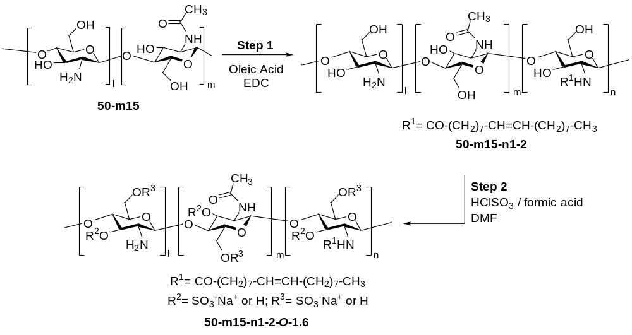
Step 1: 50-m15 was grafted with oleic acid according to Procedure 1 (section 5.1.1), using a 50-m15:EDC:oleic acid ratio of 1:0.17:0.57 (g:g:mL). Yield of 50-m15-n1-2: 78%.
¹H NMR (D₂O, 500 MHz, 25 ºC, TFA (1%)) (selected signals): -CO-CH₂-(CH₂)₅-CH₂-CH=CH-CH₂-(CH₂)₆-CH₃ (0.78 ppm); -CO-CH₂-(CH₂)₅-CH₂-CH=CH-CH₂-(CH₂)₆-CH₃ (1.07-1.56 ppm); -CO-CH₂-(CH₂)₅-CH₂-CH=CH-CH₂-(CH₂)₆-CH₃ (1.83-1.89 and 2.06-2.15); H₃C–CONH– (1.92 ppm); H₂ (3.01 ppm) H₃₋₆ (3.46-3.86 ppm); H₁ (4.71 ppm) and -CO-CH₂-(CH₂)₅-CH₂-CH=CH-CH₂-(CH₂)₆-CH₃ (5.16 ppm).
Step 2: 50-m15-n1-2-O-1.6 was prepared from 50-m15-n1-2 according to Procedure 2 (section 5.1.2), using a 50-m15-n1-2:chlorosulfonic acid ratio of 1:2.8 (g:mL). Yield of 50-m15-n1-2-O-1.6: 96%
¹H NMR (D₂O, 500 MHz, 25 ºC) (selected signals): -CO-CH₂-(CH₂)₅-CH₂-CH=CH-CH₂-(CH₂)₆-CH₃ (0.73 ppm); -CO-CH₂-(CH₂)₅-CH₂-CH=CH-CH₂-(CH₂)₆-CH₃ (1.03-1.55 ppm); H₃C–CONH– (2.00 ppm); H₂ (3.10 ppm); H₃(H) and H_{6a-b} (H) (3.40-3.89 ppm); H₃ (SO₃⁻) and H_{6a-b} (SO₃⁻) (3.95-4.47 ppm).
ATR-FTIR (cm⁻¹): 2927, 1629, 1528, 1459, 1389, 1218 (SO₂ st as), 1136, 1066, 997 (SO₂ st sy), 942, 801 (S-O st).
Elemental analysis: %S= 14.88; %N= 3.75; S/N= 1.6.
90-m15-n1-2-O-1.7 (compound 18)
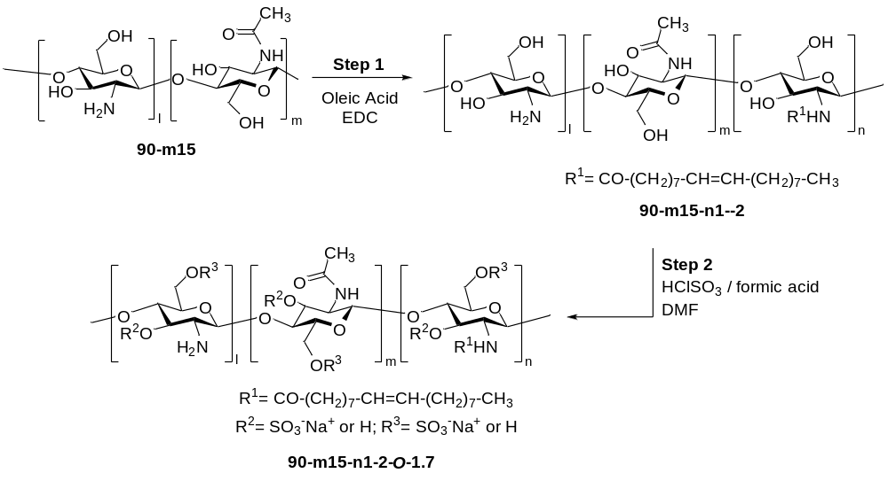
Step 1: 90-m15 was grafted with oleic acid according to Procedure 1 (section 5.1.1), using a 90-m15:EDC:oleic acid ratio of 1:0.17:0.57 (g:g:mL). Yield of 90-m15-n1-2 (Intermediate 1): 83%.
¹H NMR (D₂O, 500 MHz, 25 ºC, TFA (1%)) (selected signals): -CO-CH₂-(CH₂)₅-CH₂-CH=CH-CH₂-(CH₂)₆-CH₃ (0.77 ppm); -CO-CH₂-(CH₂)₅-CH₂-CH=CH-CH₂-(CH₂)₆-CH₃ (1.03-1.52 ppm); -CO-CH₂-(CH₂)₅-CH₂-CH=CH-CH₂-(CH₂)₆-CH₃ (1.88-1.94 and 2.11-2.22); H₃C–CONH– (1.96 ppm); H₂ (3.07 ppm) H₃₋₆ (3.48-3.89 ppm); H₁ (4.86 ppm) and -CO-CH₂-(CH₂)₅-CH₂-CH=CH-CH₂-(CH₂)₆-CH₃ (5.22 ppm).
Step 2: 90-m15-n1-2-O-1.7 was prepared from 90-m15-n1-2 according to Procedure 2 (section 5.1.2), using a 90-m15-n1-2:chlorosulfonic acid ratio of 1:2.8 (g:mL). Yield of 90-m15-n1-2-O-1.7: 92%
¹H NMR (D₂O, 500 MHz, 25 ºC) (selected signals): -CO-CH₂-(CH₂)₅-CH₂-CH=CH-CH₂-(CH₂)₆-CH₃ (0.73 ppm); -CO-CH₂-(CH₂)₅-CH₂-CH=CH-CH₂-(CH₂)₆-CH₃ (1.03-1.55 ppm); H₃C–CONH– (1.91 ppm); H₂ (3.22 ppm); H₃(H) and H_{6a-b} (H) (3.53-3.98 ppm); H₃ (SO₃⁻) and H_{6a-b} (SO₃⁻) (4.00-4.55 ppm).
ATR-FTIR (cm⁻¹): 2957, 1633, 1530, 1457, 1382, 1217 (SO₂ st as), 1064, 999 (SO₂ st sy), 942, 799 801 (S-O st).
Elemental analysis: %S= 14.29; %N= 3.74; S/N= 1.7.

125-m20-n1-O-1.6 (compound 19)
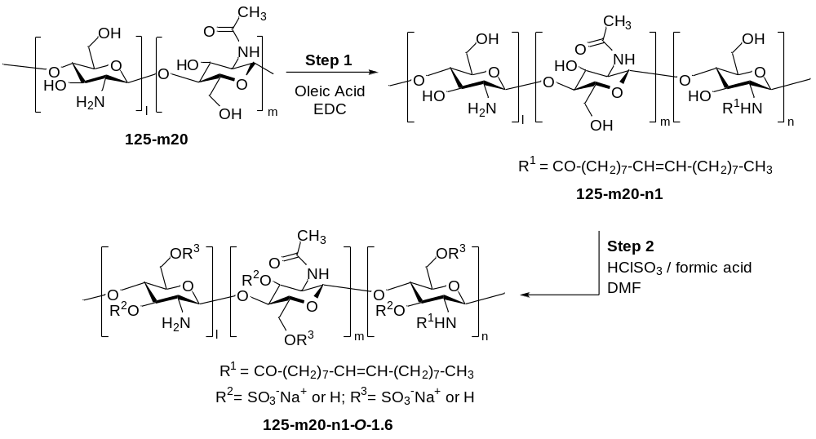
Step 1: 125-m20 was grafted with oleic acid according to Procedure 1 (section 5.1.1), using a 125-m20:EDC:oleic acid ratio of 1:0.17:0.57 (g:g:mL). Yield of 125-m20-n1: 78%.
¹H NMR (D₂O, 500 MHz, 25 ºC, TFA (1%)) (selected signals): -CO-CH₂-(CH₂)₅-CH₂-CH=CH-CH₂-(CH₂)₆-CH₃ (0.88 ppm); -CO-CH₂-(CH₂)₅-CH₂-CH=CH-CH₂-(CH₂)₆-CH₃ (1.16-1.67 ppm); -CO-CH₂-(CH₂)₅-CH₂-CH=CH-CH₂-(CH₂)₆-CH₃ (1.97-2.06 and 2.22-2.31); H₃C–CONH– (2.07 ppm); H₂ (3.18 ppm) H₃₋₆ (3.52-4.00 ppm) and -CO-CH₂-(CH₂)₅-CH₂-CH=CH-CH₂-(CH₂)₆-CH₃ (5.32 ppm).
Step 2: 125-m20-n1-O-1.6 was prepared from 125-m20-n1 according to Procedure 2 (section 5.1.2), using a 125-m20-n1:chlorosulfonic acid ratio of 1:2.8 (g:mL).. Yield of 125-m20-n1-O-1.6: 89%
¹H NMR (D₂O, 500 MHz, 25 ºC) (selected signals): -CO-CH₂-(CH₂)₅-CH₂-CH=CH-CH₂-(CH₂)₆-CH₃ (0.73 ppm); -CO-CH₂-(CH₂)₅-CH₂-CH=CH-CH₂-(CH₂)₆-CH₃ (0.97-1.26 ppm); H₃C–CONH– (1.92 ppm); H₂ (3.24 ppm); H₃(H) and H_{6a-b} (H) (3.45-3.92 ppm); H₃ (SO₃⁻) and H_{6a-b} (SO₃⁻) (3.93-4.51 ppm) and H₁ (4.81 ppm).
Elemental analysis: %S= 14.18; %N= 3.89; S/N= 1.6.

5.2.5. Synthesis of Mw-mX-nY-N-Z polysaccharides
15-m15-n27-N-0.7 (compound 14)
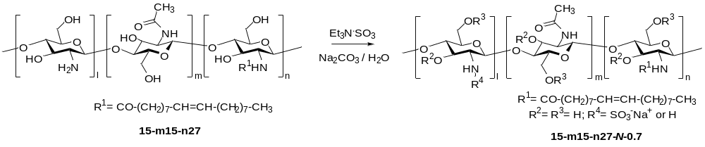
15-m15-n27-N-0.7 was prepared from 15-m15-n27 according to Procedure 3 (section 5.1.3), using a 15-m15-n27: Na₂CO₃:Me₃N·SO₃ ratio of 1:0.3:0. 7 (g:g:g). Yield of 15-m15-n27-N-0.7: 77%.
¹H NMR (D₂O + Na₂CO₃, pH=9.0, 500 MHz, 70º) (selected signals): -CO-CH₂-(CH₂)₅-CH₂-CH=CH-CH₂-(CH₂)₆-CH₃ (0.75 ppm); -CO-CH₂-(CH₂)₅-CH₂-CH=CH-CH₂-(CH₂)₆-CH₃ (0.91-1.66 ppm); H₃C–CONH– (1.91 ppm); H₂ (H) (2.68 ppm); H₂ (SO₃⁻) (2.95 ppm); H₃-H₆ (3.43-3.92 ppm); H₁ (4.45 ppm) and -CO-CH₂-(CH₂)₅-CH₂-CH=CH-CH₂-(CH₂)₆-CH₃ (5.20 ppm).
ATR-FTIR (cm⁻¹): 2958, 1753, 1634, 1531, 1457, 1384, 1217 (SO₂ st as), 1043, 1000 (SO₂ st sy), 941, 803 (S-O st).
Elemental analysis: %S= 7.83; %N= 3.84; S/N= 0.7.

- Mechanism of action of compound 17
6.1. Protein production
RBD Wuhan-Hu-1 was expressed in a baculovirus/insect cell system and purified according to the method outlined previously⁸. This protein, spanning residues Arg319 to Phe541 of Spike Wuhan, features a C-terminal 6×His-tag and is secreted into the culture medium via a gp67 signal peptide, which undergoes cleavage upon exportation⁹.
For the production of SARS-CoV-2 Spike protein, or its S1 subunit from the Wuhan variant used in SPR experiments or the Spike-D614G spike variant used in negative stain electron microscopy (NSEM), we employed a similar baculovirus/insect cell expression system and followed the purification protocol outlined previously¹⁰. In preparation for both thermofluor assays and NSEM, we generated the highly stable SpikeWuhan HexaPro41, following the methods described previously¹¹.

6.2. Surface Plasmon Resonance (SPR)
The surface of a CM5 sensor chip (Biacore Inc., GE Healthcare, USA) was activated using freshly mixed N-hydroxysuccimide (NHS; 100 mM) and 1‐(3‐(dimethylamino)propyl)‐ethylcarbodiimide (EDC; 400 mM) (1/1, v/v) in water. Next, protein (RBD, SARS-CoV-2 Spike protein, or its S1 subunit) (50 μg/mL) in aqueous NaOAc (10 mM, pH 5.0) was passed over the surface until a ligand density of 7500‐10.000 respectively, was achieved. Quenching of the remaining active esters was accomplished by passing aqueous ethanolamine (1.0 M, pH 8.5) over the surface of the chip. The control flow cell was activated with NHS and EDC, which was then treated with ethanolamine. HBS‐EP (0.01 M HEPES, 150 mM NaCl, 3 mM EDTA, 0.005% polysorbate 20; pH 7.4) was employed as the running buffer for immobilization, binding, affinity and kinetic analysis.
Serial dilutions of each compound in HBS‐EP buffer at a flow rate of 30 μL/min were employed for association and dissociation at a temperature of 25 °C. One 30 s injection of aqueous NaCl (2.0 M) at a flow rate of 30 μL/min was employed for regeneration to achieve baseline status. Affinity data were fitted to a ' 1:1 steady state affinity' model and kinetics data to a '1:1 langmuir binding model'. The evaluation was made using a BIAcore X100 evaluation software (Biacore Inc., GE Healthcare).

6.3. Thermal shift assays
Thermofluor assays¹² were conducted in a 20 μl solution containing 0.1 mg/ml of SARS-CoV-2 SpikeWuhan HexaPro protein in 10 mM Na Hepes pH 7.4, 150 mM NaCl either alone or in combination with dilutions of the compound 17 suspended in 0.9% NaCl and a 1:1000 dilution of the commercial preparation of SYPRO Orange from Invitrogen (Carlsbad, CA). For the assays, a stock solution of compound 17 at 39 mg/mL was diluted 5, 10, 20, 50, 75 and 100 times. SYPRO Orange was added last, after a 10-minute incubation at 21°C of the mixture without this fluorophore. Subsequently, the mixtures were transferred to wells in a microwell plate, sealed with tape, and placed in a real-time PCR instrument (model 7500, Applied Biosystems, Thermo Fisher Scientific, Alcobendas, Madrid, Spain). Each assay consisted of three replicate wells for each data point and was repeated at least twice on different days. Plots, curve fittings, and numerical calculations were conducted using GraphPad Prism 9 software (GraphPad Software, San Diego, CA, USA).

6.4. Negative stain electron microscopy
To further check the effect of the compounds on the stability of the Spike protein, we used negative staining electron microscopy (NSEM), which has proved to be a straightforward and effective method for scrutinizing the morphological characteristics of the Spike protein. In addition to the HexaPro version of the spike, for this assay, we also used the Spike-D614G variant used previously¹⁰. Before the introduction of the selected compound 17, the Spike protein (0.05mg/ml) undergoes equilibration at room temperature (RT) for 30 minutes in buffer 50 mM Hepes pH 7.2, 150 mM NaCl, followed by incubation with the compound for additional 30 minutes at RT and the preparation of various negative staining (NS) grids. A droplet of the mixture was carefully deposited onto NS grids for approximately 30 seconds. Subsequently, the grid is blotted with filter paper and then exposed to a 0.5% uranyl acetate (UA) solution for an additional 30 seconds. Excess of UA was eliminated, and then the grids were examined using a Hitachi HT-7800 microscope operated at 100 kV, ensuring a comprehensive analysis of the Spike protein morphology in the presence/absence of the compounds (Figure S1).

7. Preliminary toxicological evaluation

7.1. Phase 1: Single dose administration of ET36. Dose score

a) Tested doses
The first female (animal identified with number 1) received compound 17 in solution at a dose of 10 mg/kg. The successive doses administered were selected based on the viability/mortality results obtained for the immediately previous dose, the following being tested:

Table S4. Phase I. Administration regimen tested
Animal Identification | Dose of ET-36 (mg/kg)
F1 | 10
F2 | 32.5
F3 | 100
F4 | 100
F5 | 100

The trial was ended after administration of the fifth female, when one of the criteria specified in paragraph 33 and Annex 3 of the OECD guidelines, Section 4, No. 425: “3 animals have survived at the limit dose” ( 3 animals survive the limit dose).

b) Viability/Mortality and General Symptoms
No lethality was recorded after the administration of single doses of up to 100 mg of ET-36/kg body weight and all animals were sacrificed on day 14, according to the planned schedule.
The general condition of the animals did not present any relevant alterations during the 14 days of the study.

c) Weight record
As seen in Table S5, during the acclimatization period and the fourteen days after administration, there was an increase in body weight adjusted to normal. The greatest weight loss occurred in the acclimatization period (∆ Day 0-arrival) due to adaptation to the groups formed for the study and the environmental conditions.

Table S5. Phase I. Registration and weight increase. Individualized data. The table shows, for each animal, the weekly weights (g) and the weight variations observed in the established time intervals (arrival-start and weekly until slaughter). The data identified as control corresponds to the data provided by the supplier of the experimental system.
ID. Animal | Animal Weight record (g) |  |  |  |  | Weight increase (g)
ID. Animal | Arrival | Day 0  Start | Day4 | Day 7 | Day 14  Sacrifice | ∆ Day 0-arrival | ∆ Day 4-Day 0 | ∆ Day 7-Day 4 | ∆ Day 14-Day 7 | ∆Day 14-Arrival | ∆ Sacrifice-Day 0
F1 | 22.8 | 21.3 | 21.0 | 21.7 | 21.3 | -1.5 | -0.3 | 0.7 | -0.4 | -1.5 | 0.0
F2 | 22.9 | 21.7 | 21.5 | 20.8 | 22.1 | -1.2 | -0.2 | -0.7 | 1.3 | -0.8 | 0.4
F3 | 21.3 | 20.9 | 20.1 | 21.0 | 20.8 | -0.4 | -0.8 | 0.9 | -0.2 | -1.5 | -0.1
F4 | 21.7 | 22.1 | 21.2 | 21.9 | 21.6 | 0.4 | -0.9 | 0.7 | -0.3 | -0.1 | -0.5
F5 | 23.6 | 21.2 | 22.0 | 22.1 | 22.0 | -2.4 | 0.8 | 0.1 | -0.1 | -1.6 | 0.8
Control | 18.7 | 19.2 | 19.9* | 20.4 | 20.4 | 0.5 | 0.7 | 0.5 | 0.0 | 1.7 | 1.5
*Extrapolated data

d) Analytical Study
Table S6 shows the serum levels of transaminases, urea and creatinine, quantified 14 days after the single administration of compound 17 at doses of up to 100 mg/kg. All parameters were found within the normal ranges for the species (serum levels compared with the normal ranges calculated from the laboratory's records or from the data provided by the supplier of the experimental system).

Table S6. Phase I. Biochemical parameters –Day 14-: Individualized data.
The table shows for each female in phase I, the values obtained in the biochemical parameters quantified before sacrifice (day 14 of the study). The normal ranges calculated from the Toxicology laboratory's historical data are highlighted in blue, and the normal ranges calculated from the data provided by the supplier of the experimental system are highlighted in gray (https://insights.envigo.com/hubfs/resources/data-sheets/balbcann-7-8wk-male-cbc.pdf).

Animal Identification |  | Urea  (mg/dL)  41-82  47-53 | AST (U/L)  8-174  51-261 | ALT (U/L)  16-47  15-152 | Creatinine (mg/dL)  0.02-0.38  0.10-0.10
10 mg/kg | F1 | 59 | 221 | 129 | 0.22
32.5 mg/kg | F2 | 57 | 113 | 53 | 0.24
100 mg/kg | F3 | 56 | 172 | 65 | 0.13
100 mg/kg | F4 | 57 | 82 | 35 | 0.25
100 mg/kg | F5 | 64 | 75 | 36 | 0.26

e) Macroscopic Anatomopathological Study and Organ Weight
The macroscopic study carried out did not reveal alterations in thoracic and/or abdominal organs; being in accordance with normality.
In view of these results, taking into account the absence of toxic effects in all doses tested, the dose of 100 mg/kg (maximum possible dose according to solubility) was selected as the maximum dose to be used in Phase II, as it coincides with the NOAEL at a single dose.

7.2. Phase II: Administration of compound 17 at repeated dose (4 days). Dose confirmation.

a) Tested doses
Once the dose of 100 mg/kg was determined as the reference dose for Phase II dose selection, the following were selected as test doses: 100, 65 and 40 mg/kg (approximate decremental factor x1.5).

b) Viability/Mortality and General Symptoms
No alterations in general symptoms were recorded and all animals were sacrificed on day 4, according to the planned schedule.

​c) Weight record
No statistically significant differences were detected in the body weight of the test groups compared to each other (Table S7). As can be seen in the “Control” row, females between 9-11 weeks of age maintain their constant weight; Therefore, the observed weight decreases did not represent a relevant variation in the rate of weight gain and were related to the stress generated in the animals as a result of the administration operation.

Table S7. Registration and weight increase. Descriptive and inferential statistics. The table shows, ordered by test group, the descriptive statistics of centralization and dispersion (mean and standard deviation) of the weights and weight variations (g) observed in the established time intervals until sacrifice. Likewise, an inferential study was carried out comparing the treated groups with each other: T1 vs T2 (a); T1 vs T3 (b) and T2 vs T3 (c). No statistically significant differences were found in the Whitney U test performed.

Sex/Group |  | Weight record (g) |  |  | Weight increase (g)
 |  | Arrival | Day 0 | Day 4  Sacrifice | ∆ Day 0-arrival | ∆ Sacrifice-  Day 0 | ∆ Sacrifice-Arrival
FEMALES | Group 1  (100 mg/kg) | 22.17 | 21.90 | 21.13 | -0.27 | -0.77 | -1.03
FEMALES | Group 1  (100 mg/kg) | 0.21 | 1.31 | 1.15 | 1.31 | 0.21 | 1.12
FEMALES | Group 2  (65 mg/kg) | 21.23 | 20.30 | 19.57 | -0.93 | -0.73 | -1.67
FEMALES | Group 2  (65 mg/kg) | 0.68 | 0.92 | 0.78 | 0.45 | 0.15 | 0.42
FEMALES | Group 3  (40 mg/kg) | 21.50 | 20.60 | 19.30 | -0.90 | -1.30 | -2.20
FEMALES | Group 3  (40 mg/kg) | 0.26 | 0.79 | 0.36 | 0.53 | 0.89 | 0.46
FEMALES | Control | 20.4 | 20.4 | 20.4* | 0.0 | 0.0 | 0.0*

d) Analytical Study: Serum Biochemical Parameters
The analytical data quantified on day 4 were compared with the normal ranges obtained from the laboratory records. As a result of the comparison carried out, statistically significant differences were obtained (p=0.0463 and p=0.0431) in the creatinine levels of the high-dose group (100 mg/kg) and the intermediate dose (65 mg/kg) versus the low-dose group (40 mg/Kg), as shown in Table S8. However, all the individual data of the animals were found within the normal ranges for the species so it is determined that this observation has no toxicological relevance.

Table S8. Serum biochemical parameters. Day 7. Descriptive and inferential statistics. The table shows, ordered by test groups, the descriptive statistics of centralization and dispersion (mean and standard deviation) and the statistical significance obtained in the Whitney U test, according to the levels of significance: (*) significant (p<0, 05). The inferential study was carried out by comparing the treated groups with each other: T1 vs T2 (a); T1 vs T3 (b) and T2 vs T3 (c).

Sex/  Group |  | Biochemical parameters
 |  | Urea  (mg/dL) | AST (U/L) | ALT (U/L) | Creatinine (mg/dL)
FEMALE | Group 1: 100 mg/kg | 50 | 87 | 29 | 0.13
FEMALE | Group 1: 100 mg/kg | 2 | 11 | 6 | 0.02*^{b}
FEMALE | Group 2: 65 mg/kg | 87 | 30 | 46 | 0.15
FEMALE | Group 2: 65 mg/kg | 10 | 7 | 1 | 0.01*^{c}
FEMALE | Group 3: 40 mg/kg | 100 | 32 | 58 | 0.22
FEMALE | Group 3: 40 mg/kg | 45 | 7 | 16 | 0.01

e) Macroscopic Anatomopathological Study and Organ Weight
The data were subjected to the non-parametric test -Mann Whitney U-; comparing the treated groups with each other. No statistically significant differences were detected.

Table S9. Weight of organs. Descriptive and inferential statistics. The table shows, ordered by test group, the descriptive statistics of centralization and dispersion (mean and standard deviation) of the absolute and relative weights, expressed in grams. Likewise, an inferential study was carried out comparing the treated groups with each other: T1 vs T2 (a); T1 vs T3 (b) and T2 vs T3 (c). No statistically significant differences were found in the Whitney U test performed.
Group | Absolute organ weight (g)
Group | Spleen |  | Heart | Liver | Thymus | Kidney |  | Suma Kidney | Ovaries |  | Suma Ovaries
 |  |  |  |  |  | Right | Left | Suma Kidney | Right | Left
Group 1  (100 mg/kg) | 0.069 |  | 0.110 | 0.744 | 0.037 | 0.117 | 0.118 | 0.235 | 0.009 | 0.008 |  | 0.016
Group 1  (100 mg/kg) | 0.008 |  | 0.001 | 0.062 | 0.004 | 0.004 | 0.005 | 0.001 | 0.004 | 0.001 |  | 0.003
Group 2  (65 mg/kg) | 0.071 |  | 0.107 | 0.705 | 0.030 | 0.110 | 0.112 | 0.222 | 0.005 | 0.006 |  | 0.011
Group 2  (65 mg/kg) | 0.003 |  | 0.014 | 0.060 | 0.003 | 0.011 | 0.010 | 0.021 | 0.001 | 0.001 |  | 0.002
Group 3  (40 mg/kg) | 0.071 |  | 0.112 | 0.693 | 0.034 | 0.109 | 0.114 | 0.223 | 0.004 | 0.005 |  | 0.009
Group 3  (40 mg/kg) | 0.004 |  | 0.011 | 0.015 | 0.005 | 0.003 | 0.007 | 0.007 | 0.001 | 0.001 |  | 0.001
Group | Relative organ weight (%)
Group | Spleen |  | Heart | Liver | Thymus | Kidney |  | Suma Kidney | Ovaries |  | Suma Ovaries
 |  |  |  |  |  | Right | Left | Suma Kidney | Right
Group 1  (100 mg/kg) | 0.692 | 0.569 |  | 6.242 | 0.438 | 0.664 | 0.661 | 1.325 | 0.040 | 0.035 |  | 0.076
Group 1  (100 mg/kg) | 0.569 | 0.027 |  | 3.965 | 0.423 | 0.077 | 0.063 | 0.137 | 0.014 | 0.009 |  | 0.018
Group 2  (65 mg/kg) | 0.401 | 0.602 |  | 3.956 | 0.170 | 0.619 | 0.627 | 1.246 | 0.028 | 0.032 |  | 0.060
Group 2  (65 mg/kg) | 0.021 | 0.063 |  | 0.239 | 0.013 | 0.046 | 0.044 | 0.091 | 0.006 | 0.006 |  | 0.009
Group 3  (40 mg/kg) | 0.390 | 0.615 |  | 3.821 | 0.185 | 0.603 | 0.627 | 1.230 | 0.024 | 0.028 |  | 0.051
Group 3  (40 mg/kg) | 0.022 | 0.055 |  | 0.131 | 0.026 | 0.014 | 0.030 | 0.022 | 0.003 | 0.005 |  | 0.003

8. Radiolabeling and biodistribution of compound 17 in mice

8.1 Preparation of N-4-hydroxyphenylmethyl derivative of compound 17
17 (100 mg) was dissolved in 3: 1 (v:v) methanol/water (8 mL) with stirring at room temperature for 30 min. 4-Hydroxybenzaldehide (200 mg) was added and the mixture was stirred for 24 h. Then NaBH4 (0.5 g) was slowly added into the solution and the reaction mixture was stirred for an additional 22 h. After this time, the pH of the solution was adjusted to pH 5-6 by the addition of HCl. Subsequently, methanol (350 mL) was added to obtain precipitate. The precipitate was filtered and dried in a vacuum at 40 °C, to obtain the N-4-hydroxyphenylmethyl derivative of compound 17 (82 mg).
8.2. Radiolabelling of polysaccharide 17 with Iodine-131
The polysaccharide was labeled with iodine-131 (¹³¹I) using iodination beads (Thermo Scientific Pierce, UK). In brief, the N-4-hydroxyphenylmethyl derivative of 17 (4 mg) was dissolved in Tris-HCl buffer (25 mM, pH = 4.8, 180 µL) to a final concentration of 45 mg/mL. [¹³¹I]NaI (323 ± 111 MBq, Izotop, Budapest) was then added to the solution and the reaction started by the addition of two iodination beads (Thermo Scientific Pierce, UK). The reaction mixture was incubated for two hours at room temperature before being terminated by separating the solution from the beads. Purification was achieved by ultracentrifugal filtration using Amicon ultra centrifugal filters (30kDa, Millipore, USA). The residue was washed three times by centrifugation with 300µL of ultrapure water (10.000 rpm, 10min). Finally, the residue was redissolved in ultrapure water (100 µL) to achieve a final mass concentration of 40 µg/µL, assuming that all the polymer used to start the reaction was still present. The radiochemical purity was determined by instant thin layer chromatography (iTLC) using silica gel paper as the stationary phase and dichloromethane in methanol (2:1) as the eluent. TLC plates were then read with a radio-TLC reader (MiniGita, Raytest) (see Figure S2 for representative chromatogram). Four syntheses were carried out, two for dissection and gamma counting experiments (1 and 2 in Table S10) and two for in vivo imaging experiments (3 and 4 in Table S10).

Table S10. Experimental data for the syntheses of [¹³¹I]-polysaccharide carried out for in vivo experiments. RCY: radiochemical yield, non-decay corrected; RCP: radiochemical purity, as determined by instant thin layer chromatography (iTLC).
Number | Amount of precursor (mg) | Starting radioactivity (MBq) | Final Radioactivity (MBq) | RCY (%) | Final volume (µL) | RCP (%)
1 | 4 | 384 | 48.1 | 12.5 | 100 | 97.6
2 | 4 | 161 | 46.76 | 29.1 | 100 | 98.1
3 | 4 | 403 | 82.51 | 20.5 | 100 | 96.3
4 | 4 | 347 | 88.1 | 25.3 | 100 | 98.7

8.3 Animal experiments
8.3.1. General considerations
Biodistribution studies were performed in female Balb/cJrj mice (see sections below for the number of animals). Animals were maintained and handled in accordance with the Guidelines for Accommodation and Care of Animals (European Convention for the Protection of Vertebrate Animals Used for Experimental and Other Scientific Purposes) and internal guidelines. All experimental procedures were approved by the internal ethical committee and the local authorities before conducting experimental work (authorization code: PRO-AE-SS-207).

8.3.2. In-vivo SPECT/CT imaging and analysis
Healthy female Balb/cJrj mice (n = 6, age = 10 weeks at use, Charles River, UK) were anesthetized by inhalation of 3% isoflurane in pure O₂ and maintained by 1.5-2% isoflurane in 100% O₂. For dynamic SPECT imaging to determine the residence time of the labeled polymer in the nostril under anesthetic conditions, animals (n=3) were intranasally administered with 10 µL of the solution containing the labeled polymer using a micropipette following standard protocols. Animals were immediately introduced in the SPECT scanner (γ-Cube micro system, Molecubes, Gent, Belgium) and images were acquired covering from the nose to the throat (energy window of 364 keV ± 30%; scanning time = 8 min). During the scan, anesthesia was maintained by inhalation of isoflurane (1-2% v/v in pure oxygen), and animal breath and temperature were continuously monitored. Imaging sessions (10 in total, 8 min each) were consecutively acquired immediately after the finalization of the previous scan. At the end of the last SPECT imaging session, computed tomography (CT) images were obtained using the X-cube micro system (Molecubes, Gent, Belgium), to provide anatomical information of each animal as well as the attenuation map for the later SPECT image reconstruction.
For whole-body imaging studies, animals (n=3) were anesthetized by inhalation of 3% isoflurane in pure O₂ and maintained by 1.5-2% isoflurane in 100% O₂. Animals were intranasally administered 10 µL of the solution containing the labeled polymer and allowed to recover from anesthesia. At t=30 min post-administration, a 30-min whole-body SPECT scan was acquired using the same system as above. Imaging sessions were repeated at 4h and 24h after administration. After each SPECT session, CT images were obtained as above.
SPECT images were reconstructed using the maximum likelihood expectation maximization (MLEM) algorithm using attenuation correction. Analysis of the images was carried out using the π-MOD image analysis software (π-MOD Technologies Ltd, Zurich, Switzerland). For whole-body images, analysis was done only qualitatively. Images were normalized to animal body weight and the administered amount of radioactivity to get standard uptake values (SUV) and were displayed as maximum intensity projections (MIP) co-registered with 3D-rendered CT images of the same animal. For experiments to assess the retention of radioactivity in the nostril, Volumes of interest were delineated manually on the SPECT images, and the concentration of radioactivity was expressed as standard uptake values (SUV). Values were then normalized to the value obtained immediately after administration. Images were displayed as maximum intensity projections (MIP) co-registered with 3D-rendered CT images of the same animal.

8.3.3. Ex-vivo studies
For ex vivo studies, healthy female Balb/cJrj mice (n = 20, age = 10 weeks at use, Charles River, UK) were anesthetized by inhalation of 3% isoflurane in pure O₂ and maintained by 1.5-2% isoflurane in 100% O₂. With the animal under anesthesia, 10 µL of the solution containing the ¹³¹I-labelled polymer was intranasally administered. The animal was allowed to recover from anesthesia, and at different time points (0.5, 3, 6, 24, and 48h post-administration), the animal was re-anesthetized and sacrificed by exsanguination. Organs (heart, lungs, spleen, muscle, stomach, large intestine, small intestine, liver, kidneys, and brain) and body fluids (blood and urine) were extracted, and the amount of radioactivity was determined using an automated gamma counter (2470 Wizard, PerkinElmer). The residual amount of radioactivity in the animal carcass was also determined using a dose calibrator (Capintec CRC-25R, France; animals sacrificed at time intervals 0.5-6h post administration) or a multichannel gamma spectrometer (MUCHA, Raytest; animals sacrificed at time intervals 24-48 post-administration). Values were expressed as a percentage of injected dose per organ (%ID). See Figure S3.

9. Supplementary figures
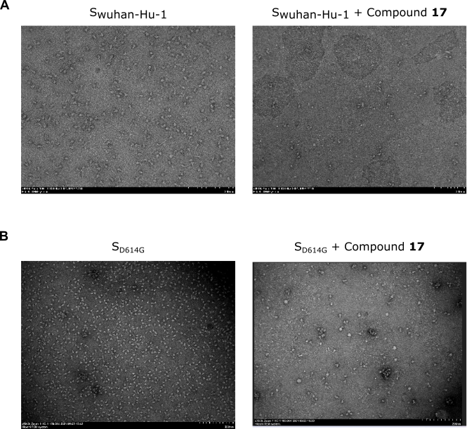

Figure S1. Structural analysis of SARS-CoV-2 Spike in the presence of compound 17.
Electron micrographs of recombinant S from the Wuhan-Hu-1 (A) or D614G (B) variant at 0.05 mg/mL incubated alone (left panels) or in the presence of compound 17 (right panels; 1.95 mg/mL or 0.39mg/mL in A or B, respectively). In the absence of the compound, intact particles of appropriate size and shape corresponding to S trimers are visualized. The addition of compound 17 (right panels) results in the alteration of S structure, including aggregates, a decreased number of particles, and the presence of smaller structures.

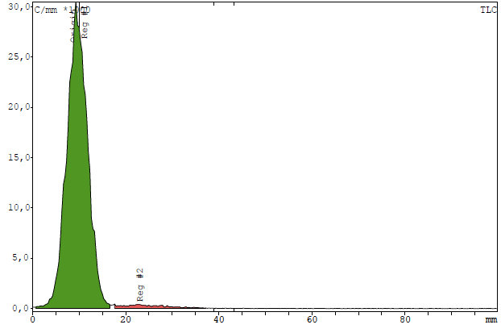
Figure S2. Chromatographic profile corresponding to the quality control of ¹³¹I-labelled polymer. The polymer stays at the seeding point.

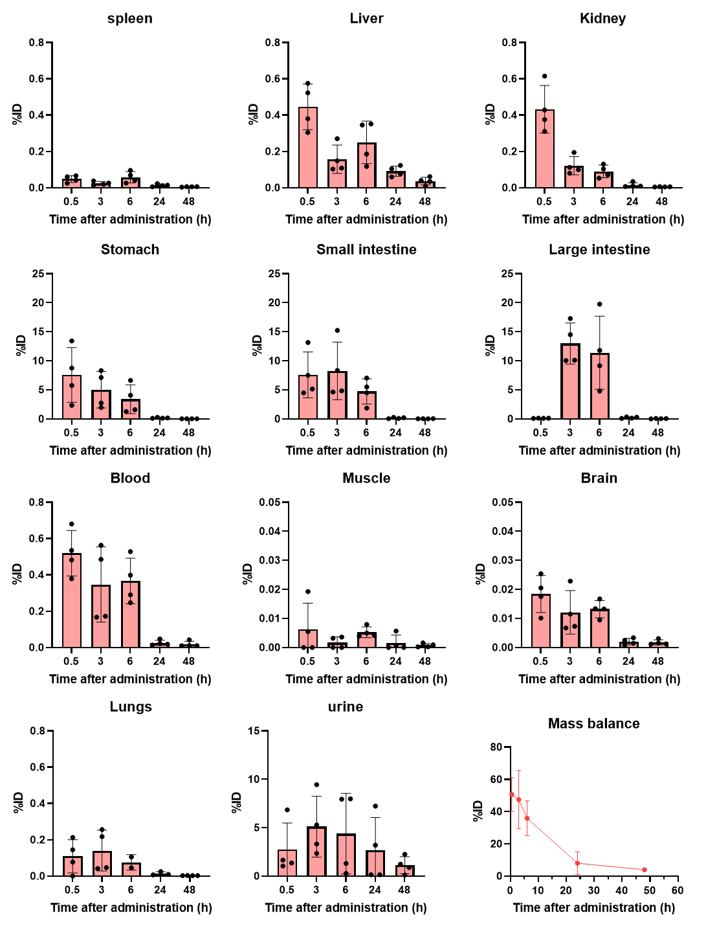

Figure S3. The distribution of ¹³¹I-labelled compound 17 in different organs and body fluids at different times after intranasal administration. Values are expressed as the percentage of injected radioactivity (%ID) in the whole organ. Bars represent average values, error bars represent standard deviation. For all time points and organs, n=4 except lungs (t=6h) in which samples were contaminated for 2 of the animals. The mass balance represents the total radioactivity in the whole animal (all organs + animal carcass).

10. ¹H NMR spectra and ATR-FTIR Spectra
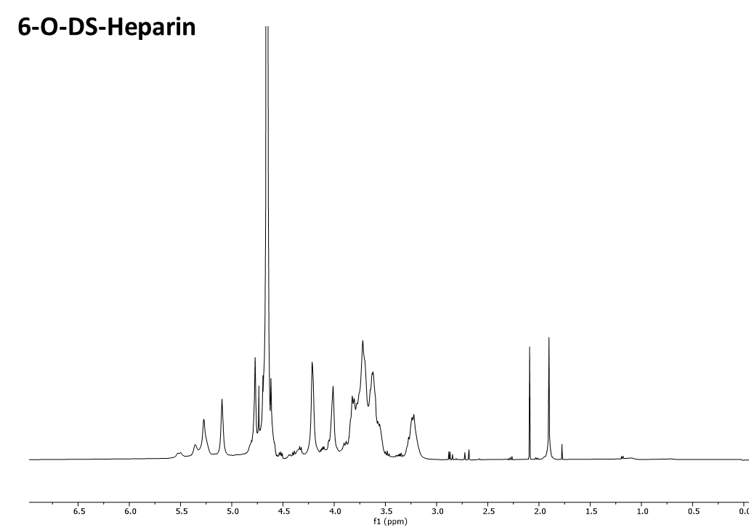

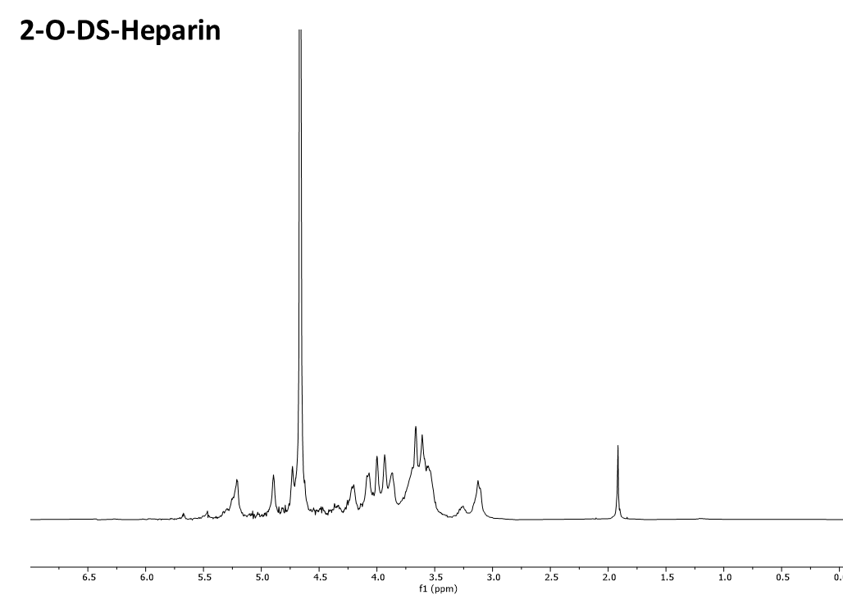

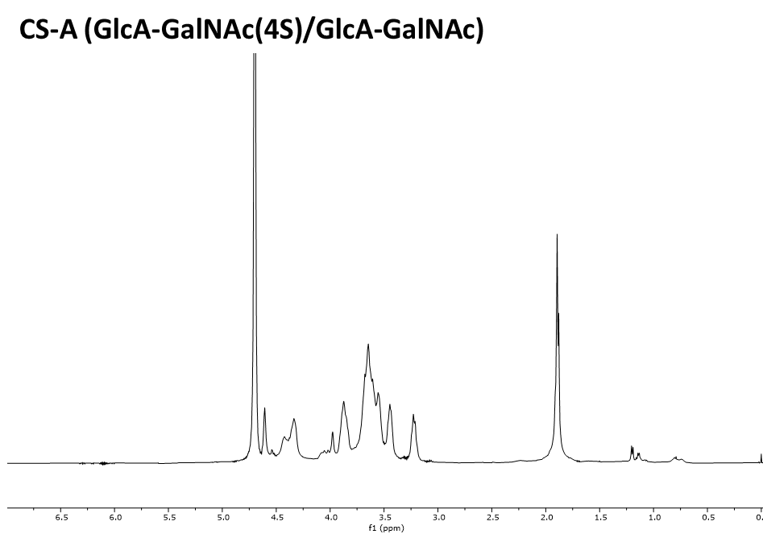

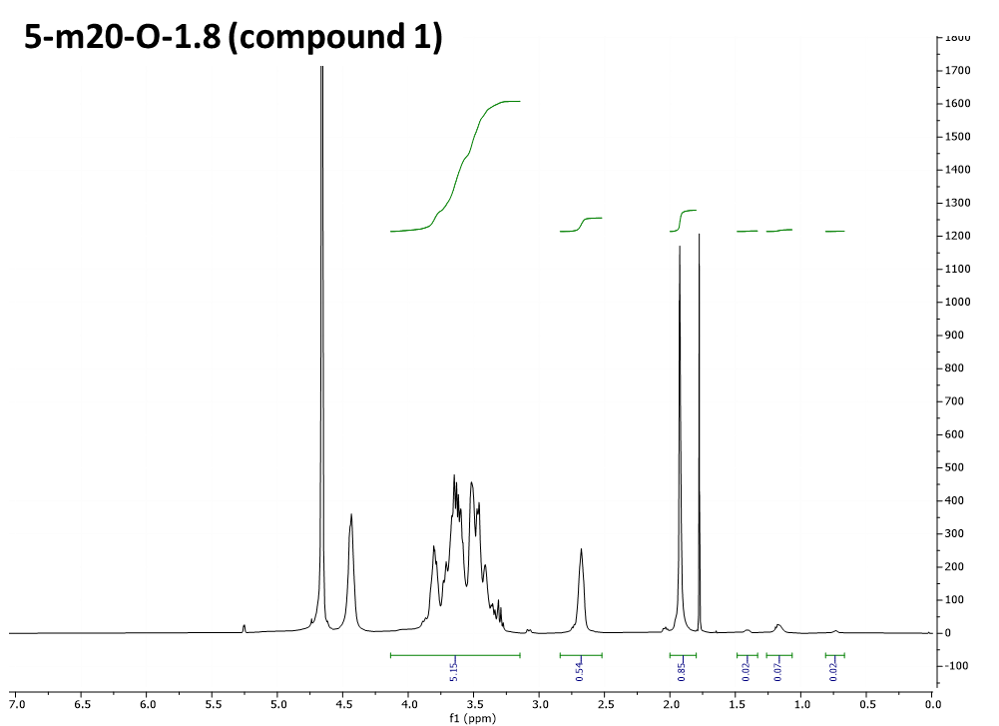

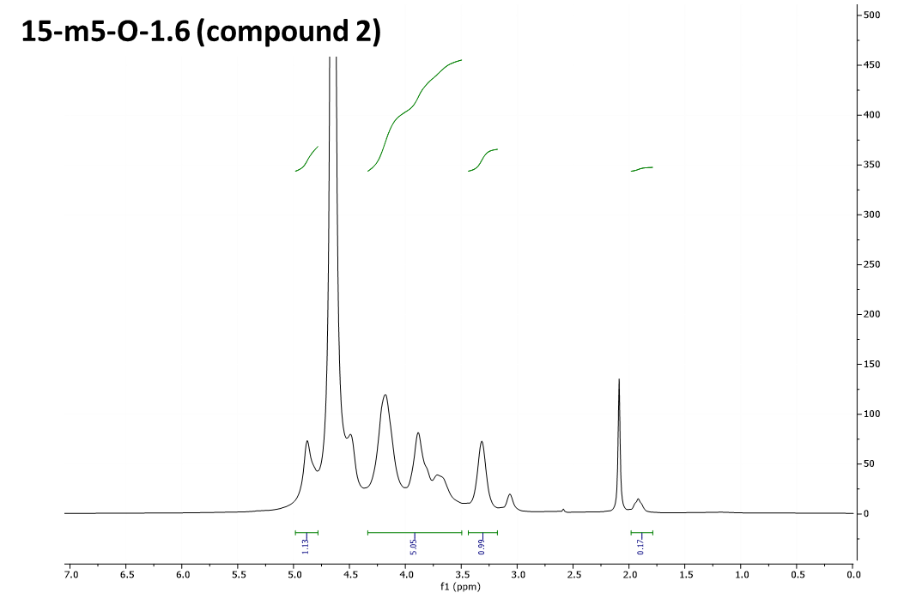

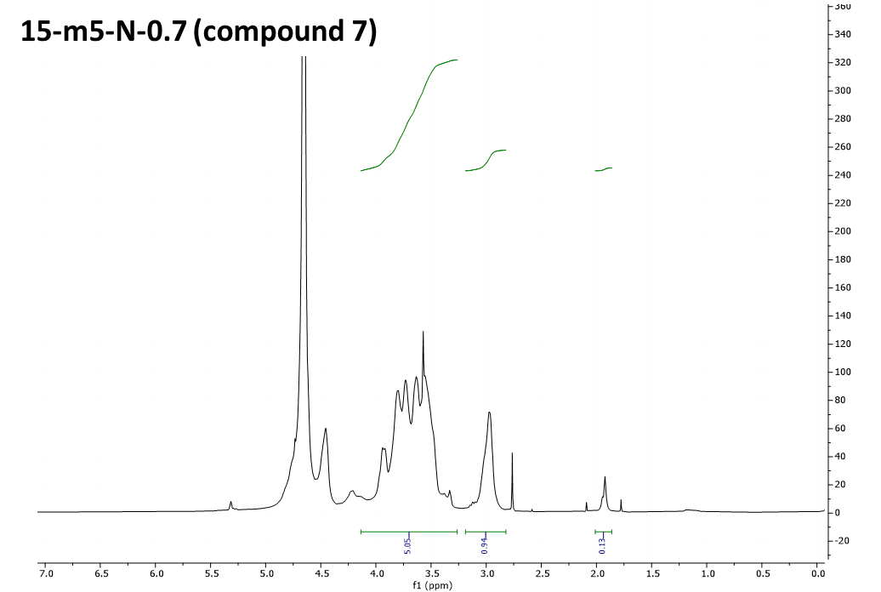

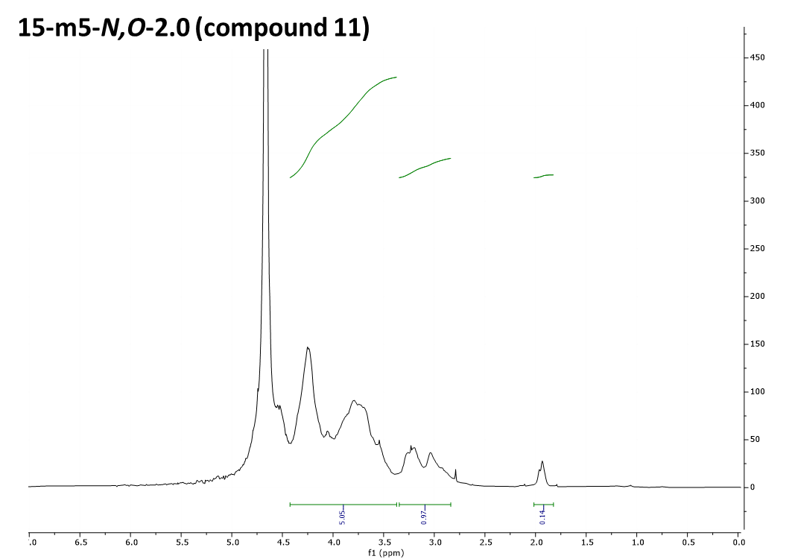

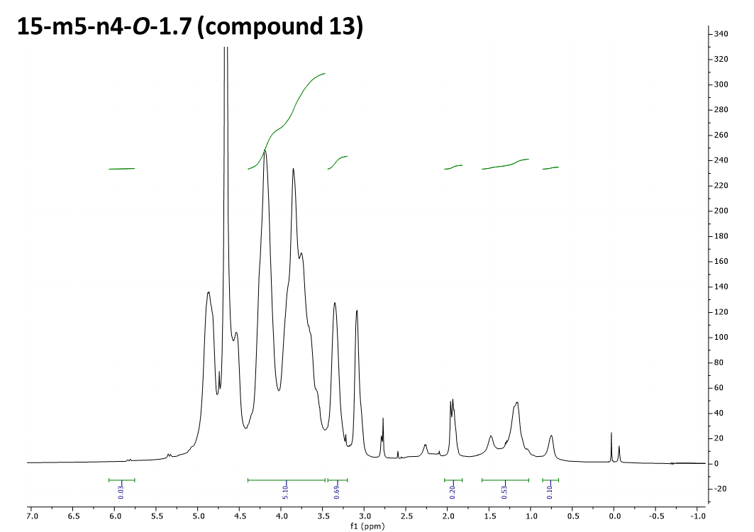

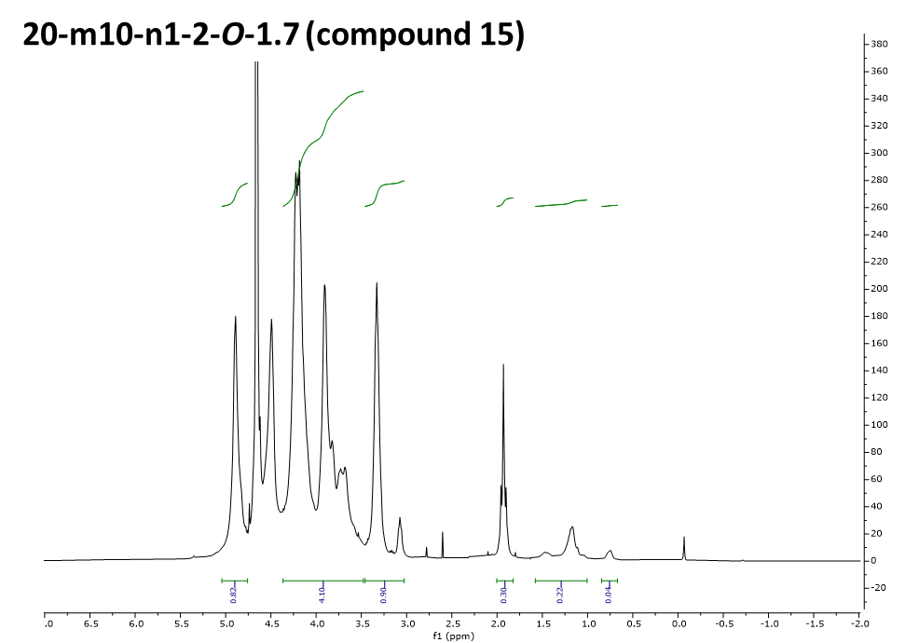

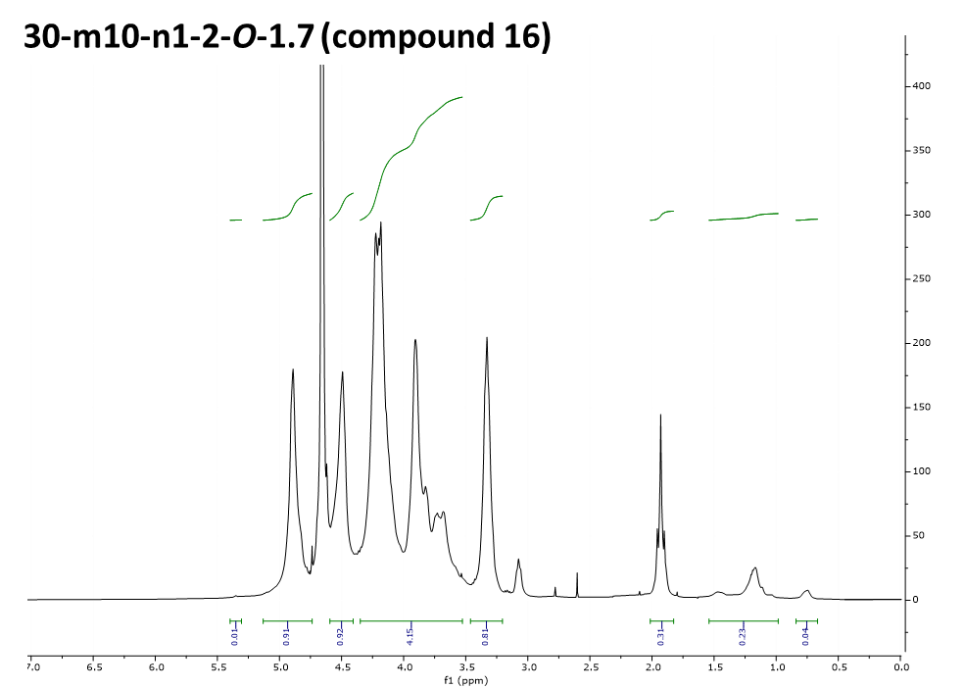

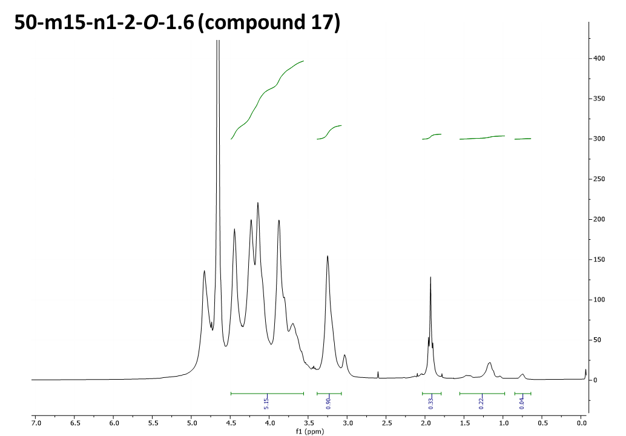

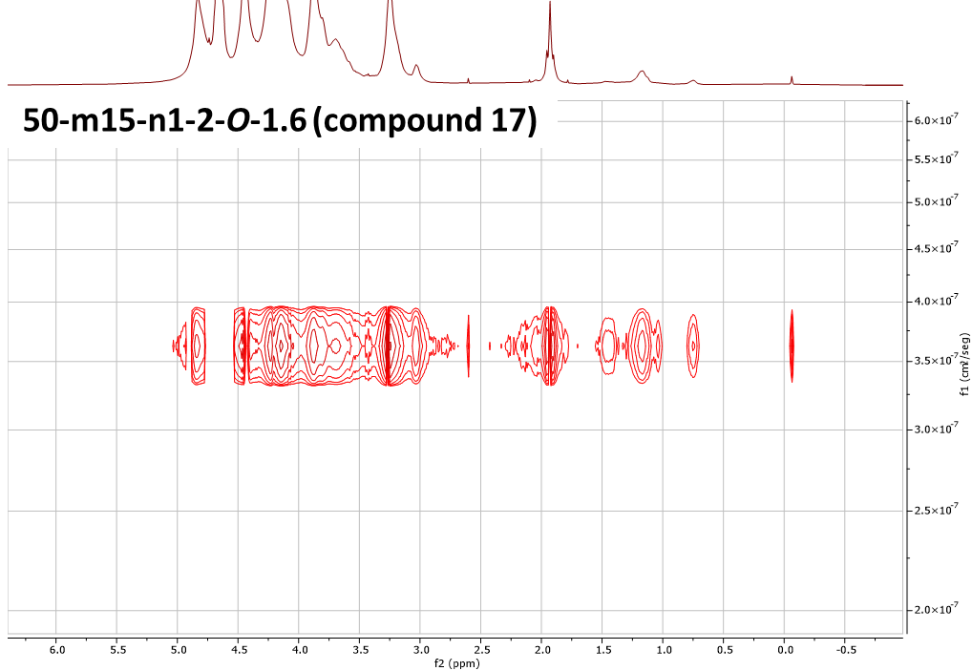

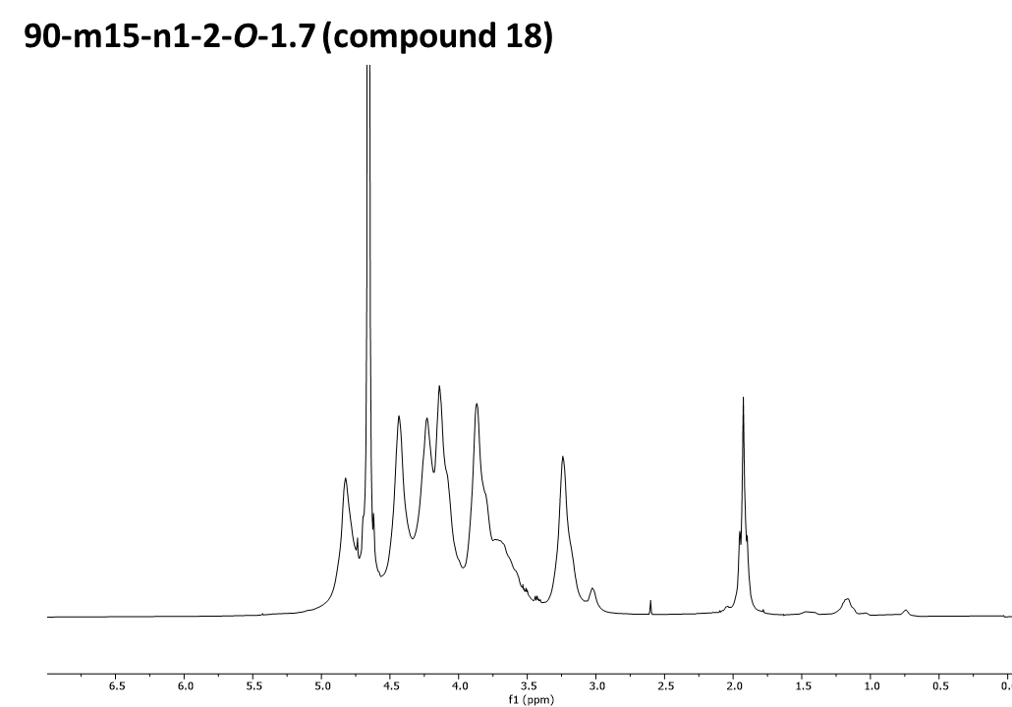

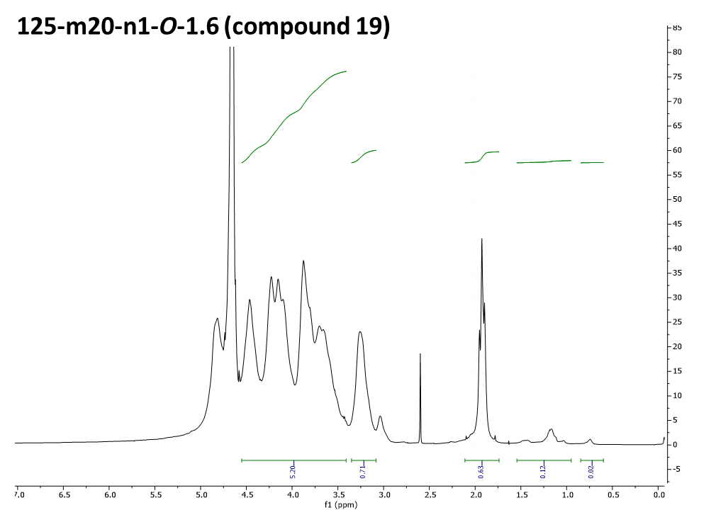

1H NMR of N-4-hydroxyphenylmethyl derivative of compound 17
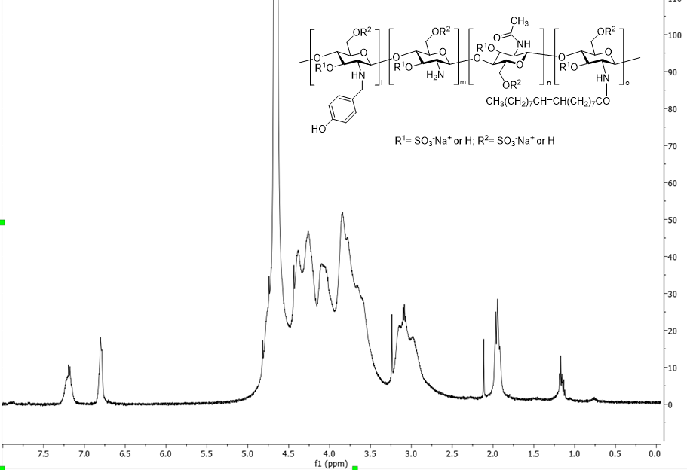

DOSY spectrum of N-4-hydroxyphenylmethyl derivative of compound 17
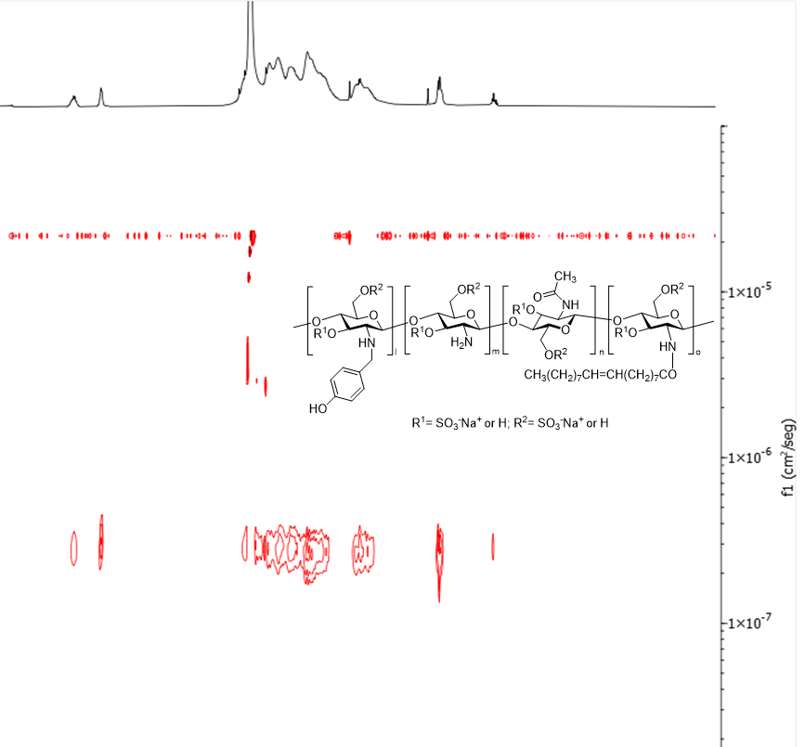
ATR-FTIR of 15-m5-N-0.7 (compound 7)
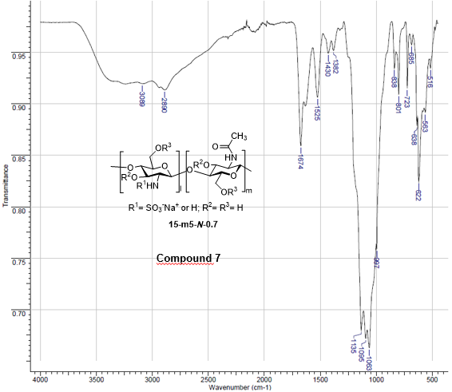

ATR-FTIR of 15-m10-n3-O-1.6 (compound 12)
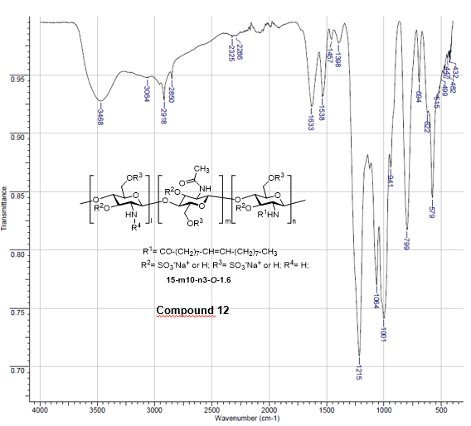
ATR-FTIR of 15-m5-n4-O-1.7 (compound 13)
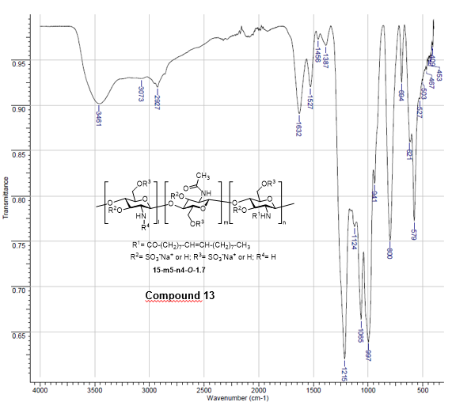

ATR-FTIR of 30-m10-n1-2-O-1.7 (compound 16)
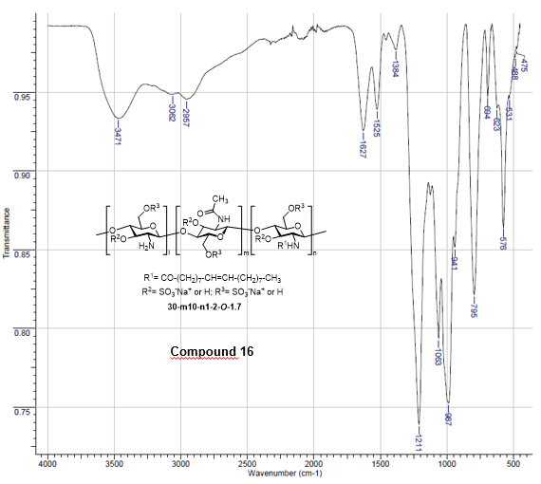

ATR-FTIR of 50-m15-n1-2-O-1.6 (compound 17)
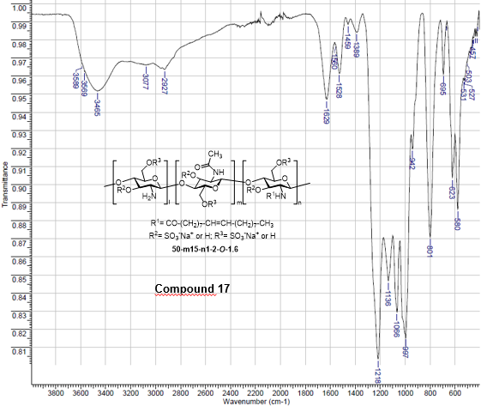

ATR-FTIR of 90-m15-n1-2-O-1.7 (compound 18)
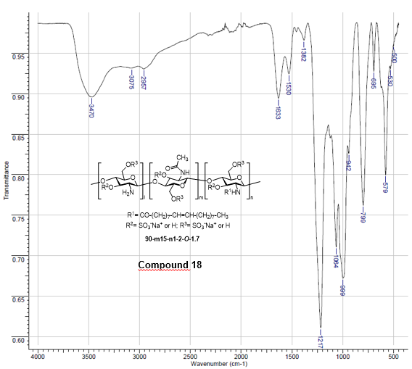
ATR-FTIR of 15-m15-n27-N-0.7 (compound 14)
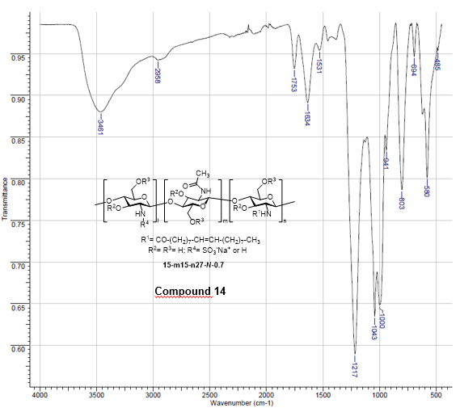

Supplementary References

1. Zieris, A. et al. Biohybrid Networks of Selectively Desulfated Glycosaminoglycans for Tunable Growth Factor Delivery. Biomacromolecules 15, 4439–4446 (2014).
2. Kariya, Y. et al. Preparation of completely 6-O-desulfated heparin and its ability to enhance activity of basic fibroblast growth factor. J Biol Chem 275, 25949–25958 (2000).
3. Baumann, H., Scheen, H., Huppertz, B. & Keller, R. Novel regio- and stereoselective O-6-desulfation of the glucosamine moiety of heparin with N-methylpyrrolidinone–water or N,N-dimethylformamide–water mixtures11Abbreviations: I, α-l-idopyranosyluronic acid residue; A, 2-deoxy-2-sulfamido-α-d-glucopyranosy. Carbohydr Res 308, 381–388 (1998).
4. Vessella, G. et al. Deciphering Structural Determinants in Chondroitin Sulfate Binding to FGF-2: Paving the Way to Enhanced Predictability of Their Biological Functions. Polymers vol. 13 Preprint at https://doi.org/10.3390/polym13020313 (2021).
5. Benito-Arenas, R. et al. A holistic approach to unravelling chondroitin sulfation: Correlations between surface charge, structure and binding to growth factors. Carbohydr Polym 202, 211–218 (2018).
6. Nakal-Chidiac, A. et al. Chitosan-stabilized silver nanoclusters with luminescent, photothermal and antibacterial properties. Carbohydr Polym 250, 116973 (2020).
7. Revuelta, J. et al. Unraveling the Structural Landscape of Chitosan-Based Heparan Sulfate Mimics Binding to Growth Factors: Deciphering Structural Determinants for Optimal Activity. ACS Appl Mater Interfaces 12, 25534–25545 (2020).
8. Lan, J. et al. Structure of the SARS-CoV-2 spike receptor-binding domain bound to the ACE2 receptor. Nature 581, 215–220 (2020).
9. Deshpande, C. N. et al. Large scale expression and purification of secreted mouse hephaestin. PLoS One 12, e0184366 (2017).
10. Ginex, T. et al. The structural role of SARS-CoV-2 genetic background in the emergence and success of spike mutations: The case of the spike A222V mutation. PLoS Pathog 18, e1010631 (2022).
11. Gargantilla, M. et al. C-2 Thiophenyl Tryptophan Trimers Inhibit Cellular Entry of SARS-CoV-2 through Interaction with the Viral Spike (S) Protein. J Med Chem 66, (2023).
12. Vedadi, M. et al. Chemical screening methods to identify ligands that promote protein stability, protein crystallization, and structure determination. Proceedings of the National Academy of Sciences 103, 15835–15840 (2006).

