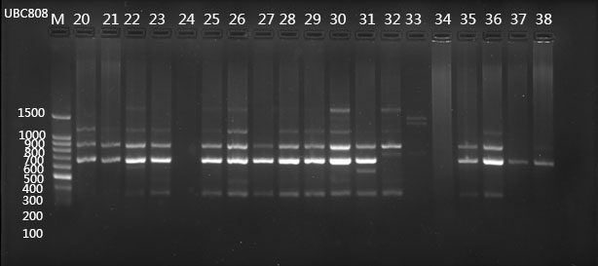

Fig. S1 ISSR-PCR electrophoretic maps of A. villosum populations with primer UBC808

Table S1 Primers informations and PCR amplification conditions
primers |  | base（5'-3'） | amplification conditions
ITS2 | 2F | ATGCGATACTTGGTGTGAAT | 94℃，5min  94℃，30s；56℃，30s；72℃，45s. 35 circles  72℃，10min
ITS2 | 3R | GACGCTTCTCCAGACTACAAT | 94℃，5min  94℃，30s；56℃，30s；72℃，45s. 35 circles  72℃，10min
psbA-trnH | fwd PA | GTTATGCATGAACGTAATGCTC | 94℃，4min  94℃，30s；55℃，1min；72℃，1min. 35 circles  72℃，10min
psbA-trnH | rev TH | CGCGCATGGTGGATTCACAATCC | 94℃，4min  94℃，30s；55℃，1min；72℃，1min. 35 circles  72℃，10min
matK | 3F_KIM | CGTACAGTACTTTTGTGTTTACGAG | 94℃，1min  94℃，30s；52℃，20s；72℃，50s. 35 circles  72℃，5min
matK | 1R_KIM | ACCCAGTCCATCTGGAAATCTTGGTTC | 94℃，1min  94℃，30s；52℃，20s；72℃，50s. 35 circles  72℃，5min
rbcL | 1F | ATGTCACCACAAACAGAAAC | 95℃，4min  94℃，1min；55℃，1min；72℃，2min. 38 circles  72℃，7min
rbcL | 724R | TCGCATGTACCTGCAGTAGC | 95℃，4min  94℃，1min；55℃，1min；72℃，2min. 38 circles  72℃，7min
ITS | 5F | GGAAGTAAAAGTCGTAACAAGG | 94℃，5min  94℃，1min；50℃，1min；72℃，1min30s. 30 circles  72℃，7min
ITS | 4R | TCCTCCGCTTATTGATATGC

