Graphical Abstract
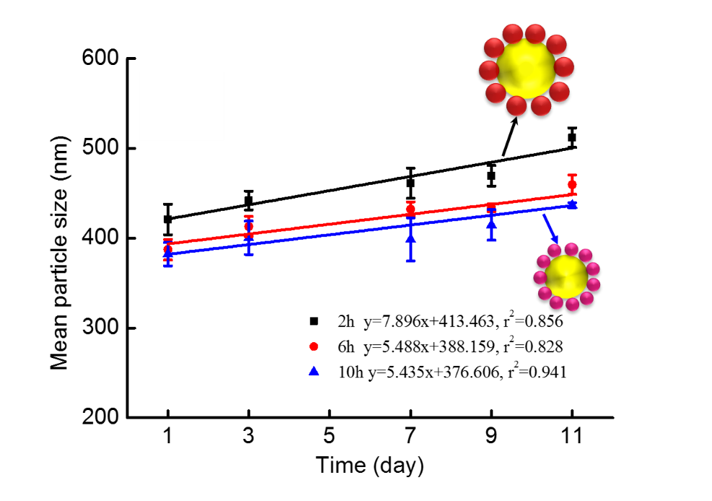
Emulsions stabilized by 10 h cellulose particles exhibited smaller particle size and better stability at all storage conditions compared to the 2 h cellulose particles due to the dense interfacial structure.

