Genetic Loci Determining Drought Resistance of Potato reveled by Genome-wide Association Study (GWAS)
Kuan Wang ^{a,} ¹, Jiepan Chen ª, Lei Liu ^{a, 1}, Benchi Ma ª, Lei Wang ª, Yan Feng ª, Lipan Qi ª, Xuechen Gong ^{b}, Jiang Yin ^{a,} *and Yan Wang ^{b,} *
ª Rain-fed Agriculture Research Center, Hebei North University, Zhangjiakou, Hebei, China
^{b} College of Agriculture and Forestry Science and technology, Hebei North University, Zhangjiakou, Hebei, China
* Correspondence: wangyan2@hebeinu.edu.cn；pubaohua@126.com
¹ These authors contributed equally to the article.

supplementary materials

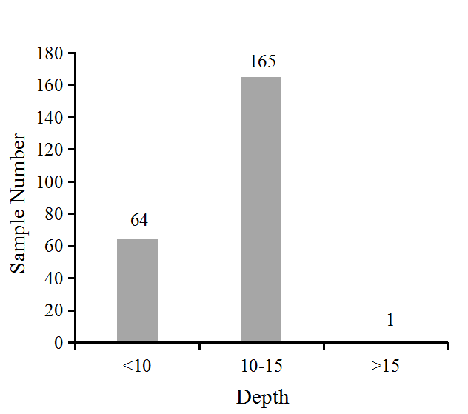
Figure S1. Sequencing depth of the 230 potato individuals re-sequenced.
Figure S2. Summary of variations within various genomic regions based on re-sequencing data from 230 potato individuals. (A) SNPs, (B) Indels.
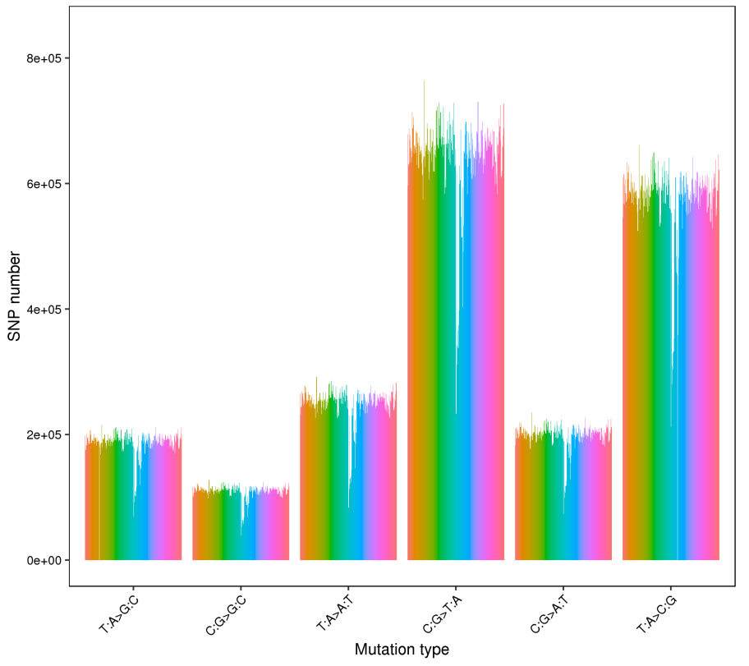
Figure S3. The summary of SNP mutation types in the whole genome based on the re-sequencing data.

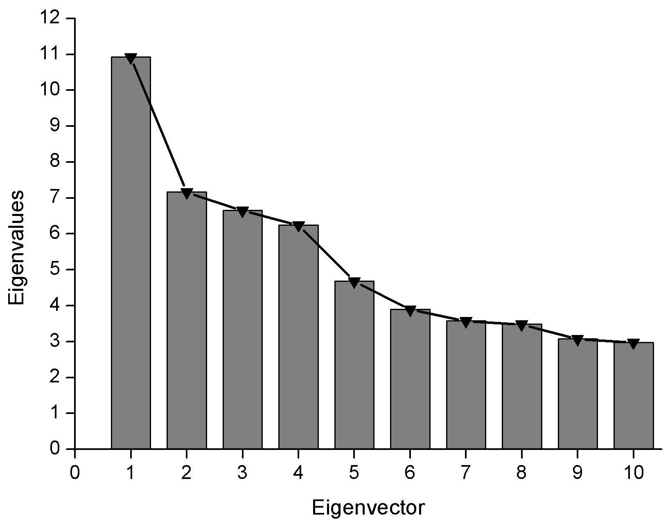
Figure S4. The eigenvalues of the first 10 eigenvectors (Ev1 to Ev10) calculated from the re-sequencing data.
Figure S5. The cross-validation (CV) error plot used for choosing the optimal K value of the population structure.

Figure S6. The distribution of phenotypic data under normal watering conditions used for genome-wide association study (GWAS). ChC: Chlorophyll content, PlH: Plant height, StM: Stem number, BrN: Branch number, PPN: Number of tubers per plant, PPW: Weight of tuber per plant. RWC: Relative water content, MSD: Moisture saturation deficit, WRR: Water retention rate.
Figure S7. The correlation analysis of phenotypic data under normal watering conditions used for genome-wide association study (GWAS). ChC: Chlorophyll content, PlH: Plant height, StM: Stem number, BrN: Branch number, PPN: Number of tubers per plant, PPW: Weight of tuber per plant. RWC: Relative water content, MSD: Moisture saturation deficit, WRR: Water retention rate.
Figure S8. The distribution of phenotypic data under drought conditions used for genome-wide association study (GWAS). ChC: Chlorophyll content. PlH: Plant height, BrN: Branch number. PPW: Weight of tuber per plant. RWC: Relative water content, VMF: Variety membership function. SSI: Stress susceptibility index.
Figure S9. The correlation analysis of phenotypic data under drought conditions used for genome-wide association study (GWAS). ChC: Chlorophyll content, PlH: Plant height, BrN: Branch number, PPW: Weight of tuber per plant. RWC: Relative water content, VMF: Variety membership function, Stress susceptibility index (SSI).
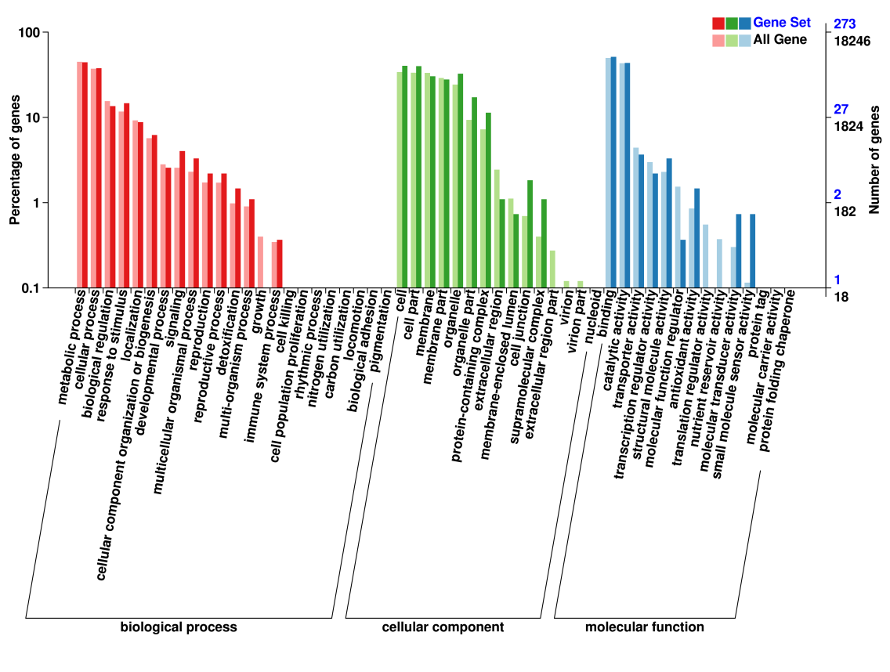
Figure S10. GO annotation of genes located in the selected regions (with the top 5% of F_{ST} and π_{DS}/π_{DR}) between drought resistant potatoes and drought susceptable potatoes.
Figure S11. Genome-wide association study (GWAS) on branch number (BrN) under drought conditions. (A) The manhattan plot of GLM model, (B) the quantile-quantile plot of GLM model, (C) the manhattan plot of FarmCPU model, (D) the quantile-quantile plot of FarmCPU model.
Figure S12. Genome-wide association study (GWAS) on chlorophyll content (ChC) under drought conditions. (A) The manhattan plot of GLM model, (B) the quantile-quantile plot of GLM model, (C) the manhattan plot of MLM model, (D) the quantile-quantile plot of MLM model, (E) the manhattan plot of FarmCPU model, (F) the quantile-quantile plot of FarmCPU model.
Figure S13. Genome-wide association study (GWAS) on plant height (PlH) under drought conditions. (A) The manhattan plot of GLM model, (B) the quantile-quantile plot of GLM model, (C) the manhattan plot of MLM model, (D) the quantile-quantile plot of MLM model, (E) the manhattan plot of FarmCPU model, (F) the quantile-quantile plot of FarmCPU model.
Figure S14. Genome-wide association study (GWAS) on weight of tuber per plant (PPW) under drought conditions. (A) The manhattan plot of GLM model, (B) the quantile-quantile plot of GLM model, (C) the manhattan plot of FarmCPU model, (D) the quantile-quantile plot of FarmCPU model.
Figure S15. Genome-wide association study (GWAS) on relative water content (RWC) under drought conditions. (A) The manhattan plot of FarmCPU model, (B) the quantile-quantile plot of FarmCPU model.
Figure S16. Genome-wide association study (GWAS) on stress susceptibility index (SSI) under drought conditions. (A) The manhattan plot of GLM model, (B) the quantile-quantile plot of GLM model, (C) the manhattan plot of MLM model, (D) the quantile-quantile plot of MLM model, (E) the manhattan plot of FarmCPU model, (F) the quantile-quantile plot of FarmCPU model.
Figure S17. Genome-wide association study (GWAS) on branch number (BrN) under normal watering conditions. (A) The manhattan plot of GLM model, (B) the quantile-quantile plot of GLM model, (C) the manhattan plot of MLM model, (D) the quantile-quantile plot of MLM model, (E) the manhattan plot of FarmCPU model, (F) the quantile-quantile plot of FarmCPU model.
Figure S18. Genome-wide association study (GWAS) on plant height (PlH) under normal watering conditions. (A) The manhattan plot of GLM model, (B) the quantile-quantile plot of GLM model, (C) the manhattan plot of MLM model, (D) the quantile-quantile plot of MLM model, (E) the manhattan plot of FarmCPU model, (F) the quantile-quantile plot of FarmCPU model.
Figure S19. Genome-wide association study (GWAS) on number of tubers per plant (PPN) under normal watering conditions. (A) The manhattan plot of GLM model, (B) the quantile-quantile plot of GLM model, (C) the manhattan plot of MLM model, (D) the quantile-quantile plot of MLM model, (E) the manhattan plot of FarmCPU model, (F) the quantile-quantile plot of FarmCPU model.
Figure S20. Genome-wide association study (GWAS) on weight of tuber per plant (PPW) under normal watering conditions. (A) The manhattan plot of GLM model, (B) the quantile-quantile plot of GLM model, (C) the manhattan plot of FarmCPU model, (D) the quantile-quantile plot of FarmCPU model.
Figure S21. Genome-wide association study (GWAS) on relative water content (RWC) under normal watering conditions. (A) The manhattan plot of MLM model, (B) the quantile-quantile plot of MLM model, (C) the manhattan plot of FarmCPU model, (D) the quantile-quantile plot of FarmCPU model.
Figure S22. Genome-wide association study (GWAS) on stem number (StM) under normal watering conditions. (A) The manhattan plot of GLM model, (B) the quantile-quantile plot of GLM model, (C) the manhattan plot of MLM model, (D) the quantile-quantile plot of MLM model, (E) the manhattan plot of FarmCPU model, (F) the quantile-quantile plot of FarmCPU model.
Figure S23. Genome-wide association study (GWAS) on water retention rate (WRR) under normal watering conditions. (A) The manhattan plot of GLM model, (B) the quantile-quantile plot of GLM model, (C) the manhattan plot of MLM model, (D) the quantile-quantile plot of MLM model, (E) the manhattan plot of FarmCPU model, (F) the quantile-quantile plot of FarmCPU model.

Table S1. The whole genome re-sequencing information of 230 potato individuals.
Table S2. Distribution of SNPs within various genomic regions based on re-sequencing data.
Table S3. The whole genome SNP mutation types and the ratio of transition/transversion (Ts/Tv) based on the re-sequencing data.
Table S4. Distribution of Indels within various genomic regions based on re-sequencing data.
Table S5. Summary of structure variations (SV) based on re-sequencing data.
Table S6. The details of population structure (Q group) analyzed by ADMIXTURE.
Table S7. The phenotypic data under normal watering conditions used for genome-wide association study (GWAS).
Table S8. The phenotypic data under drought conditions used for genome-wide association study (GWAS).
Table S9. Selected sweeps by top 5% highest F_{ST} and π_{DS}/π_{DR} between drought resistant potato and drought susceptible potato.
Table 10. The list of genes in the selected regions (top 5%) of F_{ST} and π_{DS}/π_{DR} between drought resistant potato and drought susceptible potato.
Table S11. The candidate genes identified by GWAS of phenotypic traits under drought conditions using GLM model.
Table S12. The candidate genes identified by GWAS of phenotypic traits under drought conditions using MLM model.
Table S13. The candidate genes identified by GWAS of phenotypic traits under drought conditions using FarmCPU model.
Table S14. The candidate genes identified by GWAS of phenotypic traits under normal watering conditions using GLM model.
Table S15. The candidate genes identified by GWAS of phenotypic traits under normal watering conditions using MLM model.
Table S16. The candidate genes identified by GWAS of phenotypic traits under normal watering conditions using FarmCPU model.

