Stable Lateral Heterostructure in All-inorganic Perovskites with Suppressed Halide Ions Migration
Junyu He†, Yang Li†, Tongqing Sun†, Anshi Chu†, Min Li† and Xiujuan Zhuang*,‡
†School of Physics and Electronics, Hunan University, Changsha, Hunan 410082, P. R. China
‡ College of Semiconductors (College of Integrated Circuits), Hunan University, Changsha, Hunan 410082, P. R. China
E-mail: zhuangxj@hnu.edu.cn

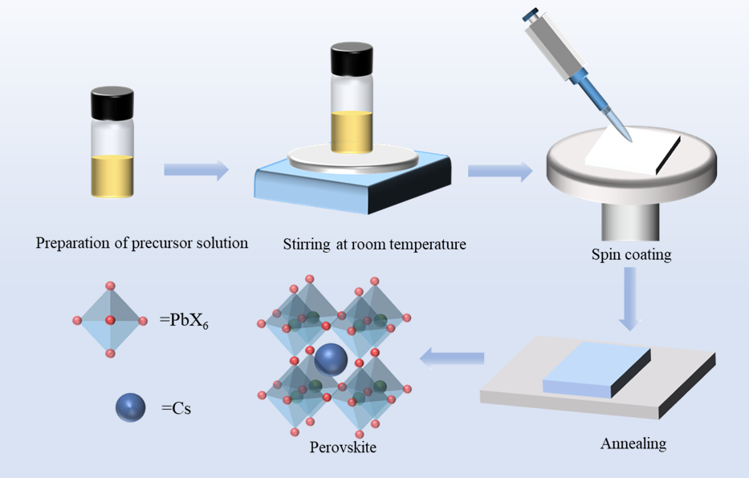
Fig. S1. Flow chart of perovskite preparation by solution spin coating.
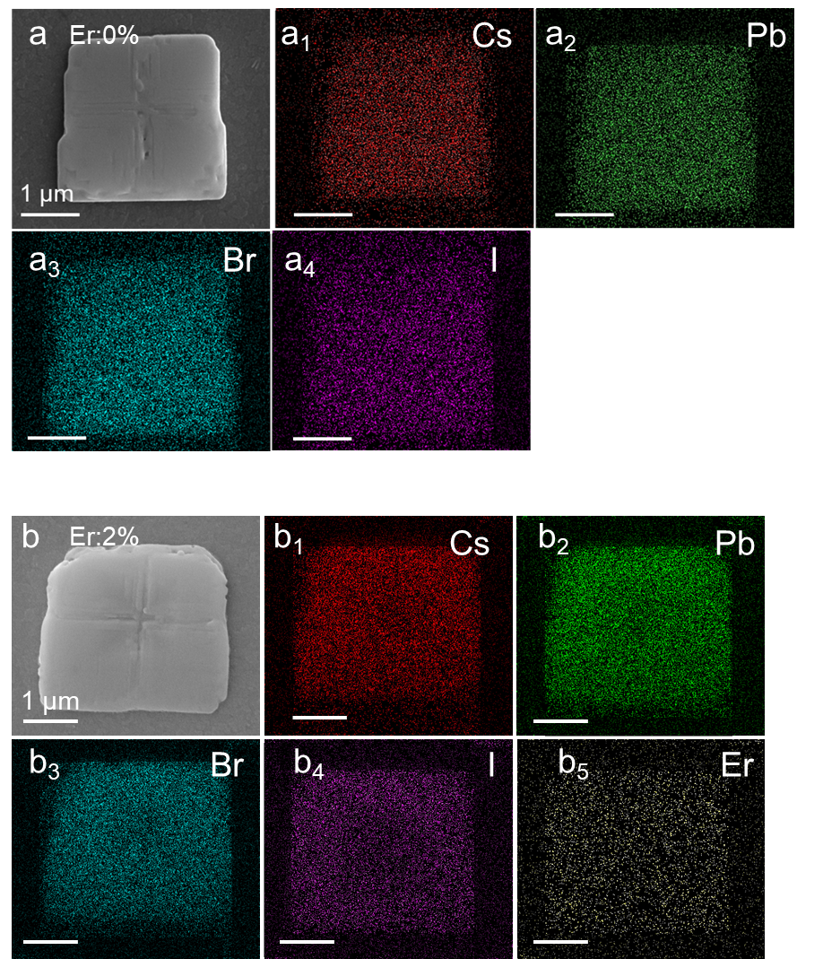
Fig. S2.SEM image EDS mapping of typical CsPb(Br_{0.77}I_{0.23})₃ (a-a₄) and
Er:2%-CsPb(Br_{0.77}I_{0.23})₃ microplate (b-b₄).

Er:0%
Position 1 |  | Position 2
Element | Atomic (%) | Element | Atomic (%)
Br | 53.5 | Br | 54.7
I | 15.3 | I | 16.6
Cs | 16.6 | Cs | 14.5
Pb | 14.6 | Pb | 14.3
Er:2%
Position 1 |  | Position 2
Element | Atomic (%) | Element | Atomic (%)
Br | 58.1 | Br | 54.9
I | 12.5 | I | 18.5
Er | 0.2 | Er | 0.4
Cs | 15.8 | Cs | 13.2
Pb | 13.5 | Pb | 13.0
Table S1. EDX spectrum of CsPb(Br_{0.77}I_{0.23})₃ and Er:2%-CsPb(Br_{0.77}I_{0.23})₃ microplate of position 1 and position 2 in figure 1e and h.

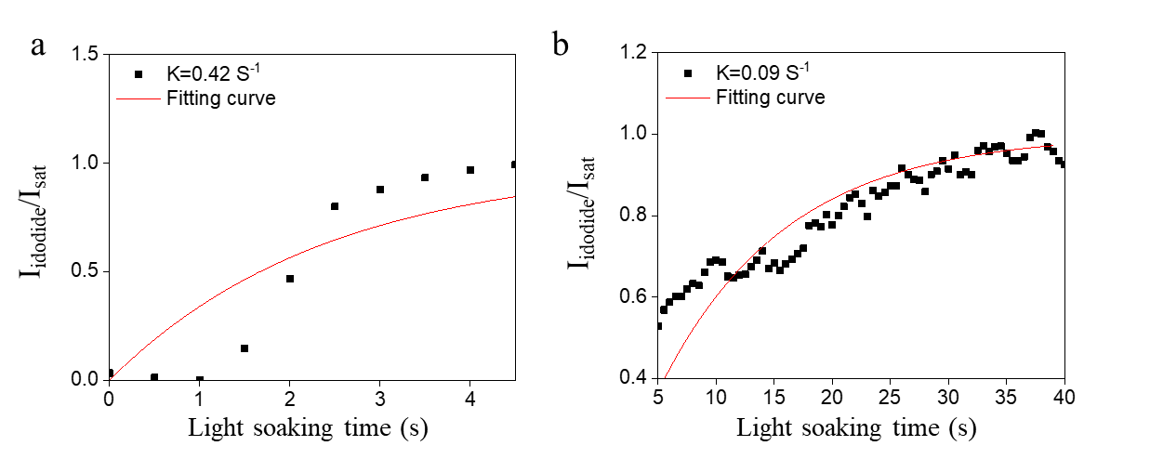
Figure S3. I_{NBP}/I_{sat} (I_{NBP} is the NBP emission intensity, I_{sat} is the saturation emission intensity) curve of Er:2%-CsPb(Br_{0.77}I_{0.23})₃ microplate under the light soaking from (a) 0-5s and (b) 5-40s.

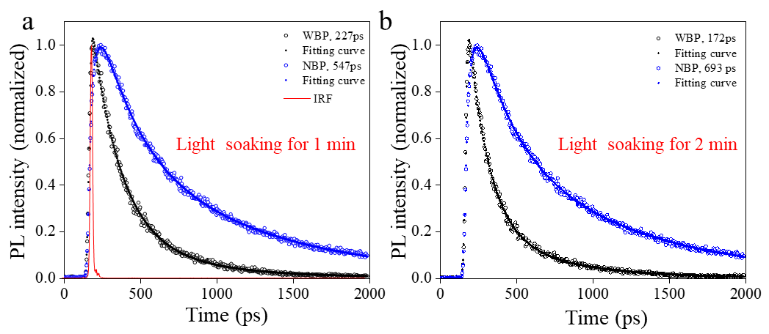
Fiure S4. Time-resolved PL curves of the CsPb(Br_{0.77}I_{0.23})₃ microplate. Dynamic curves extracted from the streak camera images centered at the WBP and NBP under the light soaking for (a) 1 min and (b) 2 min.

Light soaking for 1 min
Section | T₁ (ps) | A₁ | T₂ (ps) | A₂
WBP | 90.2 | 33.2 | 851.2 | 66.8
NBP | 33.2 | -127.3 | 686.6 | 227.3
Table S2. Fitting results of the parameters of the dynamic curves in Figure 4b.

Table S3. The lifetime values statistics of Er:1%-CsPb(Br_{0.77}I_{0.23})₃ microplate as a function of light soaking time, where t₁ is equal to 0 s, the interval between adjacent time ranges is 60s.
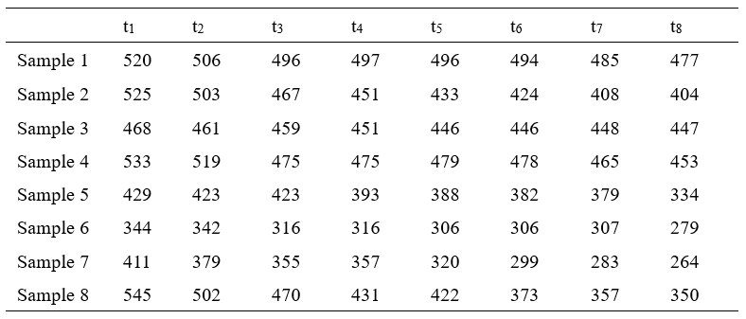

Table S4. The lifetime values statistics of Er:2%-CsPb(Br_{0.77}I_{0.23})₃ microplate as a function of light soaking time, where t₁ is equal to 0 s, the interval between adjacent time ranges is 60s.
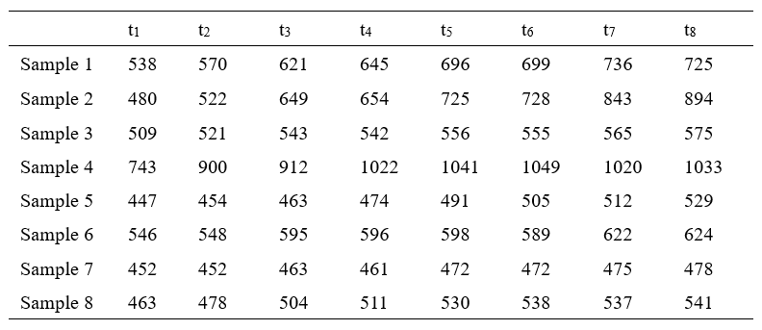

Table S5. The lifetime values statistics of Er:3%-CsPb(Br_{0.77}I_{0.23})₃ microplate as a function of light soaking time, where t₁ is equal to 0 s, the interval between adjacent time ranges is 60s.
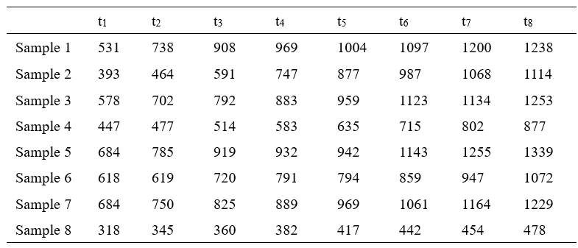

Table S6. The lifetime values statistics of Er:4%-CsPb(Br_{0.77}I_{0.23})₃ microplate as a function of light soaking time, where t₁ is equal to 0 s, the interval between adjacent time ranges is 60s.
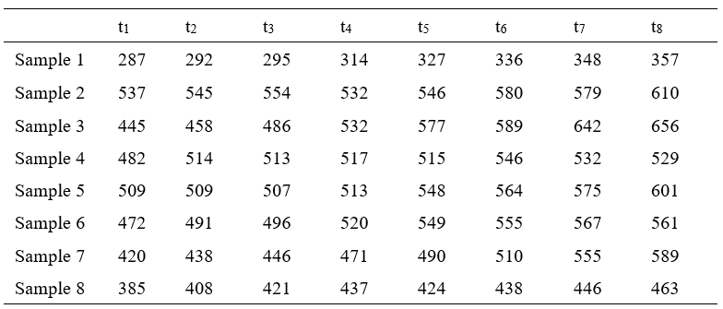

Table S7. the lifetime values statistics of Er:5%-CsPb(Br_{0.77}I_{0.23})₃ microplate as a function of light soaking time, where t₁ is equal to 0 s, the interval between adjacent time ranges is 60s.
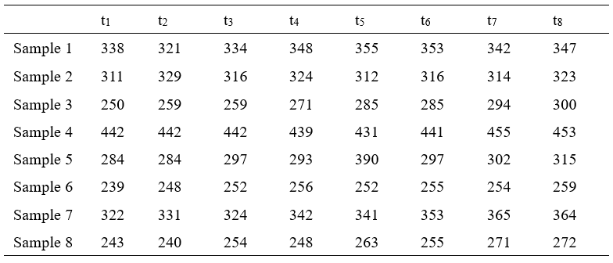

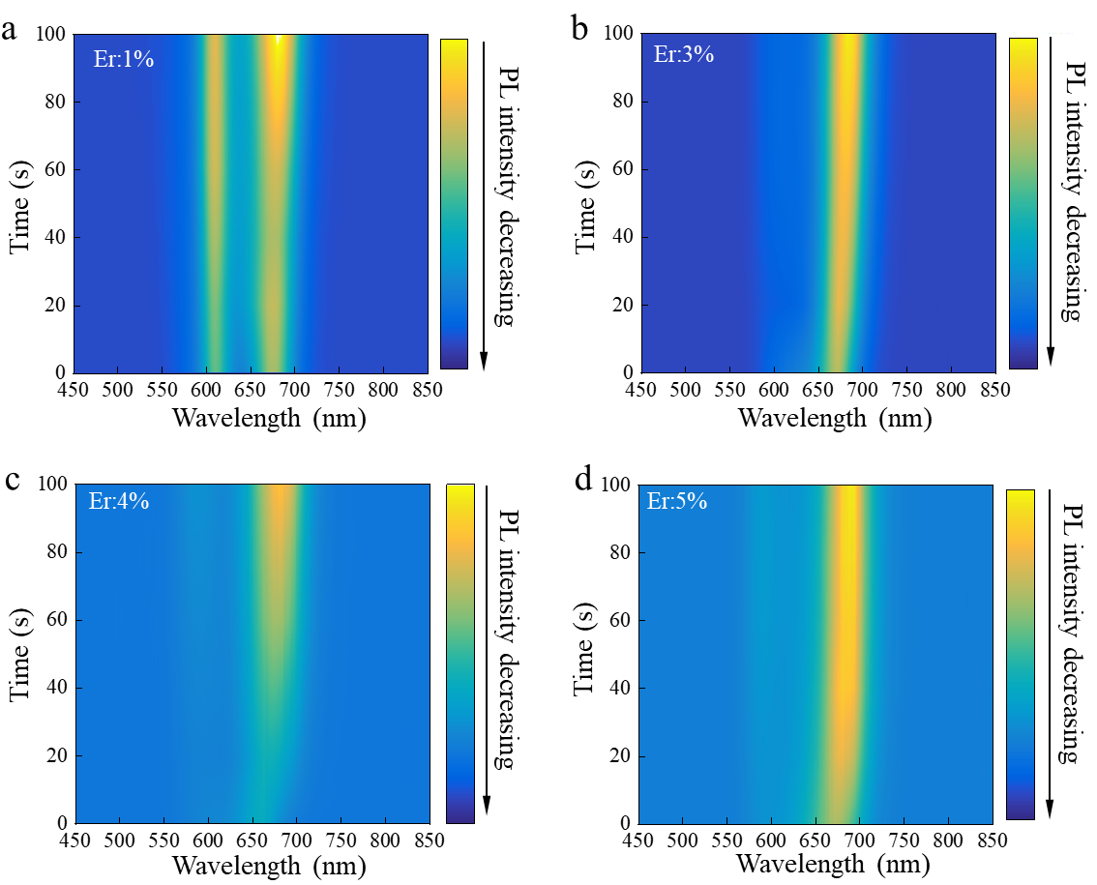
Figure S5. Time-dependent PL spectra of the typical CsPb(Br_{0.77}I_{0.23})₃ microplate with different Er doping concentrations. a. Er:1%. b. Er:3%. c. Er:4%. d. Er:5%.

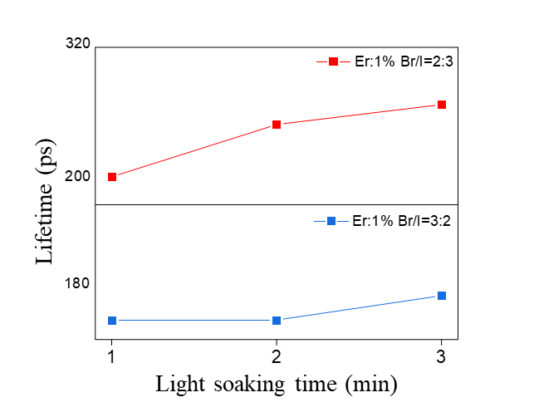
Figure S6.The lifetime change curve of Er:1%-CsPb(Br₂I₃)_{0.6} and Er:1%-CsPb(Br₃I₂)_{0.6}.

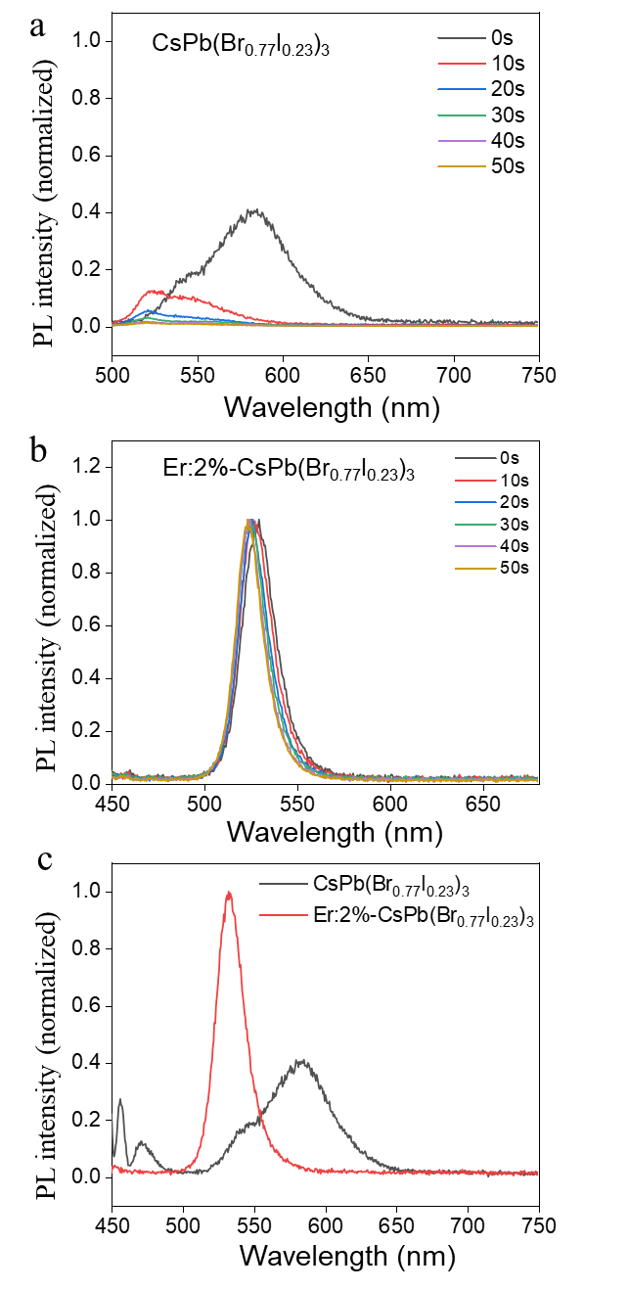
Figure S7. Time-dependent PL spectrum of a. CsPb(Br_{0.77}I_{0.23})₃ and b. Er:2%-CsPb(Br_{0.77}I_{0.23})₃ films. c. Initial PL spectrum of CsPb(Br_{0.77}I_{0.23})₃ and Er:2%-CsPbBr_{2.32}I_{0.68} films.

A method for calculating the composition of mixed perovskites based on PL spectra
The band gap of CsPb(Br_{x}I_{1-x})₃ alloy can be determined by the following formula:
E_{g(x)}=xE_{g1}+(1-x)E_{g2}-mx(1-x) (1)
E_{g1} and E_{g2} are the bandgaps of the corresponding one-component halide perovskite, here corresponding to CsPbBr₃ 2.33 eV and CsPbI₃ 1.7 eV respectively. m is the band bending parameter, here we value 0.48. Take Er:2% CsPb(Br_{0.77}I_{0.23})₃ for exampleAccording to the PL spectra in Fig. 2g, the energy of WBP and NBP of Er:2% CsPb(Br_{0.77}I_{0.23})₃ is 2.11 and 1.94 ev, respectively. By substituting the formula (1), the chemical formula of WBP and NBP is calculated as CsPb(Br_{0.78}I_{0.22})₃ and CsPb(Br_{0.56}I_{0.44})₃.

