Supplement Table 1 GVIF and VIF calculation for all covariates in Model 3.
Characteristic | Unmatched |  | Matched
Characteristic | GVIF | Adjusted GVIF | GVIF | Adjusted GVIF
Age | 2.3 | 1.5 | 2.1 | 1.4
Gender | 1.4 | 1.2 | 1.4 | 1.2
Race | 2.1 | 1.1 | 2.1 | 1.1
Education | 1.9 | 1.2 | 2.5 | 1.3
Poverty to Income Ratio | 1.2 | 1.1 | 1.3 | 1.1
SSB intake (grams) | 2.5 | 1.3 | 2.2 | 1.2
Total sugars intake(grams) | 2.1 | 1.5 | 1.8 | 1.3
BMI(kg/m²) | 1.9 | 1.2 | 1.8 | 1.2
Diabetes | 1.4 | 1.2 | 1.3 | 1.1
GVIF = Generalized Variance Inflation Factor; Adjusted VIF = GVIF^[1/(2*df)]

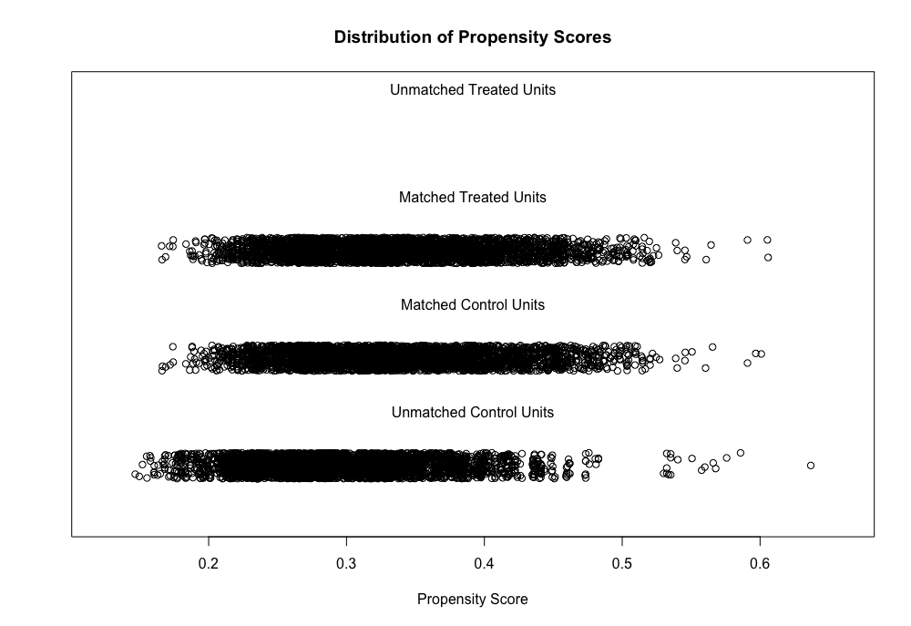
Supplement Figure 1 “Jitter plot” of the Propensity Score Matching

