Synthesis of novel 4-substituted isatin Schiff base derivatives as potential autophagy inducers and evaluation of their antitumour activity
Huayuan Tan ^{a, §}, Guanglong Zhang ^{a, §}, Chenlu Xu ª, Xue Lei ª, Jiayi Chen ª, Haitao Long ª, Xuemei Qiu ª, Wenhang Wang ª, Yue Zhou ª, Danping Chen ª, Chengpeng Li ª, Zhurui Li ^{a, b*}, Zhenchao Wang ^{a, b, c*}

ª College of Pharmacy, Guizhou University, Guiyang 550025, China;
^{b} Guizhou Engineering Laboratory for Synthetic Drugs, Guizhou University, Guiyang 550025, China.
^{c} National Key Laboratory of Green Pesticide, Key Laboratory of Green Pesticide and Agricultural Bioengineering, Ministry of Education, Center for R&D of Fine Chemicals of Guizhou University, Guiyang 550025, China.

§ Both authors contributed equally to this work.
* Corresponding authors.

Email: li-zhurui@163.com (Zhurui Li); wzc.4884@163.com (Zhenchao Wang).

1. Morphology of A549 cells after 24 h treatment with H13. 2
2. ¹H NMR, ¹³C NMR, ¹⁹F NMRand HRMS spectra for target compounds. 2
3. Statistical Parameters for the CoMFA. 45

1. Morphology of A549 cells after 24 h treatment with H13.
A549 cells were treated with H13 for 24 h. H13 at 10 μM altered, to a large extent, the membrane permeability compared to the control.
Fig. S1 A549 cells were photographed after 24h of H13 treatment, for the control and drug administration groups, respectively.

2. ¹H NMR, ¹³C NMR, ¹⁹F NMRand HRMS spectra for target compounds.
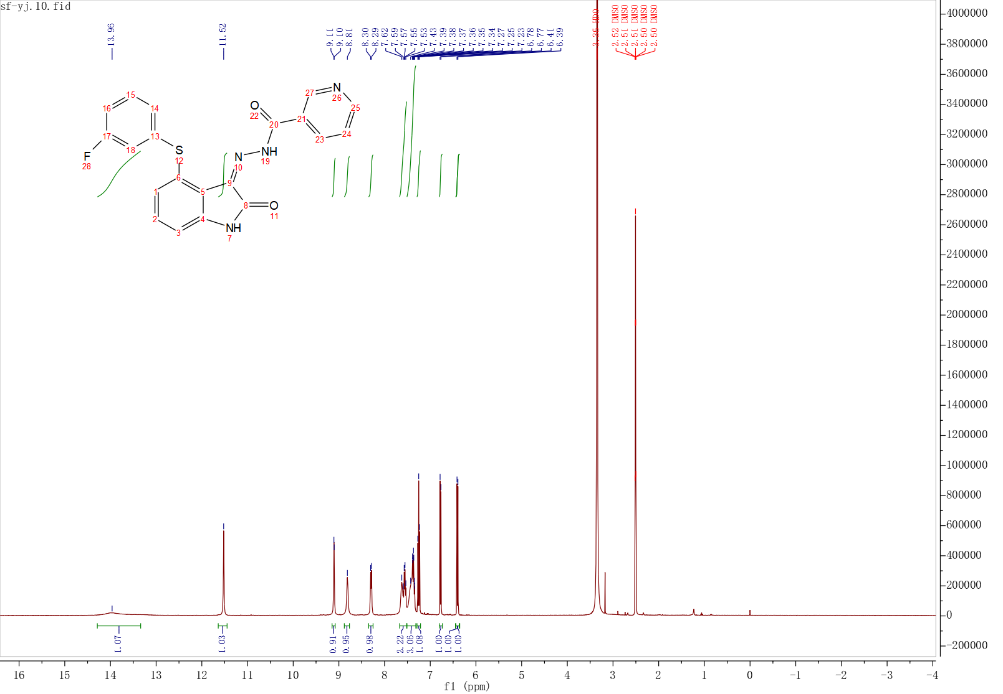
Fig. S2 The ¹H NMR Spectrum of compound H1
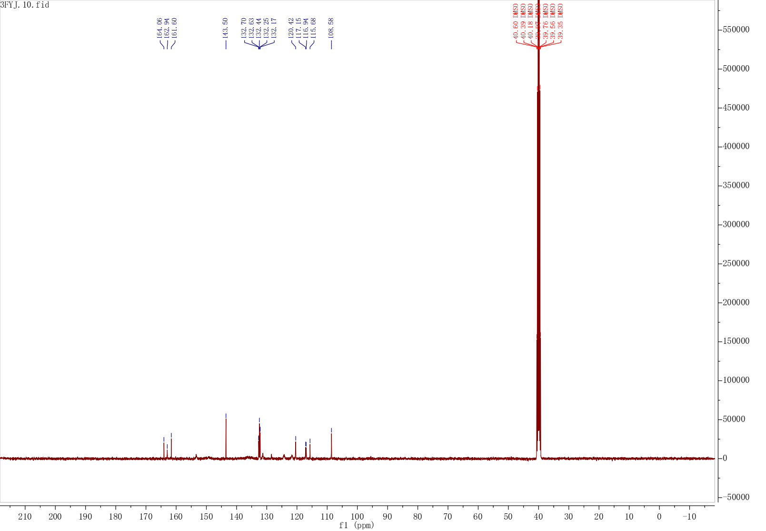
Fig. S3 The ¹³C NMR Spectrum of compound H1
Fig. S4 The HRMS spectrum of compound H1
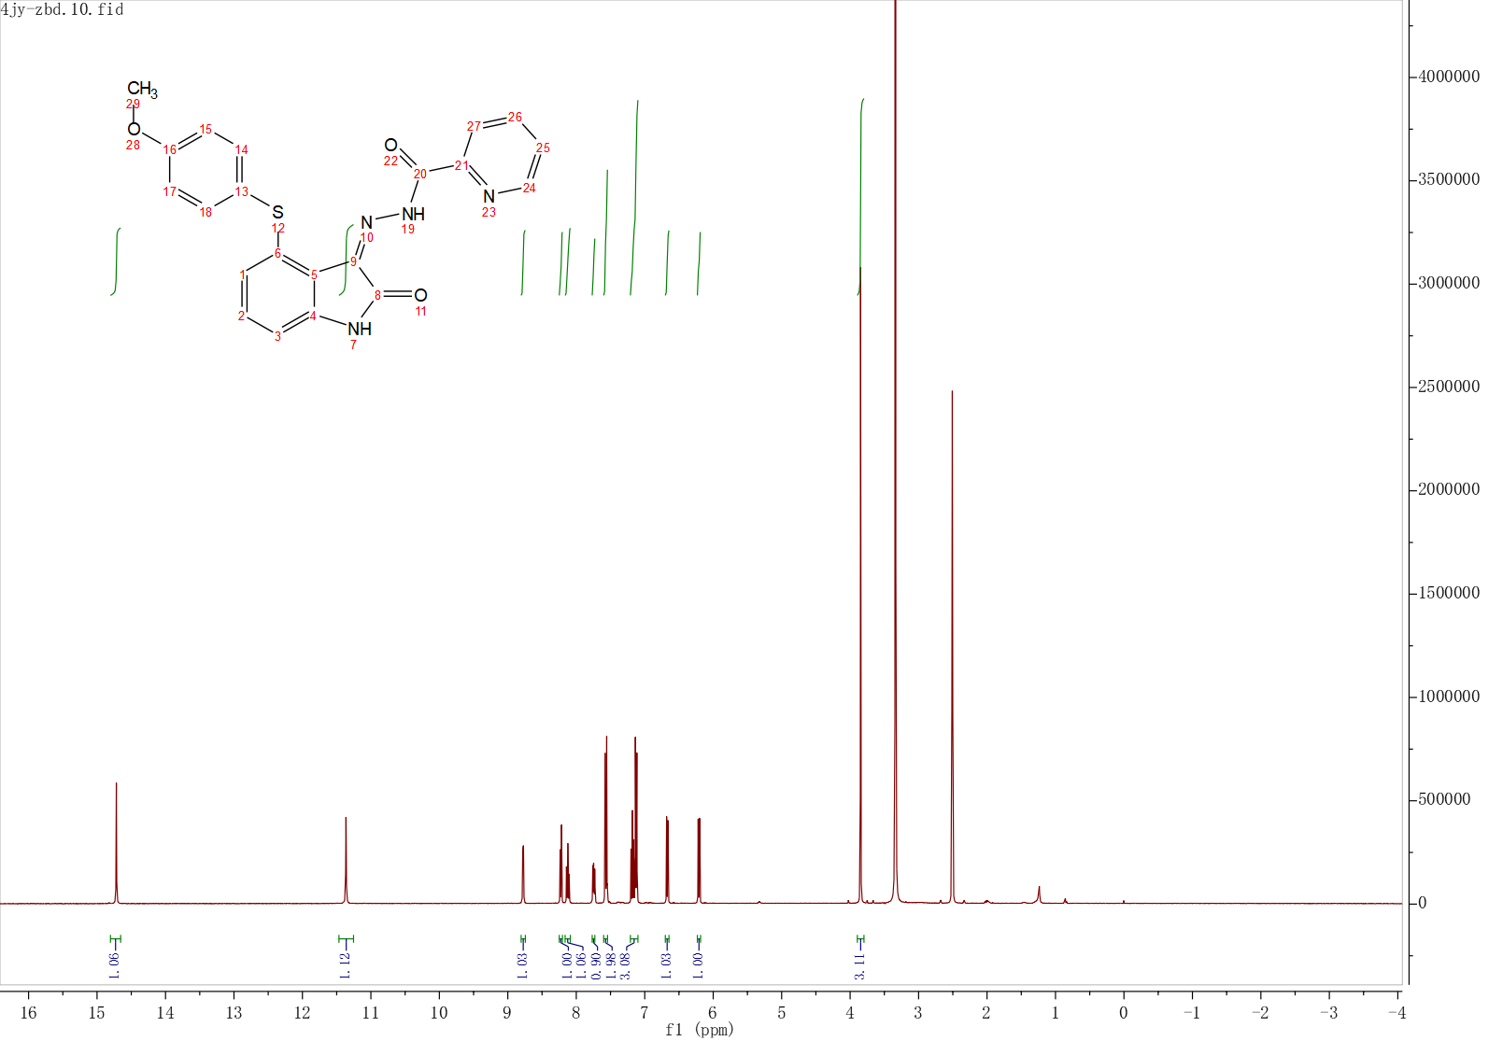
Fig. S5 The ¹H NMR Spectrum of compound H2
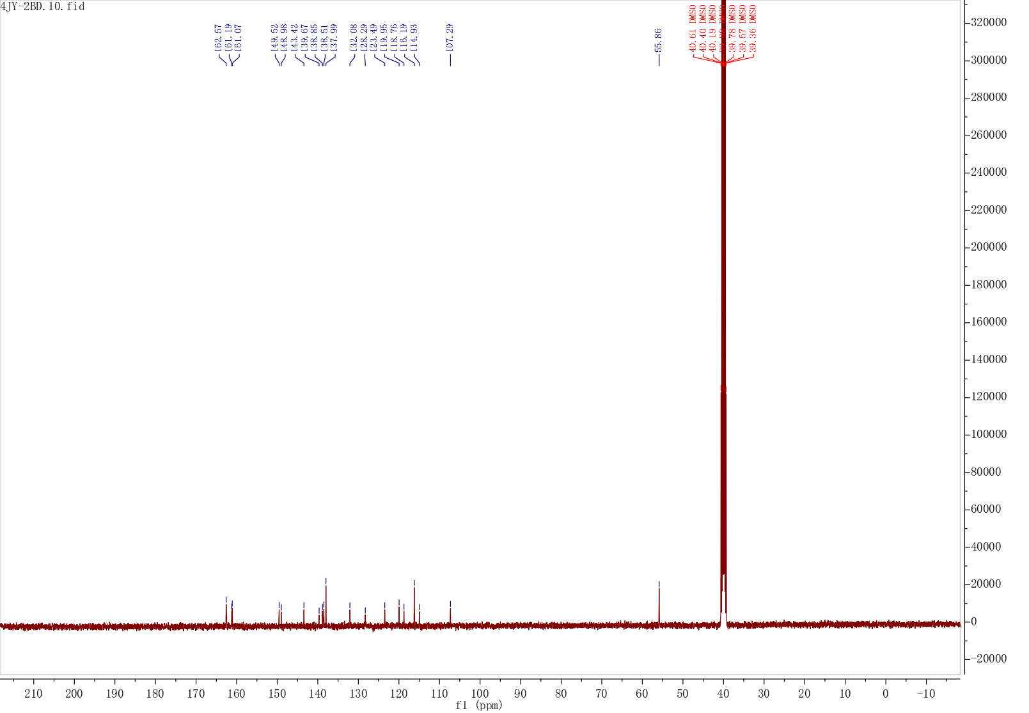
Fig. S6 The ¹³C NMR Spectrum of compound H2
Fig. S7 The HRMS spectrum of compound H2
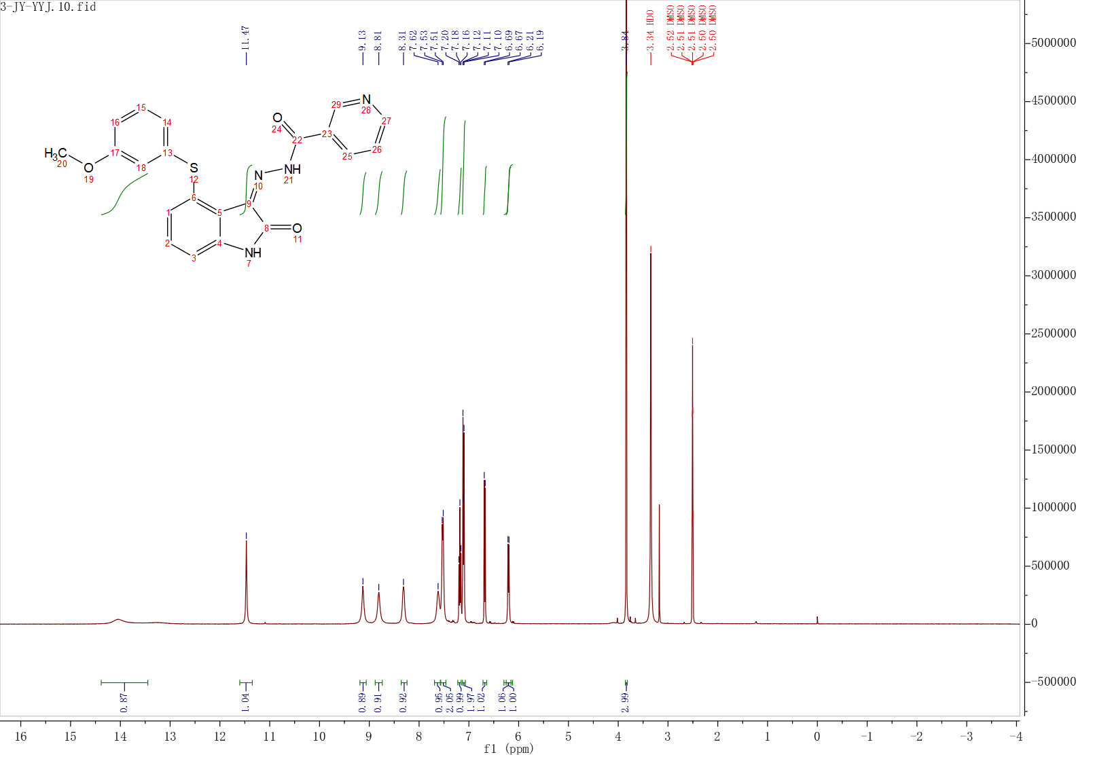
Fig. S8 The ¹H NMR Spectrum of compound H3
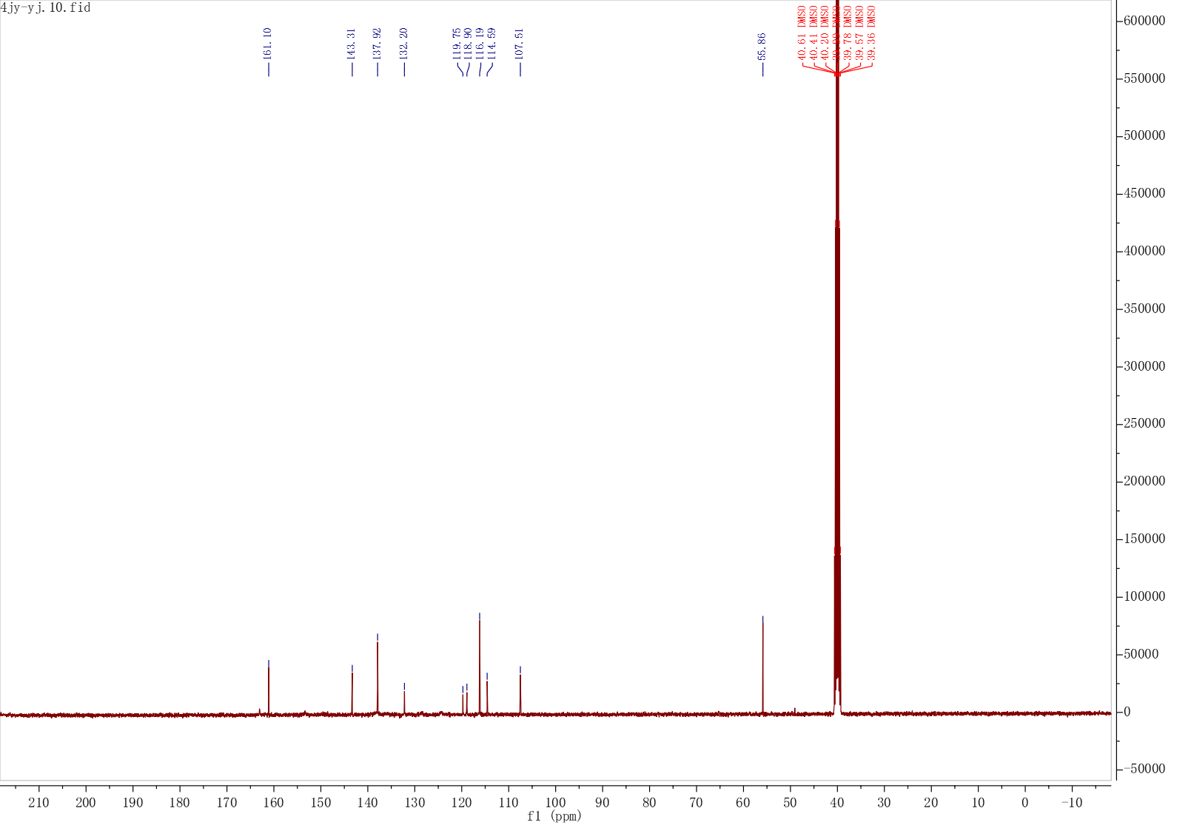
Fig. S9 The ¹³C NMR Spectrum of compound H3
Fig S10. The HRMS spectrum of compound H3
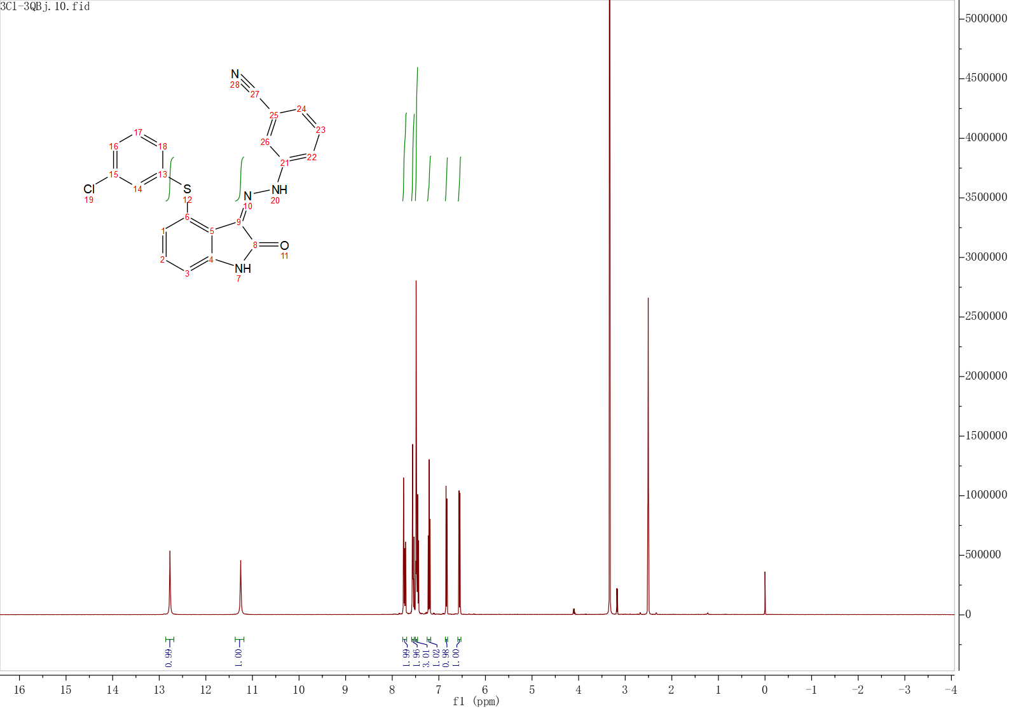
Fig. S11 The ¹H NMR Spectrum of compound H4
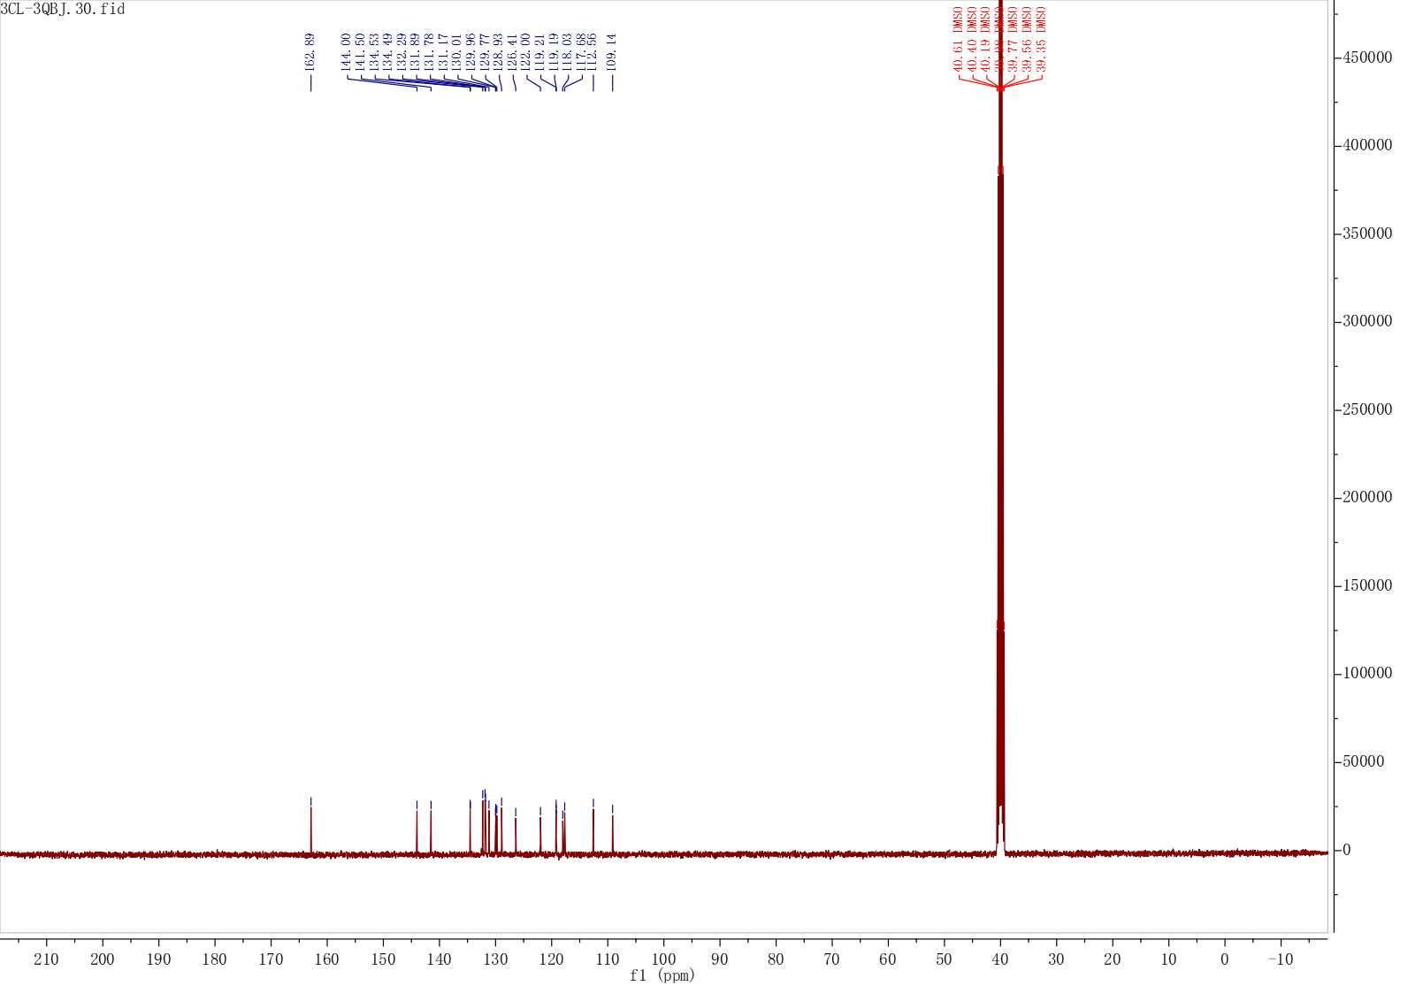
Fig. S12 The ¹³C NMR Spectrum of compound H4
Fig. S13 The HRMS spectrum of compound H4
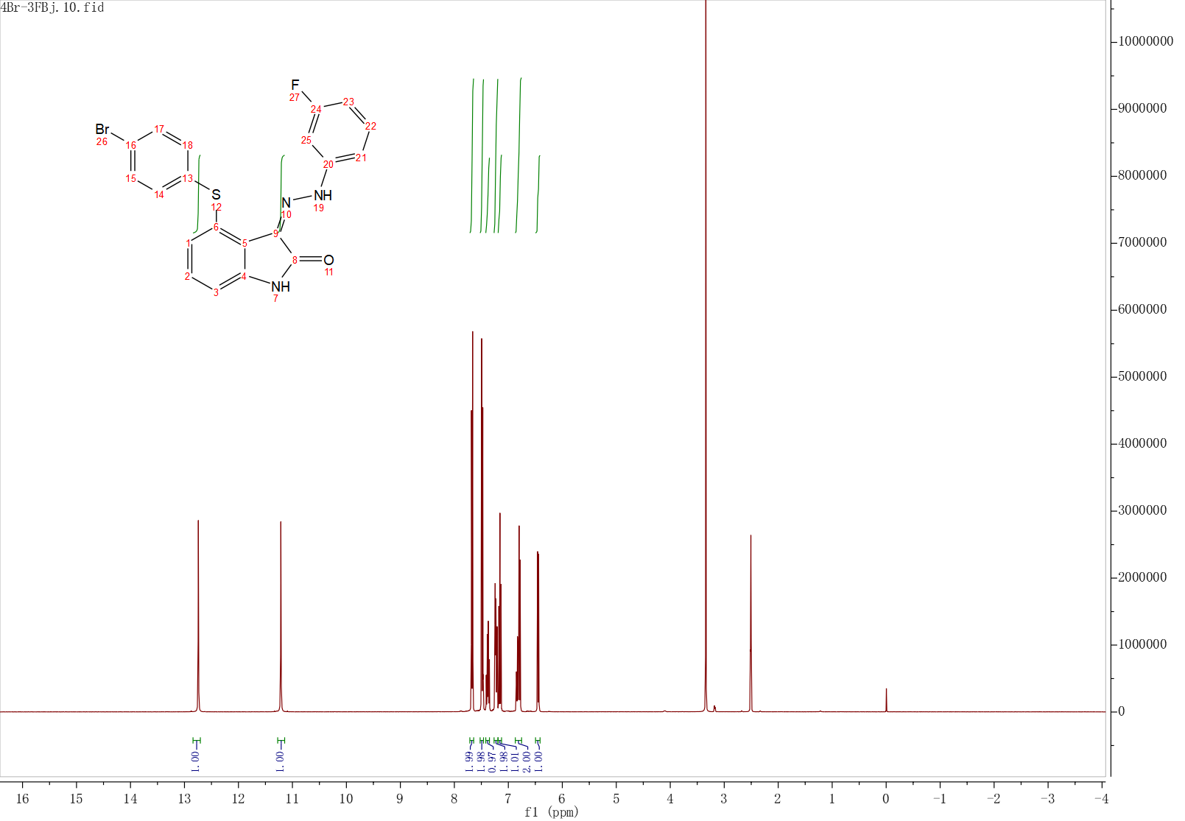
Fig. S14 The ¹H NMR Spectrum of compound H5
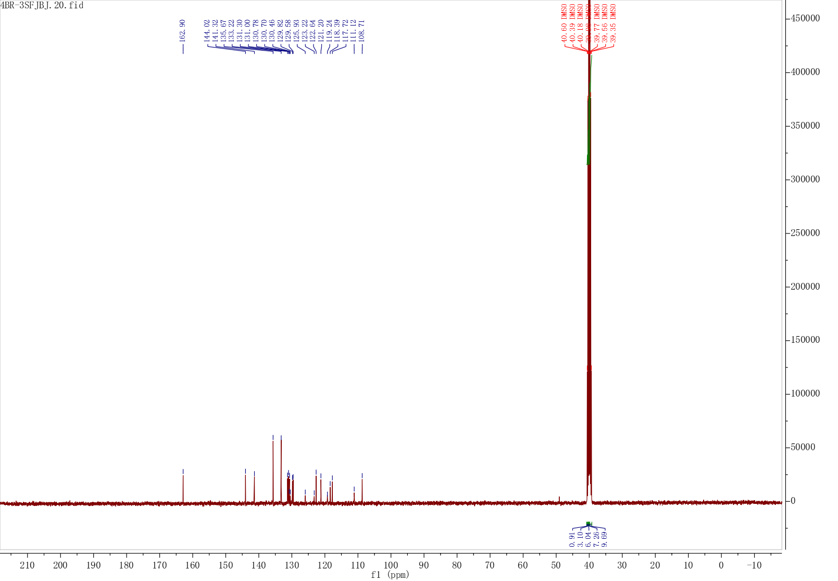
Fig. S15 The ¹³C NMR Spectrum of compound H5
Fig. S16 The HRMS spectrum of compound H5
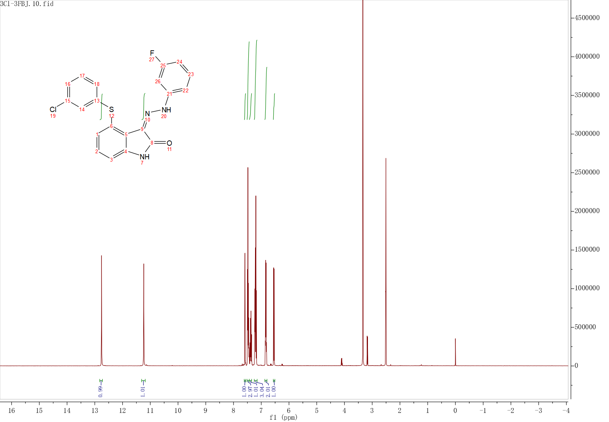
Fig. S17 The ¹H NMR Spectrum of compound H6
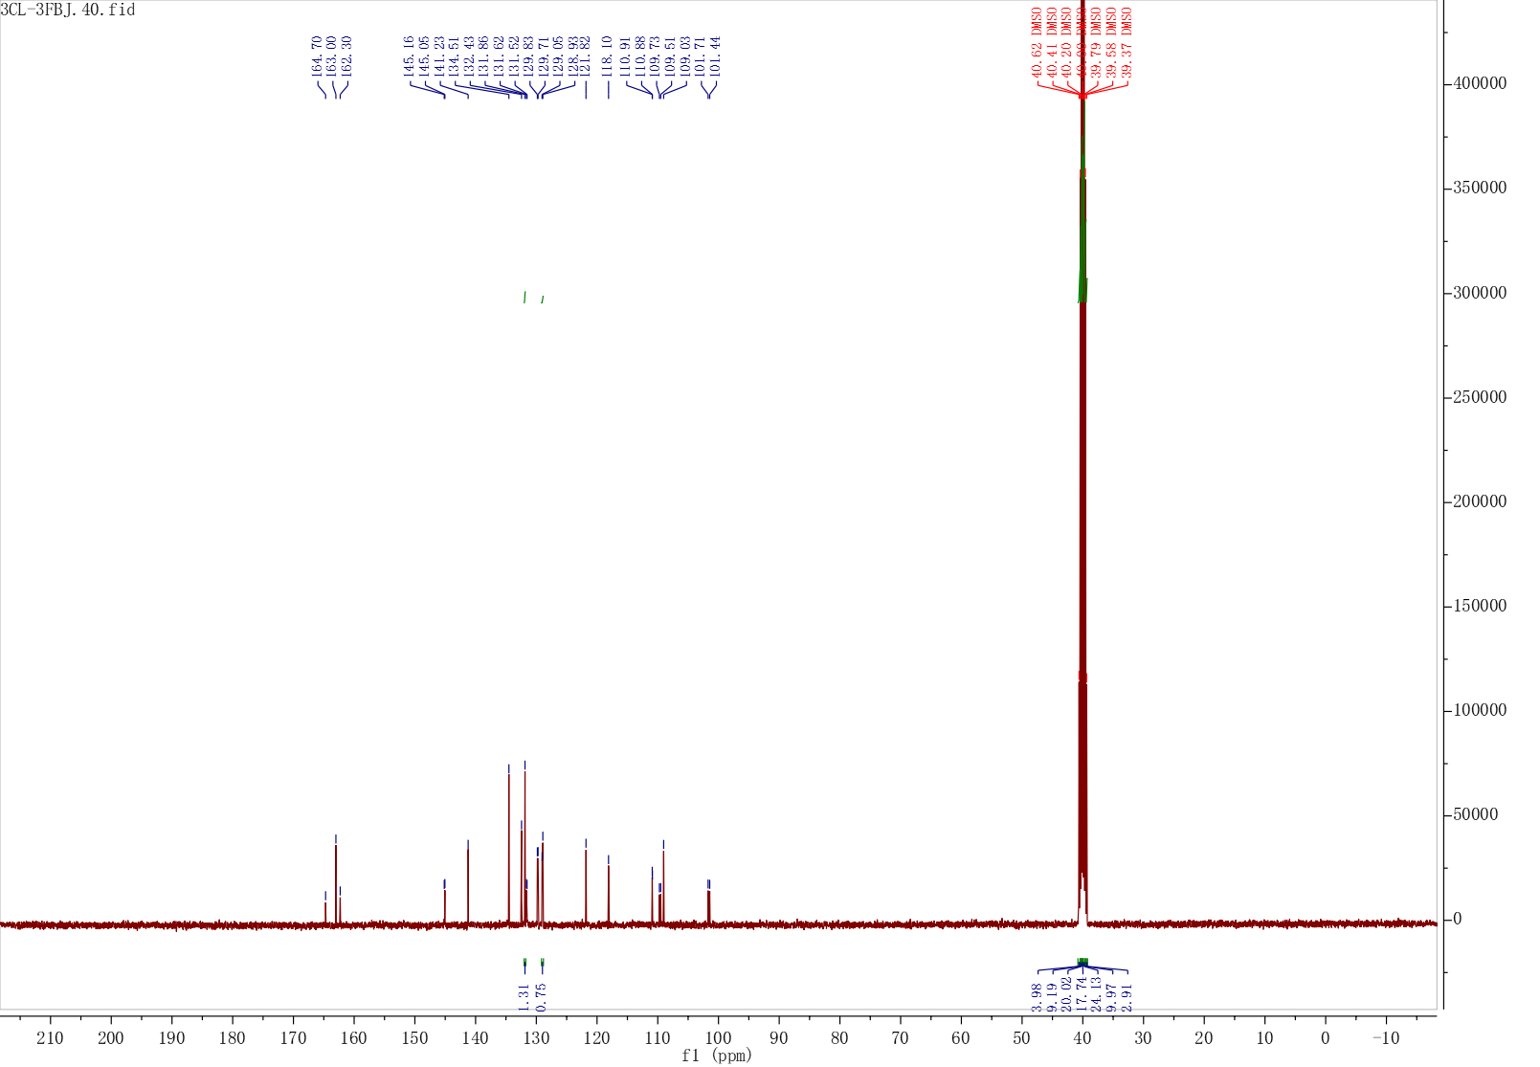
Fig. S18 The ¹³C NMR Spectrum of compound H6
Fig. S19 The HRMS spectrum of compound H6
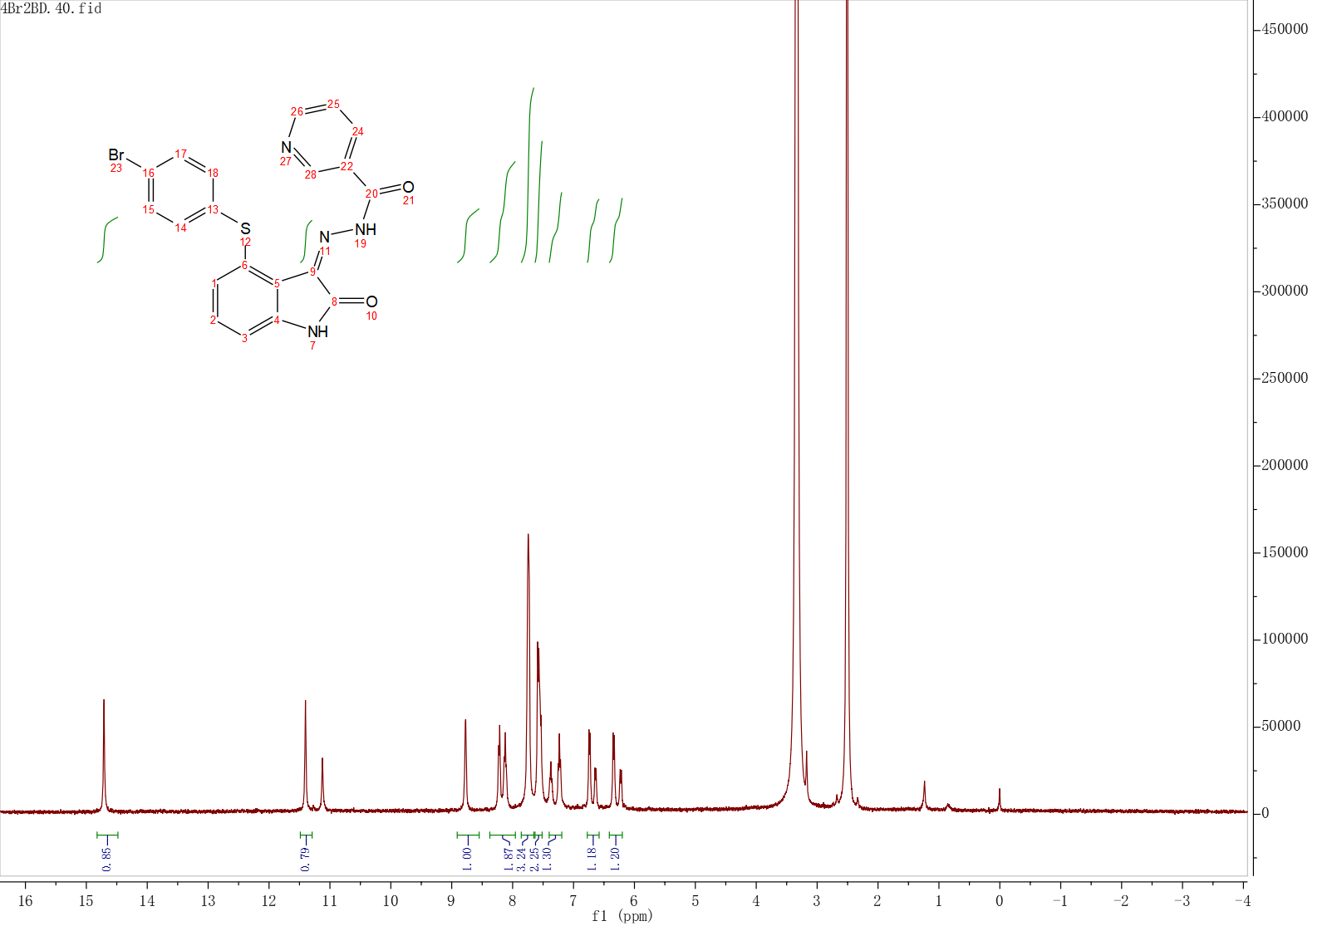
Fig. S20 The ¹H NMR Spectrum of compound H7
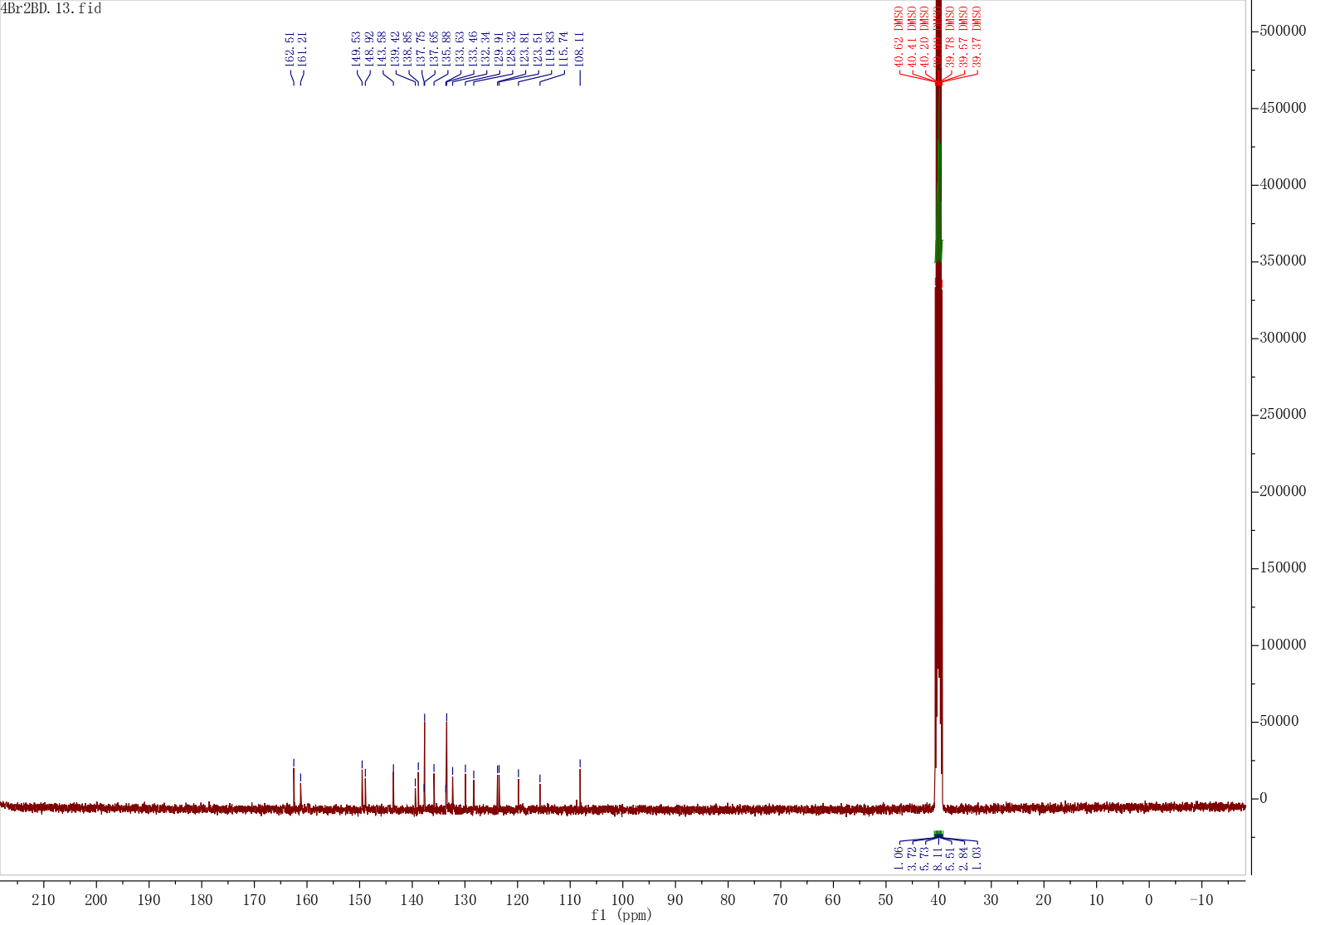
Fig. S21 The ¹³C NMR Spectrum of compound H7
Fig. S22 The HRMS spectrum of compound H7
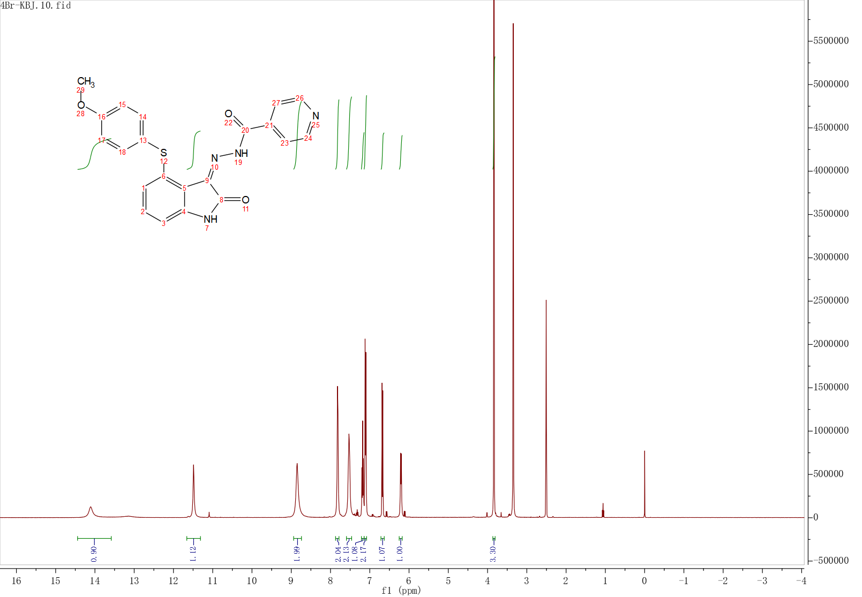
Fig. S23 The ¹H NMR Spectrum of compound H8
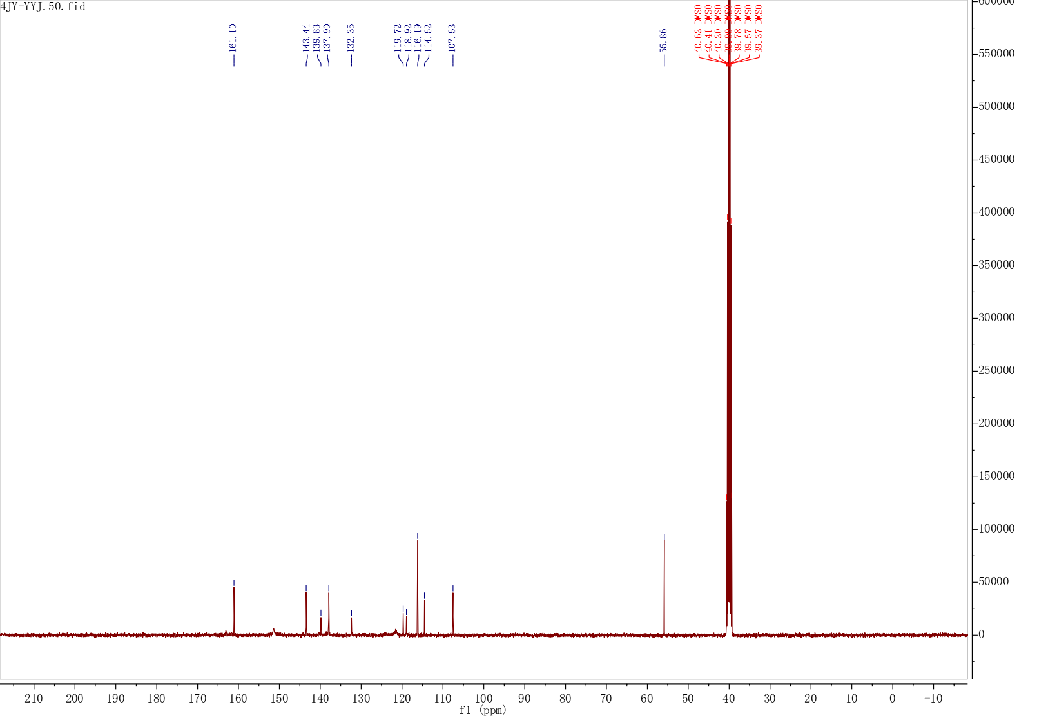
Fig. S24 The ¹³C NMR Spectrum of compound H8
Fig. S25 The HRMS spectrum of compound H8
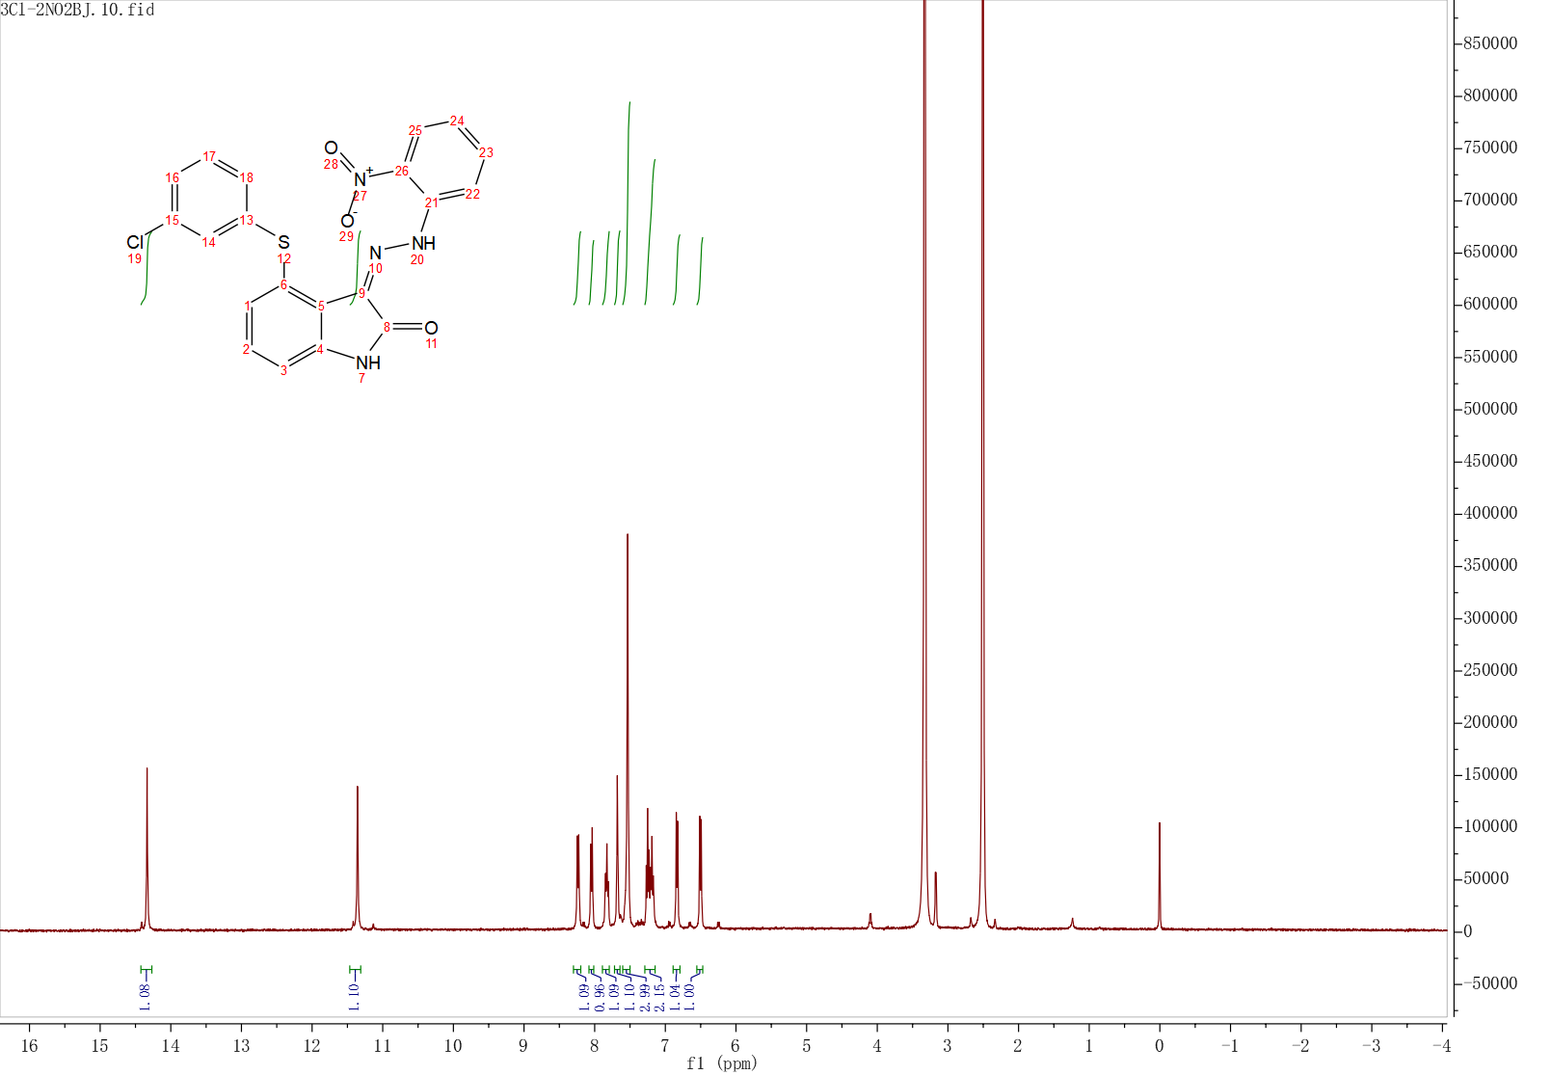
Fig. S26 The ¹H NMR Spectrum of compound H9
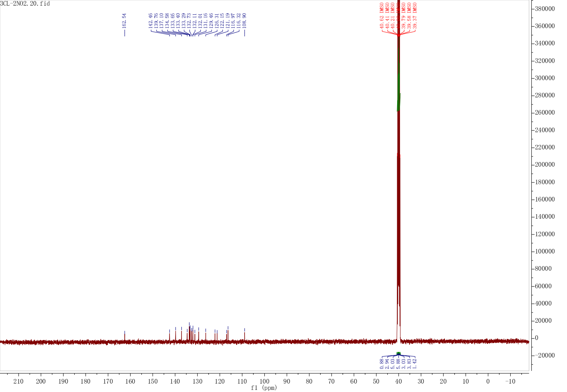
Fig. S27 The ¹³C NMR Spectrum of compound H9
Fig. S28 The HRMS spectrum of compound H9
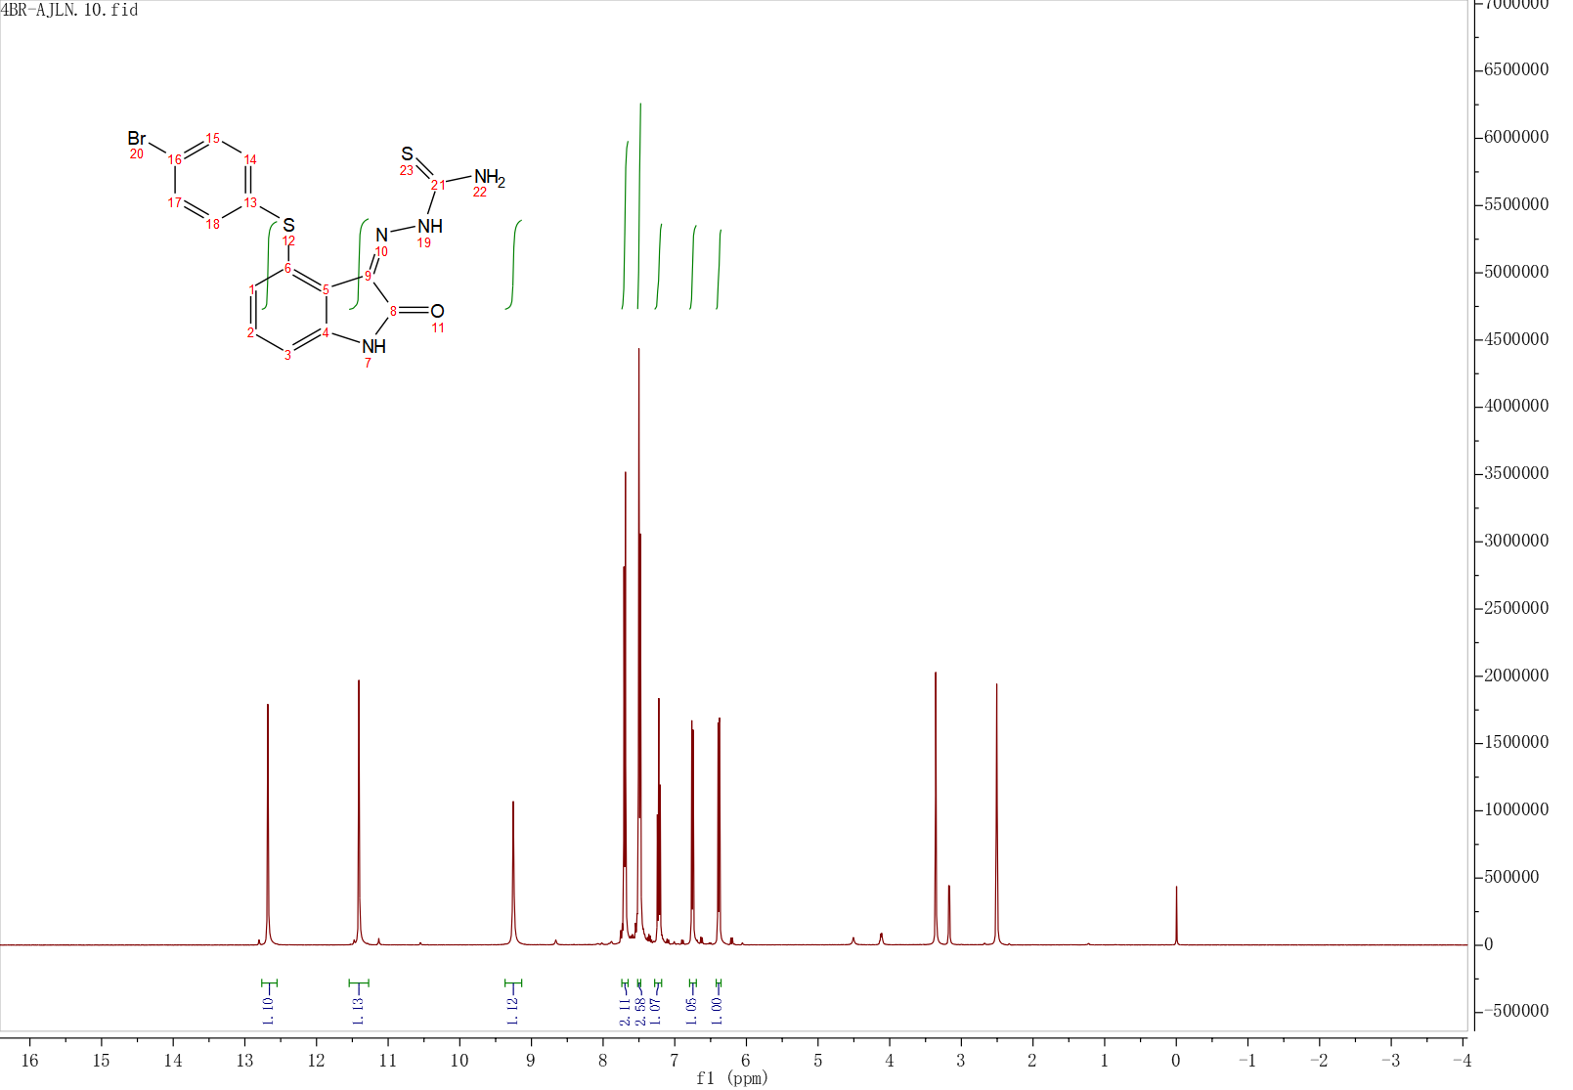
Fig. S29 The ¹H NMR Spectrum of compound H10
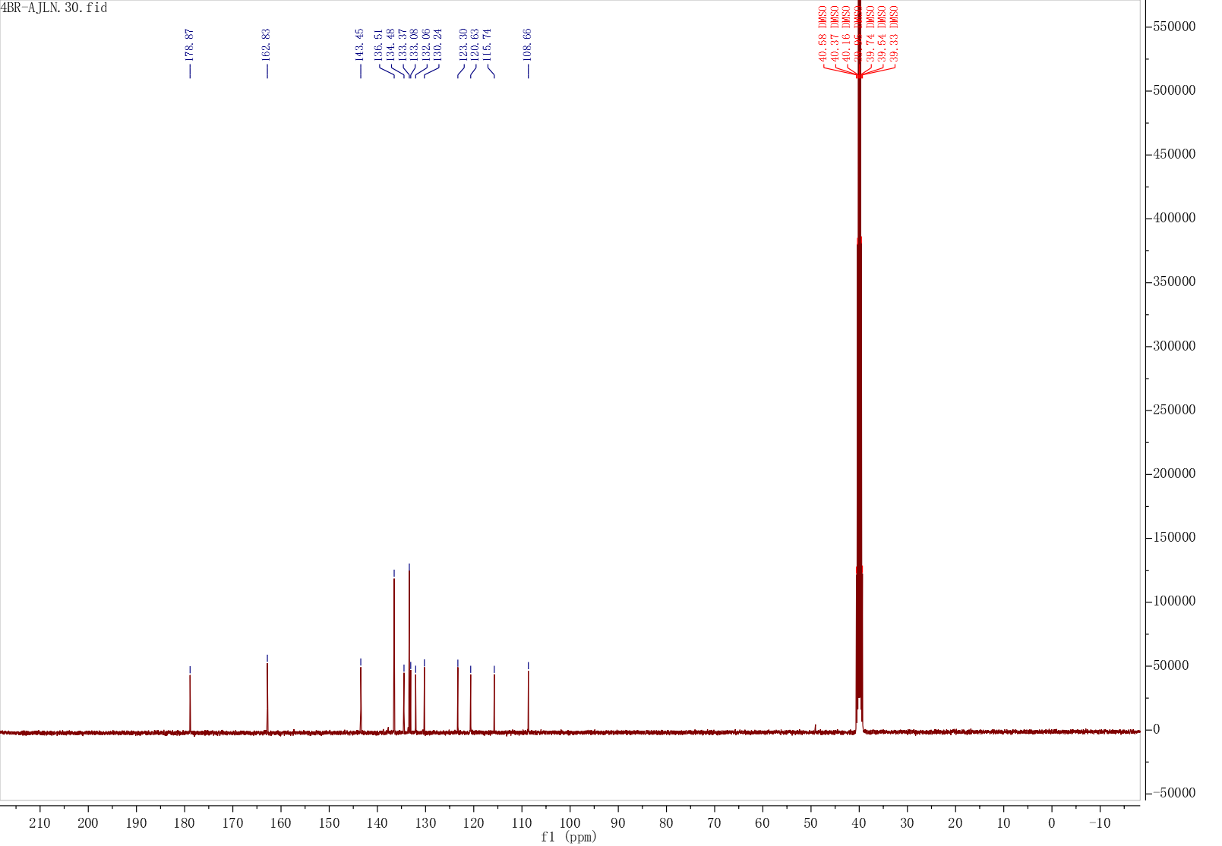
Fig. S30 The ¹³C NMR Spectrum of compound H10
Fig. S31 The HRMS spectrum of compound H10
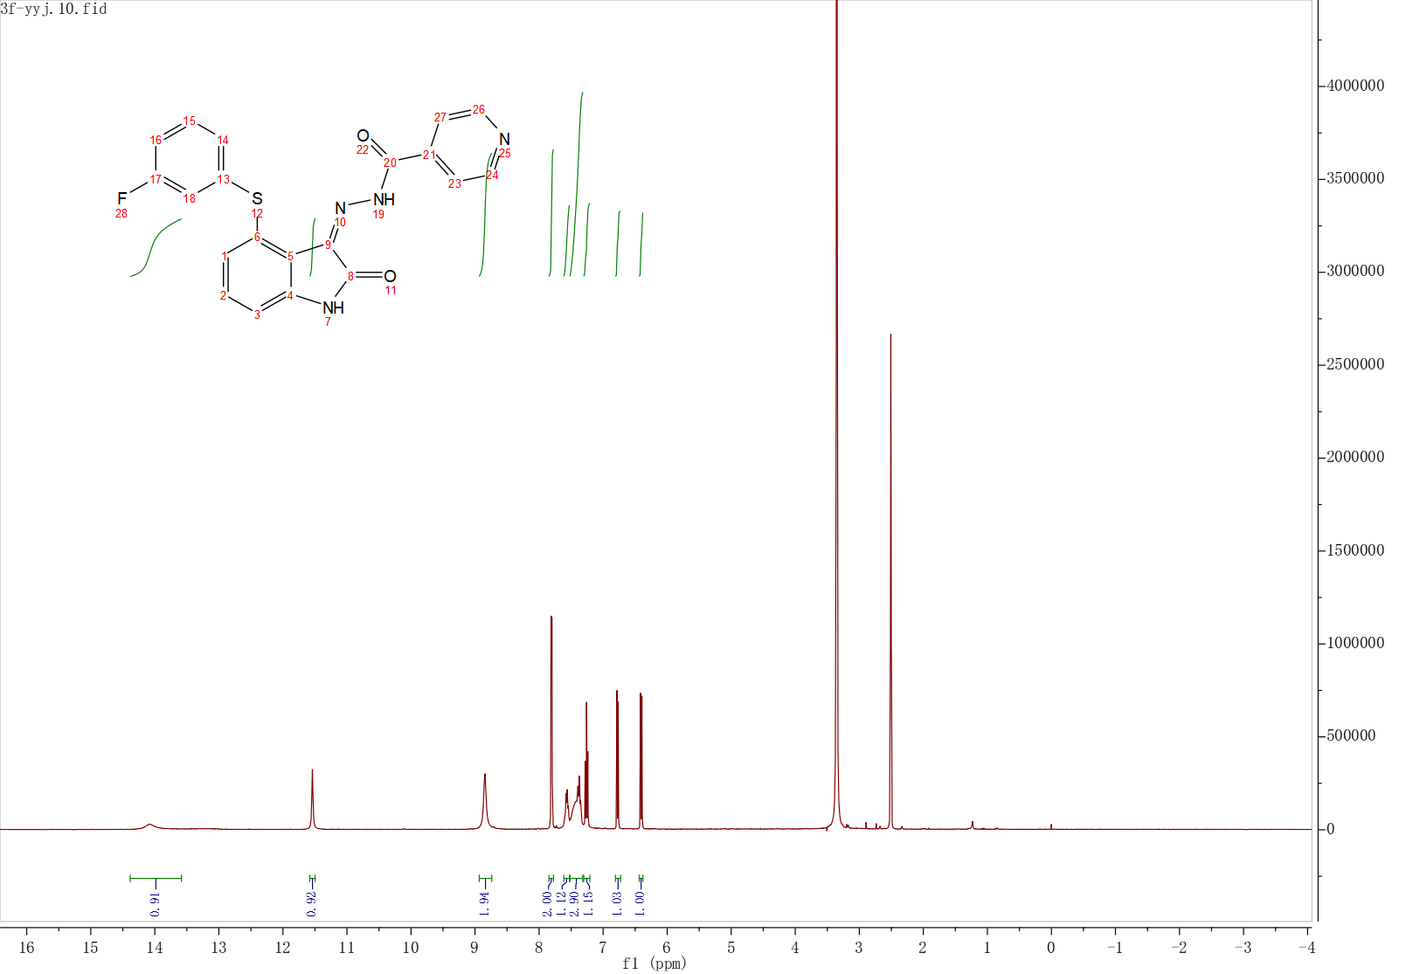
Fig. S32 The ¹H NMR Spectrum of compound H11
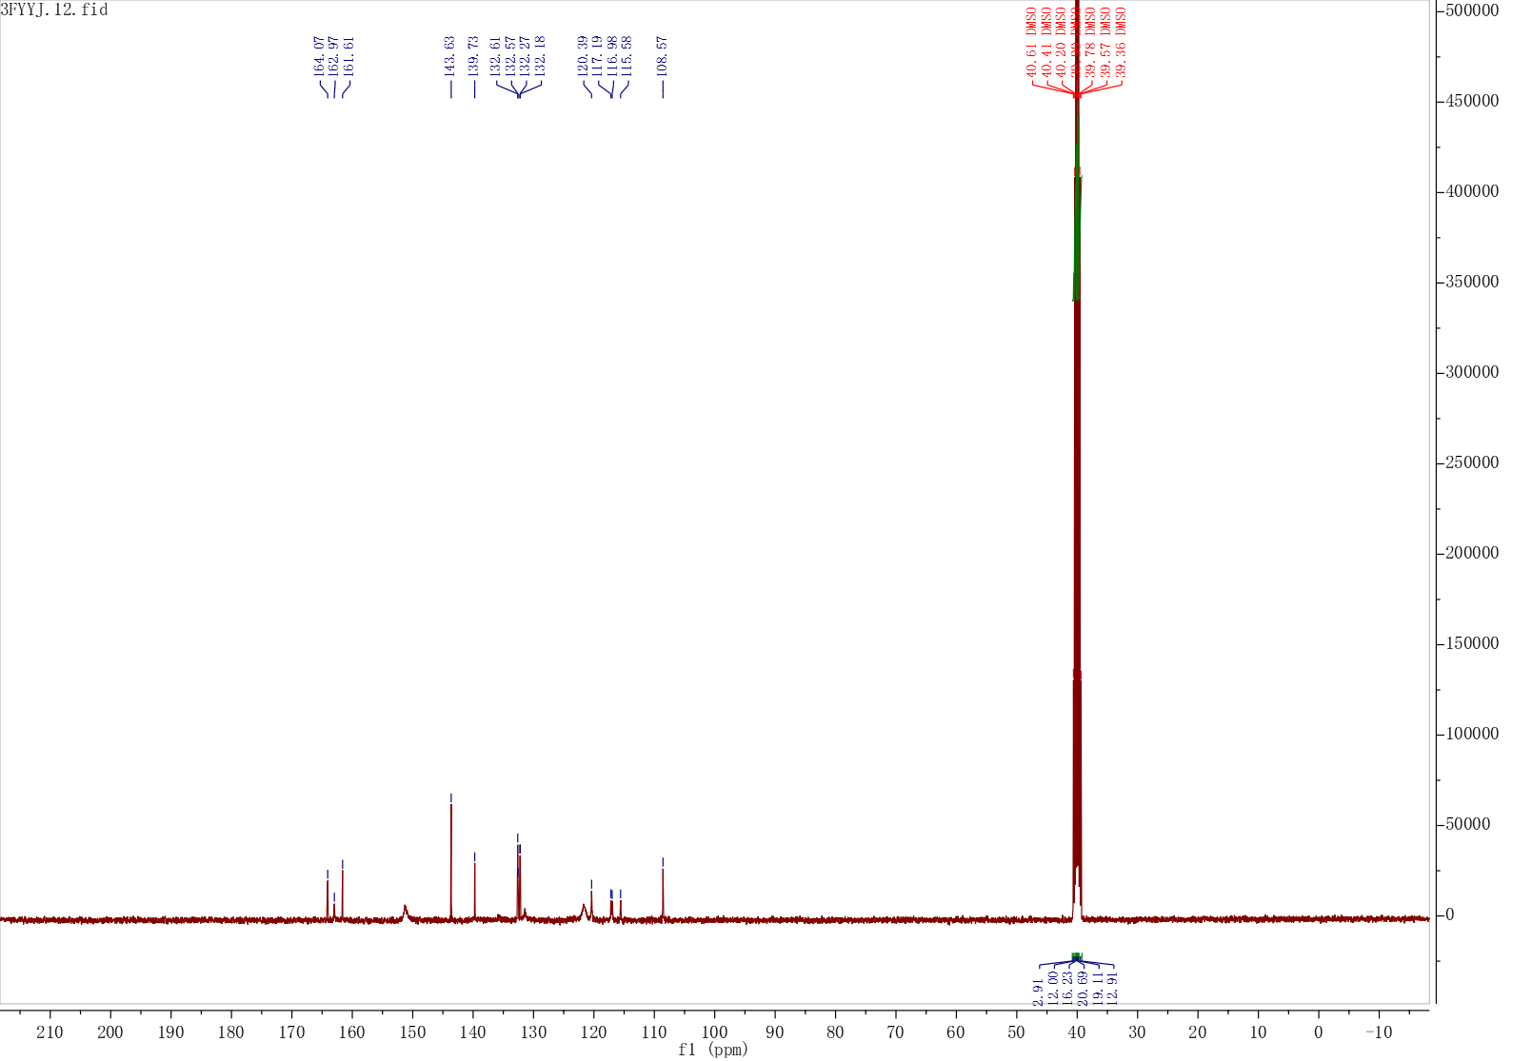
Fig. S33 The ¹³C NMR Spectrum of compound H11
Fig. S34 The HRMS spectrum of compound H11
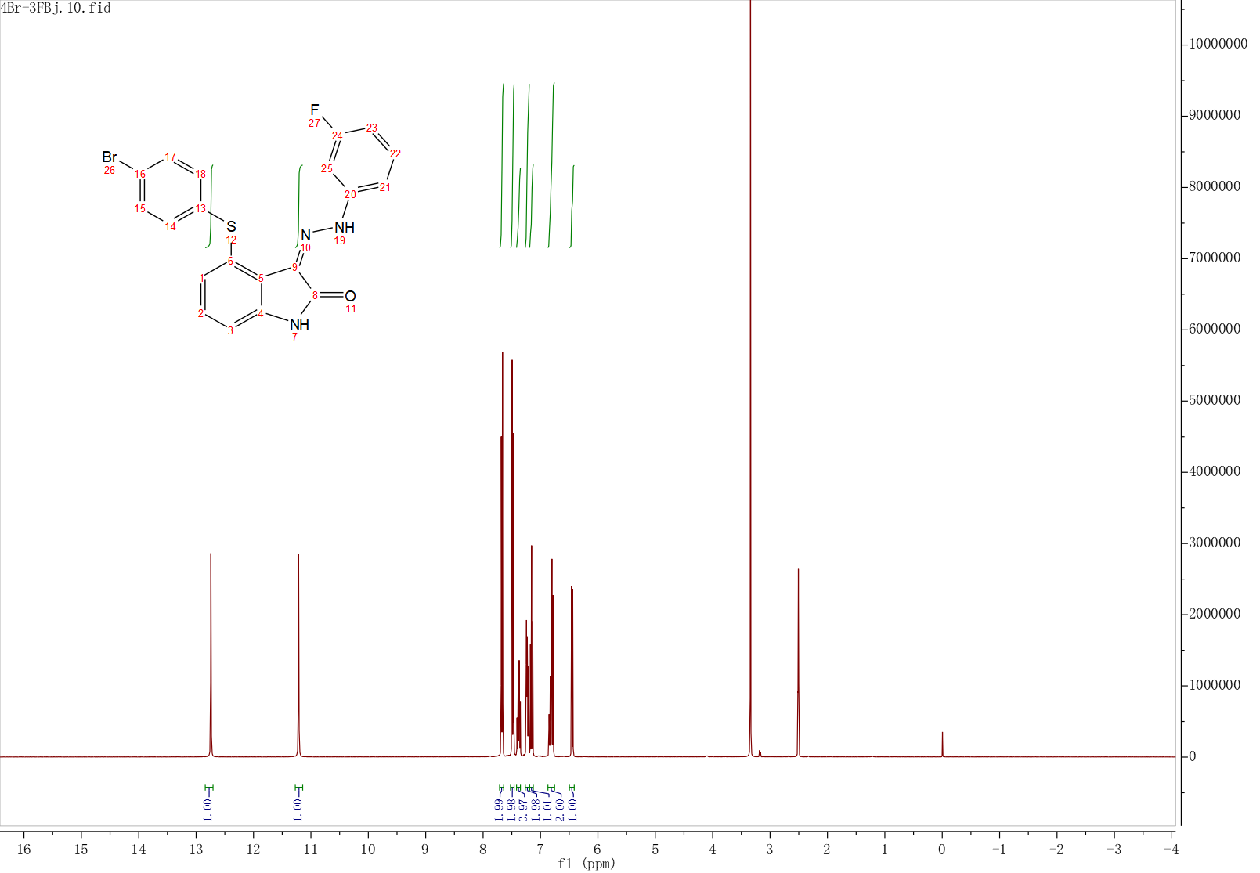
Fig. S35 The ¹H NMR Spectrum of compound H12
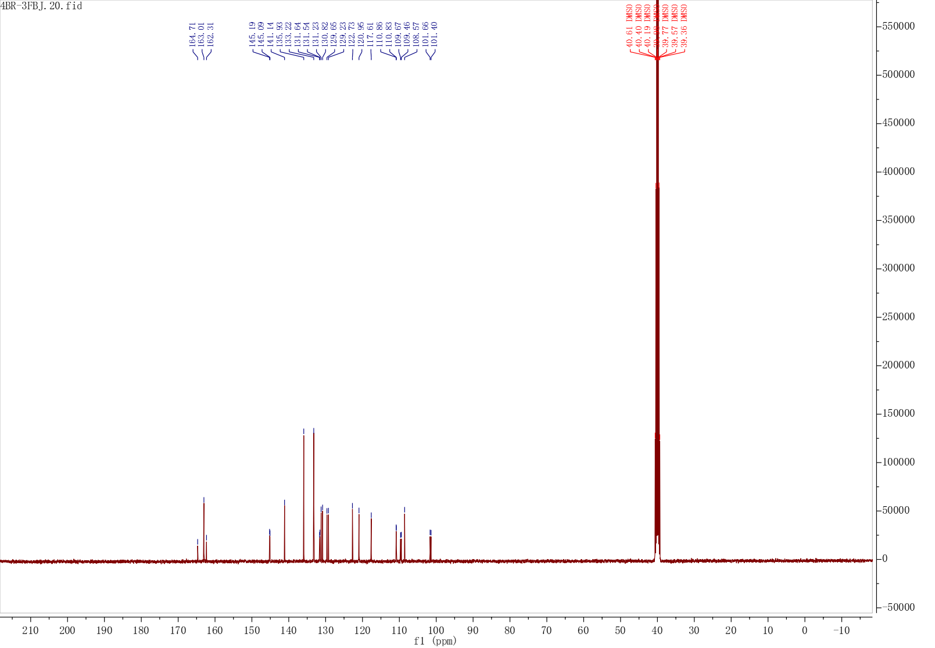
Fig. S36 The ¹³C NMR Spectrum of compound H12
Fig. S37 The HRMS spectrum of compound H12
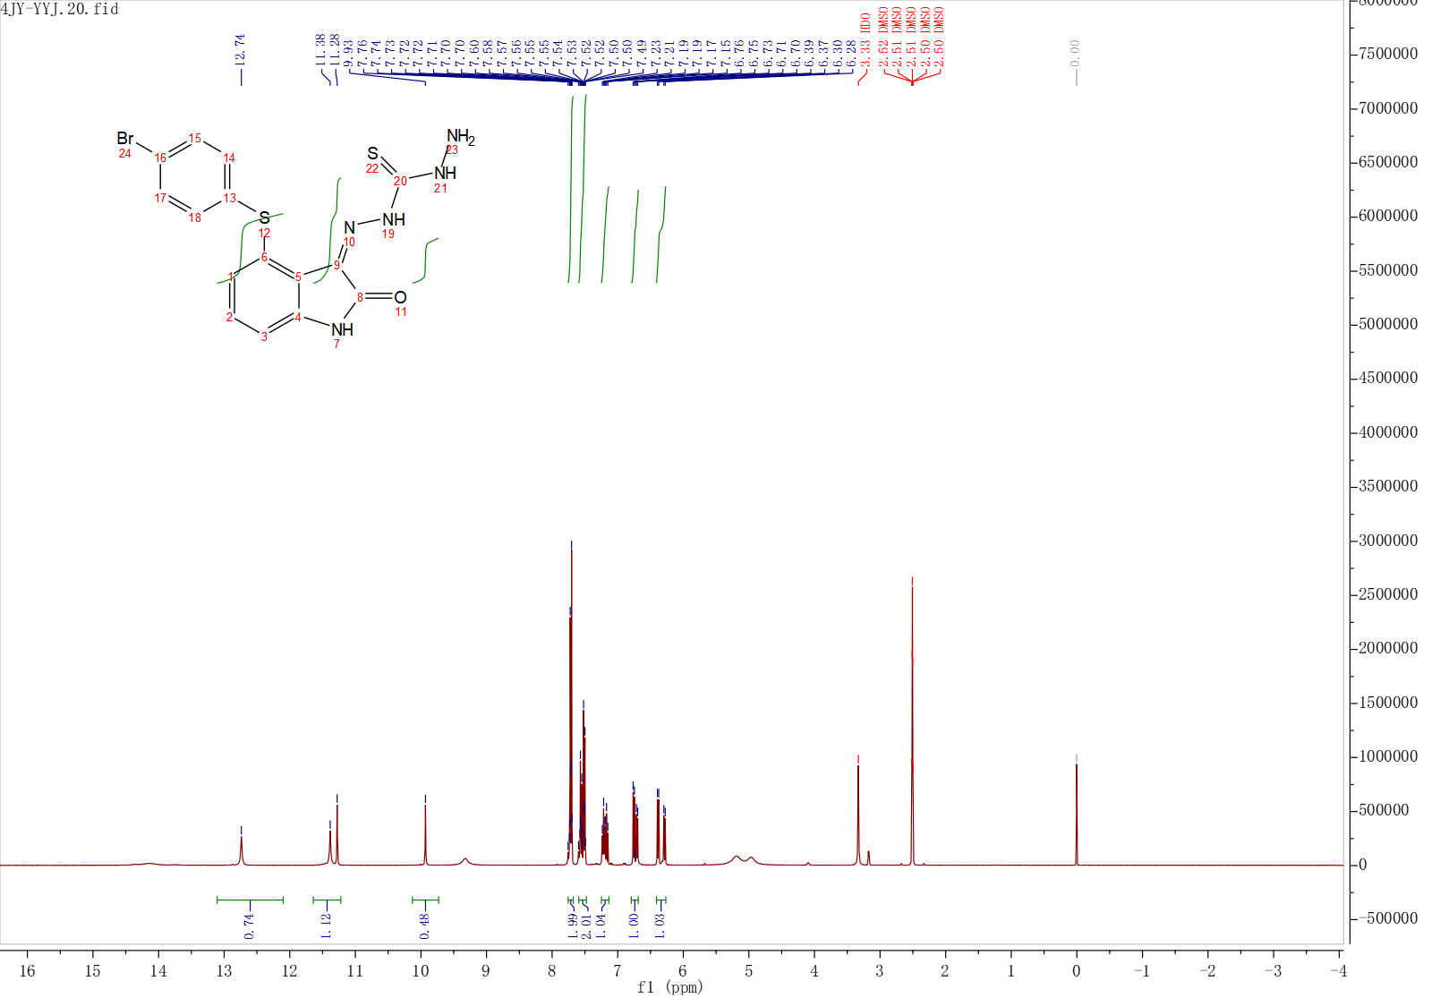
Fig. S38 The ¹H NMR Spectrum of compound H13
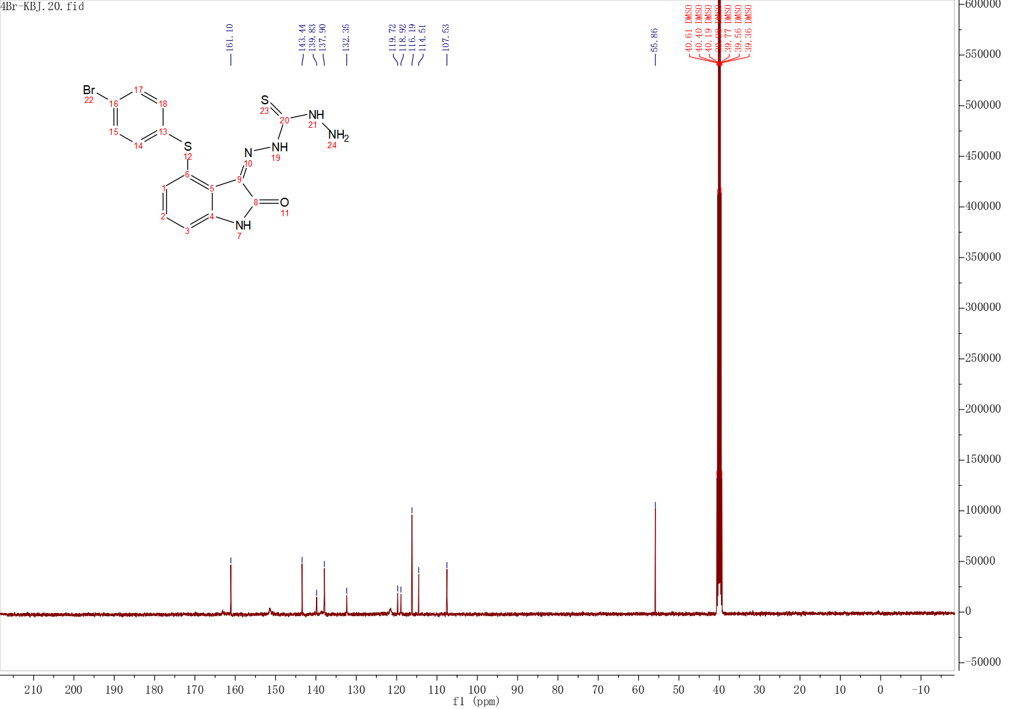
Fig. S39 The ¹³C NMR Spectrum of compound H13
Fig. S40 The HRMS spectrum of compound H13
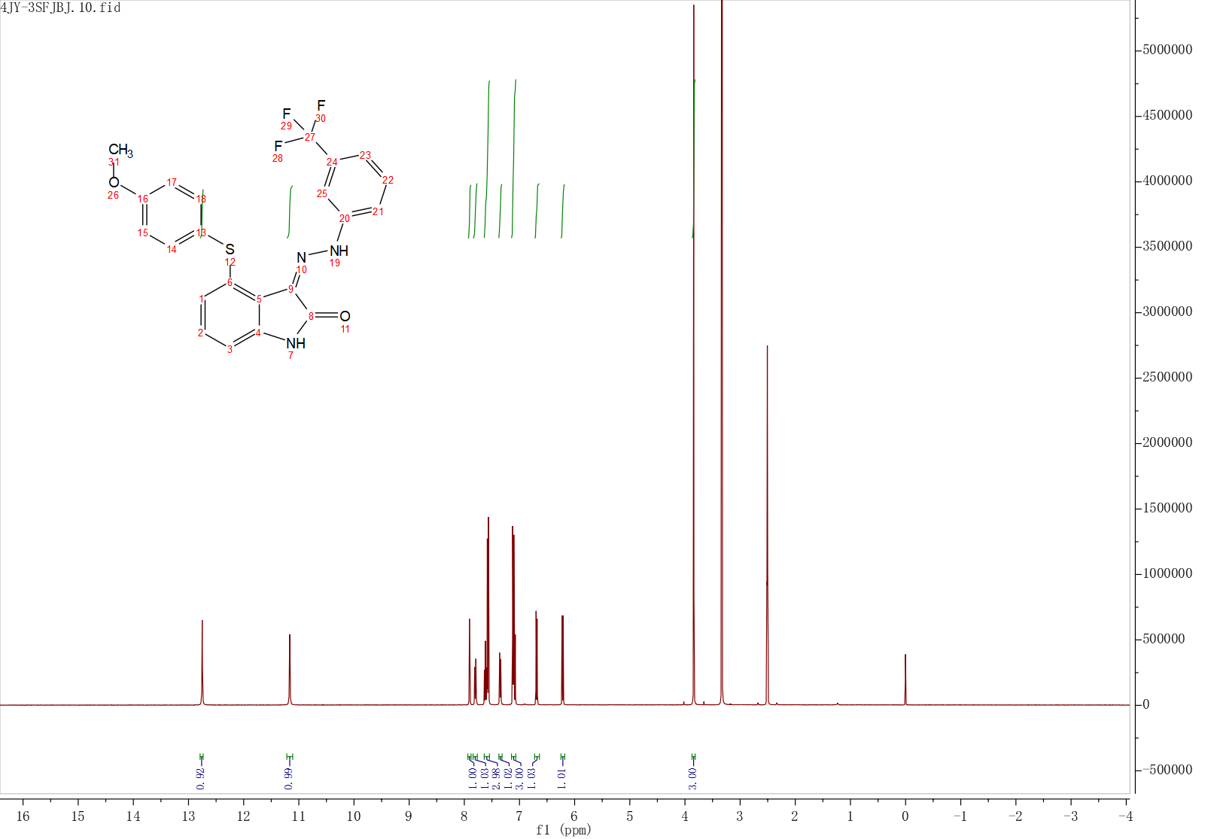
Fig. S41 The ¹H NMR Spectrum of compound H14
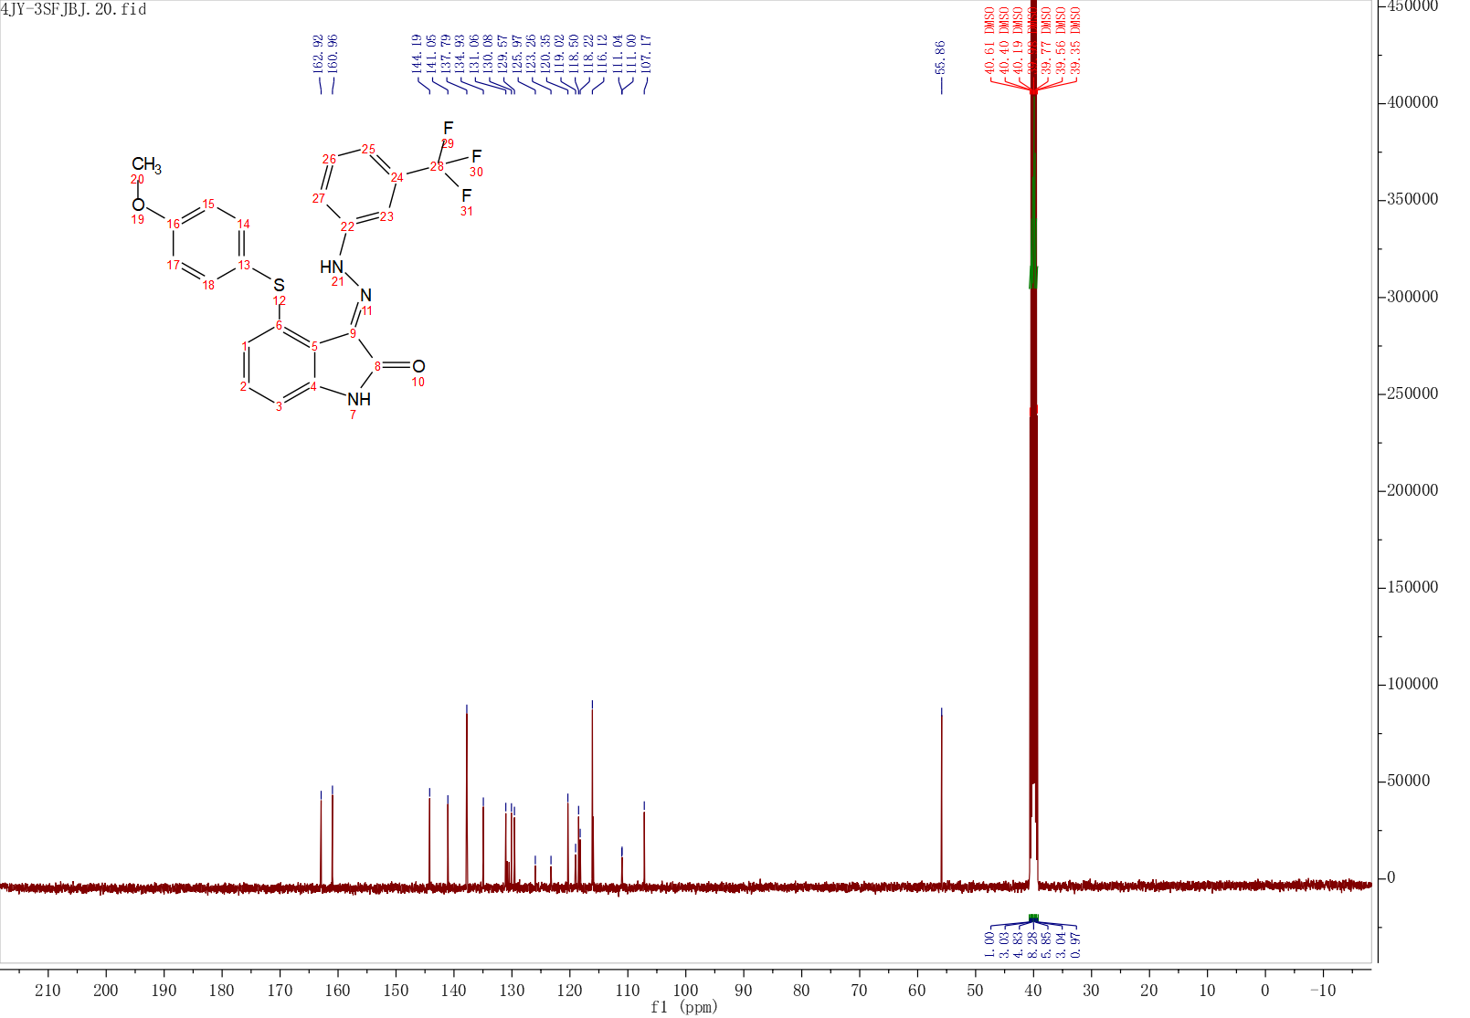
Fig. S42 The ¹³C NMR Spectrum of compound H14
Fig. S43 The HRMS spectrum of compound H14
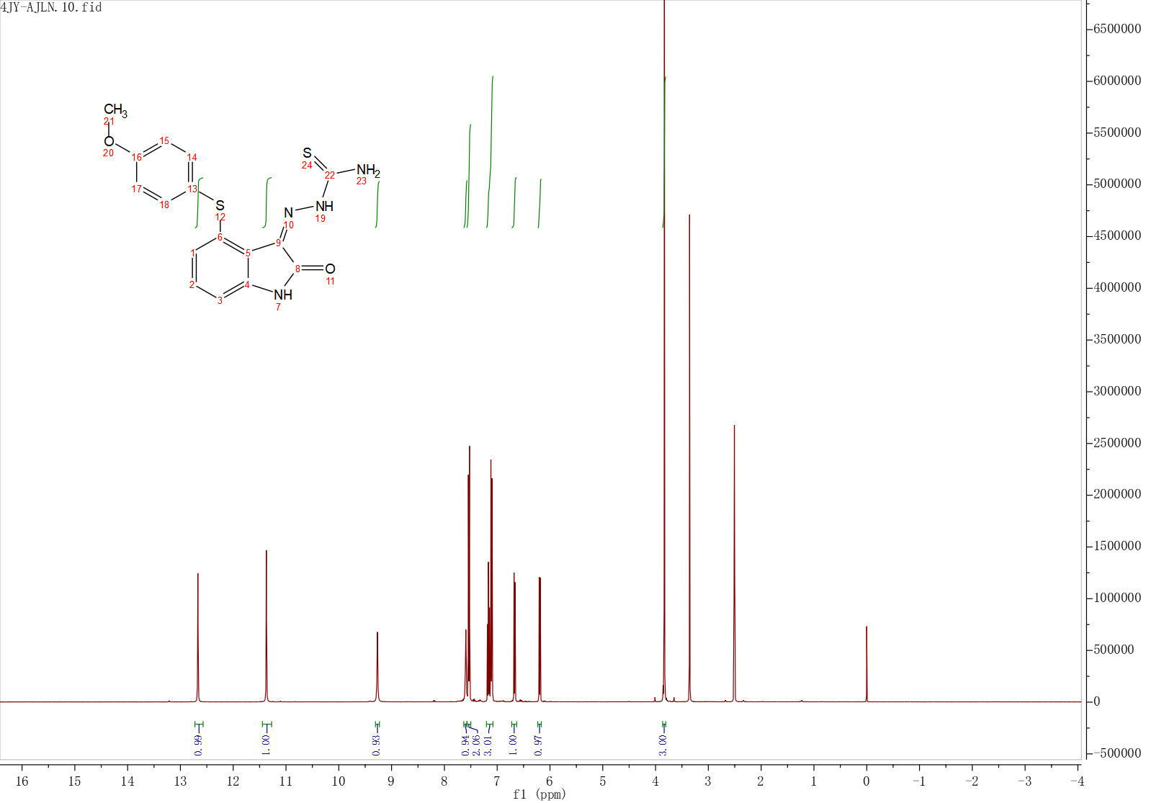
Fig. S44 The ¹H NMR Spectrum of compound H15
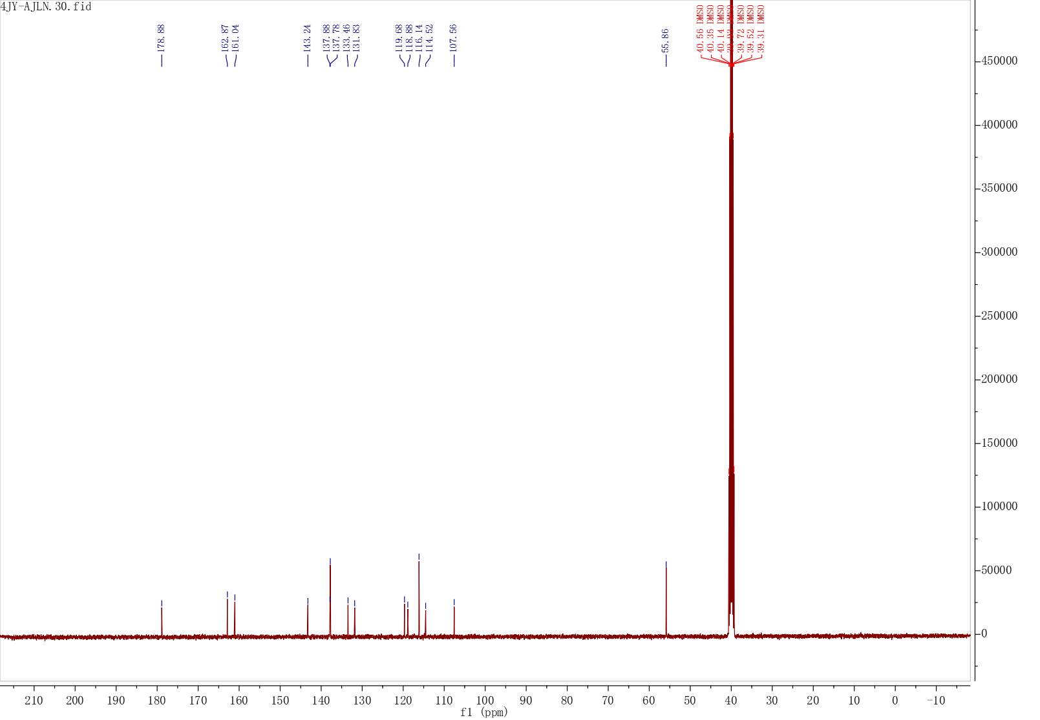
Fig. S45 The ¹³C NMR Spectrum of compound H15
Fig. S46 The HRMS spectrum of compound H15
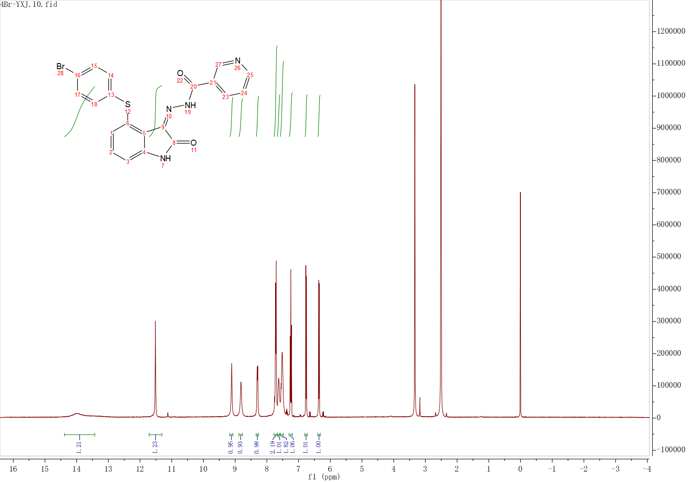
Fig. S47 The ¹H NMR Spectrum of compound H16
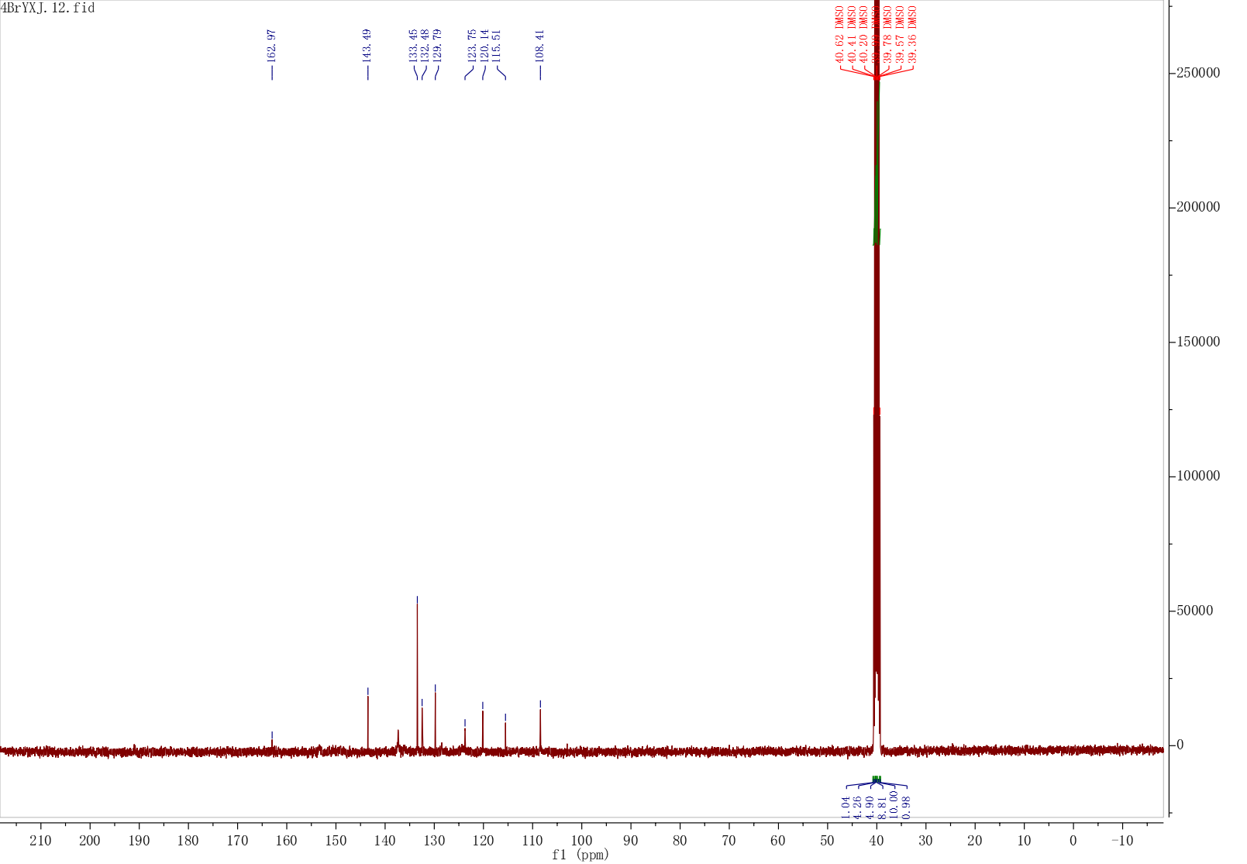
Fig. S48 The ¹³C NMR Spectrum of compound H16
Fig. S49 The HRMS spectrum of compound H16
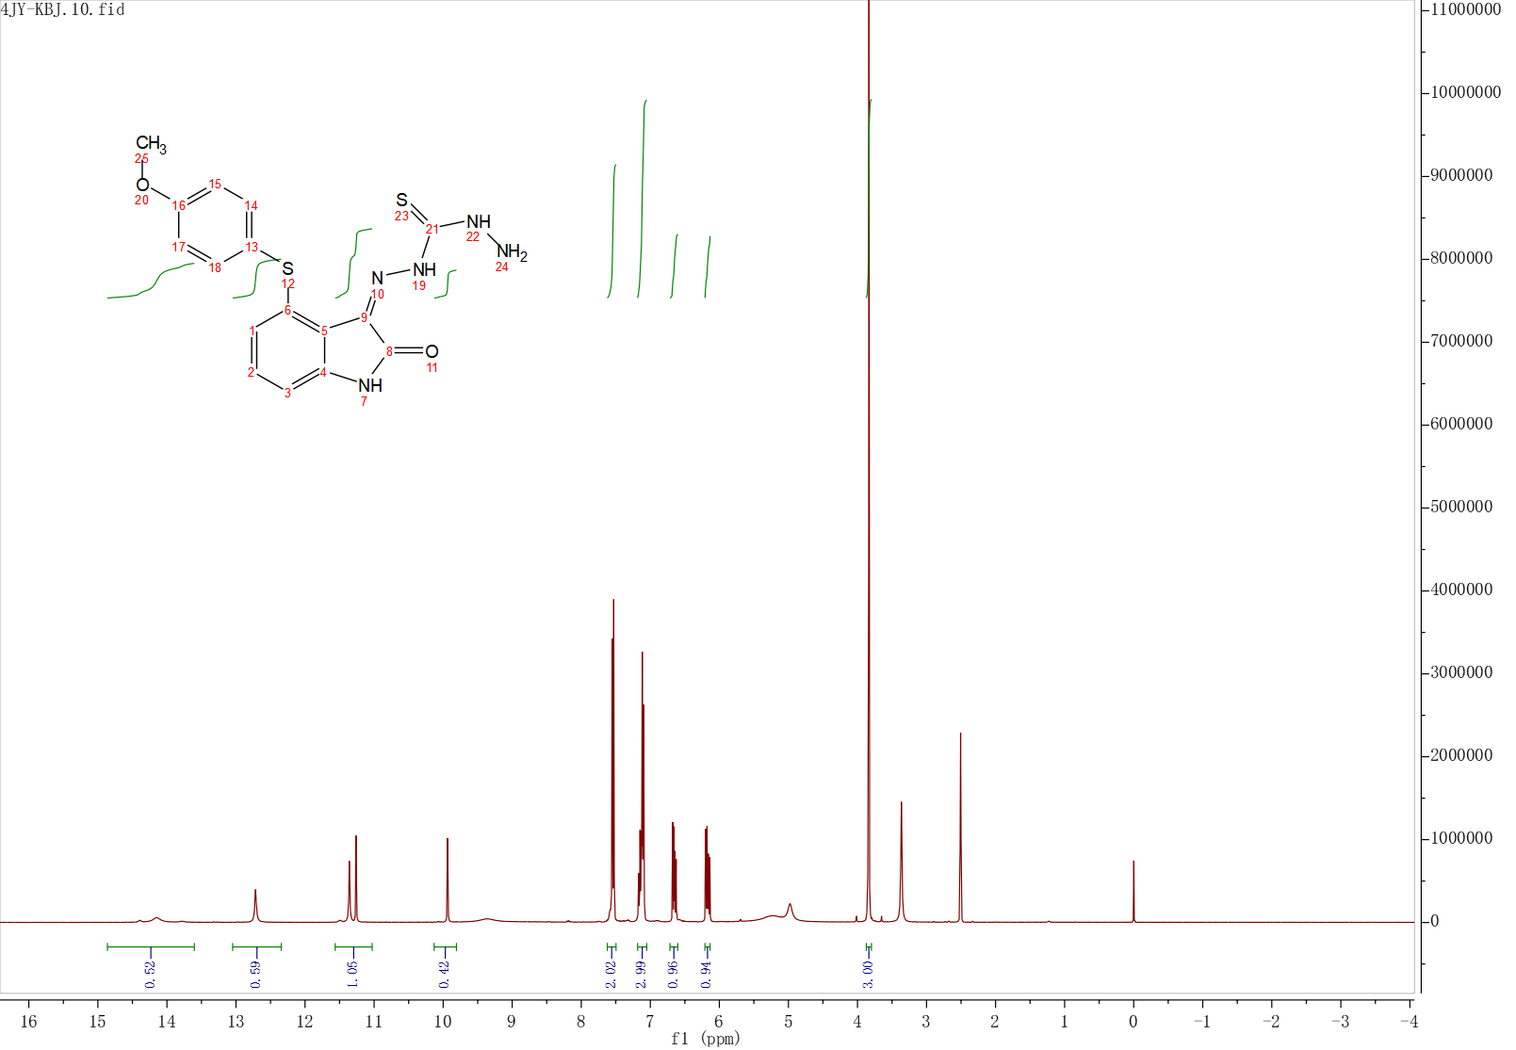
Fig. S50 The ¹H NMR Spectrum of compound H17
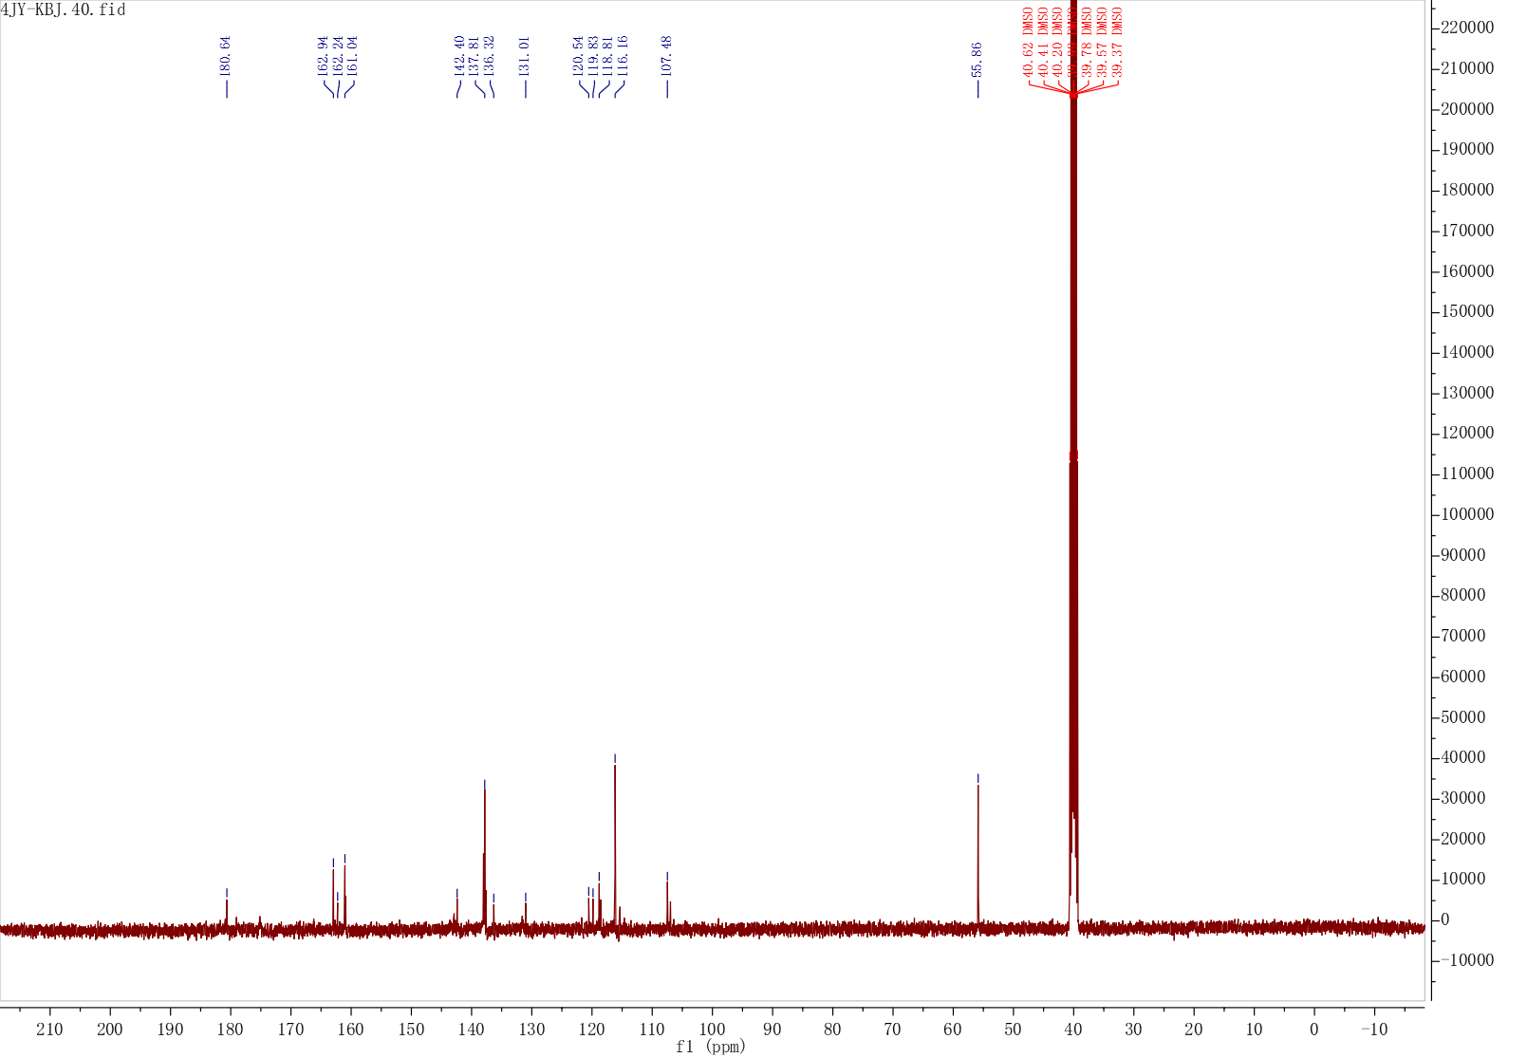
Fig. S51 The ¹³C NMR Spectrum of compound H17
Fig. S52 The HRMS spectrum of compound H17
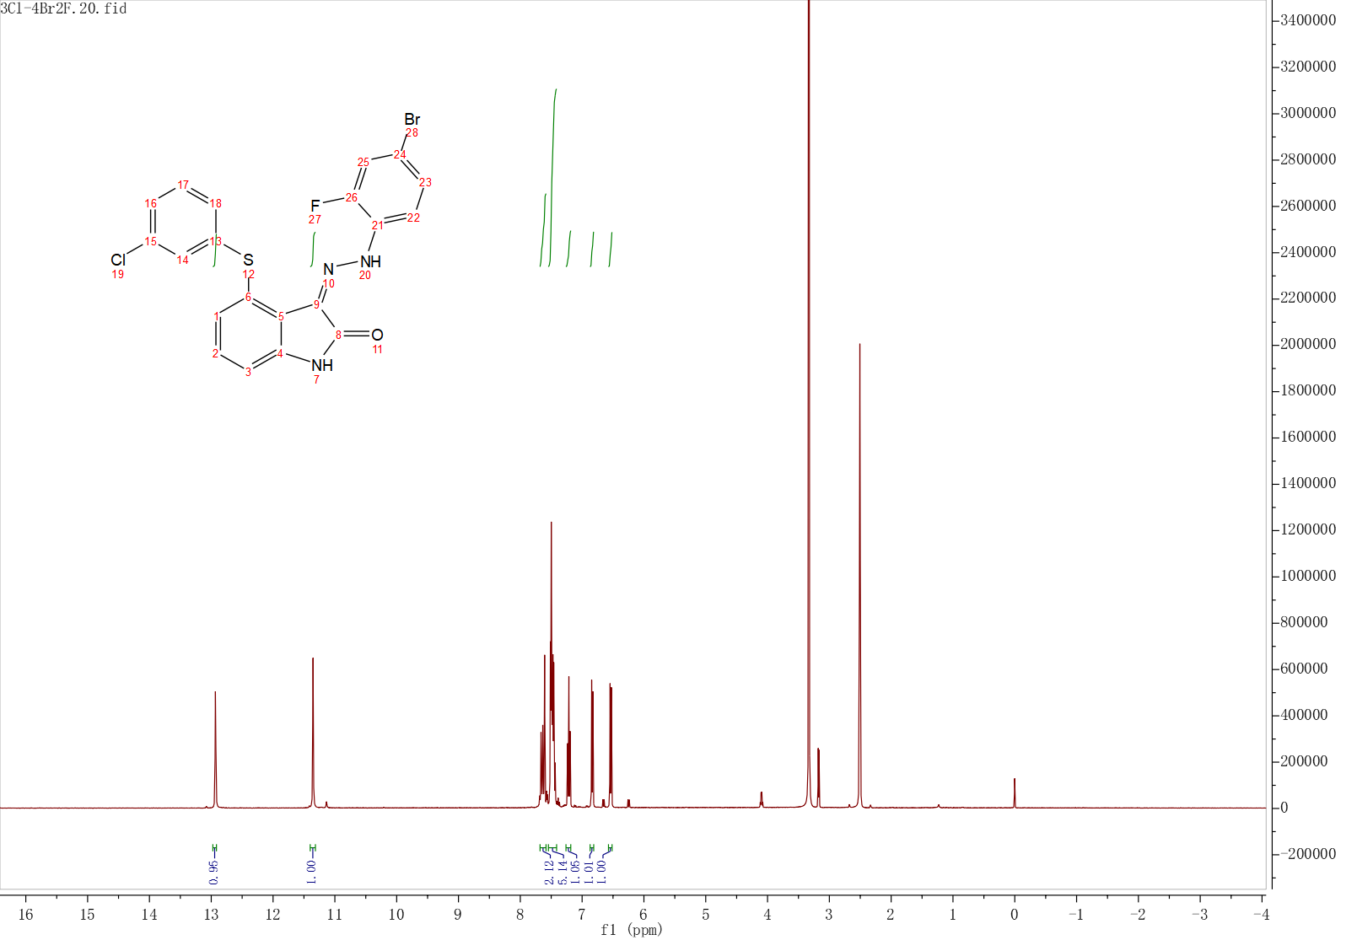
Fig. S53 The ¹H NMR Spectrum of compound H18
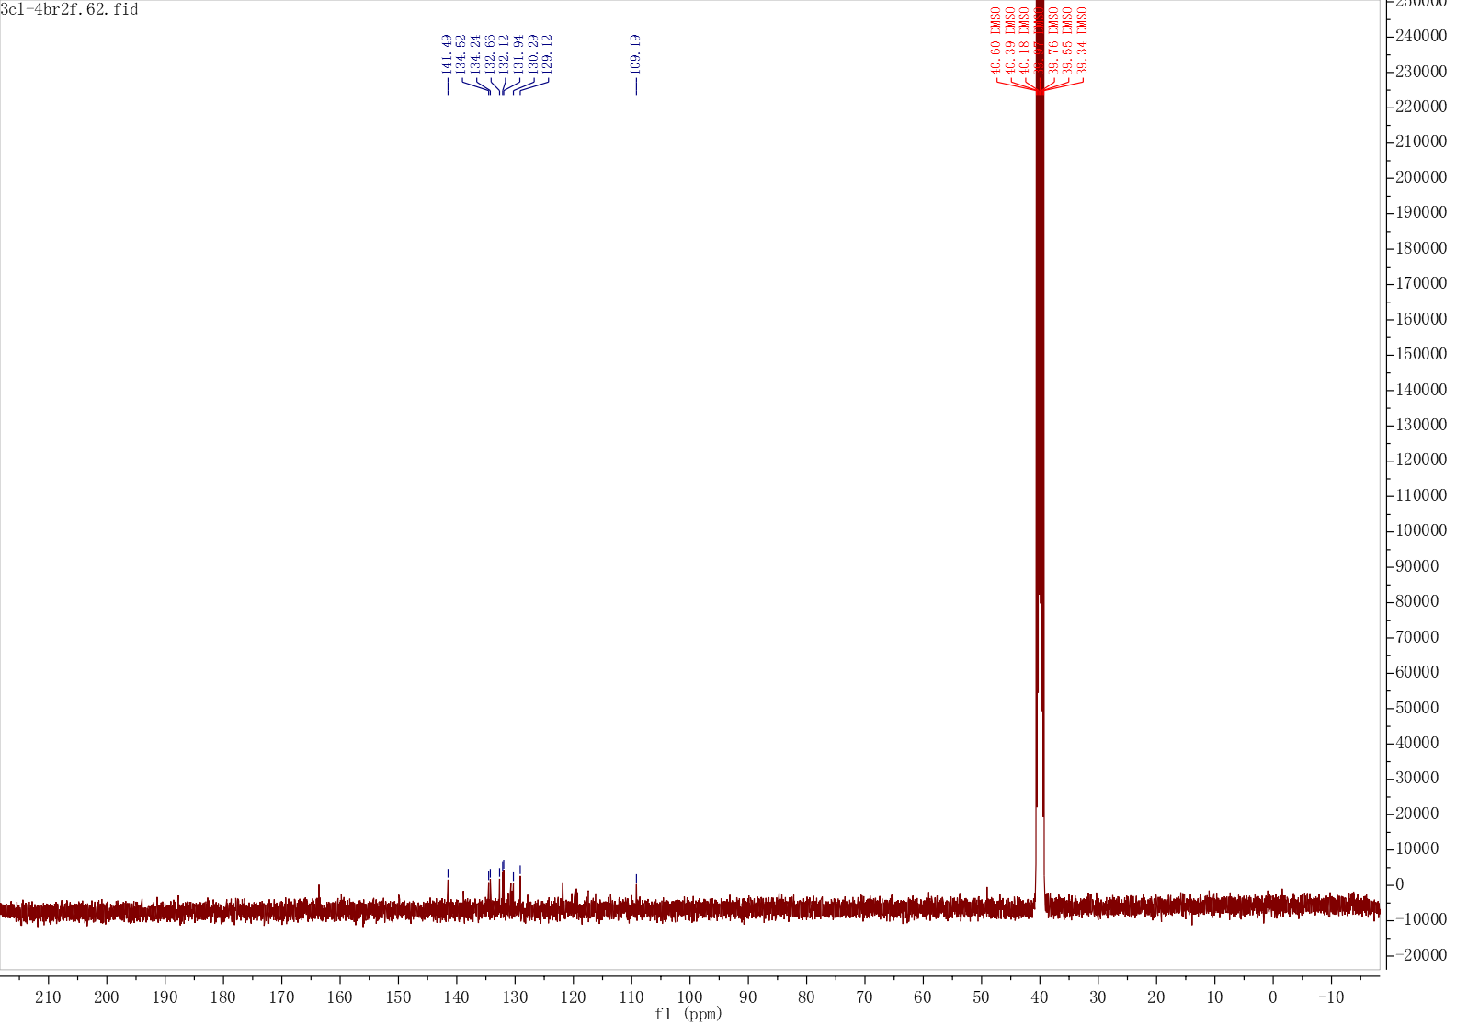
Fig. S54 The ¹³C NMR Spectrum of compound H18
Fig. S55 The HRMS spectrum of compound H18
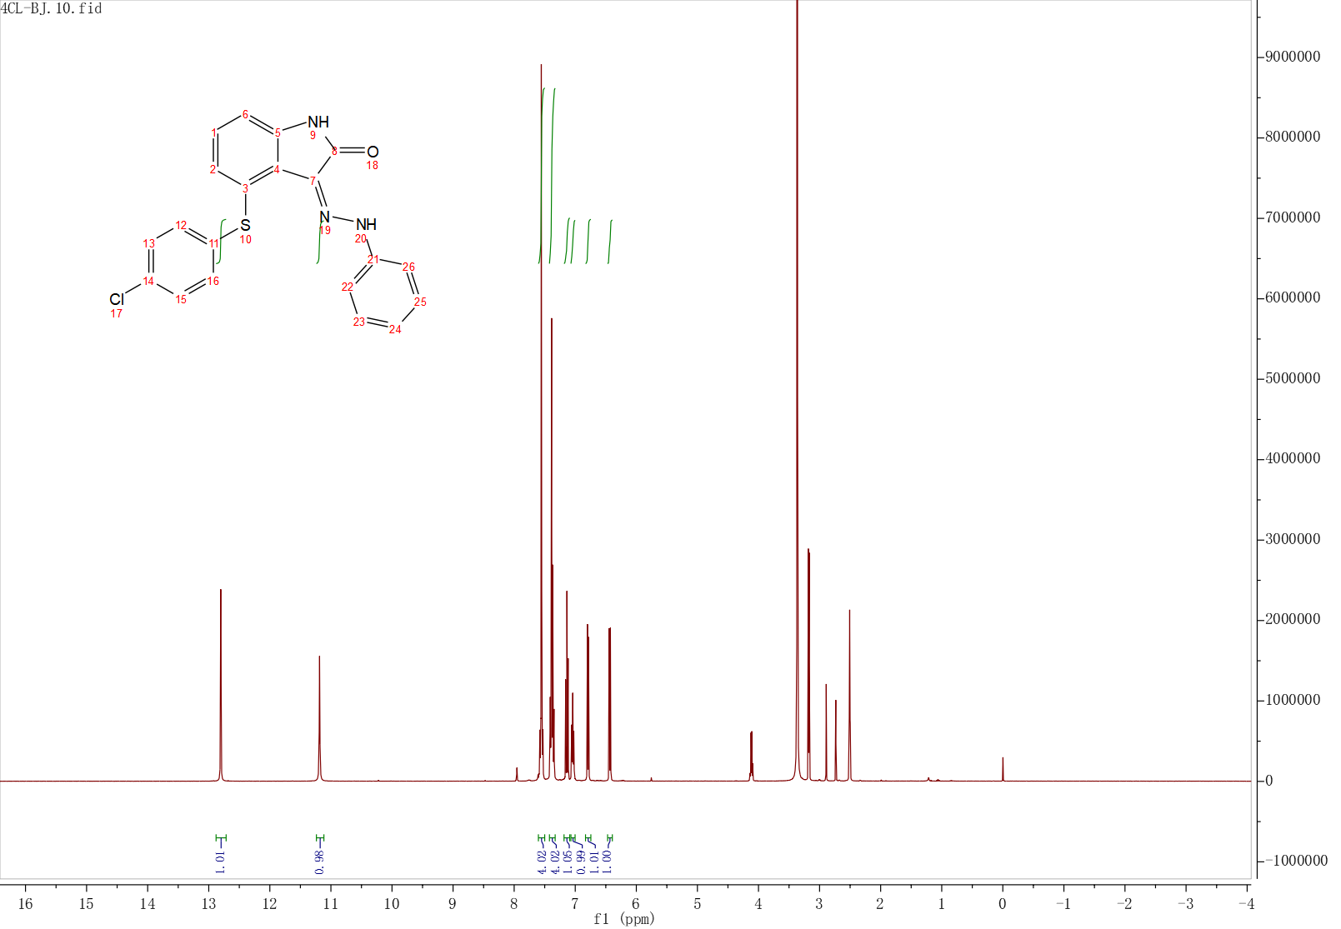
Fig. S56 The ¹H NMR Spectrum of compound H19
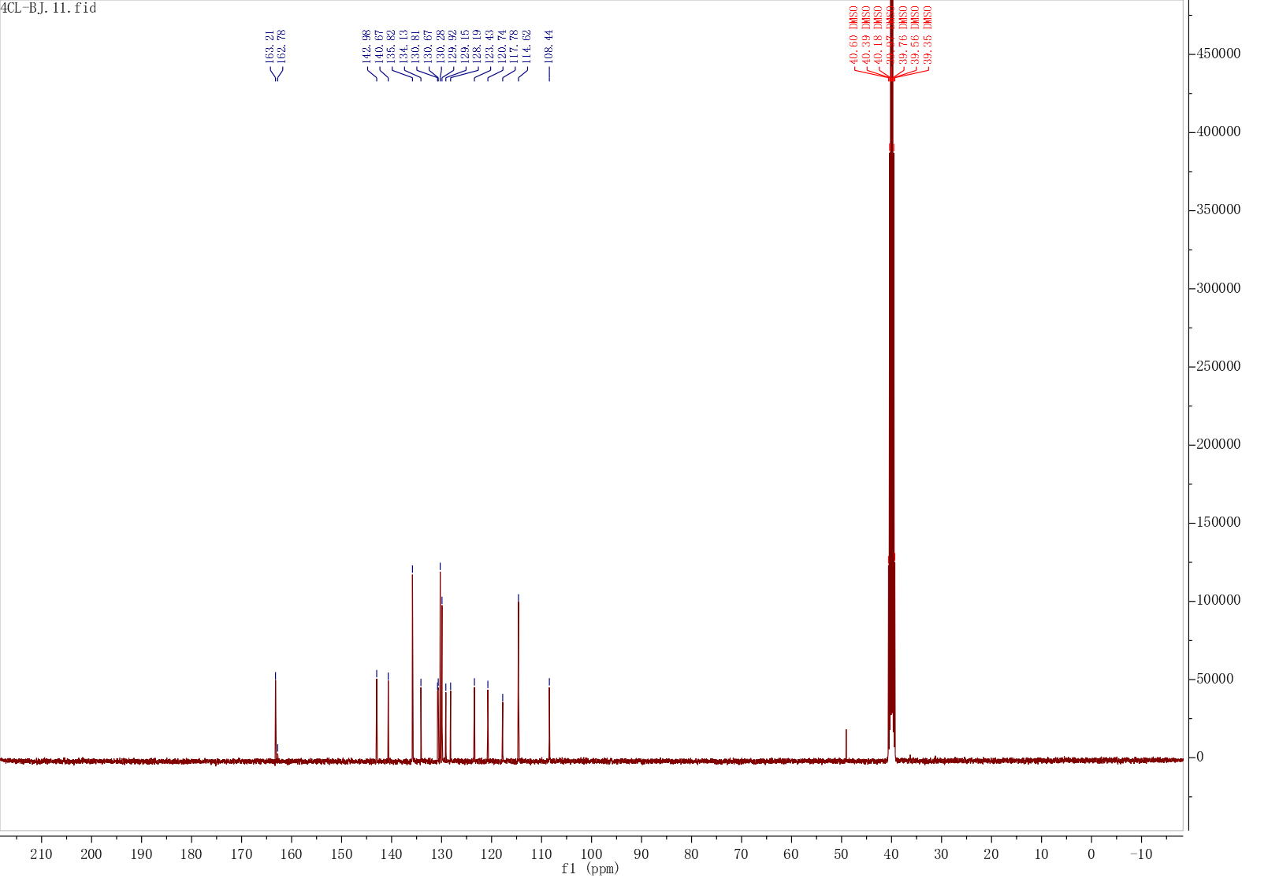
Fig. S57 The ¹³C NMR Spectrum of compound H19
Fig. S58 The HRMS spectrum of compound H19
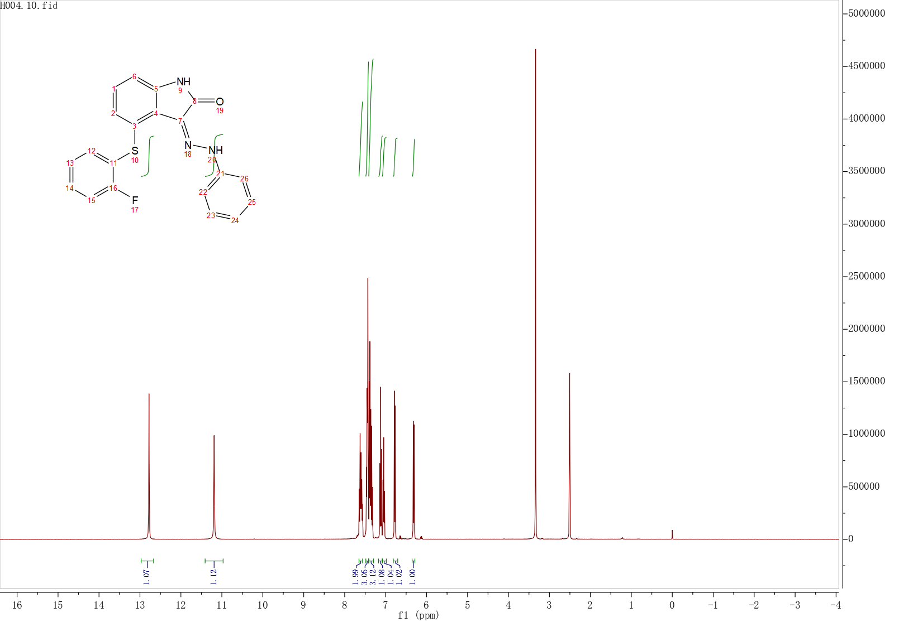
Fig. S59 The ¹H NMR Spectrum of compound H20
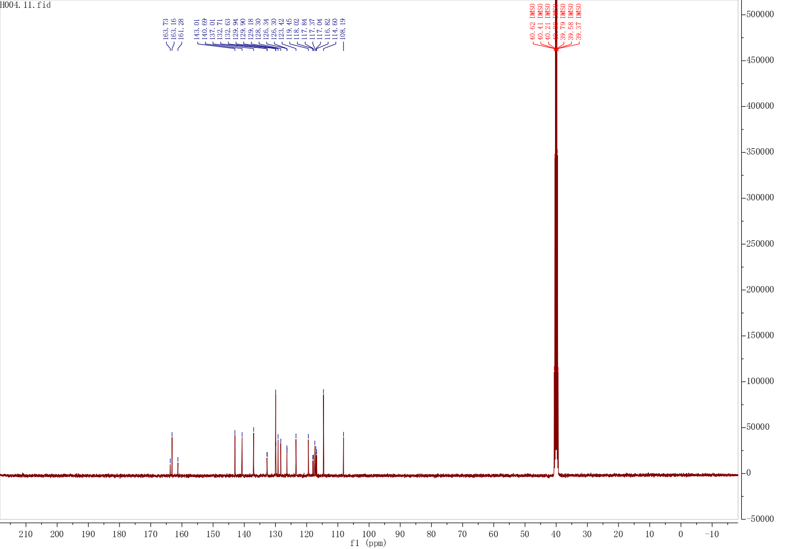
Fig. S60 The ¹³C NMR Spectrum of compound H20
Fig. S61 The HRMS spectrum of compound H20
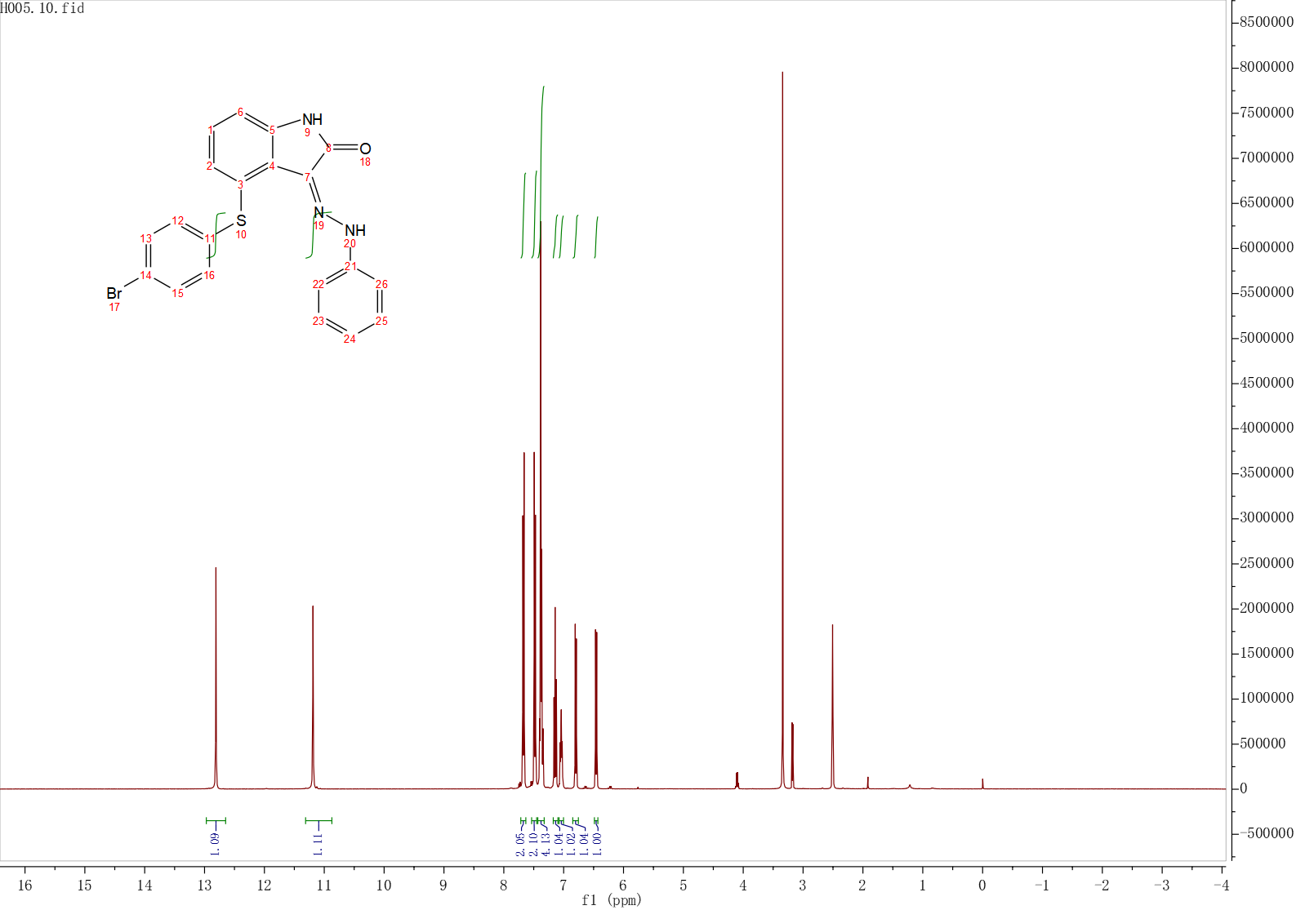
Fig. S62 The ¹H NMR Spectrum of compound H21
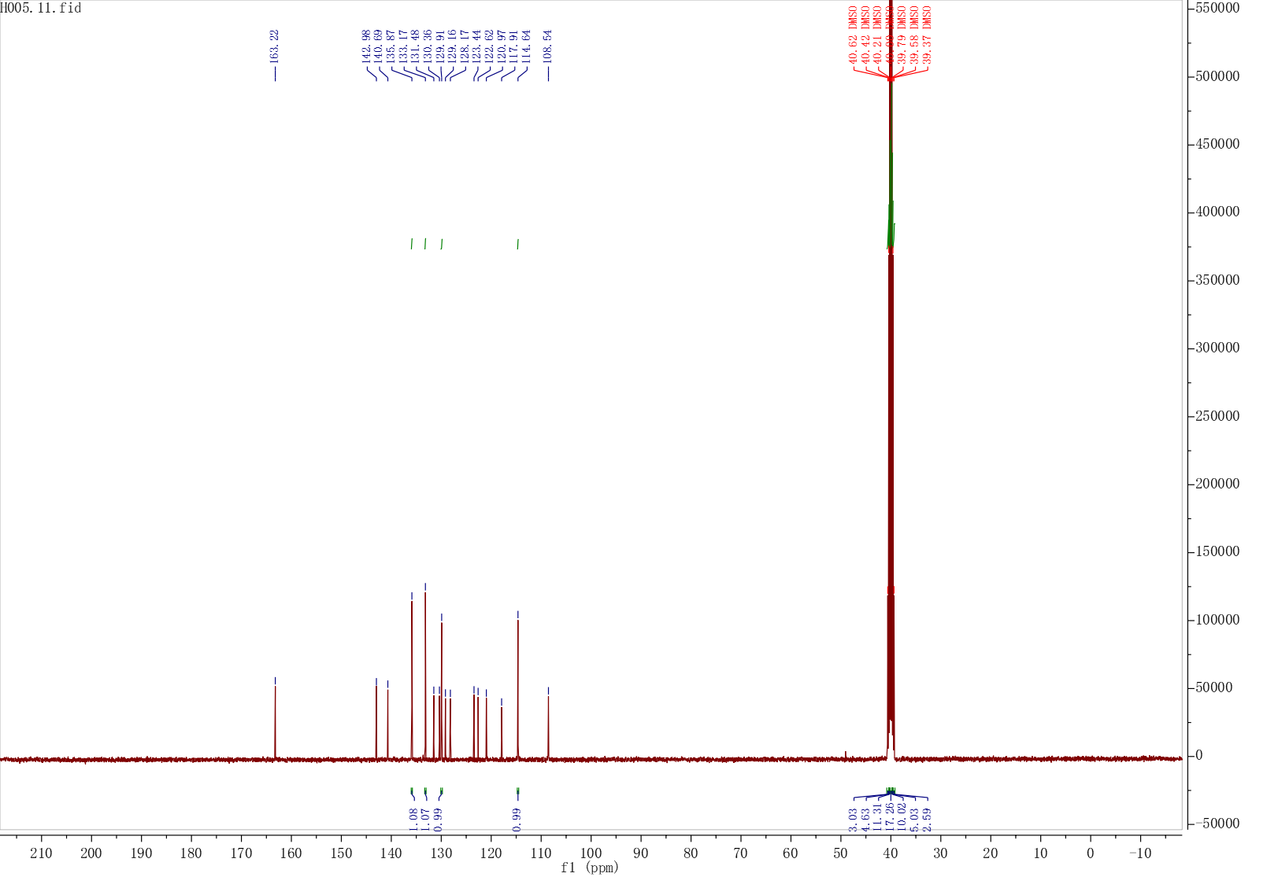
Fig. S63 The ¹³C NMR Spectrum of compound H21
Fig. S64 The HRMS spectrum of compound H21
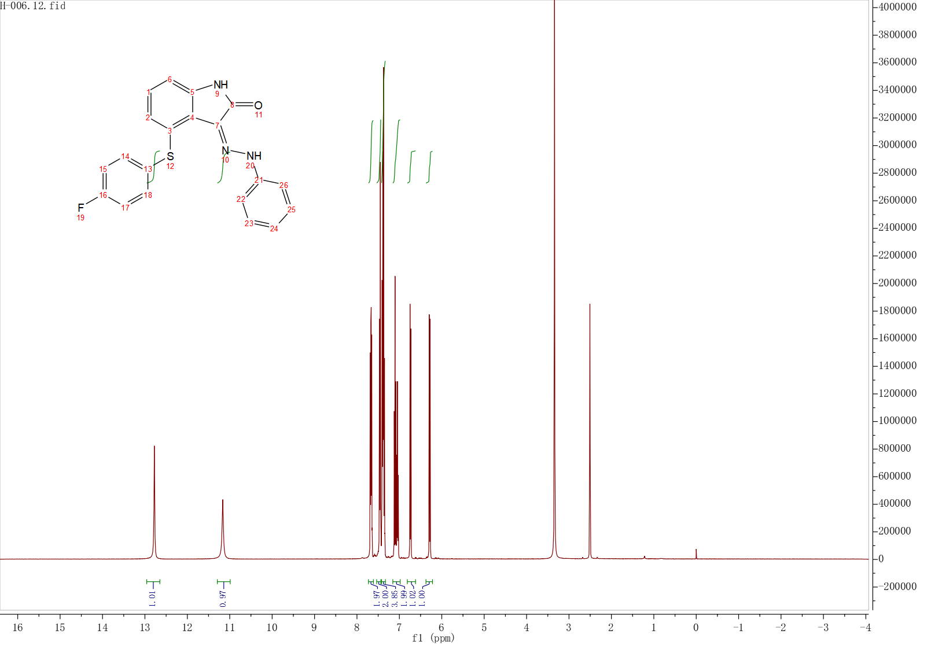
Fig. S65 The ¹H NMR Spectrum of compound H22
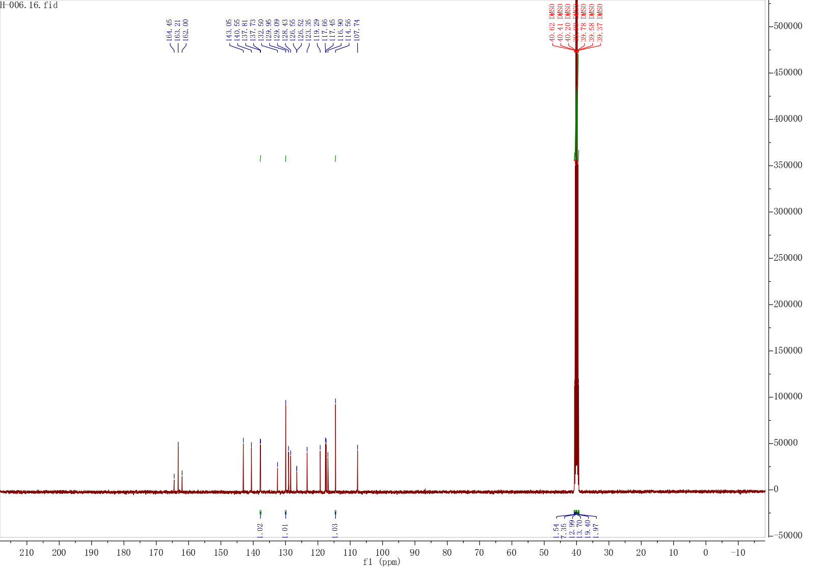
Fig. S66 The ¹³C NMR Spectrum of compound H22
Fig. S67 The HRMS spectrum of compound H22
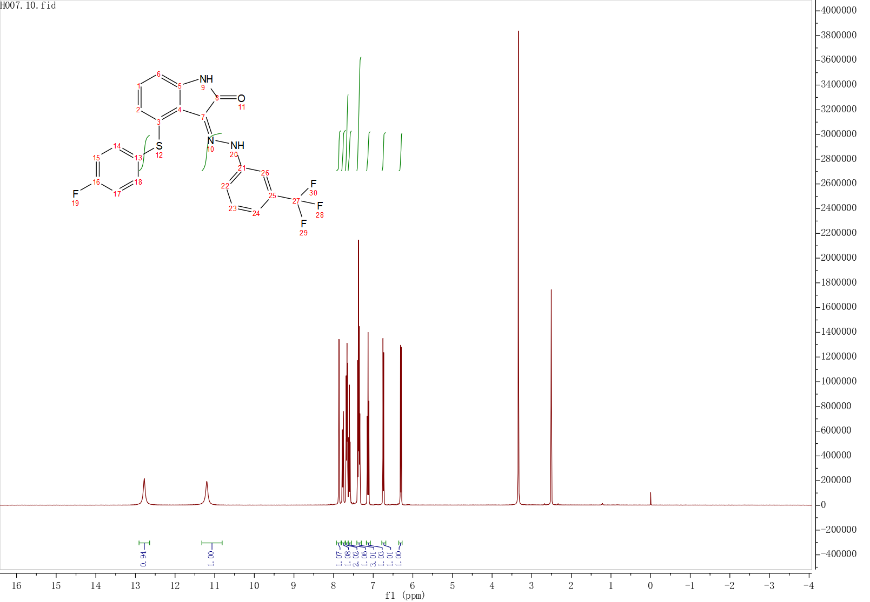
Fig. S68 The ¹H NMR Spectrum of compound H23
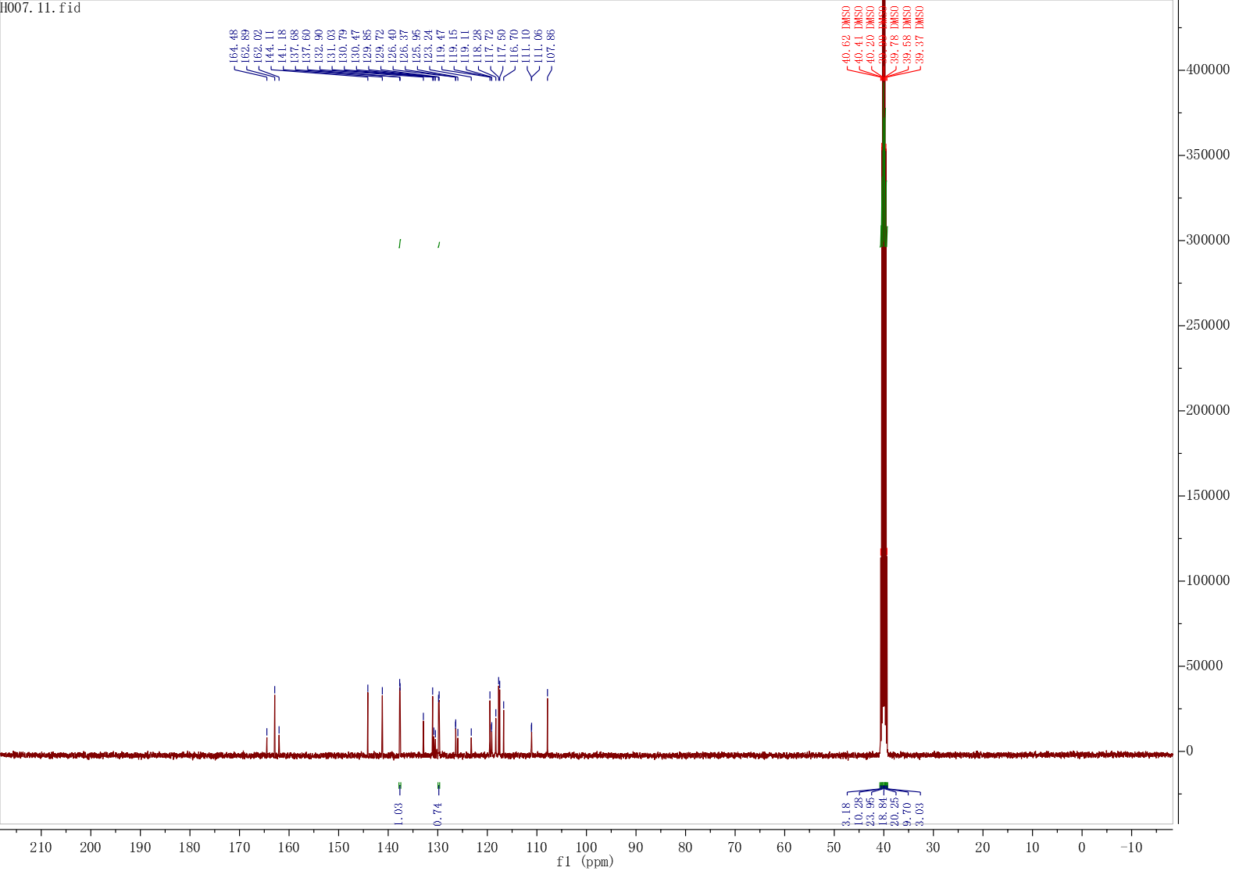
Fig. S69 The ¹³C NMR Spectrum of compound H23
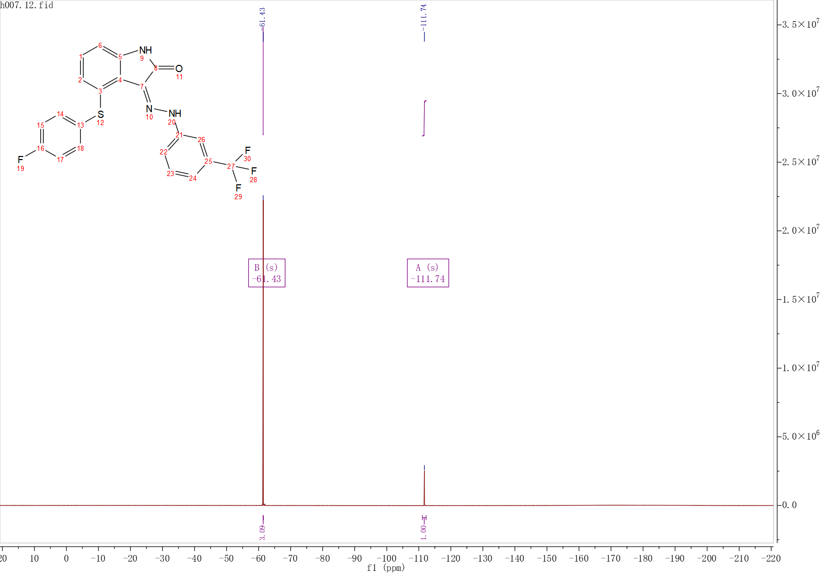
Fig. S70 The ¹⁹F NMR Spectrum of compound H23
Fig. S71 The HRMS spectrum of compound H23
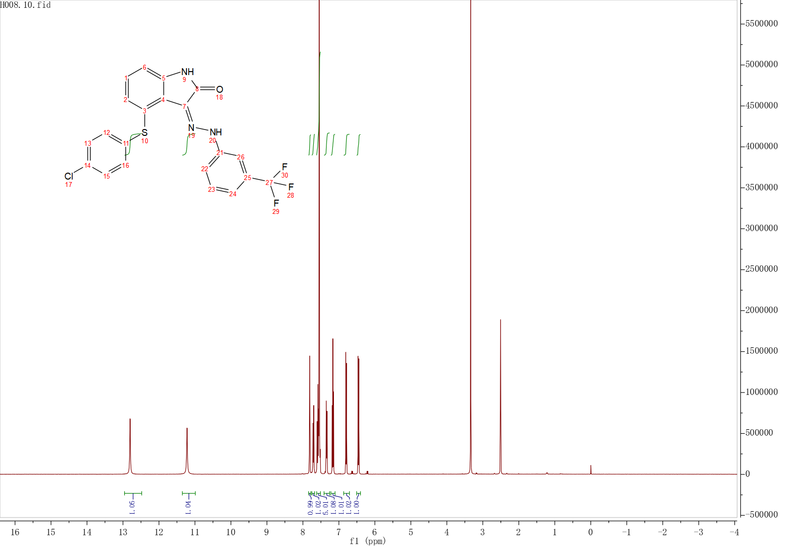
Fig. S72 The ¹H NMR Spectrum of compound H24
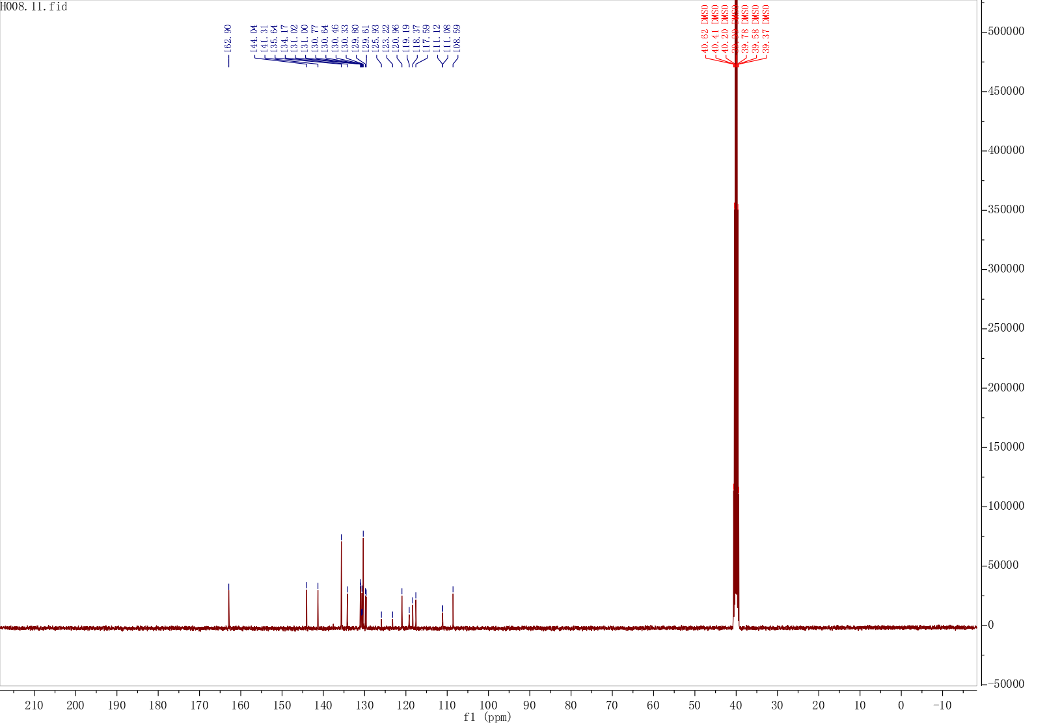
Fig. S73 The ¹³C NMR Spectrum of compound H24
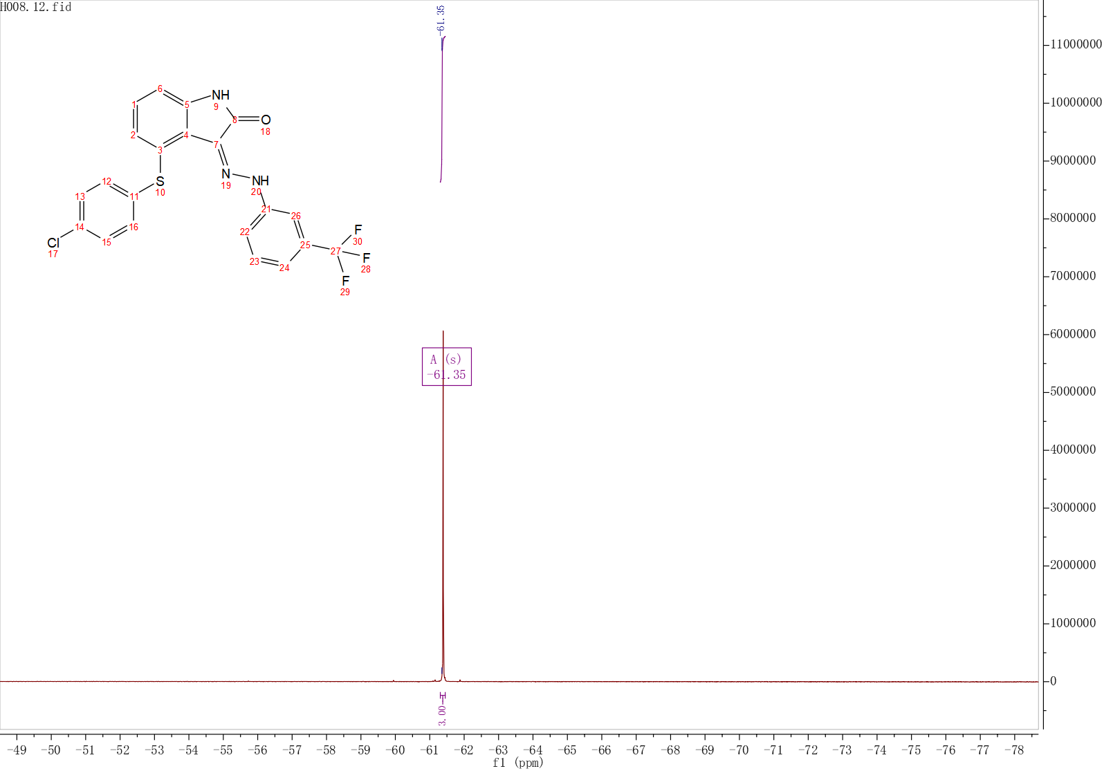
Fig. S74 The ¹⁹F NMR Spectrum of compound H24
Fig. S75 The HRMS spectrum of compound H24
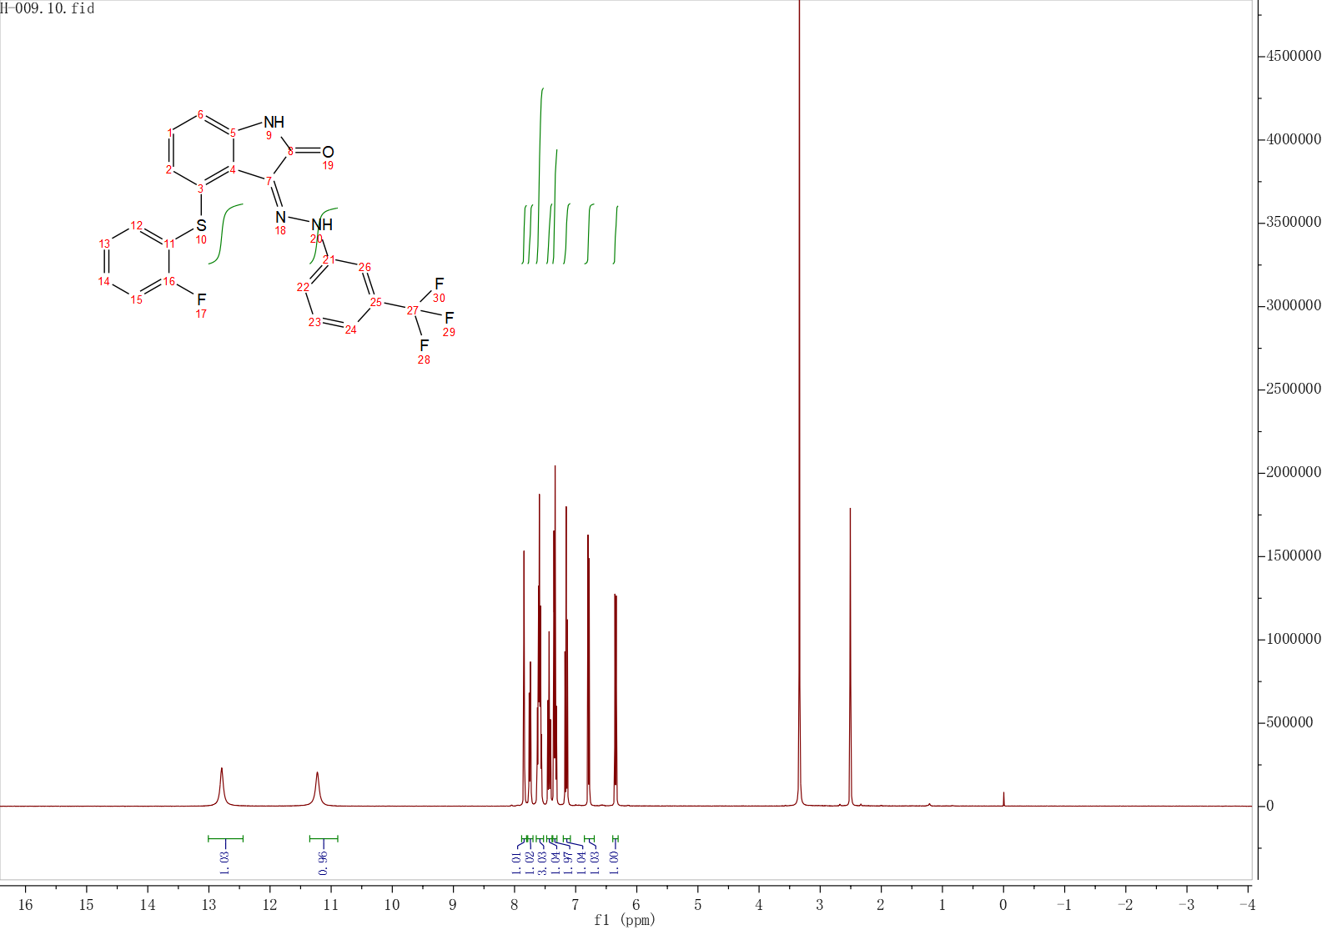
Fig. S76 The ¹H NMR Spectrum of compound H25
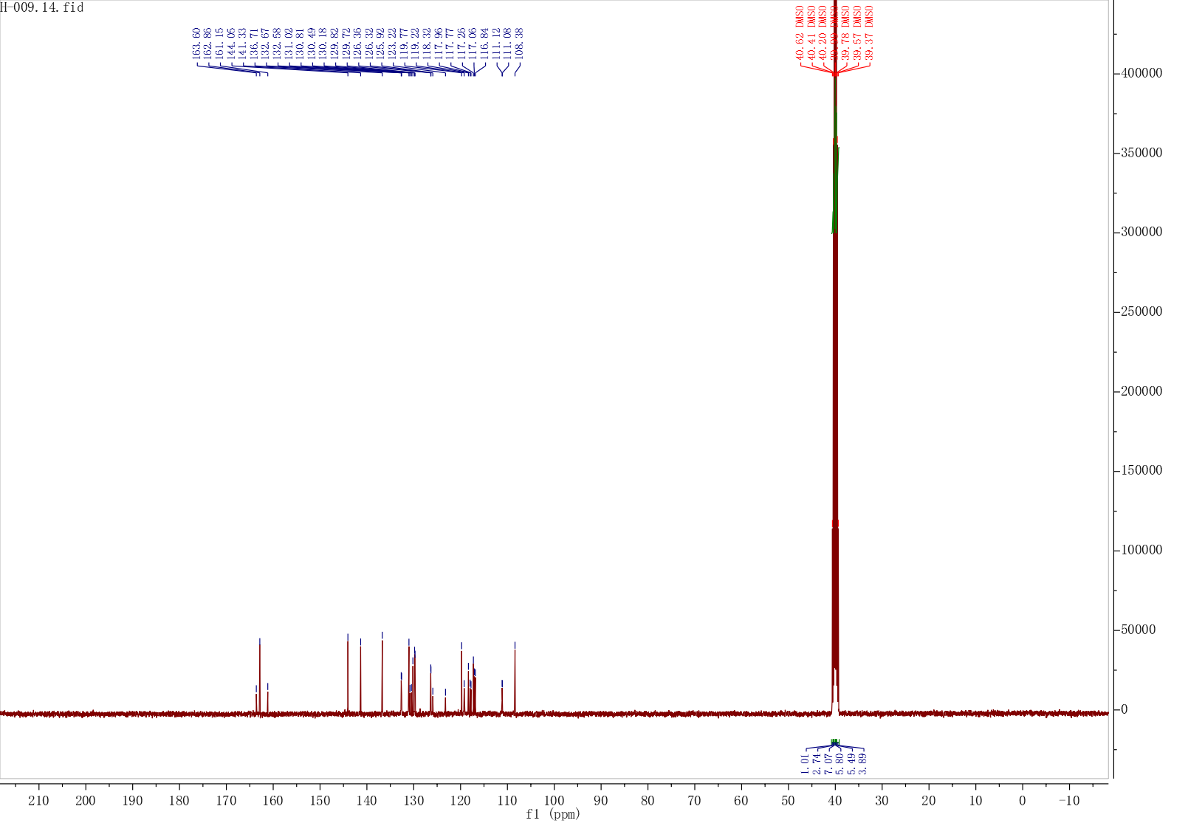
Fig. S77 The ¹³C NMR Spectrum of compound H25
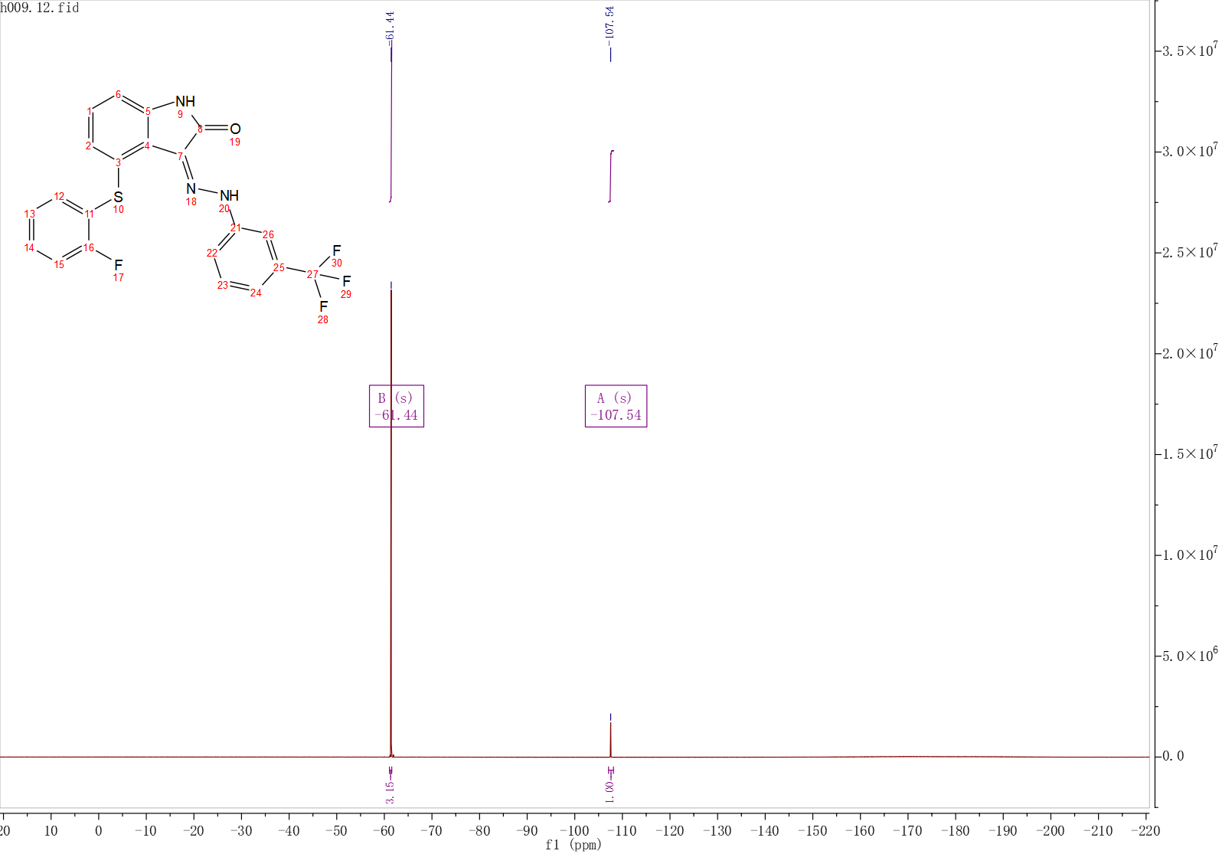
Fig. S78 The ¹⁹F NMR Spectrum of compound H25

Fig. S79 The HRMS spectrum of compound H25
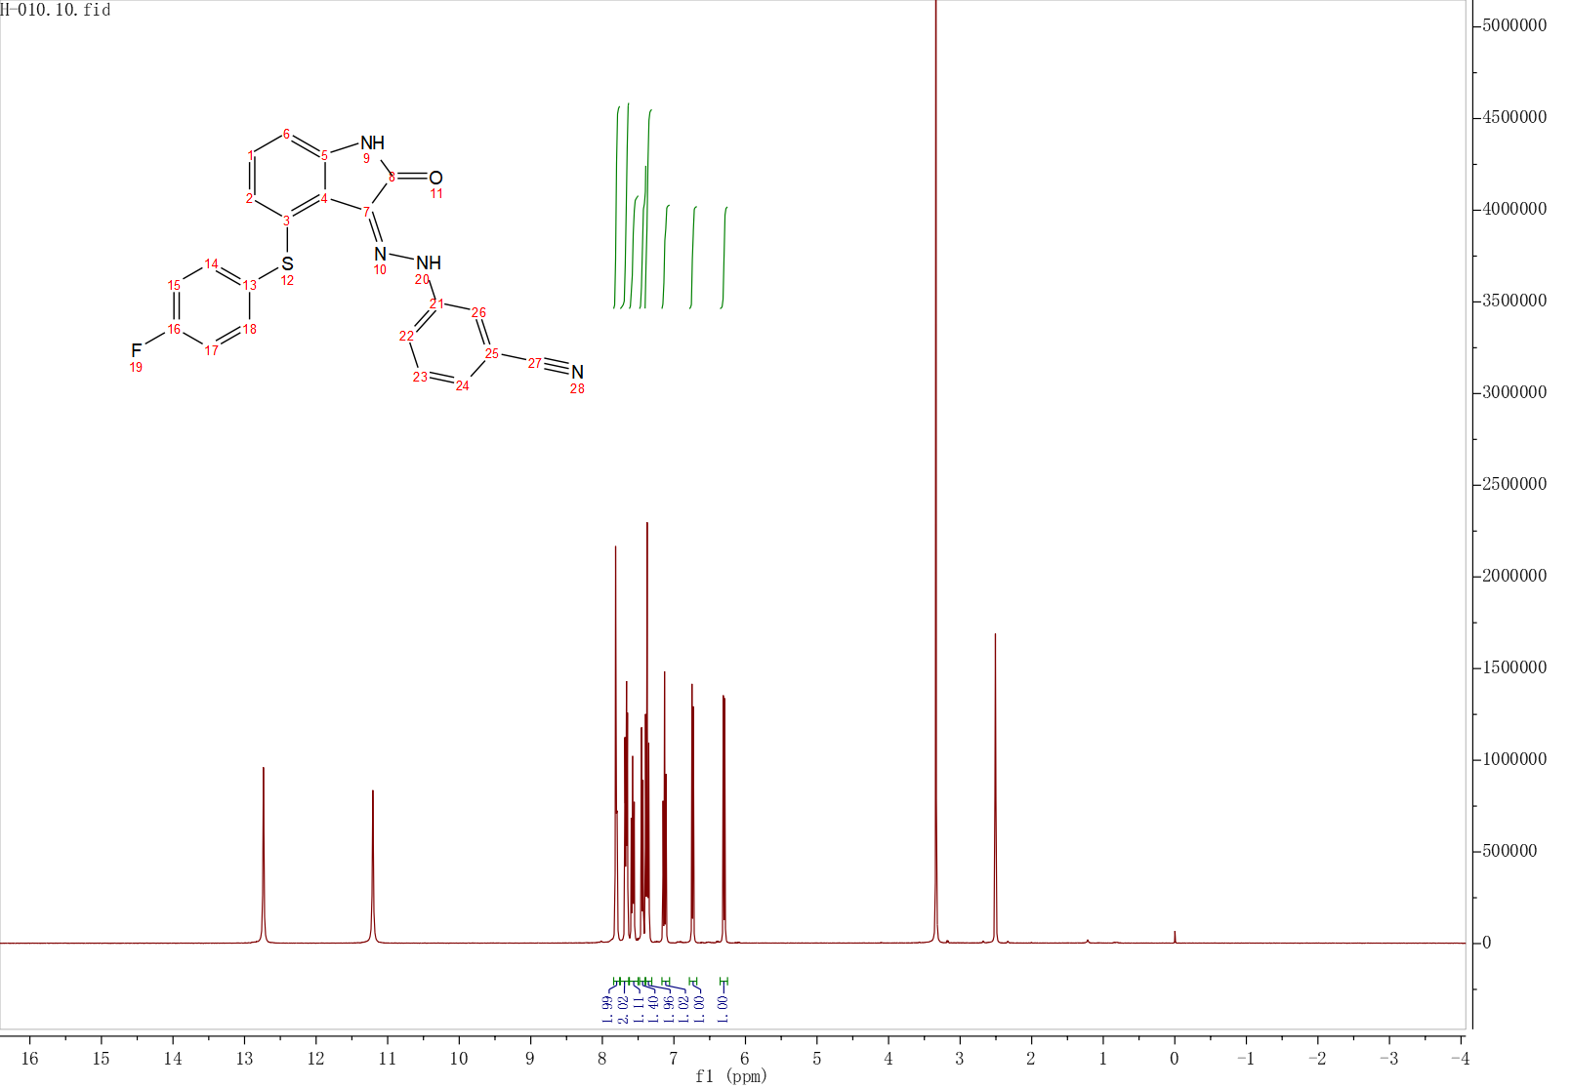
Fig. S80 The ¹H NMR Spectrum of compound H26
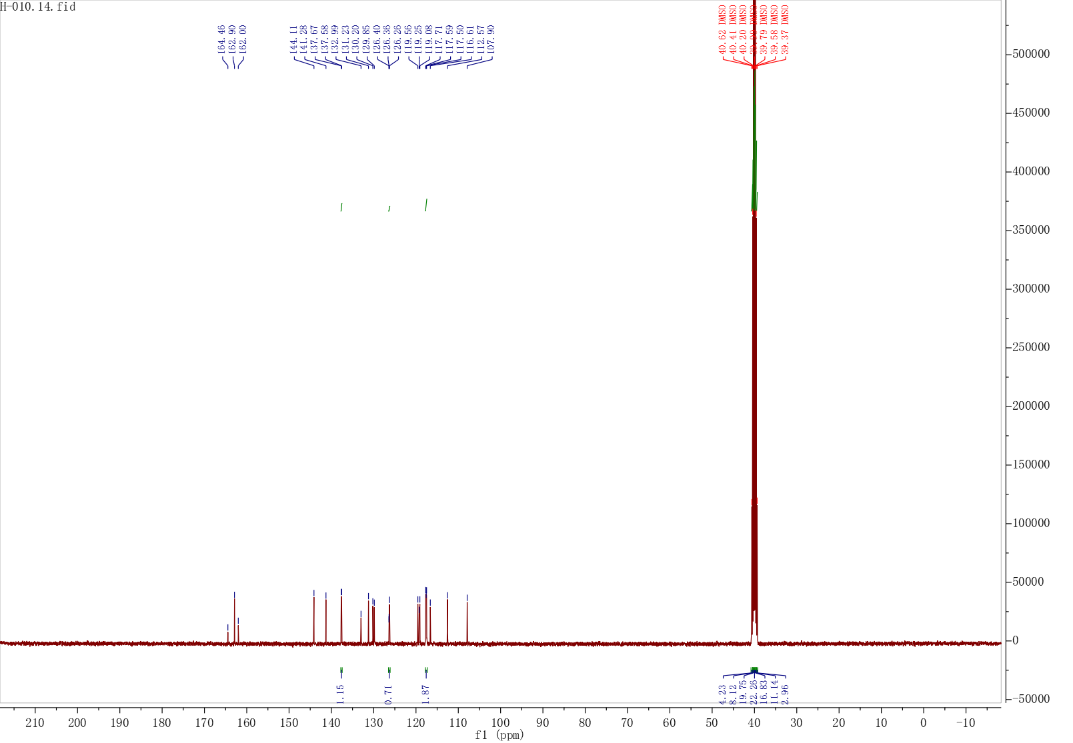
Fig. S81 The ¹³C NMR Spectrum of compound H26
Fig. S82 The HRMS spectrum of compound H26
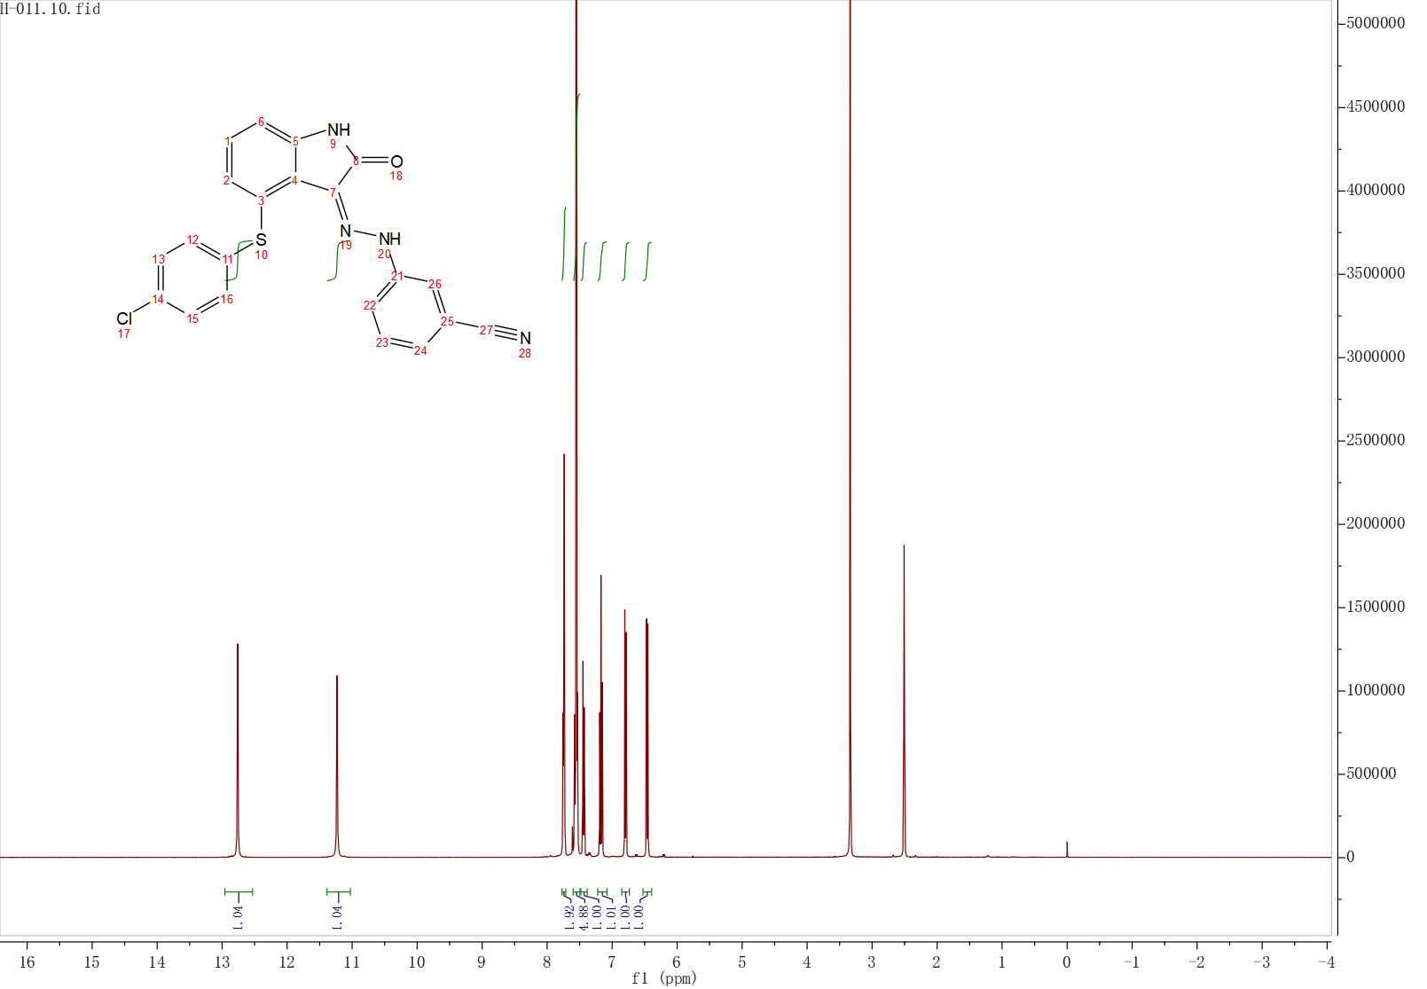
Fig. S83 The ¹H NMR Spectrum of compound H27
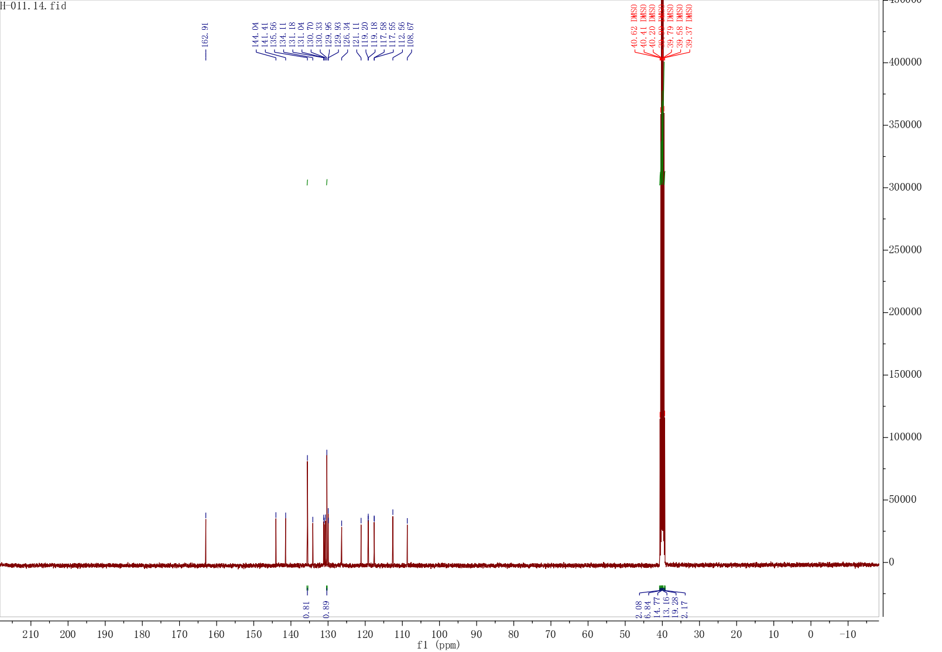
Fig. S84 The ¹³C NMR Spectrum of compound H27
Fig. S85 The HRMS spectrum of compound H27
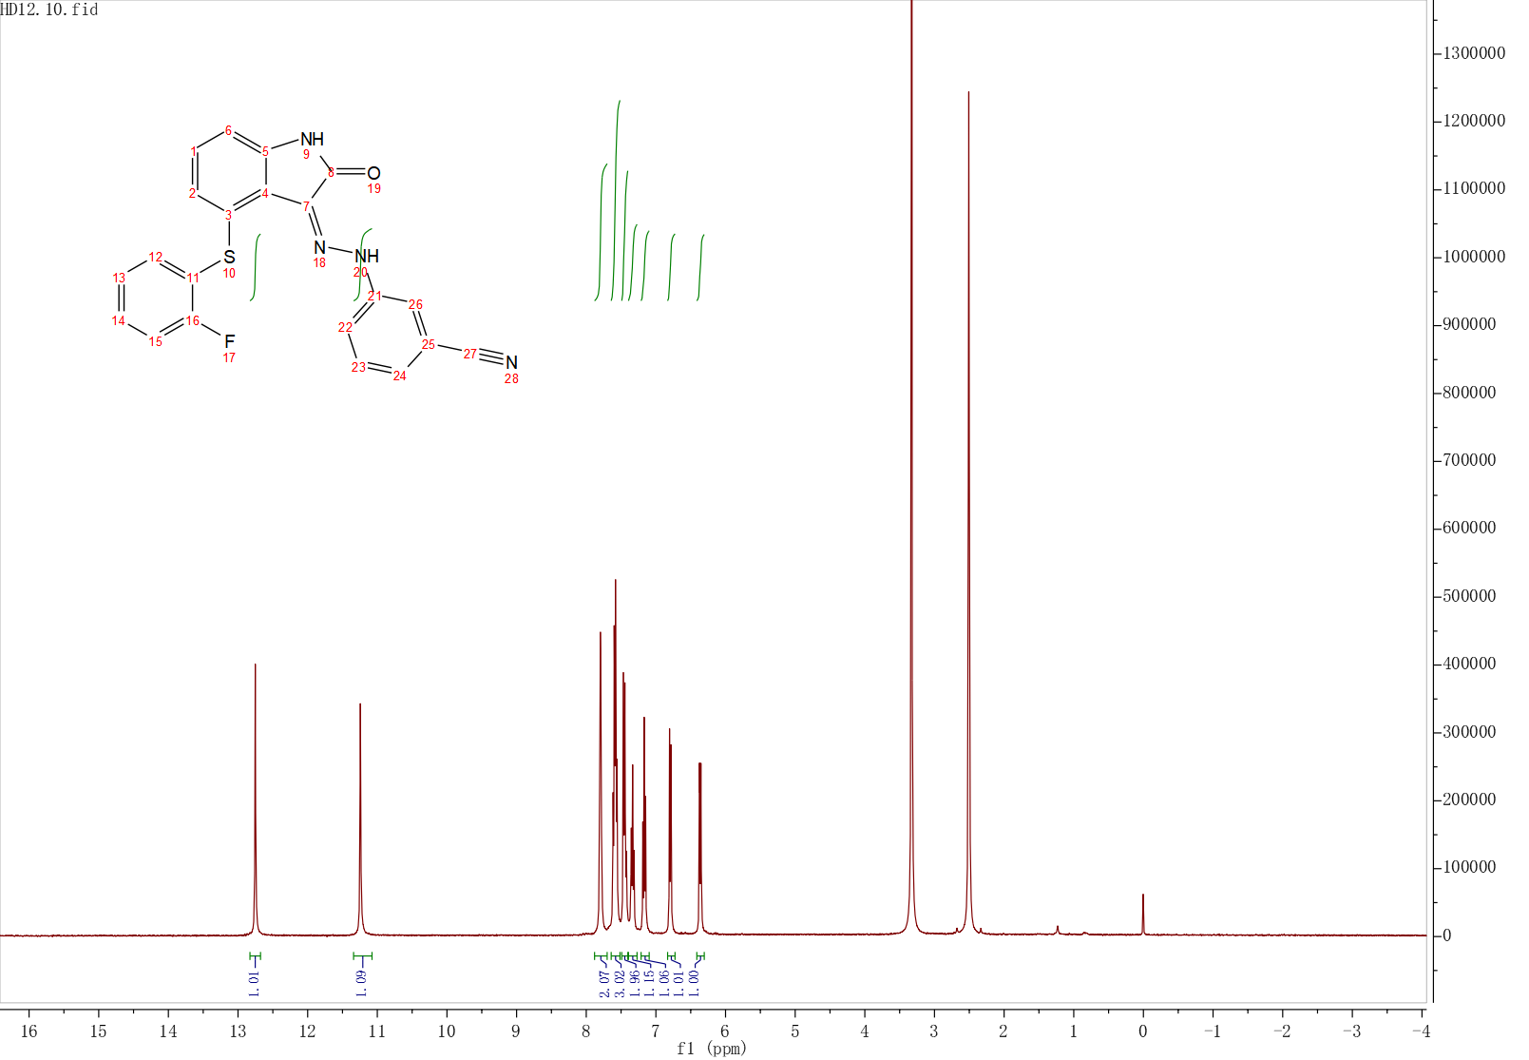
Fig. S86 The ¹H NMR Spectrum of compound H28
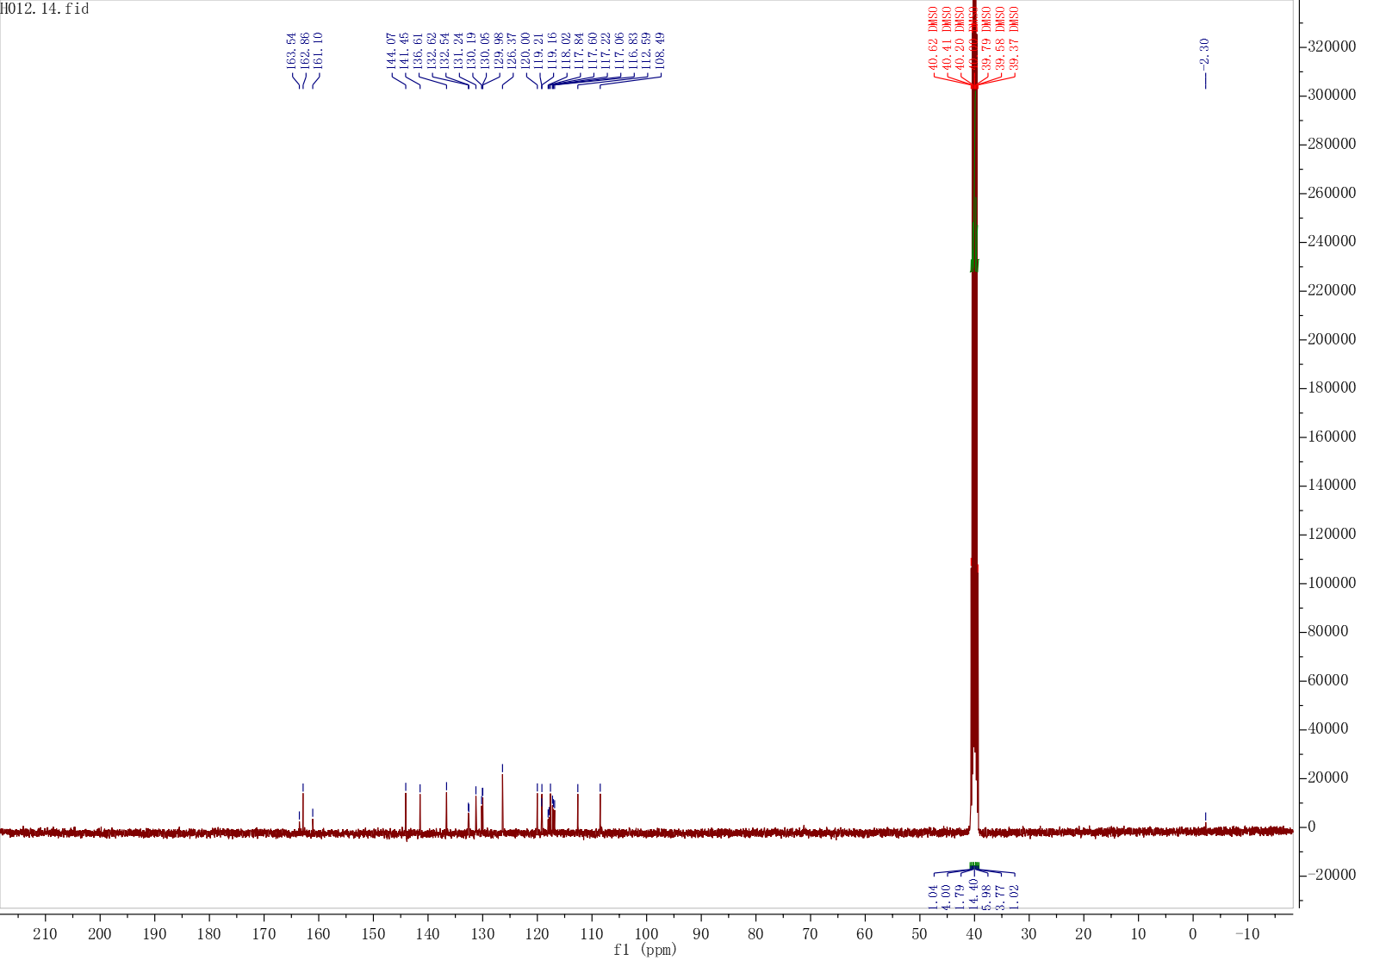
Fig. S87 The ¹³C NMR Spectrum of compound H28
Fig. S88 The HRMS Spectrum of compound H28

3. Statistical Parameters for the CoMFA.
Table S1 Statistical parameters for the CoMFA.
Statistical parameter | CoMFA | Validation criterion
q^{2a} | 0.541 | >0.5
ONC^{b} | 2
r^{2c} | 0.973 | >0.8
SEE^{d} | 0.102
Fraction of field contributions:
Steric | 0.367
Electrostatic | 0.633
ª Cross-validated correlation.
^{b} Optimum number of coMPonents.
^{c} Non-cross-validated correlation.
^{d} Standard error of estimate.

