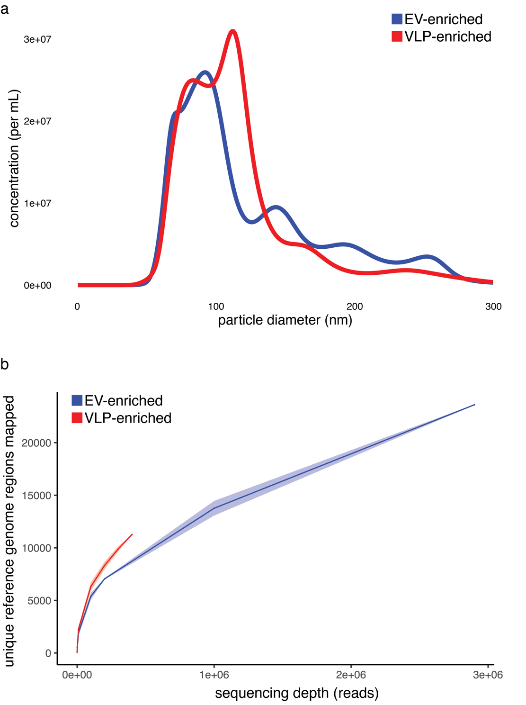

Extended Data Fig. 1. Properties of marine particle fractions. (a) Particle size distributions as determined by nanoparticle tracking analysis of the EV-enriched (blue) and VLP-enriched (red) fractions. (b) Rarefaction analysis of particle fraction diversity, as assessed by the number of unique 25kb regions of microbial reference genomes that recruited particle reads. Values indicate mean (line) and 95% confidence intervals (shaded region) of 10 replicate resamplings.

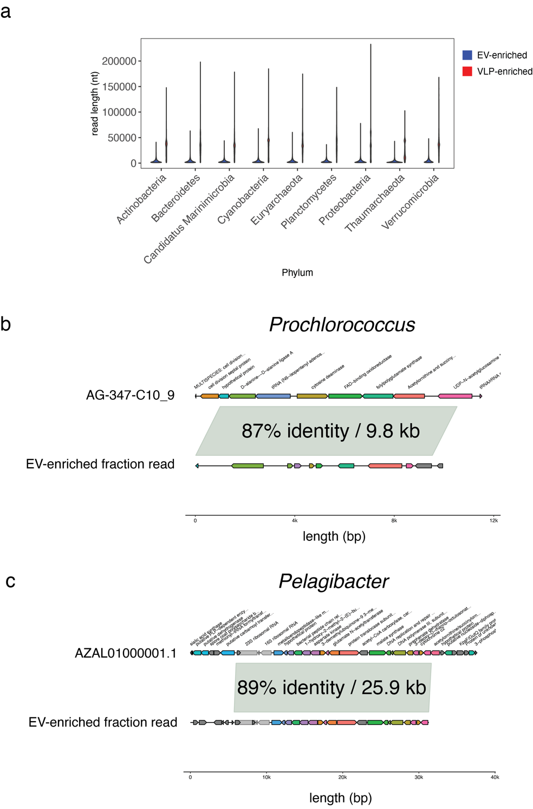

Extended Data Fig. 2. (a) Size distribution of taxonomically classified reads among the most abundant phyla. (b-c) Example alignments between (b) Prochlorococcus and (c) Pelagibacter reference genomes to reads sequenced from the EV-enriched fraction with high nucleotide identity across the indicated length.
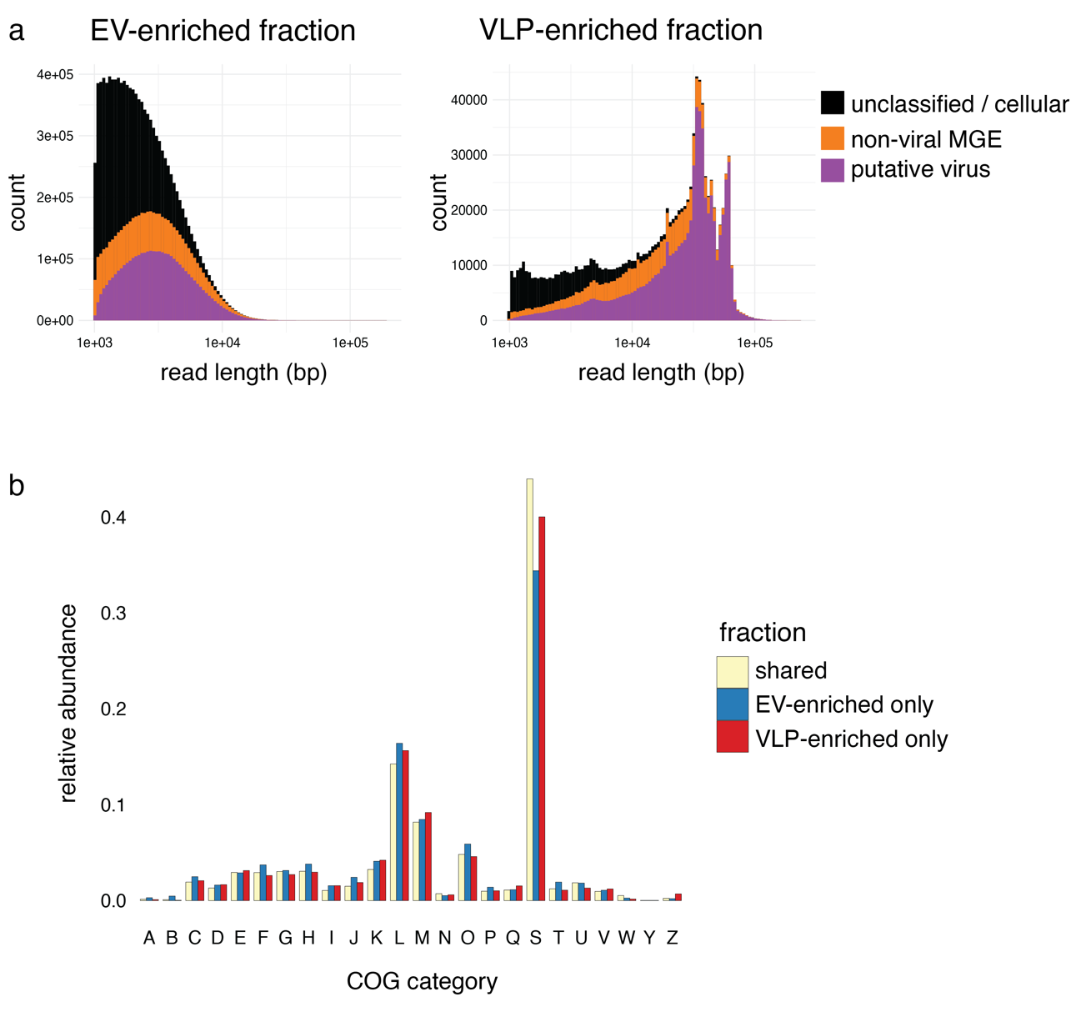

Extended Data Fig. 3. (a) DNA fragment size distributions of classified mobile element subpopulations within the EV-enriched and VLP-enriched fractions. (b) Relative abundance of annotatable proteins per COG category in the two fractions.

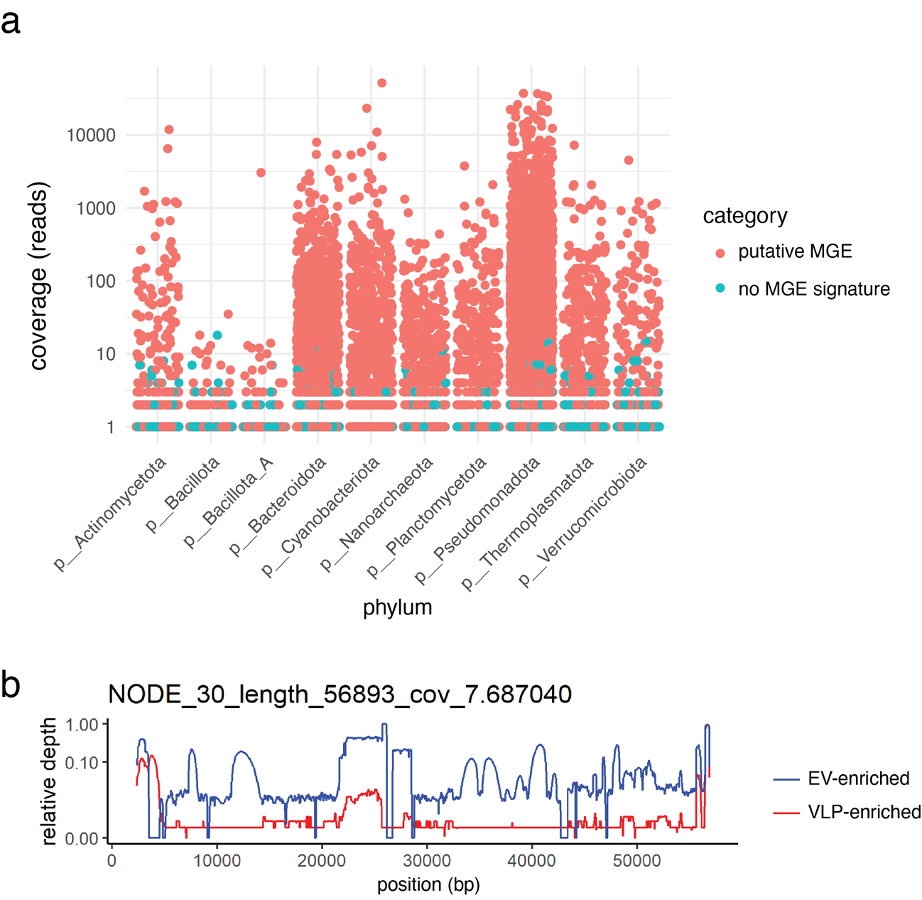

Extended Data Fig. 4. Abundance of potential mobile element-like gene regions across taxa. (a) Distribution of reference genome coverage across unique genome regions (25kb), by phylum. (b) Example of differential read recruitment patterns in the two particle fractions across the same metagenome-assembled contig.

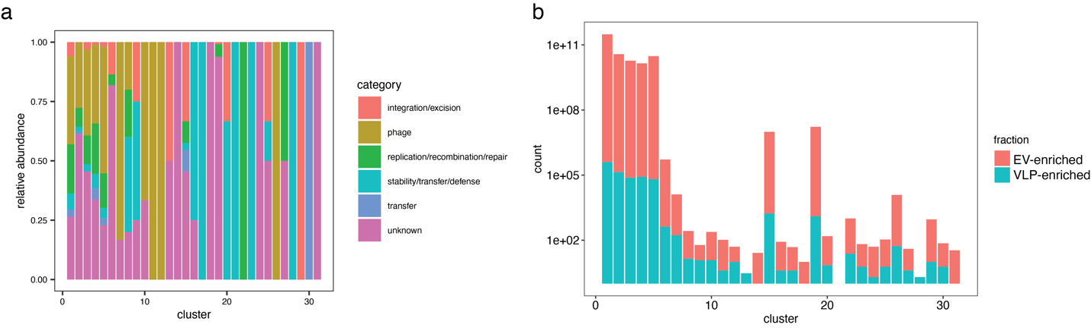

Extended Data Fig. 5. Details of potential MGE clusters inferred from hallmark gene co-occurrence patterns. (a) Relative abundance of hallmark genes associated with each greedy cluster, by functional category. (b) Number of sequenced reads associated with each inferred cluster, separated by particle fraction.
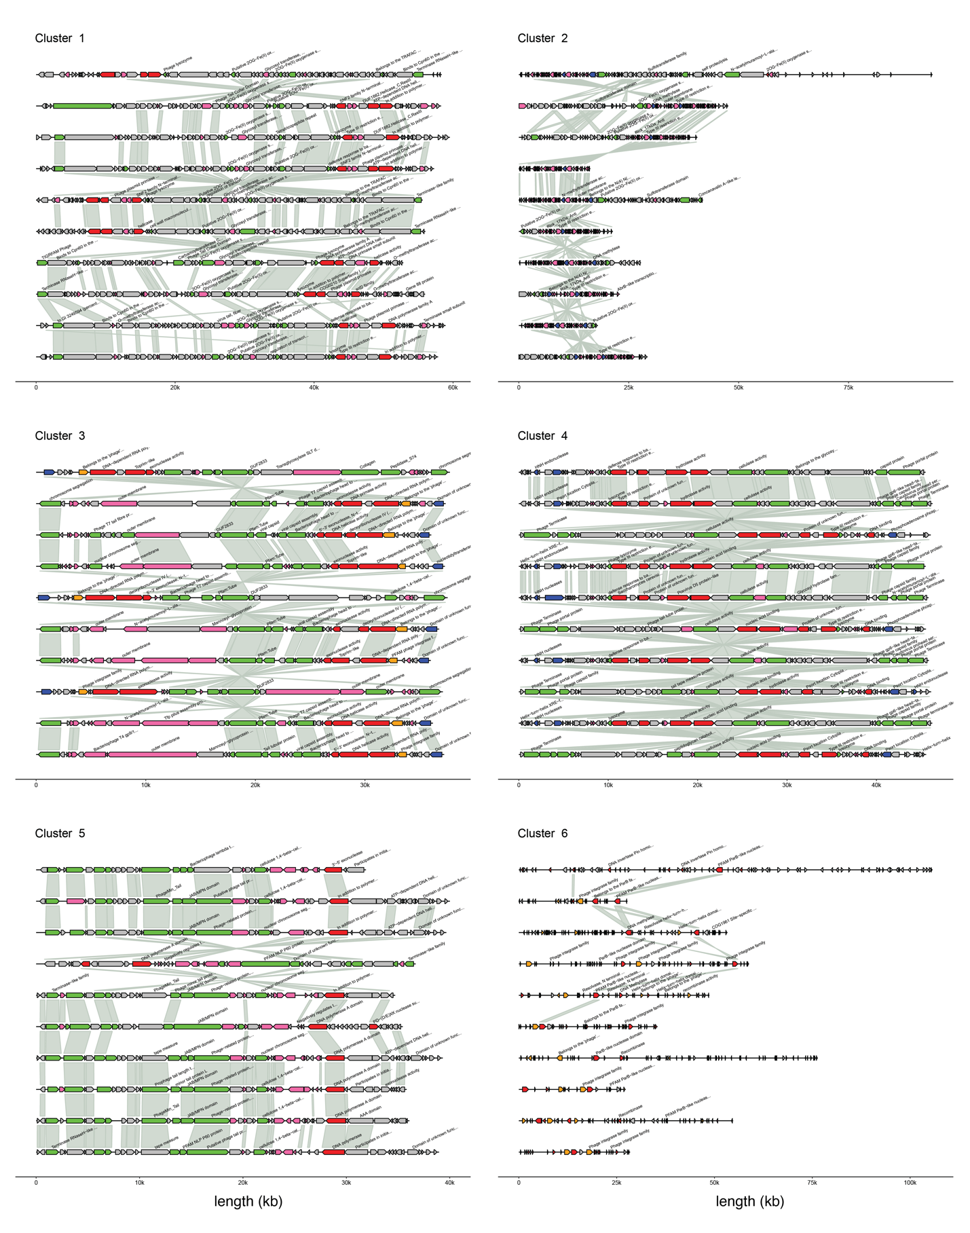
Extended Data Fig. 6. Examples of randomly selected reads from each major network cluster in Fig. 3d. Grey shared areas indicate regions of shared nucleotide-level similarity between adjacent reads. Gene colors indicate putative functional annotation of the hallmark gene as determined by mobileOG-db.

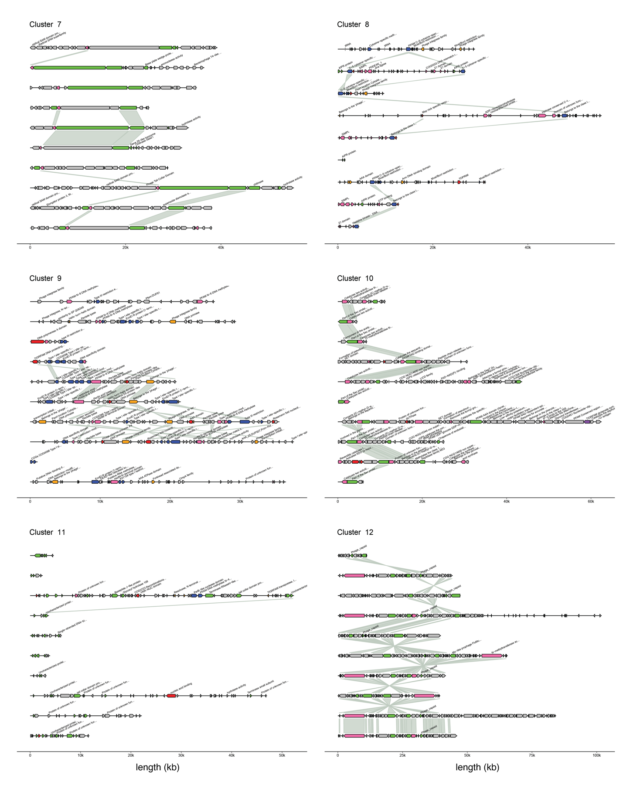
Extended Data Fig. 6 (continued).
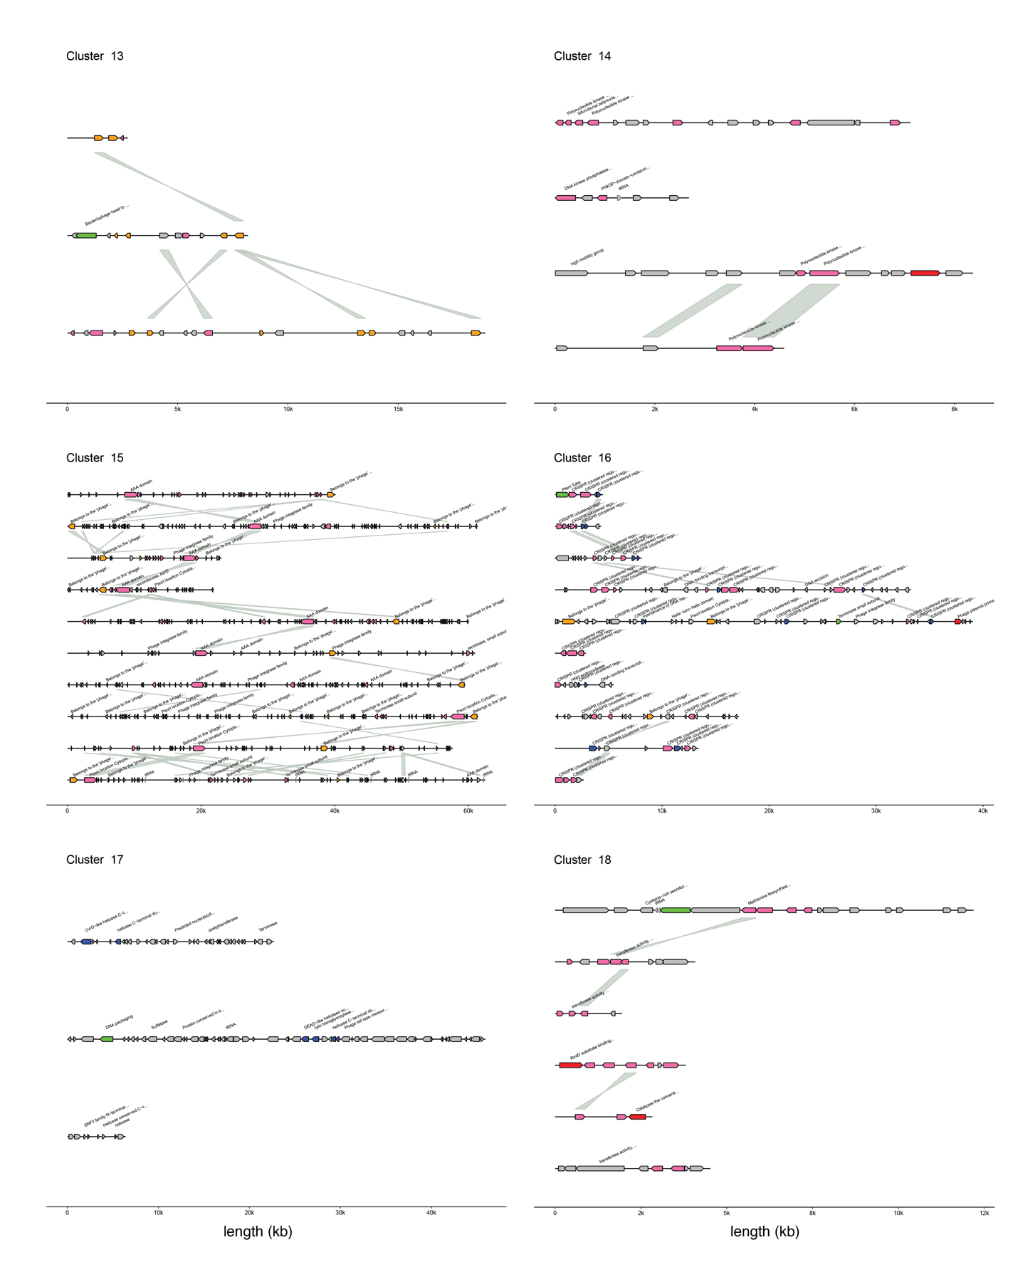
Extended Data Fig. 6 (continued).
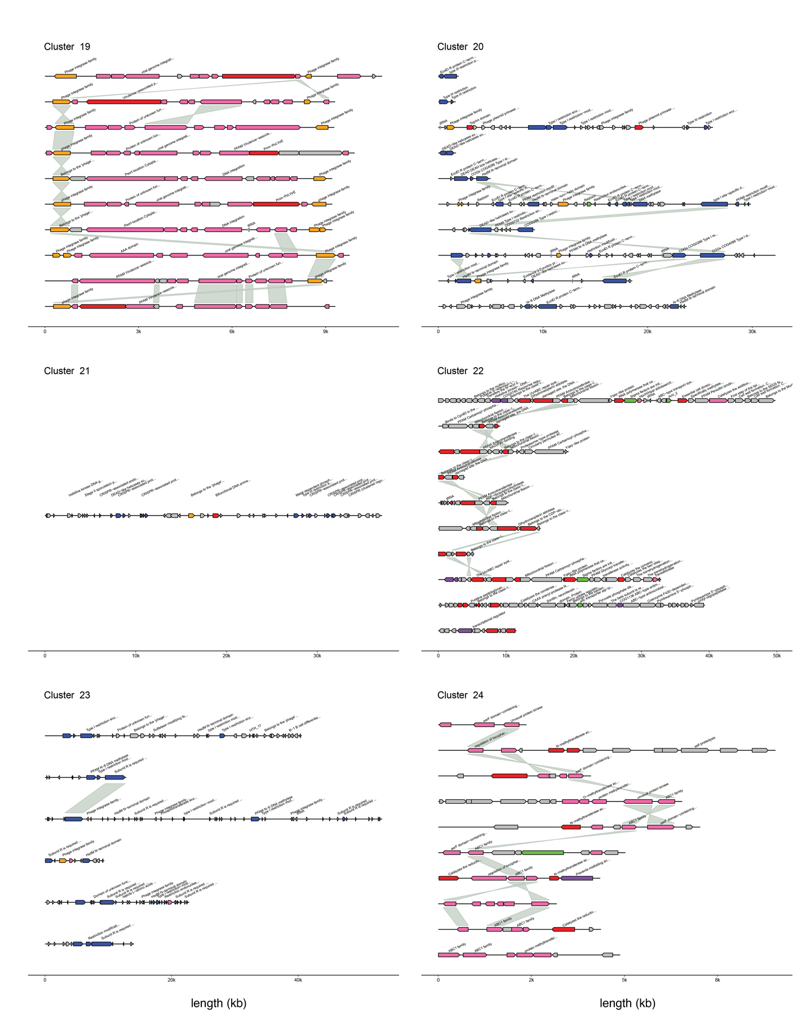
Extended Data Fig. 6 (continued).
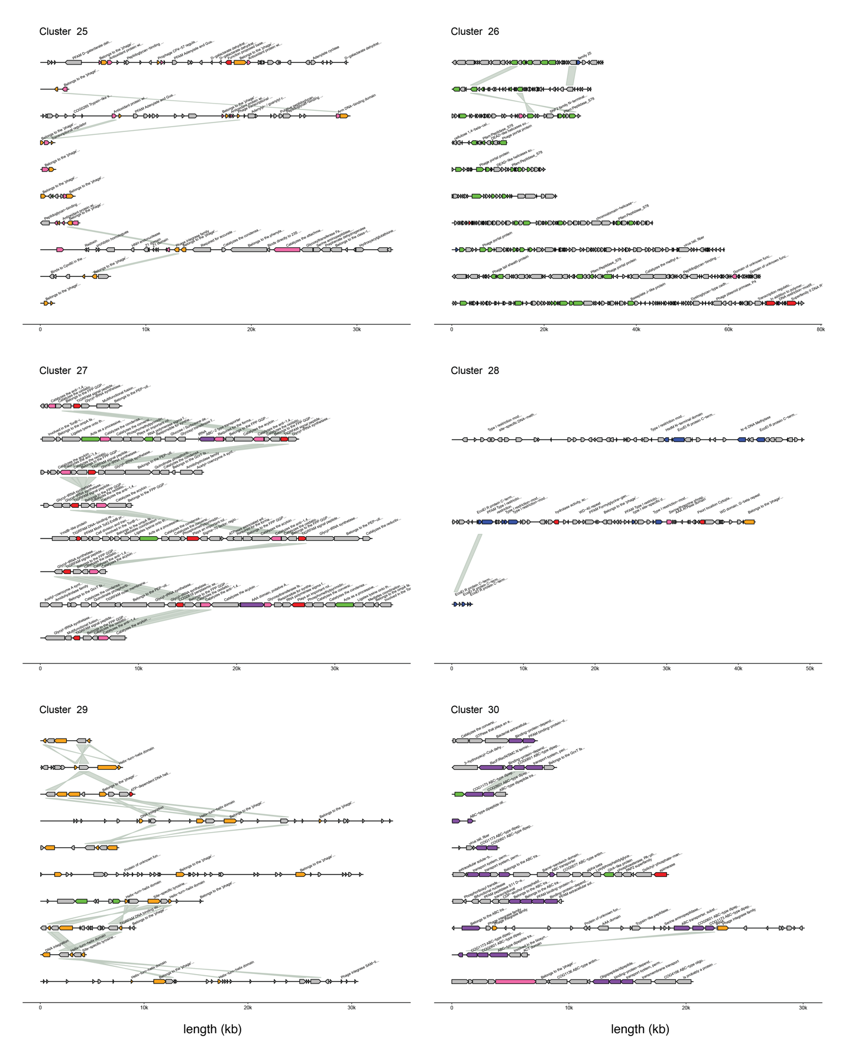
Extended Data Fig. 6 (continued).

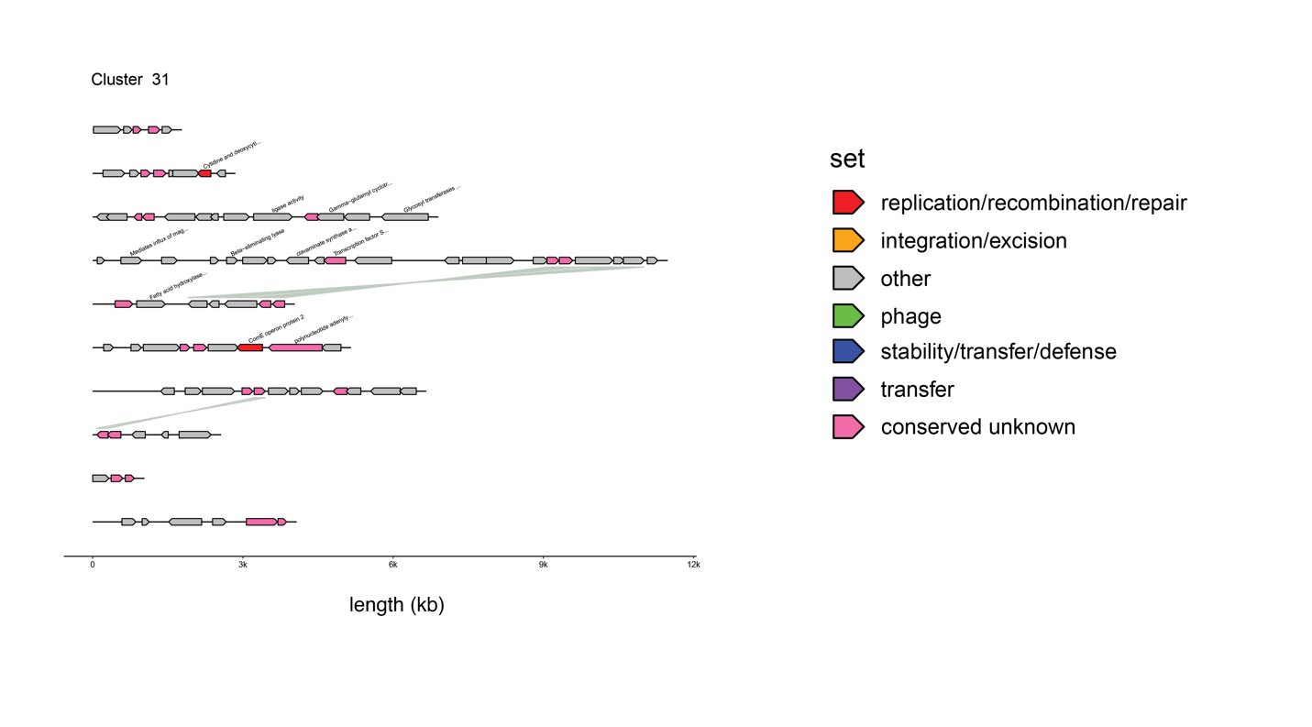
Extended Data Fig. 6 (continued).

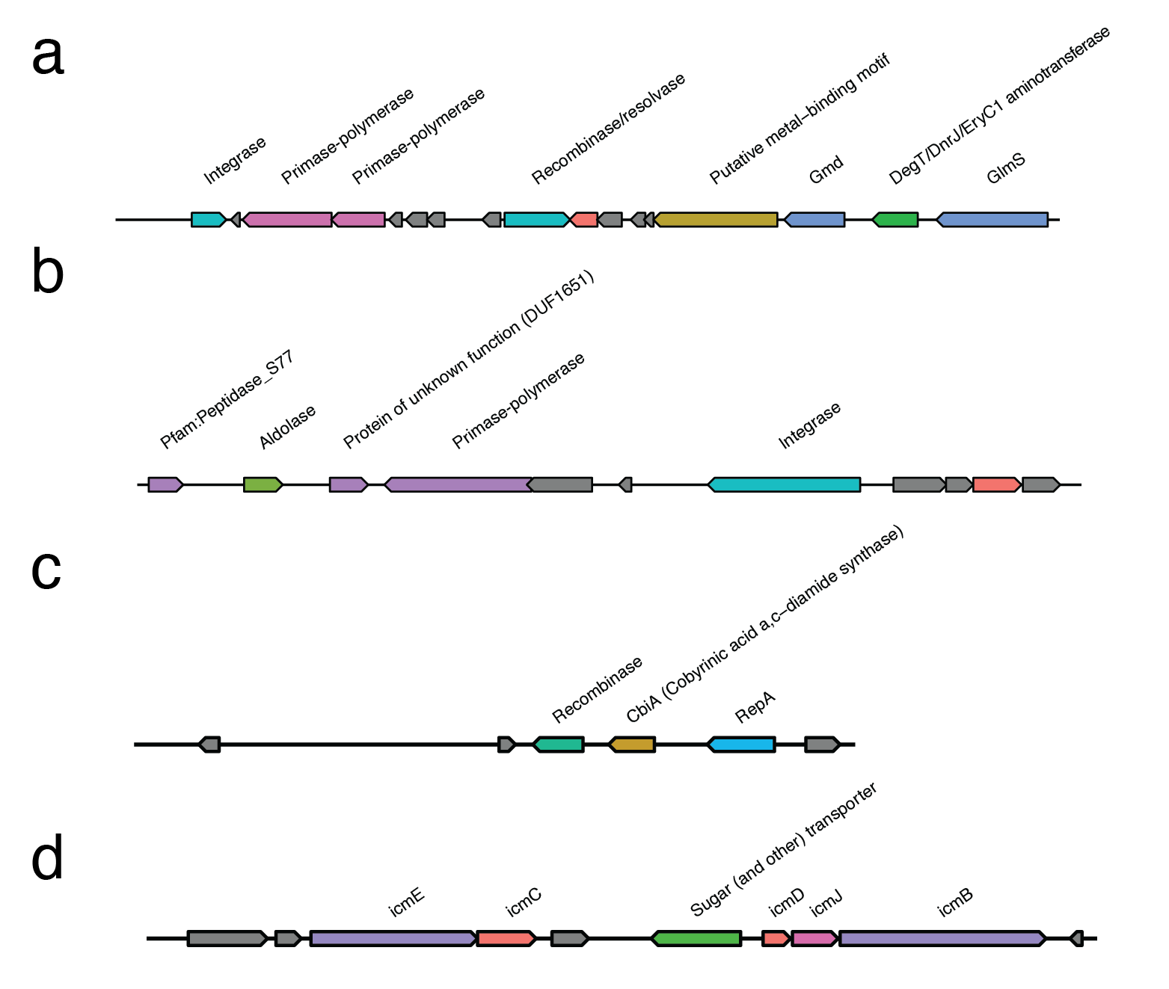
Extended Data Fig. 7. (a-b): Selected examples of particle-associated Prochlorococcus MGE-like regions containing potentially functional metabolic genes. (c-d): Selected examples of putative plasmid-like sequences identified by geNomad.

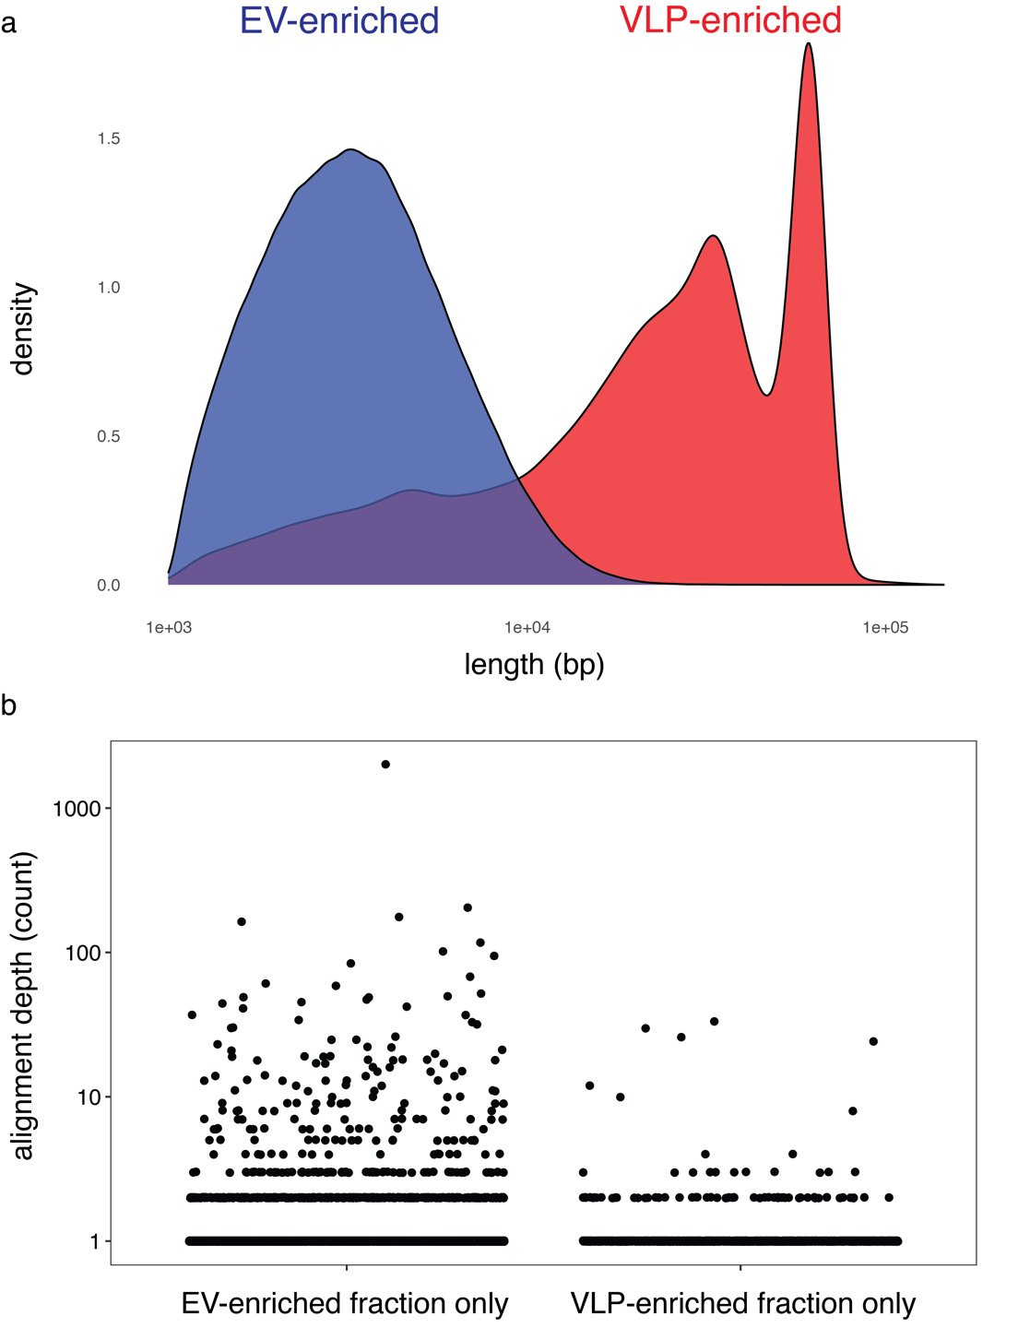

Extended Data Fig. 8. Properties of mobilized Pelagibacter genetic information. (a) Nanopore read length distribution of Pelagibacter-like sequences from the two particle fractions. (b) Coverage depth of Pelagibacter reference genome regions (25 kb) which recruited long reads exclusively from one particle fraction. Of the 1644 Pelagibacter reference genome regions that recruited >1 read, 82 were only found in the VLP-enriched fraction, and 68 regions were found exclusively in the EV-enriched fraction. EV-enriched regions were only counted as “exclusive” at a coverage level of >11 reads, to account for the greater sequencing depth of the EV-enriched vs the VLP-enriched fractions (Table 1).
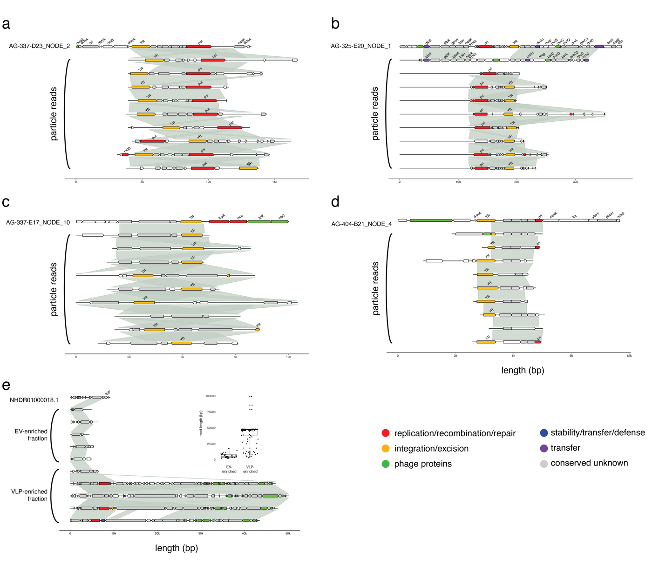
Extended Data Fig. 9. Additional examples of Pelagibacter-associated mobile elements inferred from particle read enrichment. (a-e) Alignments of Pelagibacter reference genome regions (top line) vs particle-associated reads (below). Grey lines indicate regions of significant nucleotide-level similarity between adjacent reads; gene colors indicate members of the same protein sequence cluster. (f) Alignment of reads to SAR11 reference contig NHDR01000018.1 (Candidatus Pelagibacter sp. TMED64) in the two fractions. Inset: box-and-whiskers plot showing the distribution of all long reads identified (based on sequence similarity to hypothetical protein CBC24_02375) in the EV- and VLP-enriched fractions
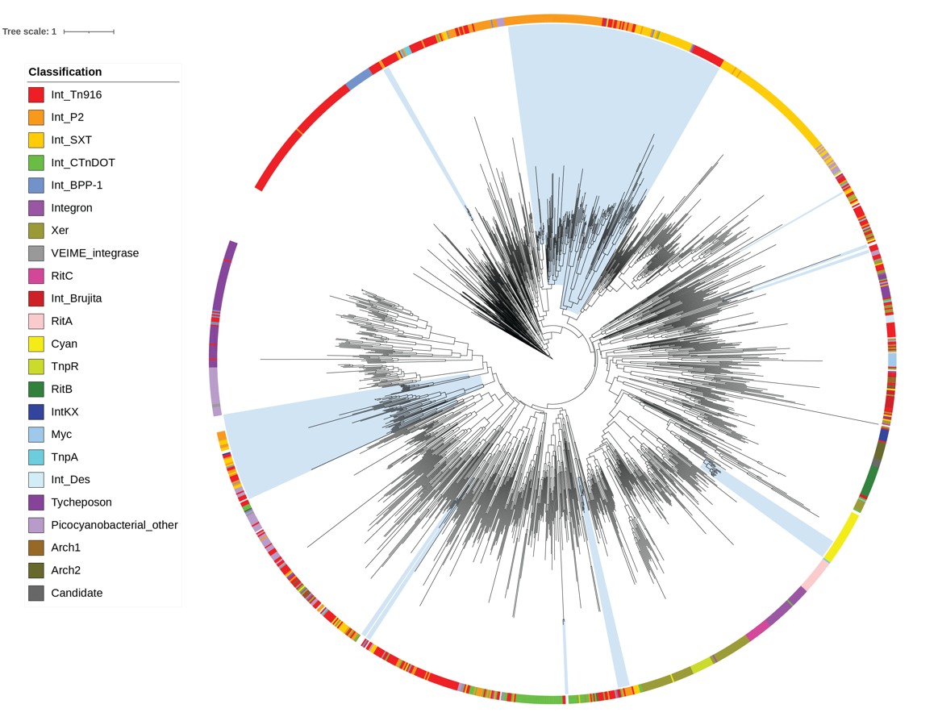

Extended Data Fig. 10. Phylogeny of Pelagibacter tyrosine integrase/recombinase enzymes identified within the particle dataset. Pelagibacter sequences are noted with blue shading in the context of reference enzymes from bacterial, archaeal, and phage genomes, and are grouped according to classifications from ref⁴⁶.

