Table 1: Antitubercular activity of compound 2-4h
Compound | Structure | MIC  in  µg/ml | Compound | Structure | MIC  in  µg/ml
2 | 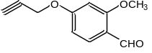 | 50 | 4c | 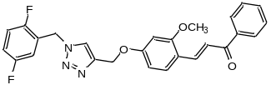 | 12.5
3a | 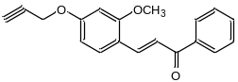 | 25 | 4e | 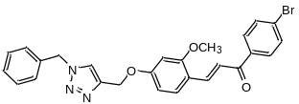 | 6.25
3b | 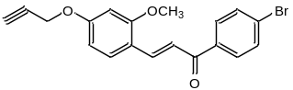 | 100 | 4f | 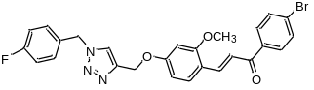 | 1.6
3c | 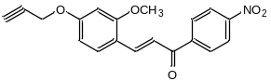 | 100 | 4i | 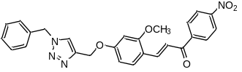 | 100
4a | 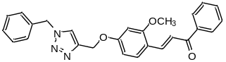 | 1.6 | 4h | 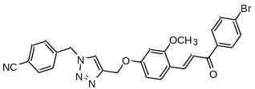 | Not active
4b | 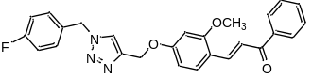 | 100

Table 2: Docking of antitubercular ligands
Ligand Code | Docking Score [Binding Affinity] (KJ/Mol) | Binding Residues (All Polar contacts through H Bonds)
4a | -7.2 | GLU218, ARG259
4c | -7.2 | GLN159
4e | -7.1 | ARG259, TYR229, ARG217, SER311
4f | -7.1 | THR221, ARG259, TYR229

Table 3: Physical parameter of compound 1(a) to 4(l)