Table 1. Growth inhibitory effects of compounds 1a-27a toward cell lines.
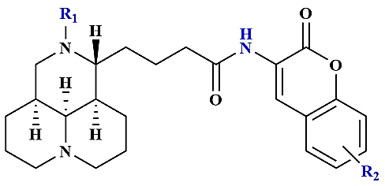
Entry | R₁ | R₂ |  | IC₅₀ ±SD (μM)ª
 |  |  | HeLa | A549 | HepG-2
Matrine  1a | -  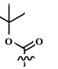 | -  6-Cl | 6000  32.32±1.5 | 5973  25.56±0.86 | 5955  30.68±0.22
2a | 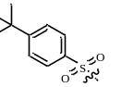 | 6-NO₂ | 19.28±0.13 | 18.27±0.46 | 12.19±0.35
3a |  | 6-NO₂ | 57.65±3.05 | 63.27±3.53 | 67.35±3.00
4a | 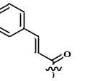 | 5-OCH₃ | 72.39±3.67 | 68.44±3.35 | 78.69±4.97
5a |  | 5-OCH₃ | 8.02±0.065 | 7.35±0.097 | 7.727±0.10
6a | 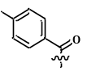 | - | 33.86±5.5 | 27.33±5.86 | 40.60±5.99
7a | H | - | 26.57±5.34 | 35.87±4.46 | 66.91±6.08
8a | 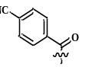 | - | 33.47±0.24 | 27.28±0.33 | 40.39±0.34
9a |  | 6-CH₃ | 18.77±0.68 | 20.47±0.53 | 14.45±0.04
10a | 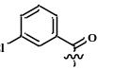 | 6-Cl | 56.77±2.13 | 63.67±4.55 | 68.69±2.14
11a |  | - | 45.25±1.18 | 38.78±2.97 | 25.05±1.24
12a | 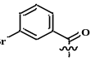 | - | 68.60±3.25 | 63.63±4.68 | 55.39±5.56
13a | 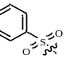 | - | 89.65±2.3 | 88.65±5.33 | 24.82±1.45
14a | 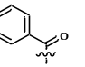 | - | 64.29±2.6 | 59.86±4.88 | 55.35±4.13
15a |  | 6-NO₂ | 57.68±2.46 | 56.35±5.46 | 40.22±2.95
16a |  | 6-Cl | 65.76±4.89 | 80.60±5.34 | 43.65±4.76
17a |  | 6-Cl | 64.85±4.64 | 70.66±5.39 | 44.36±4.86
18a | H | 6-CH₃ | 28.63±4.087 | 26.68±5.68 | 23.96±5.12
19a |  | - | 35.28±0.24 | 33.25±1.23 | 31.25±1.88±
20a | 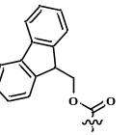 | 5-Cl | 56.28±1.23 | 54.32±5.74 | 32.65±2.98
21a |  | 5-F | 37.53±0.5 | 36.28±0.86 | 36.52±2.54

ª The data are expressed as means of three independent experiments ± standard deviation (SD).
Table 2. Growth inhibitory effects of compounds 1b-8b toward cell lines
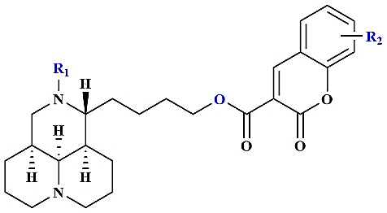
Entry | R₁ | R₂ |  | IC₅₀ ±SD (μM)ª
 |  |  | HeLa | A549 | HepG-2
1b | 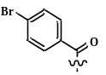 | - | 11.22±1.25 | 8.94±0.58 | 10.65±0.07
2b | 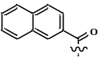 | - | 34.44±5.67 | 31.47±5.64 | 38.43±5.67
3b | 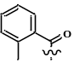 | 5-F | 39.33±3.79 | 56.32±5.46 | 28.63±6.16
4b | 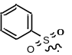 | 5-Cl | 29.68±5.86 | 40.68±5.89 | 36.32±6.53
5b |  | - | 19.22±0.45 | 20.82±0.05 | 17.31±0.19
6b |  | 6-CH₃ | 18.77±0.68 | 16.68±0.07 | 14.47±0.37
7b |  | 5-Br | 55.44±3.66 | 50.68±4.5 | 59.63±6.25
ª The data are expressed as means of three independent experiments ± standard deviation (SD).
Table 3. Growth inhibitory effects of compounds 1c-16c toward cell lines
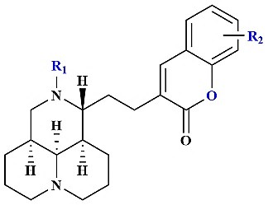
Entry | R₁ | R₂ |  | IC₅₀ ±SD (μM)ª
 |  |  | HeLa | A549 | HepG-2
1c |  | 6-NO₂ | 44.03±1.56 | 37.28±0.27 | 30.57±0.98
2c |  | 6-NO₂ | 51±2.89 | 35.18±0.59 | 40.96±1.77
3c |  | 8-OCH₃ | 29.62±0.67 | 29.93±0.25 | 27.86±0.06
4c |  | 6-CH₃ | 14.62±2.3 | 10.75±0.88 | 12.66±1.36
5c |  | - | 54.74±2.2 | 28.3±0.87 | 47.66±1.55
6c |  | 6-CH₃ | 29.92±0.14 | 28.46±0.24 | 29.93±0.21
7c |  | - | 47.45±3.3 | 38.23±5.95 | 55.43±5.12
8c |  | - | 52.68±4.67 | 33.76±6.1 | 23.66±5.08
9c |  | 8-OCH₃ | 40.56±5.4 | 29.76±5.64 | 50.32±5.06
10c |  | 6-OCH₃ | 28.08±4.96 | 28.65±5.68 | 25.63±6.15
11c |  | - | 31.73±0.86 | 36.32±0.57 | 33.54±1.08
ª The data are expressed as means of three independent experiments ± standard deviation (SD).

