Extended Data
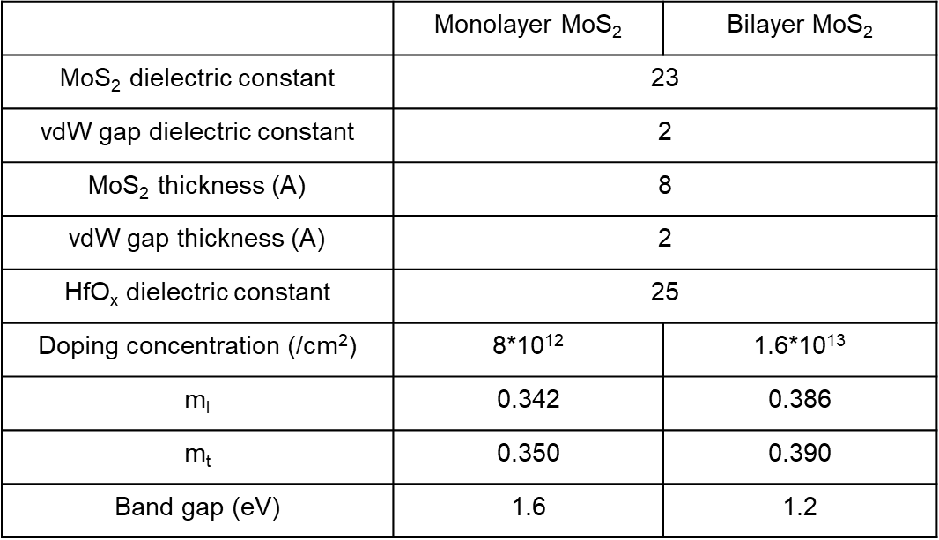
Extended Data Table 1 | Parameters used in TCAD simulation

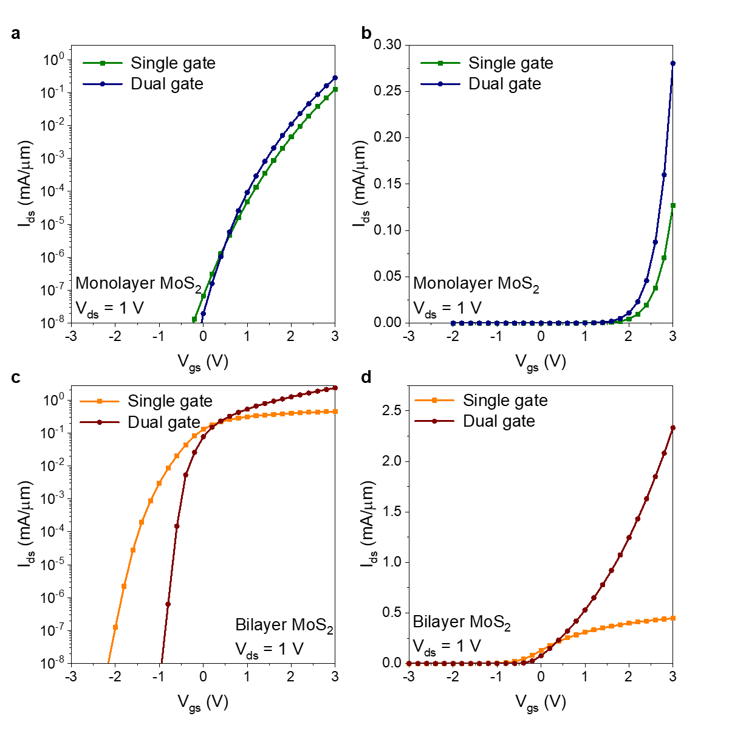
Extended Data Figure 1 | Transfer curves (I_{ds} – V_{gs}) simulated using TCAD
a, b. Transfer curves of single gate (green) and dual gate (navy) monolayer MoS₂ FETs plotted on both semi-log (a) and linear (b) scales.
c, d. Transfer curves of single gate (orange) and dual gate (wine) bilayer MoS₂ FETs plotted on both semi-log (c) and linear (d) scales.

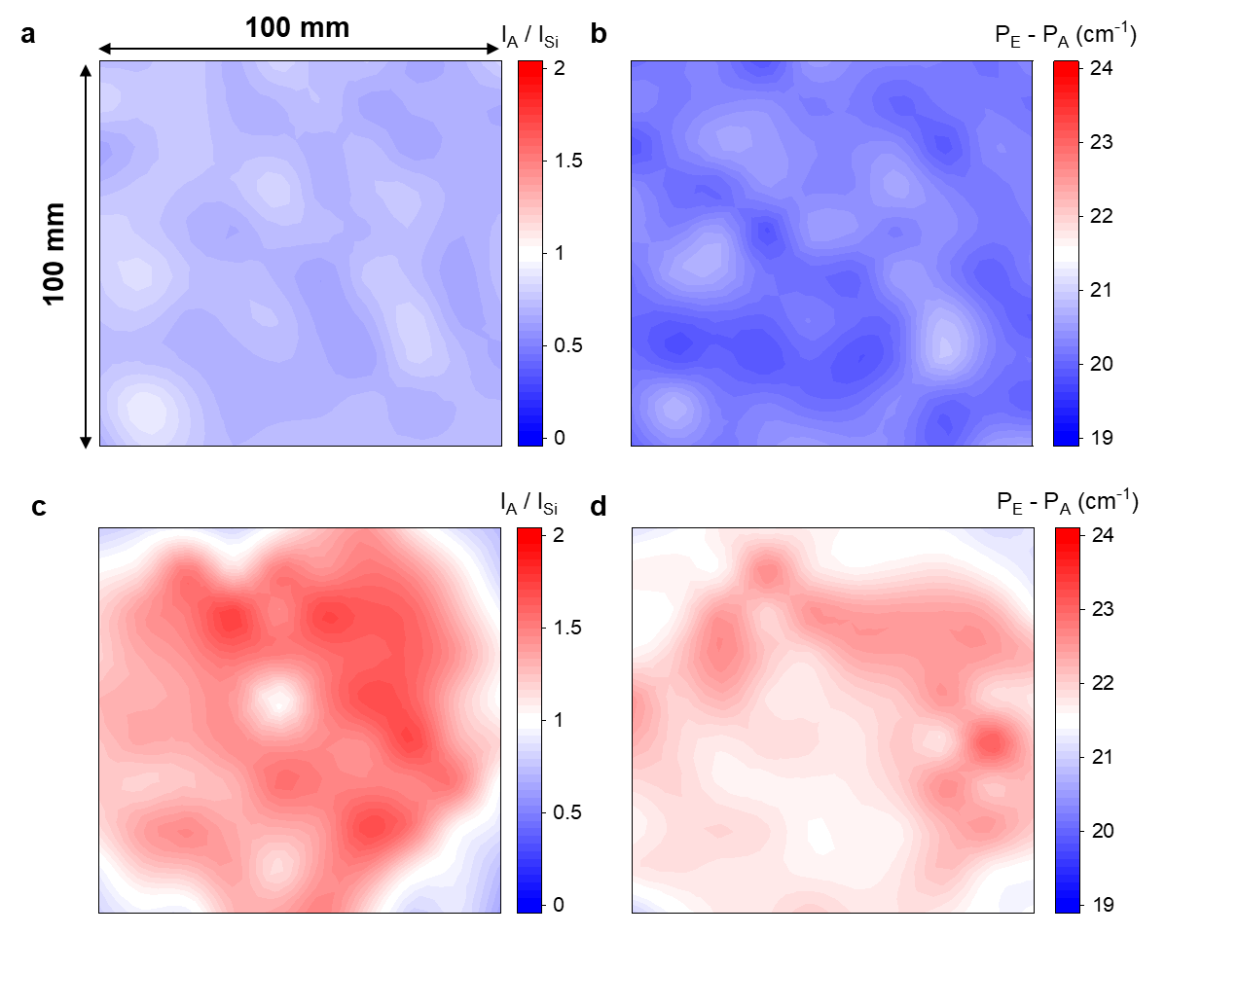
Extended Data Figure 2 | Raman map images of large area MoS₂ films
a. Image mapping the ratio of A peak intensity (I_{A}) of monolayer MoS₂ to Si peak intensity (I_{Si}).
b. Image mapping the distance between the E peak position (P_{E}) and A peak position (P_{A}) of monolayer MoS₂.
c. Image mapping the ratio of I_{A} of bilayer MoS₂ to I_{Si}.
d. Image mapping the distance between the P_{E} and P_{A} of bilayer MoS₂.
Only the 100 mm x 100 mm region is mapped, as the device fabrication area was confined to the 100 mm center region of the wafer.

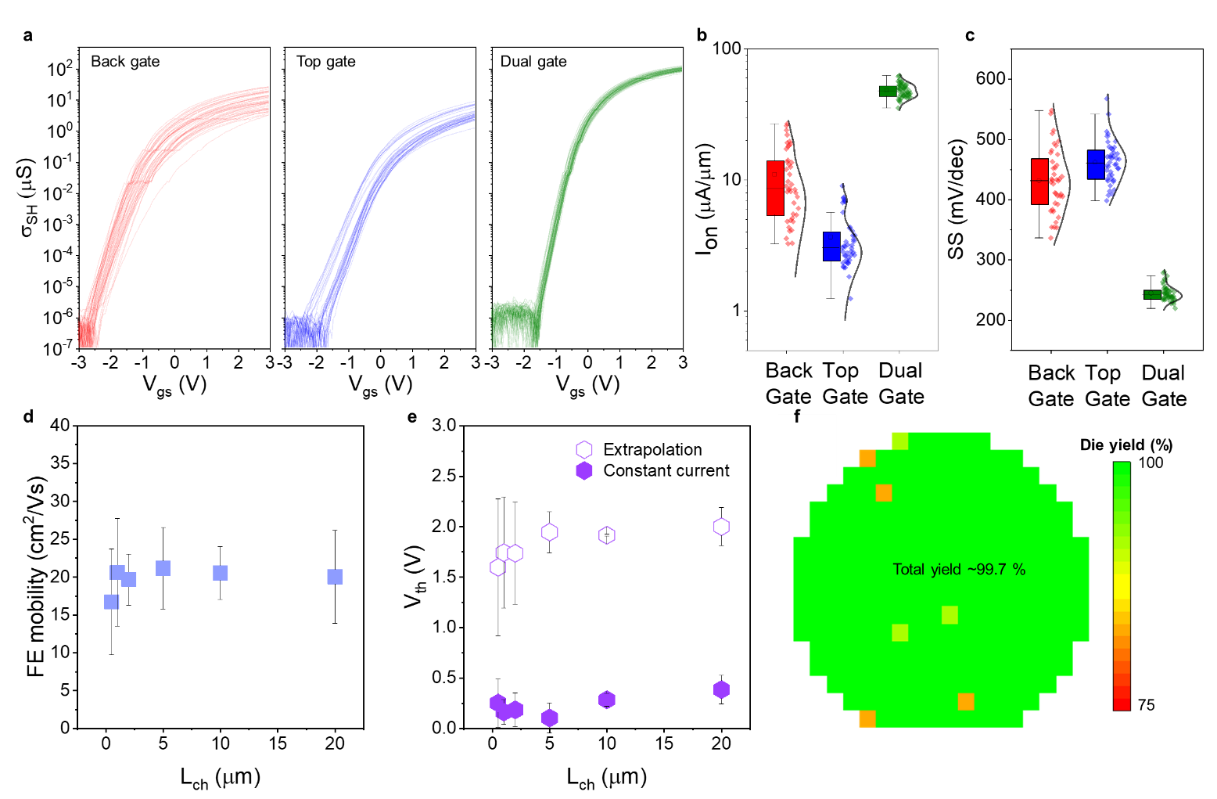
Extended Data Figure 3 | Evaluation of 200-mm-wafer-scale long channel (L_{ch} > 500 nm) FETs based on bilayer MoS₂
a. Transfer curves of back gate (red), top gate (blue), and dual gate (green) MoS₂ FETs fabricated across the entire 200 mm wafer.
b, c. Statistical distribution of I_{on} and subthreshold swing (SS) for back gate (red), top gate (blue), and dual gate (green) configurations. In dual gate configurations, not only I_{on} and SS have significantly improved, but the variance has also been greatly reduced.
d. Statistical analysis of field-effect (FE) mobility of dual gate FETs as a function of L_{ch}. The consistent FE mobility values across different L_{ch} values indicate that the R_{C} has sufficiently decreased.
e. Threshold voltage (V_{th}) of dual gate FETs extracted using the linear extrapolation method (hollow hexagon) from the transfer curve and the V_{th} extracted using the constant current method (filled hexagon). The constant current value used was 50 nA.
f. A wafer map showing die-by-die device yield for the Dual gate structure, demonstrating a high yield of 99.7%.

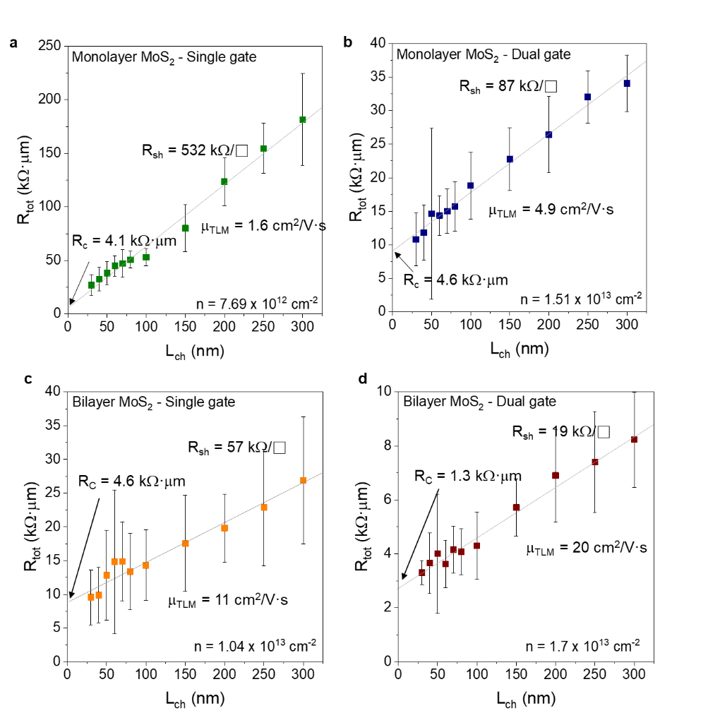
Extended Data Figure 4 | Transfer length method (TLM) of MoS₂ FETs
a. Total resistance (R_{tot}) as a function of L_{ch} for single gate and monolayer MoS₂ FET at a carrier density (n) of 7.69 x 10¹² cm⁻².
b. Same plot for dual gate and monolayer MoS₂ FET at n of 1.51 x 10¹³ cm⁻².
c. Same plot for single gate and bilayer MoS₂ FET at n of 1.04 x 10¹³ cm⁻².
d. Same plot for dual gate and bilayer MoS₂ FET at n of 1.7 x 10¹³ cm

