ZnO-Salen NPs employed as chemosensor for detection of Al³⁺ and K⁺ in aqueous medium, developing human cell images
Carlos Alberto Huerta-Aguilar,ª Iván J. Bazany-Rodríguez,^{b} Valeria Hansberg-Pastor,ª Ignacio Camacho-Arroyo,^{c} Iván Alejandro Reyes-Dominguez,^{d} Pabel Antonio Cervantes-Avilés,ª and Pandiyan Thangarasu *^{b}

- School of Engineering and Sciences, Tecnológico de Monterrey, 72456, Puebla, Mexico.
- Faculty of Chemistry, Universidad Nacional Autónoma de Mexico, 04510, CDMX, Mexico.
- Unidad de Investigación en Reproducción Humana, Instituto Nacional de Perinatología-Facultad de Química, Universidad Nacional Autónoma de México
- Instituto de Metalurgia, Universidad Autónoma de San Luis Potosí, 78210, San Luis Potosí, Mexico.

Supplementary Material
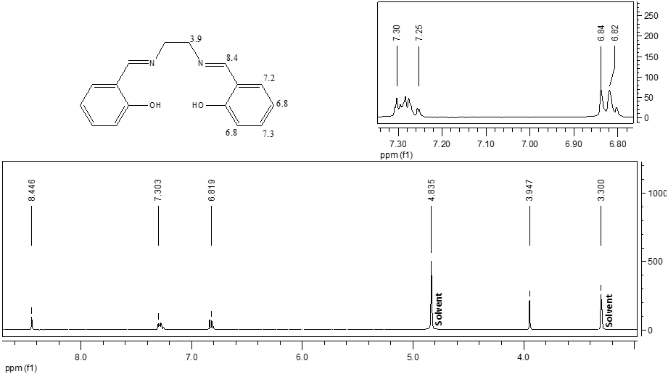
Figure S1. ¹H RMN spectra (300 MHz, solvent: methanol-d₄) of salen ligand.

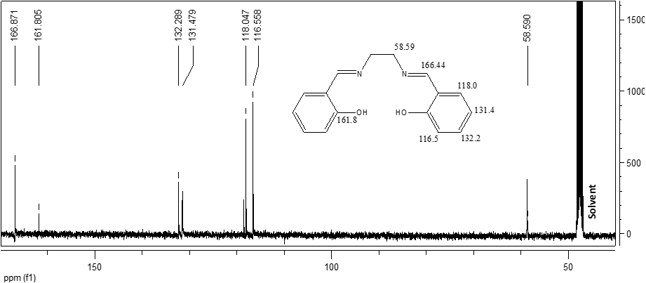
Figure S2. ¹³C RMN spectra (75 MHz, solvent: methanol-d₄) of salen ligand.
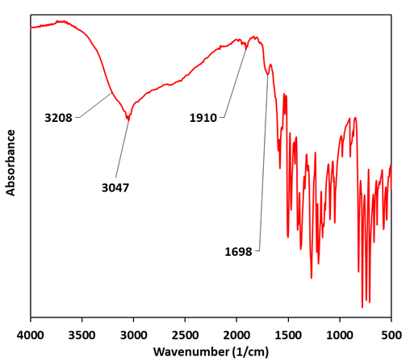
Figure S3. FT IR characterization of salen ligand.
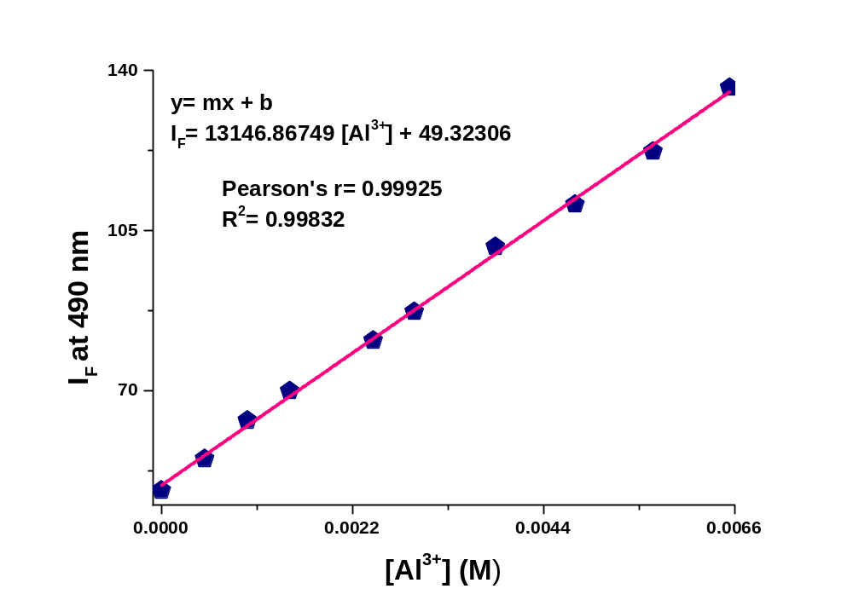
Figure S4. Linear dependence in the fluorescence intensity for ZnO-salen NPs with Al³⁺ at different concentrations (range of 0–6.0 mM, R² = 0.99832) in an aqueous solution pH 7.0.

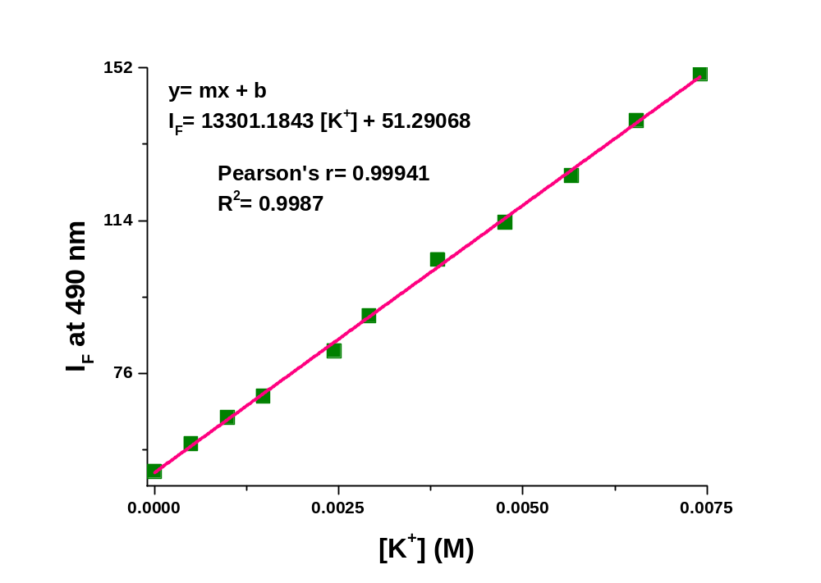
Figure S5. Linear dependence in the fluorescence intensity for ZnO-salen-Al³⁺ with K⁺ at different concentrations (range of 0–7.0 mM, R² = 0.9987) in an aqueous solution at pH 7.0.

Figure S6. The percentage of living U251 cells treated with different concentrations of ONP-Ag (log M) utilized to calculate the IC₅₀ using a non-linear regression analysis.

