Supplementary Information

Supplementary Figures
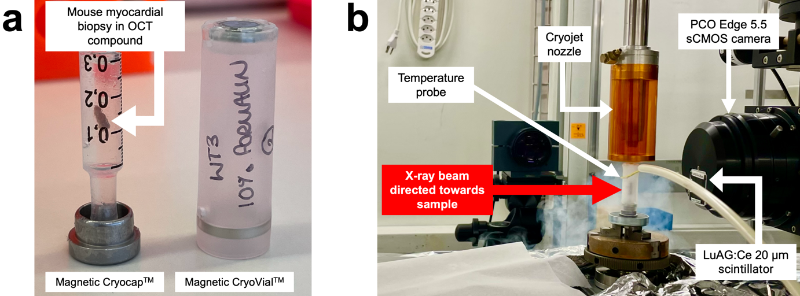
Supplementary Fig. 1 | Sample mounting and synchrotron-based cryo-X-PCI setup used to image frozen mouse myocardial biopsies. a, Myocardial biopsies were mounted in OCT mounting media (VWR Chemicals) within a 1 ml syringe placed on the central spindle of a Magnetic CryoCapTM (Molecular Dimensions MD7-400) and protected by Magnetic CryoVialsTM (Molecular Dimensions MD7-402). b, Cryo-X-PCI setup at the TOMCAT X02DA beamline (Swiss Light Source), comprised by a cryojet nozzle positioned above the biopsy, a temperature probe, and a detection system (20 µm LuAG:Ce scintillator, 10x and PCO.Edge 5.5 MOS camera).

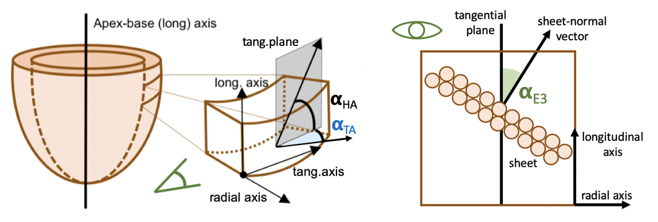
Supplementary Fig. 2 | Schematic of structure tensor and angles used for quantification of myocyte orientation (“myomapping”). Gradient-based structure tensor analysis was performed with an in-house MATLAB script as described in previous studies⁴⁴⁻⁴⁶.

Supplementary Fig. 3 | Pixel classification workflow used for segmentation of cryo-X-PCI datasets in Ilastik⁴⁸ before myomapping was performed. A segmentation mask was created for each dataset to focus structure tensor analysis to relevant areas and exclude background.
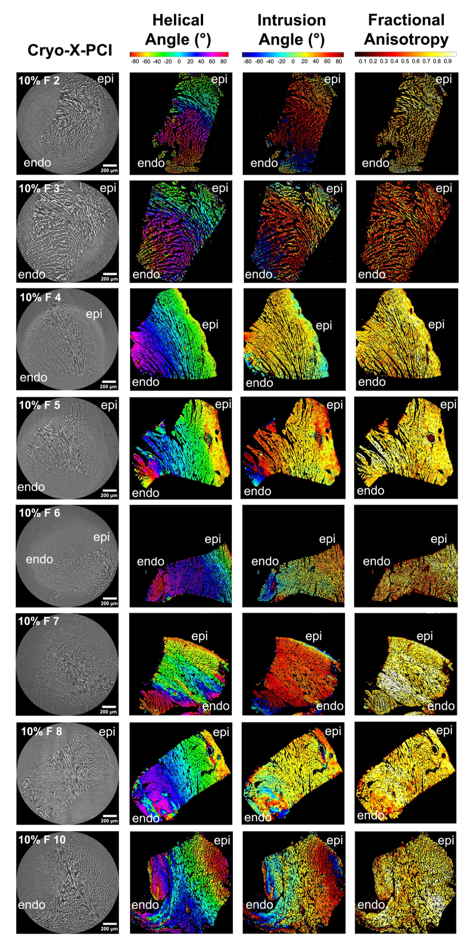
Supplementary Fig. 4 | Quantification of myocyte orientation (myomapping) in 10% formaldehyde-fixed (10% F) mouse myocardial biopsies.
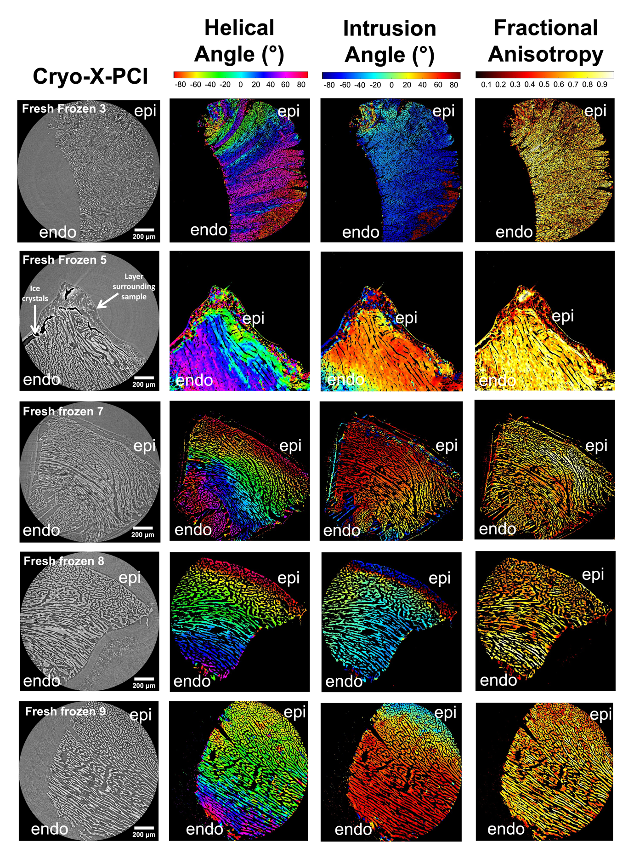
Supplementary Fig. 5 | Quantification of myocyte orientation (myomapping) in fresh frozen mouse myocardial biopsies.
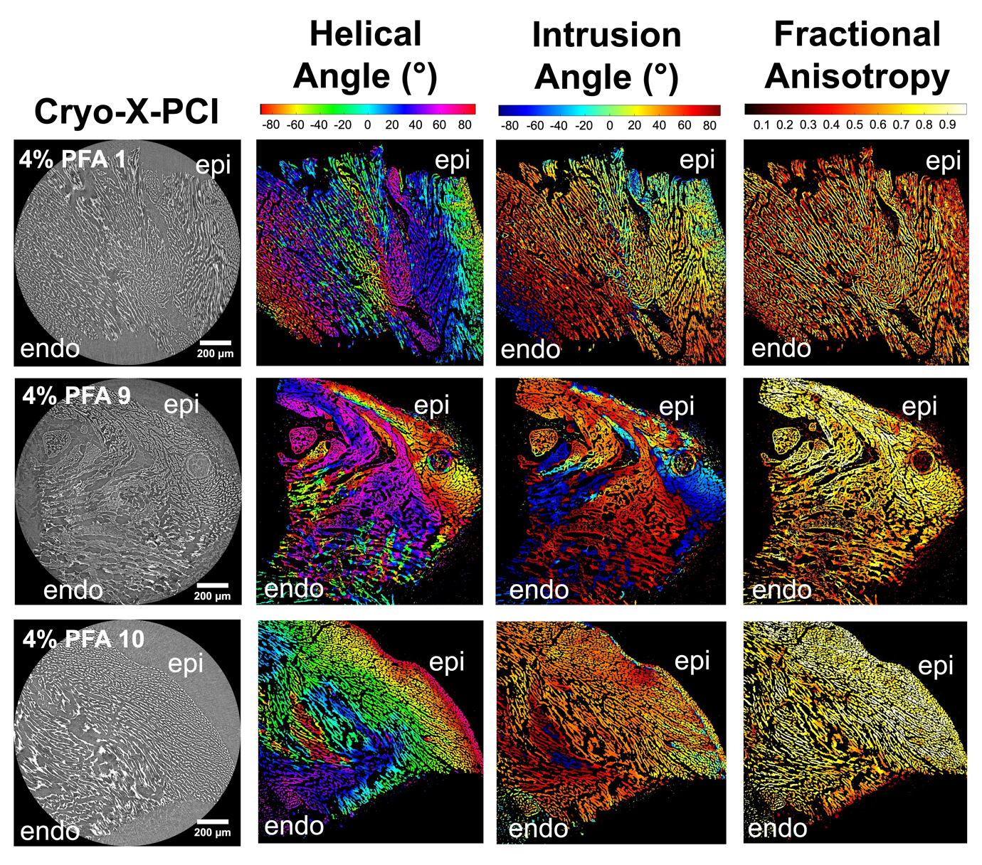
Supplementary Fig. 6 | Quantification of myocyte orientation (myomapping) in 4% paraformaldehyde (4% PFA) mouse myocardial biopsies.

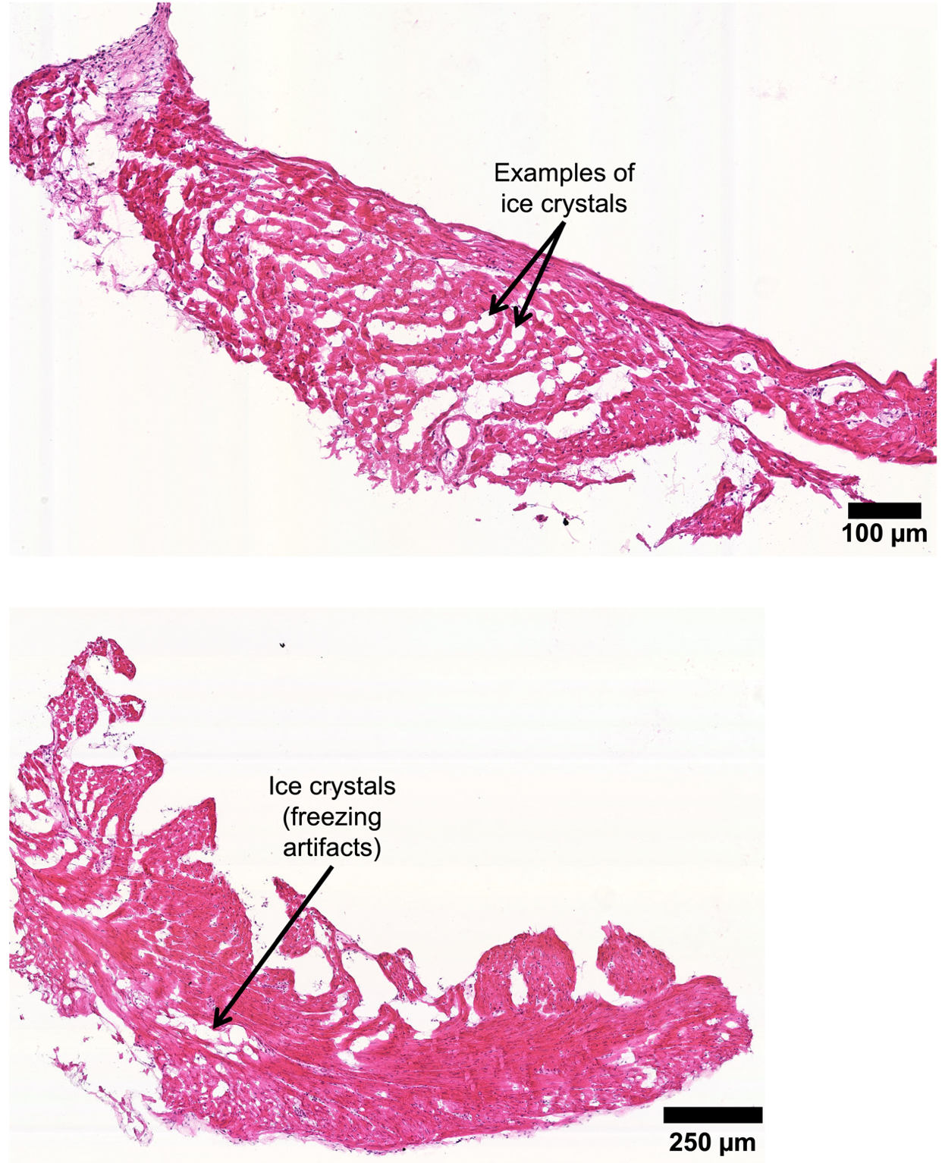
Supplementary Fig. 7 | Ice crystal artefacts in representative cryo-sections from control (no cryo-X-PCI) mouse myocardial biopsies. Cryo-sections of 8 µm thickness were cut at -20°C and collected on SuperFrostTM Plus microscope slides (VWR). A haematoxylin and eosin (H&E) frozen staining protocol was used to stain cryo-section slides via an automated system (Tissue-Tek DRS 2000 Multiple Slide Stainer, Sakura) (Supplementary Table 2).
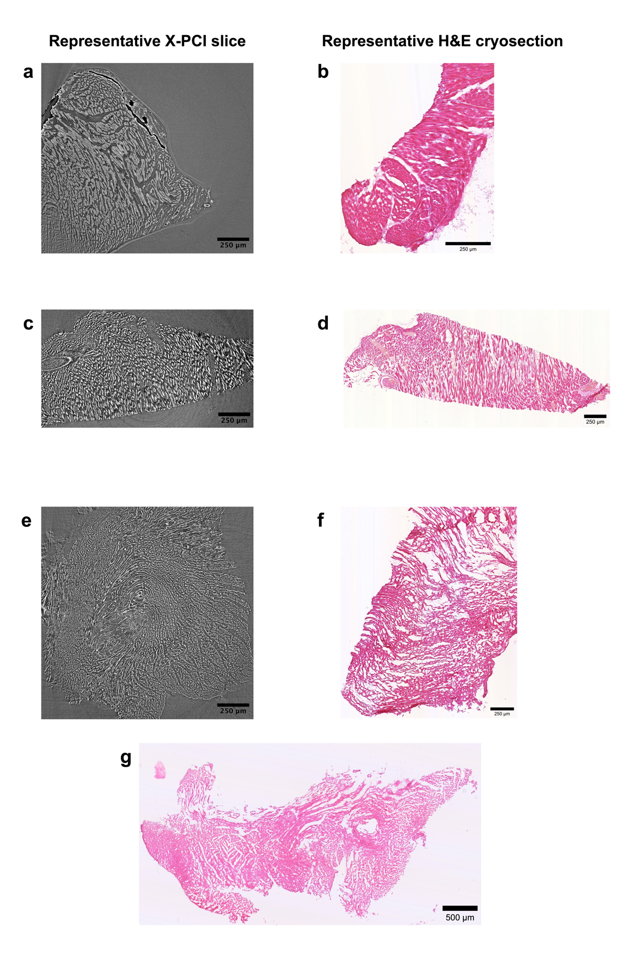
Supplementary Fig. 8 | Representative cryo-X-PCI images showing increased spacing between myocytes with corresponding H&E cryo-sections. a-b, fresh frozen, c-d, 10% formaldehyde-fixed, e-f, 4% PFA-fixed, g, control. The left column shows representative cryo-X-PCI slices. Right column shows representative haematoxylin and eosin (H&E)-stained sections from corresponding myocardial biopsies.

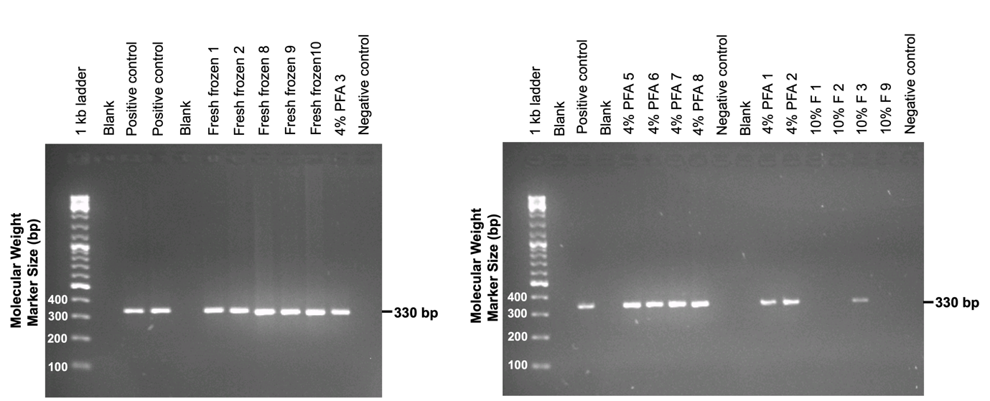
Supplementary Fig. 9 | Agarose gel electrophoresis results (2% w/v) showing PCR amplicons for exon 28 of mouse myosin binding protein C3 (Mybpc3) from fresh frozen, 4% PFA-fixed (4% PFA) and 10% formaldehyde-fixed (10% F) samples after cryo-X-PCI.

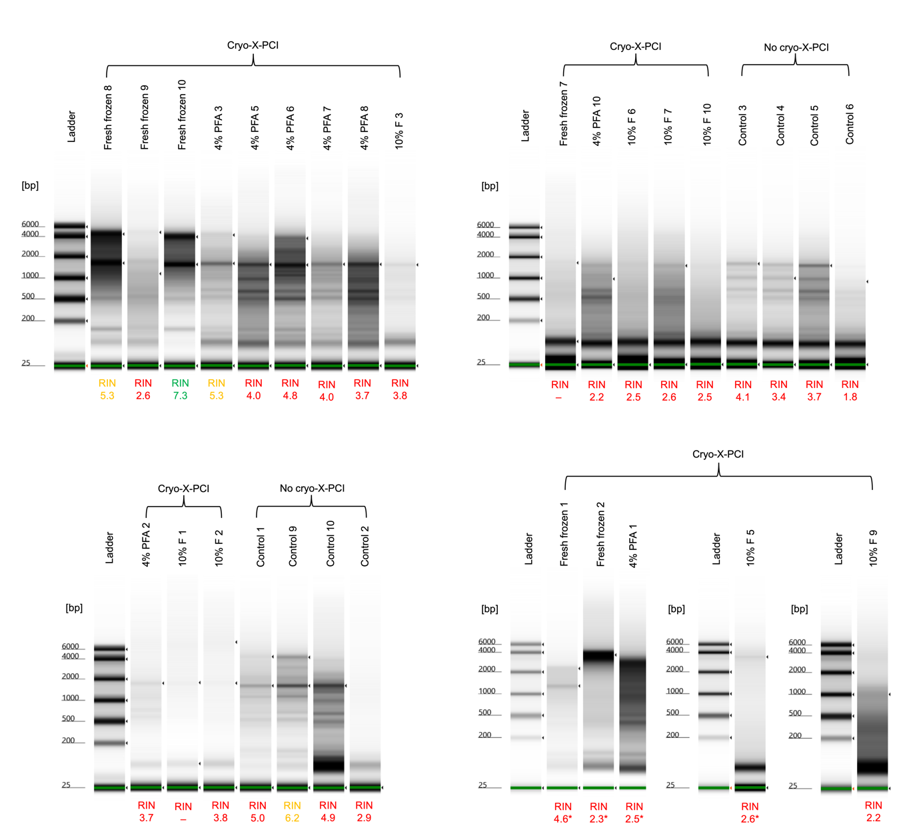
Supplementary Fig. 10 | Quality control TapeStation gels with RNA Integrity Number (RIN) values of RNA extracted from fresh frozen, 4% PFA-fixed (4% PFA), 10% formaldehyde-fixed (10% F) after cryo-X-PCI, and control mouse myocardial biopsies. Good RIN values are shown in green. Medium RIN values are shown in yellow. Poor RIN values are shown as red including those that could not be calculated due to very low concentrations of RNA. The asterisk (*) symbol represents samples that were run on High Sensitivity RNA Tape since they had very low RNA concentrations.

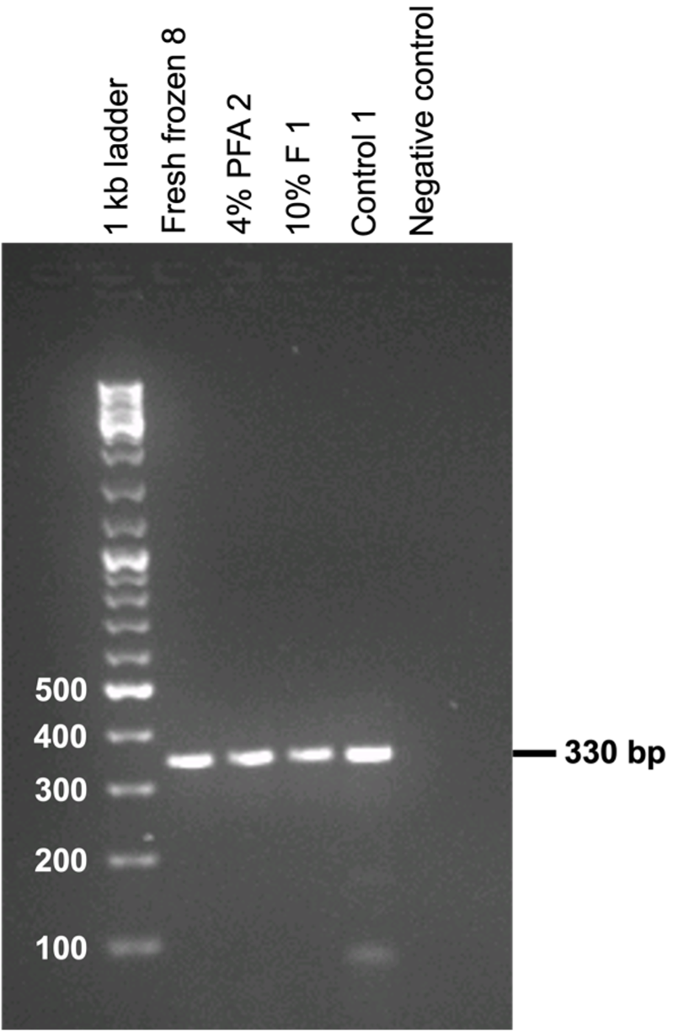
Supplementary Fig. 11 | Reverse transcription PCR results (2% w/v agarose gel electrophoresis). 11 µl of representative extracted RNA samples from mouse myocardial biopsies following cryo-X-PCI which were reverse transcribed using SuperScriptTM IV First-Strand cDNA Synthesis Reaction kit (Invitrogen).
Supplementary Tables

Supplementary Table 1 | Acquisition parameters used for synchrotron-based cryo-X-PCI of myocardial biopsies at TOMCAT X02DA beamline (Swiss Light Source).
Parameter | Value
Storage ring current | 400 mA
Beam energy | 21.002 keV
Propagation distance | 60 mm
Magnification | 10x
Effective pixel size | 0.65 µm
Field of view | 1.7 x 1.4 mm²
Number of projections | 1000
Number of darks | 30
Number of flats | 50
Exposure time | 50 ms
Camera | PCO.Edge 5.5 sCMOS
Scintillator | LuAG:Ce 20 µm
Temperature range | -80°C
Cryojet sample flow | 17.0 l/m
Cryojet shield flow | 5.7 l/m
Scan time | 3 minutes

Supplementary Table 2 | Haematoxylin and eosin (H&E) frozen staining protocol for cryo-sections.

Step | Solution | Time | Mix
1 | Start station | --- | ---
2 | Tap water | 00:10 | +
3 | Distilled water | 01:00 | +
4 | Haematoxylin | 00:45 | +
5 | Tap water | 02:00 | +
6 | HCl/E-Alc | 00:06 | +
7 | Tap water | 03:00 | +
8 | Eosin | 01:00 | +
9 | Tap water | 00:10 | ---
10 | E-Alc:70% | 00:30 | +
11 | E-Alc:100% | 01:00 | +
12 | E-Alc:100% | 02:00 | +
13 | Xylene | 02:00 | +
14 | Xylene | 02:00 | +
15 | End station | --- | ---

Supplementary Table 3 | Quality assessment and quantitation of DNA and RNA extracted from 22 wild-type mouse myocardial biopsies that underwent cryo-X-PCI, and 8 fresh frozen biopsies which did not have cryo-X-PCI. Measurements from Nanodrop and TapeStation are shown. High DNA integrity number (DIN) and RNA integrity number (RIN) values indicate high molecular weight and intact DNA and RNA, respectively, et vice versa. The asterisk (*) symbol represents samples that were subjected to High Sensitivity RNA ScreenTape assay due to very low RNA concentrations. ‘X’ denotes DIN and RIN values that could not be calculated due to very low concentrations. ‘Fresh frozen’ denotes hearts collected in RNAlater and snap frozen in liquid nitrogen. ‘4% PFA’ denotes hearts collected in RNAlater then fixed in 4% paraformaldehyde (PFA) for 1h. ‘10% formaldehyde’ denotes hearts collected in RNAlater then fixed in 10% formaldehyde (10% F) for 30 min. Control hearts, i.e., those that did not have cryo-X-PCI, were collected in RNAlater then snap frozen in liquid nitrogen.
Sample ID |  | Nanodrop measurements |  |  |  |  |  | TapeStation - Agilent 2200 TapeStation System
 |  | DNA concentration (ng/µl) | 260/280 | RNA concentration (ng/ul) | 260/280 | 260/230 | DNA concentration (ng/ul) |  | DIN | RNA concentration (ng/µl) | RIN
Cryo-X-PCI | Fresh frozen 1 | 20.1 | 2.00 | 2.6 | 1.24 | 0.06 | 9.16 |  | 6.6 | 2.95 | 4.6*
Cryo-X-PCI | Fresh frozen 2 | 37.8 | 2.23 | 3.2 | 0.97 | 0.45 | 21.6 |  | 7.5 | 16.8 | 2.3*
Cryo-X-PCI | Fresh frozen 3 | Cryo-sectioned
Cryo-X-PCI | Fresh frozen 4 | Cryo-sectioned
Cryo-X-PCI | Fresh frozen 5 | Cryo-sectioned
Cryo-X-PCI | Fresh frozen 6 | Cryo-sectioned
Cryo-X-PCI | Fresh frozen 7 | 26.5 | 1.88 | 7.5 | 1.76 | 0.187 | 22.7 |  | 6.6 | 8.23 | X
Cryo-X-PCI | Fresh frozen 8 | 116.6 | 1.83 | 123 | 2.00 | 3.074 | 74.2 |  | 6.9 | 137.0 | 5.3
Cryo-X-PCI | Fresh frozen 9 | 41.1 | 1.85 | 35.2 | 2.05 | 0.88 | 21.9 |  | 7.2 | 36.5 | 2.6
Cryo-X-PCI | Fresh frozen 10 | 94.9 | 1.80 | 65.8 | 2.04 | 1.645 | 66.2 |  | 7.4 | 89.5 | 7.3
Cryo-X-PCI | 4% PFA 1 | 1.0 | 0.74 | 19.9 | 1.70 | 0.36 | 2.84 |  | X | 28.4 | 2.5*
Cryo-X-PCI | 4% PFA 2 | 1.5 | 7.38 | 106.8 | 1.17 | 0.83 | 12.3 |  | 6.4 | 14.8 | 3.7
Cryo-X-PCI | 4% PFA 3 | 21.0 | 1.2 | 40.5 | 2.00 | 1.012 | 5.96 |  | 7.9 | 39.5 | 5.3
Cryo-X-PCI | 4% PFA 4 | Cryo-sectioned
Cryo-X-PCI | 4% PFA 5 | 29.8 | 1.57 | 84.3 | 1.99 | 2.107 | 12.7 |  | 6.8 | 83.9 | 4.0
Cryo-X-PCI | 4% PFA 6 | 26.2 | 1.73 | 98.5 | 1.99 | 2.463 | 14.6 |  | 7.6 | 99.2 | 4.8
Cryo-X-PCI | 4% PFA 7 | 30.2 | 1.65 | 42.3 | 1.98 | 1.059 | 16.9 |  | 7.2 | 41.3 | 4.0
Cryo-X-PCI | 4% PFA 8 | 49.1 | 1.73 | 90.4 | 1.98 | 2.259 | 32.9 |  | 7.0 | 94.7 | 3.7
Cryo-X-PCI | 4% PFA 9 | Cryo-sectioned
Cryo-X-PCI | 4% PFA 10 | 23.9 | 1.56 | 81.8 | 1.94 | 2.046 | 44.1 |  | 5.3 | 61.7 | 2.2
Cryo-X-PCI | 10% F 1 | 8.20 | 1.08 | 173.8 | 1.12 | 1.50 | 4.19 |  | 4.7 | 8.83 | N/A
Cryo-X-PCI | 10% F 2 | 2.60 | 1.12 | 147.8 | 1.22 | 0.81 | 3.04 |  | 2.2 | 10.9 | 3.8
Cryo-X-PCI | 10% F 3 | 9.60 | 1.03 | 27.9 | 1.85 | 0.697 | 2.68 |  | X | 17.3 | 3.8
Cryo-X-PCI | 10% F 4 | Cryo-sectioned
Cryo-X-PCI | 10% F 5 | 3.70 | 1.16 | 2.3 | 1.48 | 0.057 | 1.19 |  | X | 0.696 | 2.6*
Cryo-X-PCI | 10% F 6 | 3.40 | 1.01 | 16.9 | 1.51 | 0.422 | 0.940 |  | X | 21.1 | 2.5
Cryo-X-PCI | 10% F 7 | 5.80 | 1.24 | 48.7 | 1.72 | 1.218 | 4.13 |  | 1.7 | 33.0 | 2.6
Cryo-X-PCI | 10% F 8 | Cryo-sectioned
Cryo-X-PCI | 10% F 9 | 17.4 | 0.92 | 20.4 | 1.77 | 0.51 | 2.30 |  | X | 4.98 | 2.2*
Cryo-X-PCI | 10% F 10 | 4.30 | 1.00 | 55.8 | 1.47 | 1.395 | 1.98 |  | X | 20.7 | 2.5
No cryo-X-PCI | Control 1 | 31.1 | 1.65 | 168.4 | 2.03 | 1.40 | 19.4 |  | 7.5 | 121.0 | 5.0
No cryo-X-PCI | Control 2 | 13.3 | 2.38 | 42.9 | 0.87 | 0.21 | 9.3 |  | 7.0 | 11.0 | 2.9
No cryo-X-PCI | Control 3 | 27.8 | 1.81 | 40.5 | 1.80 | 1.012 | 12.3 |  | 7.7 | 28.1 | 4.1
No cryo-X-PCI | Control 4 | 23.1 | 1.64 | 69.8 | 2.03 | 1.744 | 17.6 |  | 7.6 | 54.6 | 3.4
No cryo-X-PCI | Control 5 | 18.3 | 1.86 | 75.7 | 1.88 | 1.892 | 20.0 |  | 7.2 | 48.1 | 3.7
No cryo-X-PCI | Control 6 | 43.4 | 1.77 | 19.6 | 1.70 | 0.491 | 22.3 |  | 6.7 | 10.7 | 1.8
No cryo-X-PCI | Control 7 | Cryo-sectioned
No cryo-X-PCI | Control 8 | Cryo-sectioned
No cryo-X-PCI | Control 9 | 14.3 | 1.94 | 107.7 | 1.21 | 0.33 | 10.5 |  | 7.0 | 27.2 | 6.2
No cryo-X-PCI | Control 10 | 12.6 | 2.11 | 43.8 | 1.85 | 0.97 | 8.63 |  | 6.8 | 44.1 | 4.9

