Table 5. Synthesis of 1(a-n) by Dª.
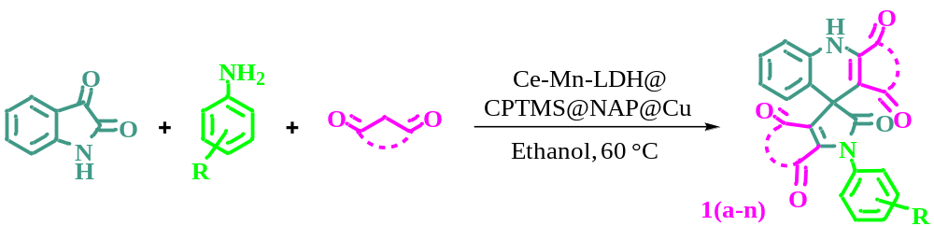
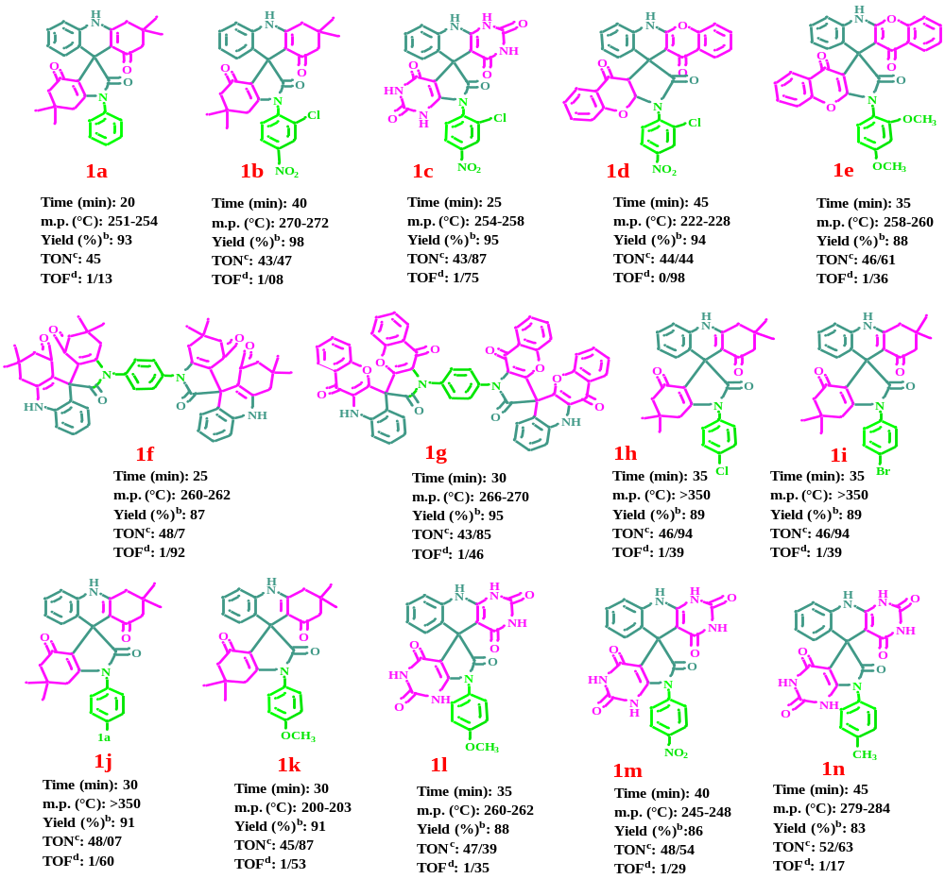
ªReaction conditions: isatin (1.0 mmol), aniline (1.0 mmol), and 1,3-diketone (2.0 mmol) by D (20 mg) in ethanol (5.0 mL) at (60 °C).
^{b}Isolated yield.
^{c}TON (turnover number): Based on ICP measurements at a ratio of 1:4, the content of Cu in the catalyst is about 31%, so the mmole of Cu in 20 mg of the catalyst is 31÷20=1.55÷63.54=0.024. For entry 1, since the yield is about 93%, the effective mmole of Cu is about 0.024×0.93=0.022 and so the TON is 1÷0.022=45.
^{d}TOF (turnover frequency): TOF=TON÷time. For entry 1, since the time is about 40 min, the TOF is 45÷40=1.13.

