Supporting Information

(Scientific Reports)

Ce-Mn-binuclear LDH based-Cu complex as a potent nanocatalyst for
green-synthesis of spiroacridineindoletriones: a comparative study

Samira Javadi, Davood Habibi*

Department of Organic Chemistry, Faculty of Chemistry and Petroleum Sciences, Bu-Ali Sina University, Hamedan, Iran
*Corresponding author email: davood.habibi@gmail.com (& dhabibi@basu.ac.ir), Tel: 98 81 38380922; Fax: 98 81 31408025

CONTENT PAGE
IR Spectrum of (1a) 2
¹HNMR Spectrum of (1a) 3
¹³CNMR Spectrum of (1a) 3

IR Spectrum of (1b) 4
¹HNMR Spectrum of (1b) 4
¹³CNMR Spectrum of (1b) 5

IR Spectrum of (1c) 5
¹HNMR Spectrum of (1c) 6
¹³CNMR Spectrum of (1c) 6

IR Spectrum of (1d) 7
¹HNMR Spectrum of (1d) 7
¹³CNMR Spectrum of (1d) 8

IR Spectrum of (1e) 8
¹HNMR Spectrum of (1e) 9
¹³CNMR Spectrum of (1e) 9

IR Spectrum of (1f) 10
¹HNMR Spectrum of (1f) 10
¹³CNMR Spectrum of (1f) 11

IR Spectrum of (1g) 11
¹HNMR Spectrum of (1g) 12
¹³CNMR Spectrum of (1g) 13

IR Spectrum of (1h) 13
IR Spectrum of (1i) 14
IR Spectrum of (1j) 14
IR Spectrum of (1k) 15
IR Spectrum of (1l) 15
IR Spectrum of (1m) 16
IR Spectrum of (1n) 16

Spectral data
3,3,6',6'-tetramethyl-1'-phenyl-3,4,6',7'-tetrahydro-1H-spiro[acridine-9,3'-indole]-1,2',4'(1'H,2H,5'H,10H)-trione (1a)
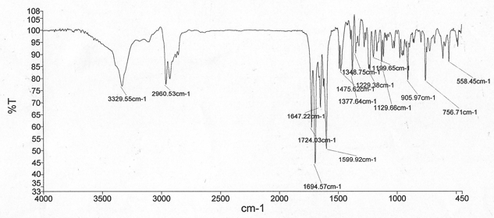
IR Spectrum of 1a

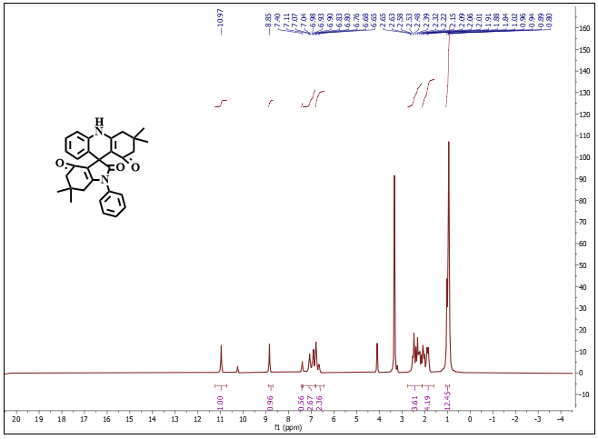
¹HNMR Spectrum of 1a
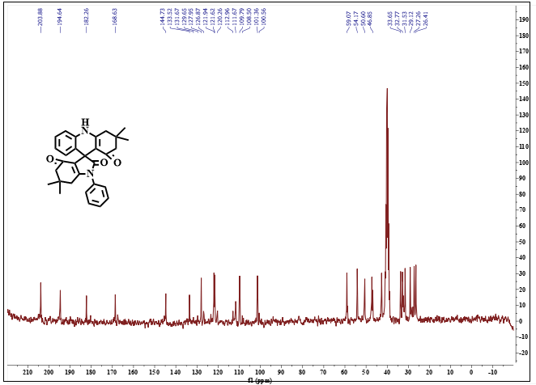
¹³CNMR Spectrum of 1a

1'-(2-chloro-4-nitrophenyl)-3,3,6',6'-tetramethyl-3,4,6',7'-tetrahydro-1H-spiro[acridine-9,3'-indole]-1,2',4'(1'H,2H,5'H,10H)-trione (1b)
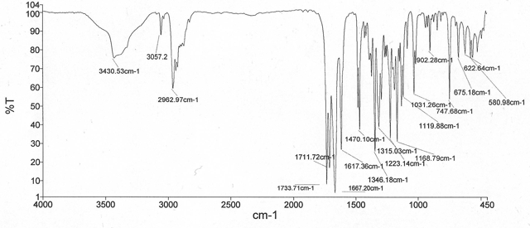
IR Spectrum of 1b
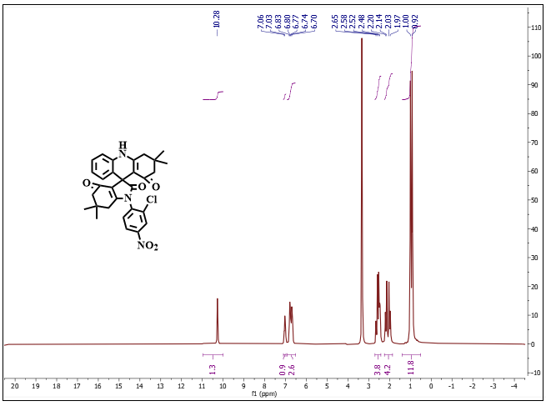
¹HNMR Spectrum of 1b

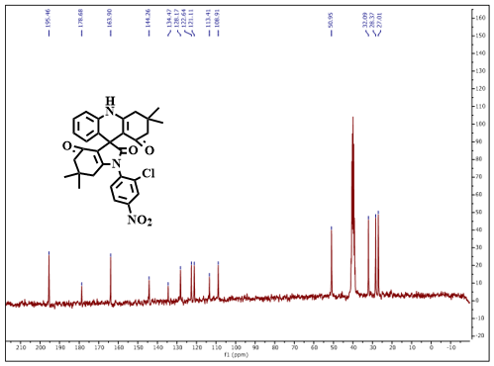
¹³CNMR Spectrum of 1b
7'-(2-chloro-4-nitrophenyl)-1H-spiro[pyrimido[4,5-b]quinoline-5,5'-pyrrolo[2,3-d]pyrimidine]-2,2',4,4',6'(1'H,3H,3'H,7'H,10H)-pentaone (1c)
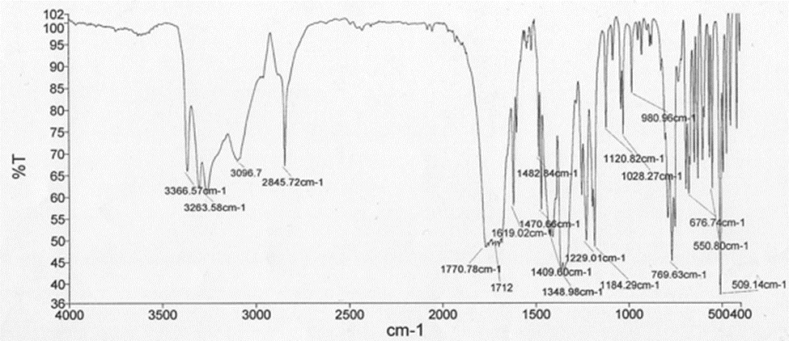
IR Spectrum of 1c

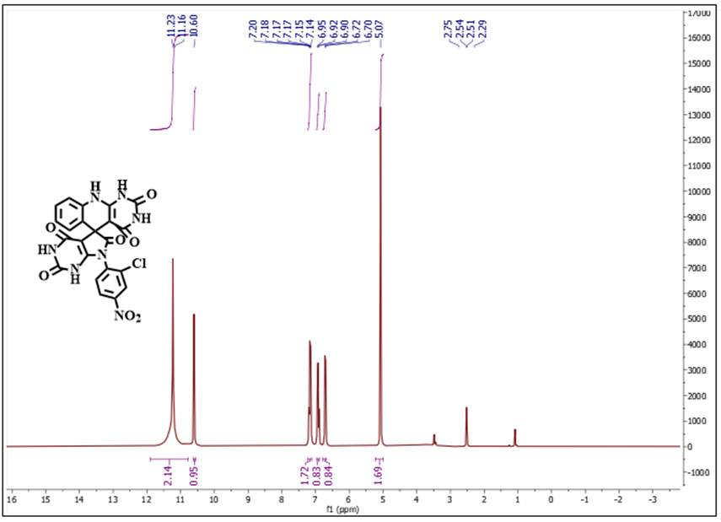
¹HNMR Spectrum of 1c

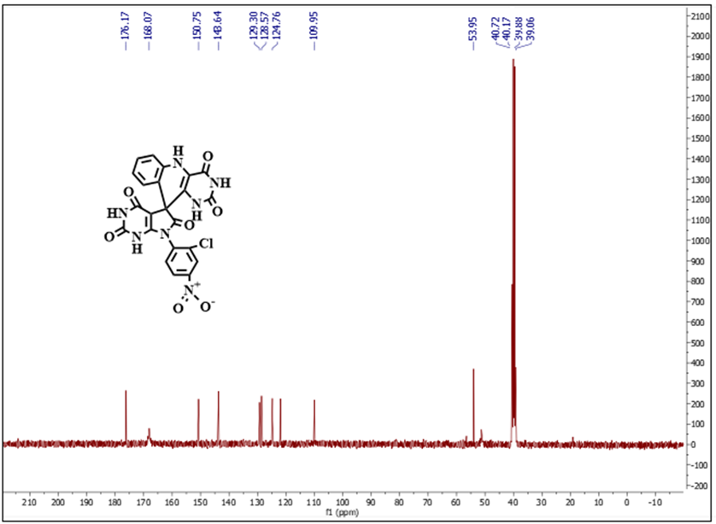
¹³CNMR Spectrum of 1c

1-(2-Chloro-4-nitrophenyl)-1H-spiro[chromeno[2,3-b]pyrrole-3,11'-chromeno[2,3-b]quinoline]-2,4,12'(6'H)-trione (1d)
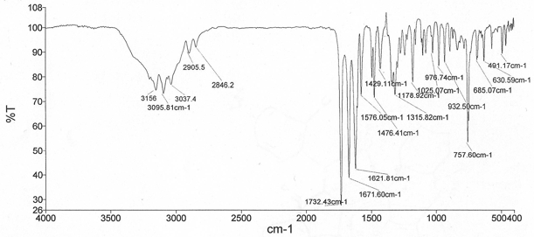
IR Spectrum of 1d
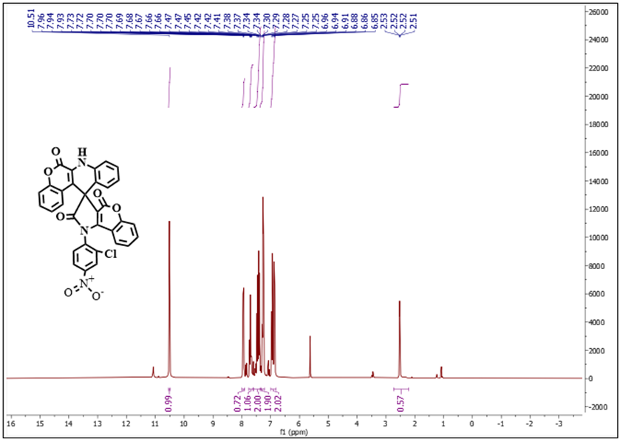
¹HNMR Spectrum of 1d

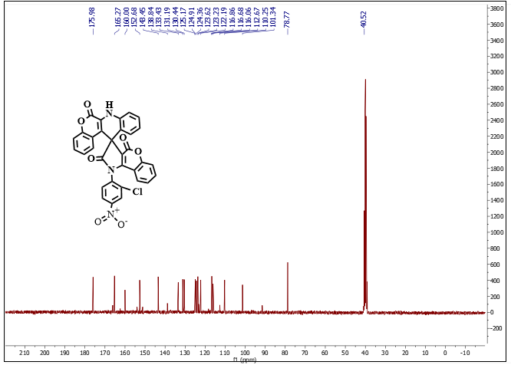
¹³CNMR Spectrum of 1d
(2,4-dimethoxyphenyl)-1H-spiro[chromeno[2,3-b]pyrrole-3,11'-chromeno[2,3-b]quinoline]-2,4,12'(6'H)-trione (1e)
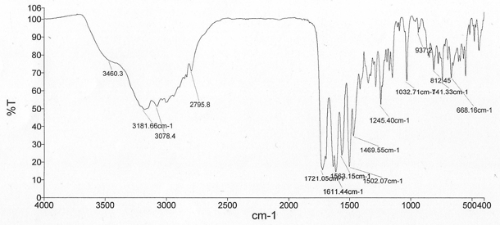
^{I}R Spectrum of 1e

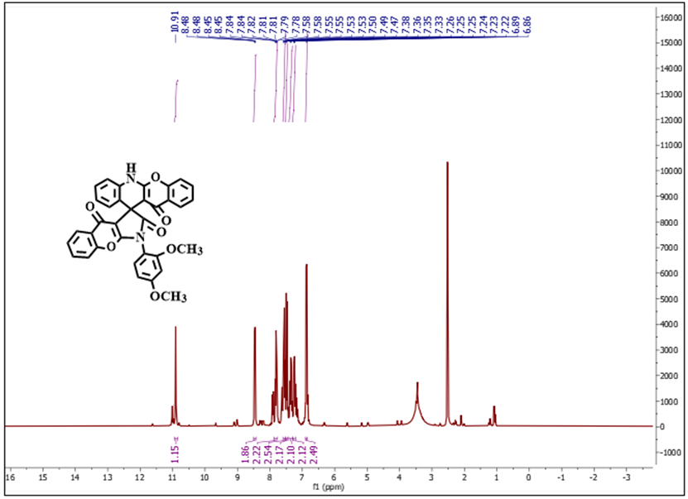
¹HNMR Spectrum of 1e
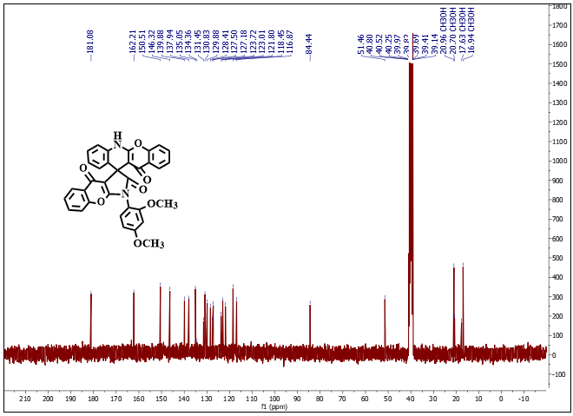
¹³CNMR Spectrum of 1e

3,3,6',6'-tetramethyl-1'-phenyl-3,4,6',7'-tetrahydro-1H-spiro[acridine-9,3'-indole]-1,2',4'(1'H,2H,5'H,10H)-trione (1f)
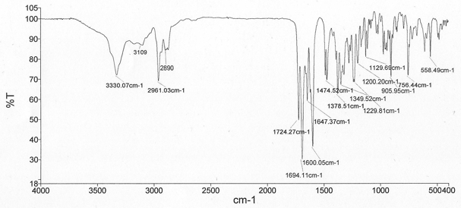
IR Spectrum of 1f

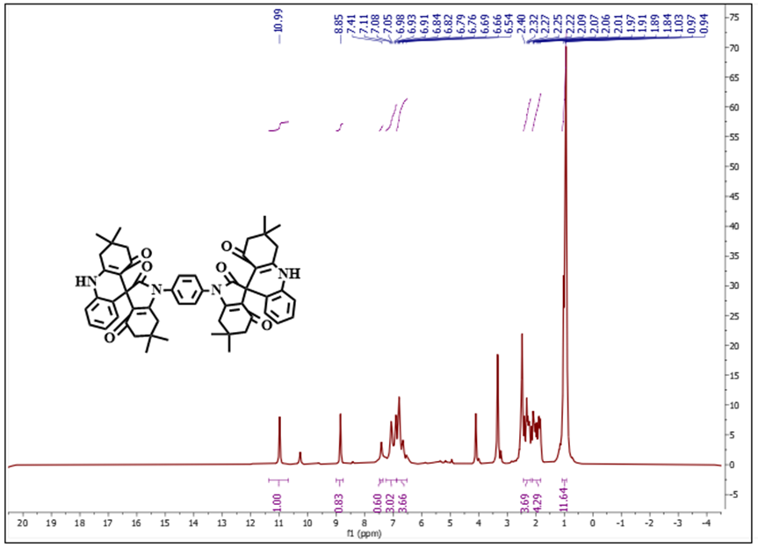
¹HNMR Spectrum of 1f

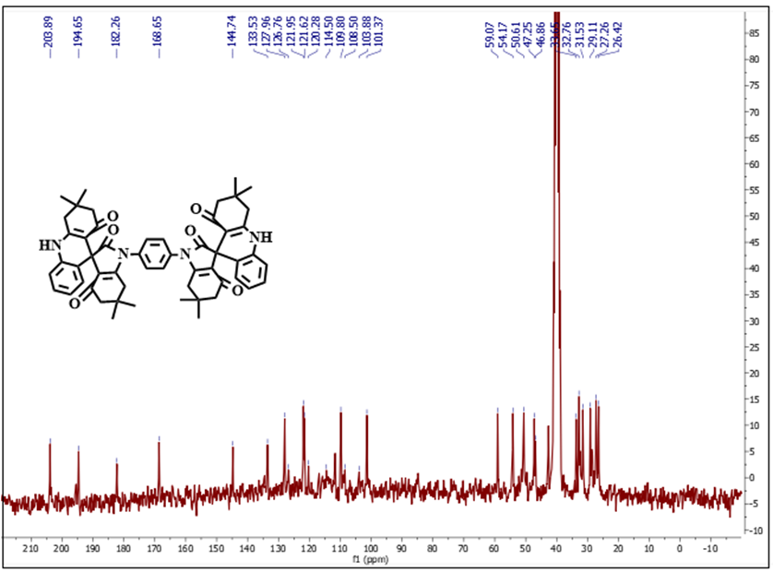
¹³CNMR Spectrum of 1f
1-phenyl-1H-spiro[chromeno[2,3-b]pyrrole-3,11'-chromeno[2,3-b]quinoline]-2,4,12'(6'H)-trione (1g)
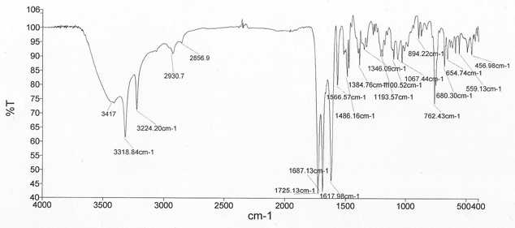
IR Spectrum of 1g

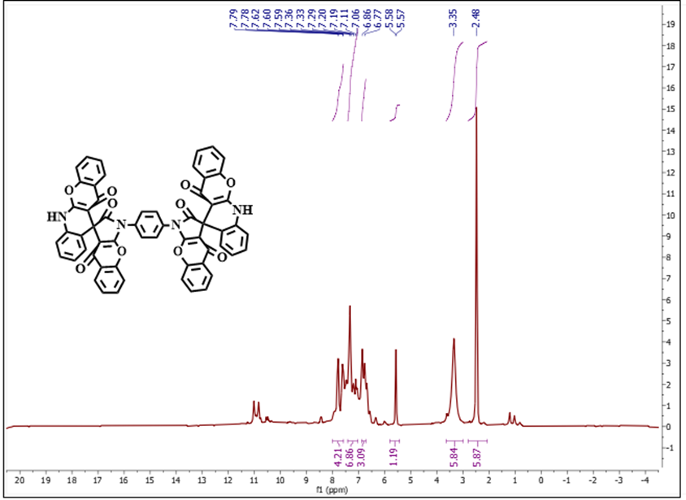
¹HNMR Spectrum of 1g
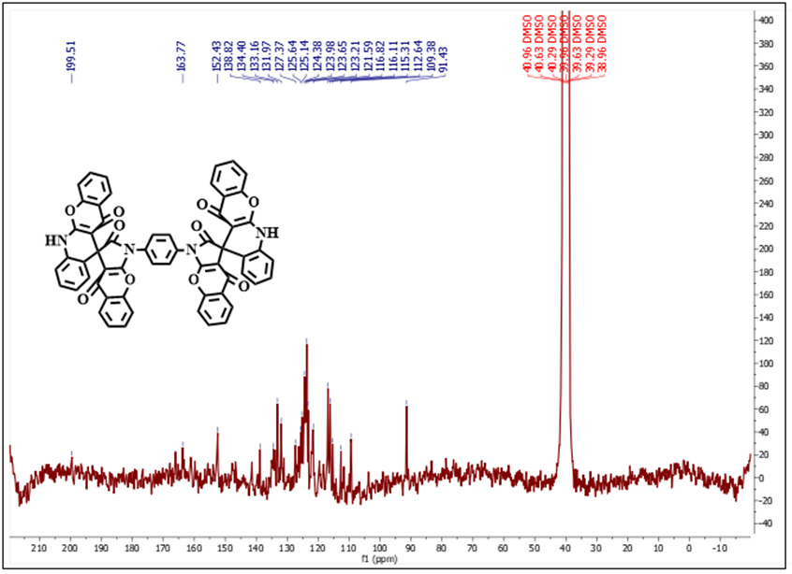
¹³CNMR Spectrum of 1g

1'-(4-chlorophenyl)-3,3,6',6'-tetramethyl-3,4,6',7'-tetrahydro-1H-spiro[acridine-9,3'-indole]-1,2',4'(1'H,2H,5'H,10H)-trione (1h)
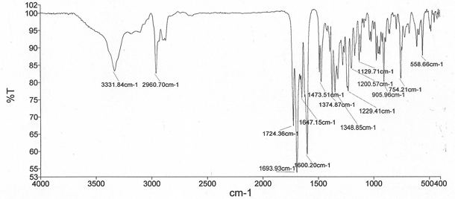
IR Spectrum of 1h

1'-(4-bromophenyl)-3,3,6',6'-tetramethyl-3,4,6',7'-tetrahydro-1H-spiro[acridine-9,3'-indole]-1,2',4'(1'H,2H,5'H,10H)-trione (1i)
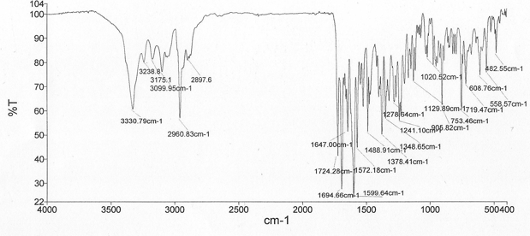
IR Spectrum of 1i

3,3,6',6'-tetramethyl-1'-(p-tolyl)-3,4,6',7'-tetrahydro-1H-spiro[acridine-9,3'-indole]-1,2',4'(1'H,2H,5'H,10H)-trione (1j)
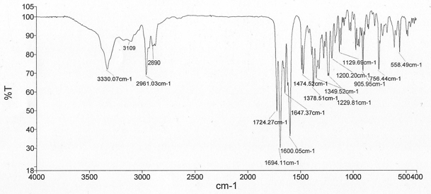
IR Spectrum of 1j
1'-(4-methoxyphenyl)-3,3,6',6'-tetramethyl-3,4,6',7'-tetrahydro-1H-spiro[acridine-9,3'-indole]-1,2',4'(1'H,2H,5'H,10H)-trione (1k)
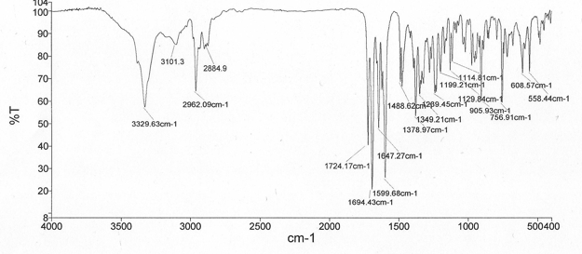
IR Spectrum of 1k

7'-(4-methoxyphenyl)-1H-spiro[pyrimido[4,5-b]quinoline-5,5'-pyrrolo[2,3-d]pyrimidine]-2,2',4,4',6'(1'H,3H,3'H,7'H,10H)-pentaone (1l)
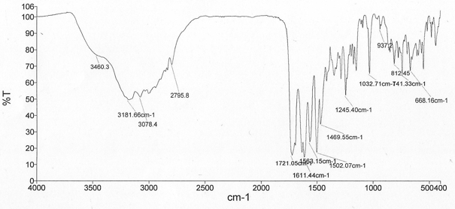
IR Spectrum of 1l

7'-(4-nitrophenyl)-1H-spiro[pyrimido[4,5-b]quinoline-5,5'-pyrrolo[2,3-d]pyrimidine]-2,2',4,4',6'(1'H,3H,3'H,7'H,10H)-pentaone (1m)
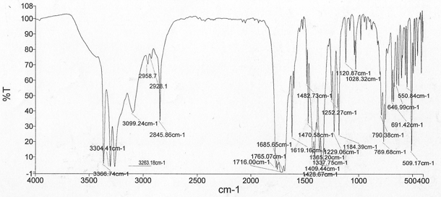
IR Spectrum of 1m

7'-(p-tolyl)-1H-spiro[pyrimido[4,5-b]quinoline-5,5'-pyrrolo[2,3-d]pyrimidine]-2,2',4,4',6'(1'H,3H,3'H,7'H,10H)-pentaone (1n)
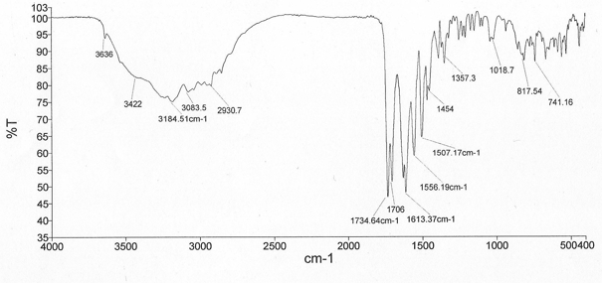
IR Spectrum of 1n

