Online Resource - Supporting Information

Forest structure predicts plant and animal species diversity and composition changes in an Amazonian forest

Marcelle São Pedro^{1*}, Marielle N. Smith^{2,3}, Gabriela Zuquim⁴, Hanna Tuomisto⁴, Scott C. Stark², Lucas Amaral⁵, Paulo Estefano D. Bobrowiec⁶, Anderson S. Bueno⁷, Ubirajara Capaverde Jr⁸, Carolina Castilho⁹, Erick Esteban¹, Albertina Lima¹, William Magnusson¹, Juliana Menger¹⁰, Maria Goretti Pinto¹, Lorena Rincón¹, Valéria da Cunha Tavares⁶, Fabiano Waldez¹¹, Juliana Schietti^{5,1}

¹Instituto Nacional de Pesquisas da Amazônia, Manaus, AM, Brazil; Michigan State University, East Lansing, Michigan, United States of America; ³Bangor University, Bangor, United Kingdon; ⁴University of Turku, Turku, Finland; ⁵Universidade Federal do Amazonas, Manaus, AM, Brazil; ⁶Instituto Tecnológico Vale, Belém, PA, Brazil; ⁷Instituto Federal de Educação, Ciência e Tecnologia Farroupilha, Júlio de Castilhos, RS, Brazil; ⁸Secretaria de Estado de Segurança Pública de Roraima, Boa Vista, RR, Brazil; ⁹Empresa Brasileira de Pesquisa Agropecuária, Boa Vista, RR, Brazil; ¹⁰Helmholtz Centre for Environmental Research, Leipzig, Germany; ¹¹Instituto Federal de Educação, Ciência e Tecnologia do Amazonas, Tabatinga, AM, Brazil

* Corresponding author: Marcelle São Pedro (marcellespedro.as@gmail.com)

The summary description of the sampling methodology and species identification for each biological group. A full description is available in the respective scientific references.

Terrestrial herbs. Terrestrial herbs were sampled in plot widths of 1 m for ferns+lycophytes and 2 m for angiosperm herbs. Each individual rooted within the plot and greater than 5 cm in height was counted and identified. For most species, it was possible to distinguish and count individuals. In clonal species, each cluster of leaves (or stems in the case of Lycophytes) was counted as the same individual, if they were less than 20 cm apart (Costa et al. 2005).

Palms. Palms were sampled in plot width of 4 m and each individual above 1m height rooted within the plot was counted and identified. Stems belonging to clonal individuals were not counted as separate individuals (Costa et al. 2009).

Trees. Individuals with DBH > 10 cm were measured in plots of 0.5 ha (250 x 20 m) and individuals with DBH > 1 cm were measured in subplots of 0.1 ha (250 x 4 m) (Castilho et al. 2010). Each plot was sampled once during the sampling period. To have trees with DBH > 1 cm, we replicated the 0.1 ha dataset of trees only with 1 cm < DBH < 10 cm (small trees) five times to an area of 0.5 ha and joined it with the 0.5 ha dataset of trees with DBH > 10 cm. Doing that, we standardize the sample area of the two subsets and analyzed them separately. We also excluded six plots from trees above 1 cm DBH because they had only 3% of small trees identified at the species level.

Bats. Frugivorous bats were captured using eight ground-level mist nets (12 X 3 m, 19 mm mesh) per plot. Each plot was sampled on three non-consecutive nights, totaling 7056 net hours (1 net hour = one net open for one hour). Nets remained open between 18:00 and 00:00 h and were checked every 15 min (Capaverde et al. 2018).

Birds. Understory birds were sampled in three discrete periods during the sampling year: 10 January to 25 May, 12 July to 7 September, and 19 September to 19 November. Each plot was sampled once in each sampling period. The abundance of a given species in each plot was calculated as the total number of individuals captured in the three sampling periods. Sixteen 9-m mist nets were arranged in pairs along the 250-m length of each plot, such that each pair was separated from adjacent pairs by 10 m. In the first sampling period, eight mist nets with 50-mm mesh and eight mist nets with 70-mm mesh were used. In the later sampling, all mist nets had 32-mm mesh. Mist nets were left open from 06:00 to 12:00 and checked hourly. Within-plot variation in mesh sizes does not affect ecological conclusions about differences among plots, as all mesh sizes were used in all plots (Bueno et al. 2012). We removed records of non-understory species that were randomly captured. We classified a species as an understory species when the sum of the ground, understory, and mid-high foraging strata was equal to or higher than 50%, according to the EltonTraits 1.0 database (Wilman et al. 2014).

Lizards. Lizards were sampled by using two complementary methods in each plot: visual sampling was conducted while walking along the plot in one direction and a finer-scale leaf litter search was conducted while walking back along the plot in the return direction, with a 10-minute break between routes. Visual sampling was carried out at a width of 10 m, inspecting the ground and the vegetation strata up to 4 m in height. The litter search was carried out at a width of 1 m, by stepping on the litter and observing the movement of lizards ahead. Thus, in each plot, the total abundance of each species was given by the sum of the individuals observed using the two methods (Pinto 2006).

Anurans. We used anuran data from three diurnal samples (November-December 2002, February-April 2003, and January-February 2004) and five nocturnal samples (November-December 2002, March-May 2003, November-December 2003, January-March 2004, and April-May 2004). In each plot, diurnal surveys were conducted in a width of 1 m, while two observers visually scanned and carefully turned over the leaf litter, detecting individuals by visual encounter. The nocturnal anuran assemblage was sampled by two complementary methods: visual encounter surveys and auditory sampling. For auditory sampling, the observers stopped in the middle of the plot every 10 m along the central line, then recorded the number of vocalizing individuals of each species and searched the litter and vegetation for anurans. Only one individual per species was noted in each 10-m segment to avoid double counting. All individuals located visually or by their call within 20 m of width were summed to give the nocturnal total abundance of each species per plot (Menin et al. 2007). We calculated the mean abundance per sampling period to attenuate the imbalance of 3 diurnal and 5 nocturnal samples. Thus, each species had a mean abundance of diurnal sampling and a mean abundance of nocturnal sampling per plot. For the analysis, we chose the highest mean abundance to consider the period in which each species is most active, following the same approach as Menin et al. (2007).

Table S1. Correlation between structural metrics (single and combined) and hydro-edaphic variables (HAND and sum of bases) in the 23 plots. Symbols in parentheses mean the significance level: “***”, “**”, “*”, and “.” for p-values 0, 0.001, 0.01, 0.05, and 0.1, respectively. HAND and the sum of bases had 0.67 (***) of correlation.

Structural metric | HAND | Sum of bases
Maximum canopy height | 0.26 | 0.34
Mean canopy height | 0.53 (**) | 0.57 (**)
Elevation-relief ratio | -0.11 | 0.09
Leaf area index | -0.02 | -0.29
Leaf area height volume | 0.38 (.) | 0.33
Gap fraction | 0.10 | 0.06
Height of 50% incident light | 0.43 (*) | 0.66 (***)
Skewness | 0.04 | -0.33
Kurtosis | -0.18 | -0.32
Canopy Shannon index | 0.47 (*) | 0.52 (*)
PCA axis 1 | 0.47 (*) | 0.59 (**)
PCA axis 2 | -0.07 | 0.20

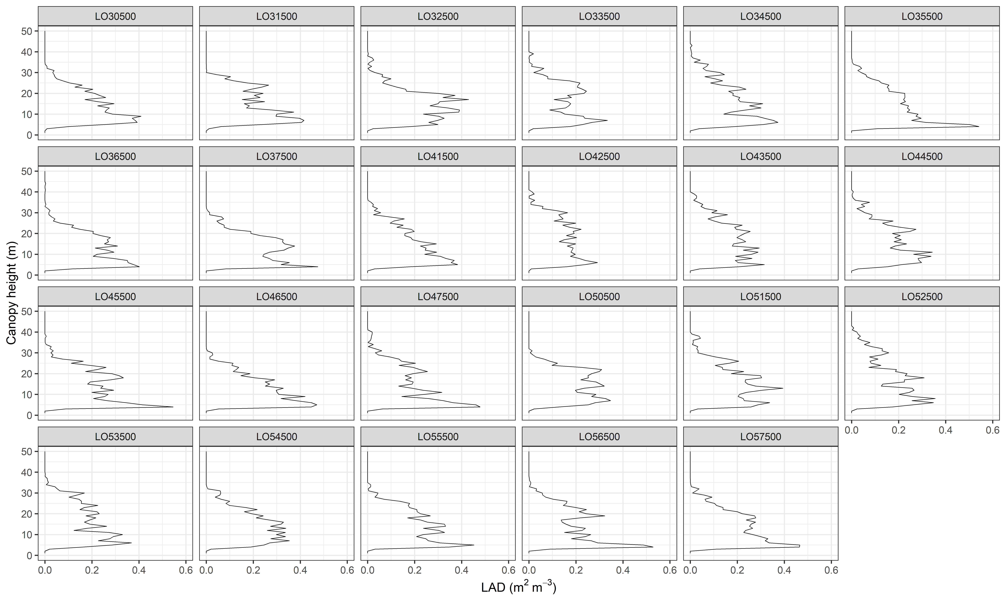
Figure S1. Leaf area density profiles of the 23 plots at Ducke Reserve.

Table S2. Contribution of each structural metric to the PCA axes.
Structural metrics | PCA axis 1 | PCA axis 2
ERR | 0.074147 | 0.452742
Gap fraction | 0.073826 | -0.17332
Ht.light50 | 0.464895 | 0.131914
Kurtosis | -0.1011 | -0.49625
Skewness | -0.05729 | -0.50153
LAHV | 0.388331 | -0.15474
LAI | -0.15477 | -0.3716
Maximum canopy height | 0.355302 | -0.2836
Mean canopy height | 0.469721 | -0.05301
Canopy Shannon index | 0.487636 | -0.06718

Figure S2. Time lag analysis of the structural models for Fisher’s Alpha index. Each point represents a biological group according to the graph legend. The x-axis is the p-value of the structural metric in the structural model. The y-axis is the time lag between the census of the biological group and the lidar survey (2009).

Figure S3. Time lag analysis of the structural models for species composition changes (PCoA axis 1 - abundance data). Each point represents a biological group according to the graph legend. The x-axis is the p-value of the structural metric in the structural model. The y-axis is the time lag between the census of the biological group and the lidar survey (2009).

Figure S4. Time lag analysis of the structural models for species composition changes (PCoA axis 2 - abundance data). Each point represents a biological group according to the graph legend. The x-axis is the p-value of the structural metric in the structural model. The y-axis is the time lag between the census of the biological group and the lidar survey (2009).
Figure S5. Time lag analysis of the structural models for species composition changes (PCoA axis 1 - presence-absence data). Each point represents a biological group according to the graph legend. The x-axis is the p-value of the structural metric in the structural model. The y-axis is the time lag between the census of the biological group and the lidar survey (2009).

Figure S6. Time lag analysis of the structural models for species composition changes (PCoA axis 2 - presence-absence data). Each point represents a biological group according to the graph legend. The x-axis is the p-value of the structural metric in the structural model. The y-axis is the time lag between the census of the biological group and the lidar survey (2009).

Figure S7. Variation partitioning of changes in species composition using abundance data. In each graph, the structural metric represents the variation partitioning of a full model including the respective structural metric and hydro-edaphic variables (HAND - terrain vertical distance to the nearest water drainage - and sum of bases). The biological group presented had only hydro-edaphic variables (blue) explaining their changes in species composition. For abbreviations of structural metrics see Table 2.

Figure S8. Variation partitioning of changes in species composition for palms and trees with DBH > 10 cm using presence-absence data. In each graph, forest structure metric represents the variation partitioning of a full model including the respective structural metric and hydro-edaphic variables. Green bars represent forest structure (single or multivariate metric), blue bars represent hydro-edaphic environment (terrain vertical distance to the nearest water drainage and sum of bases), and grey bars represent the shared contribution between the structural metric and hydro-edaphic variables.

Table S3. The proportion of variance (%) in species composition explained by the PCoA axes for each biological group.
 | Abundance data |  | Presence-absence data
Biological groups | PCoA axis 1 | PCoA axis 2 | PCoA axis 1 | PCoA axis 2
Ferns+lycophytes | 45 | 23 | 70 | 18
Angiosperm herbs | 39 | 21 | 35 | 20
Palms | 64 | 18 | 67 | 13
Trees above 1 cm DBH | 20 | 10 | 22 | 11
Trees above 10 cm DBH | 19 | 9 | 19 | 9
Frugivorous bats | 52 | 25 | 47 | 29
Birds | 20 | 16 | 23 | 17
Lizards | 47 | 21 | 44 | 31
Anurans | 64 | 31 | 76 | 28

