SUPPLEMENTARY MATERIAL
Facile recovery of terephthalic acid from PET bottles via acid hydrolysis with nitric acid and applications in synthesis of cobalt MOFs

Seabra, V.¹; Gonçalves, J. M. R.¹; Moura, A. L. S¹; Luna, V. G.¹; Santiago, P.H.O.²; Ellena, J.² Lima-Neto, B. S.¹
¹Instituto de Química de São Carlos, Universidade de São Paulo, São Carlos, SP, Brazil
²Instituto de Física de São Carlos, Universidade de São Paulo, São Carlos, SP, Brazil.
benedito@iqsc.usp.br orcid.org/0000-0003-1863-2439

Figure S1. FTIR spectra of Terephtalic Acid (H₂TPA) and 2-Nitro-Terephtalic Acid (NO₂-TPA) in KBr pellets.

Figure S2. NMR ¹H spectra of H₂TPA (a), ¹³C Spectra (b) and HSQC ¹H-¹³C (c) in DMSO d₆.
Figure S3. NMR spectra of NO₂-TPA ¹³C (a) and HSQC ¹H-¹³C (b) in DMSO d₆ at 25,0 °C.

Table S1. Selected geometric parameters (Å, º) for 1.
Co1—O1 | 1.948 (7) | Co2—O9 | 2.027 (6)
Co1—O5 | 2.014 (7) | Co2—O12 | 2.008 (7)
Co1—O4 | 1.982 (7) | Co3—O7 | 2.102 (7)
Co1—O13 | 1.960 (7) | Co3—O8 | 2.266 (6)
Co2—O2 | 2.086 (7) | Co3—O10 | 2.020 (5)
Co2—O3^{i} | 2.066 (6) | Co3—O11^{ii} | 2.049 (6)
Co2—O5 | 2.215 (6) | Co3—O14 | 2.218 (6)
Co2—O7 | 2.101 (6) | Co3—O15 | 2.002 (7)
O11^{ii}—Co3—O7 | 98.4 (3) | O9—Co2—O5 | 89.8 (2)
O11^{ii}—Co3—O8 | 94.9 (3) | O2—Co2—O7 | 87.8 (3)
O7—Co3—O8 | 60.7 (3) | O2—Co2—O5 | 91.6 (2)
O7—Co3—O14 | 86.3 (2) | O12—Co2—O7 | 93.6 (3)
O10—Co3—O11^{ii} | 101.8 (3) | O12—Co2—O9 | 96.6 (3)
O10—Co3—O7 | 95.0 (3) | O12—Co2—O5 | 87.1 (3)
O10—Co3—O14 | 84.5 (3) | O12—Co2—O3^{i} | 86.0 (3)
O15—Co3—O11^{ii} | 85.6 (3) | O3^{i}—Co2—O7 | 91.6 (2)
O15—Co3—O10 | 100.5 (3) | O3^{i}—Co2—O2 | 91.4 (3)
O15—Co3—O8 | 102.5 (3) | O3^{i}—Co2—O5 | 88.3 (2)
O15—Co3—O14 | 87.8 (3) | O1—Co1—O5 | 113.3 (3)
O14—Co3—O8 | 81.4 (2) | O1—Co1—O4 | 112.3 (3)
O9—Co2—O7 | 90.3 (2) | O1—Co1—O13 | 105.9 (3)
O9—Co2—O2 | 86.0 (3) | O13—Co1—O5 | 130.4 (3)
Symmetry code(s): (i) x+1/2, −y+1, z+1/2; (ii) x+1/2, −y, z+1/2.

Table S2. Selected geometric parameters (Å, º) for 2.
Co1—O6^{i} | 2.1062 (19) | Co1—O5 | 2.1040 (18)
Co1—O6^{ii} | 2.1014 (19) | Co1—O7 | 2.1171 (19)
Co1—O1 | 2.0656 (19) | Co1—O2^{ii} | 2.0527 (19)
O6^{ii}—Co1—O6^{i} | 90.15 (9) | O5—Co1—O6^{i} | 89.18 (8)
O6^{ii}—Co1—O5 | 95.13 (7) | O5—Co1—O7 | 85.99 (7)
O6^{i}—Co1—O7 | 91.56 (8) | O2^{ii}—Co1—O6^{i} | 91.75 (8)
O1—Co1—O6^{ii} | 90.12 (8) | O2^{ii}—Co1—O6^{ii} | 92.57 (7)
O1—Co1—O5 | 92.01 (8) | O2^{ii}—Co1—O1 | 87.03 (8)
O1—Co1—O7 | 88.16 (8) | O2^{ii}—Co1—O7 | 86.29 (8)
Symmetry code(s): (i) −x+y+2, −x+1, z; (ii) y+1, −x+y+1, −z+1.

Table S3. Selected hydrogen-bond parameters for 1 and 2.
 |  | Co-TPA-DMA
(D-H⋯A) | d(D-H)/Å | d(H-A)/Å | d(D-A)/Å | D-H-A/°
C26-H26a⋯O1¹ | 0.98 | 2.48 | 3.31(2) | 142.1
C26-H26c⋯O1 | 0.98 | 2.42 | 3.276(16) | 145.7
C35-H35a⋯O13² | 0.98 | 2.57 | 3.477(16) | 153.2
C35-H35c⋯O6¹ | 0.98 | 2.29 | 3.225(15) | 158.2
 |  | Co-NO₂-TPA-DMF
(D-H⋯A) | d(D-H)/Å | d(H-A)/Å | d(D-A)/Å | D-H-A/°
C4-H4⋯O3³ | 0.95 | 2.53 | 3.357(6) | 145.0
¹-1/2+X,-Y,1/2+Z; ² -1/2+X,1-Y,-1/2+Z; ³ 1+Y-X,1-X,+Z

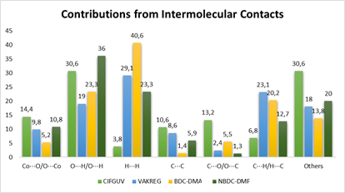
Figure S4. Representation of percentual contribution of different contacts to the Hirshfeld surfaces of 1 and 2.
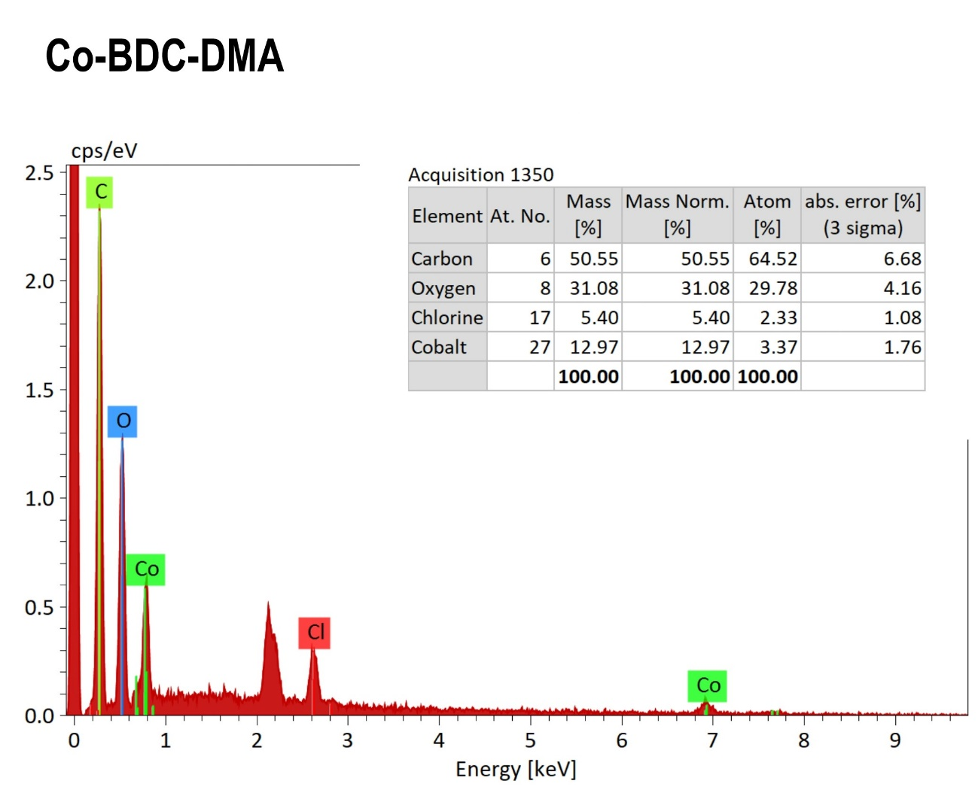
Figure S5. EDS spectrum of Co-TPA-DMA MOF (1).

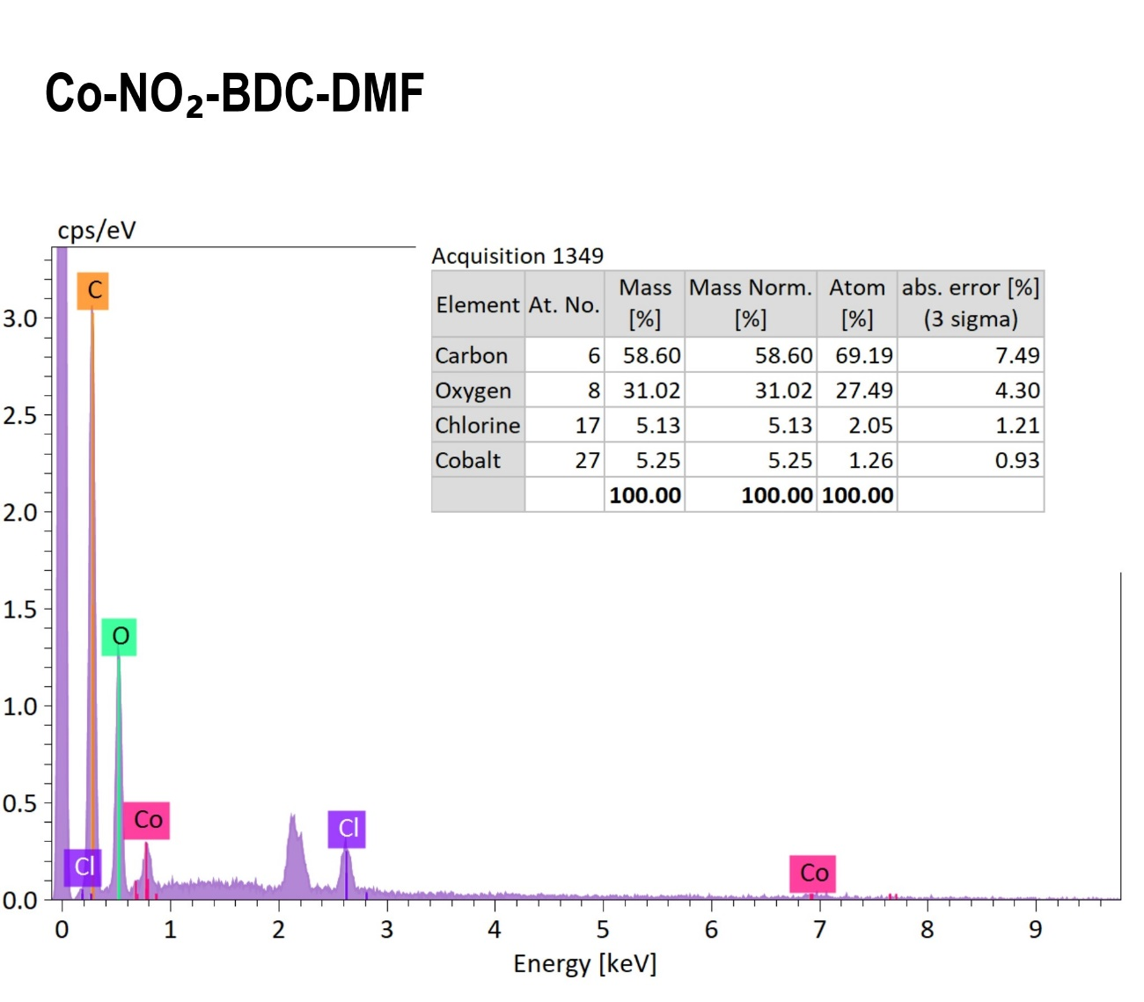
Figure S6. EDS spectrum of Co-NO₂-TPA-DMF MOF (2).

