Supplementary material
Enhanced coke resistance in methanol to olefins reaction via surplus mesoporosity of fibrous silica-wrapped SAPO-34

Muhammad Hafizuddin Mohd Sofi¹, Muhamed Yusuf Shahul Hamid^{1,2*}, Aishah Abdul Jalil^{1,2}, Tuan Amran Tuan Abdullah^{1,2}, Mohamed Yusuf Mohamud¹, Mahadi Bahari³, Nurul Sahida Hassan^{1,2}, Dai-Viet N. Vo⁴.

¹Faculty of Chemical and Energy Engineering, Universiti Teknologi Malaysia, 81310 UTM Johor Bahru, Johor, Malaysia
²Centre of Hydrogen Energy, Institute of Future Energy, 81310 UTM Johor Bahru, Johor, Malaysia
³Faculty of Science, Universiti Teknologi Malaysia, 81310 UTM Johor Bahru, Johor, Malaysia
⁴Center of Excellence for Green Energy and Environmental Nanomaterials (CE@GrEEN), Nguyen Tat Thanh University, 300A Nguyen Tat Thanh, District 4, Ho Chi Minh City 755414, Viet Nam

*To whom correspondence should be addressed,
Muhamed Yusuf Shahul Hamid (Ph.D.)
Tel: 60-7-5535581 Fax: 60-7-5536165
Email: m.yusuf@utm.my

Number of pages: 12
Number of texts: 4
Number of figures: 3
Number of tables: 2
Text S1. Proposed mechanism for the formation of fibrous silica-wrapped SAPO-34
Text S2. Acidity of the catalysts
Text S3. Textural analysis of spent catalyst
Text S4. Physical properties of the catalysts

Text S1. Proposed mechanism for the formation of fibrous silica-wrapped SAPO-34
Based on the characterization data previously discussed, the structural mechanism of FSAPO-34 has been proposed, as shown in Fig. S1. The combination of urea, CTAB, water, 1-butanol, and toluene, serving as hydrolyzing agent, surfactant, hydrophilic solvent, co-surfactant, and oil phase solvent, respectively, resulted in the creation of reverse micelles which is typical for fibrous silica or KCC-1 synthesis process (Firmansyah et al. 2016; Abdul Jalil et al. 2019; Siang et al. 2021). In the reverse micelle system, water molecules are restricted within the core of the micelle, resulting in a highly isolated water environment. It is noteworthy that the alcohol (1-butanol) has to function together with CTAB at the micellar interface to create reverse micelles in the fibrous silica colloidal mixture. Or else, alcohol forms complexes with unbound CTAB molecules in the solution, impeding the formation of reverse micelles (Mathew and Juang 2007; Febriyanti et al. 2016).
In the case of other aluminosilicate zeolites, the introduction of a hydrophilic zeolite seed enabled the interaction between the negatively charged zeolite framework and the positively charged CTAB hydrophilic groups with a hydrophobic tail. Subsequently, introducing a hydrophobic silica source such as TEOS results in the formation of a silica network around the zeolite crystal, where the center of the single silica sphere consists of a framework of zeolite (Abdul Jalil et al. 2019). This zeolite seed not only facilitates the initial formation of fibrous silica nuclei but also undergoes changes in its composition by partial dealumination during the crystallization process (Firmansyah et al. 2016; Teh et al. 2016) since hydrolysis of TEOS and condensation of silica occur in basic condition (Febriyanti et al. 2016). However, in the case of SAPO-34, instead of forming a uniform network around the SAPO-34 crystal, the fibrous silica tends to clump together or aggregate on the surface.
The potential explanations for this phenomenon to occur may be due to the size of the SAPO-34 seed, which comes with micro-sized crystals (Fig. 2a). Previous works show that the size of the SAPO-34 seed utilized in seed-assisted synthesis can influence the dissolution rate of the seed in the mother liquor which nano-sized seeds demonstrate a faster dissolution in the synthesis system compared to their micro-sized counterparts (Chen et al. 2017; Zheng et al. 2022). Besides, research conducted by Zheng et al. indicates that most of the micro-sized SAPO-34 seeds did not fully dissolve throughout the crystallization process (Zheng et al. 2022). This is due to the fact that the robust nature of SAPO-34’s framework makes it less susceptible to structural alterations under typical synthesis conditions and high resistance in basic media (Sun et al. 2018). Therefore, unlike other aluminosilicate zeolites, SAPO-34 maintains its structure during the formation of fibrous silica.
The undissolved micro-sized SAPO-34 seed also then led to the formation of smaller particle size fibrous silica (150-200 nm in Fig. 2d) compared to fibrous silica material found in the literature (480-950 nm) (Bayal et al. 2016). The smaller size of fibrous silica in the shell can be attributed to steric hindrance caused by the simultaneous growth of crystals in the shell structure. The close proximity of the growing crystals in the shell hinders their free growth and results in smaller crystal sizes (Bouizi et al. 2005; Li et al. 2019). Finally, the drying and calcination process will remove the water, surfactant, co-surfactant, and oil, leaving the dendrimeric fibrous silica on the surface of SAPO-34, which is denoted as FSAPO-34.
Text S2. Acidity of the catalysts
Fig. S2 (a) represents the acidity and quantities of weak and strong acid sites obtained from the thermal desorption of NH₃. Clear desorption peaks were evident at approximately 100–300 °C and 300–500 °C for both samples, suggesting the existence of acid sites with varying strengths. The low-temperature peak is attributed to ammonia weakly bonded on defect sites like T-OH (where T= Si, Al, and P), which corresponds to weak acid sites, and the high-temperature peak is attributed to the strong adsorption of ammonia on the strong bridge hydroxyl Si-(OH)-Al acidic groups which are associated with strong acid sites (Izadbakhsh et al. 2009; Varzaneh et al. 2014; Soltanali and Darian 2019).
The desorption peak areas of the weak and strong acid sites for FSAPO-34 are lower than SAPO-34, implying that both catalysts have different acid concentrations for the weak and strong acid sites, as shown in Fig. S2 (b). This observation of the acidities also indicates that the formation of fibrous silica on SAPO-34 significantly reduced the acidity of the samples since the fibrous silica framework is composed solely of silica, which lacks surface acidity (Palčić and Valtchev 2020). Another reason for this may be due to the alteration of the silicon-to-alumina (Si/Al) ratio of SAPO-34, as tabulated in Table S1. In general, a higher Si/Al ratio signifies a lower presence of acidic sites, including both Brønsted and Lewis acid sites. This, in turn, results in a decrease in the overall acidity of the material (Wei et al. 2011; Khanmohammadi et al. 2016; Huang et al. 2019). In addition, the weak acid site of FSAPO-34 is maintained at moderate intensity compared to the strong acid site. This is due to the existence of a terminal silanol group on the external surface of FSAPO-34, which agrees with FTIR-KBr results (Fig. 1b).

Text S3. Textural analysis of spent catalyst
The N₂ physisorption analysis was conducted to measure the amount of coke deposits on the surface and pores of the spent catalysts, as depicted in Fig. S3 (a-b). Virtually both catalysts demonstrated a decrease in surface area and pore volume. The BET surface area of SAPO-34 was decreased by 92%, reducing from 569 m²/g to 46 m²/g. In the case of FSAPO-34, the reduction was 37%, with the surface area decreasing from 738 m²/g to 465 m²/g. Similarly, in terms of total pore volume, SAPO-34 reduces 57% of its initial pore volume compared to FSAPO-34, which reduces only 47%. The reduction of surface area and pore volume in FSAPO-34 is significantly lower compared to SAPO-34, which indicates that the deposition of carbonaceous materials within the surface and pores of the catalyst after 30 hours of continuous catalytic reaction of the spent FSAPO-34 is lesser compared to SAPO-34. Thus providing a more active surface available for methanol adsorption before the commencement of deactivation. These results can be attributed to the formation of mesopores within FSAPO-34 since obstruction of pores due to coke formation is more prominent in the micropores rather than in the mesopores, which is a typical occurrence in the zeolite-based catalysts (Rostamizadeh et al. 2018; Monama et al. 2020; Díaz et al. 2021).

Text S4. Physical properties of the catalysts
Table S1 provides detailed information regarding the physical characteristics of SAPO-34 and FSAPO-34. Notably, FSAPO-34 demonstrates marked enhancements over commercial SAPO-34, exhibiting a BET-specific surface area of 738 m²/g and a total pore volume of 1.840 cm³/g, compared to SAPO-34's respective values of 569 m²/g and 0.343 cm³/g. FSAPO-34 exhibits a mesopore volume of 1.749 cm³/g, constituting 95% of the total pore, significantly exceeding the mesopore volume of 0.098 cm³/g observed in SAPO-34, accounting for only 29% of the total pore. A similar pattern of results was observed in a previous study regarding the textural properties of fibrous silica zeolite. Hussain et al. justified that the improvement has resulted from the formation of new mesopores of fibrous silica zeolite, which occurred through the self-assembly of the cetyltrimethylammonium bromide (CTAB) as surfactant during the synthesis step (Hussain et al. 2020).
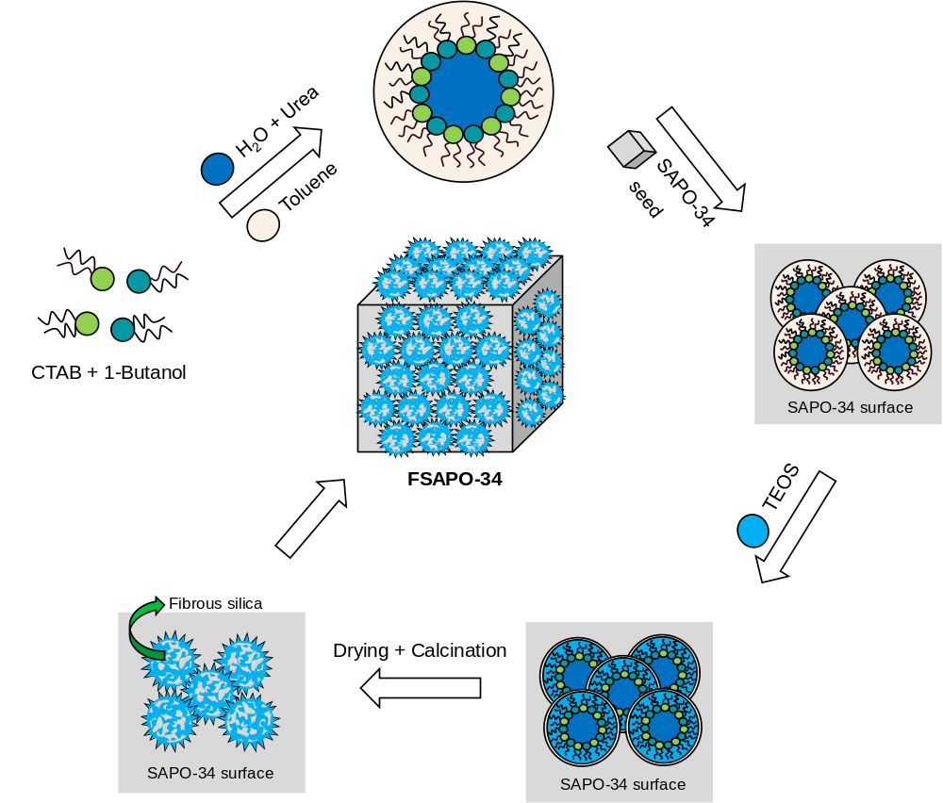
Fig. S1 Proposed mechanism for the formation of fibrous silica-wrapped SAPO-34 (FSAPO-34). Note that the mixture of urea, CTAB, water, 1-butanol, and toluene led to the formation of reverse micelles. The addition of SAPO-34 seeds caused the fibrous silica to aggregate or clump together on the surface of the SAPO-34 while maintaining the cubic structure. Then, the drying and calcination steps eliminate residual components, leaving dendrimeric fibrous silica on the SAPO-34 surface, referred to as FSAPO-34.

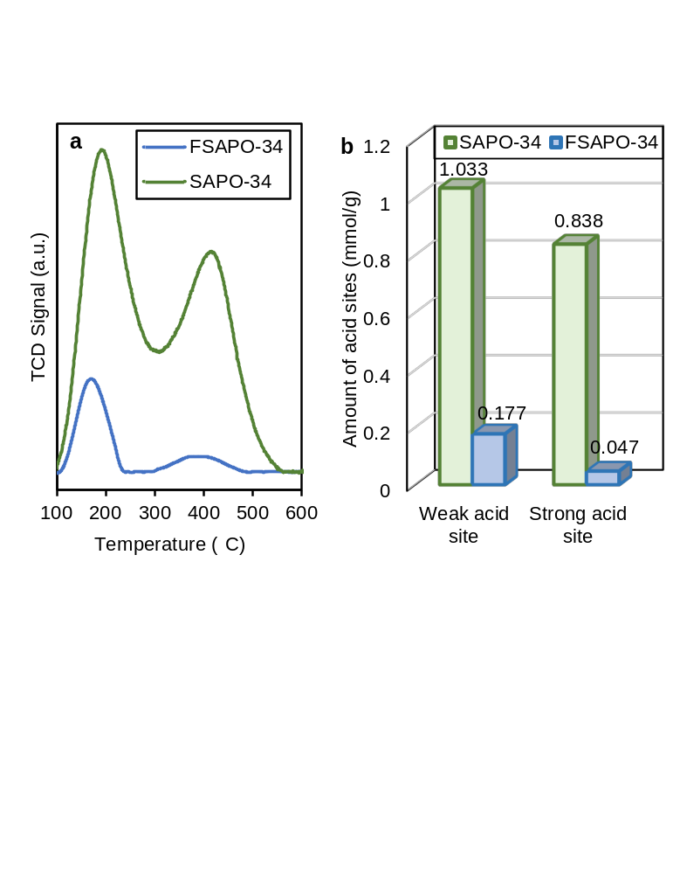
Fig. S2 (a) Ammonia temperature-programmed desorption (NH₃-TPD) profiles and (b) amount of acid sites for SAPO-34 and fibrous silica-wrapped SAPO-34 (FSAPO-34). Note that the formation of fibrous silica on SAPO-34 substantially decreased the weak and strong acid sites of the sample.

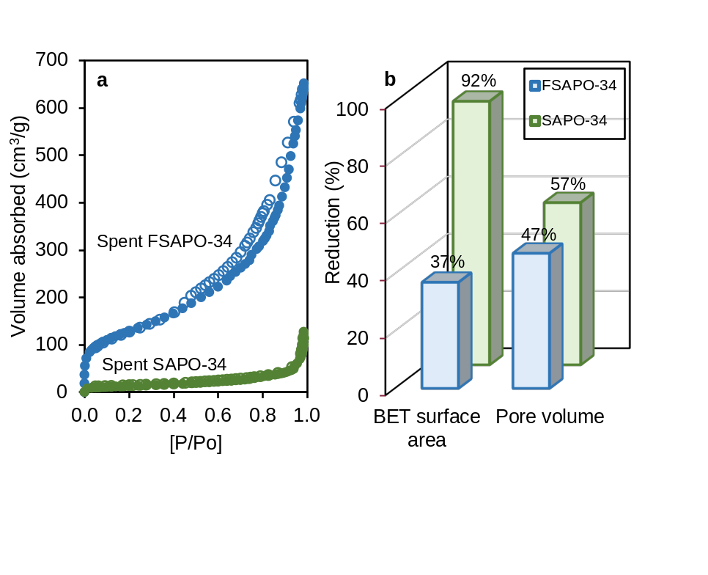
Fig. S3 (a) Nitrogen physisorption and (b) percentage reduction of Brunaeur-Emmet-Teller (BET) surface area and pore volume for spent SAPO-34 and fibrous silica-wrapped SAPO-34 (FSAPO-34). Note that the spent fibrous silica-wrapped SAPO-34 (FSAPO-34) shows a minor reduction in BET surface area and pore volume compared to the spent SAPO-34, indicating lower deposition of coke on the catalyst’s surface and pores.

Table S1. Physical properties of SAPO-34 and FSAPO-34 samples.
Catalyst | ªS_{BET} (m²/g) | ^{b}V_{micro} (cm³/g) | ^{b}V_{meso} (cm³/g) | ^{b}V_{total} (cm³/g) | ^{c}Si/Al | ^{c}Si/P
SAPO-34 | 569 | 0.245 | 0.098 | 0.343 | 2.3 | 0.8
FSAPO-34 | 738 | 0.091 | 1.749 | 1.840 | 13.5 | 17.3
ªS_{BET} (total surface area) was determined by the Brunaeur-Emmet-Teller method.
^{b}V_{micro} (micropore volume), V_{meso} (mesopore volume), and V_{total} (total pore volume) were determined by t-plot method.
^{c}Si/Al and Si/P were determined using inductively coupled plasma optical emission spectrometry (ICP-OES).

Table S2. Product distribution and methanol conversion for commercial SAPO-34 and FSAPO-34
Reaction temperature (°C) | Conversion (%) | Selectivity (%) |  |  |  |  | C₂₌ + C₃₌ yield (%)
Reaction temperature (°C) | Conversion (%) | C₂₌ | C₃₌ | C₂₌ + C₃₌ | DME | Other HCs | C₂₌ + C₃₌ yield (%)
SAPO-34
300 | 90.4 | 30.9 | 23.5 | 54.4 | 4.3 | 41.3 | 49.2
350 | 95.0 | 34.8 | 24.1 | 58.9 | 0.1 | 41.0 | 55.9
400 | 96.3 | 41.7 | 22.3 | 64.0 | 0.2 | 35.8 | 61.7
450 | 98.0 | 56.0 | 18.8 | 74.8 | 0.3 | 24.9 | 73.4
500 | 96.7 | 83.1 | 10.0 | 93.1 | 0.7 | 6.2 | 90.1
FSAPO-34
300 | 35.1 | 32.0 | 11.2 | 43.2 | 27.7 | 29.1 | 15.2
350 | 91.8 | 31.4 | 24.3 | 55.7 | 5.1 | 39.2 | 51.1
400 | 95.4 | 37.5 | 24.7 | 62.2 | 0.8 | 37.1 | 59.3
450 | 96.8 | 52.1 | 19.6 | 71.7 | 0.4 | 27.9 | 69.4
500 | 96.4 | 79.5 | 12.5 | 92.0 | 1.7 | 6.3 | 88.7

References
Abdul Jalil A, Zolkifli AS, Triwahyono S, et al (2019) Altering Dendrimer Structure of Fibrous-Silica-HZSM5 for Enhanced Product Selectivity of Benzene Methylation. Ind Eng Chem Res 58:553–562. https://doi.org/10.1021/acs.iecr.8b03147
Bayal N, Singh B, Singh R, Polshettiwar V (2016) Size and Fiber Density Controlled Synthesis of Fibrous Nanosilica Spheres (KCC-1). Sci Rep 6:. https://doi.org/10.1038/srep24888
Bouizi Y, Diaz I, Rouleau L, Valtchev VP (2005) Core-shell zeolite microcomposites. Adv Funct Mater 15:1955–1960. https://doi.org/10.1002/adfm.200500231
Chen G, Sun Q, Yu J (2017) Nanoseed-assisted synthesis of nano-sized SAPO-34 zeolites using morpholine as the sole template with superior MTO performance. Chemical Communications 53:13328–13331. https://doi.org/10.1039/c7cc07508a
Díaz M, Epelde E, Valecillos J, et al (2021) Coke deactivation and regeneration of HZSM-5 zeolite catalysts in the oligomerization of 1-butene. Appl Catal B 291:. https://doi.org/10.1016/j.apcatb.2021.120076
Febriyanti E, Suendo V, Mukti RR, et al (2016) Further Insight into the Definite Morphology and Formation Mechanism of Mesoporous Silica KCC-1. Langmuir 32:5802–5811. https://doi.org/10.1021/acs.langmuir.6b00675
Firmansyah ML, Jalil AA, Triwahyono S, et al (2016) Synthesis and characterization of fibrous silica ZSM-5 for cumene hydrocracking. Catal Sci Technol 6:5178–5182. https://doi.org/10.1039/c6cy00106h
Huang H-W, Hui Z, Zhang S-H, et al (2019) Effect of silicon to aluminum ratio on the selectivity to propene in methanol conversion over H-ZSM-5 zeolites
Hussain I, Jalil AA, Hassan NS, et al (2020) Fabrication and characterization of highly active fibrous silica-mordenite (FS@SiO2-MOR) cockscomb shaped catalyst for enhanced CO2 methanation. Chem Eng Sci 228:. https://doi.org/10.1016/j.ces.2020.115978
Izadbakhsh A, Farhadi F, Khorasheh F, Yan ZF (2009) Effect of heating profile on desorption curve in temperature programmed desorption analysis: Case study of acid sites distribution of SAPO-34. Journal of Porous Materials 16:599–603. https://doi.org/10.1007/s10934-008-9237-4
Khanmohammadi M, Amani S, Bagheri Garmarudi A, Niaei A (2016) Methanol-to-propylene process: Perspective of the most important catalysts and their behavior. Cuihua Xuebao/Chinese Journal of Catalysis 37:325–339
Li X, Zheng Z, Wang S, et al (2019) Preparation and Characterization of Core–Shell Composite Zeolite BEA@MFI and Their Catalytic Properties in ESR. Catal Letters 149:766–777. https://doi.org/10.1007/s10562-018-2638-3
Mathew DS, Juang RS (2007) Role of alcohols in the formation of inverse microemulsions and back extraction of proteins/enzymes in a reverse micellar system. Sep Purif Technol 53:199–215
Monama W, Mohiuddin E, Thangaraj B, et al (2020) Oligomerization of lower olefins to fuel range hydrocarbons over texturally enhanced ZSM-5 catalyst. Catal Today 342:167–177. https://doi.org/10.1016/j.cattod.2019.02.061
Palčić A, Valtchev V (2020) Analysis and control of acid sites in zeolites. Appl Catal A Gen 606:117795. https://doi.org/10.1016/j.apcata.2020.117795ï
Rostamizadeh M, Yaripour F, Hazrati H (2018) Selective production of light olefins from methanol over desilicated highly siliceous ZSM-5 nanocatalysts. Polyolefins Journal 5:. https://doi.org/10.22063/poj.2017.1501
Siang TJ, Jalil AA, Abdulrahman A, Hambali HU (2021) Enhanced carbon resistance and regenerability in methane partial oxidation to syngas using oxygen vacancy-rich fibrous Pd, Ru and Rh/KCC-1 catalysts. Environ Chem Lett 19:2733–2742. https://doi.org/10.1007/s10311-021-01192-0
Soltanali S, Darian JT (2019) Synthesis of mesoporous SAPO-34 catalysts in the presence of MWCNT, CNF, and GO as hard templates in MTO process. Powder Technol 355:127–134. https://doi.org/10.1016/j.powtec.2019.07.008
Sun Q, Xie Z, Yu J (2018) The state-of-the-art synthetic strategies for SAPO-34 zeolite catalysts in methanol-to-olefin conversion. Natl Sci Rev 5:542–558
Teh LP, Triwahyono S, Jalil AA, et al (2016) Fibrous silica mesoporous ZSM-5 for carbon monoxide methanation. Appl Catal A Gen 523:200–208. https://doi.org/10.1016/j.apcata.2016.05.031
Varzaneh AZ, Towfighi J, Mohamadalizadeh A (2014) Comparative study of naphtha cracking over SAPO-34 and HZSM-5: Effects of cerium and zirconium on the catalytic performance. J Anal Appl Pyrolysis 107:165–173. https://doi.org/10.1016/j.jaap.2014.02.017
Wei R, Li C, Yang C, Shan H (2011) Effects of ammonium exchange and Si/Al ratio on the conversion of methanol to propylene over a novel and large partical size ZSM-5. Journal of Natural Gas Chemistry 20:261–265. https://doi.org/10.1016/S1003-9953(10)60198-3
Zheng T, He P, Zhang R, et al (2022) Seed-assisted synthesis of SAPO-34 zeolites: Genetic effect of seeds. J Taiwan Inst Chem Eng 131:. https://doi.org/10.1016/j.jtice.2022.104211

