Supplementary Information: Constitutive overexpression of a nicotianamine synthase gene in bread wheat and in vivo assessment of iron and zinc bioavailability
Jacquelyn Cheng1, Jesse T. Beasley2, Nikolai Kolba1, Cydney Jackson1, Eliot Dugan1, Alexander A. T. Johnson2 and Elad Tako1 *
¹ Department of Food Science, Cornell University, Ithaca, New York 14853, USA
² School of BioSciences, The University of Melbourne, Parkville, Victoria, 3010, Australia
*Corresponding author: johnsa@unimelb.edu.au

Supplementary Methods
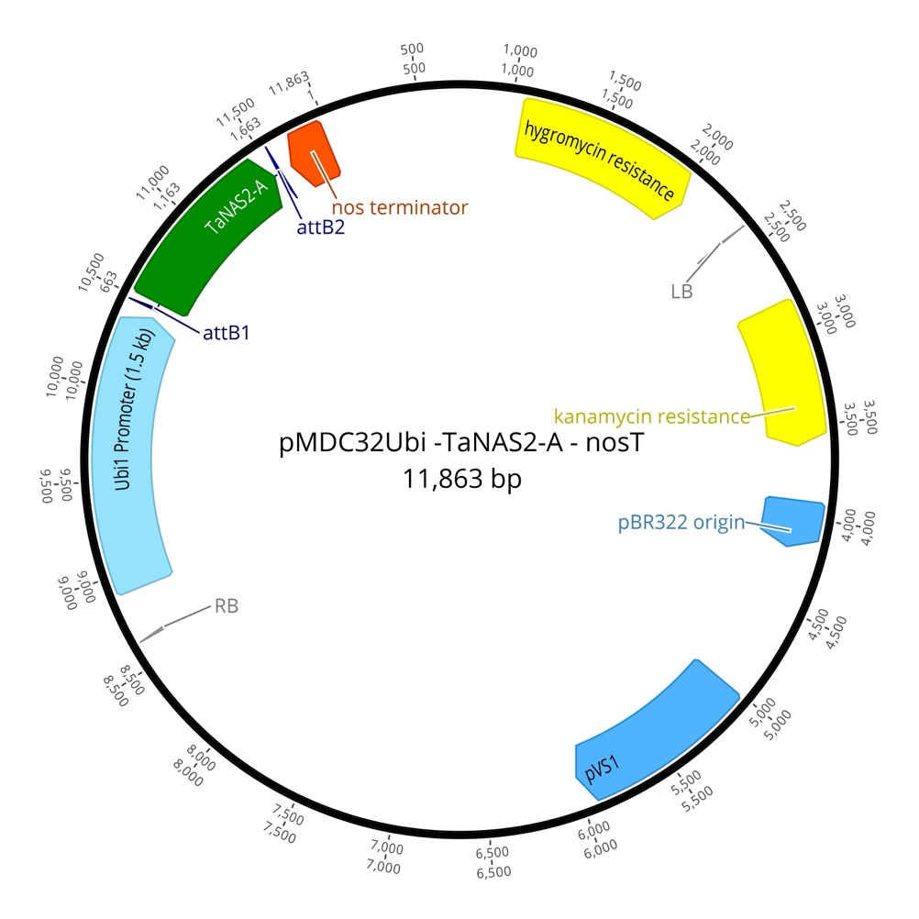
Figure S1. T-DNA construct.

Table S1. Primer sequences used for real-time polymerase chain reaction (RT-PCR). The annealing temperature and GenBank identifier for each gene is provided.
Gene | Location | Forward primer (5'-3') | Reverse primer (5'-3') | GenBank identifier | Annealing temp. (°C)
18s rRNA | Liver, Duodenum | GCAAGACGAACTAAAGCGAAAG | TCGGAACTACGACGGTATCT | 7262899 | 55
DcytB | Duodenum | CATGTGCATTCTCTTCCAAAGTC | CTCCTTGGTGACCGCATTAT | 20380692 | 56
DMT1 | Duodenum | TTGATTCAGAGCCTCCCATTAG | GCGAGGAGTAGGCTTGTATTT | 206597489 | 54.9
Ferro-portin | Duodenum | CTCAGCAATCACTGGCATCA | ACTGGGCAACTCCAGAAATAAG | 61098365 | 55
Hepcidin | Liver | AGACGACAATGCAGACTAACC | CTGCAGCAATCCCACATTTC | SAMN08056490 | 51
PAT1 | Duodenum | CCTCCATTGGGTACTTCTTACTG | CAGCACTGGGCACAGATATT | CR524358.1 | 50.1
SI | Duodenum | CCAGCAATGCCAGCATATTG | CGGTTTCTCCTTACCACTTCTT | 2246388 | 56
MUC2 | Duodenum | CCTGCTGCAAGGAAGTAGAA | GGAAGATCAGAGTGGTGCATAG | 423101 | 55
IL6 | Duodenum | ACCTCATCCTCCGAGACTTTA | GCACTGAAACTCCTGGTCTT | 302315692 | 53
TNF-α | Duodenum | GACAGCCTATGCCAACAAGTA | TTACAGGAAGGGCAACTCATC | 53854909 | 54
NF-κB1 | Duodenum | CACAGCTGGAGGGAAGTAAAT | TTGAGTAAGGAAGTGAGGTTGAG | 2130627 | 54.5
Δ6-desaturase | Liver | GGCGAAAGTCAGCCTATTGA | AGGTGGGAAGATGAGGAAGA | 261865208 | 55.5
ZIP4 | Duodenum | TCTCCTTAGCAGACAATTGAG | GTGACAAACAAGTAGGCGAAAC | 107050877 | 55.4
ZIP9 | Duodenum | CTAAGCAAGAGCAGCAAAGAAG | CATGAACTGTGGCAACGTAAAG | 237874618 | 56
ZnT1 | Duodenum | GGTAACAGAGCTGCCTTAACT | GGTAACAGAGCTGCCTTAACT | 54109718 | 52.6
PCK1 | Liver | GCGATGGCTCAGAAGAAGAA | CTTGCTACGTCTCTTGGGTTAG | 396458 | 57.2
G6PC1 | Liver | GTCTGTCTGTCCCGCATTT | CATGGTAGATGGAGTGGATGTG | 100857298 | 57.2
18S rRNA, 18S ribosomal subunit; DcytB, duodenal cytochrome b; DMT1, divalent metal transporter 1; PAT1, Proton-coupled amino acid transporter 1; SI, sucrose isomaltase; MUC2, mucin 2; IL6, interleukin 6; NF-_{Κ}B, nuclear factor kappa B subunit 1; TNF-α, tumor necrosis factor-alpha; ZIP4, zinc transport protein 4; ZIP9, zinc transport protein 9; ZnT1, zinc transporter 1; PCK1, phosphoenolpyruvate carboxykinase; G6PC1, glucose-6-phosphatase catalytic subunit 1.
Supplementary Results

Supplementary Table S2. Osmolality, Zn, and Fe concentration of OE-TaNAS2A (NA-biofortified) and null segregant (control) whole wheat flour extracts and Zn solution for intraamniotic administration. The mean of three technical replicates depicted. NS, null segregant; OE, overexpression; Zn, 20 mg/kg ZnSO₄.
Group | Osmolality | Zn (µg/g) | Fe (µg/g)
No injection | -- | - | -
H₂O injection | 25 | - | -
Zn | 33.5 | 20 | -
NS-1 | 78 | 0.25 | 0.49
OE-TaNAS2-1 | 79 | 0.43 | 1.00
NS-2 | 80 | 0.28 | 0.73
OE-TaNAS2-2 | 81 | 0.72 | 1.03
NS-3 | 79 | 0.39 | 0.60
OE-TaNAS2-3 | 81 | 0.35 | 0.63

Supplementary Table S3. Plasma Zn and Fe concentration following intraamniotic administration of OE-TaNAS2A (NA-biofortified) and null segregant (control) whole wheat flour extracts on day of hatch (Day 21). Data shown is the mean of three technical replicates from a single pooled plasma sample from 3-6 biological replicates. NS, null segregant; OE, overexpression; Zn, 20 mg/kg ZnSO₄.

Group | Plasma Zn  (µg/g) | Plasma Fe  (µg/g)
No injection | 1.80 | 4.80
H₂O injection | 1.20 | 12.24
Zn | 1.14 | 8.40
NS-1 | 0.80 | 6.00
OE-TaNAS2-1 | 1.08 | 10.64
NS-2 | - | -
OE-TaNAS2-2 | 1.05 | 4.05
NS-3 | 1.20 | 6.75
OE-TaNAS2-3 | 0.96 | 8.52

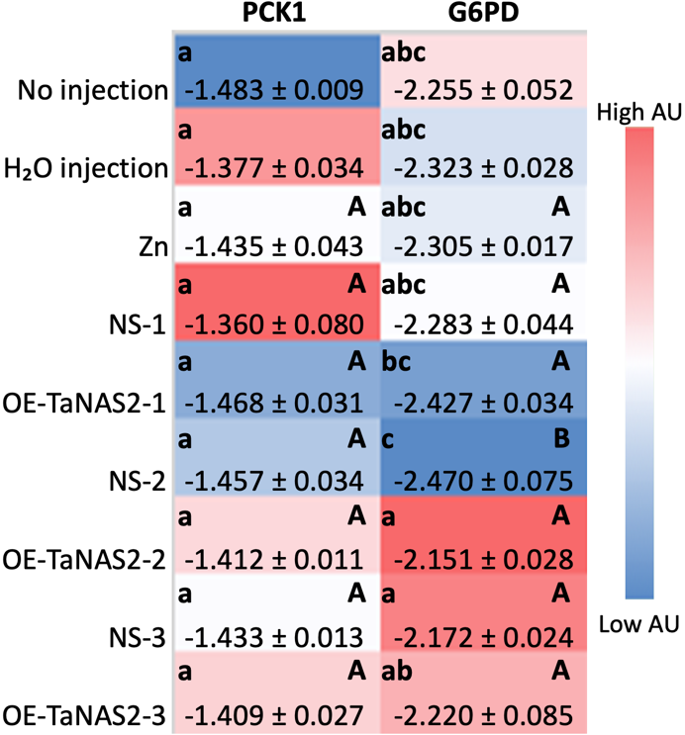
Supplementary Figure S2. Effect of intraamniotic administration of OE-TaNAS2A (NA-biofortified) wheat and null segregant (control) whole wheat flour extracts on chicken duodenal gluconeogenesis mRNA gene expression on day of hatch (Day 21). Gene expression has been normalized to the 18S housekeeping gene, is shown in arbitrary units (AU), and has been log2 transformed. Values are presented as mean ± SEM of 3-6 biological replicates, each with two technical replicates of quantitative RT-PCR. ^{a-c} Per gene (in the same column), treatments groups not indicated by the same letter are significantly different (p < 0.05) according to one-way ANOVA with post-hoc Duncan test. ^{A, B} Per gene (in the same column), each OE-TaNAS2A group relative to its respective null segregant group indicated by different letters is significantly different (p < 0.05) as determined by Student’s t-test. NS, null segregant; OE, overexpression; Zn, 20 mg/kg ZnSO₄. PCK1, phosphoenolpyruvate carboxykinase; G6PC1, glucose-6-phosphatase catalytic subunit 1.

Supplementary Table S4. Effect of intraamniotic administration of OE-TaNAS2A wheat (NA-biofortified) and null segregant (control) whole wheat flour extracts on duodenal villi goblet cell type and count. Values are the means ± SEM. Three biological samples per treatment group and four segments for each biological sample were analyzed. Ten randomly selected villi were analyzed per segment and cell size measurements and counts were counted in ten randomly selected villi per segment (40 replicates per biological sample). ^{a-f} Treatment groups not indicated by the same letter in the same column are significantly different (p < 0.05) as determined by one-way ANOVA and post-hoc Duncan test. ^{A, B} Per parameter, each OE-TaNAS2A group relative to its respective null segregant group indicated by different letters is significantly different (p < 0.05) as determined by Student’s t-test. NS, null segregant; OE, overexpression; Zn, 20 mg/kg ZnSO₄.
Group | Villi Goblet Cell Number (Unit)
Group | Acidic | Neutral | Mixture | Total
No injection | 15.83 ± 0.66 ᶠ | 0.00 ± 0.00 ᶜ | 2.08 ± 0.17 ᶜᵈ | 17.92 ± 0.67 ᵉ
H₂O injection | 27.16 ± 0.76 ᵈ | 0.03 ± 0.02 ᶜ | 3.97 ± 0.32 ᵃᵇ | 31.16 ± 0.82 ᵇᶜ
Zn | 27.51 ± 0.87 ᵈ | 0.07 ± 0.04 ᶜ | 4.27 ± 0.29 ᵃ | 31.84 ± 1.00 ᵇ
NS-1 | 28.48 ± 0.83 ᶜᵈ, ᴬ | 0.30 ± 0.08 ᵇ, ᴮ | 2.62 ± 0.33 ᶜ, ᴬ | 31.39 ± 0.93 ᵇᶜ, ᴬ
OE-TaNAS2-1 | 22.87 ± 0.99 ᵉ^{, B} | 0.94 ± 0.14 ᵃ, ᴬ | 3.33 ± 0.22 ᵇ, ᴬ | 27.13 ± 1.05 ᵈ, ᴮ
NS-2 | 27.04 ± 0.80 ᵈ^{, B} | 0.22 ± 0.09 ᵇᶜ, ᴬ | 1.27 ± 0.17 ᵉᶠ, ᴮ | 28.53 ± 0.81 ᶜᵈ, ᴮ
OE-TaNAS2-2 | 34.81 ± 1.15 ᵃ, ᴬ | 0.08 ± 0.03 ᶜ, ᴮ | 1.92 ± 0.16 ᶜᵈᵉ, ᴬ | 36.49 ± 1.18 ᵃ, ᴬ
NS-3 | 30.53 ± 0.87 ᵇᶜ, ᴬ | 0.11 ± 0.04 ᵇᶜ, ᴬ | 0.92 ± 0.14 ᶠ, ᴮ | 31.56 ± 0.88 ᵇ, ᴮ
OE-TaNAS2-3 | 32.49 ± 0.94 ᵃᵇ, ᴬ | 0.00 ± 0.00 ᶜ, ᴬ | 1.66 ± 0.19 ᵈᵉ, ᴬ | 34.15 ± 0.95 ᵃᵇ, ᴬ

Supplementary Table S5. Effect of intraamniotic administration of OE-TaNAS2A wheat (NA-biofortified) and null segregant (control) whole wheat flour extracts on duodenal crypt goblet cell type and count. Values are the means ± SEM. Three biological samples per treatment group and four segments for each biological sample were analyzed. Ten randomly selected crypts were analyzed per segment and cell size measurements and counts were counted in ten randomly selected crypts per segment (40 replicates per biological sample). ^{a-e} Treatment groups not indicated by the same letter in the same column are significantly different (p < 0.05) as determined by one-way ANOVA and post-hoc Duncan test. ^{A, B} Per parameter, each OE-TaNAS2A group relative to its respective null segregant group indicated by different letters is significantly different (p < 0.05) as determined by Student’s t-test. NS, null segregant; OE, overexpression; Zn, 20 mg/kg ZnSO₄.
Group | Crypt Goblet Cell Number (Unit)
Group | Acidic | Neutral | Mixture | Total
No injection | 5.73 ± 0.32 ᵇᶜ | 0.03 ± 0.03 ᵃ | 1.82 ± 0.19 ᵃ | 7.57 ± 0.39 ᵃᵇ
H₂O injection | 7.29 ± 0.36 ᵃ | 0.00 ± 0.00 ᵃ | 0.98 ± 0.12 ᵇ | 8.27 ± 0.38 ᵃ
Zn | 5.47 ± 0.32 ᵇᶜᵈ | 0.00 ± 0.00 ᵃ | 1.92 ± 0.15 ᵃ | 7.38 ± 0.39 ᵃᵇ
NS-1 | 5.05 ± 0.28 ᵇᶜᵈ, ᴬ | 0.00 ± 0.00 ᵃ, ᴬ | 1.10 ± 0.10 ᵇ, ᴬ | 6.15 ± 0.31 ᶜᵈ, ᴬ
OE-TaNAS2-1 | 4.81 ± 0.25 ᶜᵈ, ᴬ | 0.01 ± 0.01 ᵃ, ᴬ | 0.93 ± 0.09 ᵇ, ᴬ | 5.74 ± 0.26 ᵈ, ᴬ
NS-2 | 4.58 ± 0.24 ᵈ, ᴮ | 0.00 ± 0.00 ᵃ, ᴬ | 1.02 ± 0.12 ᵇ, ᴬ | 5.60 ± 0.28 ᵈ, ᴮ
OE-TaNAS2-2 | 5.62 ± 0.30 ᵇᶜ, ᴬ | 0.00 ± 0.00 ᵃ, ᴬ | 1.23 ± 0.10 ᵇ, ᴬ | 6.85 ± 0.33 ᵇᶜ, ᴬ
NS-3 | 5.85 ± 0.27 ᵇ, ᴮ | 0.00 ± 0.00 ᵃ, ᴬ | 1.14 ± 0.12 ᵇ, ᴬ | 6.99 ± 0.3 ᵇᶜ, ᴮ
OE-TaNAS2-3 | 7.40 ± 0.31 ᵃ, ᴬ | 0.00 ± 0.00 ᵃ, ᴬ | 0.99 ± 0.09 ᵇ, ᴬ | 8.39 ± 0.32 ᵃ, ᴬ

