Supplementary Information for:
Spatiotemporal analysis of Holiday Climate Index for urban and beach destinations in Greece.

Petrou Ilias* and Kassomenos Pavlos
Laboratory of Meteorology, Department of Physics, University of Ioannina, University Campus, GR-45110, Ioannina, Greece
*Corresponding author at: Laboratory of Meteorology, Department of Physics, University of Ioannina, University Campus, GR-45110, Ioannina, Greece, E-mail address: petroui@hotmail.com (I. Petrou).

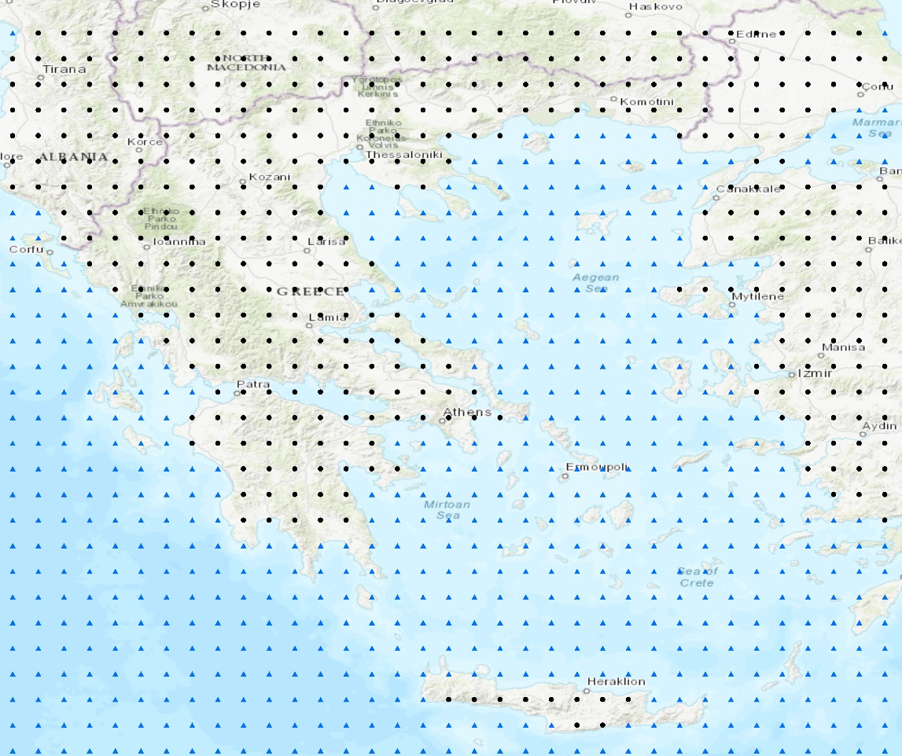
Fig. S1 The geographical domain used in this study. Black dots indicate the continental areas and blue triangles the maritime ones.

Table S1 The SSP scenario experiments used in this study and their description
SSP scenarios | Description
SSP1-2.6 | Sustainable development, low population growth, reduced inequality, and a balanced approach to economic, social, and environmental priorities. In this "best case" scenario, temperature increase stabilizes at around 1.8°C and the radiative forcing reaches 2.6 Wm⁻² by the end of the century. Sustainable practices are adopted across all sectors, leading to strongly reduced CO₂ emissions and reduced environmental degradation compared to other scenarios
SSP2-4.5 | A middle-of-the-road scenario where the world's development is characterized by moderate population growth, intermediate levels of economic development, and a balanced focus on environmental conservation and social equity. Under this scenario CO₂ emissions remain at present levels until the middle of the century, when they start to decrease, while temperatures rise by 2.7°C.
SSP5-8.5 | Substantial environmental degradation, climate change impacts, societal challenges, high energy use, rapid economic growth and limited environmental regulation. Continuously rising emissions throughout the 21st century (CO₂ emissions are almost doubled by 2050) and the planet's average temperature will have increased by a disastrous 4.4°C by the year 2100.

Table S2 Rating for Thermal Comfort (based on Humidex), aesthetic (cloud cover), precipitation and wind speed aspects scores for ${HCI}_{Beach}$ index.
Beach
Thermal Comfort (TC) |  | Aesthetic |  | Precipitation (mm) |  | Wind speed (km/h)
Humidex (º C) |  | Cloud cover (%)
Min – Max | Rating | Min – Max | Rating | Min – Max | Rating | Min – Max | Rating
-9999 – 9.9 | -10 | 0 – 0.99 | 8 | 0 – 0.01 | 10 | 0 – 0.59 | 8
10 – 14.99 | -5 | 1 – 14.99 | 9 | 0.01 – 2.99 | 9 | 0.6 – 9.99 | 10
15 – 16.99 | 0 | 15 – 25.99 | 10 | 3 – 5.99 | 8 | 10 – 19.99 | 9
17 – 17.99 | 1 | 26 – 35.99 | 9 | 6 – 8.99 | 6 | 20 – 29.99 | 8
18 – 18.99 | 2 | 36 – 45.99 | 8 | 9 – 11.99 | 4 | 30 – 39.99 | 6
19 – 19.99 | 3 | 46 – 55.99 | 7 | 12 – 24.99 | 0 | 40 – 49.99 | 3
20 – 20.99 | 4 | 56 – 65.99 | 6 | 25 – 9999 | -1 | 50 – 69.99 | 0
21 – 21.99 | 5 | 66 – 75.99 | 5 |  |  | 70 – 9999 | -10
22 – 22.99 | 6 | 76 – 85.99 | 4
23 – 23.99 | 7 | 86 – 95.99 | 3
26 – 27.99 | 9 | 96 – 9999 | 2
28 – 30.99 | 10
31 – 32.99 | 9
33 – 33.99 | 8
34 – 34.99 | 7
35 – 35.99 | 6
36 – 36.99 | 5
37 – 37.99 | 4
38 – 3899 | 2
39 – 9999 | 0

Table S3 Rating for Thermal Comfort (based on Humidex), aesthetic (cloud cover), precipitation and wind speed aspects scores for ${HCI}_{Urban}$ index.
Urban
Thermal Comfort (TC) |  | Aesthetic |  | Precipitation (mm) |  | Wind speed (km/h)
Humidex (º C) |  | Cloud cover (%)
Min – Max | Rating | Min – Max | Rating | Min – Max | Rating | Min – Max | Rating
-9999 – -6 | 1 | 0 – 0.99 | 8 | 0 – 0.01 | 10 | 0 – 0.01 | 8
-5.99 – -0.01 | 2 | 1 – 10.99 | 9 | 0.01 – 2.99 | 9 | 0.02 – 9.99 | 10
0 – 6.99 | 3 | 11 – 20.99 | 10 | 3 – 5.99 | 8 | 10 – 19.99 | 9
7 – 10.99 | 4 | 21 – 30.99 | 9 | 6 – 8.99 | 5 | 20 – 29.99 | 8
11 – 14.99 | 5 | 31 – 40.99 | 8 | 9 – 11.99 | 2 | 30 – 39.99 | 6
15 – 17.99 | 6 | 41 – 50.99 | 7 | 12 – 24.99 | 0 | 40 – 49.99 | 3
18 – 19.99 | 7 | 51 – 60.99 | 6 | 25 – 9999 | -1 | 50 – 69.99 | 0
20 – 22.99 | 9 | 61 – 70.99 | 5 |  |  | 70 – 9999 | -10
23 – 25.99 | 10 | 71 – 80.99 | 4
26 – 26.99 | 9 | 81 – 90.99 | 3
27 – 28.99 | 8 | 91 – 99.99 | 2
29 – 30.99 | 7 | 100 - 101 | 1
31 – 32.99 | 6
33 – 34.99 | 5
35 – 36.99 | 4
37 – 38.99 | 2
39 – 9999 | 0

Table S4 Rating for ${HCI}_{Beach}$ and ${HCI}_{Urban}$ indices.
HCI _{Beach} and HCI _{Urban}
Score | Rating
0 – 19.99 | Dangerous
20 – 39.99 | Unacceptable
40 – 49.99 | Marginal
50 – 59.99 | Acceptable
60 – 69.99 | Good
70 – 79.99 | Very Good
80 – 89.99 | Excellent
90 – 100 | Ideal

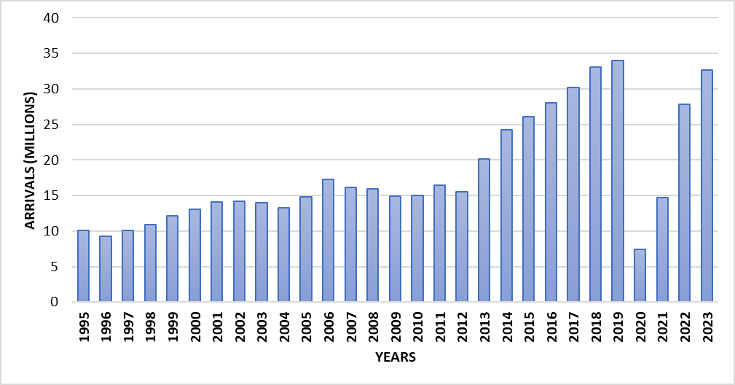
Fig. S2 International tourist arrivals in Greece during the period 1995–2023.

Table S5 Sen’s slope and Mann-Kendall test results for the annual mean of future HCI rating per climate scenario.
 | HCI Beach |  |  | HCI Urban
 | 2025 - 2099 |  |  | 2025 - 2099
 | Slope | Significance |  | Slope | Significance
SSP1-2.6 June | -0.04 | a |  | -0.05 | a
SSP1-2.6 July | -0.02 |  |  | -0.02
SSP1-2.6 August | -0.01 |  |  | -0.02
SSP2-4.5 June | -0.1 | a |  | -0.125 | a
SSP2-4.5 July | -0.1 | b |  | -0.156 | b
SSP2-4.5 August | -0.08 | b |  | -0.1 | c
SSP5-8.5 June | -0.15 | a |  | -0.2 | a
SSP5-8.5 July | -0.1 | c |  | -0.1 | b
SSP5-8.5 August | -0.08 | b |  | -0.08 | c
Blank cells denote significance level >0.1.
ª Highly significant: p value ≤ 0.001.
^{b} Very significant: p value ≤ 0.01.
^{c} Significant: 0.01< p value ≤ 0.05.
^{d} Not Significant: 0.05< p value ≤ 0.1.

