A. Data analytic Procedures
We provide detailed descriptions of the digital twins (DTs), including the hierarchical Bayesian model (HBM) core, evaluation procedures for the DT predictions, and methods for incorporating DT predictions as informative priors in qCSF testing. The HBM encompasses population, subject, and test levels, leveraging conditional dependency across levels and covariance hyperparameters to constrain parameters of the contrast sensitivity function (CSF) across subjects and conditions. By integrating historical data (Group I) and new data in each prediction task, the HBM generates posterior CSF parameter distributions for each test in the historical data and predicts Group II outcomes in unmeasured conditions. Additionally, we outline procedures for quantifying the accuracy and precision of DT predictions and using them as informative priors to both rescore existing data and simulate the qCSF procedure.
OVERVIEW of the HBM
We first organized the trial-by-trial data as $y_{ijkm}=\left(f_{ijkm},c_{ijkm}, r_{ijkm}\right),$ where $r_{ijkm}$, either correct or incorrect, is individual i’s response in trial m of test k in experimental condition j tested with a stimulus of spatial frequency $f_{ijkm}$and contrast $c_{ijkm}$. We then modeled the contrast sensitivity $S\left(f_{ijkm},θ_{ijk}\right)$ at spatial frequency $f_{ijkm}$with a log parabola function with three parameters, $θ_{ijk}=\left(γ_{ijk}^{max},f_{ijk}^{max},β_{ijk}\right)$[1–3].
The three-level HBM incorporates conditional dependencies across test, individual, and population levels to improve estimates of CSF parameters for each test (Figure S1) [4]. The HBM consists of (1) trial-by-trial response probabilities in each CSF test determined by a log-parabola model of the contrast sensitivity function with three parameters and a psychometric function, (2) conditional dependency of CSF parameters at the test level on hyperparameters at the individual level, (3) conditional dependency of CSF hyperparameters at the individual level on those at the population level.
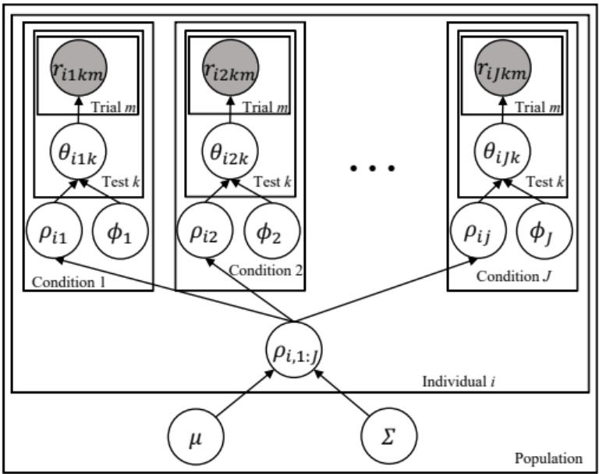
Figure S1. A three-level hierarchical Bayesian model (HBM) of CSFs across multiple individuals, conditions and tests. At the population level, $μ$ and $Σ$ are the mean and covariance hyperparameters of the population distribution $η$. At the individual level $ρ_{ij}$ and $ϕ_{j}$ are the mean and covariance hyperparameters of $τ_{ij}$distribution of the individual i in experimental condition j. At the test level, $θ_{ijk}$ is the CSF parameter of individual i in test k of condition j.

In the HBM, the joint distribution of CSF hyperparameters $η$ across all the J experimental conditions at the population level, $p(η)$, is modeled as a mixture of 3$×$J-dimensional Gaussian distributions $N$ with mean $μ$ and covariance $Σ$. The joint distribution of CSF hyperparameter $τ_{i1:J}$ of individual i across all experimental conditions 1:J at the individual level, $p\left(τ_{i1:J} | η\right)$, is modeled as a mixture of 3-dimensional Gaussian distributions with mean $ρ_{ij}$ and covariance $ϕ_{j}$. Finally, at the test level, $p(θ_{ijk}|τ_{ij})$, the joint distribution of the CSF parameters, $θ_{ijk}$, is conditioned on $τ_{ij}$.
The probability of obtaining the entire dataset $p\left(Y_{1:I,1:J,1:K,1:M} | X\right)$ is computed by probability multiplication of the priors and likelihoods of obtaining the data across all subjects and tests, where $X={(θ}_{1:I,1:J,1:K},ρ_{1:I,1:J},ϕ_{1:J},μ,Σ)$ are all the parameters and hyperparameters in the HBM, and $Y_{1:I,1:J,1:K,1:M}=\left\{y_{ijkm} \right\}$, for i=1, …, I, j=1, …, J, k=1, … K, and m = 1, …, M, where I is the total number of subjects, J is the total number of conditions, K is the total number of repetitions of each test, and M is the total number of trials in a test.
We use Bayes’ rule to compute the joint posterior distribution of the CSF parameters and hyperparameters in an entire dataset, including both the historical data and the new data to generate marginal distributions in unmeasured conditions for predictions.
The implementation described here is equivalent to but deviates in terms of the computational procedure from the conceptual representation in Figure 1, where the HBM is solely applied to the historical data, and the DTs integrate the joint posterior distribution from the historical data and new data to generate marginal distributions in unmeasured conditions for predictions. Our implementation leverages all accessible data, encompassing both historical and new data, to produce predictions that are more accurate and precise while simplifying the computation.
Computing the HBM
The Markov Chain Monte Carlo (MCMC) algorithm facilitated efficient sampling of the posterior distributions through a random walk procedure [5]. Starting at a randomly chosen position in the 1089-dimensional parameter spaces for the HBM, the algorithm randomly selected one of the parameters at each step. The one-dimensional conditional posterior probability distribution of the selected parameter was then evaluated by fixing the values of all the other parameters at the current position. A new value of the selected parameter was chosen based on the one-dimensional conditional probability distribution. This process was repeated until a convergence criterion was met. For the BIP, the random walk followed a similar procedure but only in a one-dimensional parameter space for each CS estimate.
Implementation of the MCMC was carried out using the R [6] function run.jags in JAGS [7]. This generated 2,000 kept representative samples (thinning ratio = 100) of the joint posterior distribution of $θ_{ij1}$(3 parameters/condition $×$ 3 conditions $×$ 112 subjects=1008 parameters), $ρ_{i1:J}$ (9 parameters), $ϕ_{j}$ (6 parameters/condition $×$ 3 conditions =18 parameters), $μ$ (9 parameters), and $Σ$ (45 parameters) in each of the three MCMC chains with for the HBM after 10000 burn-in and 100000 adaptation steps. The number of adaptation steps were selected for convergence based on the Gelman and Rubin diagnostic rule [8] for each parameter, ensuring that the Gelman and Rubin statistics for all the parameters smaller than 1.05. The HBMs were fit to the first 25 (L = 25) and all 50 qCSF trials (L = 50), with the results on the first 25 trials reported in the main text and the results on 50 trials presented in Supplemental Material C. We have excluded the MCMC chains with significant autocorrelations based on the Ljung-Box test [9] ($α=$ 0.05 and with Bonferroni correction) in subsequent statistical analyses.
Evaluation of the HBM predictions
The three-dimensional posterior distributions from the original qCSF served as the observed standard. To quantify the similarity between observed and predicted three-dimensional CSF parameter distributions, a linear discriminant classifier was implemented with MATLAB function fitcdiscr. Areas under the log CSF (AULCSF) was computed between 1.5 ad 18 cpd. The absolute mean AULCSF difference between the qCSF and HBM at the test level was used to quantify the accuracy of the estimates. The standard deviation (SD) of the posterior distribution of the AULCSF at the test level was used to quantify the precision of the estimates.

Rescoring and simulations with informative priors
Construction Informative priors based on the predictions from the HBM
Predictions from the HBMs were used as the informative priors. For each test, 4000 MCMC samples were binned into the same three-dimensional CSF parameter grid (Table S1) used in the qCSF test.
Table S1. The minimum and maximum linear value, and number of grid points (evenly distributed in log₁₀ units) of the CSF parameter grid in the qCSF test.
 | PG | PF | BW
min | 1.05 | 0.1 | 1
max | 1050 | 20 | 9
# grid points | 60 | 40 | 27
PG: peak gain; PF: peak spatial frequency; BW: bandwidth.

Evaluation
Accuracy was measured as the absolute difference between the observed and rescored/simulated AULCSF, while precision was quantified as the standard deviations (SD) of the rescored/simulated AULCSF. The accuracy and precision of the rescored/simulated AULCSF were statistically equivalent to those from the qCSF when the absolute difference and SD were less than one SD from the qCSF plus the SD of SDs across all tests from the qCSF.

B. Supplementary results from the first 25 qCSF trials (L = 25)
Correlations in the Historical Data
Figures S2, S3, and S4 show the posterior distributions of the CSF hyperparameters and parameters of the HBM model at the population, subject, and test levels based on the historical data with 25 qCSF trials.
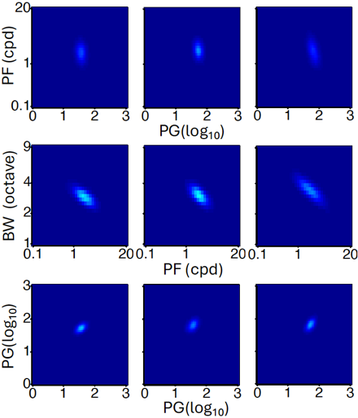
Figure S2. Two-dimensional marginal posterior distributions of $η$ from the HBM modeling of the historical data with 25 qCSF trials. Row 1: PG and PF components in the L (column 1), M (column 2), and H (column 3) conditions. Row 2: PF and BW components in the L (column 1), M (column 2), and H (column 3) conditions. Row 3: PG components in the L and M (column 1), L and H (column 2), and M and H (column 3) conditions.

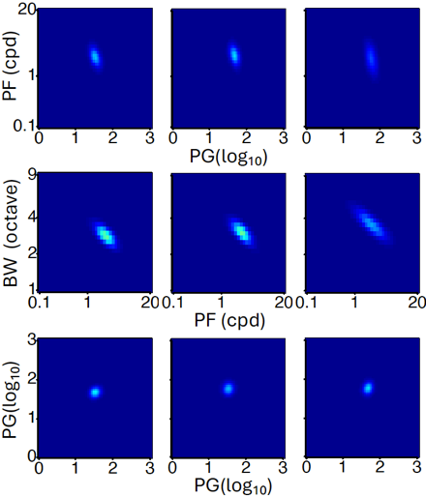
Figure S3. Two-dimensional marginal posterior distributions of $τ_{i}$ from the HBM of a typical individual i from the historical data with 25 qCSF trials. Row 1: PG and PF components in the L (column 1), M (column 2), and H (column 3) conditions. Row 2: PF and BW components in the L (column 1), M (column 2), and H (column 3) conditions. Row 3: PG components in the L and M (column 1), L and H (column 2), and M and H (column 3) conditions.

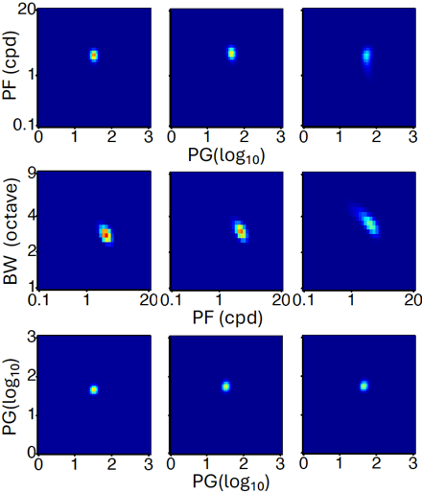
Figure S4. Two-dimensional marginal posterior distributions of $θ_{ij}$ at the test level from the HBM for the same individual in Figure S3 from the historical data with 25 qCSF trials. Row 1: PG and PF components in the L (column 1), M (column 2), and H (column 3) conditions. Row 2: PF and BW components in the L (column 1), M (column 2), and H (column 3) conditions. Row 3: PG components in the L and M (column 1), L and H (column 2), and M and H (column 3) conditions.

Additional Subject Level Predictions
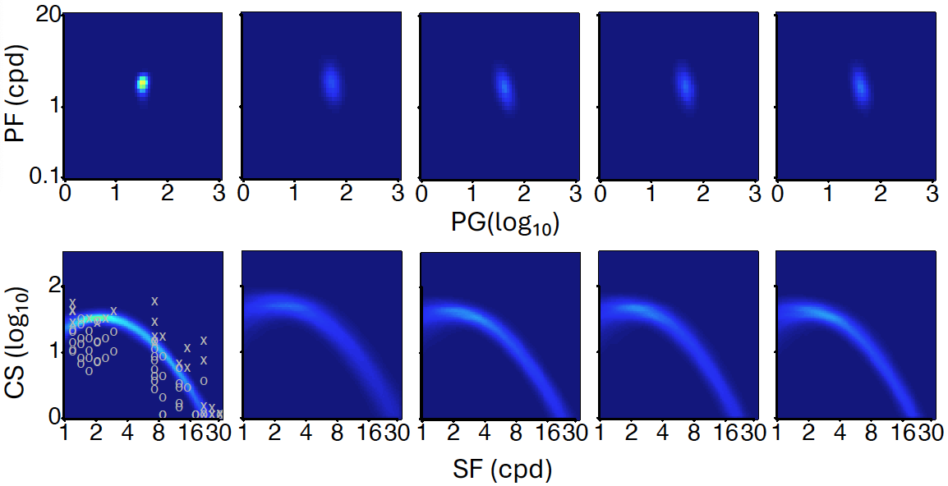
Figure S5. Predictions for subject #90 in the medium luminance condition. Column 1: Posterior distribution of peak gain and peak frequency (row 1) and the contrast sensitivity function (row 2) from the observed data. Columns 2-5: Predicted distributions of PG and PF (row 1) and CSF with no data (column 2), data in the L (column 3), H (column 4), and both the L and H (column 5) conditions. Circles and crosses represent correct and incorrect trials from the qCSF test.

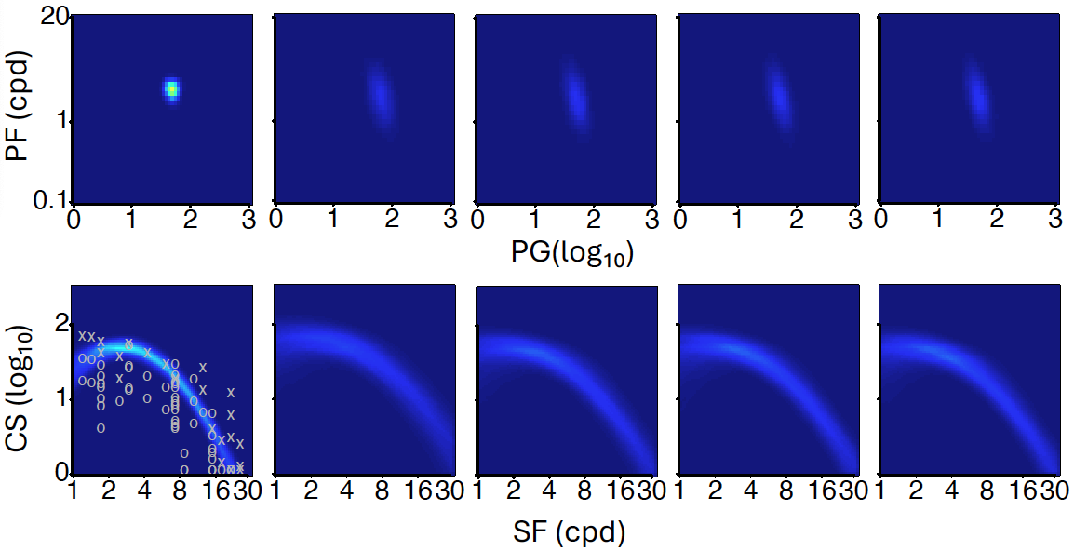
Figure S6. Predictions for subject #90 in the high luminance condition. Column 1: Posterior distribution of peak gain and peak frequency (row 1) and the contrast sensitivity function (row 2) from the observed data. Columns 2-5: Predicted distributions of PG and PF (row 1) and CSF with no data (column 2), data in the L (column 3), M (column 4), and both the L and M (column 5) conditions. Circles and crosses represent correct and incorrect trials from the qCSF test.

Additional Group Level Predictions
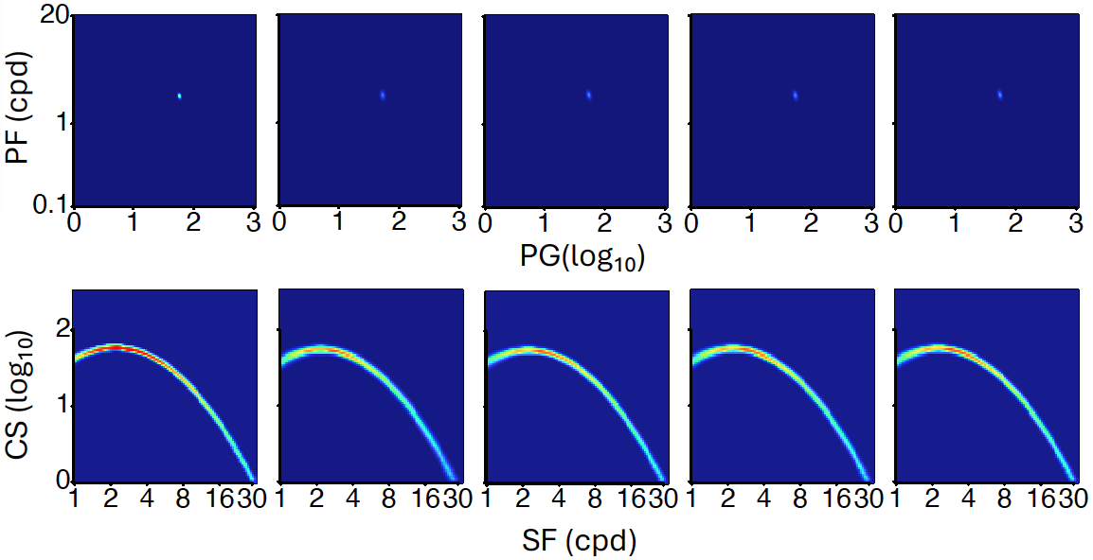
Figure S7. Group-level predictions in the medium luminance condition with 25 qCSF trials. Column 1: Posterior distribution of peak gain and peak frequency (row 1) and the contrast sensitivity function (row 2) from the observed data. Columns 2-5: Predicted distributions of PG and PF (row 1) and CSF with no data (column 2), data in the L (column 3), H (column 4), and both the L and H (column 5) conditions. Circles and crosses represent correct and incorrect trials from the qCSF test.

The predicted parameter and CSF distributions in the 12 prediction tasks at the group level were constructed by averaging the corresponding distributions from all 56 subjects in Group II with 25 qCSF trials. Figures S7 and S8 display the observed and predicted distributions of peak gain and peak frequency, as well as the corresponding CSF distributions at the group level in the M and H luminance conditions, respectively.

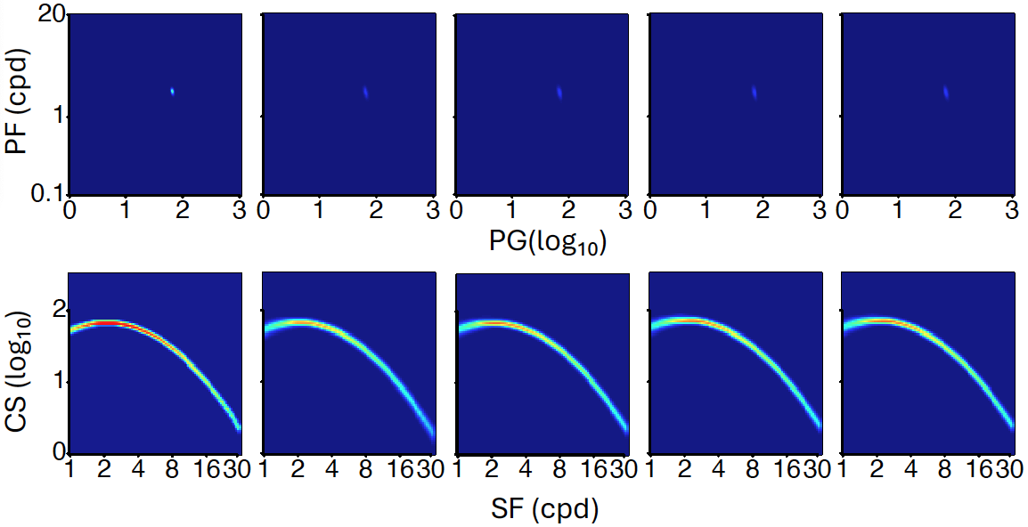
Figure S8. Group-level predictions in the high luminance condition with 25 qCSF trials. Column 1: Posterior distribution of peak gain and peak frequency (row 1) and the contrast sensitivity function (row 2) from the observed data. Columns 2-5: Predicted distributions of PG and PF (row 1) and CSF with no data (column 2), data in the L (column 3), M (column 4), and both the L and M (column 5) conditions. Circles and crosses represent correct and incorrect trials from the qCSF test.

C. Supplementary results from the 50 qCSF trials (L = 50)
Correlations in the Historical Data
Figures S9, S10, and S11 show the posterior distributions of the CSF hyperparameters and parameters of the HBM model at the population, subject, and test levels based on the historical data with 50 qCSF trials.
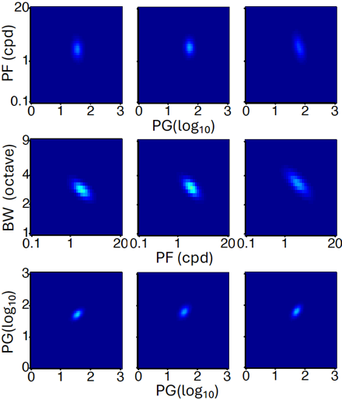
Figure S9. Two-dimensional marginal posterior distributions of $η$ from the HBM modeling of the historical data with 50 qCSF trials. Row 1: PG and PF components in the L (column 1), M (column 2), and H (column 3) conditions. Row 2: PF and BW components in the L (column 1), M (column 2), and H (column 3) conditions. Row 3: PG components in the L and M (column 1), L and H (column 2), and M and H (column 3) conditions.

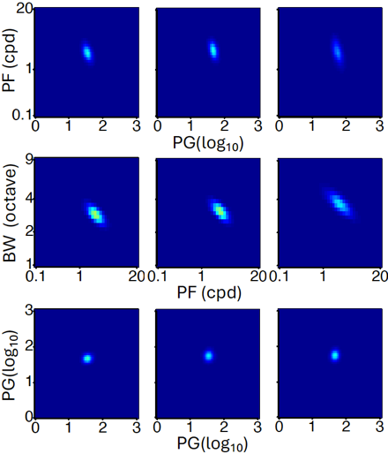
Figure S10. Two-dimensional marginal posterior distributions of $τ_{i}$ from the HBM of a typical individual i from the historical data with 50 qCSF trials. Row 1: PG and PF components in the L (column 1), M (column 2), and H (column 3) conditions. Row 2: PF and BW components in the L (column 1), M (column 2), and H (column 3) conditions. Row 3: PG components in the L and M (column 1), L and H (column 2), and M and H (column 3) conditions.
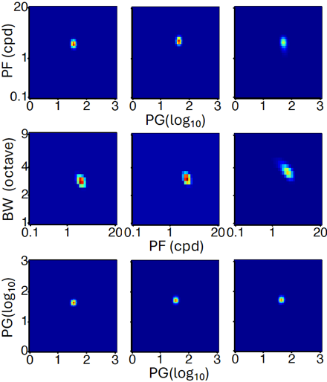
Figure S11. Two-dimensional marginal posterior distributions of $θ_{ij}$ at the test level from the HBM for the same individual in Figure S10 from the historical data with 50 qCSF trials. Row 1: PG and PF components in the L (column 1), M (column 2), and H (column 3) conditions. Row 2: PF and BW components in the L (column 1), M (column 2), and H (column 3) conditions. Row 3: PG components in the L and M (column 1), L and H (column 2), and M and H (column 3) conditions.

Table S2. Between-subject correlations of CSF hyperparameters at the population level from the HBM of the historical data with 50 qCSF trials.

 |  | L |  |  | M |  |  | H
 |  | PG | PF | BW | PG | PF | BW | PG | PF | BW
L | PG | 1 | -0.047 | 0.106 | 0.578 | 0.186 | -0.141 | 0.440 | -0.026 | 0.138
L | PF | -0.047 | 1 | -0.772 | 0.270 | 0.394 | -0.102 | 0.268 | 0.021 | 0.161
L | BW | 0.106 | -0.772 | 1 | -0.105 | -0.235 | 0.297 | -0.132 | -0.001 | 0.088
M | PG | 0.578 | 0.270 | -0.105 | 1 | -0.036 | 0.008 | 0.560 | -0.008 | 0.117
M | PF | 0.186 | 0.394 | -0.235 | -0.036 | 1 | -0.756 | 0.200 | 0.062 | 0.051
M | BW | -0.141 | -0.102 | 0.297 | 0.008 | -0.756 | 1 | -0.115 | -0.077 | 0.273
H | PG | 0.440 | 0.268 | -0.132 | 0.560 | 0.200 | -0.115 | 1 | -0.460 | 0.372
H | PF | -0.026 | 0.021 | -0.001 | -0.008 | 0.062 | -0.077 | -0.460 | 1 | -0.816
H | BW | 0.138 | 0.161 | 0.088 | 0.117 | 0.051 | 0.273 | 0.372 | -0.816 | 1
PG: peak gain; PF: peak spatial frequency; BW: bandwidth.

Tables S2, S3, and S4 present correlation matrices from the historical data with 50 qCSF trials used to train the HBM. At the population level, the HBM revealed strong positive correlations between peak gains across luminance conditions (0.440 to 0.578) and strong negative correlations between peak spatial frequency and bandwidth within each luminance condition (-0.816 to -0.756). Similarly, at the subject level, it identified strong negative correlations between peak gain and peak spatial frequency (-0.519 to -0.435) and strong negative correlations between peak spatial frequency and bandwidth within each luminance condition (-0.904 to -0.882). Additionally, at the test level, the model found strong negative correlations between peak spatial frequency and bandwidth within each luminance condition (-0.887 to -0.884).
Table S3. Within-subject correlations of CSF hyperparameters at the subject level from the HBM of the historical data with 50 qCSF trials.

 |  | L |  |  | M |  |  | H
 |  | PG | PF | BW | PG | PF | BW | PG | PF | BW
L | PG | 1 | -0.475 | 0.196
L | PF | -0.475 | 1 | -0.887
L | BW | 0.196 | -0.887 | 1
M | PG |  |  |  | 1 | -0.435 | 0.113
M | PF |  |  |  | -0.435 | 1 | -0.886
M | BW |  |  |  | 0.113 | -0.886 | 1
H | PG |  |  |  |  |  |  | 1 | -0.519 | 0.213
H | PF |  |  |  |  |  |  | -0.519 | 1 | -0.884
H | BW |  |  |  |  |  |  | 0.213 | -0.884 | 1
PG: peak gain; PF: peak spatial frequency; BW: bandwidth.

Table S4. Correlations of CSF parameters at the test level from the HBM of the historical data with 50 qCSF trials.
.
 |  | L |  |  | M |  |  | H
 |  | PG | PF | BW | PG | PF | BW | PG | PF | BW
L | PG | 1 | -0.221 | -0.066
L | PF | -0.221 | 1 | -0.906
L | BW | -0.066 | -0.906 | 1
M | PG |  |  |  | 1 | -0.175 | -0.132
M | PF |  |  |  | -0.175 | 1 | -0.900
M | BW |  |  |  | -0.132 | -0.900 | 1
H | PG |  |  |  |  |  |  | 1 | -0.227 | -0.082
H | PF |  |  |  |  |  |  | -0.227 | 1 | -0.897
H | BW |  |  |  |  |  |  | -0.082 | -0.897 | 1
PG: peak gain; PF: peak spatial frequency; BW: bandwidth.

These robust correlations indicate that CSF hyperparameters and parameters are highly correlated between- and within-subjects/conditions at all three levels of the hierarchy from the HBM of the historical data with 50 qCSF trials. They represent the fundamental mathematical properties utilized by the digital twins to make predictions.
Subject Level Predictions
In the section, the results of the 12 prediction tasks at the individual subject level are presented from the HBM of the historical data with 50 qCSF trials. By utilizing the observed data from all subjects in Group II, a comparison was made between the predictions and the actual observed data. Generally, the alignment between predictions and observations improved as more new data became available for computing the predictions, resulting in increased accuracy and precision. For example, predictions for the low luminance (L) condition showed improvements from having no new data to having data in either the medium (M) or high (H) luminance condition, and further improvement with data in both the M and H conditions.
To quantify the similarity between observed and predicted CSF parameter distributions, a linear discriminant classifier was used. A p-value of 1.0 indicates complete alignment, while a p-value of 0.0 indicates complete separation. Accuracy was measured as the absolute difference between the observed and predicted areas under the log CSF (AULCSF), while precision was quantified as the standard deviations of the predicted AULCSFs.
The first column of Figure S12 presents the observed posterior distribution of peak gain and peak frequency, along with the observed posterior CSF distribution for a typical subject (#90) in the low luminance condition with 50 qCSF trials. Columns 2 to 5 display the predicted parameter and CSF distributions under different scenarios: no new data, new data in the medium (M), new data in the high (H), and new data in both the M and H conditions, respectively.

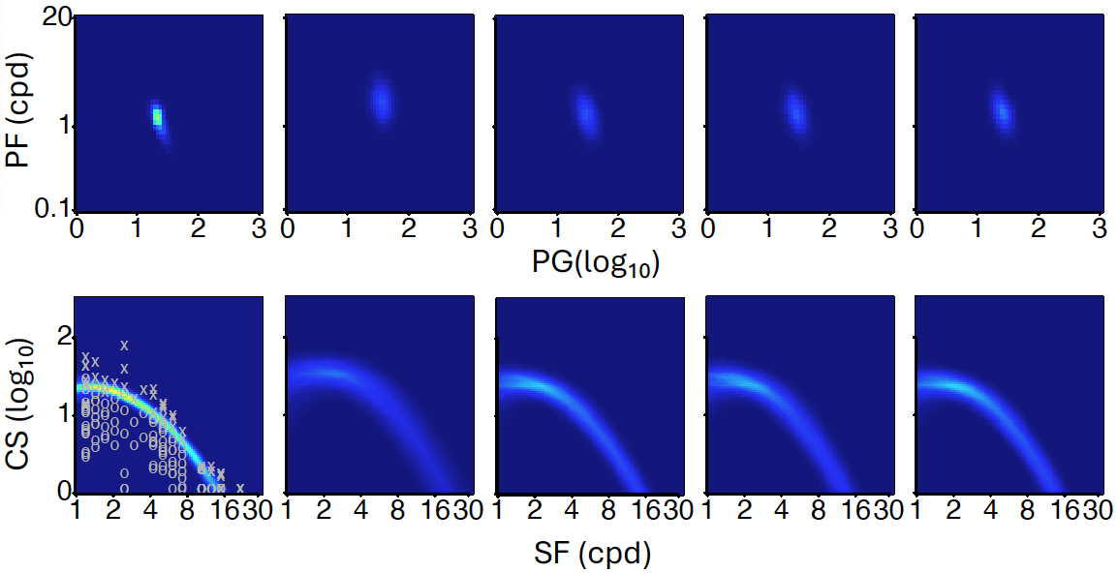
Figure S12. Predictions for subject #90 in the low luminance condition with 50 qCSF trials. Column 1: Posterior distribution of peak gain and peak frequency (row 1) and the contrast sensitivity function (row 2) from the observed data. Columns 2-5: Predicted distributions of PG and PF (row 1) and CSF with no data (column 2), data in the M (column 3), H (column 4), and both the M and H (column 5) conditions. Circles and crosses represent correct and incorrect trials from the qCSF test.

The p-values obtained from the linear discriminant analysis of the observed and predicted CSF parameter distributions were 0.16, 0.19, 0.35, and 0.31 for the four prediction results. These values indicate that the predicted CSF parameter distributions were not significantly different from the observed distributions.
Regarding accuracy, the absolute differences between the predicted and observed areas under the log CSF (AULCSFs) were 0.354, 0.056, 0.077, and 0.038 log10 units, respectively. Considering that the standard deviation of the observed AULCSF was 0.031 log₁₀ units, the predicted AULCSFs were not significantly different from the observed AULCSF when there was new data for the prediction. However, the standard deviations of the predicted AULCSFs were 0.174, 0.131, 0.110, and 0.104 log₁₀ units, respectively, indicating less precision compared to the observed AULCSF.
The results for the prediction tasks in the medium (M) and high (H) luminance conditions with 50 qCSF trials were similar (Figures S13 and S14). For instance, in the M condition, the p-values between the predicted and observed CSF parameter distributions were 0.10, 0.20, 0.23, and 0.32. The absolute differences between the predicted and observed AULCSFs were 0.309, 0.053, 0.107, and 0.046 log10 units, while the standard deviations of the predicted AULCSFs were 0.142, 0.110, 0.093, and 0.088 log₁₀ units. In comparison, the standard deviation of the observed AULCSF was 0.035 log10 units.
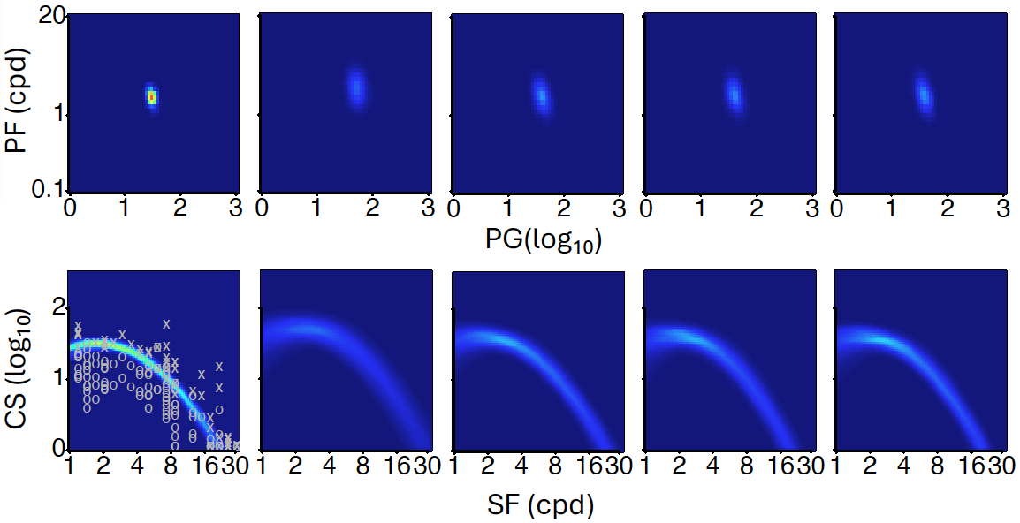
Figure S13. Predictions for subject #90 in the medium luminance condition with 50 qCSF trials. Column 1: Posterior distribution of peak gain and peak frequency (row 1) and the contrast sensitivity function (row 2) from the observed data. Columns 2-5: Predicted distributions of PG and PF (row 1) and CSF with no data (column 2), data in the L (column 3), H (column 4), and both the L and H (column 5) conditions. Circles and crosses represent correct and incorrect trials from the qCSF test.

Similarly, in the H condition with 50 qCSF trials, the p-values between the predicted and observed CSF parameter distributions were 0.13, 0.17, 0.17, and 0.16. The absolute differences between the predicted and observed AULCSFs were 0.292, 0.085, 0.120, and 0.073 log₁₀ units, while the standard deviations of the predicted AULCSFs were 0.144, 0.113, 0.118, and 0.108 log₁₀ units. In comparison, the standard deviation of the observed AULCSF was 0.038 log10 units.

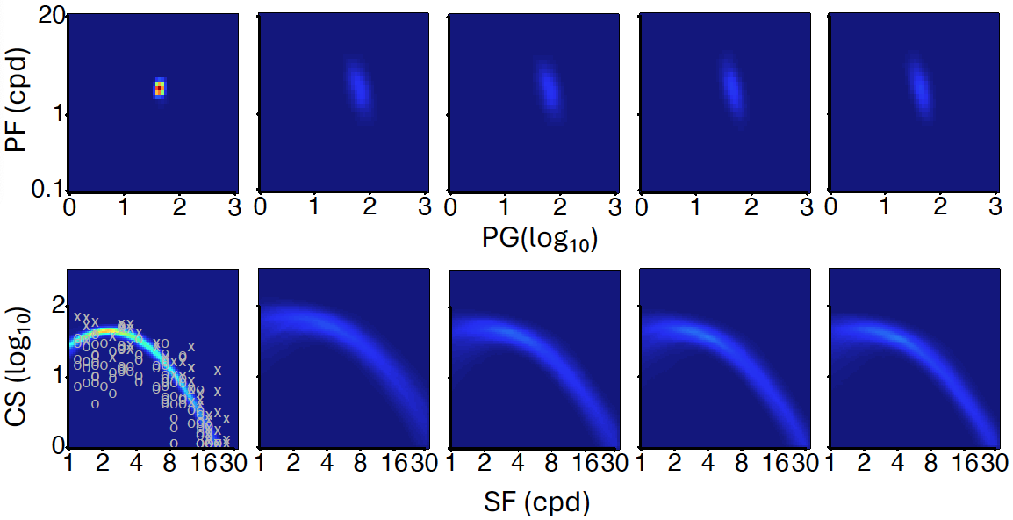
Figure S14. Predictions for subject #90 in the high luminance condition with 50 qCSF trials. Column 1: Posterior distribution of peak gain and peak frequency (row 1) and the contrast sensitivity function (row 2) from the observed data. Columns 2-5: Predicted distributions of PG and PF (row 1) and CSF with no data (column 2), data in the L (column 3), M (column 4), and both the L and M (column 5) conditions. Circles and crosses represent correct and incorrect trials from the qCSF test.

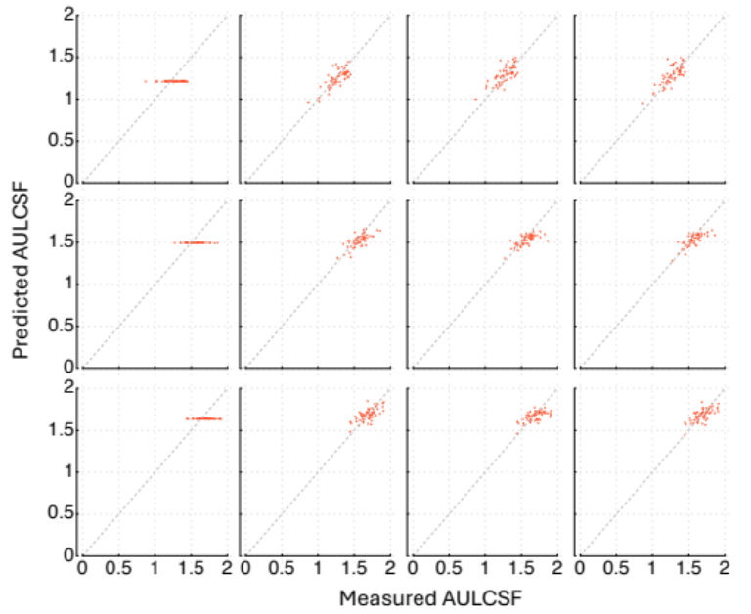
Figure S15. Scatter plots of the predicted and observed AULCSFs with 50 qCSF trials. Row 1: The L condition with no data (column 1), new data in the M (column 2), H (column 3), and both the M and H conditions (column 4). Row 2: The M condition with no data (column 1), data in L (column 2), H (column 3), and both L & H (column 4); in the H (row 3) with no data (column 1), data in L (column 2), M (column 3), and both L & M (column 4).

Across all 12 prediction tasks for all 56 subjects in Group II, none of the predicted CSF parameter distributions were significantly different from the observed with 50 qCSF trials (α=0.05, with Bonferroni correction). Figure S15 displays scatter plots of the predicted and observed areas under the log CSF (AULCSFs) for all subjects in the 12 prediction tasks.
Tables S5 and S6 present, with 50 qCSF trials, the average absolute differences between the predicted and observed AULCSFs and the average standard deviations of the predicted AULCSFs across all 56 subjects in the 12 prediction tasks, with standard error (SE) in parenthesis. The average absolute differences decreased with the amount of new data available, indicating improved accuracy. Consistent with results for subject #90, the predicted AULCSFs were not significantly different from the observed when any new data became available. Similarly, precision of the predicted AULCSF also improved with the amount of new data available.
Table S5. Average absolute difference between the predicted and observed AULCSFs with 50 qCSF trials in log₁₀ units, with SE in parenthesis.
 | Number of conditions with new data
 | 0 | 1 |  | 2
L | .109 (.010) | .056 (.006) | .054 (.006) | .050 (.005)
M | .105 (.009) | .054 (.005) | .048 (.005) | .041 (.004)
H | .094 (.009) | .052 (.006) | .059 (.006) | .051 (.006)

Table S6. Average standard deviations of the predicted AULCSFs with 50 qCSF trials in log₁₀ units, with SE in parenthesis.
 | Number of conditions with new data
 | 0 | 1 |  | 2
L | .178 (.0003) | .123 (.0006) | .108 (.0004) | .102 (.0004)
M | .143 (.0002) | .093 (.0006) | .085 (.0003) | .076 (.0004)
H | .147 (.0003) | .103 (.0004) | .109 (.0003) | .099 (.0004)

With 50 qCSF trials, the average standard deviations of the predicted AULCSFs ranged from 0.176 to 0.102, 0.143 to 0.076 and 0.147 to 0.099 for the L, M, and H prediction tasks, respectively. In comparison, the average SDs of the observed AULCSFs were 0.037, 0.040, and 0.043 log₁₀ units in the three conditions. On average, the SDs of the predicted AULCSFs with data from 0, 1, and 2 luminance conditions were 3.9, 2.6, and 2.3 times those from the observed data (Wilcoxon Signed-Rank Test¹⁰, all p < 0.01, with Bonferroni correction).
Group Level Predictions
The predicted parameter and CSF distributions in the 12 prediction tasks at the group level were constructed by averaging the corresponding distributions from all 56 subjects in Group II with 50 qCSF trials. Figures S16, S17, and S18 display the observed and predicted distributions of peak gain and peak frequency, as well as the corresponding CSF distributions at the group level in the L, M and H luminance conditions, respectively.
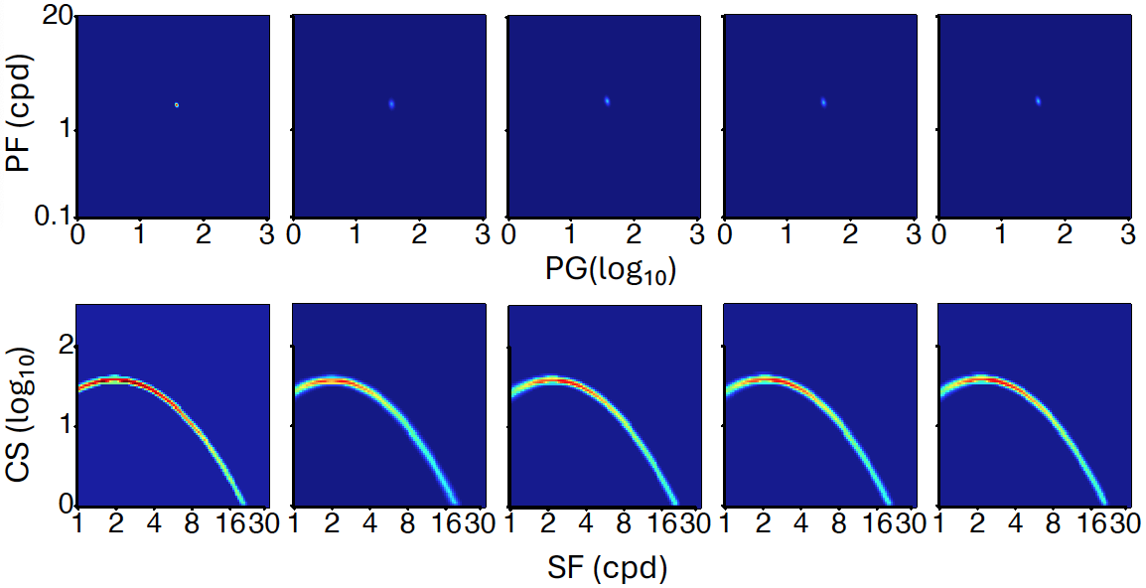
Figure S16. Group level predictions in the low luminance condition with 50 qCSF trials. Column 1: Posterior distribution of peak gain and peak frequency (row 1) and the contrast sensitivity function (row 2) from the observed data. Columns 2-5: Predicted distributions of PG and PF (row 1) and CSF with no data (column 2), data in the M (column 3), H (column 4), and both the M and H (column 5) conditions. Circles and crosses represent correct and incorrect trials from the qCSF test.

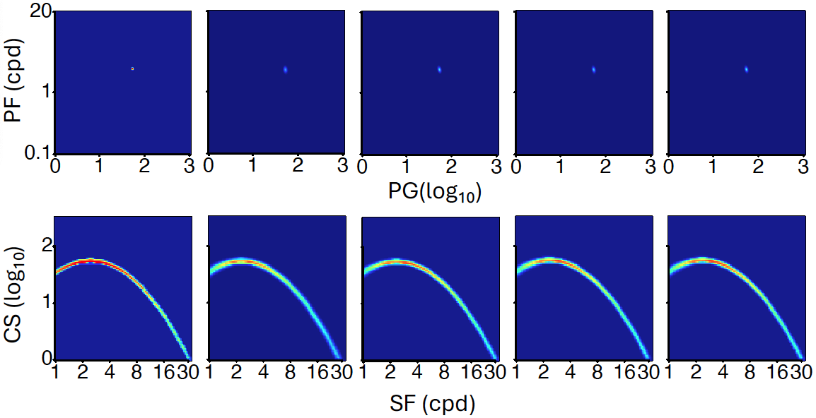
Figure S17. Group-level predictions in the medium luminance condition with 50 qCSF trials. Column 1: Posterior distribution of peak gain and peak frequency (row 1) and the contrast sensitivity function (row 2) from the observed data. Columns 2-5: Predicted distributions of PG and PF (row 1) and CSF with no data (column 2), data in the L (column 3), H (column 4), and both the L and H (column 5) conditions. Circles and crosses represent correct and incorrect trials from the qCSF test.

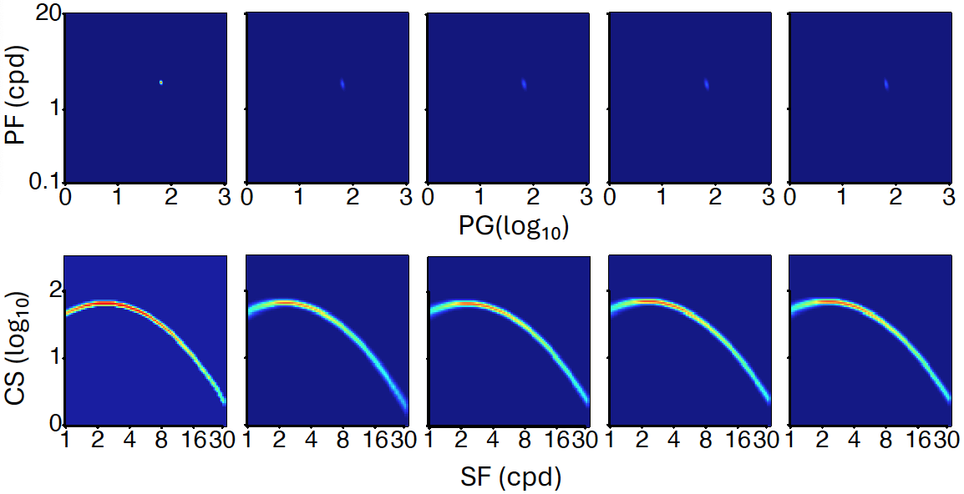
Figure S18. Group-level predictions in the high luminance condition with 50 qCSF trials. Column 1: Posterior distribution of peak gain and peak frequency (row 1) and the contrast sensitivity function (row 2) from the observed data. Columns 2-5: Predicted distributions of PG and PF (row 1) and CSF with no data (column 2), data in the L (column 3), M (column 4), and both the L and M (column 5) conditions. Circles and crosses represent correct and incorrect trials from the qCSF test.

None of the predicted CSF parameter distributions at the group level were significantly different from the observed with 50 qCSF trials (all p > 0.05). Tables S7 and S8 present the absolute differences between the predicted and observed AULCSFs and standard deviations of the predicted AULCSFs at the group level. Both the accuracy and precision of the predicted AULCSFs improved with the amount of new data available. The absolute difference between the predicted and observed AULCSFs ranged from 0.001 to 0.048 log₁₀ units, suggesting that the predicted AULCSFs were very close to the observed. The standard deviations of the predicted AULCSFs ranged from 0.016 to 0.037 log₁₀ units. In comparison, the standard deviations of the observed AULCSFs were 0.005, 0.005, and 0.006 log₁₀ units in the L, M, and H conditions. On average, the SDs of the predicted AULCSFs with new data from 0, 1, and 2 luminance conditions were 5.4, 3.7, and 3.3 times of the SDs of the observed AULCSFs. This suggests that while they were quite accurate, the predicted AULCSFs exhibited greater variabilities compared to the observed data.
Table S7. Absolute differences between the predicted and observed AULCSFs at the group level (log₁₀ units) with 50 qCSF trials.
 | Number of conditions with new data
 | 0 | 1 |  | 2
L | 0.038 | 0.006 | 0.027 | 0.026
M | 0.048 | 0.014 | 0.010 | 0.007
H | 0.032 | 0.008 | 0.001 | 0.008

Table S8. Standard deviations of the predicted AULCSFs at the group level (log₁₀ units) with 50 qCSF trials.

 | Number of conditions with new data
 | 0 | 1 |  | 2
L | 0.037 | 0.026 | 0.022 | 0.021
M | 0.028 | 0.019 | 0.018 | 0.016
H | 0.027 | 0.020 | 0.021 | 0.019

Using Predicted Parameter Distributions as Informative Priors
We evaluated the benefits of using the predicted parameter distributions in the 12 prediction tasks from the HBM with 50 qCSF trials as informative priors in the qCSF procedure. First, we used the informative priors to rescore existing data collected with an un-informative prior and evaluated the number of trials necessary to achieve comparable precision and statistically equivalent AULCSFs obtained with 50 qCSF trials. Because the stimulus sequences were not optimized with the informative priors in the existing dataset, we additionally used the informative priors in a simulated qCSF procedure to further evaluate the number of trials that can be saved when they were incorporated into the qCSF procedure directly.
Figure S19 shows the average absolute difference between the rescored and observed AULCSFs across all the 56 subjects in group II as functions of the number of qCSF trials used in rescoring, as well as the average standard deviations of the rescored AULCSFs. Both the average absolute differences and SDs decreased with the number of trials used in rescoring.
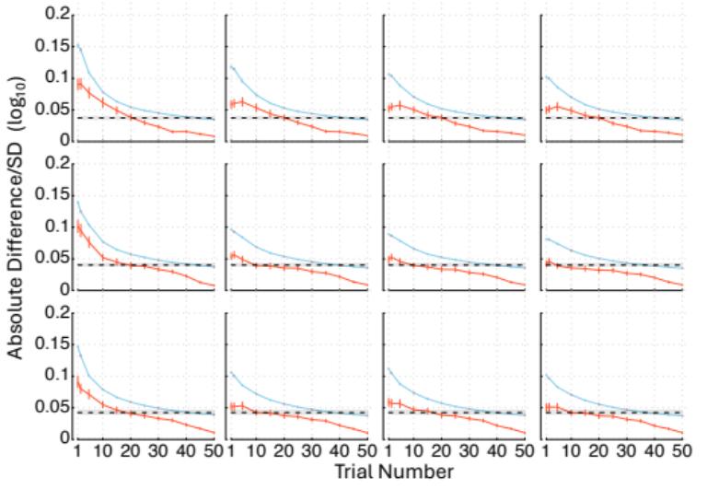
Figure S19. Average absolute difference between the rescored and observed AULCSF (orange solid lines) across all the 56 subjects in Group II as functions of the number of qCSF trials used in rescoring and average standard deviations of the rescored AULCSFs (blue solid lines), with informative priors from the HBM with 50 qCSF trials. In row 1, results in the low luminance condition are displayed with no data (column 1), data in the medium luminance condition (column 2), high luminance condition (column 3), and both the medium and high luminance conditions (column 4). Row 2 shows results in the medium luminance condition with no data (column 1), data in the low luminance condition (column 2), high luminance condition (column 3), and both the low and high luminance conditions (column 4). In row 3, results in the high luminance condition are presented with no data (column 1), data in the low luminance condition (column 2), medium luminance condition (column 3), and both the low and medium luminance conditions (column 4). The black dashed lines represent the average standard deviations of the observed AULCSF with standard deviation, and error bars indicate standard errors.

Figure S20 depicts histograms of the number of trials needed in rescoring to reach statistically equivalent precision as the observed AUCLSFs. On average, 32.9 $±$ 0.2 trials were necessary. We also determined the number of trials needed to obtain estimated AULCSFs that are not significantly different from the observed and found that 11.1 $±$ 0.5 trials on average were required. Combining these results together, we conclude that the informative priors from the HBM with 50 qCSF trials, even without trial-by-trial optimal stimulus selection, can save about 17.1 trials or 34% of the data collection burden in qCSF.

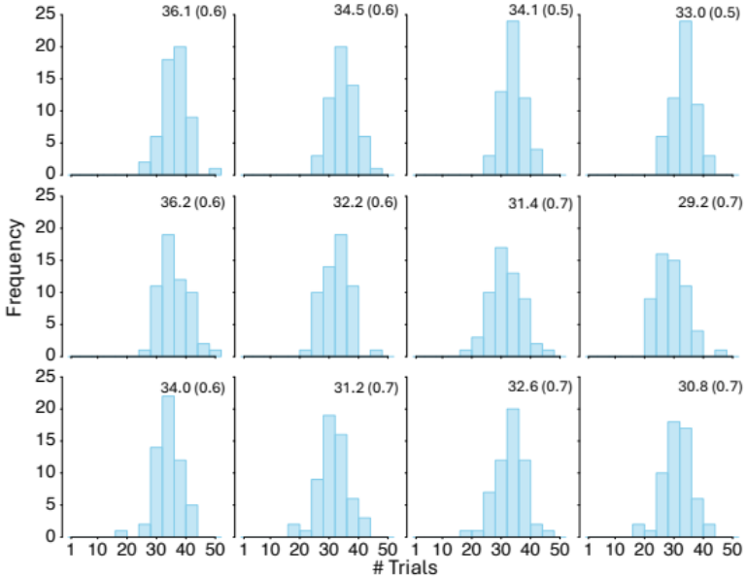
Figure S20. Histograms of the number of trials needed to reach comparable precision as the observed AUCLSF in rescoring, with informative priors from the HBM with 50 qCSF trials. Row 1: results in the low luminance condition with no data (column 1), data in the M (column 2), H (column 3), and both the M and H (column 4) conditions. Row 2: results in the medium luminance condition with no data (column 1), data in the L (column 2), H (column 3), and both the L and H (column 4) conditions. Row 3: results in the high luminance condition with no data (column 1), data in the L (column 2), M (column 3), and both the L and M (column 4) conditions. The average number of trials with standard error are displayed in each condition.

Next, we present results from the simulated qCSF experiment. In this simulation, we incorporated informative priors from the HBM with 50 qCSF trials into the data collection process. Each simulation began with the predicted CSF parameter distribution as the informative prior. In the first trial, the qCSF algorithm selected the optimal test stimulus based on this prior. The simulated observer’s response was generated using the CSF parameters of the observer in the same condition and used to update the posterior CSF parameter distribution using Bayes’ rule. This updated posterior then served as the prior in the next trial. The process was repeated until we collected 50 trials.
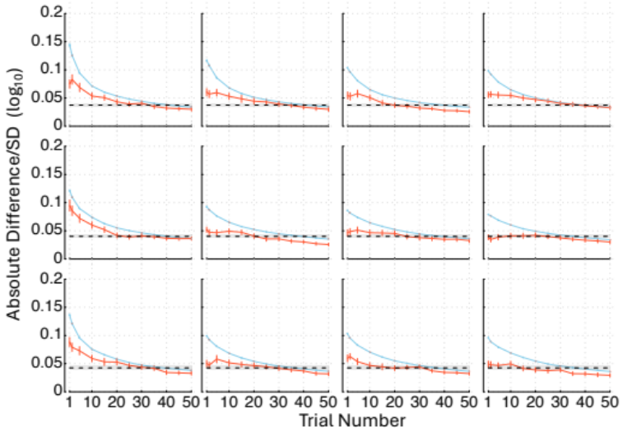
Figure S21. Average absolute difference between the AULCSFs from the simulated and observed data (orange solid lines) across all the 56 subjects in Group II as functions of the number of qCSF trials used in the simulation and average standard deviations of the simulated AULCSFs (blue solid lines), with informative priors from the HBM with 50 qCSF trials. In row 1, results in the low luminance condition are displayed with no data (column 1), data in the medium luminance condition (column 2), high luminance condition (column 3), and both the medium and high luminance conditions (column 4). Row 2 shows results in the medium luminance condition with no data (column 1), data in the low luminance condition (column 2), high luminance condition (column 3), and both the low and high luminance conditions (column 4). In row 3, results in the high luminance condition are presented with no data (column 1), data in the low luminance condition (column 2), medium luminance condition (column 3), and both the low and medium luminance conditions (column 4). The black dashed lines represent the average standard deviations of the observed AULCSF with standard deviation, and error bars indicate standard errors.

We stimulated the qCSF test for all the 56 subjects in Group II with the informative priors from the 12 prediction tasks. Figure S21 illustrates the progression of the simulation, showing the average absolute difference between the AULCSFs obtained from the simulation and the observed data, along with the average standard deviation of the simulated AULCSFs across all subjects. Both measures consistently decreased as the number of trials increased.
Moreover, Figure S22 provides a histogram depicting the distribution of the number of trials needed to achieve statistically equivalent precision as the observed AULCSF. On average, only 31.7 ± 0.3 trials were necessary. We also determined the number of trials needed to obtain estimated AULCSFs that are not significantly different from the observed and found that 14.8 $±$ 0.7 trials on average were required. Combining these results together, we conclude that the informative priors from the HBM with 50 qCSF trials, even without trial-by-trial optimal stimulus selection, can save about 18.3 trials or 37% of the data collection burden in qCSF.
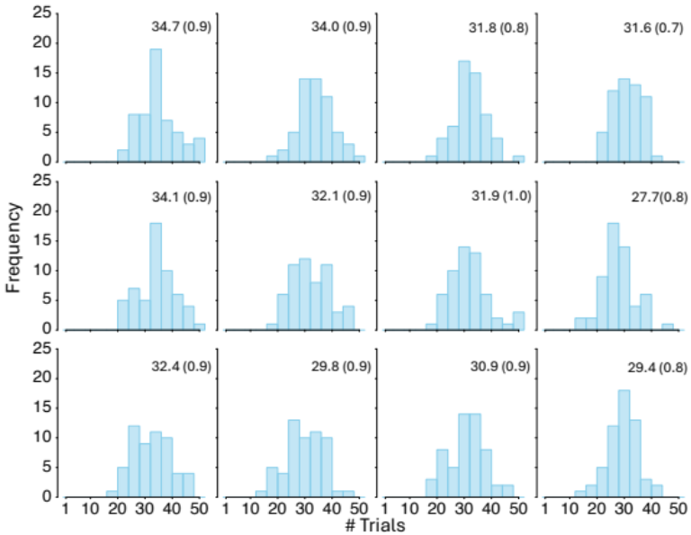
Figure S22. Histograms of the number of trials needed to reach comparable precision as the observed AUCLSF in the simulation experiment, with informative priors from the HBM with 50 qCSF trials. Row 1: results in the low luminance condition with no data (column 1), data in the M (column 2), H (column 3), and both the M and H (column 4) conditions. Row 2: results in the medium luminance condition with no data (column 1), data in the L (column 2), H (column 3), and both the L and H (column 4) conditions. Row 3: results in the high luminance condition with no data (column 1), data in the L (column 2), M (column 3), and both the L and M (column 4) conditions. The average number of trials with standard error are displayed in each condition.

References
1. Lesmes, L. A., Lu, Z.-L., Baek, J. & Albright, T. D. Bayesian adaptive estimation of the contrast sensitivity function: the quick CSF method. Journal of Vision 10, 17.1-21 (2010).
2. Rohaly, A. M. & Owsley, C. Modeling the contrast-sensitivity functions of older adults. J Opt Soc Am A 10, 1591–1599 (1993).
3. Watson, A. B. & Ahumada, A. J. A standard model for foveal detection of spatial contrast. Journal of Vision 5, 717–740 (2005).
4. Zhao, Y., Lesmes, L. A., Hou, F. & Lu, Z.-L. Hierarchical Bayesian modeling of contrast sensitivity functions in a within-subject design. Journal of Vision 21, 9 (2021).
5. Kruschke, J. K. Doing Bayesian Data Analysis: A Tutorial with R, JAGS, and Stan. (Cambridge, MA:Academic Press, 2014).
6. R Core Team. R: A language and environment for statistical computing. R Foundation for Statistical Computing (2003).
7. Plummer, M. JAGS: A program for analysis of Bayesian graphical models using Gibbs sampling. in Proceedings of the 3rd international workshop on distributed statistical computing (2003).
8. Gelman, A. & Rubin, D. B. Inference from Iterative Simulation Using Multiple Sequences. Statistical Science 7, 457–472 (1992).
9. Ljung, G. M. & Box, G. E. P. On a Measure of Lack of Fit in Time Series Models. Biometrika 65, 297–303 (1978).
10. Bauer, D. F. Constructing Confidence Sets Using Rank Statistics. Journal of the American Statistical Association 67, 687–690 (1972).

